MISSION PLAN
FLIGHT ID | 20230823I1 | STORM | AL08/Franklin
MISSION ID | 0508A | TAIL NUMBER | NOAA-43
TASKING | NHC-EMC TDR | PLANNED PATTERN | Landfall Circumnavigation
MISSION SUMMARY
TAKEOFF [UTC] | 1449 | LANDING [UTC] | 2018
TAKEOFF LOCATION | Aruba | LANDING LOCATION | Lakeland
FLIGHT TIME | 5.5 | BLOCK TIME | 5.9
TOTAL REAL-TIME RADAR ANALYSES  (Transmitted) | 2 | TOTAL DROPSONDES Deployed (Transmitted) | 9 (9)
OCEAN EXPENDABLES (Type) | n/a | sUAS (Type) | n/a
APHEX EXPERIMENTS / MODULES | n/a
HRD CREW MANIFEST
LPS ONBOARD | Marks | LPS GROUND | Hazelton
TDR ONBOARD | Marks | TDR GROUND | Reasor
ASPEN ONBOARD | AOC FD | ASPEN GROUND | n/a
NESDIS SCIENTISTS | n/a
GUESTS (Affiliation) | n/a
AOC CREW MANIFEST
PILOTS | Copare/Wood/Palmer
NAVIGATOR | Miller/Schaefer
FLIGHT ENGINEERS | Darby/Tyson
FLIGHT DIRECTOR | Kalen/Parrish/Timmers
DATA TECHNICIAN | Richards
AVAPS | Wagonner/Kotz

PRE-FLIGHT
Flight Plan | 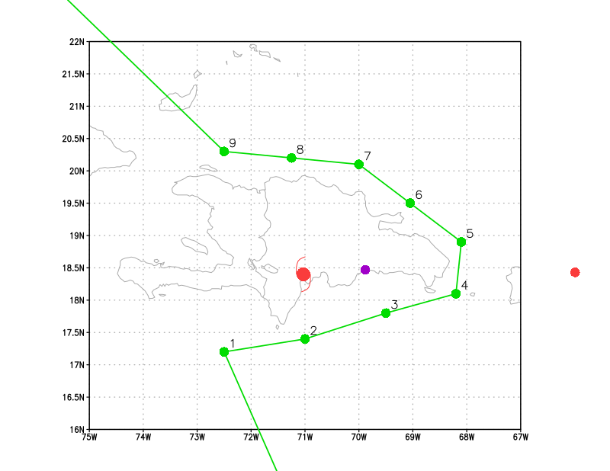  Island circumnavigation is planned en route back to Lakeland, since the center of Franklin is over the island of Hispaniola.
Expendable Distribution | 9 drops planned
Preflight Weather Briefing | 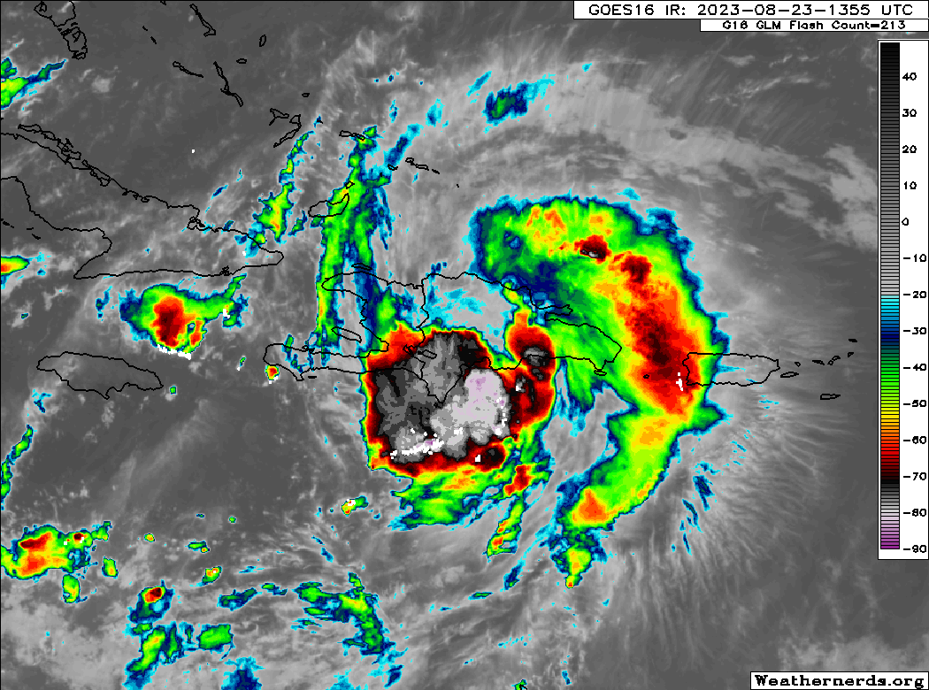  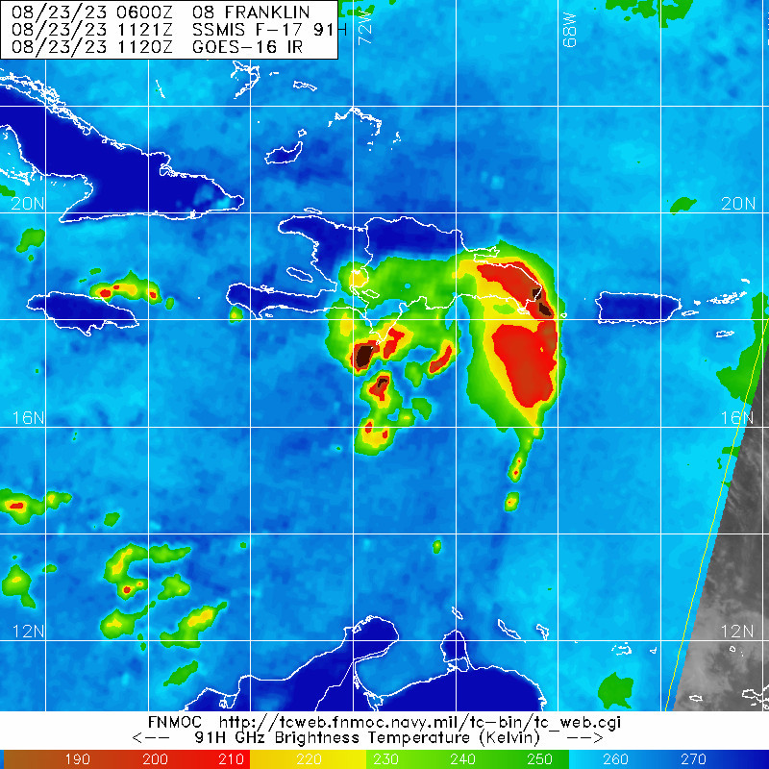  Franklin is over the island of Hispaniola.  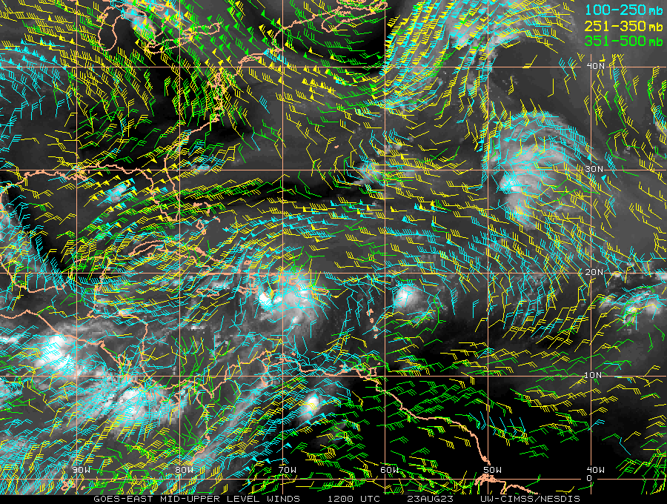  Vertical wind shear is still fairly strong over the storm as well, but the upper low to the west appears to be retrogradign some, and so the outflow is improving over the cyclone.
Instrument Notes | Instruments appear to be functioning normally.

IN-FLIGHT
Time [UTC] | Event
1449 | Take-off from Aruba
1503 | TDR is up
1547 | Onboard LPS notes some tops to 14-15 km
1552 | Descended to 11 kft
1556 | IP, turn TK 080, Drop 1
1601 | 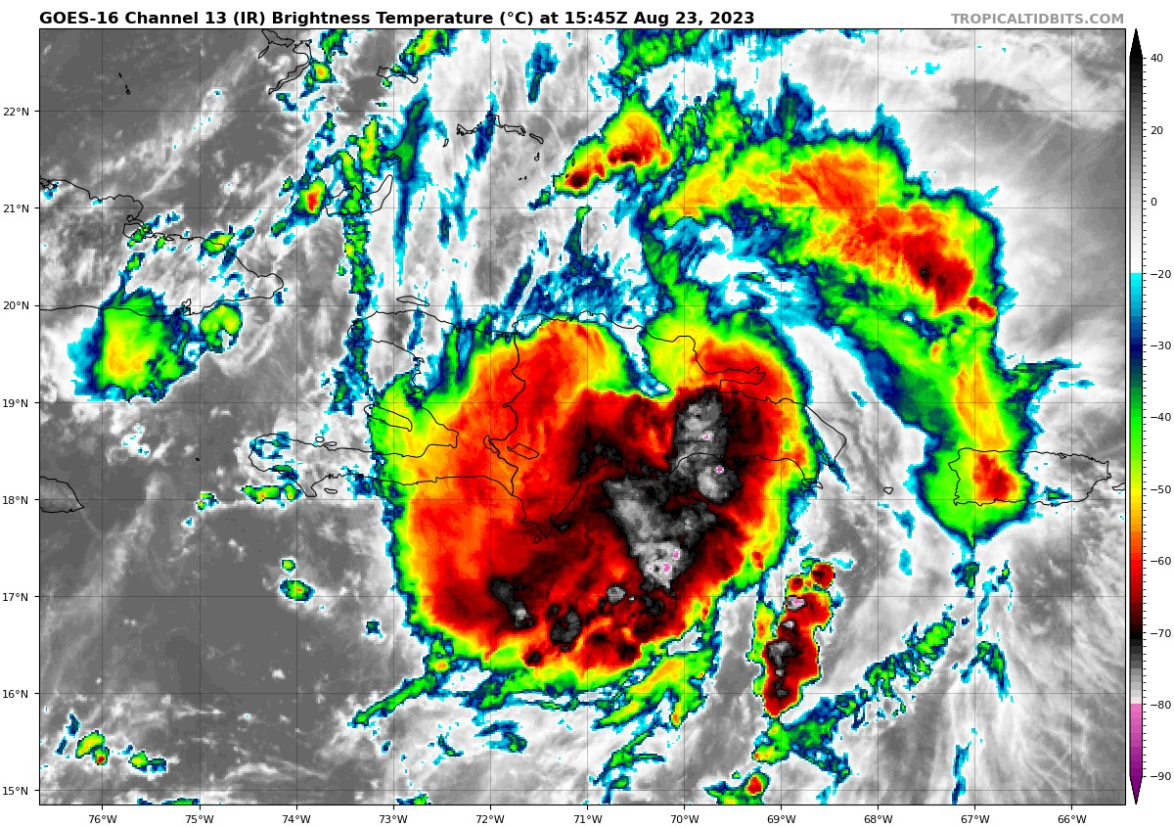  The outer band seems to be weakening now, and the core is becoming a bit disrupted by the terrain.
1615 | Drop #2, in heavy stratiform
1622 | Descending to 10 kft
1626 | looking pretty convective in 10 nm as we cross a major N-S rainband
1627 | 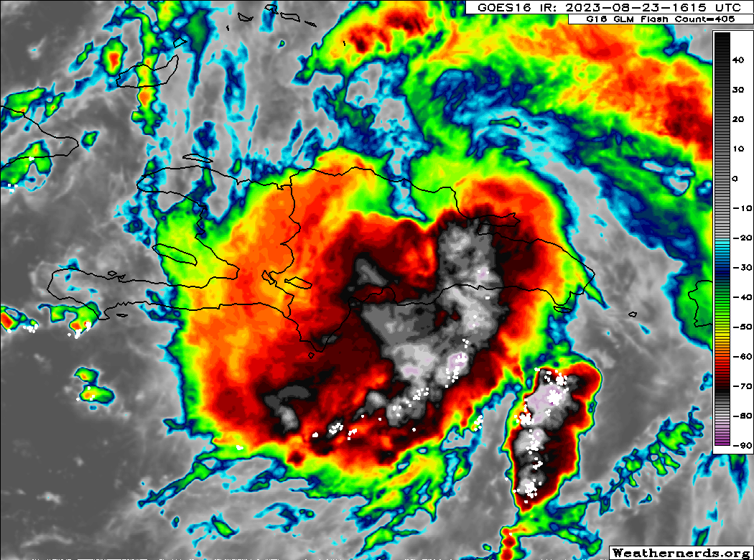
1631 | Echoes to 18 kft and lightning
1634 | 19 m/s updraft and 5 m/s downdrafts  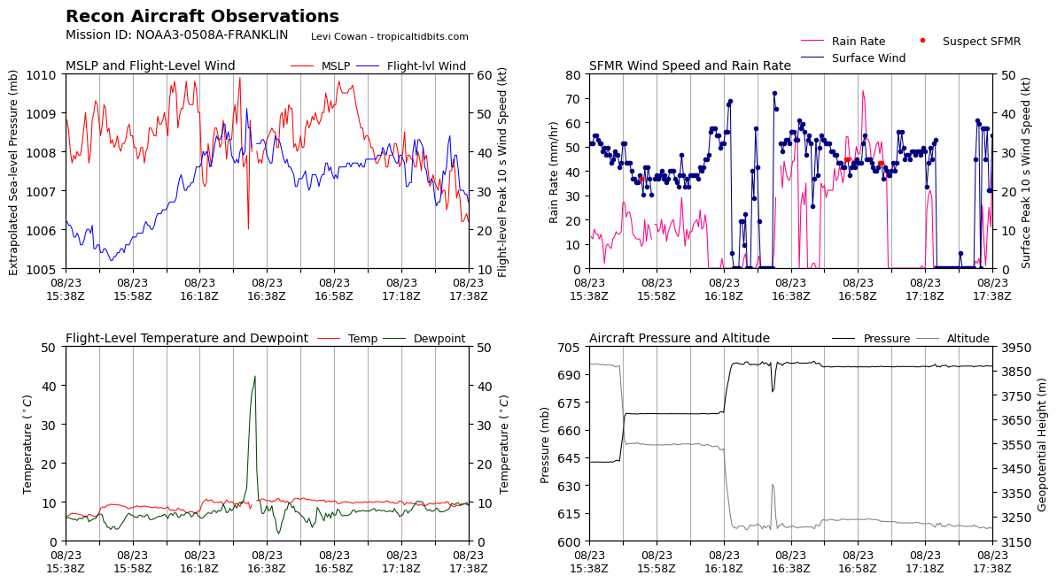  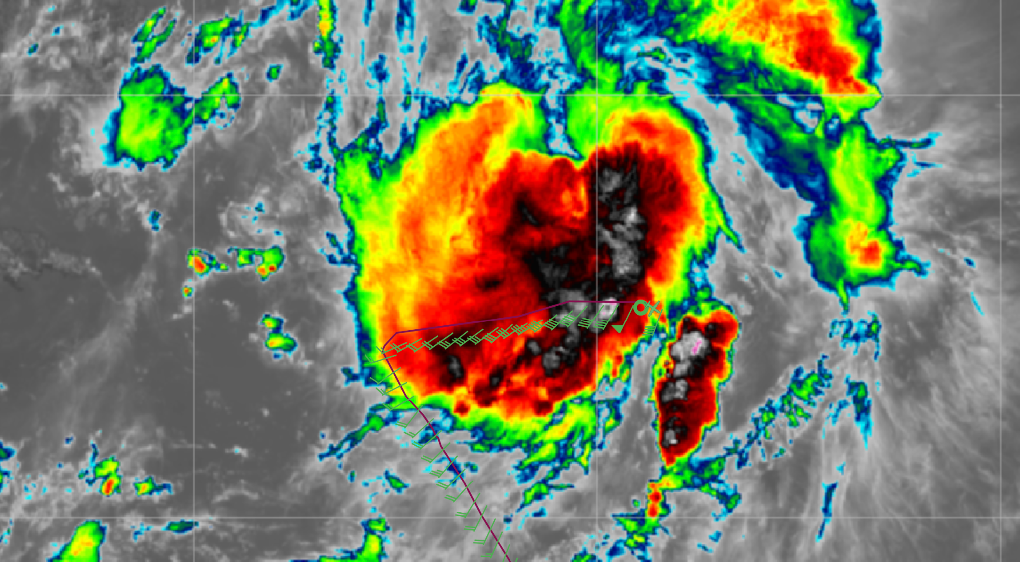
1634 | Sonde 3, dipping S to avoid cells  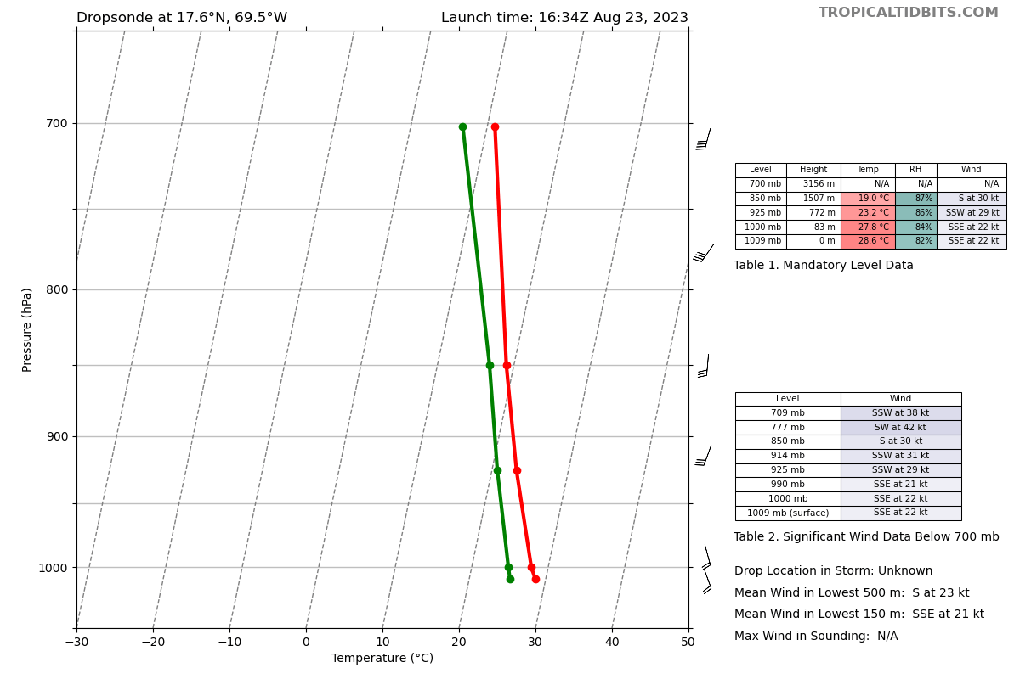
1642 | Many N-S rainbands separated by 20 nm out here on the east side of the system. cells with tops to 15-17 km
1645 | picking our way through the intense convective cell minefield out here
1653 | Drop 4, dropped early to avoid a ship
1705 | Drop 5, turn TK 300
1721 | Sonde 6, ON the N edge of strat precip from major rainband  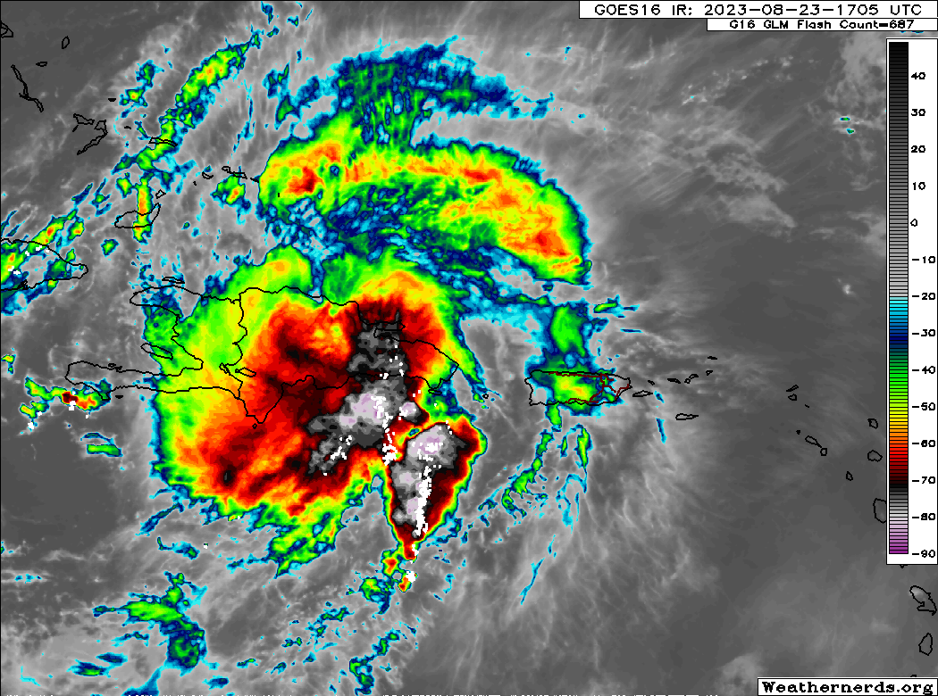
1730 | 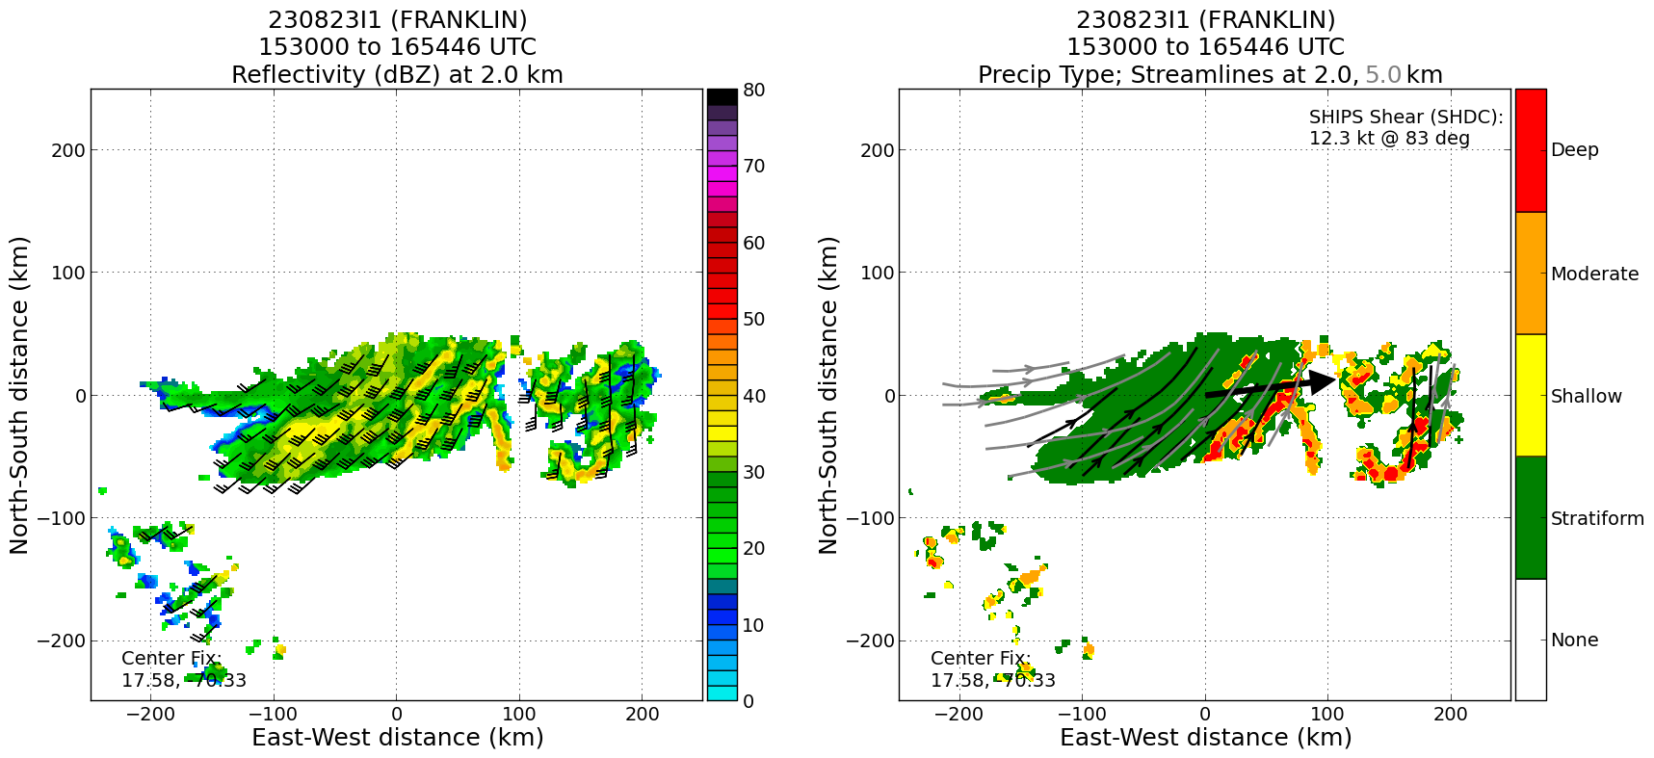
1734 | Drop #7
1750 | Drop #8
1806 | Drop #9, end pattern, turn TK 310 climb to 24 kft
2018 | Landed KLAL

POST-FLIGHT
Mission Summary | The circumnavigation of Hispaniola through the storm was successfully executed. There was quite a bit of heavy convection on the east (downshear) side of the storm, including an updraft of 19 m/s.  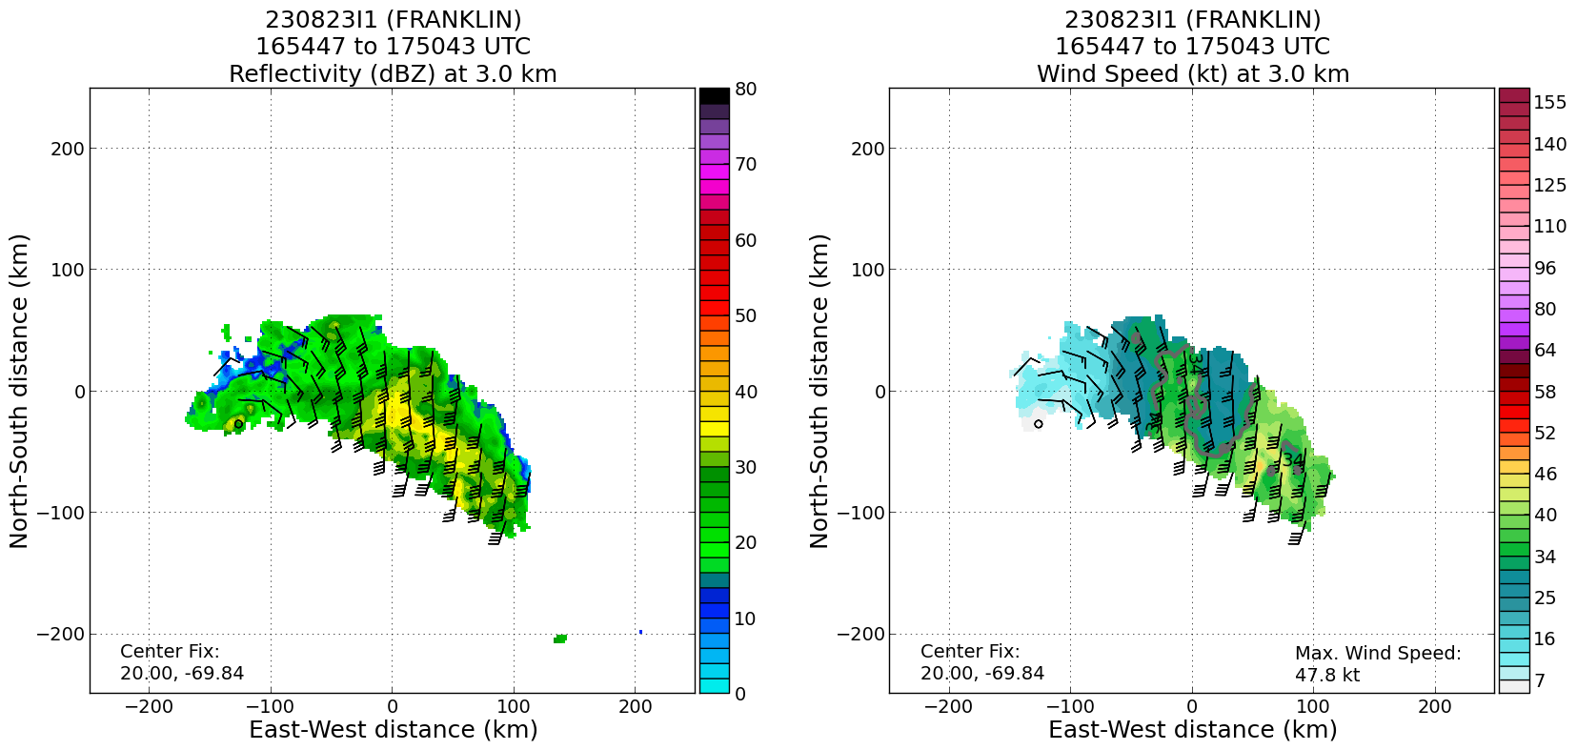  The storm appears to be holding together somewhat despite passing over Hispaniola.
Actual Standard Pattern Flown | Circumnavigation
APHEX Experiments / Modules Flown | N/A
Plain Language Summary | -> We flew a mission around Tropical Storm Franklin while it was over Hispaniola  -> There were some strong thunderstorms in a rain band on the east side.
Instrument Notes | Instruments functioned properly. There were some transmission issues of the final TDR analyses (the files going to SEB).
Final Mission Track

