MISSION PLAN
FLIGHT ID | 20230822I1 | STORM | AL08 / Franklin
MISSION ID | 0408A | TAIL NUMBER | (NOAA-42, -43, -49)
TASKING | (EMC/NHC) | PLANNED PATTERN | Rotated Figure-4
MISSION SUMMARY
TAKEOFF [UTC] | 1531 | LANDING [UTC] | 2221
TAKEOFF LOCATION | Aruba | LANDING LOCATION | Aruba
FLIGHT TIME | 6.8 | BLOCK TIME | 7.1
TOTAL REAL-TIME RADAR ANALYSES  (Transmitted) | 5 | TOTAL DROPSONDES Deployed (Transmitted) | 12 (11)
OCEAN EXPENDABLES (Type) | 1 AXBT | sUAS (Type) | n/a
APHEX EXPERIMENTS / MODULES | VAM
HRD CREW MANIFEST
LPS ONBOARD | Marks | LPS GROUND | Rogers
TDR ONBOARD | Marks | TDR GROUND | Fischer, Reasor
ASPEN ONBOARD | AOC FD | ASPEN GROUND | n/a
NESDIS SCIENTISTS | n/a
GUESTS (Affiliation) | n/a
AOC CREW MANIFEST
PILOTS | Copare/Wood/Palmer
NAVIGATOR | Miller/Schaefer
FLIGHT ENGINEERS | DArby/Tyson
FLIGHT DIRECTOR | Kalen/Parrish/TImmers
DATA TECHNICIAN | Richards
AVAPS | Waggoner/Kotz

PRE-FLIGHT
Flight Plan | Rotated Figure-4 pattern for NHC-EMC tasked NOAA-43 Fix/TDR mission into Tropical Storm Franklin - 1130L / 1530z takeoff from Aruba and recovering in Aruba. Timing of the pattern is to provide a 1730z center fix during the 1st pass (WP 1-2) or 2nd pass (WP 3-4) through the storm. The pattern is also designed to be on-station for EMC data collection for the 1800z model assimilation window between 1500z and 2100z. 105 nm leg lengths planned. Flight altitude was changed from 10kft to 5kft because of difficulty in previous missions in locating a center.  Vortex Alignment Module (VAM) will be attempted, with in-storm location(s) for the VAM module will be at the discretion of the onboard HRD LPS  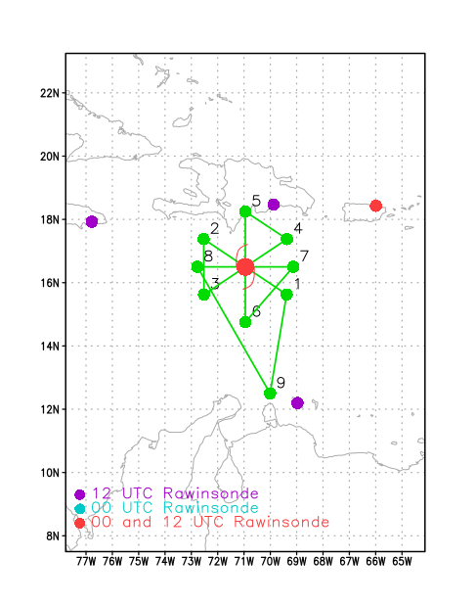
Expendable Distribution | - 20 sondes (all dropsondes transmitted to the GTS; all sondes charged to NWS)  - Release sondes at endpoints, midpoints, centers  - No AXBTs
Preflight Weather Briefing | Franklin is still struggling to organize in the presence of moderate southwesterly shear. There have been persistent bursts of deep convection within the envelope of the circulation, as seen by the various screen grabs of infrared imagery, but so far an aligned vortex has not developed.  Shear is the dominant feature here, with the system along a shear gradient of 30 kt of westerly shear to the north and 15 kt to the south.  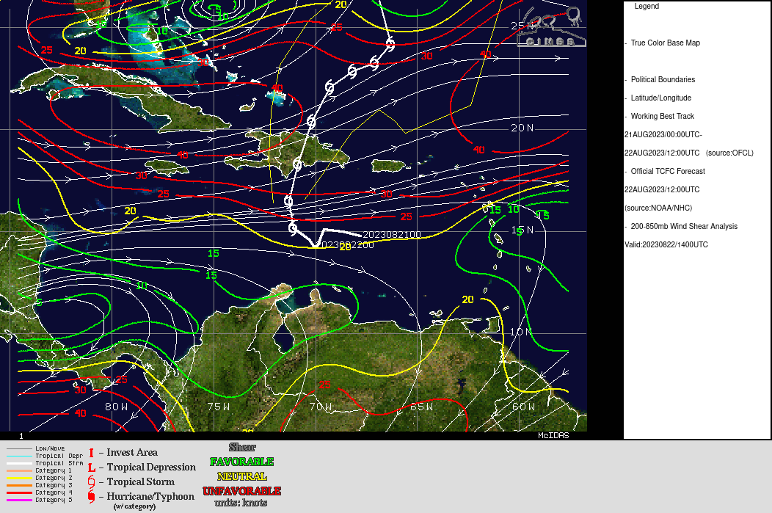
Instrument Notes | All instruments working

IN-FLIGHT
Time [UTC] | Event
1531 | Take-off from Aruba
1557 | On approach to IP, issues with TDR. Not producing product raw files. Aircraft within region of coldest cloud tops and lightning ahead, widespread stratiform rain here.
1559 | Now approaching region of likely deep convection, overshooting tops, with a localized region of lightning and a core of coldest cloud tops  Onboard is reporting very heavy stratiform here, probable top-heavy heating and mass flux profile
1605 | Deviating to the west of lightning core, deep convection identified from TDR there, echo tops estimated at 16-18 km
1606 | Drop 1, at IP, pattern appears to have been shifted to the south by 50 km or so. Lots of scatterers, should be good TDR analysis (see picture below of MMR, nose radar, and TDR).  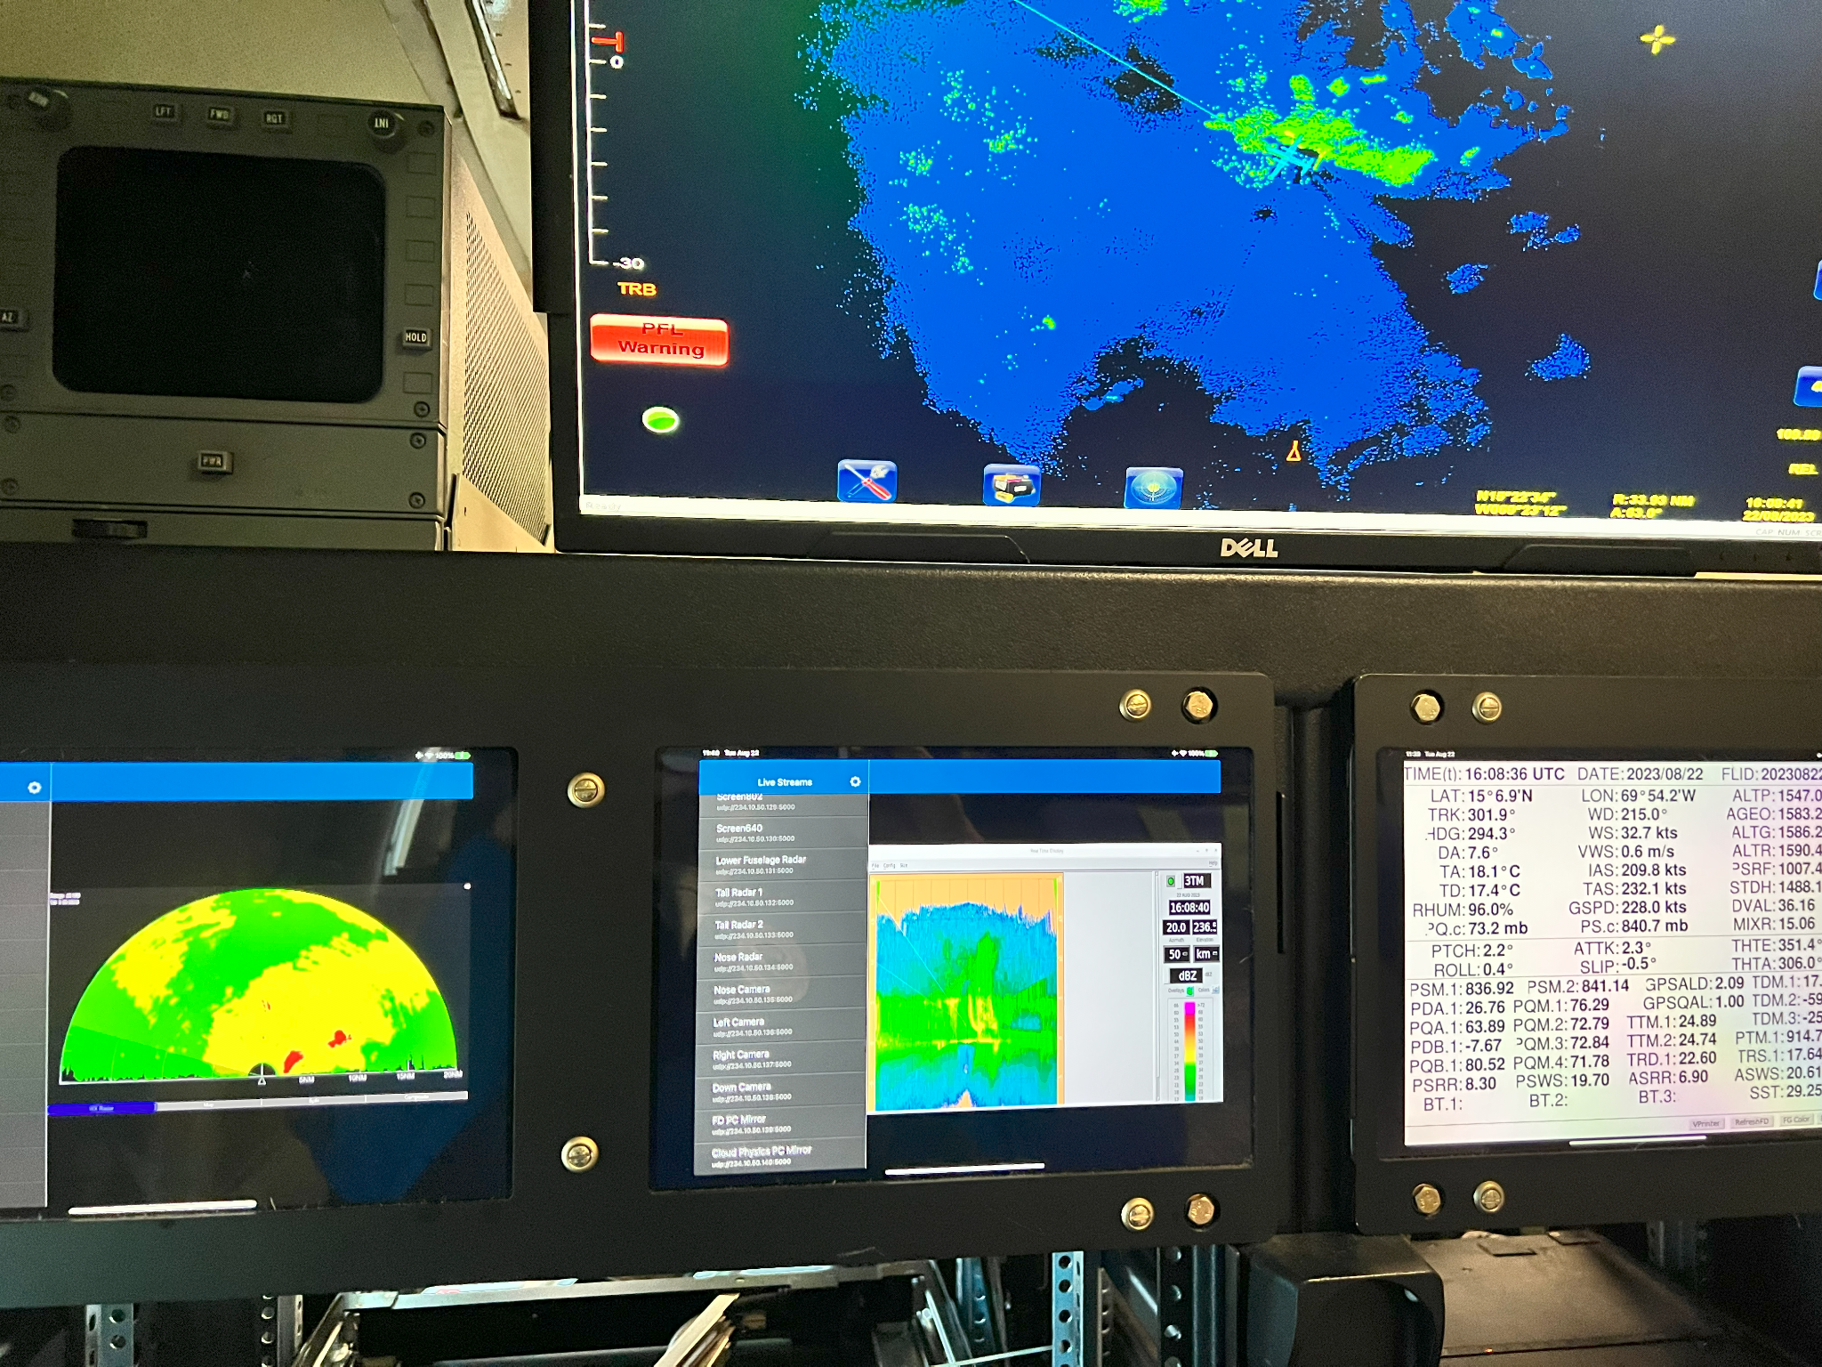
1613 | May trim the outbound leg to the northwest to allow time to get the fix requirement at 1730 UTC. Not a lot of scatterers at the end of the outbound leg so likely not a big problem.
1619 | Drop 2, midpt SE, no launch detect. Backup sonde worked fine
 | Looks like center, as it were, at 5kft is likely broad and well to the west of the aircraft. Perhaps in the area of cold cloud tops to the west, where lightning is also seen
1632 | Will try to get the first analysis done as quickly as possible to provide an estimate of a LLC for to shoot for on the second leg
1633 | Going to shorten the outbound leg by 20 nmi so can get back into the center by 1730-1745 UTC. We will not shorten the inbound leg from SW.
1632 | Drop 3, near center but missed it, FL winds 170/16 kt
1636 | In western cloud shield, hitting some good chop, possible convective/bottom-heavy profiles here. Bunch of tiny growers just getting to our altitude
 | Not much in the way of scatterers ahead, clear sky ahead under a CDO
1641 | little swirl in sea clutter 25 nm s of our position 16.15, 71.85
1646 | Midpt sonde #4
1651 | Combo drop #5, endpt NW, test of BT training and procedure evaluation. BT failed.
1652 | Turn to track 190, downwind leg
1658 | Next pass from SW-NE will be at 2.5kft to try to fix center based on FL wind
1716 | Center estimate from first pass – (15.72,71.35) at 2 km ... (15.09,70.74) at 6 km  2-6-km Vortex Tilt: 96.1 km at 137 deg
1716 | Descending to 1.5 kft for this pass, now climbing to 2.5 kft
1720 | Drop 6, endpt NW, turn to track 060
1735 | Vorticity analysis from first center pass shows a fairly well-defined midlevel circulation center with a local vorticity maximum, between about 4 and 8 km. Hard to discern much of a circulation in the low-level flow, even in storm-relative framework.  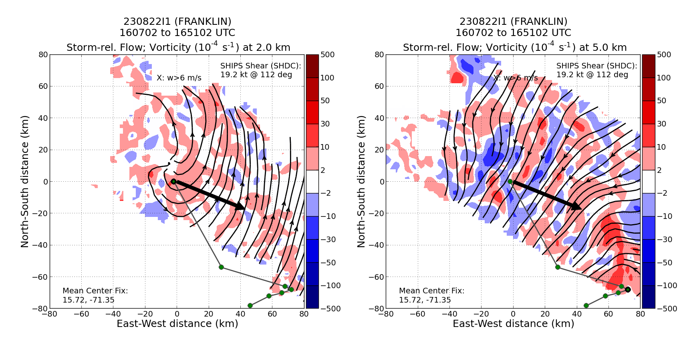
1736 | Turning now to the northwest on the inbound leg because FL winds indicate a turn was warranted. May be following along a shear axis, though, and not locating a circulation center.
1749 | Center marked, now tracking almost due east to pick up the original center estimate made on the first pass. Then will pick up the 060 track to point 4.
1757 | Visible animation shows a low-level swirl at the northwest edge of the cloud shield.
1811 | Pattern change – NHC is requesting the P-3 turn due north once 71W is reached.
1823 | Encountering pretty significant bumps here in heavy stratiform. High (16-18) echo tops off the left wing.
1825 | Turn to track 000, looks like an outbound leg, based on where we extrapolate a center to have been from the previous pass
1837 | Drop #7, endpoint of eastbound leg. At 1500 ft.
1840 | Turning to track WNW to a point NE of the previous center fix. That is what CARCAH wants to continue to center the pattern on.
1852 | Reached endpoint NE of previously-fixed FL center. Heading to inbound track 225 toward that fixed center. Release drop #8. Descending to 2500 ft
1914 | Marked a low-level center at 15.74N 73.04W
1915 | Turned to track 320, using the FL wind to try to fix a center. Found a wind shift, but appears to be a shear line; i.e., NNE of the previously-fixed center
2003 | New plan: aircraft is near MLC, which was determined from 2nd TDR analysis to be at 15.3 71.12. From there, head outbound on a 030 track for 105 nm to sample NE region that hadn’t been sampled before. Then turn downwind to a point N of the MLC, and track 180 back to the MLC. If there’s time and fuel, turn back toward LLC (previously marked at 15.74N 73.04W) and extend about 10-20 nm beyond, reverse track back to MLC for a VAM. If not enough time, go a fraction of that distance.
2005 | TDR analysis of 3, 5, and 7-km winds from second “pass” shows a coherent circulation nearly aligned. Below and above that layer there is little to no indication of such a circulation. Clear MLC.  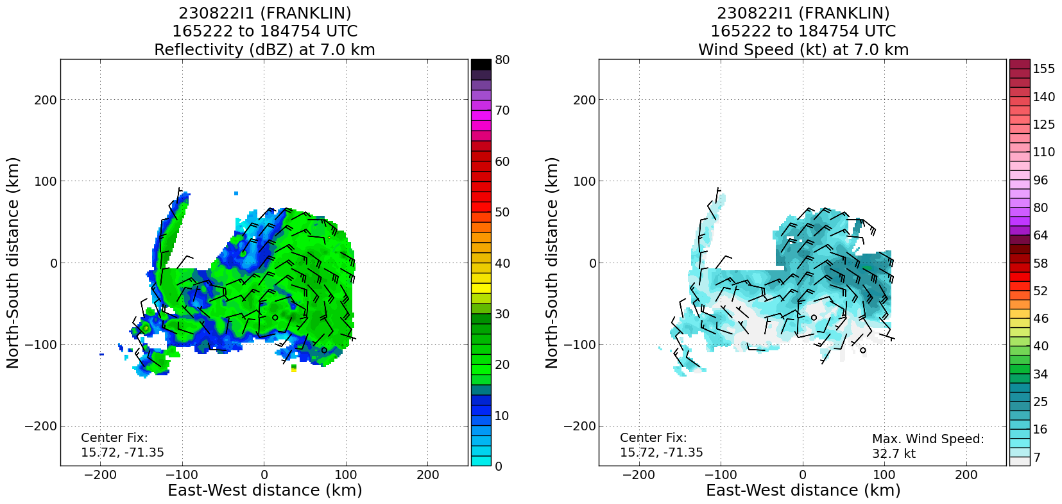  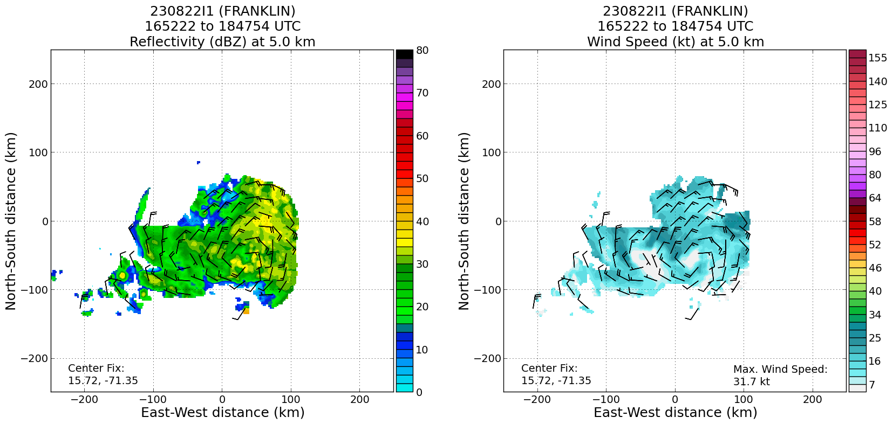  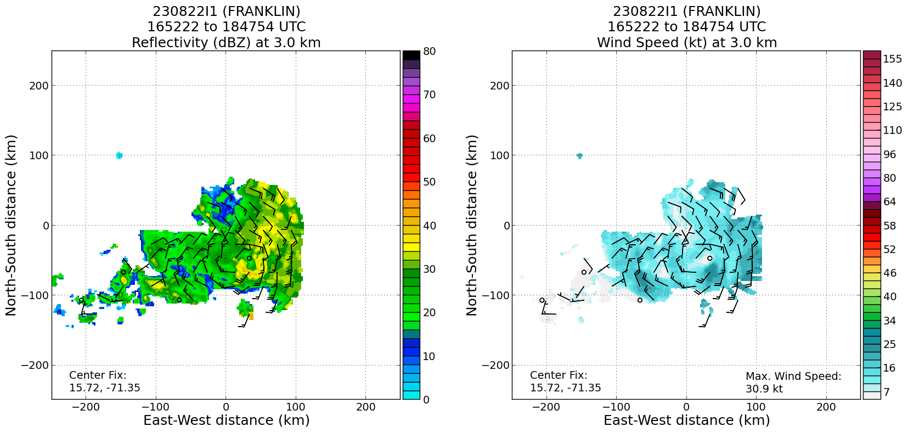
2004 | Drop #9 at MLC (at 5kft altitude)
2020 | Heading outbound to the NE from MLC, in broad cold cloud shield. Mostly stratiform precip with embedded young cumulus congestus developing within stratiform shield.
2026 | Climbing to 10 kft and turning to a point N of MLC
2029 | Drop #10 at NE point, at 10 kft
2038 | Flying downwind to point N of MLC
2040 | Drop #11 at N point
2041 | Turn to track 180 toward MLC
2053 | Easterly flow evident at 10 kft on inbound leg to MLC. Once the MLC is reached, aircraft will turn to a track 280 or 290, toward previous LLC, for about 10 min (40 nm), then reverse track back to MLC
2106 | Drop #12, at MLC
2113 | There was a very strong rainband curving from the SW toward the MLC location that we turned at. We turned to avoid smacking into it while we were dodging the convection over the MLC. It was tight and bumpy We are tracking along the north side of the west extension of that band in heavy stratiform rain
211935 | End of outbound (from MLC) leg of VAM
212042 | Start of inbound (to MLC) leg of second VAM pass
Vorticity analysis from third pass shows a clear vorticity, vertical velocity maximum coincident with circulation center at 5 km

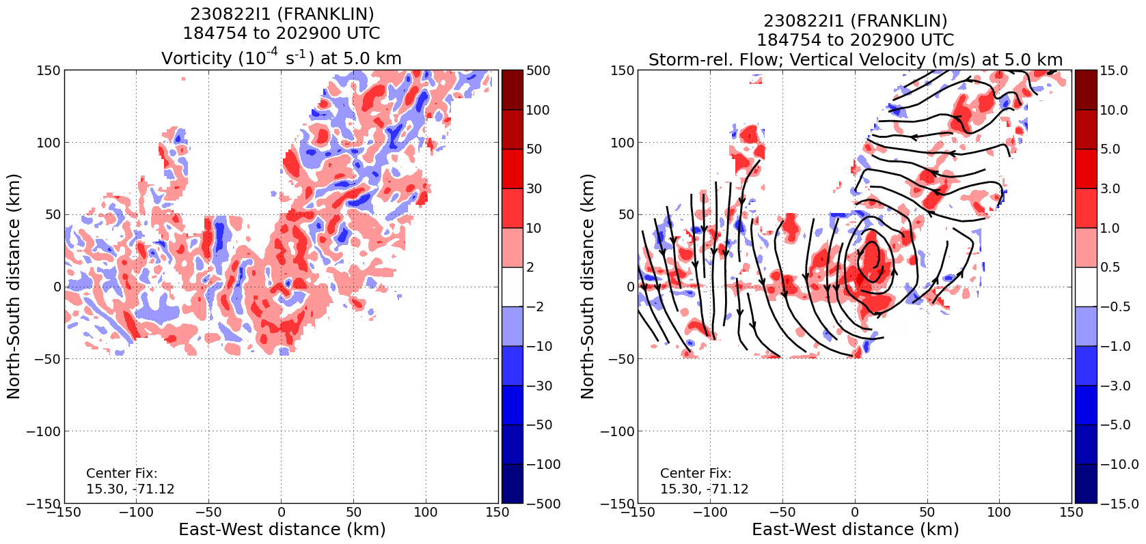
2125 | Southern edge of the big stratiform area has a ring of cells stretching back west from the rainband hooking into the MLC location
2129 | Comparing strength of MLC from yesterday to today, appears that MLC has weakened today, but circulation is more symmetric  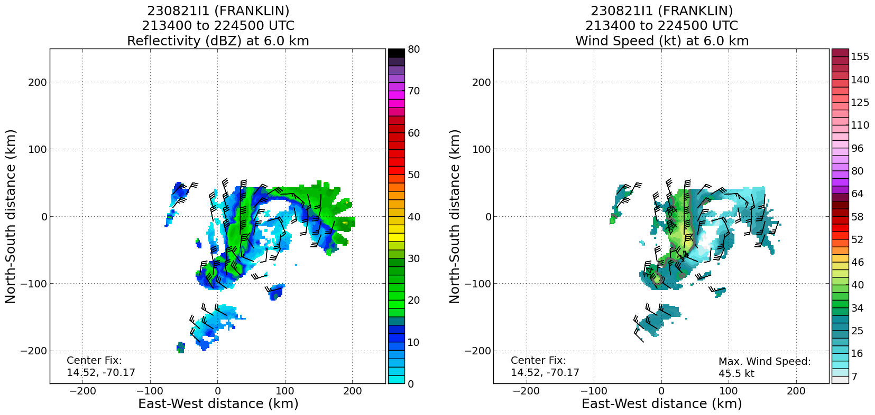  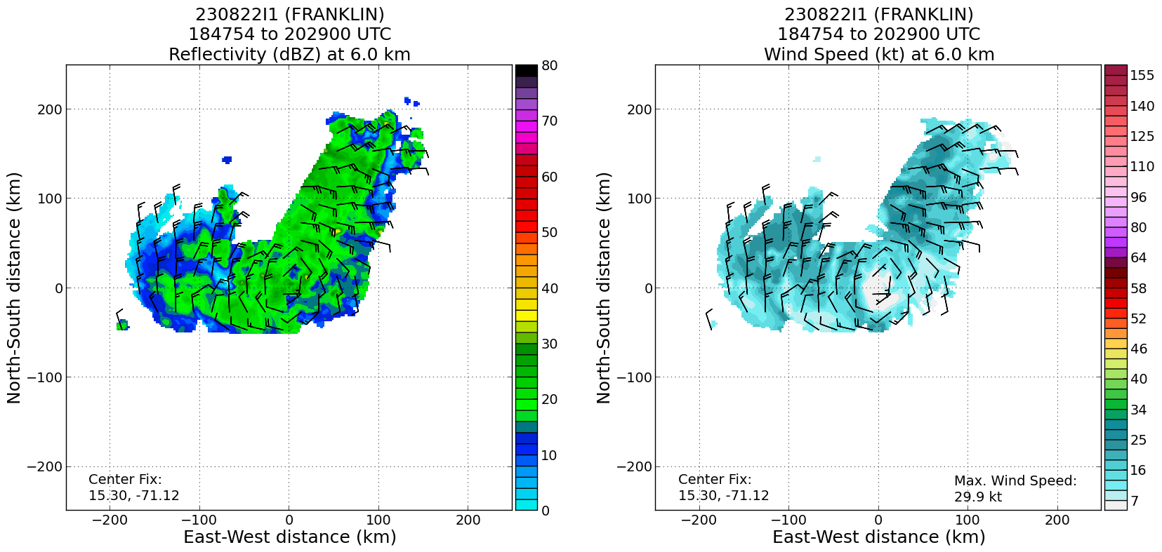
2137 | Final pass through MLC, encountered significant up- and downdrafts, including +9 m/s and -4 m/s. RTB to Aruba.
2202 | 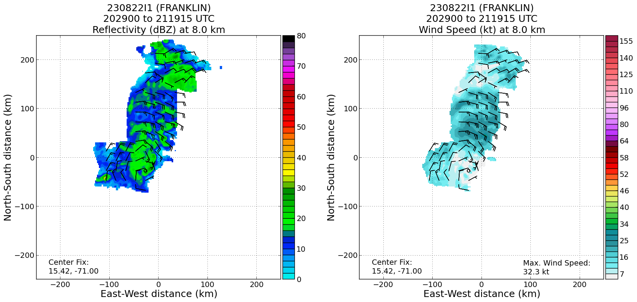  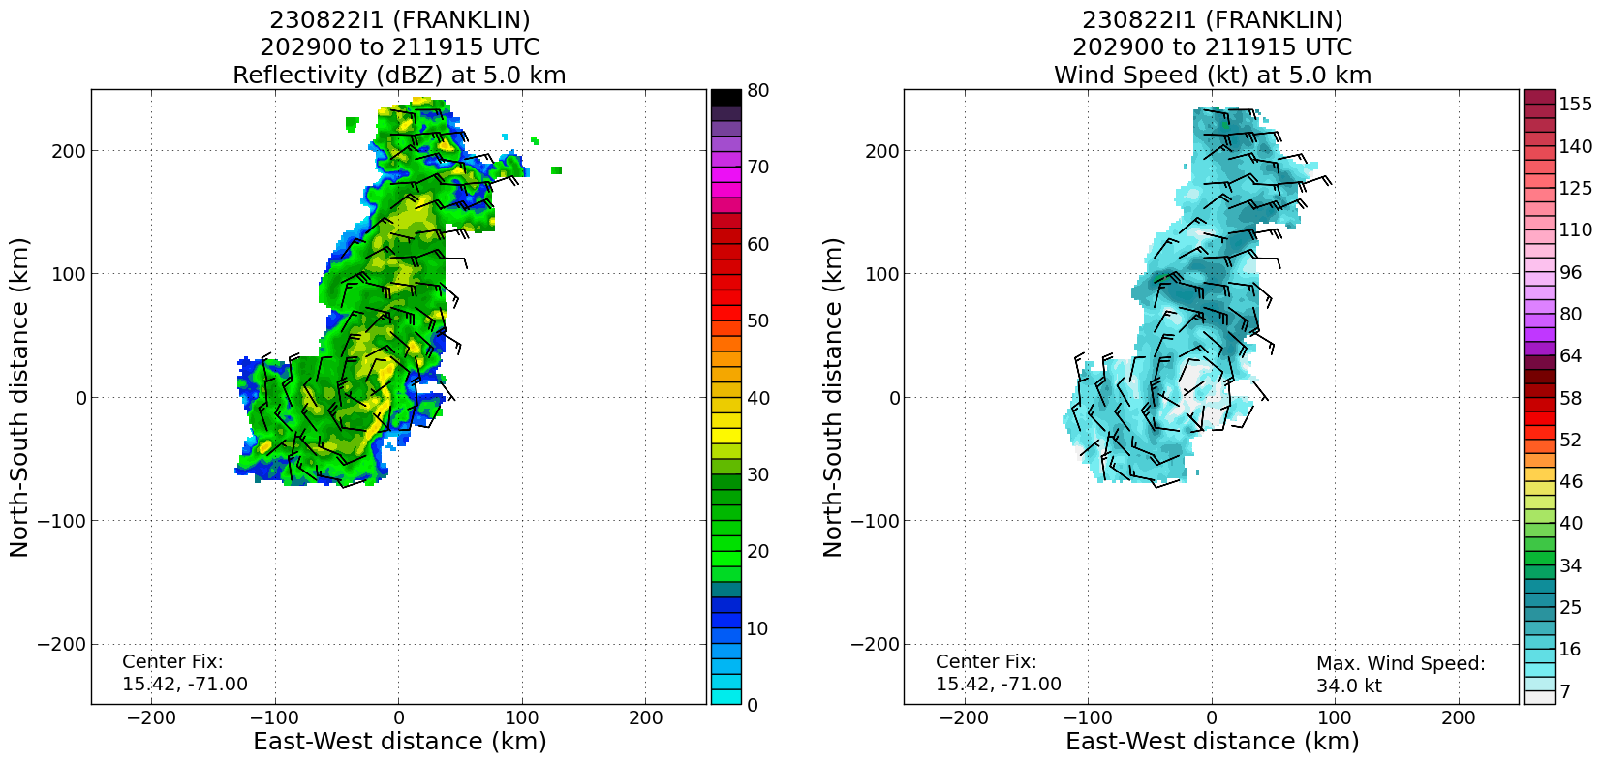  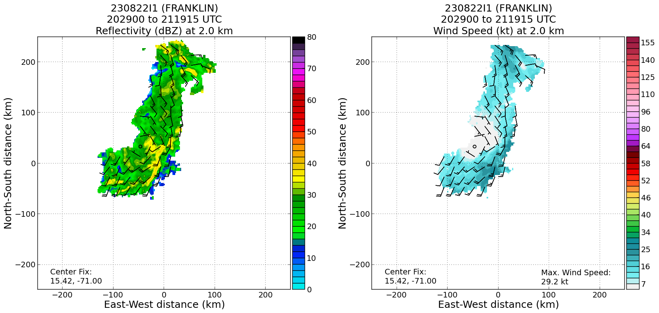  Analyses from the fourth pass show that the circulation now is identifiable down to 2 km, so vortex appears to be deepening, even if it’s not becoming stronger in terms of winds
2212 | Precipitation partitioning from fourth analysis shows widespread moderate convection and deep convection embedded within stratiform precip in the vicinity of the MLC – bottom-heavy mass flux profile within MLC?  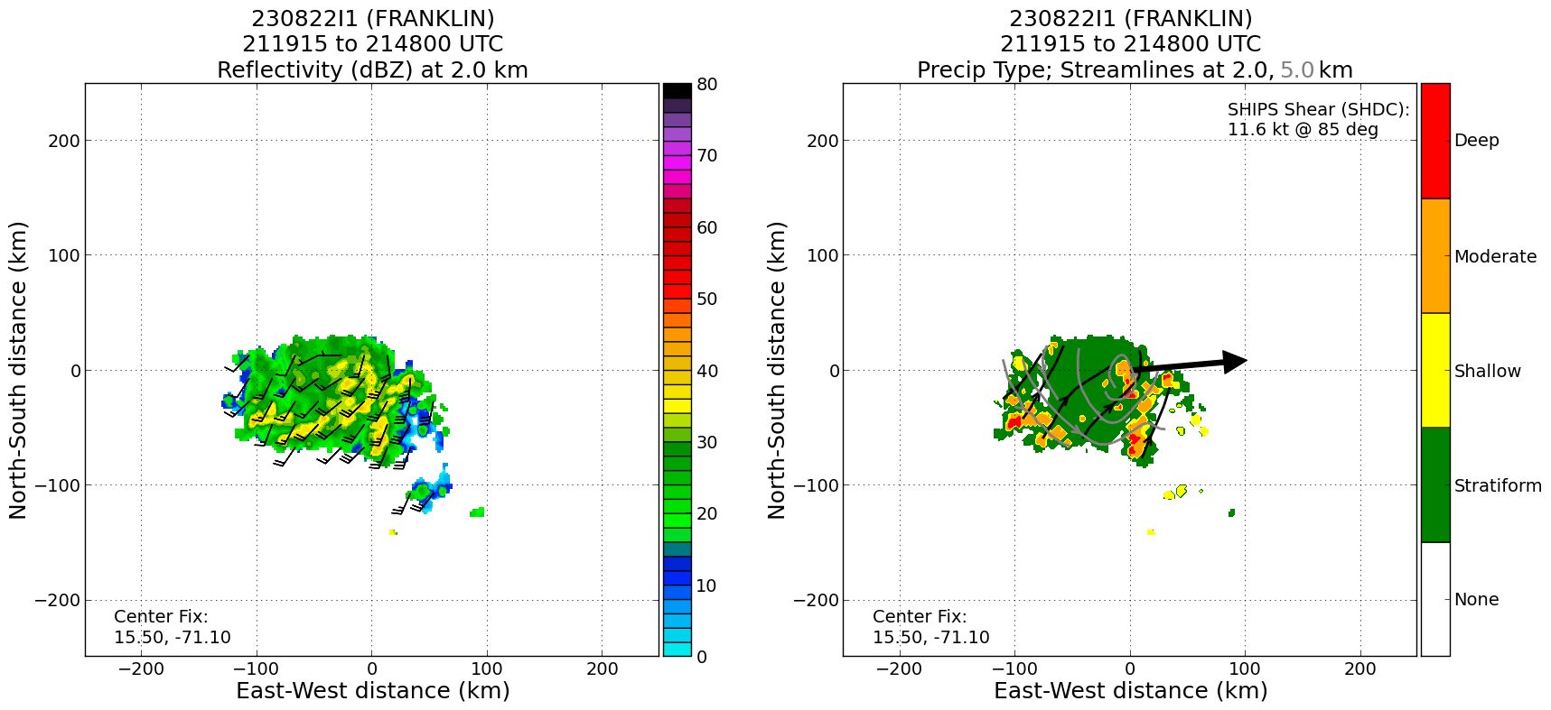
2220 | Land in Aruba

POST-FLIGHT
Mission Summary | Mission was successful in accomplishing objectives. Accomplished the fix at 1730 UTC, and collected several legs’ worth of TDR analyses. Also performed a modified VAM. Pattern was significantly modified from the original plan because of a desire from CARCAH to find a low-level center evident at the western edge of the cloud shield on visible imagery. Once a wind shift was detected, which may or may not have been a shear axis instead of a circulation center, the aircraft was freed up for TDR-type patterns. TDR analyses from earlier in the pattern had identified a clear MLC from about 3-7 km. That was used as an anchor for the subsequent pattern, which consisted of an outbound leg to the northeast, then downwind to a point north of the MLC, then an inbound track to the MLC from the north, then outbound toward the previously-defined low-level “center” for about 40 nm, then a reverse track toward the MLC, then RTB. In all, there were four  There was widespread stratiform precipitation and embedded young convection as well as deep convective towers throughout the mission, particularly near the MLC. By the time of the fourth analysis, there are indications that the circulation had grown vertically, with a definable circulation center at 2 km. The wind speeds did not increase, but the system appears to be getting better organized in terms of depth of the circulation center.  A total of 13 sondes were dropped, all of them charged to NHC. One AXBT was dropped.
Actual Standard Pattern Flown | Modified Rotated Figure-4
APHEX Experiments / Modules Flown | Fix/TDR mission, VAM (modified)
Plain Language Summary | - Mission flown into Tropical Storm Franklin, a system dealing with a fairly hostile environment with wind speeds and direction changing with height  - Storm remains rather disorganized, with a circulation center in the lowest 5000 ft located well to the west of the strongest thunderstorm activity, where most of the energy is released  - Airborne radar analyses showed that the flow in the middle levels of the atmosphere (about 10,000 - 25,000 ft) was well-organized, with a circulation center that was vertically stacked. This circulation appeared to extend over a deeper layer over the course of the mission, suggesting that Franklin has become a bit better organized, even if it wasn’t increasing in intensity (yet).  - This could be an important step in intensification, provided the environment does not remain hostile.
Instrument Notes | TDR was a bit delayed producing files at the start of the mission, but came online prior to reaching IP. Otherwise all instruments performed well. One no launch detect for the sondes, but it was successfully backed up.
Final Mission Track

