MISSION PLAN
FLIGHT ID | 20230821I1 | STORM | AL08 / Franklin
MISSION ID | 0208A Franklin | TAIL NUMBER | NOAA 43
TASKING | NHC | PLANNED PATTERN | Center Fix
MISSION SUMMARY
TAKEOFF [UTC] | 1705 | LANDING [UTC] | 2323
TAKEOFF LOCATION | Aruba | LANDING LOCATION | Aruba
FLIGHT TIME | 6.3 | BLOCK TIME | 6.5
TOTAL REAL-TIME RADAR ANALYSES  (Transmitted) | 3 | TOTAL DROPSONDES Deployed (Transmitted) | 14 (14)
OCEAN EXPENDABLES (Type) | none | sUAS (Type) | none
APHEX EXPERIMENTS / MODULES | none
HRD CREW MANIFEST
LPS ONBOARD | n/a | LPS GROUND | None / Alvey
TDR ONBOARD | n/a | TDR GROUND | Fischer/Reasor
ASPEN ONBOARD | AOC FD | ASPEN GROUND | n/a
NESDIS SCIENTISTS
GUESTS (Affiliation)
AOC CREW MANIFEST
PILOTS | Copare/Wood/Palmer
NAVIGATOR | Miller/Schaefer
FLIGHT ENGINEERS | Darby/Tyson
FLIGHT DIRECTOR | Kalen/Parrish/Timmers
DATA TECHNICIAN | Richards
AVAPS | Waggoner/Kotz

PRE-FLIGHT
Flight Plan | [Insert image of submitted flight pattern here]  [Insert image of ONR/TCRI detailed pattern image, if available]  [If you want, briefly describe the pattern in words]
Expendable Distribution | [Describe planned dropsonde, ocean buoy, sUAS deployment locations; e.g., “Dropsondes/AXBT combo drops at endpoints, midpoints, and center”
Preflight Weather Briefing | Moderate 15-20 knot westerly shear. Tropical storm with 50 mph sustained winds. From 11am NHC disco: “There is no lack of cold cloud tops associated with Tropical Storm Franklin this morning. The structure on satellite consists of a large bursting pattern, with cloud tops as cold as -90C close to and just east of the estimated center. However, it is unclear if any of  this deep convection has resulted in structural improvement to  the storm, with the most recent microwave imagery from a SSMIS F-16  pass at 1007 UTC showing a chaotic structure, with evidence the  center remains near the western edge of this large convective shield.”  Some model variability regarding alignment/intensification: Previous HAFS simulations (HAFS-B) indicated potential of reformation / alignment prior to Hispaniola. More recent 06/12 UTC runs indicate that Franklin may remain tilted throughout the near term. GFS and Co-amps indicate potential for alignment / reformation too in next 24-36 hours.
Instrument Notes | [What instruments are working, not working, not functioning nominally, not installed?]

IN-FLIGHT
Time [UTC] | Event
Preflight | Persistent deep/intense convection throughout the overnight period
1650 UTC | Convection appears to become more disorganized and propagating southward, almost squall line like…outflow boundary?
 | Time Eastern (through 14 UTC)
 | Through 1630 UTC
1705 | Take-off from Aruba
1755 | 1st center pass leg start
1815 | 1st Center pass time. SE - NW and then back in towards center because unable to fix, then back out again to the NW
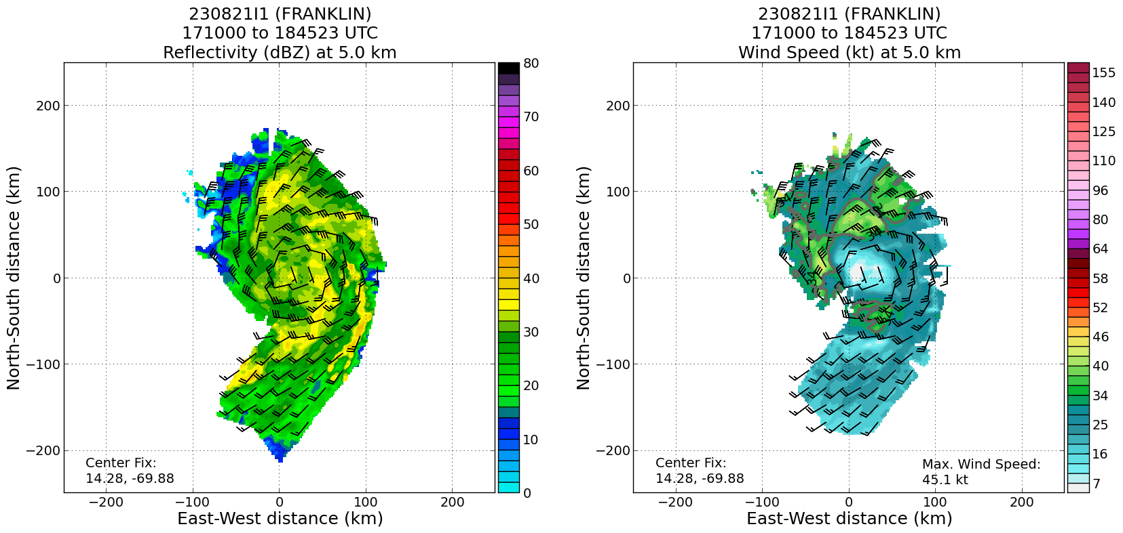
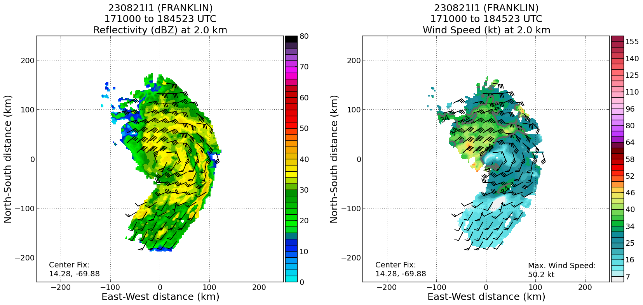
Very surprising seeing the organization of the LLC and MLC well defined and nearly vertically stacked despite the disorganized satellite appearance. Hypothesis that perhaps the deep convection overnight had helped it align and this is the peak of organization which should become more misaligned given lack of deep convection to “anchor” unless new convection develops near the center. Largely stratiform precipitation now.
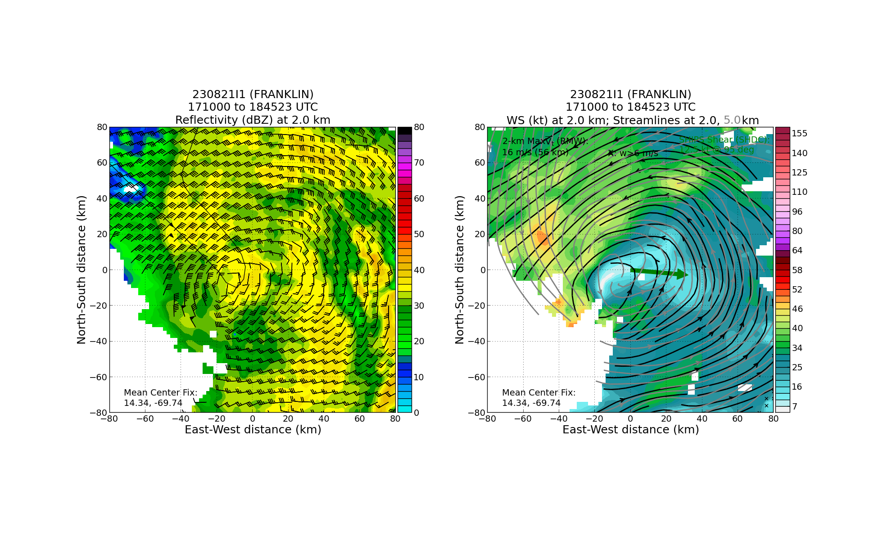
Another view from the first pass showing the near alignment

1845 | Turned on NW back to south
1923 | Inbound on SW side (SW-NE), pass 2
1942 | 2nd center time
1930 | Most intense / deep convection appears to be weakening
2005
 | 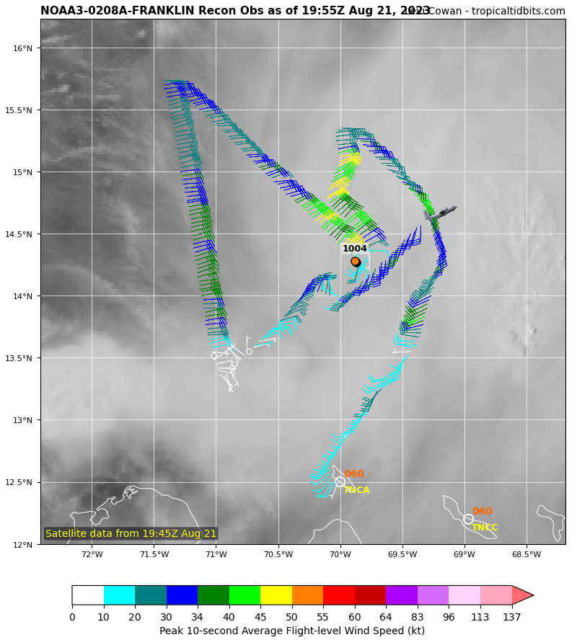
 | Through ~20 UTC (Local time is eastern time)
2004 | Tilt has increased on 2nd leg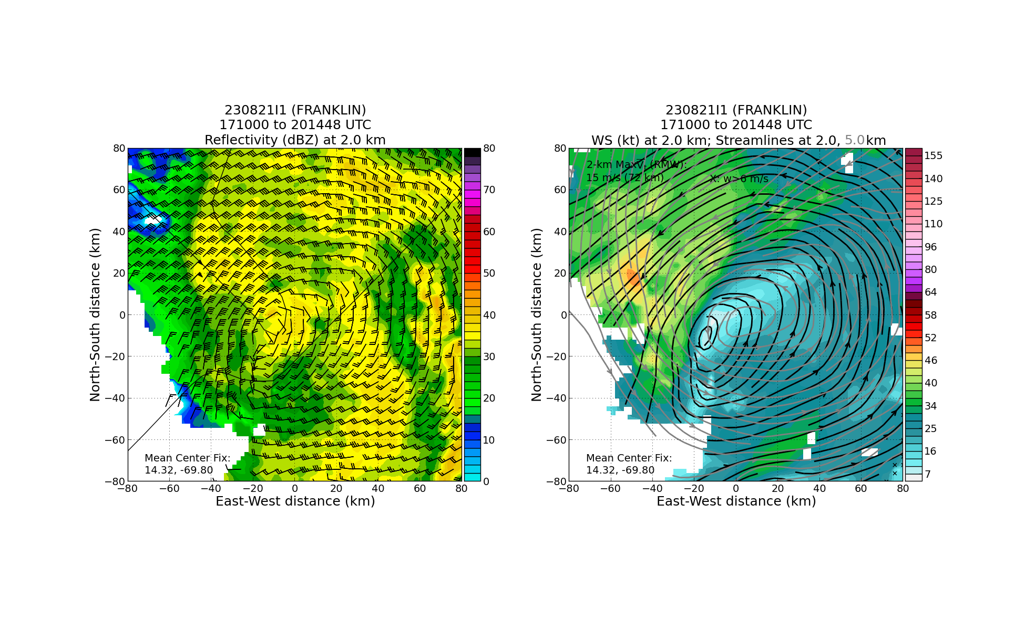
2015 | Turned back to NW
2045 | N-S Leg
2048 | Pronounced mid-level circulation more apparent in visible imagery now that not obscured by deep convection + anvil earlier. Looks to potentially be decoupling, however
2105 | Via FD - Tiny little cells starting to pop up around the center
2245 | 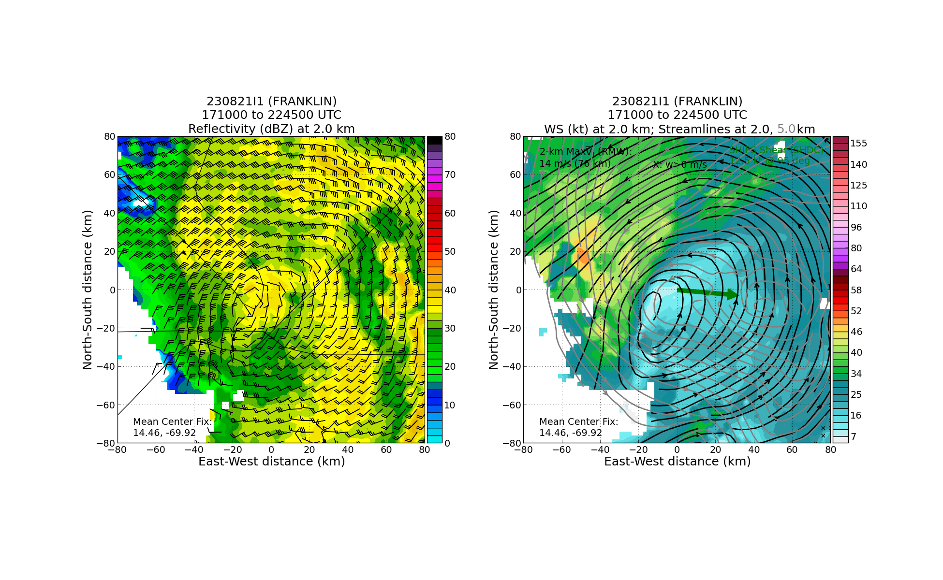  Substantially larger tilt now towards the east - > 60 km  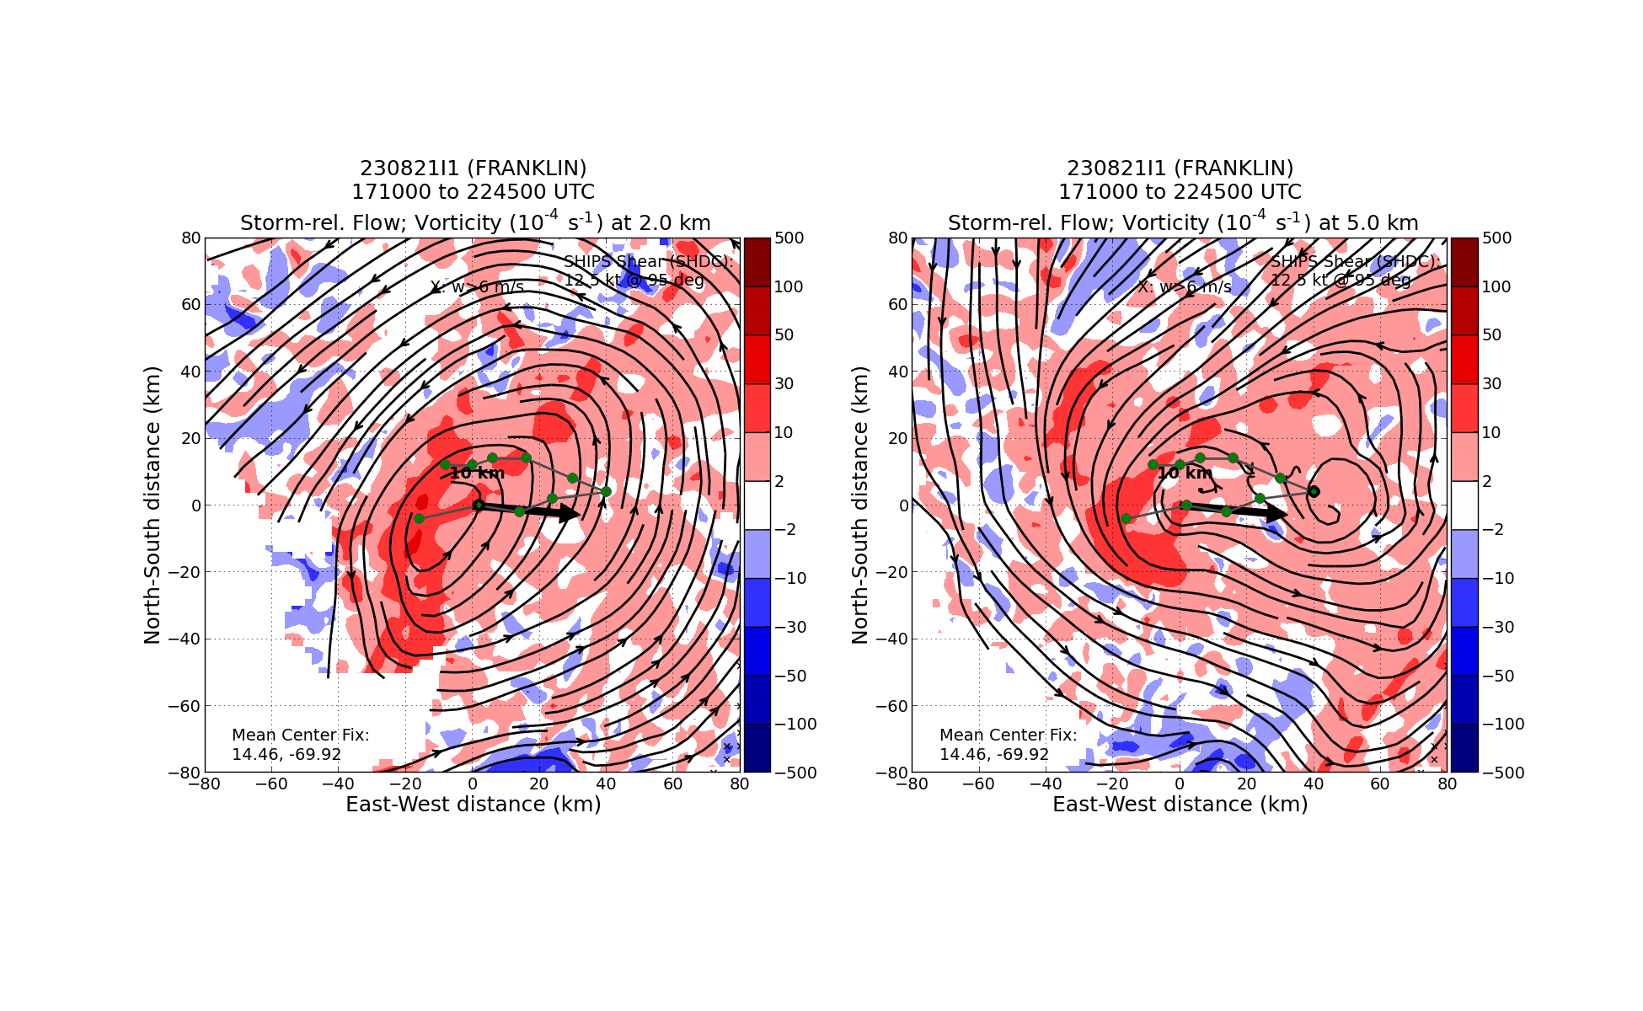Michael F. - “The anti-VAM”
 | 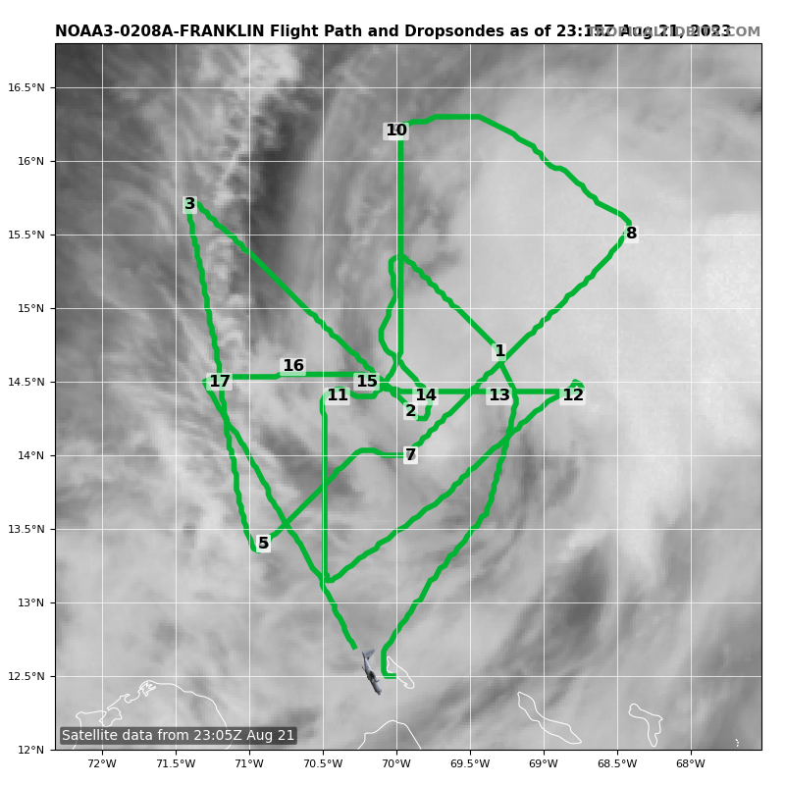
 | 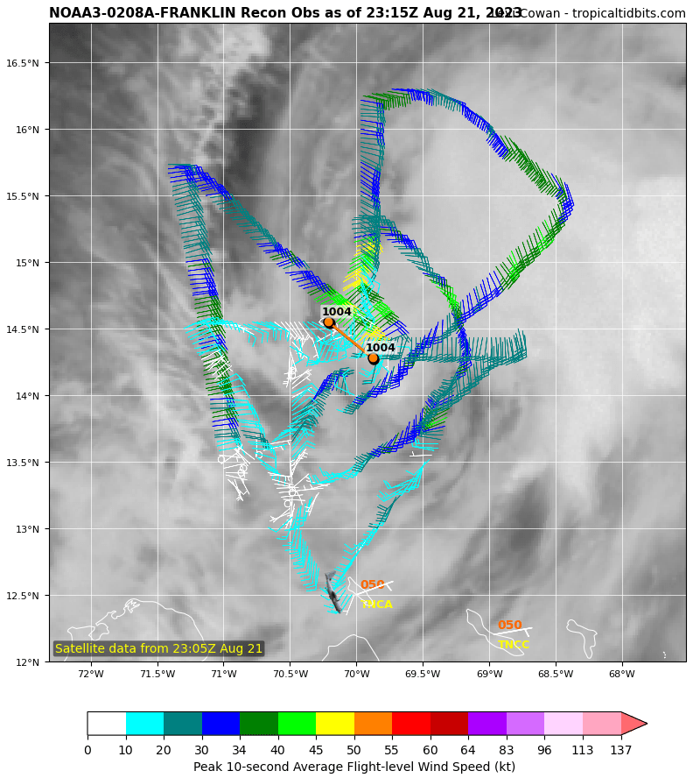
 | Dropsondes 12-17 on that last E-W pass. Progression from an unstable airmass within inflow region to one that has a progressively drier and cooler boundary layer. Perhaps this is related to the outflow/cold pools from the persistent deep convection and now stratiform precipitation

POST-FLIGHT
Mission Summary | [Short description of interesting observations from the flight; what objectives were successful? What was unsuccessful? Was the planned pattern flown? What deviations occurred?  [Don’t forget to fill in Tables on page 1]  [Sonde and ocean expendable accounting: how many total of each? How many are charged to each account?]
Actual Standard Pattern Flown | [Butterfly, Rotated Figure-4, Lawnmower, etc]
APHEX Experiments / Modules Flown | [Linked to HFP Plan; fill in regardless of whether the mission was operationally or research tasked]
Plain Language Summary | [Boil down the above into a couple of bullet points in “plain language”. This will help us when we report to management & OAR Public Affairs and prepare storm mission summaries]
Instrument Notes | [Notes about instrument status from during and after the mission]
Final Mission Track | [Insert MTS screenshot of final flown track, ideally at the completion of the pattern with satellite imagery]

