MISSION PLAN
FLIGHT ID | 20230820I1 | STORM | AL90 / Franklin
MISSION ID | 01BBA INVEST | TAIL NUMBER | NOAA-43
TASKING | NHC | PLANNED PATTERN | Low-level / NHC  18 UTC fix
MISSION SUMMARY
TAKEOFF [UTC] | 1706 | LANDING [UTC] | 2341
TAKEOFF LOCATION | Aruba | LANDING LOCATION | Aruba
FLIGHT TIME | 6.6 | BLOCK TIME | 6.8
TOTAL REAL-TIME RADAR ANALYSES  (Transmitted) | 4 | TOTAL DROPSONDES Deployed (Transmitted) | n/a
OCEAN EXPENDABLES (Type) | n/a | sUAS (Type) | n/a
APHEX EXPERIMENTS / MODULES | n/a
HRD CREW MANIFEST
LPS ONBOARD | n/a | LPS GROUND | None / Alvey
TDR ONBOARD | n/a | TDR GROUND | Gamache/Fischer/Alvey
ASPEN ONBOARD | n/a | ASPEN GROUND | n/a
NESDIS SCIENTISTS | n/a
GUESTS (Affiliation) | n/a
AOC CREW MANIFEST
PILOTS | Copare/Wood/Palmer
NAVIGATOR | Miller/Schaefer
FLIGHT ENGINEERS | Darby/Tyson
FLIGHT DIRECTOR | Kalen/Parrish/Timmers
DATA TECHNICIAN | Richards
AVAPS | Waggoner/Kotz

PRE-FLIGHT
Flight Plan | unknown
Expendable Distribution | none
Preflight Weather Briefing | n/a  Invest 90L continues to become more organized this AM with evidence that a weak low level-circulation (near/slightly displaced from convection) may have formed overnight.  NHC currently has 70% & 80% probabilities of genesis for 2- and 7-days as of 8AM EDT. Increased to 90% at 2PM EDT.
Instrument Notes | TDR is up

IN-FLIGHT
Time [UTC] | Event
1706 | Take-off from Aruba
 | Large convective burst ongoing this AM displaced from potential LLC that may have formed overnight
 | Same timeframe as the infrared loop above but visible reveals the exposed LLC with intense convection to the SE
 | Persistent convective burst - continues near/SE of LLC with cirrus obscuring the LLC once again
 | Large amounts of lightning activity associated with the convective bursting
 | Some expansion of cold cloud tops upshear but still pretty asymmetric
 | Convective burst can be also seen on PR ground radar (times are MDT)
1st pass - SW - NE
2nd pass - NW - SE

 | Convective burst appears to be weakening a bit
2120 UTC | 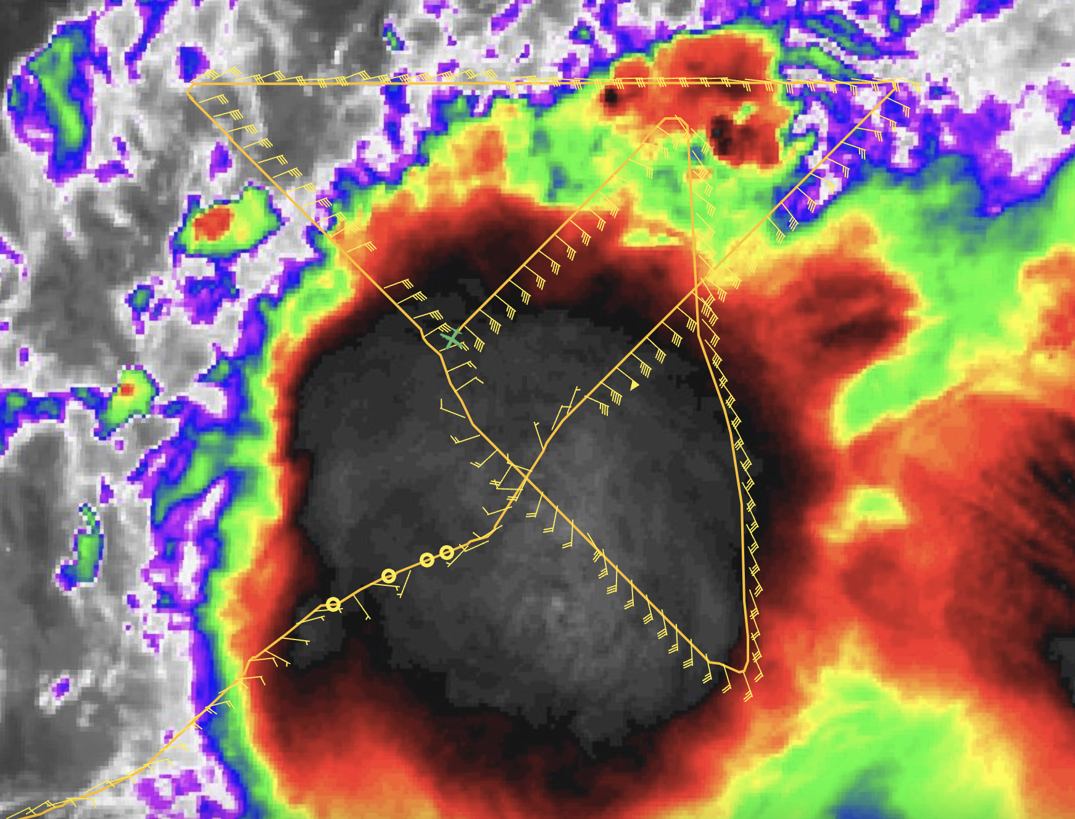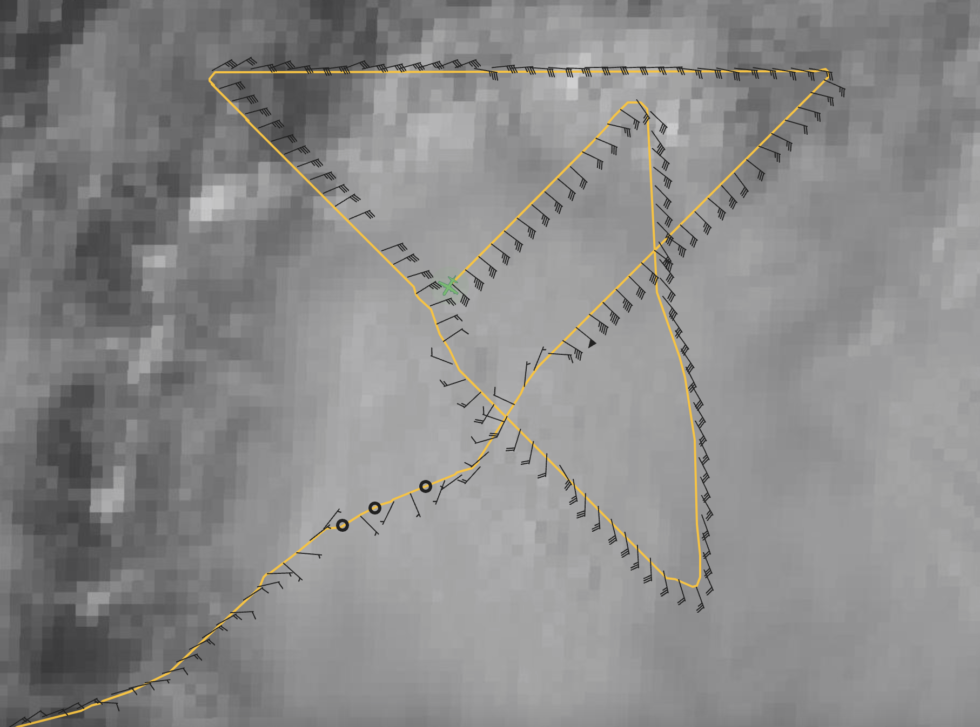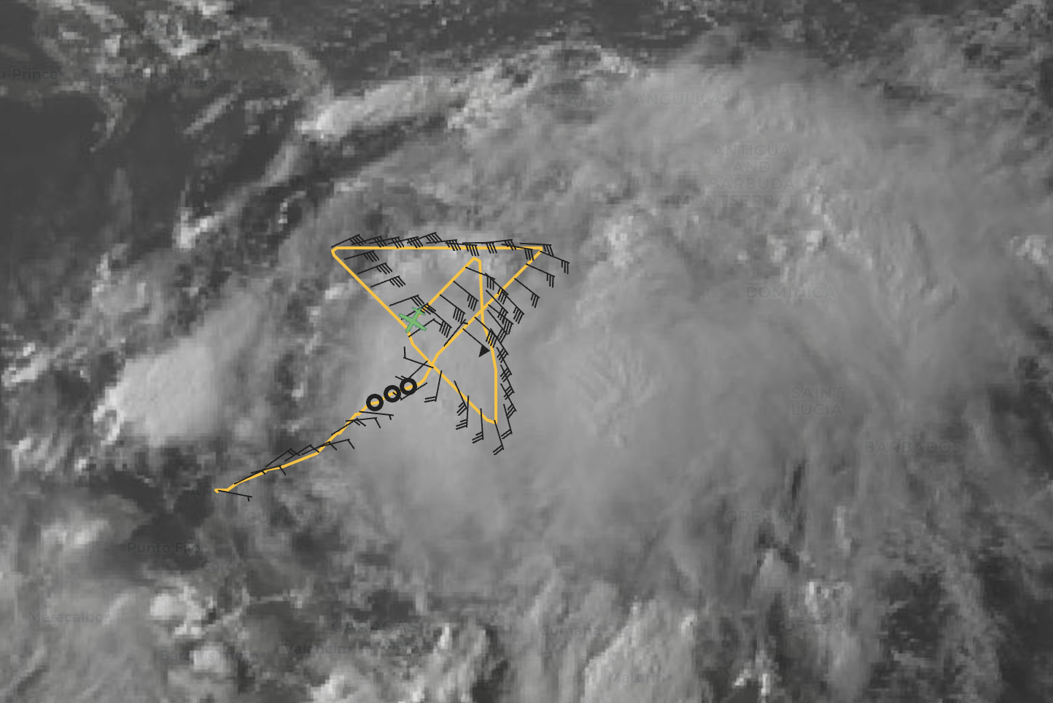  3rd pass -NE to SW
2100 UTC | Upgraded to Tropical Storm Franklin by NHC  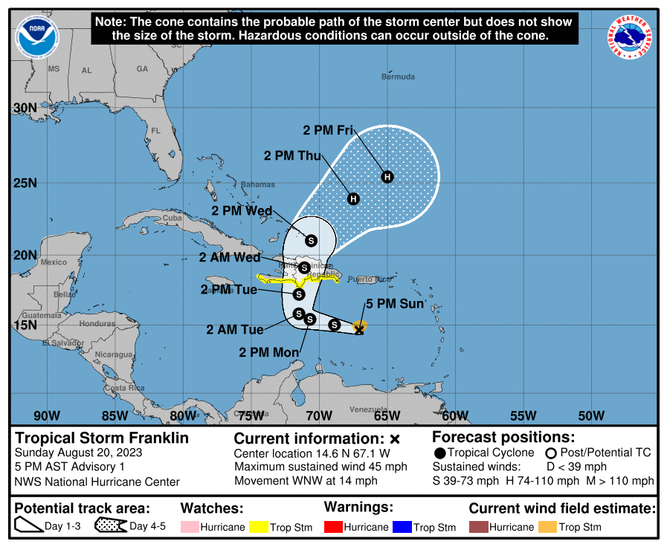  “This afternoon we have received a wealth of data from both a NOAA  reconnaissance mission and satellite imagery near the area of low  pressure located in the eastern Caribbean Sea.” Discussion also notes some westerly shear affecting Franklin initially but more favorable environment expected in coming days.
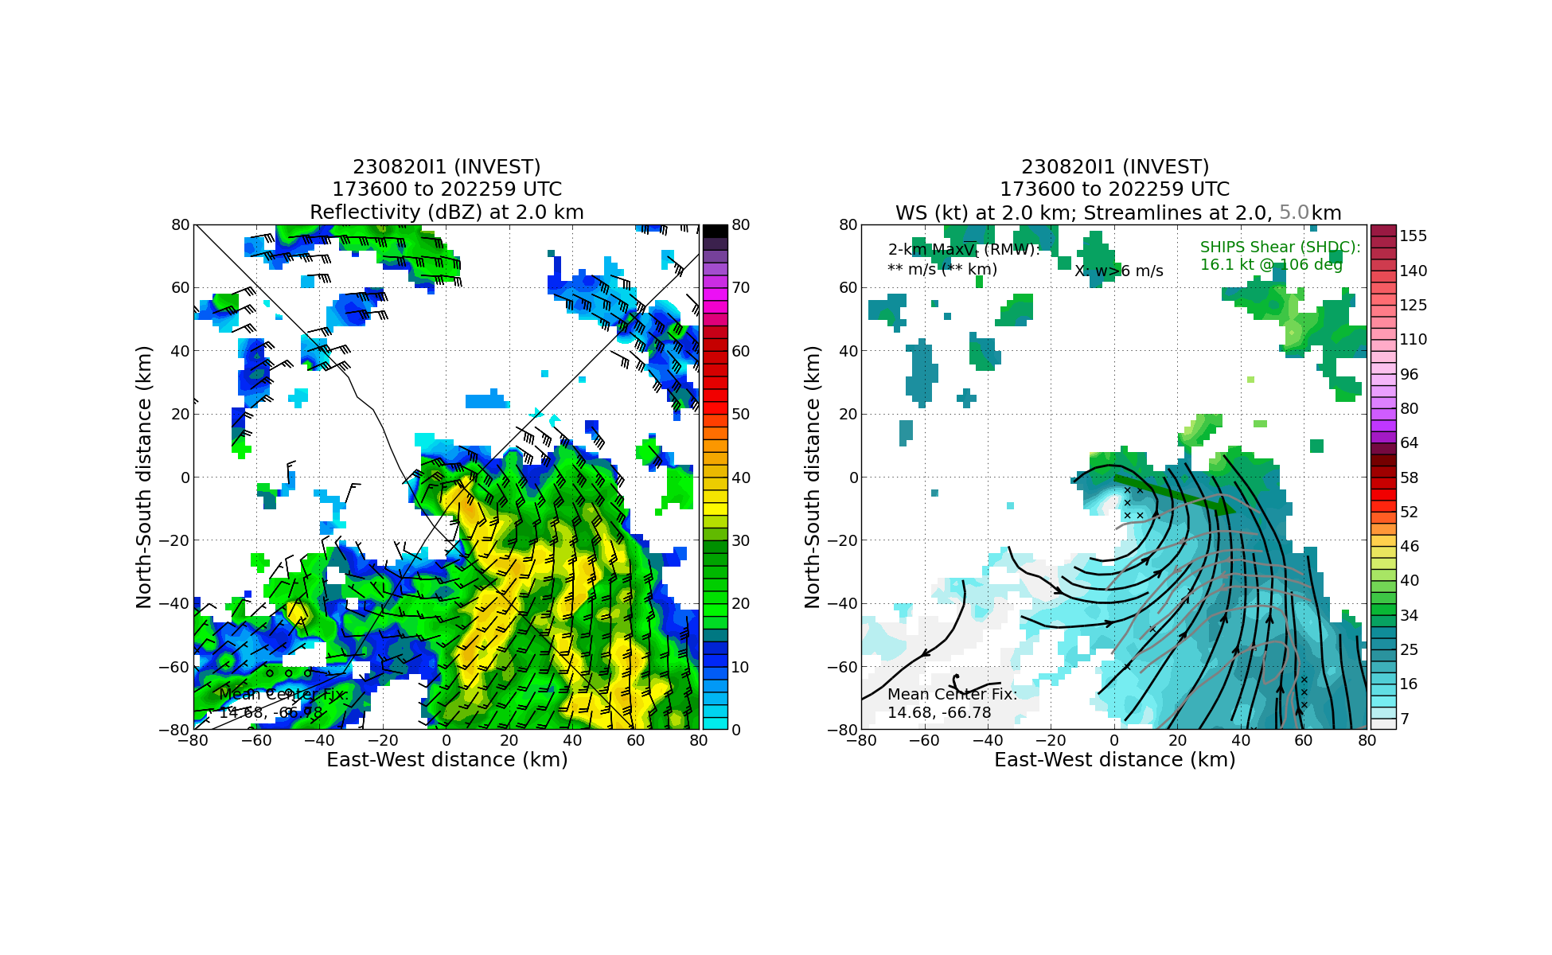
Fairly substantial misalignment to the SE evident based on first 2 center passes
 | 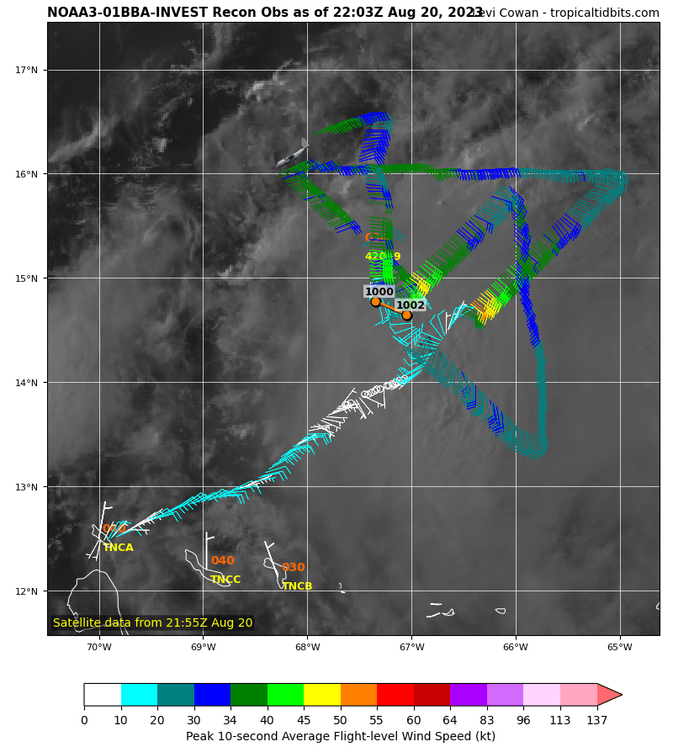
 | 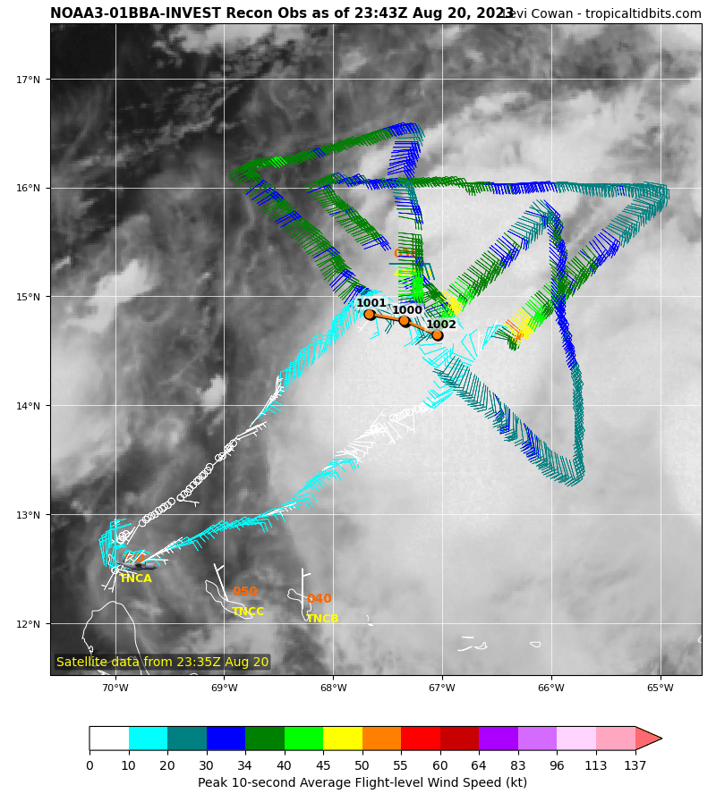
 | Last leg - NW-SE-CENTER-SW

POST-FLIGHT
Mission Summary | [Short description of interesting observations from the flight; what objectives were successful? What was unsuccessful? Was the planned pattern flown? What deviations occurred?  [Don’t forget to fill in Tables on page 1]  [Sonde and ocean expendable accounting: how many total of each? How many are charged to each account?]
Actual Standard Pattern Flown | [Butterfly, Rotated Figure-4, Lawnmower, etc]
APHEX Experiments / Modules Flown | [Linked to HFP Plan; fill in regardless of whether the mission was operationally or research tasked]
Plain Language Summary | [Boil down the above into a couple of bullet points in “plain language”. This will help us when we report to management & OAR Public Affairs and prepare storm mission summaries]
Instrument Notes | [Notes about instrument status from during and after the mission]
Final Mission Track | [Insert MTS screenshot of final flown track, ideally at the completion of the pattern with satellite imagery]

