MISSION PLAN
FLIGHT ID | 20230807N1 | STORM | N/A
MISSION ID | WCWXA MAGPIE3 | TAIL NUMBER | (NOAA-49)
TASKING | HRD | PLANNED PATTERN | Lawnmower
MISSION SUMMARY
TAKEOFF [UTC] | 2200 | LANDING [UTC] | 0551
TAKEOFF LOCATION | Barbados | LANDING LOCATION | Barbados
FLIGHT TIME | 7.9 | BLOCK TIME | 8.0
TOTAL REAL-TIME RADAR ANALYSES  (Transmitted) | n/a | TOTAL DROPSONDES Deployed (Transmitted) | 25 (21)
OCEAN EXPENDABLES (Type) | n/a | sUAS (Type) | n/a
APHEX EXPERiMENTS/MODULES | TC Genesis, Saharan Air Layer, Numerical Model Sensitivity
HRD CREW MANIFEST
LPS ONBOARD | n/a | LPS GROUND | Kaplan
TDR ONBOARD | n/a | TDR GROUND | n/a
ASPEN ONBOARD | AOC FD | ASPEN GROUND | n/a
NESDIS SCIENTISTS | n/a
GUESTS (Affiliation) | n/a
AOC CREW MANIFEST
PILOTS | Nardi/Bhatnagar/Cozart
NAVIGATOR | n/a
FLIGHT ENGINEERS | n/a
FLIGHT DIRECTOR | Henning/Timmers
DATA TECHNICIAN | Defeo
AVAPS | Dykeman/Patel

PRE-FLIGHT
Flight Plan | 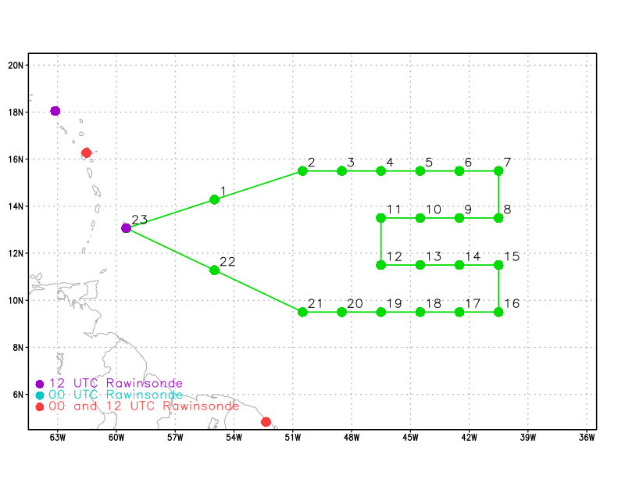  Lawnmower pattern to survey environment surrounding the tropical wave.
Expendable Distribution | 22 drops designed to be equally spaced.
Preflight Weather Briefing | 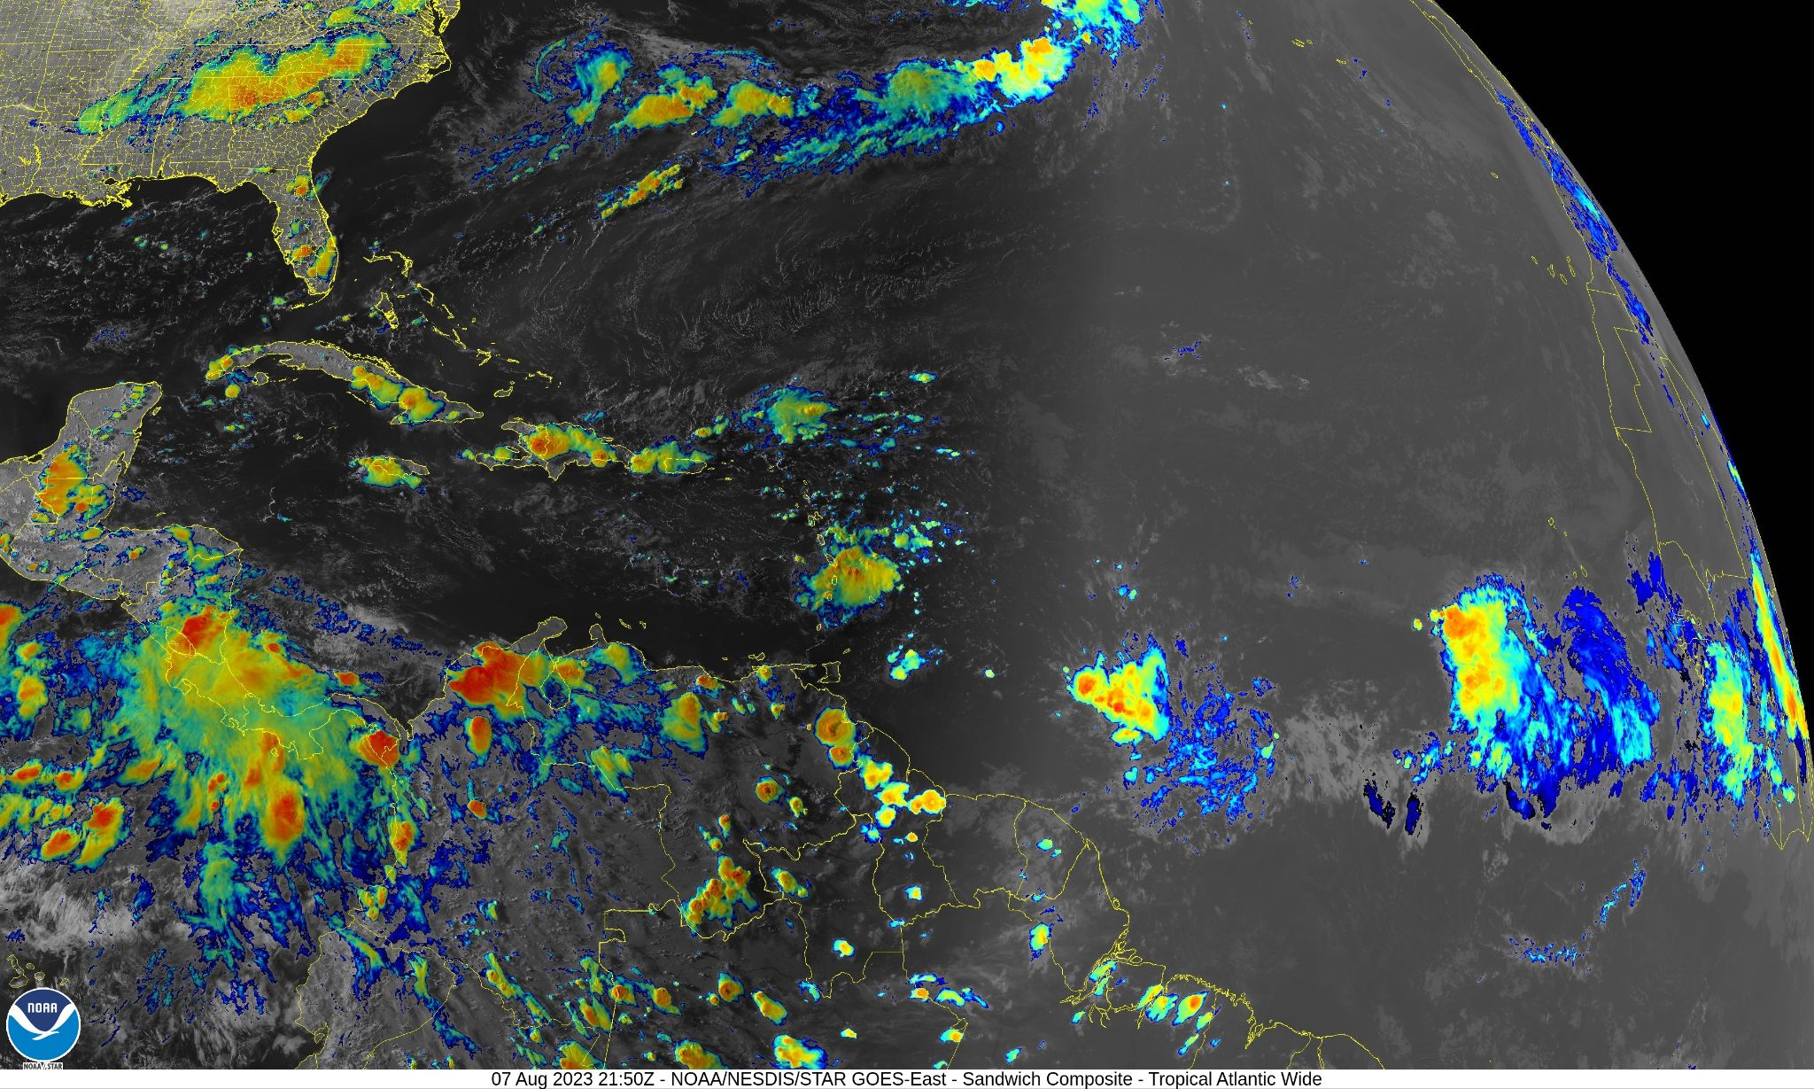  Nesdis 230807 2150 UTC Sandwich RGB.  The convection associated with the wave is fairly limited particularly on the northern side of the wave as seen in the above NESDIS imagery near the time of takeoff. However, some deep convection is seen on the southwest side of the wave near drops 19 and 20 and that information was conveyed to the flight director.
Instrument Notes | Instrumentation working correctly

IN-FLIGHT
Time [UTC] | Event
2200 | Take-off from Barbados
2200 | 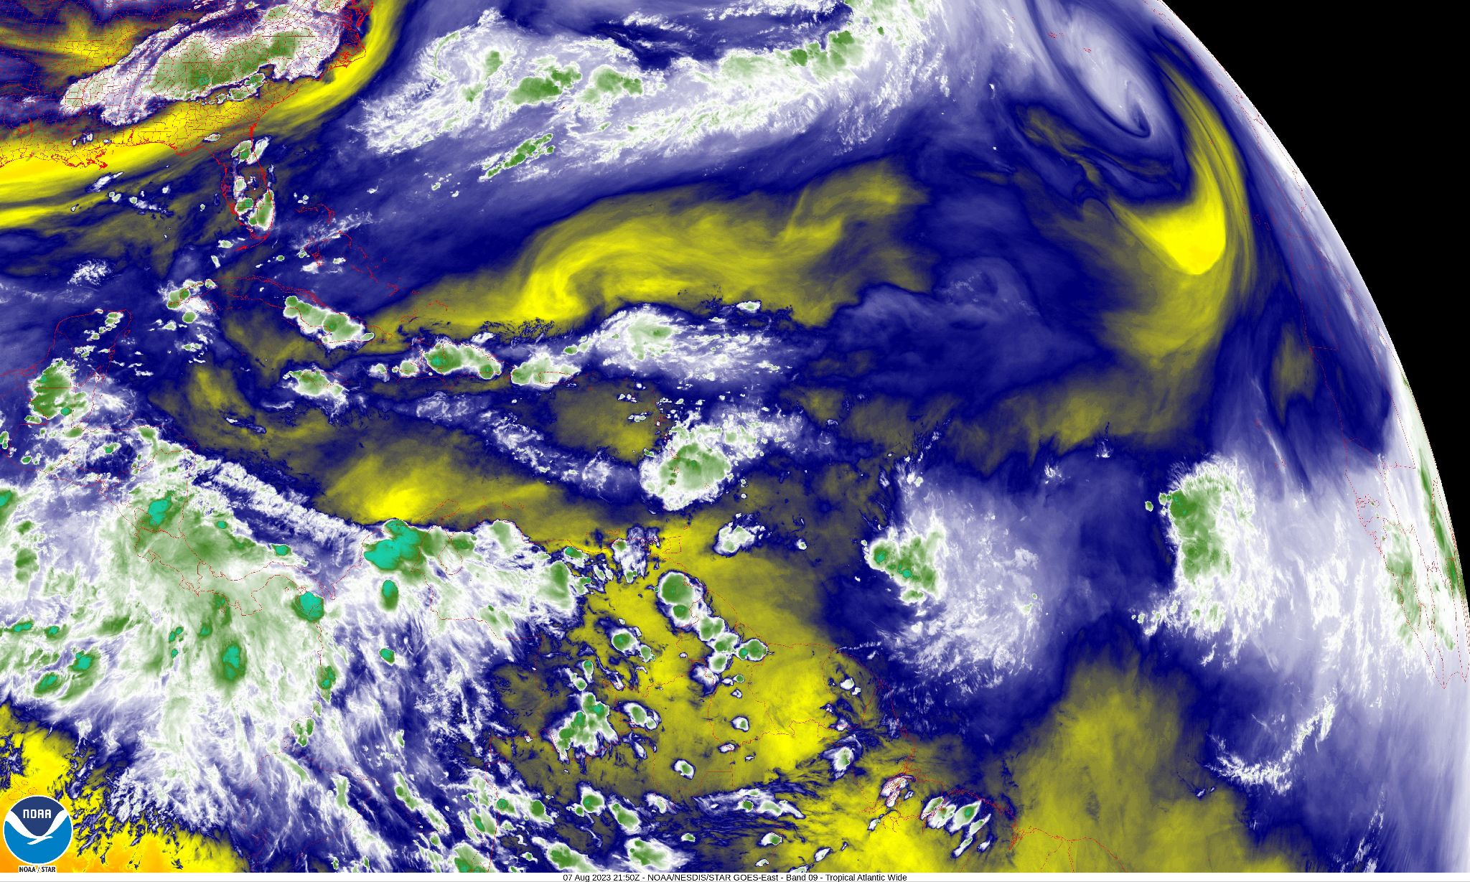  Nesdis Mid-level water vapor @ 2150 UTC on 20230807.  Dry mid-levels on the northern side of the wave axis seen in the above NESDIS water vapor image.
2242 | Drop 1/Obs 1 @ 2242 UTC received at NHC at ~2309  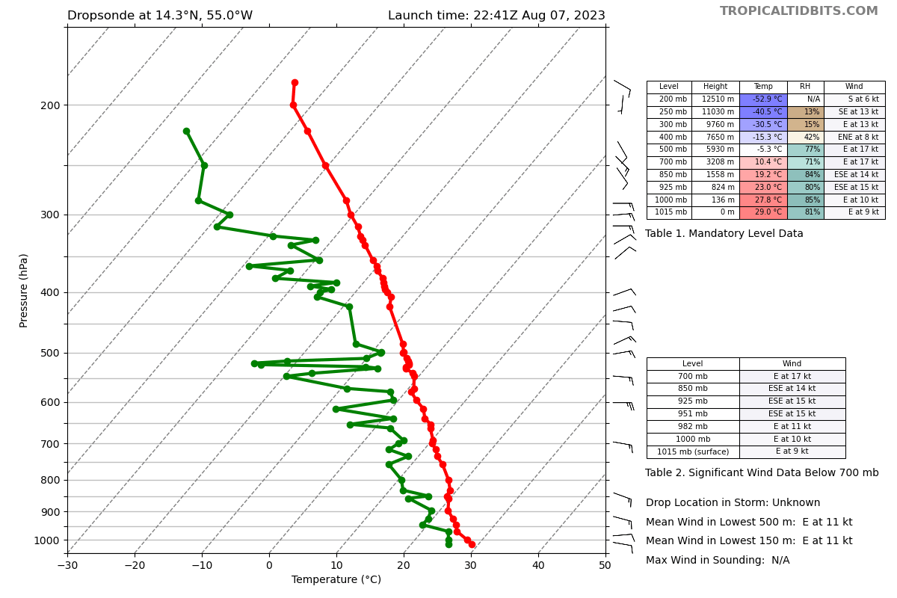
22318232 | Drop 2/Obs2  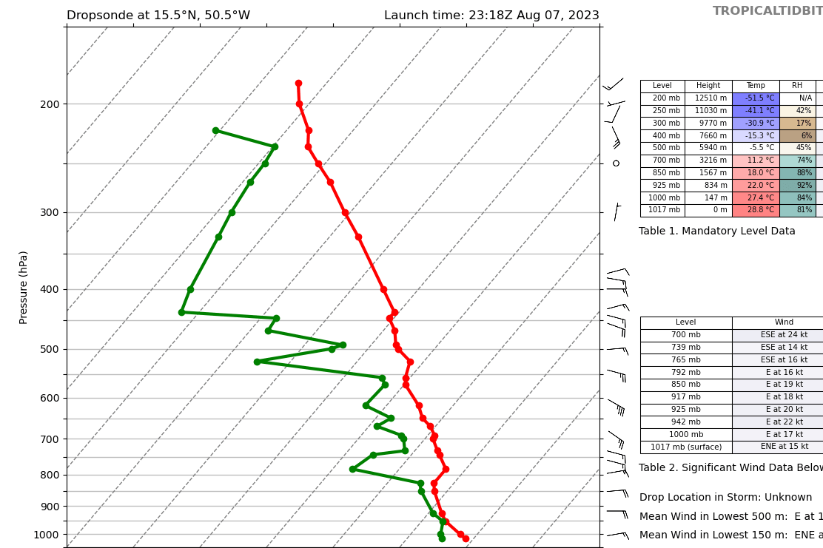  Very dry mid to upper levels (6% RH at 400 mb).
2334 | Drop 3/Obs 3  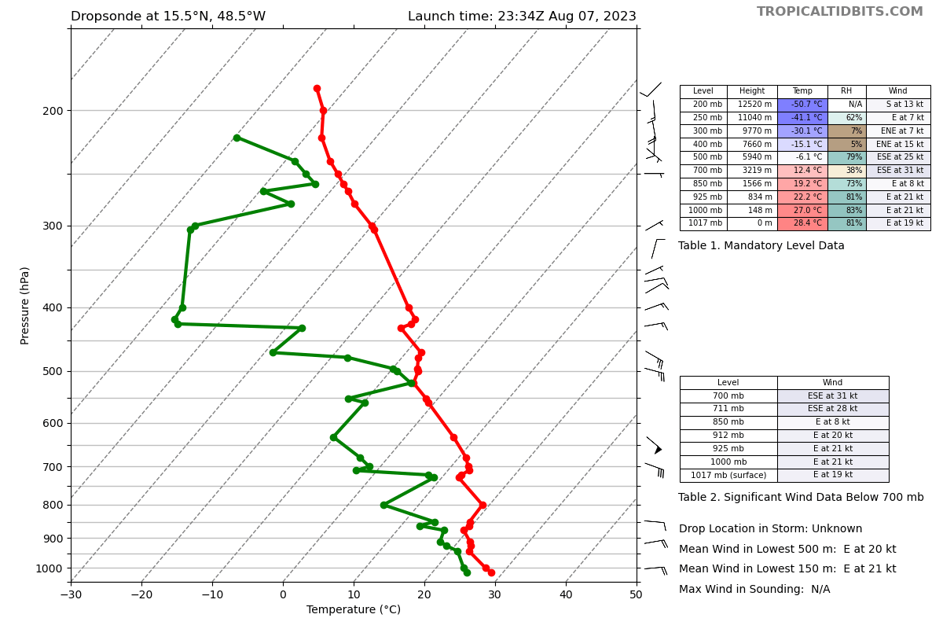  Very dry mid and upper levels (38% @700mb and 5% at 400 mb)
2349 | Drop 4/Obs 4
0003 | Drop 5 stopped working at 27000 ft and was not transmitted.
0021 | Drop 6/Obs. 5
0036 | Drop 7/Obs. 6  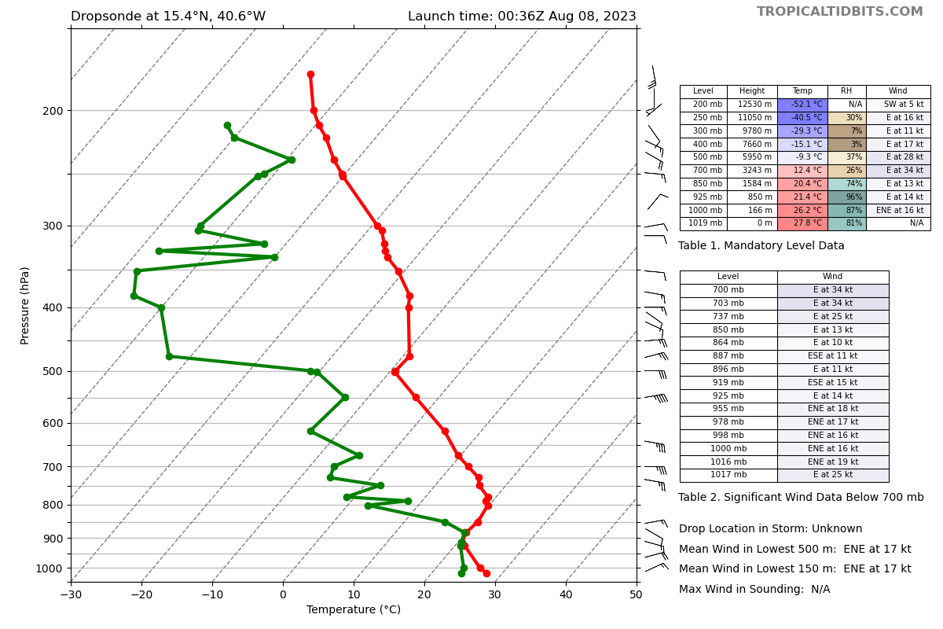  Driest sounding yet. 26% RH at 700 mb and 3% at 400 mb!
0053 | Drop 8/Obs 7
0109 | Drop 9/Obs 8
0124 | Drop 10/Obs 9
0140 | Drop 11/ Obs 10  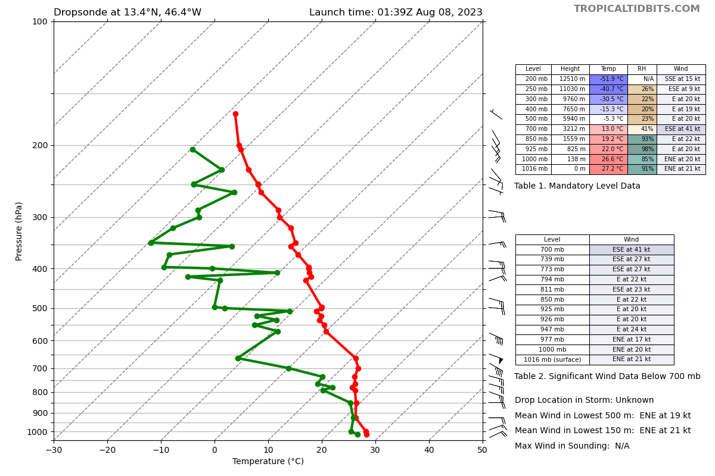
0159 | Drop 12/ Obs 11
0210 | Drop 13/ Obs 12
0215 | Discussed the need to deviate around convection between points 20 and 20. Flight director stated that if deep convection persisted the plan would be to go from point 19 to point 22 to avoid highest tops and also conserve fuel that was running a little on the low side.
0226 | Drop 14/Obs 13  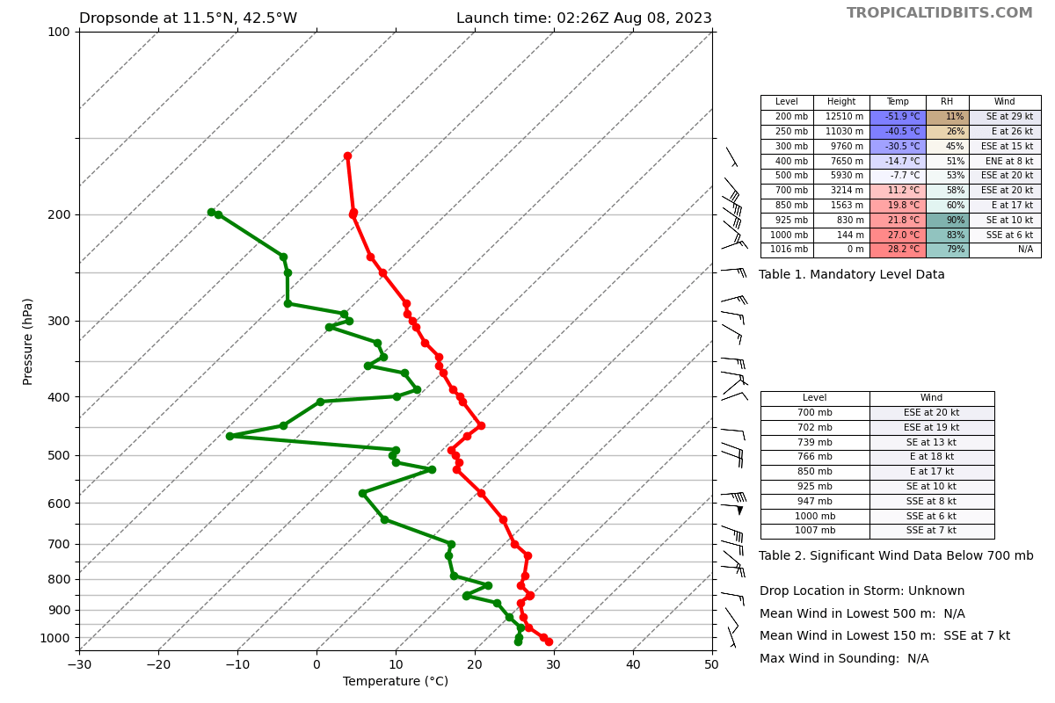
0243 | Drop 15/Obs 14
0259 | Drop 16/Obs 15 Very strong easterly jet (50 kt?) at 600 mb
0314 | Drop 17/Obs 16
0330 | Drop 18/Obs 17
0348 | Drop 19/Obs 18  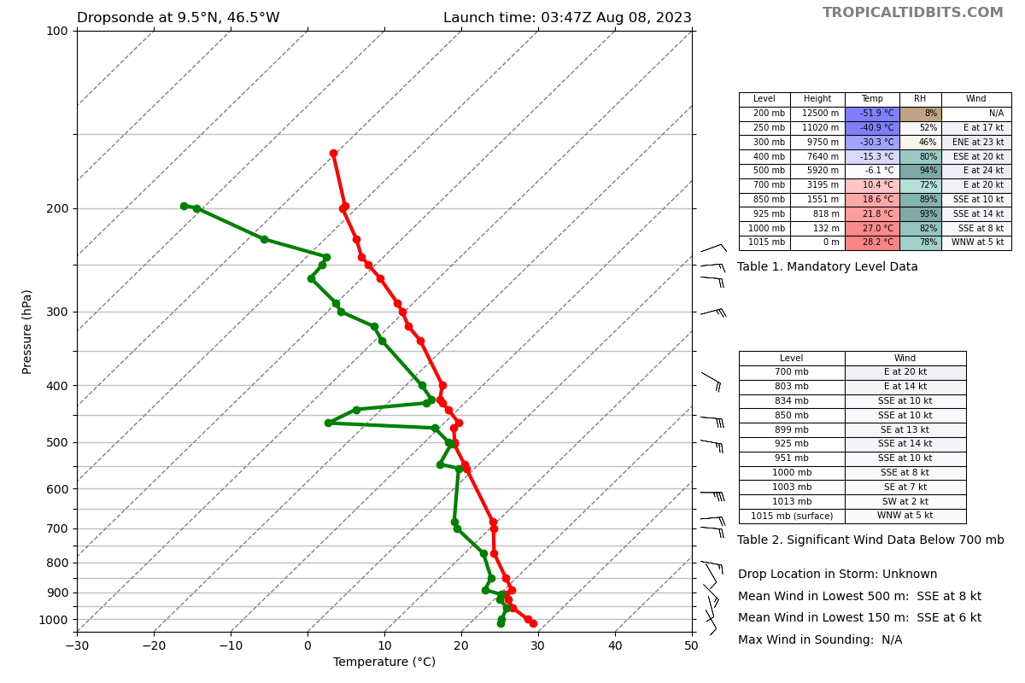  Note how moist this drop is compared to those farther to the north.
0350 | The plane had to deviate significantly around deep convection (48-50 kt ft tops) near drops 19 and 20 and thus drops 20, 21 and 22 were not made.

POST-FLIGHT
Mission Summary | Overall, the mission was carried out successfully with 19 of the 22 drops made and 18 transmitted. However, due to deep convection the aircraft was unable to make drops 20-22. The wave exhibited significant gradients in moisture with the northern portion being very dry at mid and upper levels and the southern portion quite moist. There was also a rather strong easterly jet near 600 mb seen near the central portion of the wave.  A total of 19 sondes were dropped with 18 being transmitted. All sondes were charged to HRD.
Actual Standard Pattern Flown | Lawnmower
APHEX Experiments / Modules Flown | Tropical cyclone Genesis, Saharan Air Layer Experiment, Model Sensitivity experiment.
Plain Language Summary | This mission was designed to gather the environment surrounding a tropical wave to evaluate how favorable it was for the wave to undergo genesis.It was also designed to target model sensitive regions and the Saharan air Layer to the north of the wave.
Instrument Notes | Instrumentation worked well throughout the mission
Final Mission Track | 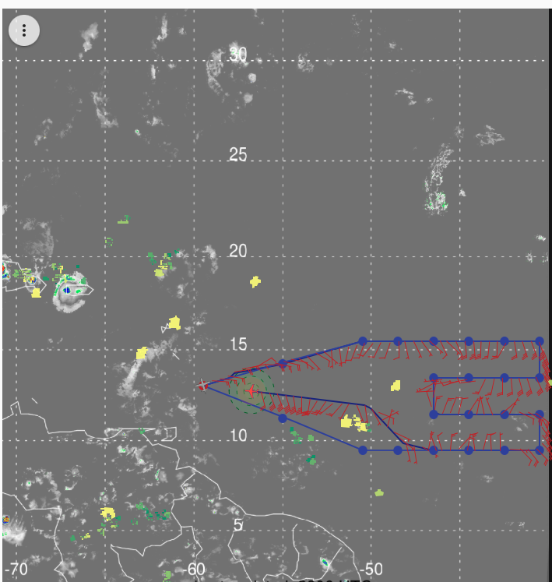  Screen shot at 220808 0520 UTC . Note significant deviation near end of mission from drop location 19 back to Barbados was required to avoid deep convection.
0430 UTC | 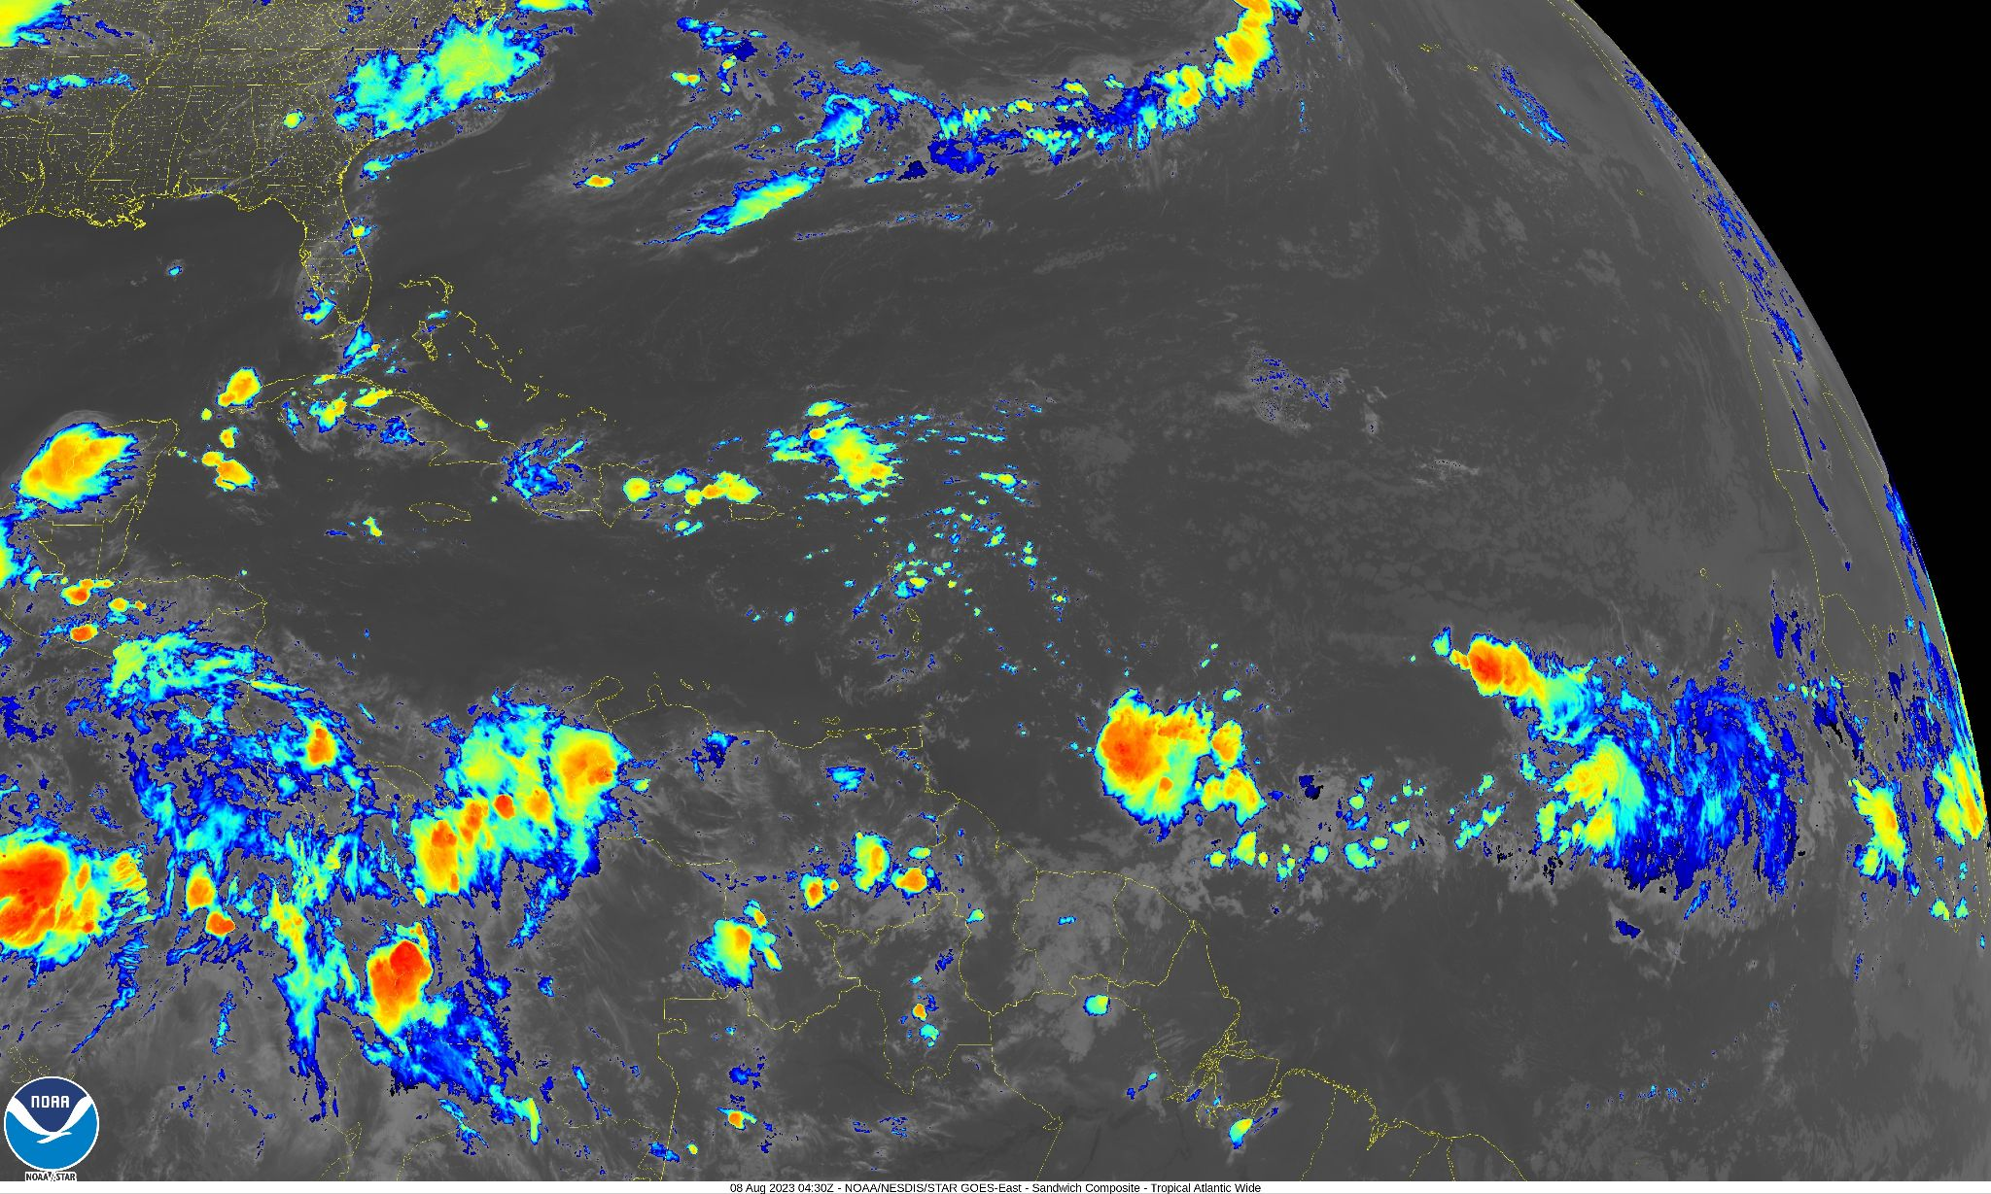  NESDIS image 230808 0430 UTC sandwich RGB IR imagery. Note strong convection on the SW side of the wave.

