MISSION PLAN
FLIGHT ID | 20230807I1 | STORM | AEW
MISSION ID | WBWXA MAGPIE2 | TAIL NUMBER | NOAA--43
TASKING | HRD | PLANNED PATTERN | Lawnmower
MISSION SUMMARY
TAKEOFF [UTC] | 1059 | LANDING [UTC] | 1842
TAKEOFF LOCATION | Barbados | LANDING LOCATION | Barbados
FLIGHT TIME | 7.7 | BLOCK TIME | 7.9
TOTAL REAL-TIME RADAR ANALYSES  (Transmitted) | n/a | TOTAL DROPSONDES Deployed (Transmitted) | 25 (25)
OCEAN EXPENDABLES (Type) | 6 (4) AXBT | sUAS (Type) | n/a
APHEX EXPERIMENTS / MODULES | Exact name of the Experiment in the HFP Plan; identify relevant experiments / module even if not a research tasking
HRD CREW MANIFEST
LPS ONBOARD | Alaka | LPS GROUND | Rogers
TDR ONBOARD | n/a | TDR GROUND | n/a
ASPEN ONBOARD | Aberson | ASPEN GROUND | n/a
NESDIS SCIENTISTS | n/a
GUESTS (Affiliation) | n/a
AOC CREW MANIFEST
PILOTS | Doremus/Keith/Palmer
NAVIGATOR | Miller/Schaefer
FLIGHT ENGINEERS | Tyson/Wysinger
FLIGHT DIRECTOR | Kalen/Lundry
DATA TECHNICIAN | Richards
AVAPS | Lambert/Waggoner

PRE-FLIGHT
Flight Plan | 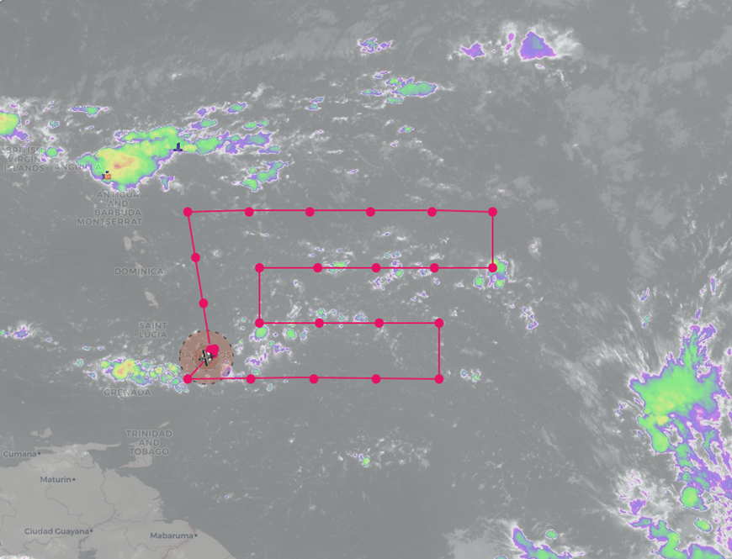  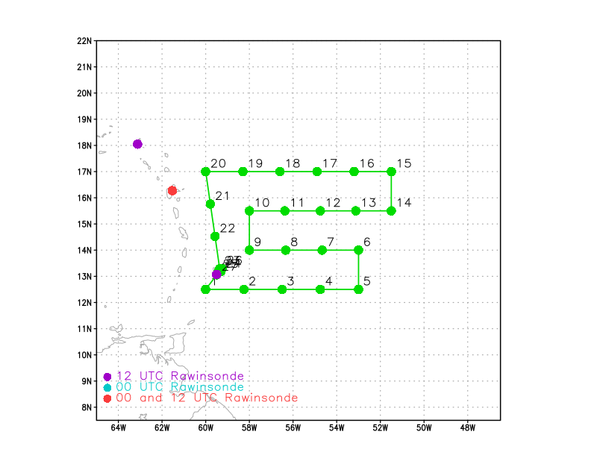  The proposed survey/lawnmower pattern for Monday's APHEX HRD-tasked P-3 (N43) mission into the tropical wave located near 50W - 0700L / 1100Z takeoff from Barbados recovering in Barbados. The P-3 pattern will target the tropical wave axis, model sensitive regions associated with the wave and the Saharan Air Layer to the north of the tropical wave. Coordination with the NPS Twin Otter is also planned off the east coast of Barbados after the main pattern is completed.  Pattern:  Fly survey/lawnmower pattern + coordination with the NPS Twin Otter  - After main mission (drops 1-24), coordinate with the NPW Twin Otter off Ragged Point, Barbados  - Leg #1: SW-NE leg (WPs 25-26): dropsonde-BT combos at midpoint and endpoint of leg; NPS Twin Otter will loiter beyond WP 26 until P-3 completes Leg #1  - Leg #2: (NE-SW; reverse track (fly WP 26-25) tracking toward Ragged Point): Twin Otter flies at or below 2,500 ft, P-3 follows at 5,000-10,000 ft (altitude TBD)  - P-3 should overfly the Twin Otter on Leg #2 with as minimal horizontal separation as possible (no P-3 dropsondes or AXBTs during Leg #2);  Altitude:  - ~25,000 ft or as high as possible for the main pattern (WPs 1-24)  - 5,000-10,000 ft (altitude TBD) for the coordinated legs off Ragged Point, Barbados  Expendables:  - 26 dropsondes planned (all dropsondes transmitted to the GTS)  - 8 ABTS: WPs 6, 10, 15, 20; 2 AXBTs along Leg #1 at WP 25-26 midpoint and WP 26 (additional AXBTs at the LPS’s discretion)
Expendable Distribution | See sonde distribution plot above
Preflight Weather Briefing | First P-3 mission to sample an African easterly wave (AEW) and its environment approaching the lesser Antilles. Wave can be seen in the total precipitable water (TPW) plot below as a region of elevated TPW and positive meridional (southerly) flow on the east side of the TPW maximum just east of Barbados:  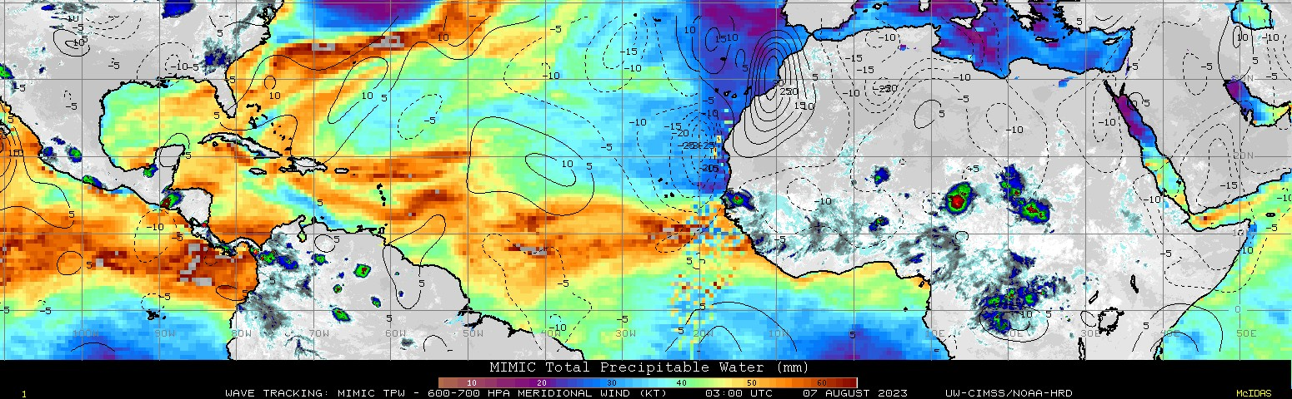  The wave is not very amplified, and it shows a SW-NE oriented tilt. There is some indication of a Saharan Air Layer (SAL) to its north, though the strength of the SAL is not that evident.  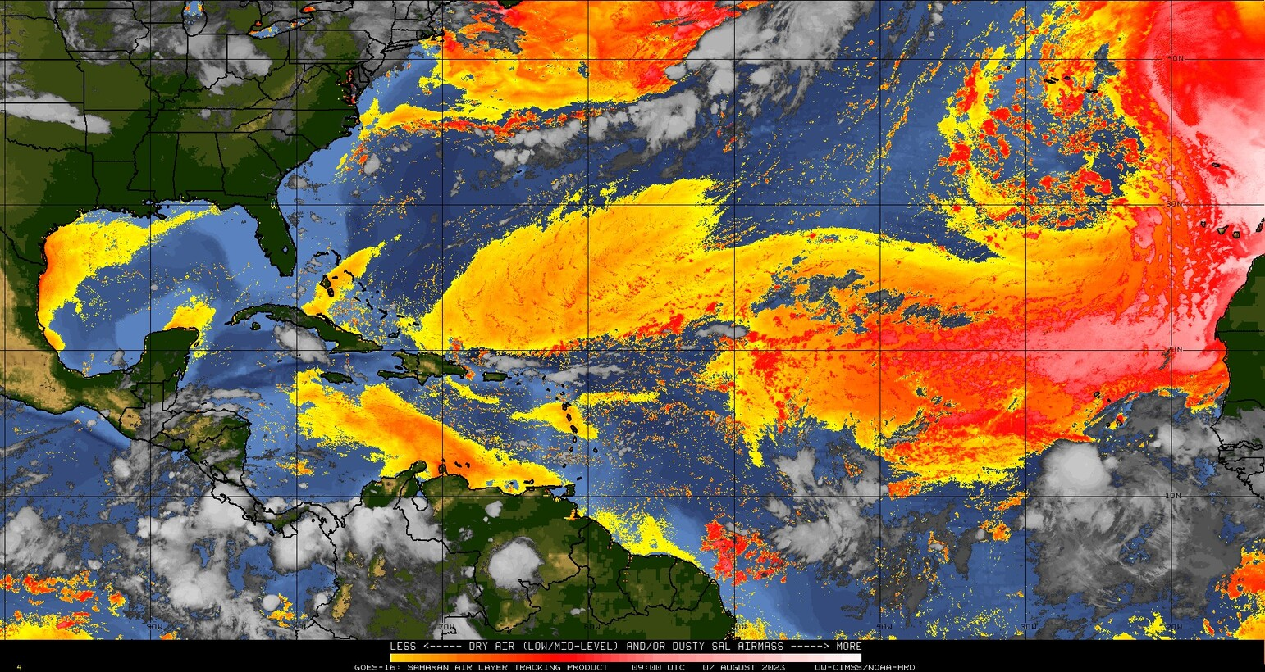  The goal of this mission is to sample the air ahead of, within, and to the north and behind the AEW.  TrueColor satellite animation below shows that the wave is essentially void of convection, or any precipitation. Only a small line of cumulus clous and otherwise widely-scattered shallow cumulus in the area. There are more widespread areas of disturbed weather, convection in an AEW trailing the AEW of interest, around 45 W
Instrument Notes | No TDR on this mission (no scatterers anticipated during mission)

IN-FLIGHT
Time [UTC] | Event
1100 | Take-off from Barbados
111532 | Drop 1, 12.4952 59.8876. Altitude was 18 kft on first drop because aircraft was too heavy to climb to 20 kft
111658 | Drop 2, WP1, 12.5004 59.7780 (previous drop was thought to be a fast fall, so dropped backup)
1121 | Visual from aircraft indicates puffy cumulus below and cirrus above aircraft
1122 | Forward and bottom-facing cameras on for this mission
113444 | Drop 3, WP2, 12.5004 58.2376
1136 | Drop 1 was not a fast fall, it turns out
1142 | The plan for the first BT drop: drop sonde at WP5, then descend to 10kft on the way to WP6 and drop the BT, then climb back to 20kft and drop a sonde at WP6
115416 | Drop 4, WP3, 12.5005 56.4859
1156 | Will be curious what, if any, kind of wind shift will be seen as you cross the wave "axis"
121333 | Drop 5, WP4, 12.5005 54.7370
1232 | After completing the lawnmower survey pattern, aircraft will turn to the NE at WP25 and travel ~20 n mi to WP26. Sondes at WP25, midpoint, and WP26. Then, aircraft may attempt to overfly a saildrone which is ~15 n mi farther ENE from WP26, probably releasing another drop near it. The twin otter will be out near WP26
123233 | Drop 6, WP5, 12.5289 53.0171
1235 | Descending to 10kft to drop BT at WP6. Will assess how long this takes. If it takes too long, will likely not drop future BTs in order to preserve the ability for the MAGPIE coordination with the Twin Otter. Will definitely release an AXBT on the WP25-26 leg, though.
123938 | AXBT 1 released 12.39 52.94, possible SST 29.02 C
125153 | Drop 7, WP6, 13.9895 53.0292
1252 | Flight-level winds (mostly at 20 kft) on first W-E leg show no sign of a wind shift, other than a very small-scale shift near small region of cold cloud tops that relaxes back to ENE flow. Wave is either very weak and/or shallow or axis is further east.  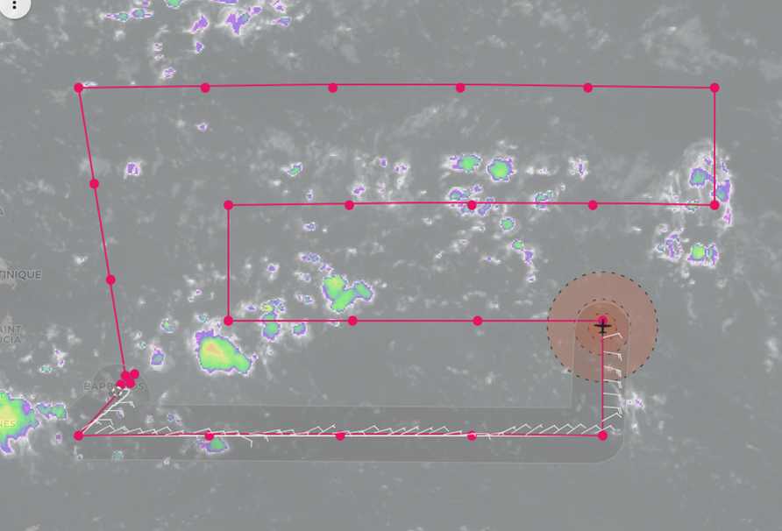
1301 | Climb to 22 kft
130924 | Drop 8, WP7, 54.6781 221540609
1324 | Approaching western point of first E-W leg  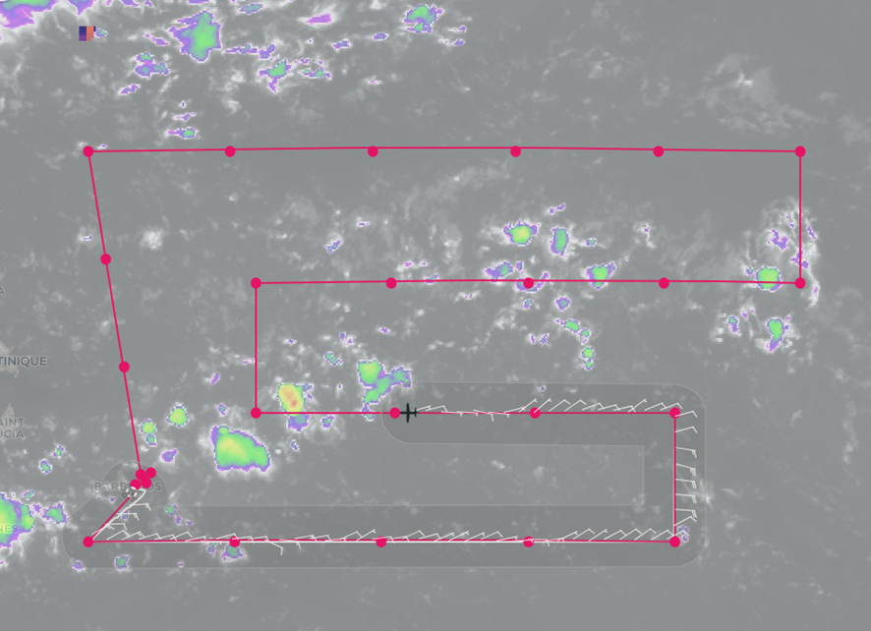  Visual reports indicating dusty air, mostly on the horizon. Some weak convection in the area, cumulus congestus. Appears to be capped and could be evidence of large-scale subsidence in the area despite ample moisture as aircraft approaches SW-NE line of cold (-50 C) cloud tops
132647 | Drop 9, WP8, 13.9996 56.3457
134412 | Drop 10, WP9, 14.0237 57.9874
1357 | AXBT 2 dropped, 15.04 58.0, 29.17 C
1405 | Had to deviate a bit around developing region of convection on approach to WP9  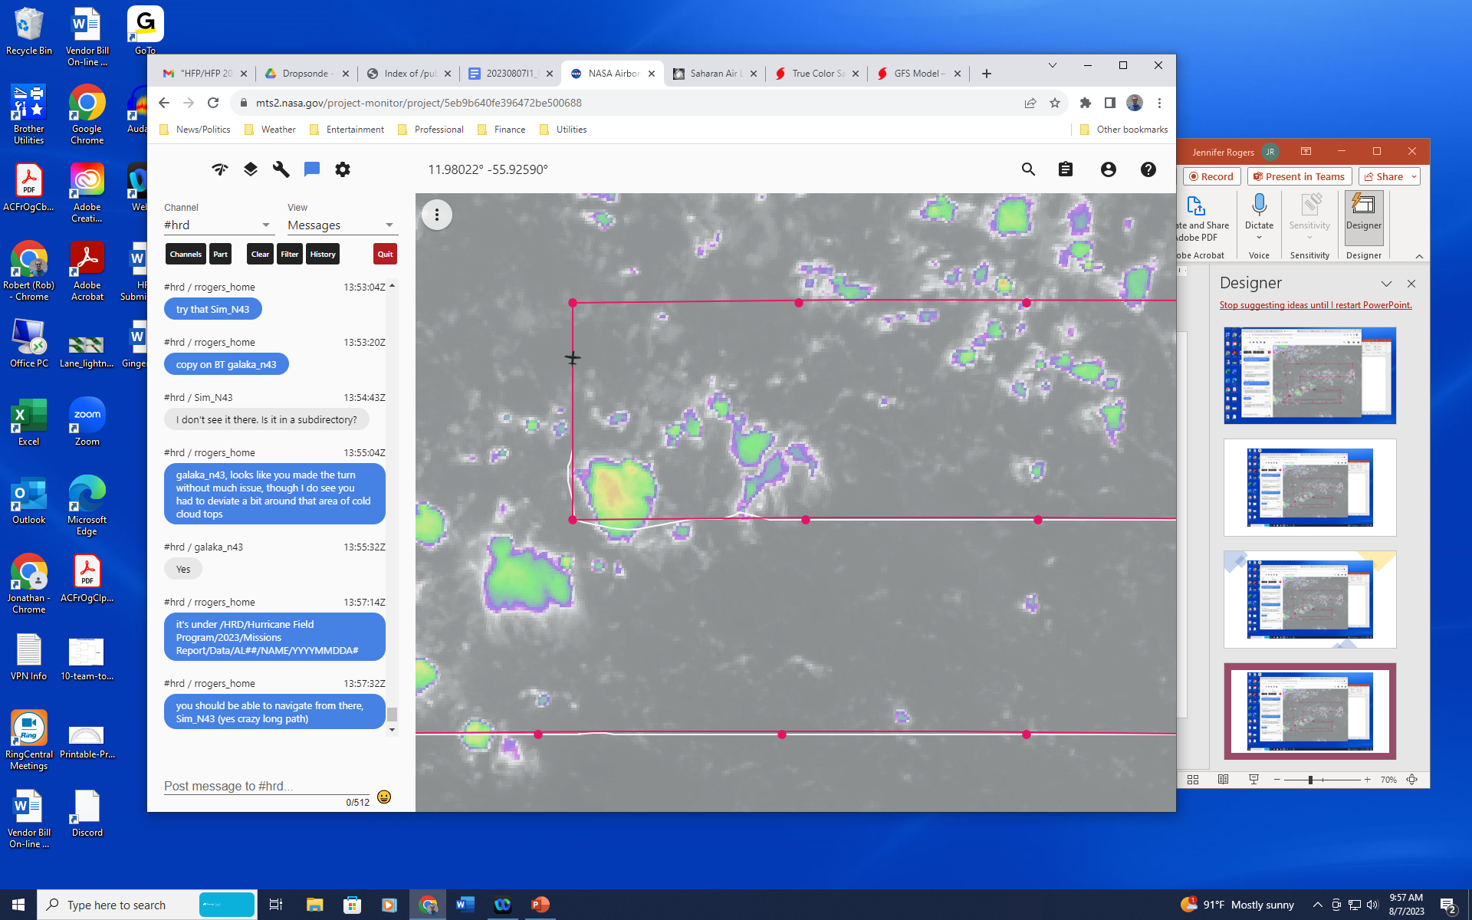
140803 | Drop 11, WP10, 15.4900 57.9801
1425 | Plan for Twin Otter coordination (pending review by flight director):  WP23 (~20K ft): drop only  WP24 (~20K ft): drop only  Leg 1 (SW-NE): ~6-8K ft-TBD, P-3 only; WP25=no drop/no BT >> mid point=BT/Drop combo >> WP26= drop only  Next continue NE to the Saildrone, currently at 13.42289N -59.13413W; after midpoint BT closes out (ok to loiter) >> BT/drop combo ...MMR might useful to locate it  No more expendables after that saildrone combo  Leg 2 (NE-SW): ~6-8K ft-TBD, P-3 + twin otter >> Twin Otter will be at 3K ft or below...overfly Twin otter if possible  Leg 2 (NE-SW): ~6-8K ft-TBD, P-3 + twin otter >> Twin Otter will be at 3K ft or below...overfly Twin otter if possible  Leg 2 (NE-SW): ~6-8K ft-TBD, P-3 + twin otter >> Twin Otter will be at 3K ft or below...overfly Twin otter if possible; pilots can shoot for the same lat Lon as earlier and/or just shoot for the ragged pt lighthouse Leg 2 (NE-SW): ~6-8K ft-TBD, P-3 + twin otter >> Twin Otter will be at 3K ft or below...overfly Twin otter if possible; pilots can shoot for the same lat Lon as earlier and/or just shoot for the ragged pt lighthouse  Repeat an outbound then inbound with the Twin Otter if we have time. We'd have to loiter for a bit while the Twin Otter sets up for a Leg 3 run (SW-NE)  Then a final NE-SW run toward ragged point and done. If we can only fit in legs 2 & 3, that's ok, but 3 & 4 would be nice
142618 | Drop 12, WP11, 15.5004 56.3747
144410 | Drop 13, WP12, 15.5003 54.7411
1454 | Update for WP 23+24: to avoid sondes drifting over Barbados, we are going to descend to 15kft for those points. Location of waypoints will remain the same.
1500 | Lawnmower pattern is straddling a SW-NE oriented line of showers and thunderstorms  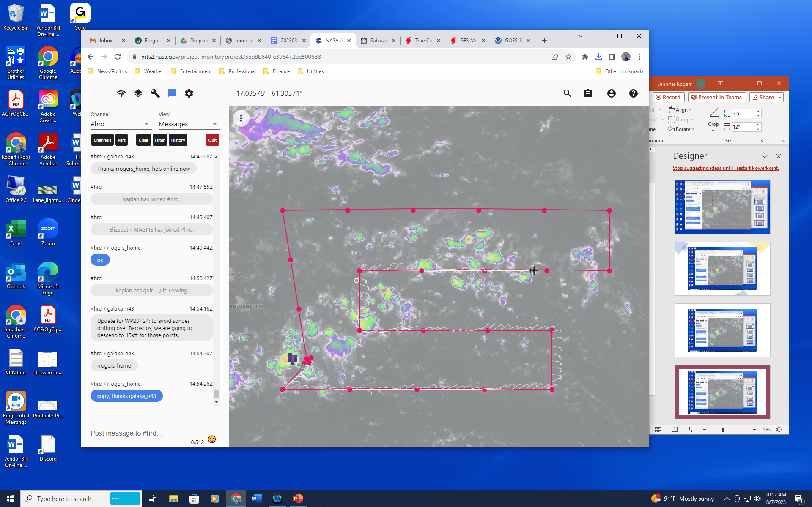  This line is loosely associated with a weak reflection of the wave in question, as indicated by True Color animation:  More pronounced wave (wave 2) is evident about 10 degrees SE of wave being targeted today. Wave 2 has widespread convective activity associated with it
150124 | Drop 14, WP 13, 15.5004 53.1028
1510 | Visual reports from mission (near WP 14, eastern edge of pattern) indicate dustier-looking air out to the east
1513 | Various skew-T’s from pattern so far do not show much in the way of dry air below aircraft  WP7:  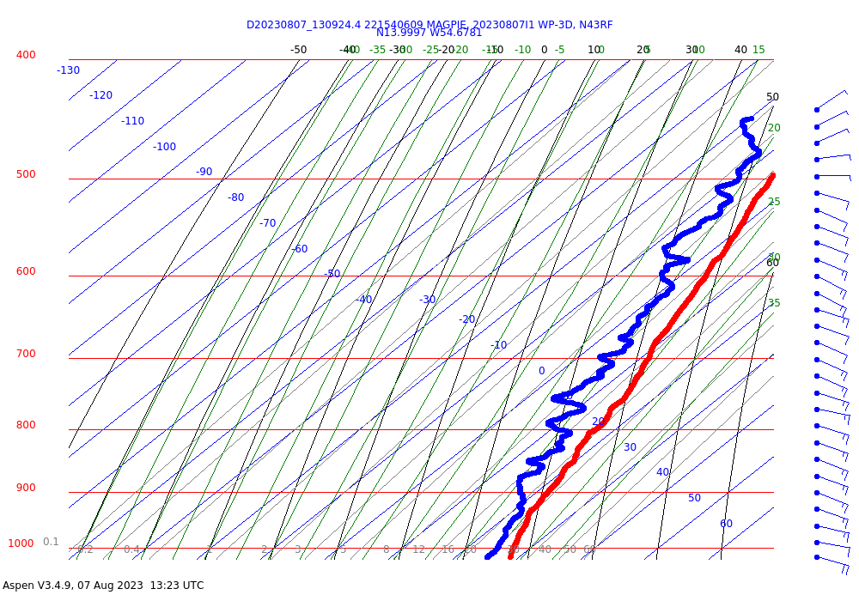  WP2:  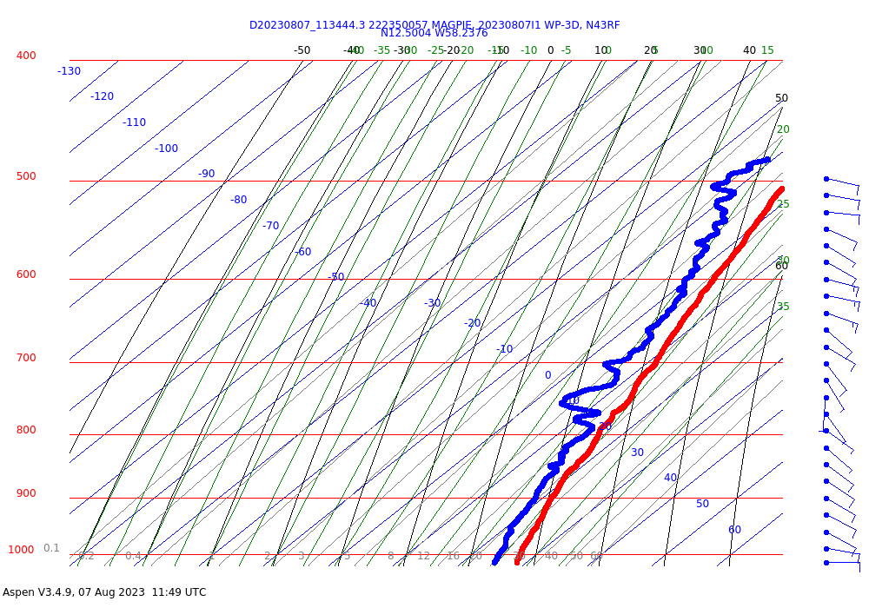  Will be curious to see how soundings along the northernmost, E-W leg look, in closer proximity to expected SAL
1516 | Sofar buoy 1.5 km off Ragged Point says 29.58 deg C, 8 m/s wind speed, 1.46 m mean wave height from 50 ish deg, 5.4 s mean period, 9.3 sec peak period. Location of buoy is 13.170450, -59.425100
151818 | Drop 15, WP 14, 15.5315 51.5175
1519 | Just turned northbound, visual is reporting much dustier air here as SAL region is approached  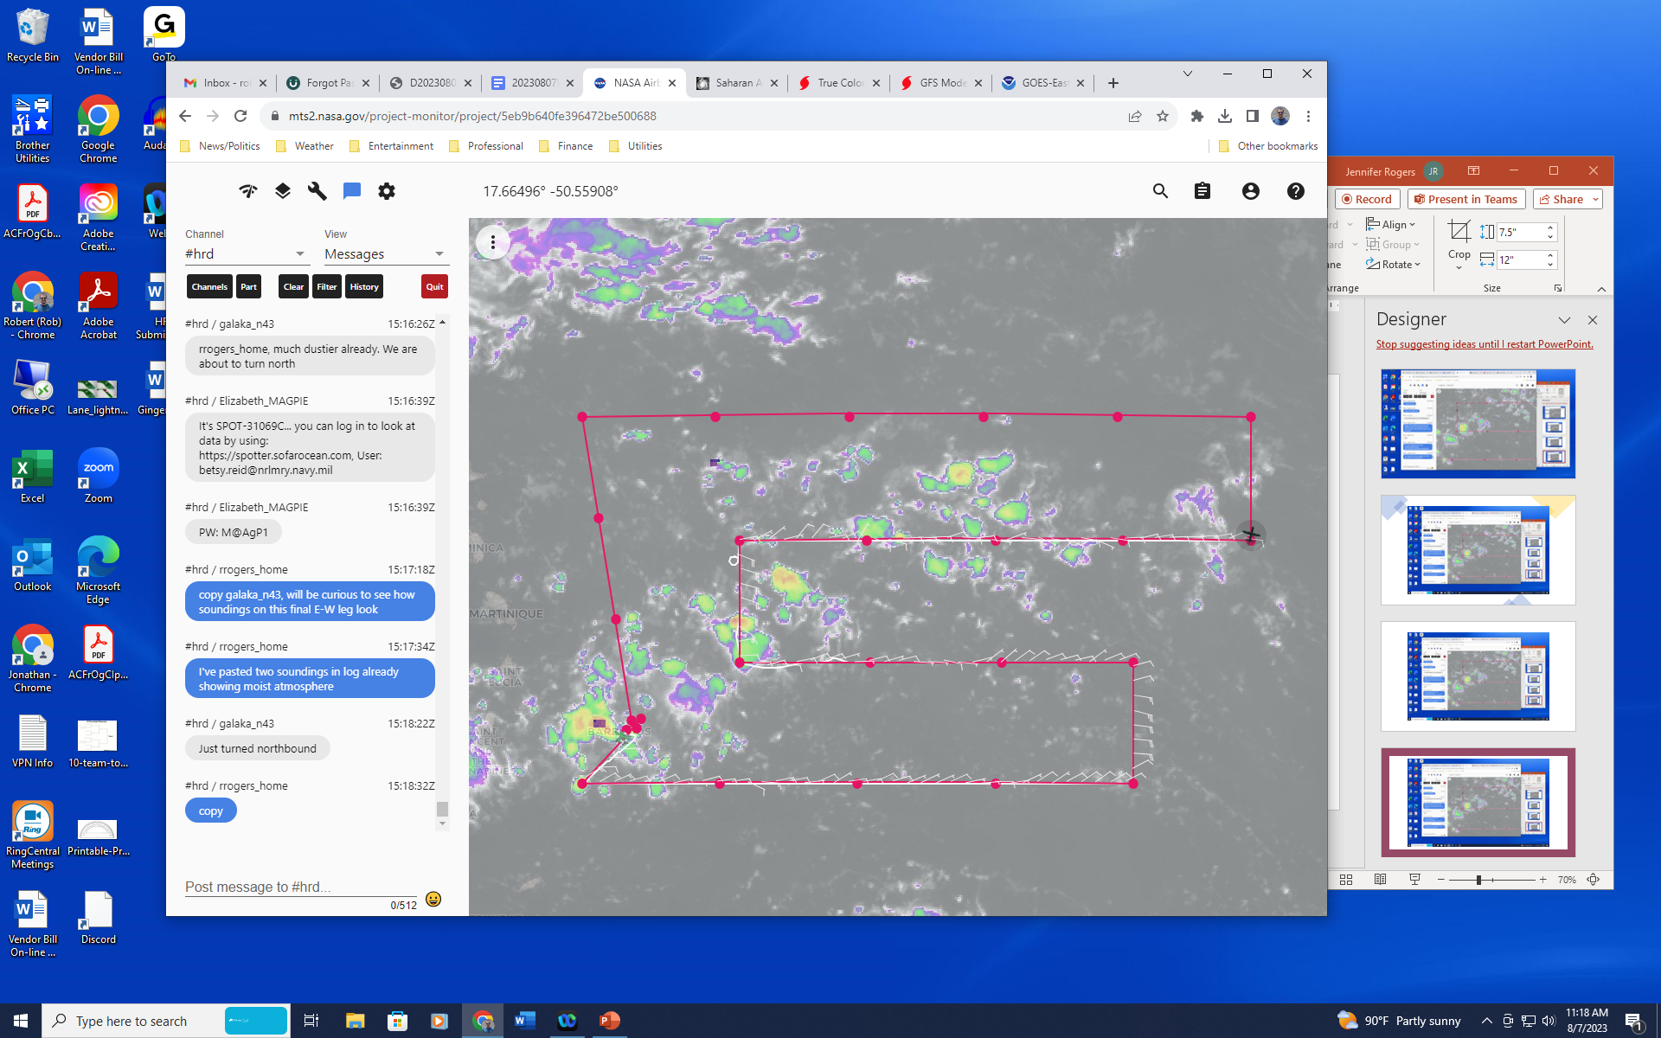
1527 | BT 3 failed (time is approximate)
1534 | MAGPIE team just launched a sounding at ragged point (11:08 edt release). It shows small surface inversion layer up to ~160 m. Another inversion base height at 1.7 km in T.
1534 | P-3 climbing to 24 kft
1535 | Twin Otter (TO) has taken off, will do boxes around the east side of the island and make sure they feel comfortable towing their near-surface turbulence device. They'll position to the Saildrone position and loiter/box there before P3 arrives into TO area, so that TO is completely out of the way. The plan is to meet at the Saildrone. Saildrone point is beyond P-3 WP26. TO is scoping out the exact bearing of our lidar path, which is the line they have extending from island from P3’s WP25 to WP26.
153611 | Drop 16, WP15, 16.9883 51.5247
155352 | Drop 17, WP16, 16.9997 53.2126
161142 | Drop 18, WP17, 16.9998 54.9555
1618 | P-3 plan for TO coordination:  P3 will descend to 15 kft before hitting WP23, fly SE to WP24. Drop a sonde at WP23 and WP24. Then descend to 6-8 kft while going WSW to WP25 (no sonde there), then "outbound" to NE and WP26, midpt combo there and sonde at WP26, then go to saildrone (WP27) which is further NE of WP26, drop a sonde/BT combo there while TO is out of the way. Then once comms are ensured between a/c p3 and TO will line up for a coordinated, stacked leg from NE-SW, inbound to Barbados.
1624 | Skew-T at northeasternmost point in pattern (WP 15) shows dry air down to 800 hPa, 25-kt east-southeasterly winds at 650 hPa. Likely reflects presence of SAL air. Pattern is similar for nearby sondes.  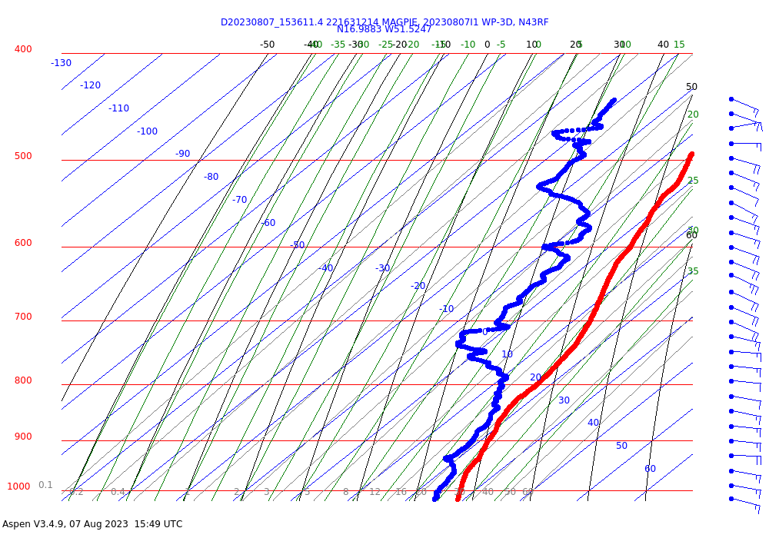
162813 | Drop 19, WP18, 16.9996 56.6096
164454 | Drop 20, WP19, 16.9996 58.3115
1702 | P3 turns southbound at WP20, descending to release BT
170915 | BT4 launched, 29.23 C
1714 | Saildrone 1040 is located at 13.382 59.136  Saildrone 1040 real-time positions: https://data.pmel.noaa.gov/generic/erddap/tabledap/sd1040_hurricane_2023.htmlTable?trajectory%2Clatitude%2Clongitude%2Ctime&time%3Enow-5days
1717 | Synoptic map up through WP16 shows region of large dewpoint depressions in NE corner of domain at 700 hPa, indicative of SAL. 20kt ESE winds there as well.  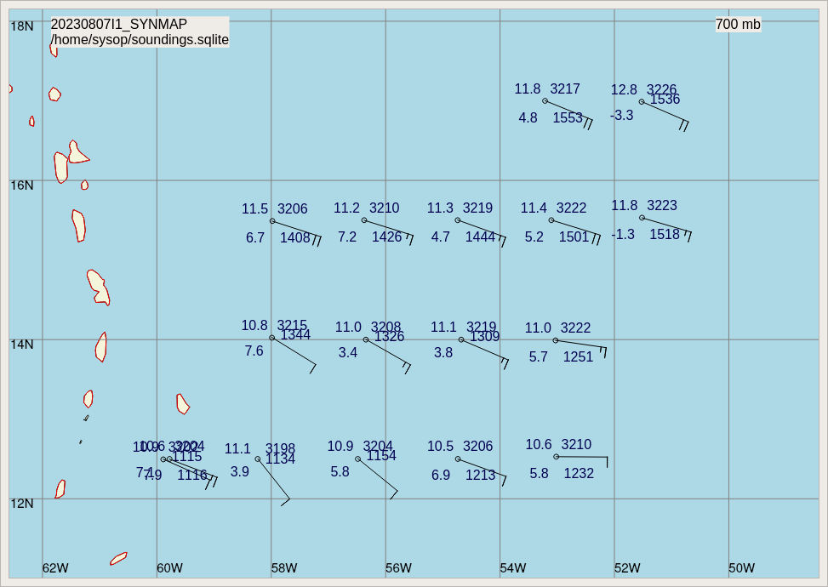
170118 | Drop 21, WP20, 16.9634 59.9701
171656 | Drop 22, WP21, 15.7585 59.7813
1718 | P-3 and TO are approaching each other. There is an area of disturbed weather, with cloud tops around -60 to -70 C, in vicinity of planned coordination region. P-3 is black airplane symbol in image below, TO is green.  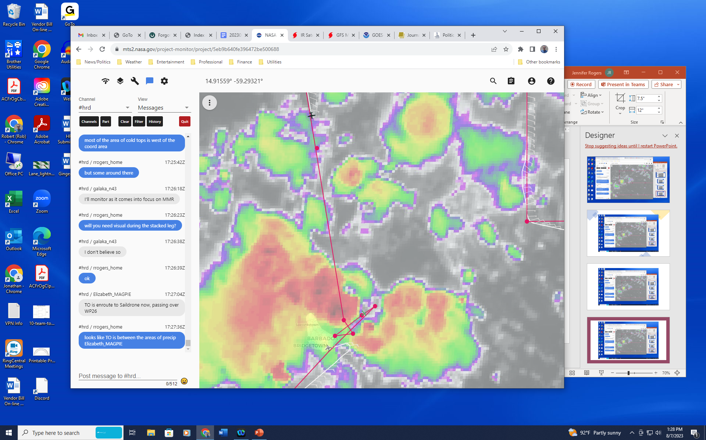
173058 | Drop 23, WP22, 14.5221 59.5643
1736 | P-3 deviating around some convection off the left wing. If they deviated like that for those cloud tops, it will be a problem coming into the coordination region.  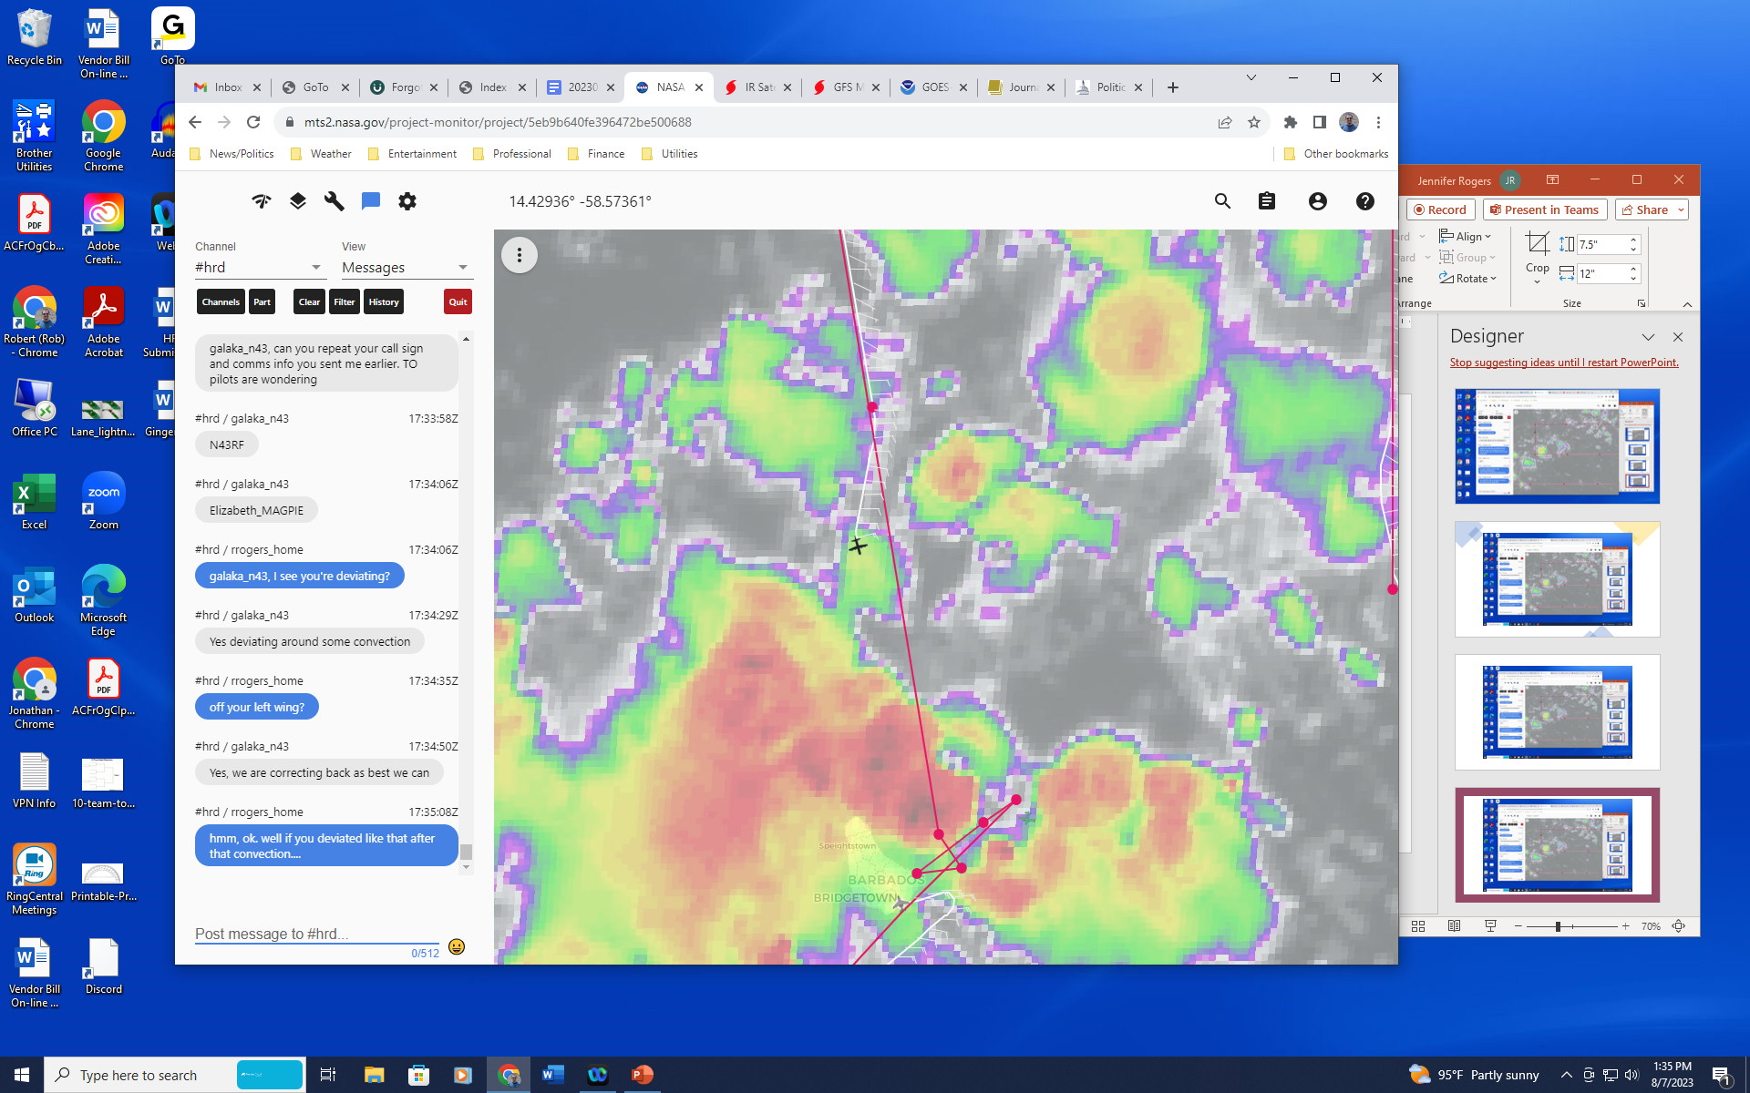
1739 | Lightning flashes in region of cold cloud tops ahead  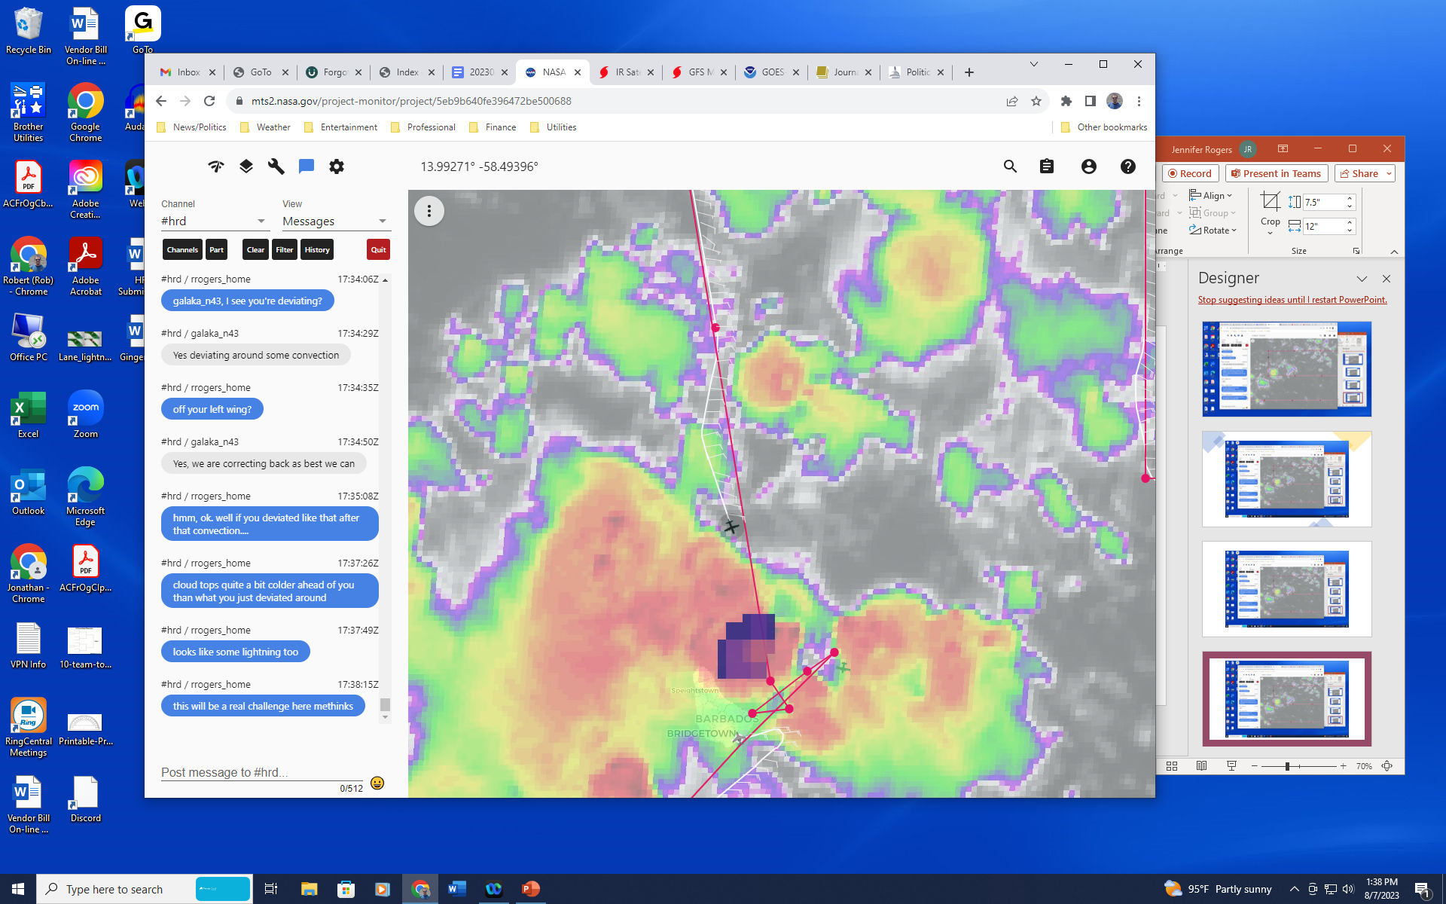  As a result, P-3 is now heading straight for saildrone (northeasternmost point in mini-pattern above), hope that convection clears up a bit for overflight coordination with TO
1743 | Deviation of P-3 to saildrone  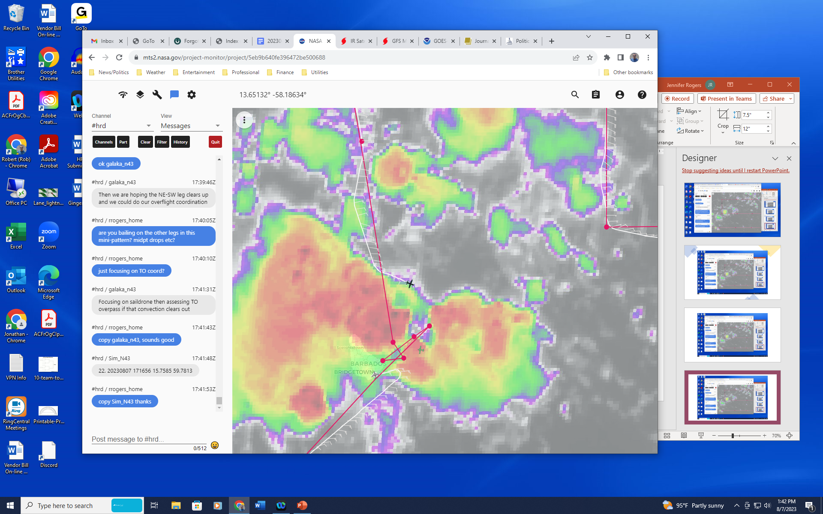
1756 | P-3 continues to deviate around cold cloud shield, away from planned rendez-vous point with TO. TO is flying at 1 kft in expansive cloud shield. Not coldest cloud tops and away from lightning though.  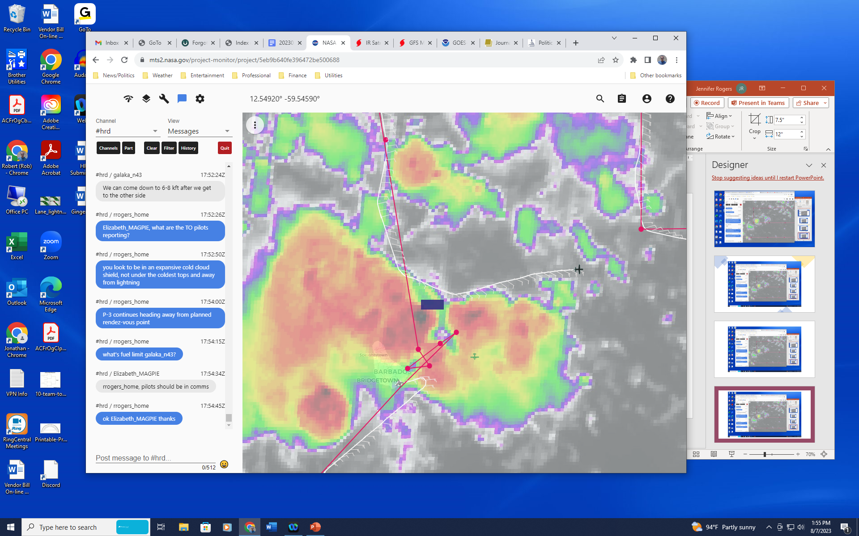
1801 | Updated plan:  P-3 will do the combo at the saildrone, then do an inbound overflight, outbound overflight, and one more inbound overflight. Then go back and drop at WP23 and WP24. Then RTB  TO is actually returning to base now. Too much lightning in the area, so no coordinated overflights.
180805 | BT 5 dropped, intermittent data, so surface data
1808 | Drop 24 13.3802 59.0482 >> charge to ONR
181108 | Drop 25 13.2723 59.2341 >> charge to ONR
182250 | BT 6 dropped, waiting for data to come in and then will RTB. SST 28.89 C
1842 | Final synoptic map shows that the warmest and driest air at 700 hPa was in the two northeasternmost points of domain  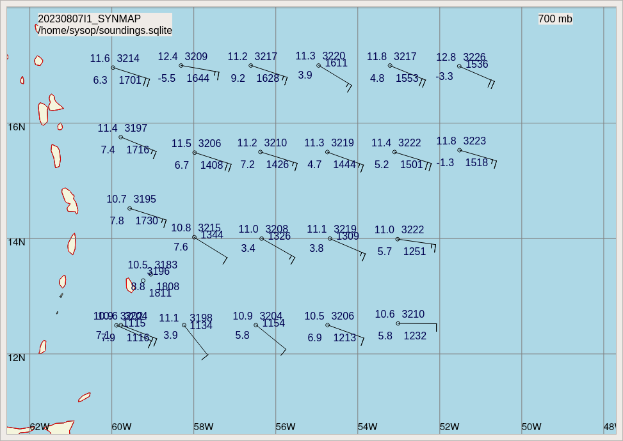  Winds there were also strongest, at 20 kt. Not an extremely strong easterly jet, but nonetheless indications of SAL air there.  Dry air was not evident at 850 hPa though  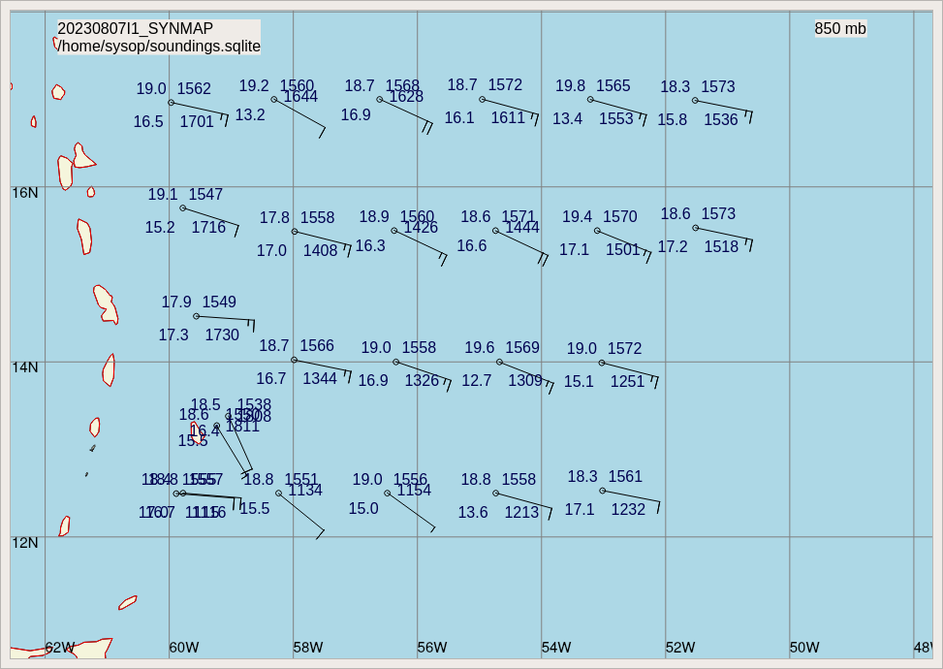
1843 | P-3 lands in Barbados
1850 | Final satellite image at landing shows full-fledged mesoscale convective system has developed over and north of Barbados (see flight track and image below)
 | 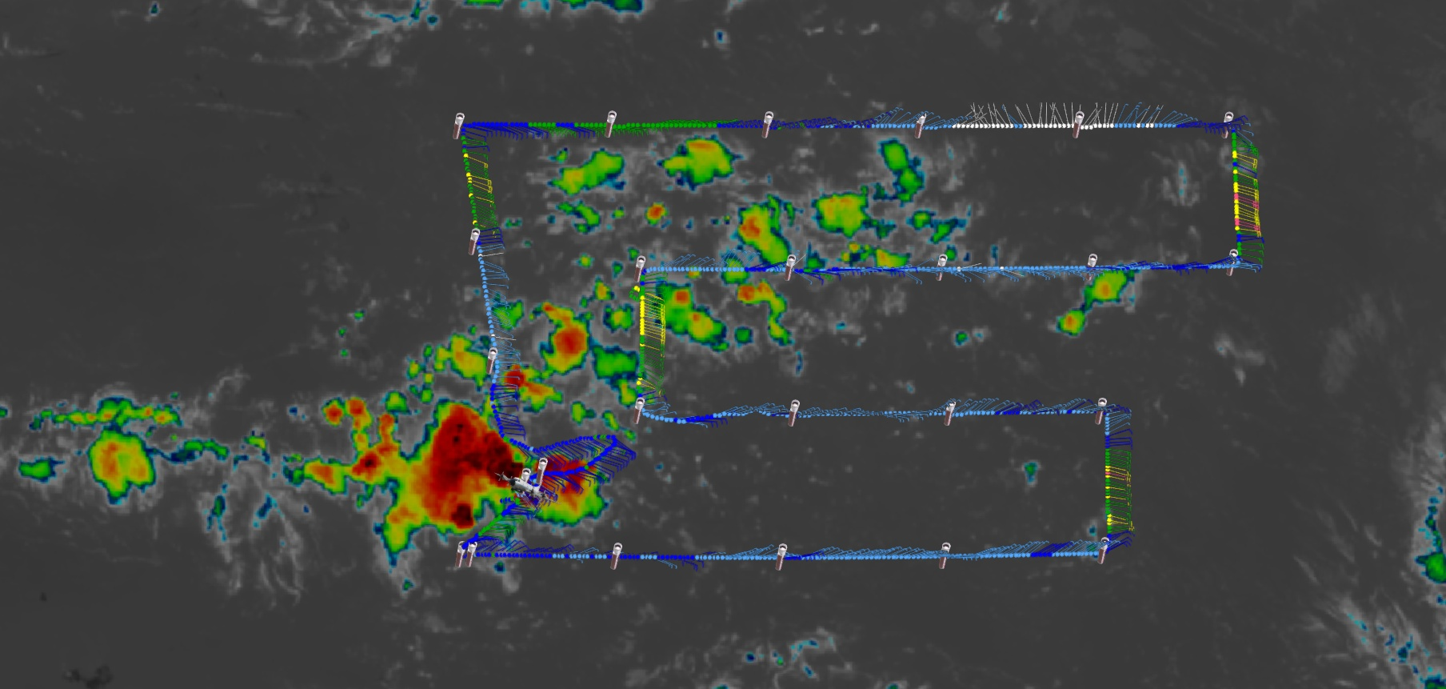

POST-FLIGHT
Mission Summary | Mission successfully flew a lawnmower pattern. Much of the pattern was in a moist region, with the only really dry area the extreme northeastern region of the domain. Dewpoint depressions of 15 C were apparent at 700 hPa, likely indicative of SAL air along the northern boundary. There was little to no indication of a wind shift, however, either at 700 or 850 hPa.  Lawnmower pattern looks like it did not sample a wave (“wave 1” discussed above) axis, at least in terms of not detecting a wind shift. Rather, it appears likely that the mission sampled the environment downstream of the trailing tropical wave (“wave 2” discussed above) that was associated with shower activity about 10 degrees southeast of the pattern at the start of the mission. Possibly a good FAM mission for this downstream environment.  During the mission there was a SW-NE-oriented line of showers, likely indicating a convergence line and possibly a weak reflection of wave 1 being targeted by this mission. Initially those showers were fairly scattered, but as the mission proceeded, and the coordination point was approached, those showers consolidated and intensified, to the point that cold cloud tops of -60 to -70 C and lightning were seen. This was as the P-3 was approaching the end of the lawnmower, and the P-3 had to deviate substantially from the planned track. After significant deviations, the P-3 ended up flying near the saildrone location, where a combo drop was released. However, due to bad weather conditions the Twin Otter had to end its mission early, so no coordination was possible between the P-3 and Twin Otter. By the end of the mission a well-defined mesoscale convective system was located at and north of Barbados.  A total of 25 sondes (23 charged to HRD, 2 charged to ONR) were dropped, all working well. There were 6 AXBTs released, with 4 of them producing good data.
Actual Standard Pattern Flown | Lawnmower
APHEX Experiments / Modules Flown | Genesis Stage FAM experiment was flown. MAGPIE coordination was attempted but bad weather prevented the coordination from occurring.
Plain Language Summary | - Survey pattern was flown into an African easterly wave (which often are the seedlings for hurricanes) approaching Barbados  - Wave structure was sampled, along with dry, dusty Saharan air to the north of the wave  - This information helps us better understand how these waves change when they interact with Saharan air, and can help us understand why some waves become hurricanes while others don’t
Instrument Notes | TDR was not used during the mission. SFMR data was not transmitted in HDOBs, but it may have still been collected.
Final Mission Track | Note: for future coordinated legs from the Ragged Point lighthouse offshore to the northeast, MAGPIE confirmed the line that the HSRL lidar instrument is projecting out from Ragged point. Future P-3/Twin Otter offshore coordinated legs will use the following coordinates:  -Ragged Point (WP 1): 13.169 N, 59.429 W¹  -NE (WP 2): 13.31616 N, 59.2286 W²  1 WP 1’s coordinates are flexible, but short be just offshore of the Ragged Point lighthouse  2 Legs can included WP1-WP2 or WP2-WP-1 and can be repeated (for WP2-WP1, the Ragged Point lighthouse can be used as a heading)  Note: on 11 Aug PhOD confirmed the location of Saildrone 1040’s position on 7 Aug 1810z: 13.3841272N, 59.132864W. NOAA-43 drop 180808z was ~5 NM ESE of the Saildrone position. HRD will work with PhOD to improve real-time access of the Saildrones for future coordinations.

