MISSION PLAN
FLIGHT ID | 20230806N1 | STORM | AEWs
MISSION ID | WAWXA MAGPIE1 | TAIL NUMBER | NOAA 49
TASKING | HRD | PLANNED PATTERN | Lawnmower
MISSION SUMMARY
TAKEOFF [UTC] | 2226 | LANDING [UTC] | 0604
TAKEOFF LOCATION | Barbados | LANDING LOCATION | Barbados
FLIGHT TIME | 7.6 | BLOCK TIME | 8.0
TOTAL REAL-TIME RADAR ANALYSES  (Transmitted) | n/a | TOTAL DROPSONDES Deployed (Transmitted) | 36 (35)
OCEAN EXPENDABLES (Type) | n/a | sUAS (Type) | n/a
APHEX EXPERIMENTS / MODULES | Genesis Experiment, Collaboration With MAGPIE Field Experiment
HRD CREW MANIFEST
LPS ONBOARD | n/a | LPS GROUND | Hazelton
TDR ONBOARD | n/a | TDR GROUND | n/a
ASPEN ONBOARD | AOC FD | ASPEN GROUND | n/a
NESDIS SCIENTISTS | n/a
GUESTS (Affiliation) | n/a
AOC CREW MANIFEST
PILOTS | Nardi, Bhatnagar, Cozart
NAVIGATOR | N/A
FLIGHT ENGINEERS | N/A
FLIGHT DIRECTOR | Henning, Timmers
DATA TECHNICIAN | Defeo
AVAPS | Dykeman, Patel

PRE-FLIGHT
Flight Plan | 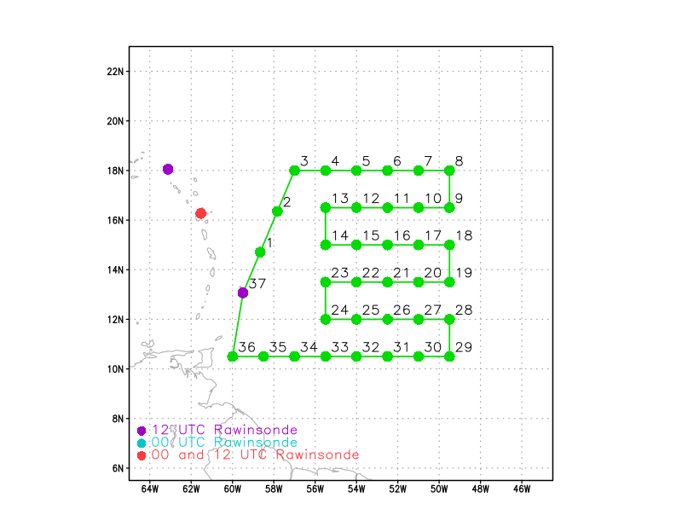
Expendable Distribution | 36 dropsondes, equally spaced along the flight track.
Preflight Weather Briefing | Not much convection, but there is a moisture gradient along the flight track.  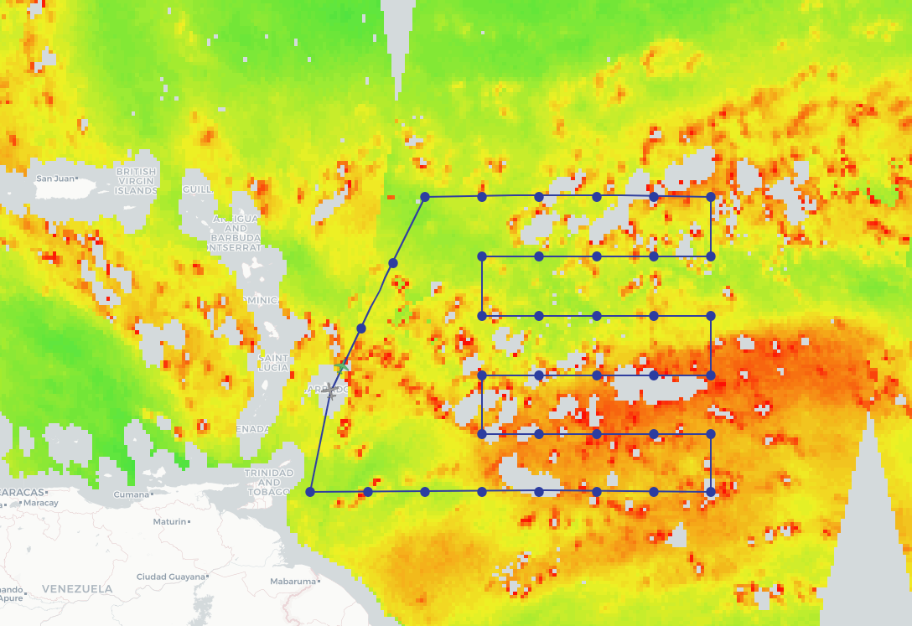
Instrument Notes | Everything seems to be working correctly

IN-FLIGHT
Time [UTC] | Event
2225 | Take-off from Barbados
2238 | IR image shortly after takeoff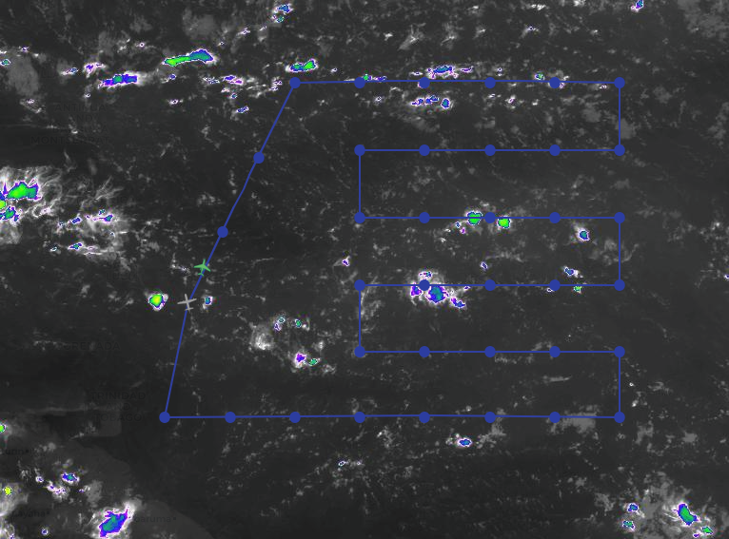  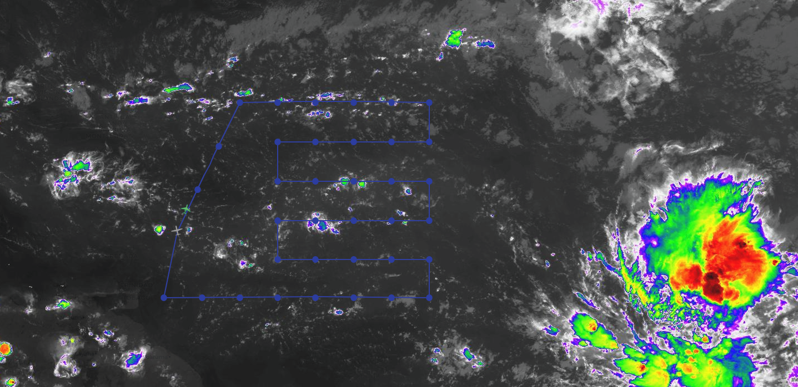
2244 | Sonde 1  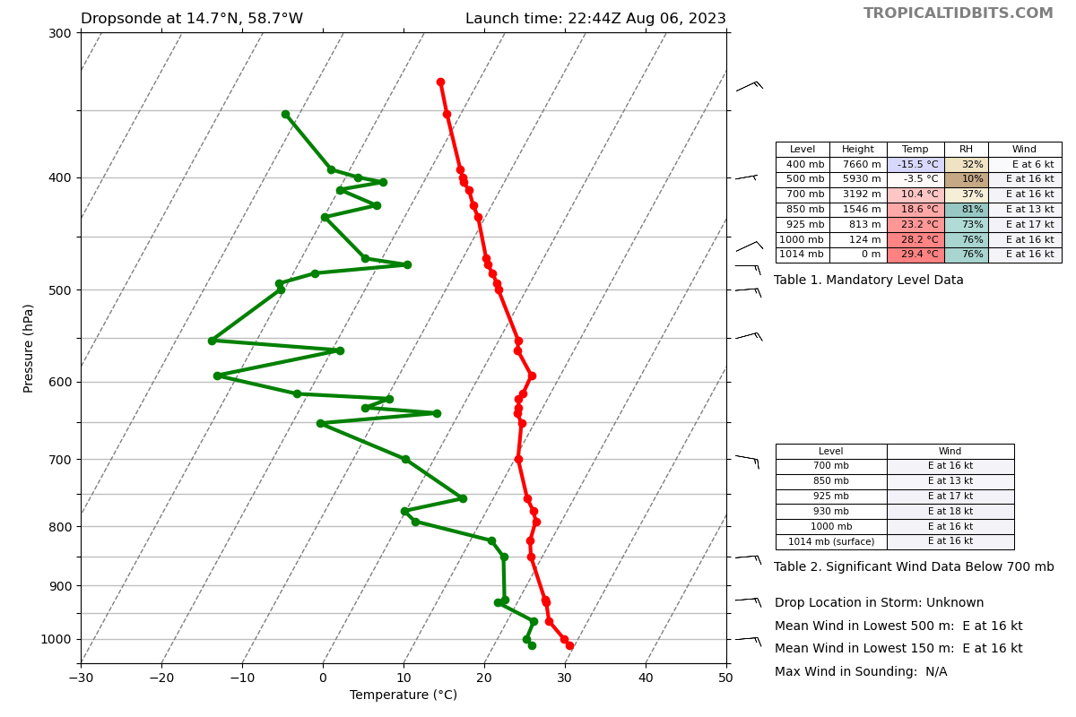  Very dry mid levels
2259 | Sonde 2
2314 | Sonde 3
2325 | Sonde 4
2337 | Sonde 5  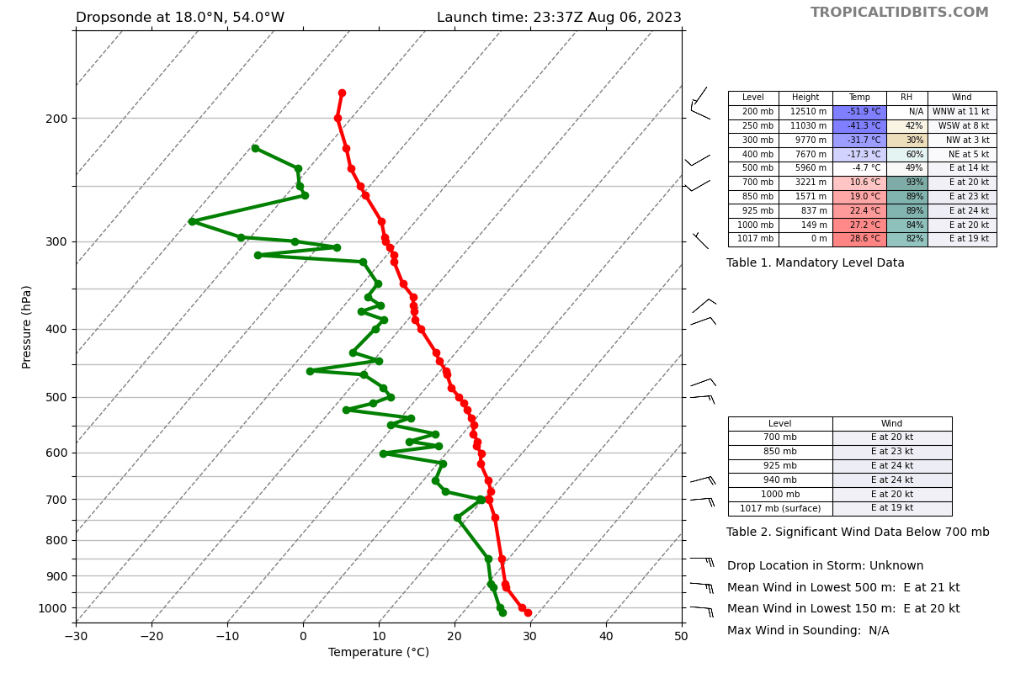
2340 | Noted a glitch with the Skew-Ts on the ASPEN directory  Passed it along to the flight director
2348 | Sonde 6
0000 | Sonde 7
0011 | Sonde 8
0022 | Sonde 9
0033 | Sonde 10  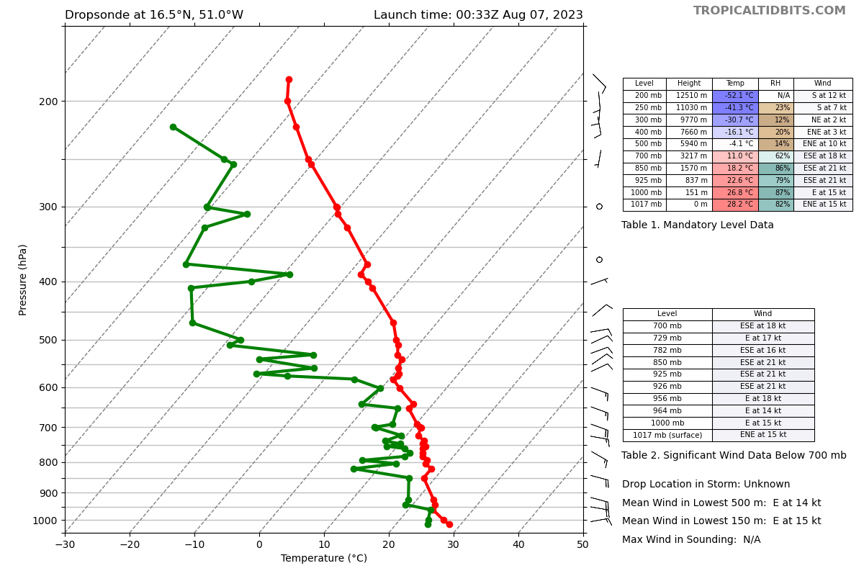  Still some dry layers above 600 hPa
0045 | Sonde 11
0057 | Sonde 12
0108 | Sonde 13
0119 | Sonde 14
0131 | Sonde 15  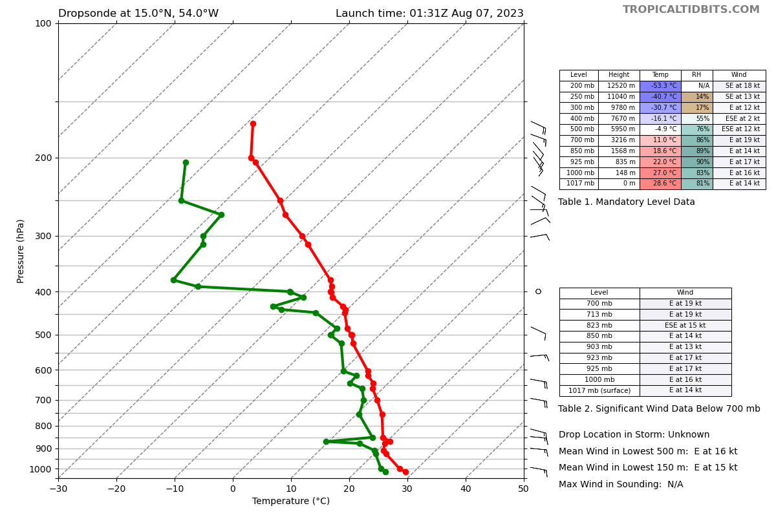  Slightly deeper moisture here
0143 | Sonde 16
0156 | Sonde 17
0208 | Sonde 18
0219 | Sonde 19
0230 | Sonde 20  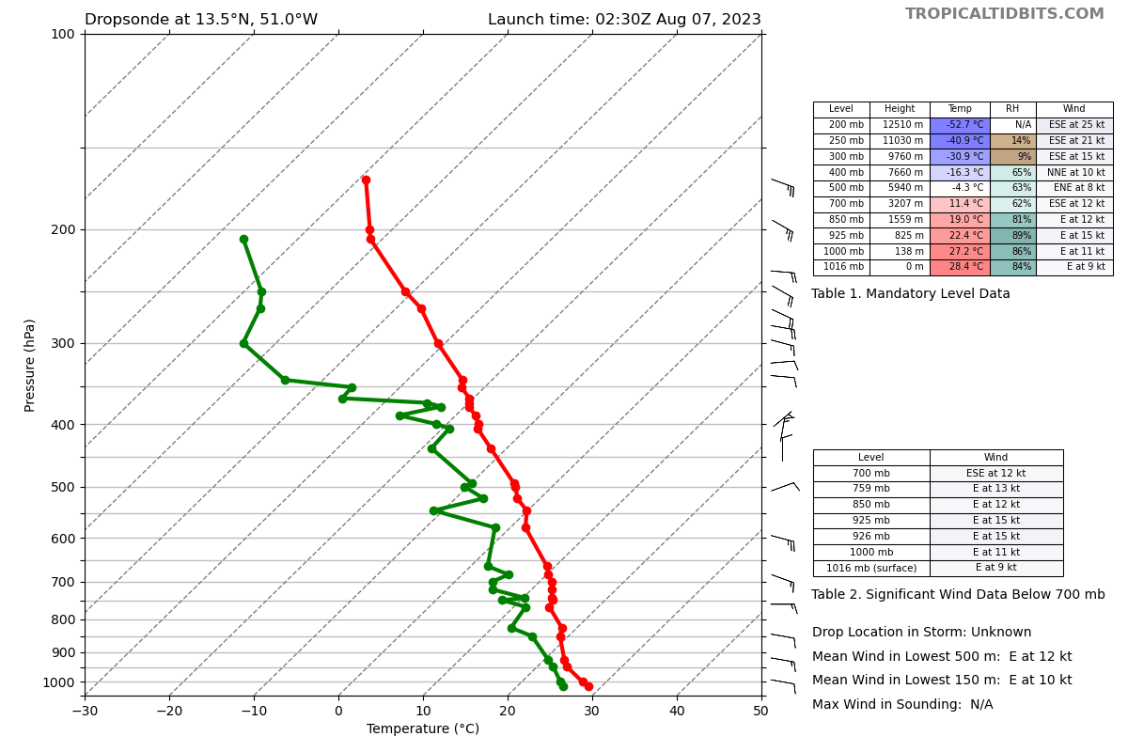
0242 | Sonde 21
0253 | Sonde 22
0304 | Sonde 23
0315 | Sonde 24  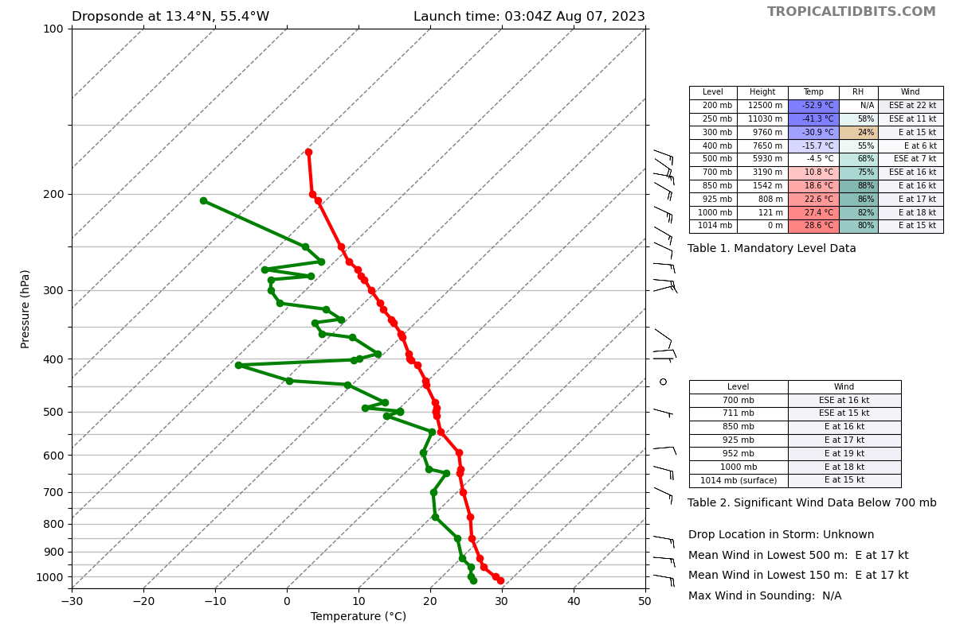  Little bit more moist - still some dry layers
0328 | Sonde 25
0341 | Sonde 26
0354 | Sonde 27
0438 | MTS IR snapshots near end of pattern 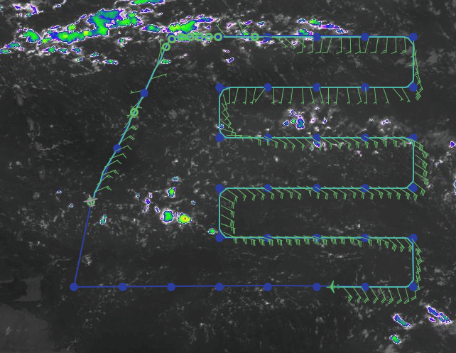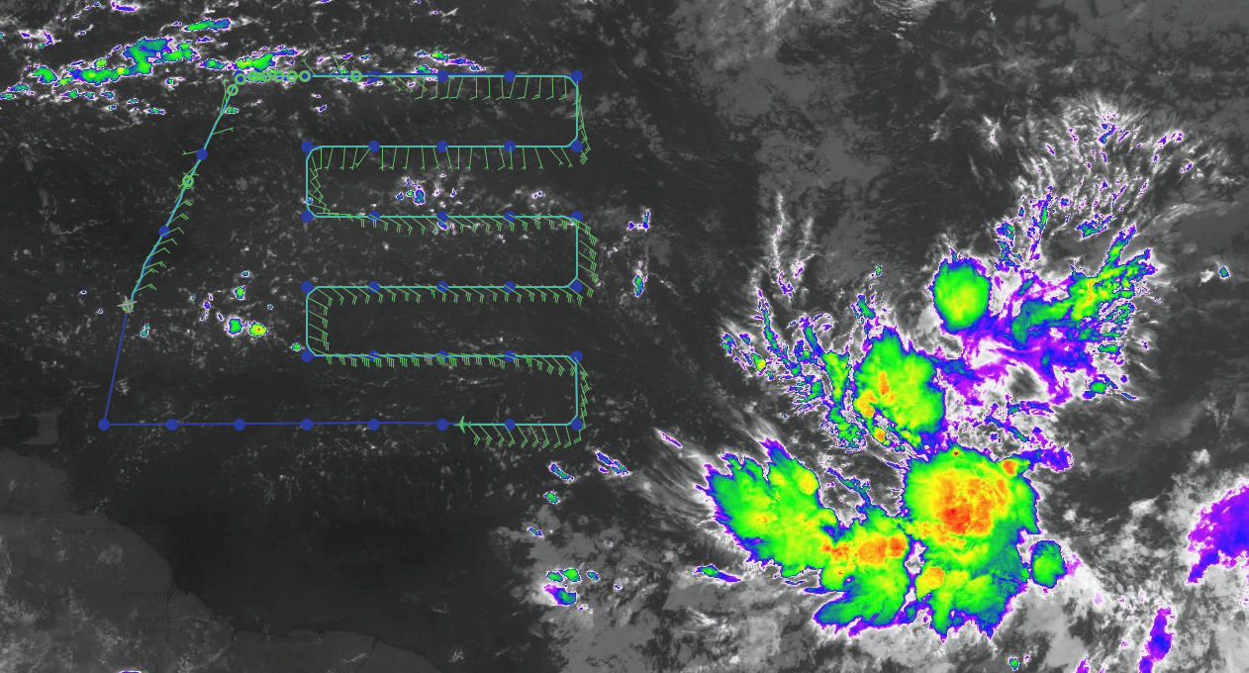
0407 | Sonde 28
0418 | Sonde 29
0429 | Sonde 30
0441 | Sonde 31
0453 | Sonde 32 (Bad Sonde No Backup)
0505 | Sonde 33
0517 | Sonde 34
0528 | Sonde 35
0536 | Sonde 36
0606 | Landed at Barbados

POST-FLIGHT
Mission Summary | The mission was executed successfully, with a lawnmower pattern across a weak wave east of the Antilles.  The environment was very dry overall, although we did see some gradients in low-level moisture.  Interestingly, the upper winds were very light throughout much of the flight, confirming that much of the hostile environment was thermodynamically driven.
Actual Standard Pattern Flown | Lawnmower East of the Antilles
APHEX Experiments / Modules Flown | Research mission into a gradient of SAL and moisture associated with a wave east of the Antilles, in collaboration with the MAGPIE field experiment.  APHEX Genesis Experiment
Plain Language Summary | We flew a research mission into a tropical wave in collaboration with partners studying areas of moist and dry air and their scientific importance.
Instrument Notes | Instruments were fine - turns out the ASPEN version on the G-IV was old (3.4.8) so the Skew-Ts were not being saved properly - they will fix on the ground.
Final Mission Track | 