MISSION PLAN
FLIGHT ID | 20221109I2 | STORM | AL17 / NICOLE
MISSION ID | 1417A | TAIL NUMBER | NOAA43
TASKING | EMC | PLANNED PATTERN | Butterfly
MISSION SUMMARY
TAKEOFF [UTC] | 2100 | LANDING [UTC] | 0236
TAKEOFF LOCATION | Lakeland | LANDING LOCATION | Mobile, AL
FLIGHT TIME | 5.6 | BLOCK TIME | 5.8
TOTAL REAL-TIME RADAR ANALYSES  (Transmitted) | 3 (3) | TOTAL DROPSONDES (Good/Transmitted) | 12 (12 / 12)
OCEAN EXPENDABLES (Type) | None | sUAS (Type) | None
APHEX EXPERIMENTS / MODULES | Early Stage Experiment: AIPEX
HRD CREW MANIFEST
LPS ONBOARD | None | LPS GROUND | Rogers
TDR ONBOARD | McAlister (AOC) | TDR GROUND | Gamache
ASPEN ONBOARD | Timmers (AOC) | ASPEN GROUND | None
NESDIS SCIENTISTS | Sapp
GUESTS (Affiliation) | None
AOC CREW MANIFEST
PILOTS | Mitchell, Rannenberg, Wood
NAVIGATOR | Miller
FLIGHT ENGINEERS | Stokes, Tyson
FLIGHT DIRECTOR | Holmes
DATA TECHNICIAN | McAlister
AVAPS | Paul

PRE-FLIGHT
Flight Plan | 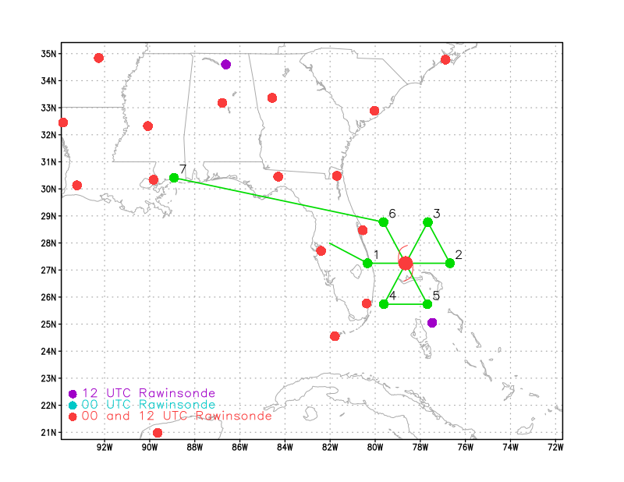  Fly EMC-tasked butterfly pattern, 105 nmi legs. IP on the west side. No research modules planned.
Expendable Distribution | Dropsondes at endpoints, midpoints, and each center pass for a total of 15 drops. No AXBTs.
Preflight Weather Briefing | Nicole has not changed much in structure or intensity. A large eye-like feature is evident on satellite animations and ground radar (see below). Little to no deep convection over the circulation center, but there are cold cloud tops in the eyewall feature at a large radius, indicative of the overall broad circulation associated with Nicole. The TC is moving toward the west at 11 kt. It remains in an environment marginally favorable for intensification, with SST’s in the 27-28 C range, moderate shear, and fairly moist low- and midlevels. The large circulation and stable environment, though, will limit (probably preclude) any significant intensification, though.  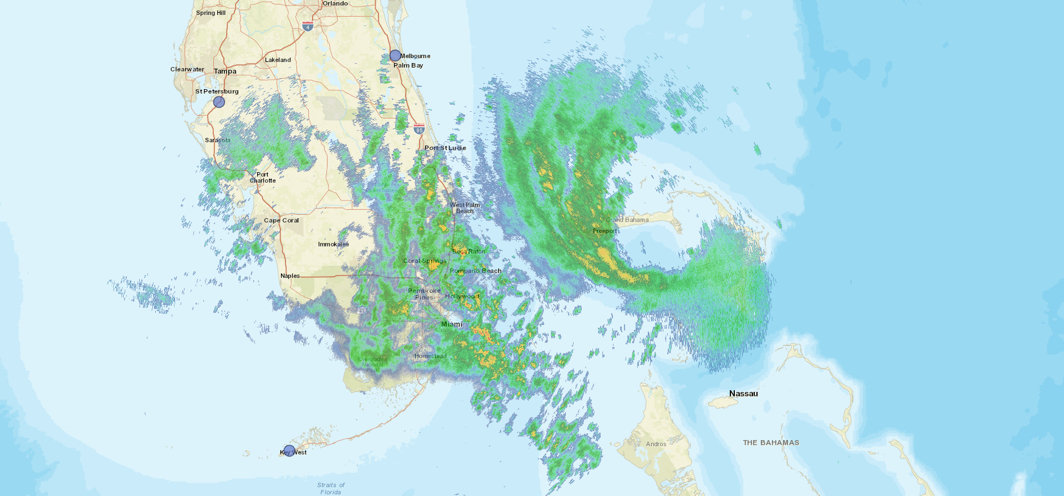  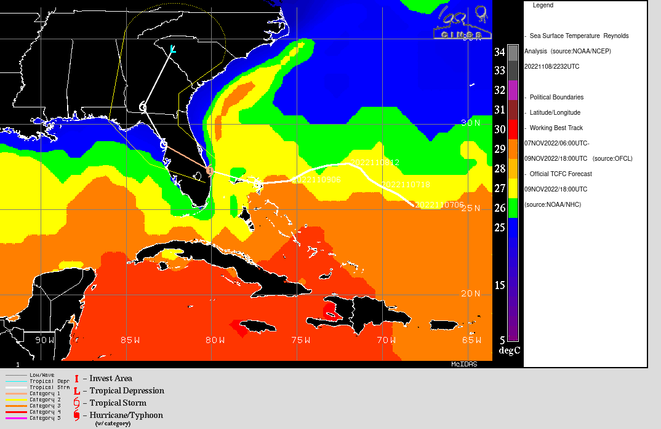  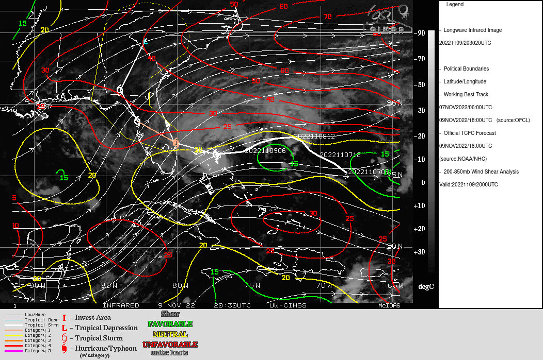  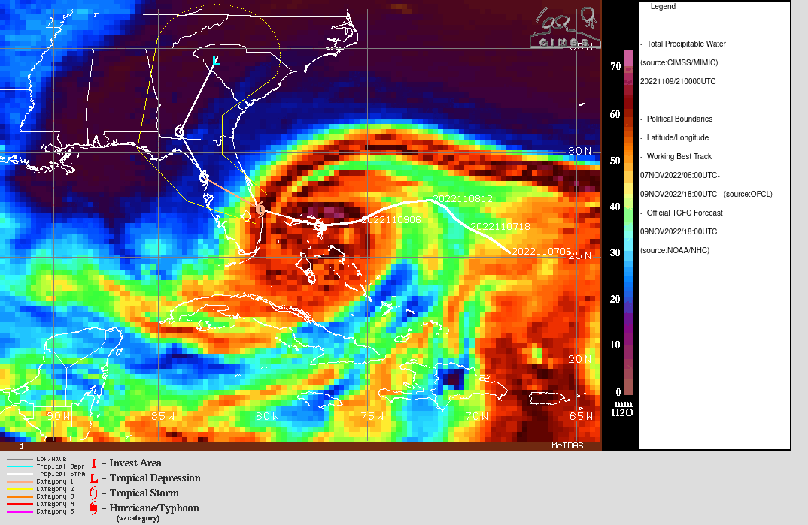
Instrument Notes | None noted

IN-FLIGHT
Time [UTC] | Event
2255 | 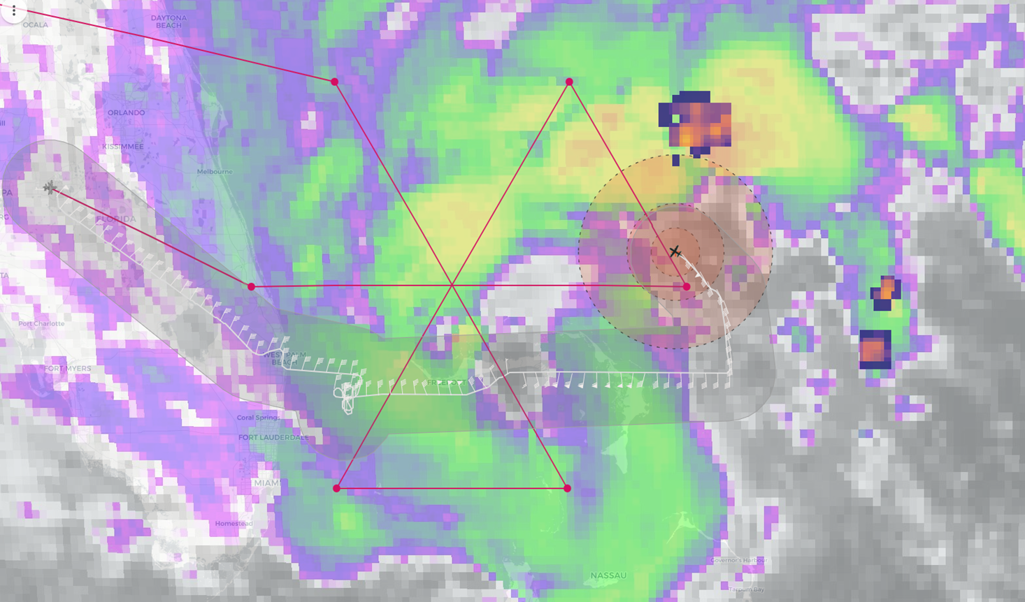  Well into the pattern. TC center is quite a bit further south than the predicted location from 24-30 h earlier. Cold cloud tops define the large, ragged eye, with the coldest tops located over the northern and northeastern portion of the eyewall. Isolated regions of lightning in the coldest cloud tops to the northeast and east of the center.  Flight track also shows a period of circling on the west side of the storm, prior to beginning the pattern. This is because the aft antenna sweeps were not being written prior to that period. A restart of the radar system was required, at which point the data from both antennas were being written.
2305 | 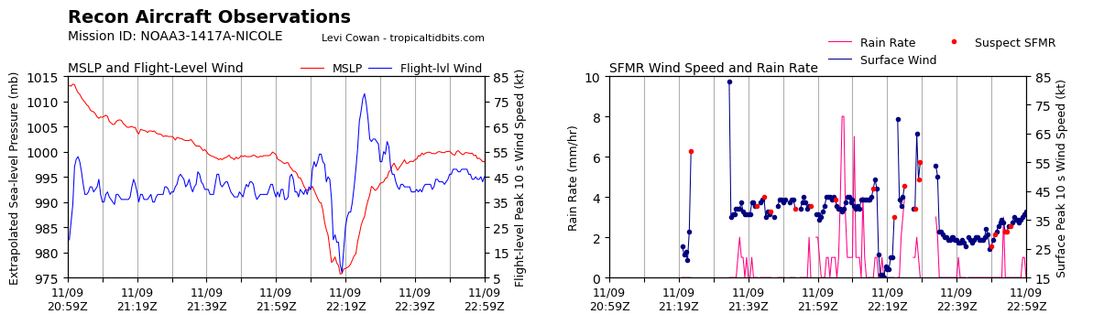  Flight-level data from first, west-east pass shows pronounced across-storm asymmetry at flight level, with >75 kt winds on east side and 55 kt winds on west side. SFMR is spotty, most likely due to islands of the Bahamas.
2316 | More issues with TDR data not getting written
2341 | Troubleshooting for data writing continues as plane continues pattern  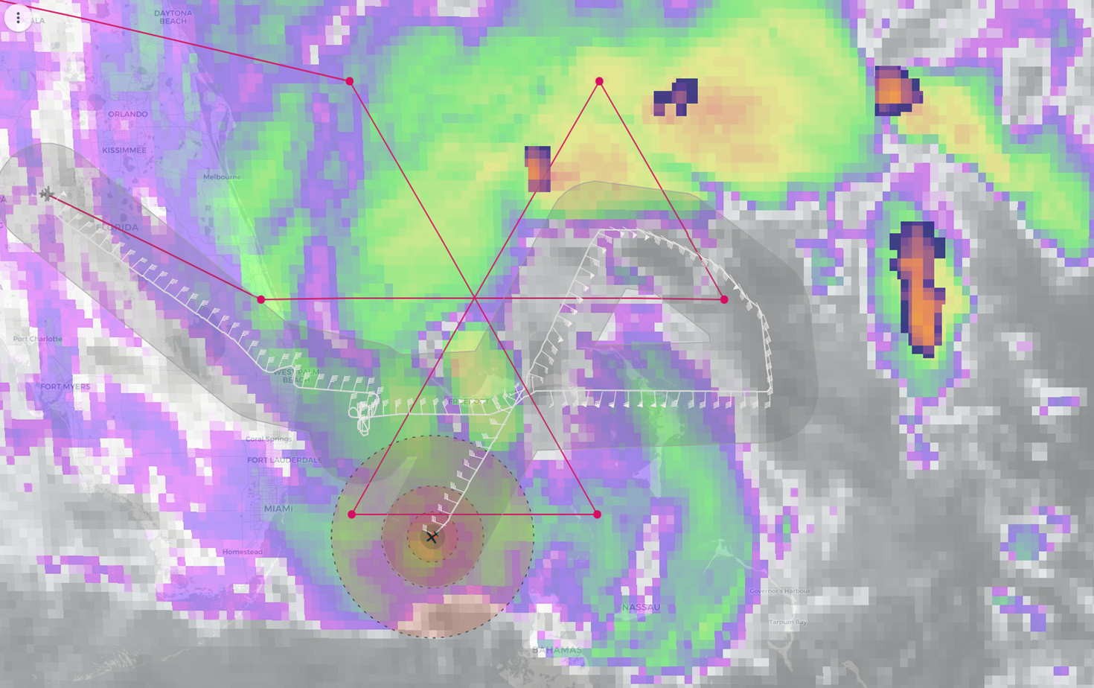
2345 | 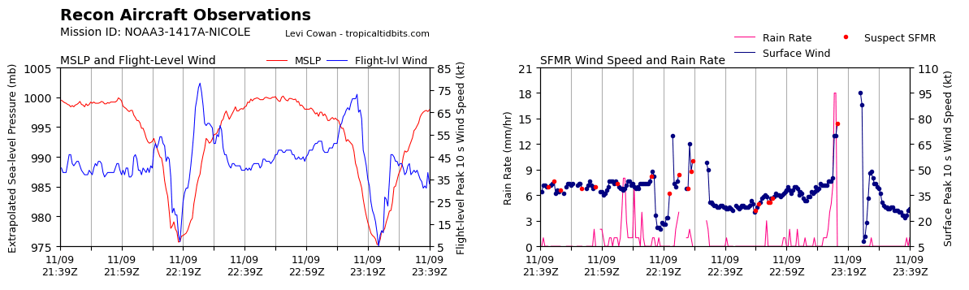  Recent pass from NE-SW shows continued asymmetry at flight-level. Winds near 75 kt on NE side, ~45 kt on SW side. SFMR winds show 95 kt on the NE side, but that seems suspicious. Trace of extrapolated sea-level pressure shows MSLP has dropped slightly, to 975 hPa, but that is likely lower than the actual MSLP.
0013 | 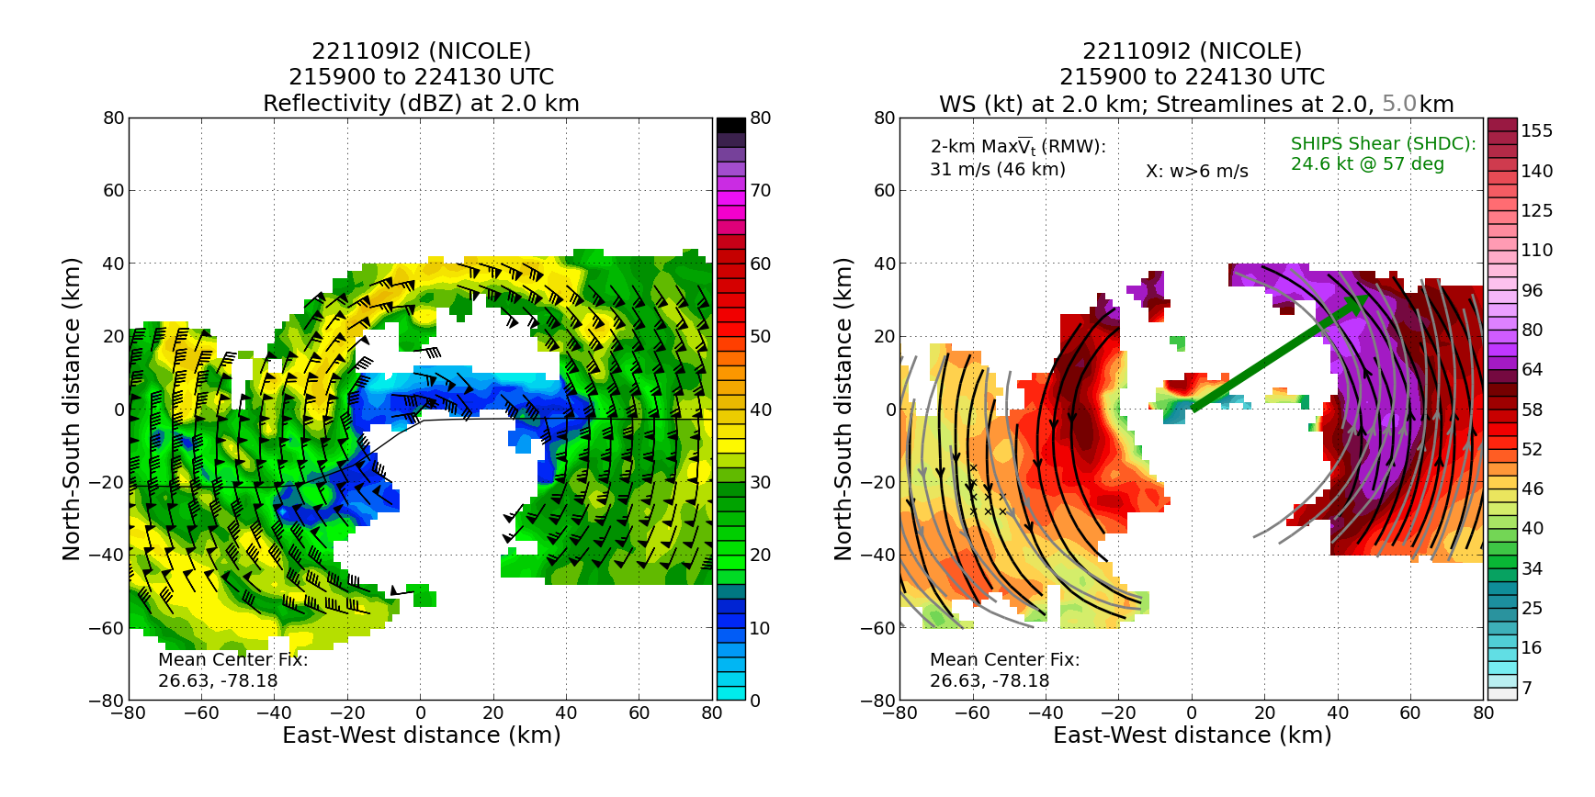  TDR analysis from first pass shows pronounced asymmetry in wind speed at 2 km, peak winds on NE side. Vortex is basically aligned though.
0014 | 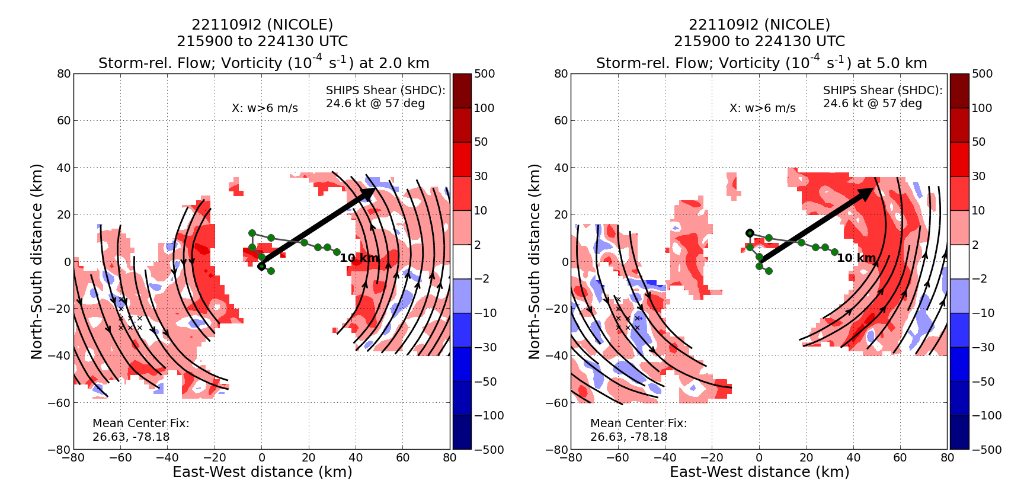  Tilt hodograph shows slight (< 20 km) tilt up to 5 km, above that vortex tilts toward the ESE up to 10 km. Magnitude of tilt, though, is still less than the 2-km RMW.
0015 | 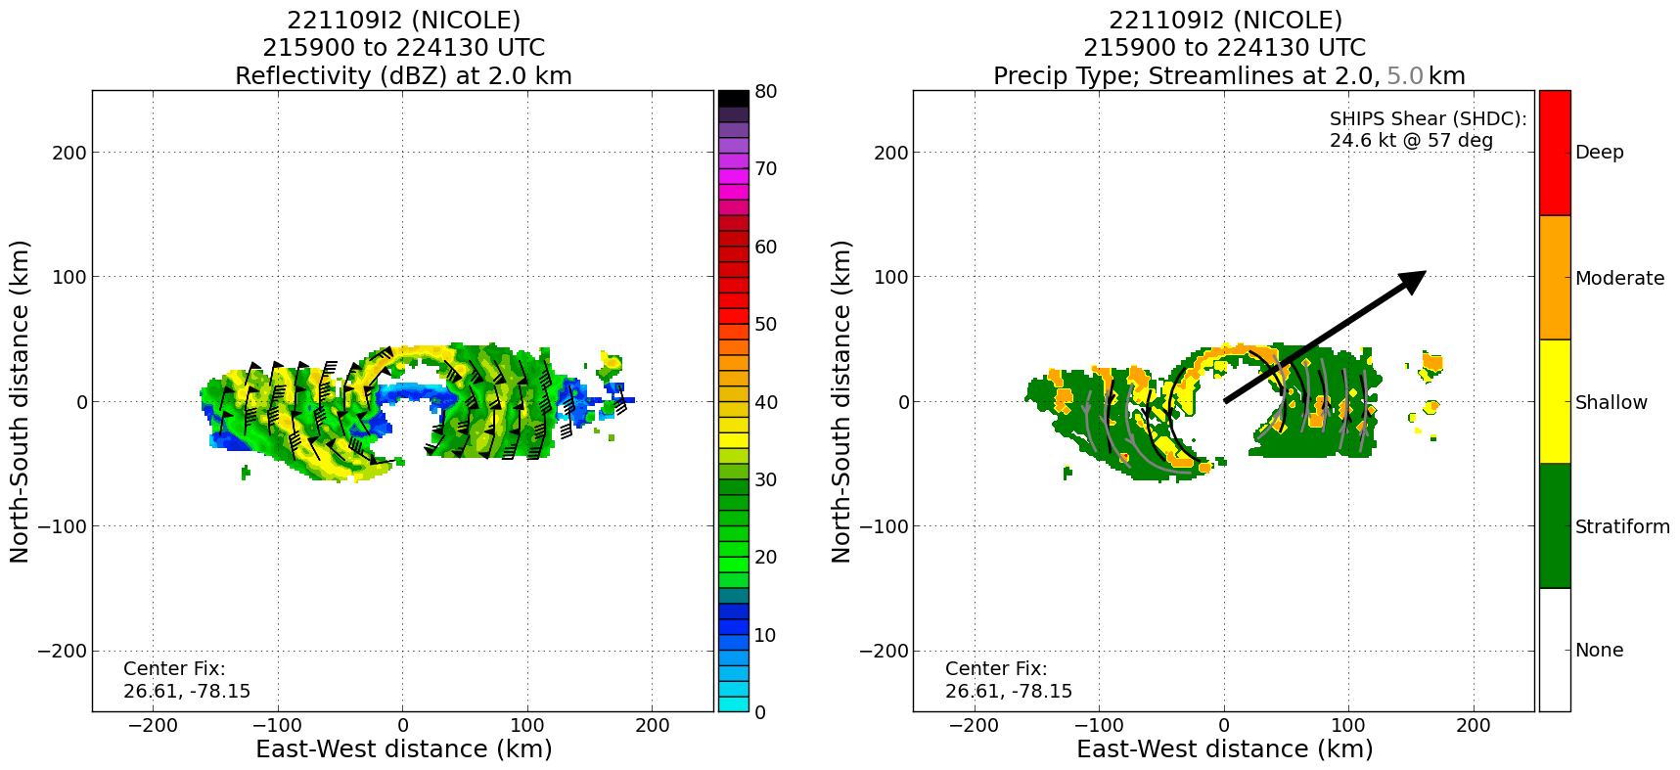  Precipitation mode is dominated by stratiform precipitation and moderate convection. Little to no deep convection, consistent with the notion that the environment is fairly stable.
0044 | Issues with TDR data files and Xchat communications seem to be resolved. There appears to have been a file from the previous mission that was hung up, that needed to be sent off the plane. Data seems to be flowing better now. Could have been related to satcom issues as well.
0048 | 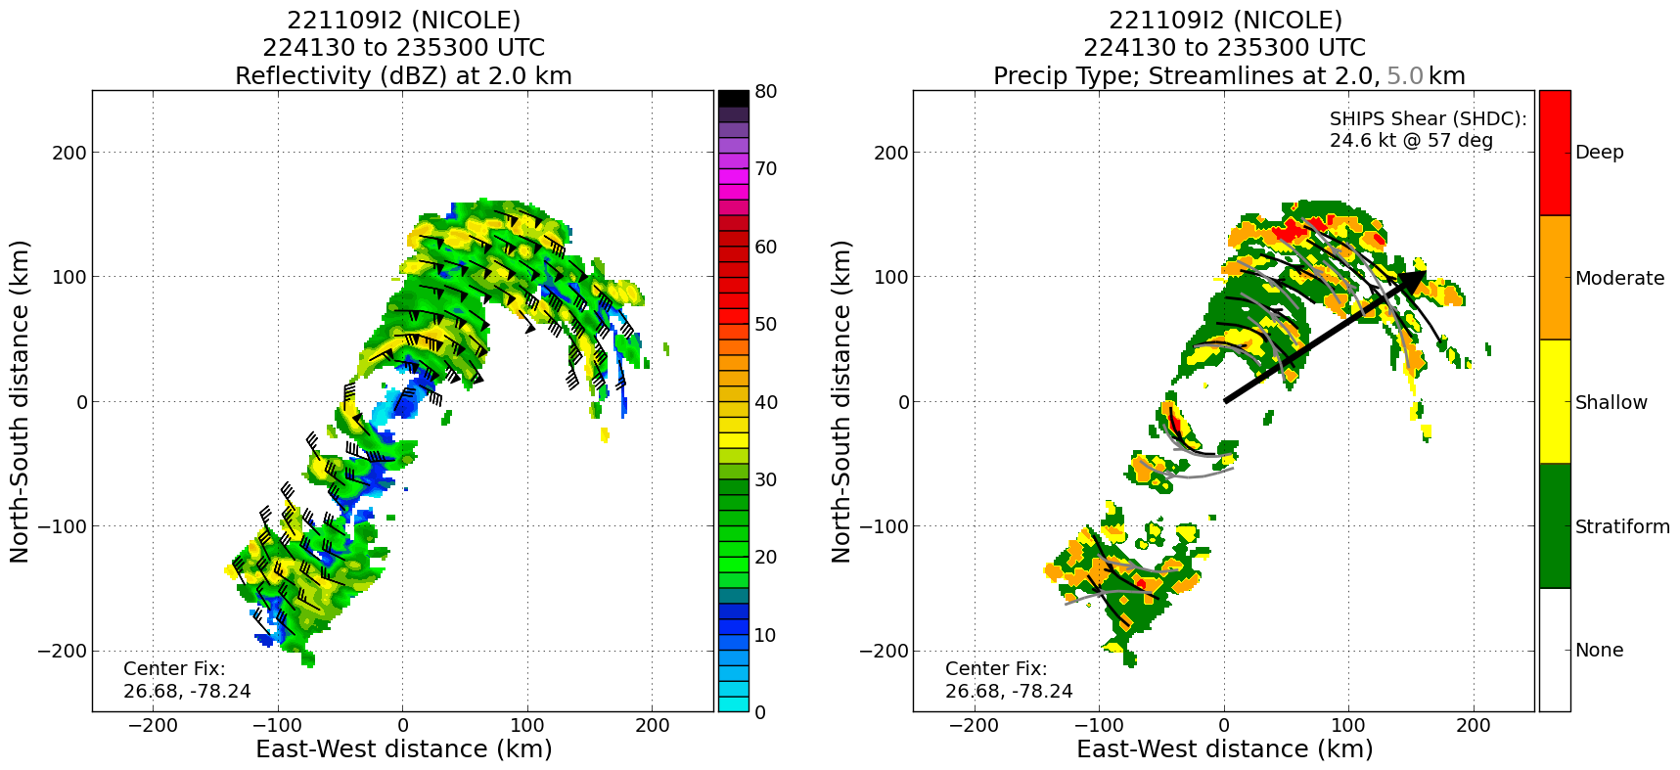  Precip mode analysis from second pass continues to show mostly moderate convection, but there are some localized regions of deep convection on the SW side, plus a more widespread region of deep convection in the NE edge of the domain. That’s consistent with the coldest cloud tops in the IR imagery above.
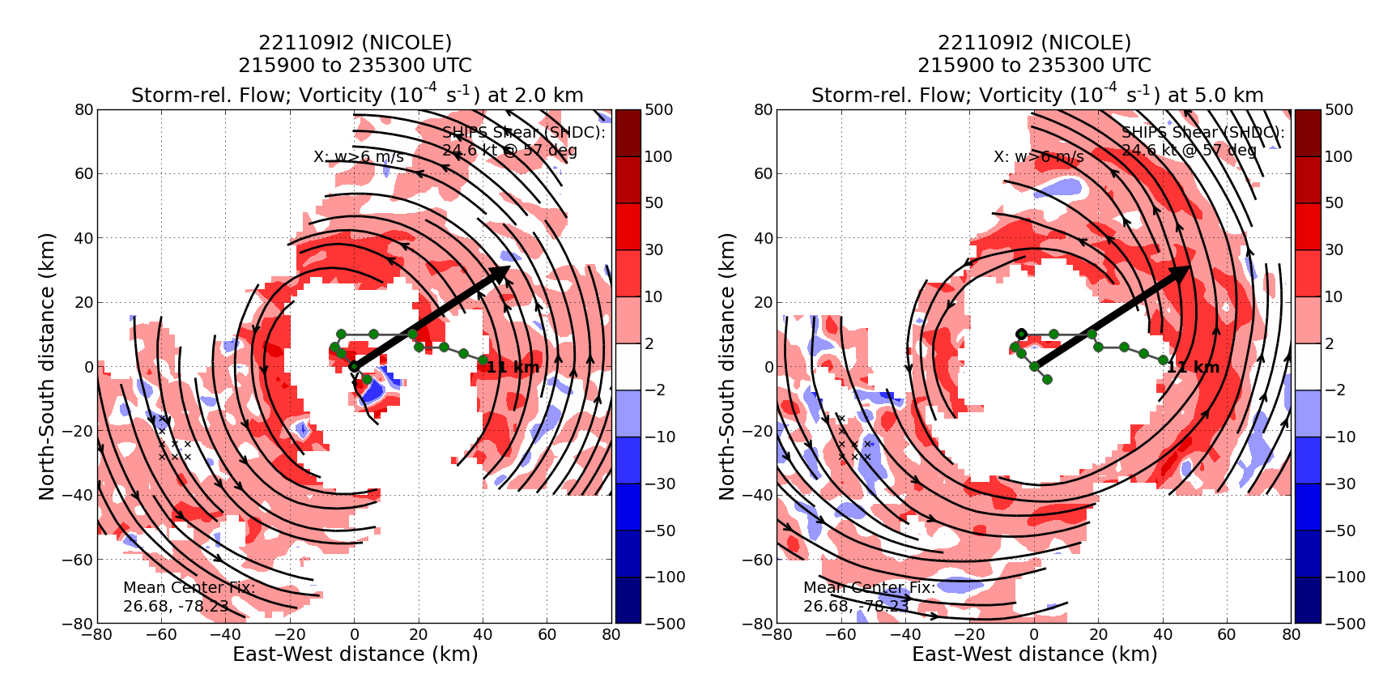
Tilt hodograph continues to show a near-aligned vortex up to 5 km, then sharp tilt toward the ESE above. Upper-level tilt is larger than the first analysis, possibly reflecting impact of additional radar coverage from inclusion of second pass.

Despite lack of scatterers in large eye, indications that vorticity core is better-defined with combined 1st and 2nd pass analyses.
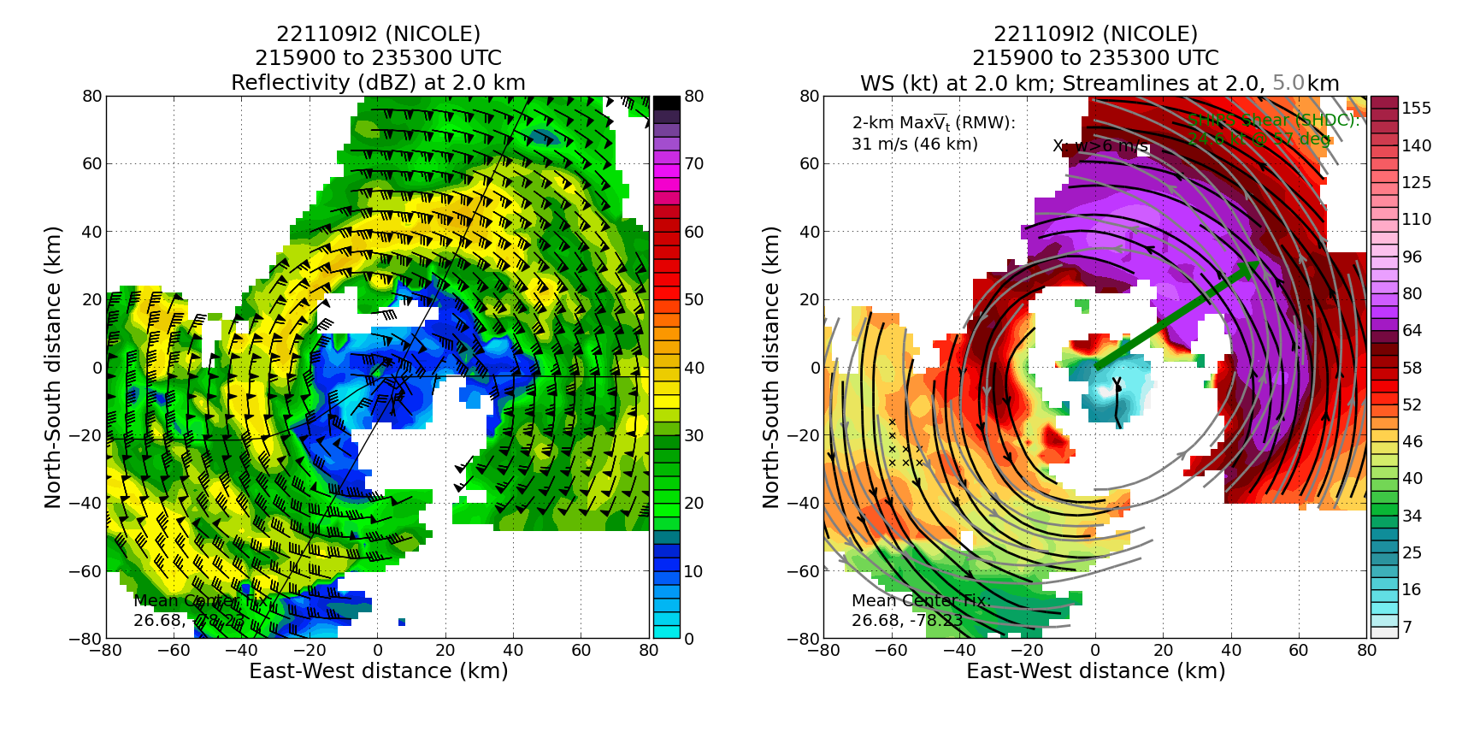
Asymmetry in the 2-km wind field is most pronounced with this analysis. Winds near 70 kt at 2 km on NE side. Reflectivity maximum is in the NW eyewall (downshear left).
0113 | End window for final TDR analysis
0153 | 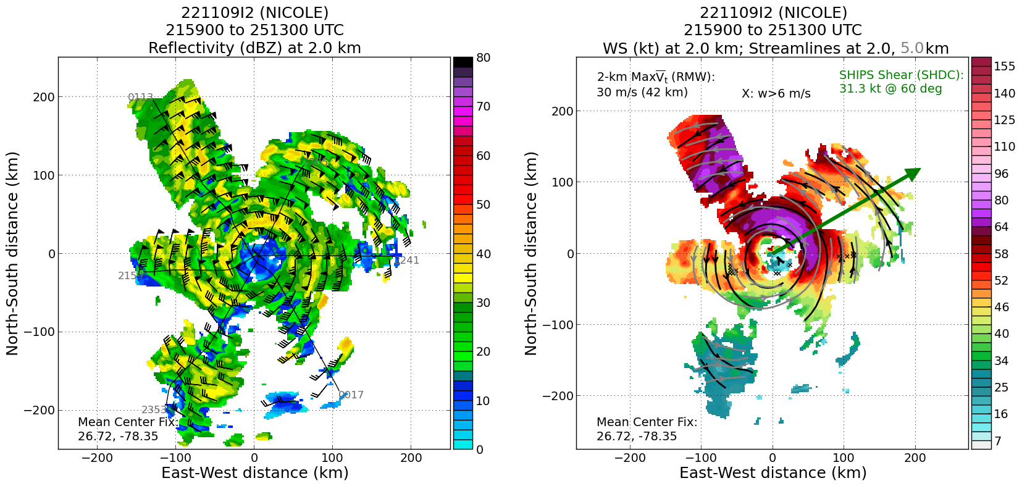  Extended collection window on the final outbound leg of the third analysis. Doing this showed a clear outer wind maximum on the NW and N side of the storm. Azimuthal location of outer wind maximum is downwind of azimuthal location of inner wind maximum. That I believe is consistent with observations of other secondary eyewall cases from Didlake and colleagues.

POST-FLIGHT
Mission Summary | Mission was successful, completing the butterfly pattern. There were several periods, some extended, where there were issues with either the writing of data files or transmitting of those files. It seemed to be related to a file from the previous mission that was “stuck” in the queue. There were also delays in Xchat communication too, which suggests a possible satcom issue. Regardless, analyses were generated and transmitted, including the real-time graphics from the TDR.  Nicole has slowly intensified, officially reaching hurricane status during the mission. The system has a ragged eye and a broad circulation that is highly asymmetric, with the strongest winds of 70 kt at 2 km on the NE side of the circulation. This is also where the coldest cloud tops are indicated by IR imagery and deep convection is shown from the TDR. The vortex is nearly aligned up to 5 km, but above that level the vortex tilts sharply toward the ESE. This tilt direction is interesting, because Nicole appears to be in WSW shear, and along a shear gradient. This suggests that the vortex tilts toward the downshear right, at least above 5 km.  The final leg was outbound to the NW. We extended the data collection window on that leg, and because of that we were able to capture a clear outer wind maximum on the NW and N sides of the storm. This is very likely associated with the outer region of cold cloud tops seen in satellite imagery. The broad circulation likely points toward a more significant surge impact on the Florida east coast than what would otherwise be the case.
Actual Standard Pattern Flown | Butterfly
APHEX Experiments / Modules Flown | Data collection supports the Early Stage Experiment: Analysis of Intensity Change Processes (AIPEX) as the storm intensified since the previous flight.
Plain Language Summary
Instrument Notes | The TDR aft antenna sweeps were not being written initially, so a restart of the TDR system was required. The airplane was put into a holding pattern to get the TDR operational before entering the pattern.
Final Mission Track | 