MISSION PLAN
FLIGHT ID | 20221107I2 | STORM | AL17 / NICOLE
MISSION ID | 0217A | TAIL NUMBER | NOAA43
TASKING | EMC | PLANNED PATTERN | Lawnmower + Fix
MISSION SUMMARY
TAKEOFF [UTC] | 1953 | LANDING [UTC] | 0323
TAKEOFF LOCATION | Lakeland | LANDING LOCATION | Lakeland
FLIGHT TIME | 7.5 | BLOCK TIME | 7.8
TOTAL REAL-TIME RADAR ANALYSES  (Transmitted) | 3 (3) | TOTAL DROPSONDES (Good/Transmitted) | 27 (26 / 26)
OCEAN EXPENDABLES (Type) | None | sUAS (Type) | None
APHEX EXPERIMENTS / MODULES | Early Stage Experiment: AIPEX
HRD CREW MANIFEST
LPS ONBOARD | Dunion | LPS GROUND | Rogers
TDR ONBOARD | Dunion | TDR GROUND | Gamache
ASPEN ONBOARD | Dunion | ASPEN GROUND | None
NESDIS SCIENTISTS | None
GUESTS (Affiliation) | None
AOC CREW MANIFEST
PILOTS | Mitchell, Rannenberg, Wood
NAVIGATOR | Utama
FLIGHT ENGINEERS | Stokes, Tyson
FLIGHT DIRECTOR | Holmes
DATA TECHNICIAN | McAlister
AVAPS | Paul

PRE-FLIGHT
Flight Plan | 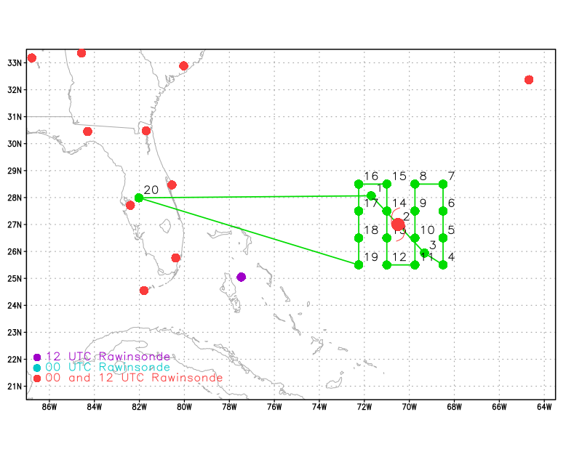  Pattern: Fly a single NW-SE center pass followed by a lawnmower pattern  Altitude:  - NW-SE center pass (WPs 1-3): 10 kft (pressure altitude)  - Lawnmower (WPs 4-19): 20 kft or as high as possible (pressure altitude)
Expendable Distribution | 19 sondes (all dropsondes transmitted to the GTS; all sondes charged to NWS). NW-SE center pass: release sondes at endpoints and center (3 sondes). Lawnmower pattern: 16 sondes.
Preflight Weather Briefing
Instrument Notes

IN-FLIGHT
Time [UTC] | Event
1953 | Takeoff from KLAL
2020 | Issues with the data system - troubleshooting…not sending HDOBS right now (data looks bad)
2025 | Dropping extra sondes along ferry (78W to IP, ~1.5 deg spacing). Sampling areas that this afternoon’s G-IV mission was targeting.
2040 | Drop #1- no launch detect- could be related to aircraft data issues we’re having. Holding off on a backup until drop #2
2056 | Drop#2: 2056z
2125 | Descending to 10 kft for approach to IP (NW-SE pass)
2150 | Turning a bit before our inbound line- lots of impressive scattered cells  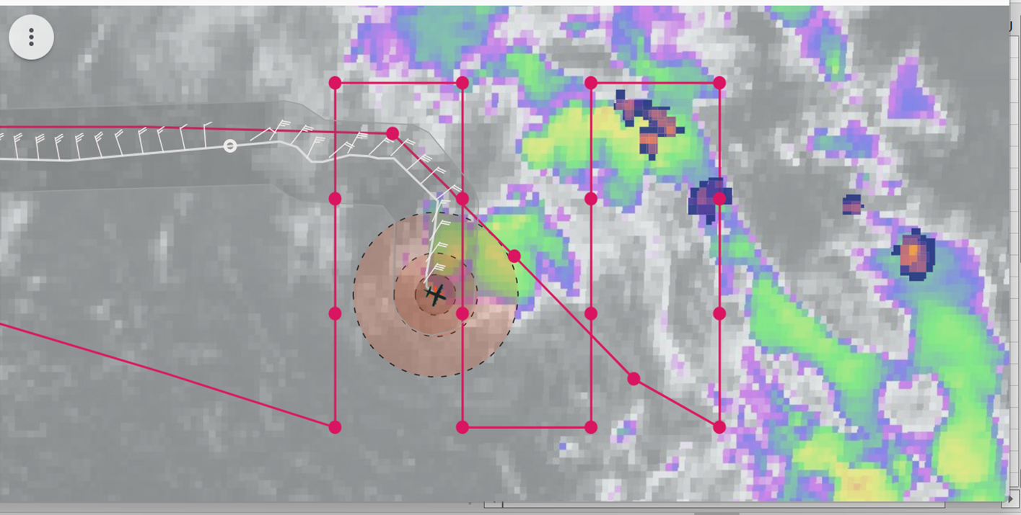
2215 | Mark broad center- moon is out though broken clouds- 999.6 mb, 115/15 kt
2340 | At 22 kft during the survey, in region of cold cloud tops, some lightning behind the aircraft. Will stay at this altitude as long as possible.  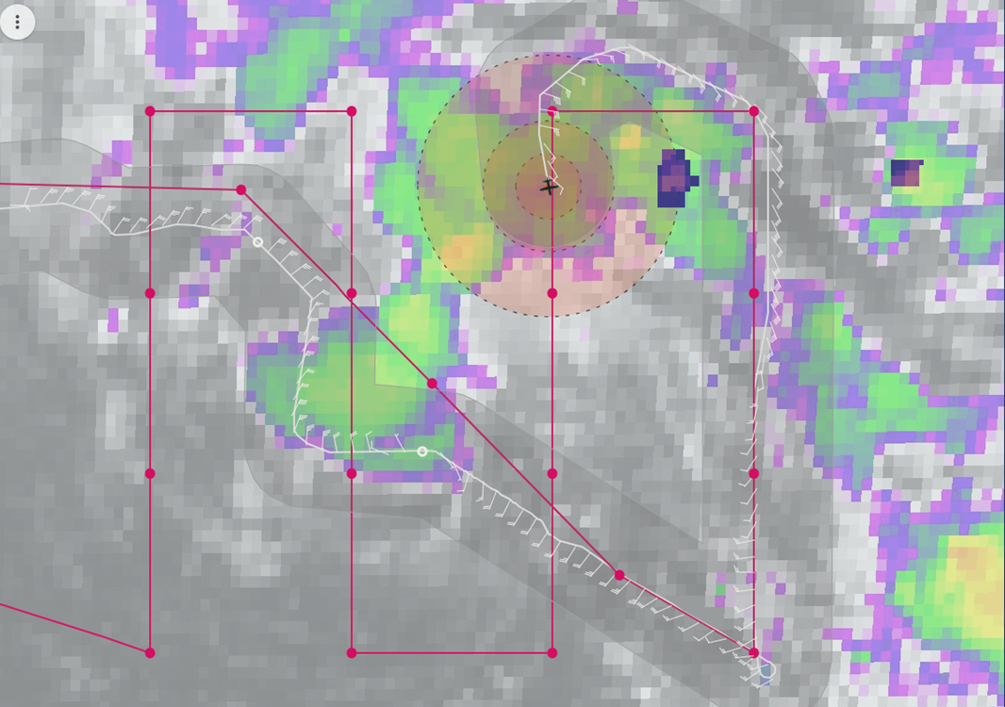
2347 | IR animation from earlier in the mission (19 UTC) shows an elongated, linear structure to the precipitation, with a clearly-defined low-level circulation in the middle of the line. Cold clouds are developing near the LLC, but they have not expanded enough to become anything like a CDO. They are becoming more persistent, though, suggesting a potential improvement (moistening) of the environment.
TDR analysis from first pass, NW-SE, shows a broad circulation at 2 km

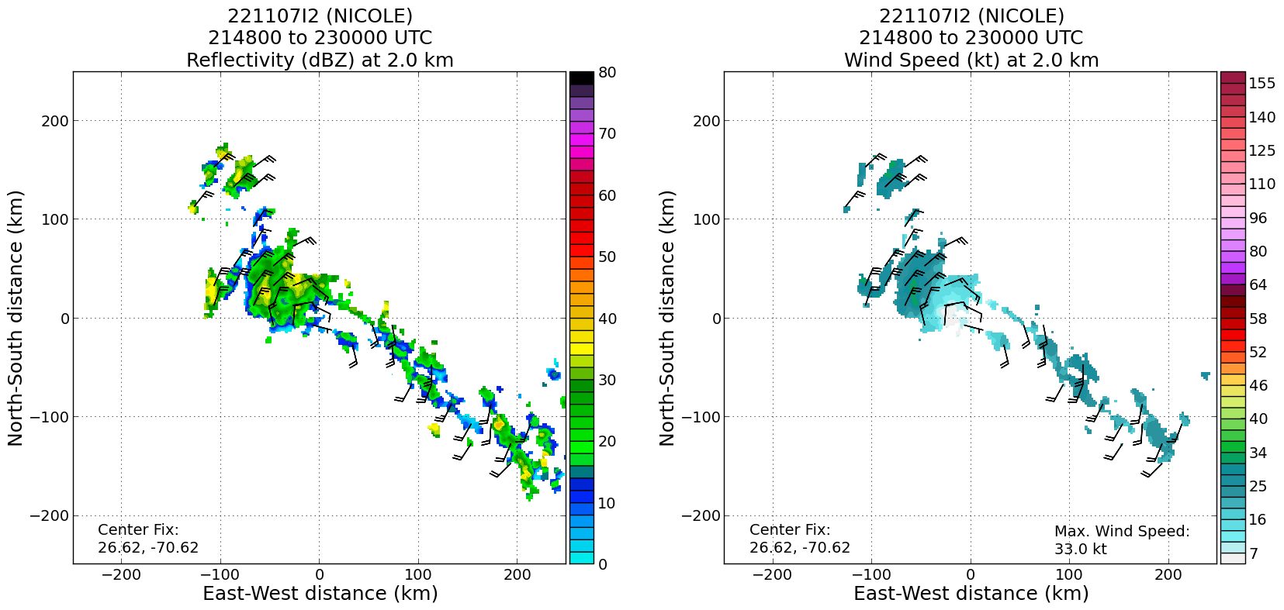
Limited scatterers at 5 km, but some suggestion of a circulation, or at least a shear axis, in the midlevels

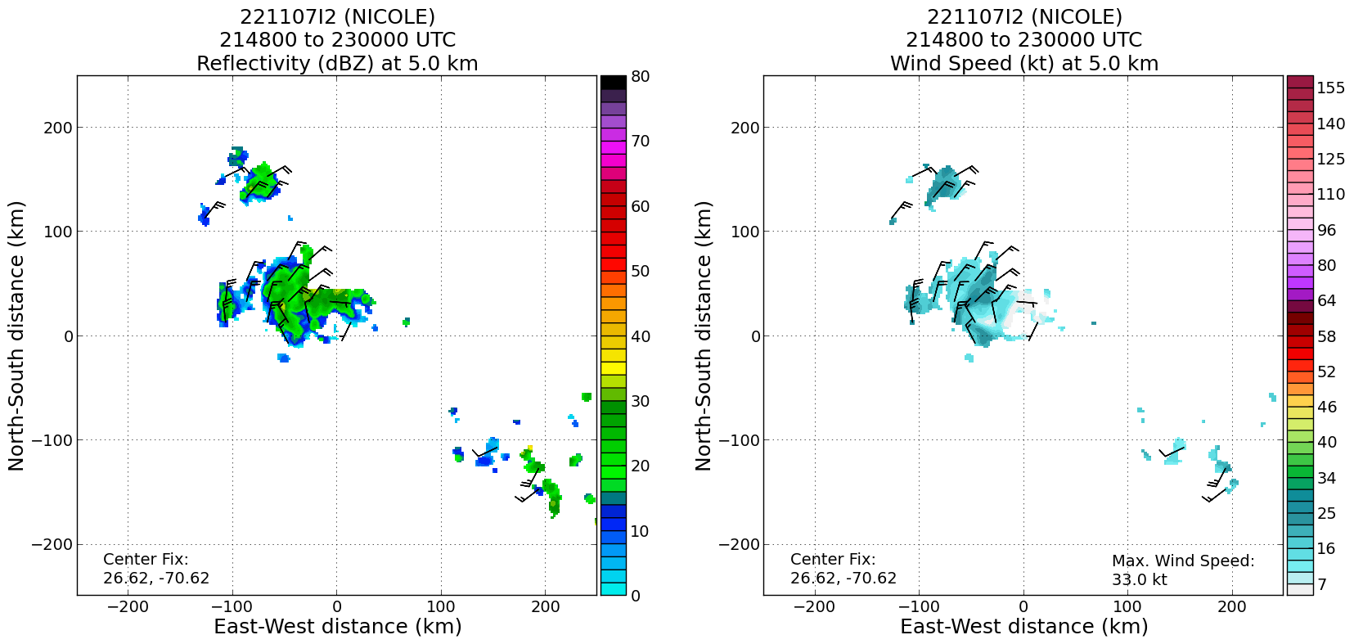
0014 | Water vapor animation from earlier in the mission shows a complex pattern, including upper-level trough, interacting with Subtropical Storm Nicole. Very dry mid- to upper-level air just west and southwest of Nicole’s LLC. This is likely continuing to impede sustained deep convection, and thereby limiting potential for Nicole to become tropical, contract, and intensify.
0015 | Cloud-drift winds in upper levels consistent with water vapor imagery  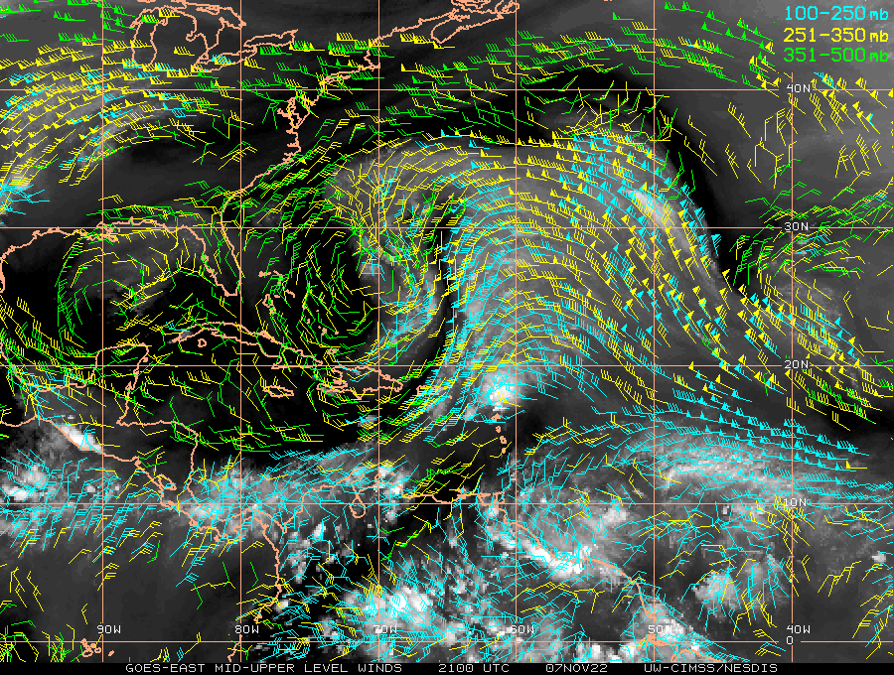
0036 | Visible animation from earlier in the mission shows multiple low-level swirls, as convection flares up in the background environment of high vorticity, stretches vorticity in the boundary layer, resulting in small-scale swirls that get ejected from cloud mass in background low-level flow. If/when the upper level environment becomes more humid and less stable, convection may persist in subsequent cycles.
0115 | System remains quite disorganized on infrared imagery. There are isolated regions with lightning, though, primarily in the northeastern portion of the circulation envelope, and northeast of the pattern.  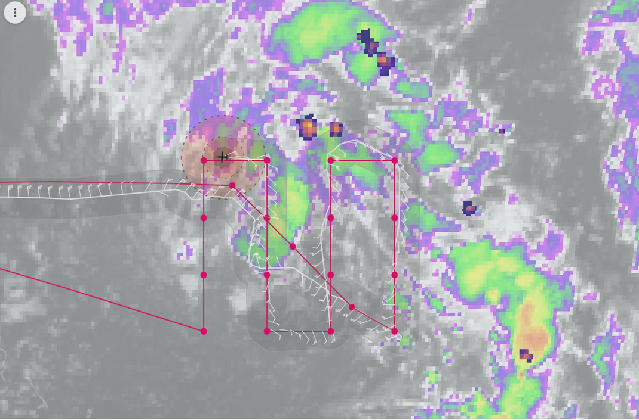
Completed pattern and returning to Lakeland. Plan is to drop sondes every 1.5 degrees until 78W is reached.

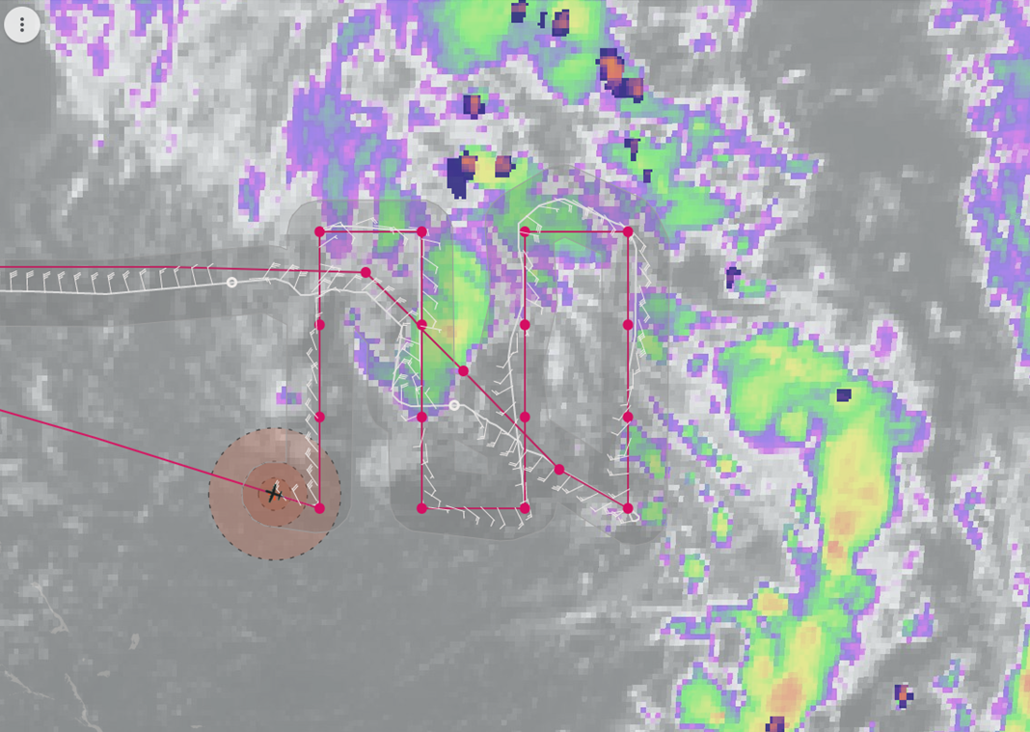
0205 | CIMSS shear analysis at 0030 UTC shows a localized area of weak shear, but shear becomes quite large (approaching 40 kt) just west of Nicole in the Bahamas. This is likely continuing to inhibit significant organization and intensification of the subtropical storm.  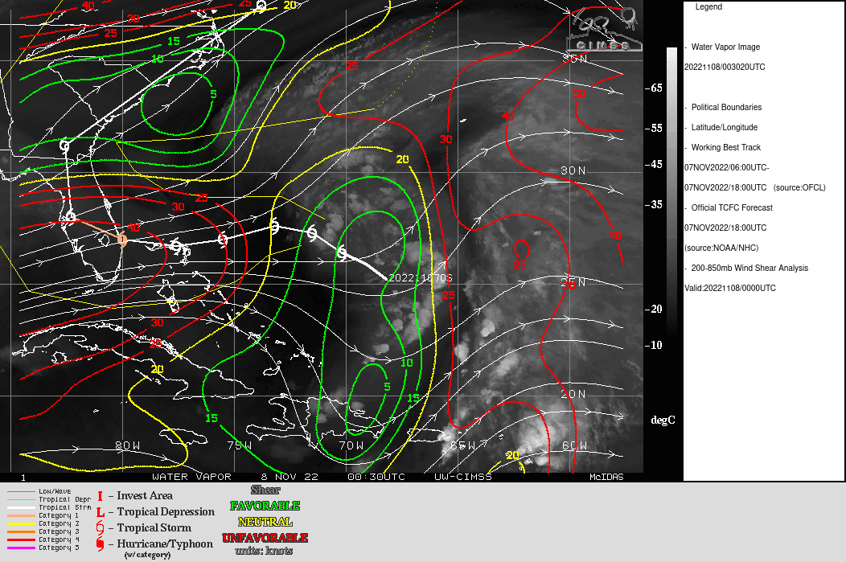
0209 | SFMR winds do not reach 40 kt on the final two legs of the lawnmower pattern.  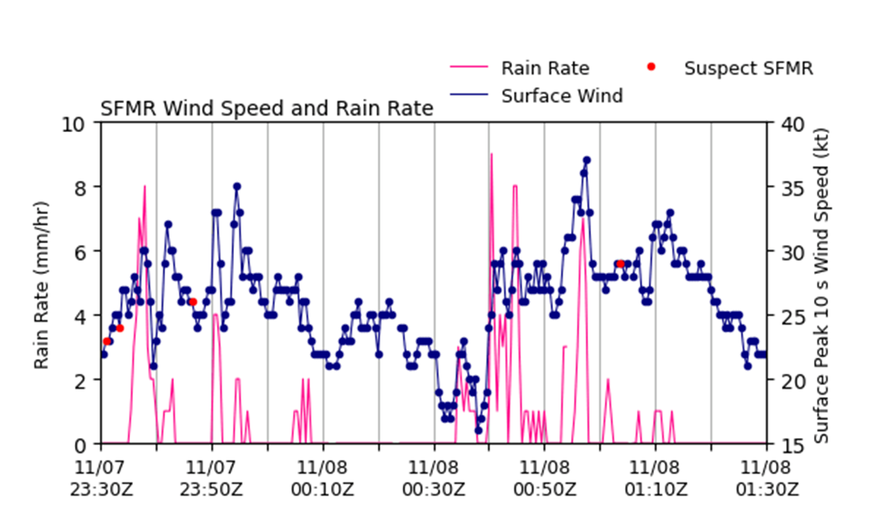
0212 | The strongest winds were found in dropsonde 10, well east of the circulation center, where winds reached 47 kt at 954 hPa.  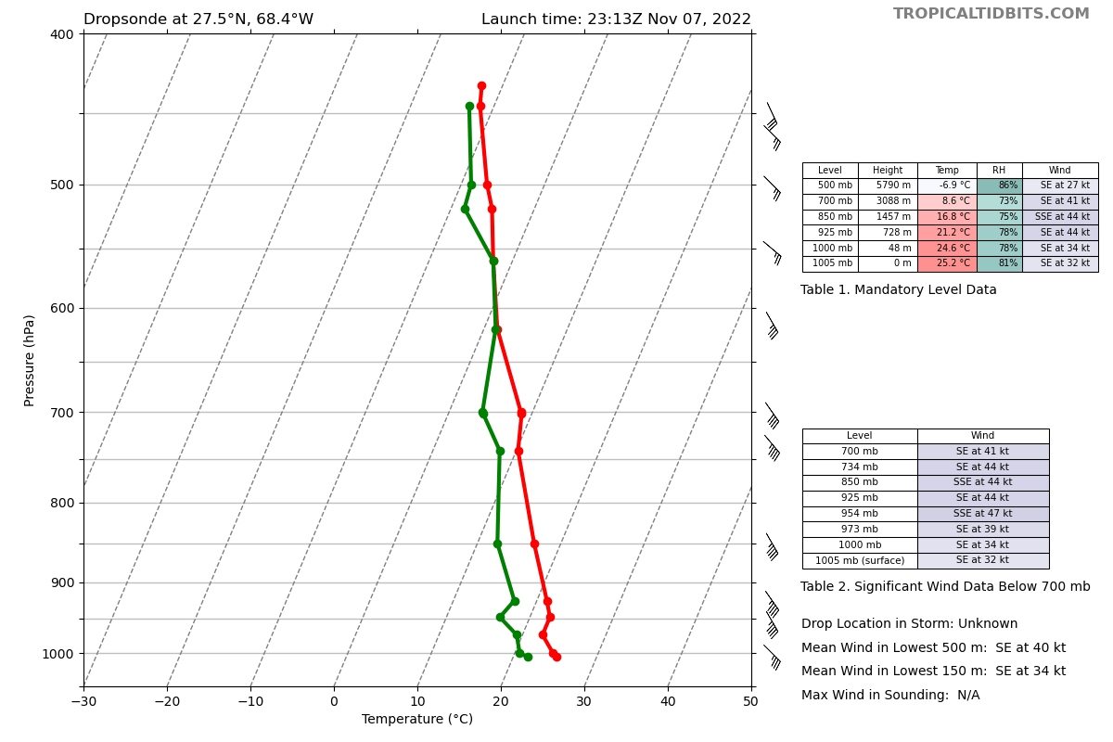
 | 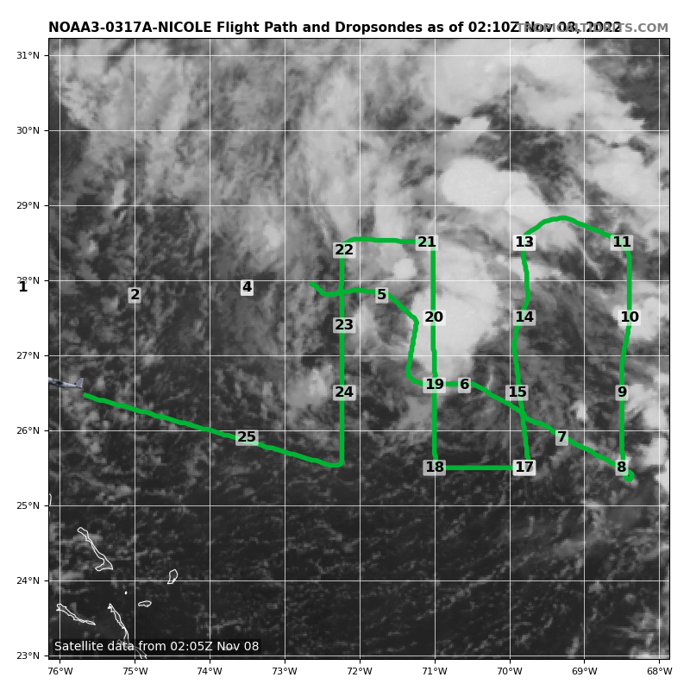
 | 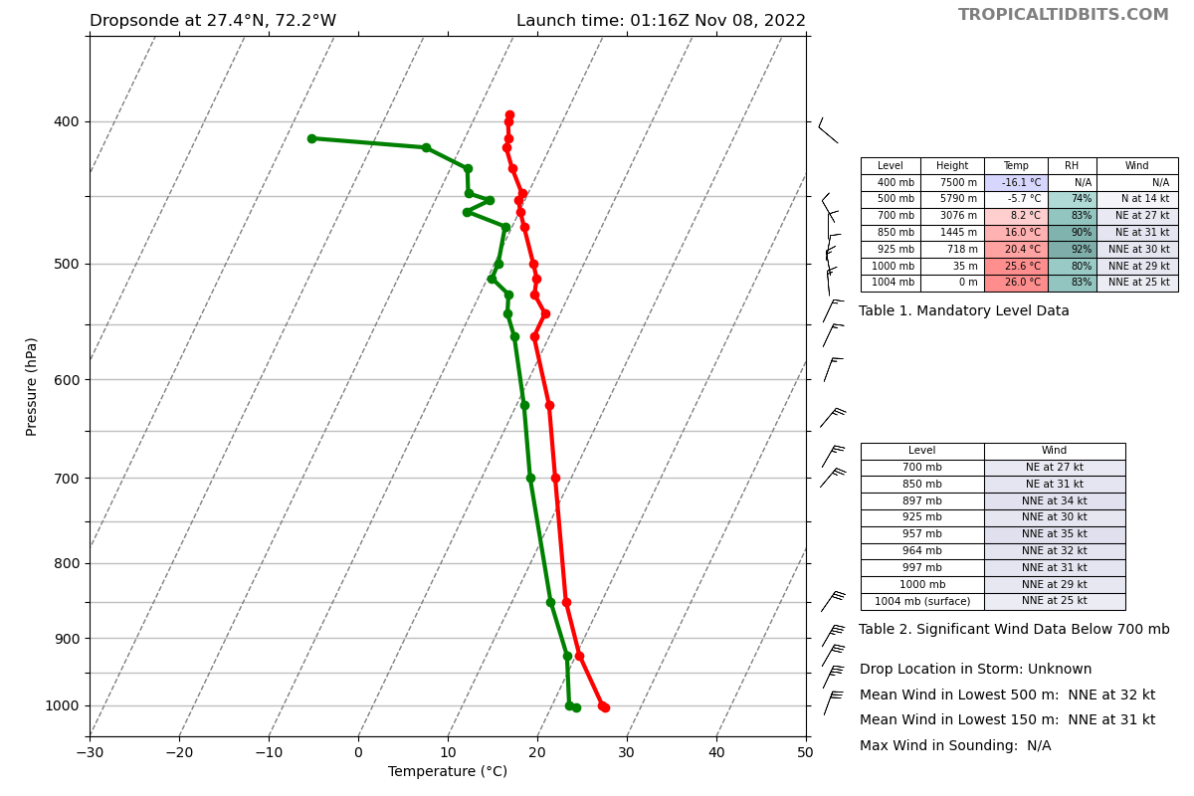
 | 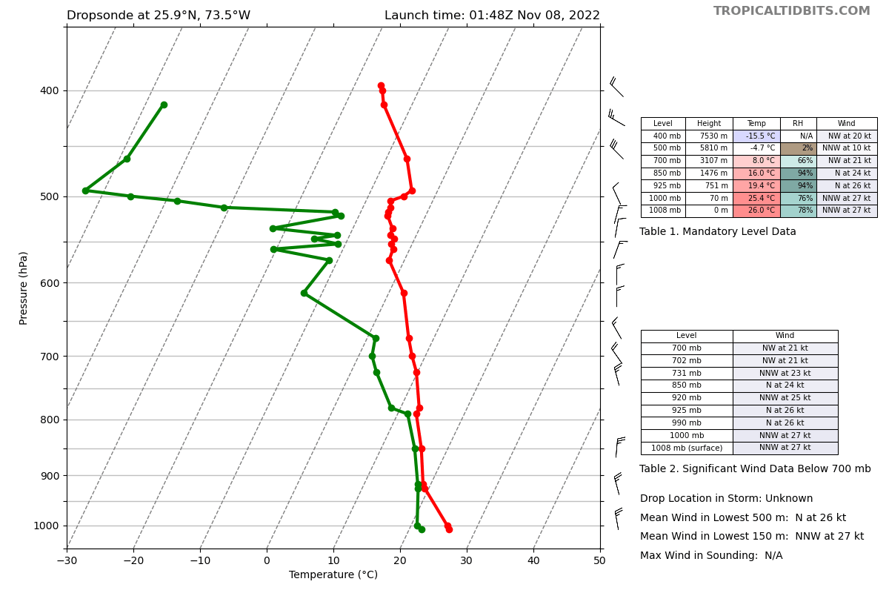
0222 | Two sondes near the end of the mission (shown above) show change in thermodynamic conditions in the vicinity of the circulation compared with the conditions ahead of the system. First sonde shows a very humid profile up to 450 hPa. Second sonde, taken on the ferry back to Lakeland and west of the pattern, shows air drying out above 700 hPa and becoming quite dry (RH < 5%) above 500 hPa. There is also an inversion at 500 hPa in the western sonde.
0323 | Landed back in Lakeland

POST-FLIGHT
Mission Summary | Mission was flown successfully into Subtropical Storm Nicole. There was a bit of a deviation on the NW-SE oriented center pass around weather, but that did not seem to negatively impact the three-dimensional tail Doppler radar analysis.  Nicole continues to struggle in the presence of upper-level dry air and westerly shear. There was little in the way of any increased organization in the satellite presentation. Aircraft data, particularly sondes, did show a moistening environment in the vicinity of the circulation center, which contrasted with very dry air to the west of the system and within the upper-level trough. TDR analyses showed the circulation extending up to about 4 km. Above that the flow remained rather disorganized. There have been intermittent flareups of convection of varying depths throughout the mission, but there has not been persistent deep convection, probably due to the continuing presence of vertical shear and remnant dry air. With the moistening environment, though, convection could become more persistent and potentially reduce the shear affecting the system. This would be necessary to contract, deepen, and intensify the vortex, at which point tropical transition could occur.
Actual Standard Pattern Flown | Combination center pass (NHC fix) and a lawnmower
APHEX Experiments / Modules Flown | Data collection marginally supports the Early Stage Experiment: Analysis of Intensity Change Processes (AIPEX) since it’s subtropical, but has a chance to undergo tropical transition and subsequently intensify.
Plain Language Summary
Instrument Notes
Final Mission Track | 