MISSION PLAN
FLIGHT ID | 20221030I2 | STORM | AL95 / PTC15
MISSION ID | 0415A | TAIL NUMBER | NOAA43
TASKING | EMC | PLANNED PATTERN | Lawnmower
MISSION SUMMARY
TAKEOFF [UTC] | 2146 | LANDING [UTC] | 0357
TAKEOFF LOCATION | St. Croix | LANDING LOCATION | St. Croix
FLIGHT TIME | 6.2 | BLOCK TIME | 6.4
TOTAL REAL-TIME RADAR ANALYSES  (Transmitted) | 5 | TOTAL DROPSONDES (Good/Transmitted) | 21 (20 / 20)
OCEAN EXPENDABLES (Type) | None | sUAS (Type) | None
APHEX EXPERIMENTS / MODULES | Genesis Stage Experiment: PREFORM
HRD CREW MANIFEST
LPS ONBOARD | Hazelton | LPS GROUND | Holbach
TDR ONBOARD | Hazelton | TDR GROUND | Gamache
ASPEN ONBOARD | Sellwood | ASPEN GROUND | None
NESDIS SCIENTISTS | Sapp
GUESTS (Affiliation) | None
AOC CREW MANIFEST
PILOTS | Rannenberg, Copare
NAVIGATOR | Hough
FLIGHT ENGINEERS | Darby, Pittman
FLIGHT DIRECTOR | Kalen, Holmes
DATA TECHNICIAN | McAlister
AVAPS | Dykeman

PRE-FLIGHT
Flight Plan | 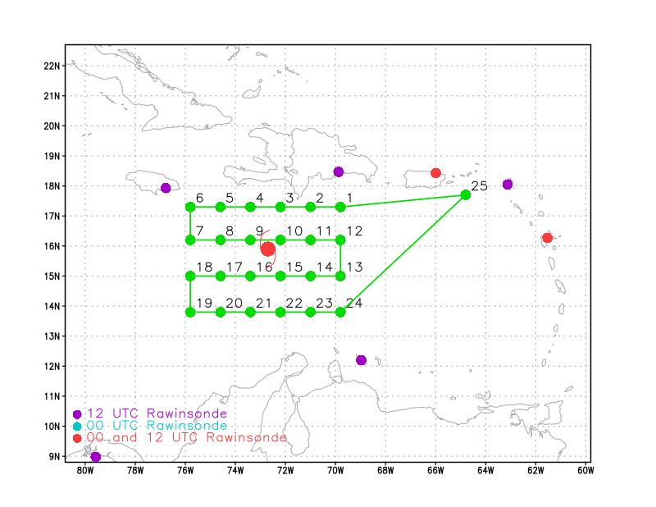  Lawnmower pattern at 20 kft pressure-altitude.
Expendable Distribution | 24 dropsondes, no AXBTs. Dropsondes at green dots in above flight track.
Preflight Weather Briefing | AL95 was classified as PTC15 at the 5 pm NHC advisory.  The system is still dealing with dry air to the west, with most of the convection on the east side of the center.  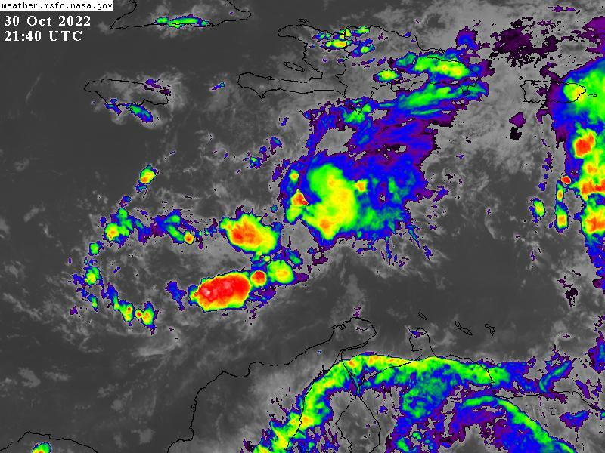
Instrument Notes | All Instruments appear to be working correctly

IN-FLIGHT
Time [UTC] | Event
2146 | Takeoff from St. Croix
2247 | Drop #1, IP leg 1  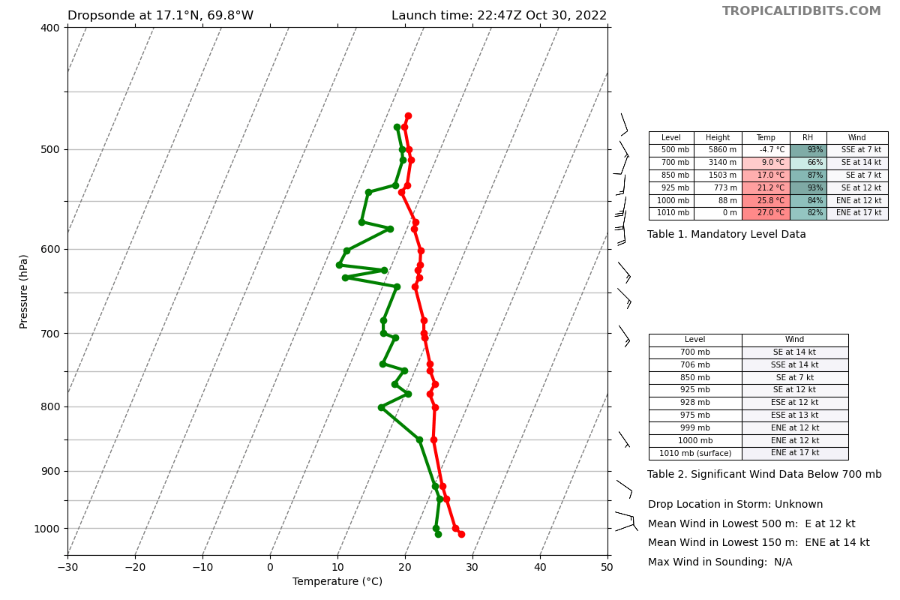
2255 | Satellite imagery shows an elongated region of deeper convection oriented SW to NE. There were some apparent low-level swirls located to the W of the deeper convection.
2300 | Drop #2  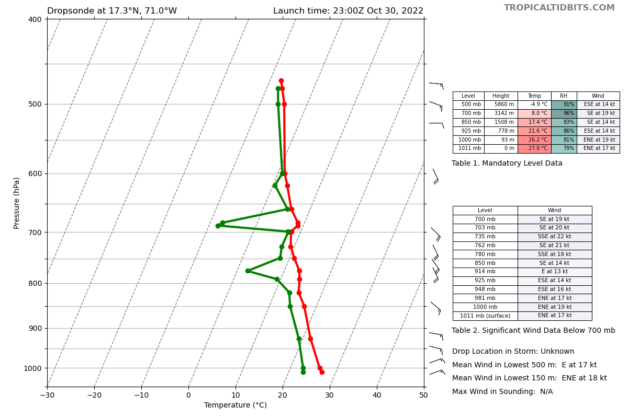
2308 | Not many radar returns in the area  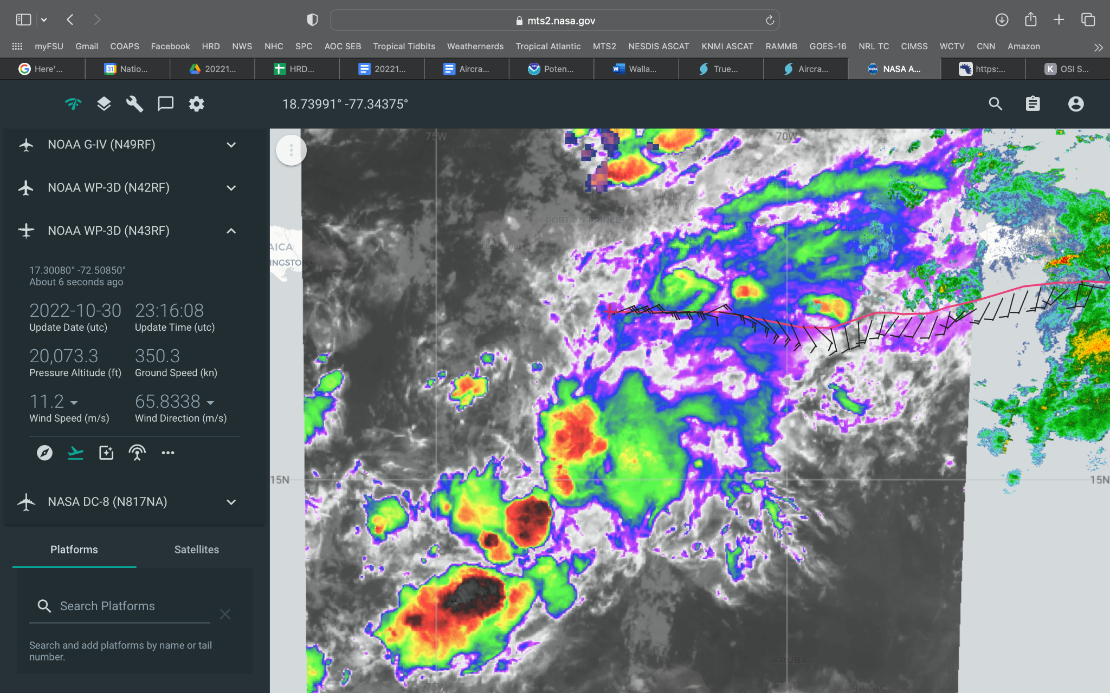
2313 | Drop #3, some dry air present between 800-850 mb  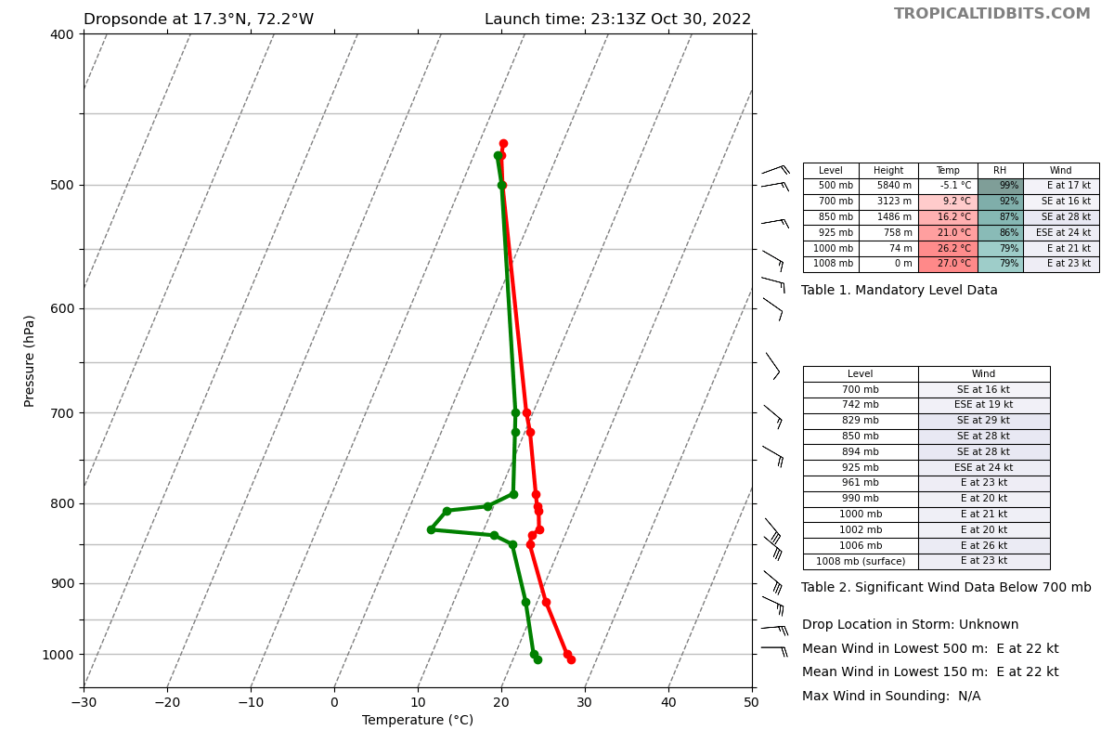
2324 | Drop #4  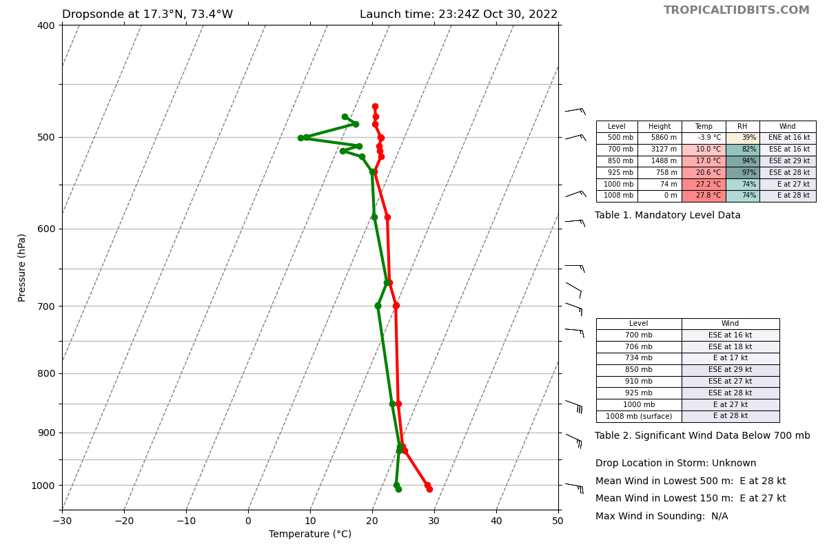
2336 | Drop #5, turning S end of leg 1  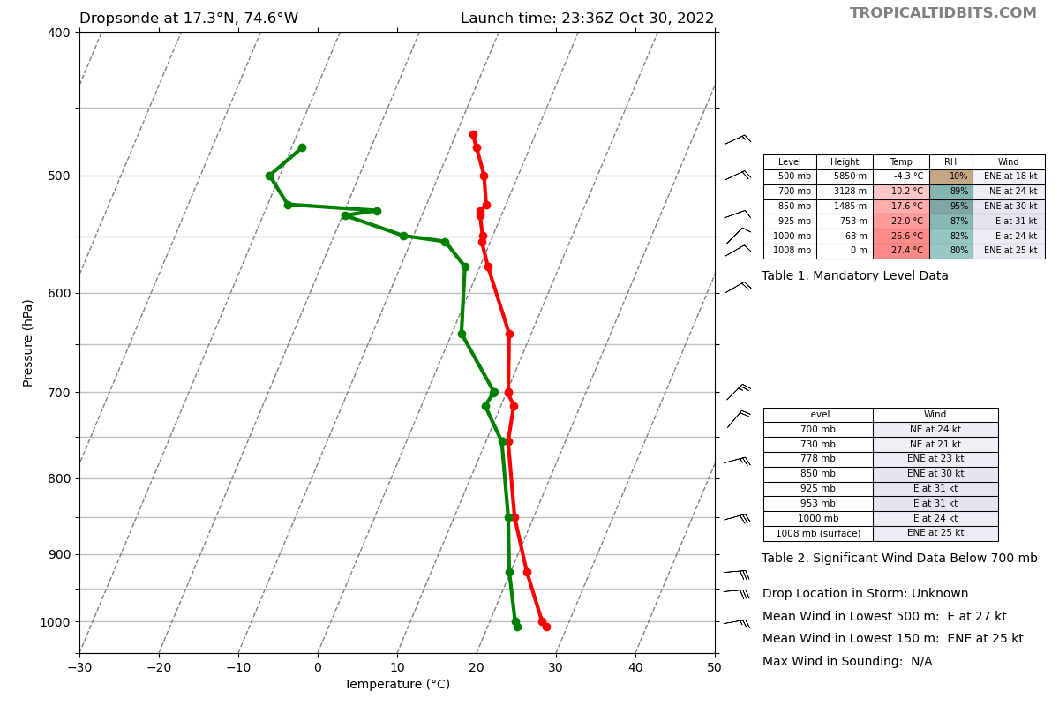  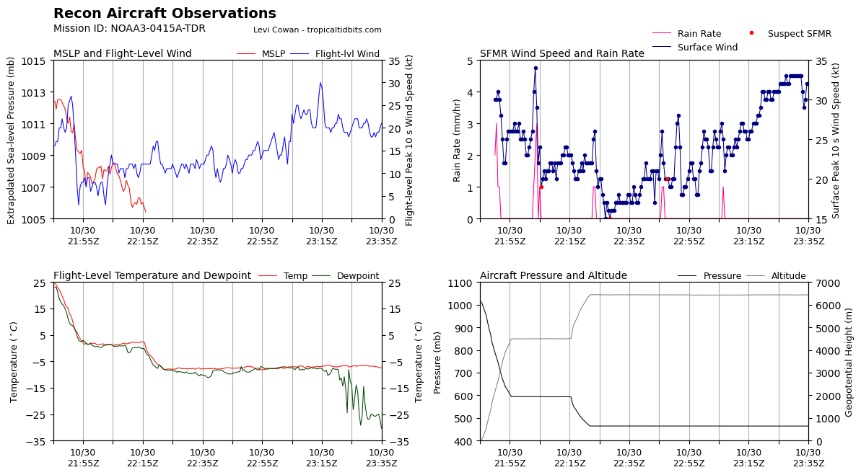
2339 | 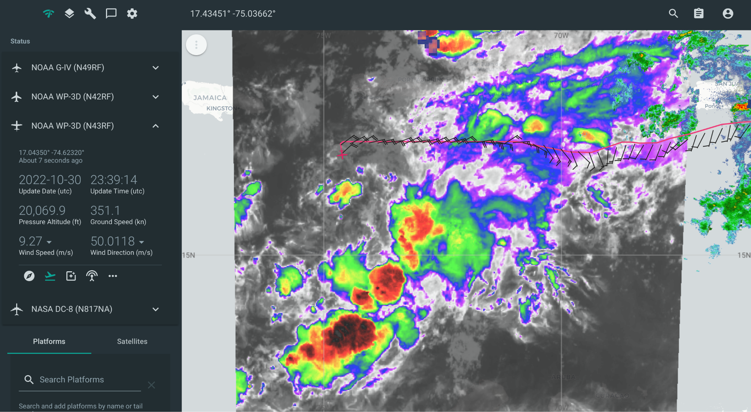
2348 | Drop #6, turning E IP for leg 2  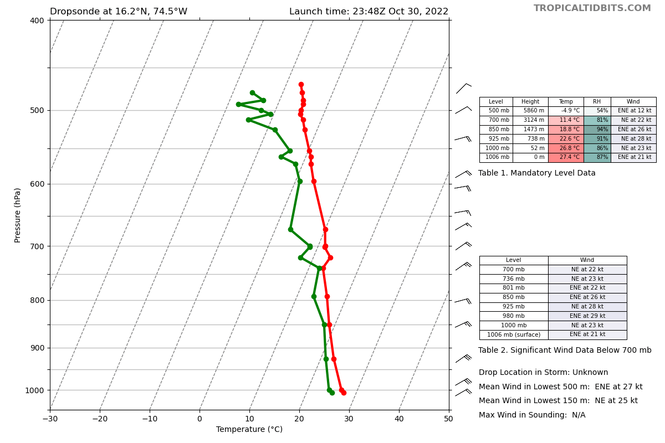
0000 | Drop #7  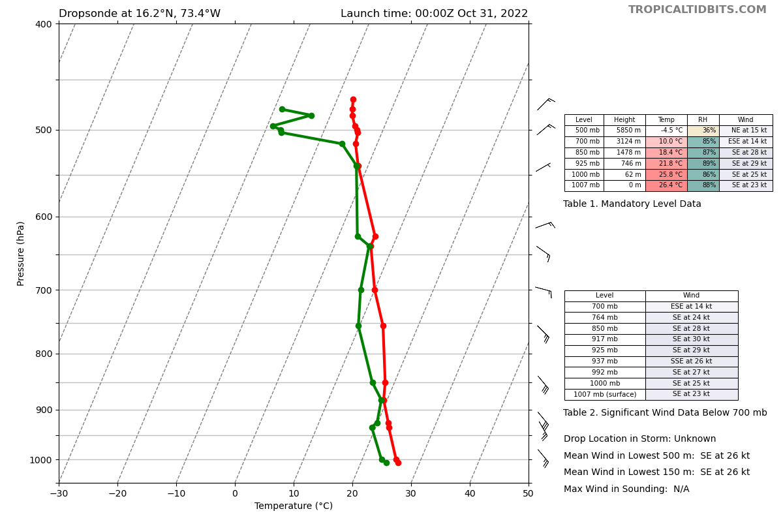
0013 | Drop #8, still relatively meager radar returns  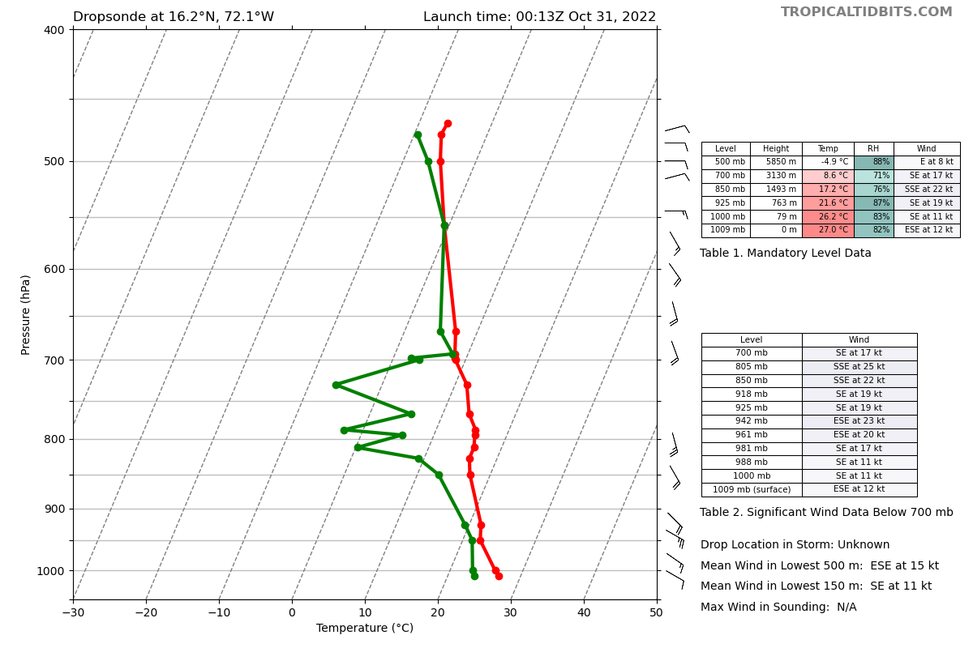
0025 | Drop #9  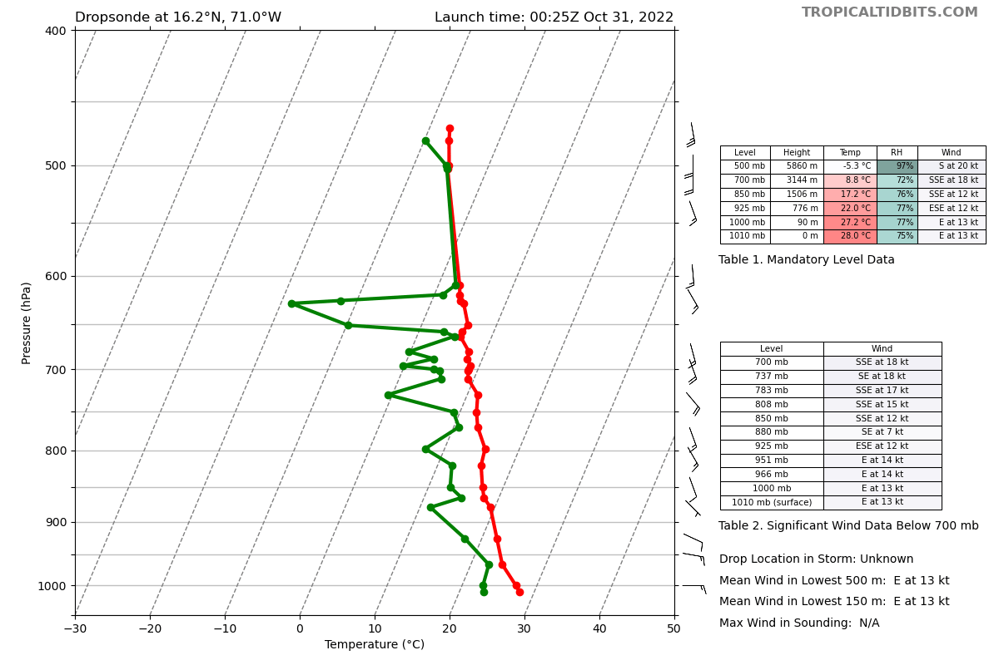
0038 | Drop #10, turning S end of leg 2. Wind shift occurred along this leg. Most of convection is still to the south though  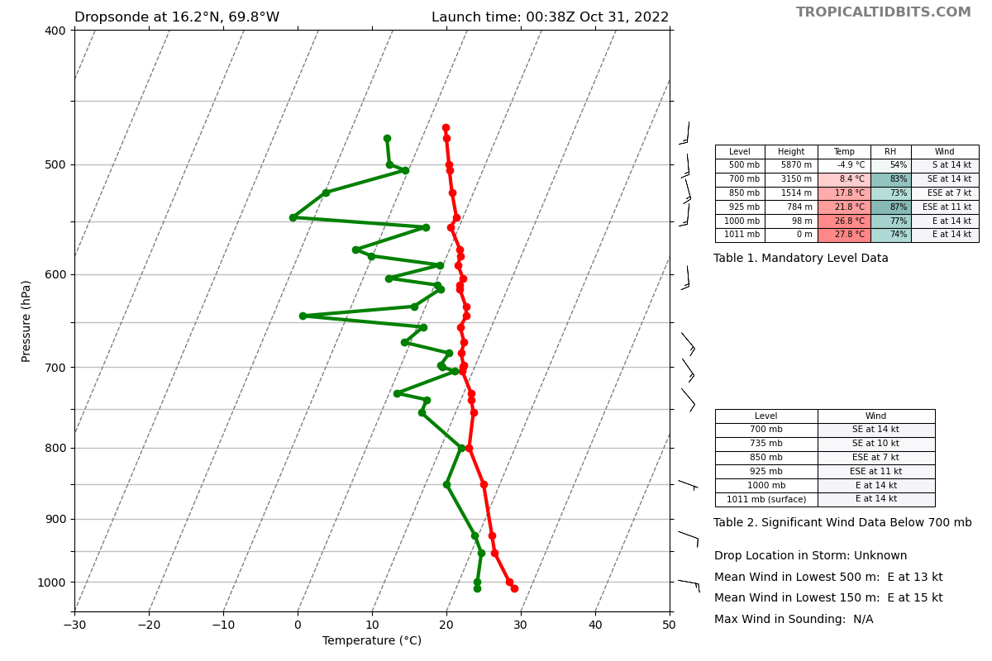  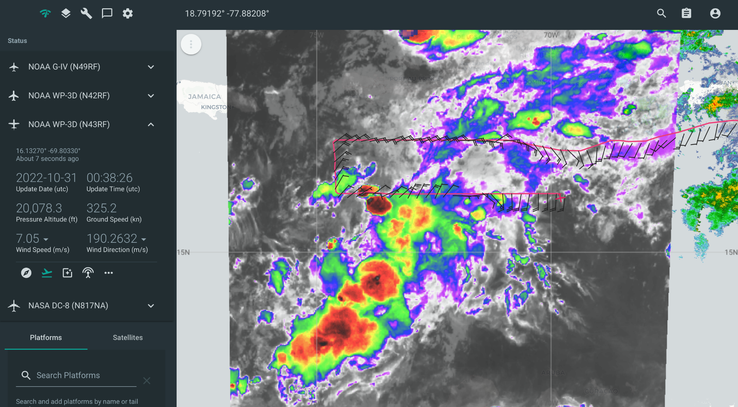
0045 | New convection firing around 16N 74W
0050 | Drop #11 Turning W, IP leg 3  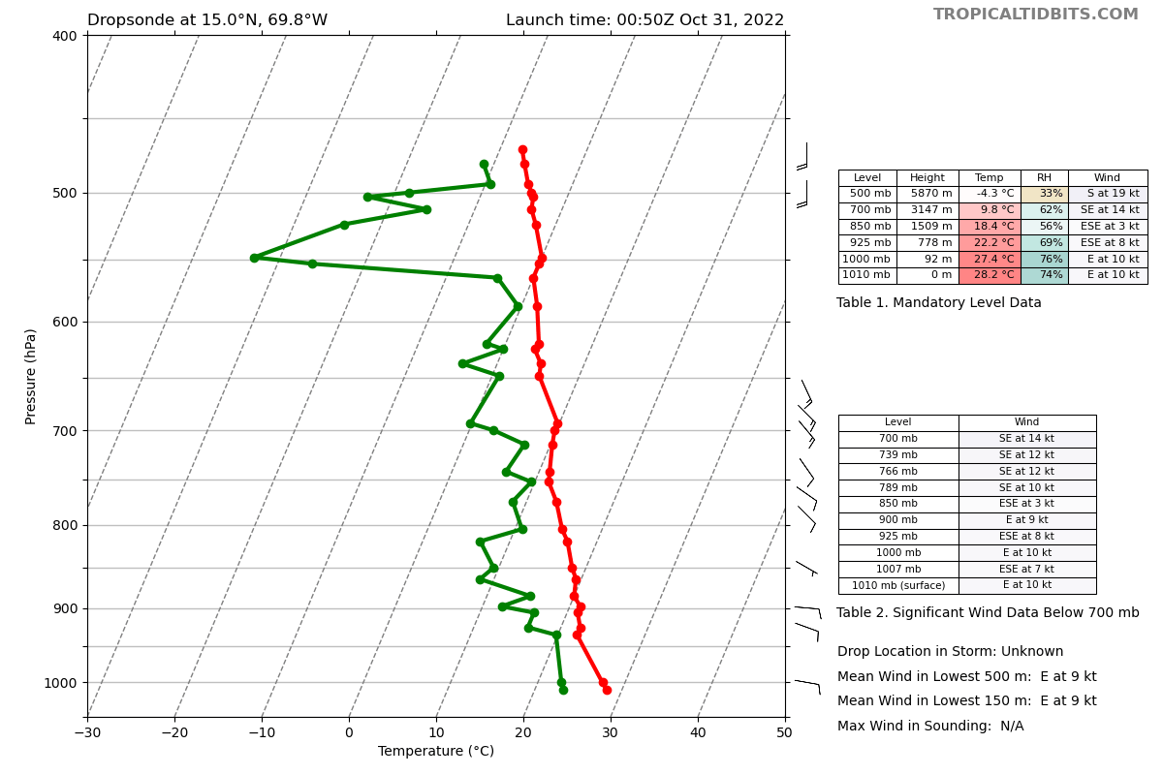
0103 | Drop #12  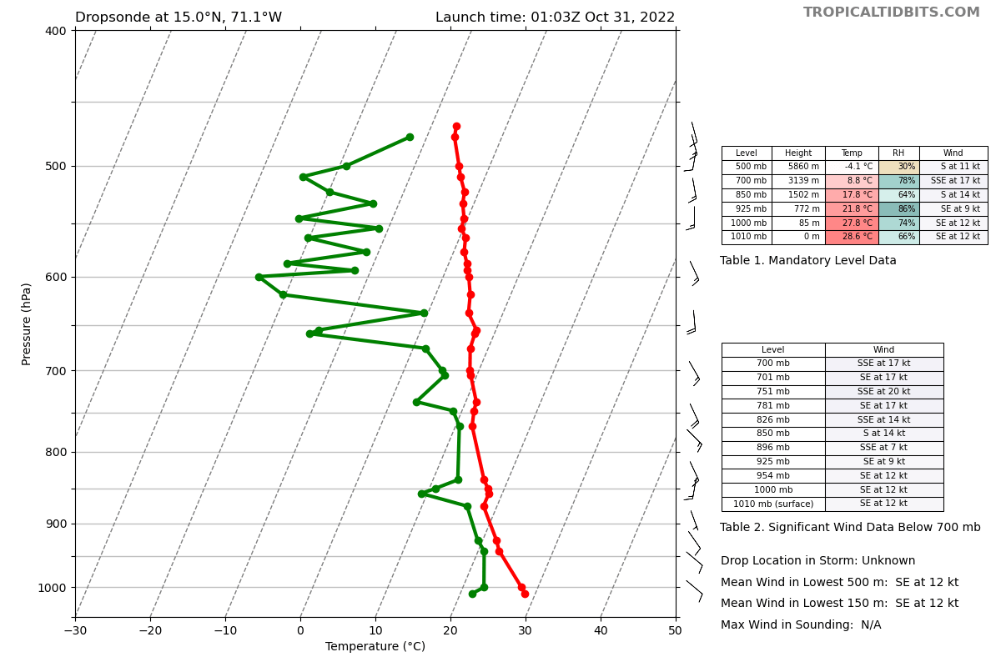
0114 | Drop #13
0119 | Drop #14 backup for drop #13  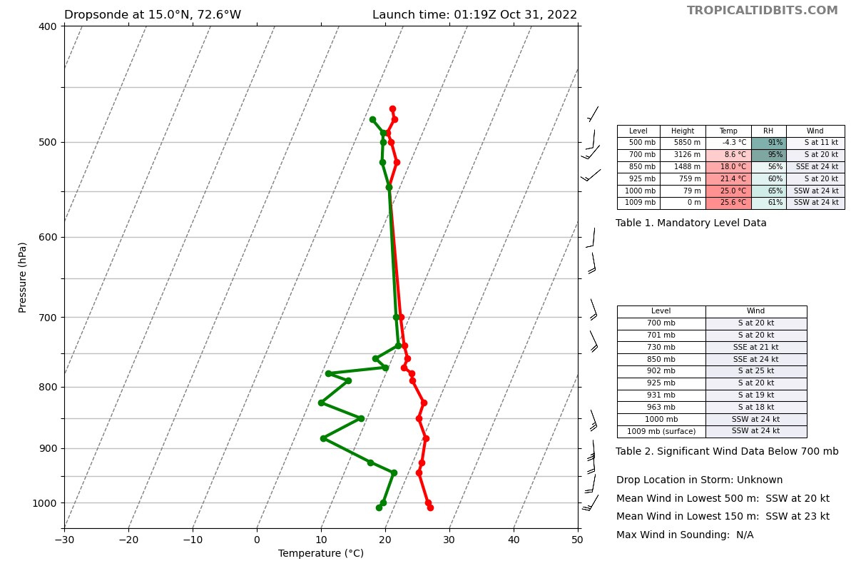
0127 | Drop #15  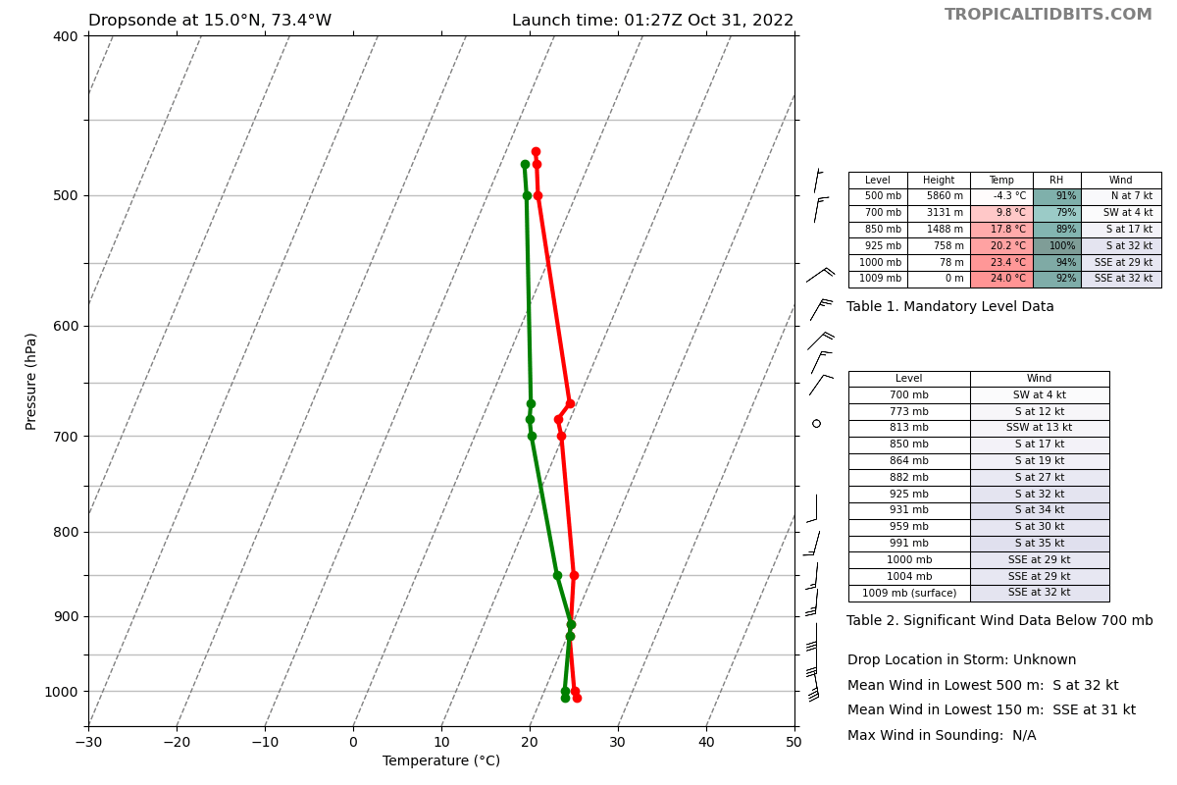
0137 | Drop #16  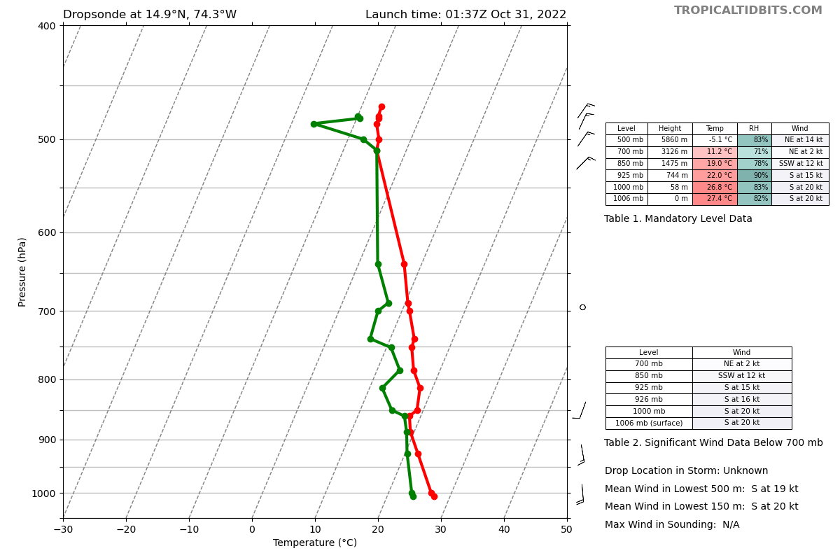
0139 | Painting the line heading SSW to point 16 then will do the final W-E leg  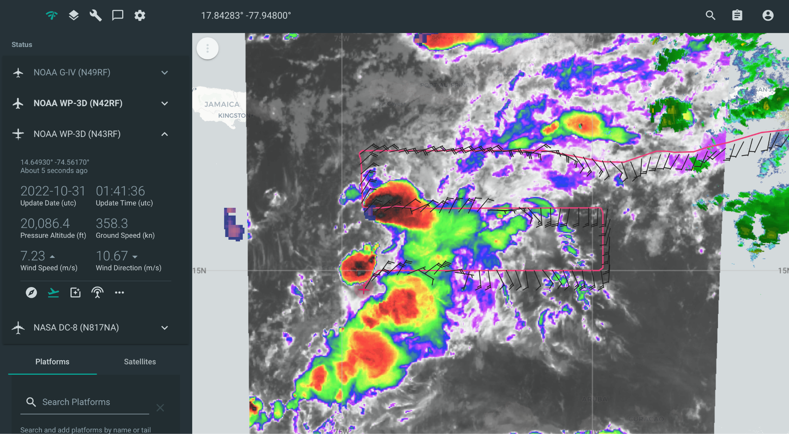
0145 | Descending to 12kft due to icing
0151 | Drop #17, turning E. IP leg 4. Encountering some graupel  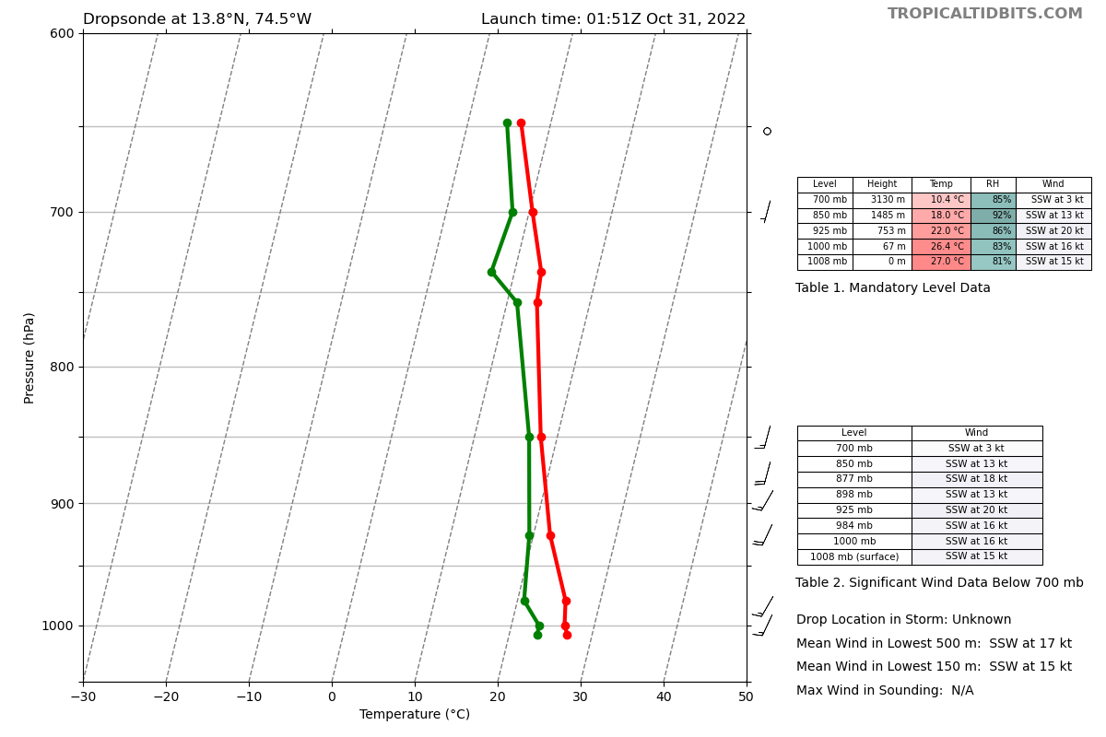  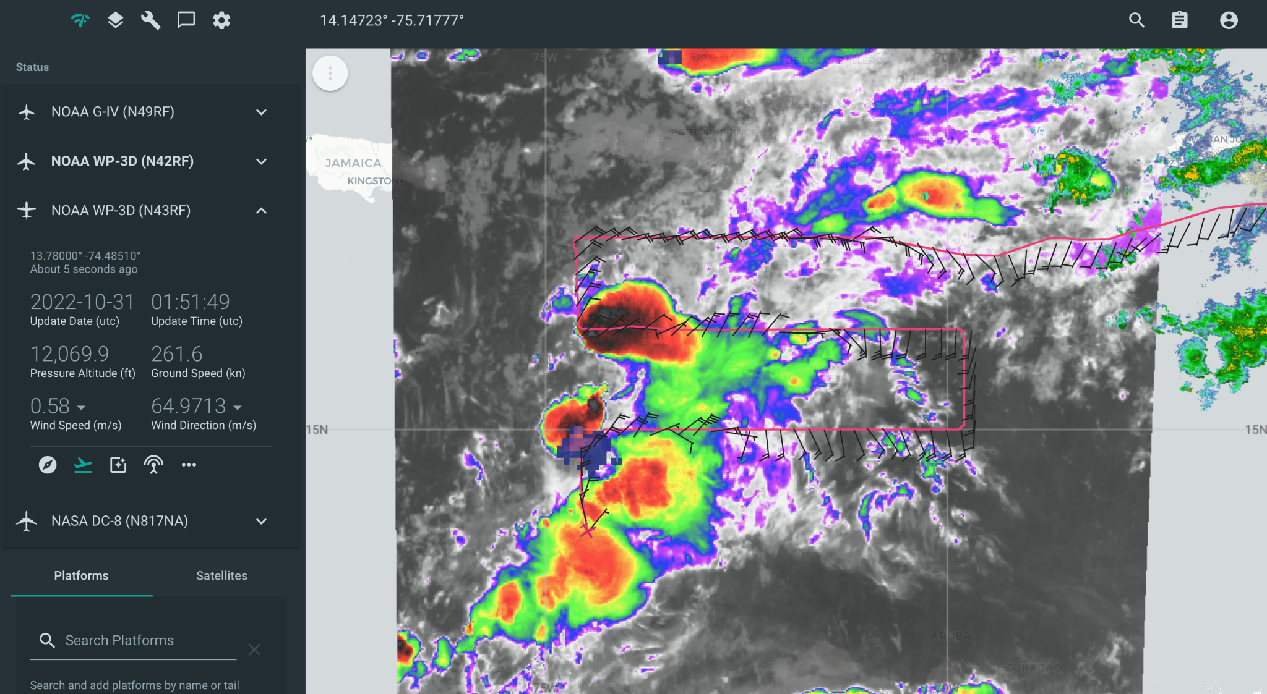
0200 | Wind shifts encountered on legs 2-4 depict more of a trough/wave axis rather than a more than a consolidated circulation trying to form. Could be that a circulation is trying to consolidate at low-levels and it just isn’t reflected at mid/upper levels yet.  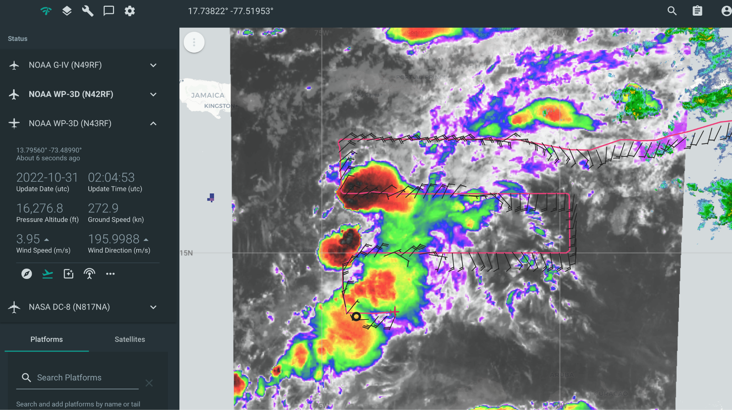
0202 | Climbing back up to 20 kft
0206 | Drop #18  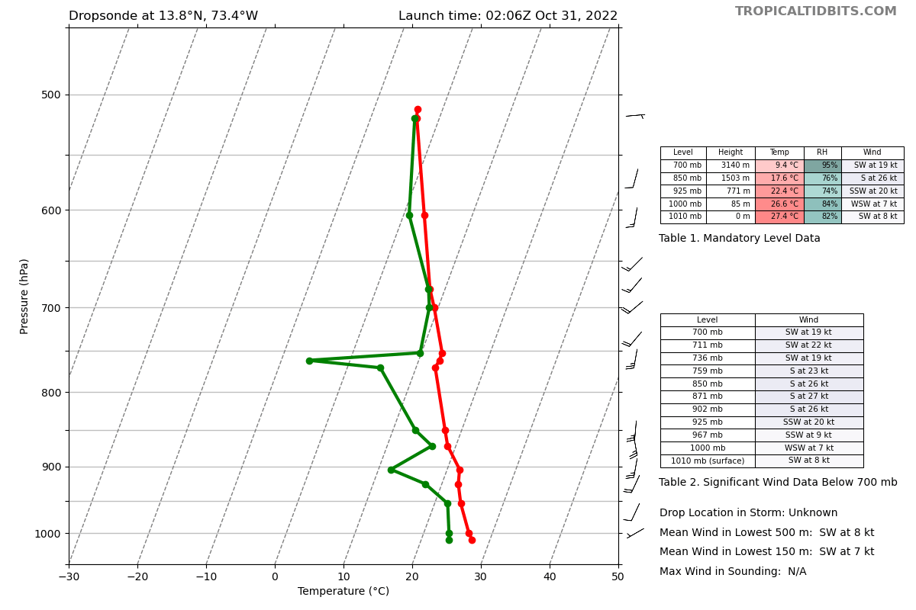
0215 | Will be interesting to see if the two new convective bursts between 15 and 17N will consolidate and allow a circulation to build upward
0219 | Drop #19  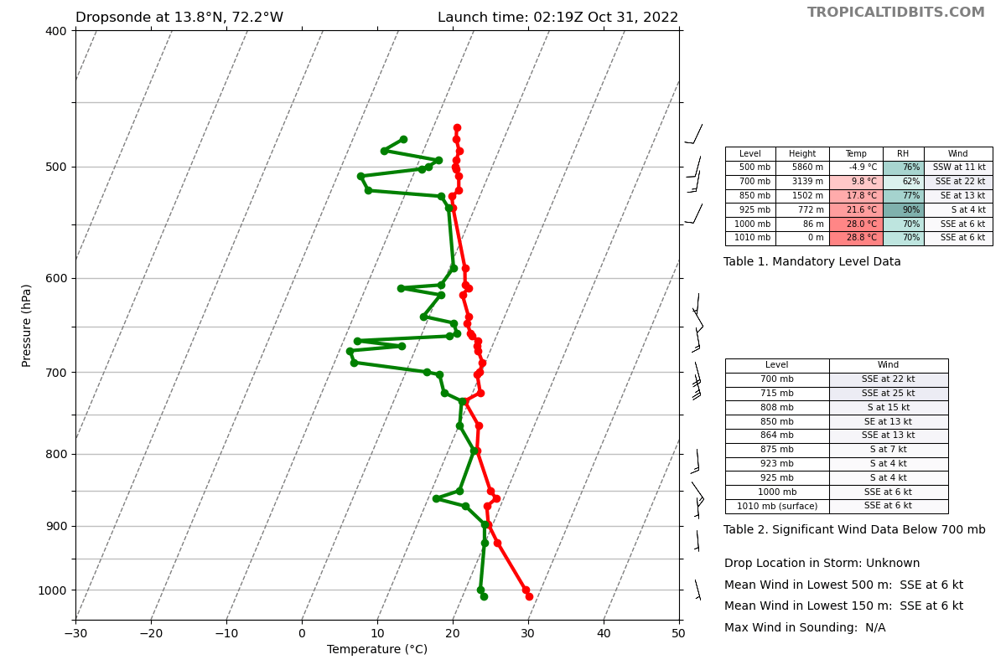
0232 | Drop #20  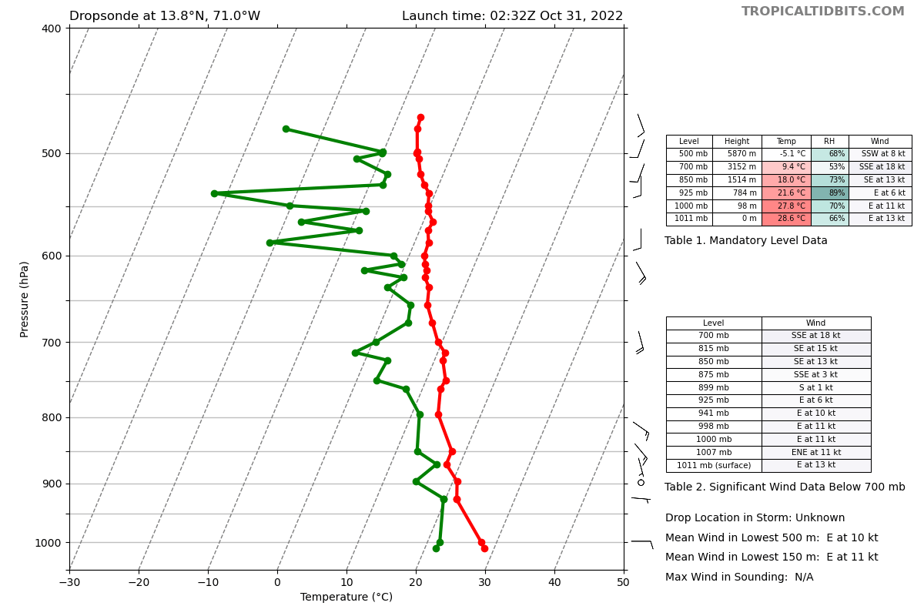
0244 | Drop #21. Science complete.  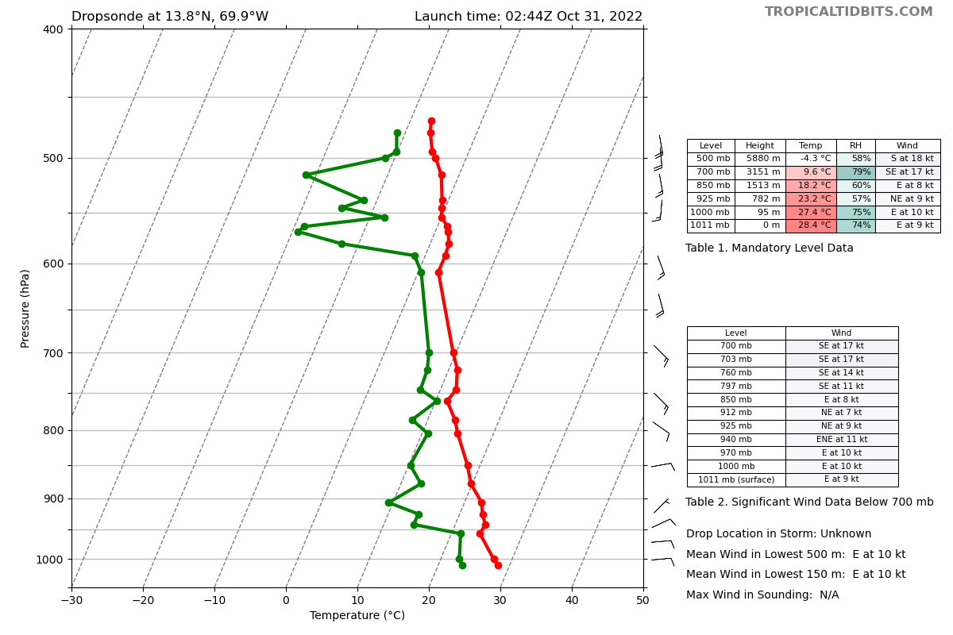  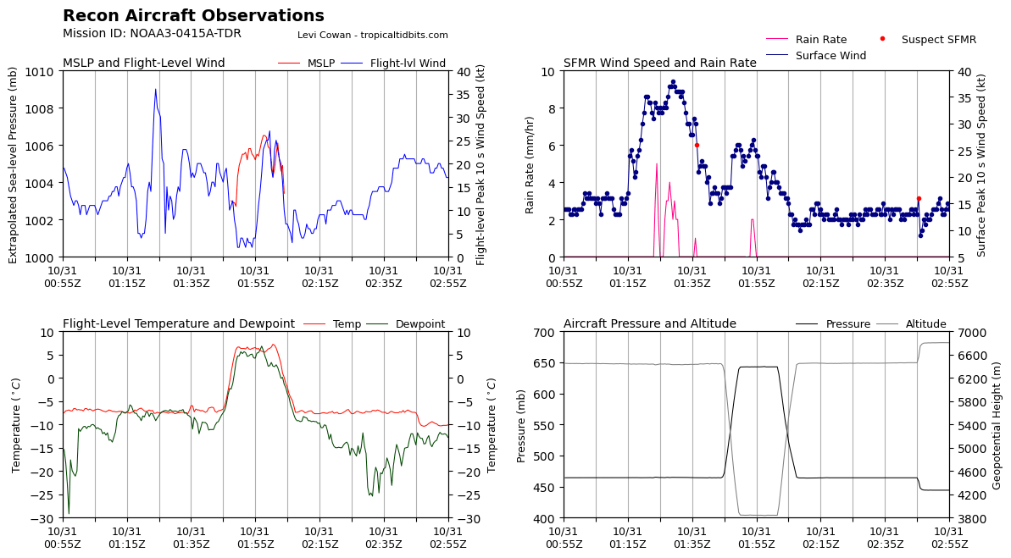  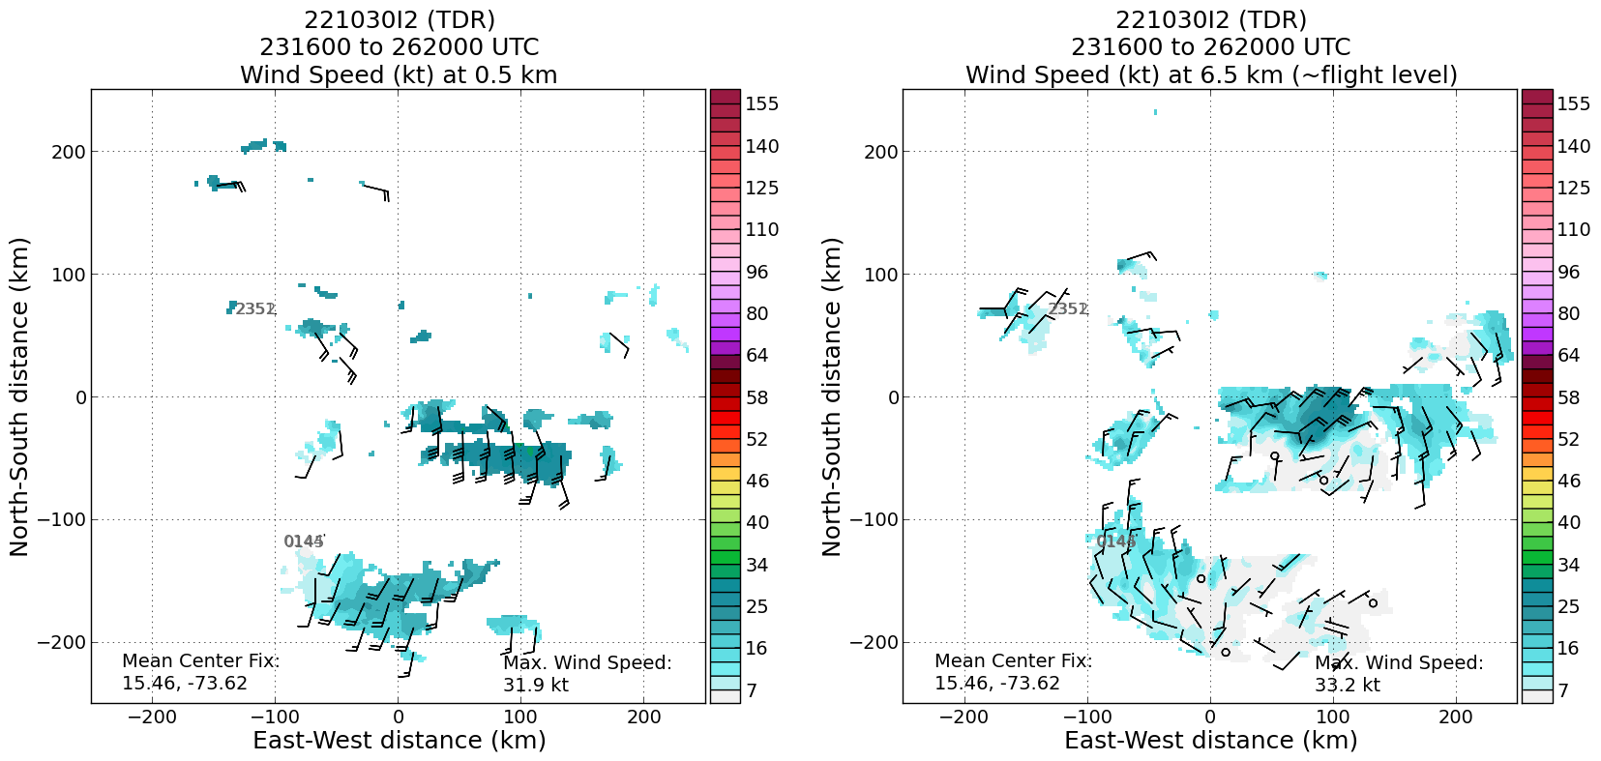

POST-FLIGHT
Mission Summary | Successful high-altitude lawnmower pattern with 20 dropsondes sampling PTC15. Many of the dropsondes had dry air present in regions around the convection. New convective bursts during the second half of the flight could help a circulation consolidate. Flight-level winds during the flight indicated the upper levels were more representative of a trough/wave axis.  We got off the deck about 45 minutes late and thus trimmed the 4 westernmost points off the pattern in order to get the mission accomplished in the available time for the assimilation window.  Some of the northern sondes suggested a small layer of dry air made its way into the storm, which might be part of why there isn’t much convection on the northern part of the system.  The convection was still asymmetric, with most of the strong thunderstorm on the south and east side of the system at this point.  We passed through a notable wind shift on both our 2nd and 3rd legs, indicating a possible center there.  Towards the end of the flight, two convective bursts developed near the potential LLC.  Dropsondes: 21 (1 bad, 20 transmitted, all charged to NWS)
Actual Standard Pattern Flown | Lawnmower at 20 kft
APHEX Experiments / Modules Flown | Data collection efforts could support the Genesis Stage Experiment: Precipitation during Formation and Observing its Response Across Multiple Scales (PREFORM) considering TC formation is forecasted.
Plain Language Summary | 1. We collected data in PTC15 to send to NCEP’s Environmental Modeling Center (EMC) for data assimilation and to NHC for real-time analysis.  2. The storm is slowly becoming a little more organized, but winds are still weak for the most part, and it is not quite organized enough to be a TC.
Instrument Notes | All instruments seemed to function properly
Final Mission Track | 