MISSION PLAN
FLIGHT ID | 20221008H1 | STORM | AL13 / JULIA
MISSION ID | 0913A | TAIL NUMBER | NOAA42
TASKING | EMC | PLANNED PATTERN | Butterfly
MISSION SUMMARY
TAKEOFF [UTC] | 1953 | LANDING [UTC] | 0348
TAKEOFF LOCATION | Aruba | LANDING LOCATION | Aruba
FLIGHT TIME | 7.9 | BLOCK TIME | 8.1
TOTAL REAL-TIME RADAR ANALYSES  (Transmitted) | 5 (5) | TOTAL DROPSONDES (Good/Transmitted) | 27 (27 / 25)
OCEAN EXPENDABLES (Type) | None | sUAS (Type) | None
APHEX EXPERIMENTS / MODULES | Early Stage Experiment: AIPEX (FLAIMS)
HRD CREW MANIFEST
LPS ONBOARD | Zawislak | LPS GROUND | Hazelton, Kaplan
TDR ONBOARD | Zawislak | TDR GROUND | Reasor
ASPEN ONBOARD | Sellwood | ASPEN GROUND | None
NESDIS SCIENTISTS | None
GUESTS (Affiliation) | None
AOC CREW MANIFEST
PILOTS | Mitchell, Rannenberg, Copare
NAVIGATOR | Utama
FLIGHT ENGINEERS | Darby, Pittman
FLIGHT DIRECTOR | Kalen, Carpenter
DATA TECHNICIAN | McCalister
AVAPS | Dykeman, Lambert

PRE-FLIGHT
Flight Plan | 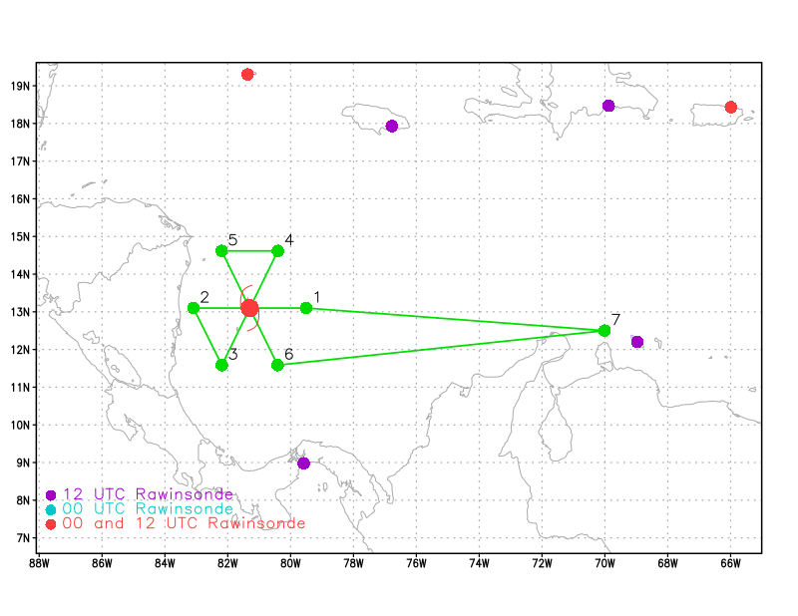  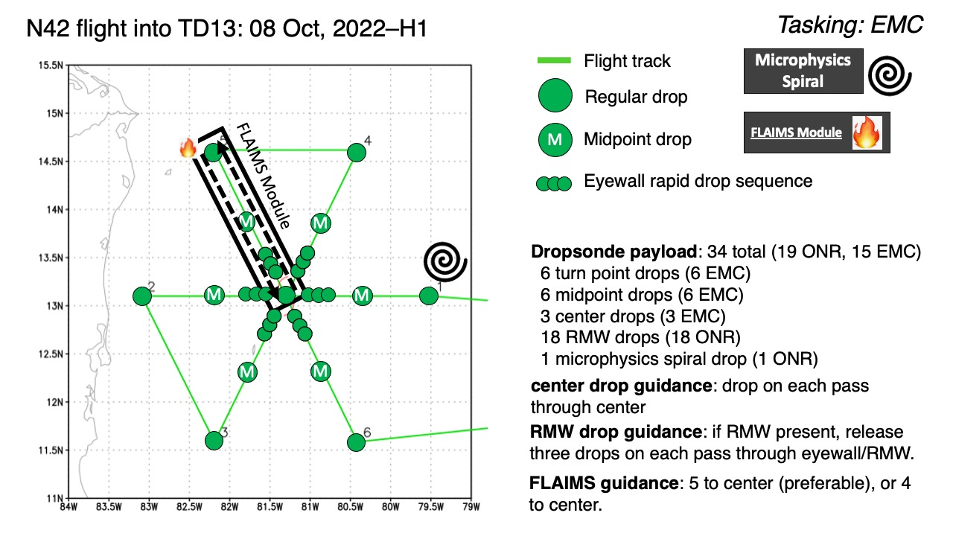  The pattern will be a standard butterfly pattern with 105 n mi radial legs, starting from the east and ending to the southeast. There are two options for additional modules, if there is time available: the Stratiform Spiral Module, which only makes sense at the IP given the available daylight, and the FLAIMS module (part of AIPEX) where there would be repeated passes through the highest winds of an intensifying storm (which Julia could be during this flight). The pattern spins up to almost 8 hours for just the butterfly (given the long transits to/from the storm), but if legs get cut short (say, due to land restrictions) then some time may be added back such that the modules are possible. The Stratiform Spiral Module, in particular, could be shortened by just flying the ferry altitude (20-21 kft) to the IP, then spiral descending down to pattern altitude (10 kft) at the IP if stratiform rain is present.  The most challenging aspect of this pattern, though, are the Colombian islands off of Nicaragua (San Andres, in particular), which we don’t have overflight clearance for. Since the center is expected to be right over San Andres island on the first pass, a potential mitigation is to fly the east to west pass angled a bit north at a center pivot point just outside of their airspace north of the island.
Expendable Distribution | The pattern will have the standard drops: endpoints, midpoints, and center of each pass (most likely closest points of approach given the challenges due to airspace in the vicinity of the expected center of Julia during the flight). Additional sondes may be released for ONR goals in the RMWs (sequences of three), if one is clearly present, or in the Straitform Spiral Module (at the beginning) or in the FLAIMS module.
Preflight Weather Briefing | Tropical Storm Julia as of the 2pm EDT NHC advisory was located at 12.6N / 80.5W, maximum sustained wind speeds of 55 kt (65 mph), gusting to 65 kt, moving 270 degrees at 18 mph, and a central minimum pressure of 993 mb. The storm still seems to be experiencing some moderate northerly wind shear as most of the inner core precipitation is located in the southern portions of the circulation. There was also a clear diurnal pulse, which has sent an impressive outer band propagating outward away from the storm during the day. This intense outer band will likely cause us to have to deviate on our way to the storm, or even force us to descend below the melting layer on our way to the IP, which would eliminate the possibility of flying the Stratiform Spiral Module at the IP.  Although influenced by shear, the storm does appear to be slowly intensifying, based on the fixes from the 53rd during the day. The forecast is for the shear to relax some, which could allow the precipitation to become more symmetric about the center and induce more rapid strengthening. The NHC forecast is still for Julia to be at hurricane strength during our mission, and indicating RI is possible just before landfall later tonight.  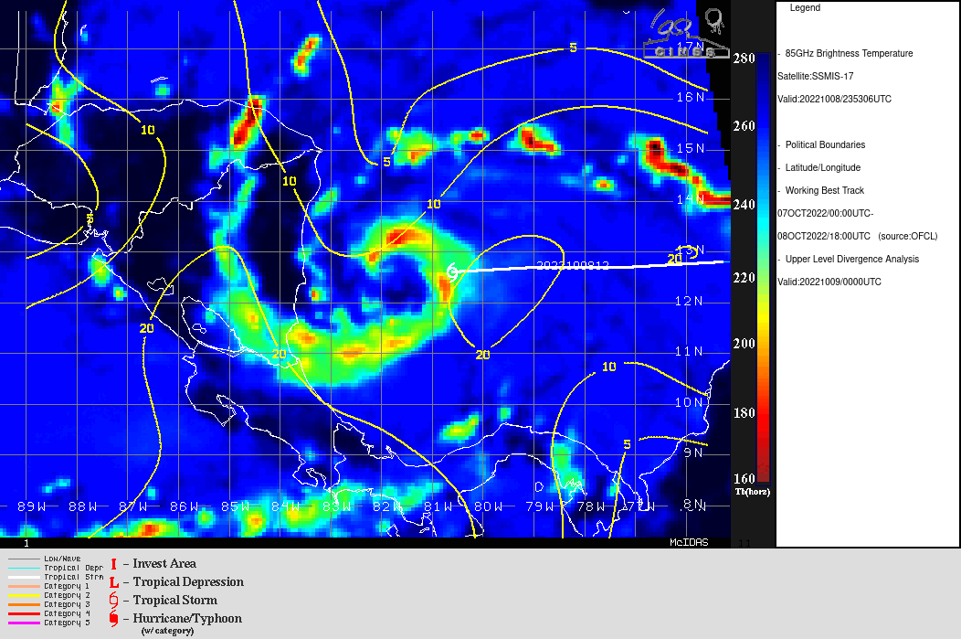  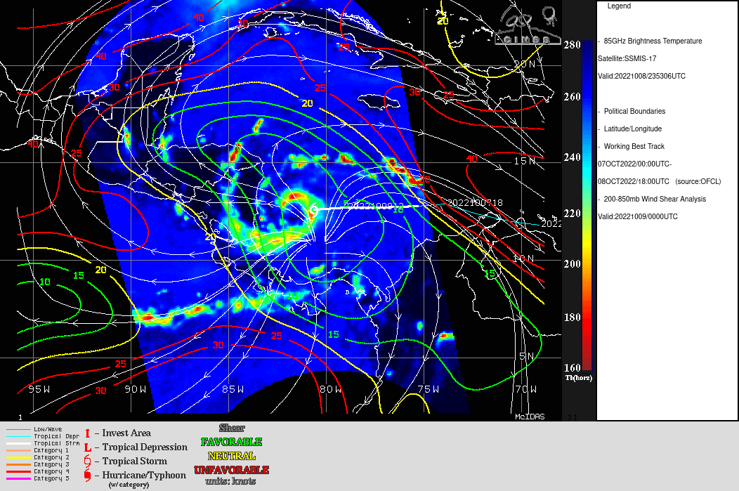  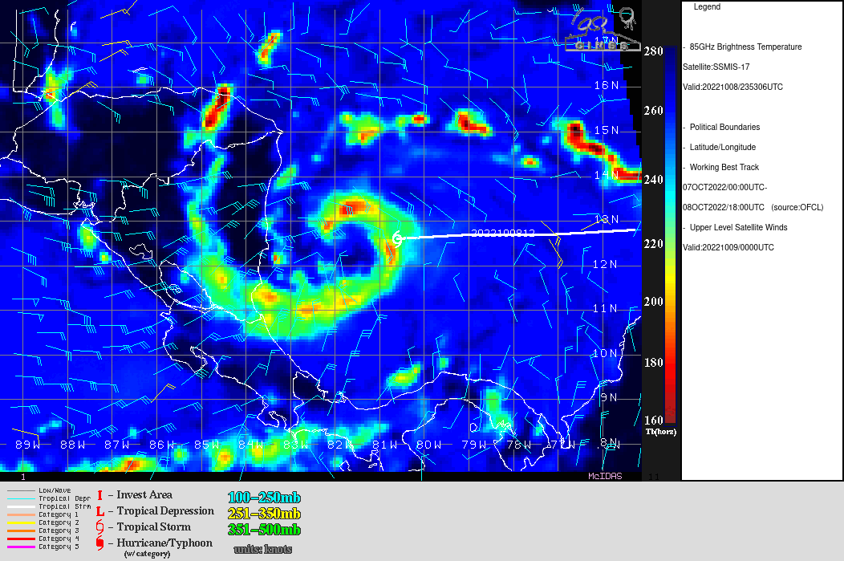
Instrument Notes | None noted

IN-FLIGHT
Time [UTC] | Event
1953 | Takeoff from Aruba after being slightly delayed to get the satcom system up. Only satcom 2 was able to be started, and with only one of the two satcoms working, this could cause some delays getting data (particularly the TDR) off the aircraft during the flight.
2030 | There were issues with the aft antenna of the TDR. Upon startup, the onboard radar scientist did not see any of the typical clear air returns (e.g., the ocean surface). The Data Tech restarted the radar software a couple of times, which did not solve the problem. He then reset the power in the back of the aircraft, and that did the trick. The antenna operated nominally for the remainder of the flight.  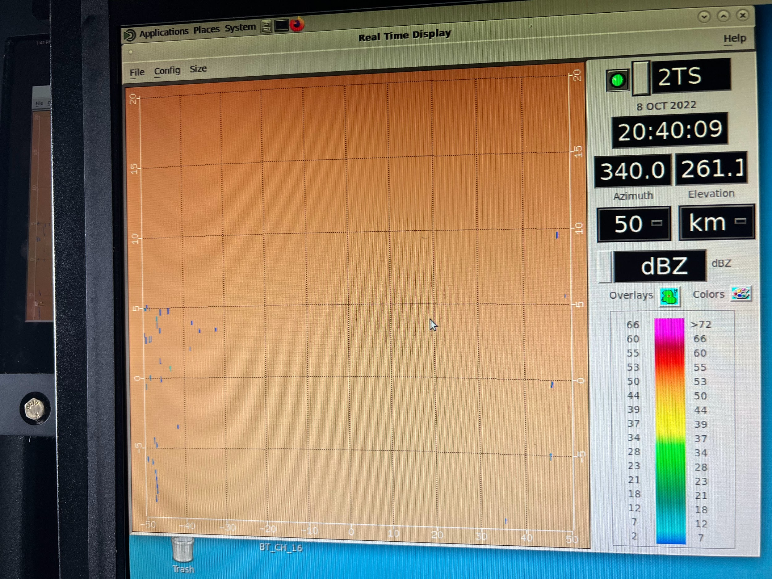
2135 | GOES-E 0.5 km Vis imagery below indicates that precipitation is now getting upshear north of the center. While it looks very much stratiform in mode, this is a sign that more rapid intensification could be commencing. It could be that the northerly moderate shear is relaxing, or that the storm is finally overcoming that shear.
2135z | CIMSS vertical wind shear analysis from 18Z today. The NATL is about as hostile as one will see WRT VWS in early Oct. TS Julia is located in one of the few areas (western Caribbean) of the NATL that is favorable as far as VWS goes.  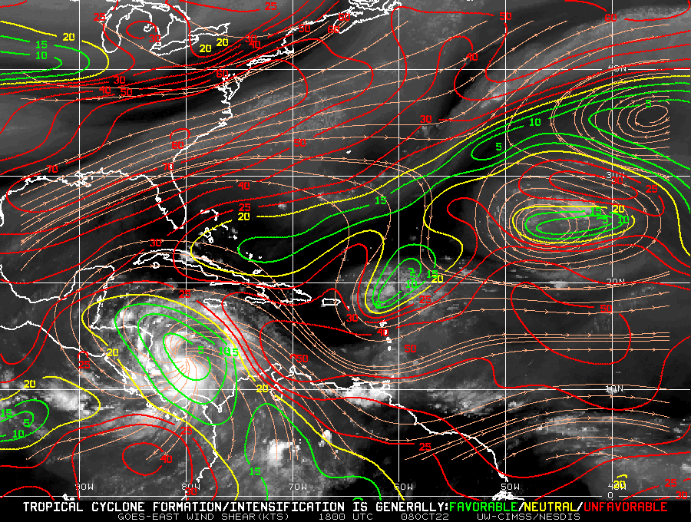
2152 | Sonde #1 at the initial point (IP), endpoint (EP) East (E)
2203 | Sonde #2 at midpoint (MP) E
2208 | Sonde #3 at quarterpoint (QTRPNT) E  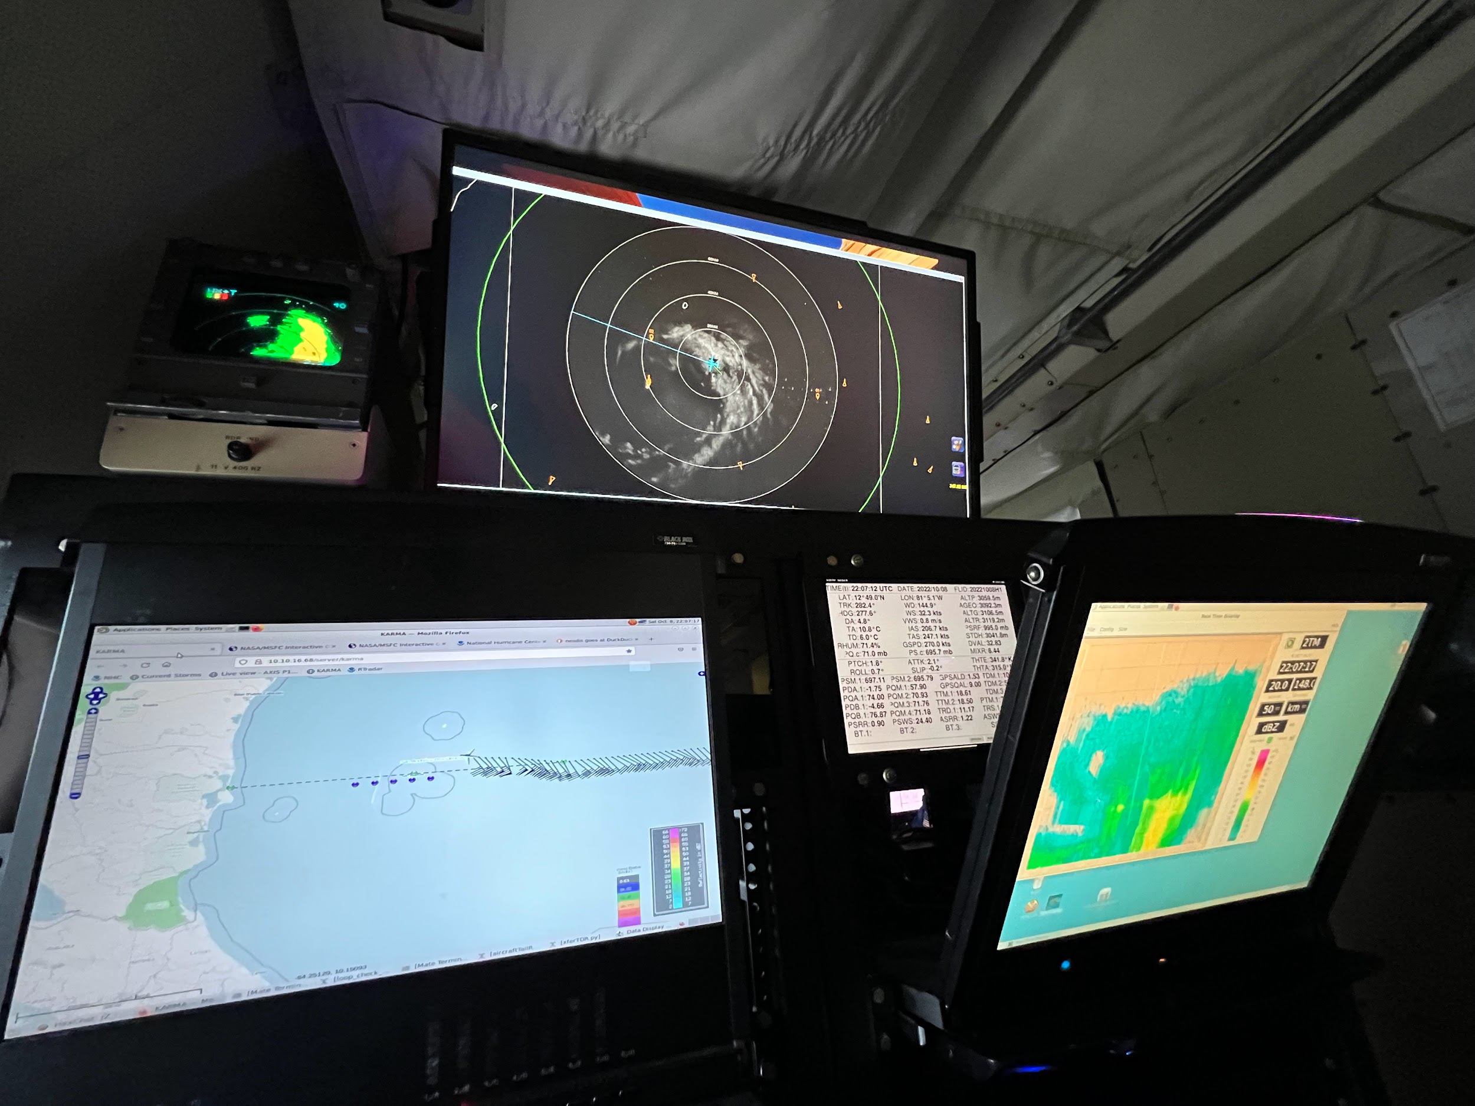
2214 | Sonde #4 Center1, closest point of approach (CPA); dropped north of center, but this was also a good observation since it was close to the potential radius of maximum winds (RMW). The winds at the surface in the sonde were 63 kt sfc (12 m).  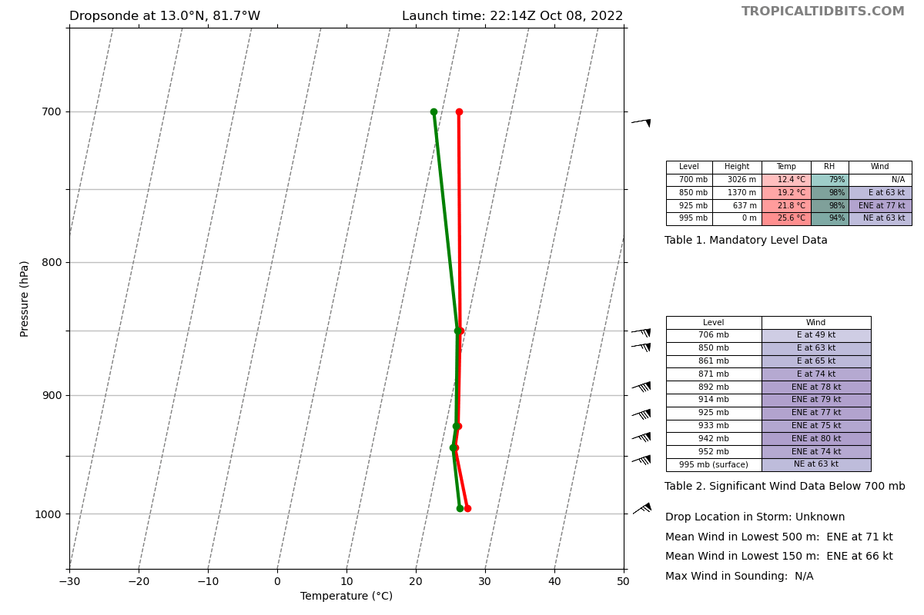
2220 | Sonde #5 QTRPNT West (W); after passing just north of the island, we’re now heading directly to a point close to the Nicaraguan coast, a bit off cross-wind, directly west of the center.
2226 | 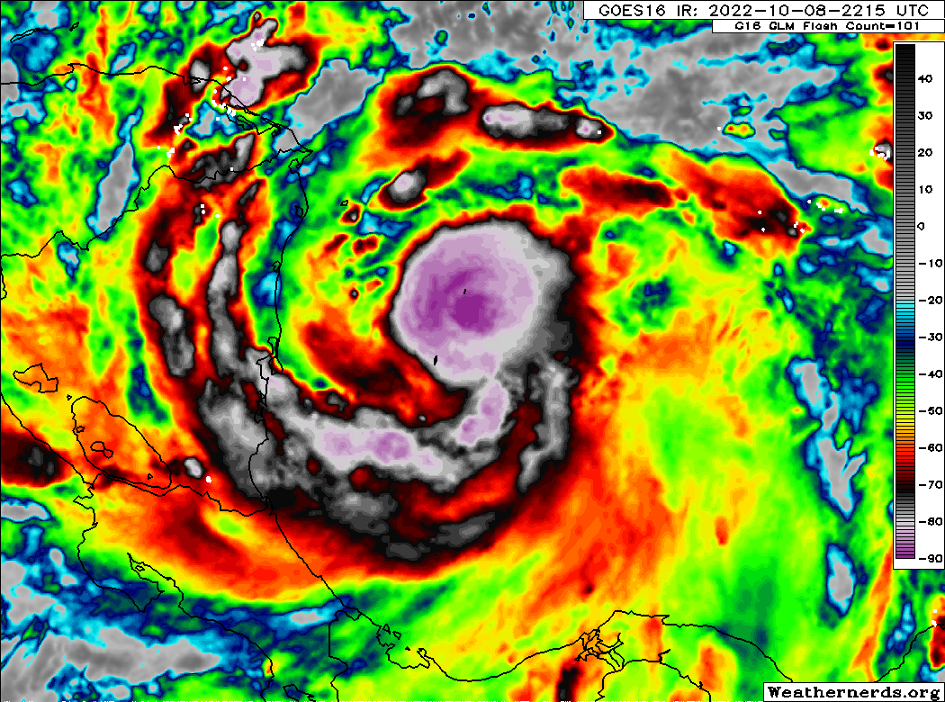  IR imaging showing the convection trying to rotate upshear
2226 | Sonde #6 MP W
2235 | Sonde #7 EP W. There will be some challenging maneuvers for this next reposition leg to the SW. There are cells to dodge and it's likely that we’ll need to head radially inward to get through them. This will likely shorten the next inbound leg.
2237 | Planning to try RMW sondes on the next outbound to the northeast since we can expect a potentially clear RMW in this quadrant.
2253 | A look at the storm from the San Andres radar, showing upshear precipitation, and a potential eyewall almost 75% closed.  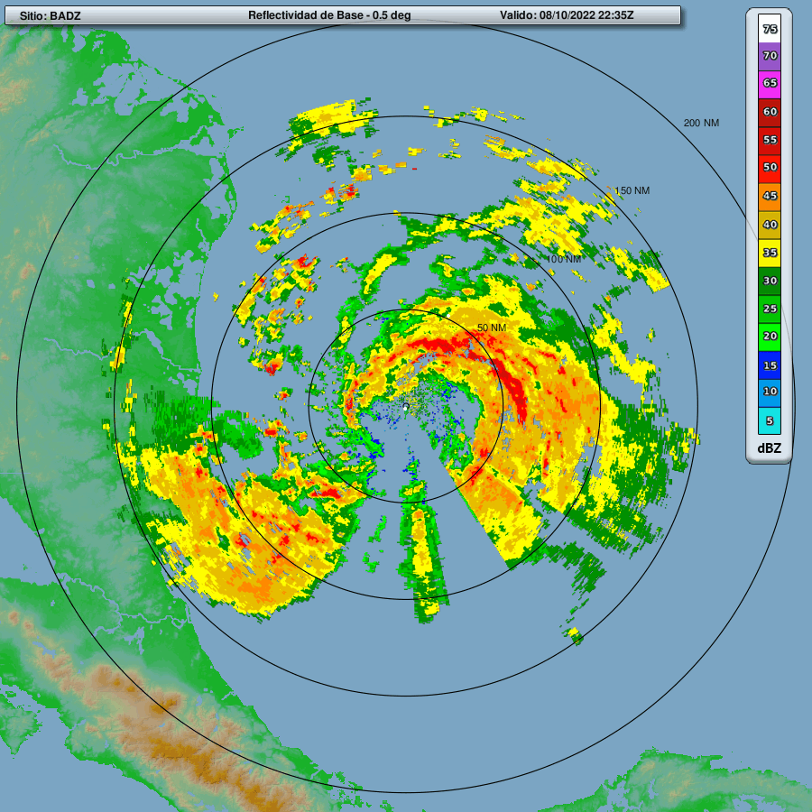
2253 | Sonde #8, EP southwest (SW); turning inbound from the SW to the center
2300 | NHC has upgraded Julia to a hurricane, in part given the observations we collected. The SFMR winds exceeded 64 kt on our pass of the center to the north, and the dropsonde CPA’ed at the center also had 63 kt.  Hurricane Julia Tropical Cyclone Update  NWS National Hurricane Center Miami FL AL132022  700 PM EDT Sat Oct 08 2022  ...JULIA BECOMES A HURRICANE...  Reports from NOAA and Air Force Reserve Hurricane Hunter aircraft indicate that Julia has become a hurricane with 75 mph (120 km/h)maximum sustained winds as it passes near San Andres and Providencia Islands.  SUMMARY OF 700 PM EDT...2300 UTC...INFORMATION  ---------------------------------------------------  LOCATION...12.5N 81.7W  ABOUT 10 MI...15 KM S OF SAN ANDRES ISLAND COLOMBIA  ABOUT 140 MI...225 KM E OF BLUEFIELDS NICARAGUA  MAXIMUM SUSTAINED WINDS...75 MPH...120 KM/H  PRESENT MOVEMENT...W OR 270 DEGREES AT 17 MPH...28 KM/H  MINIMUM CENTRAL PRESSURE...990 MB...29.23 INCHES  $$  Forecaster Beven
2303 | Sonde #9 MP SW
2308 | Sequencing of dropsondes on this pass will be QRTPNT SW, CENTER CPA (to remain clear of the San Andres and Providencia islands), 3 RMW outbound to the NE if clear of those islands, then MP, EP NE.
2308 | Sonde #10 QTRPNT SW  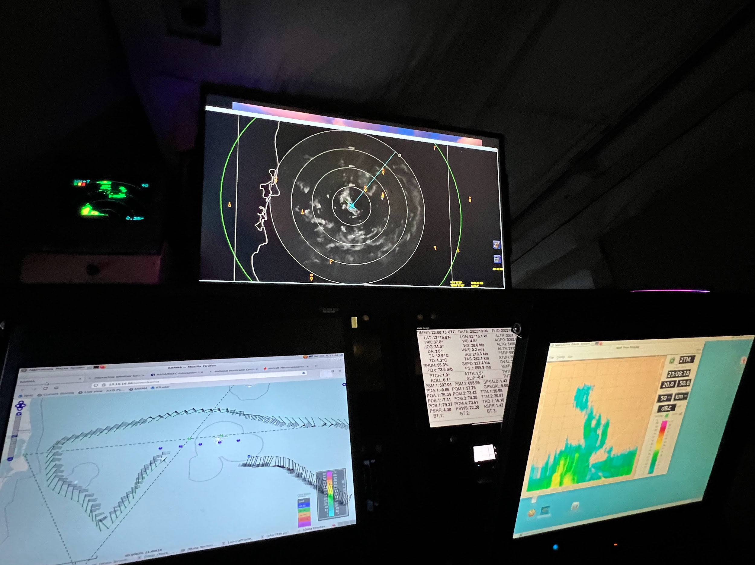
2312 | A look at the first TDR analysis from the first pass at 1 km, showing hurricane-force winds (it appears we also likely hit the RMW), and heavy precipitation. The onboard radar scientist reports that the precipitation was mostly stratiform in mode.  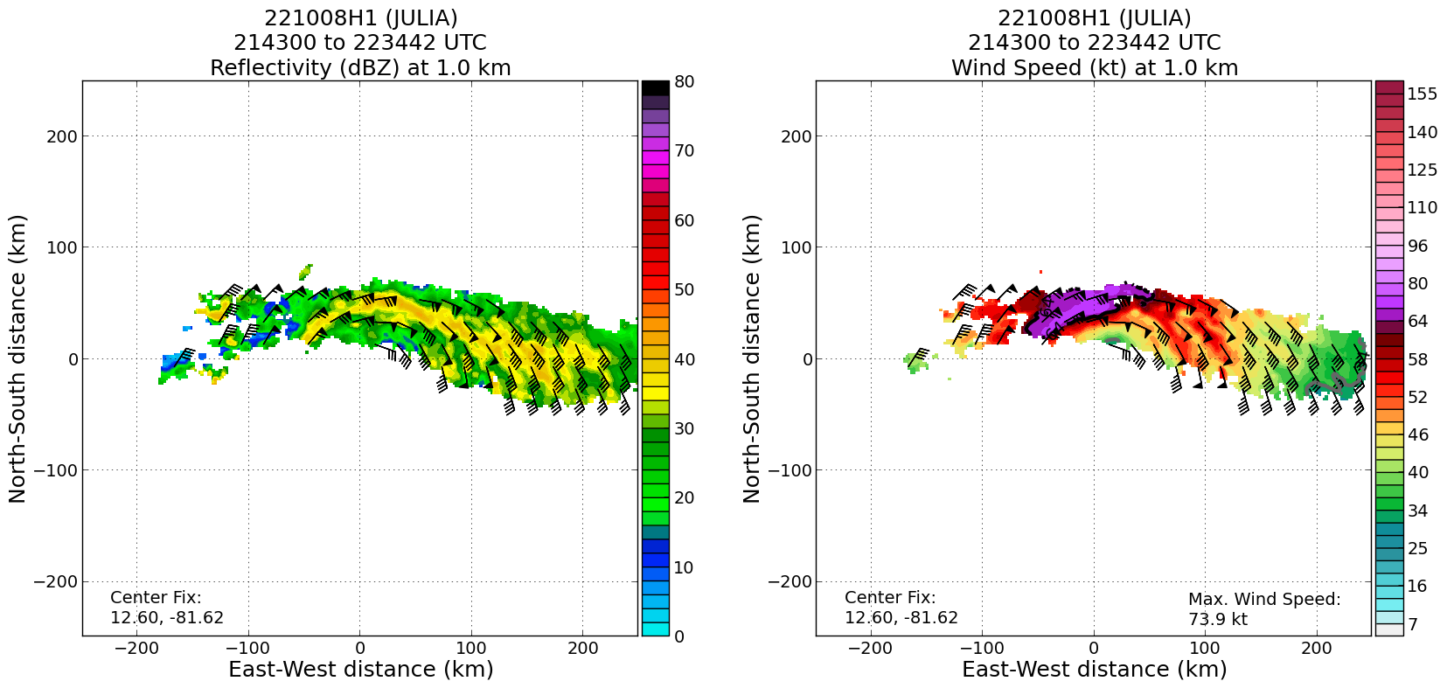
2315 | Sonde #11 Center2 CPA  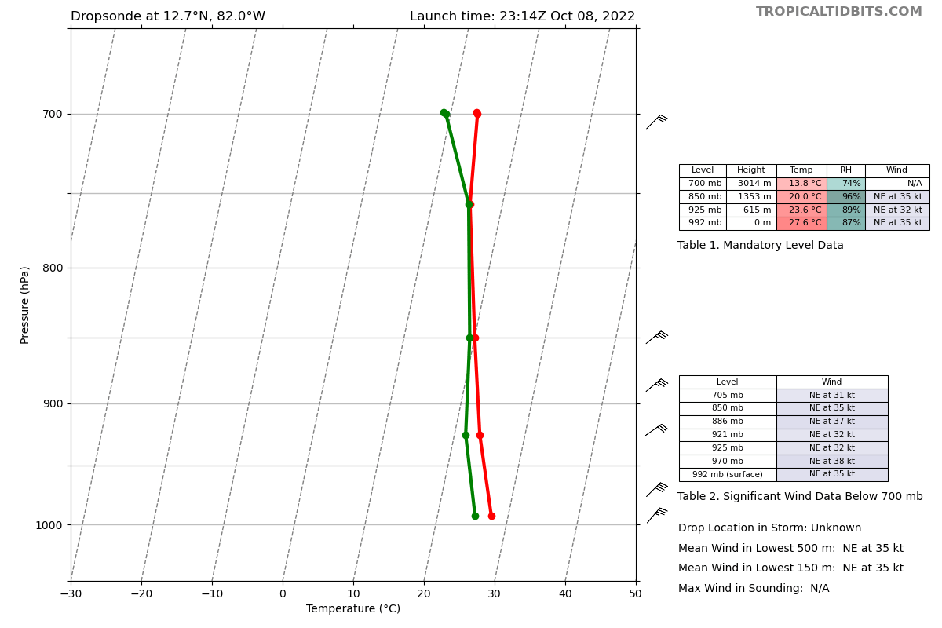
2318 | Sonde #12 RMW1 NE
2321 | Sonde #13 RMW2 NE
2322 | Sonde #14 RMW3 NE – this was the last in a sequence of 3 RMW sondes, though the winds were not as strong as expected (~50-55 kt) through this sequence. We later hit winds above 60 kt at FL on the outbound, which means this sequence targeted short (radially inward) of the RMW in the northeast quadrant.
2330 | Sonde #15 MP NE
2332 | 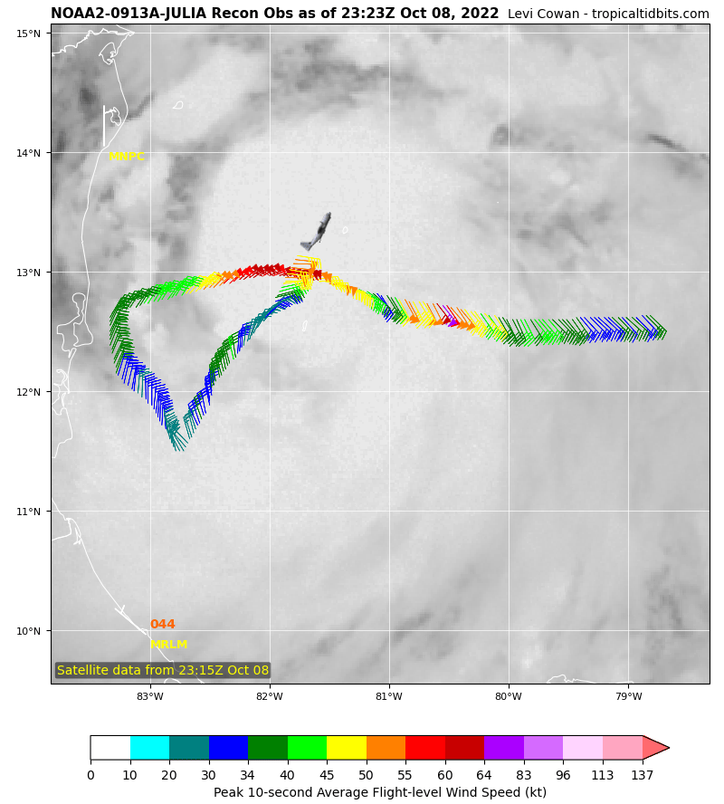
2335 | Flight informed the LPS that there may be enough time for a module. Given the darkness, the Stratiform Spiral Module is not possible, but FLAIMS would be. Considering setting up a short FLAIMS module on the third and final pass.
2338 | Sonde #16 EP northeast (NE)
2341 | Going to do a mini FLAIMS module on the NW side where the strongest winds are. The plan will be to come in from the NW on the first inbound, get close to the center (again challenging because of the islands), then reverse track and head back out to the NW to about 50 n mi (approximate midpoint of the first inbound leg), then head back inbound from the NW on the same track to finish the pattern. Dropsondes would be released at the midpoint of the first inbound leg, and in that same location when we come back outbound for FLAIMS, each time passing the RMW (but at about the same location each time, even if the RMW is missed), then in the “center” after the first inbound, then in the same “center” location after the FLAIMS return inbound. So, in total, that would be three passes through what should be the highest wind quadrant, with also plenty of rain (stratiform in mode). Azimuth will be 320 or 330, depending on which one we come in on for the first inbound.
2352 | Recent microwave imagery shows a nearly complete encompassing of a developing eyewall by precipitation (red indicates high scattering from ice from convection in the 91 GHz channel of SSMIS-17).  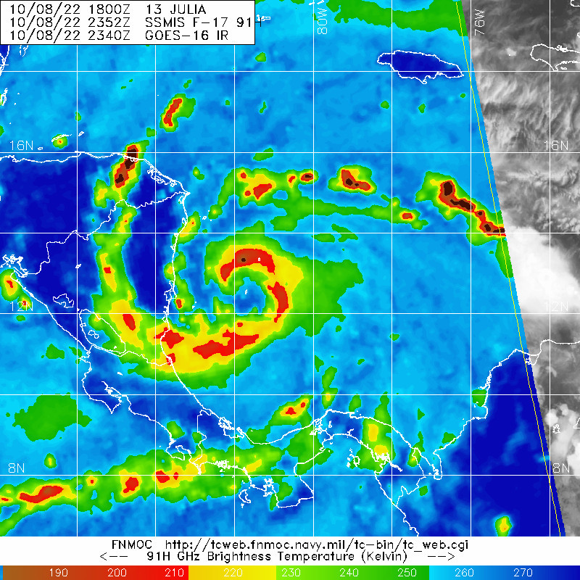
2358 | Sonde #17 EP NW, now inbound from the NW on a 320 azimuth, 140 heading.
0004 | A look at the IR loop showing plenty of upshear precipitation, present along the inbound track and likely stratiform in mode.
0009 | Sonde #18 MP NW; this point is marked as the location of the sonde for the FLAIMS module when we come back outbound from the center for the module.
0015 | A look at the TDR analysis from the 2nd pass at 1 km, once again showing a well-defined center and hurricane force winds at 1 km peaked on the north side.  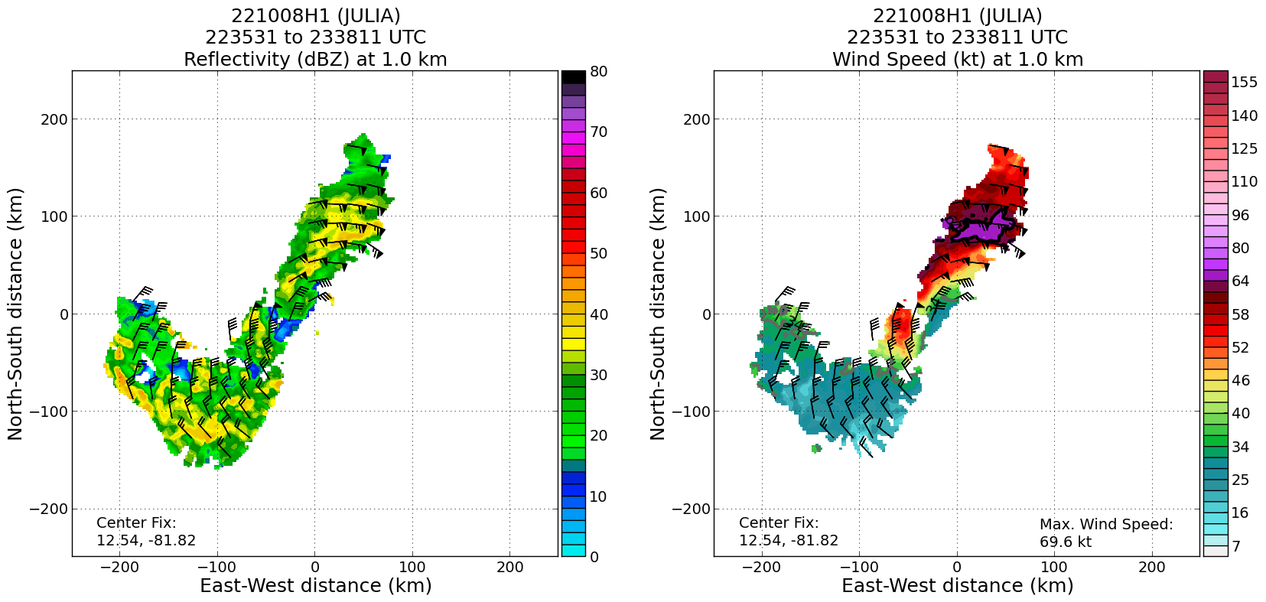
0015 | Sonde #19 RMW1 NW (didn’t really end up being the RMW; we had stronger winds just radially outward of this release). This sonde location will be repeated for each pass of the upcoming FLAIMS module.
0024 | Sonde #20 CENTER3 CPA, now turning around and heading back outbound to the NW on the same azimuth (320 degrees) for the first pass of the FLAIMS module.
0030 | Sonde #21 RMW (FLAIMS) NW (ONR sonde) – repeated at the same location as the inbound dropsonde release location.  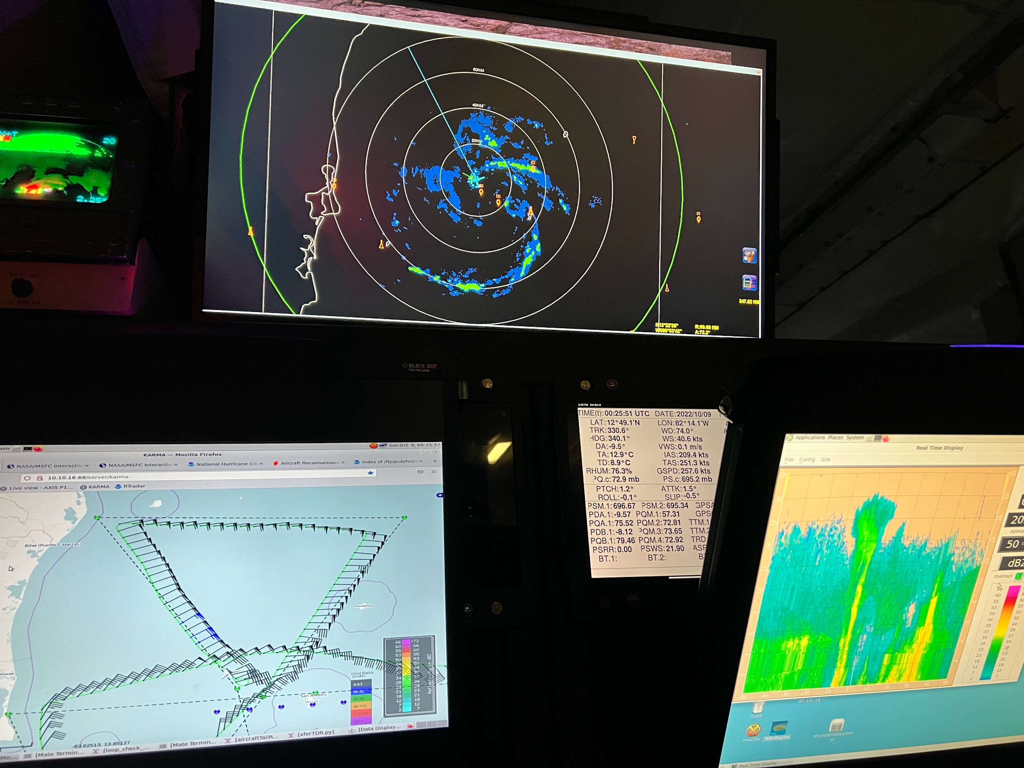
0036 | Sonde #22 MP (FLAIMS) NW (ONR sonde) – repeated at the same location as the MP sonde on the previous inbound. Interestingly! The flight level winds on this outbound pass were as much as 10 kt and even 15 kt higher than on the last inbound pass. So we’re actually flying FLAIMS in the highest wind region, and actually observing intensification during the brief module.  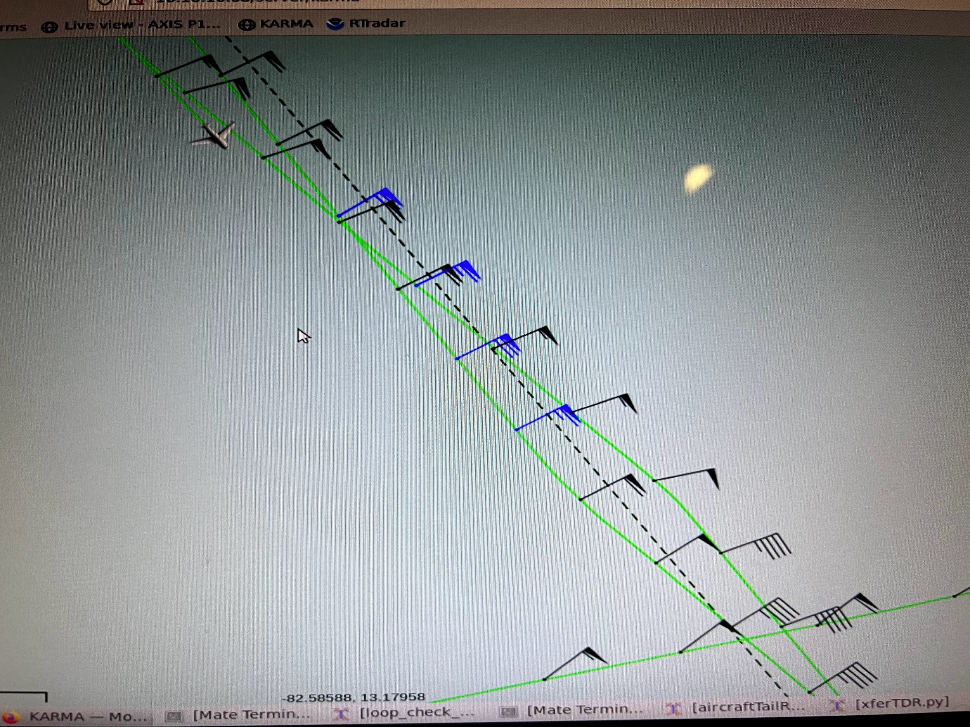
0047 | Sonde #23 RMW (FLAIMS) NW IN (ONR sonde) – repeated location as inbound and last outbound.
0052 | A look at the IR satellite imagery during the FLAIMS module.  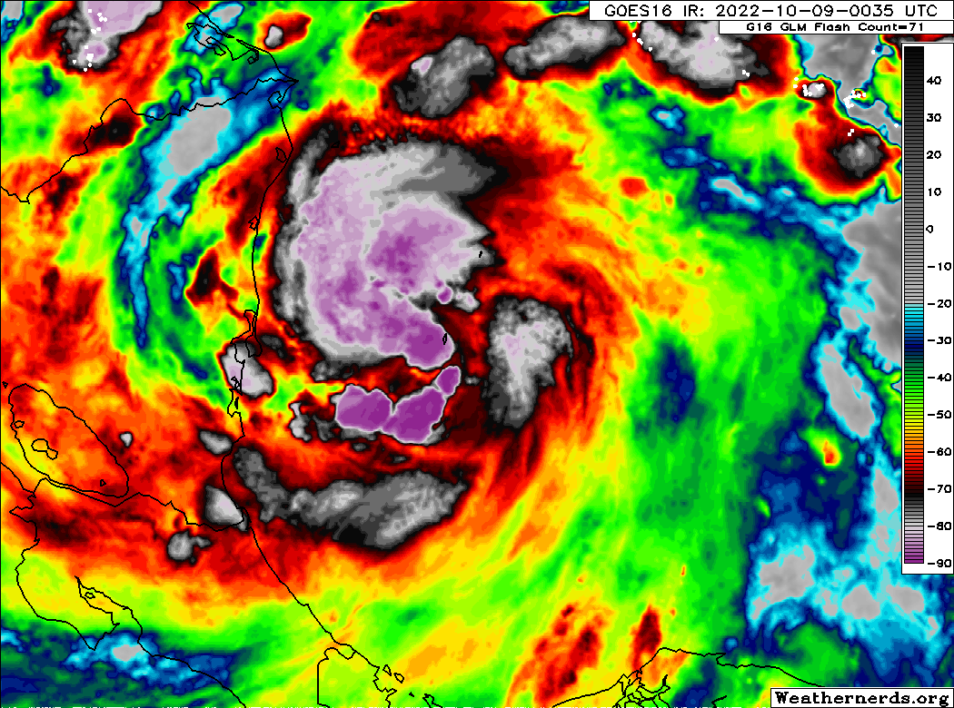
0053 | Sonde #24 CENTER4 (FLAIMS) (ONR sonde). This completes the FLAIMS module. We’re now hunting the center since island clearance is no longer an issue. Once the center is identified, we’ll head outbound to the southeast to complete the pattern.  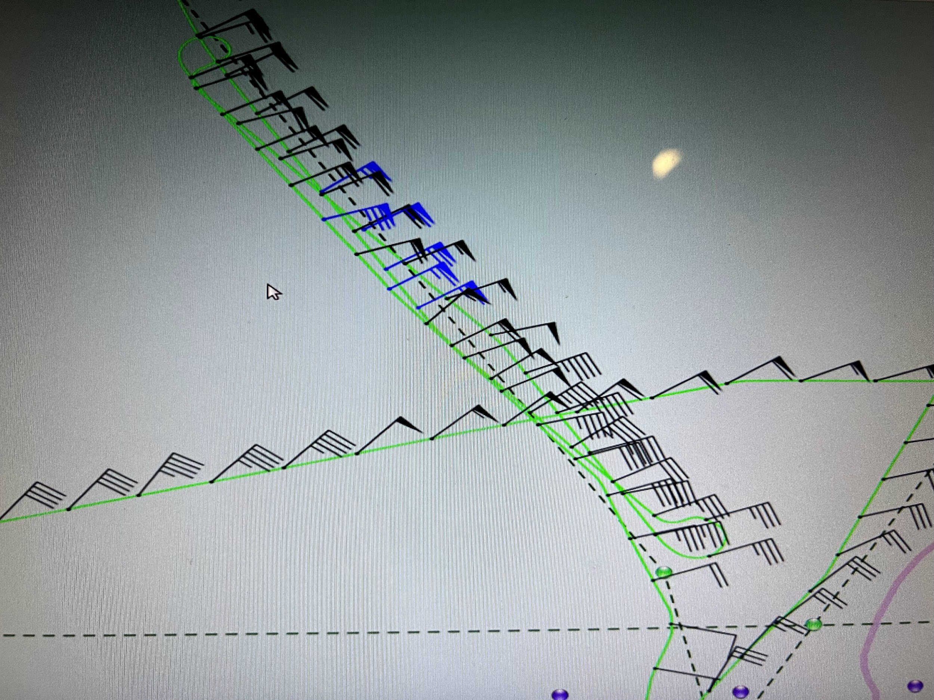
0057 | Sonde #25 CENTER5 for NWS; fixed the center this time
0102 | A look at the 3rd TDR analysis from downwind leg on the north side and the first inbound from the NW to the center, as well as the radial cross section of winds on the inbound.  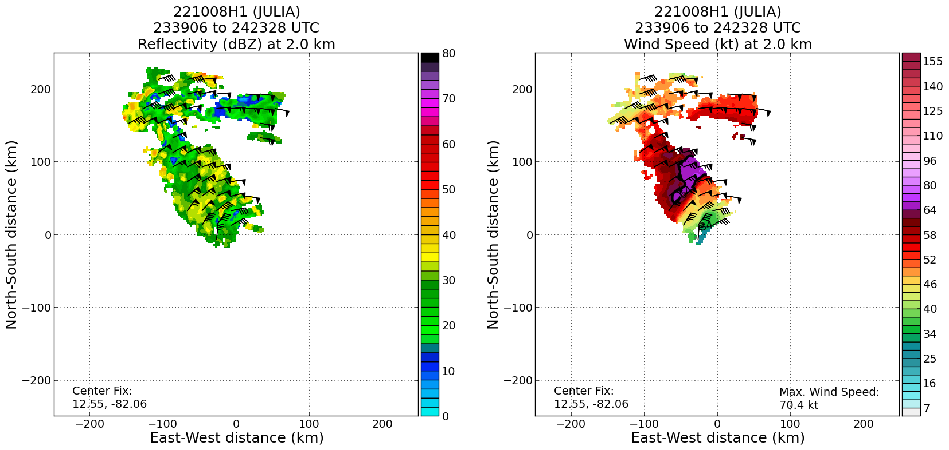  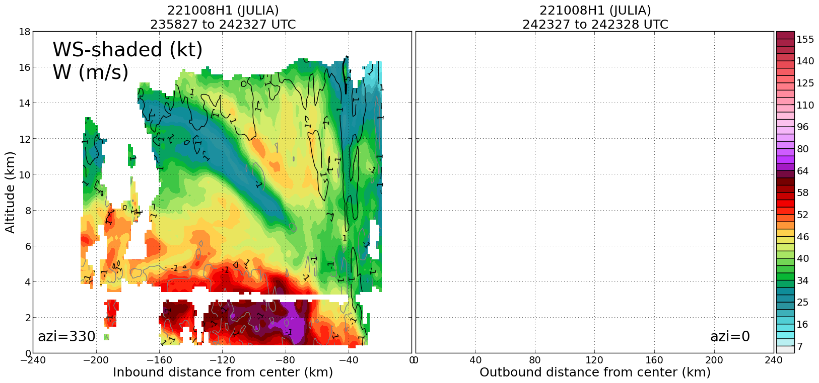
0108 | Sonde #26 MP SE – missed the QTRPNT SE
0121 | 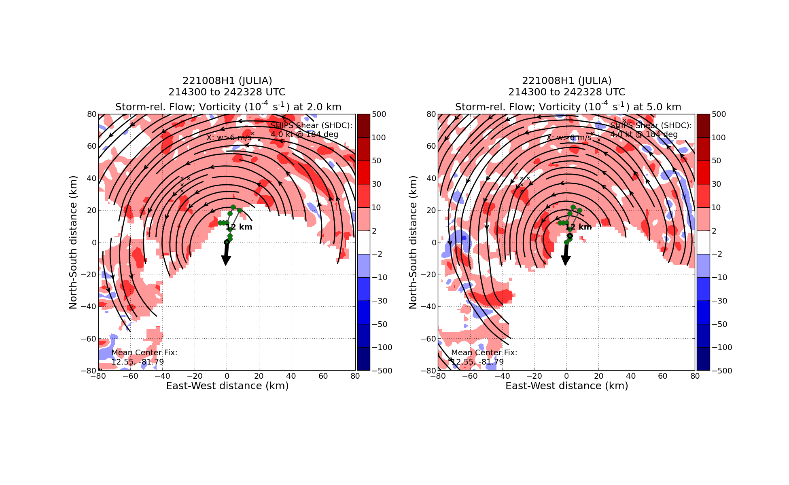
0123 | Sonde #27 EP SE – pattern complete
0128 | A look at the radar picture from the lower fuselage multi-mode radar (MMR) on the P-3 showing the “eyewall” of Hurricane Julia. Disorganized, yes, but an improvement from earlier in the day when the precipitation wasn’t getting upshear on the northern side of the circulation.  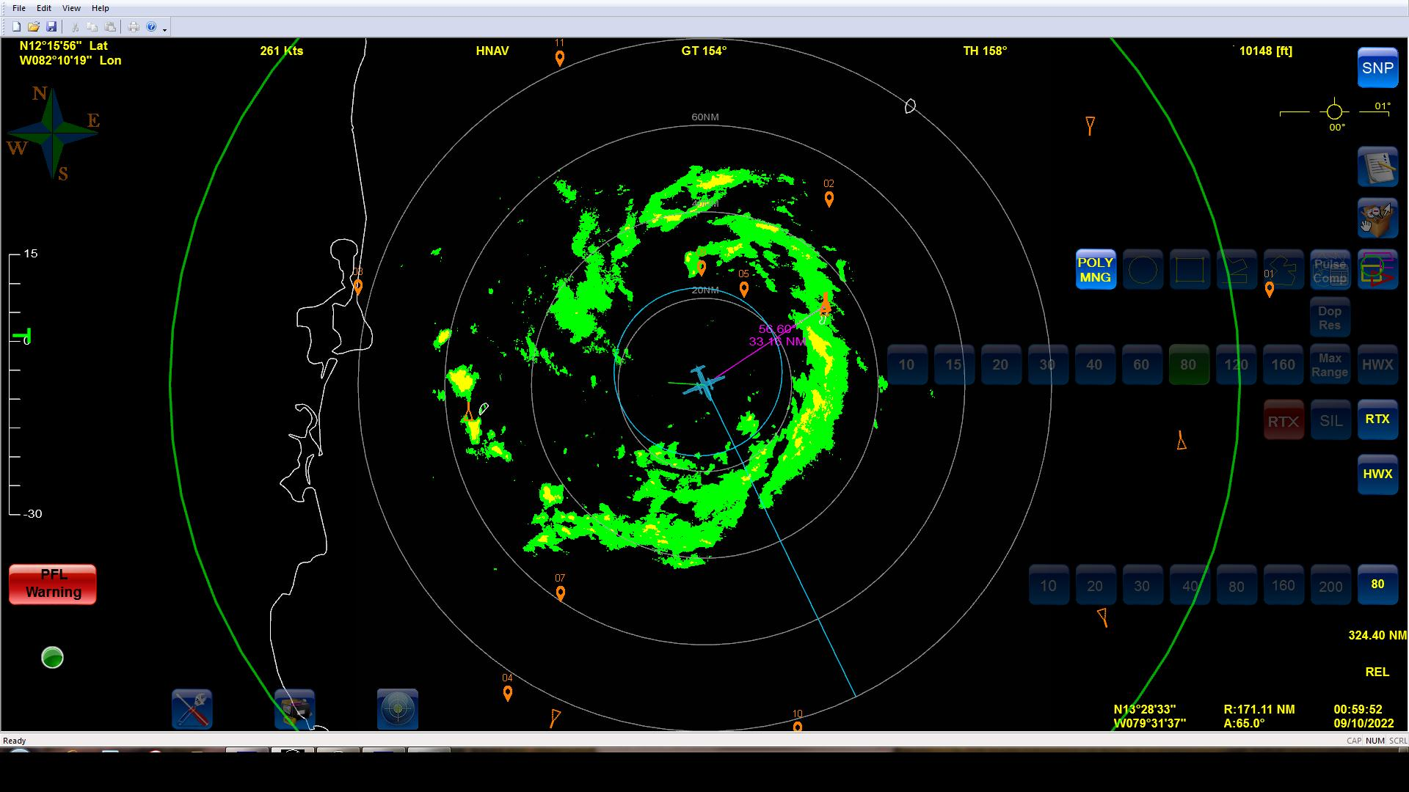
0222 | A look at the IR satellite loop encompassing the last couple of passes through the storm.
0227 | Final TDR composite from all three passes (minus the FLAIMS module legs, which in themselves showed intensification from pass to pass).  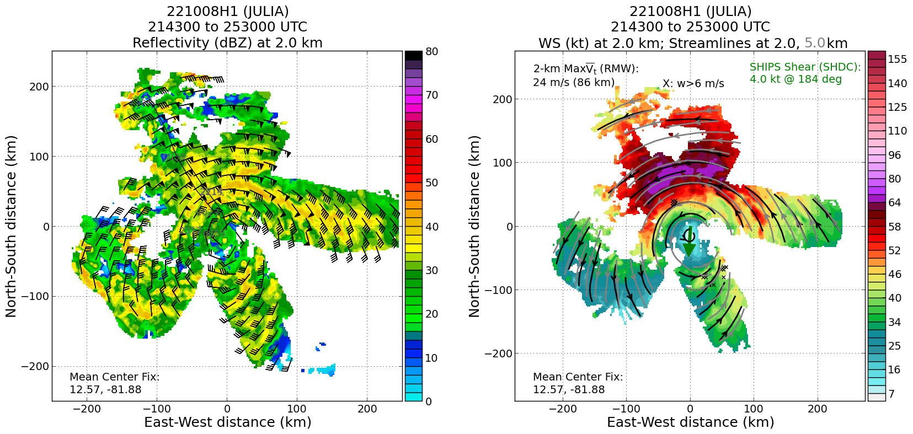

POST-FLIGHT
Mission Summary | We flew a butterfly pattern to collect TDR data for EMC and NHC, while also flying the FLAIMS module for ONR and the APHEX Early Stage Experiment, AIPEX. The FLAIMS Flight-Level Assessment of Intensification in Moderate Shear) module focused on the highest wind quadrant (northwest), where there was also a decent eyewall developing. This quadrant was also upshear of the center. Interestingly, the inbound/outbound/inbound sequence of passes in that northwest quadrant during the FLAIMS module actually showed intensification in the brief time the module was flown (really only added about 30 min to the pattern). The winds on the outbound actually showed 10-15 kt higher than the first inbound, and that was with less than 20-30 min separating the passes. So, a brief FLAIMS was flown, but despite being brief was also successful. The repeated sondes released at the midpoint, RMW (really radially inside of it), and center were all good, and the TDR data will be especially helpful to show the structural changes that occurred while flying the module.  According to the TDR data, the storm appeared to be better aligned than the previous day, while the RMW was also better defined. Look no further than the fact the convection / precipitation was making it upshear during the flight – even though there appeared to be some potentially moderate northerly shear impacting the storm environment – to show how favorable the storm was for intensification. Based on the data from the first pass, as well as the data from the 53rd’s first pass through the center soon after the P-3’s pass, NHC upgraded Julia to a hurricane in a special advisory at 7 pm EDT. So, considering the intensity 24 hours earlier, this 2-mission P-3 sequence in Julia should count as a rapid intensification case.  The storm appeared to continue to intensify on approach to landfall in Nicaragua as official NHC forecasts and high-resolution guidance had been suggesting.  27 dropsondes were released during the mission, all good; 15 were charged to NWS, while the other 12 were charged to ONR (FLAIMS module sondes). 25 of the 27 were transmitted to the GTS.
Actual Standard Pattern Flown | Butterfly at 10 kft pressure altitude flown mostly as planned, with exception for changes due to the proximity of the San Andres and Providencia islands and Nicaragua.
APHEX Experiments / Modules Flown | Data collection supports the Early Stage Experiment: Analysis of Intensification Processes Experiment (AIPEX) and data was specifically collected for the FLAIMS (Flight-Level Assessment of Intensification in Moderate Shear) module within AIPEX. The mission was flown in collaboration with ONR’s Tropical Cyclone Rapid Intensification (TCRI) Experiment.
Plain Language Summary | - We flew a TDR mission for NCEP’s Environmental Modeling Center (EMC) to collect data in Julia, which will feed data into HWRF and HAFS high-resolution hurricane models. Radar data was also sent to NHC in near real time. Based partially on data from this mission, Julia was upgraded to a hurricane by NHC after the first P-3 pass of Julia’s center.  - The storm was becoming better organized throughout the flight, with the pressure falling and the flight-level and surface winds increasing, suggesting the storm was potentially rapidly intensifying before and during the flight. A specific module was flown in the highest winds in the northwest quadrant, with repeated passes in and out of the center observing the strengthening of those winds on each pass.
Instrument Notes | In the end, the instruments worked well, but there were some hiccups at the start of the mission. At pre-flight we only had one of the two satellite communication systems working on the airplane, which potentially slowed data transmission to the ground. And the aft antenna of the TDR didn’t start up correctly and required a power reset.
Final Mission Track | 