MISSION PLAN
FLIGHT ID | 20220920I1 | STORM | AL07 / FIONA
MISSION ID | 2107A | TAIL NUMBER | NOAA43
TASKING | EMC/NHC | PLANNED PATTERN | Modified Butterfly
MISSION SUMMARY
TAKEOFF [UTC] | 2003 | LANDING [UTC] | 0503
TAKEOFF LOCATION | Lakeland | LANDING LOCATION | Lakeland
FLIGHT TIME | 9.0 | BLOCK TIME | 9.3
TOTAL REAL-TIME RADAR ANALYSES  (Transmitted) | 7 (7) | TOTAL DROPSONDES (Good/Transmitted) | 41 (40 / 34)
OCEAN EXPENDABLES (Type) | 4 AXBT (ONR) (4 good) | sUAS (Type) | None
APHEX EXPERIMENTS / MODULES | Mature Stage Experiment: Surface Wind and Wave Validation, NESDIS Ocean Winds; Early Stage Experiment: AIPEX (FLAIMS)
HRD CREW MANIFEST
LPS ONBOARD | Holbach | LPS GROUND | Hazelton
TDR ONBOARD | Holbach | TDR GROUND | Gamache
ASPEN ONBOARD | Murillo | ASPEN GROUND | None
NESDIS SCIENTISTS | Chang, Jelenak, Sapp, Bjorland
GUESTS (Affiliation) | Camposano (UM/RSMAS/CIMAS), Alexis Rudd (US Senate Staffer)
AOC CREW MANIFEST
PILOTS | Mitchell, Doremous, Keith
NAVIGATOR | Utamo
FLIGHT ENGINEERS | Darby, Pittman, Tyson
FLIGHT DIRECTOR | Carpenter
DATA TECHNICIAN | T. Richards
AVAPS | Warnecke

PRE-FLIGHT
Flight Plan | 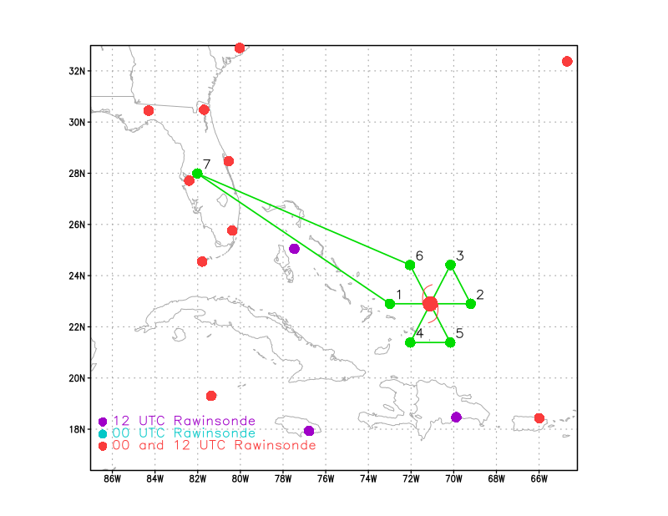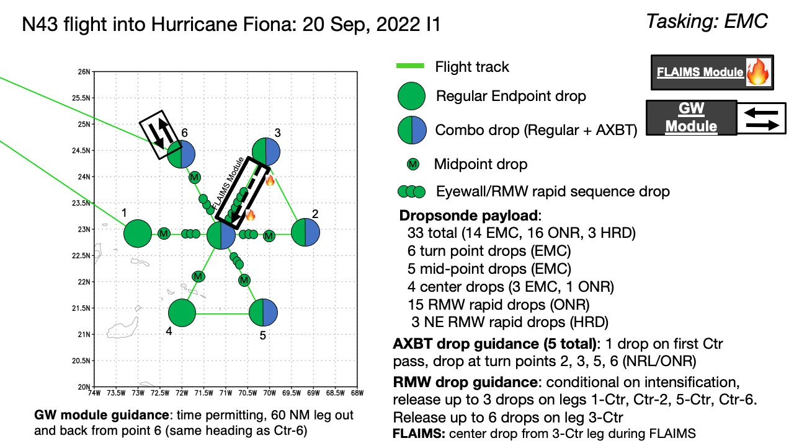  Pattern: Fly butterfly pattern with 105 nmi legs  Altitude: 10 kft (pressure altitude)  Potential add-on Modules:  - Surface Wind and Wave Validation  - FLAIMS Module (AIPEX)  33 sondes (all dropsondes transmitted to the GTS); 5 ONR/NRL AXBTs (all AXBTs transmitted to the AOC ground server if possible)
Expendable Distribution | Release sondes at endpoints, midpoints, centers; possible supplemental rapid RMW drops
Preflight Weather Briefing | Fiona is a Category 3 hurricane with 100 knot winds. The TC appears to have just completed an eyewall replacement cycle, and the eye is clearing out again with pressure falling.  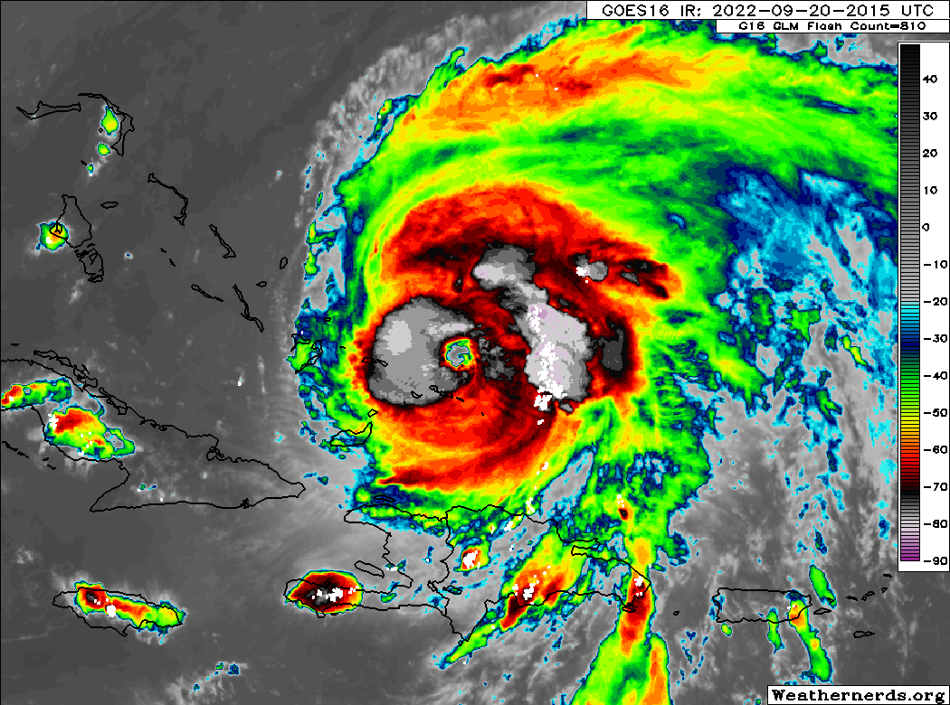  The storm is slowly moving off to the north and northeast, recurving away from the CONUS.
Instrument Notes | None

IN-FLIGHT
Time [UTC] | Event
2003 | Takeoff from KLAL
2017 | MMR being restarted
2026 | MMR back up
2050
2155 | IP sonde 1, 22.46N 73.30W
2206 | Midpoint (MP) drop 22.5N 72.42W
2215 | RMW Drop 3 22.47N 72.3W
2217 | RMW Drop 4 22.4N 71.57W
2218 | RMW Drop 5 22.46N 71.52W
2221 | Center Drop 6 22.46N 71.36W
2230 | RMW Drop 7
2230 | RMW E Drop 8  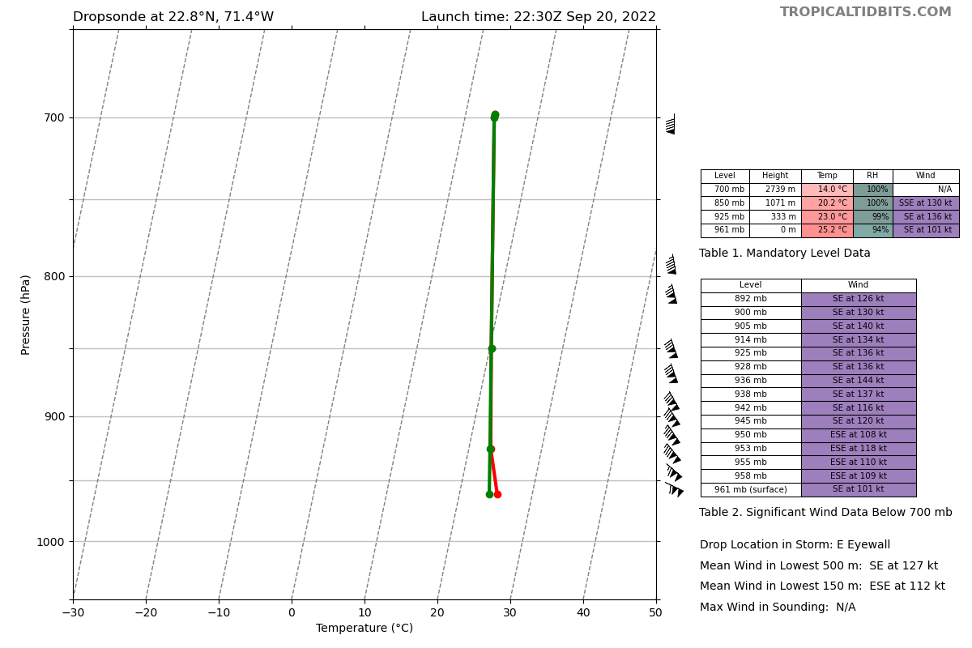
2231 | RMW E Drop 9
2236 | MP Drop 10 22.4N 70.54W
2241 | There is a pretty cellular rain band by our EP so we are going to turn downwind before we reach that
2242 | 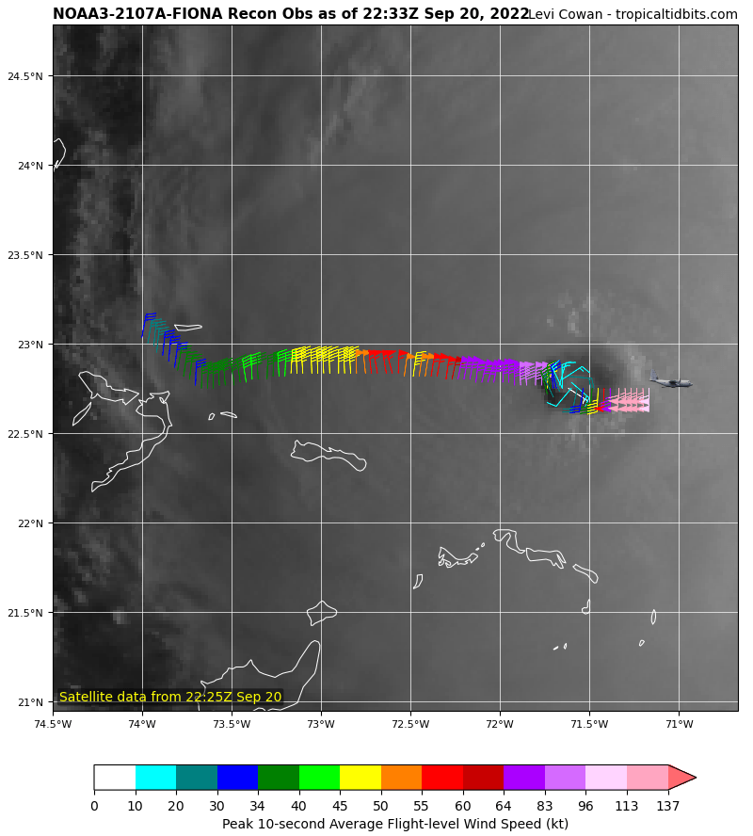
2244 | Endpoint (EP) drop 11 22.45N 70.3W
2246 | 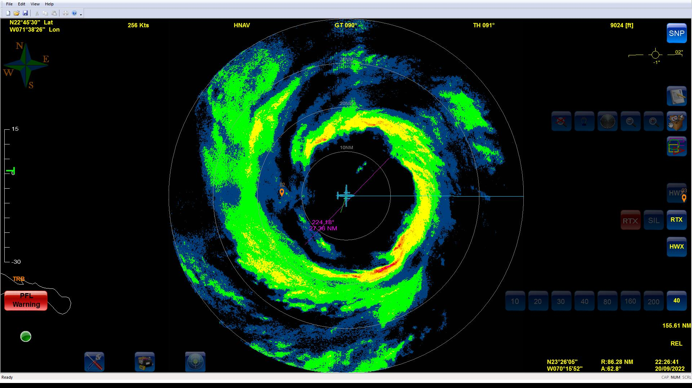
2254 | 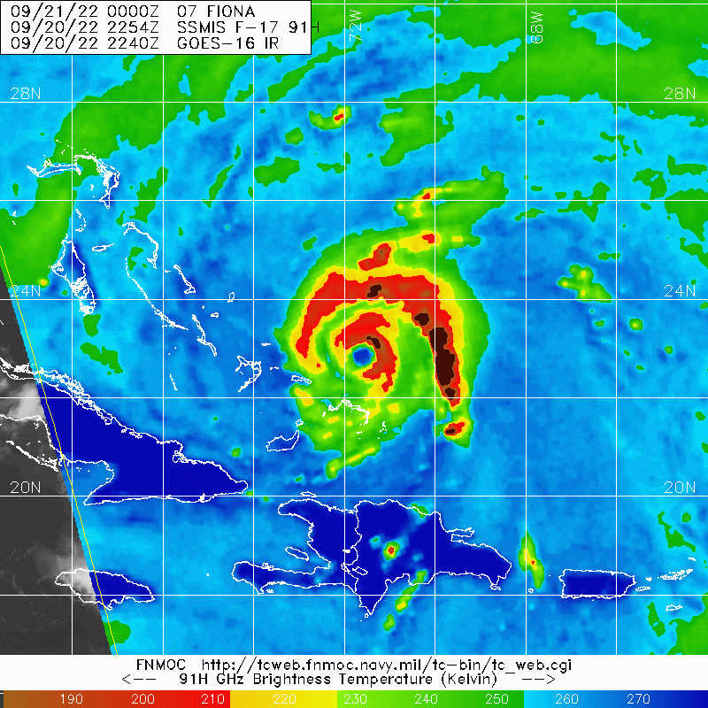
2301 | Endpoint sonde 12, AXBT drop, 23.42N 71.9W
2301 | Heading inbound for fix, then back out for FLAIMS
2308 | 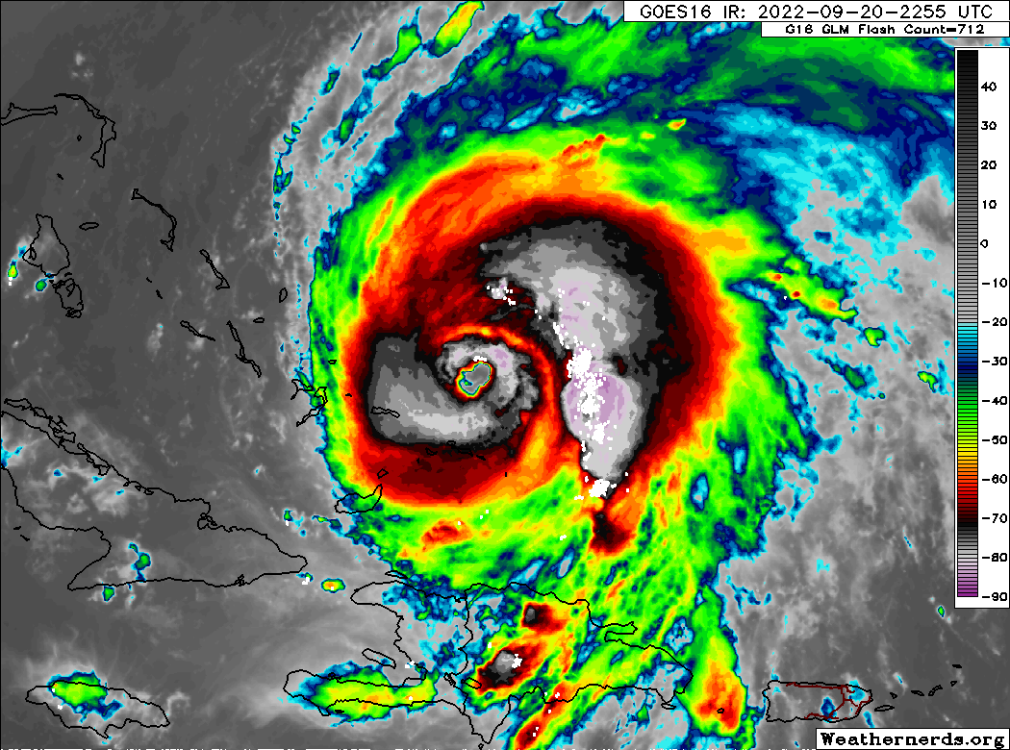
2211 | Center sonde 13 22.51N 71.37W, AXBT #2
2323 | Heading back out NE for FLAIMS module
2329 | 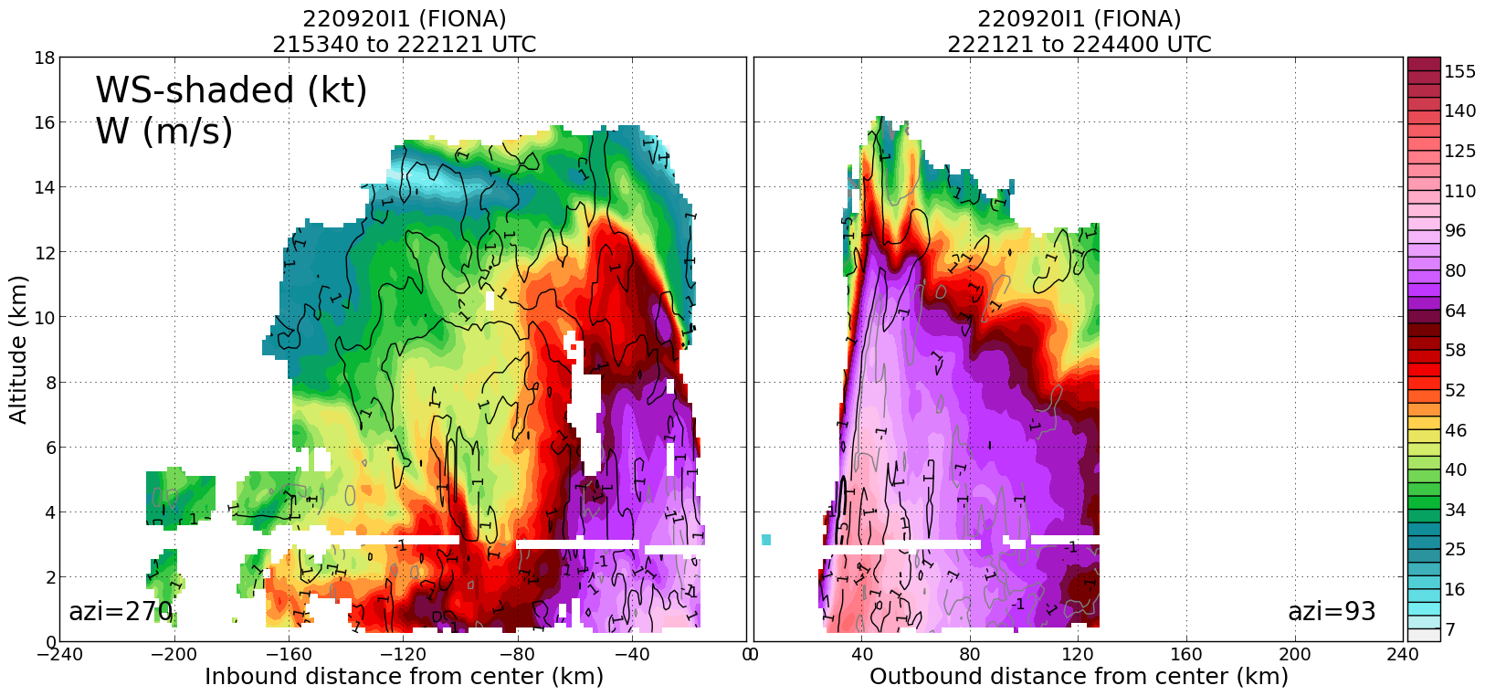
2336 | 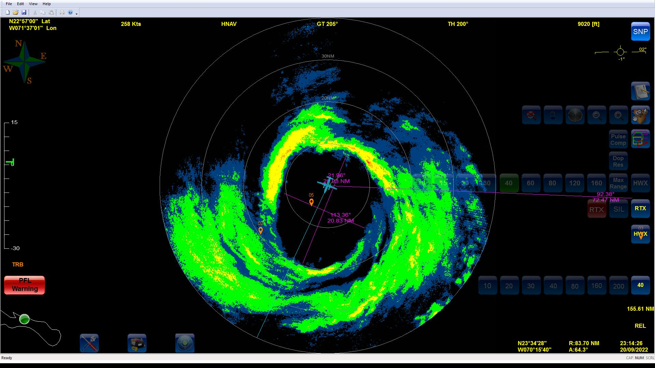
2336 | Planning FLAIMS module sondes: 5 RMW in, 1 center, 1-2 RMW out
2342 | RMW NE Sonde 14 23.12N 71.23W  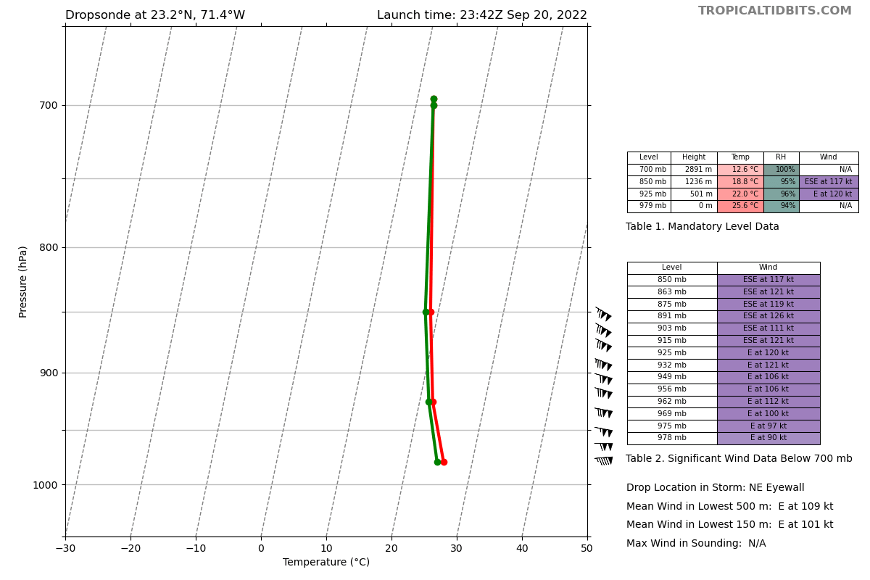
234348 | RMW NE Sonde 15 23.8N 71.26W
234447 | RMW NE Sonde 16 23.5N 71.28W
234508 | RMW NE Sonde 17 23.5N 71.29W
234541 | RMW NE Sonde 18 23.3N 71.31W
2349 | Center Sonde 19 22.53N 71.42W
000208 | RMW Sonde 20 22.40N 71.51W
000219 | RMW Sonde 21 22.38N 71.53W
000320 | RMW Sonde 22 22.36N 71.55W
0008 | 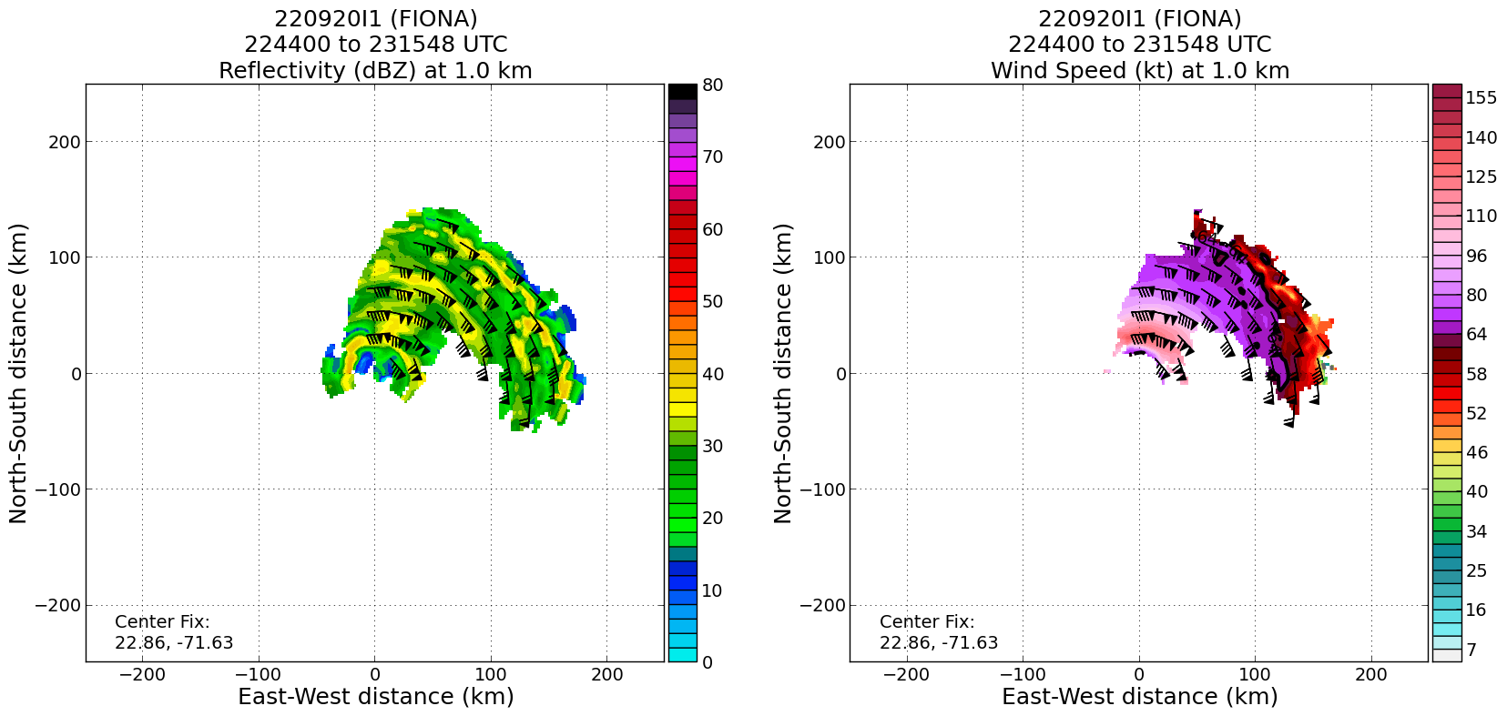
0008 | Midpoint drop 23 22.21N 72.8W
0011 | 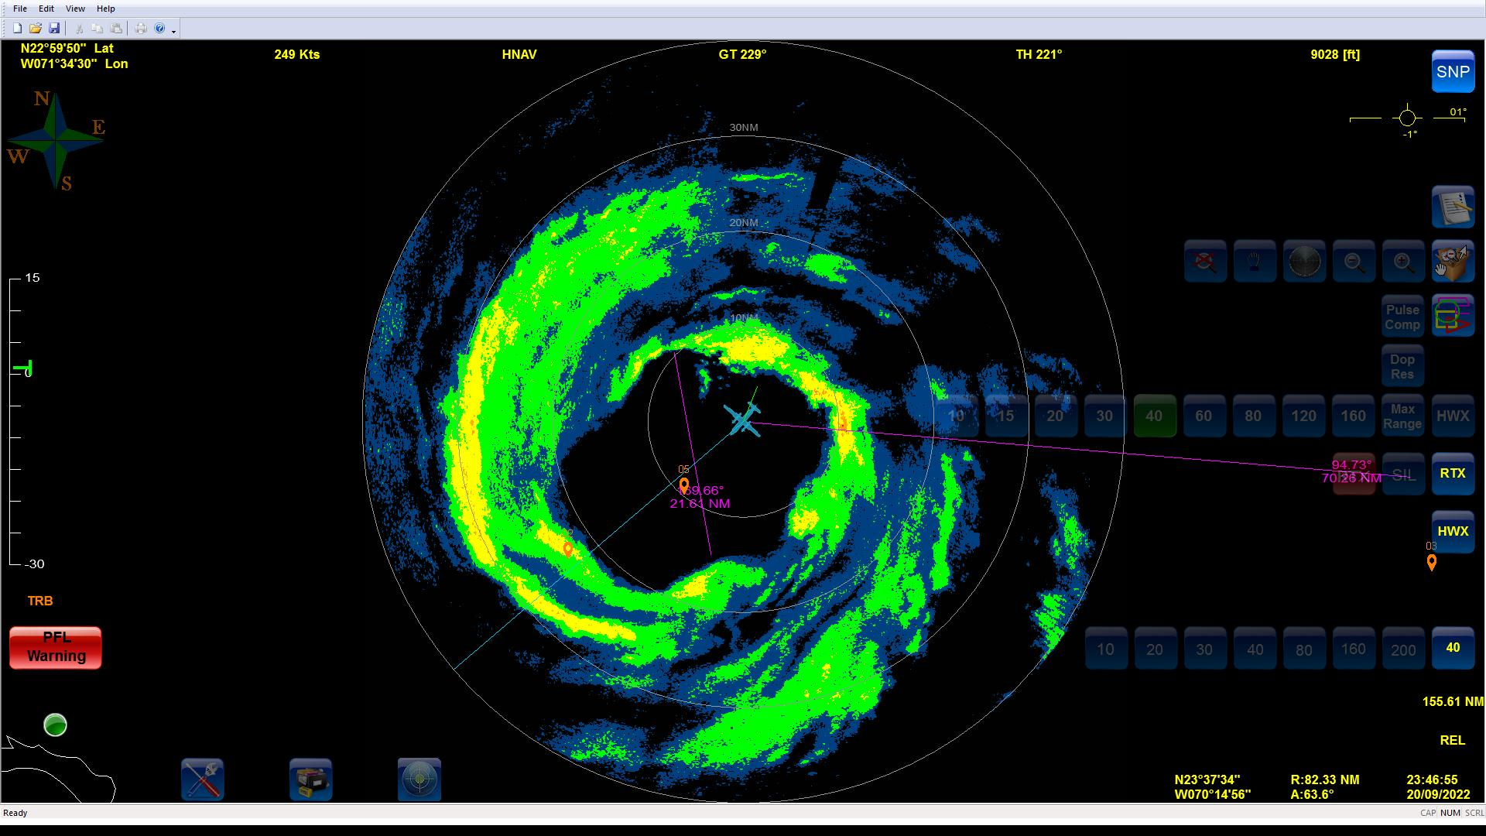
0024 | Endpoint drop #24 21.45N 72.47W
0044 | Planning to do inbound leg as planned then break off into research radials before final outbound pass to NW
0056 | Sonde 25 (Combo drop, AXBT 3) 21.39N 71.3W
0059 | AXBT SSTs so far: SSTs 1) 29.00C, 2) 27.98C, 3) 27.54C
0104 | Possible concentric eyewalls
0106 | Midpoint drop #26: 0106Z 22.23N 71.25W
0110 | RMW drop #27 22.36N 71.34W
0112 | RMW drop #28 22.44N 71.39W
0113 | RMW drop #29 22.47N 71.40W
0117 | Center drop #30 22.59N 71.48W
0126 | Outbound 030
013525 | RMW Sonde #31 23.12N 71.39W
013558 | RMW Sonde #32 23.1N 71.51W
013618 | RMW Sonde #33 23.9N 71.41W
0141 | Orbiting to get splash point for overflight, 23.198N 71.796W
0142 | 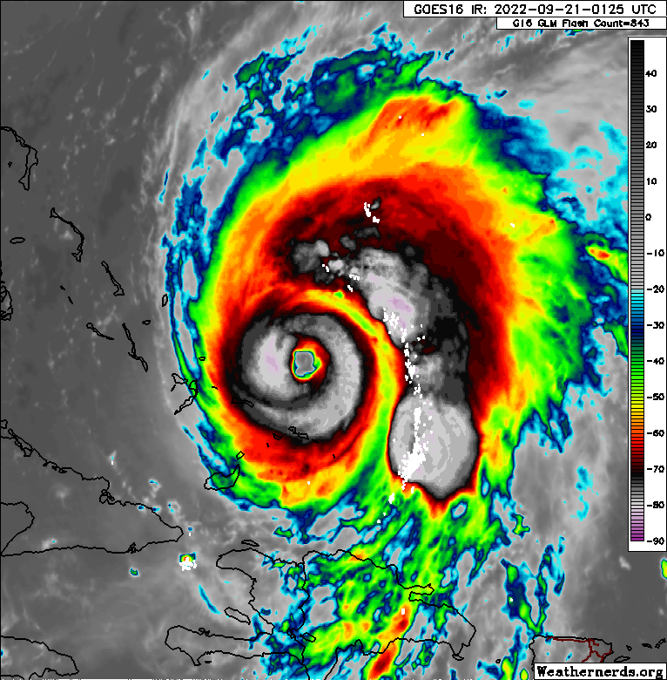
0200 | Heading back inbound from N
0219 | Heading inbound from NE
022423 | RMW Sonde 34 23.14N 71.35W
022453 | RMW Sonde 35 23.13N 71.36W
022533 | RMW Sonde 36 23.11N 71.38W
0237 | 23.2299N 71.7519W is splash point
0239 | 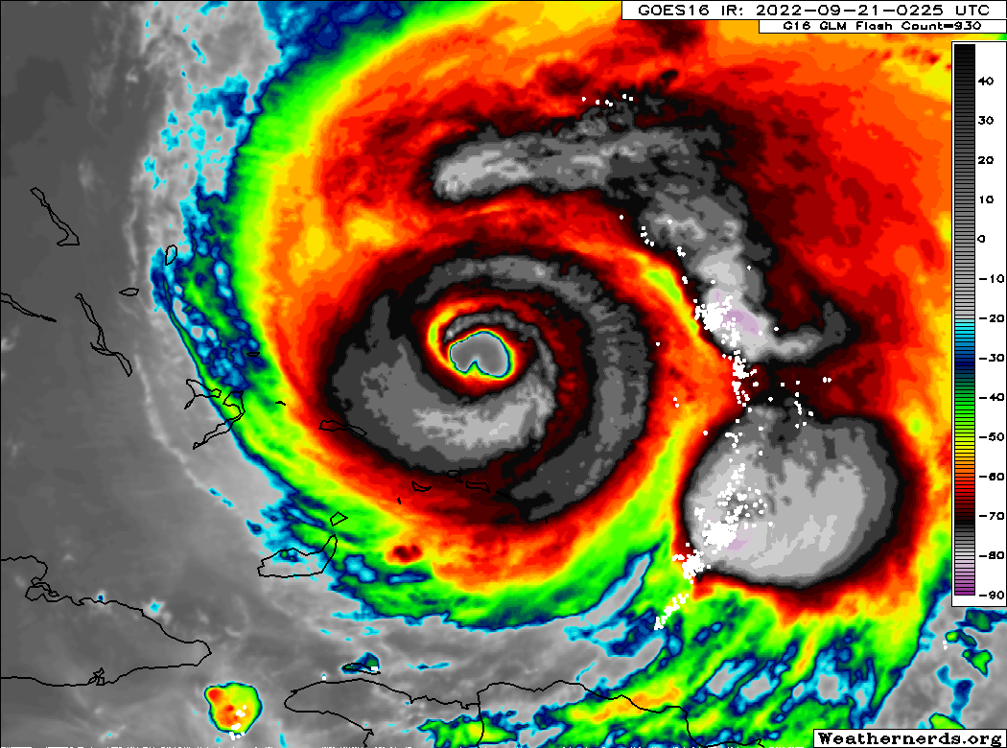
0249 | Final radar analysis  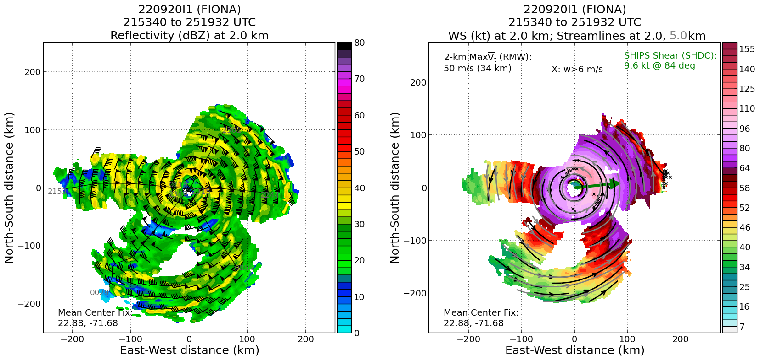
0252 | 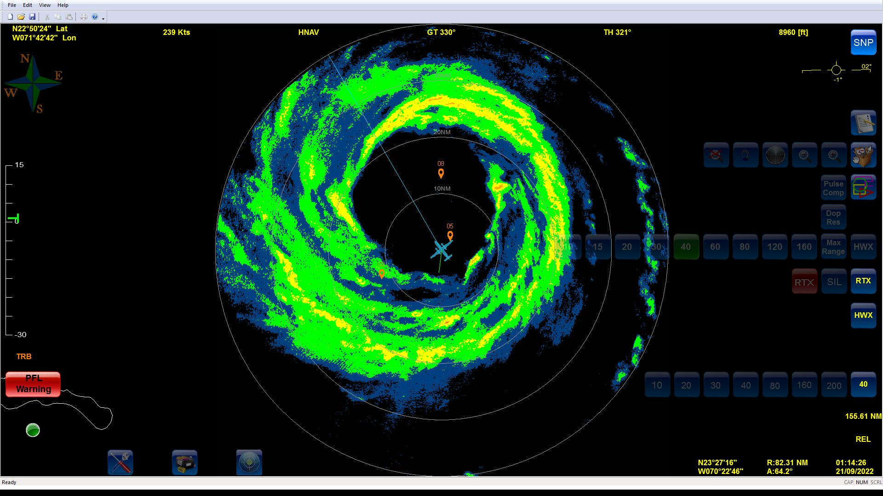
025555 | RMW Sonde 37 23.19N 71.5W
025627 | RMW Sonde 38 23.19N 71.5W
025649 | RMW Sonde 39 23.2N 71.52W
0308 | Midpoint Sonde 40 24.3N 72.12W
0324 | Combo Away (AXBT 4, Sonde 41) 24.5N 72.53W, SST 29.52C
0325 | Science Complete

POST-FLIGHT
Mission Summary | The mission was a successful TDR butterfly with a FLAIMS module added on as well as several SFMR validation sonde overflights and NESDIS Ocean Winds radial legs.  Fiona was completing an ERC and strengthened throughout the flight, becoming a high-end Category 3 hurricane by the end of the flight. Max SFMR in HDOBs was 112 kt, max 1-sec SFMR was 59 m/s, and max flight-level in HDOBs was 120 kt. 8 eyewall penetrations.  We were able to drop 41 sondes including quite a few in the RMW to sample the wind field of the intensifying TC.
Actual Standard Pattern Flown | Butterfly with a FLAIMS module, overflight of dropsonde splash locations, and Ocean Winds legs.
APHEX Experiments / Modules Flown | Modules were flown for the Mature Stage Experiment with the Surface Wind and Wave Validation and Ocean Winds. Though the storm was well into the mature stage, the Flight-level Assessment of Intensification in Moderate Shear (FLAIMS) Module, part of the Early Stage Experiment: Analysis of Intensity Change Processes (AIPEX) was also flown.
Plain Language Summary | - Hurricane Fiona was strengthening through the flight.  - We collected data for NHC (storm characteristics), data assimilation into the Hurricane Weather Research and Forecasting (HWRF) and Hurricane Analysis and Forecast Systems (HAFS) models, and instrument validation of surface winds.
Instrument Notes | Instruments worked well
Final Mission Track | 