MISSION PLAN
FLIGHT ID | 20220908I1 | STORM | AL06 / EARL
MISSION ID | 2206A | TAIL NUMBER | NOAA43
TASKING | EMC | PLANNED PATTERN | Butterfly
MISSION SUMMARY
TAKEOFF [UTC] | 1954 | LANDING [UTC] | 0524
TAKEOFF LOCATION | St. Croix | LANDING LOCATION | St. Croix
FLIGHT TIME | 9.5 | BLOCK TIME | 9.7
TOTAL REAL-TIME RADAR ANALYSES  (Transmitted) | 9 (9) | TOTAL DROPSONDES (Good/Transmitted) | 24 (24 / 24)
OCEAN EXPENDABLES (Type) | 4 AXBT (ONR) | sUAS (Type) | None
APHEX EXPERIMENTS / MODULES | Mature Stage Experiment: NESDIS Ocean Winds Experiment,  Ocean Surface Wind and Wave Validation Module
HRD CREW MANIFEST
LPS ONBOARD | Holbach | LPS GROUND | Alaka
TDR ONBOARD | Holbach | TDR GROUND | Gamache
ASPEN ONBOARD | Aberson | ASPEN GROUND | None
NESDIS SCIENTISTS | Chang, Jelenak, Sapp, Bjorland
GUESTS (Affiliation) | None
AOC CREW MANIFEST
PILOTS | Doremus, Copare, Wood
NAVIGATOR | Utama
FLIGHT ENGINEERS | Darby, Pittman
FLIGHT DIRECTOR | Kalen, Holmes
DATA TECHNICIAN | T. Richards
AVAPS | Warnecke

PRE-FLIGHT
Flight Plan | 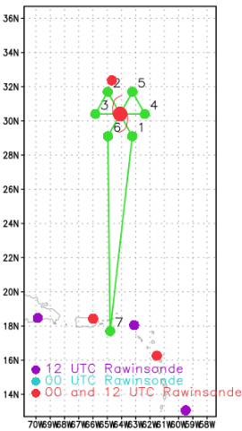  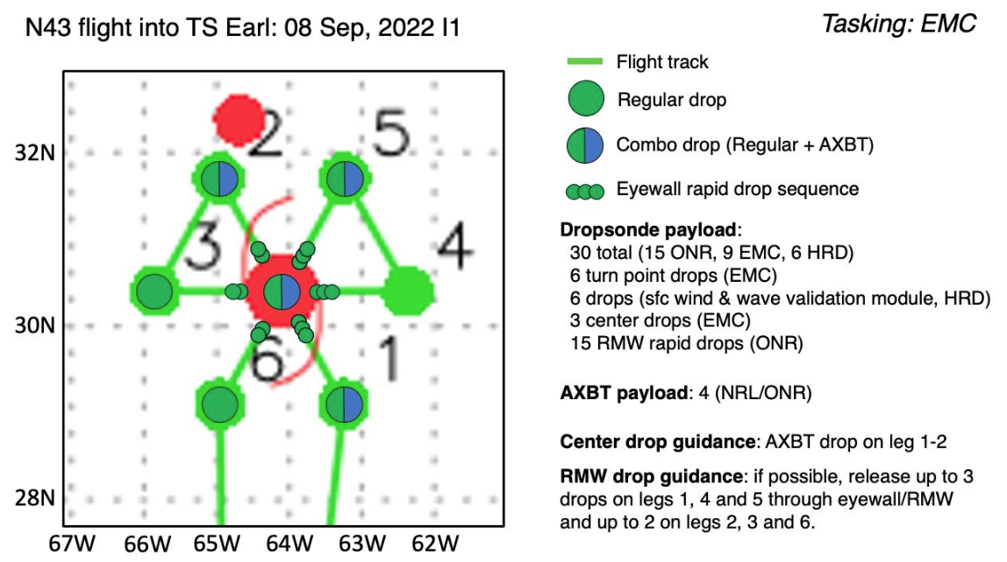  Ferry north from STX to Earl; standard butterfly pattern; ferry south from Earl to STX  Pattern: Fly butterfly pattern with 90 nmi legs  Altitude: 10 kft (pressure altitude- can be adjusted to 10 kft radar altitude for NESDIS Ocean Winds)  Potential add-on Modules:  - NESDIS Ocean Winds Experiment  - Surface Wind and Wave Validation Module  Load 30 sondes (all dropsondes transmitted to the GTS); 4 ONR/NRL AXBTs (all AXBTs transmitted to the AOC ground server if possible)
Expendable Distribution | Release dropsondes at endpoints, centers; possible supplemental rapid RMW drops across. Due to the shorter leg lengths and planned RMW sequences, midpoints are omitted for this mission.
Preflight Weather Briefing | Earl is currently a category 2 hurricane with maximum sustained winds of 90 kt and minimum sea level pressure of 962 mb as of the 2pm AST NHC advisory. It is starting to make a turn towards the NE and is slowly accelerating. Earl is expected to pass just to the east of Bermuda this evening. NHC forecasts Earl to have maximum sustained winds of 100 kt at 00Z this evening while we are in the storm.  Despite the improved appearance of Earl in satellite imagery, recent aircraft data from NOAA42 and the AF have not found SFMR winds greater than ~70 kt today despite a continued drop in minimum sea level pressure. TDR analysis from NOAA42 also reflected the decrease in wind speeds from NOAA43’s flight last night. The surface winds do not seem to be reflecting the drop in sea level pressure, so this could be a very interesting case to investigate the relationship between wind and pressure.
Instrument Notes | None

IN-FLIGHT
Time [UTC] | Event
1855 | 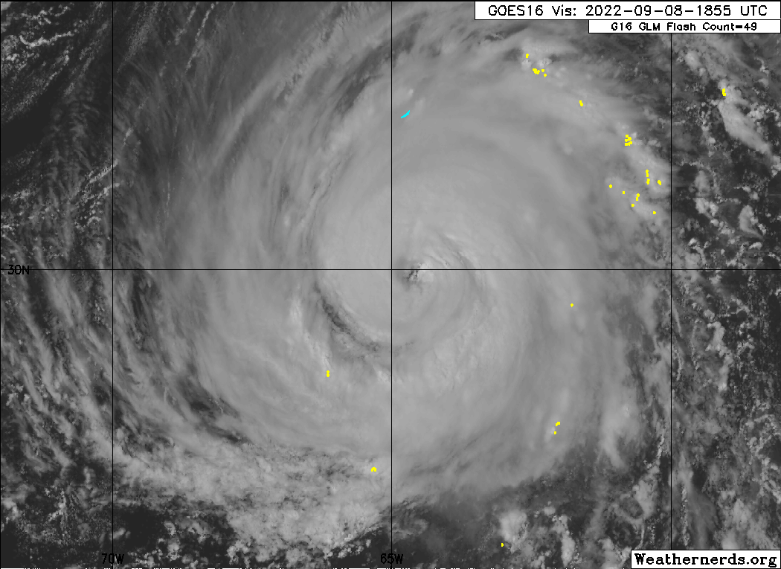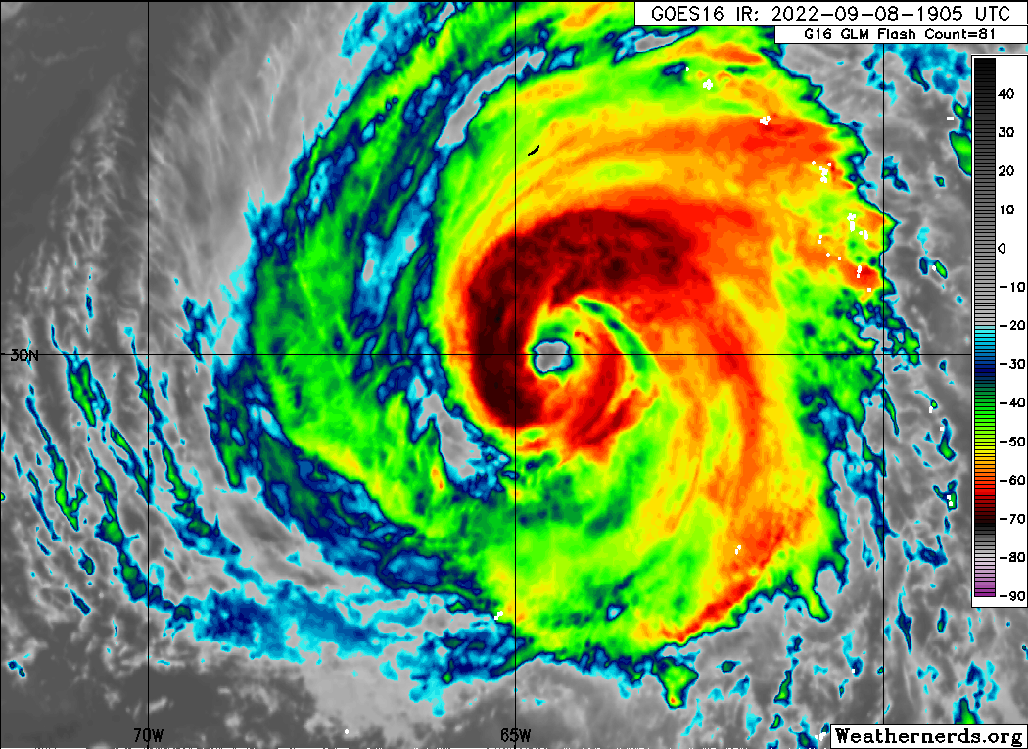  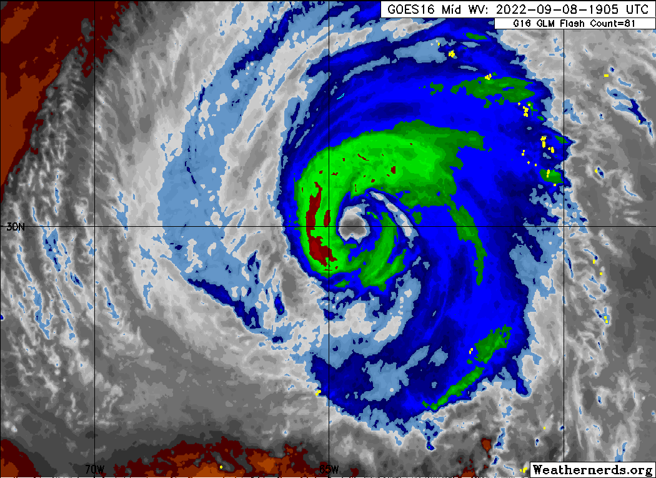
1905 | Earl is racing toward a baroclinic low pressure system. The resulting interaction could be complex, including the potential for baroclinic forcing to assist further intensification of Earl before a quick extratropical transition. The outflow from Earl appears to be strengthening an upper-level low to its east, which is increasing wind shear of 95L and decreasing its chances for development. This is an “indirect” storm-storm interaction as Earl is modulating the environment that is then modulating 95L.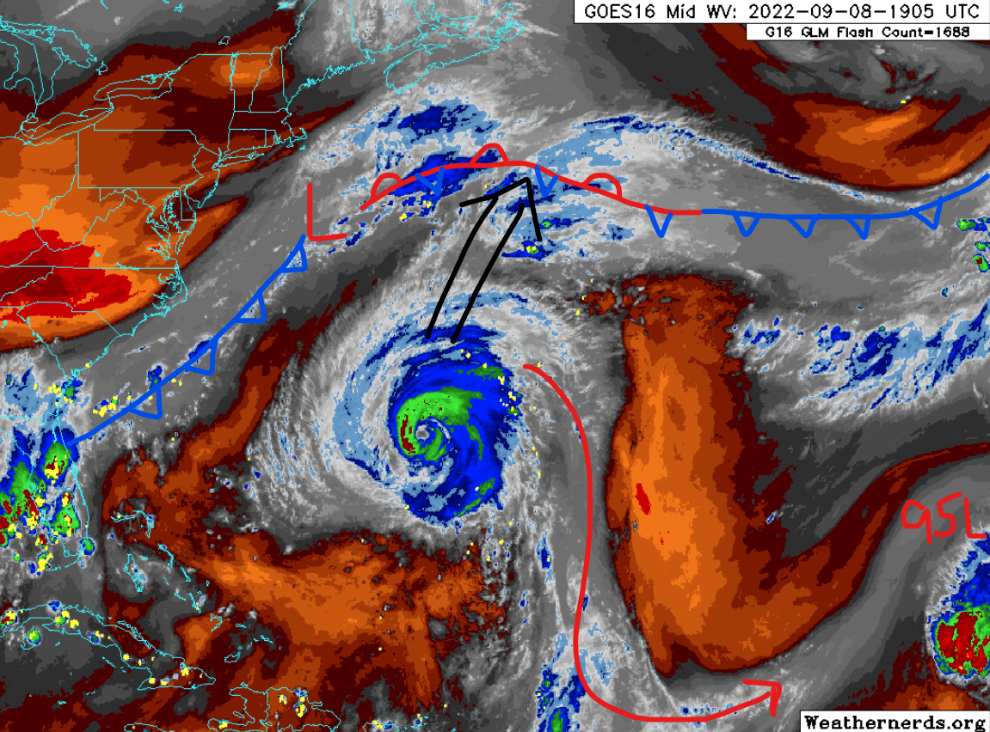
1937 | Air Force mission preceding this mission  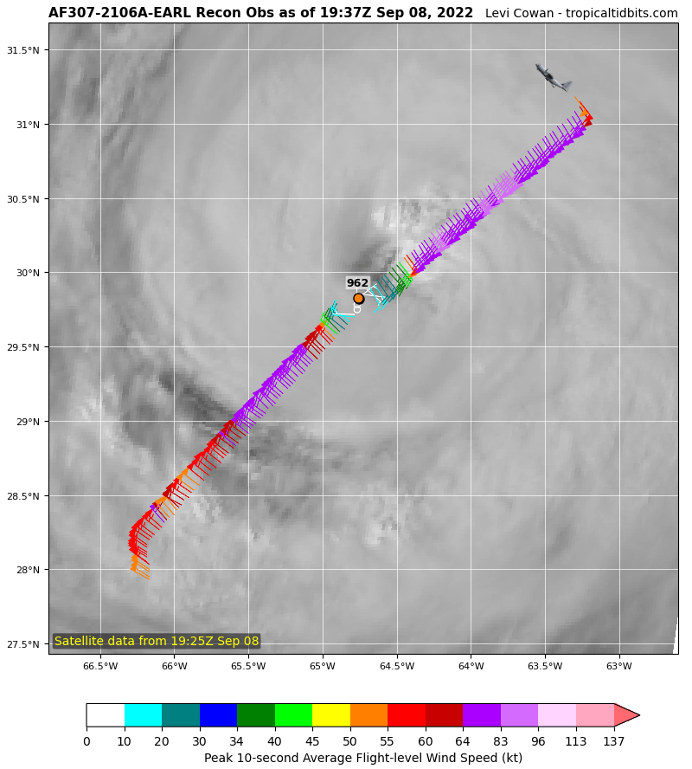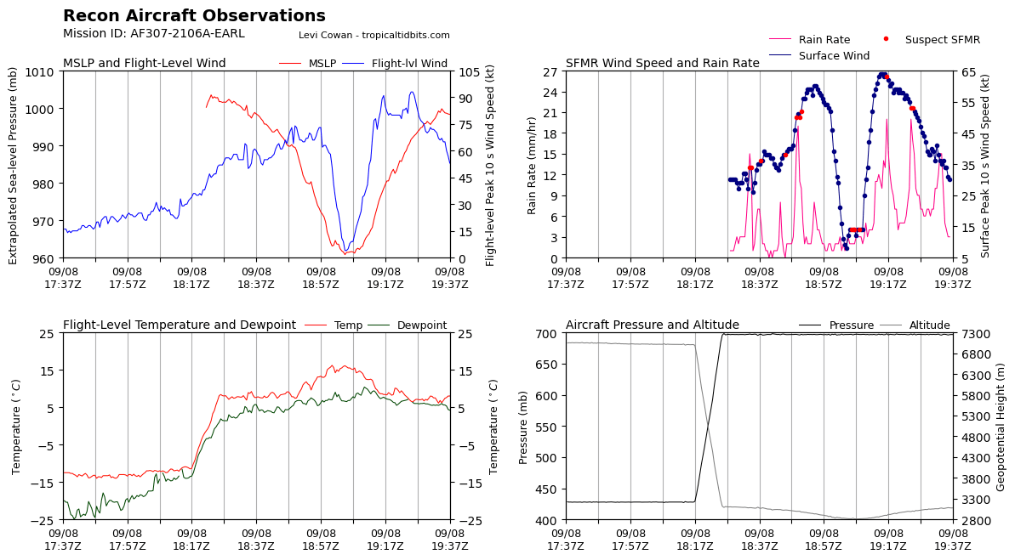
1951 | Flight plan and geocolor satellite just before takeoff  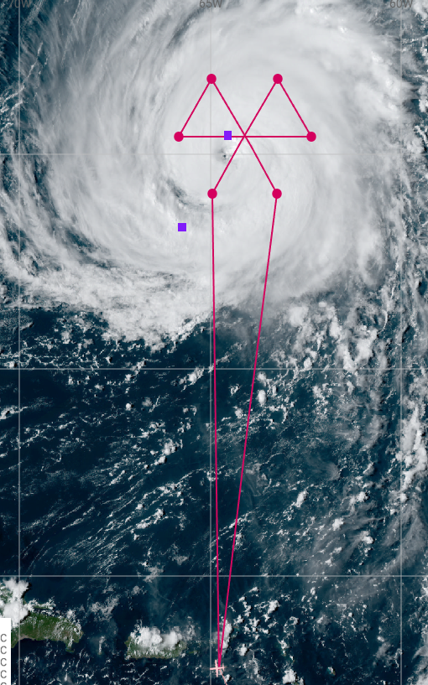
1954 | Take off from St. Croix
2052 | TDR looks good - level on fore and aft
2055 | 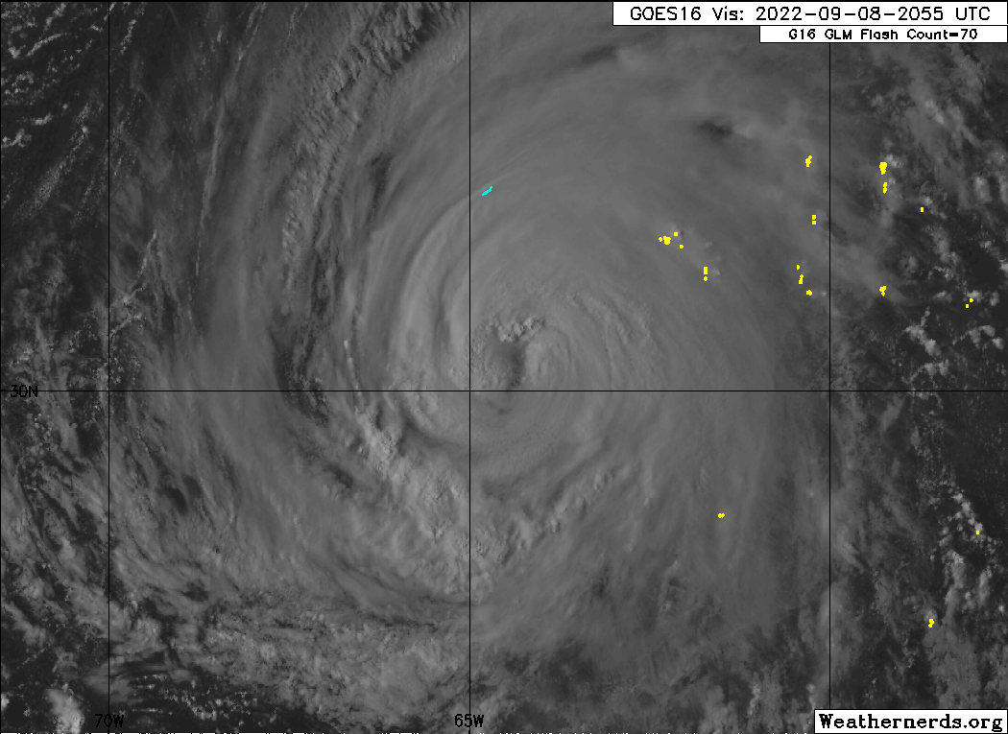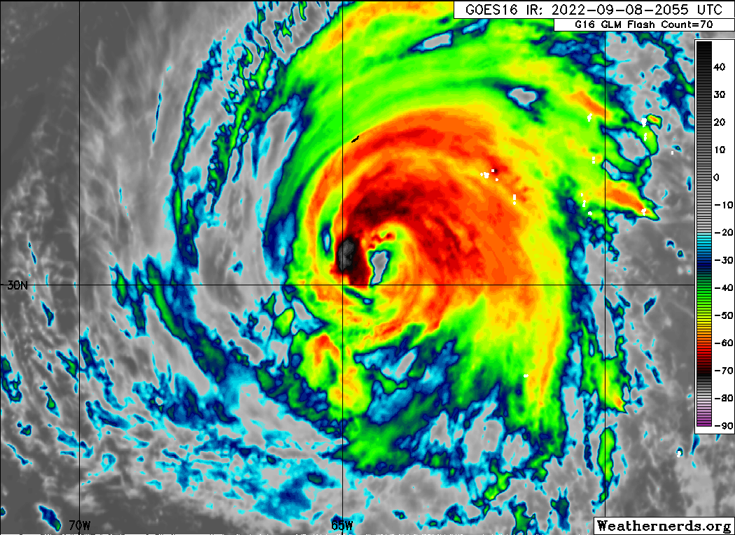  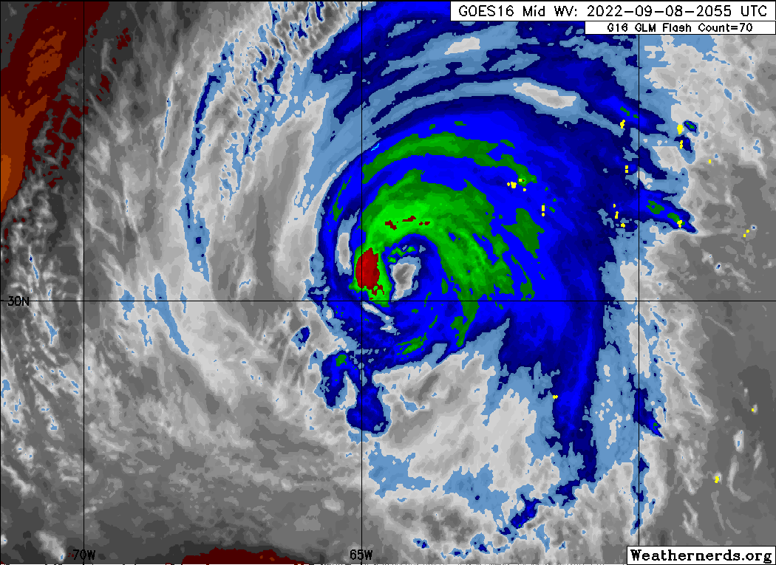
2136 | Flying over mid-level clouds at the edge of Earl’s circulation
2141 | 961mb from latest AF fix. SFMR near 70kt in the NW eyewall. Surface winds up a bit but still low given the pressure. Wind field has expanded (esp. SE), which could be contributing to the breakdown of the pressure-wind relationship.  Under the CDO now. It entrained some dry air earlier today. Will be interesting to see if it can recover.
2145 | Beginning descent to IP
2200 | AXBT #1 (SE Endpoint)  early drop due to weather; failed
2201 | IP
2205 | Drop #1 (SE Endpoint; EMC)  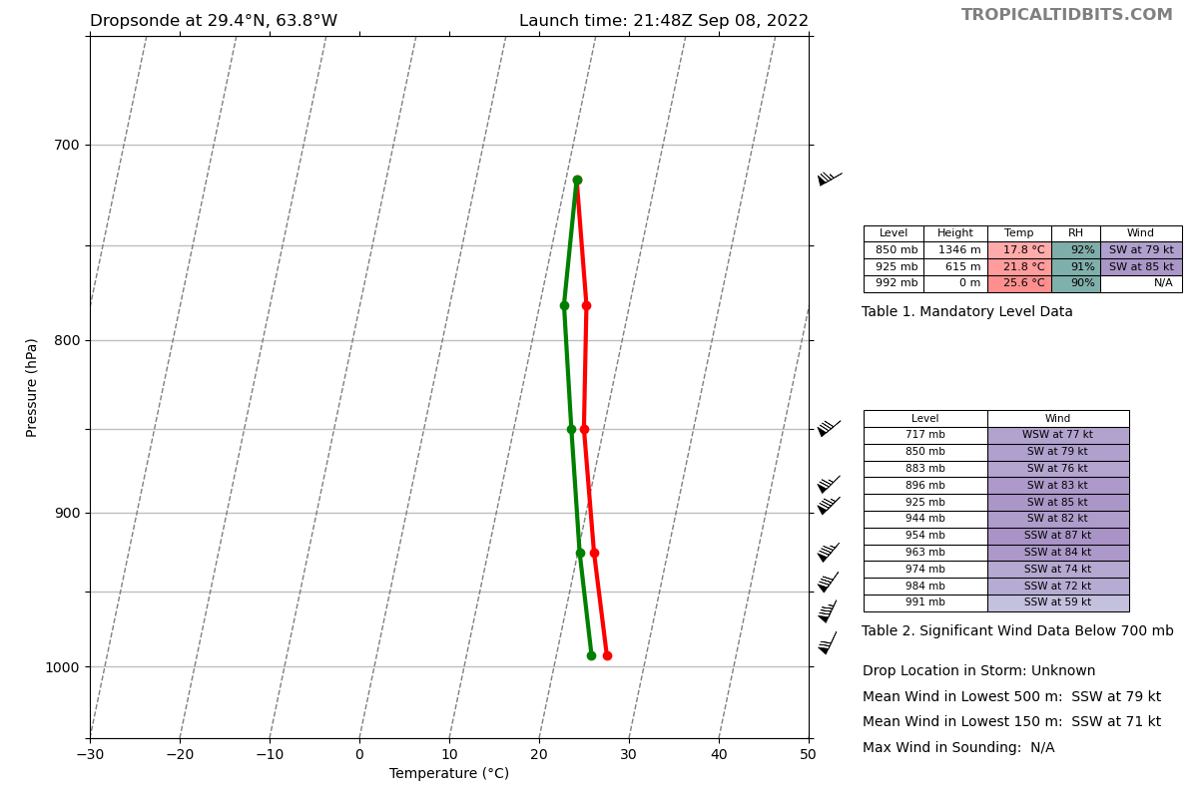
Drop #2 (SE Eyewall; ONR)
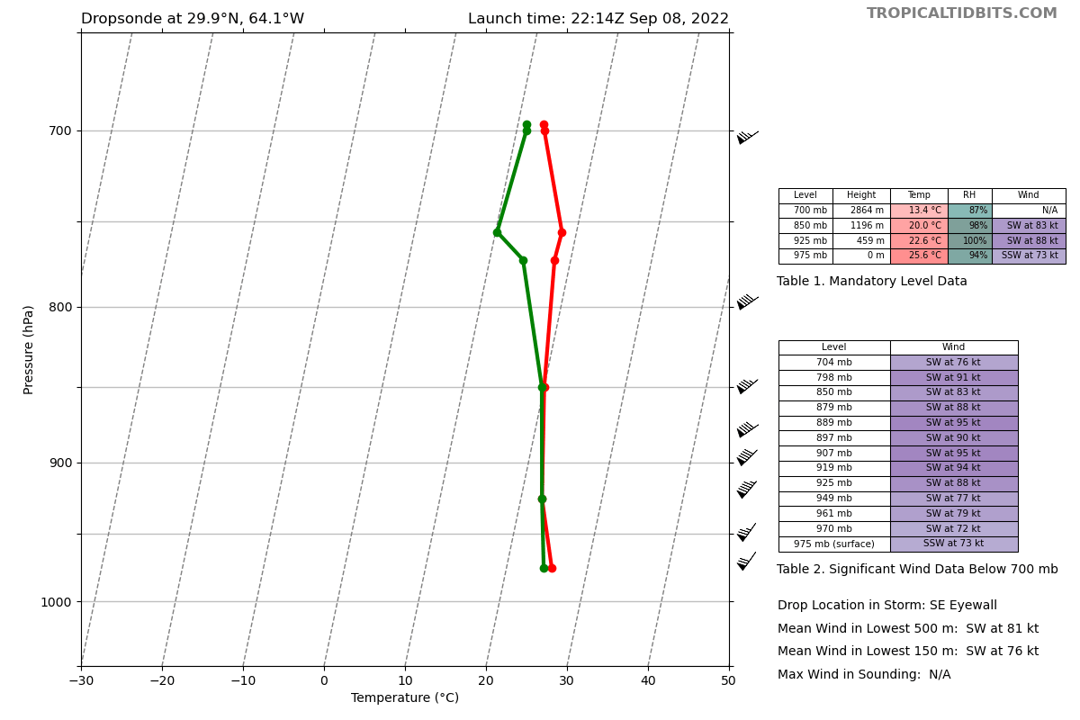
Drop #3 (SE Eyewall; ONR)
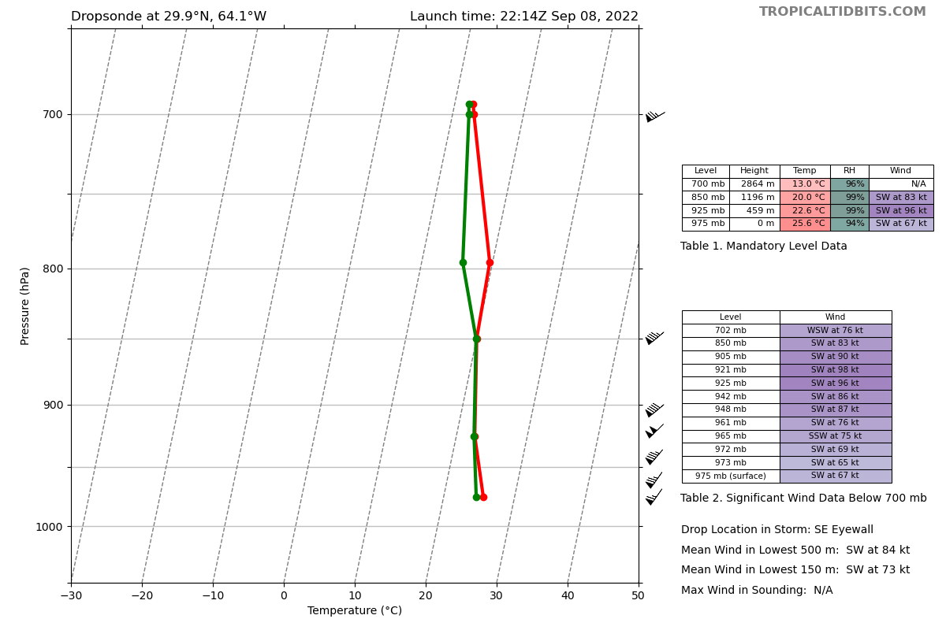
Drop #4 (SE Eyewall; ONR)
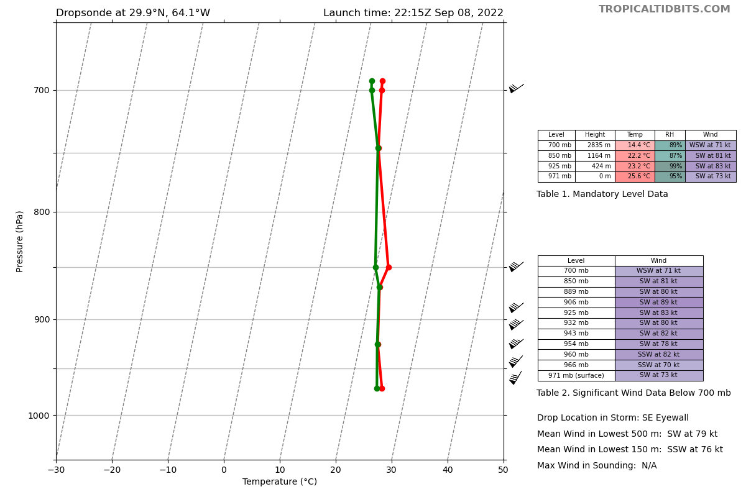
2219 | 52 n mi eye, mostly clouded over (observed by Holbach)
2220 | AXBT #2 (Eye)  28.00C
2222 | Mark center
2222 | Drop #5 (Eye; EMC)  962 mb; 10-m wind 22008  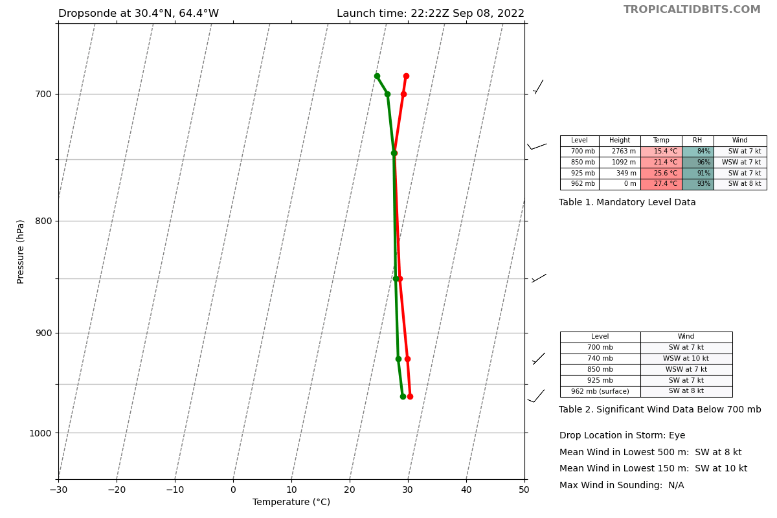
Drop #6 (NW Eyewall; ONR)
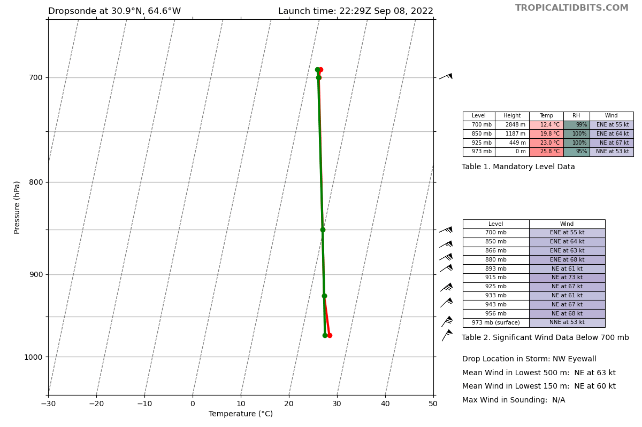
Drop #7 (NW Eyewall; ONR)
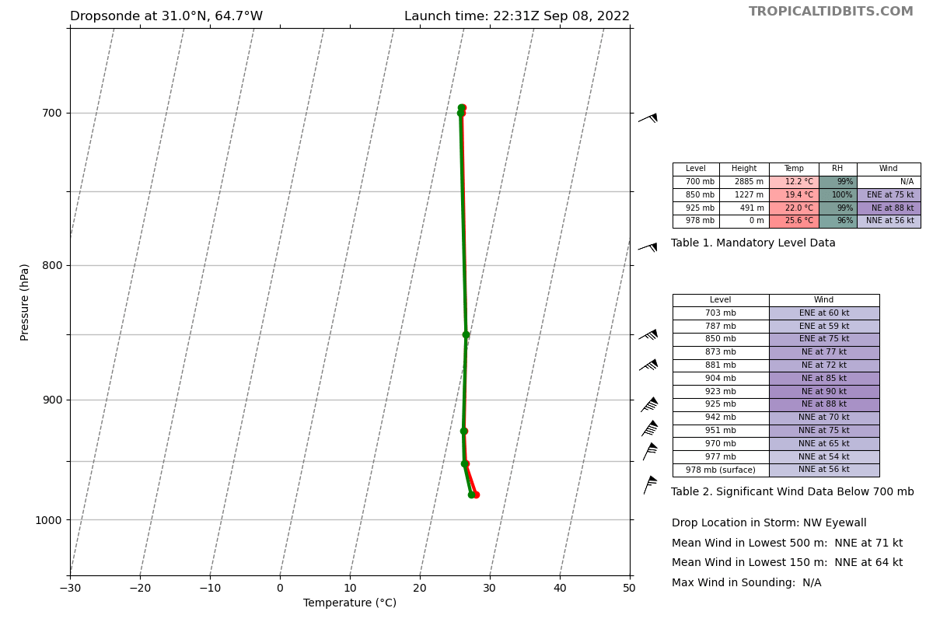
2235 | Sim will fill out a local dropsonde log on the aircraft computer and will upload it periodically to Google Drive. Gus will check that the upload works as expected.
2239 | Holbach observes that the eyewall is not as clean as the last N43 mission
2244 | Drop #8 (NW Endpoint; EMC)  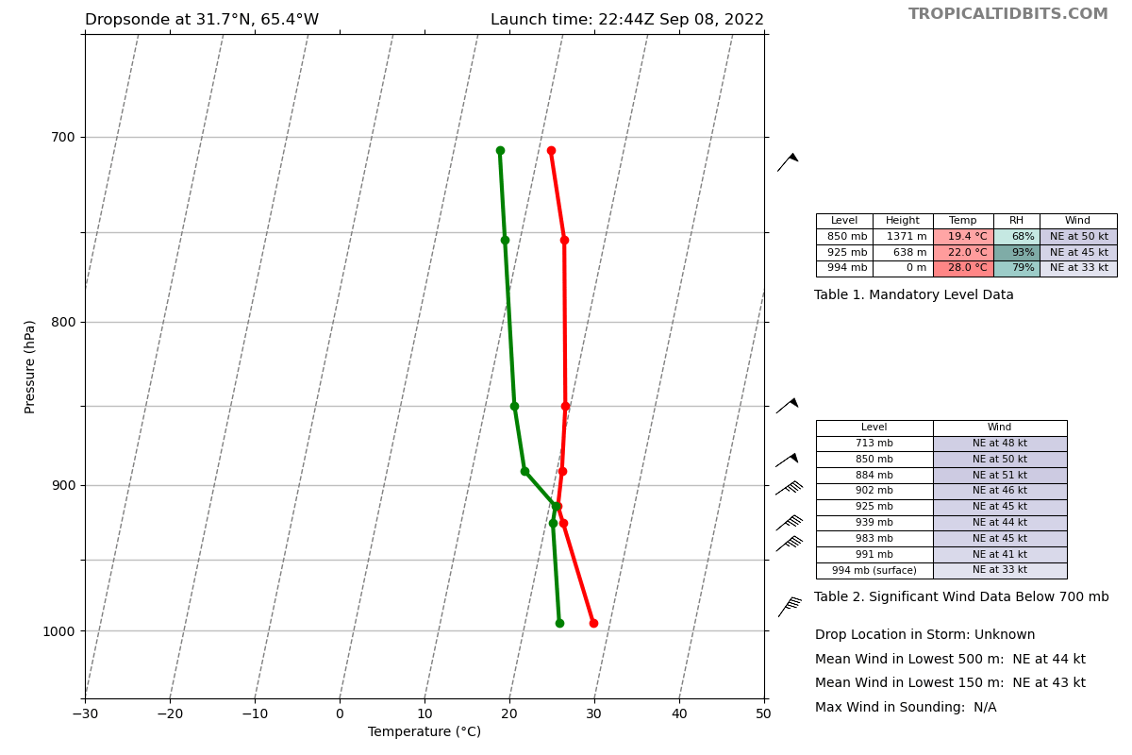
2244 | TDR Composite for 1st leg  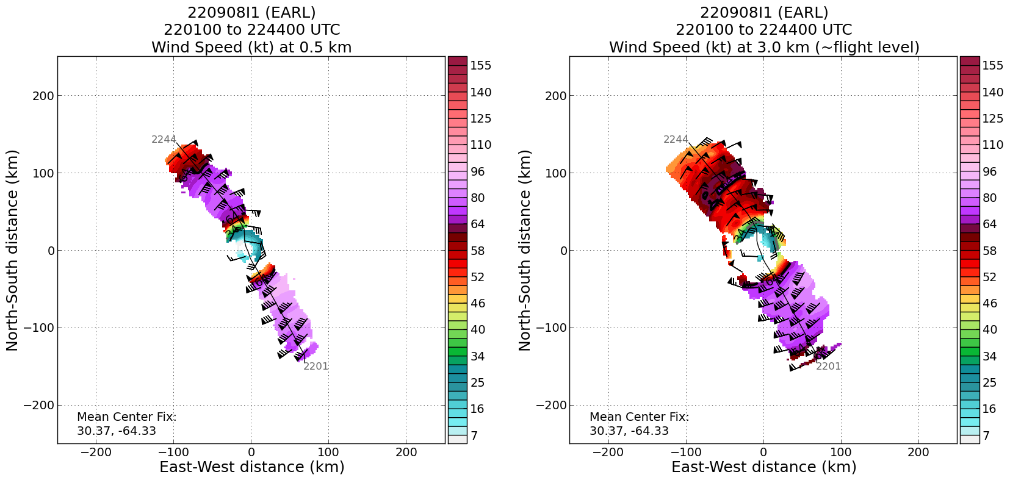
2246 | AXBT #3 (NW Endpoint)  failed
2247 | Flying downwind along the edge of a stratiform region
2255 | There was evidence of a double wind max in the last AF flight. Still a slight hint of that. Earl might be in the midst of an ERC  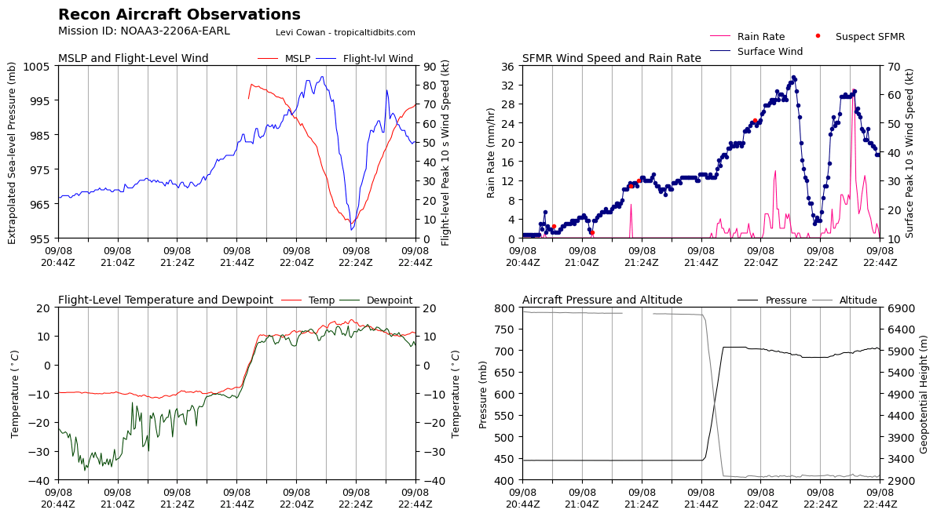
2255 | Ragged appearance on IR and WV as Earl restructures. Seems like an ERC is nearly complete. It will be interesting to see if Earl resumes intensification (forecasted) by the end of this mission  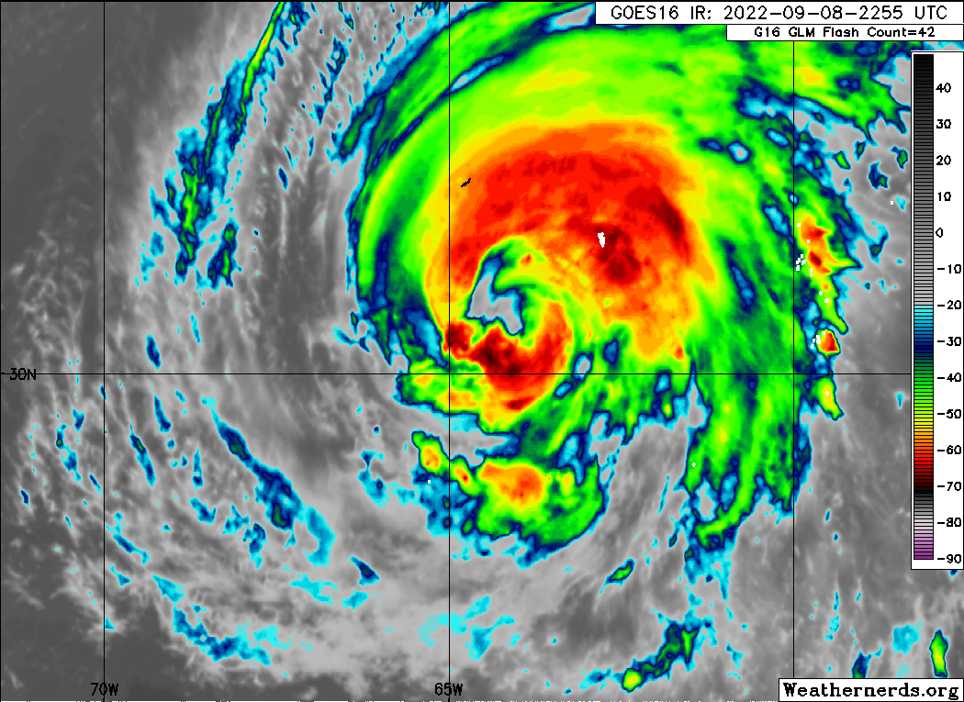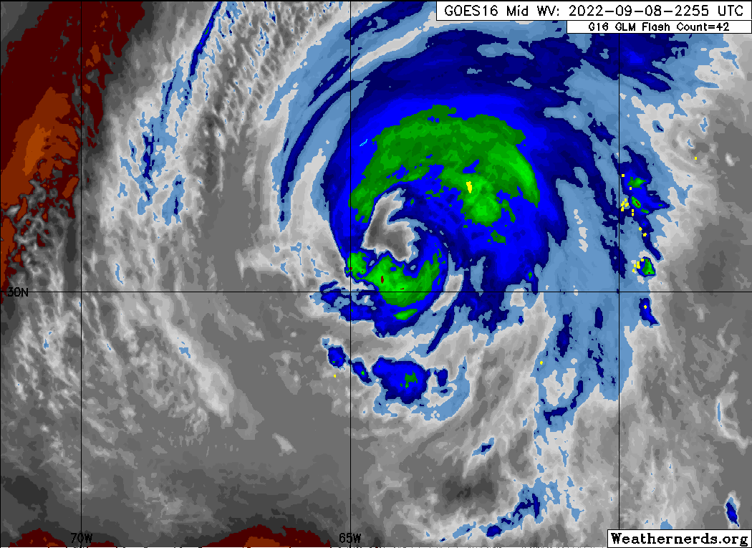
2300 | Turning inbound (eastward)
2302 | Drop #9 (W Endpoint; EMC)  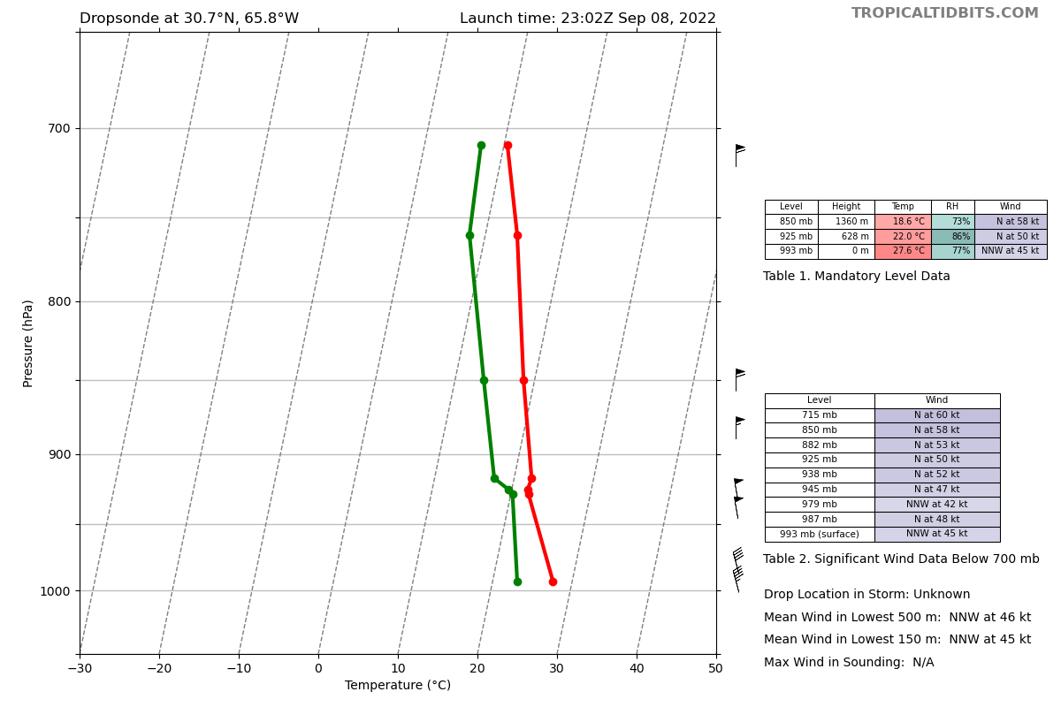
2316 | Holbach observes a pretty broad surface wind peak on the W side.
2311 | Drop #10 (W Eyewall; ONR)  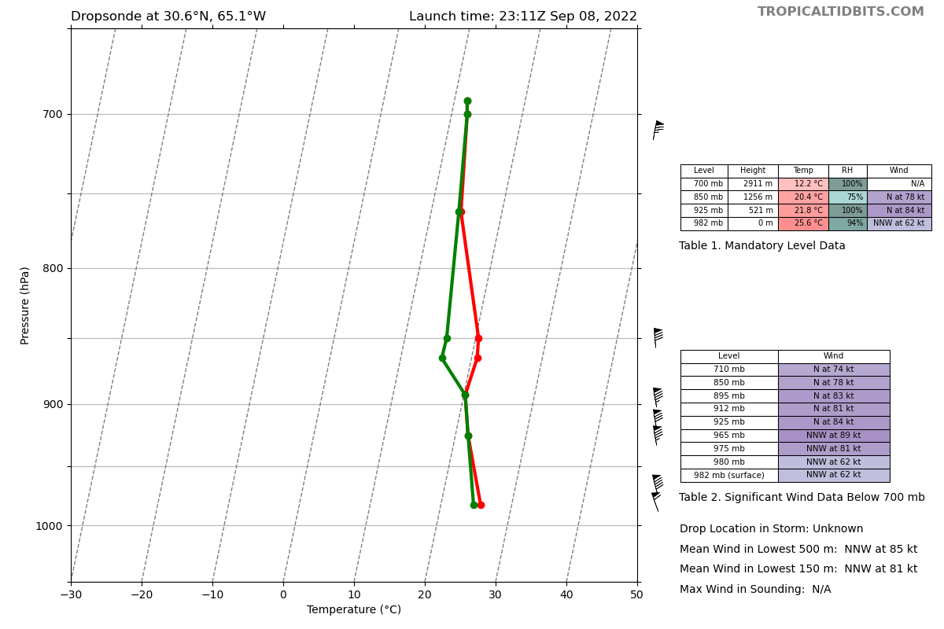
231X | Drop #11 (W Eyewall; ONR)  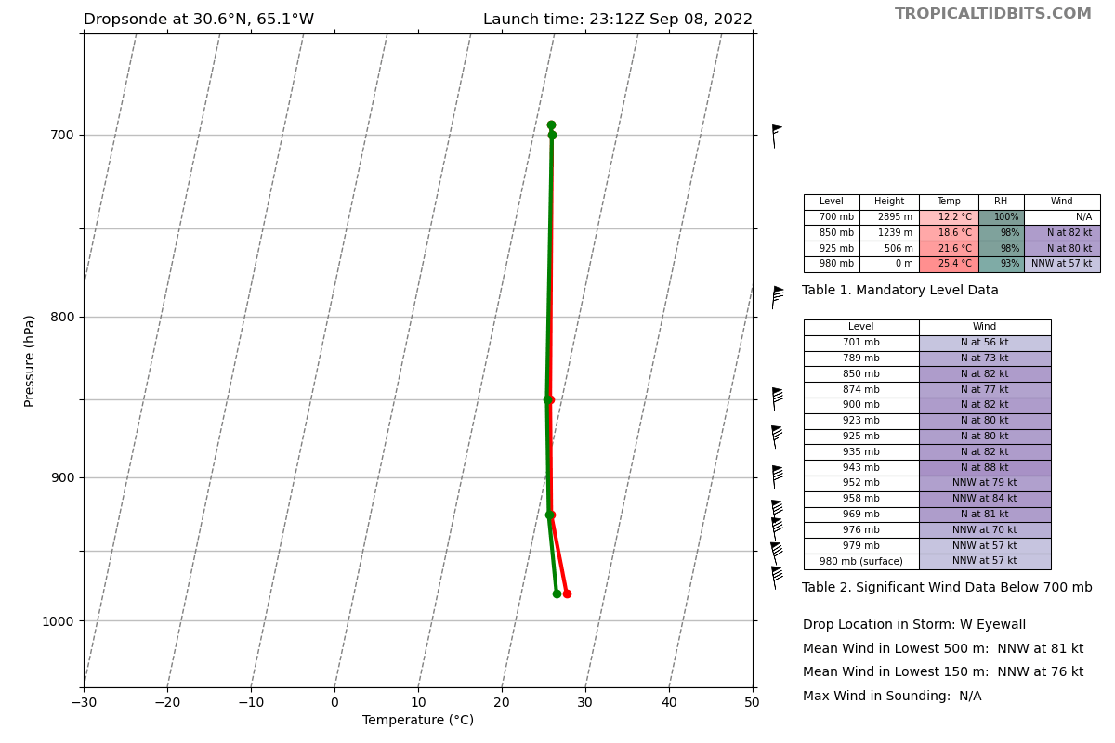
2321 | Drop #12 (Eye; EMC)  964 mb, 10-m wind 06002  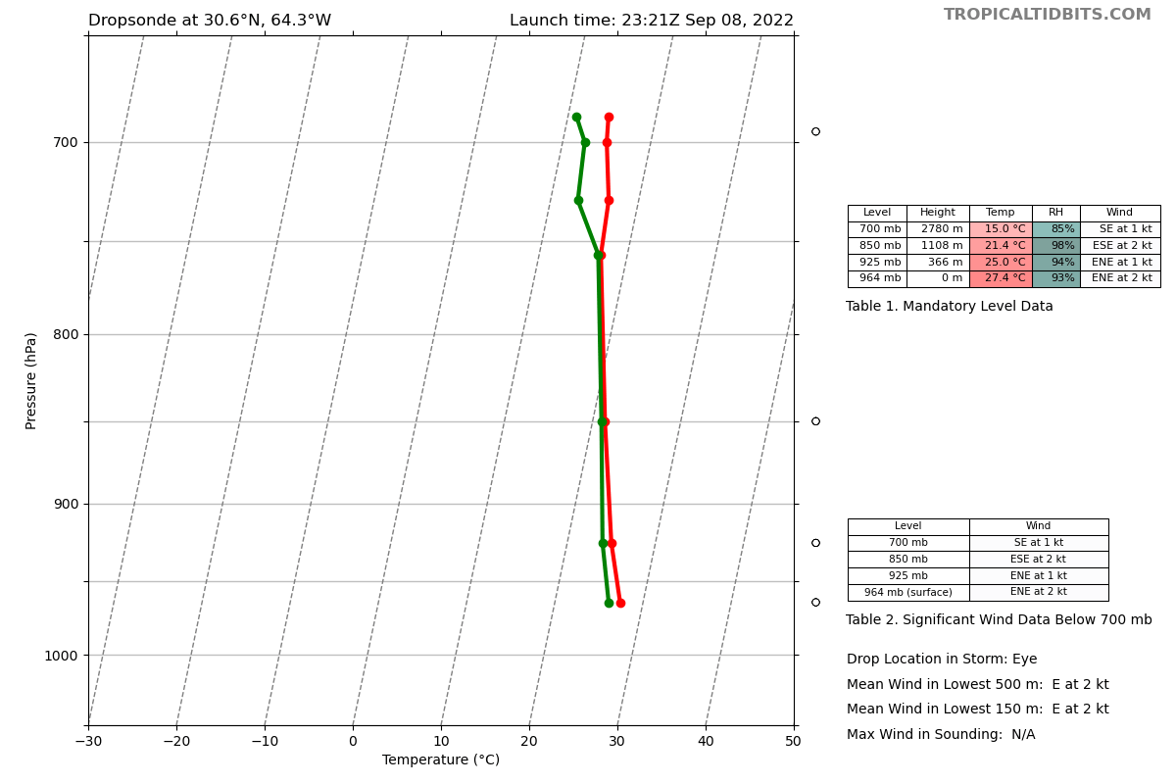
2329 | Drop #13 (E Eyewall; ONR)  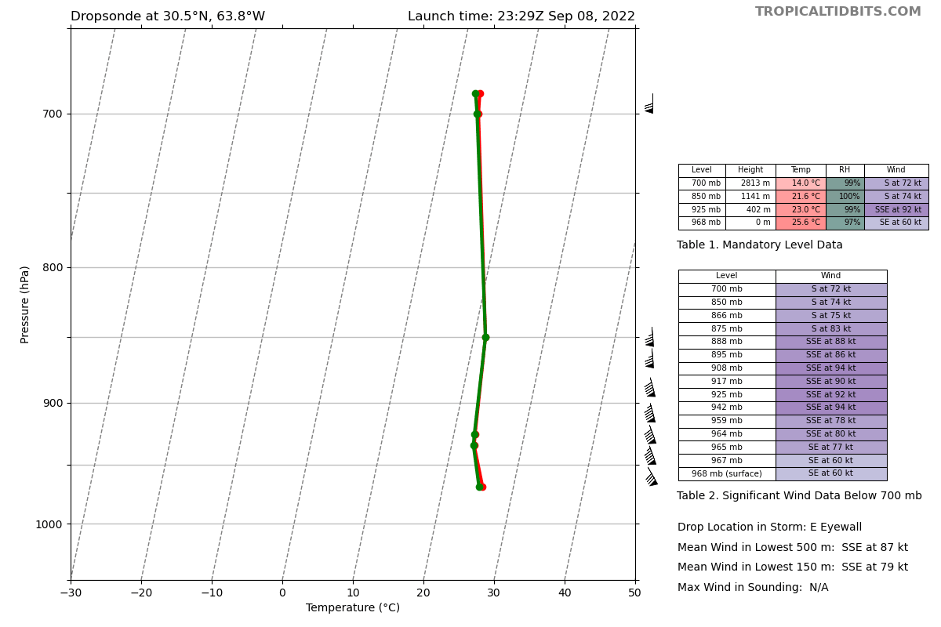
2330 | Drop #14 (E Eyewall; ONR)  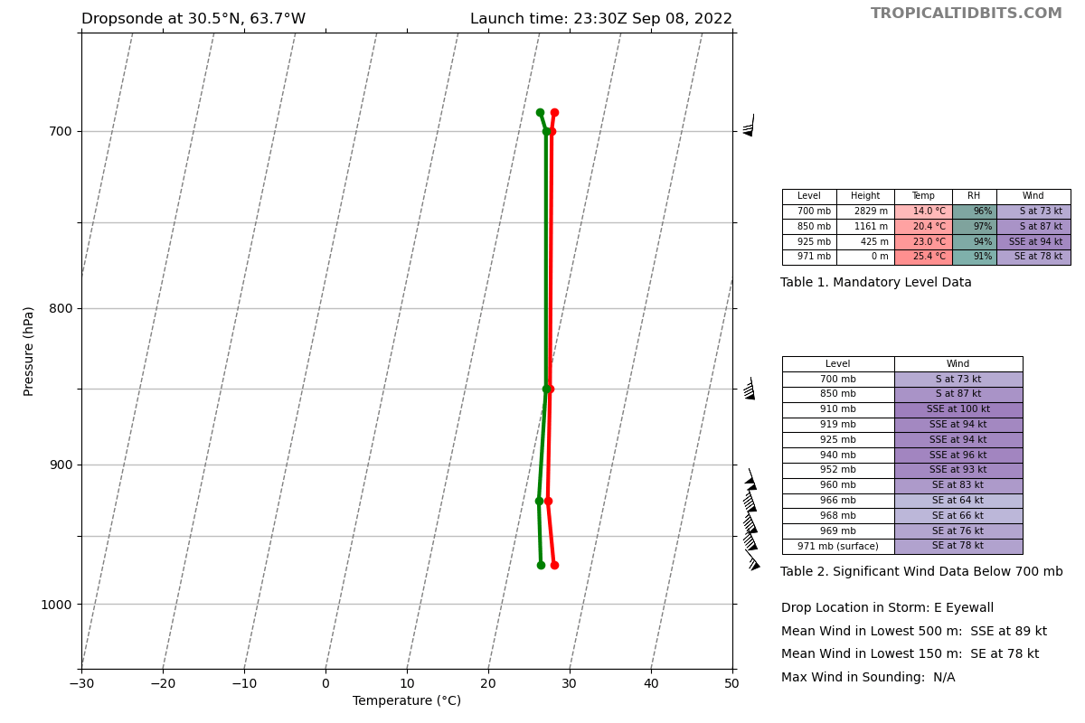
2331 | Drop #15 (E Eyewall; ONR)  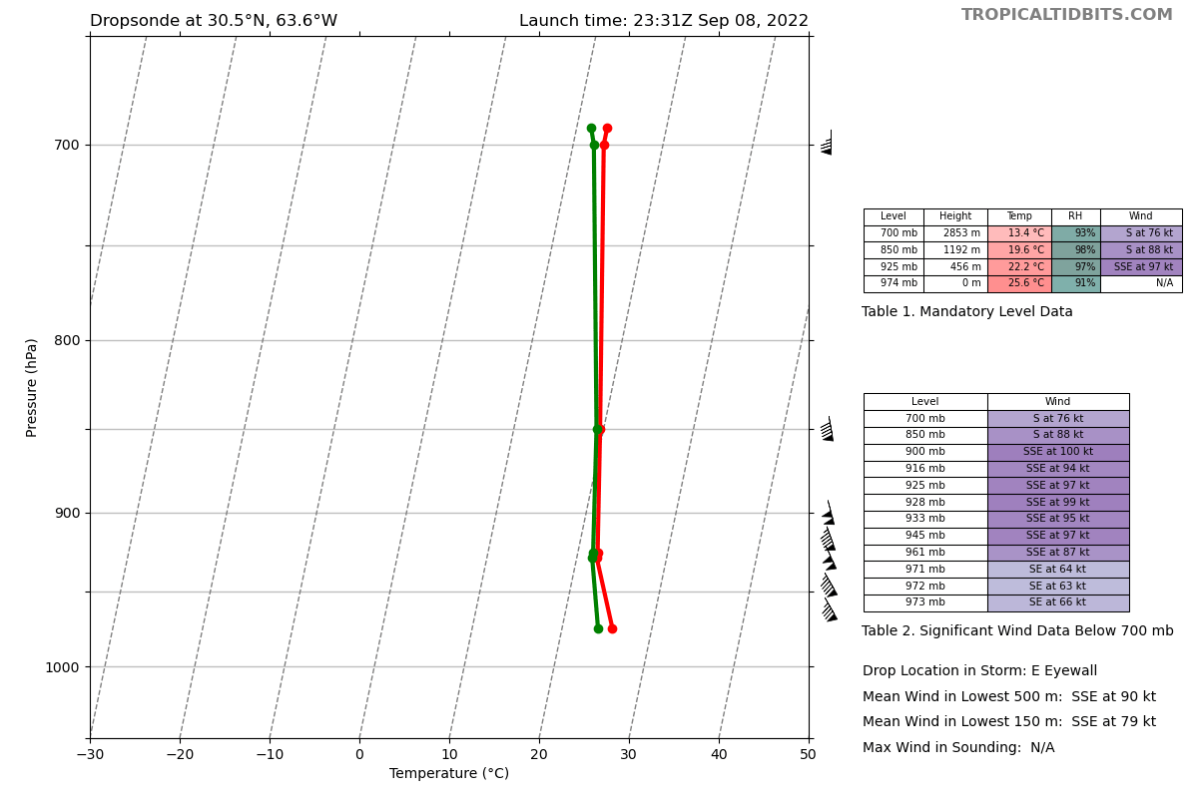
2335 | Despite disorganization, winds are still > hurricane force at the surface. Flight level winds are not mixing down efficiently
2342 | In addition to some internal structural changes, it does seem like the storm is feeling some SW shear, which is beginning to increase.  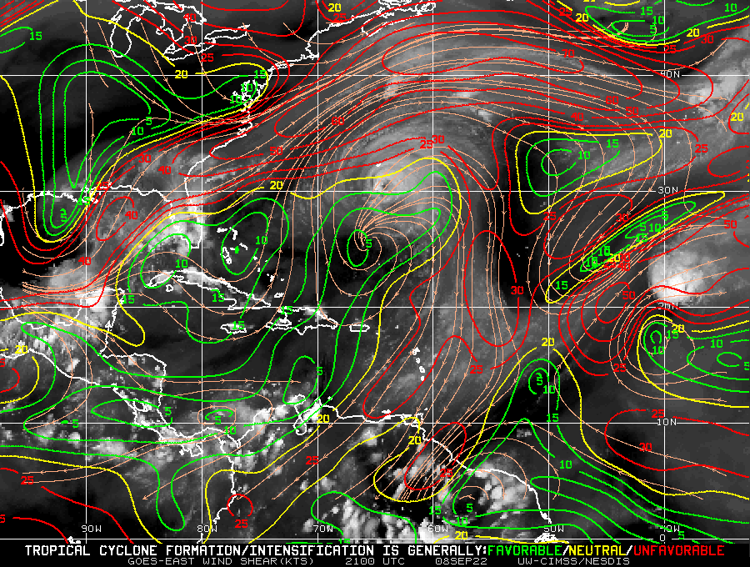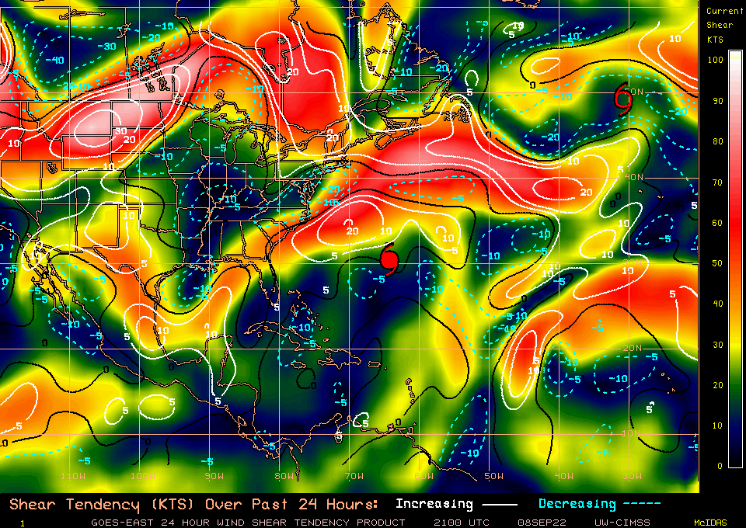
2343 | Drop #16 (E Endpoint; EMC)  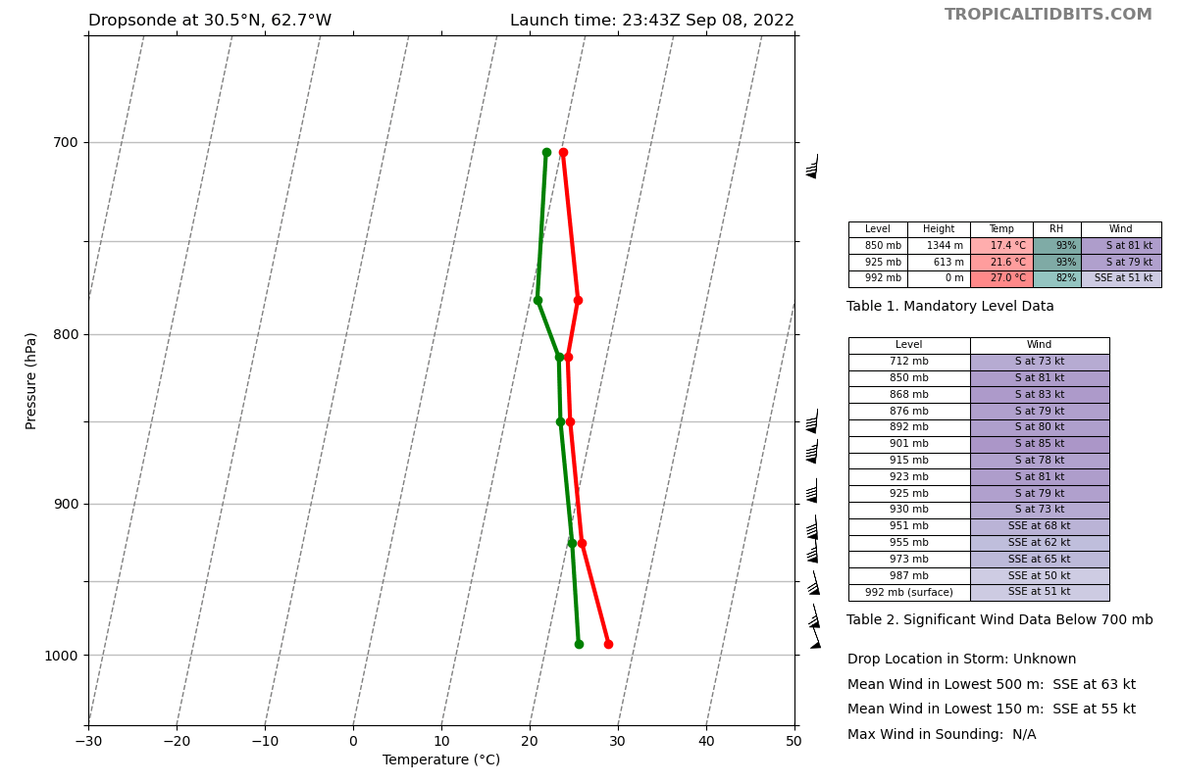
2343 | TDR composite for the first 2 legs  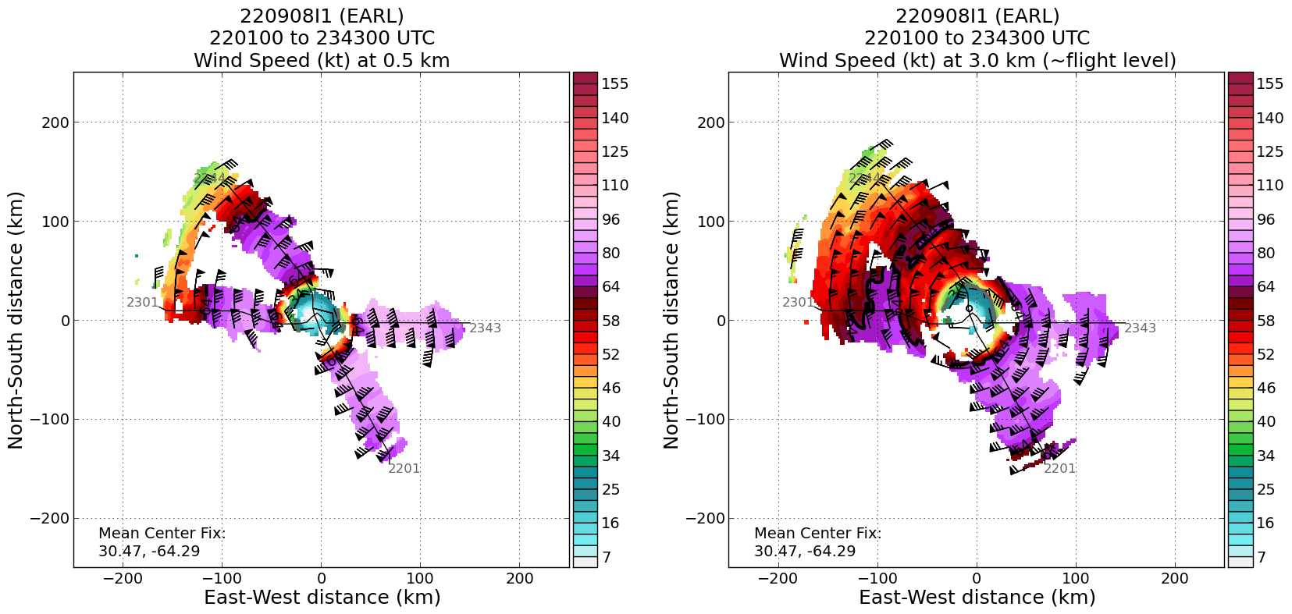
2344 | Turning downwind
2345 | Band off our right wing looks more cellular and band off left wing looks more stratiform. TDR is painting them nicely
2353 | Very broad wind max on the E side, double wind max not as evident
2355 | AXBT #4 (NE Endpoint)  28.38C
2355 | Convection trying to wrap around to the western side. Lightning in the northern eyewall  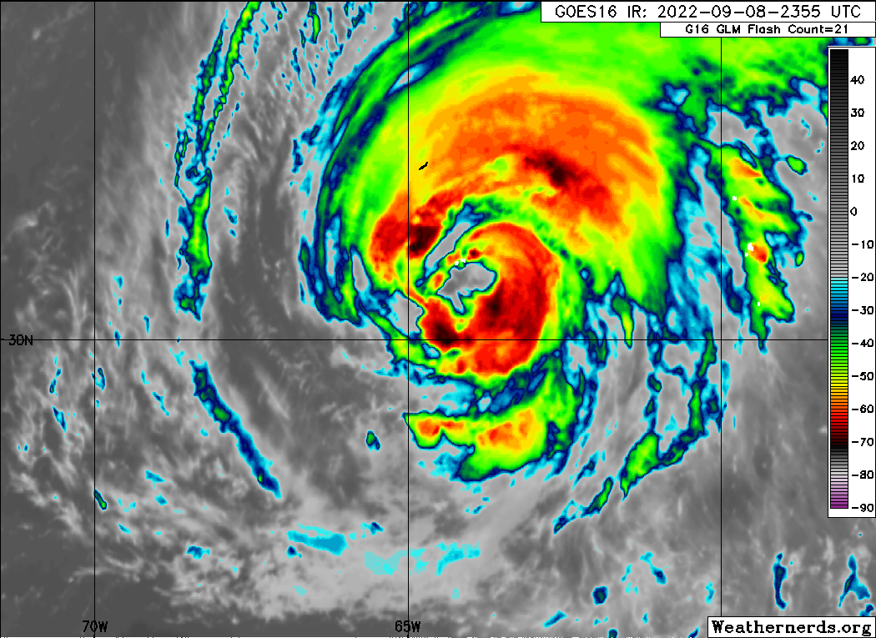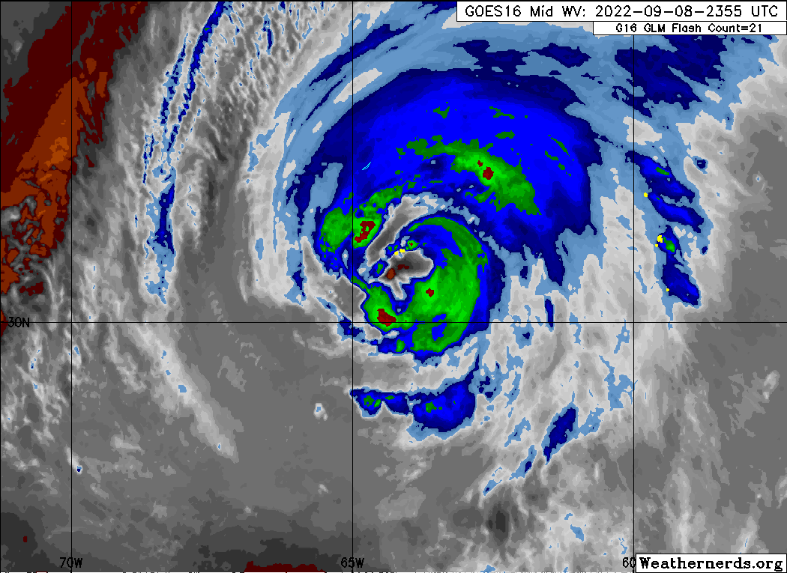
0000 | Turning inbound (SW)
0000 | Drop #17 (NE Endpoint; EMC)  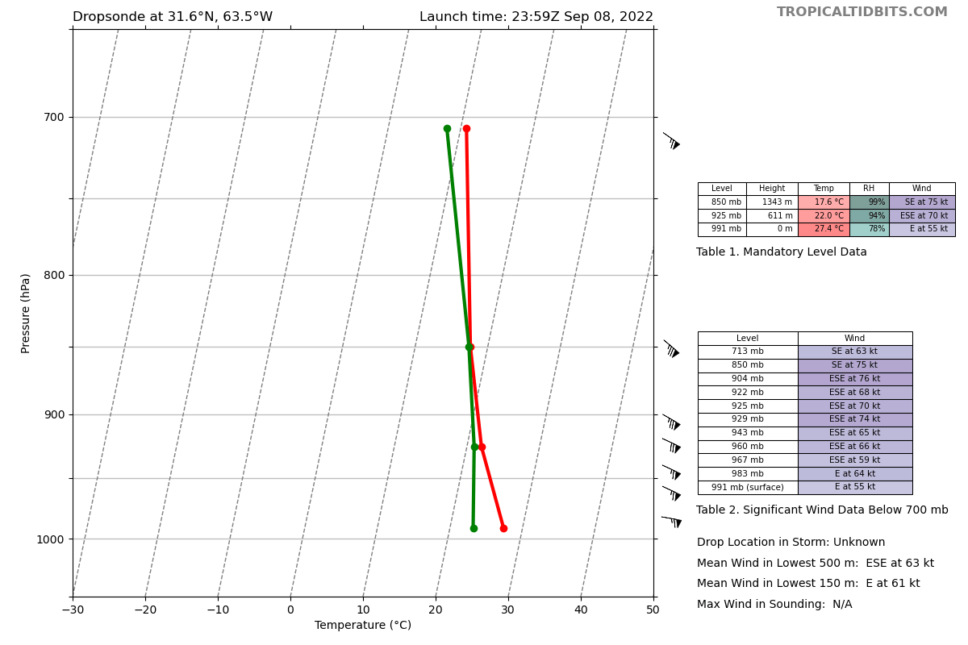
Drop #18 (NE Eyewall; ONR)
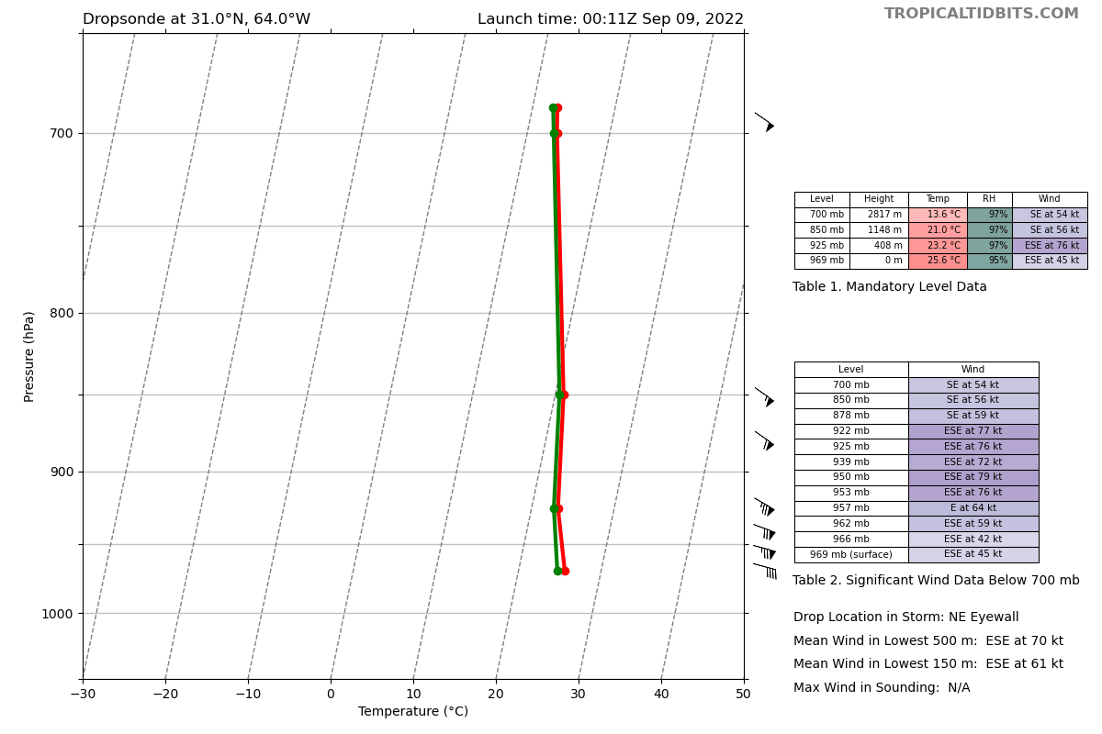
0016 | Drop #19 (Eye; EMC)  964 mb, 10-m wind 15012  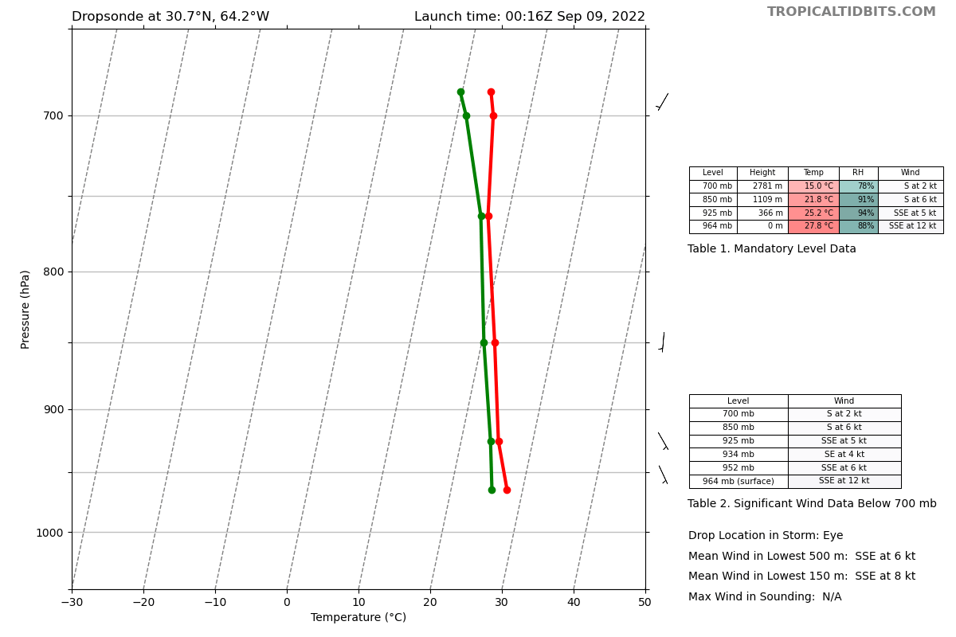
0024 | Drop #20 (SW Eyewall; ONR)  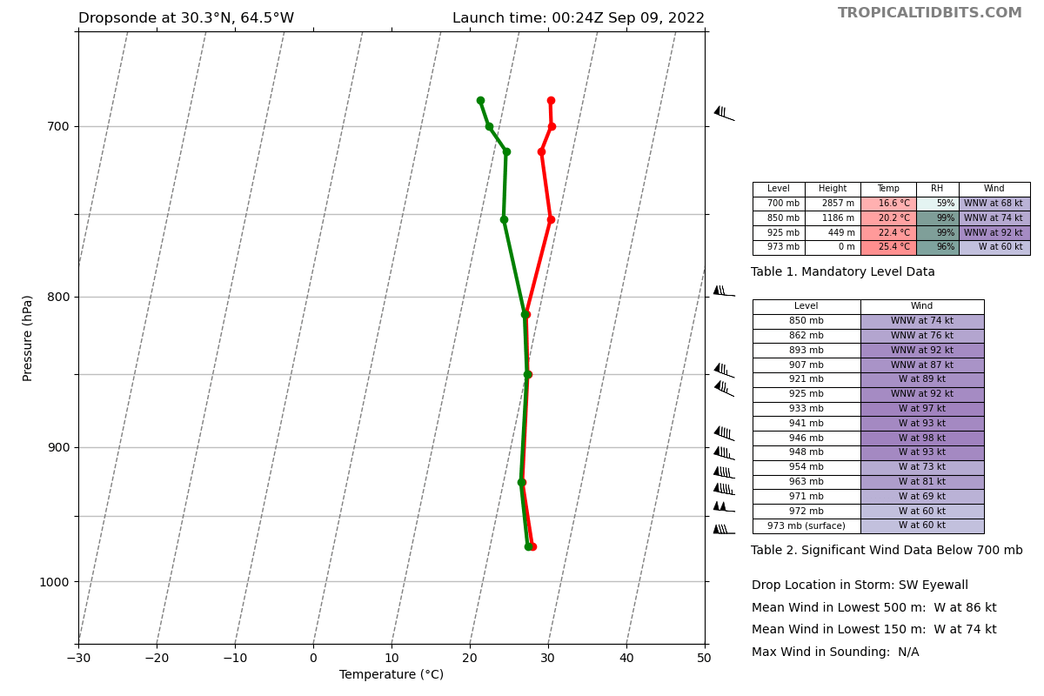
0025 | Drop #21 (SW Eyewall; ONR)  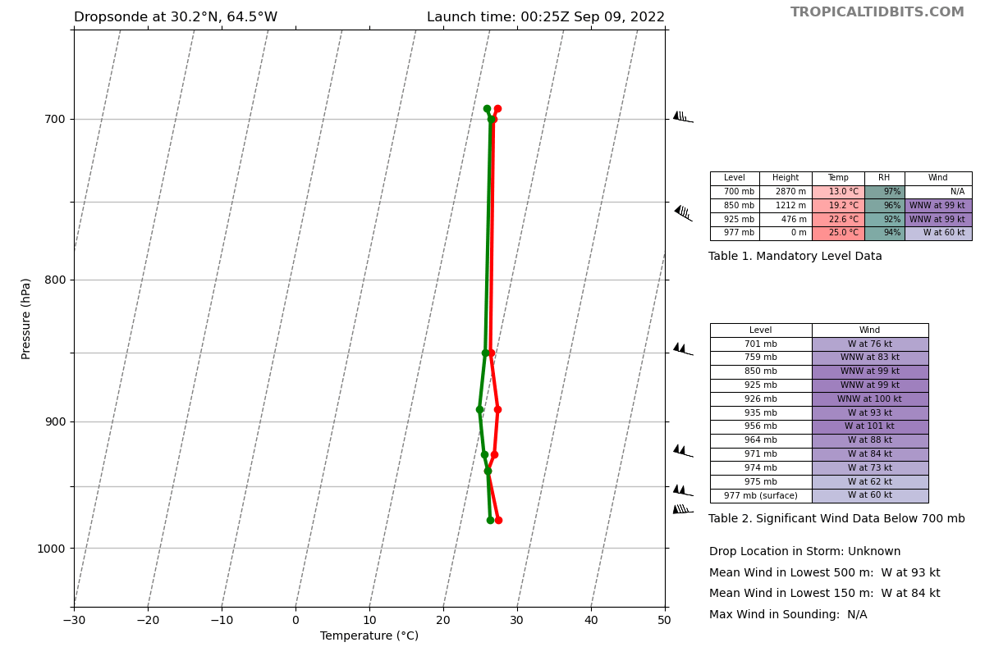
0025 | Eyewall structure changed rapidly between the 2nd and 3rd pass. Eyewall is now clearly open to the south. Will it continue to evolve quickly?  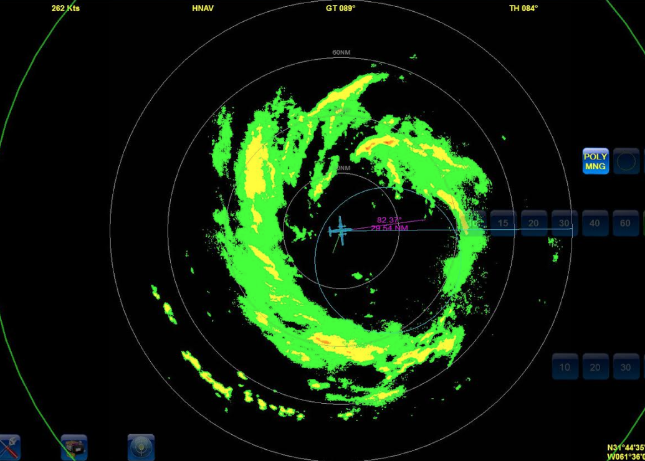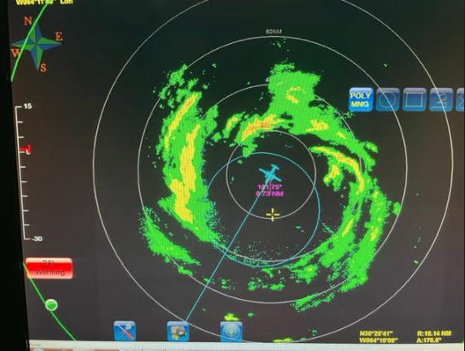
0029 | Latest plan for Ocean Winds:  I think we pick a direction with a good rain band and fly out and turn around and come back inbound to release sondes ...get splash point and fly over
0036 | Drop #22 (SW Endpoint; EMC)  Early drop due to rain  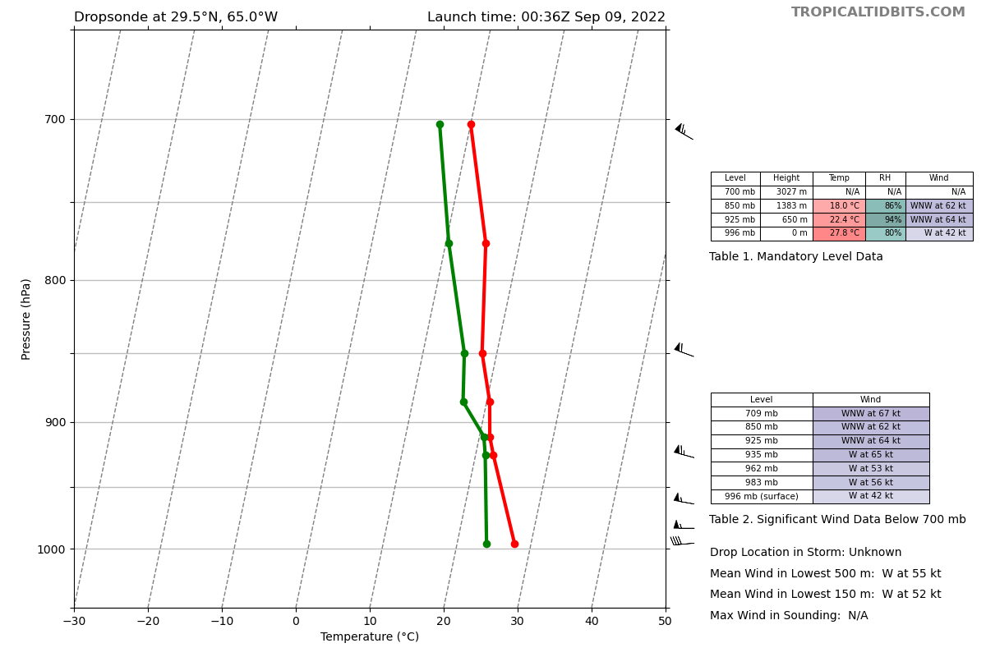
0036 | TDR composite for the first 3 legs  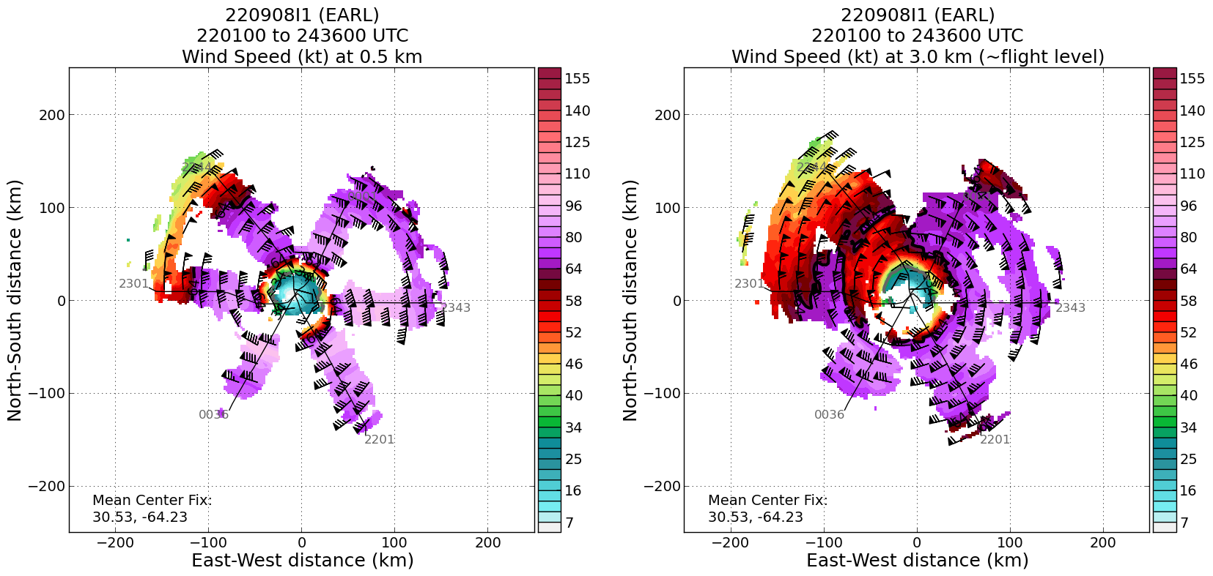
0100 | Begin Ocean Winds Experiment targeting the western eyewall  Fly outbound to W from center
0128 | Turn around inbound E toward center  Target 2 sondes for the outer eyewall and 1 sonde for the inner eyewall (if it’s still there)  Update - no drop for the inner eyewall
 | Drop #23 (Ocean Winds/SFMR RMW; HRD)
 | Drop #24 (Ocean Winds/SFMR RMW; HRD)
0152 | Turn around outbound WSW
0210 | Turn back inbound ENE
0226 | Turning outbound 300 deg to sample the most convectively active part of the eyewall
0240 | Science complete
0247 | There are still problems with ASPEN. It crashed three nights in a row in exactly the same part of making synmaps.

POST-FLIGHT
Mission Summary | This mission was flown successfully and was the last of a long series into AL91/AL06/Earl. The biggest uncertainty going into this mission was if Earl would continue to intensify. NHC was still forecasting Earl to become a major hurricane when this mission began. However, the storm appeared to be dealing with unfavorable conditions for immediate intensification, including dry air, southwesterly wind shear, and an eyewall replacement cycle. It was remarkable to observe how quickly Earl’s inner core structure evolved over the course of this flight. It seems as though dry air was entrained earlier today and its effects finally showed this evening. On top of that, the first pass showed double wind maxima on either side of the eye, suggesting that an eyewall replacement cycle might have been occurring as well. The double wind max was consistent with observations from the previous mission (Air Force) a few hours earlier. However, by the second pass, the double wind maxima had blended into a broad wind peak. On radar and satellite, remnants of the old eyewall were observed rotating in the eye. Also, it should be noted that southwesterly wind shear seemed to increase this evening, and, although values are still low-to-moderate (15 kt), that may have caused additional disruption in Earl. All that said, Earl still looks poised for some potential intensification over night as the eyewall looks more complete on radar and the satellite appearance isn’t quite as ragged.  Overall, the primary objective of transmitting TDR analyses and dropsonde data to EMC for assimilation into numerical weather prediction models was met. Rapid RMW sondes were successful, except for the NE inbound leg because there really wasn’t an RMW (it was a broad, low wind max). The Ocean Winds Experiment and Surface Wind and Wave Validation Module was moderately successful, although the rapidly evolving eyewall and weaker surface winds than anticipated made it difficult to drop sondes in rain and then fly over.  The mission was challenging due to how rapidly Earl evolved, especially the structure of the eyewall. That said, the planned pattern was flown, with only minor deviations for weather or center hunting. NHC decreased Earl’s intensity to 80 kt as a result of the data collected during this mission.  Dropsondes: 24 dropsondes released; all good and transmitted to the GTS (2 chargred to HRD, 9 NWS, 13 ONR)  AXBTs: 2/4 (had two different channels and the ones that are typically less reliable are the ones that failed)
Actual Standard Pattern Flown | Butterfly
APHEX Experiments / Modules Flown | Data collection supported the Mature Stage Experiment: NESDIS Ocean Winds Experiment and Surface Wind and Wave Validation Module
Plain Language Summary | - Earl was less organized and weaker after dry air entered the circulation earlier in the day and possibly underwent an eyewall replacement cycle  - Earl’s structure was rapidly changing throughout the flight making it challenging to plan for modules
Instrument Notes | All instruments worked optimally.  ASPEN continues to crash when creating synoptic maps (reported by Sim)
Final Mission Track | 