MISSION PLAN
FLIGHT ID | 20220908H1 | STORM | AL06 / EARL
MISSION ID | 2006A | TAIL NUMBER | NOAA42
TASKING | EMC | PLANNED PATTERN | Butterfly
MISSION SUMMARY
TAKEOFF [UTC] | 0818 | LANDING [UTC] | 1657
TAKEOFF LOCATION | St. Croix | LANDING LOCATION | Lakeland
FLIGHT TIME | 8.7 | BLOCK TIME | 9.1
TOTAL REAL-TIME RADAR ANALYSES  (Transmitted) | 3 | TOTAL DROPSONDES (Good/Transmitted) | 28 (23 / 23)
OCEAN EXPENDABLES (Type) | 3 AXBT (ONR) | sUAS (Type) | None
APHEX EXPERIMENTS / MODULES | Mature Stage Experiment: Gravity Wave Module
HRD CREW MANIFEST
LPS ONBOARD | Alvey, Rogers | LPS GROUND | None
TDR ONBOARD | Rogers, Alvey | TDR GROUND | Reasor
ASPEN ONBOARD | J. Zhang | ASPEN GROUND | None
NESDIS SCIENTISTS | None
GUESTS (Affiliation) | None
AOC CREW MANIFEST
PILOTS | Abitbol, Rannenberg, Keith
NAVIGATOR | Hough
FLIGHT ENGINEERS | Stokes, Gee
FLIGHT DIRECTOR | Carpenter
DATA TECHNICIAN | McAllister
AVAPS | Dkykeman

PRE-FLIGHT
Flight Plan | Plan is very similar to the past few days with a butterfly pattern.  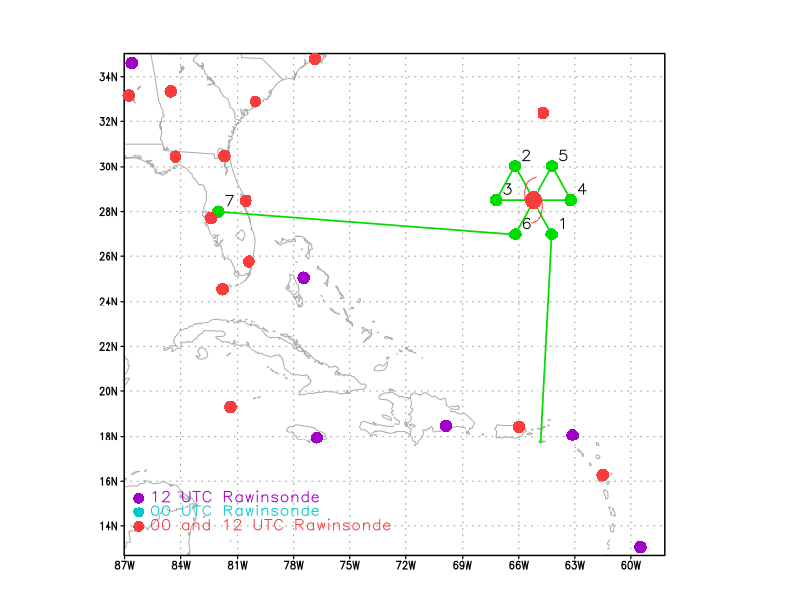  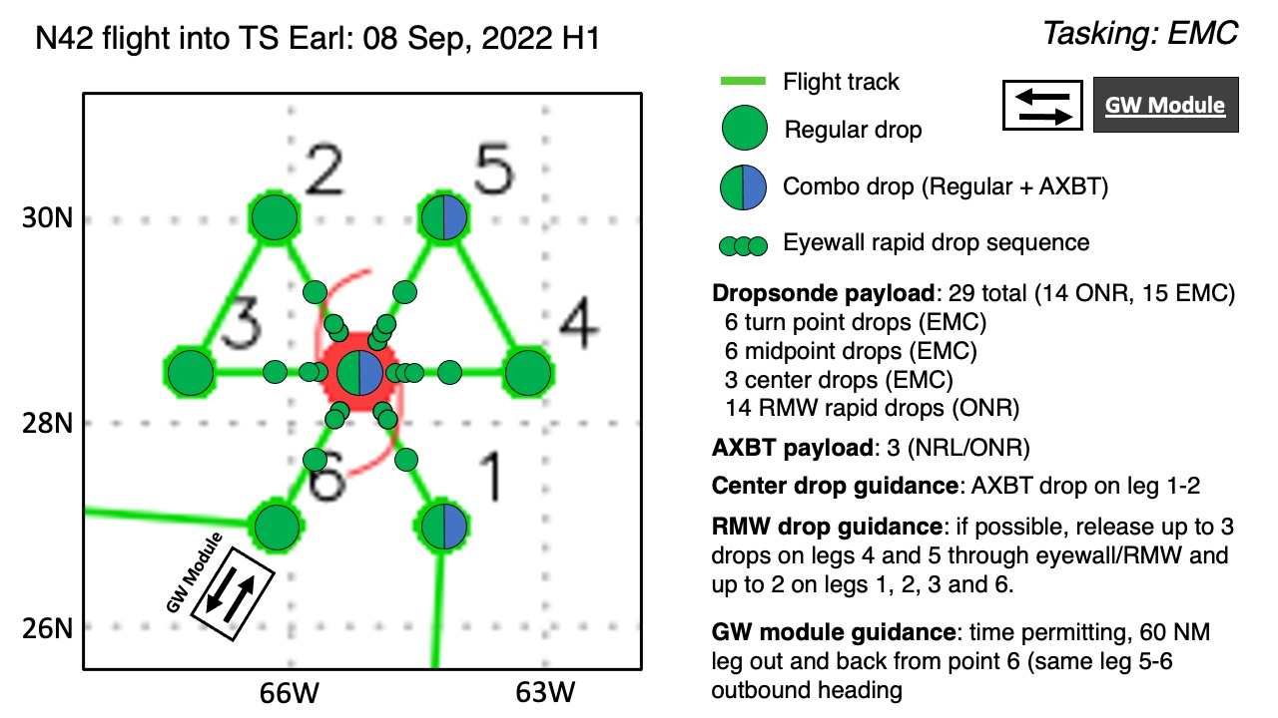
Expendable Distribution | Dropsondes released at endpoints (endpts), midpoints (midpts), radius of maximum wind (RMW) rapid-fire drops on all legs (W/S legs only 2 drops in rapid fire due to limited number of left available). For AXBTs, combo AXBT/dropsonde at the SE point, center point, then NE point on final inbound
Preflight Weather Briefing | The satellite presentation of Earl has continued to gradually improve over the past 12-24 h. Earl is now a Category 2 hurricane with 90 kt maximum sustained winds and expected to become a major hurricane via the official NHC forecast and numerical models over the next 12-24 h. The forward speed towards the north is continuing to increase as expected as a trough is approaching Earl from the west. Vertical wind shear has also continued to slowly decrease over the past 12-24 h. Despite the decrease in wind shear there is still some slight tilt observed in the upper levels via NHC discussion yesterday afternoon. Also, the inner core precipitation and eyewall structure remains asymmetric and most dominant downshear/left of shear (northern semicircle). The wind field, however, has seen some increased symmetry over the past 12-24 h.  Some interesting tidbits from the 5 AM NHC discussion: “Earl has developed a 20-30 n mi wide eye in infrared satellite  imagery, although a recent Air Force Reserve Hurricane Hunter flight  indicates that the circulation is still tilted toward the east with  height due to continued moderate shear. That said, this particular  flight measured a peak 700-mb flight-level wind of 97 kt and SFMR  winds as high as 82 kt, while the central pressure dropped to 969  mb. Recent research on SFMR measurements from the NOAA Hurricane  Research Division and the University of Miami has shown that the  SFMR undersampling for a hurricane of Earl's size is typically  about 10 percent, which would suggest that the maximum winds are up  to around 90 kt. This estimate also more closely aligns to the  107-kt flight-level wind measured by the NOAA Hurricane Hunter  flight last evening.”
Instrument Notes | All functional

IN-FLIGHT
Time [UTC] | Event
1005 | Outer convective band appears to be propagating outwards
1009 | Dropsonde #1 endpoint, start of IP on SE-NW leg through center. AXBT combo drop. No data initially measured in the AXBT, but 27.53C at 50 m
1022 | Dropsonde #2 midpoint
1025 | Dropsonde #3 RMW rapid fire (1st of 2 in sequence)
102530 | Dropsonde #4 RMW rapid fire (2nd in sequence)
1033 | Dropsonde #5 RMW (this extra sonde was released b/c first 2 were a little early on secondary wind max forming). No data (bad dropsonde).
103600 | Dropsonde #6 Center drop, AXBT combo, measured an SST of 27.94C
 | Circular closed eye 47 nmi
104410 | Dropsonde #7 RMW rapid fire (1st of 2 in sequence). Outbound SE-NW.  Bad sonde, failed GPS altitude, no wind, didn’t send TEMPDROP.
104440 | Dropsonde #8 RMW rapid fire (2nd of 2 in sequence). Outbound SE-NW.
104900 | Dropsonde #9 midpoint
1059 | Dropsonde #10 endpoint, Bad sonde no T, RH at all, All data ended at 3100 m w/ no data below
 | Large stratiform region between mid and endpoints
112355 | Dropsonde #11 endpoint starting W-E
1138 | Dropsonde #12 midpoint
114240 | Dropsonde #13 RMW (rapid fire first)
114310 | Dropsonde #14 RMW (rapid fire second)
1150 | Center 964 mb with 18 kt (966 on 1st drop) drop #15
115815 | Drop #16 RMW (rapid fire 1 of 2)
115845 | Drop #17 (RMW 2 of 2)
 | FL wind max is much higher than SFMR (48 vs 36 m/s). Interesting boundary layer jet type structure is noted.
120555 | Midpoint drop #18 (missing winds)
120640 | Midpoint drop re-released #19
1220 | Endpoint drop #20 (bad sonde)
1244 | Endpoint drop #21 and AXBT for start of NE-SW leg, measured SST of 28.88 C
1245 | Comparing FL and SF wind peaks on W-E pass, it’s clear that the FL and SFMR peaks are nearly identical on the W (upshear) side, while the FL peak is much larger than the SFMR peak on the E (downshear) side. This is consistent with the notion of a tilted vortex, though the TDR analyses don’t show much tilt. Maybe you don’t need much tilt to produce these across-shear/tilt FL/SF asymmetries.
1253 | Midpoint drop #22
130230 | Drop #23 NE RMW #1
130300 | Drop #24 NE RMW #2
1306 | Drop #25, center drop
1314 | Drop #26, SW RMW (did not release a second sonde because there are now only 3 remaining. Want to save one for a backup for the midpt and endpt sondes). Was too far inside on drop. There was an inner local peak that I dropped based on. Then we proceeded outbound another few nmi to the point where a band was spiraling into the eyewall. That was where the surface wind maximum was located.
1319 | Drop #27, SW midpoint
1333 | Drop #28, SW endpoint
1334 | Begin Gravity Wave Module, heading outbound along a radial to the SW for 90 nmi, then will return back inbound along same radial
1406 | We have had to adjust the Gravity Wave Module because the return leg would take us through so much convection we’d have to deviate substantially. Instead, we turned right and traveled about 30 nmi upwind to find a radial to the storm center that would not require those deviations. We will then turn inbound for as far as we can go, given fuel limitations. The Gravity Wave PI confirms that this is acceptable.
1420 | End of GW module, science complete
1754 (post-flight) | 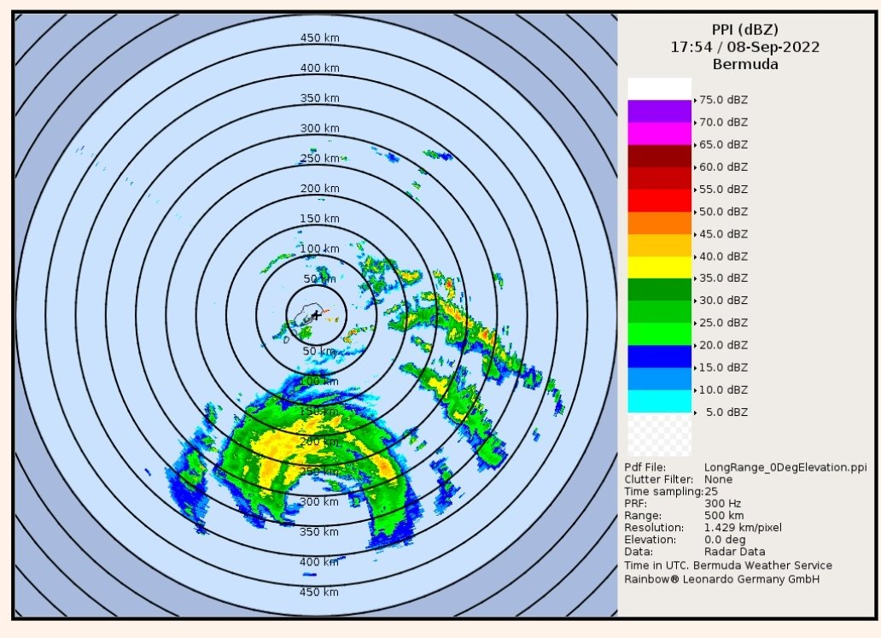
 | Despite being in a somewhat favorable environment characterized by anomalously high SST (for this latitude) and decreasing vertical wind shear, it doesn’t appear that Earl is getting more organized and may in fact be degrading in structure around the end of this flight. It appears this may be a forecast bust (over forecasted intensification) and Earl may struggle to reach major hurricane intensity now.
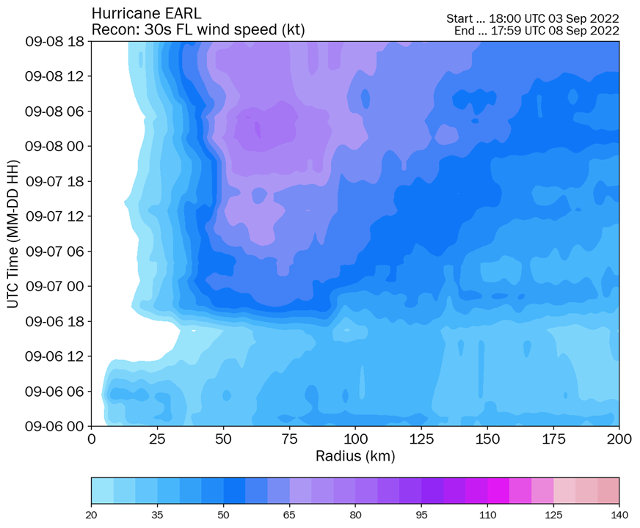

Via Tomer Berg: Hovmoller of FL wind speed indicates that despite decreasing MSLP over the past couple of days, the wind field has not notably intensified, likely due to the rather large/broad RMW field.

POST-FLIGHT
Mission Summary | Successful mission was flown as planned beginning with a butterfly pattern for EMC TDR. A Gravity Wave Module was flown at the end of the SW leg. In the future, it might be a better idea to do this a little farther away from the center of the storm after beginning enroute back to Lakeland. Because of precipitation developing around us, we had to do the repeat inbound leg appx. 15 degrees farther to the north. PI Zhang for the module said that the deviation we made, though, should still be okay.  A total of 28 dropsondes were released (12 charged to ONR, 16 charged to NWS; 23 were transmitted to the GTS as the other 5 were “bad”). All EMC planned dropsondes were executed except for the end of the W-E leg (endpoint). By the time it was called out that the dropsonde was bad, we were already 5-10 minutes further downwind and opted to not re-release. Also, due to the limited number of dropsondes onboard we had to limit the rapid fire RMW sequences to 2 on a few of the legs and 1 on the final SW leg.  During this period the vertical wind shear has continued to decrease. It’s interesting to note that the high VWS was predominantly caused by strong 200-300 mb winds with not much mid-level shear. The decrease in VWS actually doesn’t appear to be from significant changes in that upper-level layer, but rather an increase and re-orientation of the low-level flow. There were also some interesting discussions in chat about this upper level vertical wind shear perhaps not being as detrimental (as discussed by several Ryglicki papers). Furthermore, the broad structure of the storm may have promoted increased resiliency, while also counter actively preventing more rapid intensification rates.  The flight-level winds were actually relatively symmetric today...NE was strongest, but it was pretty strong everywhere but SW, I think. Dan Stern noted that he thinks there definitely was some intensification either between AF and our flight, or during the start of our flight. Very asymmetric radial wind profile potentially caused by shear? Motion-induced symmetry shouldn’t be very great due to the motion being < 10 kt. Does shear impact the surface winds more than FL? Rob Rogers notes, “I’m not totally sure, but I'm guessing it has to do with the interplay between asymmetric friction (storm motion) and shear.” Paul Reasor noted that the storm is more aligned above 9 km than 12 h ago ... based on Michael's center finding ... but similar shear-relative tilt magnitudes up to 8-9 km.  Structure of eyewall and eye appeared most organized on the second W-E leg before some slight deterioration was noted on final NE-SW pass potentially due to some dry air entrainment (and/or interactions with shear). It’s interesting how large the eye diameter and wind field is: hypothesized that it’s allowed increased resiliency in the somewhat hostile environment over the past few days, however, it has/will likely prevent any sort of RI episode.
Actual Standard Pattern Flown | Butterfly with additional Gravity Wave Module
APHEX Experiments / Modules Flown | Data collection possibly supports the Early Stage Experiment: AIPEX, though the storm is more or less mature now. A Gravity Wave Module was flown in support of the Mature Stage Experiment.
Plain Language Summary
Instrument Notes | The LPS noticed SFMR stopped showing on display after RMW on W-E leg. Rebooted on downwind leg before the NE-SW pass.
Final Mission Track | Courtesy of Tomer Berg  