MISSION PLAN
FLIGHT ID | 20220907H1 | STORM | AL06 / EARL
MISSION ID | 1606A | TAIL NUMBER | NOAA42
TASKING | EMC | PLANNED PATTERN | Butterfly
MISSION SUMMARY
TAKEOFF [UTC] | 0823 | LANDING [UTC] | 1455
TAKEOFF LOCATION | St. Croix | LANDING LOCATION | St. Croix
FLIGHT TIME | 6.5 | BLOCK TIME | 6.7
TOTAL REAL-TIME RADAR ANALYSES  (Transmitted) | 5 | TOTAL DROPSONDES (Good/Transmitted) | 35 (34 / 34)
OCEAN EXPENDABLES (Type) | 3 AXBT (ONR) | sUAS (Type) | None
APHEX EXPERIMENTS / MODULES | Early Stage Experiment: AIPEX (FLAIMS), Rapid RMW
HRD CREW MANIFEST
LPS ONBOARD | Alvey | LPS GROUND | None
TDR ONBOARD | Rogers | TDR GROUND | Reasor
ASPEN ONBOARD | J. Zhang | ASPEN GROUND | None
NESDIS SCIENTISTS | None
GUESTS (Affiliation) | Stern (NRL)
AOC CREW MANIFEST
PILOTS | Abitbol, Rannenberg, Keith
NAVIGATOR | Hough
FLIGHT ENGINEERS | Stokes, Gee
FLIGHT DIRECTOR | Carpenter
DATA TECHNICIAN | McAllister
AVAPS | Dkykeman

PRE-FLIGHT
Flight Plan | 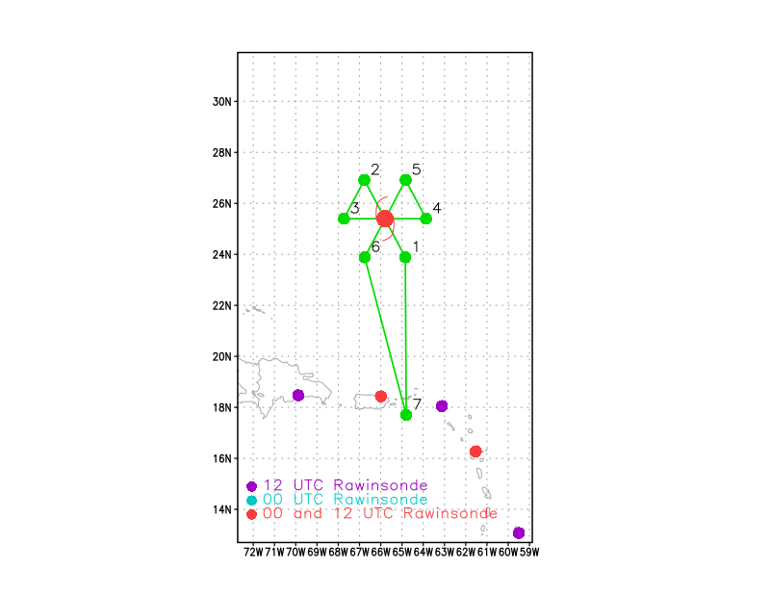  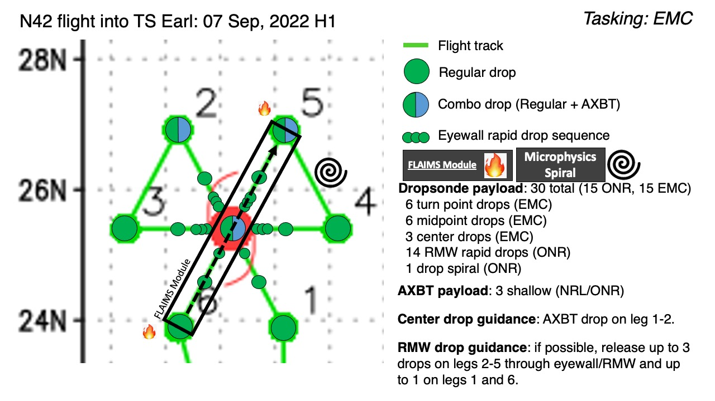
Expendable Distribution | Dropsondes at endpoints (endpts), midpoints (midpts), RMW rapid-fire drops (x3) on all legs. During two passes of the FLAIMS module, release a single sonde at the RMW. For AXBTs, combo AXBT/sonde at the NE point, NW point and during the final center pass.
Preflight Weather Briefing | The satellite presentation of Earl showed improved organization during and just following yesterday’s PM flight (~6-12 h prior). However, strong westerly shear (~30 knots) continues to affect Earl and the inner core / eyewall structure indicates asymmetry with only a partial eyewall (open south). Overall, there have been no significant changes to the forecast thinking in terms of track and intensity. Slow / steady intensification (~15-20 kt / 24 h) is expected to continue over the next 24-48 hours as Earl continues to move towards a more favorable environment characterized by lower vertical wind shear. A trough is expected to move off of the coast and cause an acceleration towards the north and *favorable* trough-storm interaction with Earl.
Instrument Notes | All functional

IN-FLIGHT
Time [UTC] | Event
0937 | Drop #1 Endpoint SE
094920 | Drop #2 Midpoint SE
095225 | Drop #3 RMW Rapid drop sequence SE
095255 | Drop #4 RMW 2nd rapid drop SE
095325 | Drop #5 RMW 3rd rapid drop SE
 | 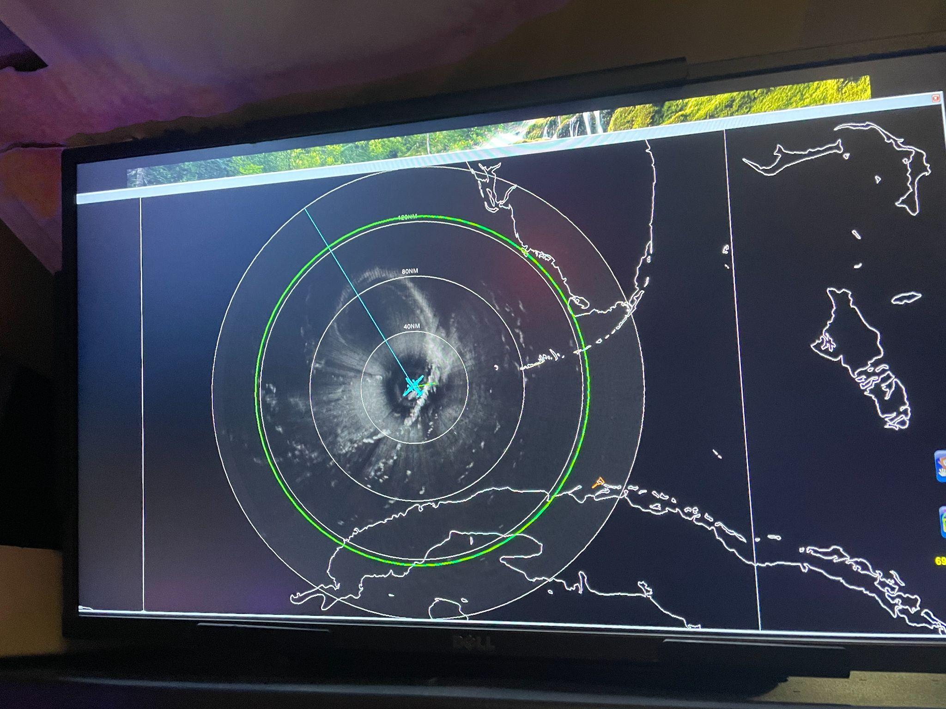
0954 | Eyewall open to the S / SE and eye is ~40 nmi wide
0959 | Combo center drop #6 with AXBT #1 released and measured an SST of 28.15ºC
100620 | RMW Rapid fire sequence Drop #7 NW
100650 | Drop #8 RMW Rapid 2nd NW
100725 | Drop #9 RMW Rapid 3rd NW
1016 | Midpoint drop #10 NW
1031 | Drop #11 combo AXBT #2 released and measured an SST of 29.18C at NW Endpoint
1035 | 979 mb pressure which is ~4 mb lower than the previous AF pass a few hours earlier
1056 | Drop #12 endpoint for start of W-E leg
1106 | Midpoint sonde drop #13 W
111335 | RMW Drop #14 rapid sequence 1st W
111405 | RMW Drop #15 W
111438 | RMW drop #16 W
1119 | Center drop #17
1124 | New precipitation trying to form inward of the eyewall. Choppy air near these new developing cells.
 | 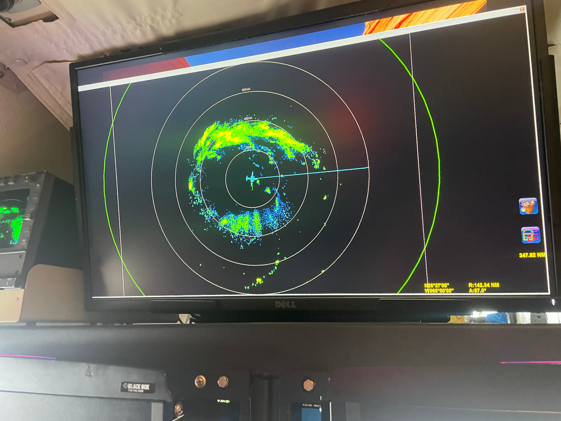
112723 | Drop #18: RMW Rapid fire sequence E
112753 | Drop #19 RMW E
112823 | Drop #20 RMW E
1132 | Midpoint sonde# 21 E
1142 | 980 mb central pressure on second drop
Eastern eyewall rapidly developed on MMR after our last E-W pass. Also looks like it was associated with some lightning
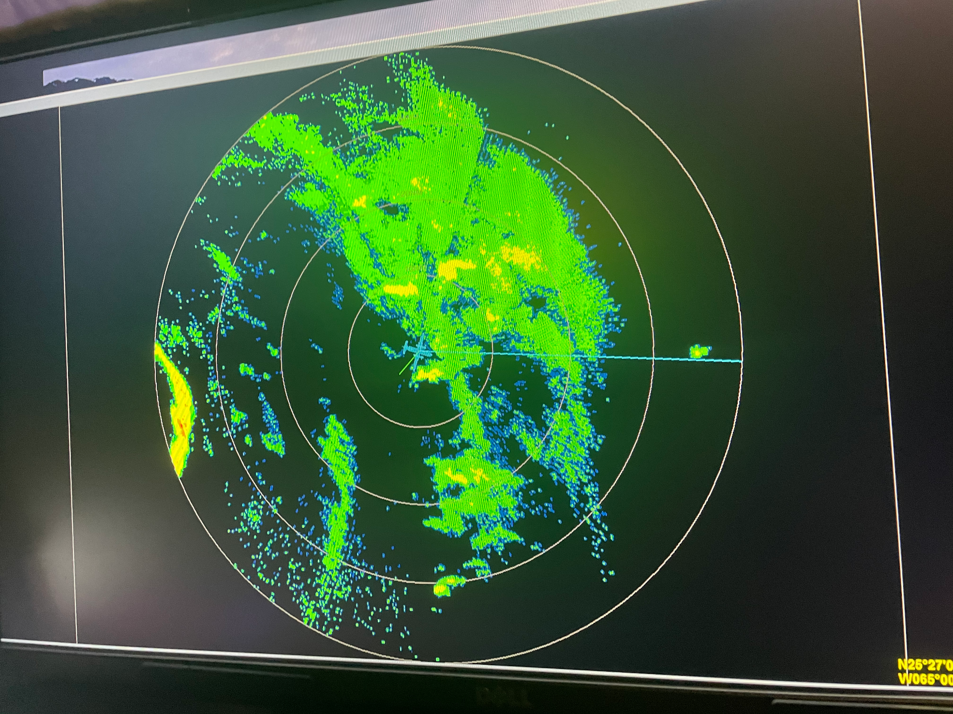
1145 | Endpoint sonde #22, no wind E
1146 | Endpoint sonde 2nd attempt: #23 good E
 | 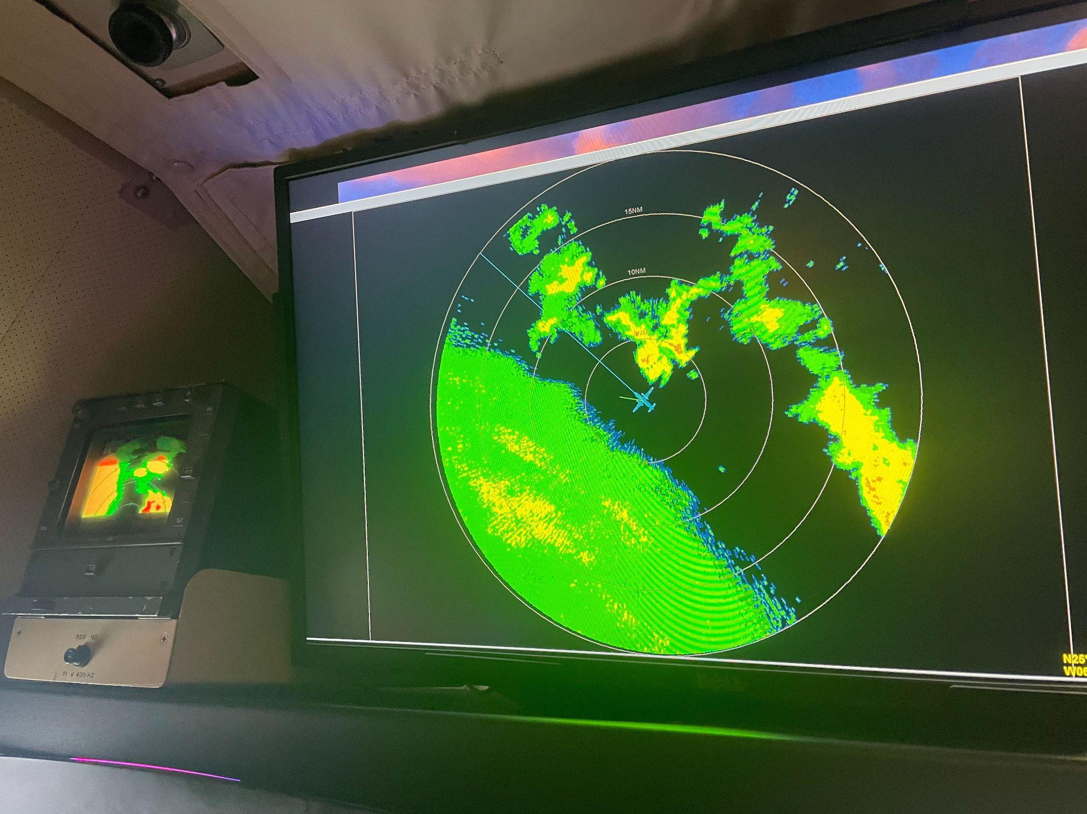
1212 | Combo AXBT and dropsonde #24; AXBT measured an SST of 28.44 ºC NE
1232 | RMW single drop for FLAIMS module #25 (NE-center inbound)
1243 | RMW single drop for FLAIMS #26 (center-NE outbound)
1251 | Midpoint sonde release #27 NE
125932 | RMW rapid sequence #28 NE (back inbound)
130000 | RMW rapid #29 NE
130030 | RMW rapid #30 NE
1309 | Center drop #31
1318 | RMW rapid sequence in SW quadrant #32 SW
131830 | RMW SW #33
1319 | RMW SW #34 (late launch detect)
Open eyewall on the south side still and much weaker FL and SFMR
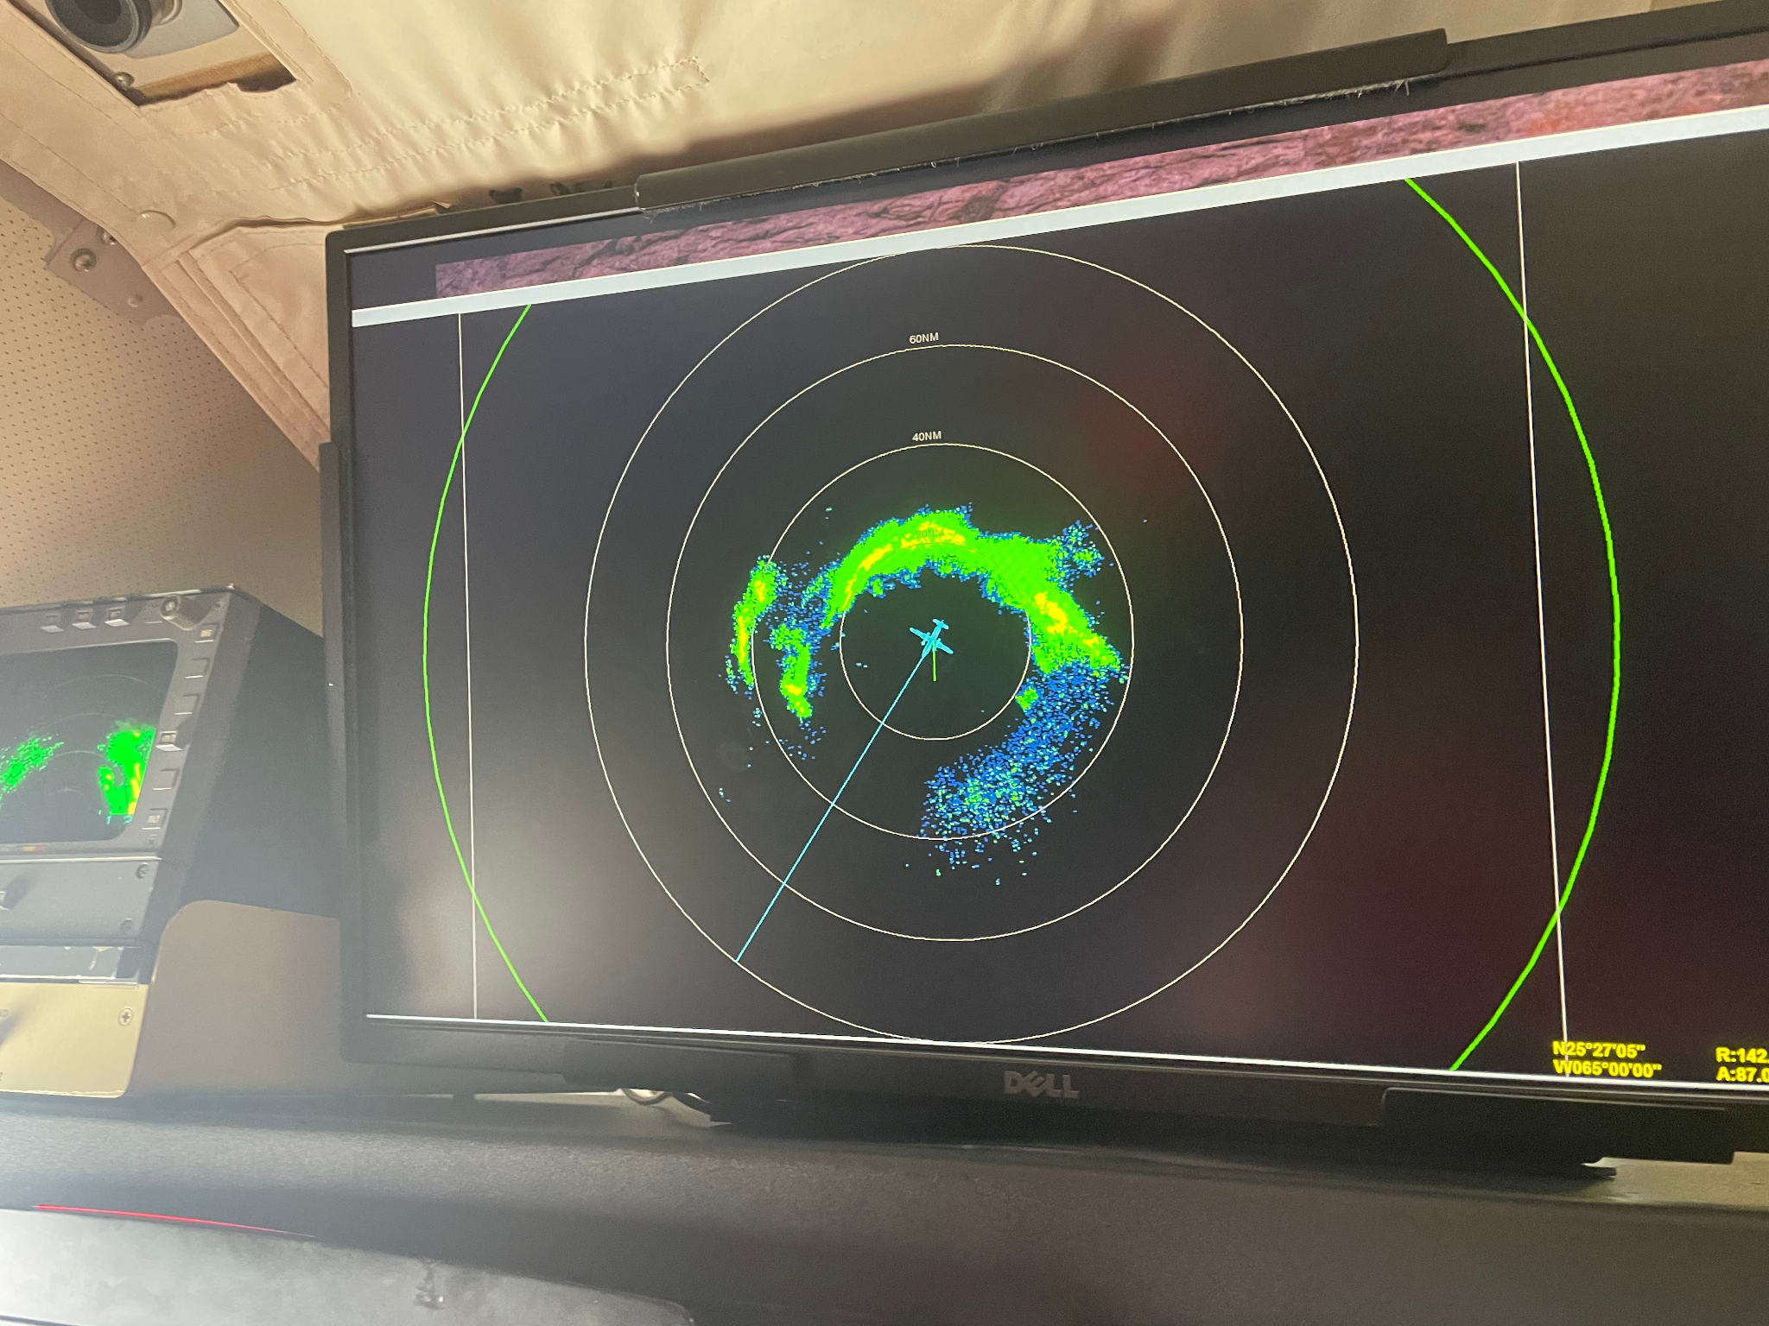
1322 | SW midpoint sonde #35. Continued along leg another ~5 mins and then RTB & end of science since there were limited scatterers.
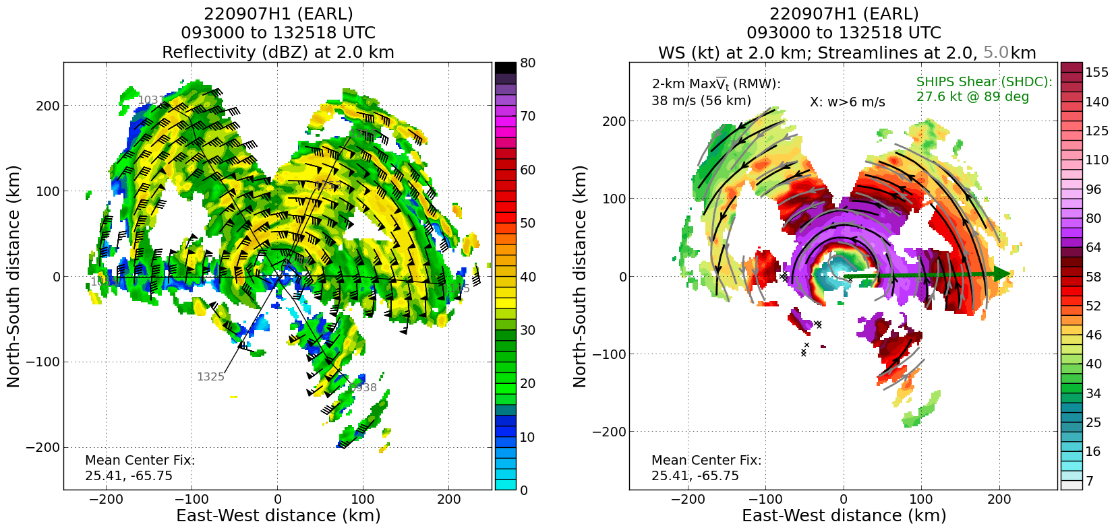

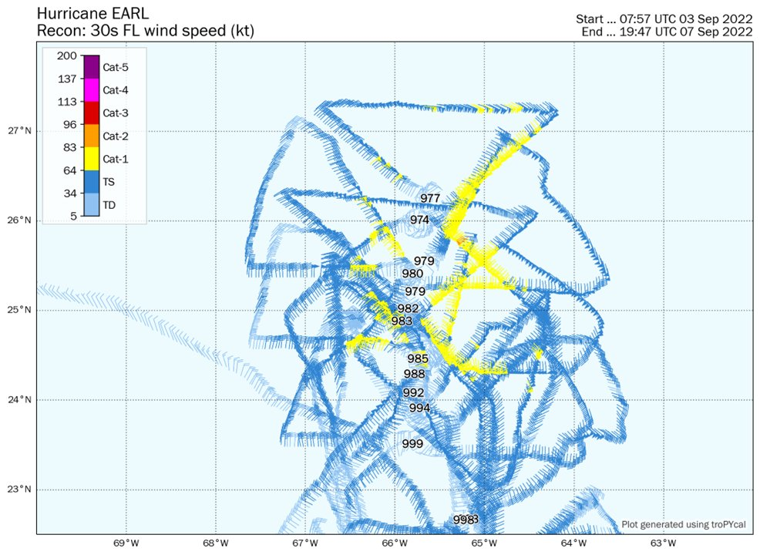
FL wind speed and MSLP evolution shows the increase in winds and decreases in MSLP from flights over the past few days
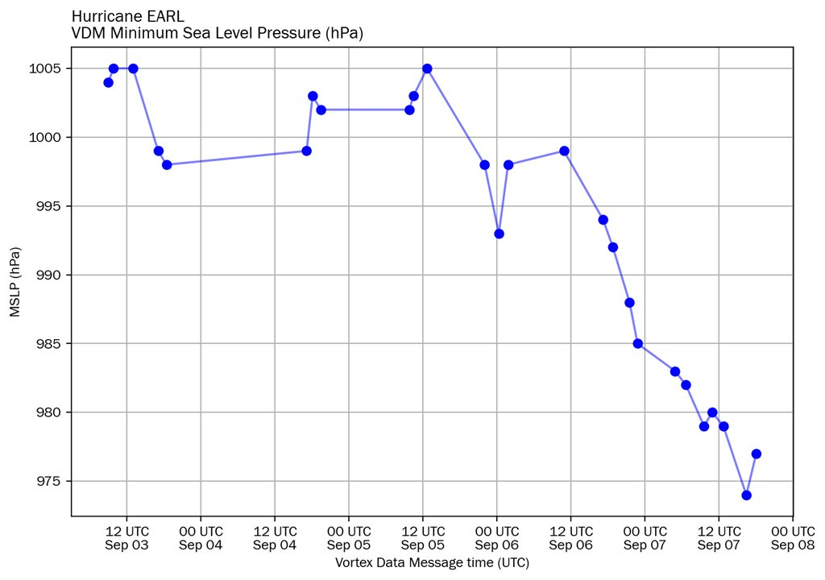

POST-FLIGHT
Mission Summary | Successful mission was flown as planned beginning with a butterfly pattern for EMC TDR. The stratiform spiral module was unable to be executed due to embedded convection in stratiform regions and choppiness per Flight Director (FD). FLAIMS module was also flown NE-SW as planned and rapid RMW drop sequences (3x) were executed in all quadrants. The final NE-SW outbound and inbound legs were cut a little short due to a convective band with lightning that FD didn’t want to risk trying to cross.  Some impressive mid- to upper-level ventilation is noted in the 2 TDR profile analyses from the FLAIMS module. Strong inflow is apparent on the downshear side and return flow above. No significant change between the profiles was noted due to the storm being closeish to steady state.  Ideas for future research/real-time ops: It would be beneficial to maybe setup a pattern to be able to easily visualize and track the changes of the inflow/outflow field over a 2-3 h period. For example, we could begin with a pass like we did, then continue the survey, and finally end with a repeat leg.  https://www.aoml.noaa.gov/ftp/pub/hrd/data/RTradar/2022/20220907H1/profiles/220907H1_EARL_1119_vr_rel_profile_270_092.png  The composite tilt is consistent with what we previously found with no big changes from about 12 h ago. The eyewall/wind max. contracted a little bit (maybe a bit stronger in the azi-mean?). The overall structure is kind of similar in the core at low levels 12 h ago and now, just a bit more intense wind today with similar asymmetry in dBZ that is concentrated left of shear. It’s basically a slowly intensifying storm maintaining a similar structure. Despite the strong shear, the flight-level winds were actually relatively symmetric today...NE was strongest, but it was pretty strong everywhere but SW I think. Dan Stern noted that he thinks there definitely was some intensification either between AF and our flight, or during the start of our flight. We also noted an asymmetric radial wind profile (potentially caused by shear?). Motion induced symmetry shouldn’t be very great due to the motion being < 10 kt. Does shear impact the surface winds more than FL? Rob notes, I’m not totally sure, but I'm guessing it has to do with the interplay between asymmetric friction (storm motion) and shear. Paul noted that the storm is more aligned above 9 km than 12 h ago ... based on Michael's center finding ... but similar shear-relative tilt magnitudes up to 8-9 km  Reasor: “I don't see any night and day changes in vortex structure over the past 12 h. Bit more intense. Doesn't seem that much more vertically deep. More aligned in the 9-12-km layer. Similar shear-relative precip. asymmetry.”  1 bad sonde  A total of 35 dropsondes were released (1 bad sonde; 15 dropsondes charged to EMC, 20 dropsondes ONR).
Actual Standard Pattern Flown | Butterfly with an additional FLAIMS module
APHEX Experiments / Modules Flown | Data collection supports the Early Stage Experiment: Analysis of Intensity Change Processes (AIPEX), specifically the Flight-level Assessment of Intensification in Moderate Shear (FLAIMS) module and rapid release of dropsondes across the RMW in each quadrant flown.
Plain Language Summary
Instrument Notes
Final Mission Track | 