MISSION PLAN
FLIGHT ID | 20220906I1 | STORM | AL06 / EARL
MISSION ID | 1406A | TAIL NUMBER | NOAA43
TASKING | EMC | PLANNED PATTERN | Butterfly
MISSION SUMMARY
TAKEOFF [UTC] | 2026 | LANDING [UTC] | 0321
TAKEOFF LOCATION | St. Croix | LANDING LOCATION | St. Croix
FLIGHT TIME | 6.9 | BLOCK TIME | 7.1
TOTAL REAL-TIME RADAR ANALYSES  (Transmitted) | 8 (8) | TOTAL DROPSONDES (Good/Transmitted) | 29 (29 / 27)
OCEAN EXPENDABLES (Type) | 3 AXBT (ONR)  (2 good) | sUAS (Type) | None
APHEX EXPERIMENTS / MODULES | Early Stage Experiment: AIPEX (FLAIMS)
HRD CREW MANIFEST
LPS ONBOARD | Holbach | LPS GROUND | Hazelton
TDR ONBOARD | Holbach | TDR GROUND | Gamache
ASPEN ONBOARD | Aberson | ASPEN GROUND
NESDIS SCIENTISTS | Chang, Sapp, Bjorland
GUESTS (Affiliation) | None
AOC CREW MANIFEST
PILOTS | Doremus, Copare, Wood
NAVIGATOR | Utama
FLIGHT ENGINEERS | Pittman
FLIGHT DIRECTOR | Kalen, Holmes
DATA TECHNICIAN | Richards
AVAPS | Warnecke

PRE-FLIGHT
Flight Plan | 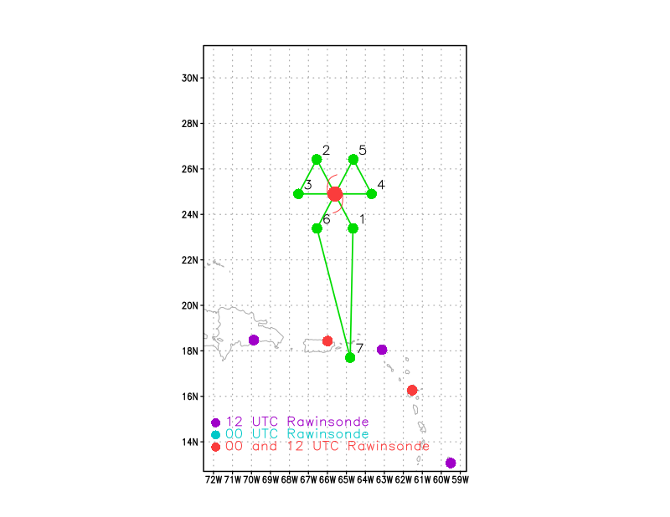  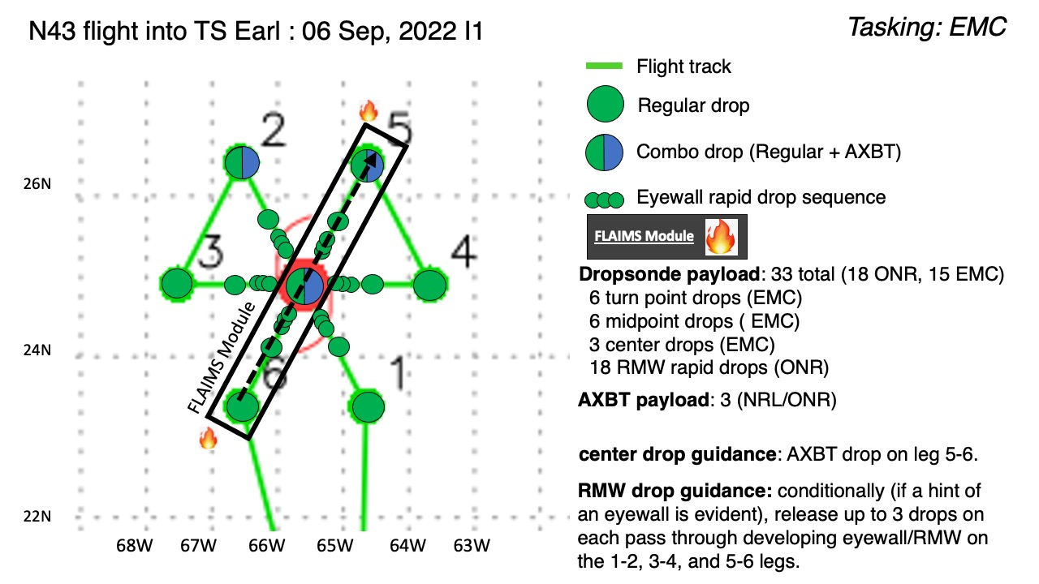  Pattern: Fly butterfly pattern with 105 nmi legs  Altitude: 10 kft (pressure altitude)  Potential add-on Modules:  - Analysis of Intensity Change Processes Experiment (AIPEX) >> Vortex Alignment Module (VAM)  - Analysis of Intensity Change Processes Experiment (AIPEX) >> FLAIMS Module  - Convective Burst Structure and Evolution Module (CBM)  - Rainband Complex Module (RCM)  Load 40 sondes (all dropsondes transmitted to the GTS); 3 ONR/NRL AXBTs (all AXBTs transmitted to the AOC ground server if possible)
Expendable Distribution | Release sondes at endpoints, midpoints, centers; possible supplemental rapid RMW drops across (see flight pattern graphic for detailed expendable distribution plan)
Preflight Weather Briefing | Earl has fired some convection again after most of it collapsed overnight. It still shows a sheared appearance, but an Air Force flight shows winds near hurricane strength. A 1728 UTC AMSR2 overpass showed a partial eyewall developing.  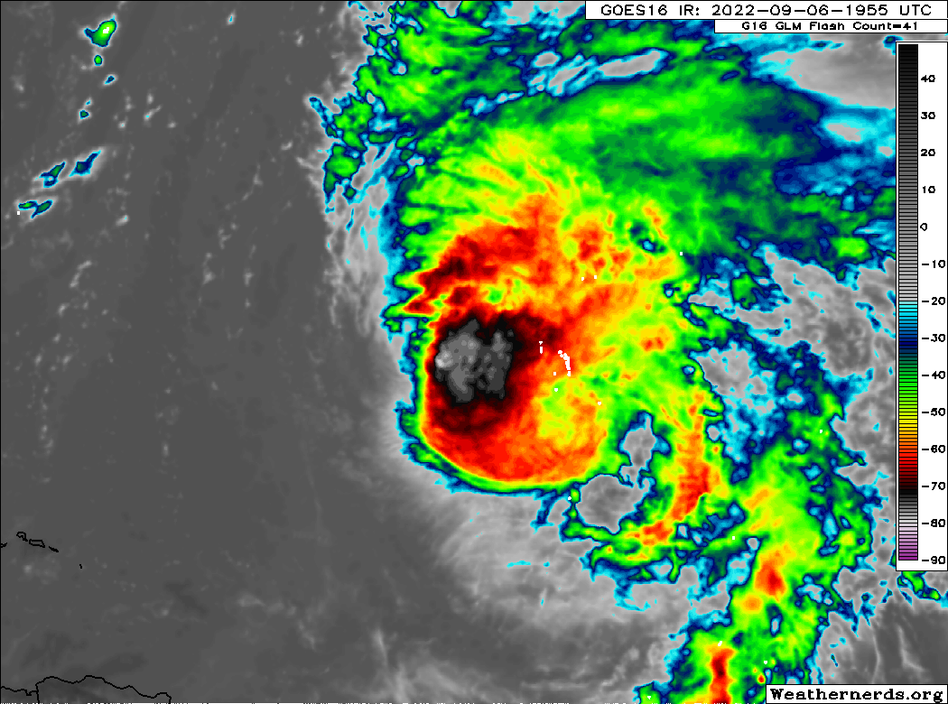  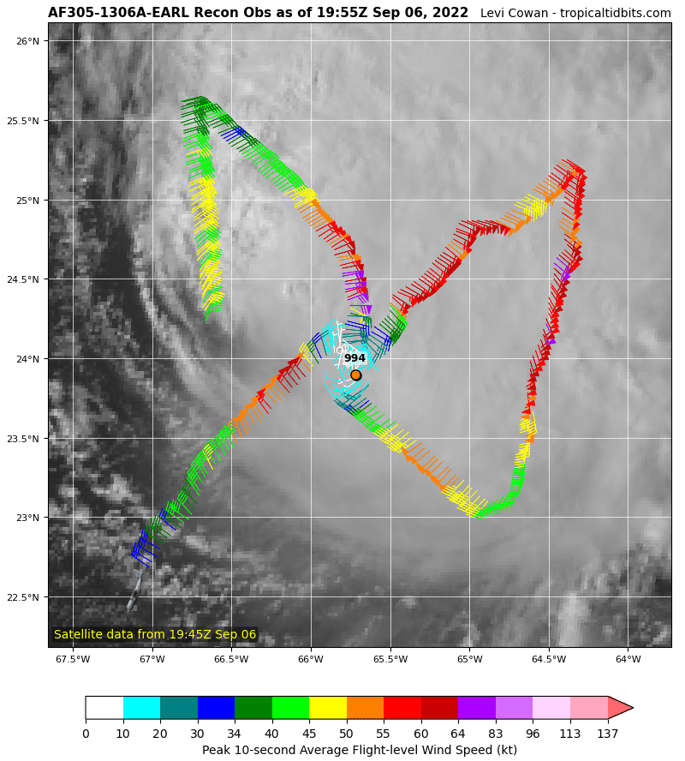  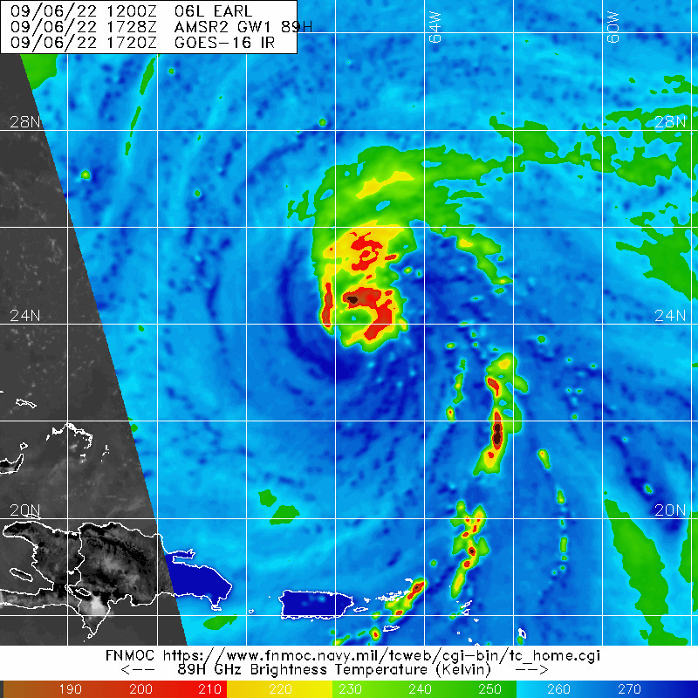

IN-FLIGHT
Time [UTC] | Event
2026 | Takeoff from St. Croix
2043 | Looks like lightning in the downshear-right quadrant, with deep cloud tops downshear-left and rotating upshear-left.  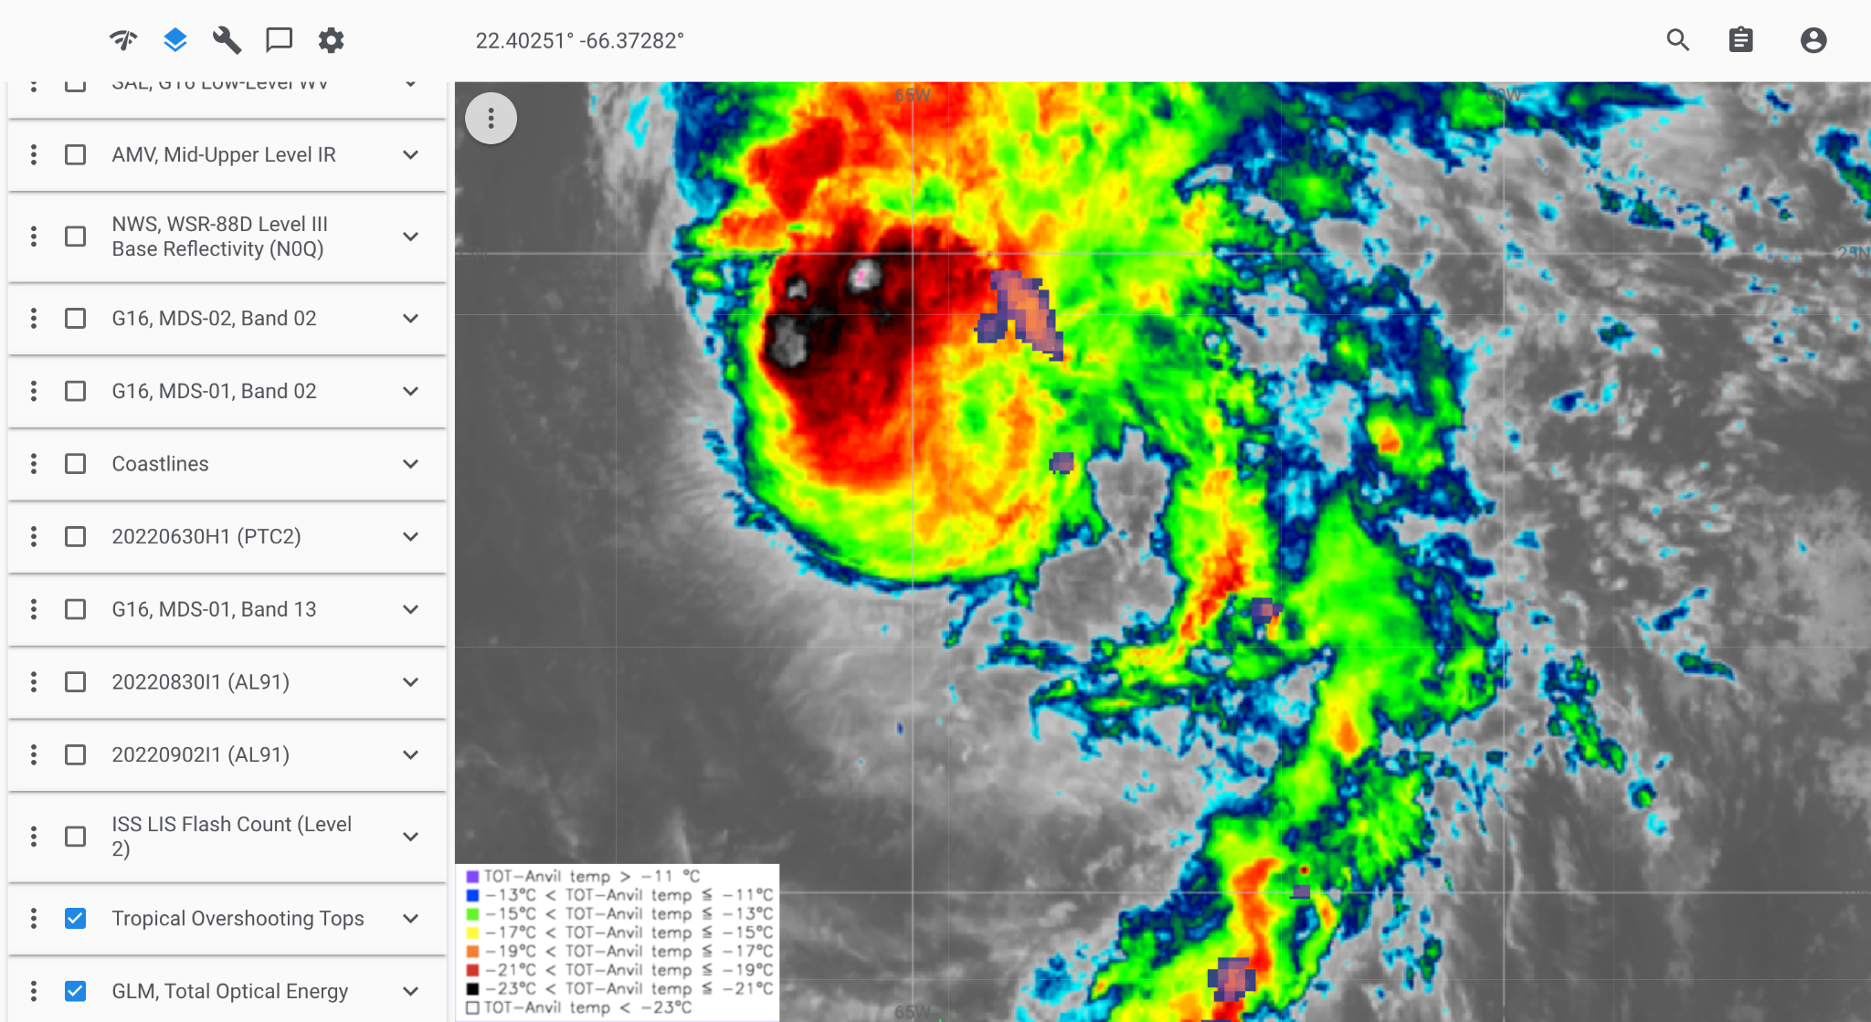
2056 | Appears a little hazy, maybe some SAL wrapping around south side
2101 | Divergent shear pattern  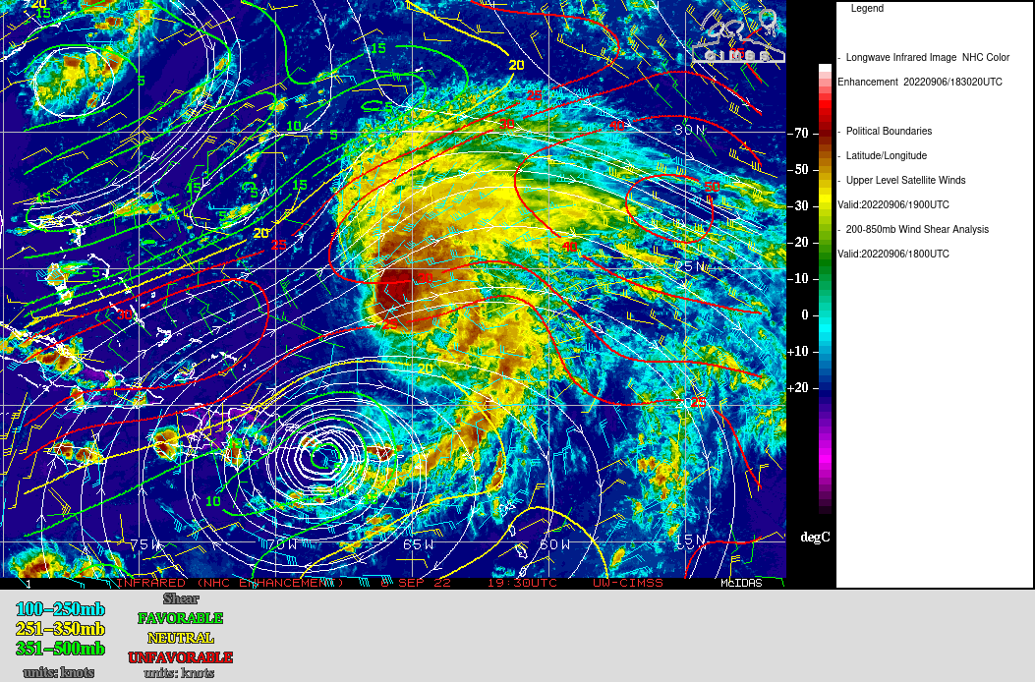
2106 | Restarting WMM app since HDOBs aren't flowing off yet
2110 | Starting to enter a region with more low-level cumulus clouds
2115 | Beginning descent, HDOBs flowing now
2130 | Initial Point (IP) SE, Drop #1
2132 | Some white caps below us. Flight level winds are already over 40 kts.
2138 | Just passed through what looks like a very scattered rain band. Got up to 21 m/s on the SFMR.
2142 | Midpoint drop #2
2147 | Can see some nice curvature in the low-level clouds ahead of us  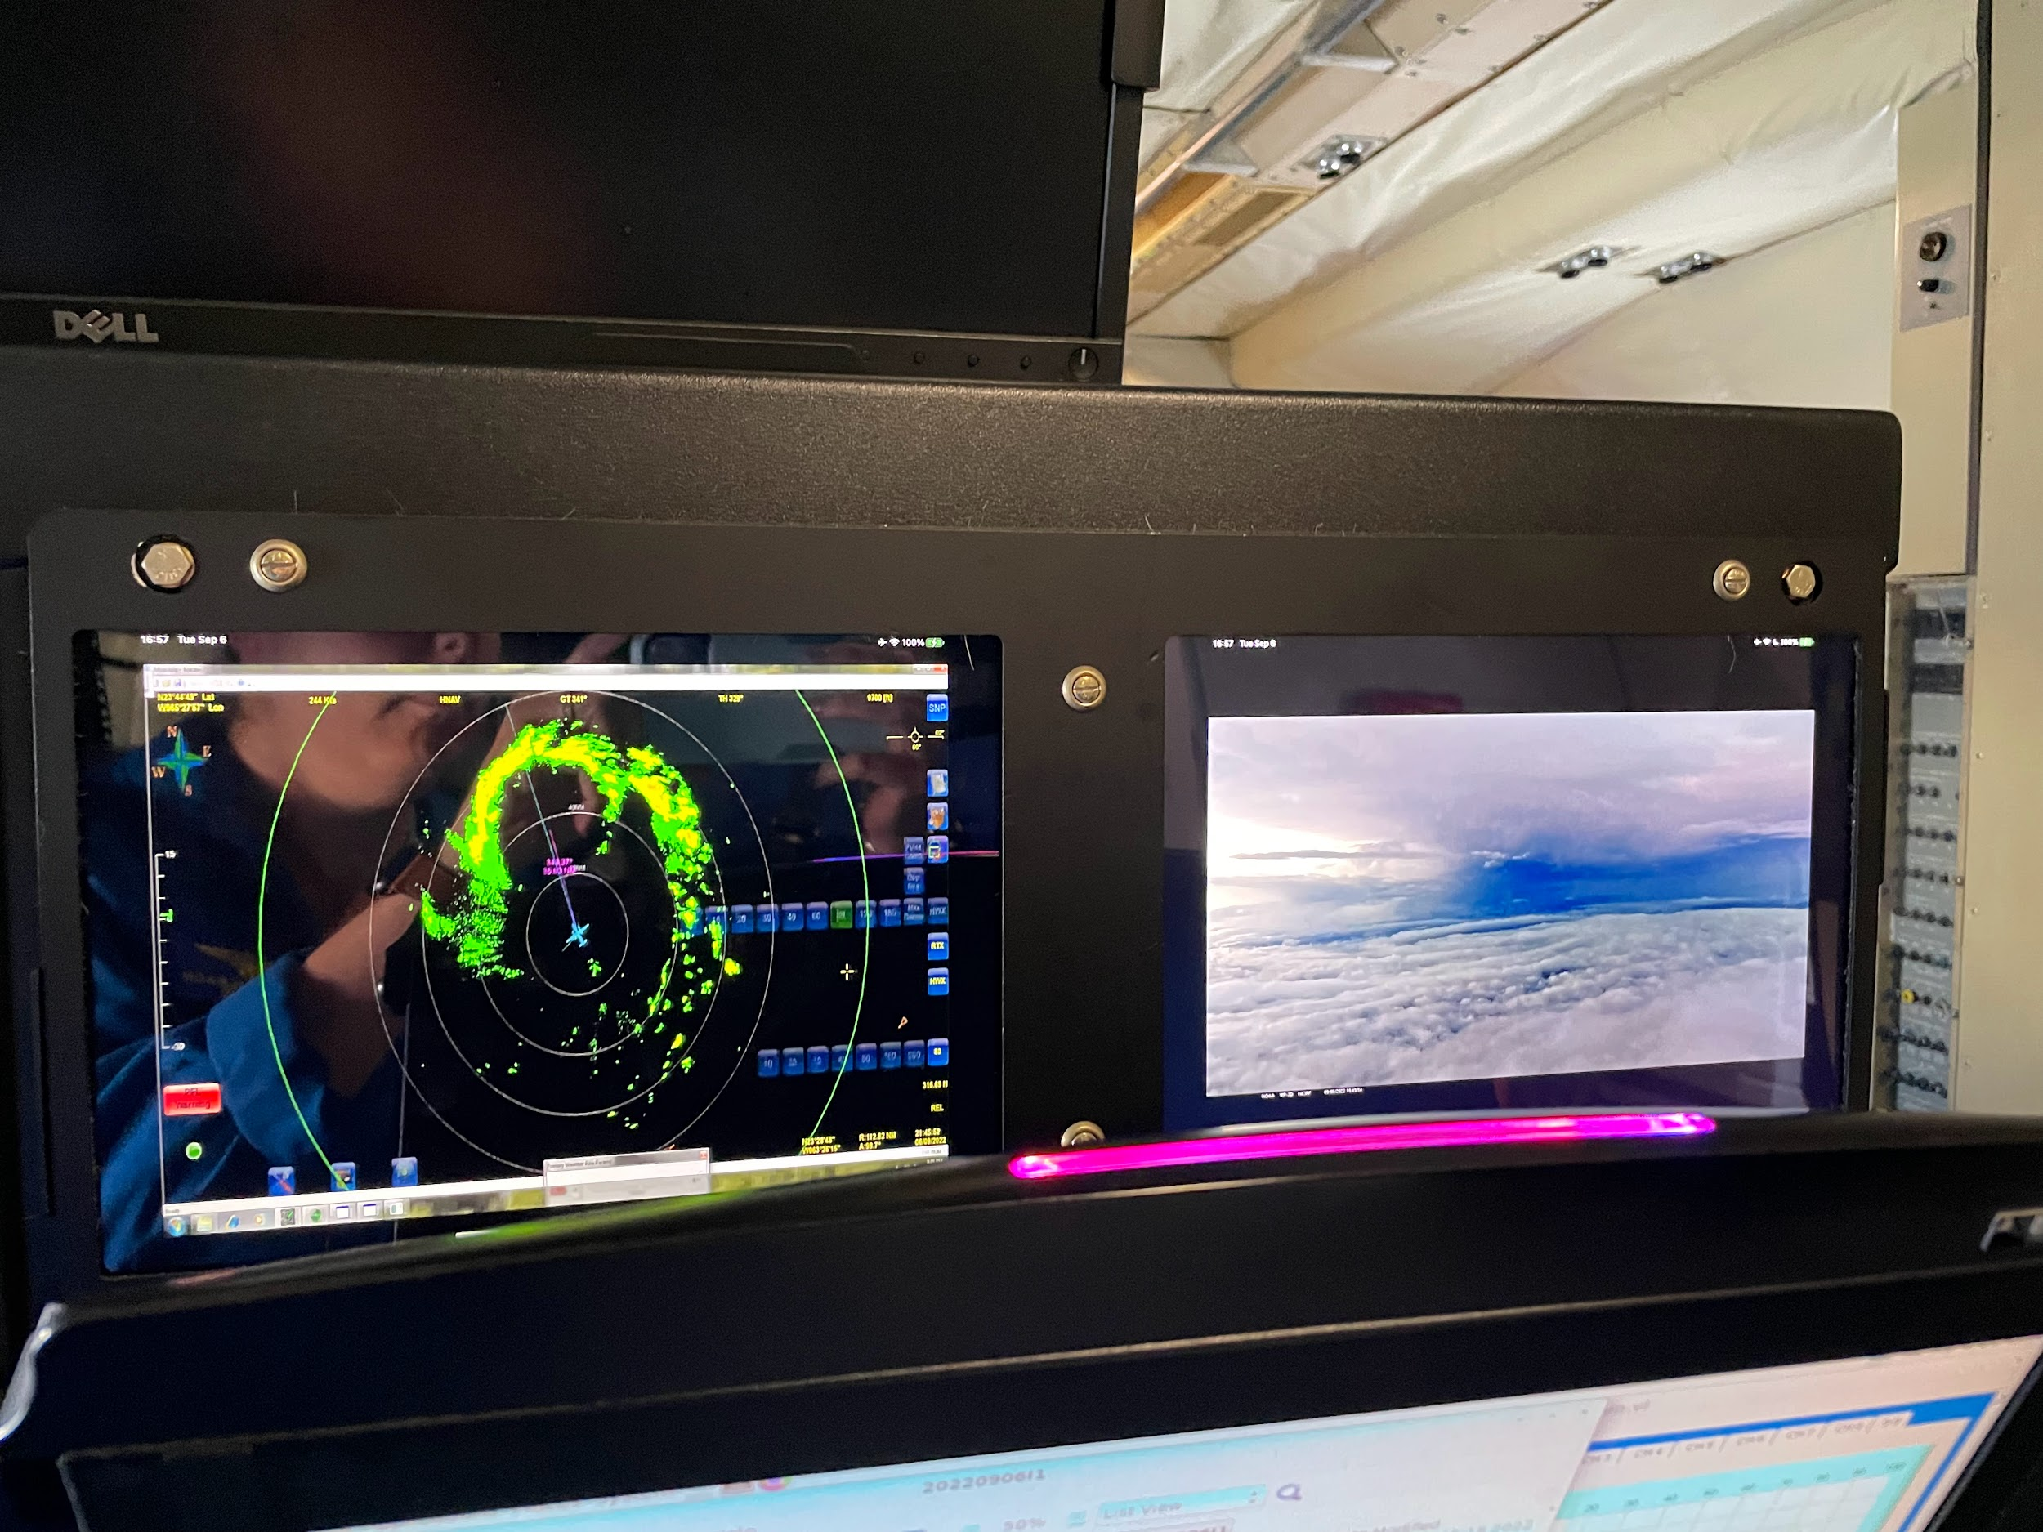
2150 | About 40 n mi diameter eye
2151 | AXBT #1 released and measured an ​​SST of 28.60C
2154 | Looks like the LLC is a bit SW of the MLC on satellite.  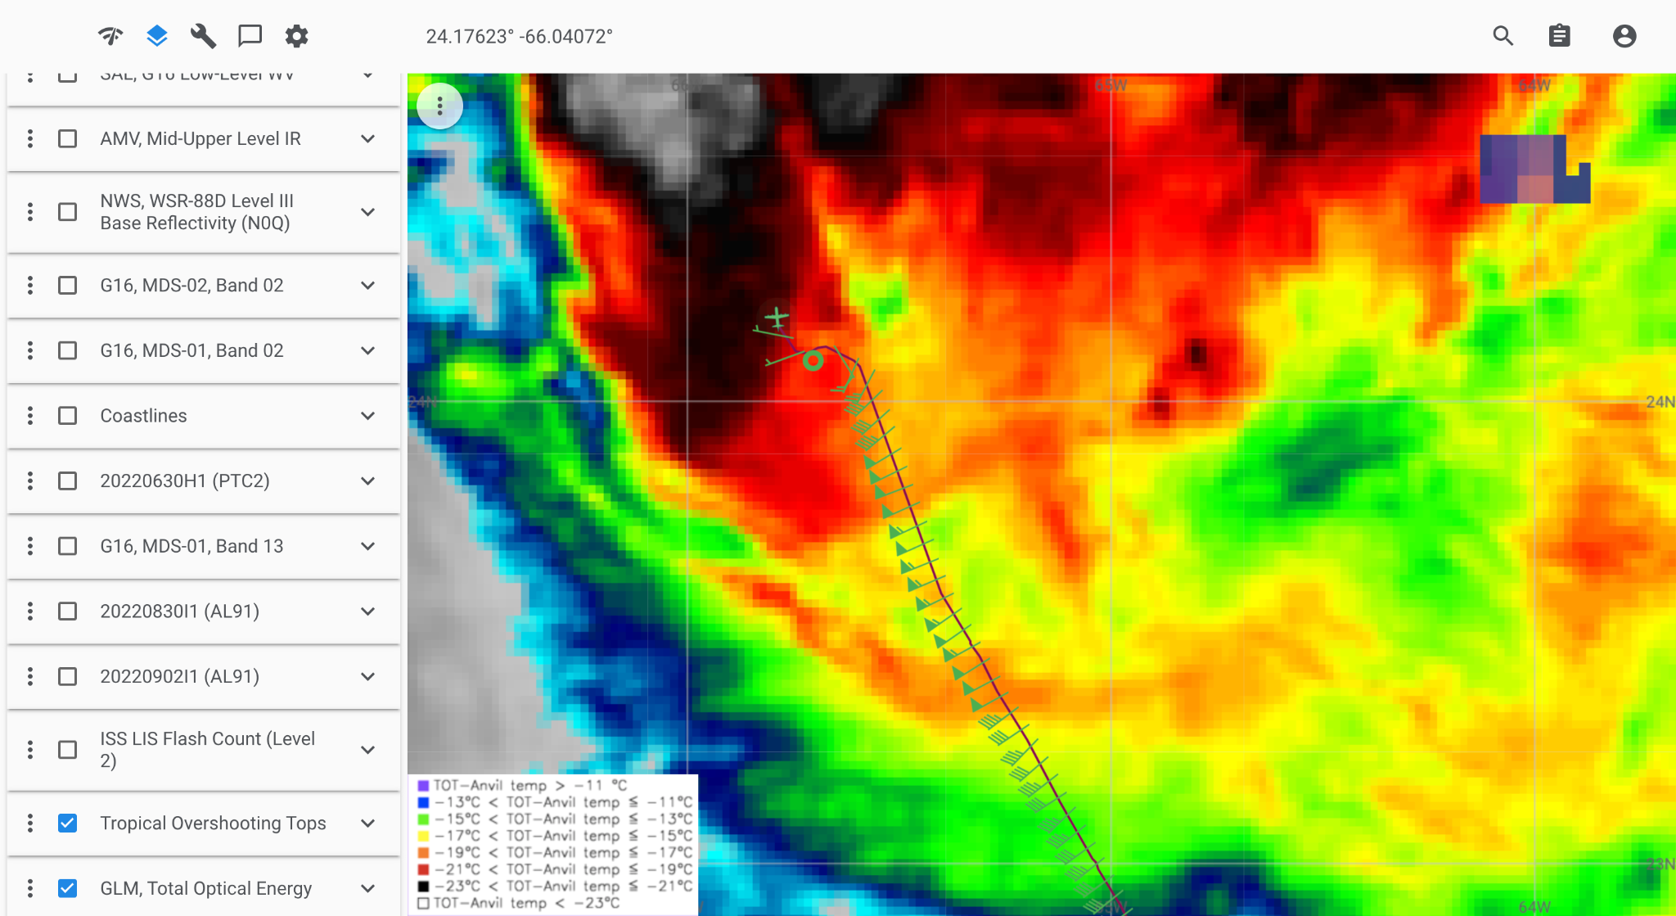
2155 | Mark center, drop #3
2156 | Backup to center, drop #4. No gps initially on drop #3 but came in just after backup
2157 | 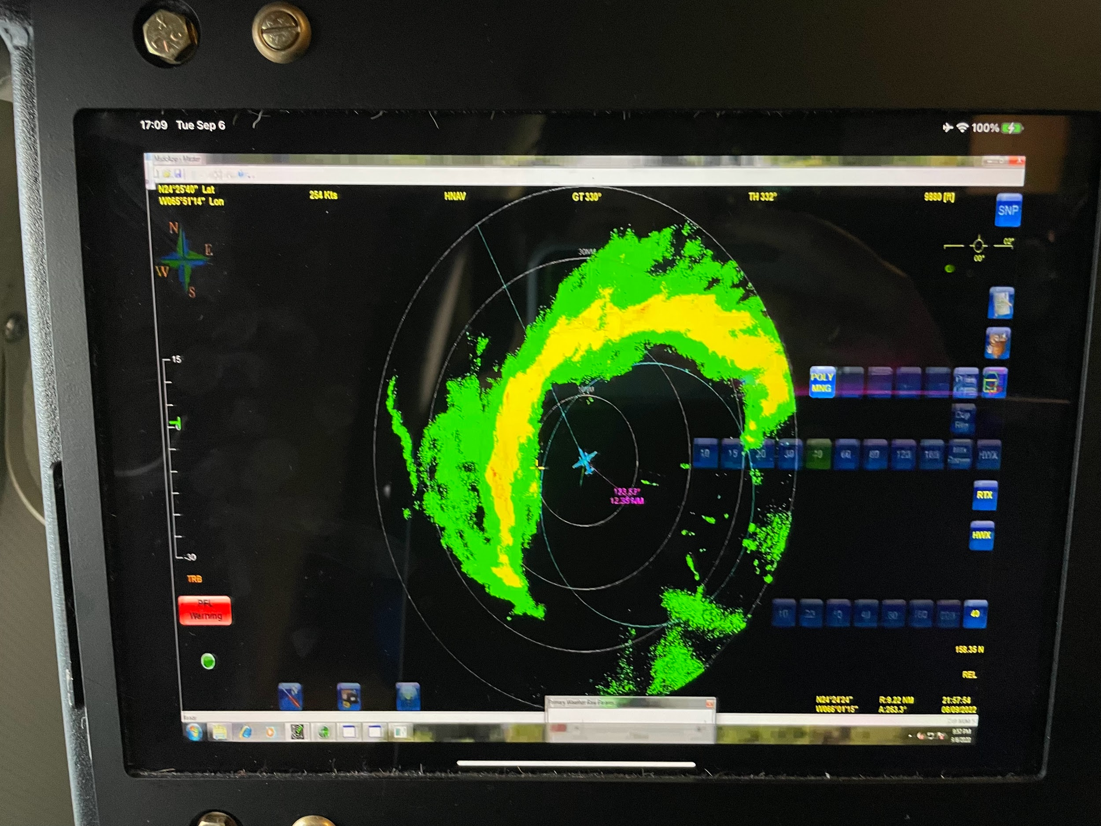
220030 | RMW drop #5  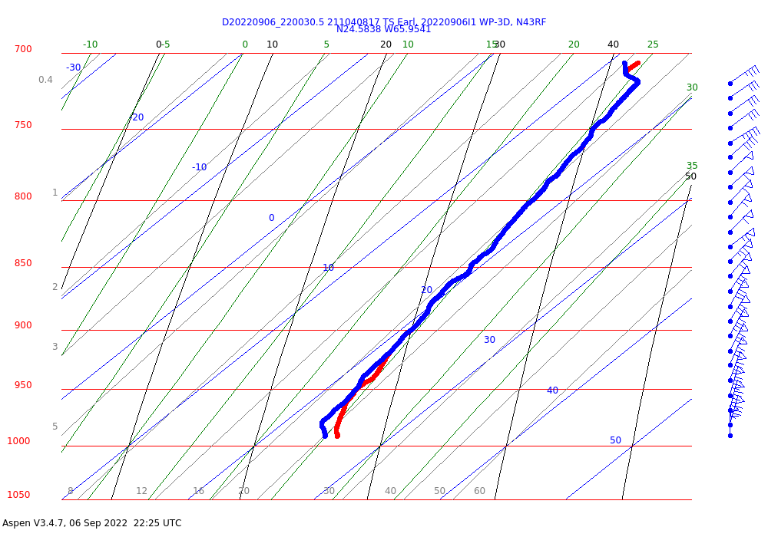
220116 | RMW drop #6
220150 | RMW drop #7
2206 | Fairly broad area of >30 m/s SFMR  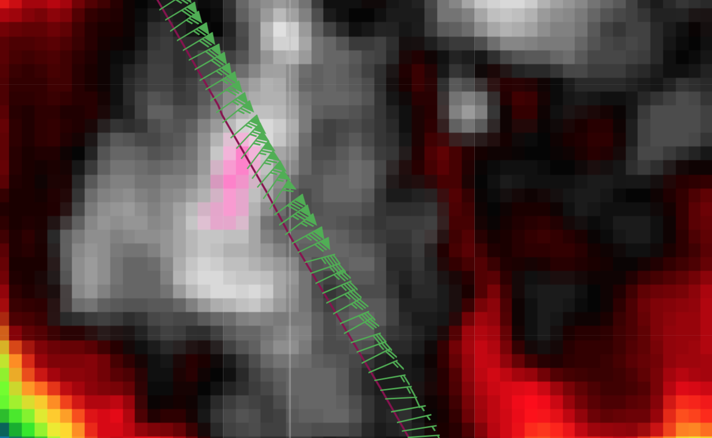
2208 | Midpoint drop #8
2216 | 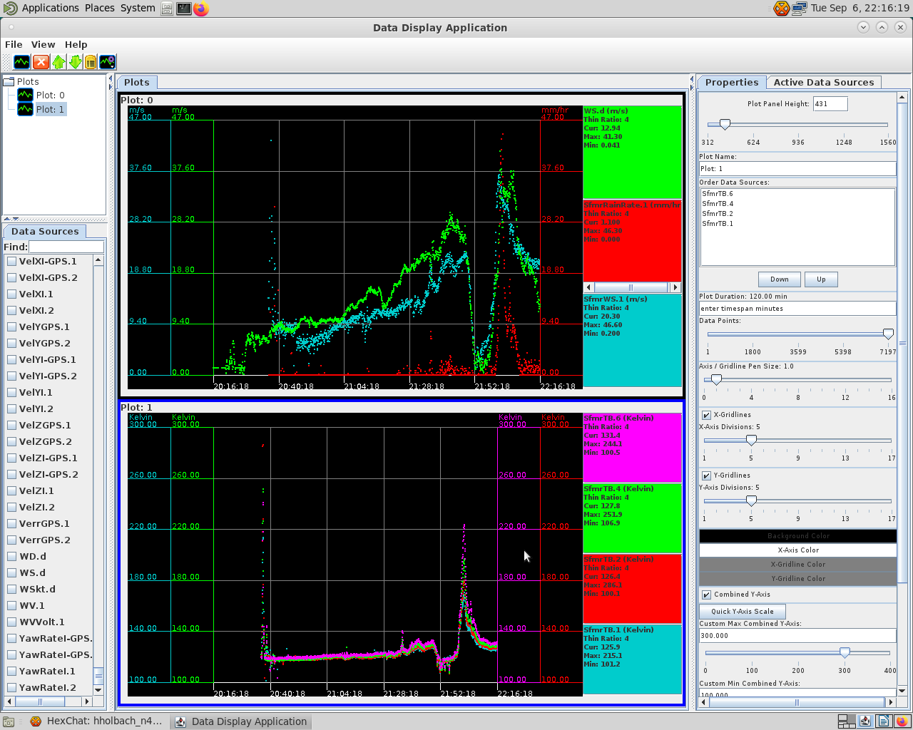
2218 | Quite hazy right now. Can see the surface. Looks like we are in a bit of a "moat”.  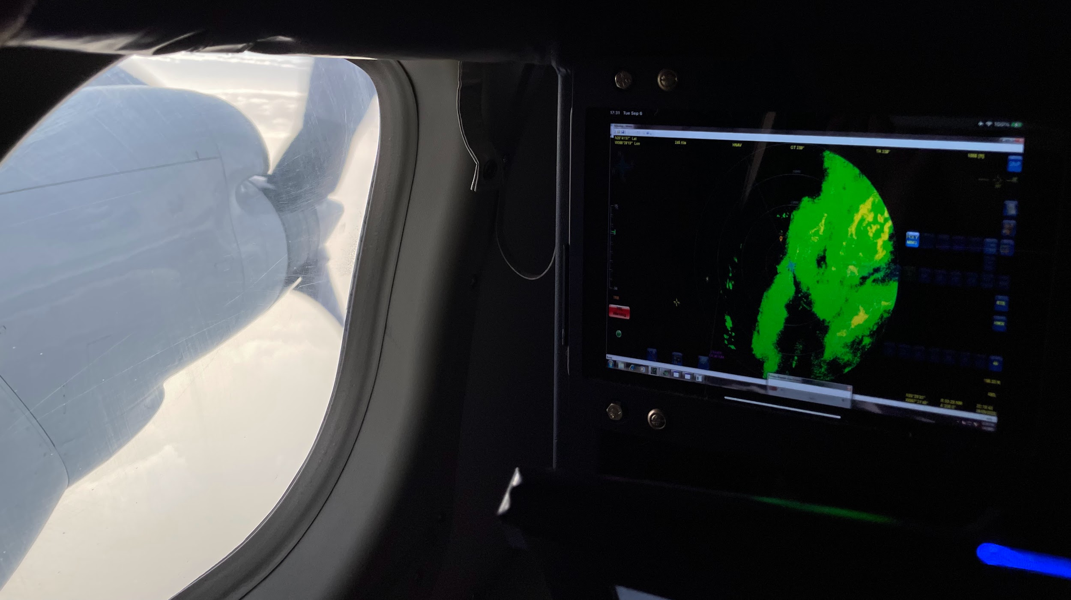
2223 | Endpoint Drop #9, AXBT #2 released and measured an SST of 28.99C
2225 | Backup sonde for EP drop #10
2247 | IP leg 2 drop #11
2254 | Nice eyewall showing up on mmr about 60 n mi ahead  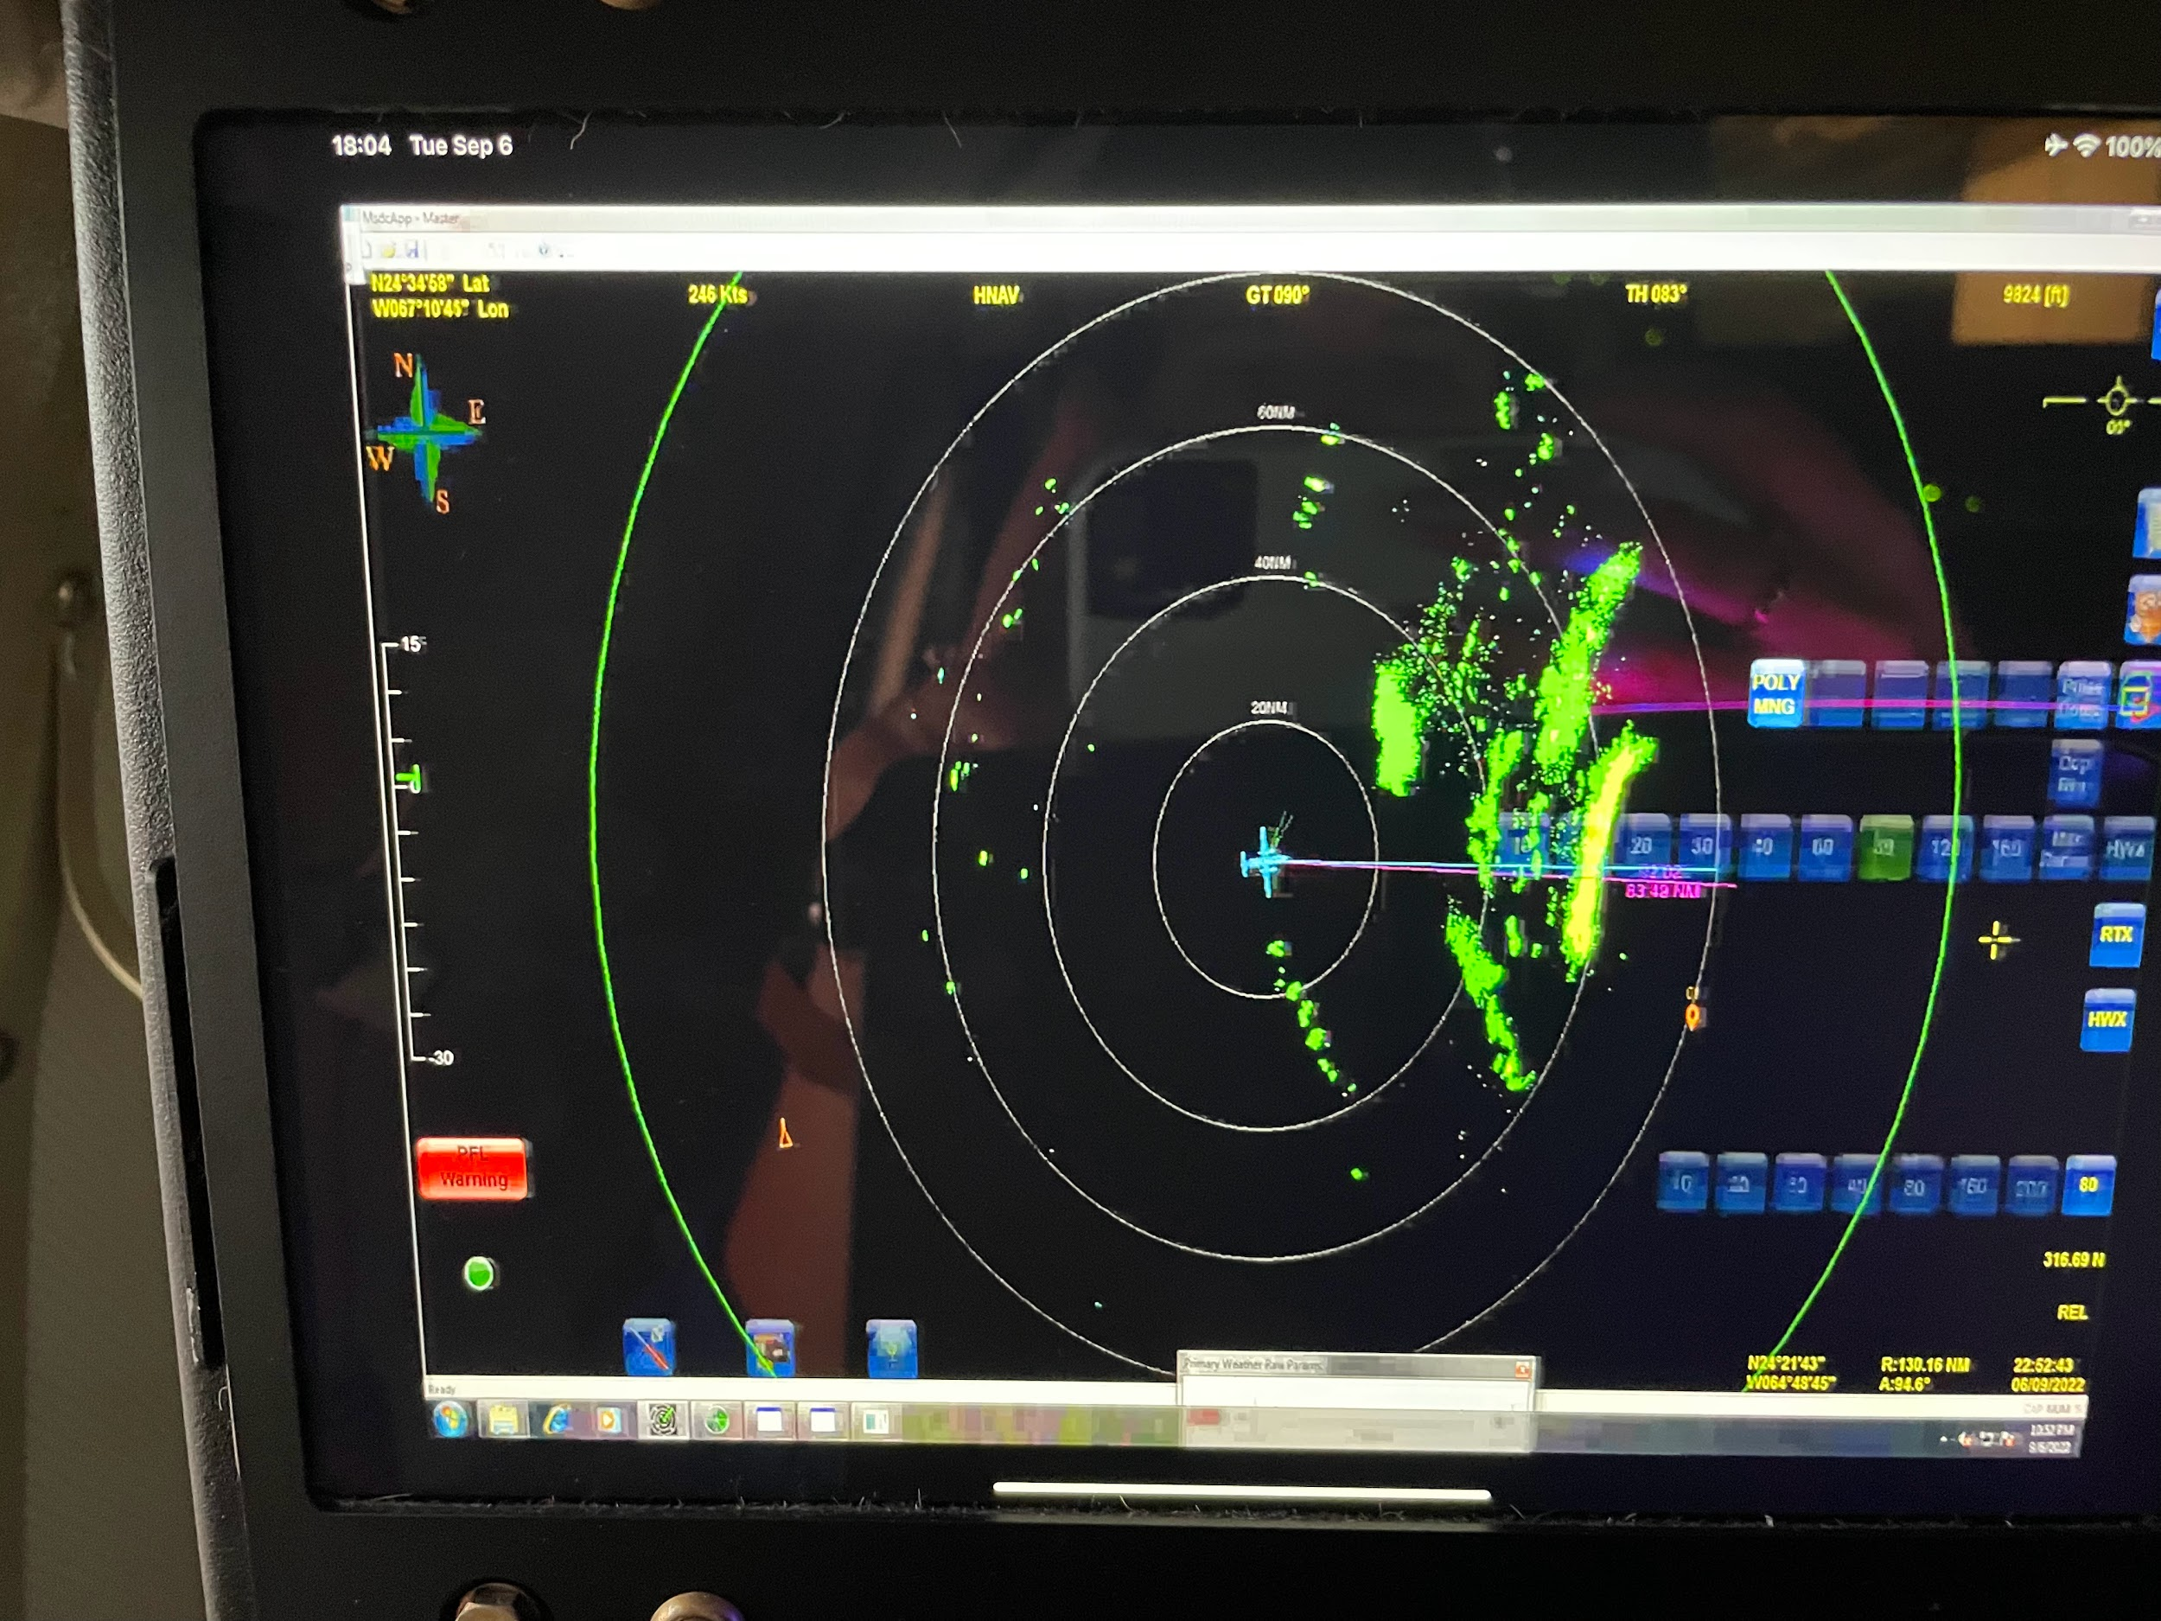
2258 | Midpoint drop #12
2259 | 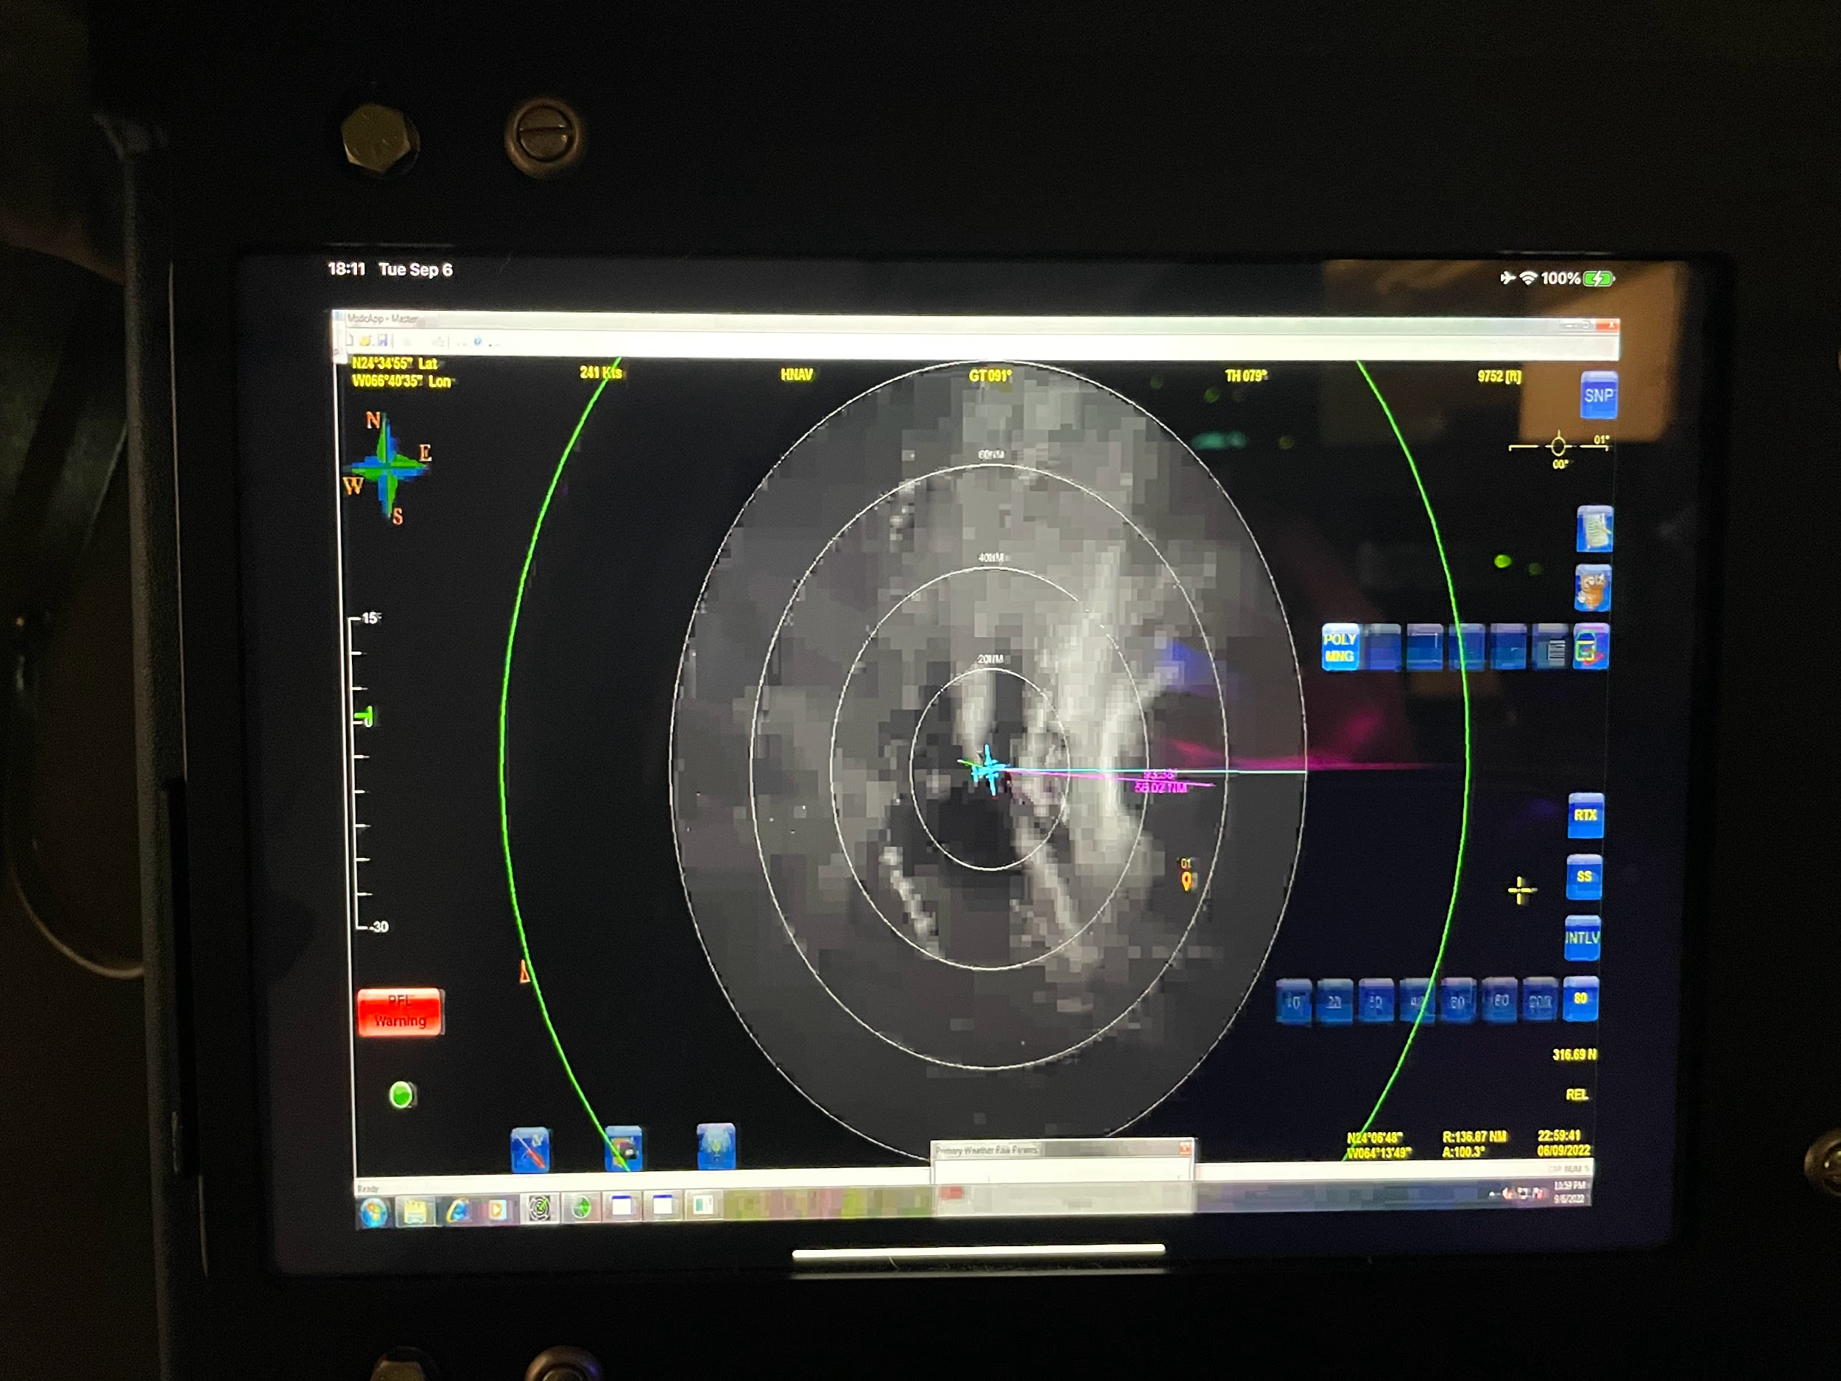
2305 | Robust eyewall forming on the NW Side  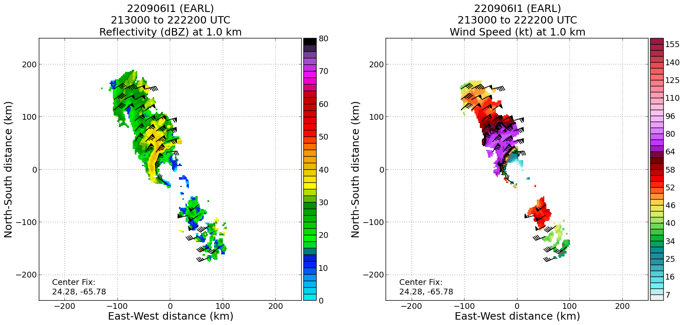
2305 | 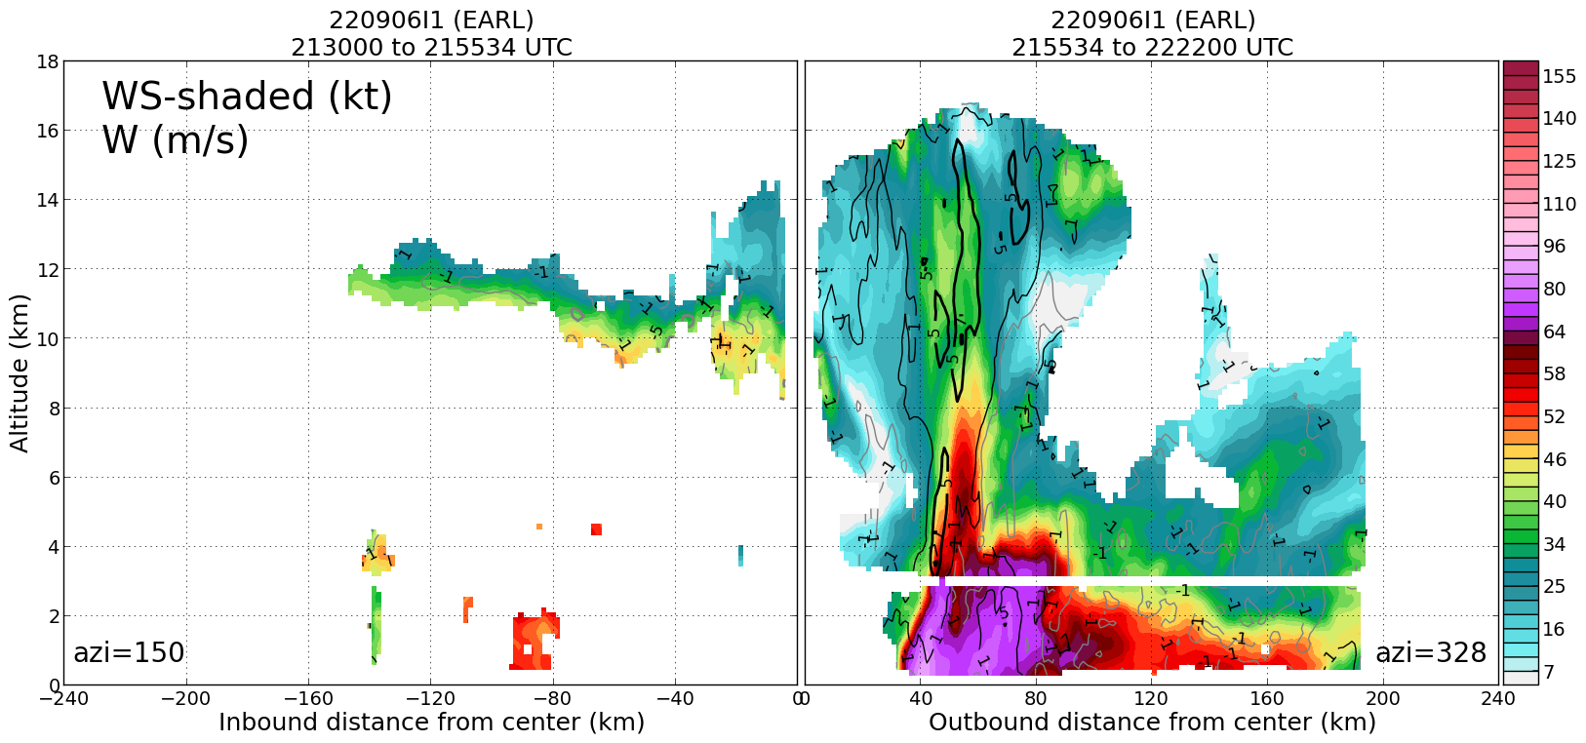
2310 | 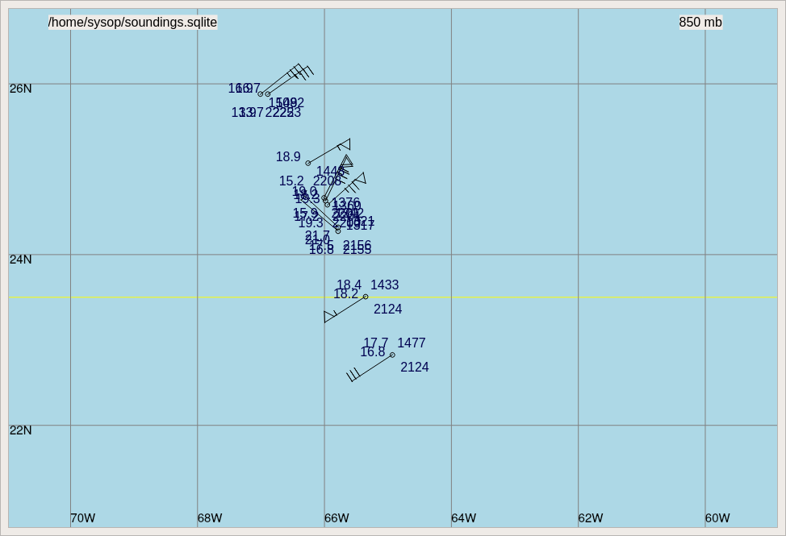  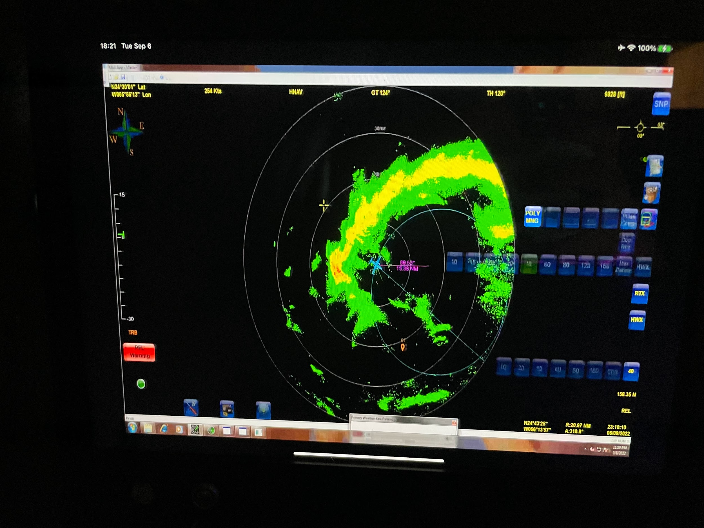
230620 | RMW Drop #13
230648 | RMW Drop #14, 9 m/s downdraft
230714 | RMW Drop #15  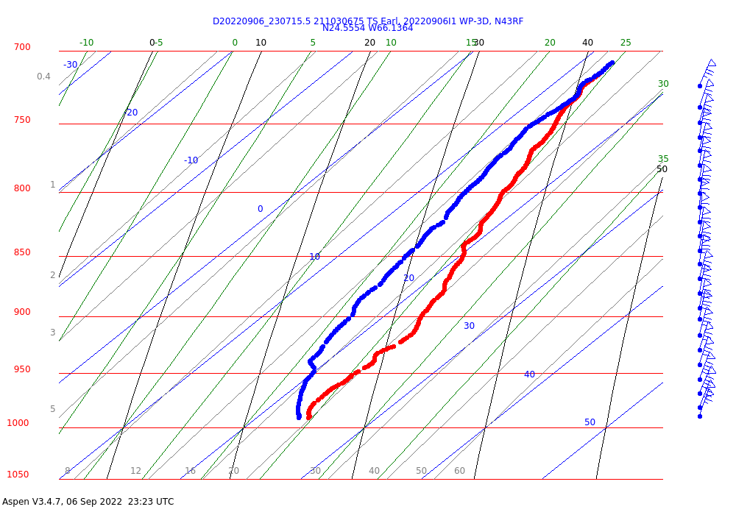
2312 | Center drop #16
2316 | 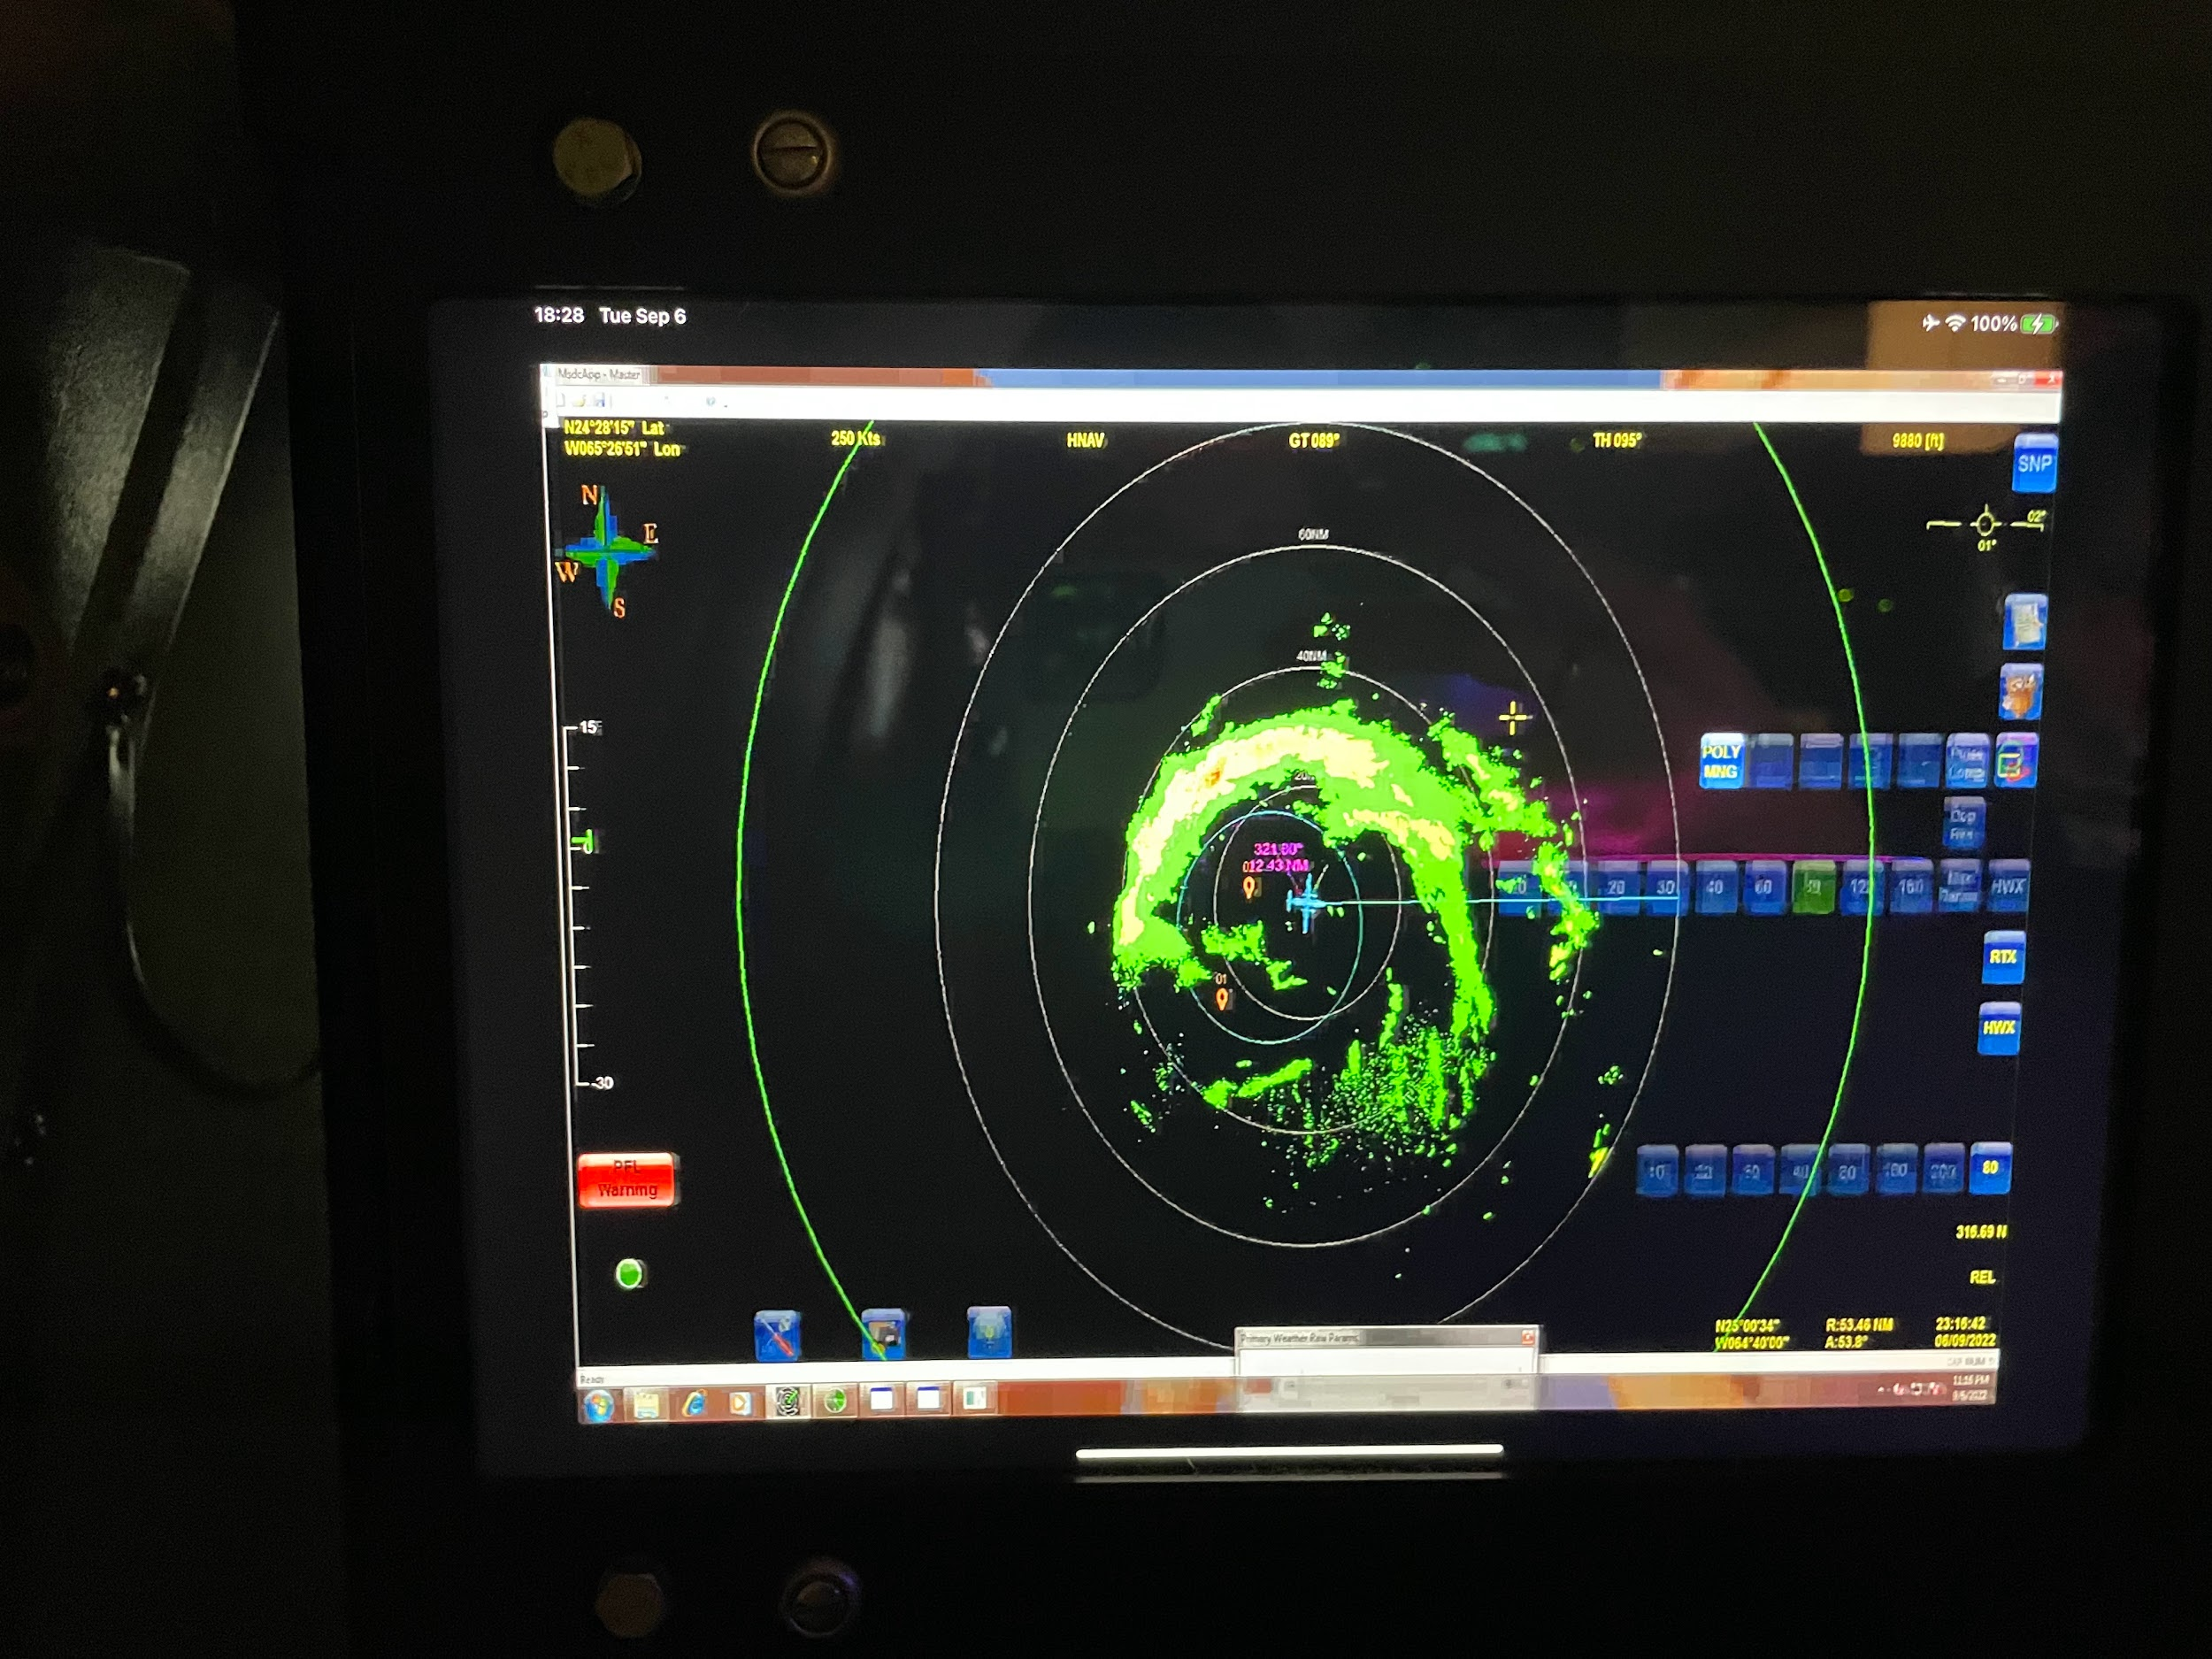
2320 | Outbound East RMW Drop #17
2325 | 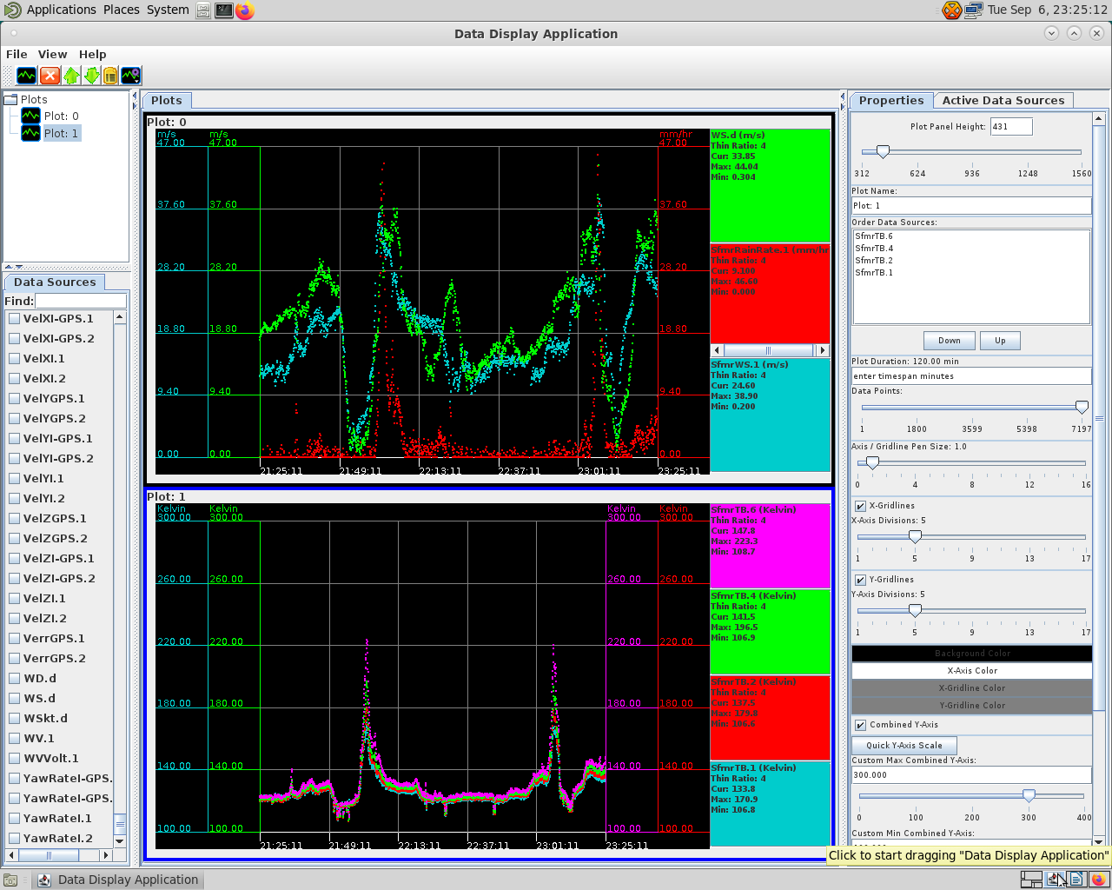
2328 | Midpoint Drop #18
2329 | 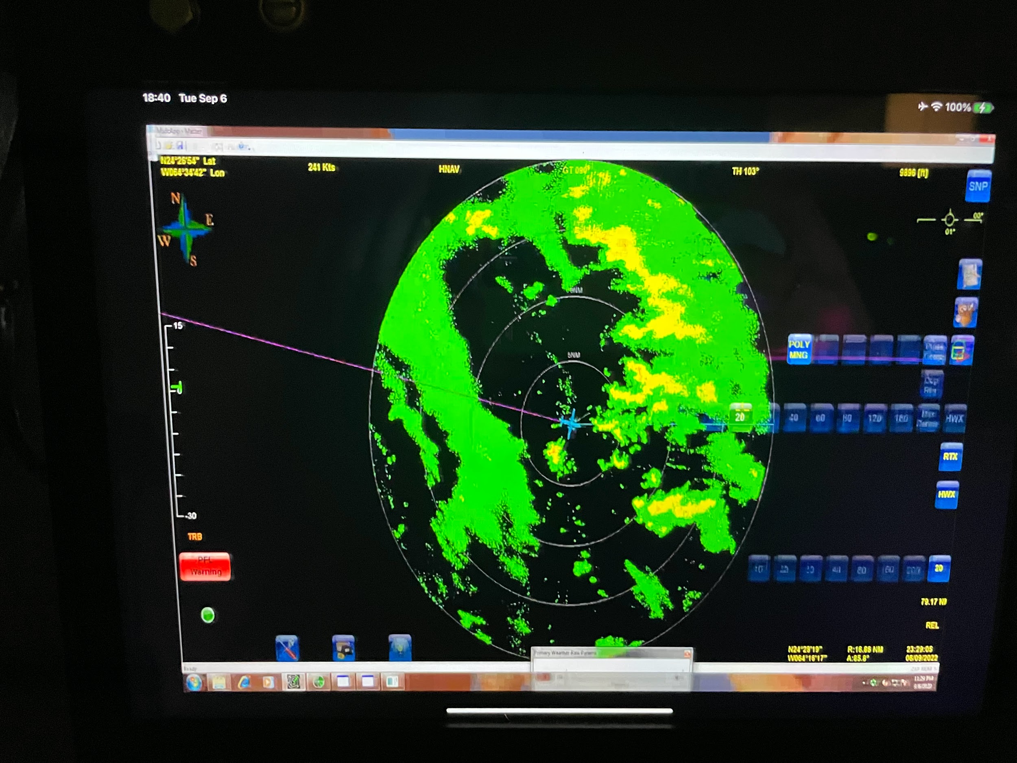
2330 | 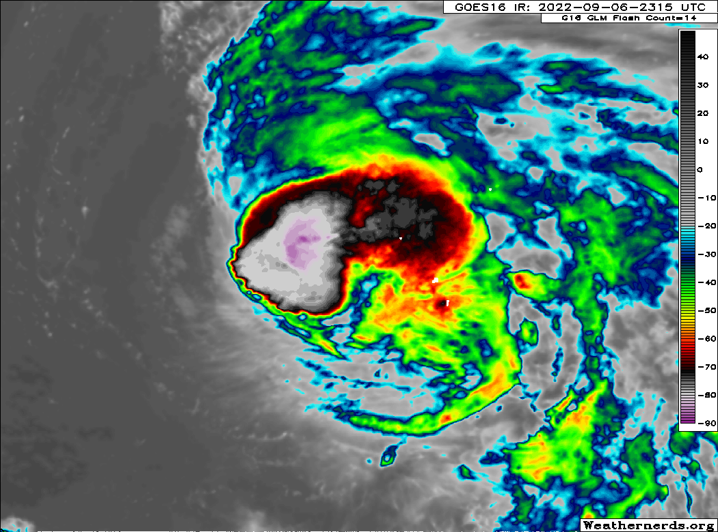
2336 | Endpoint Drop #19
2346 | 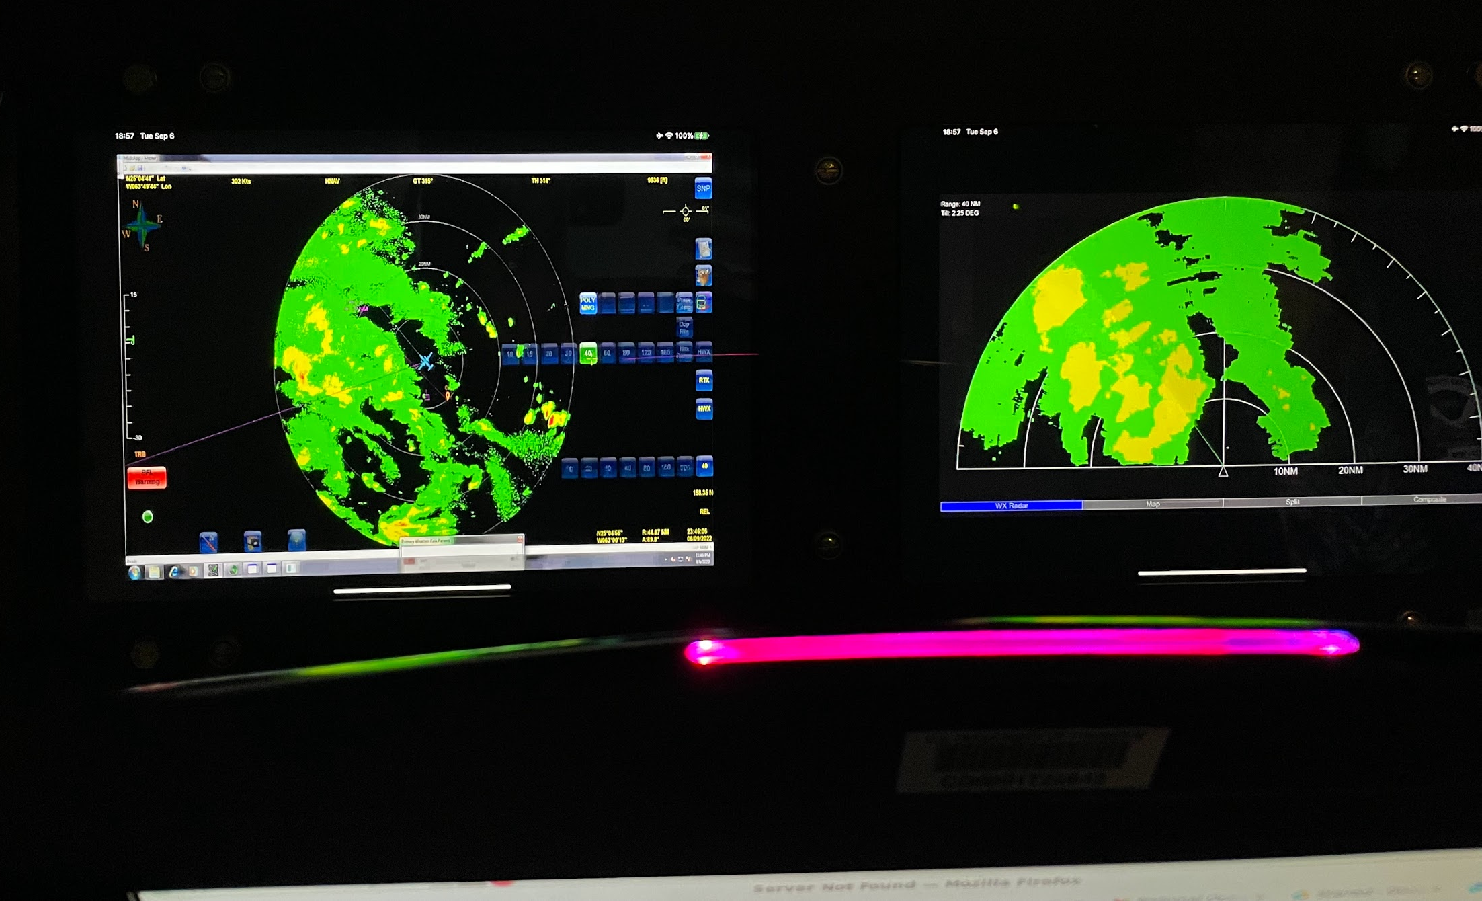
2358 | AXBT #3 released
0002 | IP NW, endpoint Drop #20
0003 | Discussing strategy for FLAIMS module (whether we should do it NE or NW)
0008 | 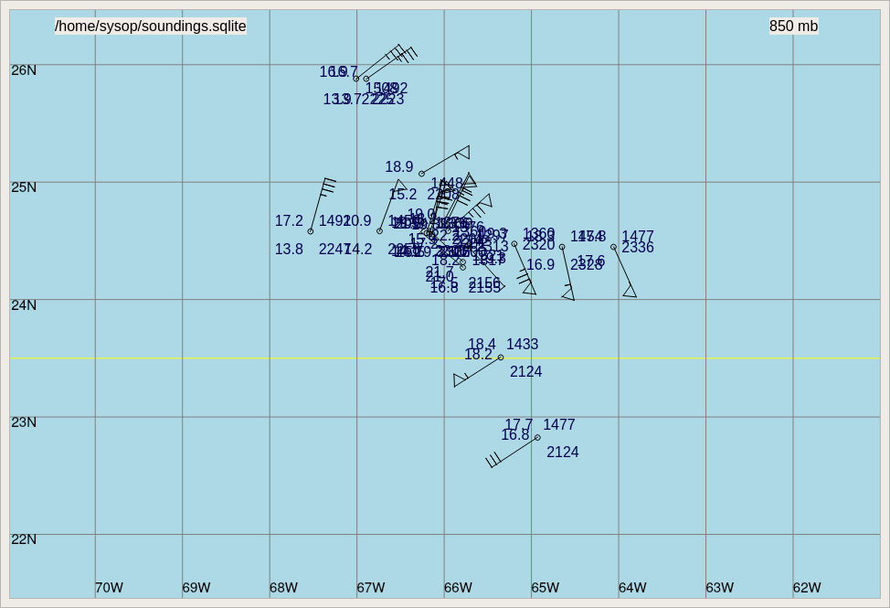
0011 | Decision was made to do the FLAIMS sampling in the NW side of the storm
0012 | Midpoint drop #21
002007 | RMW Drop #22
002035 | RMW Drop #23, #24 (one had a no launch detect)
0028 | Center drop #25, repositioning for outbound NW for FLAIMS module
0030 | 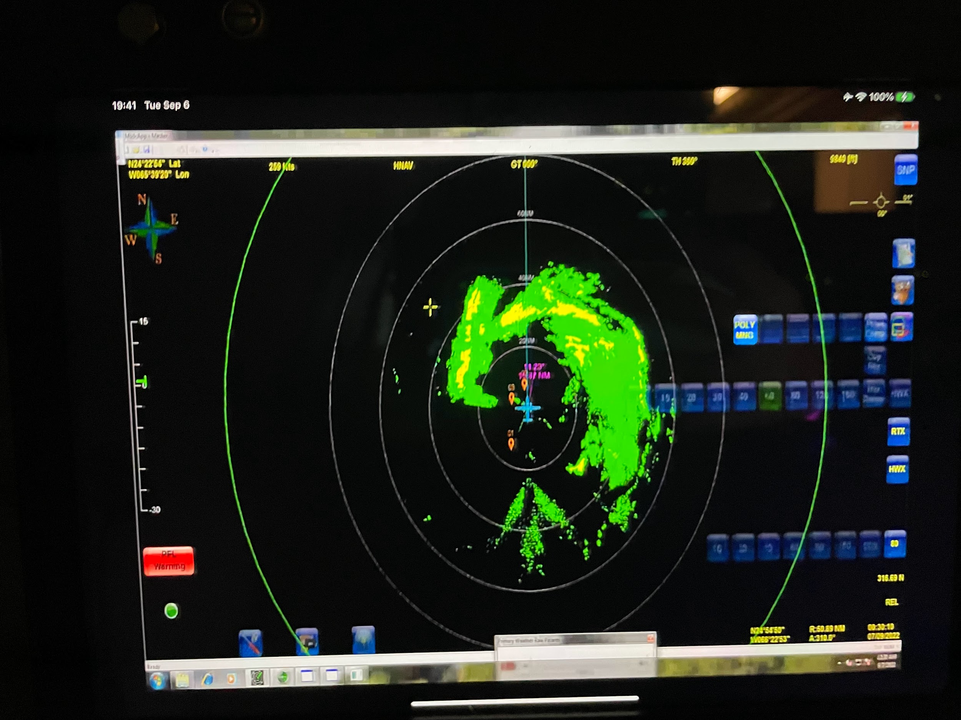
0034 | 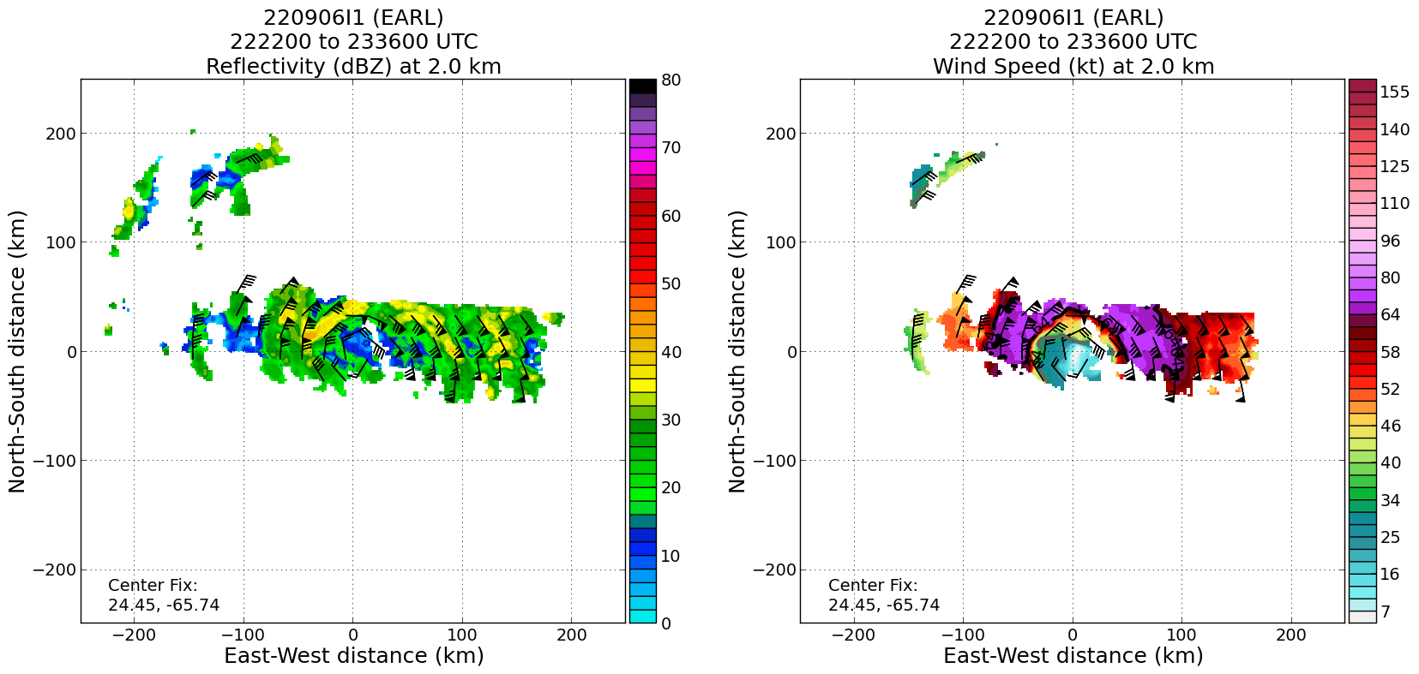  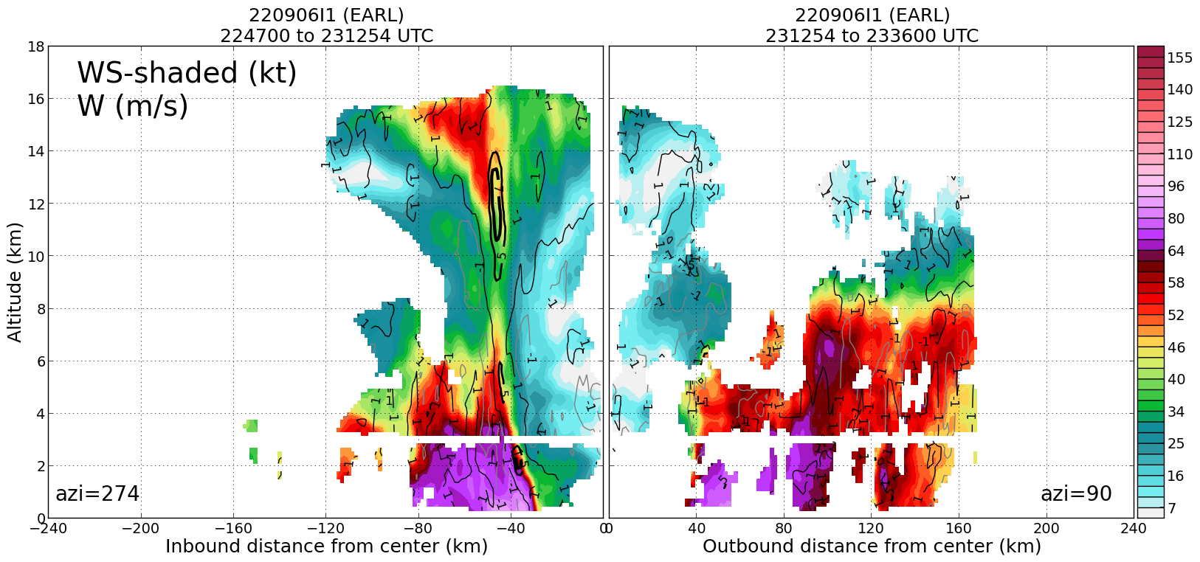  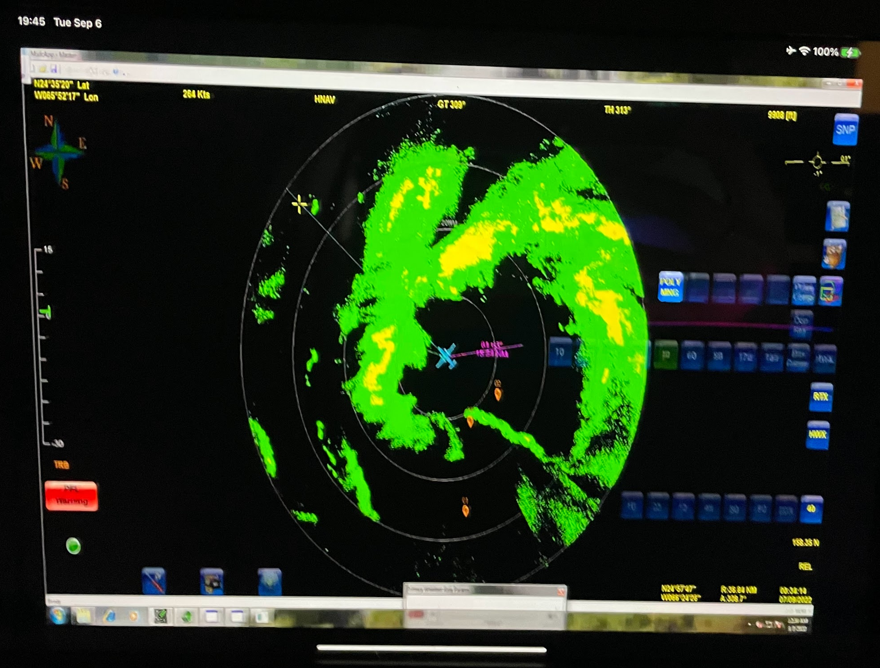
0046 | Going upwind to turn and come back in from NW
0053 | RMW sonde #26 NW for FLAIMS module
0111 | 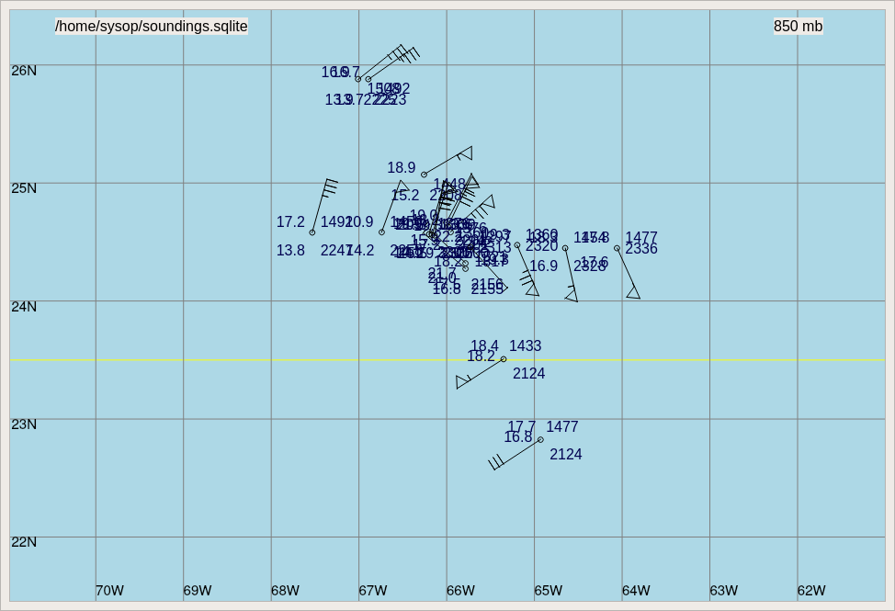
0113 | 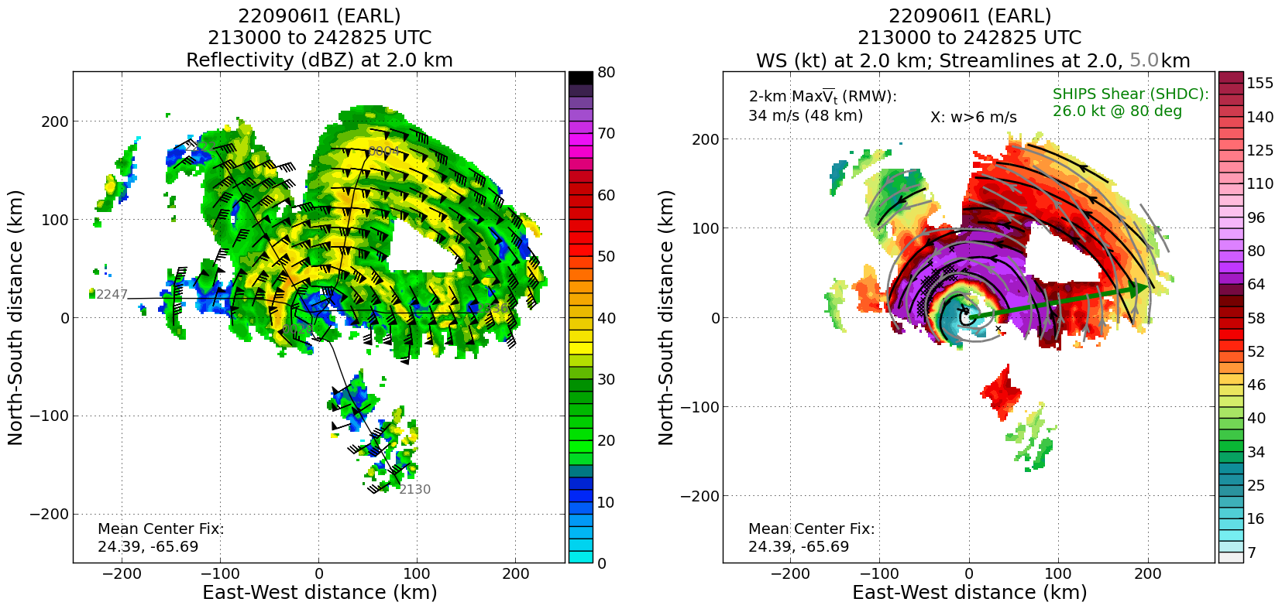
0127 | Recent microwave overpass shows a more symmetric eye forming  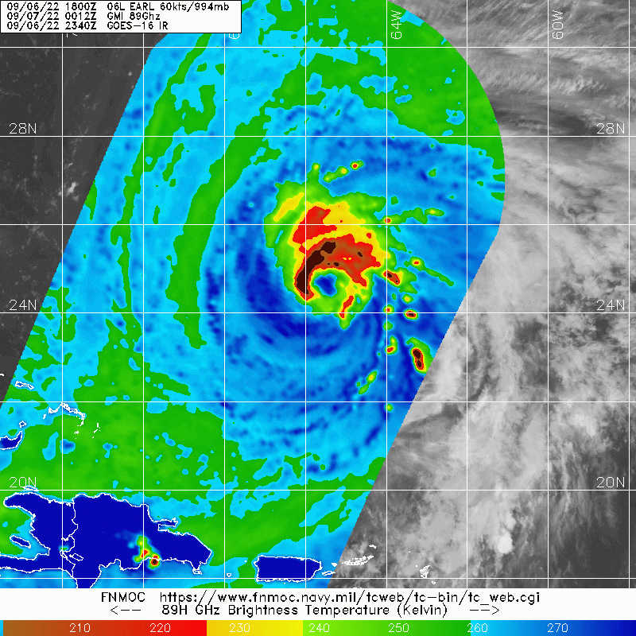
0139 | 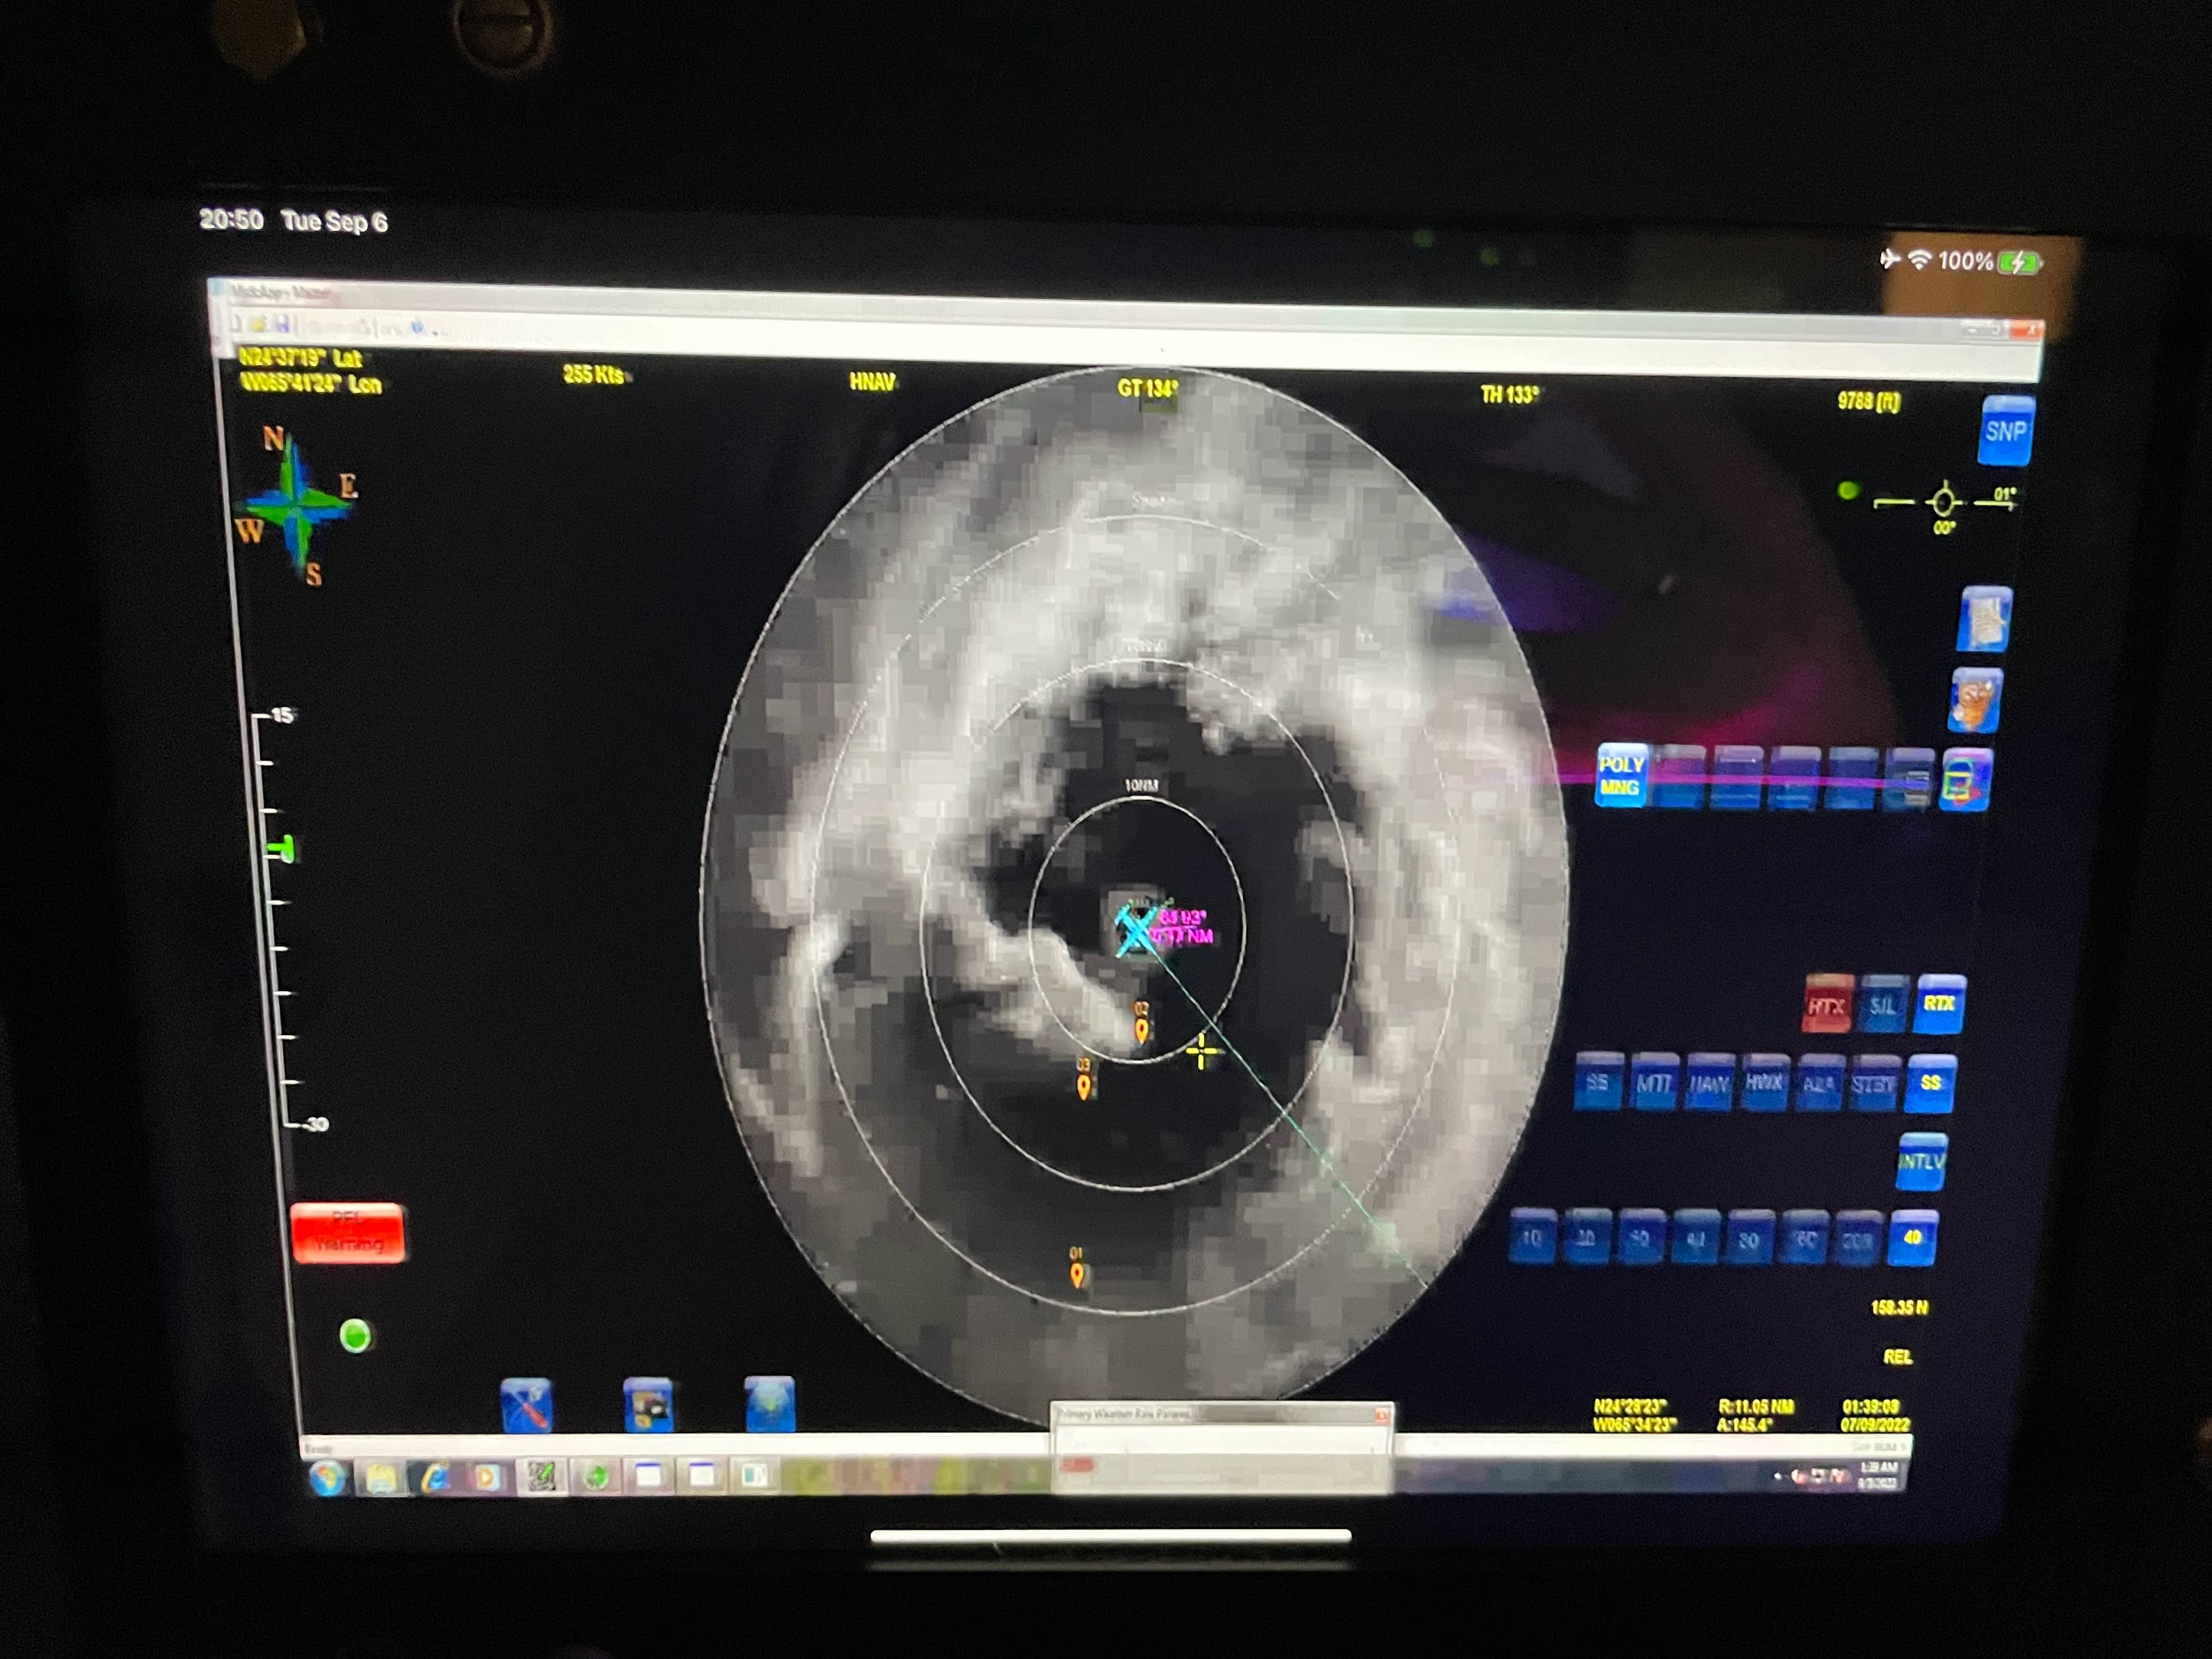
0149 | RMW drop #27 SW
0156 | Midpoint drop #28 SW
0157 | Some lightning in the SE (DSR) quadrant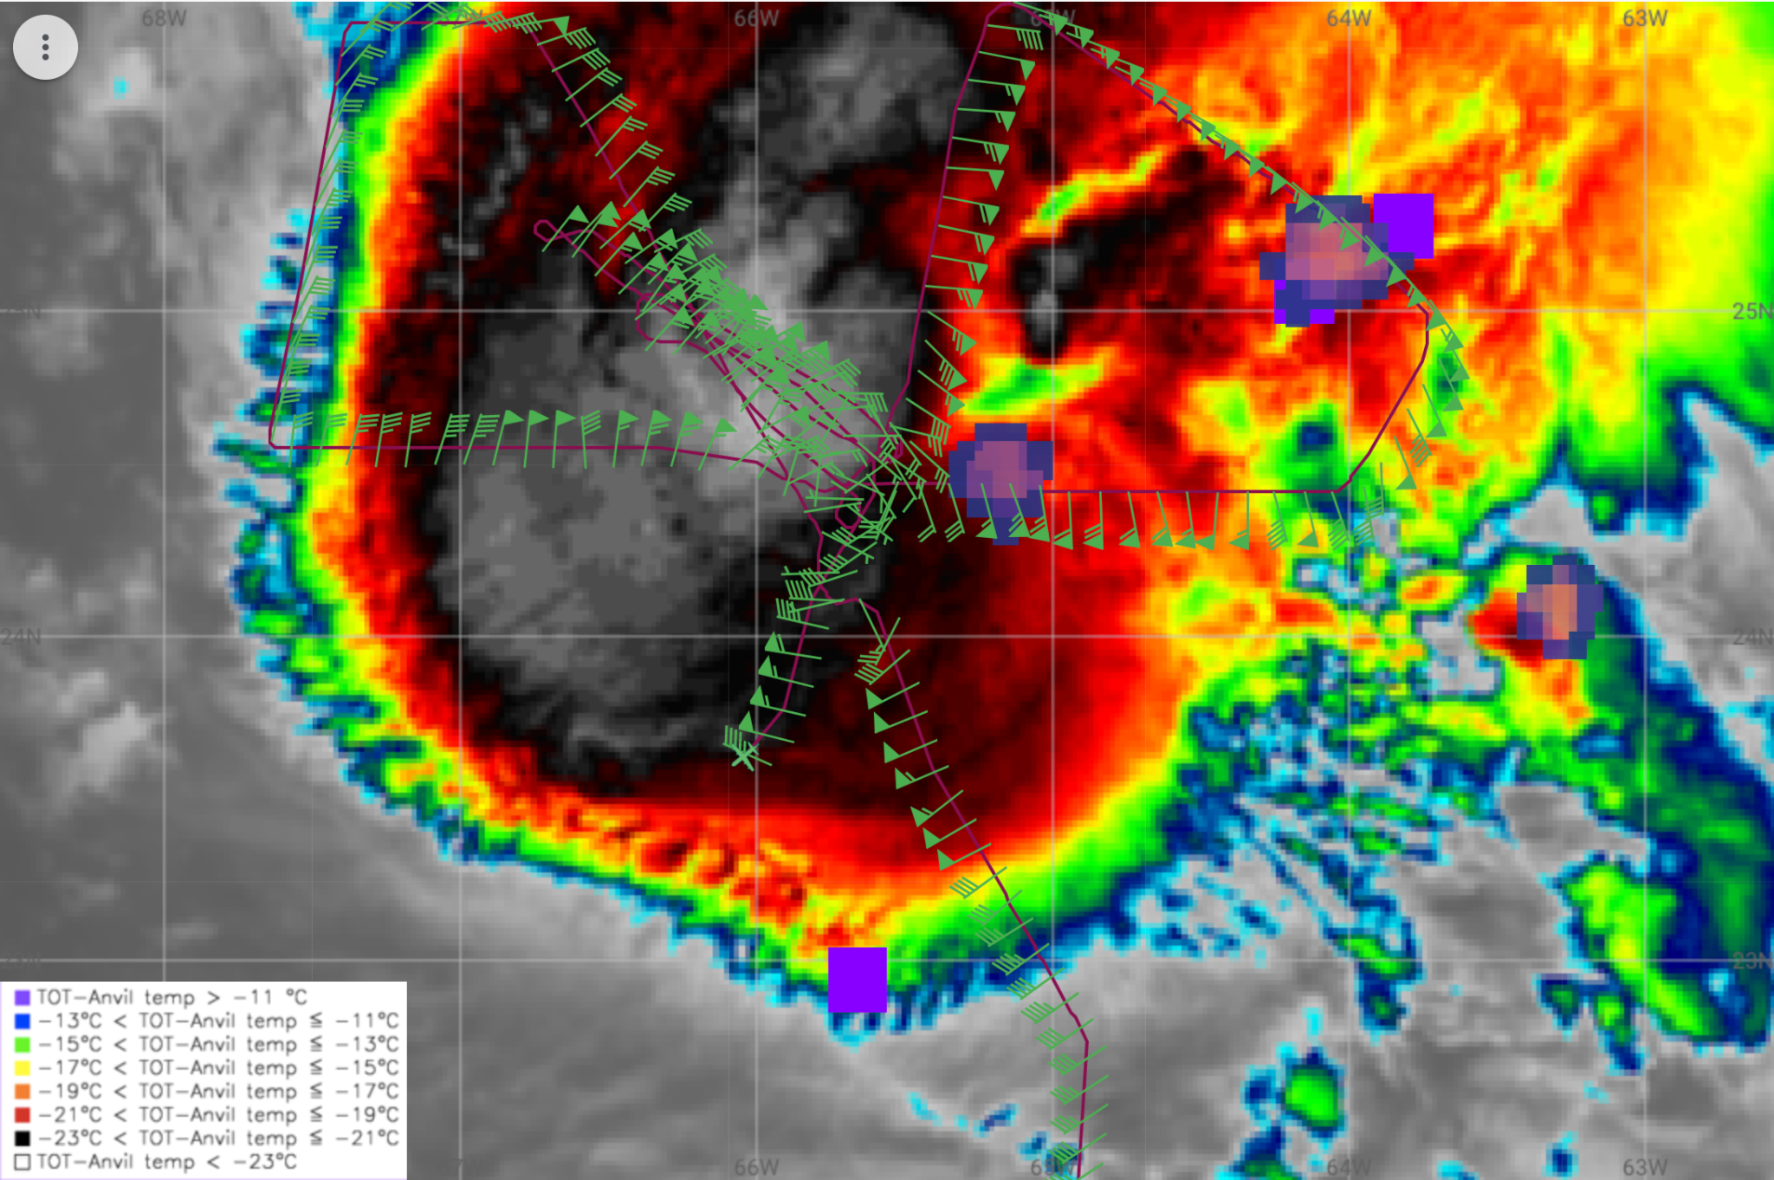
0208 | Endpoint SW drop #29. Science complete
0225 | Final synoptic maps (850 hPa):  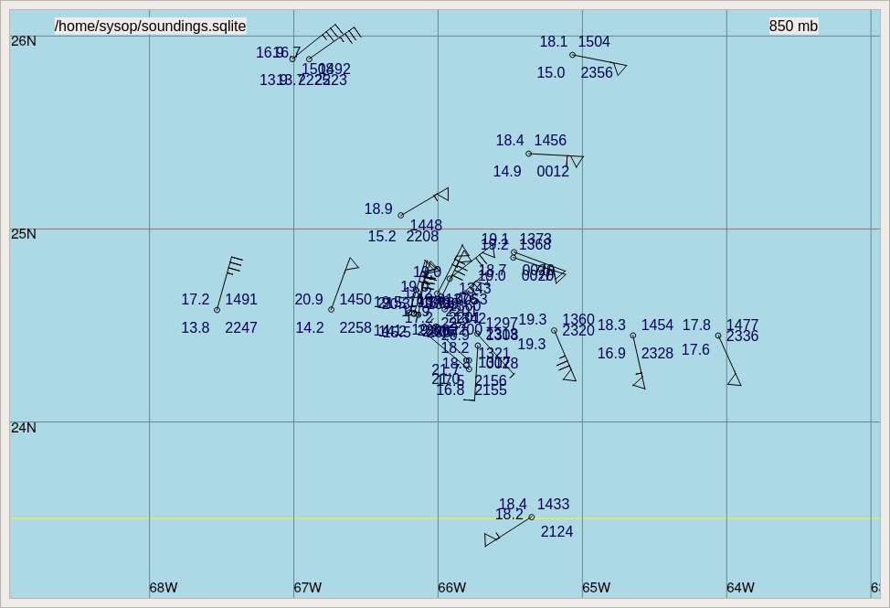
0226 | 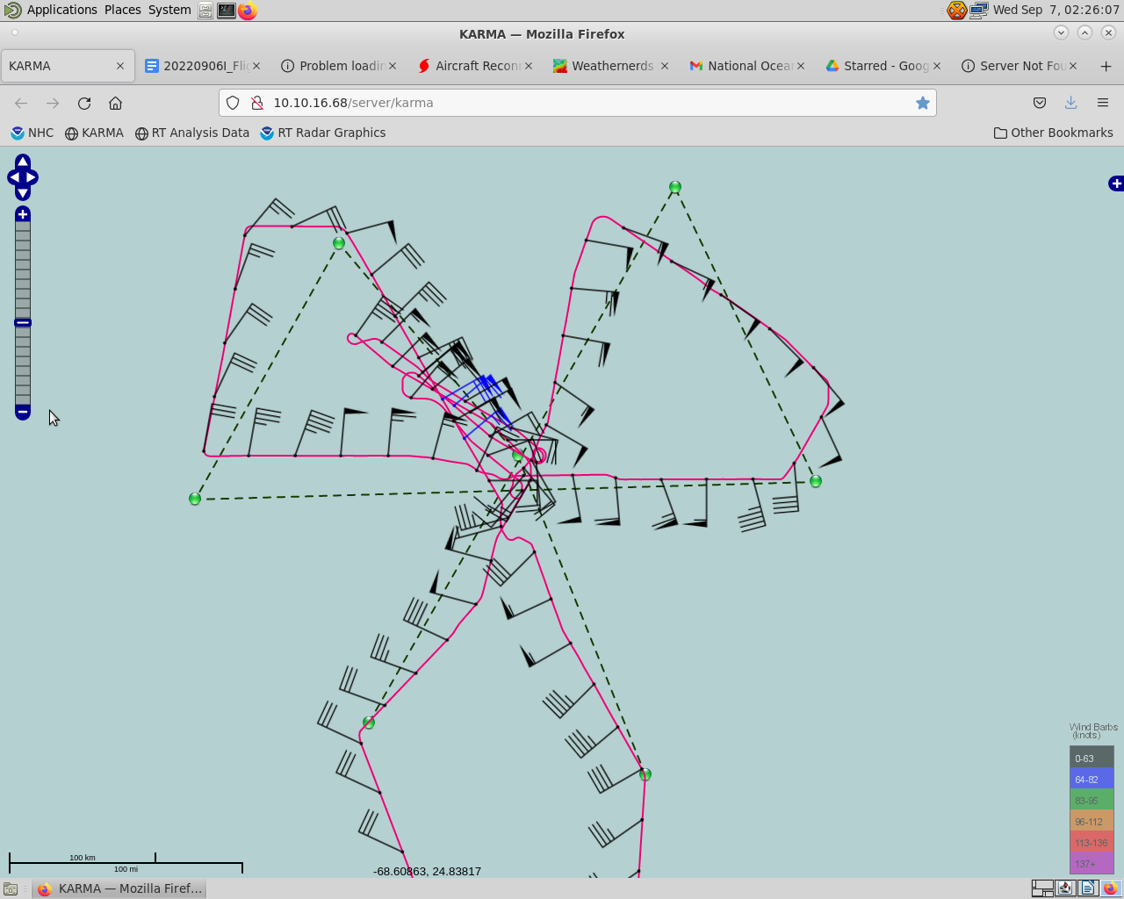
0238 | Final TDR Analysis:  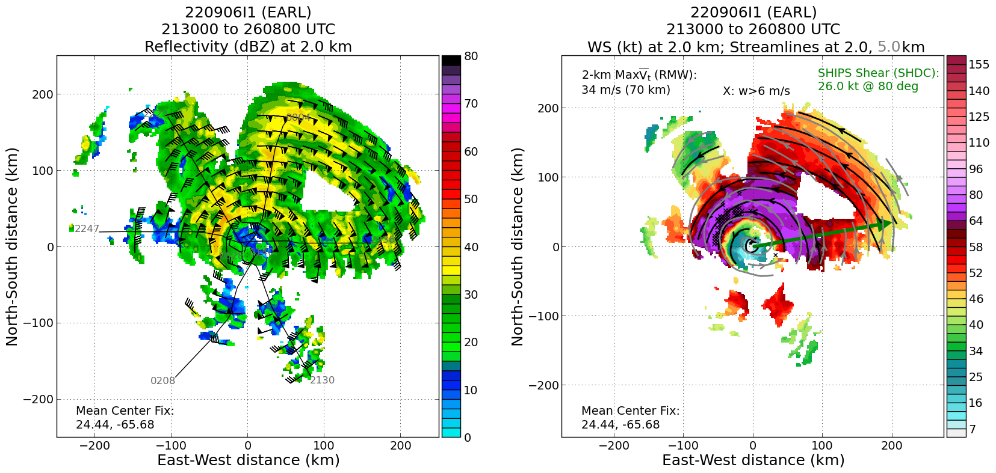

POST-FLIGHT
Mission Summary | Earl was getting better organized throughout the day, and showed a robust eyewall on the NW half.  Convection appeared to be wrapping into the upshear quadrant, and the strongest winds were in the upshear-left region.  In addition, the tilt appeared to be reduced compared to the earlier flight, based on the TDR data.  As a result of data from the mission, Earl was upgraded to a hurricane at the 8 pm intermediate NHC advisory.  The FLAIMS module was executed well with 2 extra in-out passes through the NW quadrant. In retrospect we could have kept it NE since the storm was symmetrizing throughout the flight, but the data we got was good.
Actual Standard Pattern Flown | Butterfly with the addition of the FLAIMS module between points 5 and 6.
APHEX Experiments / Modules Flown | Data supported the Early Stage Experiment: Analysis of Intensification Processes (AIPEX), specifically with the FLAIMS (Flight-level Assessment of Intensification in Moderate Shear) module being flown with 2 additional passes through the NW quadrant of the TC.
Plain Language Summary | - We flew a mission into Earl and found winds that supported it being upgraded to a hurricane. The system was becoming better organized despite some vertical wind shear, and intensifying throughout the flight.
Instrument Notes | Several dropsondes had mismatched release and 31313 times. OB27 is a good example: the 31313 has 1210z, while the release is 123227z…we’ll need to look into this more:  921  UZNT13 KWBC 071245  XXAA 57129 99259 70655 07955 99991 25411 09061 00576 ///// /////  92609 21807 10085 85365 ///// 70985 ///// 88999 77999  31313 09608 81210  61616 NOAA2 1606A EARL OB 27  62626 EYEWALL 045 MBL WND 09574 AEV 30407 DLM WND 10577 991749 WL  150 09066 083 REL 2594N06546W 123227 SPG 2596N06555W 123621 =  XXBB 57128 99259 70655 07955 00991 25411 11850 ///// 22755 11409  33715 12415  21212 00991 09061 11749 11070  31313 09608 81210  61616 NOAA2 1606A EARL OB 27  62626 EYEWALL 045 MBL WND 09574 AEV 30407 DLM WND 10577 991749 WL  150 09066 083 REL 2594N06546W 123227 SPG 2596N06555W 123621 =
Final Mission Track | 