MISSION PLAN
FLIGHT ID | 20220905I1 | STORM | AL06 / EARL
MISSION ID | 1106A | TAIL NUMBER | NOAA43
TASKING | EMC | PLANNED PATTERN | Rotated Fig-4
MISSION SUMMARY
TAKEOFF [UTC] | 1905 | LANDING [UTC] | 0326
TAKEOFF LOCATION | Lakeland | LANDING LOCATION | St. Croix
FLIGHT TIME | 8.4 | BLOCK TIME | 8.6
TOTAL REAL-TIME RADAR ANALYSES  (Transmitted) | 4 (3) | TOTAL DROPSONDES (Good/Transmitted) | 27 (27 / 23)
OCEAN EXPENDABLES (Type) | 4 AXBT (ONR) | sUAS (Type) | None
APHEX EXPERIMENTS / MODULES | Early Stage Experiment: AIPEX
HRD CREW MANIFEST
LPS ONBOARD | Aberson | LPS GROUND | Holbach, Marks
TDR ONBOARD | Aberson | TDR GROUND | Gamache
ASPEN ONBOARD | Aberson | ASPEN GROUND | None
NESDIS SCIENTISTS | Chang, Sapp, Jelenak
GUESTS (Affiliation) | None
AOC CREW MANIFEST
PILOTS | Doremus, Copare, Wood
NAVIGATOR | Utama
FLIGHT ENGINEERS | Darby, Pittman
FLIGHT DIRECTOR | Kalen, Holmes
DATA TECHNICIAN | Richards
AVAPS | Warnecke

PRE-FLIGHT
Flight Plan | 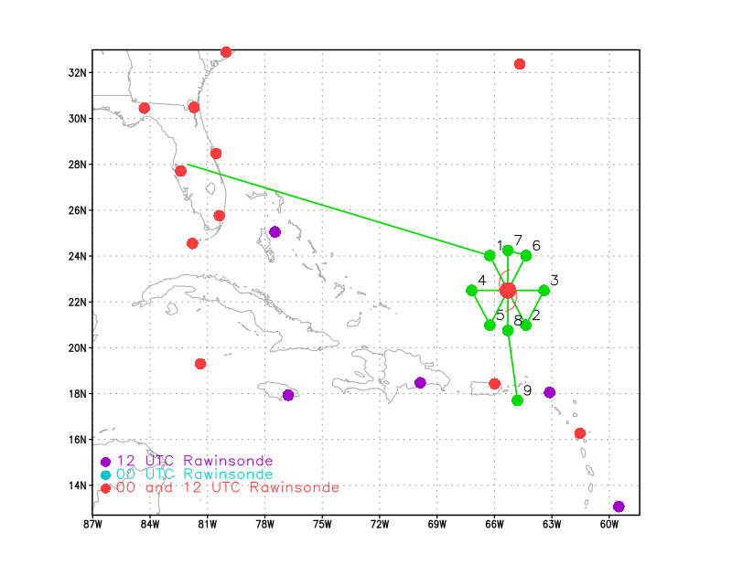  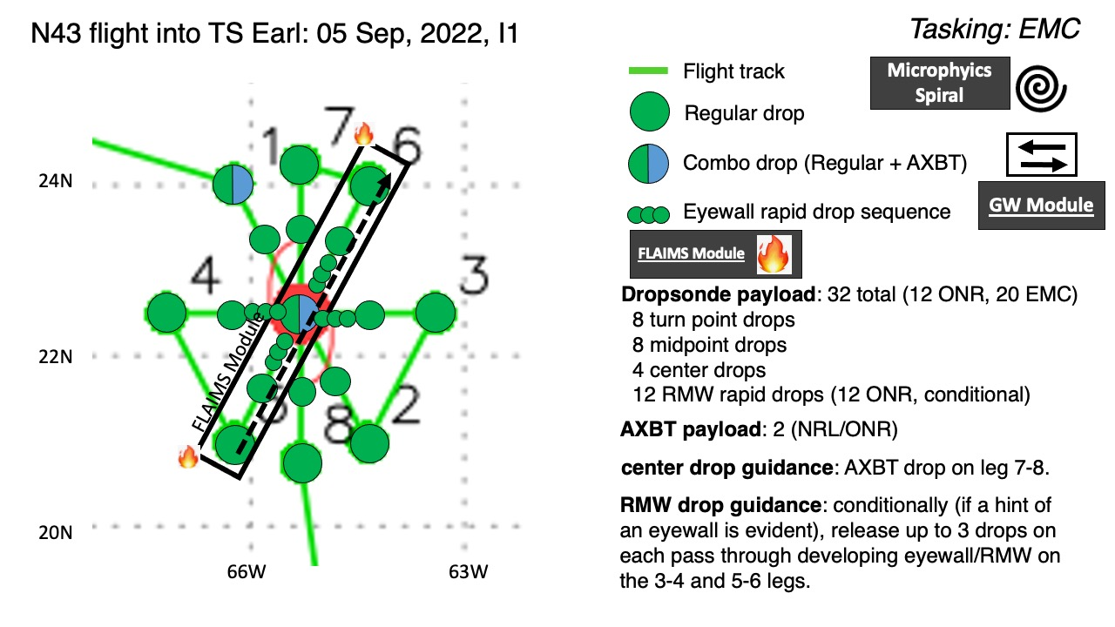  Pattern: Fly butterfly pattern with 105 nmi legs  Altitude: 10 kft (pressure altitude)  On-station time for EMC data collection for the 0000Z assimilation window is between 2100Z and 0300Z.  AXBTs deployed from internal BT chute.  Update from original plan: Flight pattern has been modified to a modified butterfly, 5 degrees off cardinal directions. Entering from NW. AXBT at Initial Point (IP) and center. This will allow for more even coverage of the legs (every 45 degrees) and lining one leg up with the shear direction.  CARCAH has requested that we hunt for the center.
Expendable Distribution | Up to 32 sondes planned (all endpoint/midpoint/center dropsondes transmitted to the GTS, others time-permitting); 2 ONR/NRL AXBTs (all AXBTs transmitted to the AOC ground server if possible)  Release sondes at endpoints, midpoints, centers; possible supplemental rapid RMW drops across RMW/eyewall inbound and outbound.
Preflight Weather Briefing | Tropical Storm Earl’s intensity is 55 kt as of the 15Z NHC advisory moving to the NNW at 340/4 kt. It is forecast to continue moving slowly northward with only slight intensification in the short-term. Earl continues to experience westerly vertical wind shear as can be seen in the visible satellite loop below.  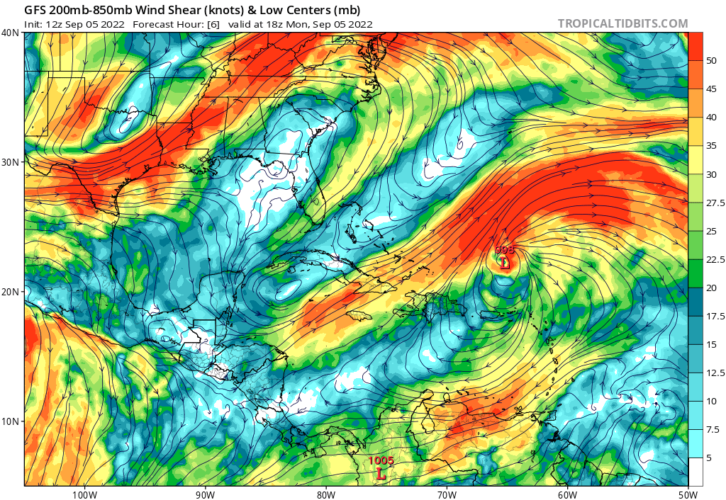  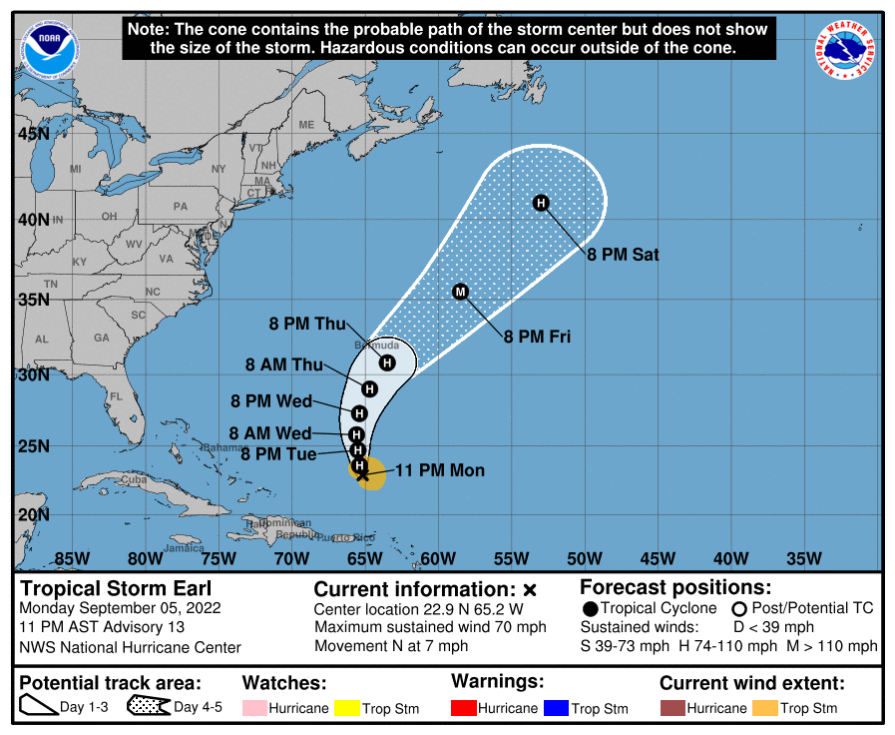

IN-FLIGHT
Time [UTC] | Event
1905 | Takeoff from Lakeland
2014 | Comms dropped out
2044 | Position started updating regularly on MTS again, but no xchat
2046 | GOES-16 GLM shows lightning near the inner core
2116 | Appears IWG stream has stopped again, no regular updates on MTS
2127 | 5pm AST NHC advisory updates Earl’s motion to 360/5 kt and maintains 55 kt intensity with MSLP of 998 mb
2130 | Comms back up
2132 | Start descent to operational altitude.
2155 | IP Drop #1, AXBT #1 released with measured SST of 28.72C
2208 | Overshooting cloud tops evident on visible imagery with lightning in them ahead of the aircraft  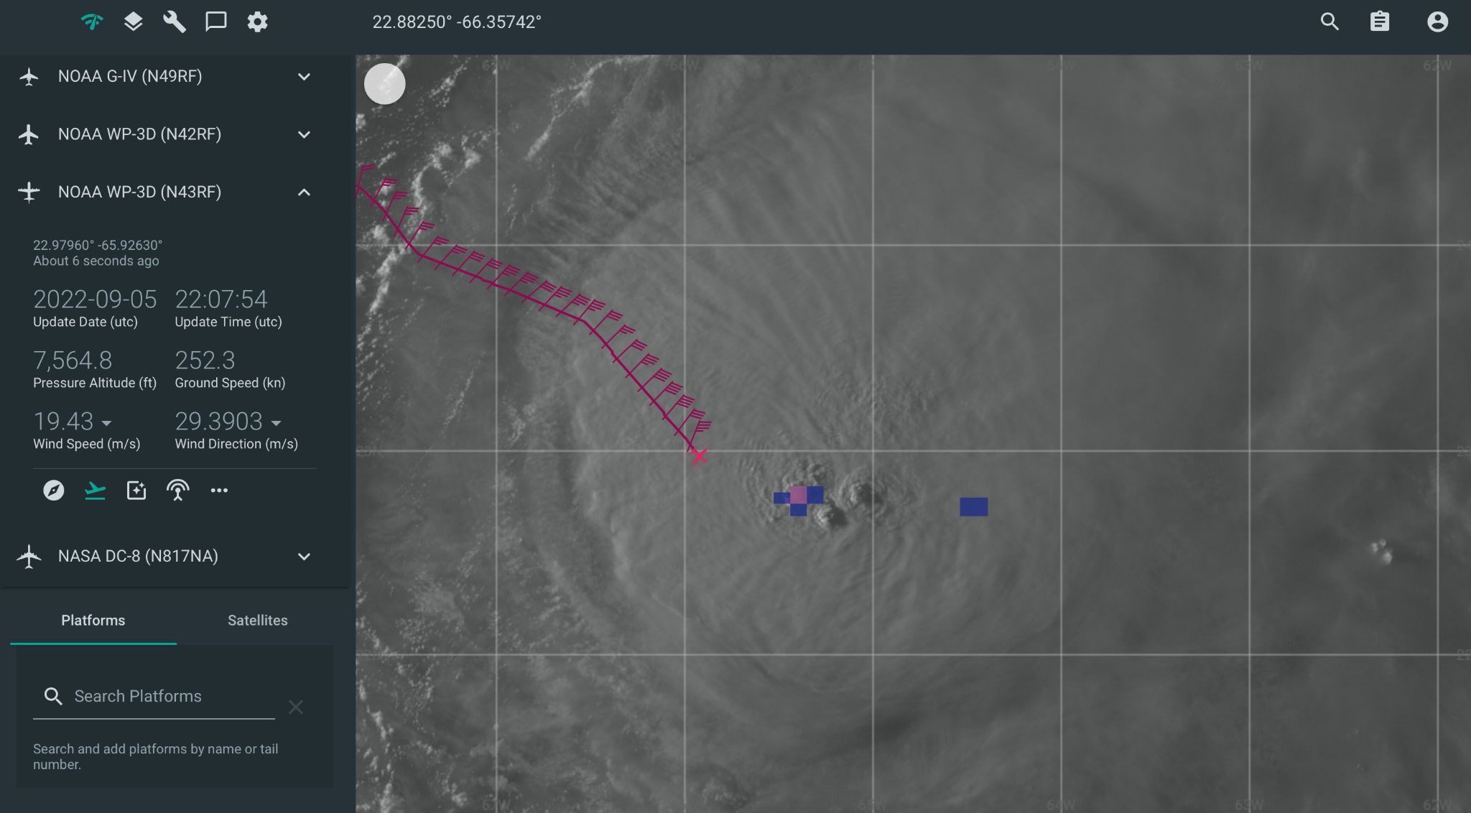
2208 | Mid-point drop #2
2226 | CPA center drop #3, measured SLP of 998.1 mb, 23 kt  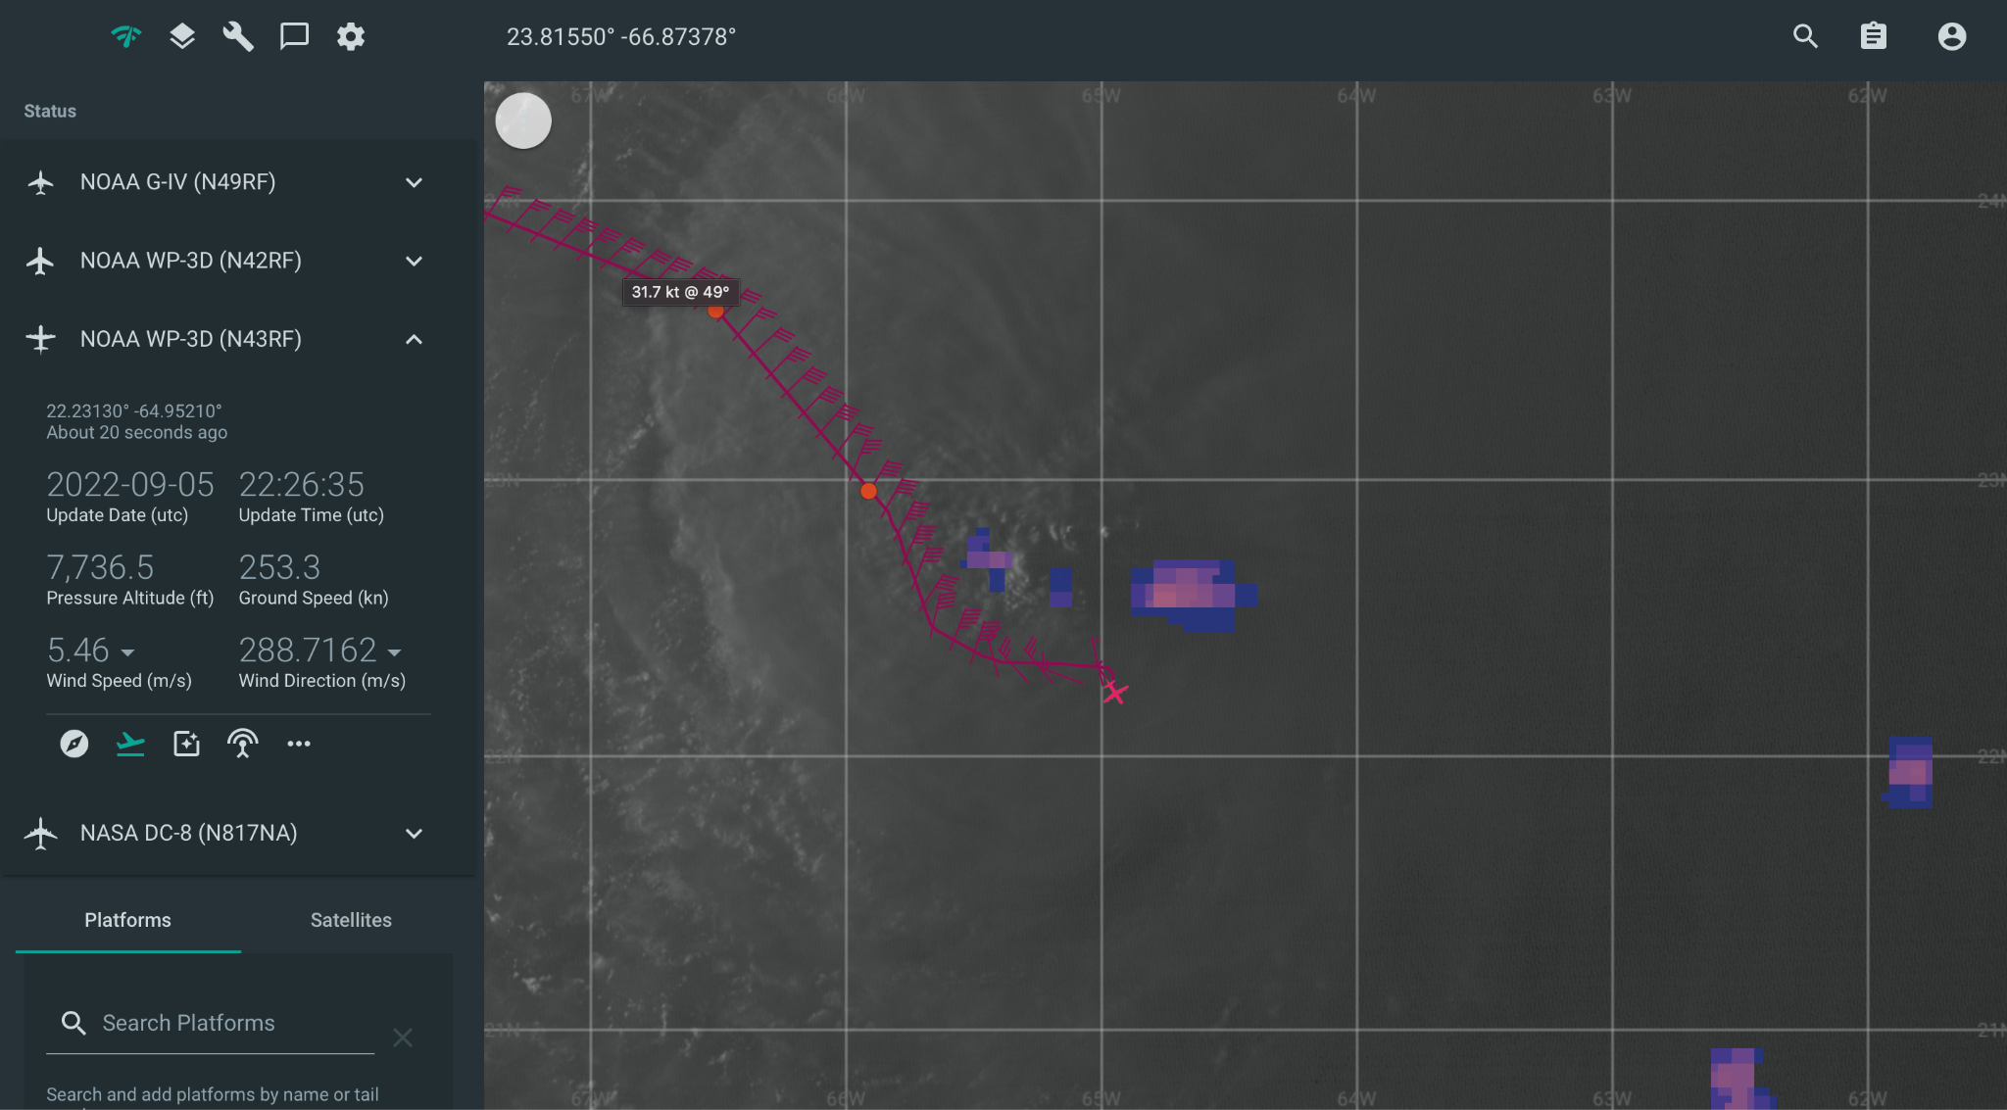
2228 | Curves on nose camera make it look like low-level center to our right
2229 | AXBT #2 released with a measured SST of 28.69C
2240 | Outbound mid-point drop #4
2246 | Large north-south band ahead of us, planning downwind leg on inside of the band
2248 | Endpoint leg 1 drop #5, AXBT #3 released
2254 | Turning downwind. HDOBs from leg 1 shows SFMR peak winds of 60 kt NW of center, and central press estimate of 995 hPa:  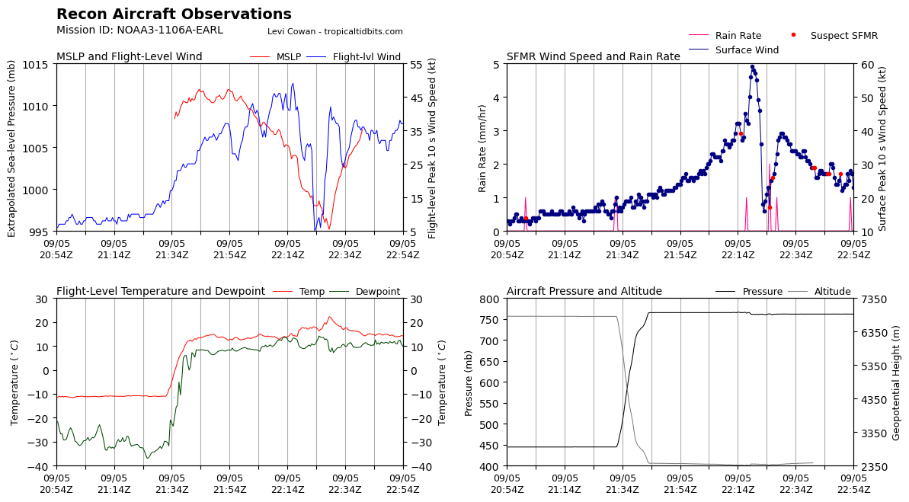  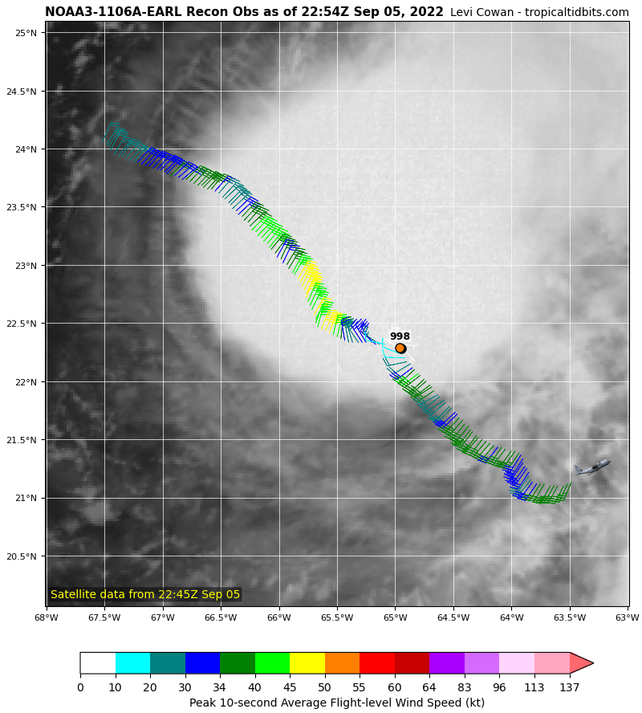
2310 | Lots of lightning on the nose camera as we go downwind along the convective band
2311 | Drop #6, AXBT #4 released
2312 | Beginning 2nd leg, avoiding convective cells
2324 | Drop #7 mid point
2338 | Passed just south of the center near 22.43N, 65.06W
2353 | Drop #8
0006 | End 2nd pass, Turn as track 135 degrees, drop #10  HDOBS leg 2 show peak SFMR winds 65 kts on the west side of the center, and central pressure estimate of 997 hPa  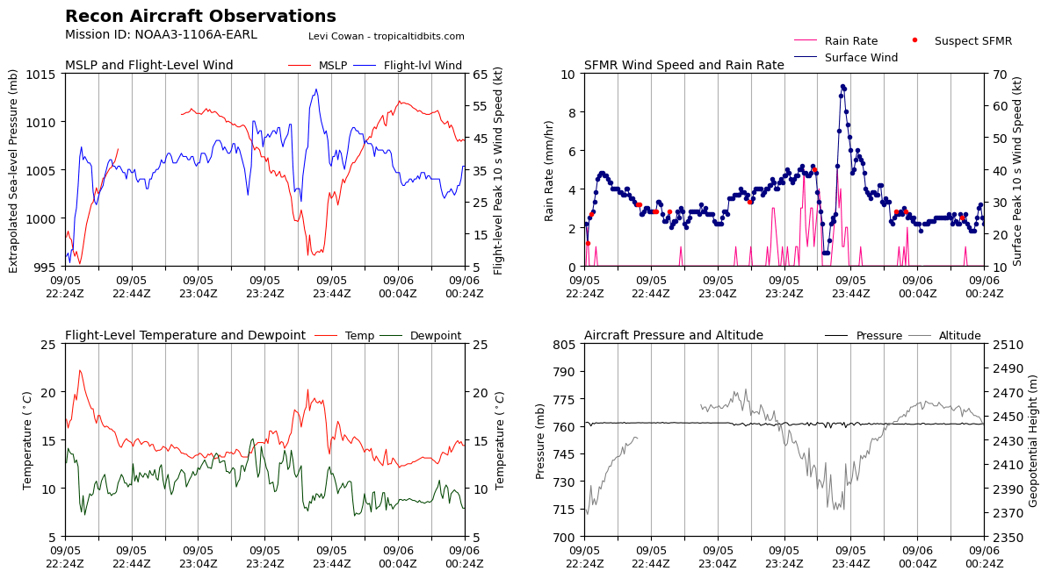  MTS plot…  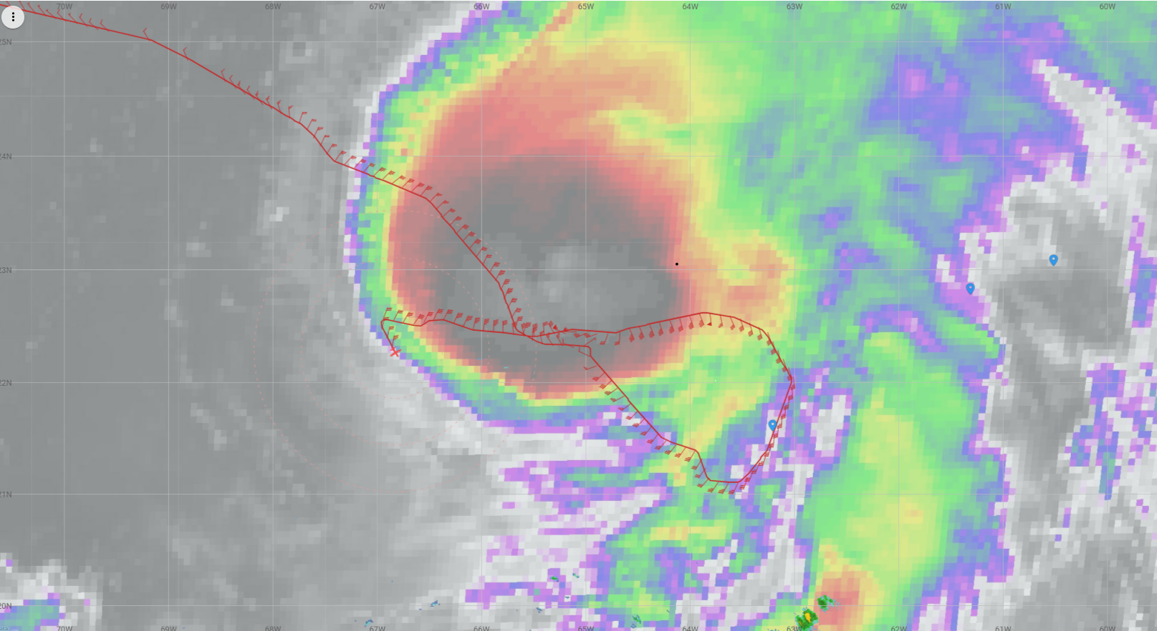
0019 | Begin leg #3, Drop #10, AXBT #5 released
0029 | Drop #11 mid point
0039 | 50 dbz and a nearly closed eyewall.
0040 | Nice and bumpy here where neither the nose nor MMR show anything.
0044 | Center, drop #12, had an SLP of 992.8 hPa with 20 kt wind. Looks like an elliptical eye open northeast. Sporty ride with more than 1G acceleration down.
0047 | Pressure falls and wind speed increases suggest Earl is undergoing RI
0057 | Drop #13, mid point
0100 | Considering doing rapid RMW drops on final leg
0106 | Reinitializing INS for MMR. Trying to find an area to fly straight and level to fix it  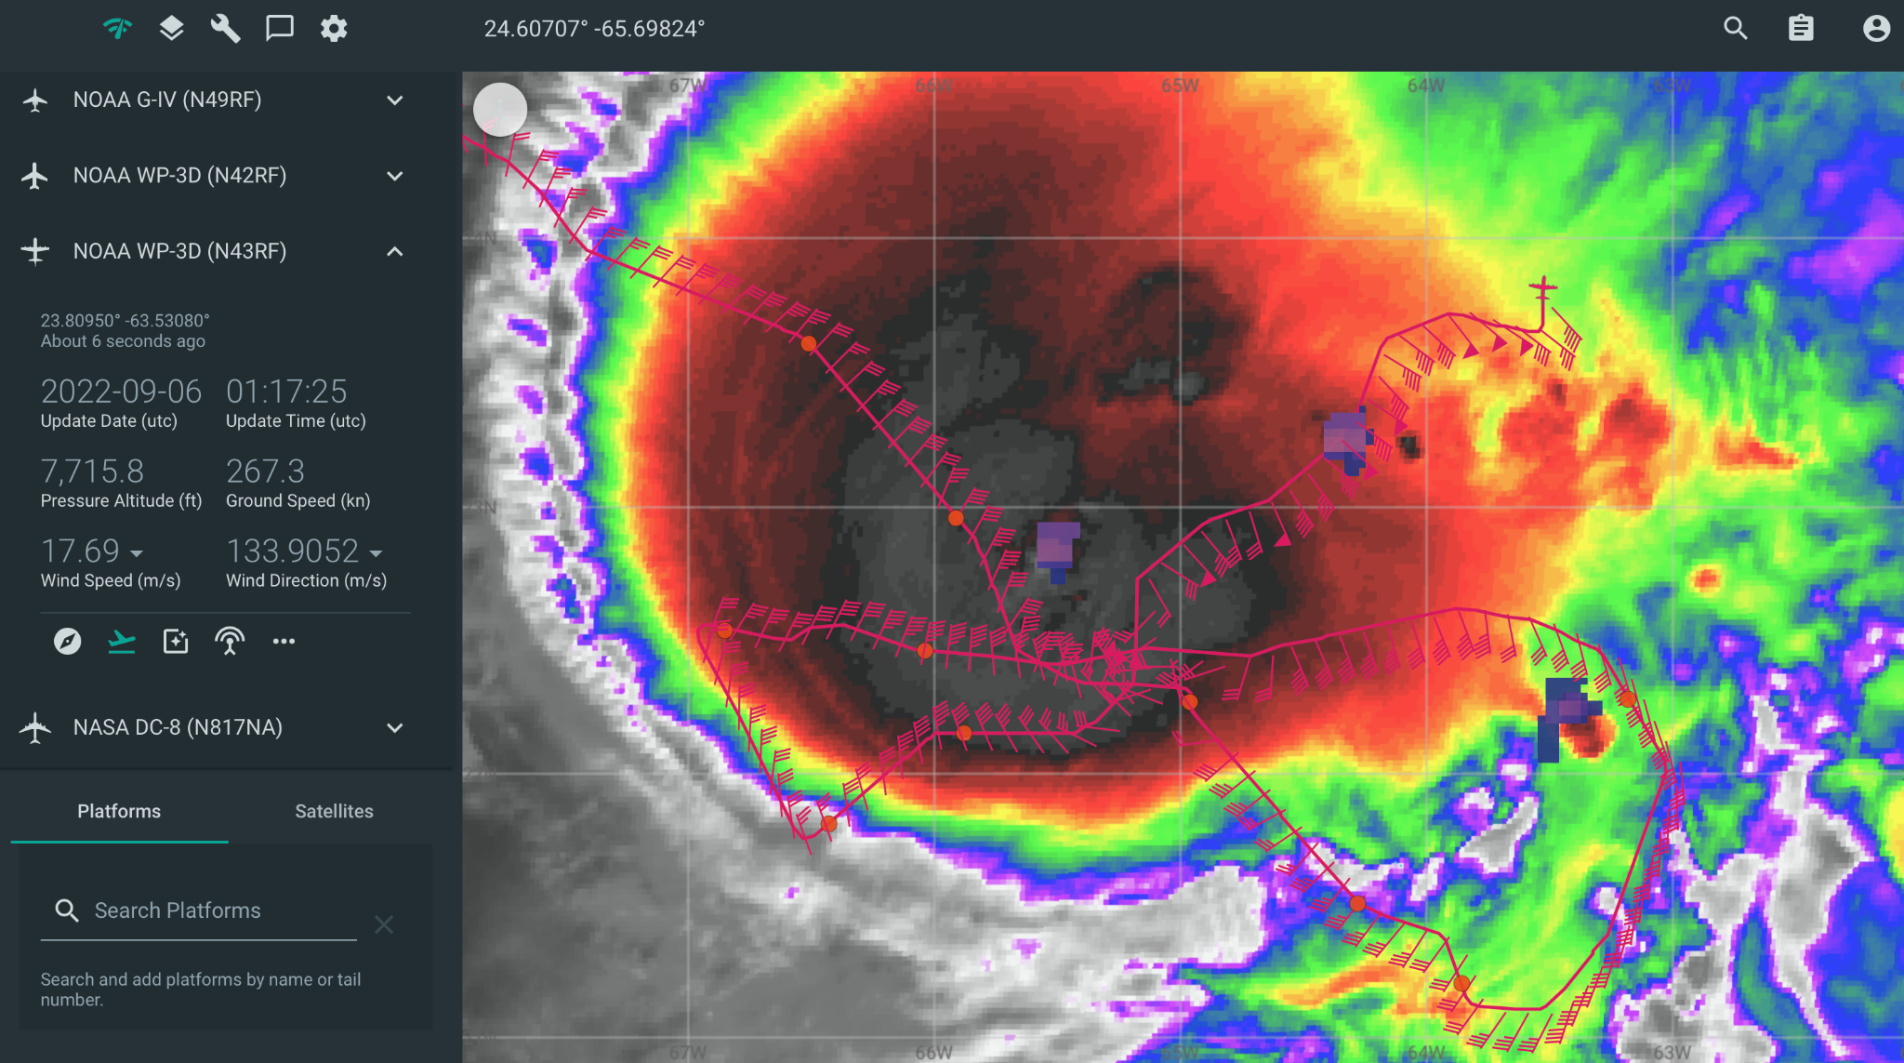
0113 | Endpoint, drop #14
0113 | Backup for endpoint sonde, drop #15
0124 | HDOBs for leg 3  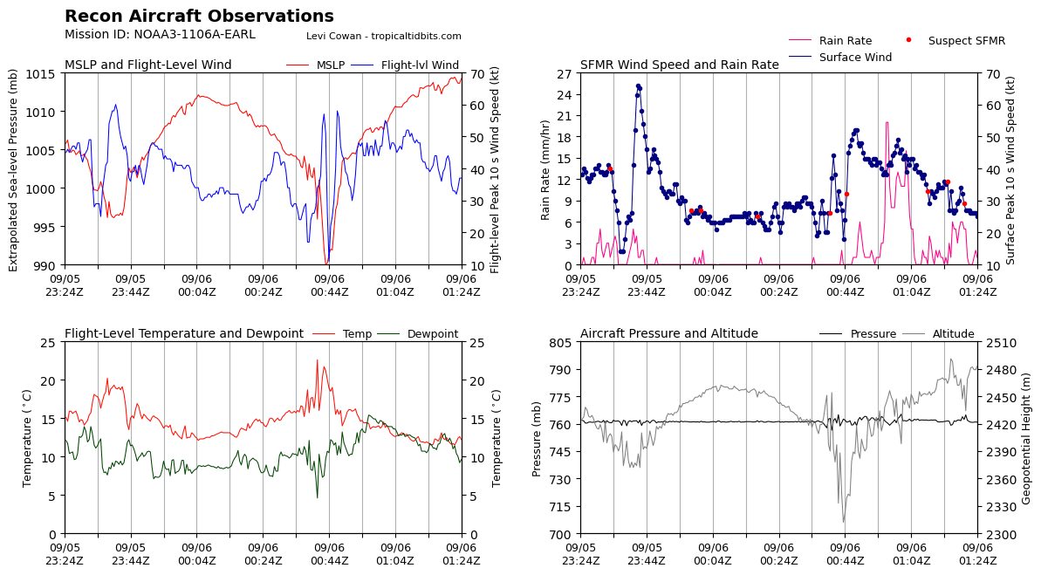  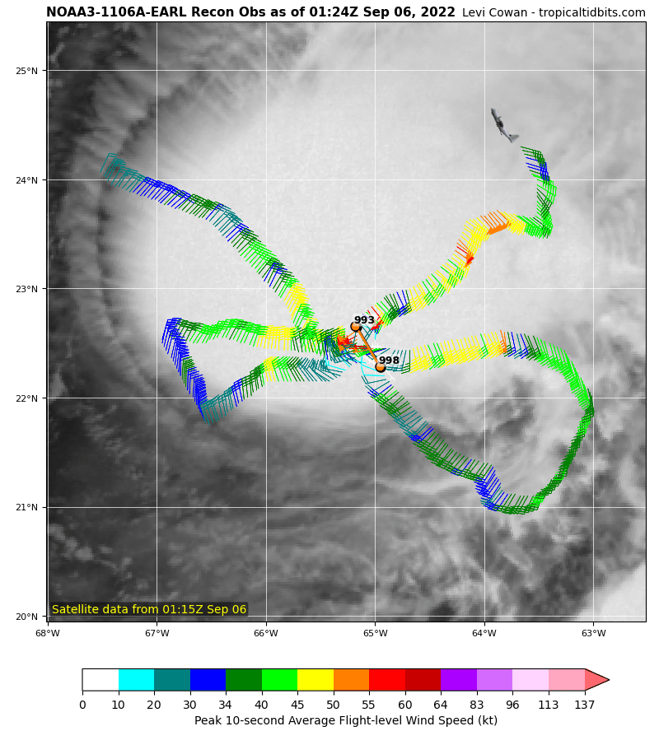
0146 | IP leg 4, drop #16
0150 | Planning to target rapid RMW sondes N and S side. Estimate of RMW from TDR on N side is 25 km and S side is 15 km  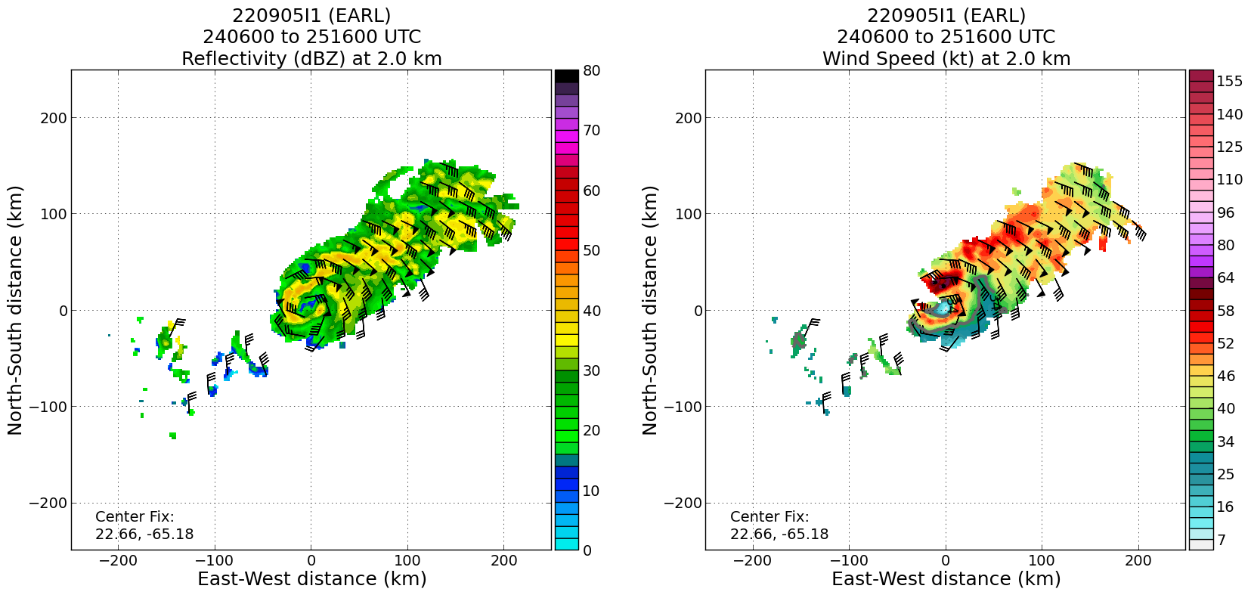  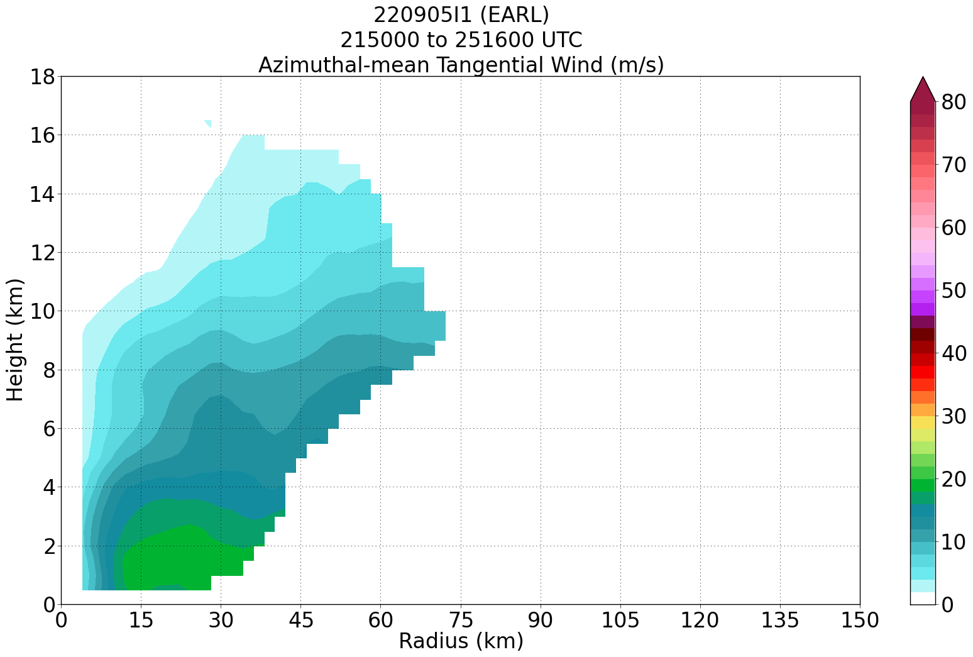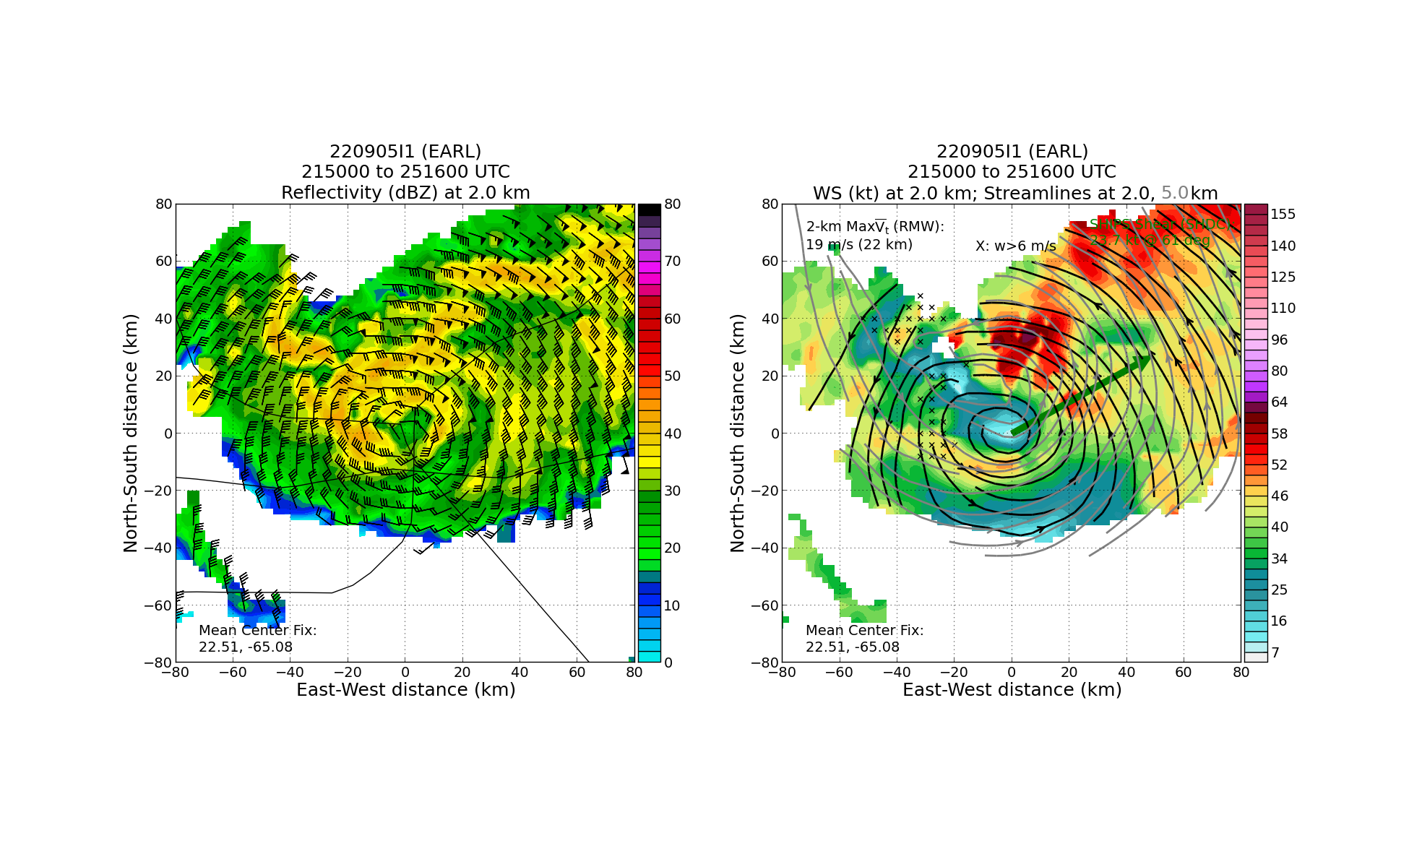
0213 | MMR from final pass through center:  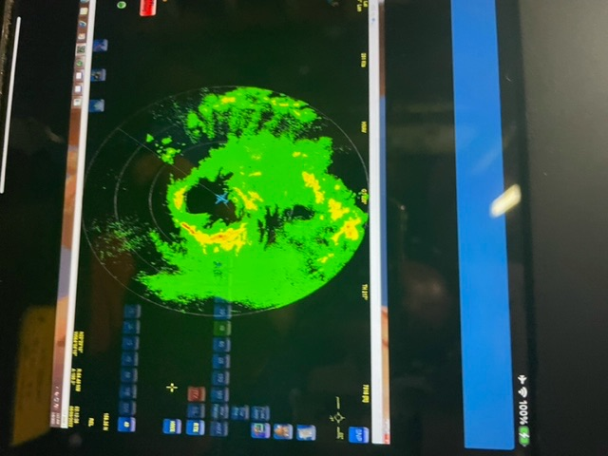  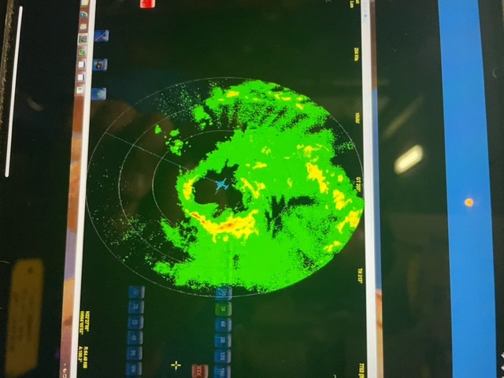  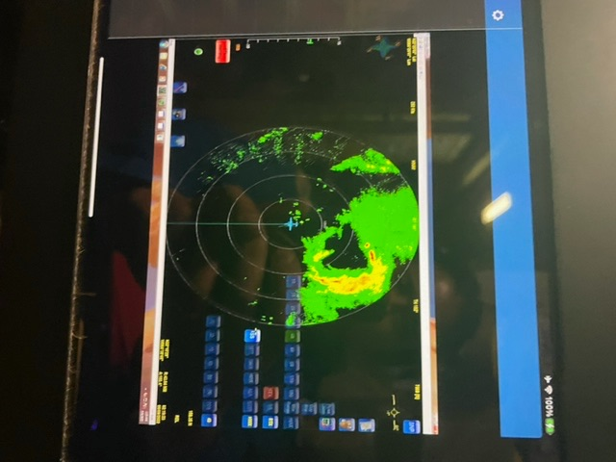
0241 | End TDR final analysis
0250 | End 4th leg
Final leg HDOBS:

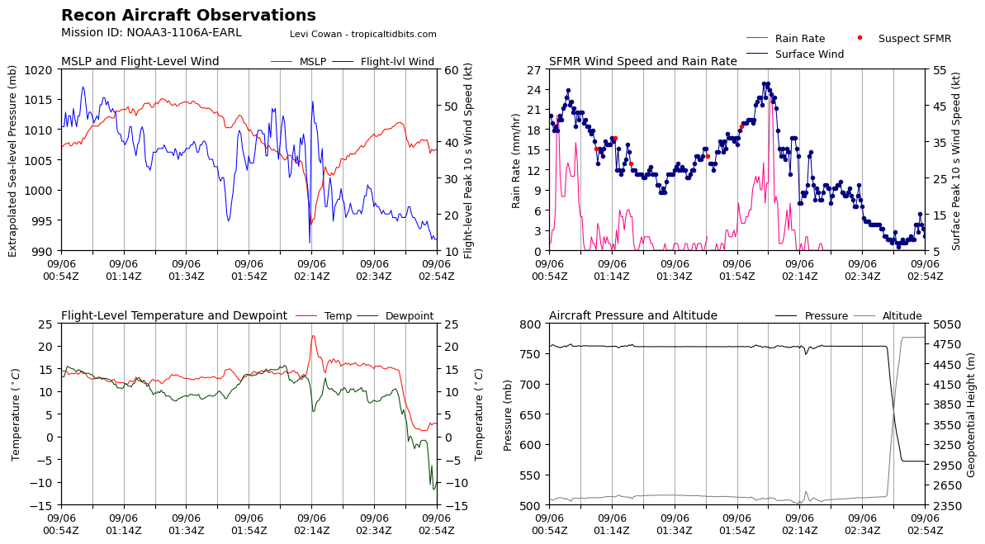
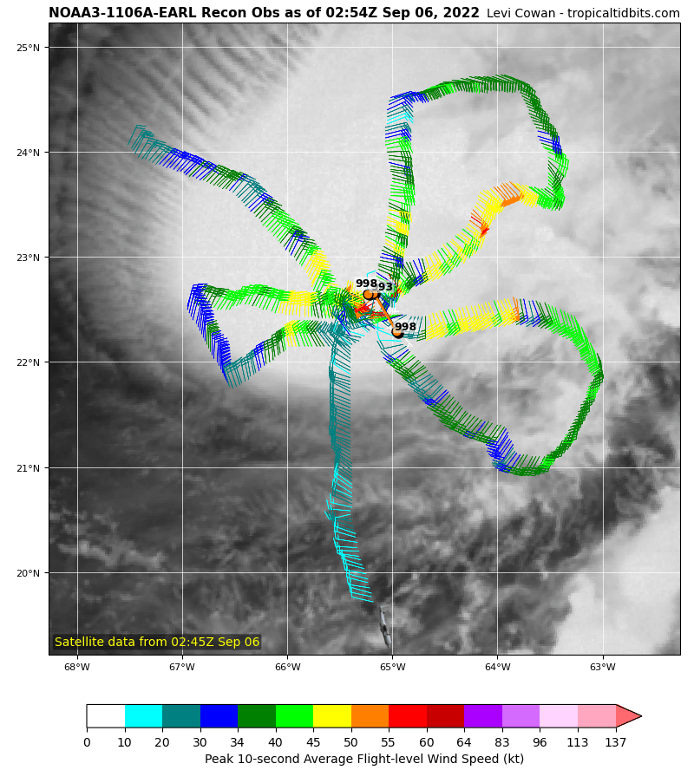
0326 | Landed in St. Croix

POST-FLIGHT
Mission Summary | This was a successful mission into a rapidly evolving Tropical Storm Earl that appears to be on the verge (or already started) rapidly intensifying. After a rocky start with data communications being out until the aircraft descended, the mission plan was completed with the addition of the RMW rapid drop sequence on the last N-S leg in the developing eyewall. Several deviations around convection were required, particularly near that developing eyewall. This made the pattern challenging to fly, but also provided quite a bit of interesting radar and dropsonde data in this potential rapid intensification event.
Actual Standard Pattern Flown | Butterfly at 8 kft
APHEX Experiments / Modules Flown | Data collection supports the Early Stage Experiment: Analysis of Intensity Change Processes (AIPEX), though no modules within AIPEX were flown. We did do a RMW rapid drop sequence on the final north to south leg through the center for ONR’s Tropical Cyclone Rapid Intensification (TCRI) experiment.
Plain Language Summary | - Excellent mission in a rapidly evolving tropical storm approaching hurricane strength. Appeared to be beginning RI as the mission evolved.
Instrument Notes | IWG down from 2014-2044  Chat down from 2014-2130  MMR INS issue at the end of the third leg
Final Mission Track | 