MISSION PLAN
FLIGHT ID | 20220903H1 | STORM | AL06 / EARL
MISSION ID | 0506A | TAIL NUMBER | NOAA42
TASKING | HRD | PLANNED PATTERN | Butterfly
MISSION SUMMARY
TAKEOFF [UTC] | 0758 | LANDING [UTC] | 1419
TAKEOFF LOCATION | Barbados | LANDING LOCATION | St. Croix
FLIGHT TIME | 6.4 | BLOCK TIME | 6.5
TOTAL REAL-TIME RADAR ANALYSES  (Transmitted) | 5 | TOTAL DROPSONDES (Good/Transmitted) | 13 (13 / 13)
OCEAN EXPENDABLES (Type) | 3 AXBT (ONR) | sUAS (Type) | None
APHEX EXPERIMENTS / MODULES | Early Stage Experiment: VAM, Stratiform Spiral Module (SSM)
HRD CREW MANIFEST
LPS ONBOARD | Rogers | LPS GROUND | None
TDR ONBOARD | Englert, Rogers | TDR GROUND | Fischer, Gamache
ASPEN ONBOARD | J. Zhang | ASPEN GROUND | None
NESDIS SCIENTISTS | None
GUESTS (Affiliation) | None
AOC CREW MANIFEST
PILOTS | Abitbol, Rannenberg, Keith
NAVIGATOR | Hough
FLIGHT ENGINEERS | Stokes, Gee
FLIGHT DIRECTOR | Carpenter
DATA TECHNICIAN | McAllister
AVAPS | Dykeman

PRE-FLIGHT
Flight Plan | 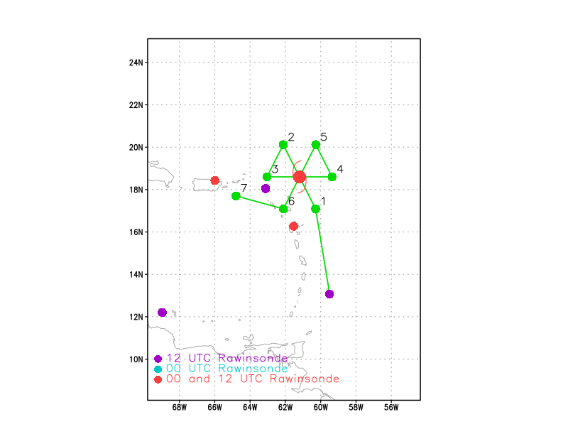  Pattern: Butterfly  Altitude: 10 kft
Expendable Distribution | Drops at endpoints, midpoints on all legs, plus all center passes. BTs at endpoints of SE to NW leg, and on the third center pass.
Preflight Weather Briefing | AL91 was upgraded to Tropical Storm (TS) Earl at 11pm prior to our mission. Earl continues to exhibit a disorganized structure, with convection primarily located east of the low-level circulation (LLC). Earl is contending with substantial westerly vertical wind shear and some remaining upper-level dry air to its northwest.  The previous mission documented a significant tilt in the LLC and midlevel circulation (MLC) of about 100 km toward the east. During that mission there was deep convection located within the LLC, while the MLC, which was located near the broad region of convection to the east, was associated with primarily stratiform precipitation, which is expected given the latent heating profiles of stratiform precipitation. We will replicate the pattern flown by the previous mission and attempt another VAM during the west-east pass, given that the LLC and MLC are expected to show a similar configuration as before.
Instrument Notes

IN-FLIGHT
0758 | Takeoff from Barbados
0839 | Strong convection with lightning occurring near LLC in the presence of moderate shear
0857 | MTS screenshot with 09 UTC NHC advisory location shown in range rings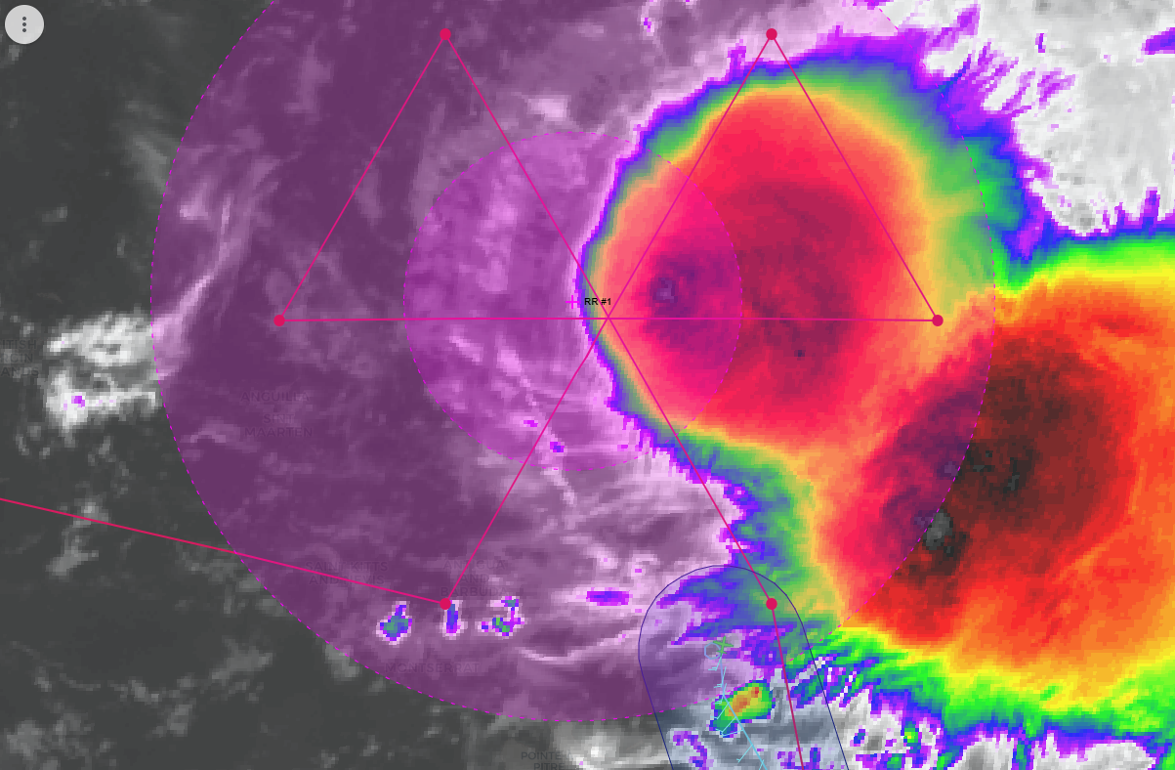
0901 | Drop #1, endpt SE; AXBT #1 released but no measured SST
0901 | This first inbound leg is a bit west of the main convective shield. We’ll fix at flight level, which will likely be east of the surface center. From there we’ll adjust the pattern based on that new fix. We’ll extend out our outbound leg to the east as needed to sample more convection.
0914 | Drop #2, midpt SE
0925 | Hunting the flight level (FL) center, winds shifted to northerly at the last minute, so we took a hard right turn to find the center. FL center ended up being a fair distance east of expected LLC.
0926 | Drop #3, at FL center near 18.6N, 61.3W. The expected location of the LLC was 18.65N, 61.5W, so the FL center was 0.2 degrees east and a little bit south (0.05 degrees) of LLC.
0926 | 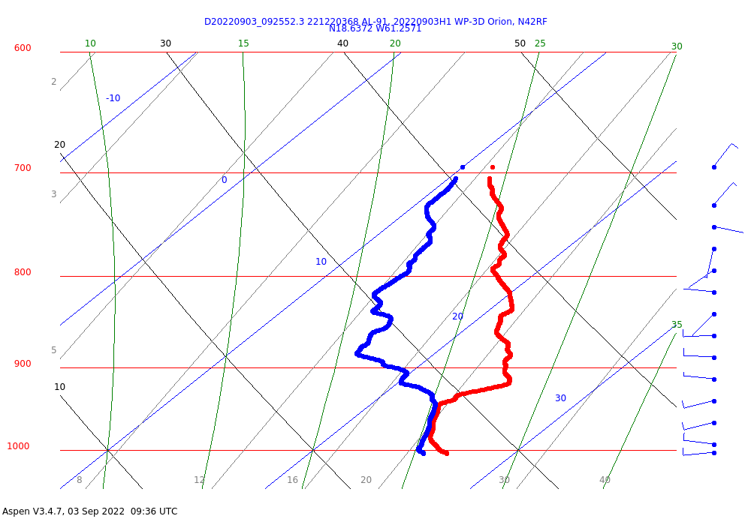  Skew-T from FL center drop. Pronounced subsidence, probably associated with mesoscale descent in stratiform precipitation (or along edge of stratiform precipitation). Winds are uniformly from the west from the surface up to 850 hPa, then switch to weak easterlies and northeasterlies above. Does that mean the surface center was north of the FL center?
0931 | MTS screenshot after first center fix with approximate TDR range overlaid in swath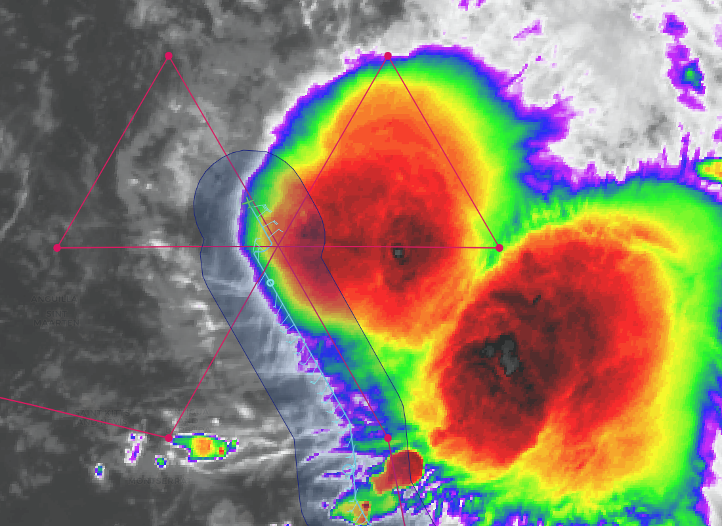
0938 | Drop #4, now endpt NW (was midpt NW originally); AXBT #2 released and measured an SST of 31.1W
1004 | Drop #5, now endpt W (was midpt W originally); began the VAM legs
1010 | First TDR analysis captured TC center, with very limited coverage in the mid–upper troposphere (analysis file size was tragically small)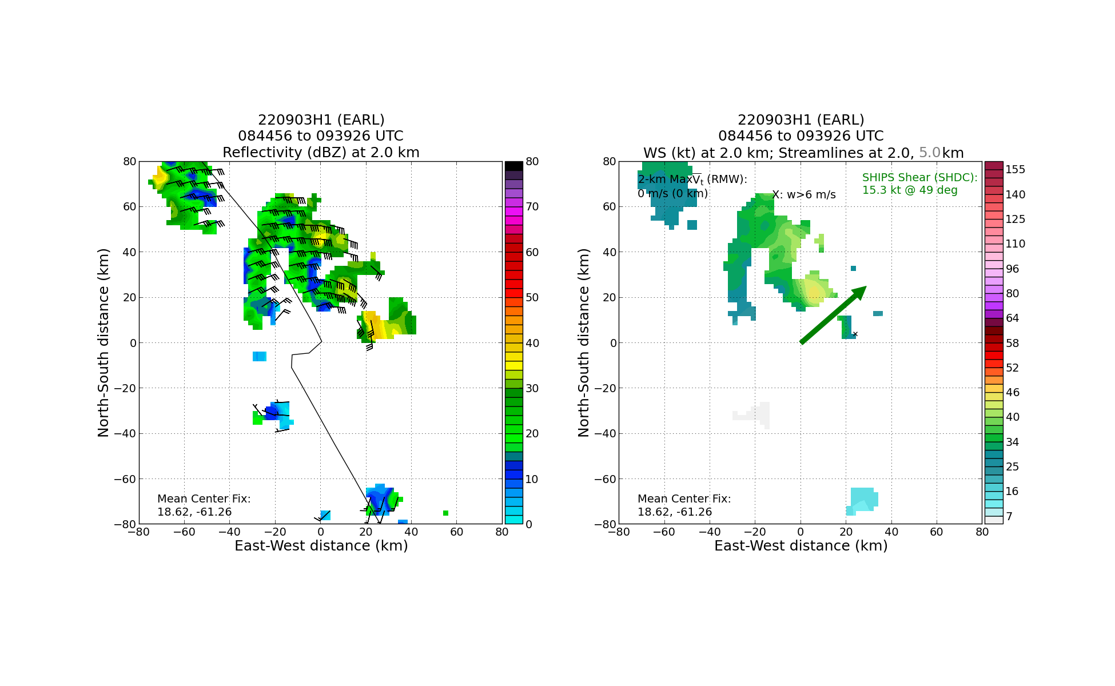
1017 | Drop #6, 2nd center pass; AXBT #3 released  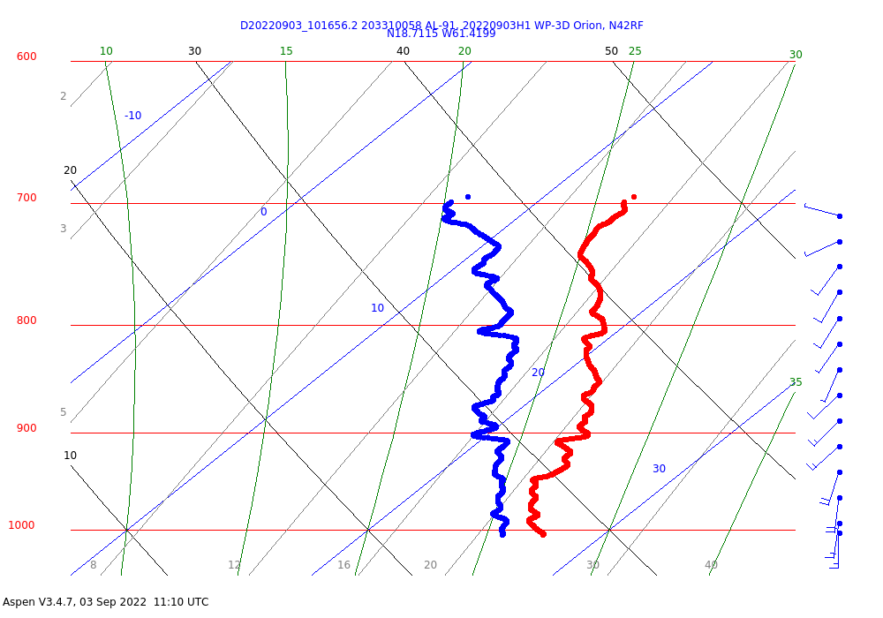
1030 | In VAM leg 1, east of FL center, widespread scatterers, heavy stratiform precip, some isolated convective cores, impressive bright banding
1034 | Drop #7, midpt E
1045 | First pass in VAM, toward east: looking at MMR now we can see the SE MCS. Looks like we'll clip it with TDR, at about 15-20 nmi on our track of 090 degrees. The heaviest echoes, though, will be 30 nmi or more out of TDR range, I believe. Maybe on the return leg and the 3rd leg it'll be further north and we'll catch more of it. We are getting good coverage now in SE MCS, all of the right side of the sweep domain is filled.
1047 | MTS screenshot near end of second pass, with approximate TDR range overlaid in swath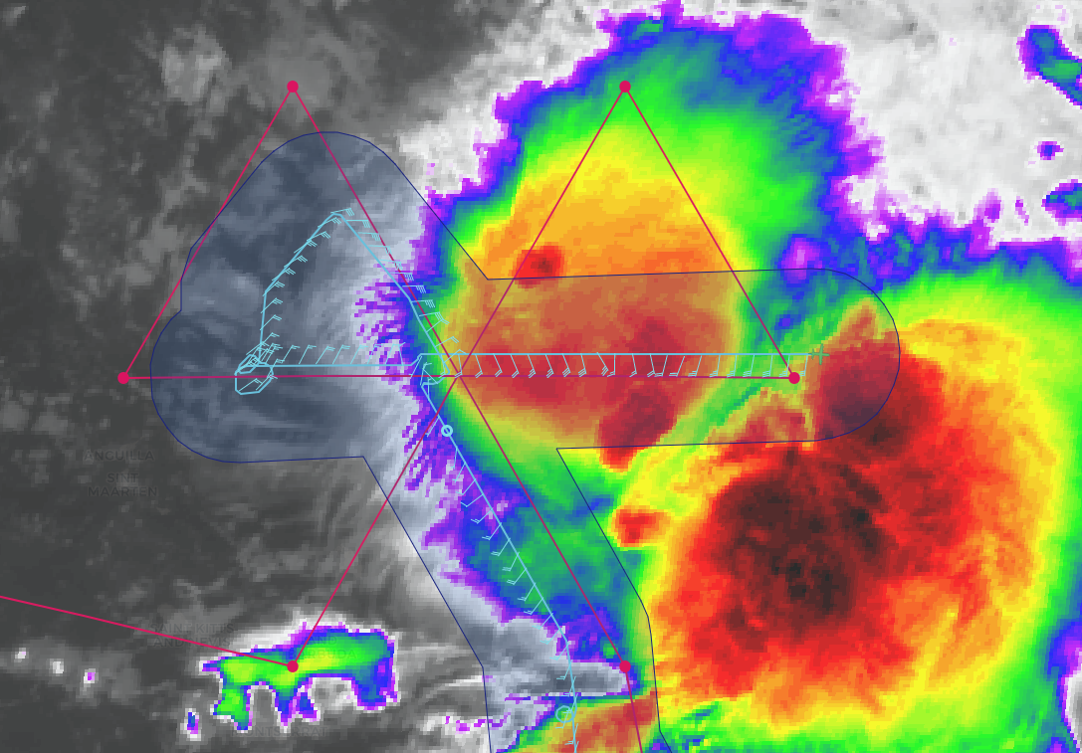
1051 | Drop #8 (endpt E), end VAM leg 1 (1st W-E leg)
1052 | Turn to track 270, begin VAM leg 2 (E-W leg)
1104 | Outbound leg of the second pass found a local minimum is MSLP. When in the return portion of the leg associated with VAM, a swirl was seen on MMR in the area of the local MSLP minimum. This minimum may have been in the vicinity of subsidence found in the first FL center drop, suggesting it could be related to subsidence warming. It could also indicate a possible center reformation.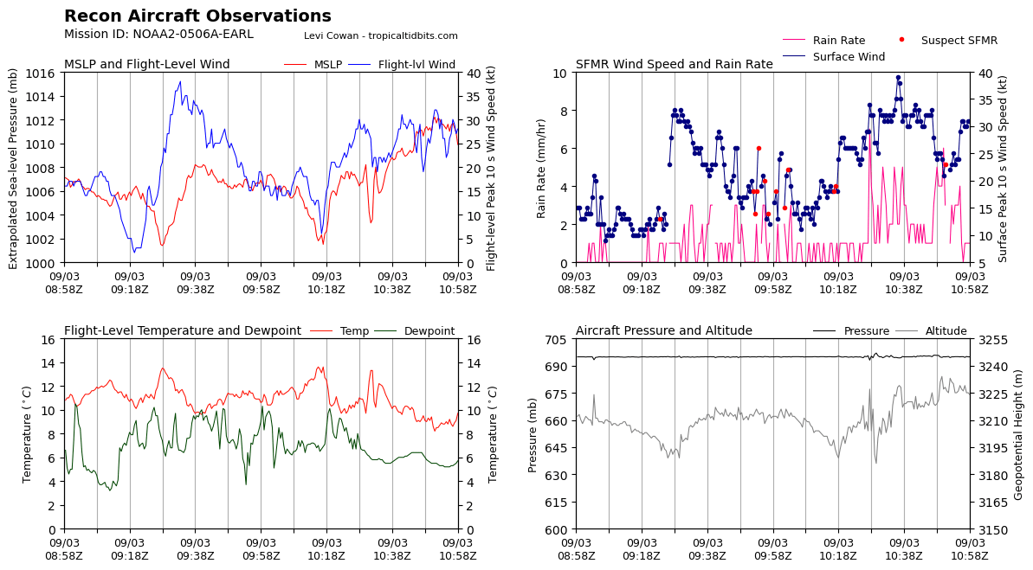
1115 | IR satellite loop showing convective burst occurred near location of local MSLP minimum
1122 | Second TDR analysis nicely captured mid-level center displaced ~125–150 km east of low-level center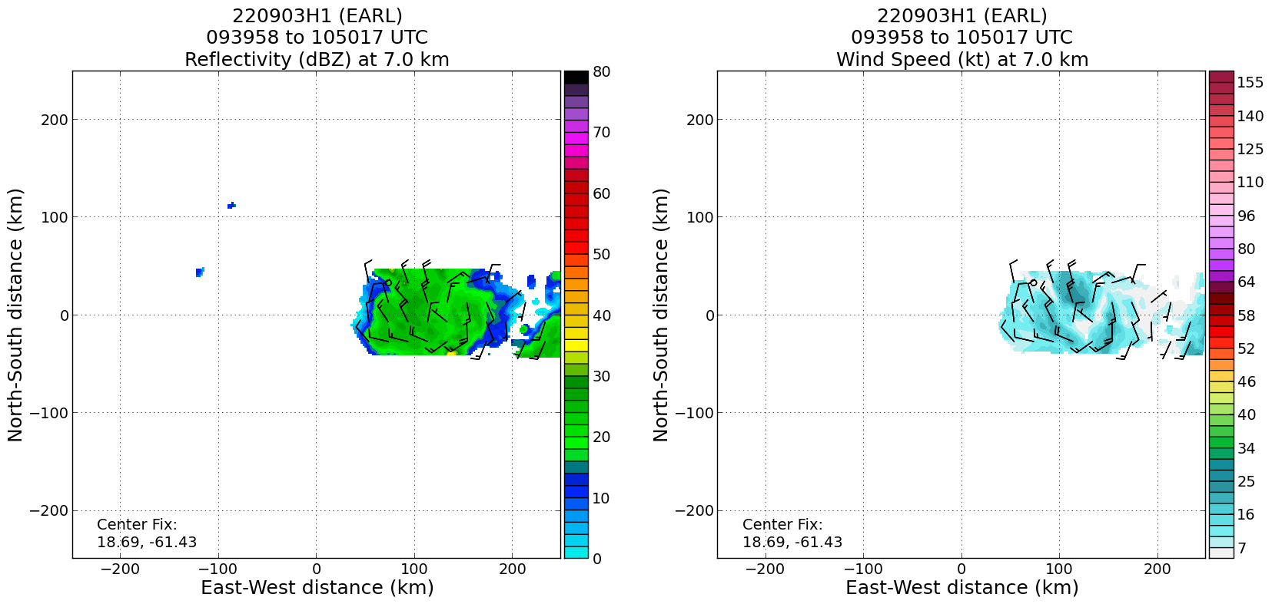  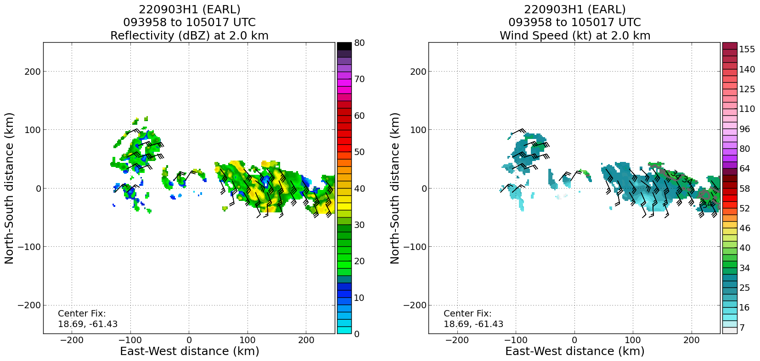
1135 | Flew 30 nmi west of visually-identified low-level swirl (LLC), end of VAM leg 2
1135 | Begin VAM leg 3 – track 90. Will fix FL center then fly 105 nmi east of that point, then head downwind for next and final center pass. Along that downwind leg will try for a microphysics spiral if we get clearance to 20 kft and there’s a target
1209 | Third TDR analysis (First of two analyses from VAM) again nicely captured both LLC and MLC. 2-km center surrounded by a ring of reflectivity.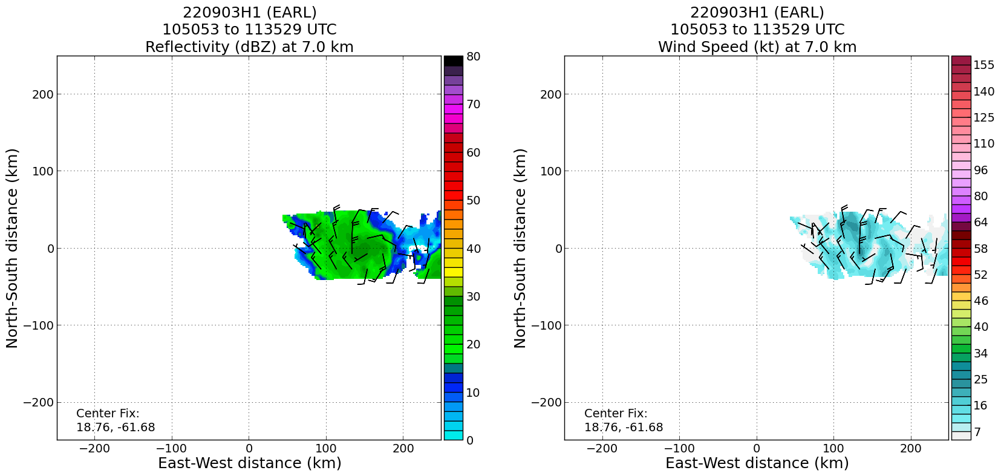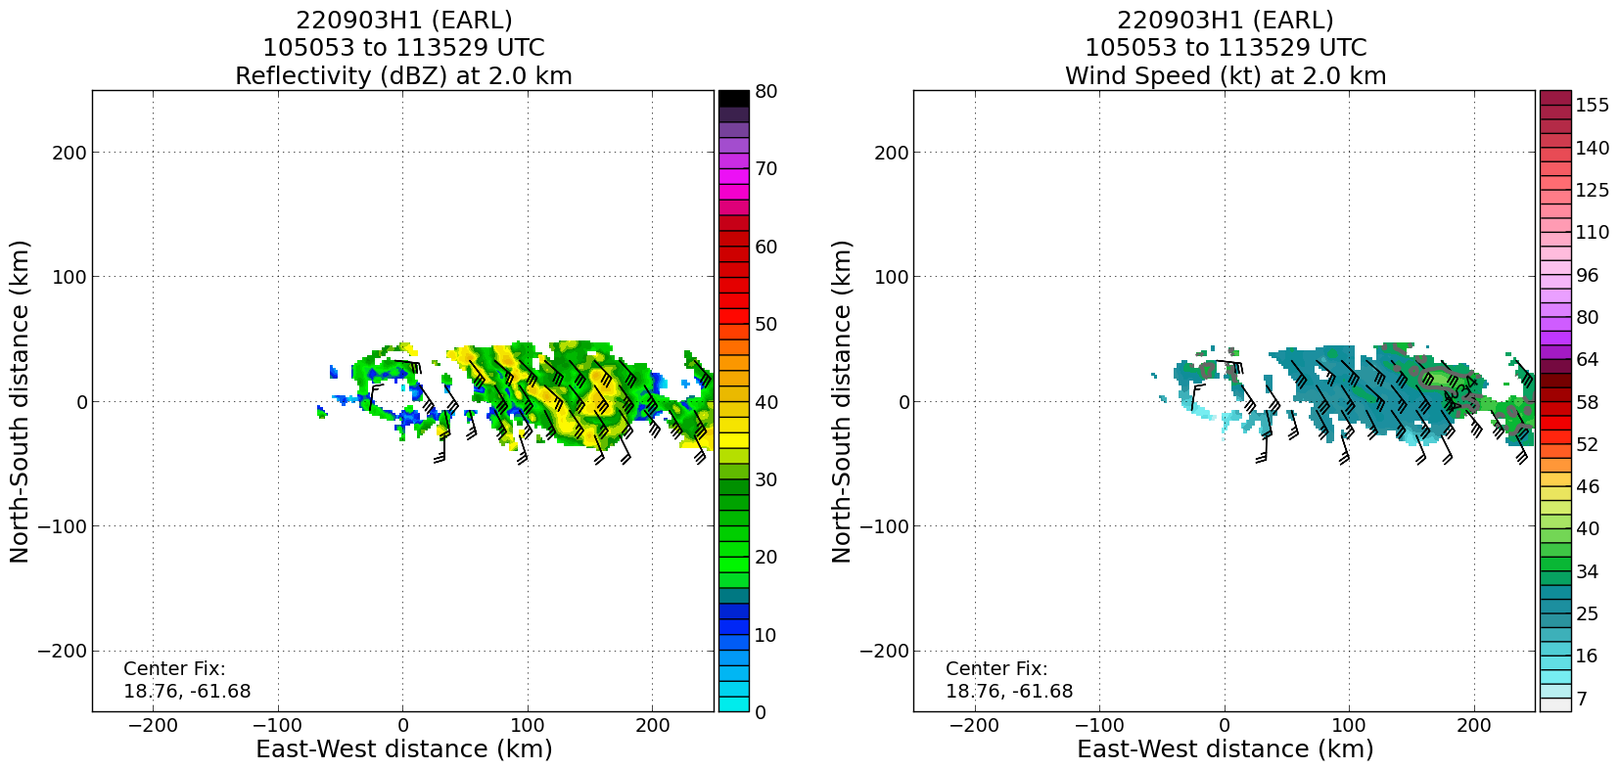
1212 | End VAM leg 3
1218 | Beginning stratiform spiral module, doing one 360-deg loop then climbing to 20 kft
1218 | MTS screenshot at start of microphysics spiral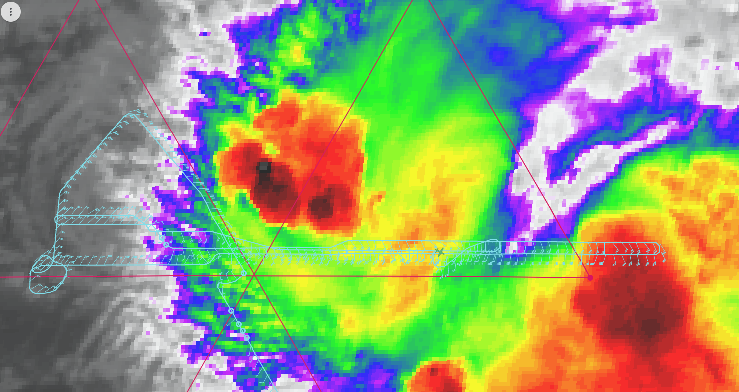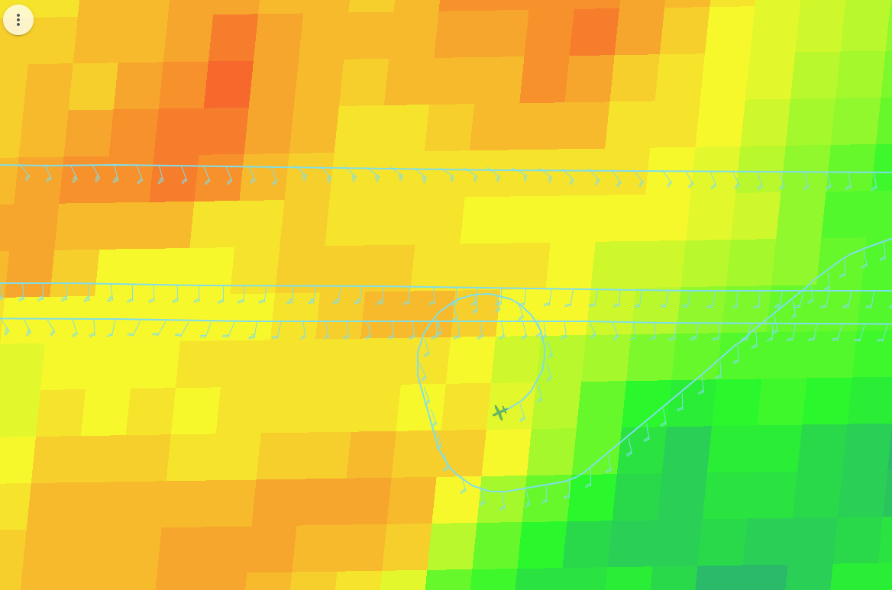
1226 | At freezing/melting level during microphysics spiral. Ice crystals seen. IR brightness temps in MTS overlaid at the time.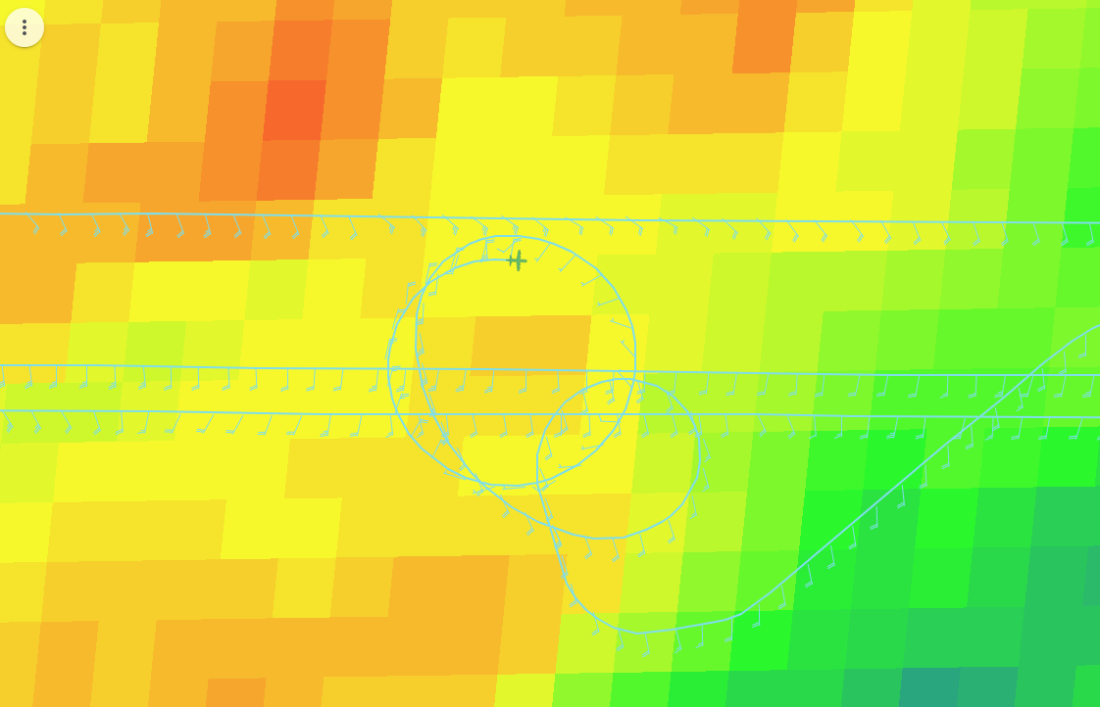
1233 | Spiral at 20 kft, descending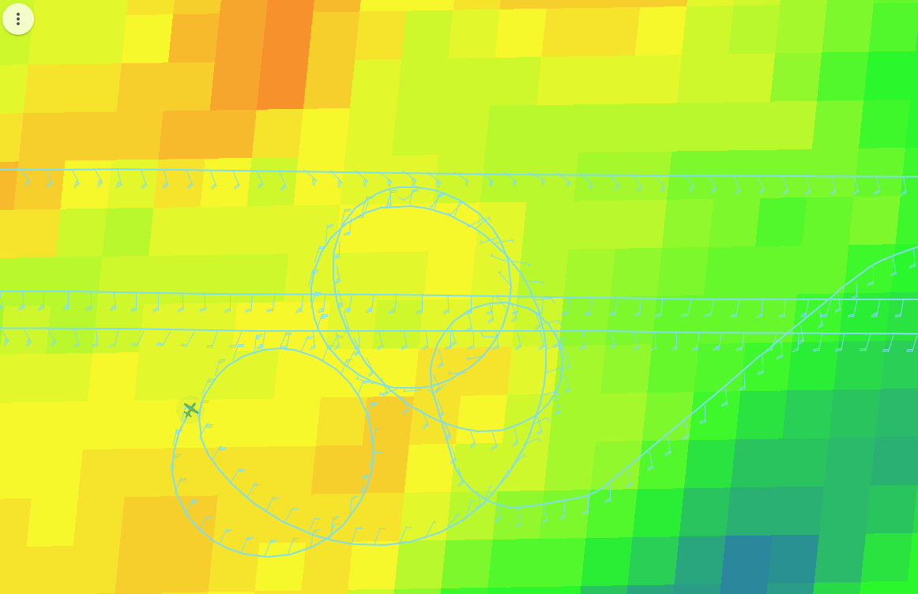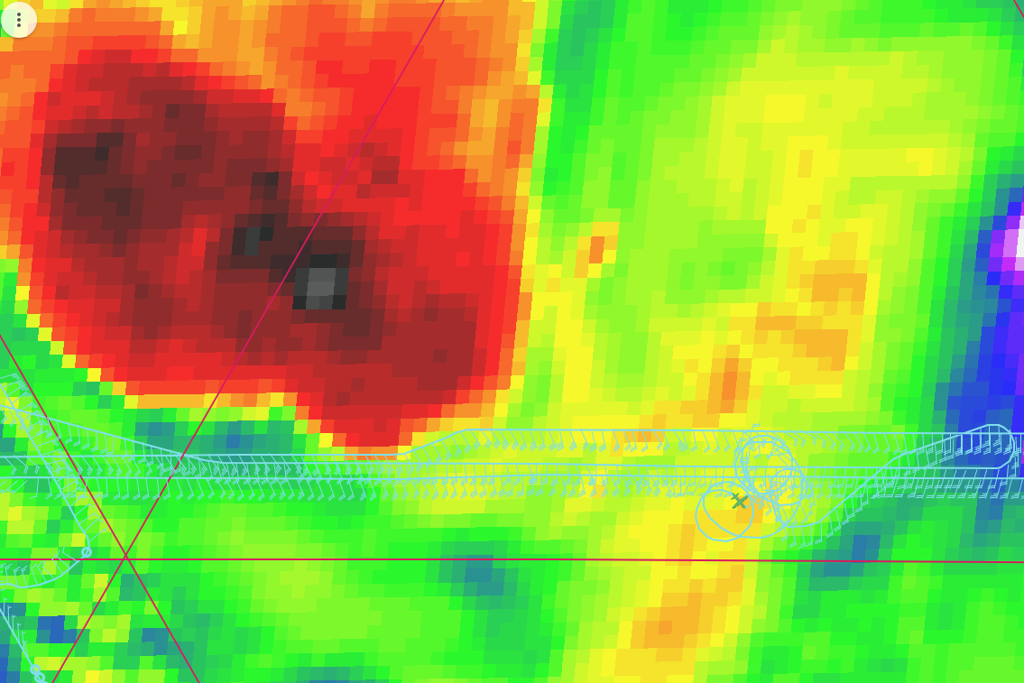
1233 | Drop #9, top of spiral
1238 | In descent, possible indications of graupel
1242 | Near end of spiral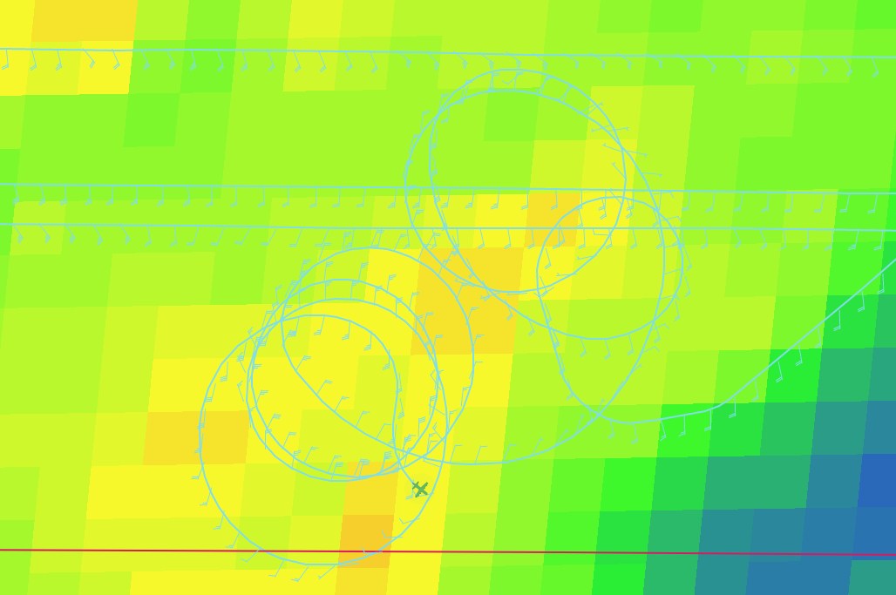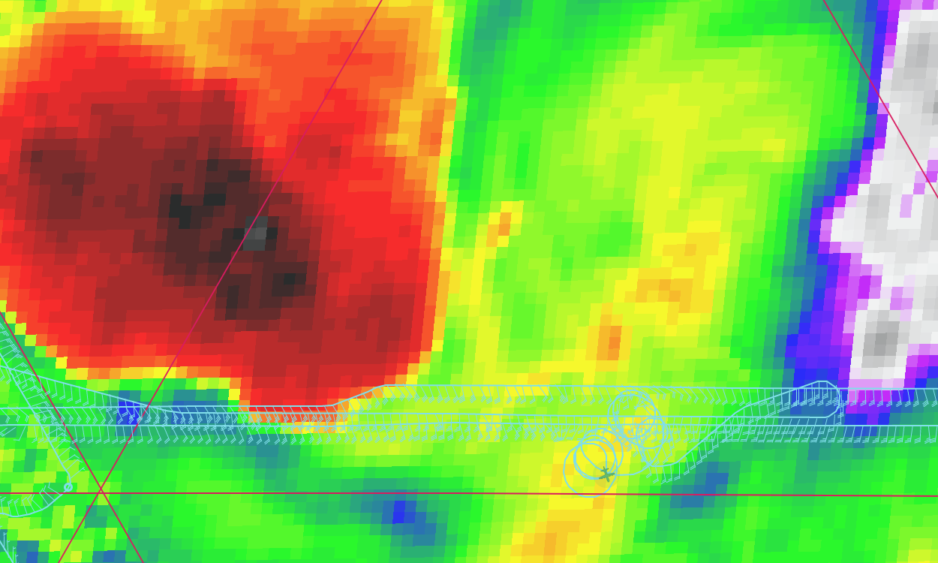
1301 | Fourth TDR analysis shows MLC may have been sheared off to the east or ESE. Convection near MLC has weakened. Signs of convective band around LLC, with vertical growth of convection downwind.  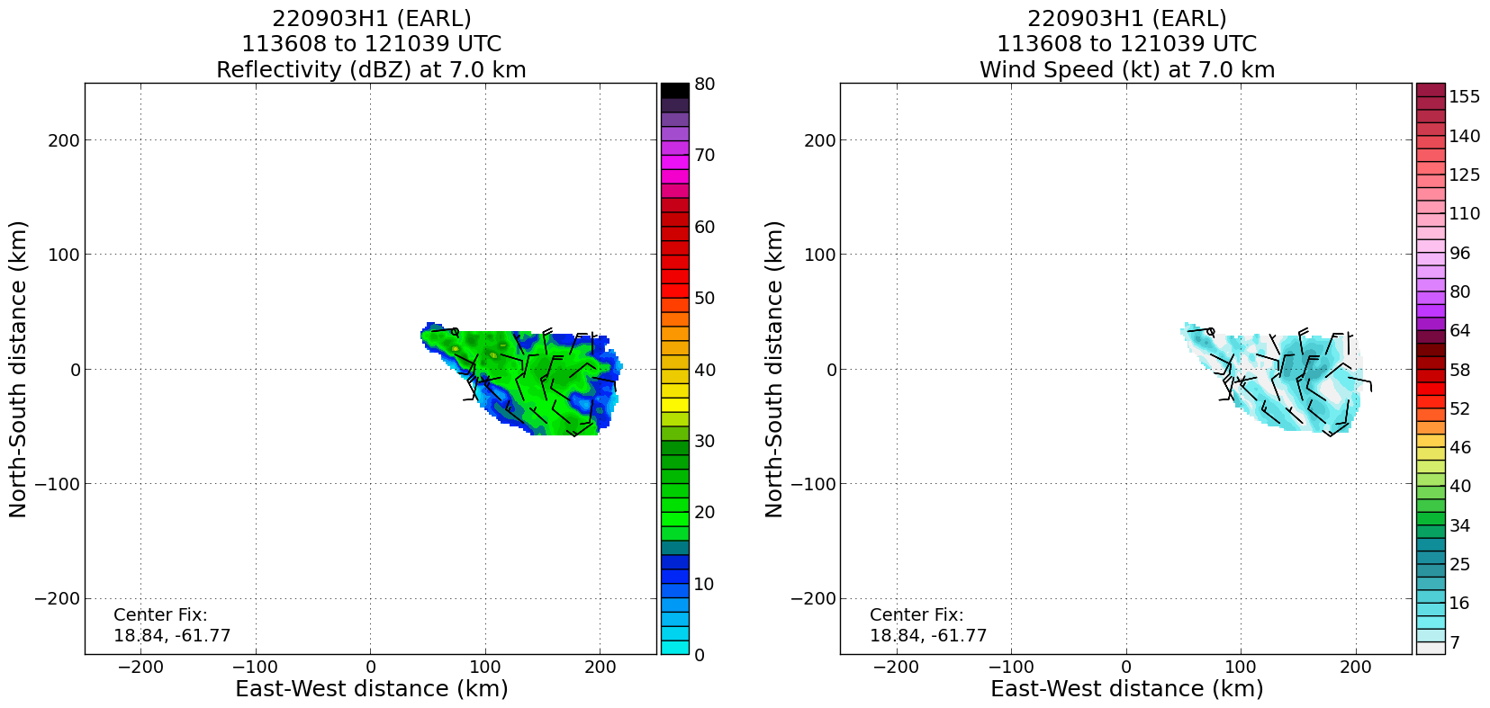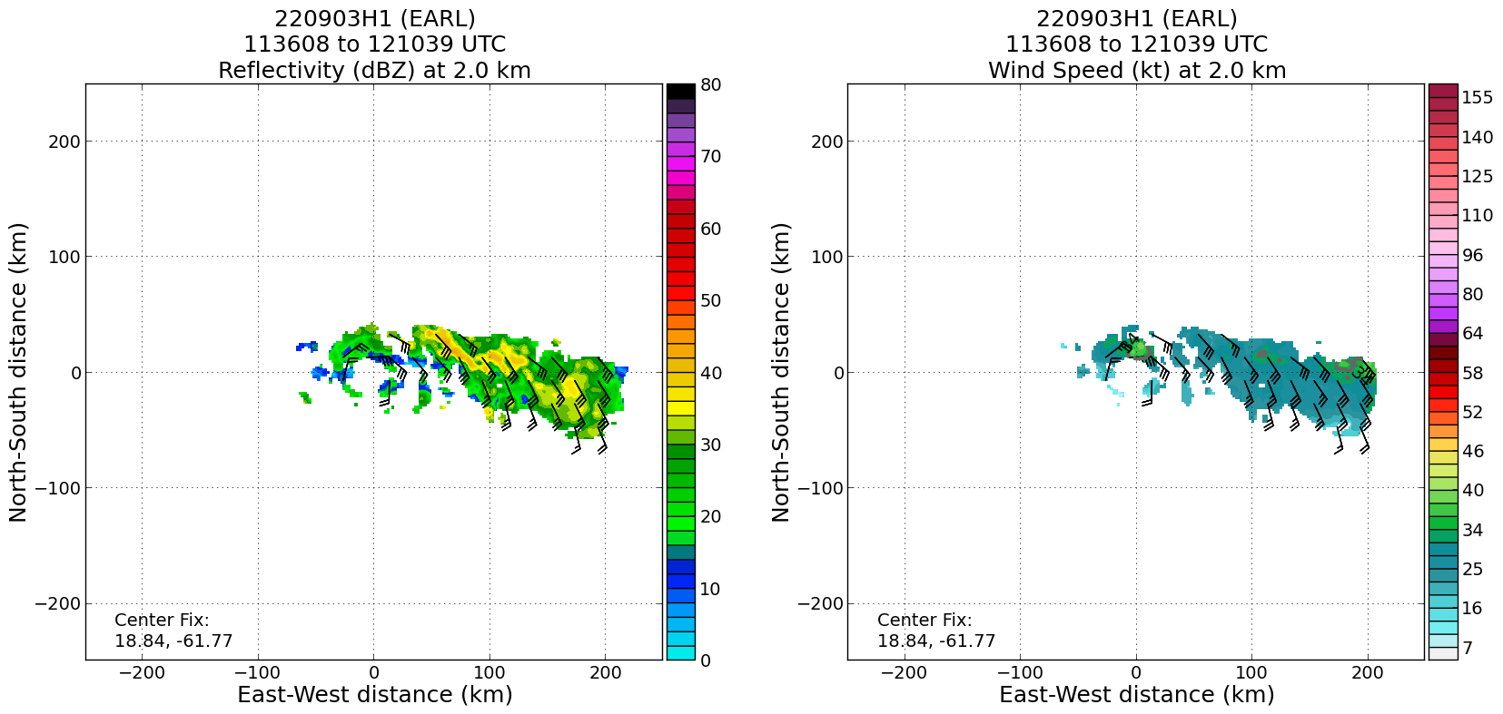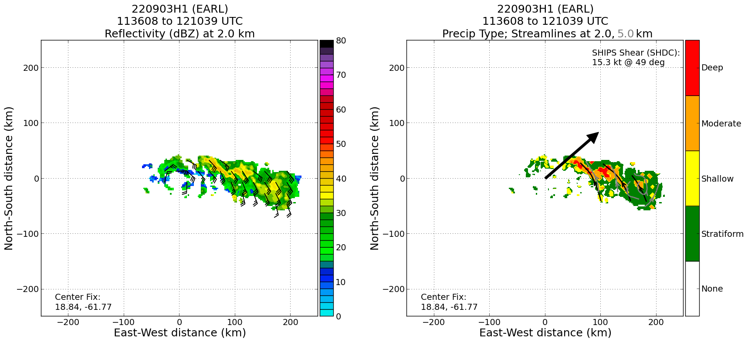
1308 | Shortwave IR/visible satellite animation showing exposed LLC
1339 | Drop #12, midpt SW
1408 | MTS screenshot of completed mission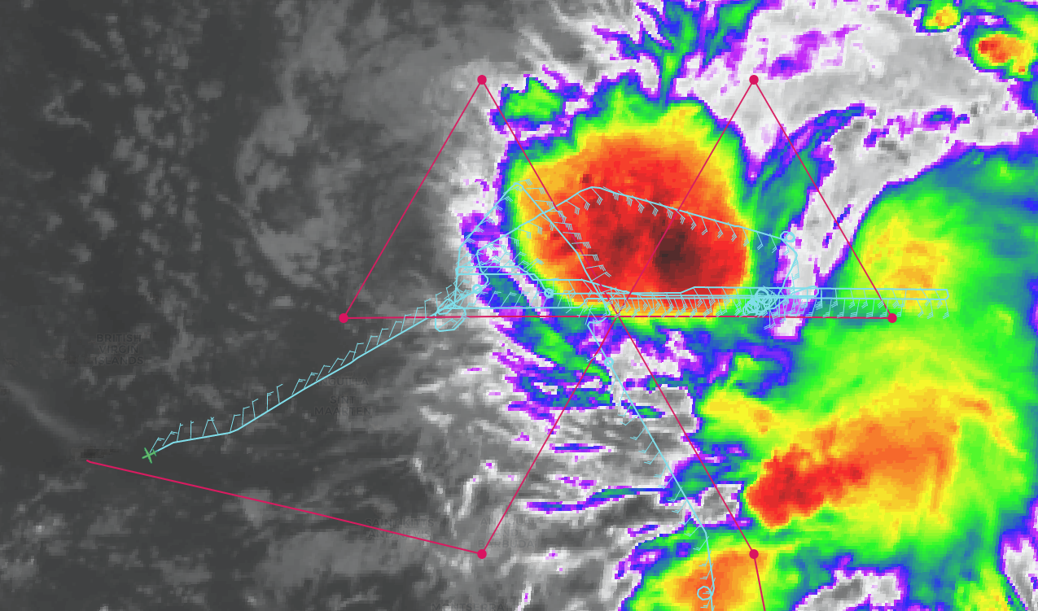
1352 | Drop #13, endpt SW

POST-FLIGHT
Mission Summary | Earl continues to struggle with westerly shear and dry air. We flew a modified butterfly pattern as part of an EMC tasked operational mission. Our first inbound leg was anchored to the low-level center (LLC). On that track we were passing too far to the west of the southeast mesoscale convective system (MCS). Upon reaching the center we fixed the center at flight level, which resulted in a shift of about 20-25 km to the east. We continued to fix the flight-level center from there on out.  We truncated the outbound leg to the NW due to a lack of scatterers, and a desire to get back to the east side of the storm where all of the scatterers were located. For similar reasons we truncated the leg on the west side, beginning the inbound leg at the midpoint of the original pattern. At that point we began a vortex alignment module (VAM), extending the outbound leg to the east an additional 30 nmi from the original plan. That allowed us to better sample the southeast MCS seen in the satellite images above. We turned 180 degrees and performed the second VAM leg, returning back to and past the LLC, and then turned 180 degrees again to complete the third VAM leg. We ended that third VAM leg 105 nmi from the FL center.  From there we turned back to perform a stratiform spiral module in some precipitation we had noted on our third pass. We performed the module along the northern edge of the southeastern MCS, climbing up to 20 kft. We did see evidence of ice crystals and even some graupel possibly on our descent in the spiral.  From there we modified the final center pass of the butterfly to stay further south than planned and better capture a new convective burst that was developing near the LLC. We sampled that feature well, intersecting the original inbound NE leg at the midpoint and proceeding inbound from there for our final center pass.  There was a lot of evolution seen in the VAM legs. We saw the midlevel center (MLC) clearly defined in the 6-10 km layer, and the LLC displaced about 100 km to the east. There was deep and moderate convection and stratiform precipitation associated with at various times both the MLC and the LLC. While the thought was that this could portend a possible reformation/repositioning, the deep convection coverage seemed to decrease with each successive pass and the LLC remained exposed on satellite. Evidently the storm is still experiencing shear strong enough to prevent alignment, even in the presence of intense, and repeated (though transient) bursts of convection. The working hypothesis is that the continued presence of dry air prevents the occurrence of persistent, deep convection. This allows the shear to continue to maintain a significant displacement between the LLC and the MLC. Only when the shear relaxes, the environment humidifies, or both, will Earl align. That’s the thought, anyway.
Actual Standard Pattern Flown | Butterfly pattern with additional VAM and SSM modules
APHEX Experiments / Modules Flown | Data collection supported the Early Stage Experiment: Analysis of Intensity Change Processes (AIPEX), with the Vortex Alignment Module (VAM) and Stratiform Spiral Module (SSM) flown within AIPEX.
Plain Language Summary
Instrument Notes
Final Mission Track | 