MISSION PLAN
FLIGHT ID | 202200901N1 | STORM | AL91
MISSION ID | WHWXA | TAIL NUMBER | NOAA49
TASKING | HRD | PLANNED PATTERN | Survey/Lawnmower
MISSION SUMMARY
TAKEOFF [UTC] | 1837 | LANDING [UTC] | 0110
TAKEOFF LOCATION | Barbados | LANDING LOCATION | Lakeland
FLIGHT TIME | 6.5 | BLOCK TIME | 6.8
TOTAL REAL-TIME RADAR ANALYSES  (Transmitted) | 2 | TOTAL DROPSONDES (Good/Transmitted) | 16 (15 / 15)
OCEAN EXPENDABLES (Type) | None | sUAS (Type) | None
APHEX EXPERIMENTS / MODULES | Genesis Experiment: FAM; Early Stage Experiment: ITOFS
HRD CREW MANIFEST
LPS ONBOARD | None | LPS GROUND | Kaplan
TDR ONBOARD | None | TDR GROUND | Gamache
ASPEN ONBOARD | AOC FD | ASPEN GROUND | None
NESDIS SCIENTISTS | None
GUESTS (Affiliation) | None
AOC CREW MANIFEST
PILOTS | Mansour, Waddington
NAVIGATOR | None
FLIGHT ENGINEERS | None
FLIGHT DIRECTOR | Henning
DATA TECHNICIAN | Defeo
AVAPS | Lynch

PRE-FLIGHT
Flight Plan | 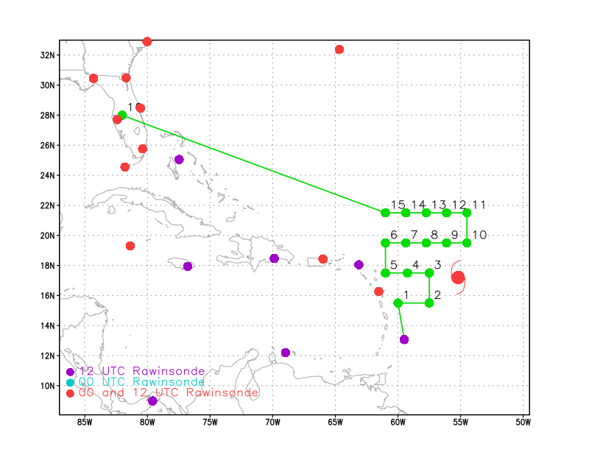
Expendable Distribution | Release a dropsonde at each of the green points in the above flight track image
Preflight Weather Briefing | 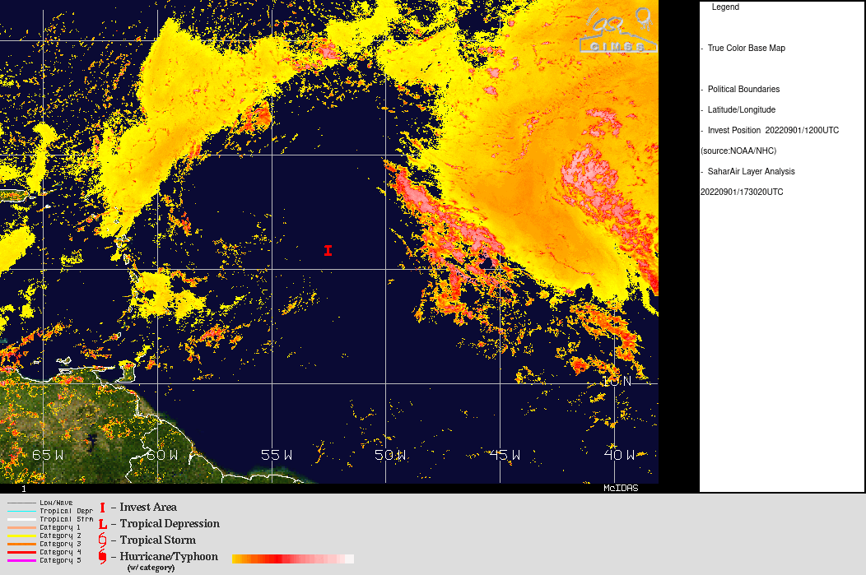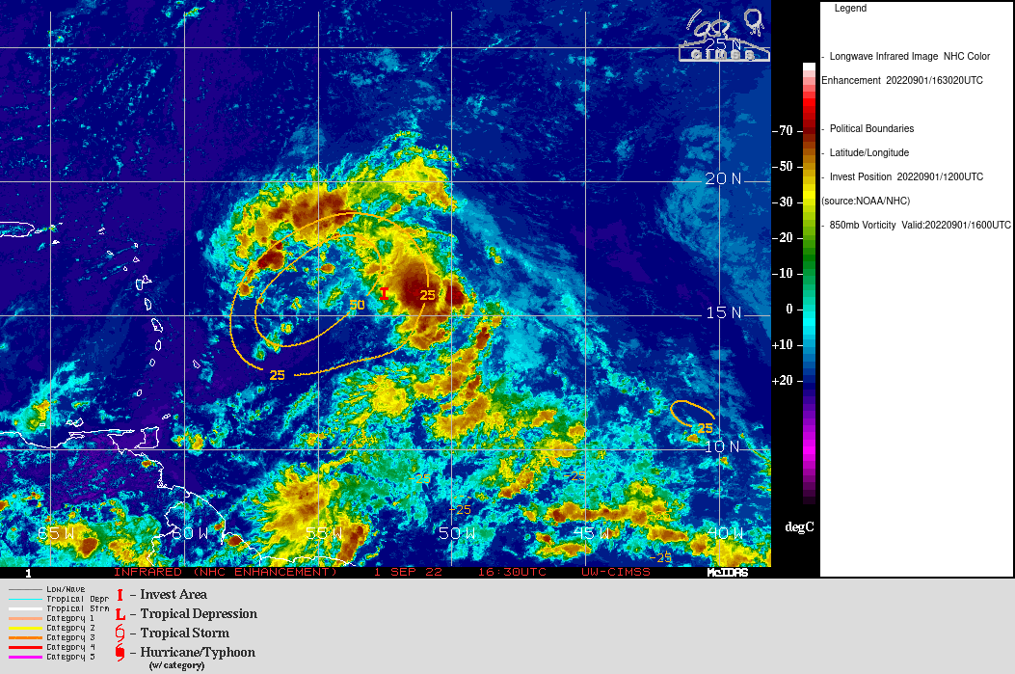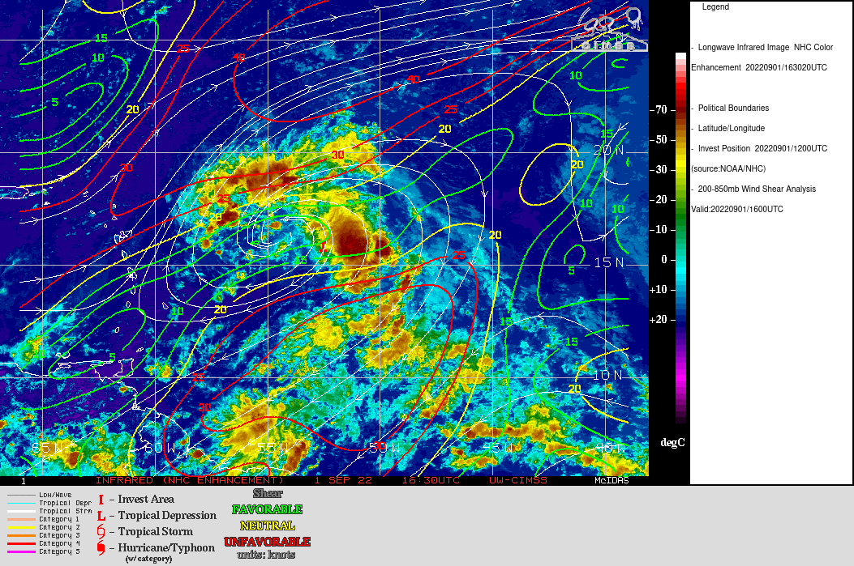
Instrument Notes

IN-FLIGHT
Time [UTC] | Event
1837 | Takeoff from Barbados
0109 | Landing in Lakeland

POST-FLIGHT
Mission Summary | The mission was conducted as planned. There was an airborne balloon located near Dropsonde point 8 (blue open circle on MTS track shown below) that was near at an altitude of 47,000 ft that resulted in communications between Jason Dunion and that group to ensure that it remained above that level during the mission.  16 dropsondes (15 good and transmitted) were released during the mission (all charged to NWS).
Actual Standard Pattern Flown | Survey / Lawnmower
APHEX Experiments / Modules Flown | Data collection supported the Genesis Stage Experiment: Favorable Air Mass (FAM) and the Early Stage Experiment: Impact of Targeted Observations on Forecasts (ITOFS).
Plain Language Summary
Instrument Notes | SATCOM ~2300 UTC – there were some Satcom issues reported  that resulted in a delay in the transmission of some sondes. However, 15 sondes were ultimately transmitted successfully. The TDR-AOC engineer reported that the G-IV INE was not functioning properly during turns apparently due to a loose cable that was subsequently tightened which appeared to have resolved the problem.
Final Mission Track | 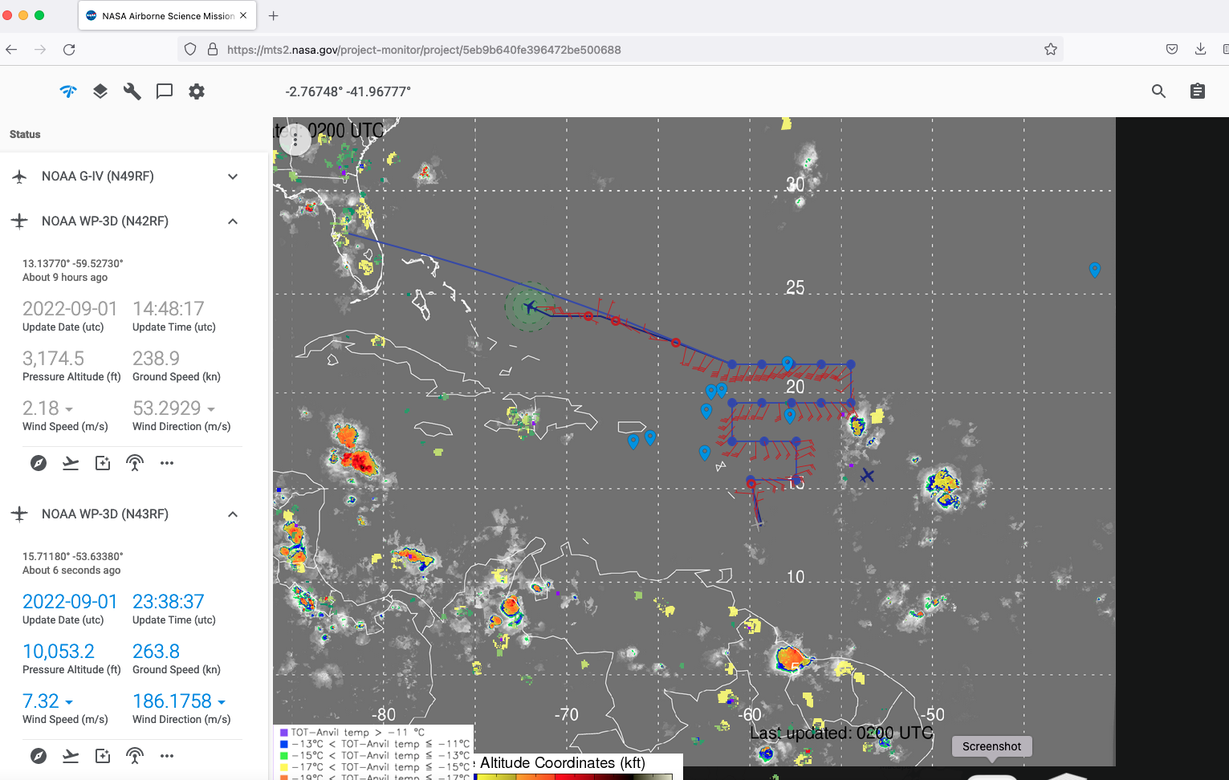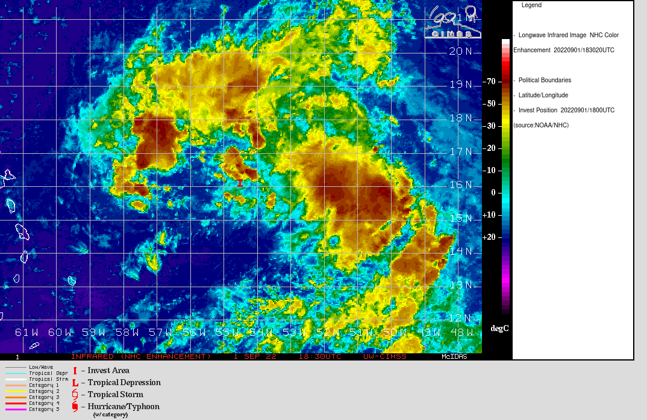  9/1 2340 UTC

