Flow Chart:

The MATLAB code from Jeff Kepert was translated to IDL and is contained in the file called CMRC_PROCESS.m (see above flow chart). The rest of the files which are described in the document IDL_CommercialModel_Soft_Eng_Doc.doc were needed to build the commercial model.

Validation results
From the two tables below (1st table shows the mean error and the 2nd table shows the root mean square error) we see that the mean error (LModeled-Observed) is -0.18 m/s and the rms is 5.88 m/s.
The comparison plots for all the validation storms can be found in a file called Validation_Swaths_Linear_Vs_Oberserved.ppt.

Storms | Year | 25_33  Model  Threshold | 33_50 Model Threshold | >50  Model Threshold | >25 Model Threshold | 25-33  H*Wind  Threshold | 33-50  H*Wind Threshold | >50  H*Wind  Threshold | >25 H*Wind Threshold
Andrew | 1992 | 111, 3.56 | 141, 6.14 | 88,  -5.05 | 340, 2.40 | 139,  -6.64 | 54,  -3.93 | 88, 5.66 | 281,  -2.26
Charley | 2004 | 149,  -2.54 | 38,  -11.28 | NA | 187,  -4.32 | 122, 3.64 | 63, 8.61 | 17, 16.84 | 202, 6.30
Frances | 2004 | 763, 3.29 | 169, 4.66 | NA | 932, 3.54 | 372,  -0.25 | 96,  -0.95 | NA | 468,  -0.39
Ivan | 2004 | 34, 0.67 | 39, -2.92 | NA | 73, -1.25 | 22,  -0.26 | 41, 3.07 | NA | 63, 1.90
Jeanne | 2004 | 234, 1.27 | 138, 0.86 | NA | 372, 1.12 | 225,  -0.01 | 121, 0.94 | NA | 346, 0.31
Dennis | 2005 | 35, -0.67 | 38, 2.95 | NA | 73, 1.21 | 29,  -4.07 | 29, 0.98 | 3, 12.27 | 61,  -0.86
Katrina | 2005 | 130,  -5.46 | 57, -2.91 | NA | 187,  -4.68 | 93, 2.78 | 149, 7.18 |  | 242, 5.49
Rita | 2005 | 7, 3.15 | 3, 6.17 | NA | 10, 4.06 | 5, -5.43 | NA | NA | 5, -5.43
Wilma | 2005 | 157,  -4.64 | 322,  -8.22 | NA | 479, -7.04 | 87, 1.35 | 396, 8.37 | NA | 483, 7.11
Mean Bias N | All | 1620,  1.76 | 945,  1.53 | 88,  -5.05 | 2653,  -0.18 | 1094,  -0.32 | 949,  5.15 | 108,  7.6 | 2151,  2.66

Storms | Year | 25-33ms  Model  Threshold | 33-50ms Model Threshold | >50ms  Model Threshold | >25ms Model Threshold | 25-33ms  H*Wind  Threshold | 33-50ms  H*Wind Threshold | >50ms  H*Wind  Threshold | >25ms H*Wind Threshold
Andrew | 1992 | 111, 3.89 | 141, 7.47 | 88, 6.38 | 340, 6.21 | 139, 7.06 | 54, 4.98 | 88, 6.74 | 281, 6.61
Charley | 2004 | 149, 5.96 | 38, 13.20 | NA | 187, 7.98 | 122, 4.89 | 63, 9.45 | 17, 17.88 | 202, 8.32
Frances | 2004 | 763, 5.07 | 169, 6.95 | NA | 932, 5.46 | 372, 3.78 | 96, 4.07 | NA | 468, 3.84
Ivan | 2004 | 34, 2.41 | 39, 3.20 | NA | 73, 2.86 | 22, 1.23 | 41, 3.42 | NA | 63, 2.85
Jeanne | 2004 | 234, 3.79 | 138, 2.70 | NA | 372, 3.43 | 225, 4.23 | 121, 2.81 | NA | 346, 3.79
Dennis | 2005 | 35, 6.19 | 38, 5.38 | NA | 73, 5.78 | 29, 4.75 | 29, 6.31 | 3, 12.96 | 61, 6.16
Katrina | 2005 | 130, 6.95 | 57, 3.39 | NA | 187, 6.09 | 93, 3.54 | 149, 8.72 | NA | 242, 7.19
Rita | 2005 | 7, 3.24 | 3, 6.17 | NA | 10, 4.33 | 5, 5.51 | Na | Na | 5, 5.51
Wilma | 2005 | 157, 6.57 | 322, 8.63 | NA | 479, 8.01 | 87, 2.34 | 396, 8.75 | NA | 483, 7.98
RMS N | All | 1620,  5.14 | 945,  6.79 | 88,  6.38 | 2653,  5.88 | 1094,  4.26 | 949,  7.04 | 108,  8.66 | 2151,  5.96

Losses from Linear model versus Losses from Residential model
The table Comparison_A3v3.1_A3-2D-CR_20090904.xls contains the total insured losses (TIL) comparison of the personal residential (PR) and the linear model. The computer science team ran the linear model and WSC with V3.1's roughness on V3.1's baseset to generate the 3sec gust winds and then computed Form A3. The end results are as follow;
TIL for Residential model is $534,422,376,672
TIL for Linear model is $680,362,799,964
Linear – Residential is $145,940,423,293
Pct Change : 27.31%

Main reason for higher losses:

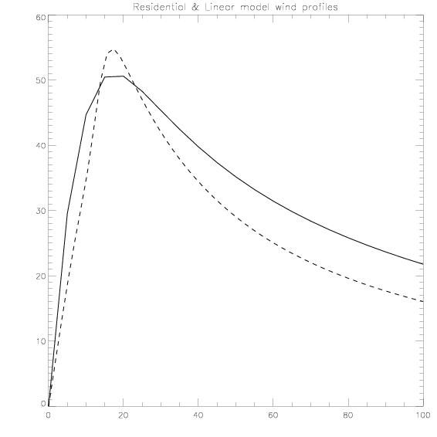

The discontinuous curve is from the slab model (George 1998) and the continuous line is from the linear model (same storm). We see that the linear model tend to have higher far fields wind than the slab one.

Proposed changes
- The model is using an eddy diffusivity of 50, if we vary it we can have different wind speed values as seen in the two figures below.
First figure shows the wind swath for George for K=5 and the second figure shows the same wind swath but for K=50

- Experiment with the updated Holland model.
- Experiment with different (height, eddy diffusivity) combinations.

