Statistical Standards

S-1 Modeled Results and Goodness-of-Fit

A. The use of historical data in developing the model shall be supported by rigorous methods published in currently accepted scientific literature.

The historical data for the period 1900-2006 was modeled using scientifically accepted methods that have been published.

B. Modeled and historical results shall reflect agreement using currently accepted scientific and statistical methods.

Modeled and historical results are in agreement as indicated by appropriate statistical and scientific tests. Some of these tests will be discussed below.

Disclosures

- Identify the form of the probability distributions used for each function or variable, if applicable. Identify statistical techniques used for the estimates and the specific goodness-of-fit tests applied. Describe whether the p-values associated with the fitted distributions provide a reasonable agreement with the historical data.

Historical initial conditions are used to provide the seed for storm genesis in the model. Small uniform random error terms are added to the historical starting positions, intensities and changes in storm motion. Subsequent storm motion and intensity is determined by randomly sampling empirical probability distribution functions derived from the HURDAT historical record.

Figure 44 shows the occurrence rate of both modeled and historical landfalling storms in Florida. The figure shows a good agreement, and a Chi square goodness of fit gives a p-value of approximately 0.24. An analysis of landfalls by each region and intensity in Florida is given in Form M-1.

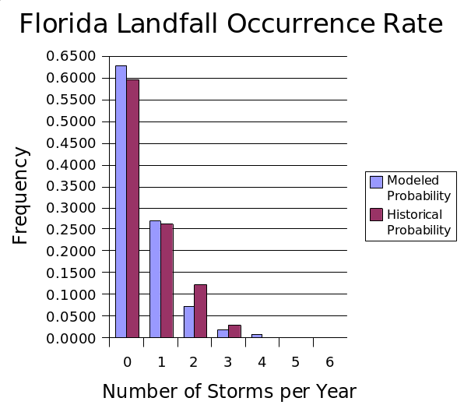
Figure 1. Comparison of simulated vs historical occurrences

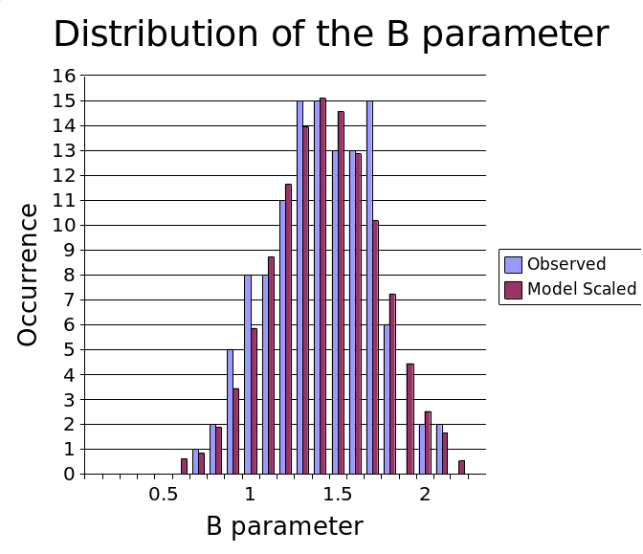
Figure 2: Comparison between the modeled and observed Willoughby and Rahn (2004) B data set

The random error term for the Holland B is modeled using a Gaussian distribution with a standard deviation of 0.286. Figure 45 shows a comparison between the Willoughby and Rahn (2004) B data set (see Standard M-4.1) and the modeled results (scaled to equal the 116 measured occurrences in the observed data set). The modeled results with the error term have a mean of about 1.38 and are consistent with the observed results. The figure indicates excellent agreement, and the Chi square goodness of fit gives a p-value about 0.89.

We develop a new Rmax model using the revised landfall Rmax database which includes 108 measurements for storms up to 2005. We have opted to model the Rmax at landfall rather than the entire basin for a variety of reasons. One is that the distribution of landfall Rmax may be different than that over open water. An analysis of the landfall Rmax database and the 1988-2007 DeMaria Extended Best Track data shows that there appears to be a difference in the dependence of Rmax on central pressure (Pmin) between the two data sets. The landfall data set provides a larger set of independent measurements, more than 100 storms compared to about 31 storms affecting the Florida threat area region in the Best Track Data. Since landfall Rmax is most relevant for loss cost estimation, and has a larger independent sample size, we have chosen to model the landfall data set. Future studies will examine how the Extended Best Track Data can be used to supplement the landfall data set.

Based on the semi-boundedness and skewness of Rmax, we sought to model the distribution using either a log normal or gamma distribution. Using maximum likelihood estimators, we found the parameters for a log normal distribution to be 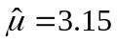, 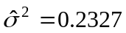, and for the gamma distribution, 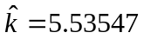, 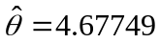. With these parameters, we show a plot of the observed and expected distribution for log normal and gamma in 3. The Rmax values are binned in 5 sm intervals, with the x-axis showing the end value of the interval.

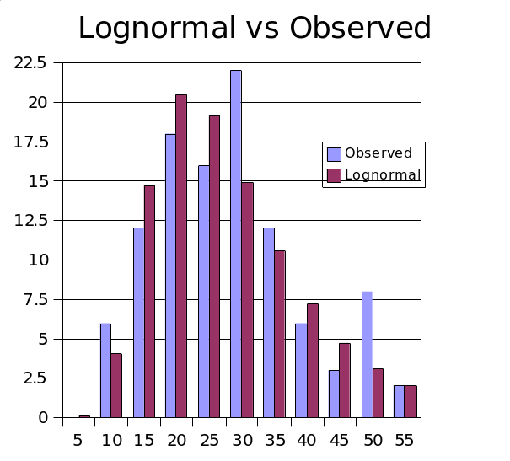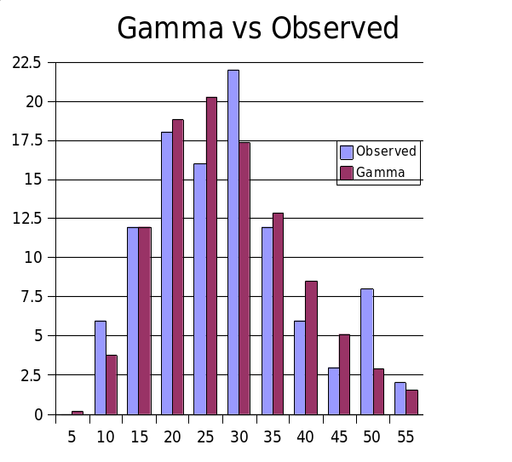
Figure 3. Observed and expected distribution for Lognormal (left) and Gamma (right)

The gamma distribution proved to be a better fit. A Chi square goodness of fit test shows that using a log normal distribution yields a p-value of 0.41, while for a gamma distribution it is 0.71. The log normal also has a longer tail, which inflates the variance somewhat and leads to a greater probability of excessively large storms. On this basis, we have opted to use the gamma distribution function for the stochastic model.

- Provide the source and the number of years of the historical data set used to develop probability distributions for specific hurricane characteristics. If any modifications have been made to the data set, describe them in detail and their appropriateness.

The model uses the National Hurricane Center HURDAT file from June 2006 for the period 1900-2005. This information is provided in detail in Disclosures M-1.1, M-1.2 and M-2.1. (Met Standards).

- Describe the nature and results of the tests performed to validate the wind speeds generated.

We compare the cumulative effect of a series of modeled and observed wind fields by comparing the peak winds observed at a particular zip code during the entire storm life-cycle. We also compare our modeled wind fields to those that have been constructed from all available observations which are freely available on the NOAA AOML-HRD web site. A subsequent section describes the process for recording the peak modeled and observed wind speeds (wind swaths) from which the validation statistics are generated. Our validation is based on nine hurricanes that by-passed or made landfall in Florida. These hurricanes were well observed and we will have the ability to add new storms and quickly conduct new validation studies as our validation set grows and we make enhancements to the model. In order to run the Loss Model in “scenario” mode for doing validation studies, we had to construct detailed storm track histories for recent storms affecting Florida using the HURDAT, Rmax and Holland Beta databases. The validation suite included 1992 Hurricane Andrew and the following 2004 and 2005 storms: Charley, Frances, Jeanne, Ivan, Dennis, Katrina, Rita, and Wilma. The validations make use of the Hurricane Research Division’s Surface Wind Analysis System (H*Wind).

a. H*Wind

The HRD approach to hurricane wind analysis employed in H*Wind evolved from a series of peer-reviewed, scientific publications analyzing landfalls of major hurricanes including Frederic of 1979, Alicia of 1983, Hugo of 1989, and Andrew of 1992 (Powell et al., 1991, Powell and Houston, 1996, 1998, Powell et al., 1998). In Powell et al., (1991) which described Hurricane Hugo's landfall, a concept was developed for conducting a real-time analysis of hurricane wind fields.. The system was first used in real-time during Hurricane Emily in 1993 (Burpee et al., 1994). Since 1994, HRD wind analyses have been conducted on an experimental basis to create real time hurricane wind field guidance for forecasters at the National Hurricane Center. During Hurricane landfall episodes from 1995-2005, HRD scientists have conducted research side by side with hurricane specialists at NHC analyzing wind observations on a regular 3 or 6 hour schedule consistent with NHC's warning and forecast cycle.

An HRD wind analysis requires the input of all available surface weather observations (e.g., ships, buoys, coastal platforms, surface aviation reports, reconnaissance aircraft data adjusted to the surface, etc.). Observational data are downloaded on a regular schedule and then processed to fit the analysis framework. This includes the data sent by NOAA P3 and G4 research aircraft during the HRD hurricane field program, including the Step Frequency Microwave Radiometer measurements of surface winds and U.S. Air Force Reserves (AFRES) C-130 reconnaissance aircraft, remotely sensed winds from the polar orbiting SSM/I and ERS, the QuikScat platform and TRMM microwave imager satellites, and GOES cloud drift winds derived from tracking low level near-infrared cloud imagery from these geostationary satellites. These data are composited relative to the storm over a 4-6 hour period. All data are quality controlled and processed to conform to a common framework for height (10 m or 33 feet), exposure (marine or open terrain over land), and averaging period (maximum sustained 1 minute wind speed) using accepted methods from micrometeorology and wind engineering (Powell et al., 1996, Powell and Houston, 1996). This framework is consistent with that used by the National Hurricane Center (NHC), and is readily converted to wind load frameworks used in building codes.
Based on a qualitative examination of various observing platforms and methods used to standardize observations, Powell et al., 2005 suggest that the uncertainty of the maximum wind from a given analysis ranges from 10-20 % depending on the observing platform. In general the uncertainty of a given H*Wind analysis is of the order of 10% for analysis of Hurricanes Ivan, Frances, Jeanne, and Katrina, all of which incorporated more accurate surface wind measurements from the Stepped Frequency Microwave Radiometer (SFMR) aboard the NOAA research aircraft. The SFMR data used for those analyses was post-processed during the fall of 2005 using the latest geophysical model function relating wind speed to sea surface foam emissivity. Hurricanes Charley, Dennis, Rita, Wilma, and Andrew did not have the benefit of SFMR measurements but relied on adjusting Air Force reconnaissance observations at the 3 km altitude to the surface with empirical reduction methods. The method used was based on how SFMR measurements compared to flight level winds and depended on storm relative azimuth. Preliminary results suggest that this method has an uncertainty of 15%.
We created wind swaths for both the modeled and observed winds. We also computed the maximum winds at zip codes for both the observed and modeled winds, and from that we derived the mean and root-mean-square error (see Table 1 and Table 2).

b. Wind Swaths
For each storm in the validation set, the peak sustained surface wind speed is recorded at each zip code in Florida for the duration of the storm event. Observed wind fields from H*Wind and modeled wind fields from the public model are moved along the exact same tracks, which are the observed high-resolution storm tracks assembled from reconnaissance aircraft and radar data. For each storm, the recorded peak of the observed and modeled wind speed is saved at each grid point as well as of each zip code, and the resulting zip code comparison pairs provide the basis for the model validation statistics. The peak grid point values are color contoured and mapped as graphics showing the “swath” of maximum winds swept out by the storm passage. Wind swaths are sometimes confused with a wind field. The winds depicted in a wind swath do not have time continuity, cannot depict a circulation, and therefore cannot be described as a wind field. A wind field represents a vector field that represents a representative instance of the surface wind circulation.
Wind swaths were constructed for both the modeled and observed winds. Maximum marine exposure winds were compared at all zip codes for both the observed and modeled winds (Figure 47) from which we derived the mean and root-mean-square error statistics shown in Table 2. This type of comparison provides an unvarnished assessment of model performance.
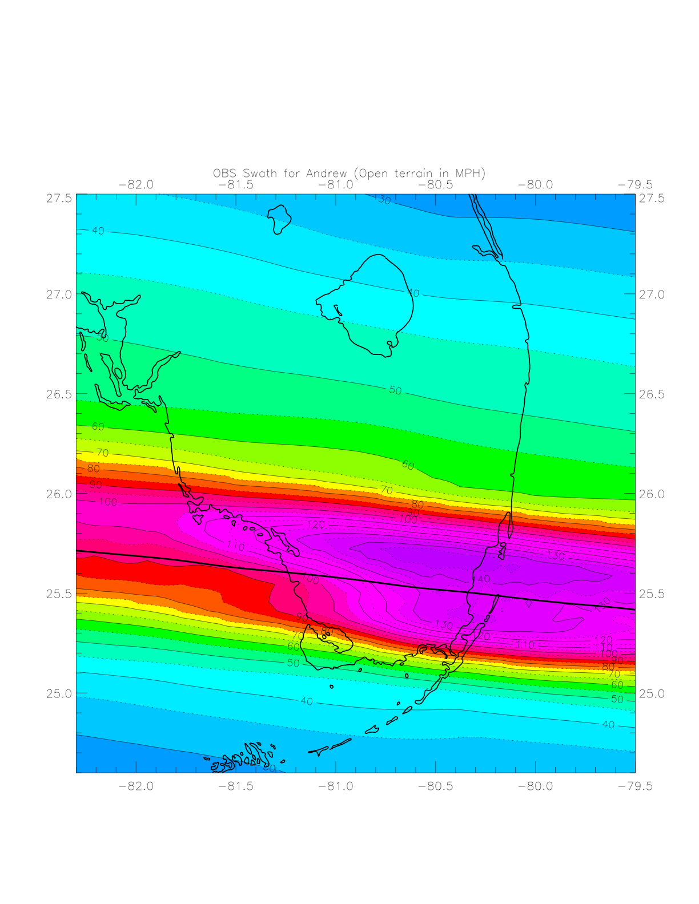
Figure 4. Comparison of modeled (left) and observed (right) swaths of maximum sustained open terrain surface winds for Hurricane Andrew of 1992 in South Florida. Hurricane Andrew observed swath is based on adjusting flight-level winds with the SFMR-based wind reduction method.
Table 1. Validation Table based on zip code wind swath comparison of the Public wind field model to H*Wind. Mean errors (bias) of model for the set of validation wind swaths. Errors (upper number in each cell) are computed as Modeled – Observed (Obs) at zip codes where modeled winds were within wind thresholds (model threshold) or where observed winds were within respective wind speed threshold (H*Wind threshold). Number of zip codes for the comparisons is indicated as the lower number in each cell.

Storms | Year | 56-74  Model  Threshold | 75-112 Model Threshold | >112mph  Model Threshold | >56mph Model Threshold | 56-74  H*Wind  Threshold | 75-112  H*Wind Threshold | >112mph  H*Wind  Threshold | >56mph H*Wind Threshold
Andrew | 1992 | 5.25  92 | 13.86  107 | 2.73  100 | 7.49  299 | 10.26  139 | 12.47  54 | 0.66  88 | 7.68  281
Charley | 2004 | 12.96  112 | 21.36  244 | -7.36  13 | 17.80  369 | 8.58  122 | -3.09  63 | -8.91  17 | 3.47  202
Frances | 2004 | 3.99  693 | -0.99  96 | None | 3.38  789 | -0.59  372 | -4.48  96 | None | -1.38  468
Ivan | 2004 | -6.95  20 | -3.35  38 | None | -4.59  58 | -5.76  22 | -3.73  41 | None | -4.44  63
Jeanne | 2004 | 6.78  250 | 3.95  190 | None | 5.56  440 | 2.67  225 | -3.87  121 | None | 0.38  346
Dennis | 2005 | 2.45  15 | 6.98  46 | None | 5.87  61 | 5.22  29 | 7.57  29 | -4.37  3 | 5.87  61
Dennis Keys | 2005 | None | None | None | None | -12.65  5 | None | None | -12.65  5
Katrina | 2005 | -11.43  77 | -2.42  100 | None | -6.34  177 | -8.93  93 | -11.57  149 | None | -10.55  242
Rita | 2005 | 6.28  5 | 14.54  3 | None | 9.38  8 | 12.01  5 | None | None | 12.01  5
Wilma | 2005 | 0.44  133 | -9.99  394 | None | -7.35  527 | 6.54  87 | -13.35  396 | None | -9.77  483
Mean Bias N | All | 3.99  1397 | 2.80  1218 | 1.56  113 | 3.33  2728 | 2.38  1099 | -7.76  949 | -0.98  108 | -2.25  2156

Table 2. Validation Table based on zip code wind swath comparison of the Public wind field model to H*Wind. Root mean square (RMS) wind speed errors (mph) of model for the set of validation wind swaths. Errors are based on Modeled – Observed (Obs) at zip codes where modeled winds were within wind thresholds (model threshold) or where observed winds were within respective wind speed threshold (H*Wind threshold). Number of zip codes for the comparisons is indicated as the lower number in each cell.

Storms | Year | 56-74  Model  Threshold | 75-112 Model Threshold | >112mph  Model Threshold | >56mph Model Threshold | 56-74  H*Wind  Threshold | 75-112  H*Wind Threshold | >112mph  H*Wind  Threshold | >56mph H*Wind Threshold
Andrew | 1992 | 6.11 | 15.75 | 7.024 | 10.81 | 12.19 | 14.26 | 5.82 | 11.10
Charley | 2004 | 19.84 | 26.59 | 10.08 | 24.30 | 16.65 | 8.60 | 11.69 | 14.21
Frances | 2004 | 8.08 | 11.20 | None | 8.52 | 4.99 | 10.20 | None | 6.41
Ivan | 2004 | 7.07 | 5.20 | None | 5.91 | 6.11 | 5.51 | None | 5.72
Jeanne | 2004 | 10.14 | 9.65 | None | 9.93 | 10.88 | 6.16 | None | 9.50
Dennis | 2005 | 3.06 | 9.19 | None | 8.12 | 6.15 | 9.93 | 4.59 | 8.12
Dennis Keys | 2005 | None | None | None | None | 12.67 | None | None | 12.67
Katrina | 2005 | 14.66 | 8.25 | None | 11.49 | 12.50 | 17.97 | None | 16.09
Rita | 2005 | 6.4992 | 14.54 | None | 10.28 | 12.41 | None | None | 12.41
Wilma | 2005 | 14.73 | 14.05 | None | 14.22 | 12.51 | 14.83 | None | 14.44
RMS N | All | 10.18  1397 | 14.87  1218 | 6.26  113 | 12.37  2728 | 9.75  1099 | 12.79  949 | 6.71  108 | 11.19  2156

Comparison of model and H*Wind sustained marine exposure wind speeds at zip codes receiving model wind speeds over the given thresholds (Table 1) indicates a positive bias. For zip codes where model wind speeds exceeded 56 mph, the bias is +3.3 mph and negative bias was apparent in Hurricanes Ivan, Katrina, and Wilma. At other wind speed thresholds, low bias is evident for winds > 112 mph in Charley, and winds of 75-112 mph in Frances, Ivan, Katrina, and Wilma. For winds of 56-74 mph, low bias is noted in Hurricanes Ivan, and Katrin,. Errors for Andrew are relatively high but the lack of observations for Andrew makes it difficult to determine if it was a Cat 4 or Cat 5 hurricane during its landfall in South Florida. Rita in the Keys also shows relatively high bias but observations indicate that there were fluctuations in intensity over a short period of time during its passage past the Keys. Model errors for Charley are also relatively highly likely due to the model producing too broad a wind field. When model winds are compared to H*Wind at zip codes exceeding H*Wind, and sustained wind speed thresholds of 56 mph are considered, the mean bias is -2.2 mph. However, bias at other wind speed thresholds is larger, primarily caused by large model - H*Wind differences in Hurricane Andrew, Charley, and Rita.

When swaths are evaluated at zip codes, a positive wind speed bias of ~3 mph is indicated. However, the model can also under-predict swaths for individual cases. While bias correction is an accepted practice for numerical weather prediction, there is no evidence that the model has a consistent bias. The swath bias is probably associated with limitations in specifying the radial pressure profile after landfall. The tendency for the Holland pressure profile parameter to produce too broad an area of strong winds near the eyewall is the most likely cause of bias and is likely a feature found in many of the current risk models. Therefore we have decided to forego any corrective measures at this point.

Our validation set is unique in that the values of storm position, motion, Rmax and Pmin are observed, and B is determined independently from the H*Wind field. In other words, there is no tuning dial that we can turn to try to improve our results. Although additional validation storms are desired, we believe the positive bias for locations with winds > 56 mph is a characteristic of models that use the Holland B pressure profile parameter, which tends to produce model fields that are too broad outside the radius of maximum winds. Our validation method provides an objective means of assessing model performance by evaluating the portion of the wind field that contains damaging winds.

The root mean square (RMS) error (Table 2) provides a better estimate of model uncertainty. For zip codes in which model winds were 56-74 mph, the rms error is +/- 10 mph (~ 15%), for 75-112 mph the error is +/- 15 mph (~16%), and for winds > 112 mph the errors is +/- 6 mph (~ 5%). In general, for winds > 56 mph, the rms error is +/- 12 mph or ~ 13%. RMS errors are similar for zip codes in which H*Wind wind speeds fell into the respective thresholds.

j. Summary of Wind Field Model Validation

Validation of the winds from the wind model against the H*WIND analyses was prepared by considering winds that would be strong enough to be associated with damage. Threshold-based comparisons could miss places where the observed winds were greater than the model and the model was below the threshold. Conversely, observed winds over the same thresholds can be compared to the co-located model grid points but would miss places where the observed winds were below the threshold. It is important to evaluate the errors both ways to see if a consistent bias is evident. According to our validation statistics, albeit for a relatively small number of cases, wind swath zip code comparisons show evidence of a 3 mph positive bias but it is not consistent for all storms. The bias is likely related to the limitations of the Holland B pressure profile specification. The model uncertainty, as estimated by the RMS error, is on the order of 15%.

4. Provide the date of loss of the insurance company data available for validation and verification of the model.

The following hurricane data from different insurance companies are used to validate the different models of the project:

Andrew | 1992
Charley | 2004
Frances | 2004
5. Provide an assessment of uncertainty in loss costs for output ranges using confidence intervals or other accepted scientific characterizations of uncertainty.

While the model does not automatically produce confidence intervals for the output ranges, the data does allow for the calculation of confidence intervals. The average loss as well as the standard deviation of the loss is calculated for each county and found that the standard errors are within less than 2.5% of the means in the counties. We have calculated the coefficient of variation (CV) for all counties and drew a histogram which is provided in Figure 48. We noticed that the range of the CVs is found to be (2.98 to 5.22). The Bootstrap 95% confidence interval for the true CV is found to be between 3.74 and 4.01. The width of the interval is 0.27.

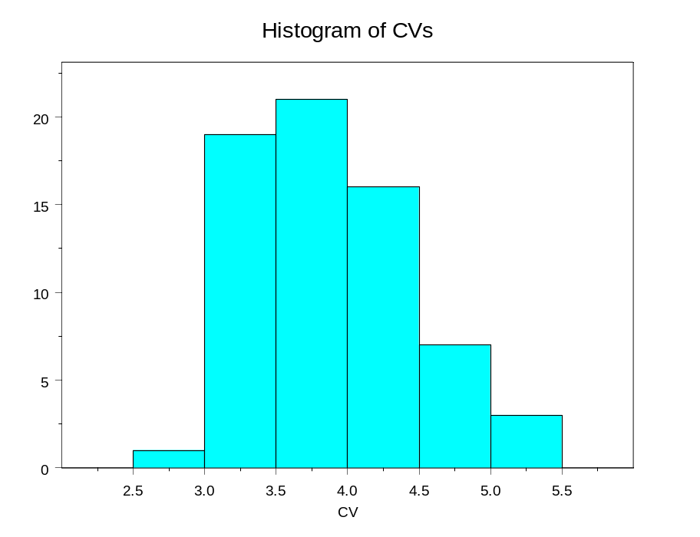
Figure 5. Histogram of the CVs for county wise losses

6. Provide graphical comparisons of modeled and historical data and goodness-of-fit tests. Examples include hurricane frequencies, tracks, intensities, and physical damage

For hurricane frequencies as a function of intensity by region, see Form M1 plots and goodness of fit table. Moreover, the following histogram (Figure 49) compares the modeled and historical annual landfall distribution. The agreement between the two distributions is quite close and shows a good fit.

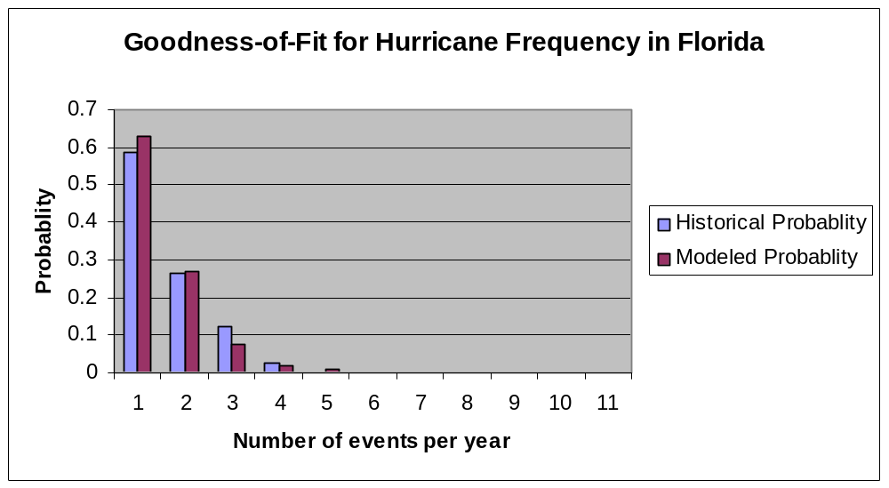

Figure 6. Modeled vs. historical probabilities

Two sample Kolmogorov-Smirnov Test gives KS = 0.0909, P-value = 1.00, which shows a very good fit. For KS goodness of fit test, we refer Conover (1999) among others. The histogram supported the KS test procedure.

- Provide a completed Form S-1, Probability of Hurricanes per Year.

See the completed S-1 form at the end of this section.

- Provide a completed Form S-2, Probable Maximum Loss.

See completed form S-2 at the end of this section.

S-2 Sensitivity Analysis for Model Output

The modeler shall have assessed the sensitivity of temporal and spatial outputs with respect to the simultaneous variation of input variables using currently accepted scientific and statistical methods and have taken appropriate action.

We have assessed the sensitivity of temporal and spatial outputs with respect to the simultaneous variation of input variables using currently accepted scientific and statistical methods.

Disclosures

- Provide a detailed explanation of the sensitivity analyses that have been performed on the model above and beyond those completed for the original submission of Form S-5 and provide specific results. (Requirement for modeling organizations that have previously provided the Commission with Form S-5. This disclosure can be satisfied with an updated Form S-5 that incorporates changes to the model since the previous submission of the Form).

Since this is our first submission, sensitivity analysis has been limited to Form S-5. The following input variables were used.
- CP = central pressure (in millibars)
- Rmax = radius of maximum winds (in statute miles)
- VT = translational velocity (forward speed in miles per hour)
- Holland B pressure profile parameter

- Provide a description of the statistical methods used to perform the sensitivity analysis.

We have followed the procedures as described in the paper “Assessing Hurricane Effects. Part 1. Sensitivity Analysis,” by Ronald L. Iman, Mark E. Johnson, and Tom Schroeder (2000a).

- Identify the most sensitive aspect of the model and the basis for making this determination. Provide a full discussion of the degree to which these sensitivities affect output results and illustrate with an example.

For sensitivity analysis, some selected graphs of the standardized regression coefficients vs time for Category 1, 3 and 5 hurricanes are provided in Figure 50- Figure 52. From these graphs, we observed that the maximum sustained surface wind speed (MSSWS) is most sensitive to Rmax parameter followed by VT, Holland B and CP. At hour 0, MSSWS is the most sensitive to Rmax, where as at hour 12, MSSWS is the most sensitive to VT. We also noticed that the sensitivity of MSSWS depends on the time, grid points and the category of hurricanes.

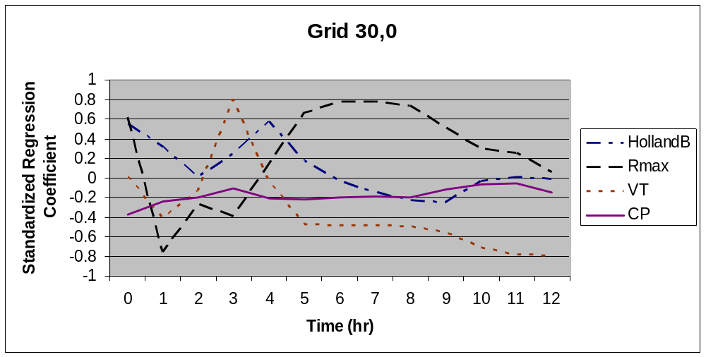

Figure 7. Standardized Regression Coefficients vs. Time at Grid Coordinates (30,0) for Category 1

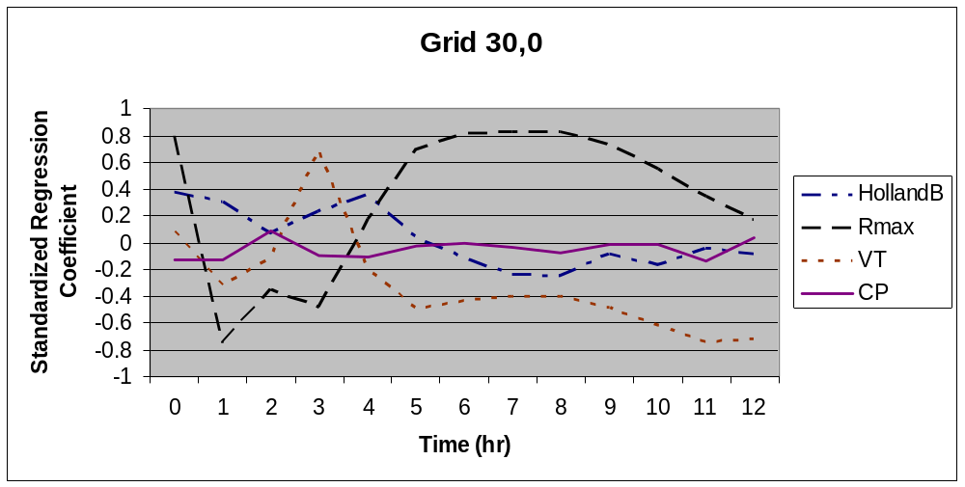

Figure 8. Standardized Regression Coefficients vs. Time at Grid Coordinates (30,0) for Category 3

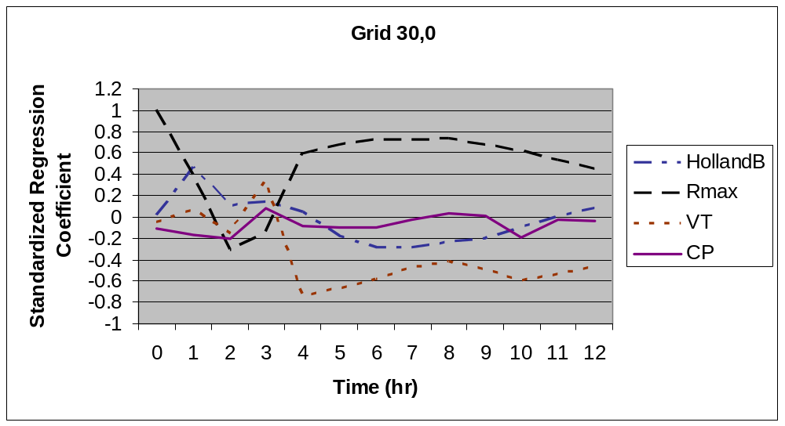

Figure 9. Standardized Regression Coefficients vs. Time at Grid Coordinates (30,0) for Category 5

- Describe how other aspects of the model may have a significant impact on the sensitivities in output results and the basis for making this determination.

Validation studies (described in Standard S1-3) indicated that air density, boundary layer height, fraction of the boundary layer depth over which the turbulent stresses act, the drag coefficient, the averaging time chosen to represent the boundary layer slab winds, and the reduction factor to adjust slab winds to the surface all have a significant effect on the output results. These quantities were evaluated during the validation process, resulting in the selection of physically consistent values. For example, the values chosen for air density, marine boundary layer height , and reduction factor from the mean boundary layer to the surface are representative of near surface GPS dropsonde measurements in hurricanes.

Model wind speeds are very sensitive to zip code roughness, which in turn depend on land use/land cover determined from satellite remote sensing, and the assignment of roughness to mean land use / land cover classifications as well as the upstream filtering or weighting factor applied to integrate the upstream roughness elements within a 45 degree sector to windward of the zip code. When zip codes are updated to reflect annual changes and population centroids are updated, the roughness table is also updated. Zip code location changes will generate different wind speeds. Experiments with different land use land cover filtering factors suggest that extending the filtering further upstream has the effect of a small reduction in roughness at Florida zip codes (probably due to proximity to the coast or smoother Everglades areas) with slightly higher wind speeds. However, loss cost sensitivity was found to be small (~ $0.24B).

- Describe actions taken in light of the sensitivity analyses performed.

Not applicable

- Provide a completed Form S-5, Hypothetical Events for Sensitivity and Uncertainty Analysis (requirement for models submitted by modeling organizations which have not previously provided the Commission with this analysis).

See the completed S5 form at the end of this section.

S-3 Uncertainty Analysis for Model Output

The modeler shall have performed an uncertainty analysis on the temporal and spatial outputs of the model using currently accepted scientific and statistical methods and have taken appropriate action. The analysis shall identify and quantify the extent that input variables impact the uncertainty in model output as the input variables are simultaneously varied.

We have performed an uncertainty analysis on the temporal and spatial outputs of the model using currently accepted scientific and statistical methods.

Disclosures

    - Provide a detailed explanation of the uncertainty analyses that have been performed on the model above and beyond those completed for the original submission Form S-5 and provide specific results. (Requirement for modeling organizations that have previously provided the Commission with Form S-5. This disclosure can be satisfied with an updated Form S-5 that incorporates changes to the model since the previous submission of the Form).

Since this is our first submission, uncertainty analysis has been limited to Form S-5. The following input variables were used.

- CP = central pressure (in millibars)
- Rmax = radius of maximum winds (in statute miles)
- VT = translational velocity (forward speed in miles per hour)
- Holland B pressure profile parameter

    - Provide a description of the statistical methods used to perform the uncertainty analysis.

We have followed the procedures as described in the paper “Assessing Hurricane Effects. Part 2. Uncertainty Analysis,” by Ronald L. Iman, Mark E. Johnson, and Tom Schroeder (2000b).

    - Identify the major contributors to the uncertainty in model outputs and the basis for making this determination. Provide a full discussion of the degree to which these uncertainties affect output results and illustrate with an example.

Expected Percentage Reductions in the variance of Maximum Sustained Surface Wind Speed (MSSWS) for Category 1, 3 and 5 Hurricanes versus Time at Coordinate (30,0) are presented in Figure 53 –Figure 55. The major contribution to the uncertainty in the model is R-max followed by VT, Holland B and CP. At hour 0, Rmax produces the most uncertainty and at hour 12 VT contributed the highest uncertainty in the model. It is also noted that at hour 2 there is no uncertainty among the four parameters except VT.

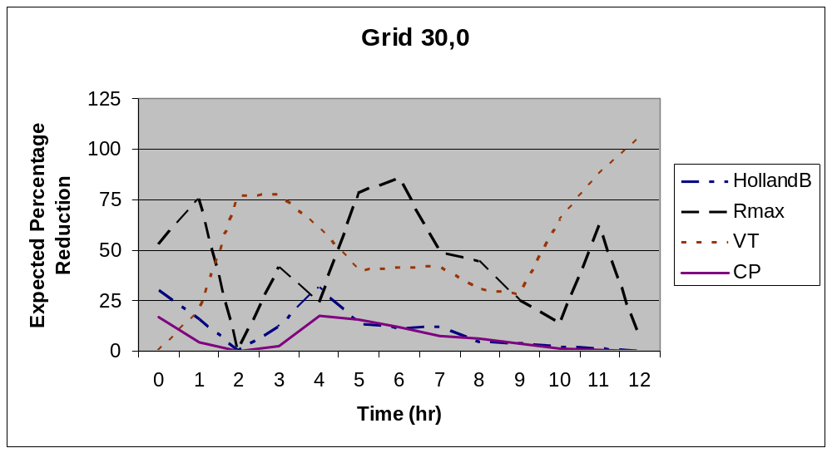

Figure 10. Expected Percentage Reductions in the Var(MSSWS) for a Category 1 Hurricane versus Time at Coordinate (30,0)

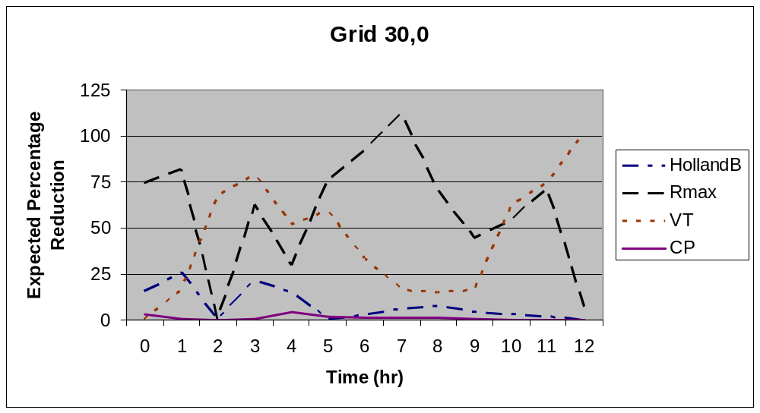

Figure 11. Expected Percentage Reductions in the Var(MSSWS) for a Category 3 Hurricane versus Time at Coordinate (30,0)

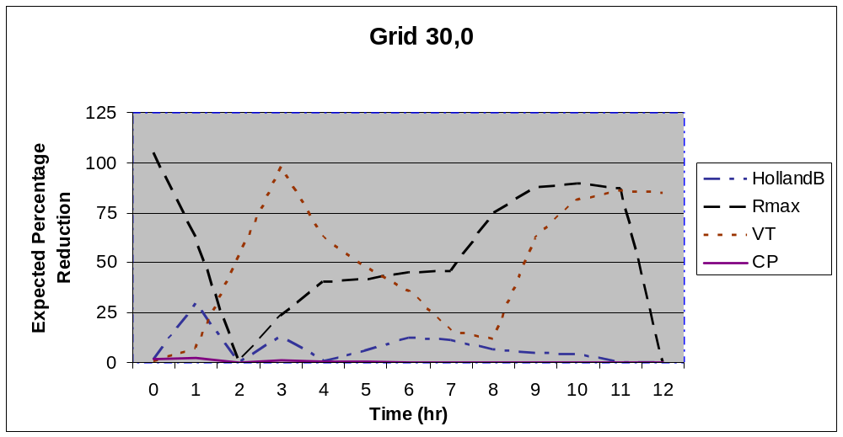

Figure 12. Expected Percentage Reductions in the Var(MSSWS) for a Category 5 Hurricane versus Time at Coordinate (30,0)

    - Describe how other aspects of the model may have a significant impact on the uncertainties in output results and the basis for making this determination.

Limitations in the HURDAT record contribute to the uncertainty of modeled tracks and pressures. Surface pressure measurements are not always available in HURDAT and estimating surface pressures by pressure-wind relationships are also fraught with uncertainty since well-observed hurricanes can demonstrate a large variation in maximum wind speeds for a given minimum surface pressure. The HURDAT record prior to the advent of satellites in the mid 1960s probably missed many hurricane that affected Florida in the early 20th century. There is still considerable uncertainty in the assessment of hurricane intensity, even today. Recent preliminary research results based on SFMR measurements indicate that some Saffir-Simpson 1-3 Category hurricanes may be rated too high while the Category 4 and 5 storms are probably rated accurately.

Uncertainty in zip code roughness has a significant impact on wind uncertainty. For a given zip code, changing the zip code roughness tables from 2004 to 2006 demonstrated some instances of large changes in roughness for the same zip code for specific upstream flow directions. This is due to a shift in the zip code population-weighted centroid location, and a resulting incorporation of different upstream land use / land cover elements.

    - Describe actions taken in light of the uncertainty analyses performed.

Not applicable

    - For models submitted by modeling organizations, which have not previously provided this analysis to the Commission, Form S-5 was disclosed under Standard S-2 and will be used in the verification of Standard S-3.

Complete form S5 has been presented at the end of this section.
S-4 County Level Aggregation*

At the county level of aggregation, the contribution to the error in loss cost estimates attributable to the sampling process shall be negligible.

The error in the county level loss costs induced by the sampling process can be quantified by computing standard errors for the county level loss costs. These loss costs have been computed for all counties in the state of Florida using 50,000 years of simulation. The results indicate that the standard errors are less than 2.5% of the average loss cost estimates for all counties.

Disclosures

  - Describe the sampling plan used to obtain the average annual loss costs and output ranges. For a direct Monte Carlo simulation, indicate steps taken to determine sample size. For an importance sampling design, describe the underpinnings of the design.

The number of simulation runs was determined through the following process:

The average loss cost,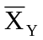, and standard deviation s_{Y}, was determined for each county Y using an initial run of 10,600 simulations. Then the maximum error of estimate 2.5% of the estimated mean loss cost, the required number of simulation runs for county Y will be:
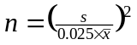

Based on the initial 10,600 simulation runs, max__{Y} N_{Y} = 43526 is obtained for Dixie County. Therefore, we have decided to use 50,000 years of simulation for our final results. From the 50,000 simulation two things are clear (a) the standard errors are less than 2.5% of the loss cost estimates (b) the optimal number of simulation is found to be 43526, which is less than 50,000.

S-5 Replication of Known Hurricane Losses

The model shall estimate incurred losses in an unbiased manner on a sufficient body of past hurricane events from more than one company, including the most current data available to the modeler. This Standard applies separately to personal residential and, to the extent data are available, to mobile homes. Personal residential experience may be used to replicate structure-only and contents-only losses. The replications shall be produced on an objective body of loss data by county or an appropriate level of geographic detail.

The following Table 3 compares the modeled and actual total losses by storm and company for residential coverage. Moreover, the following Figure 56 and Figure 57 indicate reasonable agreement between the observed and modeled losses (r=0.99, which indicates a strong positive correlation).

Disclosures

- Describe the nature and results of the analyses performed to validate the loss projections generated by the model.

For model validation purposes, the actual and modeled losses for some selected companies and hurricanes are provided in the following table.

Table 3. Actual vs. Model Loss
Company | Event | Exposure | Actual Loss | Actual Loss/Expo | Modeled Loss | Model  Loss/Exp
A | Charley | 9818982783 | 117664943 | 0.011983415 | 112974805.7 | 0.011505755
A | Frances | 4419393539 | 20467905 | 0.004631383 | 61365405.63 | 0.013885481
B | Andrew | 28625238943 | 2984373067 | 0.104256704 | 2557842943 | 0.089356213
B | Charley | 55331829601 | 1036878576 | 0.018739279 | 726707284.3 | 0.013133621
B | Frances | 37848571596 | 552366042 | 0.014594105 | 374804409.5 | 0.009902736
C | Charley | 2046506161 | 64943930 | 0.031734051 | 35989252.55 | 0.017585704
C | Frances | 7372090779 | 125028187 | 0.016959665 | 88316713.45 | 0.011979873
D | Charley | 13635644553 | 258166394 | 0.018933201 | 225616653.9 | 0.016910973
D | Frances | 8368320528 | 217156112 | 0.025949784 | 128389513.1 | 0.015342327
E | Charley | 2960460500 | 62670760 | 0.021169261 | 56932038.06 | 0.019230805
E | Frances | 1032863716 | 44410625 | 0.042997565 | 19413243.71 | 0.018795552
D | Charley_RCS | 16700649043 | 179130119 | 0.010725938 | 163104363.1 | 0.009766349
D | Frances_RCS | 8521947715 | 114715601 | 0.013461195 | 78964373.91 | 0.009266001
F | Charley | 15294438720 | 117568896 | 0.007687036 | 304193876.6 | 0.019889182
F | Frances | 15969634450 | 113227059 | 0.007090147 | 401301931.3 | 0.025129062
G | Charley | 59609484 | 1180877 | 0.01981022 | 1003747.374 | 0.016838719
G | Frances | 384480934 | 10306853 | 0.026807189 | 4178744.193 | 0.010868534
H | Charley | 170044967 | 6968536 | 0.040980548 | 4016173.66 | 0.023618304
H | Frances | 427982506 | 10153846 | 0.023724909 | 5397284.231 | 0.012610993
I | Charley | 3610401198 | 55031023 | 0.015242357 | 50447898.84 | 0.013972934
I | Frances | 3950558034 | 136515490 | 0.034556002 | 42702010.71 | 0.010809109
J | Charley | 665183557 | 2015902 | 0.003030595 | 163006.475 | 0.000245055
J | Frances | 1348805958 | 2659551 | 0.001971782 | 421008.2321 | 0.000312134
K | Charley | 3431736788 | 109841182 | 0.032007461 | 19646080.2 | 0.005724821
K | Frances | 4440649678 | 76704969 | 0.017273366 | 62047156.7 | 0.01397254

The following Figure 56 provides a comparison of total actual losses vs. total modeled losses by different hurricanes and Figure 14 provides a comparison of total actual loss ration vs. modeled loss ration by different hurricanes The comparisons indicate a reasonable agreement between the actual and modeled losses. The correlation between actual and modeled is found to be 0.9855241, which indicates a very strong positive correlation between actual and modeled losses. The correlation between actual loss ratio and modeled loss ratio is found to be 0.8494610, which also indicate a strong positive correlation between actual and modeled loss ratios. Moreover, when we test the equality of two population means, both paired (t = 1.3396, df = 24, p-value = 0.1929 ) and independent t (t = 0.2241, df = 48, p-value = 0.8236) tests provide the evidence that the average actual and modeled losses are not statistically different. Two sample Kolmogorov-Smirnov Test give, ks = 0.20, p-value = 0.7102, (for total losses) and ks = 0.32, p-value = 0.1558 (for ratios) which showed an excellent fit.
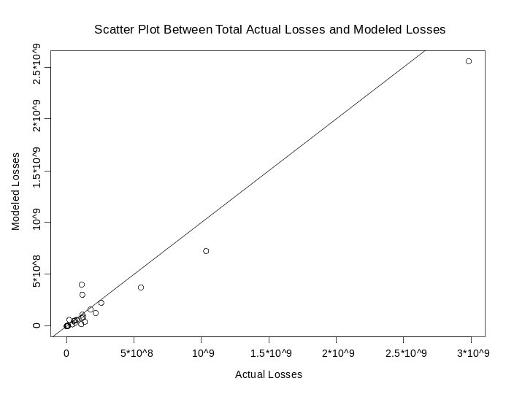
Figure 13. Scatter plot between Total Actual Losses vs. Total Modeled losses

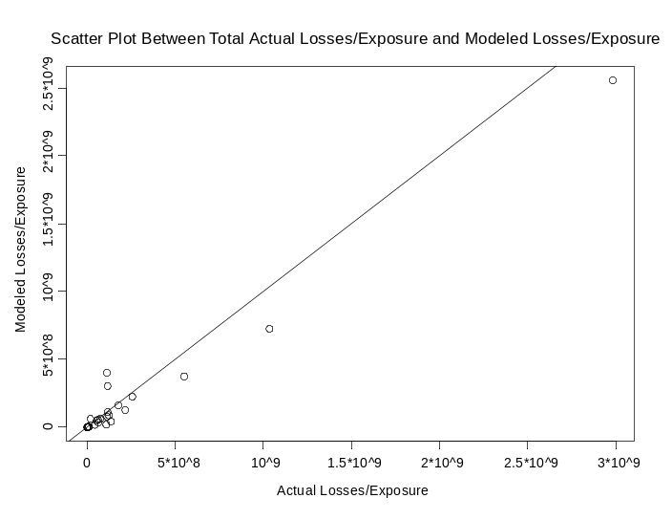
Figure 14. Scatter plot between Total Actual Loss/Exposure vs. Modeled Losses/Exposure

- Provide a completed Form S-3, Five Validation Comparisons.

See Form S3

S-6 Comparison of Projected Hurricane Loss Costs

The difference, due to uncertainty, between historical and modeled annual average statewide loss costs shall be reasonable, given the body of data, by established statistical expectations and norms.

The difference, due to uncertainty, between historical and modeled annual average statewide loss costs is reasonable as shown in the following description.

Disclosures

- Describe the nature and results of the tests performed to validate the expected loss projections generated. If a set of simulated hurricanes or simulation trials was used to determine these loss projections, specify the convergence tests that were used and the results. Specify the number of hurricanes or trials that were used.

Loss costs are generated using a simulated body of hurricanes. The number of trials used in the simulations were calculated using Standard S-4, which is found to be 50000. The standard errors are within less than 2.5% of the mean for all ranges and all counties. Extensive validation tests for generated loss costs are not possible owing to a lack of a sufficient body of data. From form S4 we found that, the 95% confidence interval on the difference between the mean of the historical and modeled losses contains 0 indicating that the modeled losses do not differ significantly from historical losses. These forms show that FPHLM (V.2.6) losses are in good agreement with the historical losses. More on this topic, we refer to Tamhane and Dunlop (2000) among others.

- Identify differences, if any, in how the model produces loss costs for specific historical events versus loss costs for events in the stochastic hurricane set.

A specific historical event is treated in the scenario mode, in which the peak 3s gust wind speed at a zip code is associated with a particular level of damage to a specific types of structures that are the characteristic of that zip code. In stochastic mode, the damage is computed according to the probability of the 3s gust wind speed being within wind speed consecutive 5 mph wind speed bands.

- Provide a completed Form S-4, Average Annual Zero Deductible Statewide Loss Costs – Historical versus Modeled.

See Form S4

Form S-1: Probability of Florida Landfalling Hurricanes per Year

Complete the table below showing the probability of landfalling Florida hurricanes per year. Modeled probability should be rounded to four decimal places. The historical probabilities below have been derived from the Commission’s Official Hurricane Set. If the National Hurricane Center’s HURDAT or other hurricanes in addition to the Official Hurricane Set as specified in Standard M-1 are used by the modeler, then the historical probabilities should be modified accordingly. If the National Hurricane Center’s HURDAT is used, provide the HURDAT revision date.
Model Results
Probability of Florida Landfalling Hurricanes per Year
Number | Historical
Of Hurricanes | Probability | Modeled
Per Year | (Hurdat June 2006) | Probability
0 | 0.5849 | .6283
1 | 0.2641 | .2707
2 | 0.1226 | .0739
3 | 0.0283 | .0197
4 | 0.0000 | .0074
5 | 0.0000 | .0000
6 | 0.0000 | 0.0000
7 | 0.0000 | 0.0000
8 | 0.0000 | 0.0000
9 | 0.0000 | 0.0000
10 or more | 0.0000 | 0.0000

Form S-2: Probable Maximum Loss (PML)

Provide projections of the insured loss for various probability levels using the hypothetical data set provided in the file named “FormA1Input06.xls.” Provide the total average annual loss for the PML distribution. If the methodology of your model does not allow you to produce a viable answer, please state so and why.

Return Time (Years) | Probability of Exceedence | Estimated Loss
50000 | 0.002% | $93,307,068
10000 | 0.01% | $82,067,542
5000 | 0.02% | $76,368,077
2000 | 0.05% | $63,590,703
1000 | 0.10% | $56,608,972
500 | 0.20% | $50,810,848
250 | 0.40% | $44,251,651
100 | 1.00% | $35,642,660
50 | 2.00% | $28,800,618
20 | 5.00% | $19,107,086
10 | 10.00% | $11,438,730
5 | 20.00% | $4,237,769
Mean | $3,208,421
Median | $0
StandardDeviation | $7,446,414
InterquartileRange | $2,107,227
Sample Size | 50,000 years of simulated stroms

Form S-3: Five Validation and Comparison

A. Provide five validation comparisons of actual exposures and loss to modeled exposures and loss. These comparisons must be provided by line of insurance, construction type, policy coverage, county or other level of similar detail in addition to total losses. Include loss as a percent of total exposure. Total exposure represents the total amount of insured values (all coverages combined) in the area affected by the hurricane. This would include exposures for policies that did not have a loss. If this is not available, use exposures for only those policies that had a loss. Specify which was used. Also, specify the name of the hurricane event compared.

B. Provide scatter plot(s) of modeled vs. historical losses for each of the five validation comparisons. (Plot the historical losses on the x-axis and the modeled losses on the y-axis.) Rather than using directly a specific published hurricane wind field, the winds underlying the modeled loss cost calculations must be produced by the model being evaluated and should be the wind field most emulated by the model.

Comparison # 1: Hurricane Charley and Company A by Coverage

 | Company Actual | Modeled | Difference
Coverage | Loss/Exposure | Loss/Exposure
Building | 0.01651 | 0.01616 | 0.00035
Contents | 0.00295 | 0.00295 | 0.00000
Appurtenant | 0.02479 | 0.01176 | 0.01302
ALE | 0.00243 | 0.00206 | 0.00037
Total | 0.01198 | 0.01151 | 0.00048

Comparison #2: Different Companies by Different Hurricanes

 |  | Company Actual | Modeled | Difference
Company | Event | Loss/Exposure | Loss/Exposure
A | Charley | 0.01198 | 0.01151 | 0.00048
B | Andrew | 0.10425 | 0.08935 | 0.01490
C | Frances | 0.01696 | 0.01198 | 0.00498
D | Charley | 0.01935 | 0.01691 | 0.00244
E | Charley | 0.02117 | 0.01923 | 0.00194

Comparison #3: Company B by Hurricane Andrew, Charley, Frances

 |  | Company Actual | Modeled | Difference
Company | Event | Loss/Exposure | Loss/Exposure
B | Andrew | 0.10425 | 0.08935 | 0.01490
B | Charley | 0.01874 | 0.01313 | 0.00561
B | Frances | 0.01459 | 0.00990 | 0.00469

Comparison #4: Construction Type for Company D and Hurricane Charley

 | Company Actual | Modeled | Difference
Coverage | Loss/Exposure | Loss/Exposure
Frame | 0.01752 | 0.01634 | 0.00118
Masonry | 0.01894 | 0.01259 | 0.00635
Manufactured | 0.04466 | 0.04962 | -0.00496

Comparison #5: County wise for Company A and Hurricane Charley

 | Company Actual | Modeled | Difference
Coverage | Loss/Exposure | Loss/Exposure
Lee | 0.00660 | 0.00785 | -0.00126
Orange | 0.00968 | 0.01260 | -0.00291
Manatee | 0.00006 | 0.00000 | 0.00006
Collier | 0.00064 | 0.00018 | 0.00046
Osceola | 0.01248 | 0.01067 | 0.00181

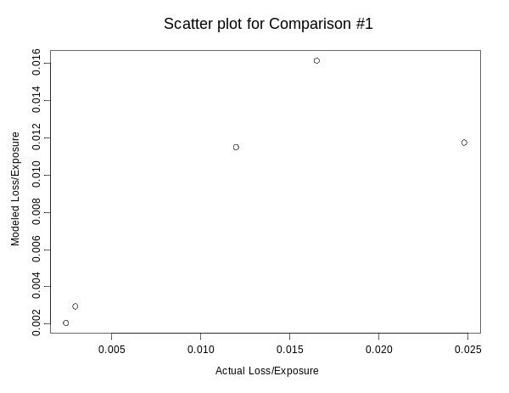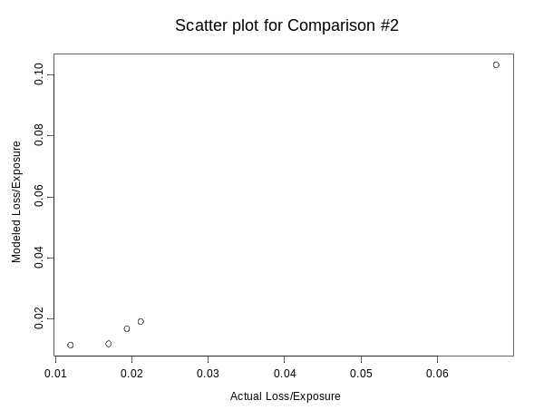
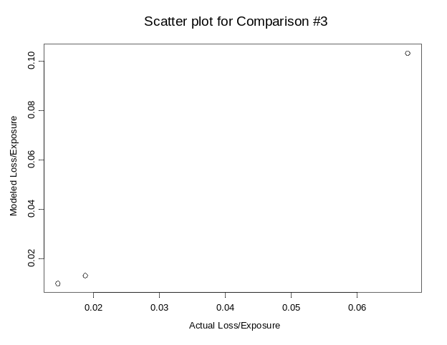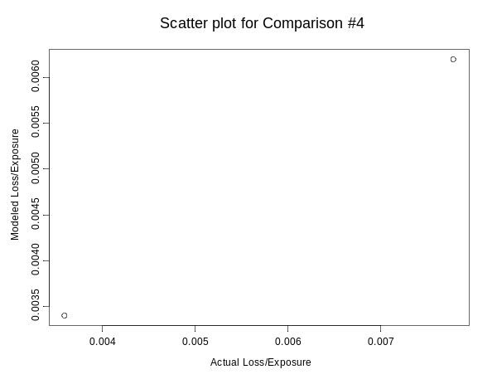
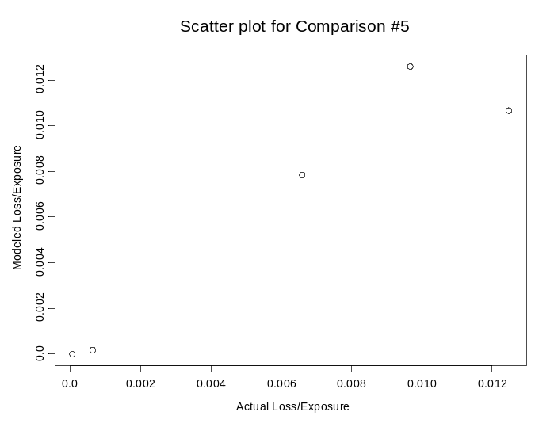

Figure 15. Scatter plots for Actual/exposure and Modeled loss/Exposure

Form S-4: Average Annual Zero Deductible Statewide Loss Costs –Historical versus Modeled

A. Provide the average annual zero deductible statewide loss costs produced using the list of hurricanes in the Base Hurricane Storm Set based on the 2002 Florida Hurricane Catastrophe Fund’s aggregate personal residential exposure data, as of August 1, 2003 (hlpm2002.exe).

Average Annual Zero Deductible Statewide Loss Costs

Time period | Historical Hurricanes | Produced by Model
Current Year | $2,804.40 | $2,673.22

B. Provide a comparison with the statewide loss costs produced by the model on an average industry basis.

The loss cost produced by the model on an average industry basis is 2.7 billion and the corresponding historical loss is 2.8 billion.

C. Provide the 95% confidence interval on the differences between the mean of the historical and modeled loss.

The 95% confidence interval on the difference between the mean of the historical and the mean of the modeled loss is between -0.95 and 1.21. Since the intervals contain 0, we are 95% confident that there is no significant difference between historical and modeled losses. Using Splus, we have also done statistical test of equality means using parametric test
(z = 0.000000261and p-value = 0.9999 and t = 0.2381, df = 50104, p-value = 0.8118 ) and equality of CDFs using nonparametric test (KS = 0.0553, p-value = 0.9004 ). In both parametric and non-paramteric cases, we have high p-values. Therefore, statistically, we may conclude that the average historical and modeled losses are not different.

Form S-5: Hypothetical Events for Sensitivity and Uncertainty Analysis (requirement for new modeling companies which have not previously provided the Commission with this analysis)

We have provided the output in ASCII files based on running a series of hurricanes as provided in the Excel file “FormS5Input06.xls.” The output files consist of wind speeds (in miles per hour for one minute sustained 10-meter winds) at hourly intervals over a 21×46 grid for the 500 combinations of initial conditions specified in the Excel file for the following model inputs:

- CP = central pressure (in millibars)
- Rmax = radius of maximum winds (in statute miles)
- VT = translational velocity (forward speed in miles per hour)
- Holland B pressure profile parameter for other input used by the modeler (0 ≤ p ≤ 1)

The value of CP, Rmax, VT and Quantile are used as direct inputs. Quantiles from 0 to 1 have been provided in the Excel input file.

For FPHLM (V2.6) model, we use first quantile input for the Holland B parameter. The specific values of the Holland B parameter that were used are given as follows:.

For output file FIU06FormS51SA.dat the following
input B were used by the model;

1.51 0.63 0.97 1.88 1.02 1.09 1.15 1.15 1.38 1.61 1.16 1.68 1.52 0.82
1.71 1.53 1.53 1.27 0.96 1.37 1.20 1.11 1.41 1.24 1.75 1.86 1.73 1.28
0.89 1.69 2.00 1.45 1.43 1.28 1.82 1.13 1.55 1.47 1.44 1.41 1.43 1.34
1.81 1.24 1.91 1.46 1.77 1.61 1.38 1.17 1.64 1.26 1.36 1.22 1.65 1.06
1.54 1.39 1.05 1.45 1.32 1.51 1.19 1.26 1.23 1.49 1.31 1.56 2.06 1.33
1.80 1.33 1.35 1.60 1.29 1.67 1.74 1.21 1.59 1.30 1.41 1.30 1.10 1.50
1.48 0.82 1.12 1.57 1.40 1.23 1.08 0.93 1.00 1.03 1.56 1.63 1.65 1.47
1.18 1.36

For output FIU06FormS51UACP.dat the following
input B were used by the model: 1.39
For output FIU06FormS51UARmax.dat the following
input B were used by the model;1.39
For output FIU06FormS51UAVT.dat the following
input B were used by the model;1.39

For output FIU06FormS51UAQuantile1.dat the following
input B were used by the model;

1.51 0.63 0.97 1.88 1.02 1.09 1.15 1.15 1.38 1.61 1.16 1.68 1.52 0.82
1.71 1.53 1.53 1.27 0.96 1.37 1.20 1.11 1.41 1.24 1.75 1.86 1.73 1.28
0.89 1.69 2.00 1.45 1.43 1.28 1.82 1.13 1.55 1.47 1.44 1.41 1.43 1.34
1.81 1.24 1.91 1.46 1.77 1.61 1.38 1.17 1.64 1.26 1.36 1.22 1.65 1.06
1.54 1.39 1.05 1.45 1.32 1.51 1.19 1.26 1.23 1.49 1.31 1.56 2.06 1.33
1.80 1.33 1.35 1.60 1.29 1.67 1.74 1.21 1.59 1.30 1.41 1.30 1.10 1.50
1.48 0.82 1.12 1.57 1.40 1.23 1.08 0.93 1.00 1.03 1.56 1.63 1.65 1.47
1.18 1.36

For output file FIU06FormS53SA.dat the following
input B were used by the model;

1.18 1.39 1.78 1.48 1.24 1.50 1.63 1.08 1.70 1.44 1.13 1.27 1.20 1.06
1.53 1.31 1.45 0.87 1.60 1.05 1.61 1.02 1.19 1.84 1.75 1.39 1.55 0.71
1.56 1.38 1.23 1.47 1.80 1.22 1.41 1.35 1.41 1.32 1.66 1.52 1.00 1.40
1.61 1.68 1.48 1.11 0.90 2.00 1.02 1.14 1.88 1.33 1.73 1.58 1.43 1.46
1.43 1.57 1.42 0.83 1.93 1.51 1.46 1.16 1.13 0.75 1.85 1.34 0.96 1.77
1.20 1.30 0.95 1.53 1.25 1.07 1.29 1.71 1.15 1.42 1.64 1.54 1.58 1.95
1.25 1.37 1.23 1.17 1.28 1.72 1.26 1.35 1.51 1.30 1.09 1.34 1.36 1.28
1.64 1.67

For output FIU06FormS53UACP.dat the following
input B were used by the model:1.39
For output FIU06FormS53UARmax.dat the following
input B were used by the model;1.39
For output FIU06FormS53UAVT.dat the following
input B were used by the model;1.39

For output FIU06FormS53UAQuantile1.dat the following
input B were used by the model;

1.18 1.39 1.78 1.48 1.24 1.50 1.63 1.08 1.70 1.44 1.13 1.27 1.20 1.06
1.53 1.31 1.45 0.87 1.60 1.05 1.61 1.02 1.19 1.84 1.75 1.39 1.55 0.71
1.56 1.38 1.23 1.47 1.80 1.22 1.41 1.35 1.41 1.32 1.66 1.52 1.00 1.40
1.61 1.68 1.48 1.11 0.90 2.00 1.02 1.14 1.88 1.33 1.73 1.58 1.43 1.46
1.43 1.57 1.42 0.83 1.93 1.51 1.46 1.16 1.13 0.75 1.85 1.34 0.96 1.77
1.20 1.30 0.95 1.53 1.25 1.07 1.29 1.71 1.15 1.42 1.64 1.54 1.58 1.95
1.25 1.37 1.23 1.17 1.28 1.72 1.26 1.35 1.51 1.30 1.09 1.34 1.36 1.28
1.64 1.67

For output file FIU06FormS55SA.dat the following
input B were used by the model;

1.00 1.70 1.23 1.75 1.45 1.51 1.16 1.52 1.47 1.40 1.13 1.39 1.56 1.10
1.01 1.62 1.29 1.72 0.81 1.58 1.56 1.18 1.19 1.55 1.33 1.26 1.35 1.34
1.36 1.48 1.49 1.37 1.22 1.27 0.93 1.61 1.27 1.73 1.64 1.19 1.24 1.90
1.28 1.61 1.53 1.87 1.66 1.53 1.32 1.37 1.65 1.17 1.31 1.05 1.43 0.50
1.25 1.33 1.51 1.78 1.35 1.68 1.38 1.28 1.54 1.70 1.49 0.97 1.42 1.08
0.83 1.40 1.58 0.88 1.30 1.31 1.48 1.12 1.76 1.11 1.14 1.16 1.91 1.43
1.84 1.41 1.04 1.21 1.06 1.09 1.60 1.21 1.95 0.95 1.44 1.44 1.45 1.81
1.95 1.63

For output FIU06FormS55UACP.dat the following
input B were used by the model:1.39
For output FIU06FormS55UARmax.dat the following
input B were used by the model;1.39
For output FIU06FormS55UAVT.dat the following
input B were used by the model;1.39
For output FIU06FormS55UAQuantile1.dat the following
input B were used by the model;

1.00 1.70 1.23 1.75 1.45 1.51 1.16 1.52 1.47 1.40 1.13 1.39 1.56 1.10
1.01 1.62 1.29 1.72 0.81 1.58 1.56 1.18 1.19 1.55 1.33 1.26 1.35 1.34
1.36 1.48 1.49 1.37 1.22 1.27 0.93 1.61 1.27 1.73 1.64 1.19 1.24 1.90
1.28 1.61 1.53 1.87 1.66 1.53 1.32 1.37 1.65 1.17 1.31 1.05 1.43 0.50
1.25 1.33 1.51 1.78 1.35 1.68 1.38 1.28 1.54 1.70 1.49 0.97 1.42 1.08
0.83 1.40 1.58 0.88 1.30 1.31 1.48 1.12 1.76 1.11 1.14 1.16 1.91 1.43
1.84 1.41 1.04 1.21 1.06 1.09 1.60 1.21 1.95 0.95 1.44 1.44 1.45 1.81
1.95 1.63

The Excel input file contains 500 (or 600) combinations of initial conditions for each of three categories of hurricanes (1, 3, and 5), which follow a straight due west track passing through the point (25.7739N, 80.1300W). These hurricanes are similar to those in Form A-1, event ID 11, 13 and 15. The first 100 combinations of initial conditions for hurricane categories 1, 3 and 5 are used in sensitivity analysis calculations. These initial conditions are given in the first worksheet (Sen Anal all Variables) of the Excel input file. The second set of 100 initial conditions for hurricane categories 1, 3 and 5 are given in the second worksheet (Unc Anal for CP) in the Excel input file. These conditions will be used in the uncertainty analysis for CP. The third worksheet (Unc Anal for Rmax), fourth worksheet (Unc Anal for VT) and fifth worksheet (Unc Anal for Quantile 1 are similar to the second worksheet and are used for performing uncertainty analysis for Rmax, VT and the input variable corresponding to the given quantiles, respectively. We have also provided the maximum wind speed produced over the 12 hours for each category of hurricanes 1, 3 and 5.

The 21×46 grid of coordinates uses approximate 3 statute mile spacing and is depicted in Figure 6 of ROA for all three hurricane categories. For purposes of hurricane decay, the modeler is instructed to use existing terrain consistent with the grid in Figure 6 of ROA.

The point (0, 0) is the location of the center of the hurricane at time 0, and is 30 miles east of the landfall location (25.7739N, 80.1300W), identified by the red rectangle in Figure 6 of ROA. The exact latitudes and longitudes for the 966 vertices in the grid (21×46) are given in the seventh worksheet of the Excel input file.

Figure 6 of ROA

• | • | • | • | • | • | • | • | • | • | • | • | • | • | • | • | • | • | • | • | • | • | • | • | • | • | • | • | • | • | • | • | • | • | • | • | • | • | • | • | • | • | • | • | • | • | 45N
• | • | • | • | • | • | • | • | • | • | • | • | • | • | • | • | • | • | • | • | • | • | • | • | • | • | • | • | • | • | • | • | • | • | • | • | • | • | • | • | • | • | • | • | • | • | 42N
• | • | • | • | • | • | • | • | • | • | • | • | • | • | • | • | • | • | • | • | • | • | • | • | • | • | • | • | • | • | • | • | • | • | • | • | • | • | • | • | • | • | • | • | • | • | 39N
• | • | • | • | • | • | • | • | • | • | • | • | • | • | • | • | • | • | • | • | • | • | • | • | • | • | • | • | • | • | • | • | • | • | • | • | • | • | • | • | • | • | • | • | • | • | 36N
• | • | • | • | • | • | • | • | • | • | • | • | • | • | • | • | • | • | • | • | • | • | • | • | • | • | • | • | • | • | • | • | • | • | • | • | • | • | • | • | • | • | • | • | • | • | 33N
• | • | • | • | • | • | • | • | • | • | • | • | • | • | • | • | • | • | • | • | • | • | • | • | • | • | • | • | • | • | • | • | • | • | • | • | • | • | • | • | • | • | • | • | • | • | 30N
• | • | • | • | • | • | • | • | • | • | • | • | • | • | • | • | • | • | • | • | • | • | • | • | • | • | • | • | • | • | • | • | • | • | • | • | • | • | • | • | • | • | • | • | • | • | 27N
• | • | • | • | • | • | • | • | • | • | • | • | • | • | • | • | • | • | • | • | • | • | • | • | • | • | • | • | • | • | • | • | • | • | • | • | • | • | • | • | • | • | • | • | • | • | 24N
• | • | • | • | • | • | • | • | • | • | • | • | • | • | • | • | • | • | • | • | • | • | • | • | • | • | • | • | • | • | • | • | • | • | • | • | • | • | • | • | • | • | • | • | • | • | 21N
• | • | • | • | • | • | • | • | • | • | • | • | • | • | • | • | • | • | • | • | • | • | • | • | • | • | • | • | • | • | • | • | • | • | • | • | • | • | • | • | • | • | • | • | • | • | 18N
• | • | • | • | • | • | • | • | • | • | • | • | • | • | • | • | • | • | • | • | • | • | • | • | • | • | • | • | • | • | • | • | • | • | • | • | • | • | • | • | • | • | • | • | • | • | 15N
• | • | • | • | • | • | • | • | • | • | • | • | • | • | • | • | • | • | • | • | • | • | • | • | • | • | • | • | • | • | • | • | • | • | • | • | • | • | • | • | • | • | • | • | • | • | 12N
• | • | • | • | • | • | • | • | • | • | • | • | • | • | • | • | • | • | • | • | • | • | • | • | • | • | • | • | • | • | • | • | • | • | • | • | • | • | • | • | • | • | • | • | • | • | 9N
• | • | • | • | • | • | • | • | • | • | • | • | • | • | • | • | • | • | • | • | • | • | • | • | • | • | • | • | • | • | • | • | • | • | • | • | • | • | • | • | • | • | • | • | • | • | 6N
• | • | • | • | • | • | • | • | • | • | • | • | • | • | • | • | • | • | • | • | • | • | • | • | • | • | • | • | • | • | • | • | • | • | • | • | • | • | • | • | • | • | • | • | • | • | 3N
• | • | • | • | • | • | • | • | • | • | • | • | • | • | • | • | • | • | • | • | • | • | • | • | • | • | • | • | • | • | • | • | • | • | • | • | • | • | • | • | • | • | • | • | • | • | 0
• | • | • | • | • | • | • | • | • | • | • | • | • | • | • | • | • | • | • | • | • | • | • | • | • | • | • | • | • | • | • | • | • | • | • | • | • | • | • | • | • | • | • | • | • | • | -3S
• | • | • | • | • | • | • | • | • | • | • | • | • | • | • | • | • | • | • | • | • | • | • | • | • | • | • | • | • | • | • | • | • | • | • | • | • | • | • | • | • | • | • | • | • | • | -6S
• | • | • | • | • | • | • | • | • | • | • | • | • | • | • | • | • | • | • | • | • | • | • | • | • | • | • | • | • | • | • | • | • | • | • | • | • | • | • | • | • | • | • | • | • | • | -9S
• | • | • | • | • | • | • | • | • | • | • | • | • | • | • | • | • | • | • | • | • | • | • | • | • | • | • | • | • | • | • | • | • | • | • | • | • | • | • | • | • | • | • | • | • | • | -12S
• | • | • | • | • | • | • | • | • | • | • | • | • | • | • | • | • | • | • | • | • | • | • | • | • | • | • | • | • | • | • | • | • | • | • | • | • | • | • | • | • | • | • | • | • | • | -15S
135W | 132W | 129W | 126W | 123W | 120W | 117W | 114W | 111W | 108W | 105W | 102W | 99W | 96W | 93W | 90W | 87W | 84W | 81W | 78W | 75W | 72W | 69W | 66W | 63W | 60W | 57W | 54W | 51W | 48W | 45W | 42W | 39W | 36W | 33W | 30W | 27W | 24W | 21W | 18W | 15W | 12W | 9W | 6W | 3W | 0

Hurricane Path from (0, 0) to (135W, 0)

We have provided output on CD-ROM in ASCII and PDF format. Five output files provided for each of the three hurricane categories. These files shall be named as shown in Figure 7 of ROA:

Figure 7 of ROA
Summary of Form S-5 Input and Output Files*

Hurricane Category | Input Values given in  FormS5Input06.xls file | Output  File | Modeler Wind Speed Output  File Name
 | Sensitivity Analysis all Variables | 1 | XXX06FormS51SA.dat
 | Uncertainty Analysis CP | 2 | XXX06FormS51UACP.dat
1 | Uncertainty Analysis Rmax | 3 | XXX06FormS51UARmax.dat
 | Uncertainty Analysis VT | 4 | XXX06FormS51UAVT.dat
 | Uncertainty Analysis Quantile | 5 | XXX06FormS51UAQuantile1.dat
 | Sensitivity Analysis all Variables | 6 | XXX06FormS53SA.dat
 | Uncertainty Analysis CP | 7 | XXX06FormS53UACP.dat
3 | Uncertainty Analysis Rmax | 8 | XXX06FormS53UARmax.dat
 | Uncertainty Analysis VT | 9 | XXX06FormS53UAVT.dat
 | Uncertainty Analysis Quantile | 10 | XXX06FormS53UAQuantile1.dat
 | Sensitivity Analysis all Variables | 11 | XXX06FormS55SA.dat
 | Uncertainty Analysis CP | 12 | XXX06FormS55UACP.dat
5 | Uncertainty Analysis Rmax | 13 | XXX06FormS55UARmax.dat
 | Uncertainty Analysis VT | 14 | XXX06FormS55UAVT.dat
 | Uncertainty Analysis Quantile | 15 | XXX06FormS55UAQuantile1.dat

Each of the files will contain 96,600 lines (100×21×46 = 96,600), each written according to the format (3I5,14F6.1).

Each row in the output files should contain the following values:

- Sample number (1-100)
- E-W Grid Coordinate (0, 3, 6, 9, 12, 15, …, 135)
- N-S Grid Coordinate (-15, -12, -9, -6, -3, 0, 3, 6, 9, …, 45)
- Wind speed at time 0hr
- Wind speed at time 1hr
- Wind speed at time 2hr
- Wind speed at time 3hr
- Wind speed at time 4hr
- Wind speed at time 5hr
- Wind speed at time 6hr
- Wind speed at time 7hr
- Wind speed at time 8hr
- Wind speed at time 9hr
- Wind speed at time 10hr
- Wind speed at time 11hr
- Wind speed at time 12hr
- Maximum wind speed*

*This is the maximum wind speed overall, if produced. Otherwise, provide the maximum wind speed over the 13 time points.

For the sensitivity analysis, some selected graphs of the standardized regression coefficients vs time for Category 1, 3 and 5 hurricanes are provided in Figure 16 - Figure 24. The calculations of the SRCs are explained on page 22 of the Professional Team Demonstration Uncertainty/Sensitivity Analysis by R.L. Iman, M.E. Johnson and T.A. Schroeder, September 2001. From these graphs, we observed that maximum sustained surface wind speed (MSSWS) is most sensitive to Rmax parameter followed by VT, Holland B and CP. At hour 0, MSSWS is the most sensitive to Rmax, where as at hour 12, MSSWS is the most sensitive to VT. We also noticed that the sensitivity of MSSWS depends on the grid points, time and hurricane category.

Figure 16. Standardized Regression Coeffs vs. Time at Grid Coordinates (30,0) for Category 1

Figure 17. Standardized Regression Coeffs vs. Time at Grid Coordinates (30,0) for Category 3

Figure 18. Standardized Regression Coeffs vs. Time at Grid Coordinates (30,0) for Category 5

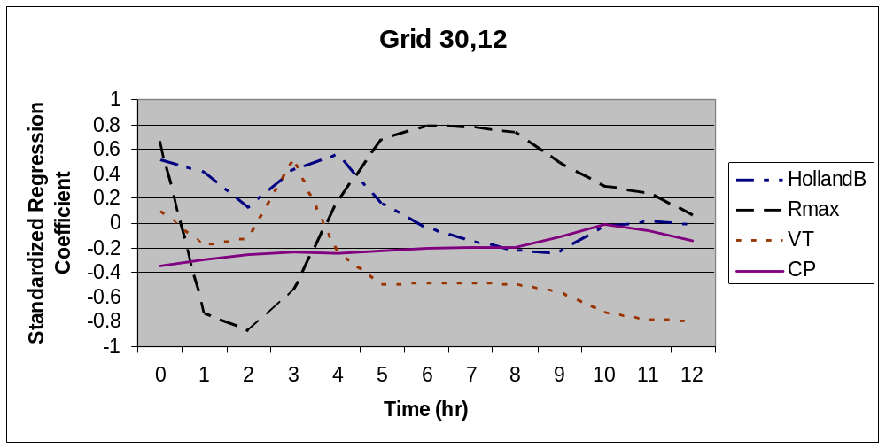

Figure 19. Standardized Regression Coeffs vs. Time at Grid Coordinates (30,12) for Category 1

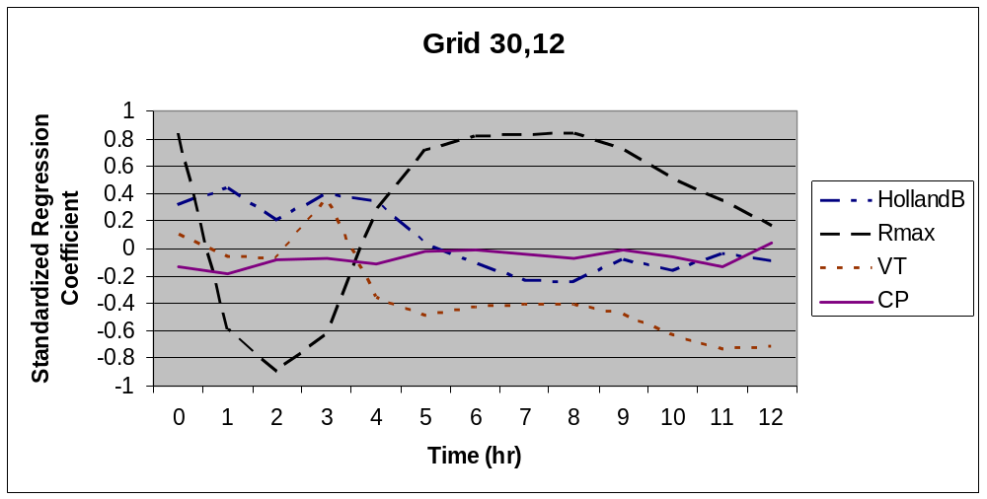

Figure 20. Standardized Regression Coeffs vs. Time at Grid Coordinates (30,0) for Category 3

Grid 30,12
-1
-0.8
-0.6
-0.4
-0.2
0
0.2
0.4
0.6
0.8
1
1.2
0
1
2
3
4
5
6
7
8
9
10
11
12
Time (hr)
Standardized
Regression

HollandB
Rmax
VT
CP

Figure 21. Standardized Regression Coeffs vs. Time at Grid Coordinates (30,12) for Category 5

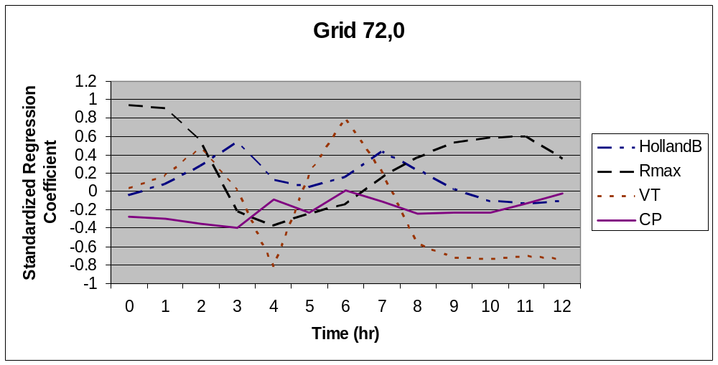

Figure 22. Standardized Regression Coeffs vs. Time at Grid Coordinates (72,0) for Category 1

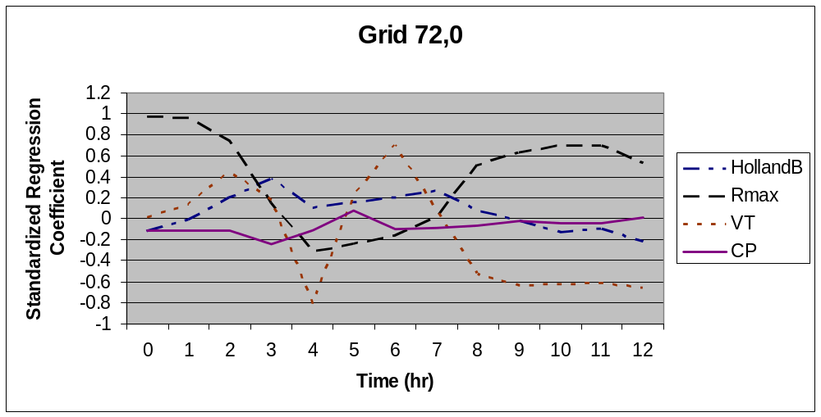

Figure 23. Standardized Regression Coeffs vs. Time at Grid Coordinates (72,0) for Category 3

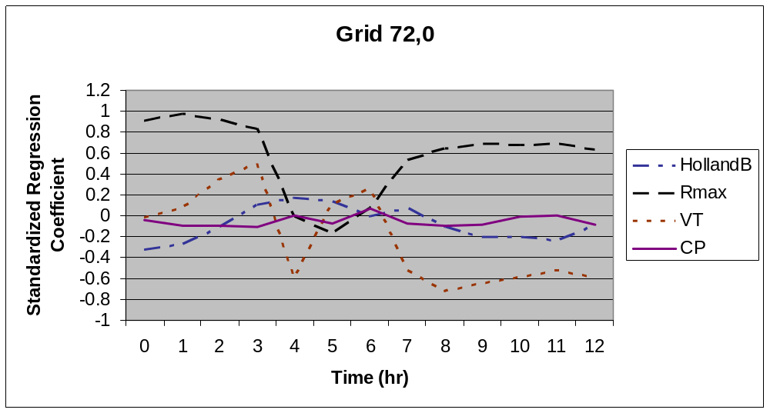

Figure 24. Standardized Regression Coeffs vs. Time at Grid Coordinates (72, 0) for Category 5

The uncertainty analysis provides the information about the influence of the uncertainty of the model parameters (Rmax, VT, Holland B and CP) in Maximum Sustained Surface Wind Speed (MSSWS) over the time. To see the influence of the parameters in MSSWS, some selected graphs (Figure 25 - Figure 33) of expected reduction in uncertainty vs. time for Category 1, 3 and 5 hurricanes are provided below. The calculation of the expected percentage reduction is explained on pages 26-30 of the Professional Team Demonstration Uncertainty/Sensitivity Analysis. From these graphs we observed that the major contribution of uncertainty for MSSWS is R-max followed by VT, Holland B and CP. At hour 0, Rmax produces the most uncertainty and at hour 12 VT contributed the highest uncertainty in the model. The contribution of R max towards uncertainty increases, while the contribution of VT decreases and vice-versa for all hurricane category. It is noted that the amount of uncertainty of the model parameters also depend on the hurricane category and grid points. The contribution of uncertainty of the parameters change as the hurricane moves from east to west. It seems that CP is the least influential.

Figure 25. Expected Percentage Reductions in the Var(MSSWS) for a Category 1 Hurricane versus Time at Coordinate (30,0)

Figure 26. Expected Percentage Reductions in the Var(MSSWS) for a Category 3 Hurricane versus Time at Coordinate (30,0)

Figure 27. Expected Percentage Reductions in the Var(MSSWS) for a Category 5 Hurricane versus Time at Coordinate (30,0)

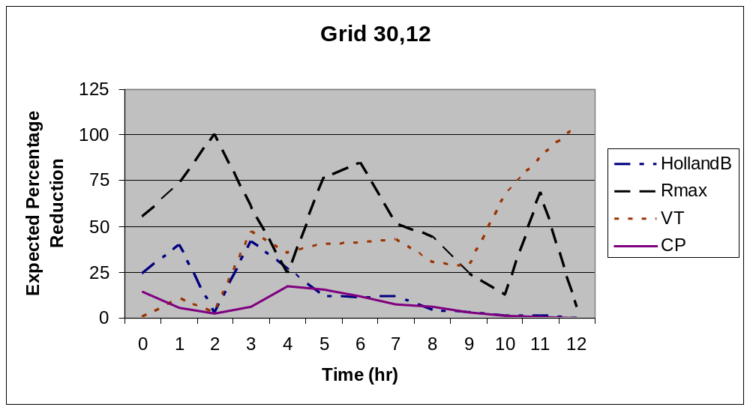

Figure 28. Expected Percentage Reductions in the Var(MSSWS) for a Category 1 Hurricane versus Time at Coordinate (30,12)

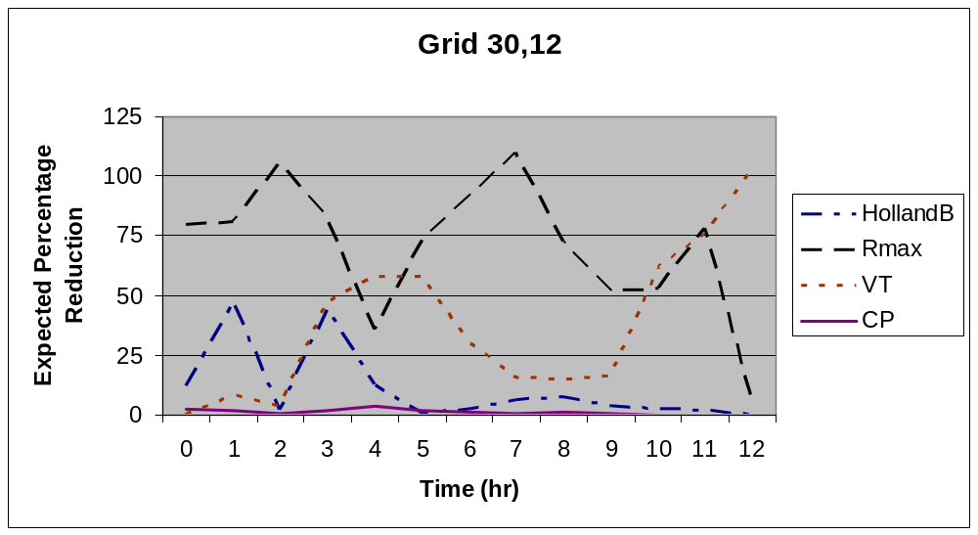

Figure 29. Expected Percentage Reductions in the Var(MSSWS) for a Category 3 Hurricane versus Time at Coordinate (30,12)

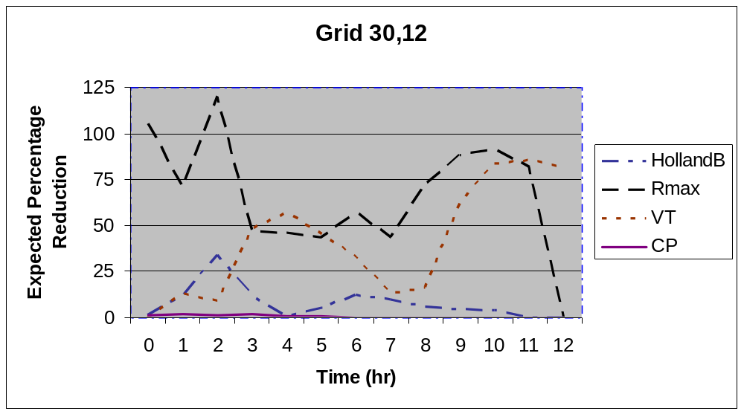

Figure 30. Expected Percentage Reductions in the Var(MSSWS) for a Category 5 Hurricane versus Time at Coordinate (30,12)

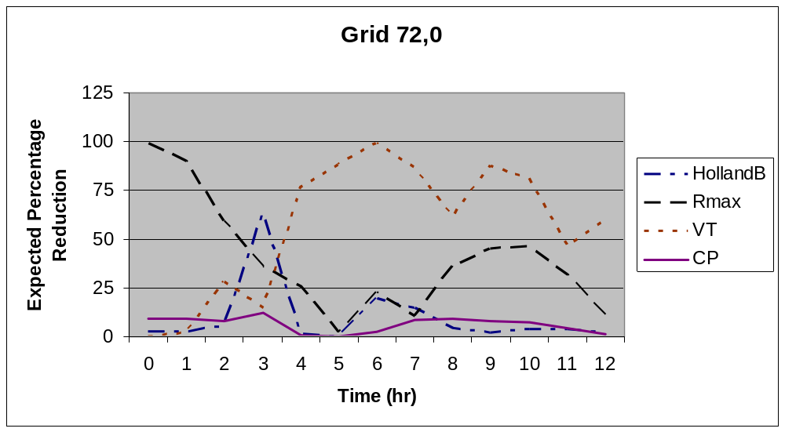

Figure 31. Expected Percentage Reductions in the Var(MSSWS) for a Category 1 Hurricane versus Time at Coordinate (72, 0)

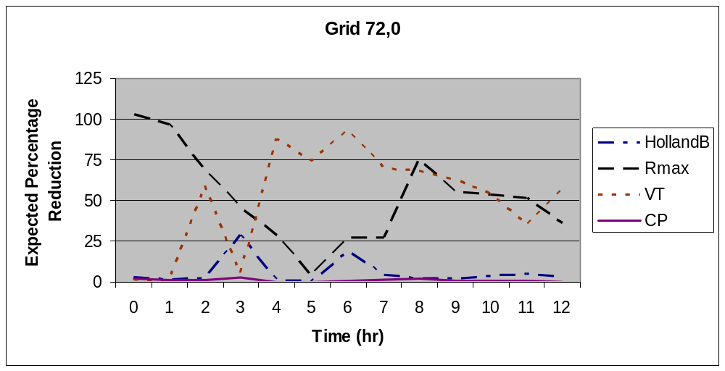

Figure 32. Expected Percentage Reductions in the Var(MSSWS) for a Category 3 Hurricane versus Time at Coordinate (72, 0)

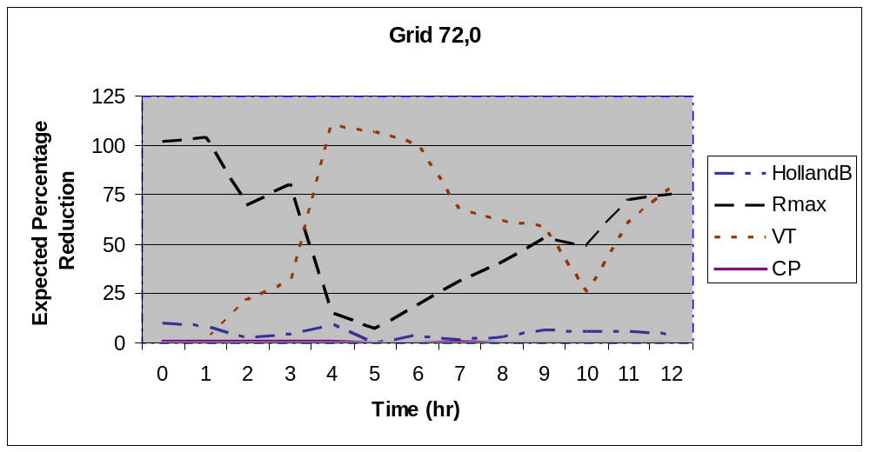

Figure 33. Expected Percentage Reductions in the Var(MSSWS) for a Category 5 Hurricane versus Time at Coordinate (72, 0)

Form S-5 Uncertainty and Sensitivity Analysis Extended to Loss Cost

In addition to uncertainty and sensitivity analyses performed for wind speed in Form S-5, we have performed the uncertainty and sensitivity analyses for loss cost using a $100,000 fully insured structure with a zero deductible policy at each of the 586 non-shaded grid points in Figure 6 of ROA. The Excel input file contains a seventh worksheet (Land-Water ID) that lists the 966 grid coordinates with an indicator variable defined as follows: 0 = coordinate is over water, 1 = coordinate is over land

The following house is assumed at each of the land-based grid points designated by the indicator variable. Single story, Masonry walls’ Truss anchors, Gable end roof, No shutters, Shingles with one layer 15# felt, 1/2" plywood roof deck with 8d nails at 6" edge and 12" field’ House constructed in 1980.

A summary of all the contour plots is given in Figure 8 of 2006 Report of Activity (ROA).

Figure 8 of ROA
Summary of Contour Plots

Model Output | Contour Plot
Wind Speed | Hourly plots for the wind speeds in output files 1, 6 and 11 in Figure 7 of ROA (39 contour plots). See example contour plot provided in Figure77.
Sensitivity Analysis | Hourly plots of standardized regression coefficients based on Form S-5 input as specified in Figure 7 of ROA and the corresponding wind speed output files 1, 6 and 11 in Figure 7 of ROA (39 contour plots). See example contour plot provided in Figure 81.
Uncertainty Analysis | Hourly plots of the expected percentage reduction in variance based on Form S-5 input as specified in Figure 7 of ROA and the corresponding output files (39 contour plots for each of the following input variables), which are as follows:  Central pressure: output files 2, 7 and 12 in Figure 7 of ROA  Radius of maximum winds: output files 3, 8 and 13 in Figure 7 of ROA  Translational velocity: output files 4, 9 and 14 in Figure 7 of ROA  Quantile: output files 5, 10, and 15 in Figure 7 of ROA  See example contour plot provided in Figure 85.
Loss Cost | Loss cost based on the maximum wind speed recorded over the 12hr time period in output files 1, 6 and 11 in Figure 7 of ROA is to be calculated at each land-based grid point in Figure 6 of ROA. The 586 land-based grid points in Figure 6 of ROA are identified in the last worksheet (Land-Water ID) of the Form S-5 input file. Since there are 100 input vectors for each hurricane category, there are 100 estimates of loss cost at each of the land-based grid points. The contour plots are based on these values expressed as a percentage. See example loss cost contour plot provided in Figure 89.

Figure 34 - Figure 37 are contour plots of wind speed (mph) for a Category 1, 3, 5 hurricanes at 2hr and Category 5 at hour 4. Contours in this figure represent average wind speeds over all 100 input vectors at each grid point. The hurricane or near hurricane force winds are shown on the contour plot. These contours show that the wind speed decrease as the hurricane moves from east to west across the grid as time increases. We also observed that the wind speed increases with the increase of Hurricane Category from 1 to category 5.

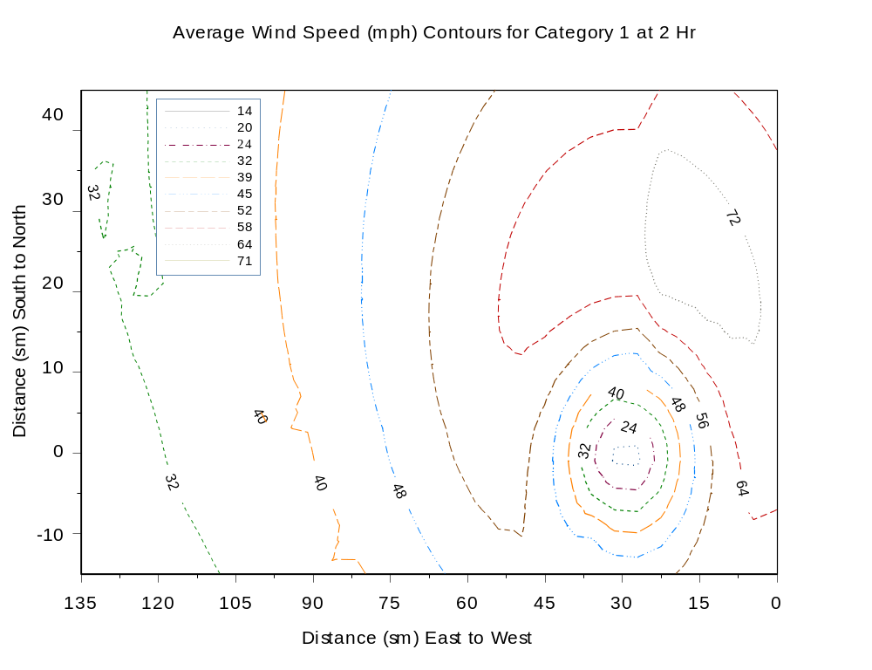

Figure 34. Average Wind Speed (mph) Contours for Category 1 Hurricane at 2hr

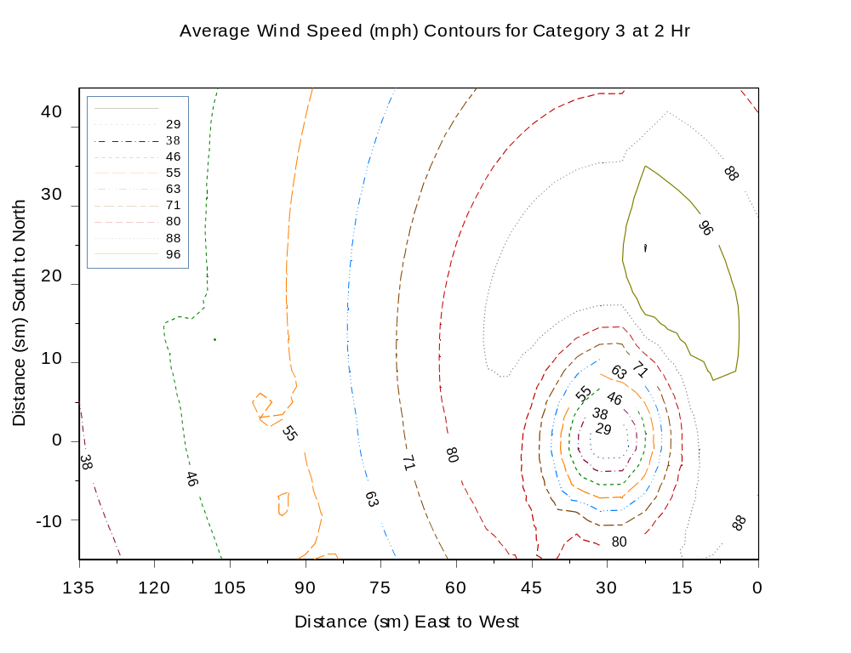

Figure 35. Average Wind Speed (mph) Contours for Category 3 Hurricane at 2hr

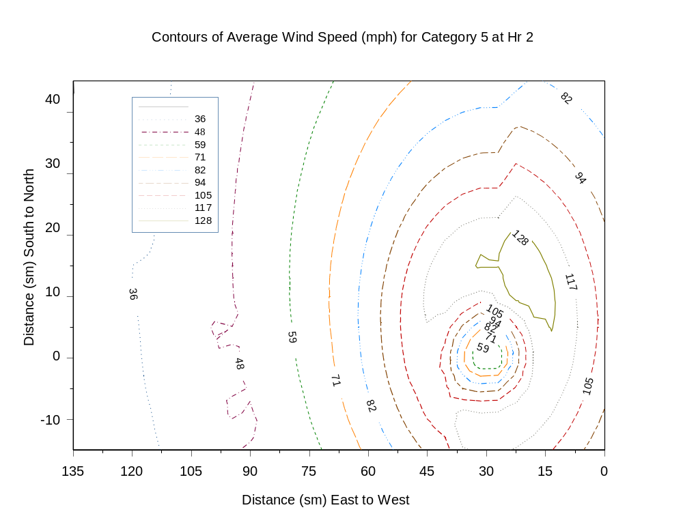

Figure 36. Average Wind Speed (mph) Contours for Category 5 Hurricane at 2hr

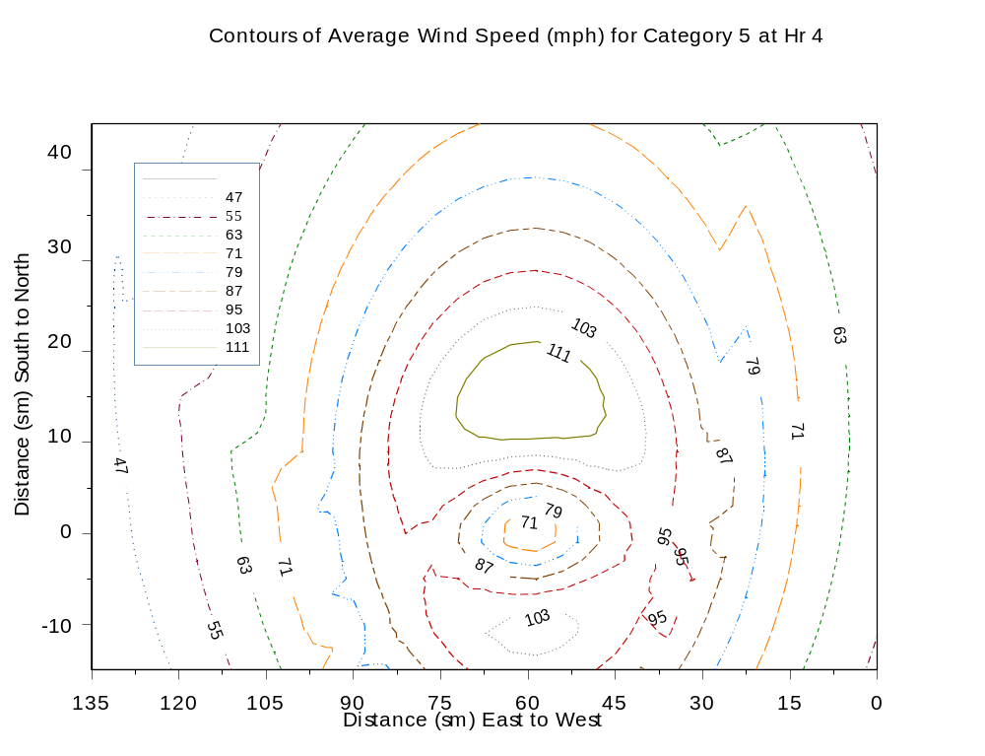

Figure 37. Average Wind Speed (mph) Contours for Category 5 Hurricane at 4hr
Figure 38 to Figure 41 show contours of standardized regression coefficients (SRC) for Holland B, Rmax, VT and CP respectively for a Category 1 hurricane at 4hr. The contours in this figure represent average SRCs for Holland B, Rmax, VT and CP over all 100 input vectors at each grid point at t=4hr. These contours show the effect of each input variable on the magnitude of wind speed (and therefore on loss cost) as the hurricane moves from right to left across the grid as time increases.

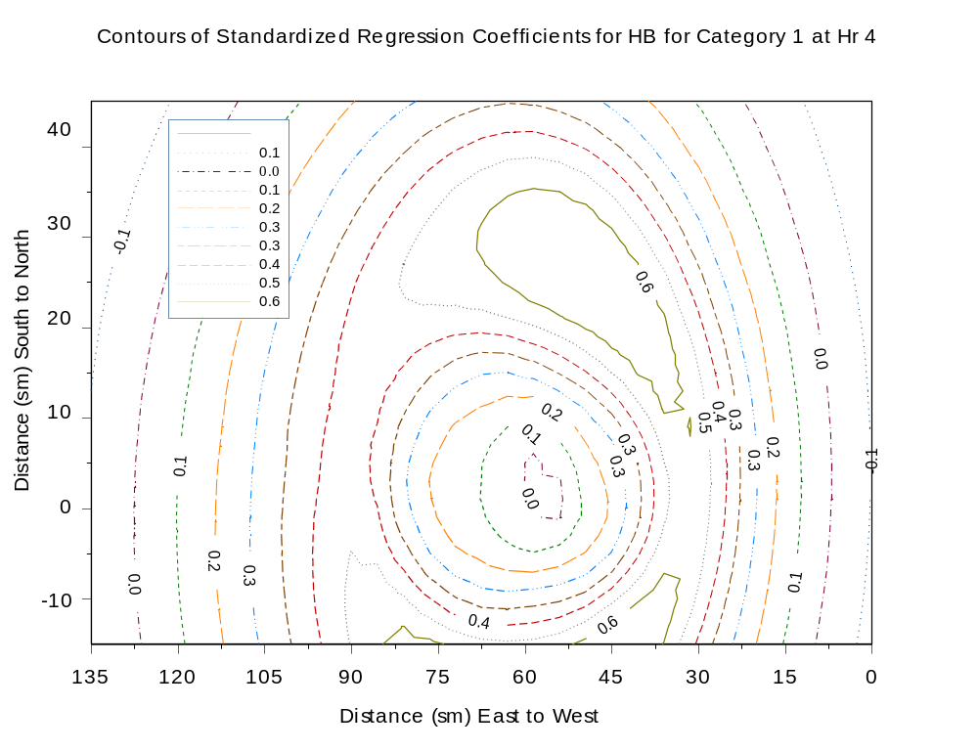

Figure 38. Contours Standardized Regression Coefficients for Holland B for Category 1
Hurricane at 4 hr

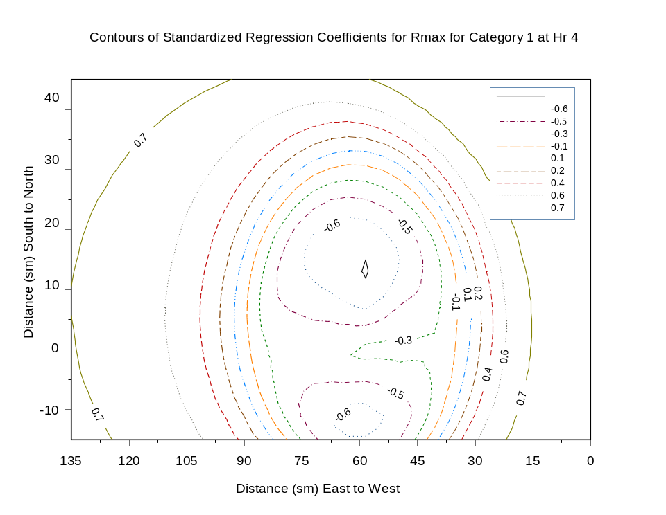
Figure 39. Contours Standardized Regression Coefficients for Rmax for Category 1 Hurricane at 4 hr
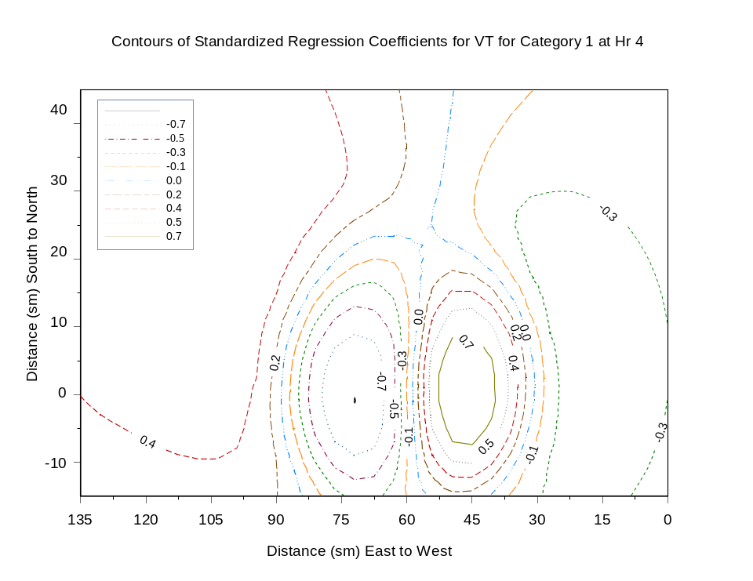

Figure 40. Contours Standardized Regression Coefficients for VT for Category 1 Hurricane at 4 hr

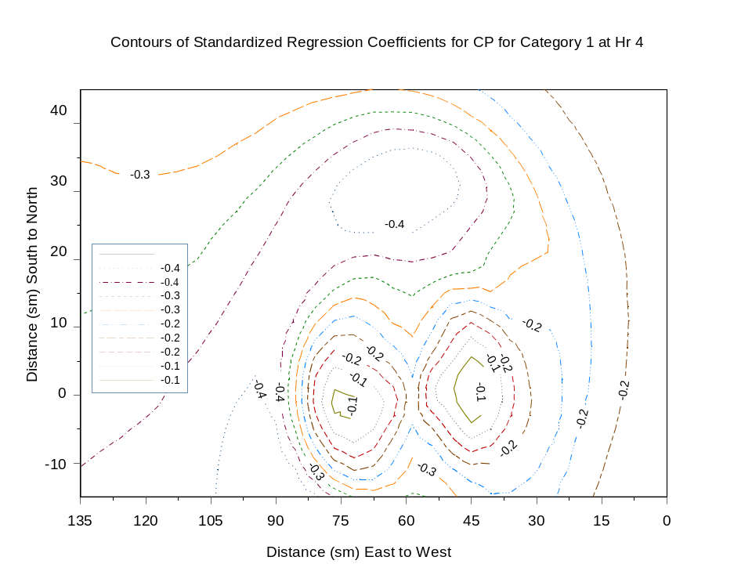

Figure 41. Figure Contours Standardized Regression Coefficients for CP for Category 1 Hurricane at 4 hr

Figure 42 - Figure 45 show some selected contours of the expected percentage reduction in variance for Holland B, Rmax, VT and CP respectively for a Category 1 hurricane at 3hr. The contours in these figures represent the average value of the expected percentage reduction in the variance of the wind speed attributable to Rmax, VT, Holland B and CP when taken over all 100 input vectors at each grid point at t=3hr. These contours illustrate the effect of each input variable on the uncertainty in wind speed (and therefore the uncertainty in loss cost) as the hurricane moves from right to left across the grid as time increases.

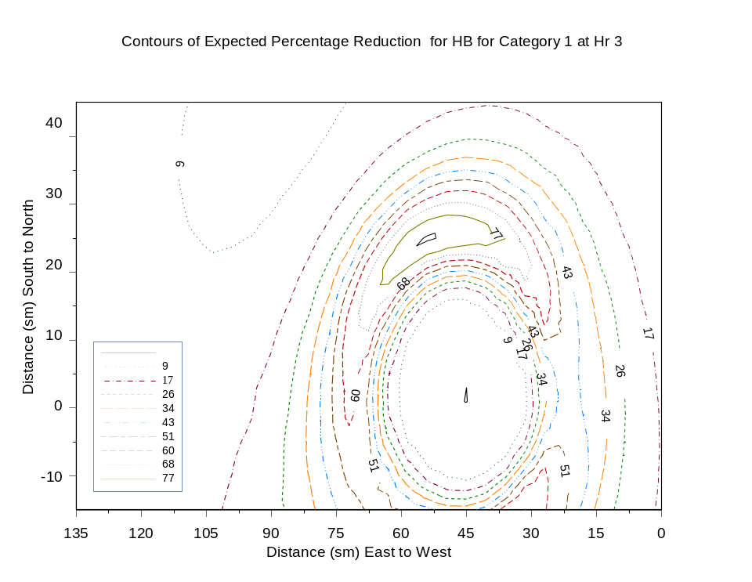
Figure 42. Contours of the Expected Percentage Reduction for Holland B for a Category 1 Hurricane at 3hr

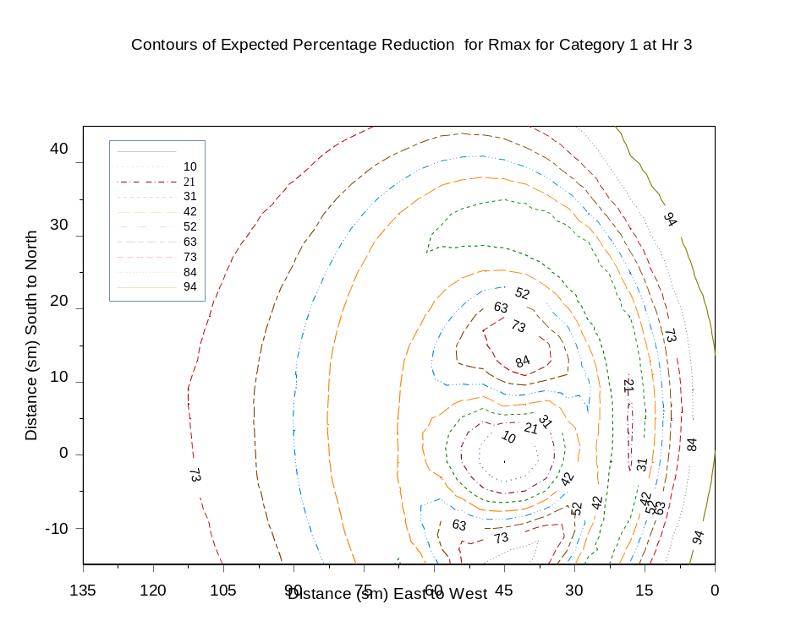
Figure 43. Contours of the Expected Percentage Reduction for Rmax for a Category 1 Hurricane at 3hr
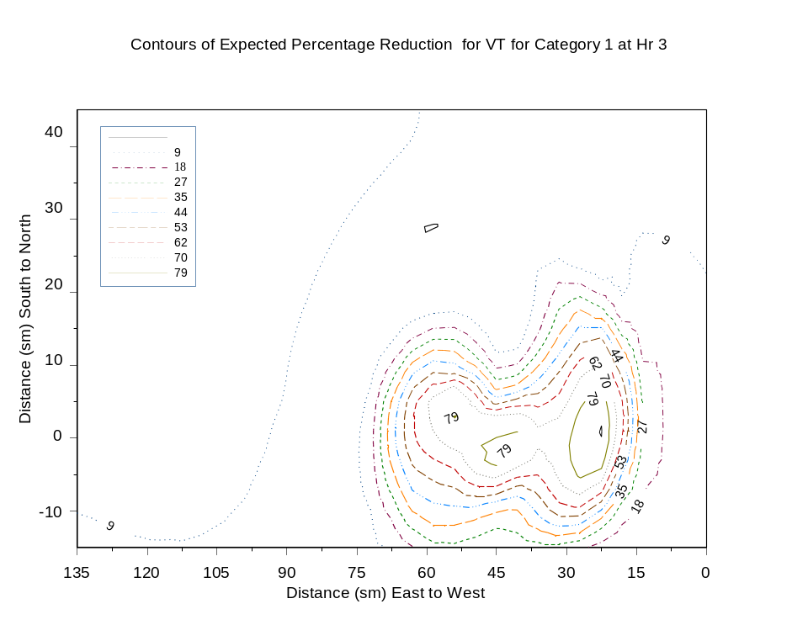
Figure 44. Contours of the Expected Percentage Reduction for VT for a Category 1 Hurricane at 3hr

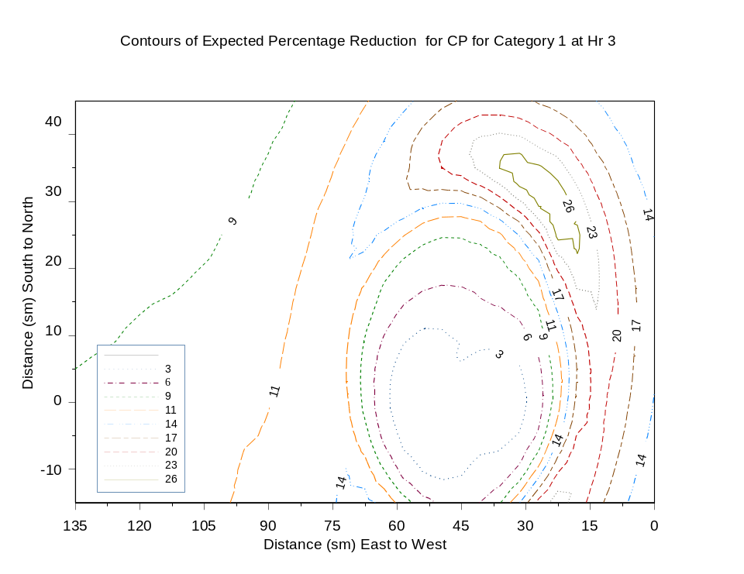
Figure 45. Contours of the Expected Percentage Reduction for CP for a Category 1 Hurricane at 3hr

Figure 46 - Figure 48 show contours of the average percentage loss cost for a Category 1, 3, and 5 hurricanes respectively for each land-based grid point. A percentage loss cost has been calculated for each land-based grid point based on the maximum wind speed observed at the point during the 12hr duration of the hurricane track. This calculation is repeated for each of the 100 input vectors. The average percentage loss costs are found to be about between 3.5% - 5.4% for Category 1, between 5.5% - 20% for Category 3 and between 4.5% - 40% for Category 5 hurricane. The largest losses occur shortly after landfall to the right of the hurricane path.

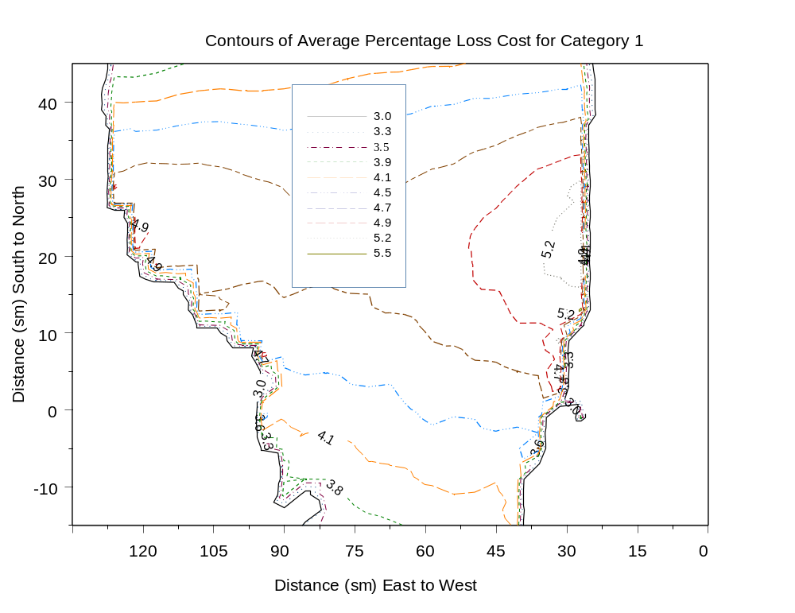
Figure 46. Average Percentage Loss Cost Contour for a Category 1Hurricane

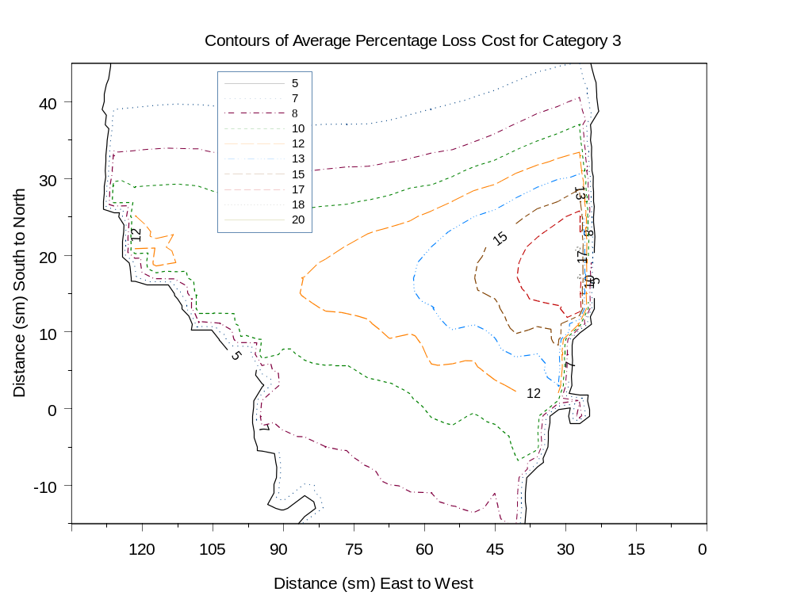
Figure 47. Average Percentage Loss Cost Contour for a Category 3 Hurricane
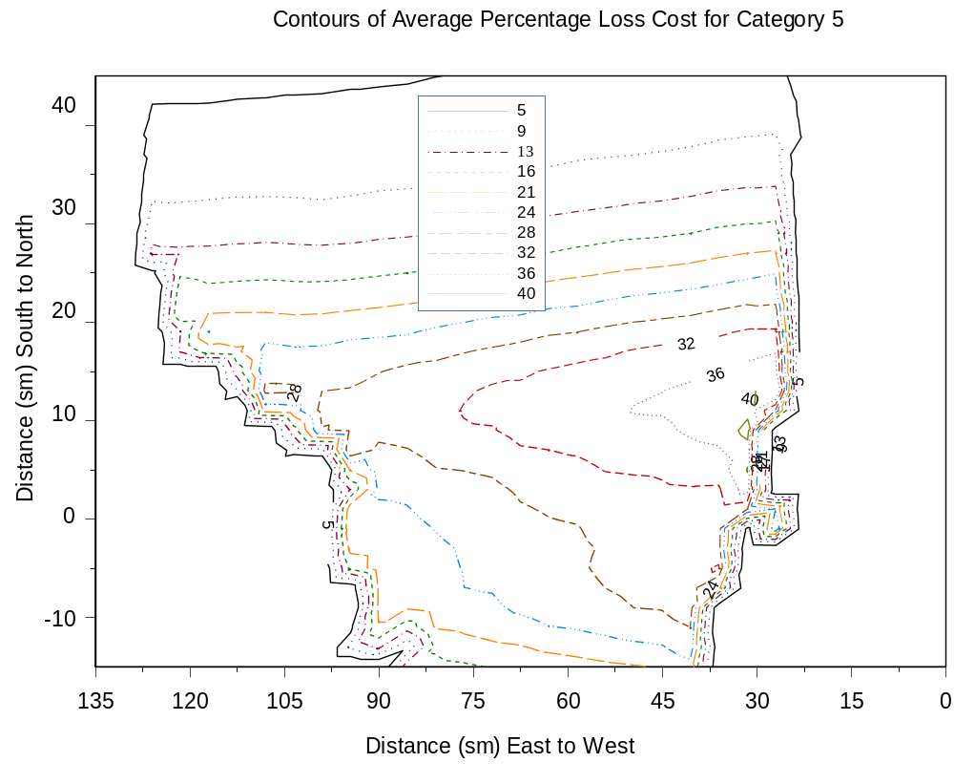
Figure 48. Average Percentage Loss Cost Contour for a Category 5 Hurricane

Figure 49 - Figure 52 show sample sensitivity analysis results for loss cost for all input variables based on a model that utilizes the Holland B parameter as the Quantile variable. The results shown in Figure 49 - Figure 52 are based on the original data. It is observed from these figures that the loss cost is sensitive to parameters Holland B, Rmax, VT and CP. The loss cost is least sensitive to VT. Holland B has positive effect while CP has negative effect on the loss cost. Rmax has both positive and negative effects on loss cost depend on the category of hurricane.

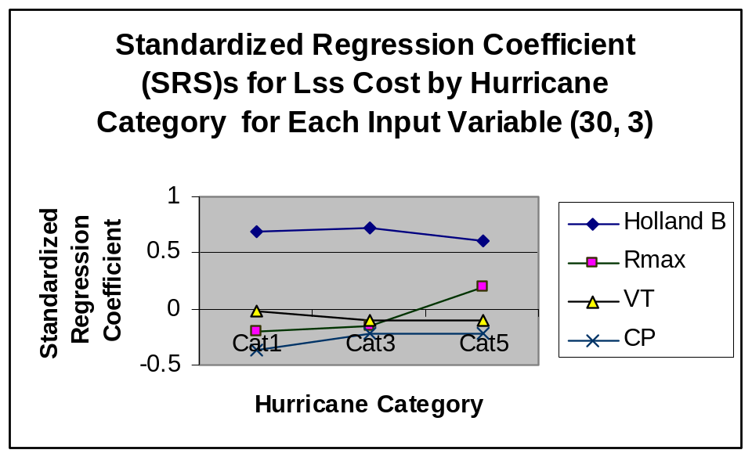

Figure 49. Standardized Regression Coefficients for Loss Cost by Hurricane Category for each input variables for coordinate (30, 3)

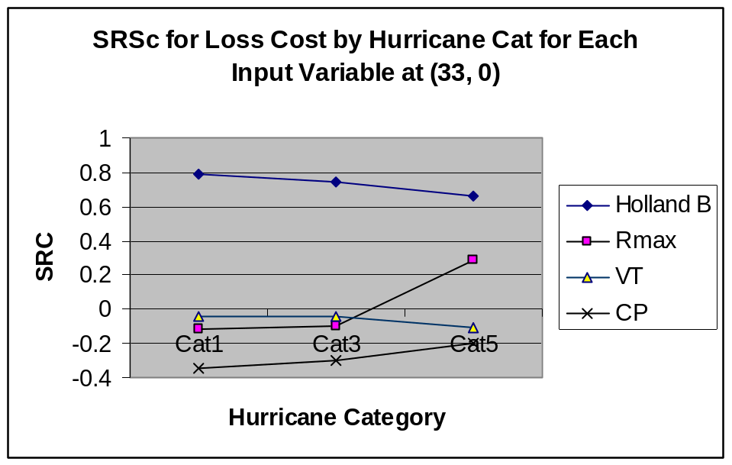

Figure 50. Standardized Regression Coefficients for Loss Cost by Hurricane Category for each input variables for coordinate (33, 0)

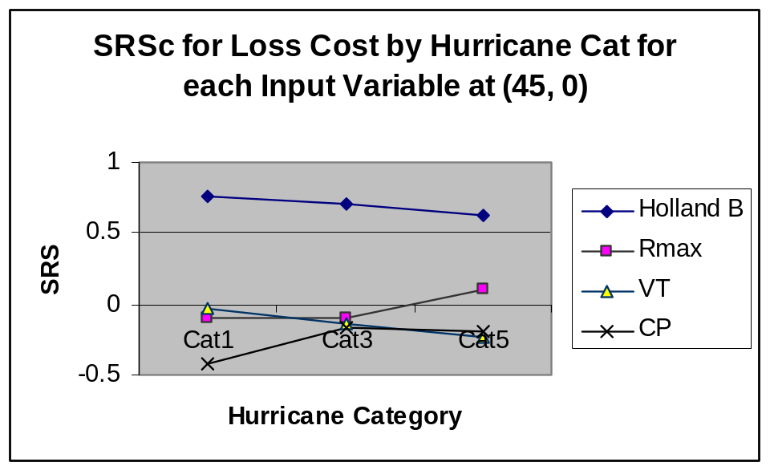

Figure 51. Standardized Regression Coefficients for Loss Cost by Input Variables for each category of hurricane for grid point (45, 0)

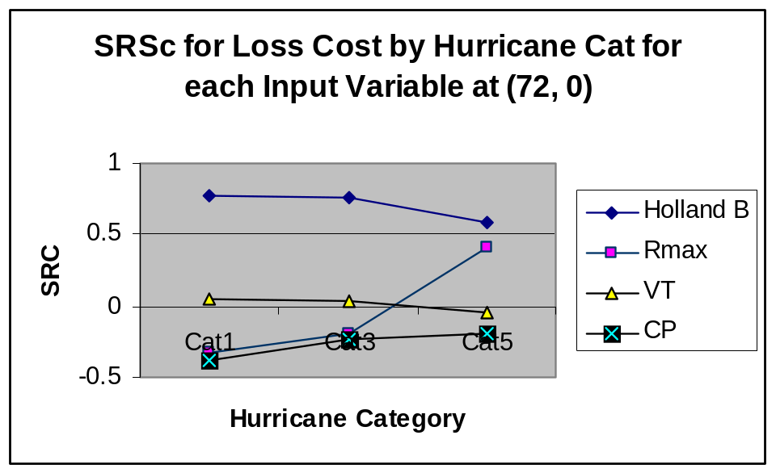

Figure 52. Standardized Regression Coefficients for Loss Cost by Input Variables for each category of hurricane for grid point (72, 0)

Figure 53 - Figure 56 show sample uncertainty analysis results for loss cost for all input variables based on a model that utilizes the Holland B parameter as the quantile variable. The results shown in Figure 53 - Figure 56 are based on the original data. From these graphs we observed that the major contributions of uncertainty for loss cost are R-max, VT and Holland B. The uncertainty increase with the increase of the hurricane category. It appears that CP is the least influential.

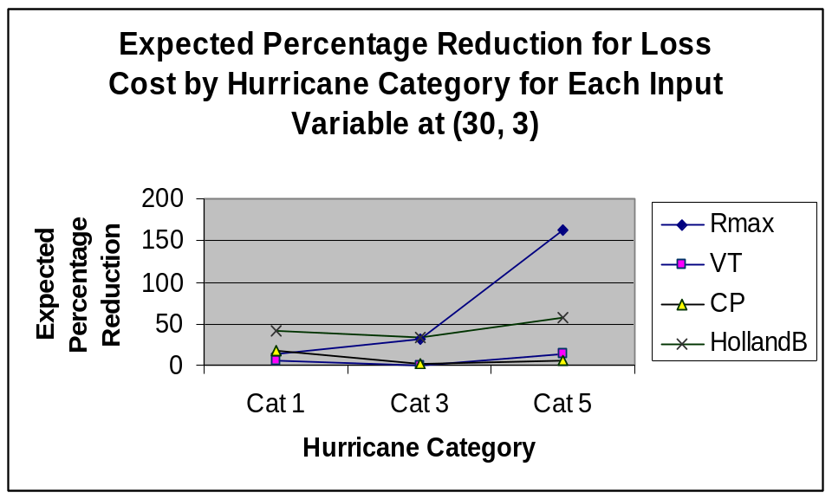
Figure 53. Expected Percentage Reduction for Loss Cost by Hurricane Category for Each Input Variable at grid point (30, 3)

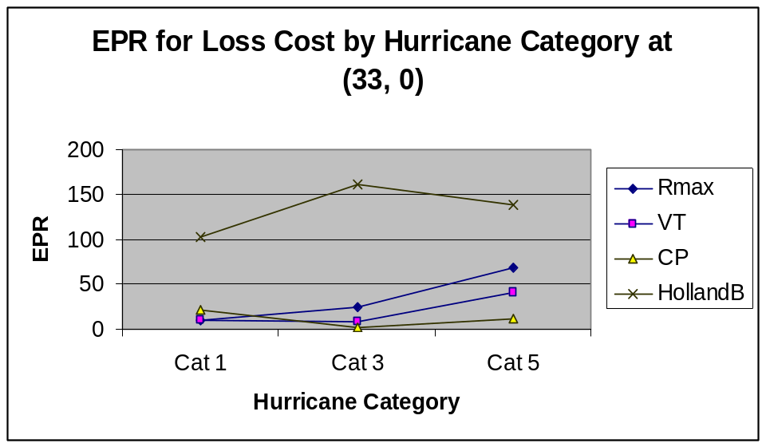

Figure 54. Expected Percentage Reduction for Loss Cost by Hurricane Category for Each Input Variable at grid point (33, 0)
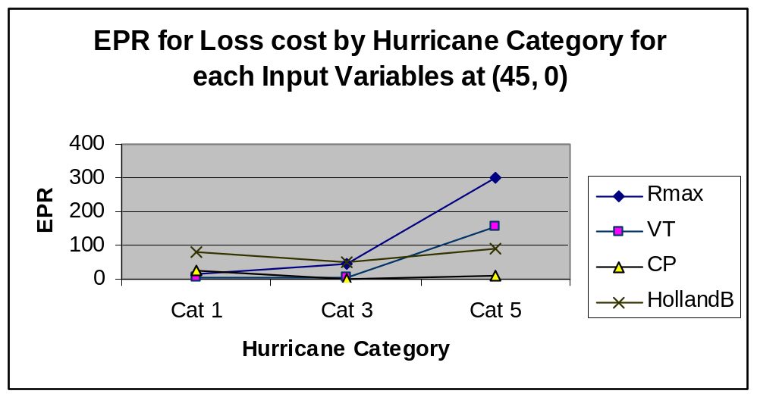
Figure 55. Expected Percentage Reduction for Loss Cost by Hurricane Category for Each Input Variable at grid point (45, 0)

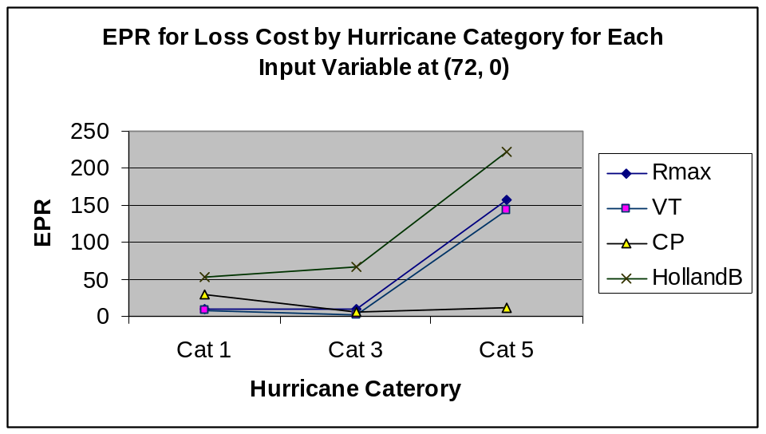
Figure 56. Expected Percentage Reduction for Loss Cost by Hurricane Category for Each Input Variable at grid point (72, 0)

