METEOROLOGICAL STANDARDS

M-1 Base Hurricane Storm Set*
(*Significant Revision)

For validation of landfall and by-passing storm frequency in the stochastic storm set, the modeler shall use the latest updated Official Hurricane Set or the National Hurricane Center HURDAT as of June 1, 2006 or later. Complete additional season increments based on updates to HURDAT approved by the Tropical Prediction Center/National Hurricane Center are acceptable modifications to these storm sets. Peer reviewed atmospheric science literature can be used to justify modifications to the Base Hurricane Storm Set.

M-1.1 Identify the Base Hurricane Storm Set, the release date, and the time period included for landfall and by-passing storm frequencies.

The National Hurricane Center HURDAT file from June 2006 for the period 1900-2005 is used to establish the official hurricane base set used by our model. All HURDAT storm tracks that have made landfall in Florida or bypassed Florida but passed close enough to produce damaging winds, are documented in our archives.

M-1.2 If the modeler has modified the Base Hurricane Storm Set, provide justification for such modifications.

NWS-38 was used to make modifications to the base set where there were gaps in the HURDAT information. Complete documentation on our base set is found on the NOAA AOML-HRD website at:

http://www.aoml.noaa.gov/hrd/lossmodel/

Region A differences:
* Storm 3 1903 - Second landfall in Region A, wind speed adjusted to agree with Ho et al. and HURDAT.
* Storm 1 1911 - Becomes Storm 2 1911, as an additional storm was added to the latest
version of HURDAT. Wind at landfall adjusted to agree with HURDAT and pressure wind relationship.
* Storm 4 1912 - Not counted as a landfall in Region A. Kept as a landfall in Region F.
* Storm 3 1917 - Pressure and wind at landfall adjusted to agree with HURDAT.
* Storm 6 1926 - Put in By-pass column NOT a landfall in Region A. Kept as a landfall in
Region F.
* Storm 2 1929 - Landfall pressure adjusted to agree with HURDAT.
* Storm 2 1939 - Pressure at exit adjusted to agree with pressure wind relationship.
* Storm 5 1941 - Winds at landfall adjusted to agree with HURDAT.
* Gladys 1968 - Winds at landfall adjusted to agree with HURDAT.
* Agnes 1972 - Pressure and winds at landfall adjusted to agree with HURDAT.
* Eloise 1975 - Winds at landfall adjusted to agree with HURDAT.
* Kate 1985 - Pressure and winds at landfall adjusted to agree with HURDAT. This upped the S-S Category to 2.
* Jeanne 2004 - Base Set shows an exit in Region A at hurricane strength, but HURDAT does not have the eye cross the coast in this Region. In addition, by the time the center was near
this coast, Jeanne had slipped below hurricane strength. So we show no Exit in Region A
for Jeanne.
* Dennis 2005 - Winds at landfall adjusted to agree with HURDAT.

Region B differences:

* Storm 2 1906 - Base Set shows entry in Region C and no exit. HURDAT shows entry in Region B and exit in Region C. Landfall values are applied to Region B entry, and corrected exit values applied to Region C.
* Storm 8 1906 - Pressure at landfall adjusted to agree with HURDAT.
* Storm 8 1909 - This is now Storm 10 1909 in new version of HURDAT. Instead of a bypass in Region C, landfalls in Region B and C were added for a strike in the Florida Keys. Pressure and winds adjusted to agree with Ho et al.
* Storm 5 1910 - Base set uses pressure and winds from a ship report as reported in Ho, et al. However, landfall values were for a weaker storm. Pressure, wind, and category at land fall adjusted.
* Storm 2 1929 - Seafall in Region B added.
* Storm 6 1935 - Pressure at exit adjusted upward to agree with inland decay model. Base set keeps pressure the same as at landfall.
* Storm 5 1941 - Pressure at exit adjusted to agree with inland decay model.
* Storm 4 1947 - Pressure at seafall adjusted for over land decay.
* Storm 7 1948 - Pressure at landfall adjusted to pressure-wind relationship.
* Storm 8 1948 - Base Set designates only landfall in Region C. HURDAT track shows initial landfall in Region B as a Category 3 hurricane.
* Donna 1960 - Winds at landfall adjusted to agree with HURDAT.
* Inez 1966 - Pressure and winds at landfall adjusted to agree with HURDAT.
* Andrew 1992 - Pressure and winds at seafall adjusted to agree with HURDAT.
* Irene 1999 - Winds at landfall adjusted to agree with HURDAT.
* Charley 2004 - Pressure and winds at landfall adjusted to agree with HURDAT.
* Frances 2004 - HURDAT shows Frances below hurricane strength when it exits Region B. Therefore there is no exit shown.
* Jeanne 2004 - Base Set shows an exit in Region B at hurricane strength, but HURDAT does not have the eye cross the coast in this Region. In addition, by the time the center was near this coast, Jeanne had slipped below hurricane strength. So we show no exit in
Region B for Jeanne.
* Katrina 2005 - Exit in Region B added, as HURDAT maintains it at hurricane strength
during seafall.
* Wilma 2005 -Winds at landfall adjusted to agree with HURDAT.

Region C differences:

* Storm 3 1903 - Winds and category at landfall adjusted to agree with HURDAT.
* Storm 2 1906 - Base Set shows entry in Region C and no exit. HURDAT shows entry in
Region B and exit in Region C. Landfall values are applied to Region B entry, and corrected exit values applied to Region C.
* Storm 1 1926 - Landfall moved from Region D to Region C to comply with Fla. Commission's regional definition. Also winds at landfall reduced to Category 1 to agree with HURDAT.
* Storm 6 1926 - Pressure and wind adjusted to agree with HURDAT.
* Storm 2 1939 - Pressure at landfall adjusted to agree with HURDAT.
* Storm 8 1947 - Pressure and winds at landfall adjusted to pressure-wind relationship.
* Storm 8 1948 - Base Set shows Category 1 winds of 86 mph at landfall. HURDAT shows
winds of 110 to 127 mph around landfall, at minimum a Category 2 at landfall. Also, initial landfall was in the Florida Keys at a Category 3.
* King 1950 - Because of possible error in sequence of days in HURDAT landfall pressure is
very high. Nevertheless our pressure is set to agree with HURDAT.
* Cleo 1964 - Pressure and winds at landfall adjusted to agree with HURDAT.
* Betsy 1965 - Winds adjusted to agree with HURDAT.
* David 1979 - Pressure and winds at landfall adjusted to agree with HURDAT.
* Charley 2004 - Exit in Region C not used.
* Katrina 2005 - Pressure and winds at landfall adjusted to agree with HURDAT.
* Wilma 2005 - Pressure and winds at landfall adjusted to agree with HURDAT.

Region D differences:

* Storm 1 1926 - Moved from Region D to Region C to comply with FL Commission's regional
definition.
* Dora 1964 - Winds at landfall adjusted to agree with HURDAT.
* Gladys 1968 - Pressure and winds at exit adjusted to agree with HURDAT.
* Charley 2004 - Pressure adjusted to agree with H*Wind.

Region E differences:

* Storm 3 1940 - Category adjusted to agree with winds.
* Storm 8 1947 - Category adjusted to agree with winds.

Region F differences:

Storm 6 1926- Changed landfall from region A to region F.

By-pass differences:

* Storm 8 1909 - This is now Storm 10 1909 in new version of HURDAT. Instead of a bypass
in Region C, landfalls in Region B and C were added for a strike in the Florida Keys. Pressure and winds adjusted to agree with Ho et al.
* Storm 3 1912 - This is now Storm 4 1912 in new version of HURDAT. Added as a
bypassing storm for region A.
* Baker 1950 - By-passing of Region A added.
* Frederic 1979- By-passing of region A.
* Danny 1997 - By-pass in Region A added.
* Ivan 2004 - Pressure and Winds at by-pass and landfall adjusted to agree with H*Wind analysis.
* Rita 2005 - Pressure and Winds at by-pass adjusted to agree with HURDAT.

References:

HURDAT is the primary source of data for the base set used by the Public model. We have also used data from NWS-38, which is discussed in the metadata on our web site at: http://www.aoml.noaa.gov/hrd/lossmodel/

A comprehensive list of peer-reviewed literature relevant to hurricanes in the base set (but not the basis for modifications of the Base Set) is detailed below:

HURDAT: The Atlantic Hurricane Database, June 2006

Available from: www.nhc.noaa.gov

Ho, F., J.C. Su, Kl.L. Hanevich, R.J. Smith, and F.P. Richards, 1987:"Hurricane climatology for the Atlantic and Gulf coasts of the United States" NOAA Technical Memorandum, NWS-38, 193pp.

Jarvinen, B. R., C. J. Neumann, and M. A. S. Davis, 1984: A tropical cyclone data tape for the North Atlantic basin, 1886-1963: Contents, Limitations, and Uses. NOAA Tech. Memo NWS NHC 22, National Hurricane Center, 22 pp

Landsea, C. W., C. Anderson, N. Charles, G. Clark, J. Dunion, J. Fernandez-Partagas, P. Hungerford, C. Neumann, and M. Zimmer, 2004: The Atlantic hurricane database re-analysis project: Documentation for the 1851-1910 alterations and additions to the HURDAT database. "Hurricanes and Typhoons: Past, Present, and Future" R.J. Murname and K-B Liu, Editors, Columbia University Press, p. 177-221

Additional references organized by storm name:

Wilma 2005
Houze Jr., R. A., S. S. Chen, W-C Lee, R. F. Rogers, J. A. Moore, G. J. Stossmeister, M. M. Bell, J. Cetrone, W. Zhao, and S. R. Brodzik, 2006: "The Hurricane Rainband and Intensity Change Experiment: Observations and Modeling of Hurricanes Katrina, Ophelia, and Rita", Bulletin of the American Meteorological Society, Volume 87, Issue 11 (November 2006) pp. 1503–1521

Oey, LY, Ezer, T, Wang, DP, et al., 2006: "Loop Current warming by Hurricane Wilma", Geophys Res Lettr, Vol. 33 No. 8 (APR 29, 2006)

Rita 2005
Houze Jr., R. A., S. S. Chen, W-C Lee, R. F. Rogers, J. A. Moore, G. J. Stossmeister, M. M. Bell, J. Cetrone, W. Zhao, and S. R. Brodzik, 2006: "The Hurricane Rainband and Intensity Change Experiment: Observations and Modeling of Hurricanes Katrina, Ophelia, and Rita", Bulletin of the American Meteorological Society, Volume 87, Issue 11 (November 2006) pp. 1503–1521

Katrina 2005
Houze Jr., R. A., S. S. Chen, W-C Lee, R. F. Rogers, J. A. Moore, G. J. Stossmeister, M. M. Bell, J. Cetrone, W. Zhao, and S. R. Brodzik, 2006: "The Hurricane Rainband and Intensity Change Experiment: Observations and Modeling of Hurricanes Katrina, Ophelia, and Rita", Bulletin of the American Meteorological Society, Volume 87, Issue 11 (November 2006) pp. 1503–1521

Kafatos, M., D. L. Sun, et al., 2006: "Role of anomalous warm gulf waters in the intensification of Hurricane Katrina", Geophys Res Lettr, Volume 33 Number 17 (Sept. 1 2006)

Shen, B. W., R. Atlas, et al., 2006: "Hurricane forecasts with a global mesoscale-resolving model: Preliminary results with Hurricane Katrina (2005)", Geophys Res Lettr, Volume 33 Number 13 (July 14 2006)

Elsner, J. B., T. H. Jagger, A. A. Tsonis, 2006: "Estimated return periods for Hurricane Katrina", Geophys Res Lettr, Volume 33 Number 8 (April 19 2006)

Dennis 2005

Morey, S. L., S. Baig,, et al., 2006: "Remote forcing contribution to storm-induced sea level rise during Hurricane Dennis", Geophys Res Lettr, Vol. 33 No. 19 (OCT 4, 2006)

Ivan 2004
Panchang, V. G. and D. Li, 2006: "Large Waves In The Gulf Of Mexico Caused By Hurricane Ivan", Bulletin of the American Meteorological Society, Volume 87, Issue 4 (April 2006) pp. 481–489

Barrett, B.S., L. M. Leslie, and B. H. Fiedler, 2006: "An Example of the Value of Strong Climatological Signals in Tropical Cyclone Track Forecasting: Hurricane Ivan (2004)", Monthly Weather Review, Volume 134, Issue 5 (May 2006) pp. 1568–1577

Wang, D. W., D. A. Mitchell, W. J. Teague, et al., 2005: "Extreme waves under Hurricane Ivan", Science Volume 309 Number 5736 (August 5 2005) pp.896-896

Mitchell, D. A., W. J. Teague, E. Jarosz, et al., 2005: "Observed currents over the outer continental shelf during Hurricane Ivan", Geophys Res Lettr, Volume 32 Number 11 (June 11 2005)

Irene 1999
Evans, J. L., and B. E. Prater-Mayes, 2004: "Factors Affecting the Posttransition Intensification of Hurricane Irene (1999)", Monthly Weather Review, Volume 132, Issue 6 (June 2004) pp. 1355–1368

Agusti-Panareda, A, C. C. Thorncroft, G. C. Craig, et al., 2004: "The extratropical transition of hurricane Irene (1999): A potential-vorticity perspective",
Quart J Roy Meteo Soc, Volume 130 Number 598 (APR 2004) pp.1047-1074 Part A

Georges 1999
Jeffrey D. Kepert, J. D., 2006: "Observed Boundary Layer Wind Structure and Balance in the Hurricane Core. Part I: Hurricane Georges", Journal of the Atmospheric Sciences, Volume 63, Issue 9 (September 2006) pp. 2169–2193

Geerts, B., G. M. Heymsfield, L. Tian, J. B. Halverson, A. Guillory, and M. I. Mejia, 2000: "Hurricane Georges's Landfall in the Dominican Republic: Detailed Airborne Doppler Radar Imagery", Bulletin of the American Meteorological Society, Volume 81, Issue 5 (May 2000) pp. 999–1018

Zheng, Q. N., R. J. Lai, N. E. Huang, et al., 2006: "Observation of ocean current response to 1998 Hurricane Georges in the Gulf of Mexico", Acta Oceanol Sin Volume 25 Number 1 ( 2006) pp.1-14

Earl 1998
McTaggart-Cowan, R., J. R. Gyakum, and M. K. Yau, 2001: "Sensitivity Testing of Extratropical Transitions Using Potential Vorticity Inversions to Modify Initial Conditions: Hurricane Earl Case Study", Monthly Weather Review, Volume 129, Issue 7 (July 2001) pp. 1617–1636

Ma, S., H. Ritchie, J. Gyakum, J. Abraham, C. Fogarty, and R. McTaggart-Cowan, 2003: "A Study of the Extratropical Reintensification of Former Hurricane Earl Using Canadian Meteorological Centre Regional Analyses and Ensemble Forecasts", Monthly Weather Review, Volume 131, Issue 7 (July 2003) pp. 1342–1359

McTaggart-Cowan, R., J. R. Gyakum, and M. K. Yau, 2003: "The Influence of the Downstream State on Extratropical Transition: Hurricane Earl (1998) Case Study", Monthly Weather Review, Volume 131, Issue 8 (August 2003) pp. 1910–1929

Elsberry, R. L., 2004: 'Comments on “The Influence of the Downstream State on Extratropical Transition: Hurricane Earl (1998) Case Study” and “A Study of the Extratropical Reintensification of Former Hurricane Earl Using Canadian Meteorological Centre Regional Analyses and Ensemble Forecasts” ', Monthly Weather Review, Volume 132, Issue 10 (October 2004) pp. 2511–2513

McTaggart-Cowan, R., J. R. Gyakum, and M. K. Yau, 2004: "The Impact of Tropical Remnants on Extratropical Cyclogenesis: Case Study of Hurricanes Danielle and Earl (1998)", Monthly Weather Review, Volume 132, Issue 8 (August 2004) pp. 1933–1951

Danny 1997
Blackwell, K. G., 2000: "The Evolution of Hurricane Danny (1997) at Landfall: Doppler-Observed Eyewall Replacement, Vortex Contraction/Intensification, and Low-Level Wind Maxima", Monthly Weather Review, Volume 128, Issue 12 (December 2000) pp. 4002–4016

Opal 1995
Rodgers, E. B., W. S. Olson, V. M. Karyampudi, and H. F. Pierce, 1998: "Satellite-Derived Latent Heating Distribution and Environmental Influences in Hurricane Opal (1995)", Monthly Weather Review, Volume 126, Issue 5 (May 1998) pp. 1229–1247

Krishnamurti, T. N., W. Han, B. Jha, and H. S. Bedi, 1998: "Numerical Prediction of Hurricane Opal", Monthly Weather Review, Volume 126, Issue 5 (May 1998) pp. 1347–1363

Henderson, J. M., G. M. Lackmann, and J. R. Gyakum, 1999: "An Analysis of Hurricane Opal’s Forecast Track Errors Using Quasigeostrophic Potential Vorticity Inversion", Monthly Weather Review, Volume 127, Issue 3 (March 1999) pp. 292–307

Bosart, L. F., C. S. Velden, W. E. Bracken, J. Molinari, and P. G. Black, 2000: "Environmental Influences on the Rapid Intensification of Hurricane Opal (1995) over the Gulf of Mexico", Monthly Weather Review,Volume 128, Issue 2 (February 2000) pp. 322–352

Hong, X., S. W. Chang, S. Raman, L. K. Shay, and R. Hodur, 2000: "The Interaction between Hurricane Opal (1995) and a Warm Core Ring in the Gulf of Mexico", Monthly Weather Review, Volume 128, Issue 5 (May 2000) pp. 1347–1365

Shay, L. K., G. J. Goni, and P. G. Black, 2000: "Effects of a Warm Oceanic Feature on Hurricane Opal", Monthly Weather Review, Volume 128, Issue 5 (May 2000) pp. 1366–1383

Persing, J., M. T. Montgomery, and R. E. Tuleya, 2002: "Environmental Interactions in the GFDL Hurricane Model for Hurricane Opal", Monthly Weather Review, Volume 130, Issue 2 (February 2002) pp. 298–317

Möller, J. D. and L. J. Shapiro, 2002: "Balanced Contributions to the Intensification of Hurricane Opal as Diagnosed from a GFDL Model Forecast", Monthly Weather Review, Volume 130, Issue 7 (July 2002) pp. 1866–1881

Shapiro, L. J. and J. D. Möller, 2003: "Influence of Atmospheric Asymmetries on the Intensification of Hurricane Opal: Piecewise PV Inversion Diagnosis of a GFDL Model Forecast", Monthly Weather Review, Volume 131, Issue 8 (August 2003) pp. 1637–1649

Romine, G., Wilhelmson, R., 2002: "A high-resolution simulation of Hurricane Opal", Bulletin of the American Meteorological Society, Volume 83 Number 9 (September 2002) pp.1273-1273

Romine, G. S. and R. B. Wilhelmson, 2006: "Finescale Spiral Band Features within a Numerical Simulation of Hurricane Opal (1995)", Monthly Weather Review, Volume 134, Issue 4 (April 2006) pp. 1121–1139

Powell, M. D. and S. H. Houston, 1998: "Surface Wind Fields of 1995 Hurricanes Erin, Opal, Luis, Marilyn, and Roxanne at Landfall", Monthly Weather Review, Volume 126, Issue 5 (May 1998) pp. 1259–1273

Erin 1995
Cocke, S., 1998: "Case Study of Erin Using the FSU Nested Regional Spectral Model", Monthly Weather Review, Volume 126, Issue 5 (May 1998) pp. 1337–1346

Andrew 1992
Keen, T. R. and S. M. Glenn, 1998: "Factors Influencing Model Skill for Hindcasting Shallow Water Currents during Hurricane Andrew", Journal of Atmospheric and Oceanic Technology, Volume 15, Issue 1 (February 1998) pp. 221–236

Landsea, C. W., J. L. Franklin, C. J. McAdie, J. L. Beven II, J. M. Gross, B. R. Jarvinen, R. J. Pasch, E. N. Rappaport, J. P. Dunion, and P. P. Dodge, 2004: "A Reanalysis of Hurricane Andrew's Intensity", Bulletin of the American Meteorological Society, Volume 85, Issue 11 (November 2004) pp. 1699–1712

Gall, R., J. Tuttle, and P. Hildebrand, 1998: "Small-Scale Spiral Bands Observed in Hurricanes Andrew, Hugo, and Erin", Monthly Weather Review, Volume 126, Issue 7 (July 1998) pp. 1749–1766

Liu, Y., D-L Zhang, and M. K. Yau, 1999: "A Multiscale Numerical Study of Hurricane Andrew (1992). Part II: Kinematics and Inner-Core Structures", Monthly Weather Review, Volume 127, Issue 11 (November 1999) pp. 2597–2616

Powell, M. D. and S. H. Houston, 1999: 'Comments on “A Multiscale Numerical Study of Hurricane Andrew (1992). Part I: Explicit Simulation and Verification” ', Monthly Weather Review, Volume 127, Issue 7 (July 1999) pp. 1706–1710

Zhang, D-L, Y. Liu, and M. K. Yau, 1999: "Surface Winds at Landfall of Hurricane Andrew (1992)—A Reply", Monthly Weather Review, Volume 127, Issue 7 (July 1999) pp. 1711–1721

Zhang, D-L, Y. Liu, and M. K. Yau, 2000: "A Multiscale Numerical Study of Hurricane Andrew (1992). Part III: Dynamically Induced Vertical Motion", Monthly Weather Review, Volume 128, Issue 11 (November 2000) pp. 3772–3788

Zhang, D-L, Y. Liu, and M. K. Yau, 2001: "A Multiscale Numerical Study of Hurricane Andrew (1992). Part IV: Unbalanced Flows", Monthly Weather Review, Volume 129, Issue 1 (January 2001) pp. 92–107

Zhang, D-L, Y. Liu, and M. K. Yau, 2002: "A Multiscale Numerical Study of Hurricane Andrew (1992). Part V: Inner-Core Thermodynamics", Monthly Weather Review, Volume 130, Issue 11 (November 2002) pp. 2745–2763

Yau, M. K., Y. Liu, D-L Zhang, and Y. Chen, 2004: "A Multiscale Numerical Study of Hurricane Andrew (1992). Part VI: Small-Scale Inner-Core Structures and Wind Streaks", Monthly Weather Review, Volume 132, Issue 6 (June 2004) pp. 1410–1433

Powell, M. D., S. H. Houston, and T. A. Reinhold, 1996: "Hurricane Andrew's Landfall in South Florida. Part I: Standardizing Measurements for Documentation of Surface Wind Fields", Weather and Forecasting, Volume 11, Issue 3 (September 1996) pp. 304–328

Powell, M. D. and S. H. Houston, 1996: "Hurricane Andrew's Landfall in South Florida. Part II: Surface Wind Fields and Potential Real-Time Applications", Weather and Forecasting, Volume 11, Issue 3 (September 1996) pp. 329–349

Breaker, L.C., L.D. Burroughs, Y.Y. Chao, J.F. Culp, N.L. Guinasso Jr., R.L. Teboulle, and C.R. Wong, 1994: "The Impact of Hurricane Andrew on the Near-Surface Marine Environment in the Bahamas and the Gulf of Mexico", Weather and Forecasting, Volume 9, Issue 4 (December 1994) pp. 542–556

Wakimoto, R. M. and P. G. Black, 1994: "Damage Survey of Hurricane Andrew and Its Relationship to the Eyewall", Bulletin of the American Meteorological Society, Volume 75, Issue 2 (February 1994) pp. 189–200

Willoughby, H.E. and P.G. Black, 1996: "Hurricane Andrew in Florida: Dynamics of a Disaster", Bulletin of the American Meteorological Society, Volume 77, Issue 3 (March 1996) pp. 543–549

Wu, C-C and K. A. Emanuel, 1995: "Potential Vorticity Diagnostics of Hurricane Movement. Part II: Tropical Storm Ana (1991) and Hurricane Andrew (1992)", Monthly Weather Review, Volume 123, Issue 1 (January 1995) pp. 93–109

Liu, Y., D-L Zhang, and M. K. Yau, 1997: "A Multiscale Numerical Study of Hurricane Andrew (1992). Part I: Explicit Simulation and Verification", Monthly Weather Review, Volume 125, Issue 12 (December 1997) pp. 3073–3093

Xu, Y. M., R. S. Wu, 2003: "The conservation of helicity in hurricane Andrew (1992) and the formation of the spiral rainband", Adv Atmos Sci, Volume 20 Number 6, (Nov 2003 )pp. 940-950

Keen, T. R., S. E. Allen, 2000: "The generation of internal waves on the continental shelf by Hurricane Andrew", J Geophys Res-Oceans Volume 105 Number C11 (Nov 15 2000) pp.26203-26224

Keen, T. R., S. M. Glenn, 1999: "Shallow water currents during hurricane Andrew",
J Geophys Res-Oceans Volume 104 Number C10 (October 15 1999) pp. 23443-23458

Stephens, G., 1994: "Hurricane Andrew", Int J Remote Sens, Volume 15 Number 16 (Nov 10 1994) pp. 3131-3132

Jackson, N. L., G. Stephens, 1994: "Hurricane Andrew from the Polar Orbiting Satellite Perspective", Int J Remote Sens, Volumes 15 Number 16 (Nov 10 1994) pp. 3133-3139

Molinari, J., P. K. Moore, V. P. Idone, et al, 1994, "CLOUD-TO-GROUND LIGHTNING IN HURRICANE-ANDREW", J Geophys Res-Atmos, Volume 99 Number D8 (August 20 1994) pp.16665-16676

Mason, B., 1993: "HURRICANE ANDREW MONITORED USING METEOSAT",
ESA Bull-Eur Space Number 73 (February 1993) pp.15-20

Young, R. S., E. R. Thieler, O, H, Pilkey, 1993: "GEOLOGIC AND OCEANOGRAPHIC FACTORS MITIGATING THE STORM-SURGE AND FLOOD DAMAGE OF HURRICANE-ANDREW IN SOUTH FLORIDA", Geology Volume 21 Number 2 (February 1993) pp. 99-99

Phillips, M., 1992: "NOAA USE EUROPEAN SATELLITE DATA DURING HURRICANE-ANDREW", Meteorol Mag Volume 121 Number 1445 (December 1992) pp. 288-288

Elena 1985
Corbosiero, K. L., J. Molinari, A. R. Aiyyer, and M. L. Black, 2006: "The Structure and Evolution of Hurricane Elena (1985). Part II: Convective Asymmetries and Evidence for Vortex Rossby Waves", Monthly Weather Review, Volume 134, Issue 11 (November 2006) pp. 3073–3091

Corbosiero, K. L., J. Molinari, and M. L. Black, 2005: "The Structure and Evolution of Hurricane Elena (1985). Part I: Symmetric Intensification", Monthly Weather Review, Volume 133, Issue 10 (October 2005) pp. 2905–2921

Velden, C. S., 1987: 'Satellite Observations of Hurricane Elena (1985) Using the VAS 6.7-μm “Water-Vapor” Channel', Bulletin of the American Meteorological Society, Volume 68, Issue 3 (March 1987) pp. 210–215

Frederic 1979
Krishnamurthi, T.N., H.S. Bedi, D. Oosterhof, and V. Hardiker, 1994: "The Formation of Hurricane Frederic of 1979", Monthly Weather Review,
Volume 122, Issue 6 (June 1994) pp. 1050–1074

J. Kaplan and W. M. Frank, 1993: "The Large-Scale Inflow-Layer Structure of Hurricane Frederic (1979)", Monthly Weather Review, Volume 121, Issue 1 (January 1993) pp. 3–20

Powell, M. D., 1982: "The Transition of the Hurricane Frederic Boundary-Layer Wind Field from the Open Gulf of Mexico to Landfall", Monthly Weather Review,
Volume 110, Issue 12 (December 1982) pp. 1912–1932

Parrish, J. R., R. W. Burpee, F. D. Marks Jr., and R. Grebe. 1982: "Rainfall Patterns Observed by Digitized Radar During the Landfall of Hurricane Frederic (1979)", Monthly Weather Review, Volume 110, Issue 12 (December 1982) pp. 1933–1944

Shay, L. K. and R. L. Elsberry, 1987: "Near-Inertial Ocean Current Response to Hurricane Frederic", Journal of Physical Oceanography, Volume 17, Issue 8 (August 1987) pp. 1249–1269

David 1979
Bosart, L. F. and G. M. Lackmann, 1979: "Postlandfall Tropical Cyclone Reintensification in a Weakly Baroclinic Environment: A Case Study of Hurricane David (September 1979)", Monthly Weather Review, Volume 123, Issue 11 (November 1995) pp. 3268–3291

Eloise 1975
Moss, M. S. and F. J. Merceret, 1976: "A Note on Several Low-Layer Features of Hurricane Eloise (1975)", Monthly Weather Review, Volume 104, Issue 7 (July 1976) pp. 967–971

Dikinov, K. Z., A. S. Ksenofontov, L. A. Moskalenko, 1986: "RESPONSE OF THE OCEAN UPPER LAYER TO THE PASSAGE OF HURRICANE ELOISE", Dokl Akad Nauk SSSR, Volume 290 Number 2 (1986) pp. 462-467

Agnes 1972
Bosart, L. F. and D. B. Dean, 1991: "The Agnes Rainstorm of June 1972: Surface Feature Evolution Culminating in Inland Storm Redevelopment", Weather and Forecasting, Volume 6, Issue 4 (December 1991) pp. 515–537

Carr, F. H. and L. F. Bosart, 1978: "A Diagnostic Evaluation of Rainfall Predictability for Tropical Storm Agnes, June 1972", Monthly Weather Review, Volume 106, Issue 3 (March 1978) pp. 363–374

Camille 1969
Shenk, W. E. and E. B. Rodgers, 1978: "Nimbus 3/ATS 3 Observations of the Evolution of Hurricane Camille", Journal of Applied Meteorology, Volume 17, Issue 4 (April 1978) pp. 458–476

Chien, H. H. and P. J. Smith, 1977: "Synoptic and Kinetic Energy Analyses of Hurricane Camille (1969) during Transit Across the Southeastern United States".
Monthly Weather Review, Volume 105, Issue 1 (January 1977) pp. 67–77

Allison, L. J., G. T. Cherrix, and H. Ausfresser, 1971: "Color Analysis of Hurricane Camille, Using Nimbus Infrared Radiation Data", Bulletin of the American Meteorological Society, Volume 52, Issue 9 (September 1971) pp. 862–862

Schwarz, F. K., 1970: "THE UNPRECEDENTED RAINS IN VIRGINIA ASSOCIATED WITH THE REMNANTS OF HURRICANE CAMILLE", Monthly Weather Review, Volume 98, Issue 11 (November 1970) pp. 851–859

Soares, C. G., Z. Cherneva, E. M. Antao, 2004: "Abnormal waves during Hurricane Camille", J Geophys Res-Oceans Volume 109 Number C8 (August 11 2004)

Ly, L. N., L. H. Kantha, 1993: "A NUMERICAL STUDY OF THE NONLINEAR-INTERACTION OF HURRICANE-CAMILLE WITH THE GULF-OF-MEXICO LOOP CURRENT", Oceanol Acta, Volume 16 Number 4, (1993) pp. 341-348

Alma 1966
Beckerle, J. C., 1974: "Air and Sea Temperatures During Traverse of Hurricane Alma 1966", Journal of Physical Oceanography, Volume 4, Issue 3 (July 1974) pp. 487–492

Inez 1966
Hawkins, H. F. and Stephen M. Imbembo,1976: "The Structure of a Small, Intense Hurricane—Inez 1966", Monthly Weather Review, Volume 104, Issue 4 (April 1976) pp. 418–442

Betsy 1965
Landis, R. C. and D. F. Leipper, 1968: "Effects of Hurricane Betsy upon Atlantic Ocean Temperature, Based upon Radio-Transmitted Data", Journal of Applied Meteorology, Volume 7, Issue 4 (August 1968) pp. 554–562

Goudeau, D. A. and W. C. Conner, 1968: "STORM SURGE OVER THE MISSISSIPPI RIVER DELTA ACCOMPANYING HURRICANE BETSY, 1965", Monthly Weather Review, Volume 96, Issue 2 (February 1968) pp. 118–124

McFadden, J. D., 1967: "SEA-SURFACE TEMPERATURES IN THE WAKE OF HURRICANE BETSY (1965)", Monthly Weather Review, Volume 95, Issue 5 (May 1967) pp. 299–302

Cleo 1964
Hill, E. L. and W. Malkin, 1965: "WEATHER NOTE: RECURVATURE OF HURRICANE CLEO, 1964, AND ASSOCIATED 500-MB. STREAMLINE ANALYSIS", Monthly Weather Review,Volume 93, Issue 9 (September 1965) pp. 565–571

Kraft, R. H., 1965: "WEATHER NOTE: RAPID INTENSIFICATION OF HURRICANE CLEO, AUGUST 1964", Monthly Weather Review, Volume 93, Issue 7 (July 1965) pp. 444–444

Dora 1964
Holliday, C. R. and A. F. Flanders, 1966: " WEATHER NOTE: REDEFINITION OF HURRICANE DORA OVER THE GULF STREAM", Monthly Weather Review, Volume 94, Issue 10 (October 1966) pp. 616–618

Isbell 1964
Penn, S., 1966: "Temperature and Ozone Variations Near Tropopause Level over Hurricane Isbell October 1964", Journal of Applied Meteorology, Volume 5, Issue 4 (August 1966) pp. 407–410

Donna 1960
Dunion, J. P., C. W. Landsea, S. H. Houston, and M. D. Powell, 2003: "A Reanalysis of the Surface Winds for Hurricane Donna of 1960",
Monthly Weather Review, Volume 131, Issue 9 (September 2003) pp. 1992–2011

Miller, B. I., 1964: "A STUDY OF THE FILLING OF HURRICANE DONNA (1960) OVER LAND", Monthly Weather Review, Volume 92, Issue 9 (September 1964) pp. 389–406

Jordan, C. L. and F. J. Schatzle, 1961: "WEATHER NOTE: THE “DOUBLE EYE” OF HURRICANE DONNA", Monthly Weather Review, Volume 89, Issue 9 (September 1961) pp. 354–356

Houston, S. H., M. D. Powell, 2003: "Surface wind fields for Florida Bay hurricanes", J Coastal Res, Volume 19 Number 3 (Summer 2003) pp. 503-513

Flossy 1956
Richter, D. A. and E. A. DiLoreto, 1956: "THE TRANSFORMATION OF HURRICANE FLOSSY INTO AN EXTRATROPICAL CYCLONE, SEPTEMBER 25–29, 1956", Monthly Weather Review, Volume 84, Issue 9 (September 1956) pp. 343–352

Hurricane 2 1949
Johnson, R. E., 1954: "ESTIMATION OF FRICTION OF SURFACE WINDS IN THE AUGUST 1949, FLORIDA HURRICANE", Monthly Weather Review, Volume 82, Issue 3 (March 1954) pp. 73–79

Hurricane 8 1947
Mook, C. P., E. W. Hoover, and R. A. Hoover, 1957: "AN ANALYSIS OF THE MOVEMENT OF A HURRICANE OFF THE EAST COAST OF THE UNITED STATES, OCTOBER 12–14, 1947, Monthly Weather Review, Volume 85, Issue 7 (July 1957) pp. 243–250

Hurricane 5 1946
Simpson, R. H., 1947: "A NOTE ON THE MOVEMENT AND STRUCTURE OF THE FLORIDA HURRICANE OF OCTOBER 1946", Monthly Weather Review, Volume 75, Issue 4 (April 1947) pp. 53–58

Hurricane 11 1944
Sumner, H. C., 1944: "THE NORTH ATLANTIC HURRICANE OF OCTOBER 13–21, 1944", Monthly Weather Review, Volume 72, Issue 11 (November 1944) pp. 221–223

Hurricane 5 1941
Sumner, H. C., 1941: "HURRICANE OF OCTOBER 3–12 AND TROPICAL DISTURBANCE OF OCTOBER 18–21, 1941", Monthly Weather Review,
Volume 69, Issue 10 (October 1941) pp. 303–304

Hurricane 2 1935
McDonald, W. F., 1935: "THE HURRICANE OF AUGUST 31 TO SEPTEMBER 6, 1935", Monthly Weather Review, Volume 63, Issue 9 (September 1935) pp. 269–271

Parisi, F., R. Lund, 2000: "Seasonality and return periods of landfalling Atlantic basin hurricanes", Aust NZ J Stat, Volume 42 Number 3, (Sept 2000) pp. 271-282

Hurricane 6 1935
Hurd, W. E., 1935: "THE ATLANTIC-GULF OF MEXICO HURRICANE OF OCTOBER 30 TO NOVEMBER 8, 1935", Monthly Weather Review, Volume 63, Issue 11 (November 1935) pp. 316–318

Byers, H. R., 1935: "ON THE METEOROLOGICAL HISTORY OF THE HURRICANE OF NOVEMBER 1935", Monthly Weather Review, Volume 63, Issue 11 (November 1935) pp. 318–320

Hurricane 4 1928
Mitchell, C. L., 1928: "THE WEST INDIAN HURRICANE OF SEPTEMBER 10–20, 1928", Monthly Weather Review, Volume 56, Issue 9 (September 1928) pp. 347–350

Fassig, O. L., 1928: "SAN FELIPE—THE HURRICANE OF SEPTEMBER 13, 1928, AT SAN JUAN, P. R.", Monthly Weather Review, Volume 56, Issue 9 (September 1928) pp. 350–352

Pfost, R. L., 2003: "Reassessing the impact of two historical Florida hurricanes",
Bulletin of the American Meteorological Society, Volume 84 Number 10 (October 2003) pp.1367–1372

Hurricane 6 1926
Mitchell, C. L., 1926: "THE WEST INDIAN HURRICANE OF SEPTEMBER 14–22, 1926", Monthly Weather Review, Volume 54, Issue 10 (October 1926) pp. 409–414

Goodwin, G., 1926: "THE HURRICANE AT TURKS ISLAND, SEPTEMBER 16, 1926", Monthly Weather Review, Volume 54, Issue 10 (October 1926) pp. 416–417

Hurricane 7 1924
Mitchell, C. L., 1924: "NOTES ON THE WEST INDIAN HURRICANE OF OCTOBER 14–23, 1924", Monthly Weather Review, Volume 52, Issue 10 (October 1924) pp. 497–498

Hurricane 6 1921
Bowie, E. H., 1921: "THE HURRICANE OF OCTOBER 25, 1921, AT TAMPA, FLA.", Monthly Weather Review, Volume 49, Issue 10 (October 1921) pp. 567–570

Hurricane 2 1919
Weightman, R. H., 1919: "THE WEST INDIA HURRICANE OF SEPTEMBER, 1919, IN THE LIGHT OF SOUNDING OBSERVATIONS ", Monthly Weather Review, Volume 47, Issue 10 (October 1919) pp. 717–721

Hurricane 3 1917
Dyke, R.A., 1917: "TROPICAL HURRICANE OF SEPTEMBER 27–28, 1917, IN SOUTHEASTERN LOUISIANA", Monthly Weather Review, Volume 45, Issue 10 (October 1917) pp. 506–508

Hurricane 1 1916
Reed, W. F., 1916: "HURRICANE OF JULY 5, 1916, AT PENSACOLA, FLA", Monthly Weather Review, Volume 44, Issue 7 (July 1916) pp. 400–402

Hurricane 2 1911
Reed, W. F., 1911: "THE SMALL HURRICANE OF AUGUST 11–12, 1911, AT PENSACOLA, FLA", Monthly Weather Review, Volume 39, Issue 8 (August 1911) pp. 1149–1151

Hurricane 3 1903
Hall, M., 1905: "THE WEST INDIAN HURRICANE OF AUGUST 11, 1903", Monthly Weather Review, Volume 33, Issue 9 (September 1905) pp. 392–397

Chart X. "West Indian Monthly Isobars, Isotherms, and Resultant Winds, August, 1903, with track of Hurricane, August 8–15", Monthly Weather Review, Volume 31, Issue 8 (August 1903) pp. c10–c10

Hurricane 4 1901
Garriott, E. B., 1901: "Forecasts and Warnings", Monthly Weather Review, Vol. 29 No. 8 (August 1901) pp. 341–345.

M-2 Hurricane Characteristics

Methods for depicting all modeled hurricane characteristics, including but not limited to wind speed, radial distributions of wind and pressure, minimum central pressure, radius of maximum winds, strike probabilities, tracks, the spatial and time variant wind fields, and conversion factors, shall be based on information documented by currently accepted scientific literature.

All methods used to depict storm characteristics are based on methods described in the peer-reviewed scientific literature. Data sets were developed by our scientists using data from published reports, the HURDAT database, archives, observations, and analyses at NOAA’s Hurricane Research Division, The Florida State University, Florida International University, and the Florida Coastal Monitoring Program.

M-2.1 Identify the hurricane characteristics (e.g., central pressure or radius of maximum winds) that are used in the model. Describe the historical data used for each of these characteristics identifying all storms used.

Characteristics modeled include the annual occurrence rate, seasonal genesis time, the storm track (translation speed and direction of the storm), radius of maximum wind (Rmax), Holland surface pressure profile parameter (B), the minimum central sea-level pressure (Pmin), the damage threshold distance, and the pressure decay as a function of time after landfall.

The annual occurrence rate, seasonal genesis time, and storm motion are modeled using the HURDAT database (June 2006). For pressure decay we use the Vickery (2005) decay model. Vickery developed the model based on pressure observations in HURDAT and NWS -38, together with Rmax and storm motion data as described in the publication. The radius of maximum winds at landfall is modeled by fitting a gamma distribution to a comprehensive set of historical data published in NWS-38 by Ho et al, (1987) but supplemented by the extended best track data of DeMaria, NOAA HRD research flight data, and NOAA-AOML-HRD H*Wind analyses (Powell et al., 1996, 1998).

Additional research was used to construct an historical landfall Rmax-Pmin database using existing literature (Ho et al 1987), extended best track data collected by Dr. Mark DeMaria, HRD Hurricane field program data, and the H*Wind wind analysis archive. We develop a new Rmax model using the revised landfall Rmax database which includes 108 measurements for storms up to 2005. We have opted to model the Rmax at landfall rather than the entire basin for a variety of reasons. One is that the distribution of landfall Rmax may be different than that over open water. An analysis of the landfall Rmax database and the 1988-2007 DeMaria Extended Best Track data shows that there appears to be a difference in the dependence of Rmax on central pressure (Pmin) between the two data sets. The landfall data set provides a larger set of independent measurements, more than 100 storms compared to about 31 storms affecting the Florida threat area region in the Best Track Data. Since landfall Rmax is most relevant for loss cost estimation, and has a larger independent sample size, we have chosen to model the landfall data set. Future studies will examine how the Extended Best Track Data can be used to supplement the landfall data set.

Based on the semi-boundedness and skewness of Rmax, we sought to model the distribution using either a log normal or gamma distribution. Using maximum likelihood estimators, we found the parameters for a log normal distribution to be µ=3.15, σ²=0.2327, and for the gamma distribution, k=5.53547, θ=4.67749. With these parameters, we show a plot of the observed and expected distribution for log normal and gamma in Figure 1. The Rmax values are binned in 5 sm intervals, with the x-axis showing the end value of the interval.
The gamma distribution proved to be a better fit. A Chi square goodness of fit test shows that using a log normal distribution yields a p-value of 0.41, while for a gamma distribution it is 0.71. The log normal also has a longer tail, which inflates the variance somewhat and leads to a greater probability of excessively large storms. On this basis, we have opted to use the gamma distribution function for the stochastic model.

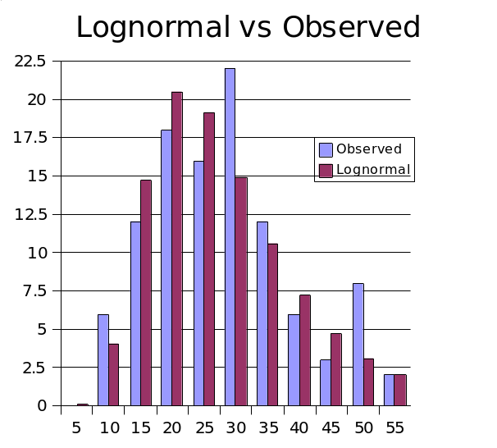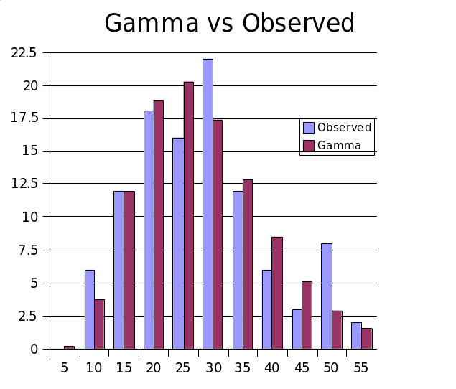
Figure 1. Comparison of observed landfall Rmax (sm) distribution to Lognormal (left) and Gamma distribution fits of the data.

An examination of the Rmax database shows that intense storms, essentially category 5 storms, have rather small radii. Thermodynamic considerations (Willoughby, 1998) also suggest that smaller radii are more likely for these storms. Thus, we model category 5 (Delp>90 mb, where Delp=1013-Pmin and Pmin is the central pressure of the storm) storms using a gamma distribution, but with a smaller value of the θ parameter, which yields a smaller mean Rmax as well as smaller variance. We have found that for Category 1-4 (Delp<80) storms there is essentially no discernable dependence of Rmax on central pressure. This is further verified by looking at the mean and variance of Rmax in each 10 mb interval. Thus we model category 1-4 storms with a single set of parameters. For a gamma distribution, the mean is given by kθ, and variance is kθ². For category 5 storms, we adjust θ such that the mean is equal to the mean of the three category 5 storms in the database: 1935 No Name, 1969 Camille and 1992 Andrew. An intermediate zone between Delp=80 mb and Delp=90 mb is established where the mean of the distribution is linearly interpolated between the Category 1-4 value and the Category 5 value. As the θ value is reduced, the variance is likewise reduced. Since there are insufficient observations to determine what the variance should be for Category 5 storms, we rely on the assumption that variance is appropriately described by the re-scaled θ, via kθ².
A simple method is used to generate the gamma-distributed values. A uniformly distributed variable, a product of the random number generator that is intrinsic to the Fortran compiler, is mapped onto the range of Rmax values via the inverse cumulative gamma distribution function. For computational efficiency, a lookup table is used for the inverse cumulative gamma distribution function, with interpolation between table values. Figure 2 shows a test using 100,000 samples of Rmax for Category 1-4 storms, binned in 1 sm intervals, and compared with the expected values.

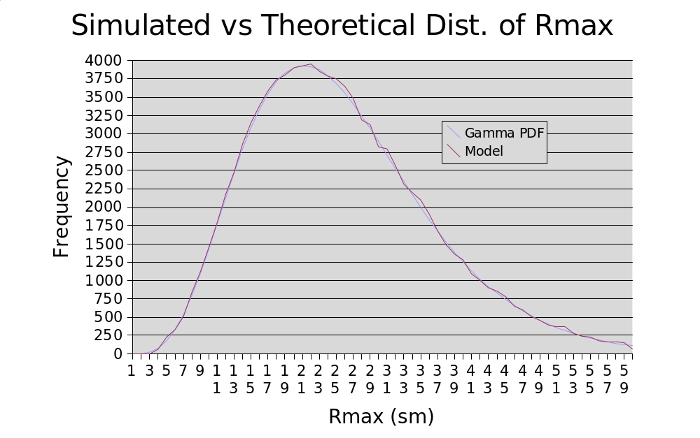
Figure 2. Comparison of 100,000 Rmax values sampled from the Gamma distribution for Cat 1-4 storms to the expected values.

For category 5 and intermediate category 4-5 storms, we utilize the property that the gamma cumulative distribution function is a function of (k,x/θ). Thus, by re-scaling θ, we can use the same function (lookup table), but just rescale x (Rmax). The rescaled Rmax will then still have a gamma distribution, but with different mean and variance.

The storms in the stochastic model will undergo central pressure changes during the storm life-cycle. When a storm is generated, an appropriate Rmax is sampled for the storm. In order to assure the appropriate mean values of Rmax as pressure changes, the Rmax is rescaled every time step as necessary. As long as the storm has Delp < 80 mb, there is in effect no rescaling. In the stochastic storm generator, we limit the range of Rmax from 4 sm to 60 sm.

Recent research results by Willoughby and Rahn (2004) based on the NOAA-AOML-HRD annual hurricane field program and Air Force reconnaissance flight-level observations are used to create the Holland B model. Ongoing research on the relationship between horizontal surface wind distributions (based on Stepped Frequency Microwave Radiometer observations) to flight level distributions is used to correct the flight level Rmax to a surface Rmax, when developing a relationship for the Holland B term. We multiply the flight level Rmax (from the Willoughby and Rahn (2004) data set) by 0.815 to estimate the surface Rmax (based on SFMR, flight level maxima pair data). This adjustment keeps the Holland pressure profile parameter consistent with a surface Rmax, and (due to the negative term in the equation) produces a larger value of B than if a flight-level value of Rmax were used. This is consistent with the concept of a stronger radial pressure gradient for the mean boundary layer slab than at flight level (due to the warm core of the storm), which agrees with GPS dropsonde wind profile observations showing boundary layer winds that are stronger than those at the 10,000 ft. flight level (which is the level for the most of the B data in Willoughby and Rahn 2004). The B adjustment for a surface Rmax produces an overall stronger surface wind field than if B were not adjusted. In addition, surface pressures from the “Best track” information on HURDAT are used to associate a particular flight-level pressure profile B with a surface pressure.

The NOAA-AOML- HRD H*Wind analysis archive was used to develop a relationship between Rmax and the extent of damaging winds to make sure that the model would only consider zip codes with potential for damaging winds. HRD wind modeling research initiated by Ooyama (1969), and extended by Shapiro (1983) has been used to develop the HRD wind field model. This model is based on the concept of a slab boundary layer model, a concept pioneered at NOAA-AOML- HRD and now in use by other modelers for risk applications (e.g. Thompson and Cardone 1996, Vickery and Twisdale 1995, 2000). The HURDAT historical database is used to develop the track and intensity model. Historical data used for computing the potential intensity is based on NCEP sea surface temperature archives and the NCEP reanalysis for determining the upper tropospheric outflow temperatures. Furthermore the ability of the model to simulate possible future climate scenarios of El Nino, La Nina, and warm or cold interdecadal periods is based on research on climate cycles including (Bove et al, 1998, Landsea et al., 1999, Goldenberg et al., 2001). Climate scenarios are disabled in Version 2.6 of the Florida Public Hurricane Loss Model. Use cases describing the various model functions and their research basis are available with the model documentation.

M-2.2 Describe the dependencies among variables in the wind field component and how they are represented in the model.

B depends linearly on Pmin, latitude, and Rmax. The gradient wind for the slab boundary layer depends on Pmin (through DelP) and B, the mean slab planetary boundary layer (PBL) wind depends on the gradient wind, the drag coefficient (which depends on wind speed), the air density, the gradients of the tangential and radial components of the wind, and the Coriolis parameter (which also depends on latitude). The wind field model solves the equations of motion on a polar grid with a 0.1 R/Rmax radial grid resolution. The input Rmax is reduced by 10% to correct a small bias in Rmax caused by a tendency of the wind field solution to place Rmax radially outward by one grid point. The wind field model terms and dependencies are further described in Powell et al., 2005.

M-2.3 Describe the process for converting gradient winds to surface winds including the treatment of the inherent uncertainties in the conversion factor with respect to location of the site compared to the radius of maximum winds over time. Justify the variation of the gradient to surface winds conversion factor relative to hurricane intensity.

Gradient winds are not converted to surface winds in this model. Gradient winds are used to help estimate the initial slab planetary boundary layer (PBL) winds in a given storm. The PBL winds depart from gradient balance due to the effects of friction and the radial advection of tangential momentum. The PBL winds are adjusted to the surface using recent results from Powell et al., 2003 which estimated a mean reduction factor of 77.5%, based on over 300 GPS sonde wind profile observations in hurricanes. The reduction factor is based on the ratio of the surface wind speed at 10 m to the mean wind speed for the 0-500 m layer (Mean Boundary Layer wind speed or MBL) published in Powell et al., 2003. This ratio is much more relevant to a slab boundary layer model than using data based on higher, reconnaissance aircraft flight levels. The depth of the slab boundary layer model is assigned a value of 450 m, which is the level of the maximum mean wind speed from GPS sonde wind profiles published in Powell et al., 2003. The uncertainty of the reduction factor is ~8% based on the standard deviation of the measurements, but no attempt is made to model this uncertainty. No spatial or intensity dependent variation of reduction factor is used at this time.

M-2.4 Describe how the wind speeds generated in the wind field model were converted from sustained to gust and identify the average time.

Wind speeds from the HRD slab boundary layer wind field model are assumed to represent 10 min averages. A sustained wind is computed by applying a gust factor to account for the highest 1 min wind speed over the 10 min period. A peak 3s gust is also computed. Gust factors depend on wind speed and the upstream fetch roughness which in turn depends on wind direction at a particular location. Gust factor calculations were developed using research in the Engineering Sciences Data Unit (ESDU) series papers as summarized and applied to tropical cyclones by Vickery and Skerlj (2005).

M-2.5 Describe how the asymmetric nature of hurricanes is considered in the model.

The asymmetry of the wind field is determined by the storm translation motion (right-left asymmetry), and the associated asymmetric surface friction. A set of form factors for the wind field also contribute to the asymmetry. The proximity of the storm to land also introduces an additional asymmetry due to the affect of land roughness elements on the flow. Azimuthal variation is introduced thru the use of two form factors (see Appendix of Powell et al., 2005 for more detail). The form factors multiply the radial and tangential profiles and provide a “factorized” ansatz for both the radial and tangential storm–relative wind components. Each form factor contains three constant coefficients which are variationally determined in such a way that the ansatz constructed satisfies (as far as its numerical degrees of freedom permit) the scaled momentum equations for the storm-relative polar wind components.
M-2.6 Describe the stochastic hurricane tracks and discuss their appropriateness. Describe the historical data used as the basis for the model’s hurricane tracks.
The hurricane tracks are modeled as a Markov process. Initial storm conditions are derived from HURDAT. Small uniform random perturbations are added to the historical initial conditions, including initial storm location, change in motion, and intensity.
Storm motion is determined by sampling empirical distributions, based on HURDAT, of change in speed and change in direction, as well as change in relative intensity. These functions are also spatially dependent, binned in variable box sizes (typically 2.5 degree), and are enlarged as necessary to ensure sufficient density of storms for the distribution.
The model has been validated by examining key hurricane statistics at roughly 30 sm milepost locations along the Gulf and Atlantic coasts. The parameters examined include average central pressure deficit, average heading angle and speed, and total occurrence by Saffir-Simpson category.
Figure 9 shows a sample of the generated stochastic tracks.

M-2.7 Describe how the coastline is segmented (or partitioned) in determining the parameters for hurricane frequency used in the model. Provide the hurricane frequency distribution by intensity for each segment.

The model does not use coastline segmentation to determine hurricane frequency.

M-2.8 For hurricane characteristics modeled as random variables, describe the probability distributions.

Initial storm positions and motion changes derived from HURDAT are modified by the addition of small uniform random error terms. Subsequent storm motion change and intensity are obtained by sampling from empirically derived PDFs as described in Section G-1.2. The random error term for the B parameter is a normal distribution with zero mean and a standard deviation derived from observed reconnaissance aircraft pressure profile fits for B (Willoughby and Rahn 2004). The radius of maximum winds is sampled from a gamma distribution based on landfall Rmax data.

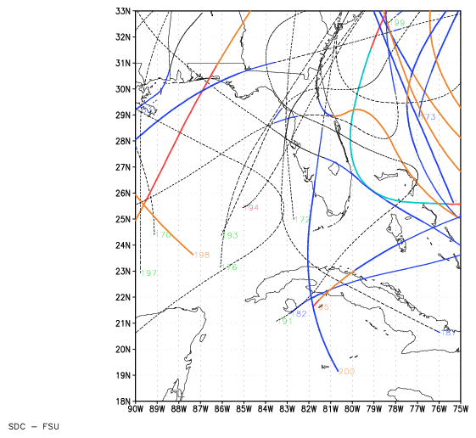
Figure 3. Representative stochastic hurricane tracks simulated by the FPHLM.

M-2.9 Identify any changes in the functional representation of hurricane characteristics during an individual storm event life cycle.

Upon landfall, the evolution of the central pressure changes from sampling a PDF, to a decay model described in Vickery (2005). When the storm exits back over water, the pressure is again modeled via the PDF. After landfall, the slab boundary layer surface drag coefficient changes from a functional marine form to a constant based on a mean aerodynamic roughness length of 0.2 m. The slab boundary layer height increases from 450 m to 1 km after the center makes landfall, and decreases back to 450 m if the center exits land to go back to sea.

M-2.10 Describe how the model’s wind field is consistent with the inherent differences in wind fields for such diverse storms as Hurricane Charley, Hurricane Katrina, and Hurricane Wilma, for example.

The model can represent a wide variety of storms through variation of parameters for radius of maximum winds, central pressure deficit and Holland Beta (B). Snapshots of model wind fields at landfall are compared to NOAA-AOML-HRD H*Wind analyses below (for further details see disclosure 3 for Standard S1).

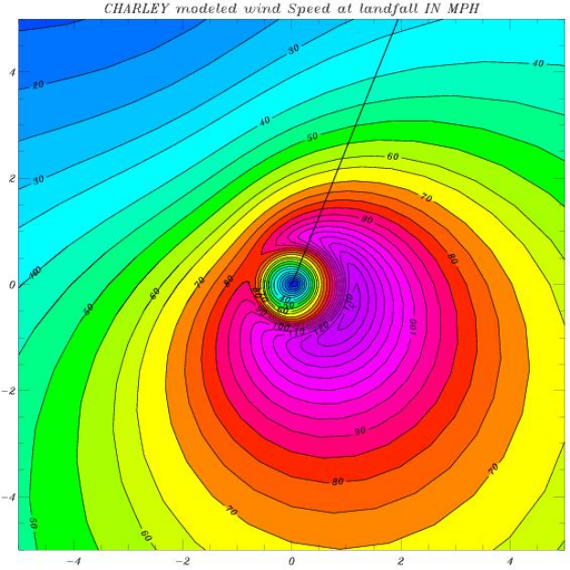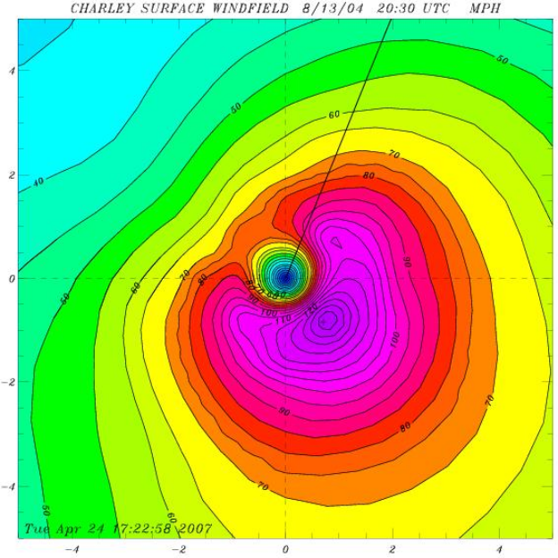
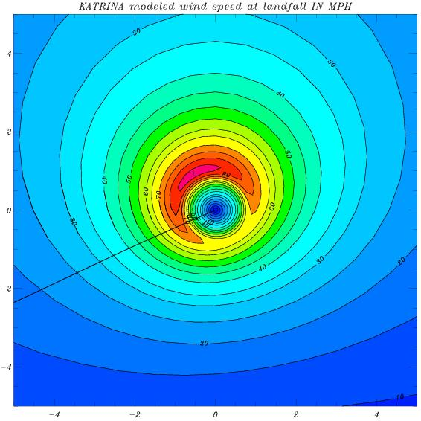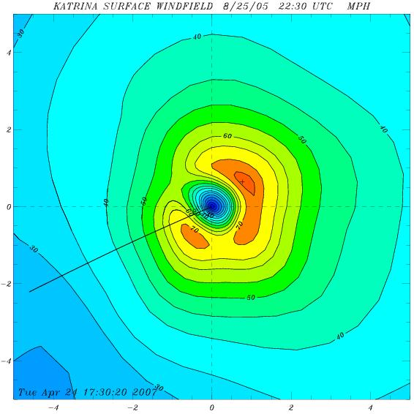
Figure 4. Comparison of observed (right) and modeled (left) landfall wind fields of Hurricanes Charley (2004, top), and 2005 Hurricane Katrina in south Florida (bottom). Line segment indicates storm heading. Horizontal coordinates are in units of R/Rmax and winds units of miles per hour.
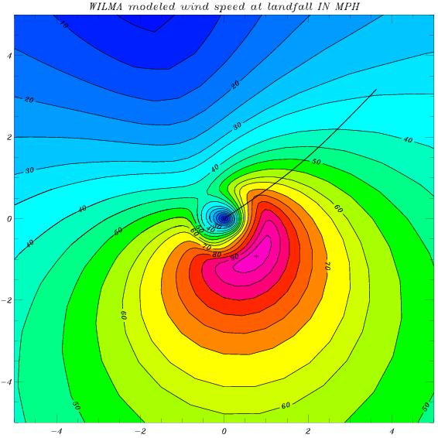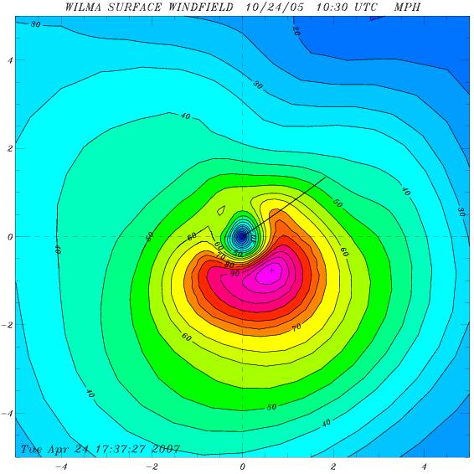
Figure 5. As in Figure 4 except for Hurricane Wilma of 2005.

M-3 Landfall Intensity

Models shall use maximum one-minute sustained 10-meter wind speed when defining hurricane landfall intensity. This applies both to the Base Hurricane Storm Set used to develop landfall strike probabilities as a function of coastal location and to the modeled winds in each hurricane which causes damage. The associated maximum one-minute sustained 10-meter wind speed shall be within the range of wind speeds (in statute miles per hour) categorized by the Saffir-Simpson scale.

Table 1. Saffir-Simpson Hurricane Scale

Category | Winds (mph) | Damage
1 | 74 - 95 | Minimal
2 | 96 - 110 | Moderate
3 | 111 - 130 | Extensive
4 | 131 - 155 | Extreme
5 | Over 155 | Catastrophic

The HRD wind field model simulates landfall intensity according to the maximum 1 min sustained wind for the 10 m level for both stochastic simulations and the Official Hurricane Set. The Saffir-Simpson damage potential scale is used to further categorize the intensity at landfall and the range of simulated wind speeds (in miles per hour) is within the range defined in the scale.

M-3.1 Define an “event” in the model. Discuss how storms that intensify or decay at or below the Category 1 level are accounted for in the model.
An event is any hurricane that makes landfall in the state of Florida or bypasses Florida but approaches close enough to pass within a specified damage threshold distance of a Florida zip code. The damage threshold distance depends on Rmax and ranges from 11 Rmax (e.g. 35 sm) for small (~4 sm Rmax) storms to 4 max (e.g. 125 sm for Rmax = 31 sm) for larger Rmax storms. The damage threshold distance does not vary by zip code; each zip code distance from the storm is compared to the threshold. If any zip code distance from the storm center is within this distance from the storm, the wind model is “turned on” and the wind speeds at all zip codes are evaluated to determine the maximum wind over the entire storm lifecycle. Once a hurricane makes landfall, it decays exponentially with time during the period the storm center remains over land. A hurricane that has made landfall is permitted to decay to less than hurricane (Cat 1) intensity provided it remains within a threshold distance of Florida zip codes. A storm dissipates over land if Pmin reaches 1011 mb. Once a landfalling hurricane decays to tropical storm strength and exits out to sea, it may reintensify to hurricane status and make subsequent landfalls. Stochastic or historical events may be simulated.

M-3.2 Describe how the model handles events with multiple landfalls and by-passing storms. Be specific with respect to how by-passing storms are handled in the model when the wind speeds are less than hurricane force winds.
If multiple landfalls of a given hurricane occur, winds are computed for all zip codes within a threshold distance of the center of the storm during its entire life cycle. A by-passing hurricane is considered in the model if it approaches close enough to pass within the damage threshold distance of a Florida zip code, provided zip code mean open terrain wind speeds exceed 30 mph. Storms that by-pass or landfall with less than hurricane (Cat 1) intensity are not considered.

M-3.3 Provide all model derived characteristics of the Florida hurricane in the stochastic storm set with the greatest over water intensity at the time of landfall.
Model run date:10 June 2007
Number of years: 50,000
Storm Date/Year: Storm#34827, Year 17656 September 8th
Location: 25.56 N, 82.25 W (Sanibel Island)
Maximum sustained surface (marine exposure) wind speed (mph): 195.9 mph
Minimum Pressure (mb): 906 mb
Rmax (sm): 8.3 sm
Holland B pressure profile parameter: 1.88

M-4 Hurricane Probabilities

A. Modeled probability distributions for hurricane intensity, forward speed, radii for maximum winds, and storm heading shall be consistent with historical hurricanes in the Atlantic basin.

Hurricane motion (track) is modeled based on historical geographic and seasonal probability distributions of hurricane genesis locations (locations where hurricanes developed or moved into the threat area), translation velocity and velocity change, initial intensity, intensity change, and potential intensity. Monthly geographic distributions of climatological sea surface temperatures (Reynolds 1 degree resolution, Reynolds et al., 2002) and upper tropospheric outflow temperatures (NCEP REANALYSIS II 100 mb, Kanamitsu et al., 2002) are used to determine physically realistic potential intensities which help to bound the modeled intensity. The radius of maximum wind at landfall is modeled from a comprehensive set of historical data published in NWS-38 by Ho et al, (1987) but supplemented by the extended best track data of DeMaria, (Penington 2000), NOAA HRD research flight data, and NOAA-HRD H*Wind analyses (Powell et al., 1996, 1998). The development of the Rmax frequency distribution fit and it’s comparison to historical hurricane data is discussed in M-2.1. Comparisons of the modeled radius of maximum wind to the observed data are shown in Form M3. H*Wind wind field analyses of historical hurricanes are available from the NOAA-AOML-HRD web site: http://www.aoml.noaa.gov/hrd/data_sub/wind.html
Modeled probability distributions for hurricane intensity, forward speed, Rmax, and storm heading are consistent with historical hurricanes in the Atlantic basin.

B. Modeled hurricane probabilities shall reflect the Base Hurricane Storm Set used for category 1 to 5 hurricanes and shall be consistent with those observed for each coastal segment of Florida and neighboring states (Alabama, Georgia, and Mississippi).

As shown in Form M1 and the accompanying plots, our model reflects reasonably the Hurricane Set for 1900-2005 for hurricanes of Saffir-Simpson Categories 1-5 in each coastal region of Florida as well as the neighboring states. In addition, a finer scale coastal mile post study of model parameters (occurrence rate, storm translation speed, storm heading, and Pmin) was conducted during the development of the model.

M-4.1 List assumptions used in creating the hurricane characteristic databases.
The Holland B database is based on flight-level pressure profiles corresponding to constant pressure surfaces at 700 mb and below. Due to a lack of surface pressure field data, an assumption is made that the Holland B at the surface is equivalent to a B determined from information collected at flight level. The surface pressure profile uses Pmin, DelP, and Rmax at the surface. It would be ideal to have a B data set also corresponding to the surface but such data are not available. The best available data on B are flight-level data from Willoughby and Rahn 2004. Willoughby and Rahn 2004 discuss: “In major hurricanes... they almost invariably flew at 3km (700 mb) .” Few lower level data are available for mature hurricanes so their plot (Fig. 14) of B vs. flight-level “provide no information about average vertical structure”. In lieu of lower level data, we model B using flight data supplied by Dr. Willoughby, but with Rmax adjusted to a surface Rmax, and with surface DelP added from NHC best track for each flight. Since we are modeling hurricane winds during landfall, our Rmax model applies only to landfall and is not designed to model the lifecycle of Rmax as a function of intensity.

M-4.2 If the model incorporates short term and long term variations in annual storm frequencies, describe how this is incorporated.
Storm frequencies are based on historical occurrences derived from HURDAT, and thus implicitly contain any long or short term variation that are contained in the historical record. No attempt is made to explicitly model long or short term variations.

M-4.3 Provide a completed Form M-1, Annual Occurrence Rates.
Form M1 is attached.

Form M-1: Annual Occurrence Rates

A. Provide annual occurrence rates for landfall from the data set defined by marine exposure that the model generates by hurricane category (defined by wind speed in the Saffir-Simpson scale) for the entire state of Florida and selected regions as defined in Figure 6. List the annual occurrence rate (probability of an event in a given year) per hurricane category. Annual occurrence rates should be rounded to two decimal places.

B. The historical frequencies below have been derived from the Commission’s Official Hurricane Set. If the National Hurricane Center’s HURDAT or other hurricanes in addition to the Official Hurricane Set as specified in Standard M-1 are used, then the historical frequencies should be modified accordingly.

Historical frequencies are based on the June 2006 version of HURDAT for the period 1900-2005. We count the first hurricane landfall in Florida and ignore subsequent landfalls of a given hurricane. For regions E and F, we count the first hurricane landfall in each region for storms that did not previously make landfall in Florida. For By-passing storms, we count any hurricane that does not make landfall in Florida, but passes close enough to the state to pass within a damage threshold of a Florida zip code. Of special note is that Region C has an abnormally large number of SS Cat 3 hurricanes and Region D has a large deficit of hurricanes.

Form M-1. Modeled Annual Occurrence Rates

 | Entire State |  | Region A – NW Florida |  | Region B – SW Florida
Category | Historical | Modeled | Historical | Modeled | Historical | Modeled
1 | 0.25 | .17 | 0.10 | .08 | 0.08 | .03
2 | 0.11 | .12 | 0.04 | .05 | 0.03 | .03
3 | 0.17 | .13 | 0.03 | .04 | 0.06 | .04
4 | 0.04 | .06 | 0.00 | .02 | 0.02 | .02
5 | 0.02 | .01 | 0.00 | .00 | 0.01 | .00
 | Region C – SE Florida |  | Region D – NE Florida |  | Florida By-Passing Hurricanes
Category | Historical | Modeled | Historical | Modeled | Historical | Modeled
1 | 0.07 | .05 | 0.00 | .01 | 0.04 | .04
2 | 0.04 | .03 | 0.01 | .01 | 0.03 | .02
3 | 0.08 | .04 | 0.00 | .01 | 0.03 | .03
4 | 0.02 | .03 | 0.00 | .00 | 0.01 | .01
5 | 0.01 | .01 | 0.00 | .00 | 0.00 | .00
 | Region E – Georgia |  | Region F – Alabama/Mississippi
Category | Historical | Modeled | Historical | Modeled
1 | 0.01 | .01 | 0.06 | .03
2 | 0.01 | .00 | 0.02 | .02
3 | 0.00 | .00 | 0.06 | .02
4 | 0.00 | .00 | 0.00 | .01
5 | 0.00 | .00 | 0.01 | .00

Note: Results based on 50,000 year simulation of 6-10-2007.
Form M-1. Chi Square Goodness of Fit Tests
Results based on 50,000 year simulation of 6-10-2007.

Region | Saffir- Simpson Category | Number of Modeled hurricanes * per 106 year period | Number of Historical hurricanes * 1900-2005 (106 years) | Chi Square | P
State | 1 | 18.5 | 27 | 4.86 | 0.18
 | 2 | 13.1 | 12
 | 3 | 13.7 | 18
 | 4-5 | 8.5 | 6
A | 1 | 8.8 | 11 | 3.18 | 0.07
 | 2-5 | 11.4 | 7
B | 1 | 3.4 | 9 | 4.48 | 0.11
 | 2 | 3.6 | 3
 | 3-5 | 6.1 | 9
C | 1 | 5.4 | 7 | 1.58 | 0.45
 | 2 | 3.7 | 4
 | 3-5 | 8.2 | 12
F | 1 | 3.5 | 6 | 2.7 | 0.26
 | 2 | 1.8 | 2
 | 3-5 | 3.6 | 7
By-Passing | 1 | 4.3 | 4 | 0.0316 | 0.86
 | 2-5 | 6.9 | 7

C. Describe model variations from the historical frequencies.

The Public model tends to under-predict the number of Cat 1 storms in Regions A, B, and C, and the number of Cat 3 storms in Regions C and F. The historical data for Regions C and F show what may be an anomalous number of Category 3 storms. Category 3 storms in Region C and F are apparently more common than the weaker Cat 1 and 2 storms. This tendency may not be realistic. The more intense hurricanes, especially major hurricanes of Category 3 or higher, are rare events that require special atmospheric and oceanic conditions to develop and thrive (Emanuel 1987, Merrill 1988, Evans 1993). Underscoring this, DeMaria and Kaplan (1995) found that on average, tropical cyclones only reach ~55% of their maximum potential intensity; therefore we would expect to find larger numbers of weak (e.g. more Cat 1 than Cat2) hurricanes than major (more Cat 2 than Cat 3, more Cat 3 than Cat 4, and more Cat 4 than Cat 5) hurricanes. We believe the early part of the historical record may have missed some of the weaker hurricanes, due to the limited population in the state at that time and the limited observing network available to document such events. For the later part of the historical record, the uncertainty in assessing peak wind speeds from historical data is such that some of the region C storms deemed to be Cat 3 are more likely to have been Cat 2, some Cat 2 storms more likely Cat 1 and some Cat 1, more likely tropical storms. Based on analyses of wind observations published in the peer-reviewed atmospheric science literature (e.g. Powell 1982, 1987, Powell et al., 1991, 1996, 1998, Powell and Aberson 2001), the intensities of Cat 1-3 hurricanes in the HURDAT database may occasionally be one category too high. Table A1 from Powell and Aberson 2001, lists landfalling hurricanes from 1975-2000 and includes several storms with alternative estimates of intensity.

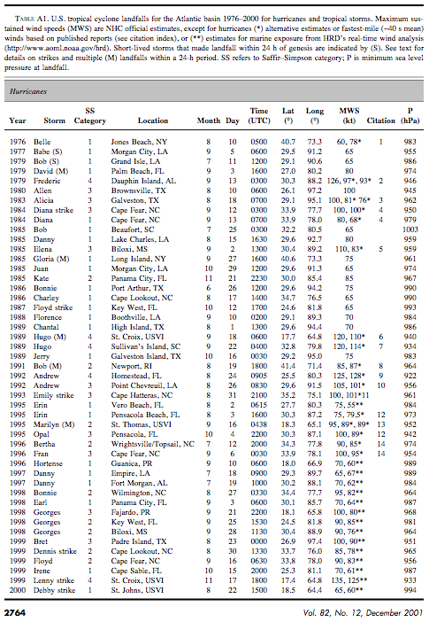

The Public model also predicts Cat 4 and 5 storms in Region A, where none are in the historical record. Cat 5 hurricanes have been in relatively close proximity to regions A (1969 Camille and 2005 Katrina were off the Mississippi and Louisiana Gulf coasts). Depending on the northward extent of the Loop current and the proximity of any warm core rings to NW Florida (Vukovitch 2005), we believe that it is likely that a Cat 4 or 5 hurricane landfall affected NW Florida prior to 1900. The Public model also predicts landfalls of major (> Cat3) hurricanes in Regions D and E, where none are indicated in the 1900-2005 record. We note that major hurricanes were documented in these areas prior to 1900.

Finally we should mention that recent work by Powell and Reinhold 2007 found that the Saffir Simpson scale, since it does not take into account storm size, is a poor indicator of destructive potential. Powell and Reinhold (2007) advocate a scale which takes into account the area coverage of damaging winds as well as the physical process behind the wind loading associated with wind damage to structures. Their Wind Damage Potential scale has a continuous numerical range from 0-5.99 and is based on the storm total surface kinetic energy contributed by sustained winds over 56 mph. The WDP storm ratings will appear in H*Wind experimental wind field analysis products during the 2007 Atlantic basin hurricane season. Comparison of observed and model WDP calculations should yield more valuable information on model performance than comparing intensity or Saffir-Simpson scale ratings.

D. Provide vertical bar graphs depicting distributions of hurricane frequencies by category by region of Florida (Figure 6) and for the neighboring states of Alabama/Mississippi and Georgia. For the neighboring states, statistics based on the closest milepost to the state boundaries used in the model are adequate.
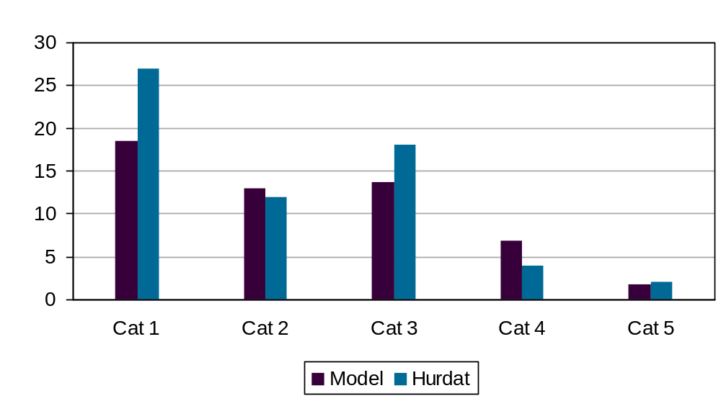
Figure 6.Form M1 comparison of modeled and historical landfalling hurricane frequency statewide.

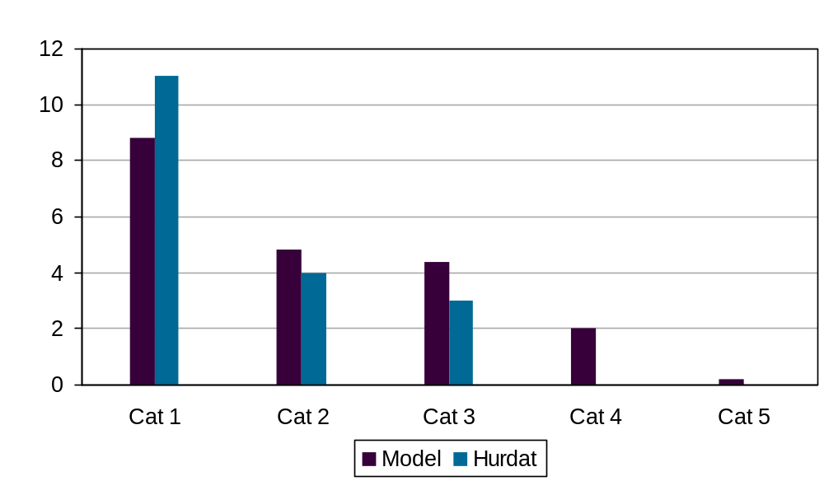
Figure 7. Form M1 comparison of modeled and historical landfalling hurricane frequency in region A

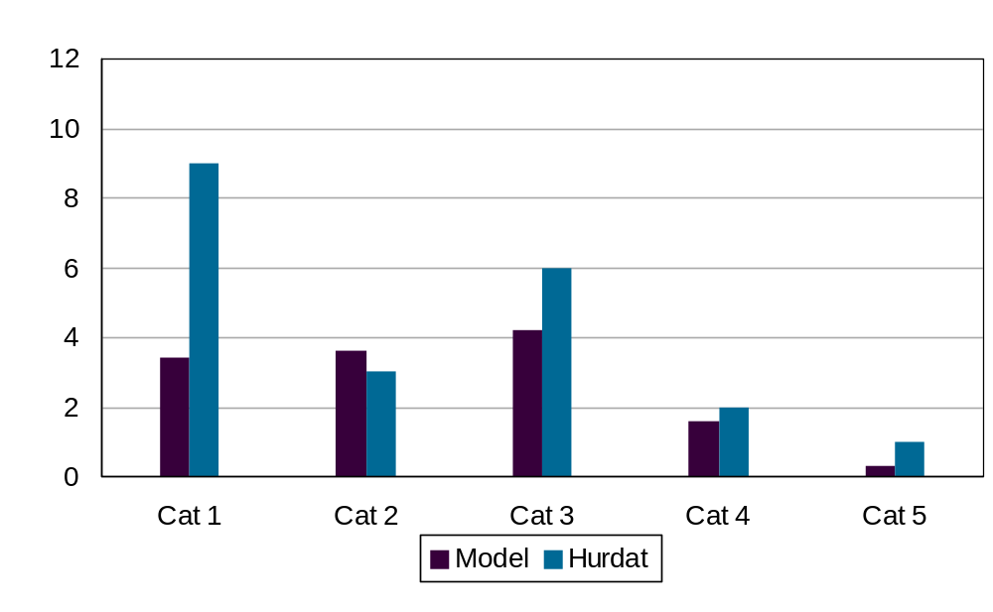
Figure 8. Form M1 comparison of modeled and historical landfalling hurricane frequency in region B

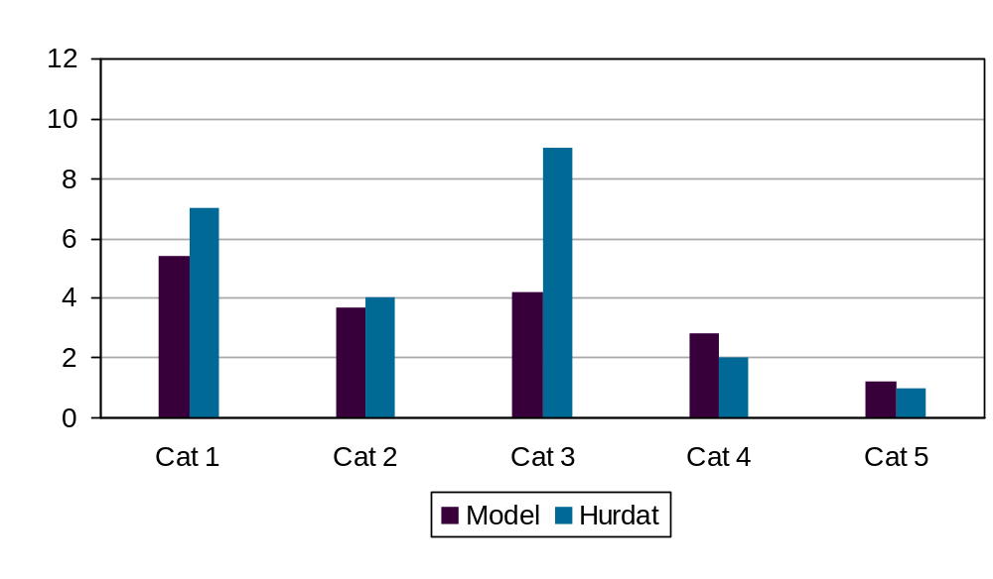
Figure 9. Form M1 comparison of modeled and historical landfalling hurricane frequency in region C

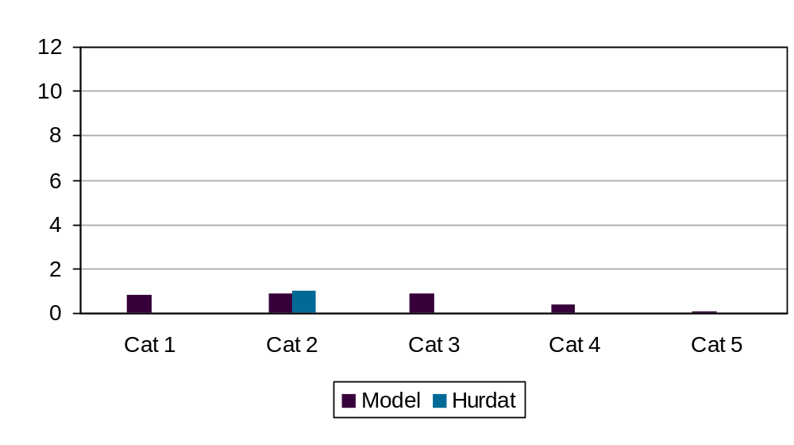
Figure 10. Form M1 comparison of modeled and historical landfalling hurricane frequency in region D

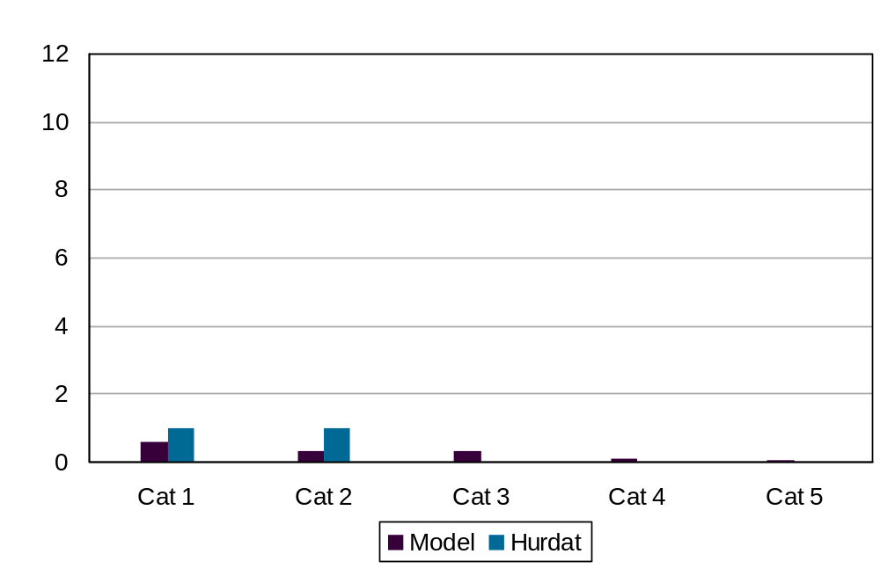
Figure 11. Form M1 comparison of modeled and historical landfalling hurricane frequency in region E

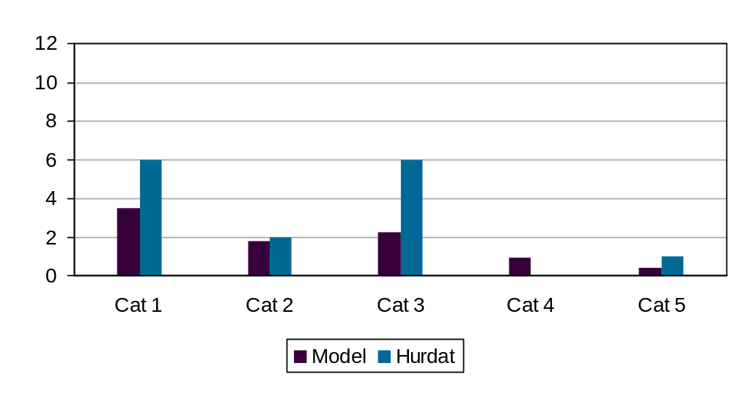
Figure 12. Form M1 comparison of modeled and historical landfalling hurricane frequency in region F

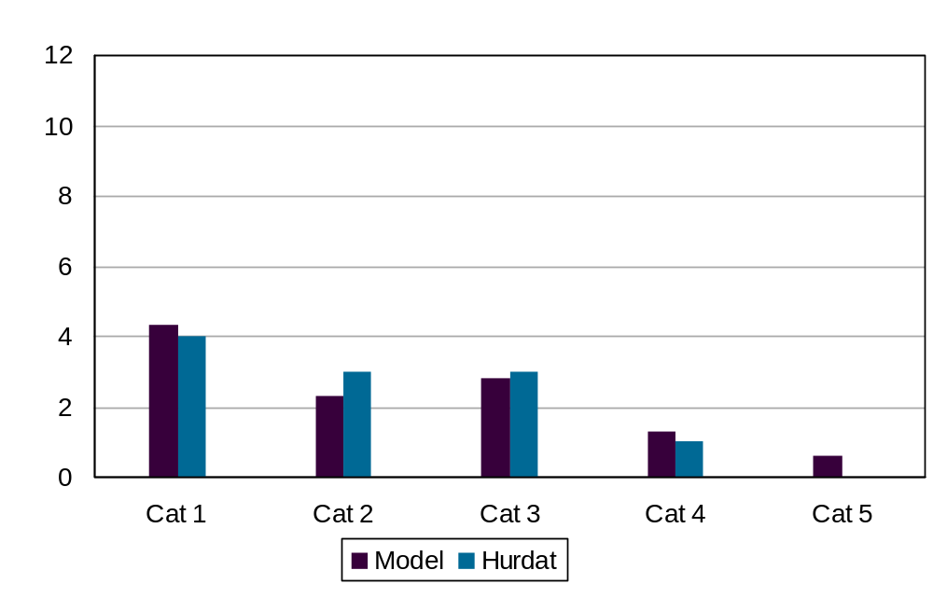
Figure 13. For Form M1 comparison of modeled and historical by-passing hurricane frequency

M-5 Land Friction and Weakening

A. The magnitude of land friction coefficients shall be consistent with currently accepted scientific literature relevant to current geographic surface roughness distributions and shall be implemented with appropriate geographic information system data.

Land friction is modeled according to the currently accepted principles of surface layer similarity theory as described in the disciplines of micrometeorology, atmospheric turbulence, and wind engineering. The geographic distribution of surface roughness is determined by careful studies of aerial photography, site visits, and satellite remote sensing measurements used to create land use - land cover classification systems. We have now incorporated the MRLC NLCD 2001 land use data set. This data set became available in Spring, 2007, and provides detailed (30 m) land use characteristics circa 2001. All population-weighted zip code centroids are assigned roughness values as a function of upstream fetch for each wind direction octant. After landfall, the surface drag coefficient used in the hurricane PBL slab model changes from a marine value to a fixed value associated with a roughness of 0.2 m.

B. The hurricane overland weakening rate methodology used by the model shall be consistent with historical records.

Overland weakening rates are based on a pressure decay model developed from historical data as described by a recent paper published in the peer-reviewed atmospheric science literature (Vickery 2005).

M-5.1 Describe and justify the functional form of hurricane decay rates used by the model.
The hurricane decay rate function acts to decrease the DelP with time after landfall. The functional form is an exponential in time since landfall and is based on historical data (Vickery 2005).

M-5.2 Describe the relevance of the gust factor used in the model.
The gust factors used in the model were developed from hurricane data and the Engineering Sciences Data Unit methods as described in Vickery and Skerlj (2005).
M-5.3 Identify all non-meteorological variables that affect the wind speed estimation (e.g., surface roughness, topography, etc.).
Upstream aerodynamic surface roughness within fixed 45 degree sector extending upstream has an effect on the determination of wind speed for a given zip code centroid and is the primary variable that affects estimation of surface wind speeds. The upstream sectors are defined according to the Tropical Cyclone Winds at Landfall Project (Powell et al., 2004), which characterized upstream wind exposure for each of eight wind direction sectors at over 200 coastal automated weather stations (Figure 14).

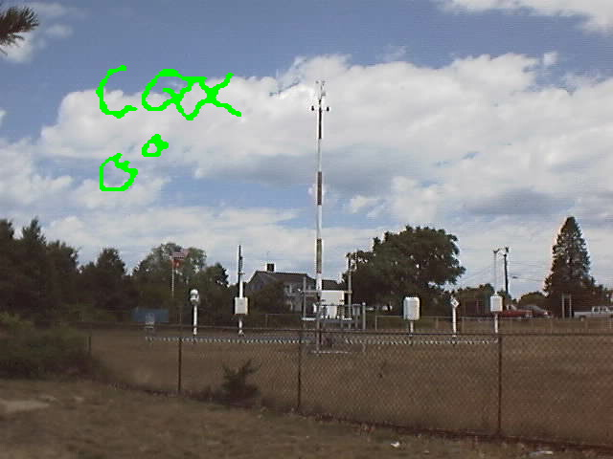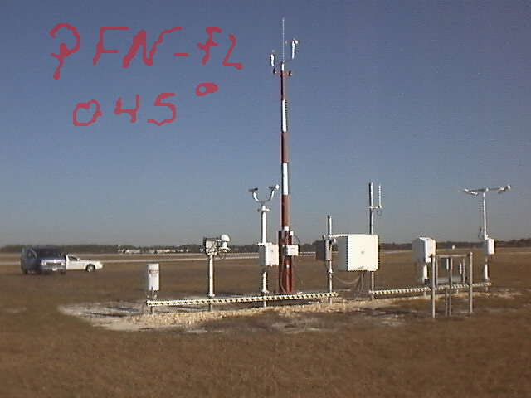

Figure 14. Upstream fetch wind exposure photograph for Chatham MS (left, looking north), and Panama City, FL (right, looking Northeast). After Powell et al., (2004)

M-5.4 Provide the collection and publication dates of the land use and land cover data used in the model and justify their timeliness for Florida.
We use the 2001 Multi-Resolution Land Characteristics Consortium (MRLC) National Land Cover Database released April 25, 2007. To the best of our knowledge, this is the most recent, high resolution (30 m) land cover data set that covers not only Florida, but the entire U.S, and roughly depicts land characteristics circa 2001 (see Homer et al., 2004 for more details).

M-5.5 Provide a graphical representation of the modeled degradation rates for Florida hurricanes over time compared to wind observations. Reference to the Kaplan-DeMaria decay rates alone are not acceptable.
The degradation of the wind field of a landfalling hurricane is associated with the filling of the central sea-level pressure and the associated weakening of the surface pressure gradient, as well as the fact that the hurricane is over land, where the flow is subject to friction while flowing across obstacles in the form of roughness elements. Maximum wind degradation is shown according to how the maximum sustained surface wind (at the location containing the maximum winds in the storm) changes with time after landfall. At landfall the marine exposure wind is assumed to be representative of the maximum winds occurring onshore. After landfall the open terrain wind is chosen to represent the maximum envelope of sustained winds over land. The NOAA-HRD H*Wind system is used to analyze the maximum winds at a sequence of times following landfalls of Hurricanes Katrina, Charley, Frances, Jeanne, and Wilma. H*Wind uses all available wind observations. The landfall wind field is used as a background field for times after landfall and compared to the available observations at a sequence of times after landfall. An empirical decay is applied to the background field based on the comparisons to the observations. These data are then objectively analyzed to determine the wind field at each time. The model maximum sustained winds are compared to the maximum winds from the H*Wind analyses for the same times and roughness exposures. In general, points after landfall are given for open terrain exposure. At times, even though the storm center is over land, the maximum wind speed may remain over water. For example, in the Frances plot, the first three pairs of points represent marine exposure, the next three open terrain, and the final three marine exposure again, while all Wilma point pairs represent marine exposure. The plots indicate that the Public wind field model realistically simulates decay of the maximum wind speed during the landfall process, as well as subsequent strengthening after exit.
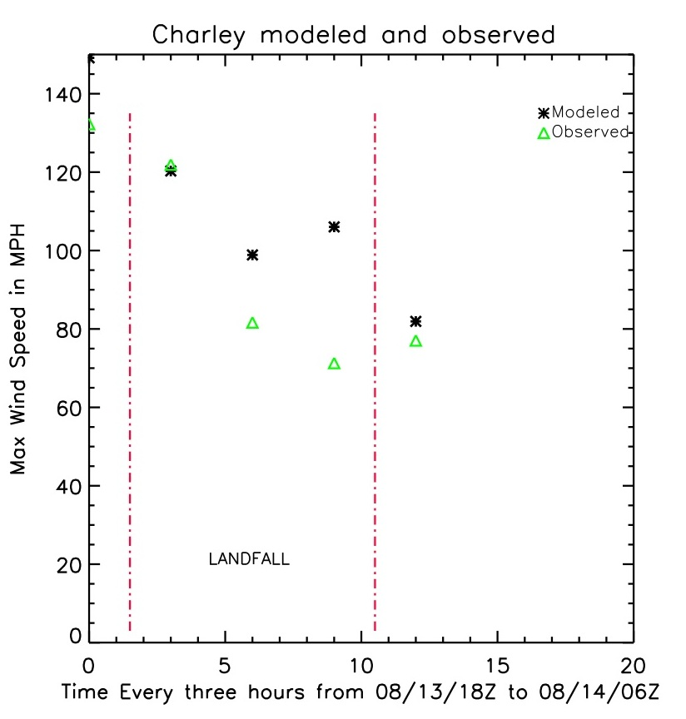
Figure 15. Observed (green) and modeled (black) maximum sustained surface winds as a function of time for 2004 Hurricanes Charley (left) and Frances (right). Landfall is represented by the vertical dash-dot red line at the left and time of exit as the red line on the right.
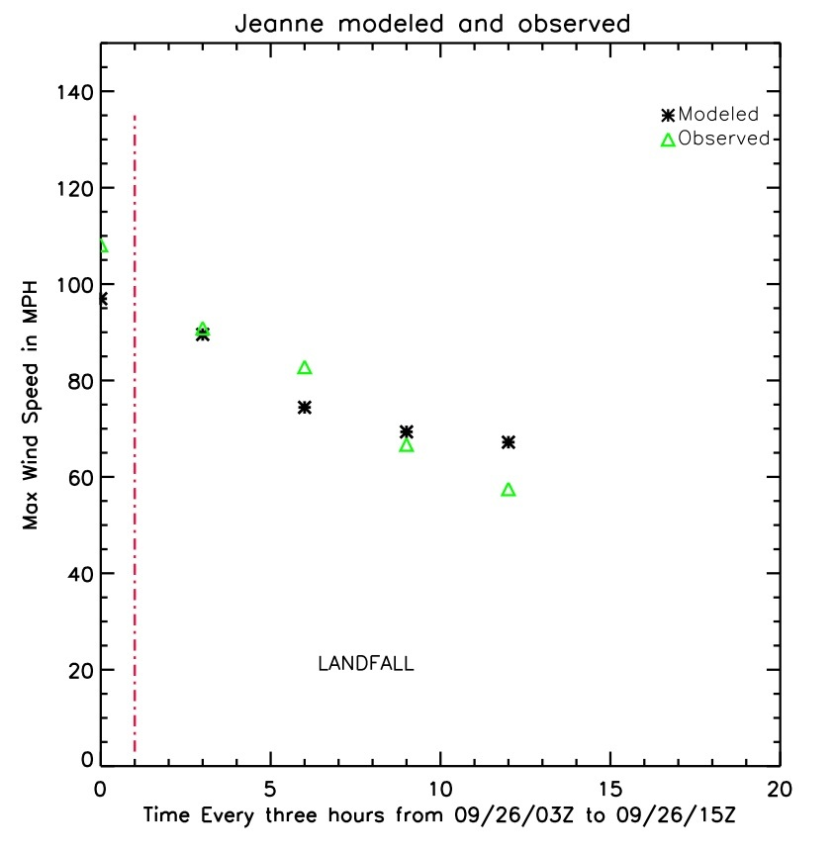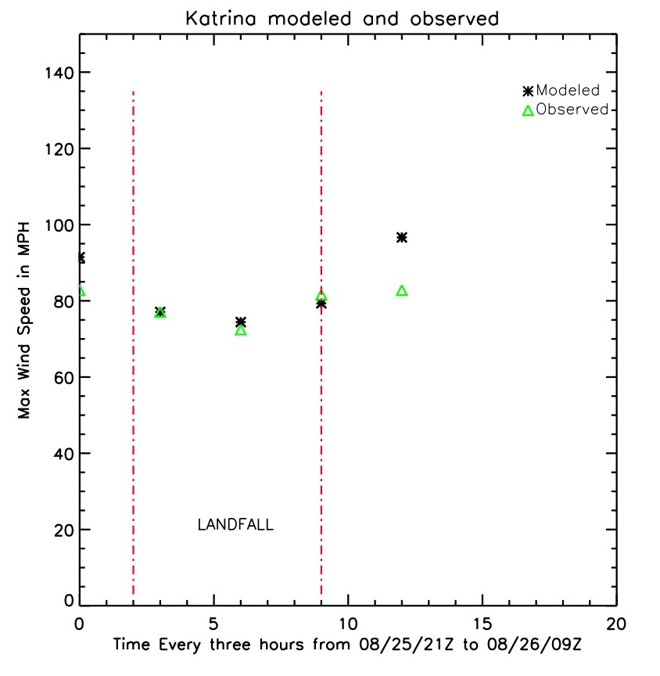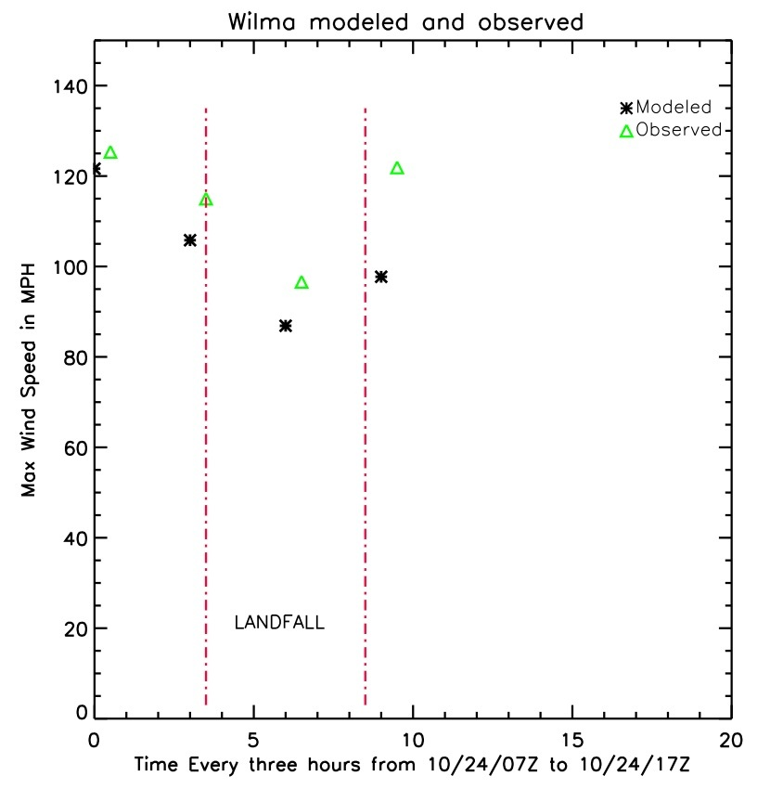

Figure 16. Observed (green) and modeled (black) maximum sustained surface winds as a function of time for Hurricanes Jeanne (2004, top left), Katrina (2005 in South Florida, top right), and 2005 Wilma (lower left). Landfall is represented by the vertical dash-dot red line at the left and time of exit as the red line on the right.

M-5.6 The spatial distribution of model-generated winds should be demonstrated to be consistent with observed winds.
See comparisons of modeled and observed wind fields in Disclosure 2.10

M-5.7 Document any differences between the treatment in the model of decay rates for stochastic hurricanes compared to historical hurricanes affecting Florida.
In the FPHLM model, decay is defined as the change in minimum sea-level pressure (Pmin) with time after landfall. The input file for the wind field model consists of a hurricane track file that contains storm position, Pmin, Rmax, and Holland B at 1h frequency. The wind field model is exactly the same for scenario (historical) or stochastic events. When running the model in scenario mode for historical hurricanes affecting Florida, we use a set of historical hurricane tracks as input to the model. When running the model in stochastic mode, the input hurricane tracks are provided by the track and intensity model. The track and intensity model uses the Vickery 2005 pressure decay after landfall. When a hurricane exits land, the Pmin over water is determined based on the Markov process as described in Disclosure G1.2

The historical tracks based on HURDAT are detailed on our web site at:

http://www.aoml.noaa.gov/hrd/lossmodel/

For historical hurricane tracks the landfall pressure is determined from HURDAT or from the Ho et al., (1987) report. If post-landfall pressure data are available in HURDAT, we interpolate pressure values over land. If post-landfall pressure data are not available, we apply the Vickery (2005) pressure decay model to the landfall pressure. After the storm exits land, the pressure is based on HURDAT data. Therefore, decay rates for historical hurricanes are based on HURDAT data if available, or the Vickery decay rate model applied to the HURDAT or Ho et al, (1987) landfall Pmin, while decay rates for stochastic hurricanes are based on Vickery 2005.

M-5.8 Provide a completed Form M-2, Maps of Maximum Winds.
Form M2 is attached.

Form M-2: Maps of Maximum Winds

A. Provide a color contour map of the maximum winds for the modeled version of the Base Hurricane Storm Set.

B. Provide a color contour map of the maximum winds for a 100-year return period from the stochastic storm set.

C. Provide the maximum winds plotted on each contour map.

Maximum winds in these maps are defined as the maximum one-minute sustained winds over the terrain as modeled and recorded at each location.

The same color contours and increments should be used for both maps.
Use the following seven isotach values:
- 40 mph
- 75 mph
- 95 mph
- 110 mph
- 130 mph
- 140 mph
- 155 mph

Note:

Two versions of Forms M2A and M2B were created corresponding to actual terrain and open terrain. The open terrain maps show the maximum winds or 100 year return period winds that would represent an upper envelope of winds that could occur for areas with wind exposures typical of an airport runway. The actual terrain maps show the affect of incorporating land-use land-cover data to determine, relative to the wind direction associated with the maximum wind speed, a roughness that takes into account elements upstream of the zip code centroid. The open terrain maps show the statewide variation of hurricane risk without the complication factor of roughness variation. The actual terrain maps show the combined effects of climatological risk as well as roughness variation, for example due to more tree cover in the northwest part of the state. The actual terrain acts as a mean condition due to the upstream smoothing methodology. Within a zip code assigned a relatively high roughness there could be small areas with open terrain that would experience higher winds.
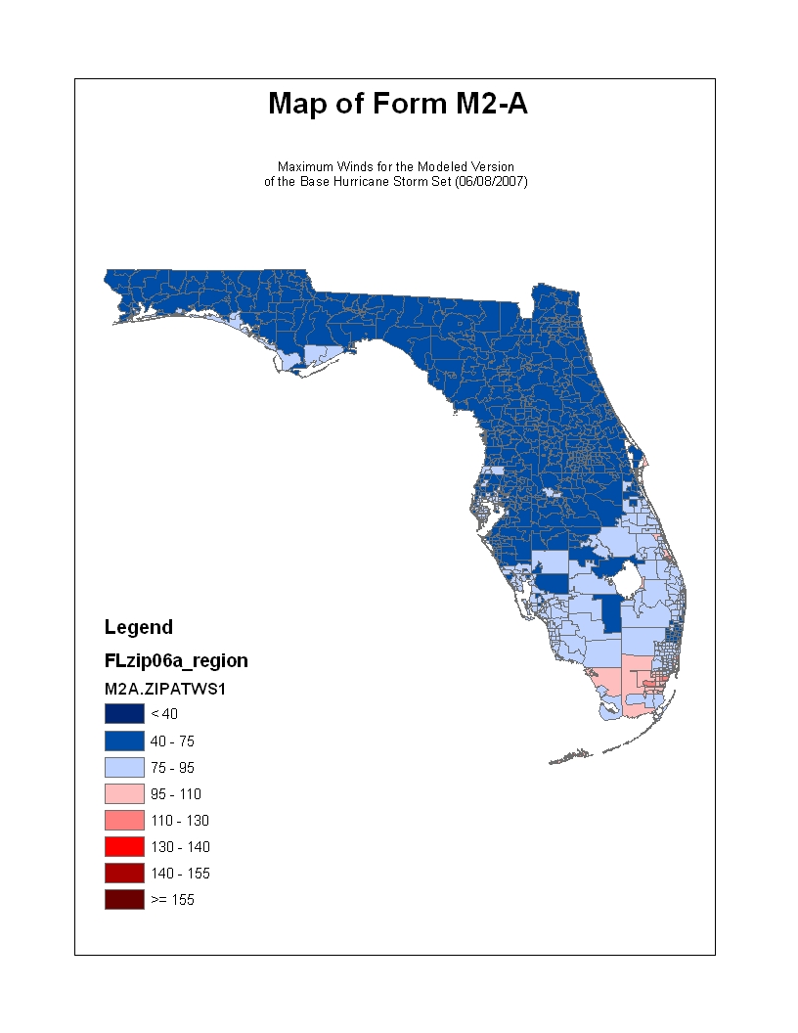
Max wind 156.7 mph at 33001 Storm 2, 1935

*
Figure 17. Maximum 1 min sustained surface (10 m) wind speeds (mph) for the hurricanes in the official base set for 1900-2005. Winds represent flow over actual terrain roughness based on remotely sensed land-use / land-cover data. Location of maximum is denoted by * symbol.
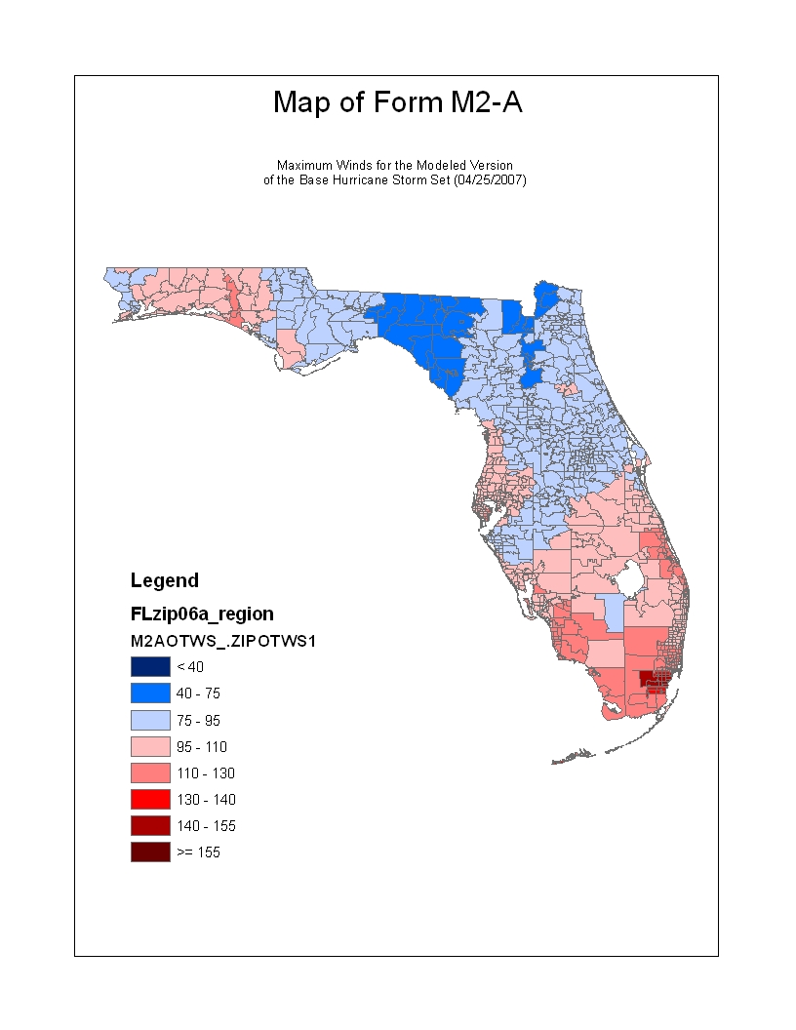
Max wind 163.5 mph at 33036
Storm 2, 1935
*
Figure 18. Maximum 1 min sustained surface (10 m) wind speeds (mph) for the hurricanes in the official base set for 1900-2005. Winds represent flow over open terrain roughness (0.03 m). Location of maximum is denoted by * symbol.
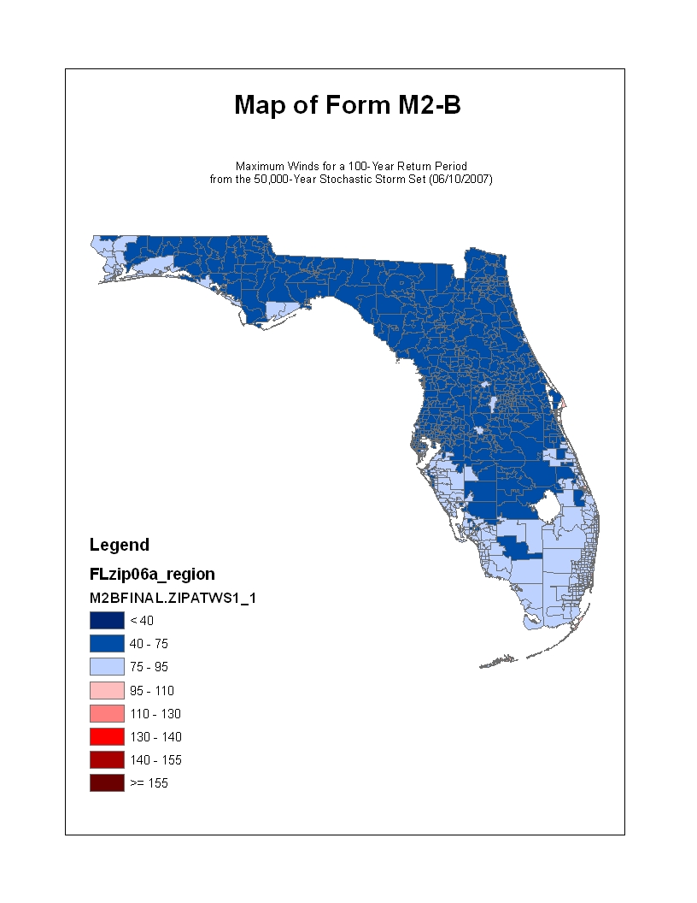
Maximum wind 107 mph at zip 33132
*
Figure 19. 100 Year return period maximum 1 min sustained surface (10 m) actual terrain wind speeds (mph) based on a 50,000 year simulation of 06-10-2007. Location of maximum is denoted by * symbol.
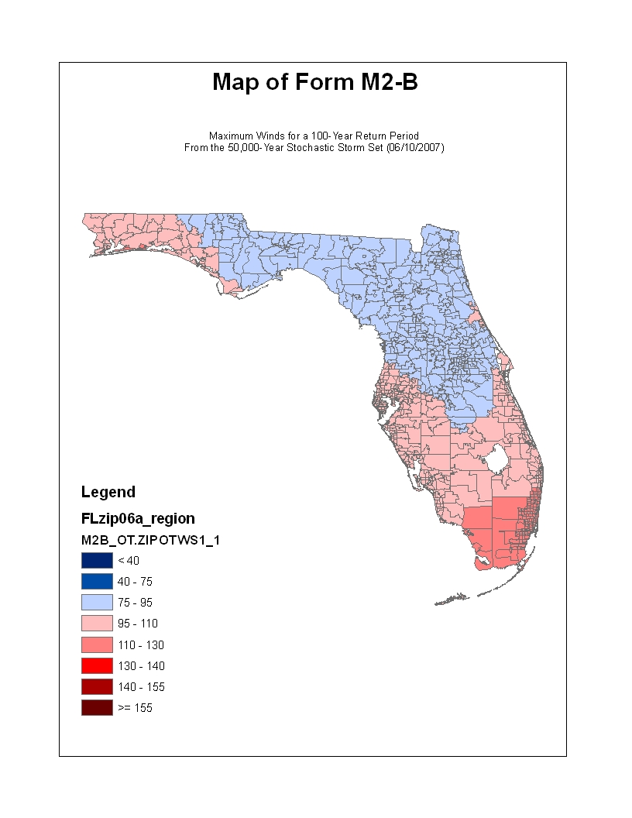
Maximum wind 117 mph at zip 33149
*
Figure 20. 100 Year return period maximum 1 min sustained surface (10 m) open terrain wind speeds (mph) based on a 50,000 year simulation of 06/10/2007. Location of maximum is denoted by * symbol.

M-6 Logical Relationships of Hurricane Characteristics

A. The magnitude of asymmetry shall increase as the translation speed increases, all other factors held constant

The storm translation speed causes a major right-left (looking in the direction the storm is moving) asymmetry in the wind field which in turn causes an asymmetry in surface friction since the surface stress is wind speed dependent. The magnitude of the asymmetry increases as the translation speeds increases; there is no asymmetry for a stationary storm except for possible land friction effects if a storm becomes stationary while a large percentage of its circulation is over both land and water.

B. The mean wind speed shall decrease with increasing surface roughness (friction), all other factors held constant.

All other factors held constant, the mean wind speed decreases with increasing surface roughness. However, the gust factor, which is used to estimate the peak one min wind and the peak 3 s gust over the time period corresponding to the model mean wind increases as a function of turbulence intensity, which increases with surface roughness (Paulsen et al., 2003, Masters 2004, Powell et al., 2004). For roughness values representative of zip codes in Florida with residential roughness values on the order of 0.2 - 0.3 m, the roughness effect on decreasing the mean wind speed overwhelms the enhanced turbulence intensity effect that increases the gust factor.

M-6.1. Provide a completed Form M-3, Radius of Maximum Winds.

Form M-3 follows.

Form M-3: Radius of Maximum Winds

A. For the central pressures in the table below, provide ranges for radius of maximum winds used by the model to create the stochastic storm set.

B. Identify the other variables that influence Rmax.
Table 2. Stochastic central pressures and Rmax range. Rmax is sampled from a Gamma distribution. The parameters of the distribution depend on Pmin

Central Pressure (mb) |  | Range of Rmax (sm)
900 |  | 4-11
910 |  | 7 - 19
920 |  | 4 - 21
930 |  | 7 - 48
940 |  | 6- 55
950 |  | 6 - 60
955 |  | 7-58
960 |  | 7-58
965 |  | 5 - 59
970 |  | 5-58
975 |  | 4 -54
980 |  | 5 -56
985 |  | 4 - 54
990 |  | 4 - 51

C. Provide a representative scatter plot of Central Pressure (x-axis) versus Rmax (y-axis) to demonstrate relative populations and continuity of sampled hurricanes in the stochastic storm set. “Representative” means that the relative distribution of hurricane frequencies across both Central Pressure and Rmax ranges should be evident.

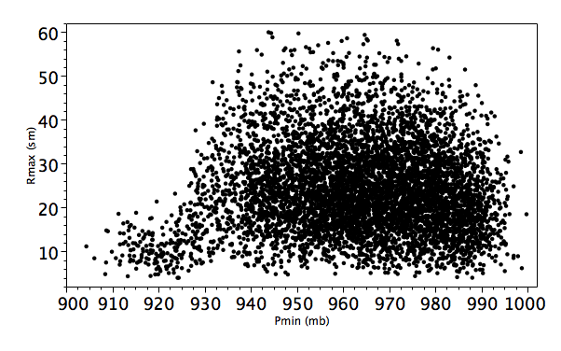

Figure 21. Form M3 representative plot of landfall radius of maximum surface wind speed (Rmax) in statute miles vs. landfall minimum central sea-level pressure (Pmin) in millibars from a 10,600 year simulation conducted on 8 June, 2007.

