Extratropical Wintertime Teleconnection associated with Two Types of El Niño Events

Sang-Ki Lee^{,1,2}, Eui-Seok Chung³, Chunzai Wang², and Carlos R. Mechoso⁴
¹Cooperative Institute for Marine and Atmospheric Studies, University of Miami, Miami FL
²Atlantic Oceanographic and Meteorological Laboratory, NOAA, Miami FL
³Rosenstiel School of Marine and Atmospheric Science, University of Miami, Miami FL
⁴Department of Atmospheric Sciences, University of California, Los Angeles, Los Angeles, CA

To be submitted to Geophysical Research Letters
June 2012

Corresponding author address: Dr. Sang-Ki Lee, NOAA/AOML, 4301 Rickenbacker Causeway, Miami, FL 33149, USA. E-mail: Sang-Ki.Lee@noaa.gov.
Abstract
Composite analysis of atmospheric reanalysis products is performed to explore the extratropical teleconnection to the winter hemisphere associated with eastern Pacific (EP) El Niños and central Pacific (CP) type El Niños. The highlight of our major findings is that, while the equatorial Pacific sea surface temperature (SST) anomalies associated with EP El Niños are much stronger than those with CP El Niños, the extratropical wintertime teleconnection to the Northern Hemisphere (NH) is quite similar and robust in both CP and EP El Niños. However, the wintertime stationary Rossby wavetrain patterns in the Southern Hemisphere (SH) associated with CP El Niños is much weaker than those with EP El Ninos. A simple two–level atmospheric model is used to find that in austral winter the background horizontal and vertical wind shears, which are the two critical factors required for tropical heating to radiate barotropic teleconnections to the high-latitudes, are not favorable over the central tropical Pacific than in the eastern tropical Pacific.

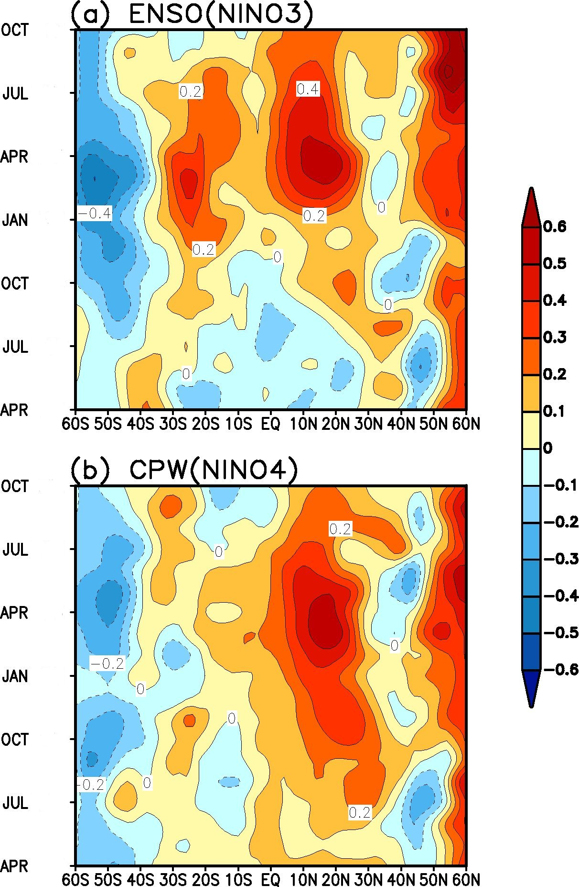
Figure 1. Composite of Atlantic SST anomalies averaged zonally between 60ºW and 20ºW for (a) ten EP El Niños and (b) ten CP El Niños obtained from ERSST3.

Tentative plan for this paper:
As well known, EP El Niños are typically associated with a warming of the tropical North Atlantic (TNA) during boreal spring (Figure 1a). It is clear from Figure 1b that this extratropical teleconnection associated with CP El Niños is quite robust. It interesting to note that the teleconnected warming of the TNA associated with CP El Niños starts earlier in boreal fall (around October). If this is indeed the case, it is worthwhile to explore why. The simple two-level model can be used to explore the impact of different background flows over the central and eastern Pacific on the extratropical teleconnection over the NH.
Although less well known (at least I was not aware of this), it is clear from Figure 1a that EP El Ninos are associated with a warming of the tropical South Atlantic (TSA) during austral summer and early fall (January-April). This implies that the South Atlantic trade wind is reduced during austral spring and summer (of course more analysis of moisture transport, geopotential height and winds at 200, 500 and 850mb, and velocity potential and divergent winds at 200 and 850mb is needed to confirm this). If this is indeed the case, the reduced moisture transport from the South Atlantic to South American eastern coast north of 20ºS may in turn cause reduced rainfall over the eastern Brazil. The warming of the TSA during the austral summer (January-February) may also interfere with the South American summer monsoon. It is interesting to note that the TSA is largely neutral during the onset and decay phases of CP El Niños (Figure 1b), suggesting that CP El Niños has no apparent effect on South American summer monsoon. This is definitely worthwhile to report and to explore why. Again, the simple two-level model can be used to explore the impact of different background flows over the central and eastern Pacific on the extratropical teleconnection over the SH. If necessary, I can design and perform CAM3 experiments to better understand the different extratropical teleconnection patterns associated with the two type of El Niños.

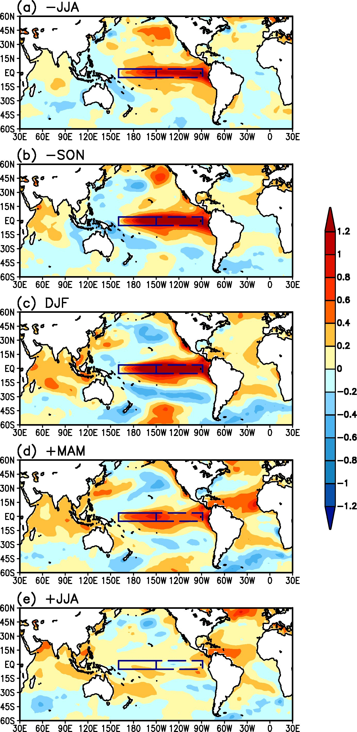
Figure 2. Composite of SST anomalies for ten EP El Niños during (a) JJA(-), (b) SON(-), (c) DJF, (d) MAM(+) and (e) JJA(+). Seasons with (-) are for El Niño onset year, and seasons with (+) are for El Niño decay year.

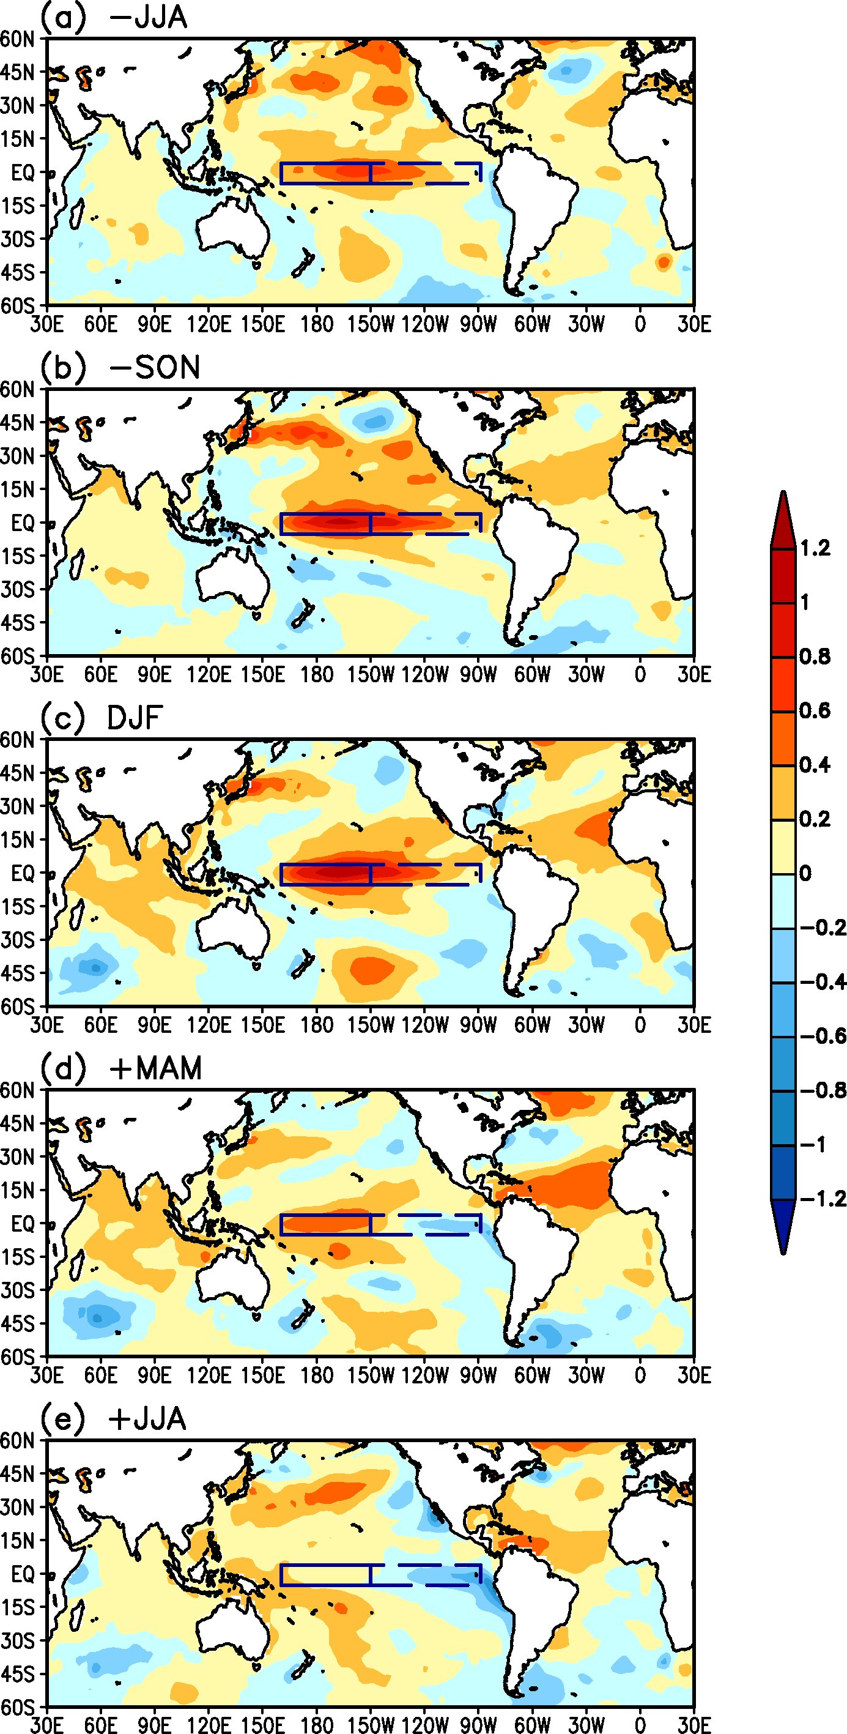
Figure 3. Composite of SST anomalies for ten CP El Niños during (a) JJA(-), (b) SON(-), (c) DJF, (d) MAM(+) and (e) JJA(+). Seasons with (-) are for El Niño onset year, and seasons with (+) are for El Niño decay year.

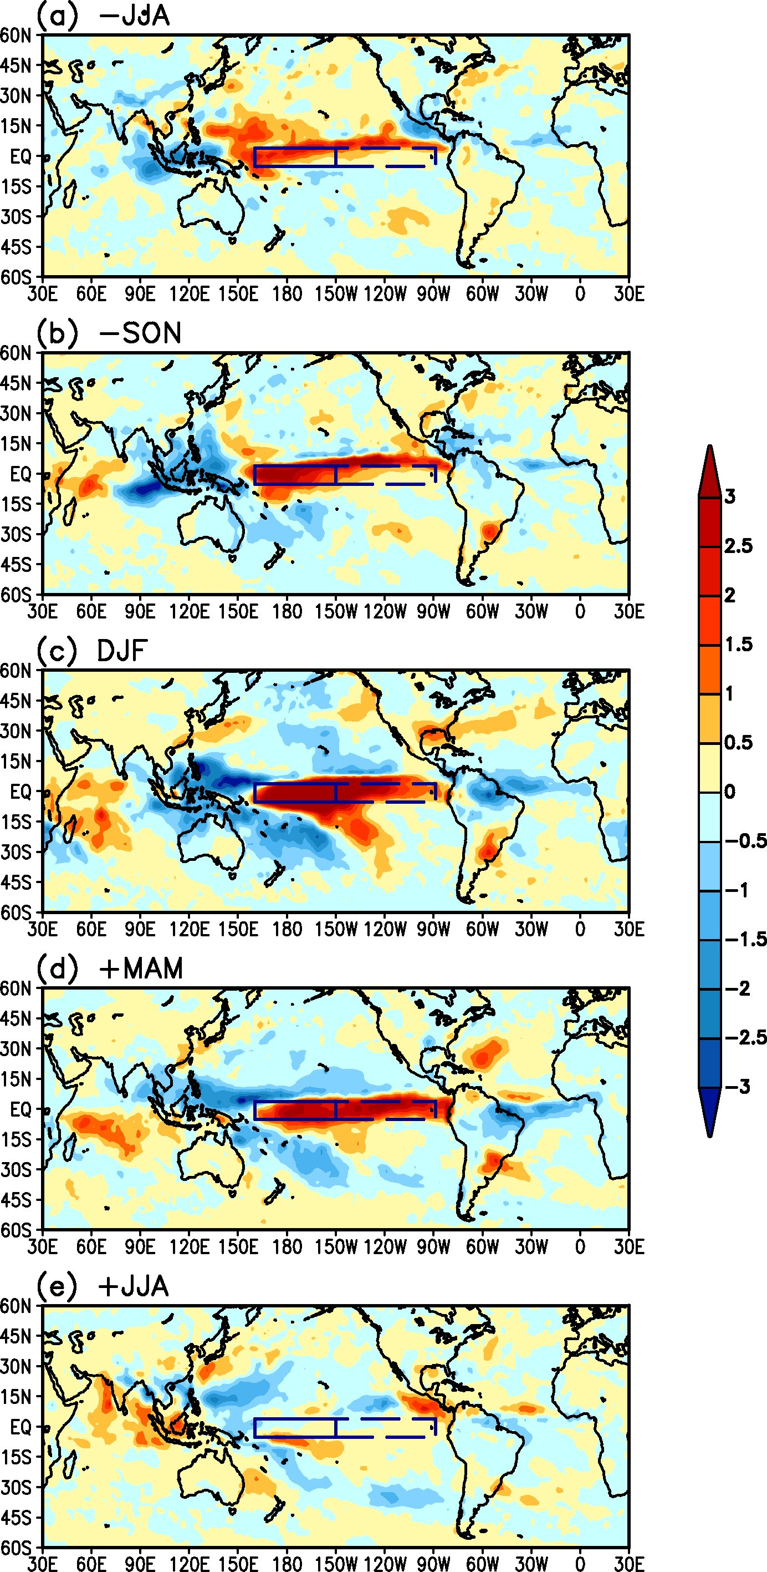
Figure 4. Composite of rainfall anomalies from GPCP for ten EP El Niños during (a) JJA(-), (b) SON(-), (c) DJF, (d) MAM(+) and (e) JJA(+). Seasons with (-) are for El Niño onset year, and seasons with (+) are for El Niño decay year.

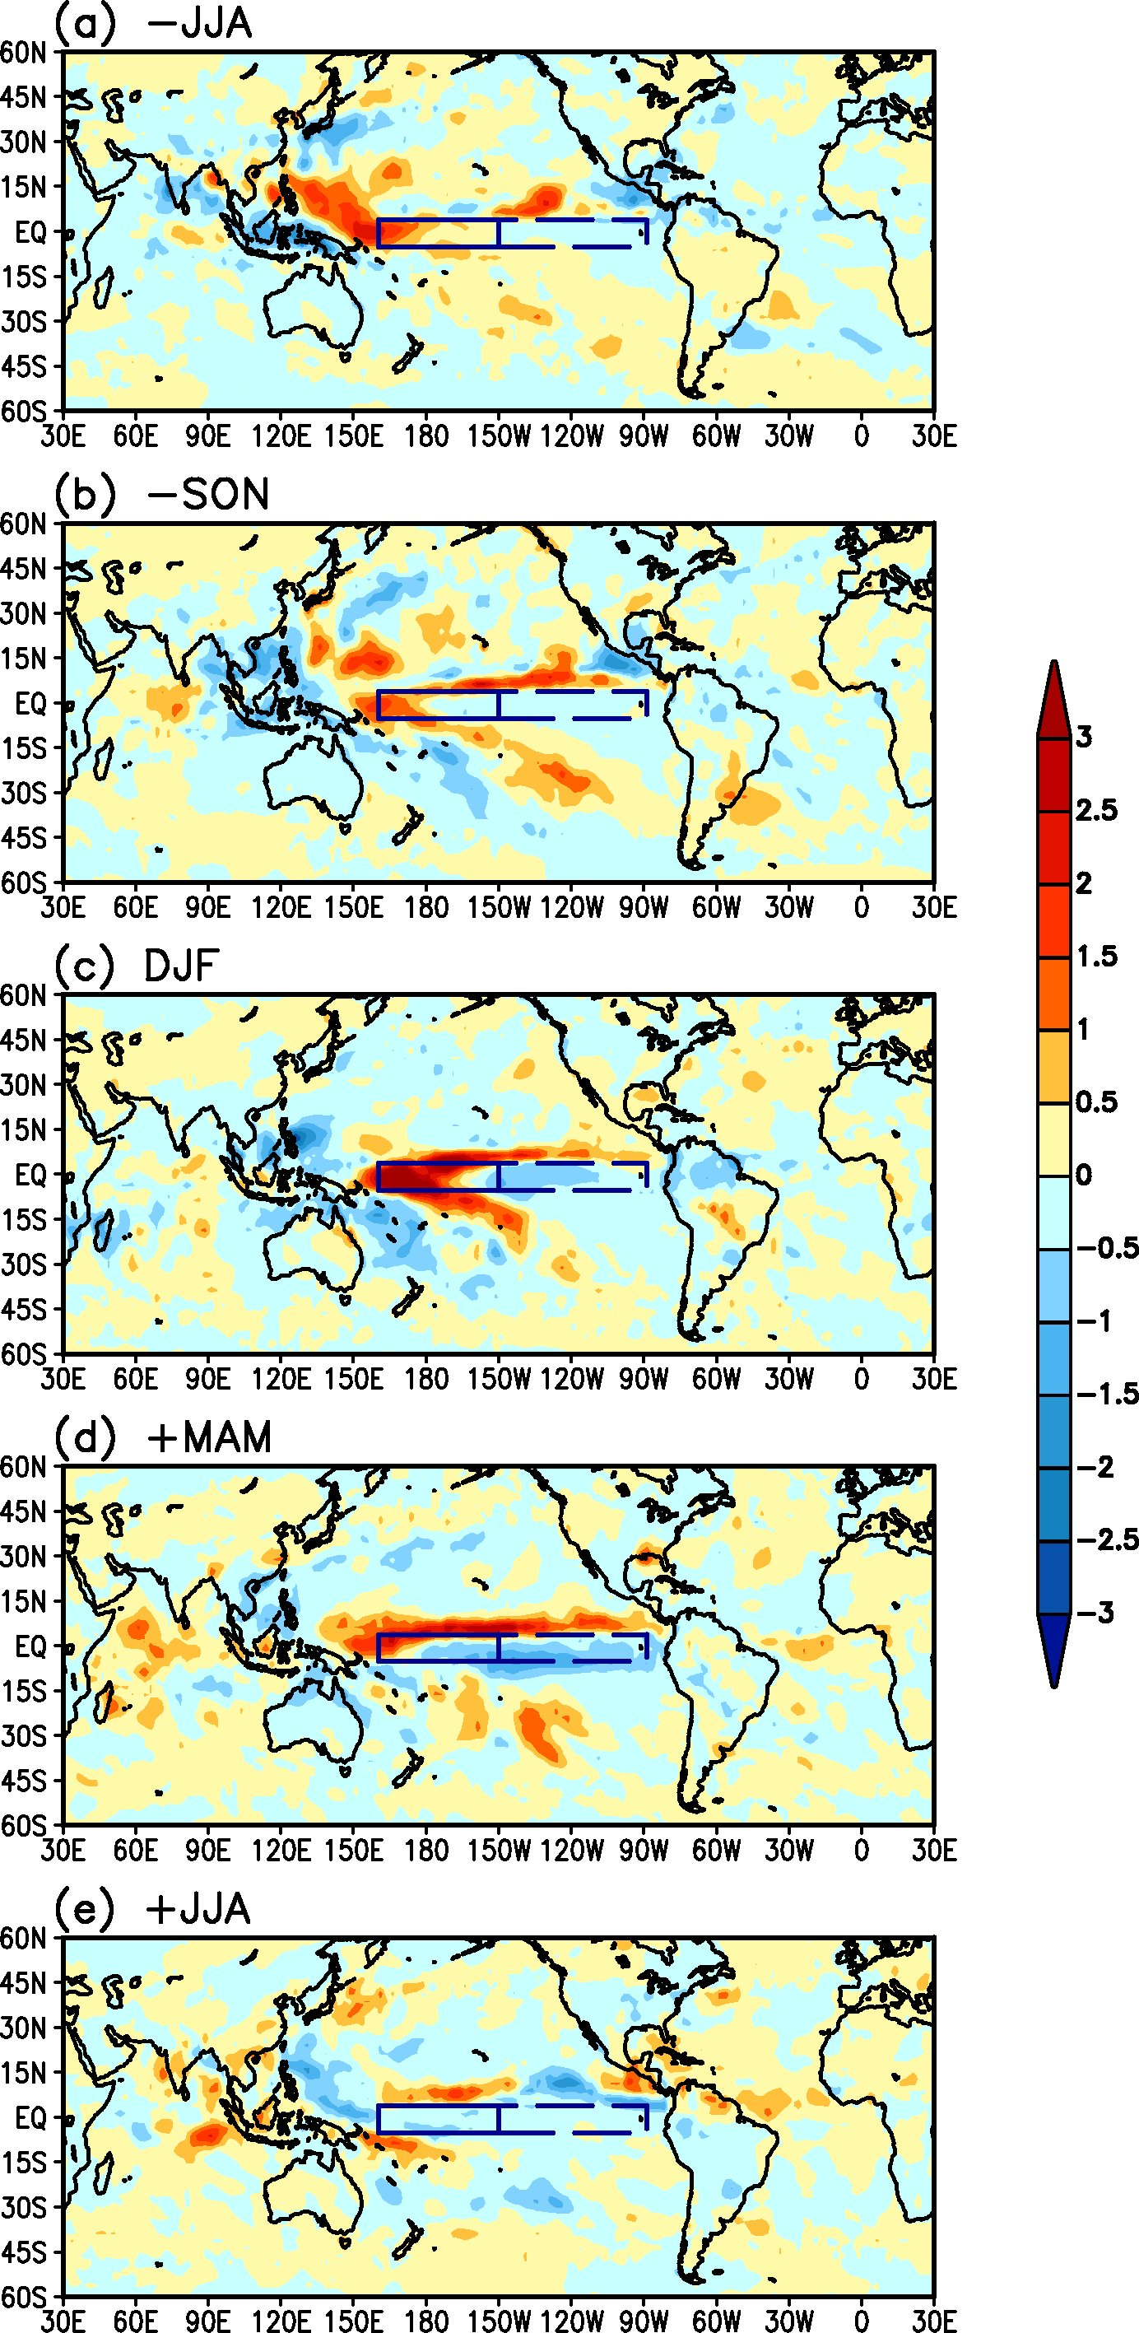
Figure 5. Composite of rainfall anomalies from GPCP for ten CP El Niños during (a) JJA(-), (b) SON(-), (c) DJF, (d) MAM(+) and (e) JJA(+). Seasons with (-) are for El Niño onset year, and seasons with (+) are for El Niño decay year.

