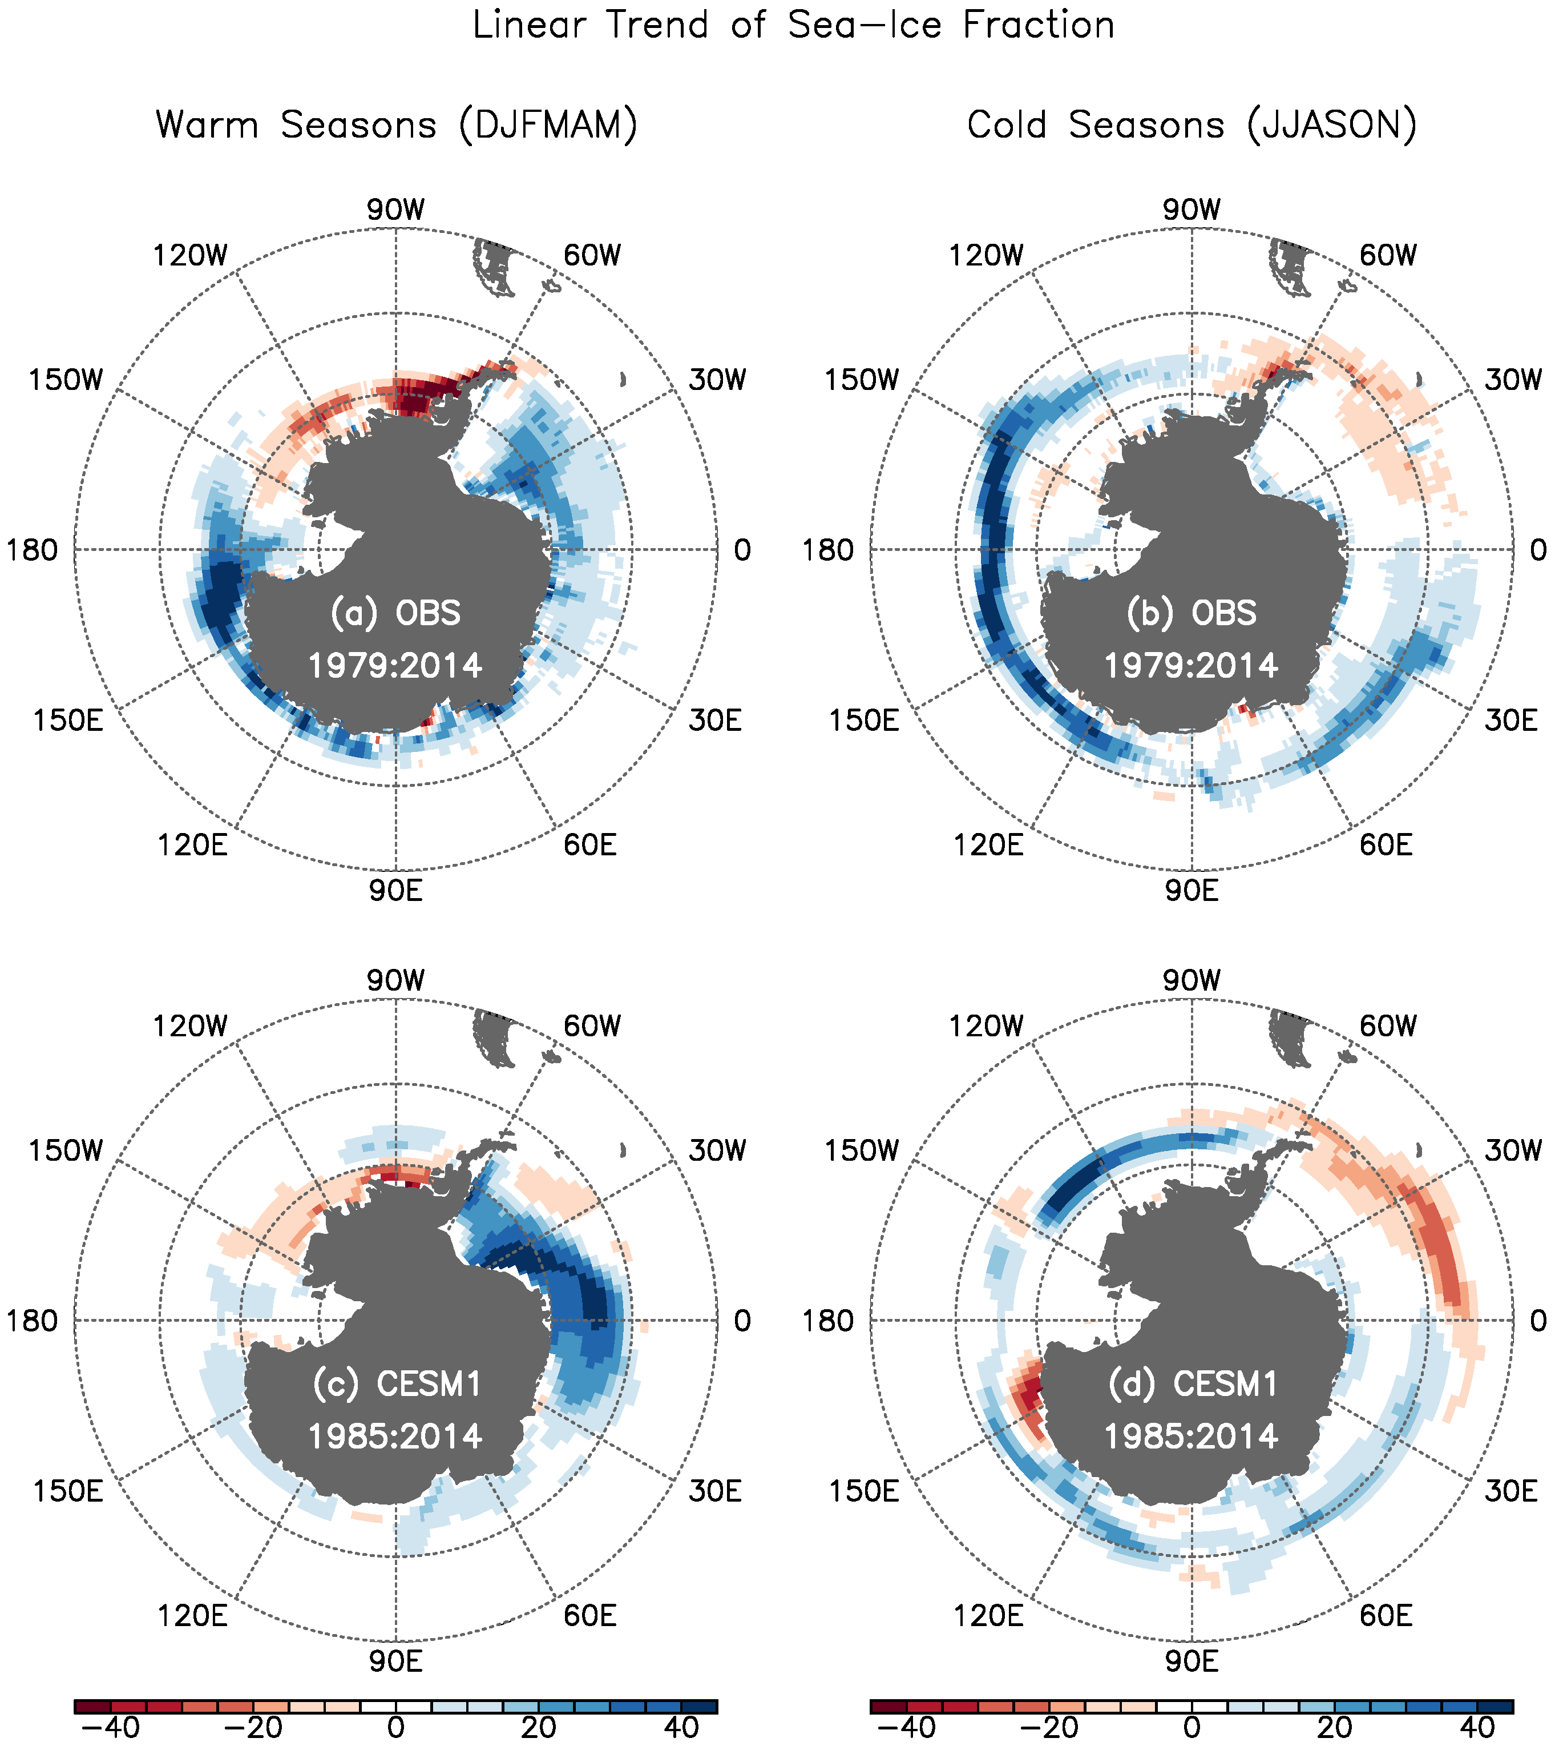

**Figure 1.** Linear trends of Antarctic sea-ice fraction during (a,c) the warm (December - May) and (b,d) cold (June - November) seasons, obtained from (a,b) the Hadley Center sea-ice and sea surface temperature data sets over the period of 1979 - 2014 and (c,d) the CESM1 control simulation over the period of 1985 - 2014. The first six years (1979 - 1984) of the model results were excluded to prevent any potential model drift in the beginning of the control simulation from affecting the modeled sea-ice trend. The units are % in 35 years.

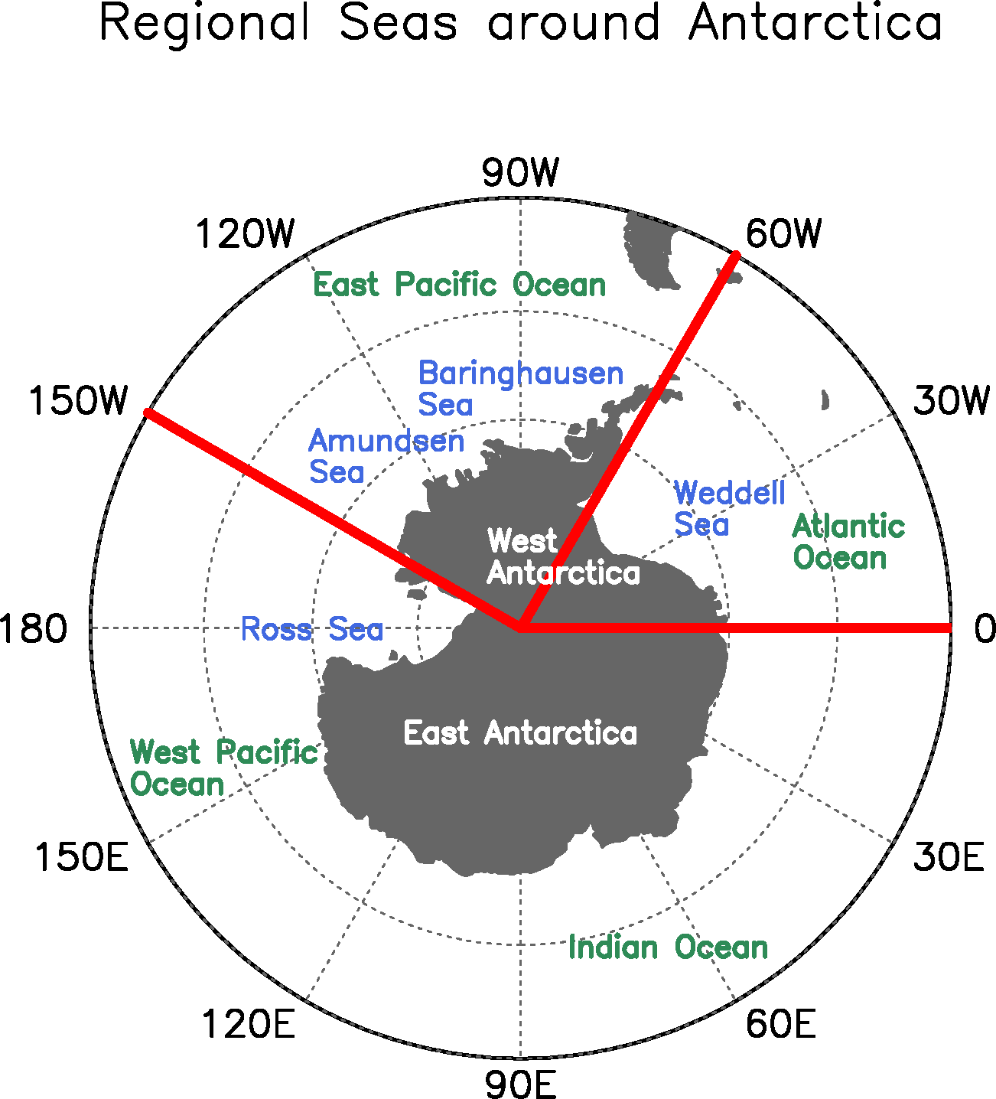

**Figure 2.** The oceans and regional seas around Antarctica. The thick red lines indicate the boundaries of the East Pacific (150°W - 60°W) and Atlantic (60°W - 0°) used in this study.

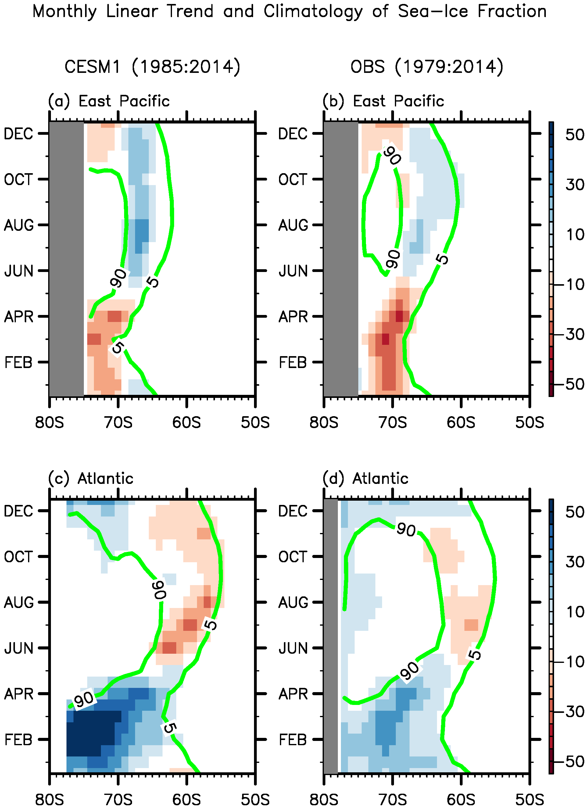

**Figure 3.** Linear trends of Antarctic sea-ice fraction averaged in (a,b) the East Pacific (150°W - 60°W) and (c,d) Atlantic (60°W - 0°) for each calendar month, obtained from (a,c) the CESM1 control simulation over the period of 1984 - 2014 and (b,d) the Hadley Center sea-ice and sea surface temperature data sets over the period of 1979 - 2014. The two green lines in each panel represent 5 and 90% climatological sea-ice fractions. The units are % in 35 years.

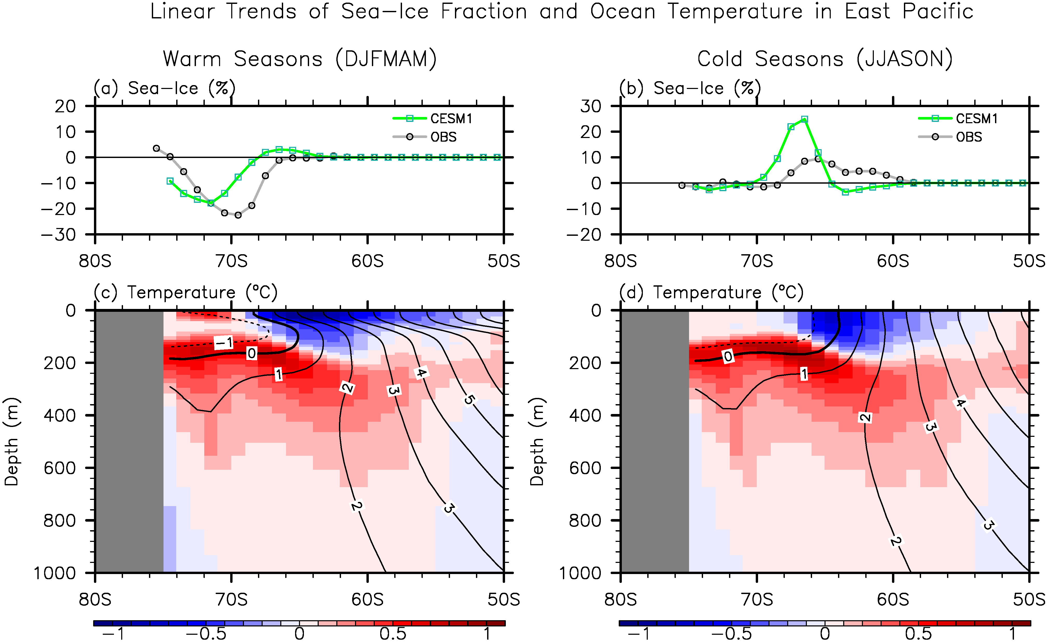

**Figure 4.** Linear trends of (a,b) Antarctic sea-ice fraction and (c,d) ocean temperatures averaged in the East Pacific (150°W - 60°W) for (a,c) the warm and (b,d) cold seasons over the period of 1985 - 2014, obtained from the CESM1 control simulation. Linear trends of observed Antarctic sea-ice fraction over the period of 1979 - 2014 averaged in the East Pacific are also shown in (a,b). The black lines in (c,d) indicate the climatological temperatures. The units are % in 35 years for sea-ice fraction and °C in 35 years for ocean temperature.

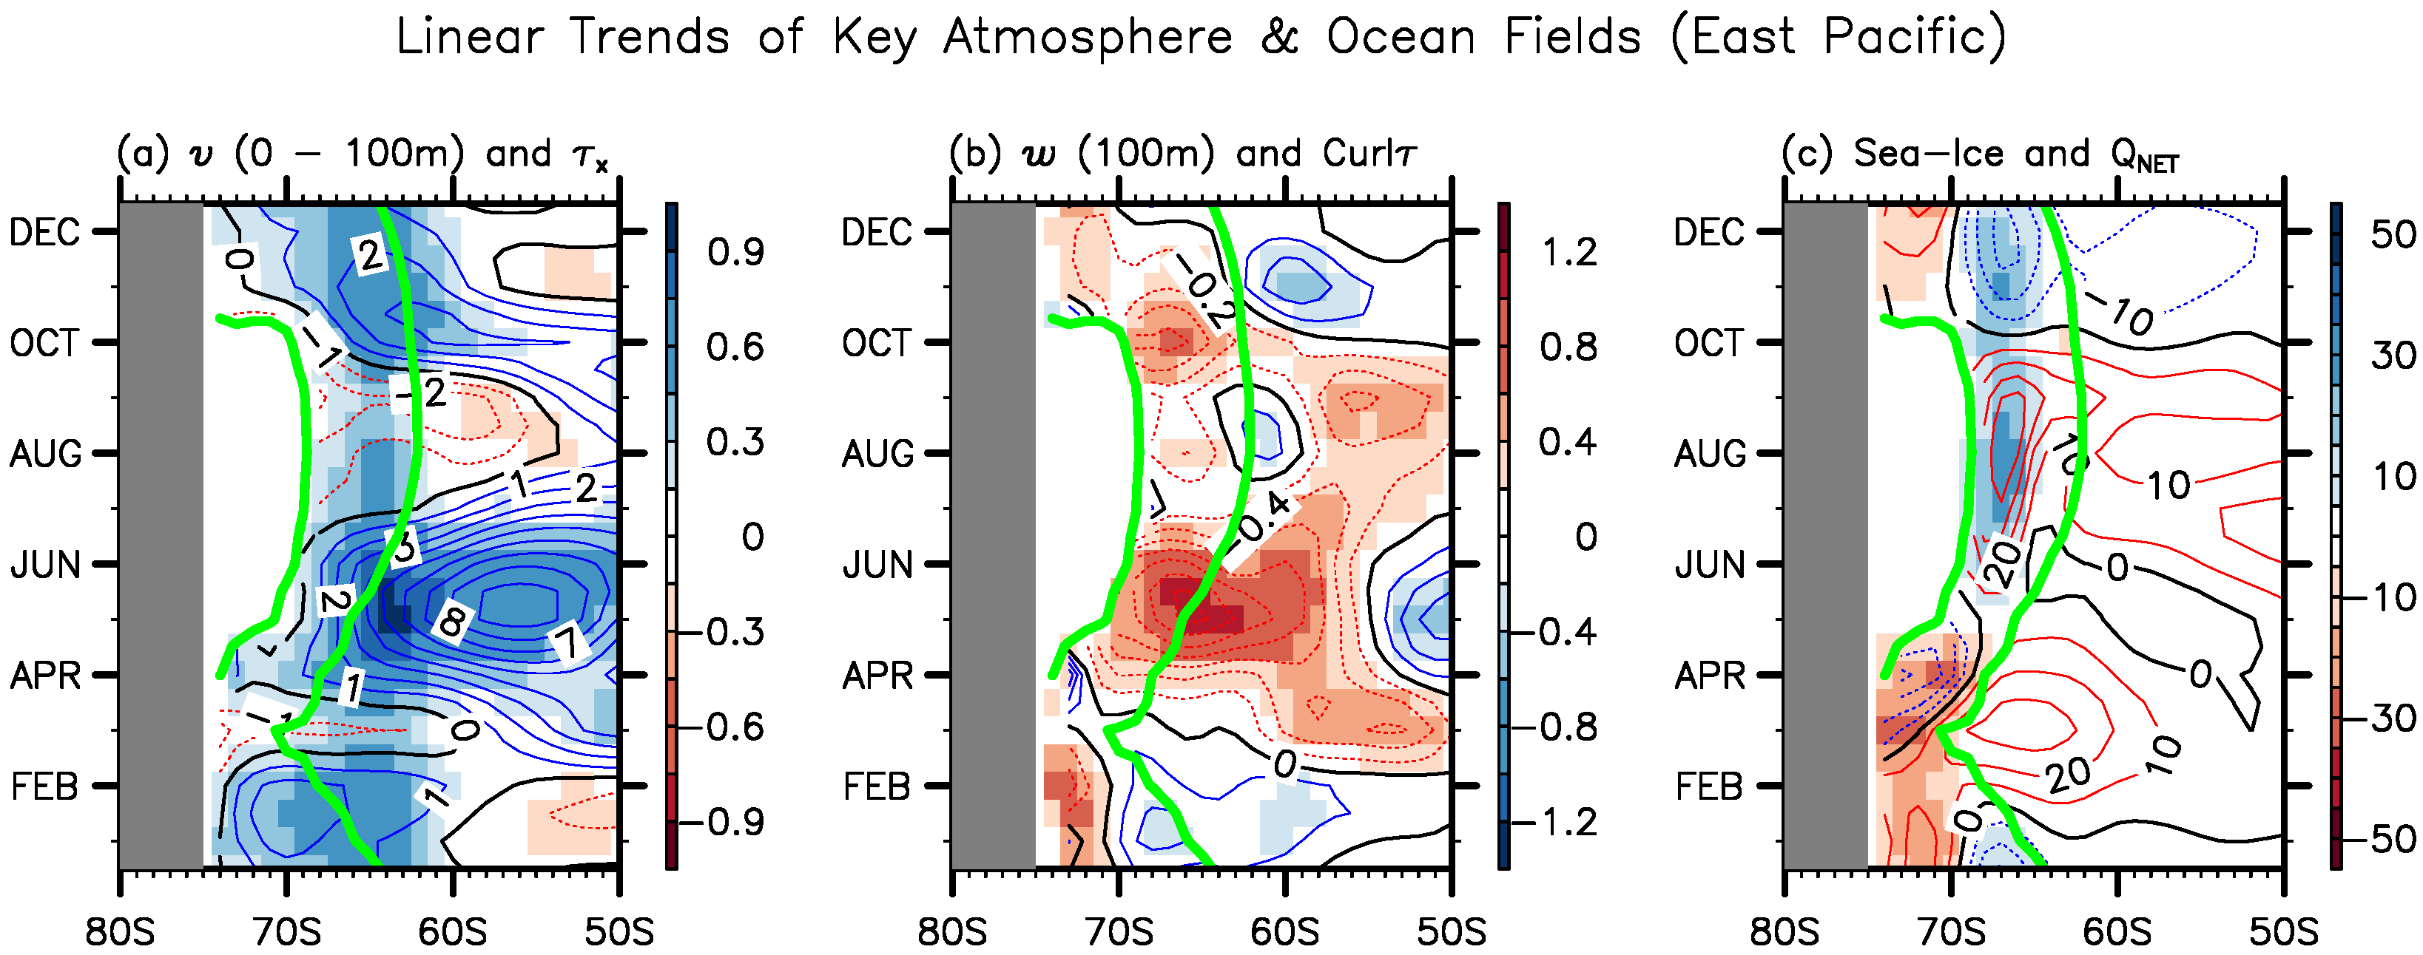

**Figure 5.** Linear trends of (a) meridional velocity averaged in the upper 100 m (shades) and zonal wind stress (contours), (b) vertical velocity at 100 m (shades) and wind stress curl (contours), and (c) sea-ice fraction (shades) and net air-sea heat flux (contours) over the period of 1985 - 2014 averaged in the East Pacific (150°W - 60°W) for each of calendar month, obtained from the CESM1 control simulation. These fields are not shown for the inner edge of climatological sea-ice extent (i.e., above 90% sea-ice fraction). The units are 10-2 ms-1 in 35 years for meridional velocity, 10-4 ms-1 in 35 years for vertical velocity and 10-6 Nm-3 in 35 years for wind stress curl, % in 35 years for sea-ice fraction, and Wm-2 in 35 years for air-sea heat flux.

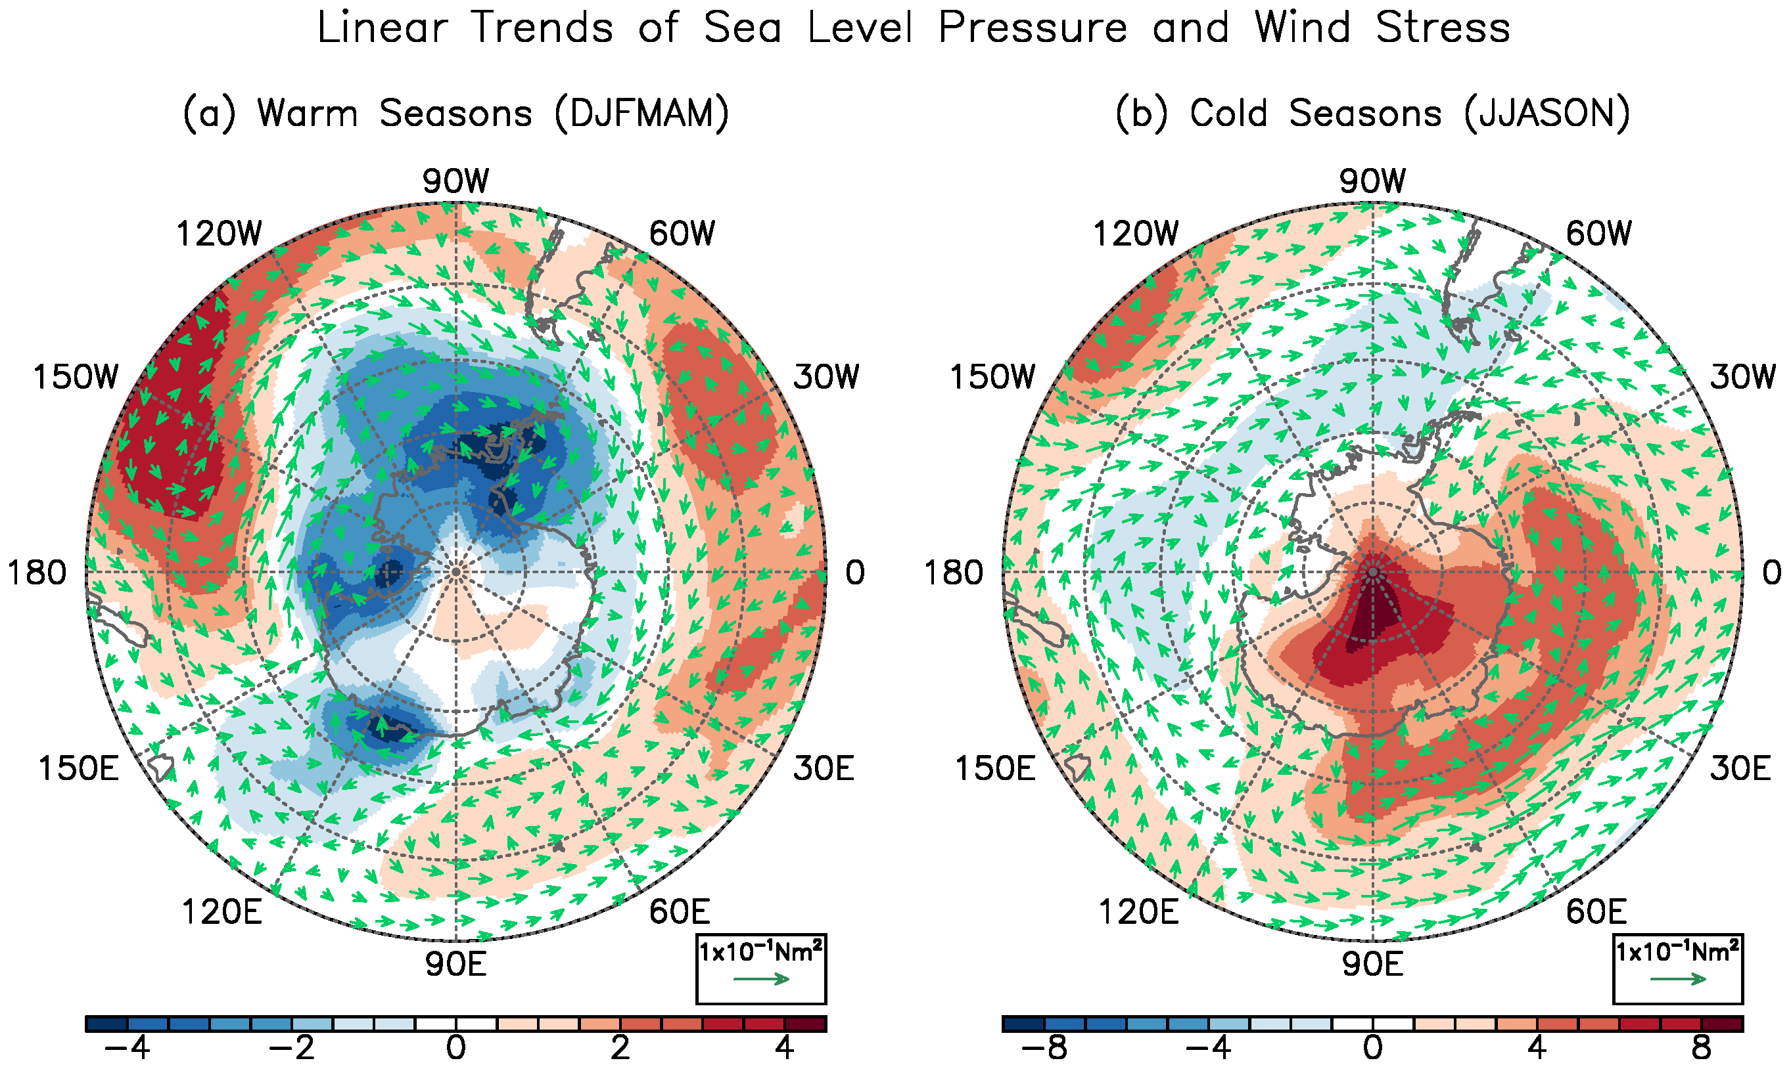

**Figure 6.** Linear trends of sea level pressure (shades) derived from MERRA and surface wind stress vectors (arrows) derived from the CESM1 control simulation over the period of 1985 - 2014 during (a) the warm and (b) cold seasons. The units are hPa in 35 years for sea level pressure, and 10-1 Nm2 in 35 years for wind stress vectors.

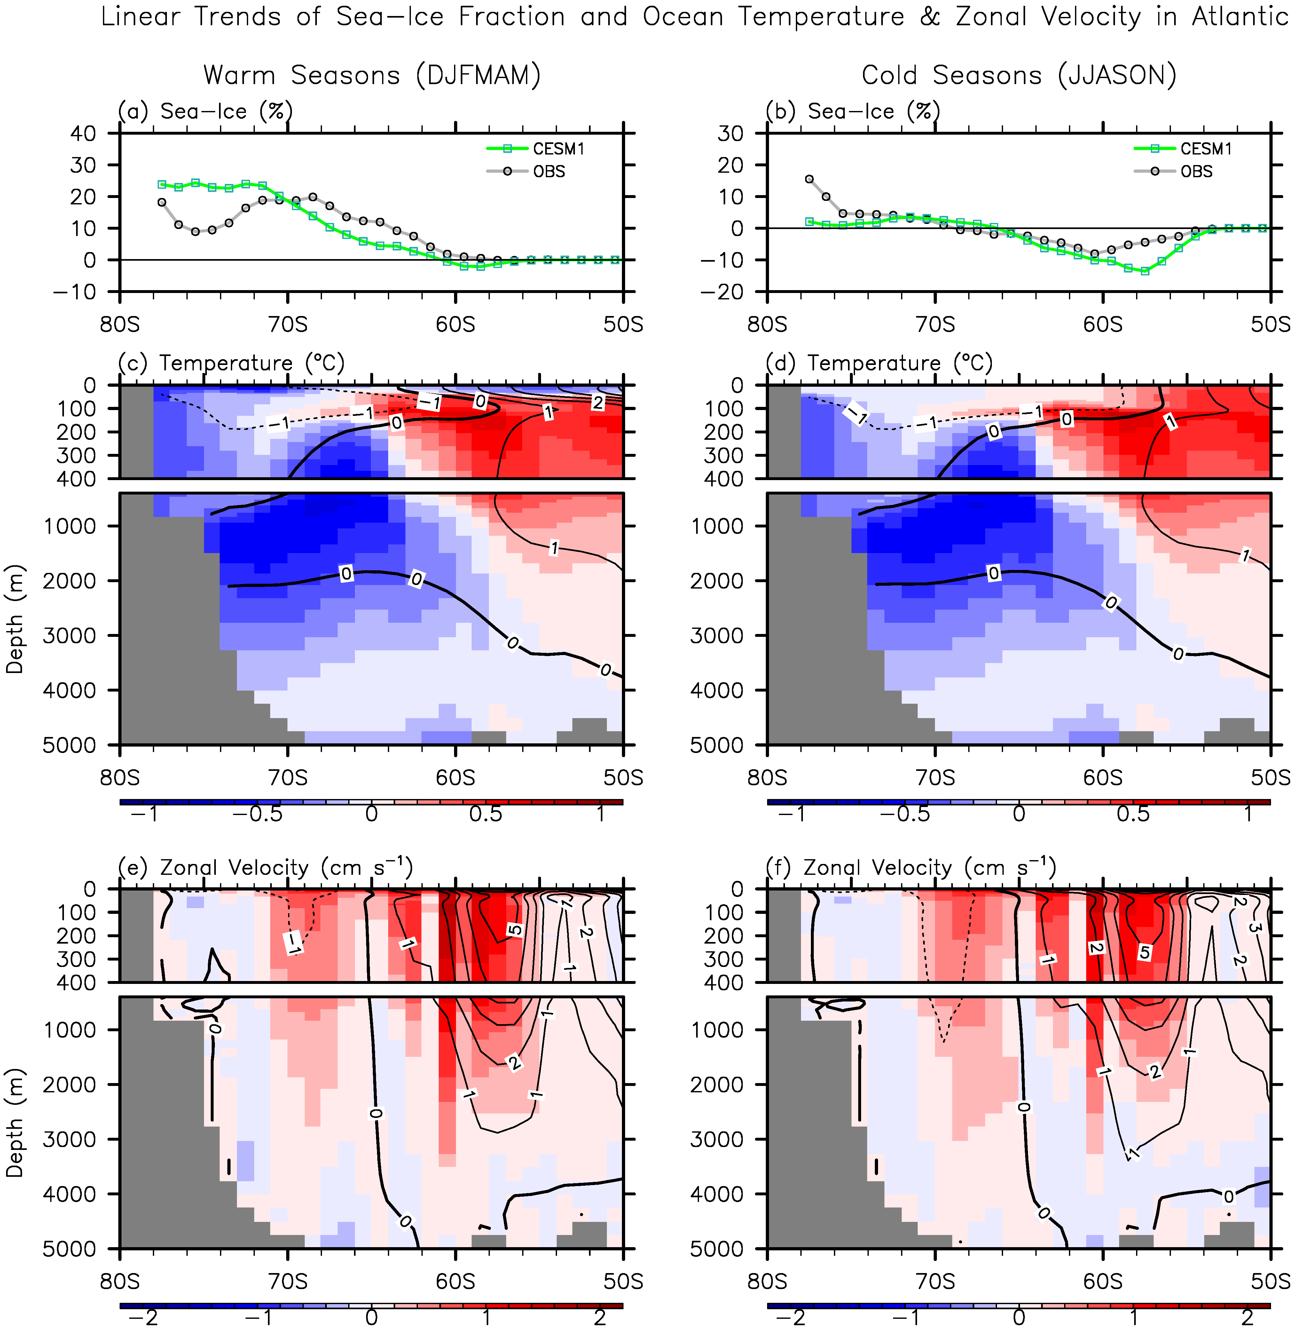

**Figure 7.** Linear trends of (a,b) Antarctic sea-ice fraction, (c,d) ocean temperatures, and (e,f) zonal velocity averaged in the Atlantic (60°W - 0°) for (a,c,e) the warm and (b,d,e) cold seasons over the period of 1985 - 2014, obtained from the CESM1 control simulation. Linear trends of observed Antarctic sea-ice fraction over the period of 1979 – 2014 averaged in the Atlantic are also shown in (a,b). The black lines in (c,d) and (e,f) indicate the climatological temperatures and zonal velocity, respectively. The units are % in 35 years for sea-ice fraction, °C in 35 years for ocean temperature and cms-1 in 35 years for zonal velocity.

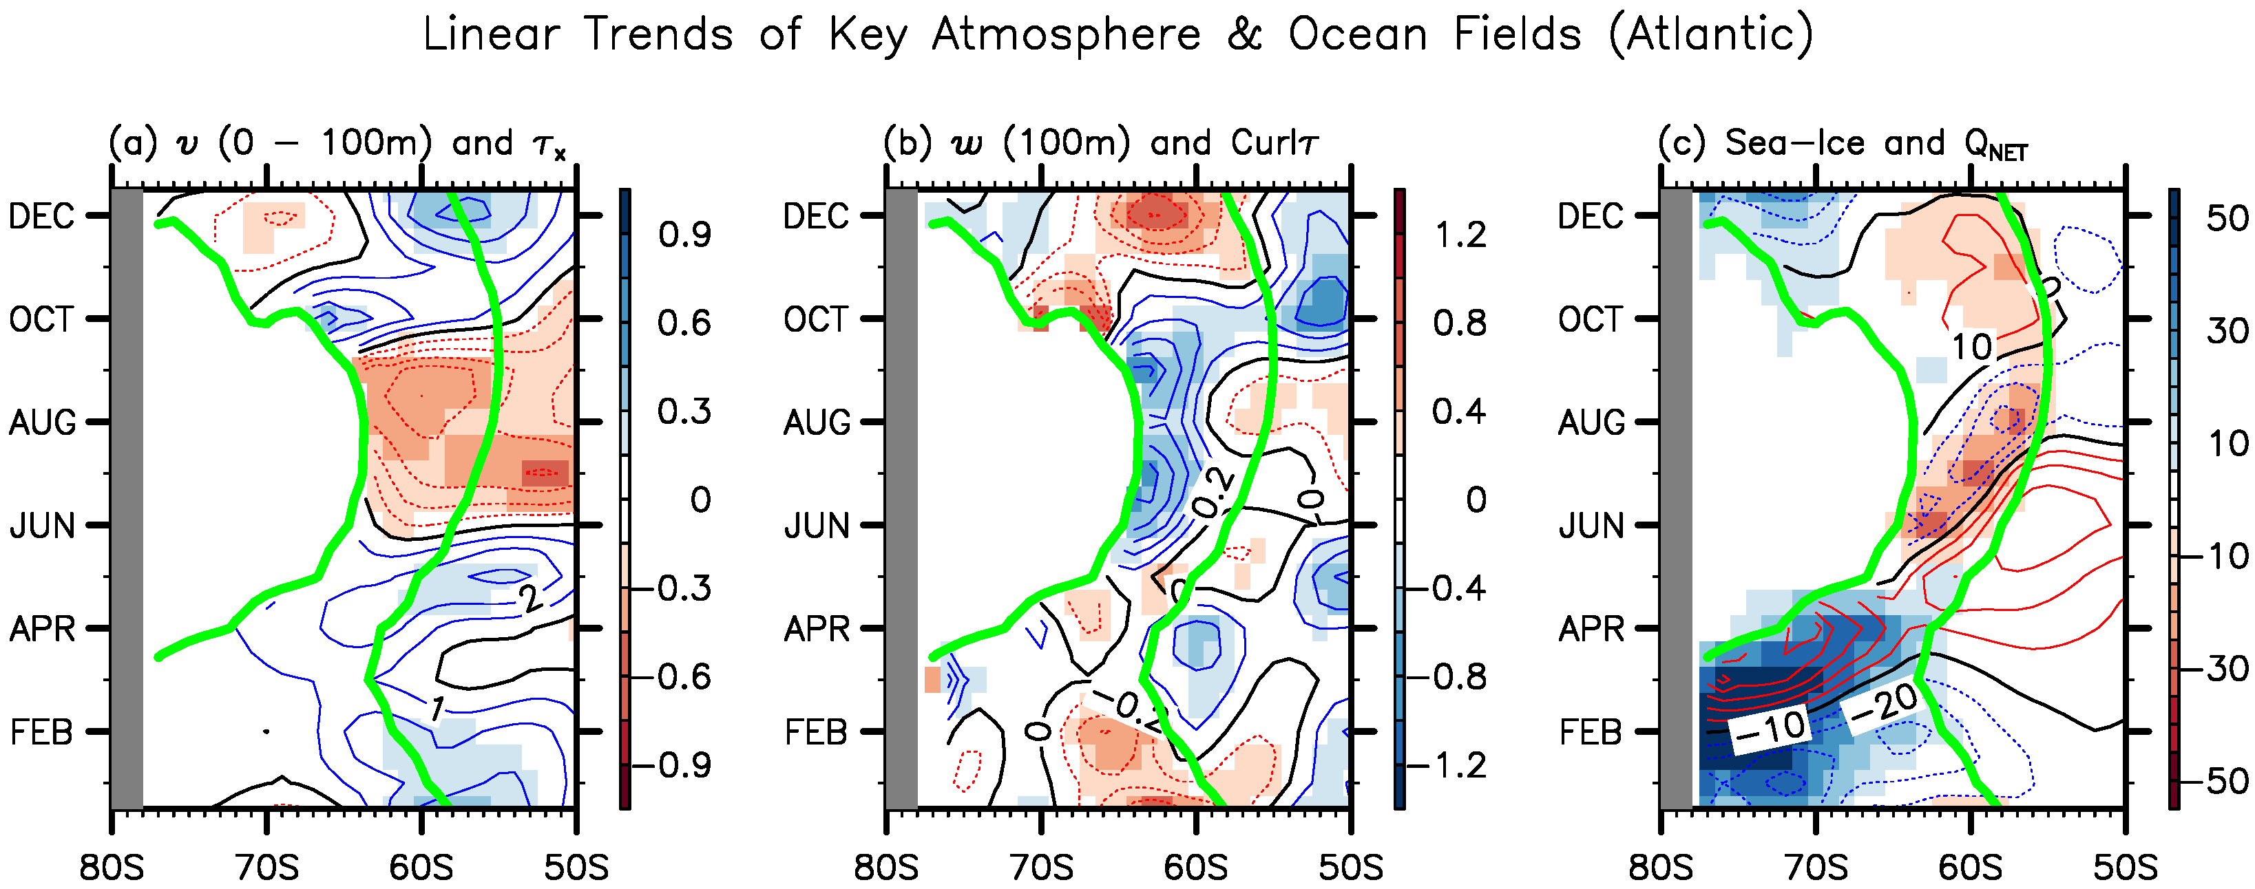

**Figure 8.** As in Figure 5, but for the Atlantic (60°W - 0°).

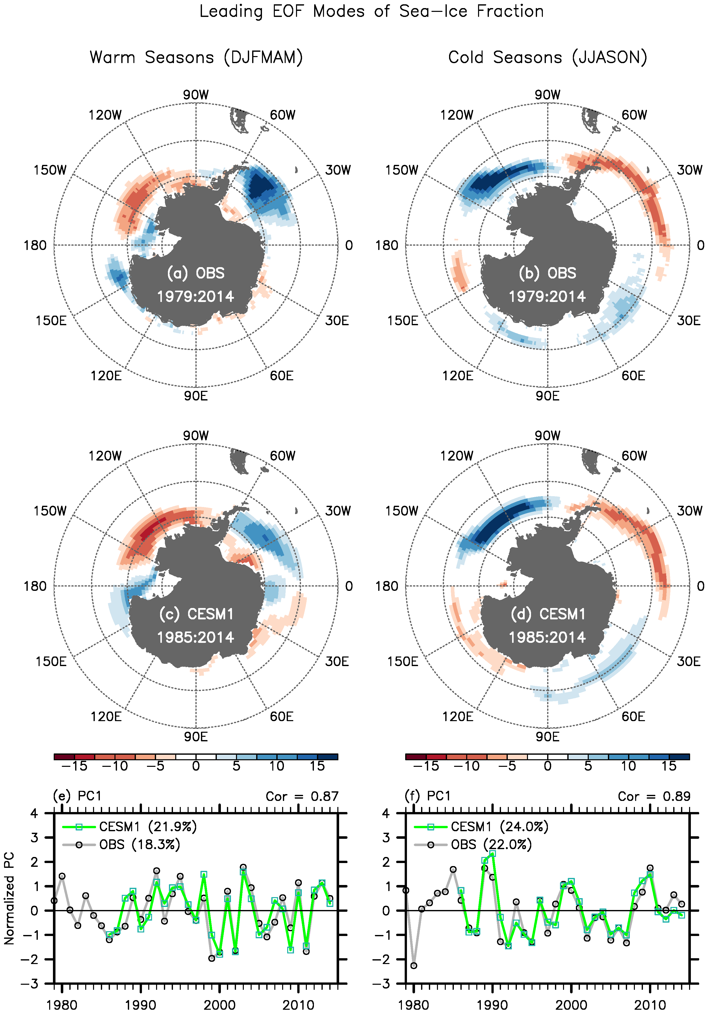

**Figure 9.** Leading Empirical Orthogonal Function (EOF) modes of detrended Antarctic sea-ice fraction variability during (a,c) the warm and (b,d) cold seasons, obtained from (a,b) the Hadley Center sea-ice and sea surface temperature data sets over the period of 1979 - 2014 and (c,d) the CESM1 control simulation over the period of 1985 - 2014. The normalized principal components (PCs) of the leading modes are also shown in (e,f). The percentage variance explained by each of the leading modes, and the correlations between the PCs derived from the observations and the control simulation are indicated in (e,f). The units in (a-d) are % per two units of the normalized PCs.



**Figure 10.** Sketch of the physical mechanisms linking the wind-driven ocean dynamics and the Antarctic sea-ice trends in (a) the East Pacific and (b) Atlantic. In the East Pacific, the strengthening SH westerlies enhanced Ekman upwelling of the warm upper CDW and increased the northward Ekman transport of cold Antarctic surface water, thus contributing to the expansion of sea-ice in the cold seasons and to the retreat in the warm seasons. In the Atlantic, the poleward intensification of SH westerlies strengthened the northern branch of the Weddell Gyre. Constrained by the thermal wind balance, the meridional thermal gradient increased across the northern branch of the Weddell Gyre, cooling the water column within the Weddell Gyre and warming the water column to the north of the Weddell Gyre, thus contributing to the expansion of sea-ice within the Weddell Gyre in the warm seasons, and to the retreat north of the Weddell Gyre in the cold seasons.