Figure 1. Regression of (a) wind stress curl and (b) wind stress component on the AMO index from 1871 to 2008 obtained from the CCSM_POP. (c) Zonal averaged wind stress (blue line) and wind stress curl (red line) from 1871 to 2008, obtained from the CCSM_POP.

Figure 2. Regression of barotropic streamfunction on the AMO index from 1871 to 2008 obtained from the CCSM_POP.
Figure 3. Three-month running means of (a) SST anomalies in the TNA region (5º–25ºN, 55º–15ºW) and SST anomalies in the TSA region (0–20ºS, 30ºW–10ºE), and (b) SST anomaly difference between the TNA and TSA obtained from the CCSM_POP model output.

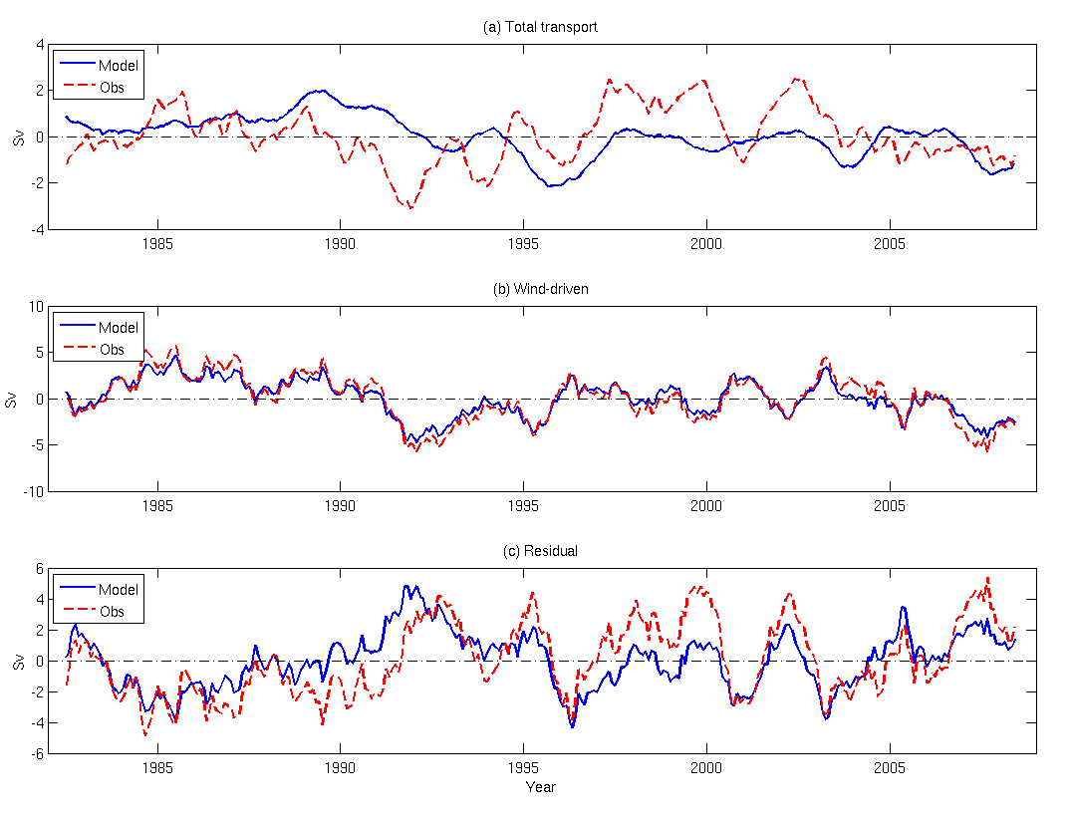
Figure 4. (a) Time series of observed (red) and CCSM_POP model simulated (blue) Florida Current transport from 1982 to 2008. (b) Time series of observed (red) and CCSM_POP model simulated wind-driven component of Florida Current transport. (c) Time series of the Residual (total minus wind-driven component) of Yucatan Current transport.

Figure 5. (a) Time series of the total Yucatan Current transport obtained from the CCSM_POP model output. (b) Time series of the anomolous total YC transport, together with the AMO index, obtained from the CCSM_POP model output. (c) Time series of total YC tranport (blue), wind-driven YC (red) and residual (total minus wind-driven component, green) YC transport obtained from the CCSM_POP model output.

Figure 6. (a) Time series of wind-driven component of YC transport (blue), together with the AMO index (red). (b) Time series of the residual YC transport (blue), together with the AMOC index (red) obtained from the CCSM_POP model output.

Figure 7. Regression of (a) wind stress curl and (b) wind stress component on the AMO index from 1871 to 2008 obtained from the SODA dataset.

Figure 8. (a) Time series of the total Yucatan Current transport obtain from the CCSM_POP (red) model output and SODA (blue) dataset. (b) Time series of total YC tranport (blue), wind-driven YC (red) and residual (total minus wind-driven component, green) YC transport obtained from the SODA dataset.

Figure 9. (a) Time series of wind-driven component of YC transport (blue), together with the AMO index (red). (b) Time series of the residual YC transport (blue), together with the AMOC index (red) obtained from the SODA dataset.

Figure 10. Regression of (a) wind stress curl and (b) wind stress component on the NAO index from 1871 to 2008 obtained from the CCSM_POP. (c) Zonal averaged wind stress (blue line) and wind stress curl (red line) on the NAO index from 1871 to 2008, obtained from the CCSM_POP.

