Multidecadal Co-variability of Sea Surface Temperature and Aerosols in the North Atlantic and Rainfall in the Sahel

Chunzai Wang ¹
Shenfu Dong ^{1 & 2}
Amato T. Evan ³
Gregory R. Foltz ¹
Sang-Ki Lee ^{1 & 2}

¹ NOAA Atlantic Oceanographic and Meteorological Laboratory
Miami, Florida

² Cooperative Institute for Marine and Atmospheric Studies
University of Miami
Miami, Florida

³ Department of Environmental Sciences
University of Virginia
Charlottesville, Virginia

To be submitted to Nature as a Letter

March 2011

Corresponding author address: Dr. Chunzai Wang, NOAA/Atlantic Oceanographic and Meteorological Laboratory, 4301 Rickenbacker Causeway, Miami, FL 33149, USA.
E-mail: Chunzai.Wang@noaa.gov; Phone: 305-361-4325; Fax: 305-361-4412.
Previous studies regarding atmospheric aerosols and climate have been limited to a short period of the satellite era. Here we use new datasets with a longer-term period to show a multidecadal co-variability of sea surface temperature (SST) and aerosols in the North Atlantic, and rainfall in the Sahel. When the North Atlantic Ocean was cold from the late 1960s to the early 1990s, the Sahel had less rainfall and the tropical North Atlantic experienced high concentrations of dust. The opposite was true when the North Atlantic Ocean was warm before the late 1960s and after the early 1990s. This suggests that a positive feedback may exist between North Atlantic SST, African dust, and Sahel rainfall on multidecadal timescales. That is, a warm (cold) North Atlantic Ocean produces a wet (dry) condition in the Sahel and thus leads to low (high) concentration of dust in the tropical North Atlantic which in turn warms (cools) the North Atlantic Ocean. An implication of this study is that coupled climate models need to be able to simulate this aerosols-related feedback in order to correctly simulate climate variability and change in the North Atlantic.

Sea surface temperature (SST) in the North Atlantic Ocean varies mainly on two timescales: a secular warming and a multidecadal variation (Is there a reference for this? I cannot think of any reference although I agree with this statement). There is a debate on the relative roles of anthropogenic global warming and natural climate variability in the North Atlantic SST variability (e.g., Elsner 2006; Trenberth and Shea 2006; Mann and Emanuel 2006; Enfield and Cid-Serrano 2010; McCabe et al. 2004; Knight et al. 2005; Zhang et al. 2007; Wang and Dong 2010). In this paper, we mainly focus on the component induced by natural variability – the Atlantic multidecadal oscillation (AMO) – a climate mode occurring in the North Atlantic SST that operates primarily on multidecadal timescales (e.g., Delworth and Mann 2000; Enfield et al. 2001; Wang et al. 2008a). [SKL: I don’t think that we need to discuss about the AMOC at this point]. Here the AMO index is defined as the detrended North Atlantic SST anomalies over the region of 0°-60°N and from the east coast of the Americas to 0° longitude (Fig. 1a). The extended reconstructed SST data from 1950 to 2008 show that the AMO was in the cold phase from the late 1960s to the early 1990s and in the warm phases before the late 1960s and after the early 1990s.
The AMO has footprints on many parts of the global oceans (Fig. 1b). In additional to the basin-wide warming (cooling) of the North Atlantic Ocean, the warm (cold) phase of the AMO is associated with the warming (cooling) in the western North and South Pacific Oceans and the tropical eastern Indian Oceans, whereas the warm (cold) phase of the AMO corresponds to the cooling (warming) over the global Southern Oceans and in the subtropical northeastern Pacific Ocean. The Atlantic SST regression shows a bipolar seesaw pattern or an inter-hemispheric gradient (Stocker 1998), supporting the hypothesis that the driving mechanism of the AMO involves fluctuations of the AMOC (e.g., Delworth and Mann, 2000; Knight et al., 2005; Dijkstra et al., 2006). As the AMOC is enhanced, a warming and a cooling will occur in the North and South Atlantic Oceans, respectively; and vice versa for a reduction of the AMOC.
AMO variability is associated with changes of climate and extreme events such as drought, flood and hurricane activity (e.g., Enfield et al. 2001; McCabe et al. 2004; Goldenberg et al. 2001; Bell and Chelliah 2006; Wang and Lee 2009). Recent studies show that only the tropical portion of the AMOC is relevant to climate since the climate response to the North Atlantic SST anomalies is primarily forced at the low latitudes (Sutton and Hodson 2007; Wang et al. 2008b [SKL: Hoerling et al. (2001) argues that North Atlantic SST is forced from the tropical Pacific. So, this paper is not very relevant. It is also not clear in this statement what you really mean by former and latter. So, it is better to delete this part]. Accordingly, the influence of the AMO on climate and hurricane activity may operate through the mechanism of the atmospheric changes induced by the tropical Atlantic warm pool (AWP) (Wang et al. 2008a) – a large body of warm water comprised the Gulf of Mexico, the Caribbean Sea, and the western tropical North Atlantic. It is therefore important to understand the mechanisms that drive multidecadal variability in the tropical North Atlantic SST.
It has been well recognized that the Atlantic SST and its inter-hemispheric gradient is the main driver for drought in the Sahel after the 1970s (e.g., Folland et al. 1986; Rowell et al. 1995; Fontaine and Janicot 1996; Giannini et al. 2003) – a region in Africa bounded north by the Saharan desert, east by the rainforests of Central Africa and south by the Guinean Coast. The Sahel rainfall anomalies co-vary with the AMO on the multidecadal timescales (Figs. 2a and b), in such a way that the warm (cold) phases of the AMO are associated with the positive (negative) rainfall anomalies in the Sahel. This relationship still holds if the AMO and Sahel rainfall time series are extended for the entire 20th century (Fig. S1). Interestingly, the dust optical depth (DOD), which is traditionally used as a proxy for atmospheric dust content, in the tropical North Atlantic (described in Supplementary Information) is also in phase with the AMO and the Sahel rainfall anomalies (Fig. 2c). Since the DOD time series is highly correlated with the dust time series observed in Barbados (Evan and Mukhopadhyay 2010) and the DOD data is longer than the station data in Barbados, we use the DOD data to study multidecadal variation in this paper. When the North Atlantic Ocean was cold during the late 1960s to the early 1990s, the Sahel showed less rainfall and the tropical North Atlantic was with high concentrations of dust. The opposite was true for the warm phases of the AMO after the early 1990s and before the late 1960s. We use the 7-year running means of indices to filter out interannual signals, and calculate the correlations among these indices. The correlations of the AMO index with the Sahel rainfall and DOD anomalies are 0.81 and -0.67, respectively, and the correlation between the Sahel rainfall and DOD anomalies is -0.85. All of these correlations are statistically significant based on student’s t-test (above 99% significant levels).
Dust concentrations over the tropical North Atlantic are strongly seasonal, with maximum during boreal summer (Kaufman et al. 2005). Moulin and Chiapello (2004) identified the northwestern Sahel as the dominant source of summertime dust variability over the tropical North Atlantic, supporting the connection between Sahel rainfall and African dust concentration from year to year (e.g., Prospero and Lamb 2003) and during the transition from a cold to warm phase of the AMO between 1980-2006 (Foltz and McPhaden 2008a). Changes in dustiness in the tropical North Atlantic in turn force a significant portion of the underlying SST variability on interannual to decadal timescales by changing the amount of solar radiation reaching the ocean’s surface (Foltz and McPhaden 2008b, Evan et al. 2009, Evan et al. 2011).
To emphasize AMO-related variability, we have detrended all data (i.e., removing linear trends). We also plotted the data with the linear trends included; that is, the data include both the components of global warming and the AMO (Figs. S2 and S3). A comparison of Fig. 1b and Fig. S2b indicates that the global warming signal is spread throughout most of the global oceans. With the global warming trend included, the rainfall anomalies in the Sahel show negative anomalies during the warm phase of the AMO after the early 1990s (Fig. S3b). This indicates that the impacts of global warming and the AMO on rainfall in the Sahel are opposite in sign (e.g., Mohino et al. 2010). The DOD anomalies in Fig. S3c are almost identical to those in Fig. 2c, indicating that the DOD data used here do not have a significant long-term linear trend.
The spatial rainfall patterns related to the AMO and aerosols in the tropical North Atlantic are shown in Fig. 3. A strong positive AMO-rainfall regression stands out in the Sahel region (Fig. 3a). This indicates that on multidecadal timescales the warm (cold) North Atlantic Ocean corresponds to more (less) rainfall in the Sahel. The mechanism is that the positive AMO phase leads to a northward shift of the intertropical convergence zone (ITCZ) (e.g., Zhang and Delworth 2006; Krebs and Timmermann 2007; Leduc et al. 2007) and the northward shift of the Atlantic ITCZ is associated with the anomalous convergence and upward motion at 500-hPa (Fig. 3c) in the Sahel, and thus enhanced rainfall over the Sahel. [SKL: This sentence is too long and perhaps not sufficient. This does not explain why marine ITCZ and land ITCZ should co-vary. I don’t know this subject well enough to make comment. Perhaps, we do not want to discuss the mechanism. If you still want to put it here, here is my editorial suggestion: “The positive AMO phase leads to a northward shift of the intertropical convergence zone (ITCZ) (e.g., Zhang and Delworth 2006; Krebs and Timmermann 2007; Leduc et al. 2007). Since the northward shift of the Atlantic ITCZ is associated with the anomalous moisture convergence in the lower troposphere and upward motion at 500-hPa (Fig. 3c) over the Sahel, rainfall in the Sahel is enhanced.”] Figure 3a also shows the significant rainfall patterns associated with the AMO from North America to equatorial South America, consistent with previous studies (e.g., Enfield et al. 2001; McCabe et al. 2004). The dust-rainfall regression shows that high (low) concentration of dust in the tropical North Atlantic is associated with less (more) rainfall in the Sahel on multidecadal timescales (Fig. 3b). For the data with the global warming trend included, the positive AMO-rainfall regression in the Sahel region is largely reduced (Fig. S4) due to the offsetting effect of global warming. Our analyses here suggest that global warming decreases rainfall in the Sahel, whereas the warm phase of the AMO after the early 1990s increases rainfall in the Sahel.
Previous studies have showed that Atlantic dust storm frequency and intensity changes are forced by variability in Sahelian precipitation (Chiapello et al. 2005; Prospero and Nees 1977). The question is: What is the mechanism for the negative relationship between Sahel rainfall and dust in the tropical North Atlantic on multidecadal timescales? A straightforward answer is that the Saharan dust source, via Sahel rainfall and atmospheric wind variability, is responsible for the dust concentrations in the tropical North Atlantic. To demonstrate this, we regress the 700-hPa wind anomalies onto the dust time series (Fig. 4a). The winds are highly correlated with the transport of Saharan dust out of the African coast at about 700-hPa (Kaufman et al. 2005), thus we use the 700-mb wind (we also use the 850-hPa wind and the results are similar as shown in Fig. S5). Associated with the anomalous anticyclone in the west coast of Africa are the strong easterly wind anomalies in the tropical region from the equator to about 15°N. The center of the anomalous anticyclone is coincident with the maximum dust-AMO regression (Fig. 4b) although the maximum of the easterly wind anomalies is south of 15°N ranging from the Guinean Coast to the western tropical North Atlantic. These results suggest that high (low) concentration of dust in the tropical North Atlantic is associated with the easterly (westerly) wind anomalies, which in turn help increase (decrease) the dust export from arid region of Africa to the tropical North Atlantic on multidecadal timescales.
The observed results suggest a feedback process between the AMO and dust in the tropical North Atlantic operated through Sahel rainfall variability. Suppose an initial warm North Atlantic. The warm North Atlantic is associated with a northward shift of the ITCZ and southwesterly wind anomalies, and thus an increase of rainfall in the Sahel. The increased rainfall leads to the increases in vegetation across the Sahel (Nicholson et al. 1998) and the decreases in source regions for mineral aerosols (Mahowald et al. 2002). Associated with the decrease of aerosols in arid regions of Africa is a decrease of atmospheric wind-blown dust over the tropical North Atlantic. The decrease of dust in the tropical North Atlantic, in turn, increases the initial warm SST in the North Atlantic. This proposed feedback is consistent with the results of Foltz and McPhaden (2008), who showed an increase in Sahel rainfall and North Atlantic SSTs during the most recent upward swing of the AMO (1980-2006) and a corresponding decrease in dust concentration in the tropical North Atlantic. Further studies are needed to quantify the impact of dust forcing on North Atlantic SSTs and to determine the processes controlling African dust emission on multidecadal timescales.
Almost of all coupled climate models have difficulty in simulating the AMO (Kravtsov and Spannagle 2008; Knight 2009) [SKL: This is not a correct statement. AMO signal is robust throughout IPCC-AR4 models. Note AMO is a natural cycle much like ENSO. So, we should not expect that IPCC-AR4 models under 20C3M scenario should reproduce the observed AMO phase. I would rather point out that the amplitudes of AMO in climate models are too weak as shown in Table 1 in Knight (2009). This may be attributed to the lack of SST-aerosol positive feedback in the model. Note that aerosol is specified in IPCC-AR4 models.]
. Our results suggest that this may be because coupled climate models cannot simulate the positive feedback described here since models do not have part of simulating atmospheric aerosols. An implication of this study is that the model biases in the Atlantic may be due to the lack of the dust component and coupled models need to simulate the feedback proposed in this paper.

References

Bell, G. D., and M. Chelliah, 2006: Leading tropical modes associated with interannual and multidecadal fluctuations in north Atlantic hurricane activity. J. Climate, 19, 590-612.
Carlson, T. N., and J. M. Prospero (1972), The large scale movement of Saharan air outbreaks over the northern equatorial Atlantic, J. Appl. Meteorol., 11, 283–297.
Delworth TL, Mann ME (2000) Observed and simulated multidecadal variability in the Northern Hemisphere. Clim Dyn 16: 661-676.
Dijkstra HA, te Raa L, Schmeits M, Gerrits J (2006) On the physics of the Atlantic multidecadal oscillation. Ocean Dyn 56: 36-50.
Elsner, J. B., Liu, K.-B. & Kocher, B. Spatial variations in major U.S. hurricane activity: Statistics and a physical mechanism. J. Clim. 13, 2293-2305 (2000).
Enfield DB, Mestas-Nunez AM, Trimble PJ (2001) The Atlantic Multidecadal Oscillation and its relationship to rainfall and river flows in the continental US. Geophys Res Lett 28: 2077-2080.
Enfield DB, Cid-Serrano L (2010) Secular and multidecadal warmings in the North Atlantic and their relationships with major hurricane activity. Int. J. Climatol. 28: doi:10.1002/joc.1881.
Evan, A. T., et al. (2009), The role of aerosols in the evolution of tropical North Atlantic Ocean temperature anomalies, Science, 324, 778-781, doi:10.1126/Science.1167404.
Evan, A. T., G. R. Foltz, and D. Zhang (2011), African dust forces the dominant ocean-atmosphere variability in the tropical Atlantic, Nature Geoscience, submitted.
Foltz, G. R., and M. J. McPhaden (2008a), Trends in Saharan dust and tropical Atlantic climate during 1980 – 2006, Geophys. Res. Lett., 35, L20706, doi:10.1029/2008GL035042.
Foltz, G.R., and M.J. McPhaden, 2008b: Impact of Saharan dust on tropical North Atlantic SST. J. Climate, 21, 5048-5060.
Goldenberg, S. B., Landsea, C., Mestas-Nunez, A. M. & Gray, W. M. The recent increase in Atlantic hurricane activity. Science 293, 474-479 (2001).
Hoerling, M. P., J. W. Hurrell, and T. Xu, 2001: Tropical origins for recent North Atlantic climate change. Science, 292, 90-92.
Kaufman, Y. J., I. Koren, L. A. Remer, D. Tanré, P. Ginoux, and S. Fan ( 2005 ), Dust transport and deposition observed from the Terra‐Moderate Resolution Imaging Spectroradiometer (MODIS) spacecraft over the Atlantic Ocean , J. Geophys. Res. , 110 , D10S12, doi:10.1029/2003JD004436.
Knight JR, Allan RJ, Folland CK, Vellinga M, Mann ME (2005) A signature of persistent natural thermohaline circulation cycles in observed climate. Geophys Res Lett 32: L20708. doi:10.1029/2005GL024233.
Kravtsov, S., and C. Spannagle (2008), Multidecadal climate variability in observed and modeled surface temperature, J. Clim., 21, 1104-1121.
Krebs, U., and A. Timmermann, 2007: Tropical air-sea interactions accelerate the recovery of the Atlantic Meridional Overturning Circulation after a major shutdown. J. Climate, 20, 4940–4956.
Mahowald, N. M. ( 2007 ), Anthropocene changes in desert area: Sensitivity to climate model predictions , Geophys. Res. Lett. , 34 , L18817, doi:10.1029/2007GL030472.
McCabe, G., M. Palecki, and J. Betancourt (2004), Pacific and Atlantic Ocean influences on multidecadal drought frequency in the United States, Proc. Nat. Acad. Sci., 101, 4136-4141.
Mohino E, S. Janicot and J. Bader (2010) Sahel rainfall and decadal to multi-decadal sea surface temperature variability, Clim. Dyn. doi: 10.1007/s00382-010-0867-2.
Moulin, C., and I. Chiapello (2004), Evidence of the control of summer atmospheric transport of African dust over the Atlantic by Sahel sources from TOMS satellites (1979 – 2000), Geophys. Res. Lett., 31, L02107, doi:10.1029/2003GL018931.
Sutton, R. T., and D. L. R. Hodson, 2007: Climate response to basin-scale warming and cooling of the North Atlantic Ocean. J. Climate, 20, 891-907.
Trenberth, K. E., and D. J. Shea (2006), Atlantic hurricanes and natural variability in 2005, Geophys. Res. Lett., 33, L12704, doi:10.1029/2006GL026894.
Wang, C., Dong, S. (2010) Is the basin-wide warming in the North Atlantic Ocean related to atmospheric carbon dioxide and global warming? Geophys. Res. Lett., 37, L08707, doi:10.1029/2010GL042743.
Wang, C., Lee, S.-K. & Enfield, D. B. Atlantic warm pool acting as a link between Atlantic multidecadal oscillation and Atlantic tropical cyclone activity. Geochem. Geophys. Geosyst. 9, Q05V03, doi:10.1029/2007GC001809 (2008).
Wang, C., Lee, S.-K. & Enfield, D. B. Climate response to anomalously large and small Atlantic warm pools during the summer. J. Clim. 21, 2437-2450 (2008).
Zhang R, Delworth TL, Held I (2007) Can the Atlantic Ocean drive the observed multidecadal variability in Northern Hemisphere mean temperature? Geophys Res Lett 34: L02709. doi:10.1029/2006GL028683.

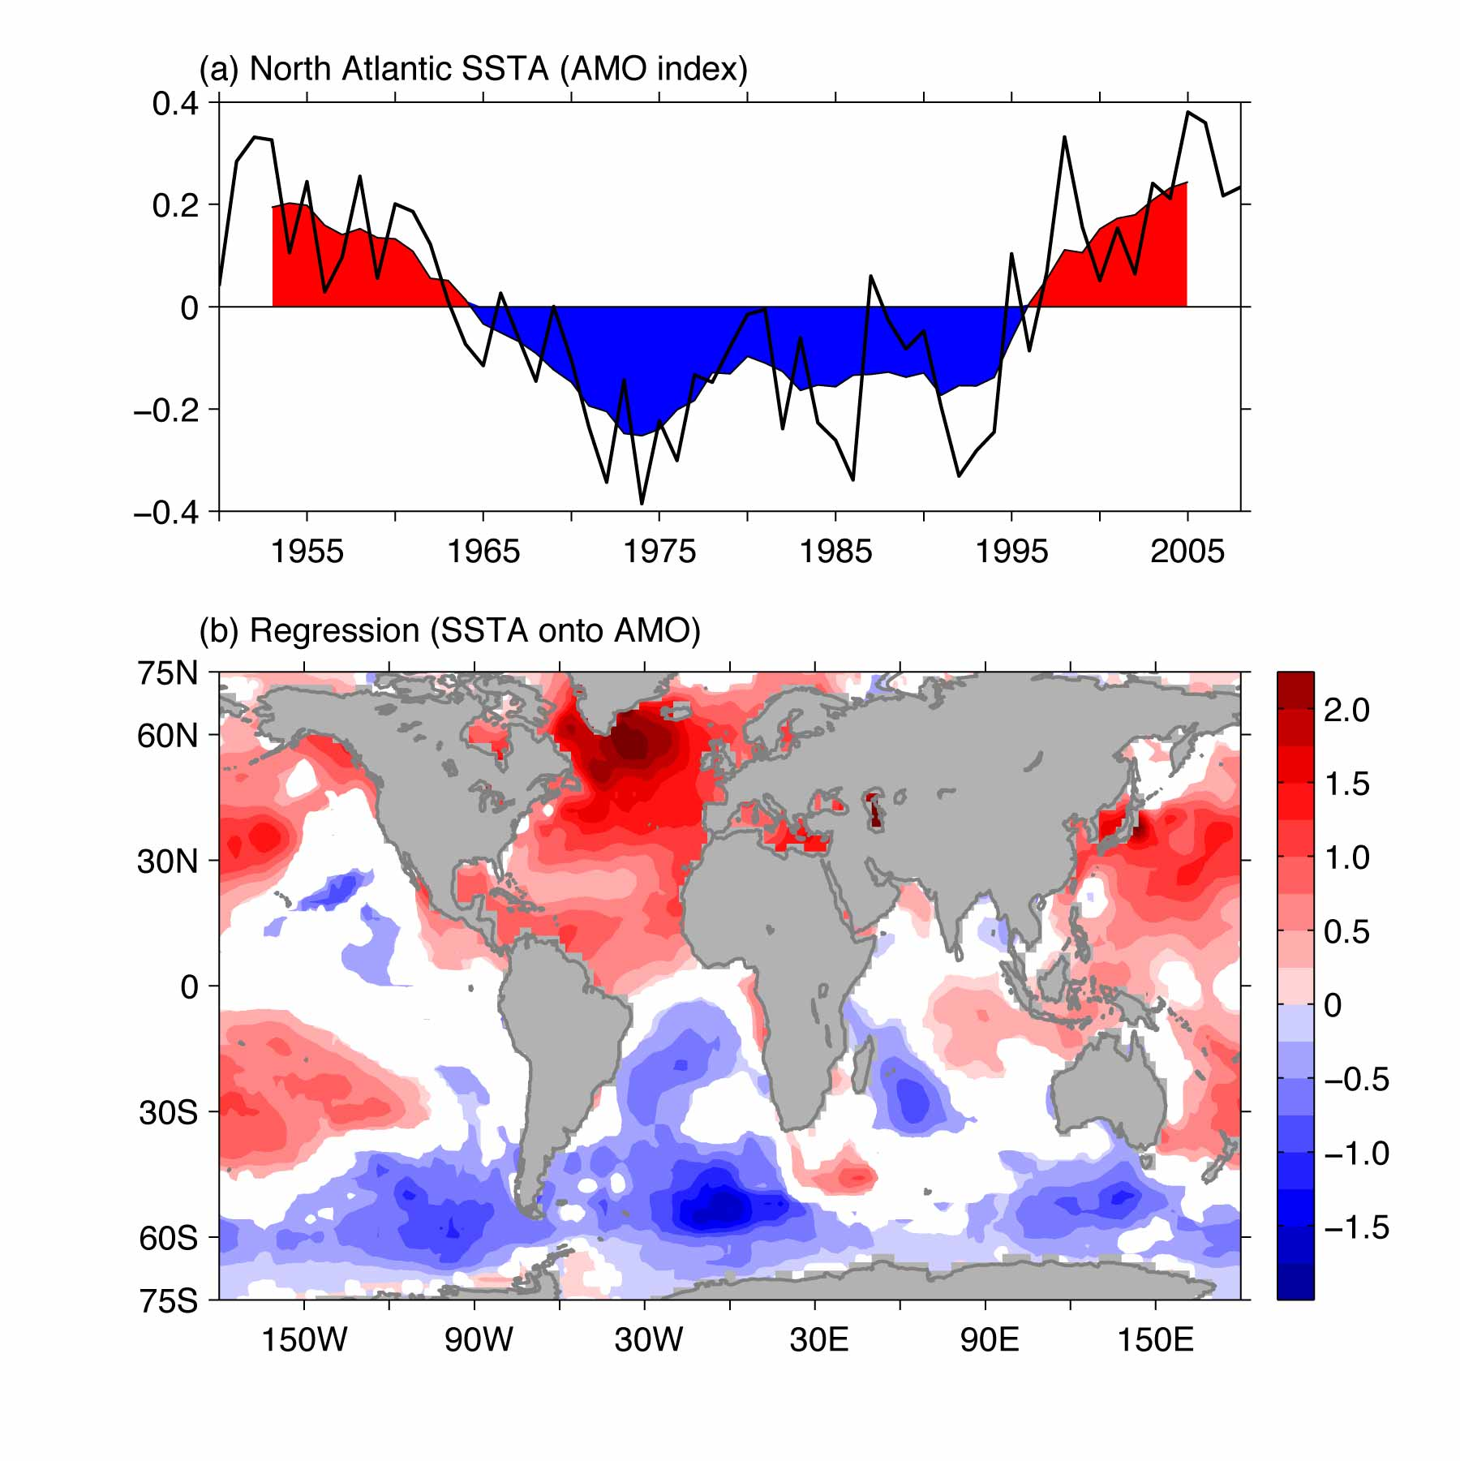

Figure 1. The AMO index and its relationship with global ocean SST. Shown are (a) the detrended annual SST anomalies (°C) in the North Atlantic of 0°-60°N and from the east coast of the Americas to 0° longitude and (b) regression (°C per °C) of global annual SST anomalies onto the AMO index. The regression is calculated based on the 7-year running mean data. The shading in (a) represents the 7-year running mean time series. The only regression exceeding the 95% significant level is plotted in (b).
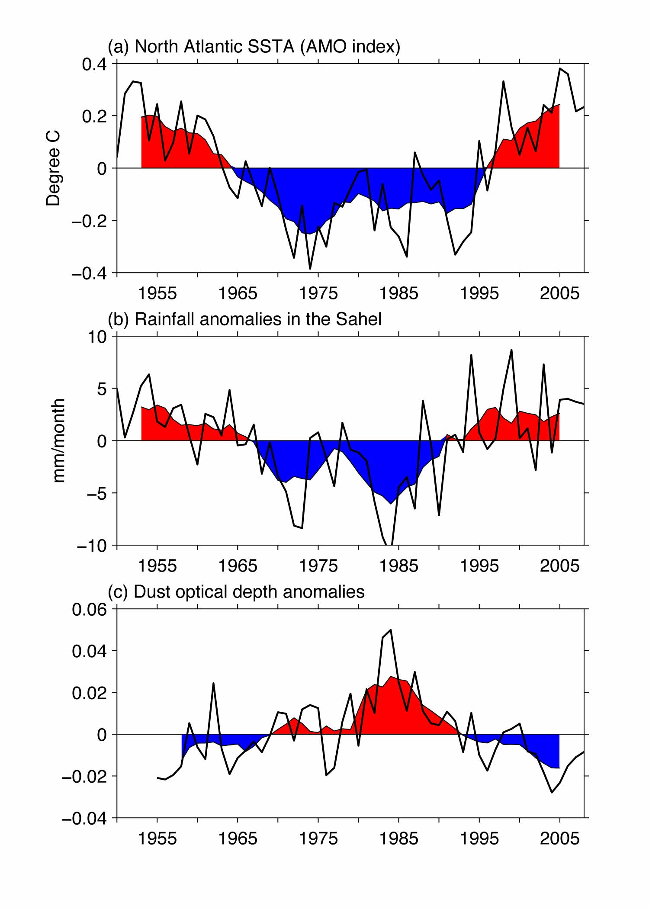

Figure 2. The AMO, Sahel rainfall and dust in the tropical North Atlantic. Shown are (a) the AMO index (°C), (b) the annual rainfall anomalies (mm/month) in the Sahel (10°N-20°N, 20°W-40°E), and (c) the annual dust optical depth anomalies in the tropical North Atlantic (0°-30°N, 10°W-65°W). The shading represents the time series of 7-year running means.
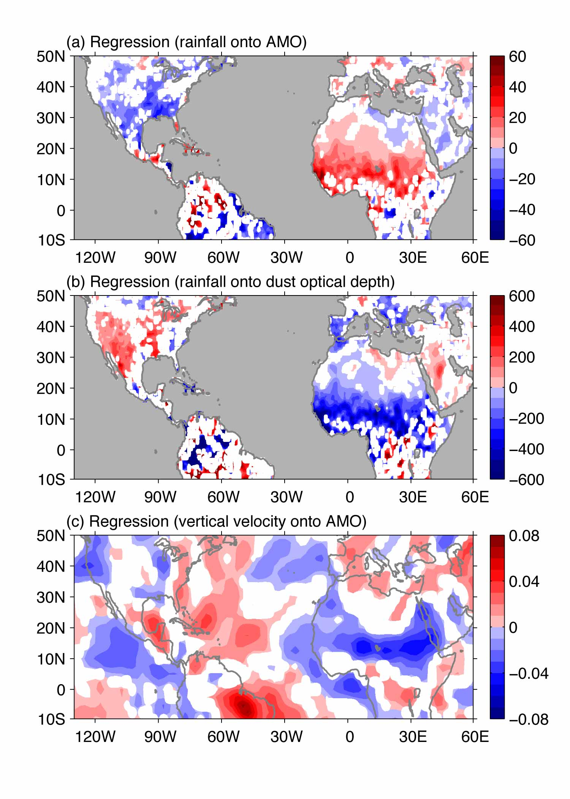

Figure 3. Linkage of the AMO, rainfall and aerosols. Shown are (a) regression (mm/month per °C) of annual rainfall anomalies onto the AMO index, (b) regression (mm/month per dust optical depth) of annual rainfall anomalies onto the dust optical depth time series in the tropical North Atlantic, and (c) regression (Pa/s per °C) of annual 500-hPa vertical pressure velocity anomalies onto the AMO index. The regressions are calculated based on the 7-year running mean data. The only regressions exceeding the 95% significant level are plotted.

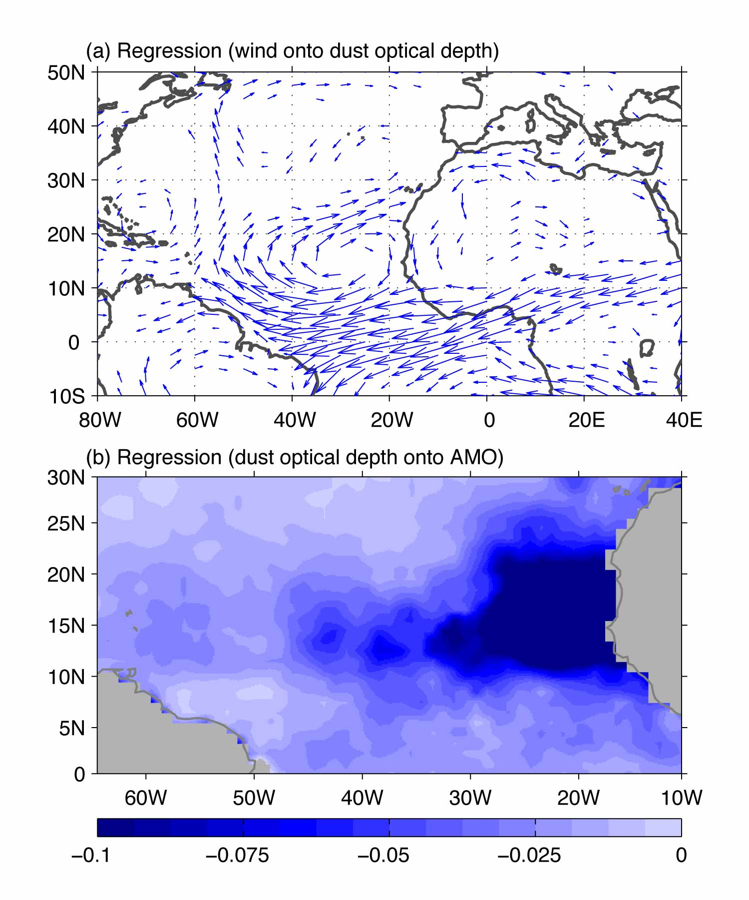

Figure 4. Wind distribution, aerosols and the AMO. Shown is (a) regression (m/s per dust optical depth) of annual wind anomalies at 700 hPa onto the dust optical depth time series in the tropical North Atlantic and (b) regression of the annual dust optical depth anomalies onto the AMO index. The regressions are calculated based on the 7-year running mean data. The only regressions exceeding the 95% significant level are plotted.

Supplementary Information for

Multidecadal Co-variability of Sea Surface Temperature and Aerosols in the North Atlantic and Rainfall in the Sahel

Chunzai Wang ¹
Shenfu Dong ^{1 & 2}
Amato T. Evan ³
Gregory R. Foltz ¹
Sang-Ki Lee ^{1 & 2}

¹ NOAA Atlantic Oceanographic and Meteorological Laboratory
Miami, Florida

² Cooperative Institute for Marine and Atmospheric Studies
University of Miami
Miami, Florida

³ Department of Environmental Sciences
University of Virginia
Charlottesville, Virginia

To be submitted to Nature as a Letter

March 2011

Supplementary Information

This supplementary information contains the description of data sets used in this study and five figures (Figs. S1-S5) referenced in the main text.

Data sets
Several data sets are used in this study. The first one is an improved extended reconstructed sea surface temperature (ERSST) data set on a 2° latitude by 2° longitude grid¹. The second data set is the National Centers for Environmental Prediction-National Center for Atmospheric Research (NCEP-NCAR) reanalysis on a 2.5° latitude by 2.5° longitude grid². Both of two data sets used here are monthly. Climatology is calculated based on the data from 1950 to 2008. Anomalies are then calculated by subtracting climatology from the monthly data.
The rainfall data set is from the Global Precipitation Climatology Centre (GPCC) Version 5. The monthly rainfall data is gridded from the complete GPCC station database with more than 70000 different raingauge stations worldwide (Rudolf et al. 1944). The gridded land precipitation is available for the period 1901-2009 in spatial resolutions of 0.5°×0.5°, 1.0°×1.0°, and 2.5°×2.5°. The data is available for downloading from ftp://ftp-anon.dwd.de/pub/data/gpcc/html/fulldata_download.html.
The extended dust optical depth over the tropical North Atlantic from 1955 to 2008 was derived from a simple model using modern and historical data from meteorological satellites and a proxy record for atmospheric dust (Evan and Mukhopadhyay 2010). Satellite data include aerosol optical thickness retrievals from the Advanced Very High Resolution Radiometer (AVHRR) Pathfinder Extended dataset (PATMOS-x) for the period 1982-2008 and the Moderate Resolution Imaging Spectroradiometer (MODIS) on board the Aqua satellite for the period 2002-2008. The proxy record for atmospheric dust is based on measurements of crustal helium-4 (4He) flux from a Porites coral at a water depth of 5 m near Pedra de Lume on Sal Island (16°45'44'' N, 22°53'23''W), part of the Cape Verde archipelago, for the period of 1955–94 (Mukhopadhyay and Kreycik 2008). The resultant 54-yr record of dust optical depth has a 1.0°×1.0° spatial resolution and a monthly temporal resolution, and covers the region 0°-30°N, 10°-65°W.

Figures S1 to S5

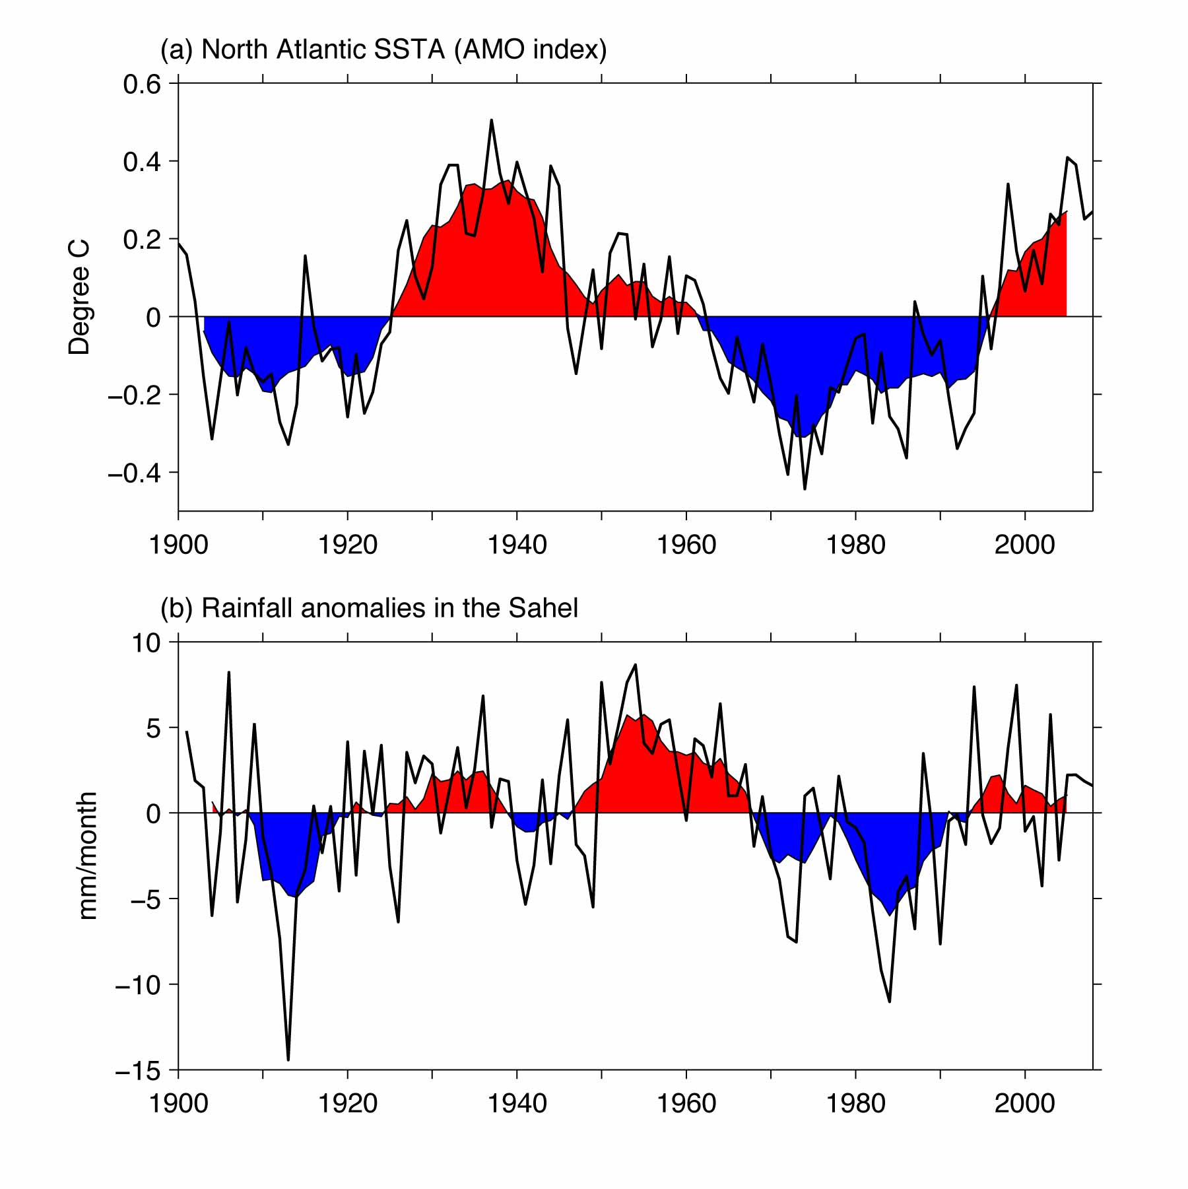

Figure S1. The AMO index and Sahel rainfall time series for a long-term record of 1900-2008. Shown are (a) the AMO index (°C) and (b) the annual rainfall anomalies (mm/month) in the Sahel (10°N-20°N, 20°W-40°E). The shading represents the time series of 7-year running means.

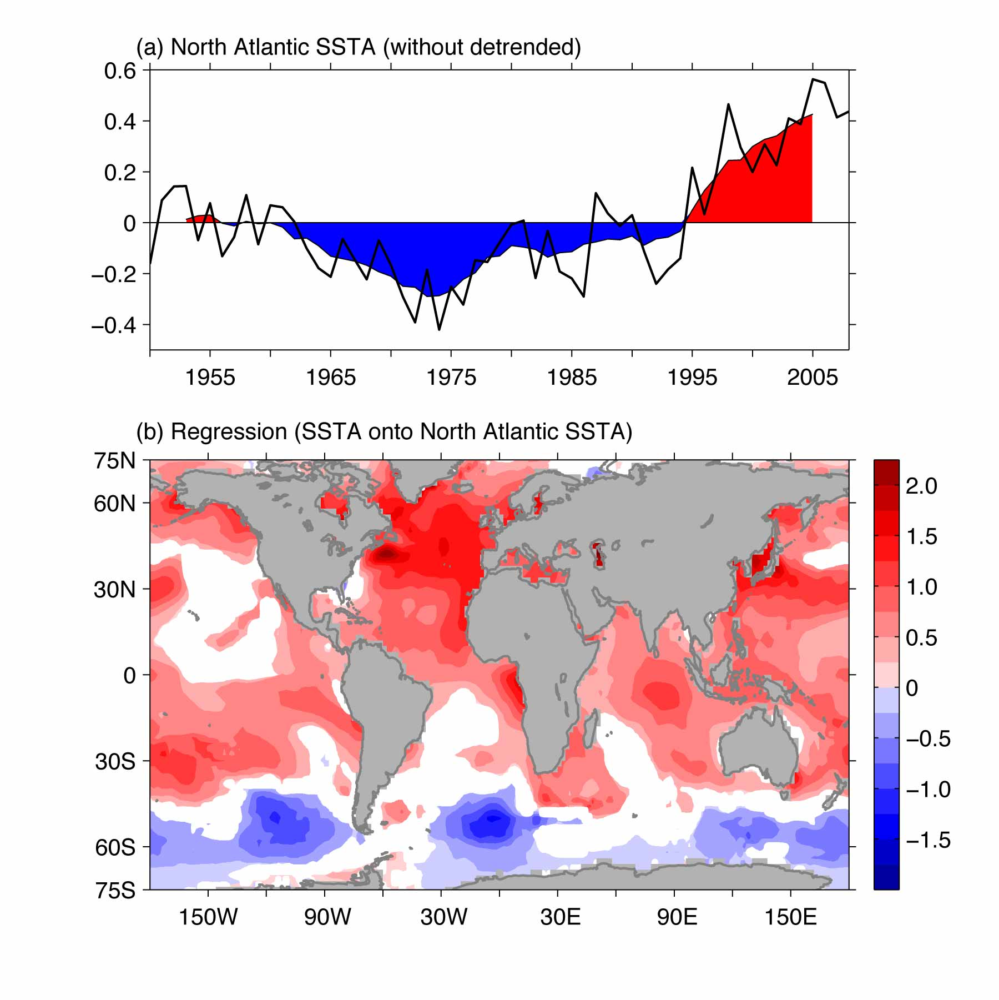

Figure S2. The time series of the North Atlantic SST anomalies and its regressed map using the data with the linear trends included. Shown are (a) the annual SST anomalies (°C) in the North Atlantic of 0°-60°N and from the east coast of the Americas to 0° longitude and (b) regression (°C per °C) of global annual SST anomalies onto the North Atlantic SST index of (a). The regression is calculated based on the 7-year running mean data. The only regression exceeding the 95% significant level is plotted. The shading in (a) represents the time series of 7-year running means.
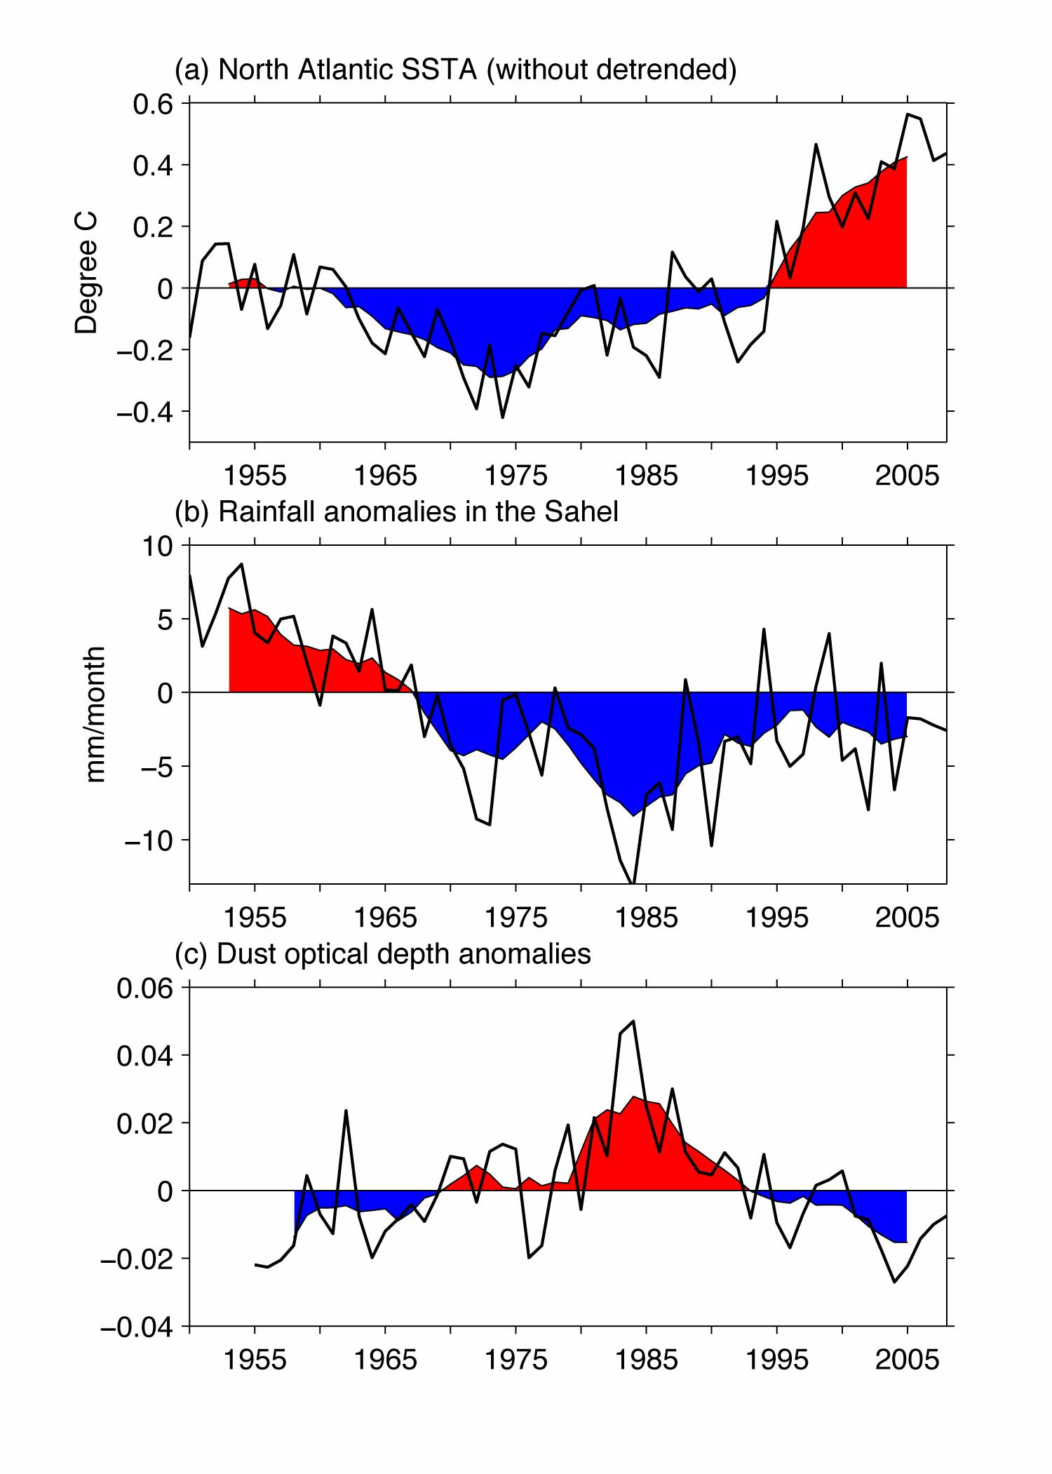

Figure S3. The time series of the North Atlantic SST, Sahel rainfall and dust in the tropical North Atlantic using the data with the linear trends included. Shown are (a) the annual SST anomalies (°C) in the North Atlantic of 0°-60°N and from the east coast of the Americas to 0° longitude, (b) the annual rainfall anomalies (mm/month) in the Sahel (10°N-20°N, 20°W-40°E), and (c) the annual dust optical depth anomalies in the tropical North Atlantic (0°-30°N, 10°W-65°W). The shading represents the time series of 7-year running means.

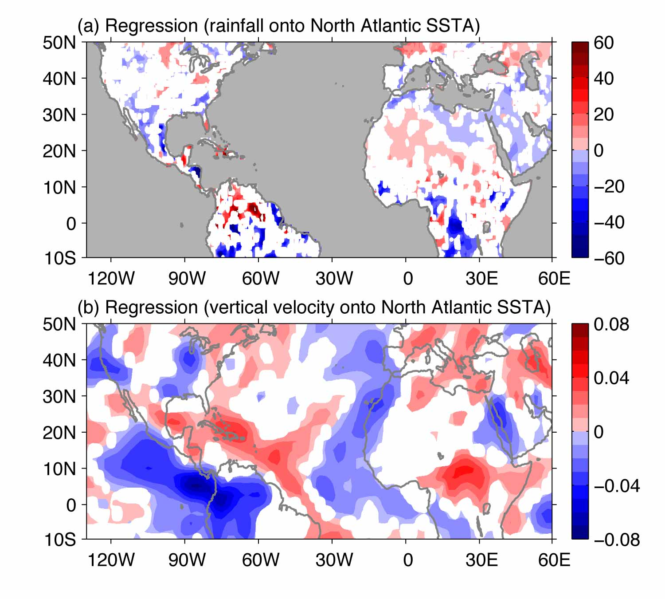

Figure S4. Linkage of the North Atlantic SST with rainfall using the data with the linear trends included. Shown are (a) regression (mm/month per °C) of annual rainfall anomalies onto the North Atlantic SST index and (b) regression (Pa/s per °C) of annual 500-hPa vertical pressure velocity anomalies onto the North Atlantic SST index. The regressions are calculated based on the 7-year running mean data. The only regression exceeding the 95% significant level is plotted.

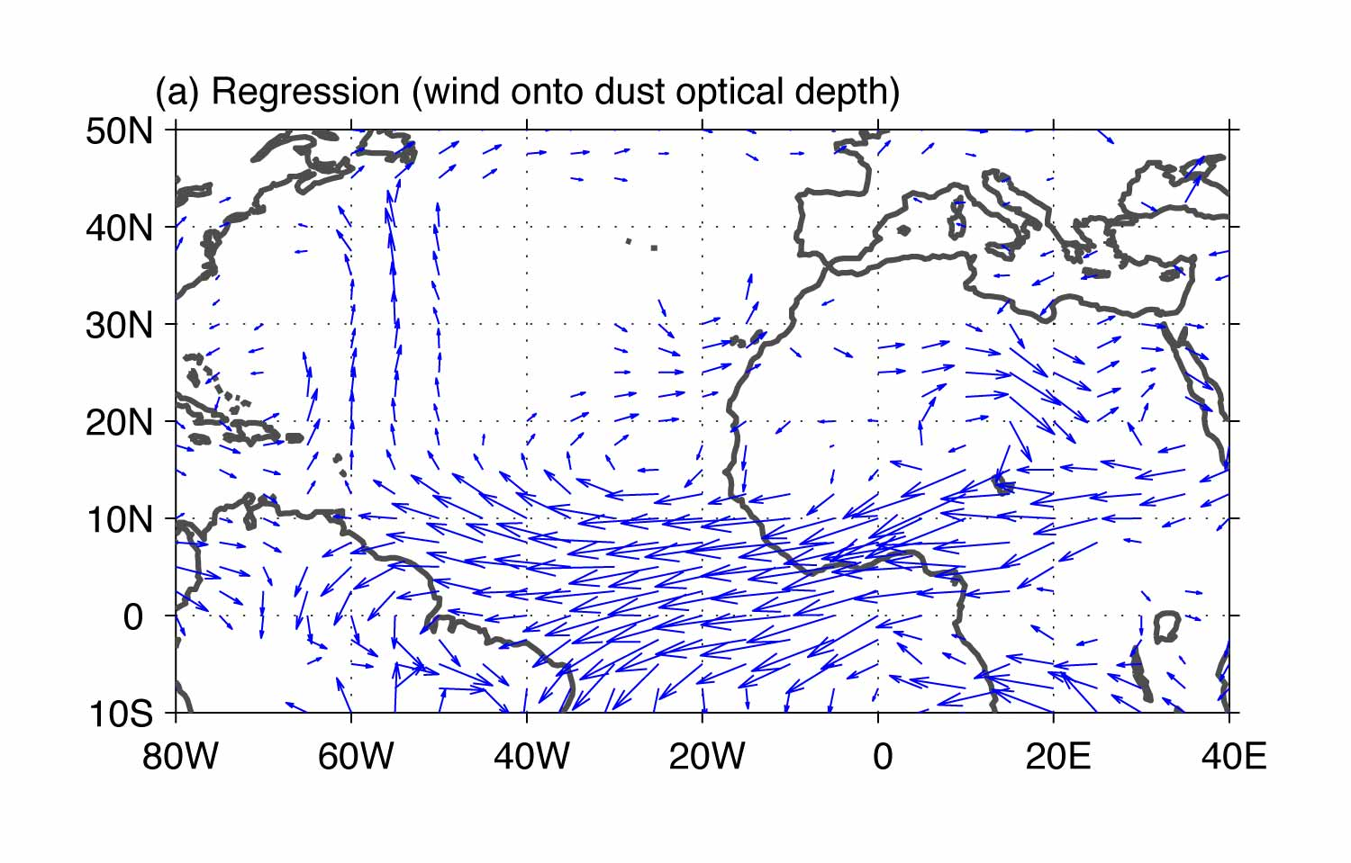

Figure S5. Regression (m/s per dust optical depth) of annual wind anomalies at 850 hPa onto the dust optical depth time series in the tropical North Atlantic. The regression is calculated based on the 7-year running mean data. The only regression exceeding the 95% significant level is plotted.

References

Smith, T. M., Reynolds, R.W., Peterson, T. C. & Lawrimore, J. Improvements to NOAA’s historical merged land-ocean surface temperature analysis (1880-2006). J Clim. 21, 2283-2296 (2008).
Kalnay, E. et al. The NCEP/NCAR 40-year reanalysis project. Bull. Am. Meteorol. Soc. 77, 437-471 (1996).
Rudolf, B., H. Hauschild, W. Ruth, and U. Schneider, 1994: Terrestrial precipitation analysis: Operational method and required density of point measurements. Global Precipitation and Climate Change, M. Dubois and M. Desalmand, Eds., Springer-Verlag, 173–186.
Evan, A. T., and S. Mukhopadhyay, 2010: African Dust over the Northern Tropical Atlantic: 1955–2008. J. Appl. Meteor. Climatol., 49, 2213–2229.

