Figure 1. Climatological sea level pressure for (a) DJF and (JJA) during 1971 - 2000 obtained from the NCEP-NCAR Reanalysis. The unit is hPa.

Figure 2. Daily solar insolation at the top of the atmosphere in (a) CTRL, and (b) SYNC, and (c) CTRL – SYNC. The unit is W m⁻².

Figure 3. Climatological sea level pressure for (a) DJF and (JJA) obtained from CTRL. The unit is hPa.

Figure 4. Sea level pressure averaged zonally for (a, d, and g) the South Pacific Ocean, (b, e, and h) the South Atlantic Ocean, and (c, f, and i) South Indian Ocean, obtained from (a, b and c) the NCEP-NCAR reanalysis, (d, e and f) CTRL, and (g, h and i) SYNC. The unit is hPa.

Figure 5. Meridional overturning circulation (mass stream function) obtained from (a) CTRL, (b) SYNC, and (c) CTRL – SYNC. Circulation is clockwise (anticlockwise) around positive (negative) stream function. The unit is 10⁹ Kg s⁻¹.
Figure 6. Velocity potential and divergent wind vector at 200 hPa obtained from (a) CTRL, (b) SYNC, and (c) CTRL - SYNC. The units are 10⁷ m² s⁻¹ for velocity potential, and m s⁻¹ for divergent wind vector.

Figure 7. (a) Sea level pressure, (b) stream function and wind vector at 500 hPa obtained from CTRL - SYNC. The zonal line at 40ºS roughly marks the southern end of the southern subtropical anticyclones in JJA. The stream function sign is reversed in such a way that circulation is anticlockwise around positive stream function. The units are hPa for sea level pressure, m for geopotential, and m s⁻¹ for wind vector.

Figure 8. Moist convective heating rate at 500 hPa in JJA obtained from CTRL - SYNC. The three regions of diabatic heating in the NH, namely the northwestern Pacific Ocean affected by summer expansion of the western Pacific warm pool, the WHWP, and the Indian summer monsoon region are indicated by red borderlines. The three regions of diabatic cooling in the equatorial oceans and the tropical SH, namely the south-central Pacific, the western equatorial Atlantic, and the equatorial Indian Ocean are shown with blue borderlines. The unit is K day⁻¹.

Figure 9. Zonally averaged climatological (a) barotropic zonal, (b) baroclinic zonal and (c) baroclinic meridional winds in JJA obtained from SYNC (solid lines), CTRL (long-dashed lines) and the NCEP-NCAR reanalysis (short-dashed line). The barotropic zonal winds are obtained by vertically averaging the zonal winds in the troposphere (100 ~ 1000 hPa). To compute the baroclinic zonal winds, the zonal winds are vertically averaged separately for the upper troposphere (100 ~ 500 hPa) and for the lower troposphere (500 ~ 1000 hPa), and the latter is subtracted from the former then divided by 2. The same methodology is used to compute the baroclinic meridional winds.

Figure 10. Barotropic stream function and wind vector responses in the simple model experiments to the moist convective heating and cooling derived from CTRL – SYNC. The units are 10⁷ m² s⁻¹ for stream function, and m s⁻¹ for wind vector.

Figure 11. Barotropic stream function and wind vector responses in the simple model experiments to diabatic cooling in (a) the central South Pacific Ocean, (b) the western equatorial Atlantic Ocean, and (c) the equatorial Indian Ocean. The units are 10⁷ m² s⁻¹ for stream function, and m s⁻¹ for wind vector.
Figure 12. Barotropic stream function and wind vector responses in the simple model experiments to diabatic cooling in (a) the northwestern Pacific Ocean, (b) the WHWP, and (c) the Indian summer monsoon region. The units are 10⁷ m² s⁻¹ for stream function, and m s⁻¹ for wind vector.
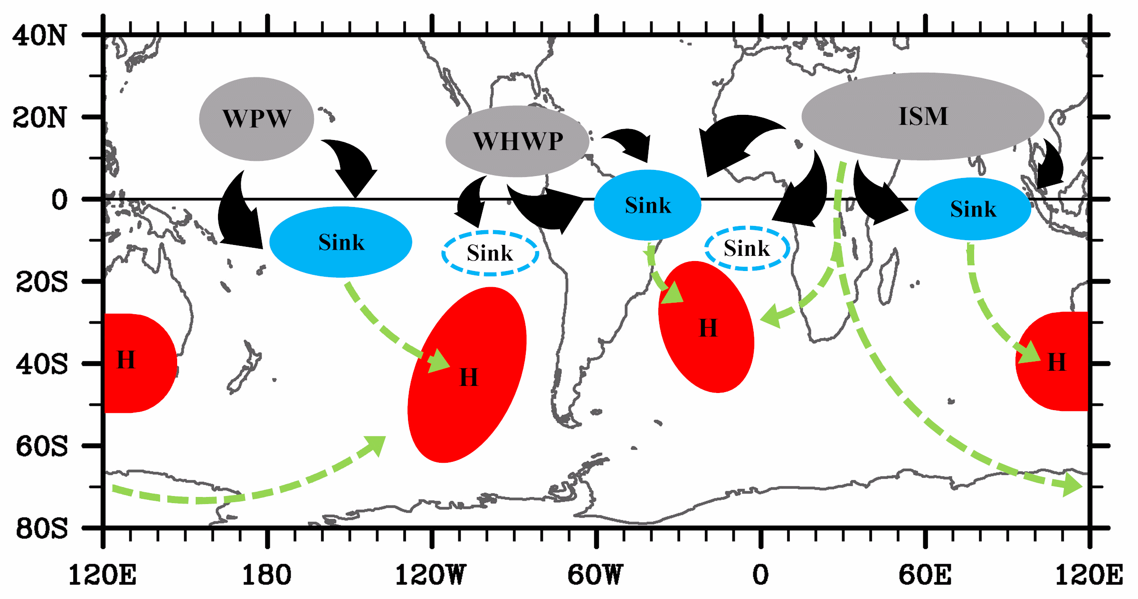
Figure 13. Sketch of the physical processes linking the major summer monsoons in the NH and the southern subtropical anticyclones. The three regions of rising motion, the three regions of sinking motion and the regions of southern subtropical anticyclones affected are filled with gray, sky blue and red colors, respectively. The sinking regions in the southeastern tropical Pacific and the southeastern tropical Atlantic are indicated by sky blue borderlines. Thick black arrows represent divergent winds in the upper level, while light green arrows represent the paths of the stationary barotropic Rossby waves forced by diabatic cooling over the three regions of sinking motion and by diabatic heating in the Indian summer monsoon region.

