Toward Developing a Seasonal Outlook for the Occurrence
of Major U.S. Tornado Outbreaks

Principal Investigators: Sang-Ki Lee, Robert Atlas, David Enfield and Chunzai Wang
Program Managers: Drs. Annarita Mariotti and Dan Barrie
Project Period: August 1, 2012 – July 31, 2015

A new research led by the PIs shows that the so-called Trans-Niño is the optimal ENSO pattern that enhances large-scale atmospheric processes conducive to tornado outbreaks in the U.S, and thus may potentially provide seasonal predictability for U.S. tornado outbreaks. Among the top ten extreme tornado outbreak years during 1950-2010, seven years including the top three years are identified with a strongly positive phase Trans-Niño. The number of intense tornadoes (Fujita scale 3 - 5) in April - May is nearly doubled during the top ten positive Trans-Niño years from that during ten neutral years.

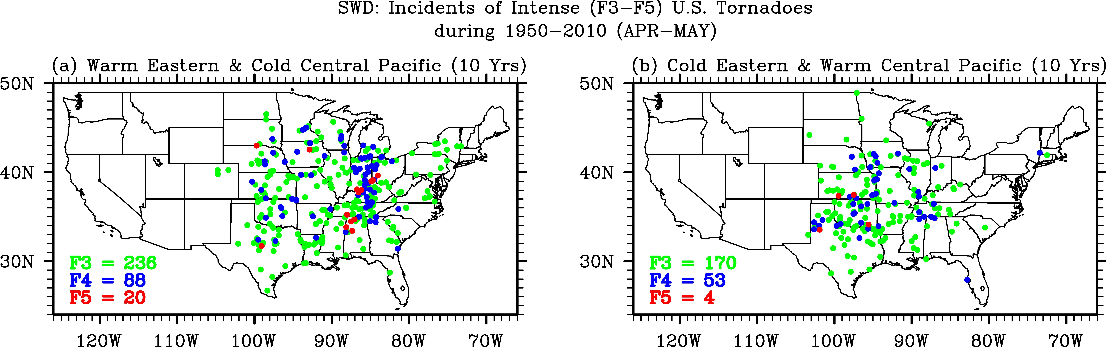
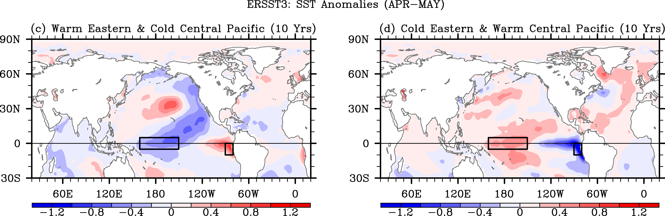

Figure: Shown in upper panels are the incidents of intense (F3–F5) U.S. tornadoes in Apr-May for (a) the top 10 positive Trans-Niño years, (b) 10 negative Trans-Niño years during 1950–2010 obtained from SWD. Green indicates F3, blue F4, and red F5 tornadoes. Shown in bottom panels are the composite SST anomalies in Apr-May obtained from ERSST3 for (a) the 10 positive Trans-Niño years and for (b) the top 10 negative Trans-Niño years during 1950–2010.

