AOML-SEFSC Collaboration: Impact of Climate Change on
Atlantic Bluefin Tuna Spawning in the 21st Century

Principal Investigators: Sang-Ki Lee, Gustavo Goni, John Lamkin (SEFSC) and Barbara Muhling (SEFSC)
Funding Sources: NASA and NOAA/NMFS
Project Period: September 1, 2010 – August 31, 2015

Although the Atlantic bluefin tuna (BFT) is widely distributed, spawning in the western Atlantic has been recorded predominantly in the Golf of Mexico (GoM), from April to June. While BFT can tolerate colder waters than other tropical tunas, they are adversely affected by warm waters. A high-resolution downscaled ocean model of the IPCC-AR4(5) projection is used to simulate the upper ocean temperature of the GoM in the 21st century. Associations between adult and larval BFT in the GOM and sea temperatures are defined using 20th century observations, and potential effects of warming on the suitability of the GOM as a spawning ground are quantified. Areas in the GOM with high probabilities of larval occurrence decrease in late spring by 39–61% by 2050 and 93–96% by the end of the 21st century.
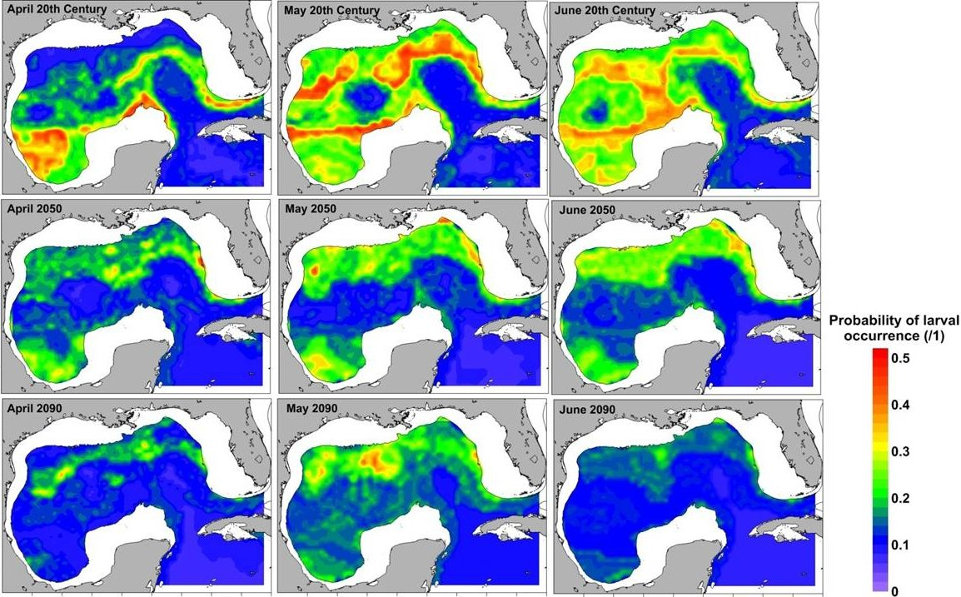
Late-20C
Late-21C
Mid-21C
April
June
May
Figure: Prediction of the extent of habitat suitable for the occurrence of larval BFT in the GOM under late 20th century conditions (1971–1999) and projected conditions in 2045–2055 and 2085–2095, for the months of March, April, May, and June. The probability of occurrence (%) is illustrated, based on output from the boosted classification-tree model using weighted mean temperature values.

