Variability and Predictability of the Atlantic Warm Pool and Its Impacts on Extreme Events in North America

Principal Investigators: Chunzai Wang, Sang-Ki Lee and David Enfield
Program Managers: Drs. Annarita Mariotti and Dan Barrie
Project Period: August 1, 2012 – July 31, 2015

Atlantic Warm Pool (AWP) is a large body of warm water composed of the Gulf of Mexico, the Caribbean Sea and the western tropical North Atlantic with its SST exceeding 28.5°C. A recent study led by the PIs in collaboration with Dr. Robert Atlas (AOML) indicates that the AWP play an important role in determine hurricane tracks. An eastward expansion of the AWP shifts the hurricane genesis location eastward, decreasing the possibility for a hurricane to make landfall (upper panels). A large AWP also induces barotropic stationary wave patterns that weaken the North Atlantic subtropical high and produce eastward steering flow anomalies along the eastern seaboard of the U.S (lower panels). Due to these two mechanisms, hurricanes are steered toward the northeast without making landfall in the United States.

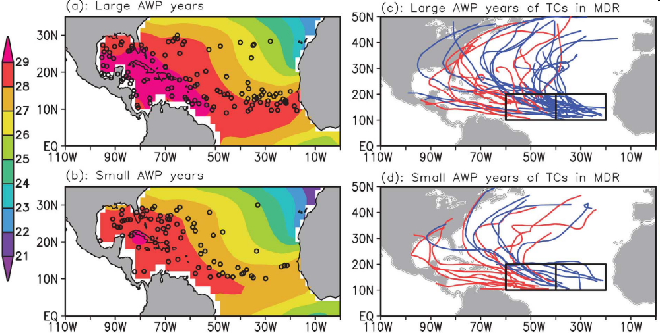
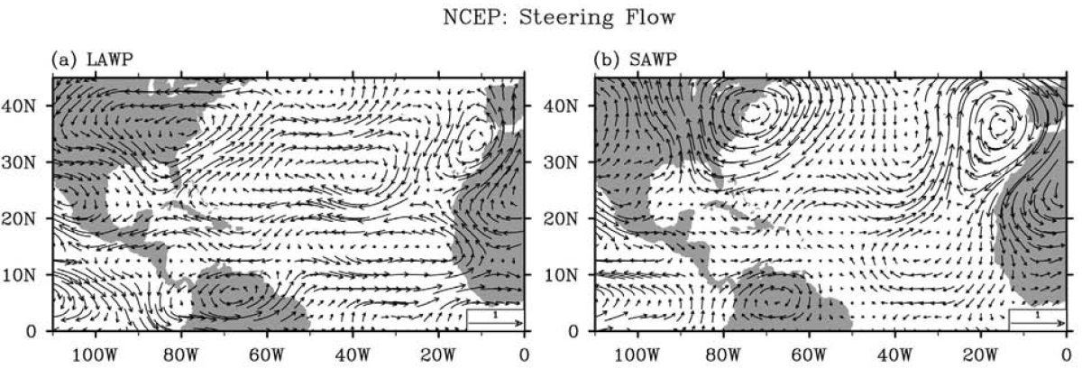

Figure: Shown in the upper panels are the TC genesis location (dots) and sea surface temperature (color shading) for (a) large and (b) small AWP years and the tracks of TCs that formed in the main development region for (c) large and (d) small Atlantic warm pools. Lower panels show the TC steering flow anomalies for (a) large and (b) small AWP years.

