Table 1. Threshold values by hurricane intensity
Category | Percentile  (10%) | Percentile  (25%)
1 | 8.94 | 10.74
2 | 8.36 | 10.76
3 | 6.67 | 10.62
4 | 10.66 | 11.24
5 | 10.70 | 11.21

Table 2. OHC ASO seasonal mean value for individual sub-regions of the AWP.
 | Historical  (1981-2000) | RCP 4.5  (2041-2060) (2081-2100) |  | RCP 8.5  (2041-2060) (2081-2100)
WAT1 | 9.7612 | 10.2213 | 10.5044 | 10.3074 | 11.0820
WAT2 | 11.0272 | 11.4785 | 11.7564 | 11.5717 | 12.3568
WAT3 | 10.8295 | 11.3218 | 11.6314 | 11.4250 | 12.2703
CBN | 11.4685 | 11.9269 | 12.2157 | 12.0182 | 12.8293
GOM | 10.7218 | 11.0692 | 11.2930 | 11.1055 | 12.0149
TNA1 | 10.6098 | 11.0850 | 11.4135 | 11.1896 | 12.0470
TNA2 | 11.1079 | 11.5880 | 11.7857 | 11.5880 | 12.3394

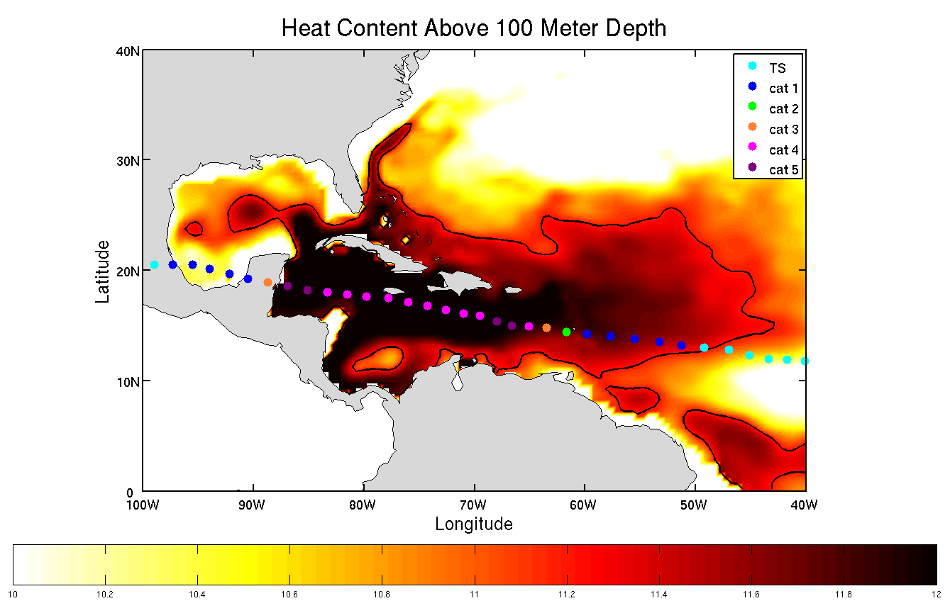
Figure 1. Hurricane Dean in August 1980 as it intensifies into category 5 storm in a high OHC region.

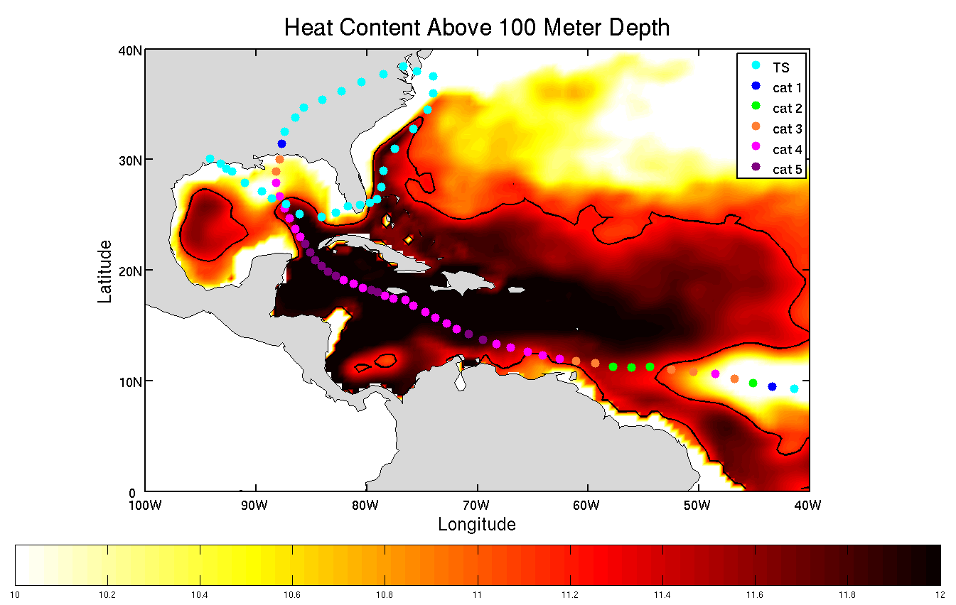
Figure 2. Hurricane Ivan during September 2004 as it intensifies in Caribbean waters

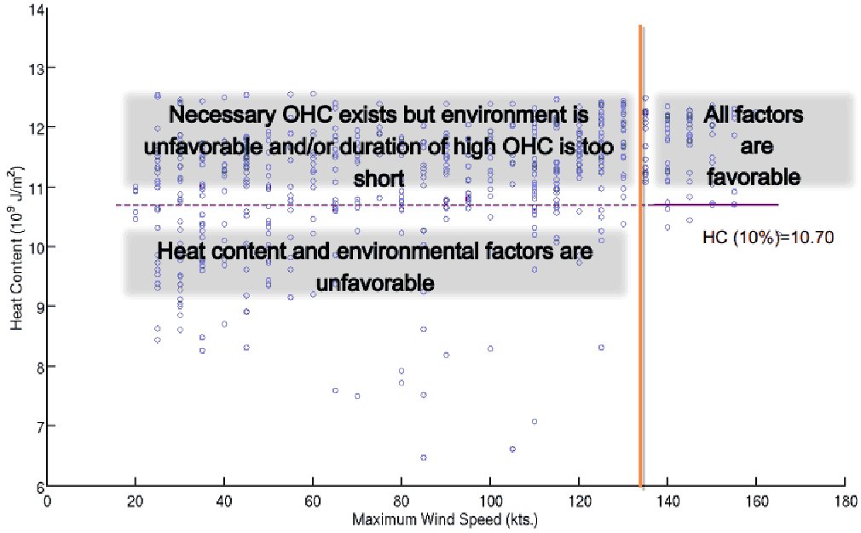
Figure 3. Maximum wind speed plotted against the corresponding OHC for every 6 hr forecast.

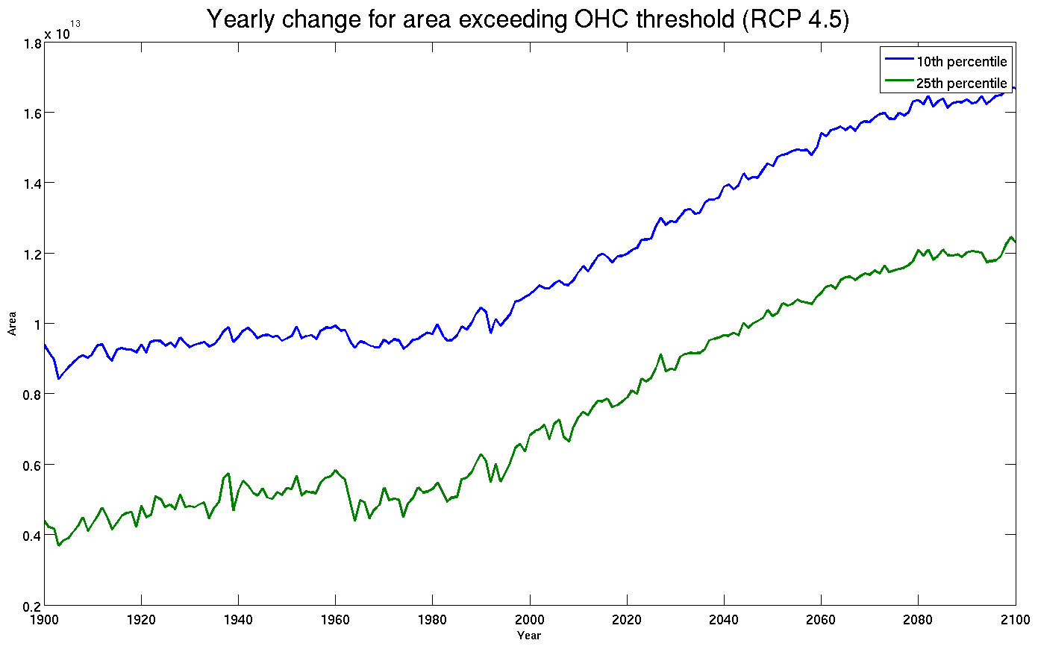
Figure 4. Yearly change in the area exceeding the 10.7 and 11.2 thresholds under the RCP 4.5 scenario.

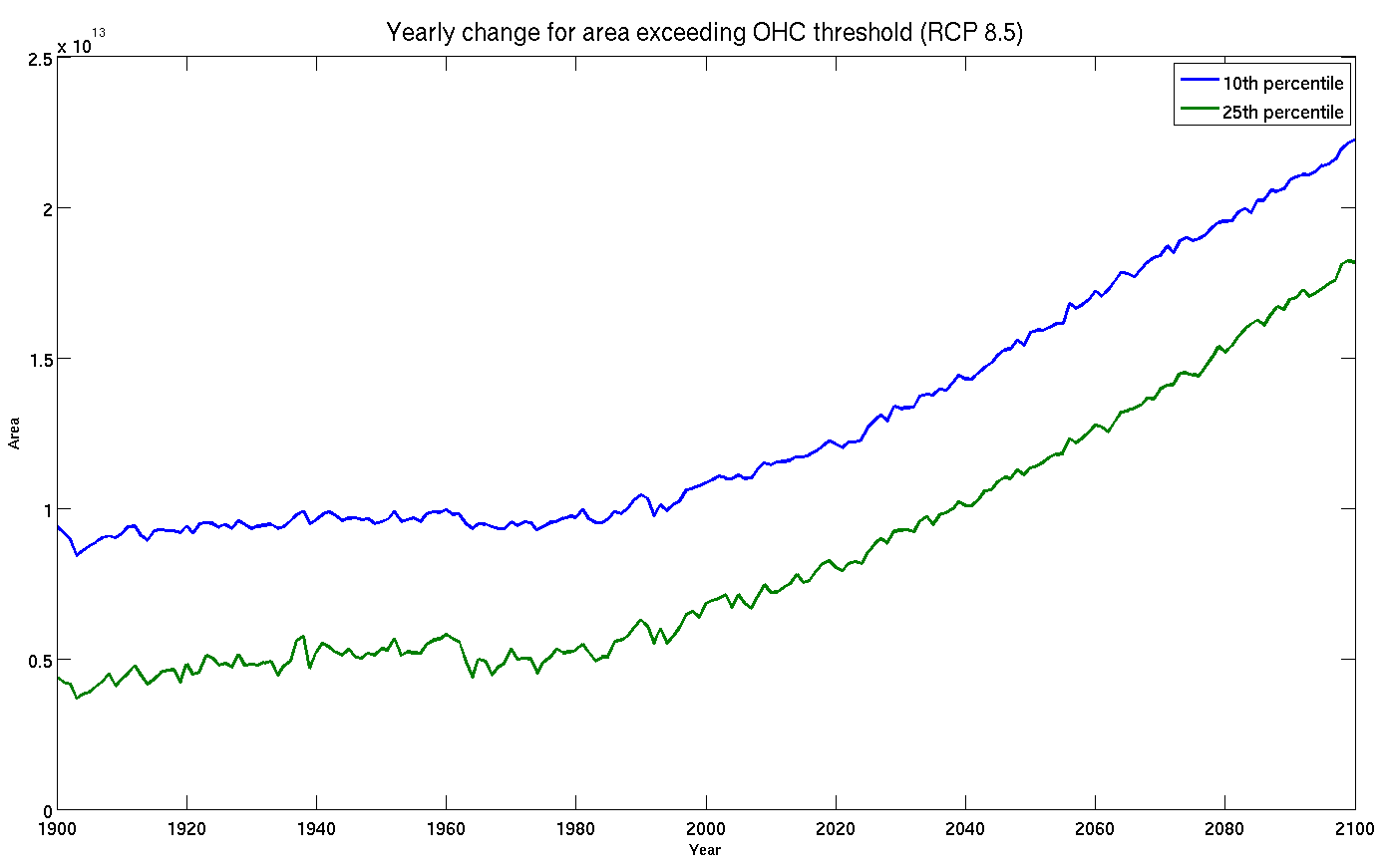
Figure 5. Yearly change in the area exceeding the 10.7 and 11.2 thresholds under the RCP 8.5 scenario.

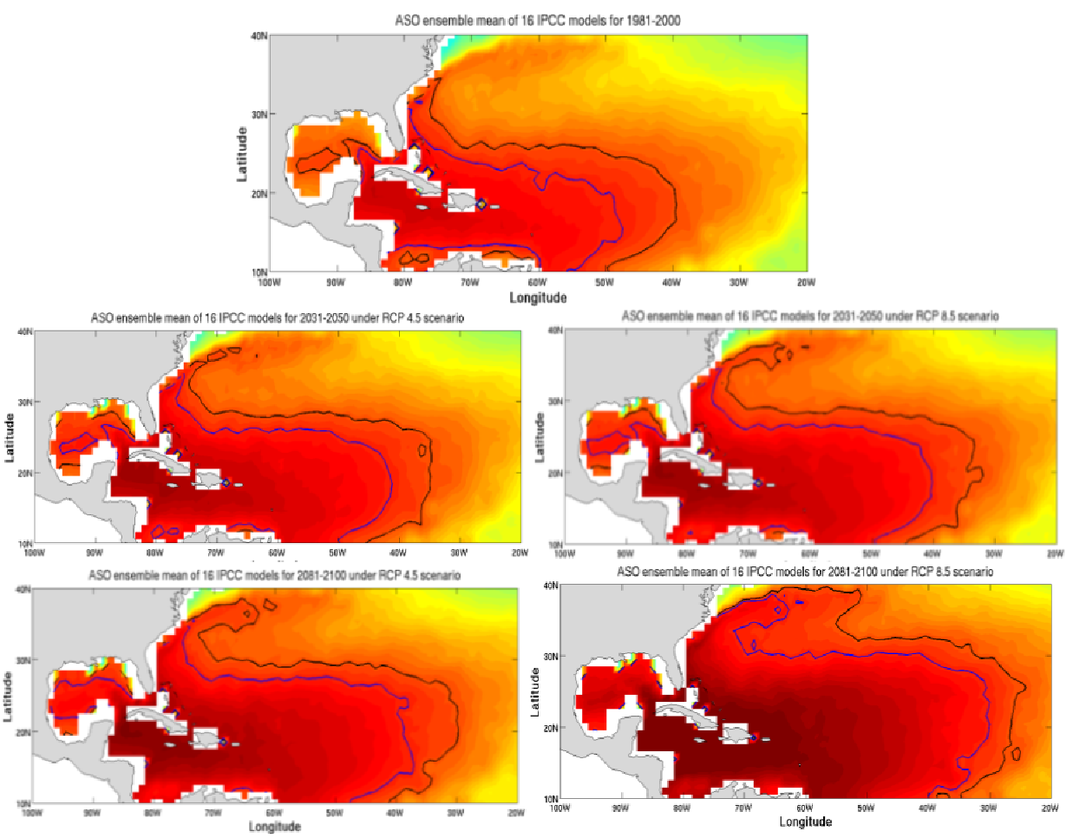
Figure 6. OHC changes for mid and late 21st century under the IPCC scenarios: RCP 4.5 and RCP 8.5

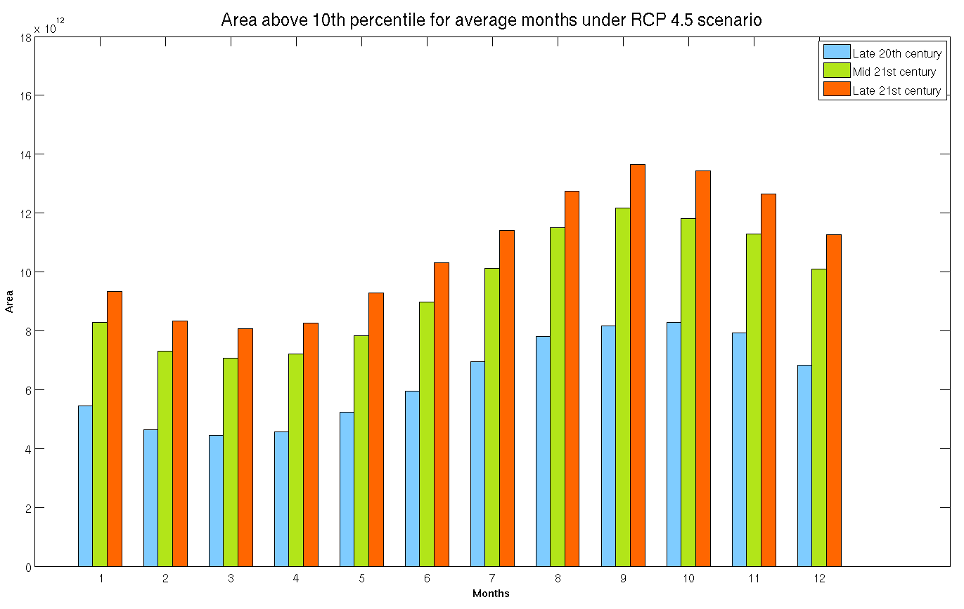
Figure 7. Monthly variations of the area exceeding the 10th percentile threshold under the RCP 4.5 scenario. The blue, green and orange line represent the average area of the threshold during the late 20th, mid 21st and late 21st century, respectively.

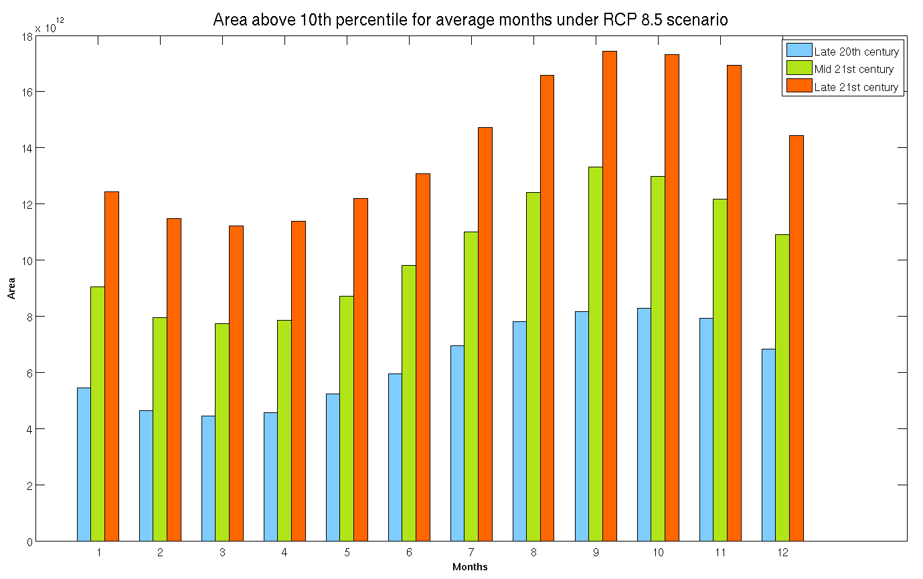
Figure 8. Monthly variations of the area exceeding the 10th percentile threshold under the RCP 8.5 scenario.

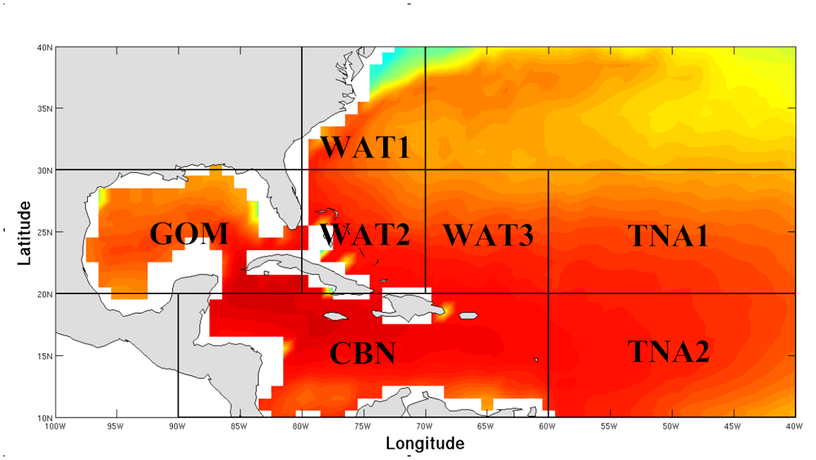
Figure 9. Atlantic Warm Pool sub-regions distributed as: the Gulf of Mexico (GOM), Western Atlantic Region (WAT1, WAT2 and WAT3), the Caribbean Sea (CBN) and the Tropical North Atlantic (TNA1 and TNA2).

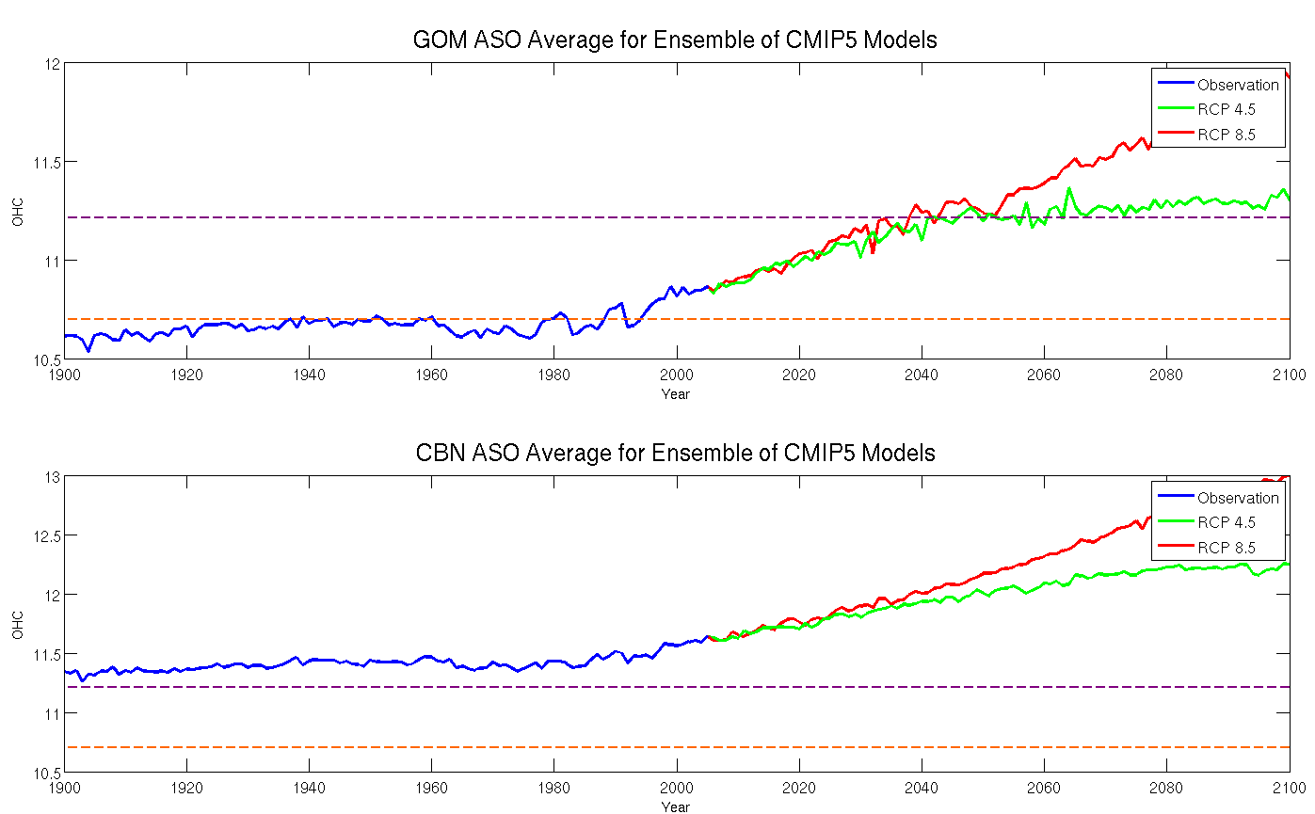
Figure 10. ASO OHC yearly average values within the Gulf of Mexico (upper figure) and the Caribbean region (lower graph). The orange and purple horizontal lines represent the 10th and 25th percentile threshold established previously.

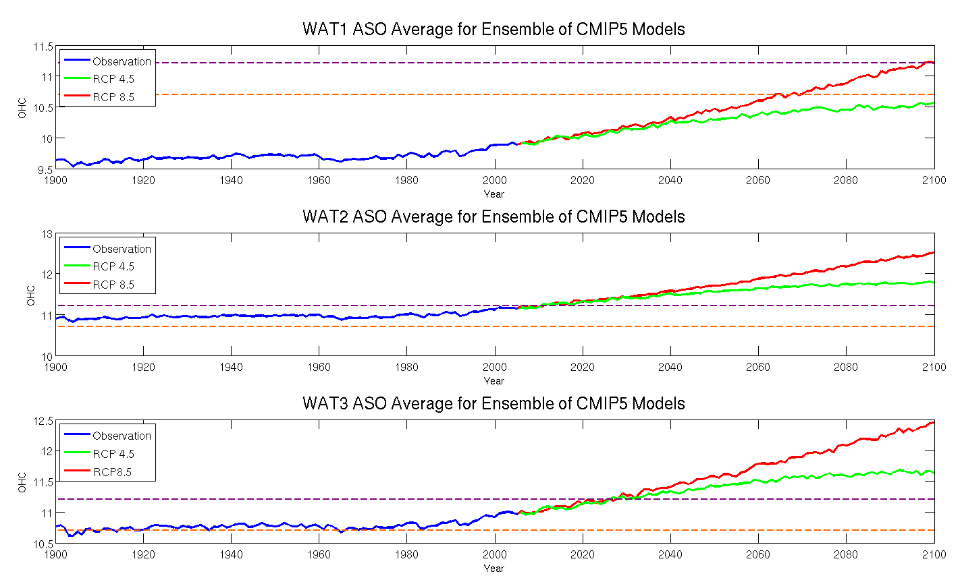
Figure 11. ASO OHC yearly means within the Western Atlantic sub-regions.

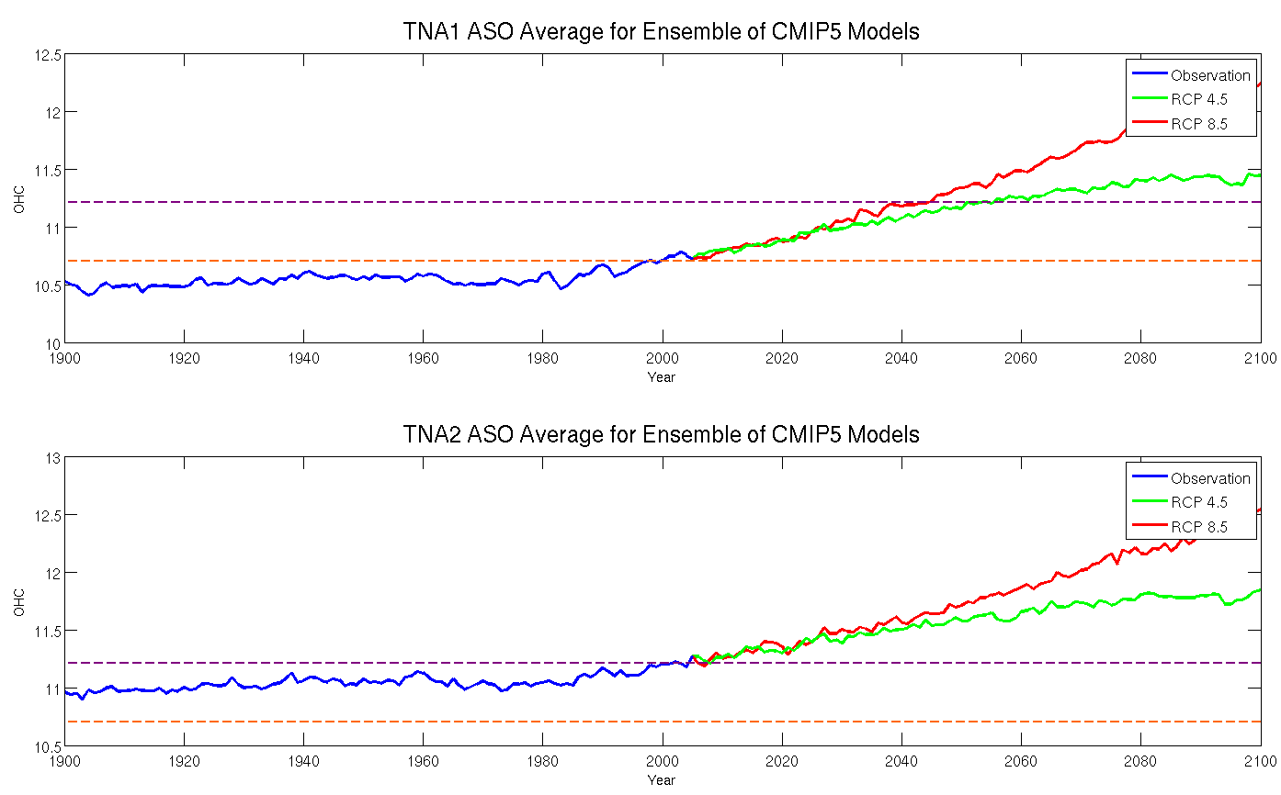
Figure 12. ASO OHC yearly means within the Western Atlantic sub-regions.

