WORLD METEOROLOGICAL ORGANIZATION  ___________ |  | INTERGOVERNMENTAL OCEANOGRAPHIC COMMISSION (OF UNESCO)  _____________
DATA BUOY COOPERATION PANEL  TWENTY-SEVENTH SESSION  Geneva, Switzerland  26-30 SEPTEMBER 2011 |  | DBCP-XXVII/Doc. 6.1  (16-Sep-11)  _______  ITEM: 6.1  ENGLISH ONLY

Report by the Task Team on Data Management (TT-DM)

(Submitted by Mayra Pazos, Chairperson, TT-DM, USA)

Summary and purpose of the document

This document contains the report by the chairperson of the DBCP Task Team on Data Management.

ACTION PROPOSED
The Panel will review the information contained in this report and comment and make decisions or recommendations as appropriate. See part A for the details of recommended actions.

_______________

Appendices: A. Report by the Task Team on Data Management

- Terms of Reference of the DBCP Task Team on Data Management

- GTS Processing Monitoring graphs from CLS-France

Results of AOML 2010 Comparison Study Performance Tables

-A- Draft TEXT for inclusion in the final report

6.1.1 Ms Mayra Pazos, Chairperson of the Task Team on Data Management (TT-DM) reported on the progress during the intersessional period. The Task Team promoted discussion between its members, revised the recommendations proposed last year to assess actions taken, and proposed new recommendations.

6.1.2 The meeting agreed on the following:

- It is recommended that all 5-digits old WMO numbers be converted to use the equivalent 7-digit WMO number to refer to drifters in all metadata files (e.g. GDP deployment log, JCOMMOPS cross-reference lists, etc). The Panel requested GDP and JCOMMOPS to implement the required changes (action; GDP & JCOMMOPS; DBCP-28)

- The Technical Coordinator (TC) should continue to assist Pierre Blouch and Jon Turton in preparing a methodology to compare non-GTS buoy data with NWP/Ocean models, open to anyone via the web (Continuation of DBCP-25 Action 8.8.2). The Panel requested the TC to report any progress made with respect to related web tools by the next DBCP Session (action; TC DBCP; DBCP-28).

- The cross reference list of WMO IDs vs. Transmitter ID provided by JCOMMOPS on the web is very useful. However, the Panel noted with concern that due to the Technical Coordinator’s position having been vacant, it was last updated on October 13, 2010. The Panel requested the Technical Coordinator to resume producing the list operationally (action; TC DBCP; ASAP).

6.1.3 The Panel thanked Ms Pazos and members of the Task Team for their efforts. It was agreed that Ms Mayra Pazos would continue as chairperson of the Task Team for the intersessional period. The full report of the Task Team is provided in Appendix A of DBCP-27 preparatory document No. 6.1 as well as in the CD-ROM accompanying the DBCP Session final report.

______________________

Appendices: 3

Report by the DBCP Task Team on Data Management

During the intersessional period, the TT-Data Management Team promoted discussion between members, revised the proposed recommendations from last year to assess actions taken and proposed new recommendations.

1. Receive and Review reports

1.1 ISDM has a page which summarizes and provides access to the most recent month of GTS DRIBU data. The page provides access to a Google Earth KML file with drift tracks, meta-data, CSV data download and data graphics/plots. The URL is

http://isdm.gc.ca/isdm-gdsi/drib-bder/KML/MonthlyKML-eng.htm

1.2 Regarding the coordination between SOC and ISDM, it was reported at IODE (iode21_doc35.pdf) in February that SOC and ISDM would work at assembling a workshop based on the recommendations contained in the Report by the Ad Hoc Task Team on Responsible National Ocean Data Centers (RNODCs) and Specialized Oceanography Data Centers (SOCs) . No progress to report at this time.

2. Table Driven coding requirements for data buoy observations

2.1 The Panel is reminded that BUFR will be the only way to communicate on the GTS after 2012.

2.2 CLS/CLS America transmit all drifter data on GTS in both, BUOY and BUFR formats.

2.3 ISDM continues to decode and store BUFR GTS messages but they have not resolved the few remaining outstanding questions with differences between the FM18 Buoy code and BUFFR message streams since Hester’s departure. Once the new Technical Coordinator is in place they will continue working through any remaining issues. ISDM continues to use the Buoy code version of GTS DRIBU data for archival and do not see any significant challenges to switching over to BUFFR as the primary data stream for QC and archival.

2.4 The chair of the Task Team on Table Driven Code Form, Bill Burnett, reports that new BUFR templates and master table-10 were submitted but not fully tested yet. He also reported that new BUFR tables for gliders have been requested.

3. Real Time Distribution of Data

3.1 The DAC continues to distribute and monitor all data from AOML’s drifters on the GTS. During this intersessional period the DAC insured that ~1300 drifters with an average of one position fix every 1.2 hours were placed on the GTS. The DAC takes immediate action after recommendations from the QC centres are received regarding suspicious data on the GTS
The DAC would like to see the WMO/ID cross reference list on the web continued to be updated once the new TC starts on the job,(ftp://ftp.JCOMMOPS.org/JCOMMOPS/GTS/wmo/wmo_list.txt). This list is very useful and needed to obtain WMO numbers assigned to platforms that are not managed by the DAC and are on the GTS. This list was last updated on October 13, 2010.

3.2 Meteo-France QC-Tools allow now to query buoys through either their 5-digit or their 7-digit WMO numbers to check GTS data against models. The 7-digit WMO numbers are mandatory for buoys having already their 3rd or 4th digits different from “0” and reporting through BUFR only. QC-tools allows now to monitor transmission delays for individual buoys. Monthly statistics of transmission delays as well as graphs showing this parameter over the last two weeks period may be displayed the same way as for the measured parameters.

Salinity measurements

3.3 More and more buoys are reporting SSS onto the GTS either in FM18-BUOY or in FM94-BUFR code. In June 2011, the data of 44 moored buoys and 41 drifting buoys were received at Meteo-France. This parameter is monitored through the QC-Tools as for other parameters. Comparisons are done with Mercator model for SSS. Graphs of differences with model outputs over the past 15 days, as well as monthly statistics, may be got from the server.

Surface current measurements

3.4 For many years, Meteo-France has been providing the Coriolis centre on a weekly basis with drifter observation data (SST and SSS), current deduced from the move of the buoys and co-located winds and wind stress. This is done for all SVP drifters reporting their data onto the GTS. An automatic test is performed on the drogue indicator (submergence or strain gauge) to assess the presence or the absence of the drogue. The test is using the average and the standard deviation of the drogue indicator as well as empirical threshold. The data are then flagged. Till now, the data of buoys supposed having lost their drogue were not distributed. Works are ongoing to add two additional tests using the relationship between wind and move of the buoys. When applied, all the data will be distributed but flagged (one flag per test). Near real time current data are required by ocean modellers such as those of Mercator. For the moment, the data are used for the validation of the models but they could be assimilated in them in a near future.

BUFR messages

3.5 BUFR messages sent by CLS Toulouse and CLS America have been using header “IOBaii” instead of “IOZaii” since the 20th of April 2011. This change occurred at AEMET (Spain) on the 18th of January 18th 2011.

3.6 It must be reminded that the use of BUFR allows to report SST with a resolution of 0.01K (instead of 0.1K through FM18-BUOY). This is essential for the PP-HRSST project.

Iridium buoys

3.7 By the beginning of July 2011, the SBD Iridium data of 97 drifting buoys were processed at Meteo-France: 89 SVP-Bs including 56 for E-SURFMAR (North Atlantic), 18 barometer upgrades in the Indian Ocean and 15 for the Met Office in the South Atlantic; and 8 French salinity drifters (SVP-BS). Hourly observation messages are sent onto the GTS either in FM18-BUOY or in FM94-BUFR code. Drogue and voltage from iridium drifter data fully processed at Joubeh were not transmitted on the GTS until the 22nd of June (GTS headers SSVX02 and SSVX05 CWAO) following a request from Blouch and thanks to Mac McLeod. Concerned drifters are operated by BoM and Environment Canada at least.

3.8 It should be reminded that PP-Iridium formats must be used for such buoys. Format #030 and #040 were created for SVP drifters fitted with a thermistor string and for basic ice buoys. New formats may be created on request if the present ones are unsuitable. Meteo-France would be glad to maintain the list and description of these data formats.

3.9 NDBC reported that during this period, they provided 24x7x365 data analysis and quality control support for 115 NDBC moored buoy platforms, 51 coastal marine stations, 221 water level stations, 39 deep-ocean tsunameters, 55 Tropical Ocean Atmospheric moored buoys in the equatorial Pacific, 40 oil and gas platforms in the Gulf of Mexico and 250 Integrated Ocean Observing Systems (IOOS) partner platforms (moored buoys and coastal stations). Through this effort, NDBC provided over 12 million quality-controlled observations to the Global Telecommunications System (GTS) in real-time.

3.10 NDBC began to implement the new techniques to support the archive of climate observations. Starting in January 2011, NDBC began using Open Geospatial Consortium Inc. standards and Sensor Observation Services to provide all their archived observations in the National Oceanographic Data Centers (NODC) approved netCDF format.

2010-2011 GTS processing enhancements at CLS

3.11 Upon a request from ET-OI (Expert Team on WIS-GTS Operation and Implementation) BUFR headers for buoys have been changed from IOZXiiLFVW to IOBXiiLFVW on the 20th of April 2011 at 12H00 UTC.

3.12 Improvements on the precision of the software module SAL_78 which computes salinity values with conductivity and sea temperature especially for BUFR. This work was made in collaboration with Dr. Iwao UEKI from JAMSTEC.

3.13 Implementation of the GTS processing template for salinity drifters of ICM (Instituto de Ciencias del Mar, Barcelona, Spain).

3.14 GTS statistics by WMO areas are available at CLS since August 15, 2011. CLS is waiting the new DBCP TC to find a solution to publish these statistics on the JCOMMOPS website.

3.15 BUFR coding for SYNOP observations is in course of validation. Deadline = end of 2011.

3.16 CLS is working on the implementation of the latest BUFR version (V.4) in the Argos-GTS processing center. Deadline = end of 2011.

3.17 New options in the CFG tool (allows PI to modify automatically GTS settings by emails and XML files) available before the end of 2011:

  - Bulletins headers (T1T2A1A2ii)
  - Drogue depth (ZdZdZd)
  - Drogue type (XtXt)

4. Delayed mode distribution and archiving of data

4.1 Regarding delayed mode distribution of data to the RNODC archiving center for drifting buoy (ISDM, Canada), the Drifter Data Assembly Center (DAC) at AOML, submitted an updated version of the SVP data set for the period July 2007 through December 2010, for archival and distribution. ISDM expects to have it available through the web by the end of September 2011. Quality-controlled interpolated drifter data through March 2011 can be downloaded from the DAC web page (www.aoml.noaa.gov/phod/dac/dacdata.php).

4.2 The GDP announced on its web site in May 2011 that:

- A new study demonstrates that a significant fraction of drifters in the time period January 2004 through December 2008 may have undiagnosed drogue loss, resulting in significantly greater windage than experienced by drogued drifters.
- While the GDP assesses these data for drogue presence reanalysis, we recommend that users interested in exclusively drogue-on data use only the first 90 days of data for drifters deployed during this time period.

4.3 A drogue presence reassessment for this period is being undertaken using different approaches at Scripps (L. Centurioni) and AOML (R. Lumpkin), the latter in collaboration with S. Grodsky and J. Carton of Univ. Maryland.

4.4 The DAC continued to monitor drifter’s performance by deploying clusters of drifters from different manufacturers at the same time and at the same location, (ADB study). During 2010 there were a total of 10 clusters deployed, five clusters were all SVP type drifters from four different manufacturers (Clearwater, Technocean, Metocean and Pacific Gyre), as of July 2011, there are 6 of a total of 20 SVP still transmitting, 3 from Metocean, 2 from Pacific Gyre and 1 from Clearwater. Three from Technocean failed on deployment and one from Pacific Gyre ran aground after 317 days. SST was good in all of them until they quit transmitting or ran aground. The other five clusters were all SVPB type drifters from 5 different manufacturers, (same manufacturers as in SVP clusters and Marlin Yug). Nine of twenty five drifters are still transmitting (1 Clearwater, 1 Metocean, 4 Pacific Gyre and 3 Marlin Yug), 4 failed on deployment, (2 Clearwater and 2 Marlin Yug). SLP and SST were good in most of them except one Clearwater whose SST nor SLP worked and one Marlin-Yug whose SST sensor failed after 296 days. The DAC has maintained a table, regularly updated and posted on the web showing these results as a response to an action item from DBCP-26, Oban, 2010 (www.aoml.noaa.gov/phod/dac/dacdata/php) , under “other presentations, posters and links”. These tables are included in appendix C.

4.5 AOML has begun acquiring Iridium data from Joubeh website from 19 deployed drifters in February 2011, in the Indian Ocean, of 30 AOML purchased, upgraded to barometers by Meteo-France and funded by DBCP to be part of the iridium-PP. They have been quality controlled, interpolated and added to the DAC database. Data from Iridium drifters purchased by NZ Met Office and Australia Bureau of Meteorology will soon be processed. AOML is also now receiving data, once a week, from Meteo-France from iridium drifters they process. Those data will be added to the AOML database as soon as a system is in place.

4.6 ISDM will be presenting a new online archive with historical data from 1978 to present, later this year. Typical surface parameters will be available for download and visualization. Online mapping and inventory applications will support data discovery, visualization and data download. Monthly summary statistics and interactive track maps will be available on demand. Comments and suggestions for these products and opportunities to integrate them with other initiatives like ODP are anticipated and welcome.

5. Format Issues

5.1 There were several problems this year with Argos PMTs used as PTTs but their format was not changed and they remained set up at CLSAmerica as PMTs, causing decoding errors and confusion. Also, many of these PMTs were in the manufacturers testing program, and remained there, even after the drifters were deployed, this caused concerned when data from recently deployed drifters could not be found. With the help of CLSAmerica, the problem was sorted out, data was found and transferred from the manufacturers testing program to the user’s program, and the format was changed.

6. Comparison to Models for non-GTS data

6.1 With respect to DBCP-25 agenda item 8.8.2 to make NWP/Ocean model outputs available to buoy operators i) to check data quality before sending to the GTS upon deployment and ii) to check data that had been removed from the GTS to assess if it had improved over time and can be released to the GTS again, Meteo-France reports there has not been any progress with regards to the comparisons of non-GTS buoy data with NWP/ocean models, open to anyone via the Web. Meteo-France internal tools are correctly working but several condition must be met:

- the raw data format must be standard (DBCP-M2 for Argos buoys, PP-Iridium formats #000 or #020 for Iridium buoys);
- the raw data must be available at Meteo-France (authorization given to CLS in order Meteo-France can get the Argos data through their account, sending of raw Iridium data to the ad hoc email address);
- the Argos/WMO or IMEI/WMO cross-reference must be known (for a better efficiency). It must be noticed that a lot of buoys have been missing in the JCOMMOPS list since Mrs Viola left.

6.2 For technical reasons, it is not planned to make these tools available on the Web. However, Meteo-France may send the result of a query further to occasional requests sent by email.

7. Review all relevant JCOMM Publications

7.1 The TTDM task team reviewed the document “Sea Surface Salinity Quality control Processes for Potential Use on Data Buoy Observations”, made some changes/additions, and sent them to TT-IBP task team, for review and final submission.

The Chair of the Task Team on Data Management would like to thank members for their hard work during the intersessional period, and for providing the input for this report.

_______________

Term of Reference of the Task Team on Data Management
(as adopted at DBCP-XXIV)

The DBCP Task Team on Data Management shall:

1. Receive and review reports from the Data Management Centres specializing in buoy data, i.e., (i) the Météo-France SOC / DB, and (ii) the ISDM, Canada RNODC / DB; reconcile any overlaps with emphasis on differences;

2. Liaise with the DBCP Task Team on Quality Management for compiling table driven coding requirements for data buoy observations, for all relevant applications, and submit them in a consolidated way to the DMPA Task Team on Table Driven Codes;

3. Address issues to do with real-time distribution of data, including GTS issues, timeliness and methods to improve data / flows;

4. Address issues relating to delayed-mode distribution and archiving of the data;

5. Seek input from data users on which instrumental metadata is most important and how it is best managed and coordinate these activities with the JCOMM Meta-T Project;

6. Review all relevant JCOMM Publications, to make sure they are kept up-to-date and comply with Quality Management terminology;

7. Follow-up with regard to the development of the WIGOS Pilot Project for JCOMM and make sure that the developments proposed by the Task Team are consistent with the WIGOS and WIS requirements;

8. Make recommendations to the DBCP Executive Board or the DBCP for addressing the issues above; and

9. Report to the DBCP Executive Board and the DBCP at its biennial Sessions.

Membership:

The membership is open to all Panel members. The Chairperson, appointed by the Panel, has selected the following team members:

- Ms Mayra Pazos (TT Chairperson and GDP representative);
- Mr Yann Bernard (CLS data manager);
- Mr. Pierre Blouch (France);
- Mr Bruce Bradshaw (RNODC representative);
- Dr Bill Burnett (NDBC data manager );
- Ms Emily Daniel (MetOcean);
- Mr Jean Rolland (SOC representative);
- Mr Johan Standler (SAWS);
- DBCP Technical Co-ordinator (ex officio).

_______________

GTS Processing Monitoring graphs from CLS-France

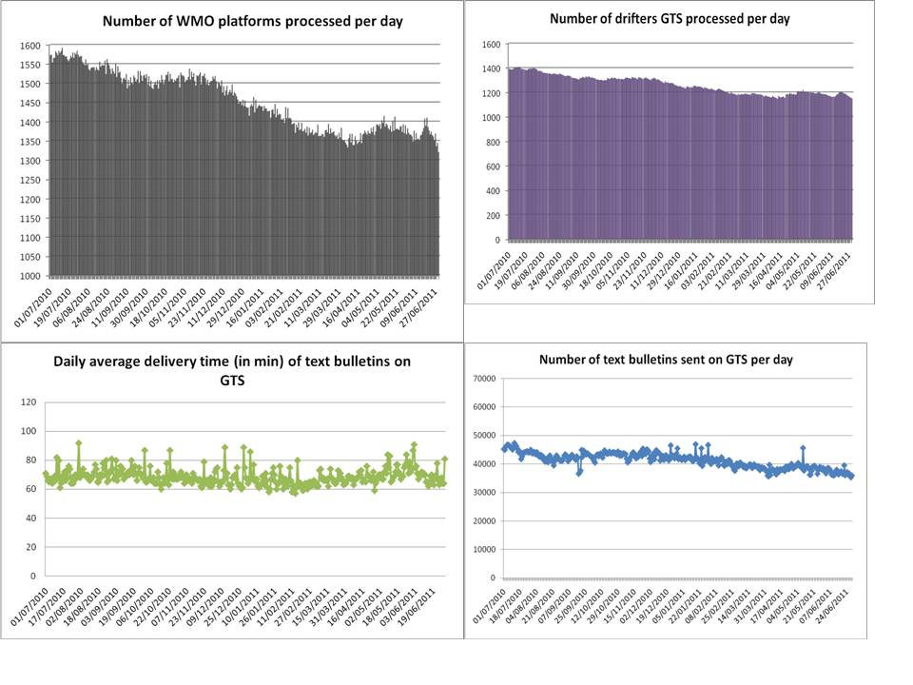
Results of AOML 2010 Comprasion Study
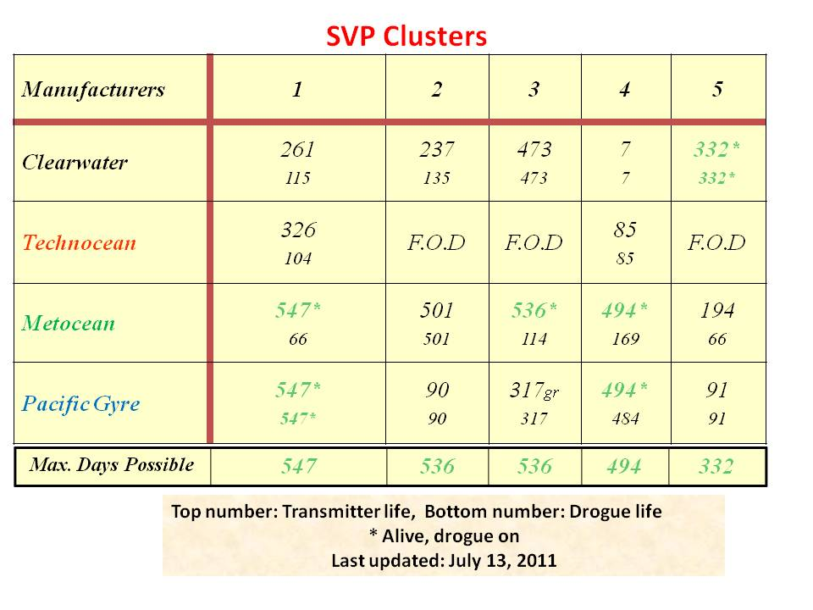

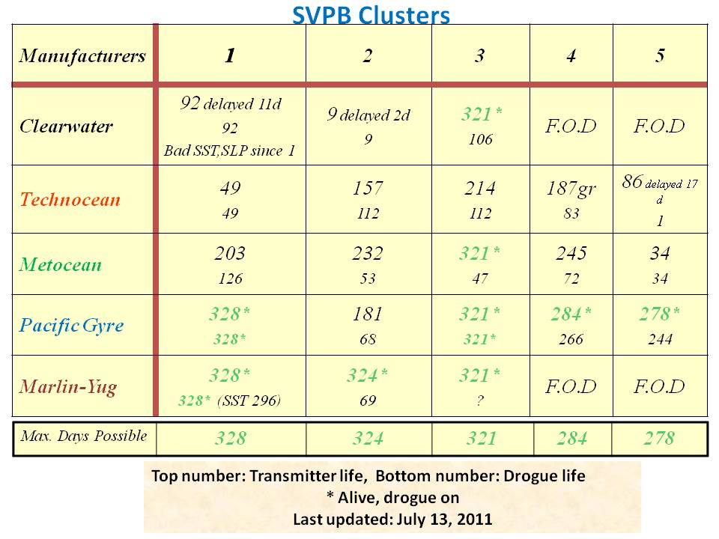
______________________

: see convention in DBCP-25 final report, paragraph 5.1.3, and DBCP-26 final report, paragraph 9.8.1.
: ftp://ftp.JCOMMOPS.org/JCOMMOPS/GTS/wmo/wmo_list.txt

