A Study of Expendable Bathythermograph (XBT) Temperature and Depth Biases From XBTs Manufactured in the Early 2000s and Six XBT Data Acquisition Systems

Authors (in no specific order): Gustavo Goni, Derrick Snowden, Molly Baringer, and Robert Molinari
National Oceanographic and Atmospheric Administration, Atlantic Oceanographic and Meteorological Laboratory, Miami, Florida

Submitted to: Journal of Atmospheric and Oceanic Technology
___________________

Corresponding author address:
Gustavo Goni National Oceanographic and Atmospheric Administration, Atlantic Oceanographic and Meteorological Laboratory, 4301 Rickenbacker Causeway, Miami, Florida 33149.
E-mail: Gustavo.Goni@noaa.gov

ABSTRACT

Several systems are currently in place to obtain eXpendable BathyThermograph (XBT) data that are comprised of different types of launchers, analog to digital converters, and software controllers. This manuscript presents the results from a one-day experiment carried out off the coast of California designed to compare XBT data obtained using different acquisition systems in six distinct configurations. The primary goal of the experiment was to verify that temperature data collected with each system was consistent with each other, and with data collected using an independent, high accuracy Conductivity-Temperature-Depth (CTD) system. Particular attention was directed to a new analog to digital recorder introduced by the manufacturer of XBTs. Results indicate that there were no significant differences between the six configurations tested. In the process of testing the different system configurations, temperature and depth biases introduced by the probes were detected. Temperature (depth biases) were estimated comparing XBT and CTD values in the portions of the casts with minimum (maximum) temperature gradients. Average differences in temperature biases were considerably less than the specifications provided by the manufacturer. Biases relative to the internationally accepted Fall Rate Equation used to compute depth were also found and potential new Fall Rate Equation coefficients for the early 2000 probes used were estimated.

1. Introduction
The eXpendable BathyThermograph (XBT) was originally developed in the 1960s for military applications. The XBT was designed to obtain vertical temperature profiles for conversion to sound velocity profiles for use in submarine detection. Rapid return of data (order of minutes) and sufficient accuracy to define the depth and location of the thermocline were initial design requirements. The Sippican Company (now Lockheed Martin Sippican) manufactured the original XBT and continues to fabricate the majority of the probes.
Research scientists quickly recognized the value of the XBT when performing regional oceanographic surveys. For instance, they formed a critical element of such mapping programs as that of the Gulf Stream (Hansen, 1970). XBTs were also extensively used in studies of interior-basin Atlantic eddies during the Mid-Ocean Dynamics Experiment, MODE, (e.g., McWilliams et al., 1983) and POLYMODE Limited Dynamics Experiment (e.g. McWilliams et al., 1986). Beginning in the mid-1980s, XBTs became an important tool in such studies as the Tropical Ocean Global Atmosphere (TOGA) and World Ocean Circulation Experiment (WOCE) programs. TOGA was directed at improving El Nino Southern Oscillation forecast capabilities (e.g., National Research Council, 1983; World Climate Research Program, 1985). The primary goal of WOCE was to collect a global suite of oceanographic observations to be used to improve eddy-resolving ocean general circulation models (e.g. World Climate Research Program, 1986). These programs required more structured sampling along specific transects selected to meet their scientific objectives.
XBT data are currently the most plentiful source of temperature profile observations in the historical archives. Between 20,000 and 25,000 XBT profiles have been collected for scientific purposes annually over the past ten years and almost two million XBTs currently populate the World Ocean Database (Boyer et al. 2006). Thus, XBTs now constitute a major source of data for use in studies of natural and anthropogenic climate change. For example, XBTs constitute one of the main platforms in defining time series of global changes in steric sea level and global ocean heat content (e.g., Gouretski and Koltermann, 2007; Domingues et al., 2008; Levitus et al., 2009).
The early military uses of XBT probes did not require extreme accuracy in either temperature or depth. Thus, the temperature accuracy of the probe is only +/-0.15°C and the depth accuracy +/-5m or 2% of the depth; whichever is greater (Sippican, 1983). With the evolution of XBT data from military to scientific use came an increased demand for more stable and accurate observations from these probes. This stability requires that changes to the XBT system (e.g., changing from strip chart to digital collection of data; changing acquisition systems, etc.) do not introduce unexpected, and thus, undetected offsets in the temperature values resulting from the probes. Such offsets, if large enough, have the potential to introduce “climate signals” in the historical record. Accuracy requires that no biases (e.g., depth dependent errors, time dependent errors, temperature dependent errors, etc.) exist in the sensors and sensing-related methods used by the XBT. It is critical to ensure that evolutionary changes in the XBT system also do not introduce differences in how an XBT observes the ocean. Thus, the initial objective of this effort was to ensure results from a new analog to digital (A-D) circuit board recently introduced by Sippican provided comparable information to the older A-D circuit board. While comparing temperature profiles using different configurations for the XBT systems, both temperature and depth biases were identified.

This work describes an experiment that was carried out off the coast of California to quantify and compare the consistency of different XBT data collection systems with each other. The primary goal was to verify that temperature data collected with the new MK-21 and Devil systems are consistent with temperature data collected from the older well vetted MK-12 system. . The methodology used here to directly compare simultaneous XBT and CTD casts was originally used by Hanawa (Hanawa et al., 1995) and applied or recommended by other studies (Ishii and Kimoto, 2009; and DiNezio and Goni, 2011). Section 2 of this manuscript describes the XBT systems used in the study, the new A-D board, experimental set-up, processing of the raw XBT data, temperature characteristics at the test site, and XBT biases. The analyses of the processed XBT data and results are described in section 3. A summary section completes the manuscript.

2. Background
A complete XBT data collection and recording system is comprised of the following elements: a) an XBT probe, b) an XBT launcher, c) a personal computer running the controller software, and d) an acquisition system composed by an A -D board, also known as recorder and through which the launcher interfaces with the computer.

2.1 The XBT probe.
The XBT measures temperature directly using a thermistor located in the nose of the probe. XBT probes have the same basic design and are designed to reach different maximum depths. The shallow Sippican T-4 probe samples to a maximum depth of 460m. Two types of deep probes, which contain more copper wire than the T-4s, are also used, the Sippican Deep Blue and the Sippican T-7. These probes are designed to sample to 760 m, although frequently data are obtained to 800 m. During this cruise Sippican Deep Blue probes were used for all casts. These probes are indistinguishable from Sippican T-7 probes as discussed in numerous other studies (e.g., Hanawa et al., 1995).
The XBT does not measure depth directly but through a theoretically-derived determined Fall Rate Equation (FRE) that contains empirically-derived coefficients. Depth is determined through a quadratic equation (1) in which the probe depth is calculated as a function of time from when the instrument enters the water. Early on in the use of XBTs, it was noticed that the manufacturer-derived FRE may need to be corrected. Depths estimated from the original FRE were too shallow and in a typical temperature profile (i.e., one with temperature decreasing monotonically with depth) a cold bias would be introduced in the measured temperature profile (Ridgway, 1994). Recently, in addition to this depth induced temperature bias, temperature biases independent of depth have been identified (e.g., Gouretski and Koltermann, 2007). Several methods involving have been proposed and applied to correct both depth and temperature biases.

The probe depth is determined empirically using an equation of the form:
Z_{xbt} = a*t + b*t**2 + c, (1)
where t represents the time from when the probe hits the water; a is a coefficient dependent on the hydrodynamical properties of the probe; b, is a coefficient dependent on the change of mass through loss of wire as the probe falls through the water column; and c, is a coefficient representing initial depth offsets as the probe enters the water. Green (1984) and Hallock and Teague (1991), for example, derived (1) from basic hydrodynamical principles assuming a simplified balance involving the vertical acceleration, the net buoyant force and the hydrodynamic drag.

2.2. The XBT Launcher.
In addition to holding the XBT probe, the launching device serves to complete the electrical circuit between the XBT and the recorder. Two types of XBT launchers are commonly used in observational programs: hand launchers and autolaunchers. A hand launcher is a small, hand held device capable of launching one probe at a time.. Hand launchers are portable and facilitate launching XBTs from multiple places on a ship. Hand launchers are typically used on research vessels and from ships of opportunity, where the crew typically deploys the XBT probes. The Sippican model LM-3A was used for this experiment.
For more intensive observational programs the use of a hand launcher on schedule becomes difficult as it is often desirable to launch multiple XBTs in close succession. For these situations, the National Oceanographic and Atmospheric Administration's Atlantic Oceanographic and Meteorological Laboratory (NOAA/AOML) and the Scripps Institute of Oceanography (SIO) independently developed autolaunchers capable of holding six to eight XBTs. Autolaunchers automatically launch successive probes with as little as one minute between consecutive casts. Both NOAA/AOML and SIO autolaunchers were utilized during this cruise.

2.3 XBT Acquisition System.
The launcher interfaces with a computer through an A-D recording device. This recorder translates the analog data sensed by the thermistor into a digital form and passes the digital data on to the computer.
In the early 1980s NOAA/AOML developed the Shipboard Environmental Data Acquisition Software (SEAS) to collect XBT and meteorological data on research and volunteer ships. This software runs on a PC using the Microsoft Disk Operating System (MS-DOS). SEAS interfaced with both hand and auto-launching devices through a Sippican MK-12 recorder and its predecessor the MK-9. The MK-9 is not considered herein as it is no longer in operational use. Similarly, SIO created another MS-DOS based software controller, referred to as K98, to interface with the SIO auto-launcher through a MK-12 recorder. Recently, AOML and SIO have collaborated to create a new version of SEAS (SEAS2000) that runs on Microsoft Windows XP computers and utilizes the MK-21 recorder. This new version (SEAS2000) has the capability of using both hand launchers from Sippican as well as auto-launchers from NOAA/AOML and SIO.

2.4. The Analog to Digital circuit board.
Recently, Sippican introduced a re-engineered element to the standard XBT data collection system. Specifically, the Analog to Digital (A to D) circuit board has been redesigned to accommodate modern personal computers (PCs), now commonly used on the commercial ships that are employed to collect most XBT data. The previous A to D board (model: MK-12), in use for more than 15 years, required an Industry Standard Architecture (ISA) slot to interface with a PC. While ISA slots were common in PCs in the 1970s and 1980s, they are increasingly less common in modern PCs. To keep pace, Sippican has developed a new A to D board, model MK-21 that interfaces to a PC through a Universal Serial Bus (USB) port. In addition to the Sippican redesign, another A to D board, model Devil, has recently been developed at the Commonwealth Science and Industrial Research Organization (CSIRO) in Australia. This board is included in the comparison.

3. The Experiment.
The experiment was carried out on a one-day cruise in the Santa Barbara Channel during in June 2005 (Figure 1). This cruise was designed to test XBT data acquisition systems using three A to D boards (i.e., MK-12, MK-21 and CSIRO Devil) in six distinct configurations (Table I) representative of normal use on both research and volunteer ships. The average temperature characteristics of the Santa Barbara Channel site during the experimental period include a thin, 7 to 8m, isothermal mixed layer with temperatures of the order 18.5°C. This mixed layer overlays a sharp thermocline. Within the thermocline, temperature decreases 8°C in less than 20 m. Beneath the thermocline the temperature profile changes slowly with temperatures decreasing only 5°C over the next 800 m. Embedded within this slowly decreasing temperature profile are two relatively isothermal layers centered at about 100 m and near the bottom of the XBT cast between 700 - 800 m. Additionally, there are temperature inversions in each downcast at approximately 120 m.

Unfortunately, there are no meta-data indicating when the probes used in this experiment were purchased. Historically, NOAA/AOML probes are used within 2 to 3 years from purchase, a typical delay employed by most XBT users (Wijffels et al., 2008). Thus, we assume that these probes were manufactured and purchased in the early 2000s (i.e., 2000 to 2004).

A Conductivity-Temperature-Depth profiler (CTD), was used to provide the ground truth data for comparison with the XBT temperature-depth pairs resulting from the different system configurations. A Seabird 25 (SBE25) internally logging profiling CTD was employed. The SBE25 logs samples at 8Hz (the XBT systems sample at a rate of 10Hz). The CTD was lowered and raised at a rate of 50 meters/min. The CTD sensor package was calibrated at the Seabird headquarters prior to the cruise in March 2005 and then again in March 2006. The accuracy of the temperature sensor on the CTD is 0.002ºC with a resolution of 0.0003ºC. During the time between calibrations the temperature drifted only 0.0003ºC. Given the magnitude of the drift error compared with the accuracy of XBT systems, no correction was made for CTD temperature drift. The accuracy of the CTD pressure sensor is 0.1% of full scale and the resolution 0.015% of full scale. On deck, the CTD pressure sensor measured values between -0.08 and 0.06 db over the course of the day. Thus, there was no evidence for a systematic offset in the pressure measurements from the CTD. Given the two orders of magnitude greater accuracy of the CTD relative to the XBTs, we take depth and temperature obtained from the CTD as groundtruth.

The instrument deployment plan was designed to maximize the number of XBT/CTD pairs available for comparison (Figure 2). The CTD began recording when the instrument was just below the sea surface (approximately 1 m). The first XBT was dropped approximately 30 seconds after the CTD down cast was initiated. Therefore, we were able to simultaneously sample a relatively shallow mixed layer with both the CTD and XBT at least one time per cast. XBT casts were repeated continuously during the course of the CTD downcast until the CTD reached the maximum depth of the down cast, approximately 800 m.
During the XBT and CTD casts, every effort was made to initiate them simultaneously. However due to subtle differences in the startup procedures of the various systems, this was not always achieved. The time between casts for the four auto-launching systems was much shorter than for the hand launching systems. Therefore, there were typically two to three more XBT casts per CTD cast for these systems. There were a total of seven CTD casts with both down and up-casts (profiles) collected during the experiment and 370 XBTs deployed using the different system configurations during these casts (Table II)
The initial XBT cast was at 16:57 GMT on June 21, 2005 at 33° 34.8’ N, 118° 24.0’ W and the final cast was at 00:14 GMT on June 22, 2005 at 33° 32.7’ N, 118° 19.5’ W. These values indicate that during the course of the day the ship drifted sporadically with a net displacement of approximately 8 km toward the east-southeast. Most of the instruments operated without problems for the entire day. However the SIOAUTO system (Table 1) was installed closest to the CTD winch and experienced some interference. In early afternoon the wind speed increased and during drops the XBT wire contacted the CTD cable causing a short in the XBT recording system. After several failures, the SIOAUTO system was moved about ten feet aft and the wire interference was not a problem for the remainder of the experiment.

4. Data Processing.
The raw temperature-depth data of the XBT and CTD casts were preprocessed and edited prior to detailed analyses. The raw XBT data (10Hz samples) were filtered with a median filter to eliminate spikes and outliers. The filter was applied twice, first with a filter width of three points and second with a filter width of five points. To eliminate any surface startup transients the 4 m temperature value was extrapolated to the surface. These XBT profiles were also trimmed at depth by manually inspecting each profile and selecting the deepest depth containing no obvious wire stretch errors, a common form of XBT failure (e.g., Daneshzadeh et al.,1996). The raw profiles were then filtered using a five point digital Butterworth filter with a cutoff frequency of 1.5 Hz. At the given fall rate this corresponds to a half power point of approximately 4 m. Finally, the filtered profiles were linearly interpolated onto an equally spaced (1 m) vertical grid.

The raw CTD data were available on a one-db pressure grid. The pressure to depth conversion followed Foffonoff and Millard (1991) and the converted data were linearly interpolated onto the same one meter vertical grid as the XBTs.

5. Results
5.1. XBT Biases.
Early studies of depth biases were based on limited data (i.e., typically one or two cruises comparing XBT depths with more accurate CTD units and/or reversing thermometers placed on Nansen Bottles). In addition to depth biases, temperature biases have also been identified (e.g., Gouretski and Koltermann (2007), and Levitus et al., 2009). A comprehensive summary of these initial studies as well as more recent efforts is given on the NOAA National Oceanographic Data Center (NODC) website at:
http://www.nodc.noaa.gov/OC5/XBT_BIAS/xbt_bibliography.html.
Several approaches have been developed to correct biases in XBT depths and/or temperatures. Hanawa et al. (1995), hereinafter H95, compiled 285 XBT and CTD profiles collected globally at approximately the same location and time between 1985 and 1992. They computed new mean fall rate equation coefficients by averaging independent estimates obtained by aligning temperature gradients of each instrument pair to eliminate bias-like temperature errors. H95 confirmed earlier studies, which found that the FRE provided by the manufacturer underestimated the actual fall rate of XBTs. This error produces readings of depths that are more shallow than the real depth producing temperature readings in the profile that are lower than the true value at that depth (Ridgeway, 1994), resulting in a cold bias for the uncorrected temperature observations. For example, an indicated reading of 300 m is actually 310 m.

Instead of using equation (1) with the new coefficients, H95 recommended implementation of a simplified correction for the Sippican and TSK probes given by,
Z_{Hanawa} = 1.0336*Z_{XBT ,} (2)
where Z_{XBT} is given by (1), which did not address temperature biases, but only provided an uncertainty estimate for depth. They estimated a mean depth error using (2) of +/-1m, but also found large unexplained probe-to-probe variability, which was greater than the manufacturers specifications.
Other approaches to correcting temperature and/or depth biases did not directly compare XBT profiles with concurrently obtained CTD profiles. Studies by Gouretski and Koltermann (2007), Wijffels et al. (2008), Ishii and Kimoto (2008), Levitus et al. (2009), and DiNezio and Goni (2010) compared individual XBT profiles to climatologies generated from various combinations of XBT, hydrographic, and CTD data, to correct for biases. H95 generated one correction independent of time and probe-type given by (2). However, the more recent studies listed above found that depth and temperature biases were time and probe dependent and provided corrections for these characteristics. Other sources of uncertainty have been found in comparisons between XBT and more accurate depth/temperature observations. For instance, Thadathil et al. (2002) found a different effect of colder polar and subpolar temperatures on the fall rate than the studies addressed above. The change in data transcription from paper charts to electronic recorders could also introduce uncertainties. Although few definitive studies have been attempted to quantify these other forms of uncertainties, FRE errors are considered to be the largest source of biases in XBT data (e.g., Wijffels et al., 2008).

5.2. Processed Data Analyses and Results
Waterfall plots of the XBT/CTD profiles from one CTD station for each instrument configuration are given in Figure 3. In each set of profiles the gray cluster of XBTs appears systematically warmer (to the right of) than the CTD profiles (black lines). This feature could be due to three possibly overlapping effects. First, all the XBT thermistors exhibit a warm bias. Second, the XBT FRE is in error in such a way that the XBT depths inferred from the elapsed time since the probe hit the water are deeper than the true depths. Third, differences are related to the different configurations used during the casts.
The nature of the observed differences (i.e. $T_{\text{xbt}}>T_{\text{ctd}}$ for each z), outside the depth range including thermostads, if due to fall rate error, would imply that the probe is actually falling through the water more slowly than the FRE predicts. The FRE used for the initial comparisons presented in this section is of the form given by equation (1), with the coefficients estimated by H95, a=6.691, b=-0.00225, and c=0. The original manufacturers coefficients were a = 6.472 and b = -0.00216 resulting, as noted previously, in XBT depths that were shallower than the actual depth of the temperature observation and, thus, producing a cold bias in the temperature reading. For this set of XBTs, the H95 coefficients produce a warm bias in the temperatures.
The effects of each of the two dominant sources of systematic errors can be isolated by considering the relationship between the XBT and CTD temperatures as a function of depth:

$T_{\text{xbt}}(z)=T_{\text{ctd}}(z+δ(z))+ε(z)$ (2)

where $T_{\text{xbt}}$is the XBT temperature at depth z; $T_{\text{ctd}}$ is the CTD temperature at the depth offset given by $δ(z)$ from the inferred XBT depth, z, and $ε(z)$is the temperature error. Expanding the CTD temperature $T_{\text{ctd}}(z+δ(z))$ in a Taylor series about z, neglecting second order terms, gives,
$T_{\text{xbt}}(z)−T_{\text{ctd}}(z)=δ(z)\frac{∂T_{\text{ctd}}(z)}{∂z}+ε(z)$ (3).
Equation (3), describes the differences between the XBT and CTD in terms of a depth error term (the first term on the right hand side) and a temperature error term (second term on the right hand side). The temperature term represents collectively any error that is not explicitly due to the fall rate error and could involve, for example, systematic errors in the temperature recorder (A to D board), calibration errors in the XBT thermistor, and/or random errors including geophysical noise.
There are at least two possible methods for estimating the magnitude of the temperature error $ε(z)$ in (3). First, in regions of the water column where the temperature gradients are negligible, the effect of an error in the FRE should also be small. In this case the total error profile is simply $T_{\text{xbt}}(z)−T_{\text{ctd}}(z)=ε(z)$. Similarly, if the depth error component can be adequately removed the same expression should apply to the total error.
In order to estimate the temperature errors, we consider here two approximately isothermal layers between 100-150 m and 725-775 m (two boxes in Figure 4). These regions are characterized by the smallest temperature gradients in the entire profile and, therefore, can be thought of as a lower bound for the total temperature-only error for each data acquisition system (zero value of the first term in the right hand of 3). The mean absolute differences between the XBT and the CTD data show a positive XBT temperature bias and mean differences in the isothermal layers well below the manufacturers specified temperature error of 0.15°C (Figure 5 upper panels). The AOMLAUTO and DEVILHAND systems show slightly lower mean differences (0.037 and 0.042°C, respectively) than the remaining four systems, with values that are all near 0.05°C. The standard errors are all an order of magnitude smaller than the means.
For the data collected during this experiment, depth errors are evident in the side-by-side comparison of the CTD and XBT profiles (Figure 3). A careful examination of the small-scale temperature features indicates that distinguishable features are 5 to 10m deeper in the water column in the XBTs than in the CTD profiles. This tendency is consistent across all six data acquisition systems. Since the same XBT probe type was used throughout, the most likely cause for this offset is an error in the coefficients used in the XBT fall rate equation.
To correct for depth offsets, we use the so called “temperature error free” method of H95. This method uses the vertical gradient of the temperature profile in order to minimize the effect of temperature errors, $ε(z)$, in determining the depth offset,$δ(z)$. Briefly, consider the vertical gradient of (3), and rearranging we have,

$\frac{∂T_{\text{xbt}}(z)}{∂z}−\frac{∂T_{\text{ctd}}(z)}{∂z}=\frac{∂T_{\text{ctd}}(z+δ(z))}{∂z}⋅\frac{∂δ(z)}{∂z}+\frac{∂ε(z)}{∂z}$. (4)

This method of identifying depth errors uses (4) to iterate through a sequence of plausible depth offsets,$d(z)$, and searching for the offset that minimizes the difference between the CTD temperature gradient and the depth-adjusted XBT temperature gradient. At each iteration, the RMS difference between the XBT temperature gradient and the depth adjusted CTD temperature gradient is calculated within a predetermined depth window. For each depth, z, the RMS of these differences is computed in a window between z-20m and z+50m and the$δ$that minimizes the RMS difference in each window was recorded.
The first term of the right hand side of (4) shows explicitly the conditions under which the minimization technique described above can be expected to yield accurate depth offsets. First, the gradient of the depth offset must be small when compared to one, or the product $\frac{∂T_{\text{ctd}}(z+δ(z))}{∂z}⋅\frac{∂δ(z)}{∂z}$ must be small compared to both terms on the left hand side of(4). If the depth offset $d(z)$ is constant with depth, then the product is identically zero. However, the depth minimization algorithm only requires that the depth-offset gradient be much smaller than one. Using this data set, we estimate that $\frac{∂δ(z)}{∂z}<0\text{.}\text{02}$ throughout the water column. A similar condition applies to the vertical gradient of the temperature error. In order for the depth minimization algorithm to work the vertical gradient of the temperature error, ε , must be smaller than the vertical gradient of both the XBT and CTD temperatures. Figure 6 shows the results of applying the H95 method to the present data set to estimate the depth offset between the XBT and CTD profiles. The fall rate equation is related to the hydrodynamic characteristics of the probe and is, therefore, identical for identical probe types. Since the same probes were used for the entire experiment (Sippican Deep Blues), we include all data acquisition systems together for the following stage of the analysis. Results indicate that the XBT depth errors, in many cases, exceed the manufacturers depth error specification and that there is considerable scatter in the (δ,z) pairs especially at depth. Therefore, we estimated new coefficients a and b of the fall rate equation to reduce the bias in the depths of the XBT probes. These new fall rate equations coefficients estimated from these data (red dots, Figure 6) differ from the standard equation (WMO Code Table 1770, Code 52) as is shown in Table 3.
Typically, the XBT fall rate equation is used without including the constant offset term c. The difficulty in determining c, in part explains this neglect. This surface offset depends on the height of launch, weather conditions, launcher position, type of launcher used, etc. This large number of variables makes determining robust values of c difficult. For the probes and configurations used in this experiment, including c in the depth estimate for a time after launch of 100s, hereinafter z100s, has a minimal effect, typically less than 1 m (Table 3). Thus, in the following discussions we will only address the depth corrections for the quadratic equations neglecting the constant offset term.
For the probes used in this experiment, the mean depth (standard deviation) for z100s is 629.7 (2.4). The range for z100s is 7 m, with greatest depth calculated for the SIOAUTO and least depth for the SIO98. The mean difference equates to a depth error of 1.1%, approximately half of the manufacturers uncertainty estimate of 2% of the greatest depth. The depth for z100s estimated from all the XBT/CTD pairs is 17 m less than the depth computed using H95, or 2.7% the depth (i.e., Code 52, Table 3). This percentage error is slightly larger than the manufactures uncertainty estimate of 2%. . The effect of such a depth difference on temperature values is obviously a function of the temperature structure in the region being studied. Therefore, no estimates of temperature uncertainty are offered in this work. The Wijffels et al. (2008) correction, using a deep-probe coefficient from the early 2000s, gives a z100s depth close to the SIO98 value and within 3 m of the depth determined using all the XBT/CTD comparisons (Table 3).

4. Summary
Results obtained from simultaneous XBT and CTD casts using six different system configurations indicate that The temperature and depth differences among these six configurations are minimal. Thus, the MK-21 and Devil boards are suitable evolutionary replacements for the MK-12 board and will not introduce any spurious signals in the climate record when fully implemented. Similarly, the hand-held and autolaunchers do not introduce any spurious signals in the temperature/depth data from the XBTs used in this experiment.
Wijffels et al. (2008) provide a time history of coefficient b for deep XBTs, as used in this experiment. The error bars for their estimate of b for the years from 2000 to 2005 encompass, except for a small 2002 offset, the Sippican (1983) estimates for this coefficient (their Figure 14). The manufacturer and all estimates of the coefficient b given in Table 2 imply a z100s depth difference of only 1m. Thus, the Wijffels et al. (2008) record of b provides strong support for the early 2000s purchase of the probes used in this experiment.

Acknowledgments.
We would like to thank the captain and crew of the R/V YELLOWFIN and the staff of the Southern California Marine Institute for facilitating a successful experiment. DS would like to thank Dr. David Palmer for several helpful and clarifying discussions.

References
Boyer, T. P., J. I. Antonov, H. Garcia, D. R. Johnson, R. A. Locarnini, A. V. Mishonov, M. T. Pitcher, O. K. Baranova, and I. Smolyar, 2006: World Ocean Database 2005, Chapter 1: Introduction, NOAA Atlas NESDIS 60, Ed. S. Levitus, U.S. Government Printing Office, Washington, D.C., 182 pp.

Daneshzadeh, Y.C., J.F. Festa, and R.L. Molinari, 1996: Quality control of XBT data
collected in the Atlantic Ocean: 1990 and 1991. National Oceanic and Atmospheric
Administration Data Report ERL AOML-29, 77 pp.

DiNezio, P.N., and G.J. Goni, 2010: Identifying and Estimating Biases between XBT and Argo Observations Using Satellite Altimetry. J. Atmos. Oceanic Technol., 27, 226-240. doi:10.1175/2009JTECHO711.1

Domingues, C.M., J.A. Church, N.J. White, P.J. Glecker, S.E. Wijffels, P.M. Barker and J.R. Dunn, 2008: Improved estimates of upper-ocean warming and multi-decadal sea-level rise. Nature, 453, 1090-1093.

Fofonoff, N. P. and R. C. Millard. (1991). "Calculation of the Physical Properties of Seawater." from http://whpo.ucsd.edu/manuals/pdf/91_1/algo6.pdf

Gouretski, V. and K.P. Koltermann, 2007: How much is the ocean really warming? Geophys. Res. Lett., 34, doi:10.1029/2006GL027834.

Greene, A.W., 1984: Bulk dynamics of the expendable bathythermograph (XBT). Deep-Sea Res., 31, 415-426.

Hallock, Z.R. and W.J. Teague, 1992: The fall rate of the T-7 XBT. J. Atm. and Ocn. Tech., 9, 470-483.

Hanawa, K., P. Rual, R. Bailey, a. Sy, and M. Szabados, 1995: A new depth-time equation for Sippican or TSK T-7, T-6 and T-4 expendable bathythermographs (XBT). Deep-Sea Res. I, 42, 1423-1451.

Ishii, M. and M. Kimoto, 2009: Reevaluation of historical ocean heat content variations with time-varying XBT and MBT depth bias corrections. J. Oceanogr., 65, 287-299.

Levitus, S., J.I. Antonov, T.P. Boyer, R.A. Locarnini, H.E. Garcia, and A.V. Mishonov, 2009: global ocean heat content 1955-2008 in light of recently instrumentation problems. Geophys. Res. Lett., 36, doi:10.1029/2008GL037155.

Hansen, D.V., 1970: Gulf Stream meanders between Cape Hatteras and the Grand
Banks. Deep-Sea Res., 17, 495-511.

Kizu, S. and K. Hanawa, 2002: Recorder-dependent temperature error of expendable
Bathythermograph. J. Oceanogr., 58: 469-476.

McWilliams, J.C. and collaborators, 1983: The local dynamics of eddies in the western North Atlantic. Eddies in the Marine Science. A.R. Robinson, Ed. Springer-Verlag, 92-113.

McWilliams, J.C., W.B. Owens, and B.L. Hua, 1986, 1986: an objective analysis of the POLYMODE Local Dynamics Experiment. Part I: General formation and statistical model selection. J. Phys. Oceanogr., 16, 483-501.

National Research council, 1983: El Nino and the Southern Oscillation: A Scientific Plan, 72 pp. Nat. Acad. Of Sci., Washington, D.C.

Ridgway, K. R., 1994: An application of a new depth correction formula to archived XBT data. Deep-Sea Res. I, 42, 1513-1519.

Sippican, 1983: Operation/Maintenance Manual MK-9 digital XBT/XSV System. R-1197/B. Sippican (now Lockheed Martin Sippican) Ocean Systems Inc. Marion, Massachusetts.

Thadathil, P., A.K. Saran, V.V. Gopalakrishna, P. Vethamony, N. Araligidad, and R. Bailey, 2002: XBT fall rate in waters of extreme temperature: A case study in the Antarctic Ocean. J. Atm. and Ocn. Tech., 19, 391-396.

Wijffels, S.E., J. Willis, C.M. Domingues, P. Barker, N.J. White, A. Gronell, K. Ridgway and J. A. Church, 2008: Changing expendable bathythermograph fall rates and their impact on estimates of thermosteric sea level rise. J. Climate, 21, 5657-5672.

World Climate Research Program, 1985: Scientific plan for the Tropical Ocean and global Atmosphere Program, Tech. Doc. WMO/TD-64, 146 pp. World Meteorol. Organ., Geneva, Switzerland.
World Climate Research Program, 1986: Scientific Plan for the World Ocean Circulation Experiment. Tech. Doc. WMO/TD-122, 84 pp. World Meteorol. Organ., Geneva, Switzerland.

List of Figures

Figure 1. The geographical site of the experiment.

Figure 2. Time depth schematic of the XBT drop plan during a typical CTD cast.

Figure 3. Waterfall plots of the CTD (black line) and XBT (gray lines) data for CTD station 4. There were seven CTD casts on the day of the cruise numbered sequentially from 3 to 9. Stations 1 and 2 were test casts on the preceding day. The profile clusters corresponding to distinct data acquisition systems are offset by 3.0°C.

Figure 4. Mean and standard deviation profiles for the seven CTD casts. The dotted regions outline depth intervals characterized by small temperature gradients that are used in more detailed analyses.

Figure 5. Average absolute difference and standard error of the mean between XBTs and CTDs for three different segments of the water column. The upper panel shows the summaries for the original data and the lower panel shows the summaries for the data with the new fall rate equation from table 3. Along the x-axis, the labels refer to instruments accordingly: 1, AOMLAUTO as aomlauto; 2, DEVILHAND as devilhand; 3, SEASAUTO as seasauto; 4, SEASHAND as seashand; 5, SIOAUTO as sioauto; 6, SIOK98 as siok98.

Figure 6. Depth error estimated with the temperature error free method of Hanawa et al. (1995). The upper panel shows the depth errors prior to estimation of a new fall rate equation. The red dots show each (dz,z) point used in the regression estimate of the new fall rate equation and the black dots represent points that were excluded after an outlier detection algorithm was applied to the data. The bottom panel shows the depth errors from the XBT profiles after the new fall rate equation was applied.

TABLE 1. XBT data collection systems tested during the R/V YELLOWFIN intercomparison cruise. PC = personal computer, SEAS = Shipboard Environmental Data Acquisition System, HAND = hand-held XBT launcher, SEAS2000, DEVIL and K98=computer software systems, SIO= Scripps Institution of Oceanography, AUTO= automatic multiple probe XBT launcher, AOML= NOAA’s Atlantic Oceanographic and Meteorological Laboratory.
System Name | Launcher Type & Recorder | Recorder Type | Controller Software and PC Type
SEASHAND | Sippican LM-3A | MK-21 | SEAS2000 (Windows  XP PC)
DEVILHAND | Sippican LM-3A | Devil | Devil Software (Windows XP PC)
SIOAUTO | SIO Auto-launcher | MK-21 | SEAS2000 (Windows XP PC)
SEASAUTO | NOAA/AOML Auto-launcher | MK-21 | SEAS2000 (Windows XP PC)
SIOK98 | SIO Auto-launcher | MK-12 | K98 Software (DOS 386 PC)
AOMLAUTO | NOAA/AOML Auto-launcher | MK-12 | AOML Software (DOS 386 PC)
TABLE 2. Summary of the total number of drops for each instrument package over the course of the seven CTD casts.
System Name | Total Number of Profiles | Profiles Trimmed at z<500m | Profiles Trimmed at z<150m
SEASAUTO | 68 | 5 | 2
SIOAUTO | 63 | 10 | 1
SIOK98 | 68 | 6 | 4
AOMLAUTO | 65 | 4 | 3
DEVILHAND | 52 | 3 | 3
SEASHAND | 54 | 1 | 0

TABLE 3. Coefficients for the fall rate equation $z_{\text{xbt}}={\text{at}}^{2}+\text{bt}+c$ estimated in this study for the XBT configurations listed in Table 1. Coefficients listed for WMO Code 1770: 52 were determined by Hanawa et al. (1995) for Sippican Deep Blue XBT probes and have been adopted for use by the international community. The instrument labeled “all” indicates the depth offsets from all instruments were included in the regression. The last row calculates the depth using the Wijffels et al. (2008) formulation: Z = (1 – r)*Z_{CODE 52}. The coefficient r is the average coefficient for deep probes for the years 2000 to 2005. The last column gives the depth calculated from the coefficients listed 100 seconds after launch of the probe.

Instrument | Coefficient a | Coefficient b | Coefficient c | Z at t = 100 s
Manufacturer’s coefficients | -0.00216 | 6.472 | 0.0 | 625.6
WMO CODE 52 | -0.00225 | 6.691 | 0.0 | 646.6 m
AOMLAUTO | -0.00221 | 6.519 | 0.0 | 629.8 m
AOMLAUTO | -0.00324 | 6.665 | -4.357 | 629.7 m
DEVILHAND | -0.00177 | 6.458 | 0.0 | 628.1 m
DEVILHAND | -0.00311 | 6.648 | -5.628 | 628.1 m
SEASAUTO | -0.00199 | 6.499 | 0.0 | 630.0 m
SEASAUTO | -0.00279 | 6.612 | -3.333 | 629.9 m
SEASHAND | -0.00140 | 6.441 | 0.0 | 630.1 m
SEASHAND | -0.00207 | 6.535 | -2.772 | 630.0 m
SIOAUTO | -0.00158 | 6.497 | 0.0 | 633.9 m
SIOAUTO | -0.00221 | 6.585 | -2.551 | 633.9 m
SIOK98 | -0.00183 | 6.449 | 0.0 | 626.6 m
SIOK98 | -0.00313 | 6.635 | -5.580 | 626.6 m
ALL | -0.00191 | 6.486 | 0.0 | 629.5 m
ALL | -0.00299 | 6.638 | -4.511 | 629.4 m
Wijffels et al. (2008) r = 0.031 |  |  |  | 626.5

Figure 1. The geographical site of the experiment.

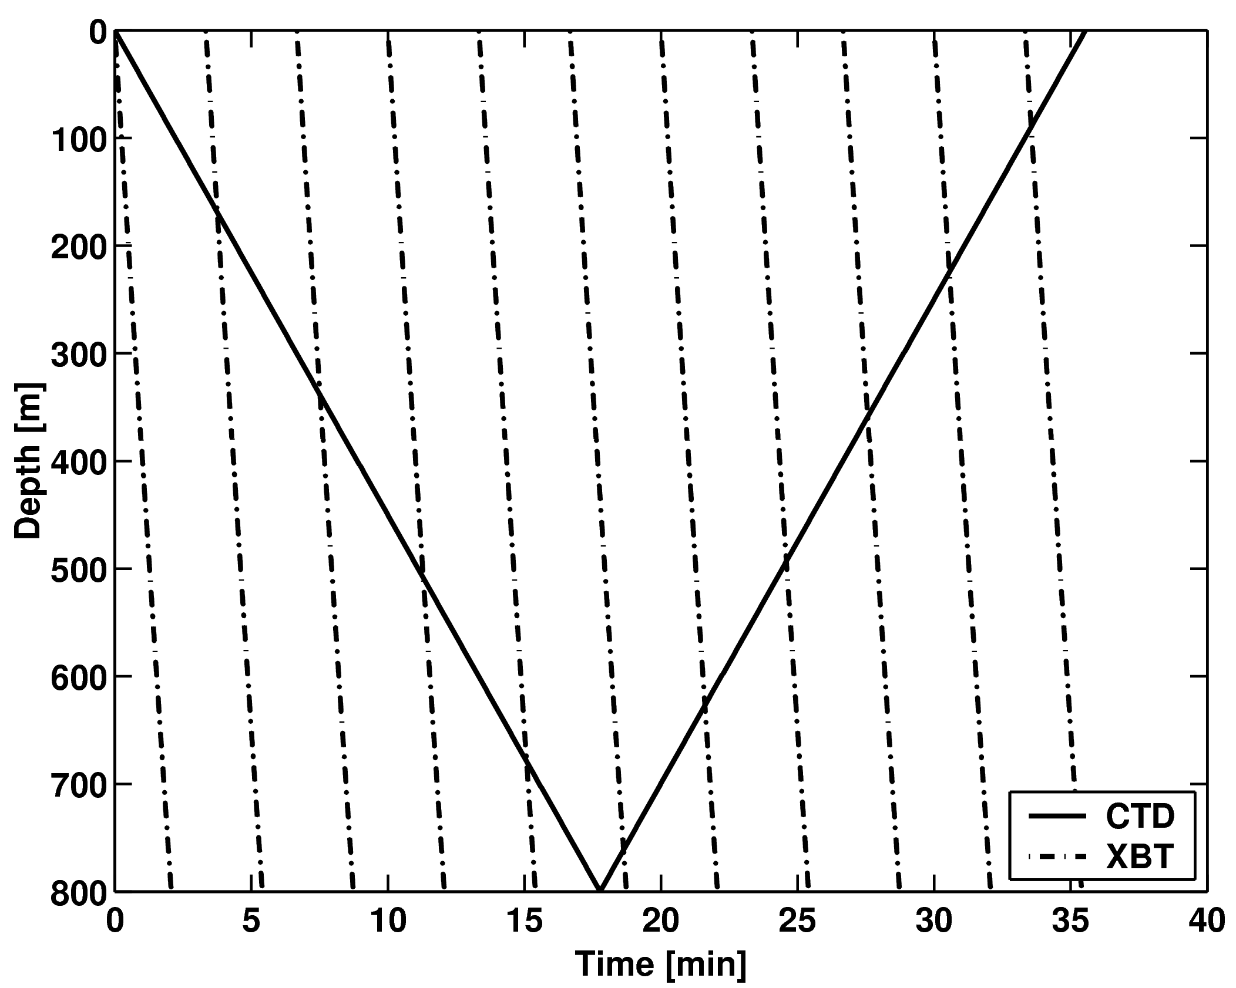

Figure 2. Time depth schematic of the XBT drop plan during a typical CTD cast.

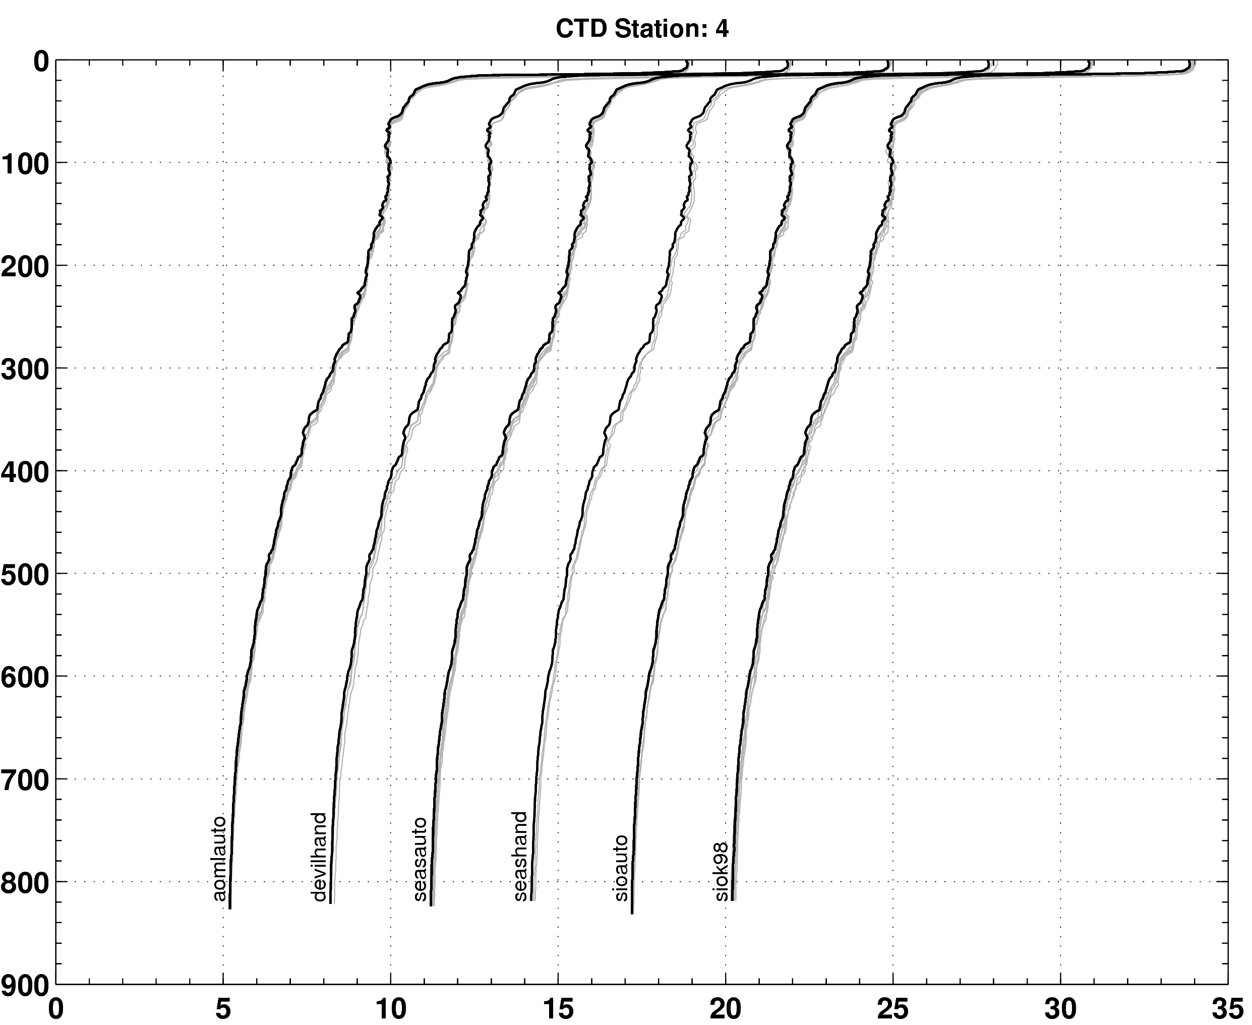

Figure 3. Waterfall plots of the CTD (black line) and XBT (gray lines) data for CTD station 4. There were seven CTD casts on the day of the cruise numbered sequentially from 3 to 9. Stations 1 and 2 were test casts on the preceding day. The profile clusters corresponding to distinct data acquisition systems are offset by 3.0°C.

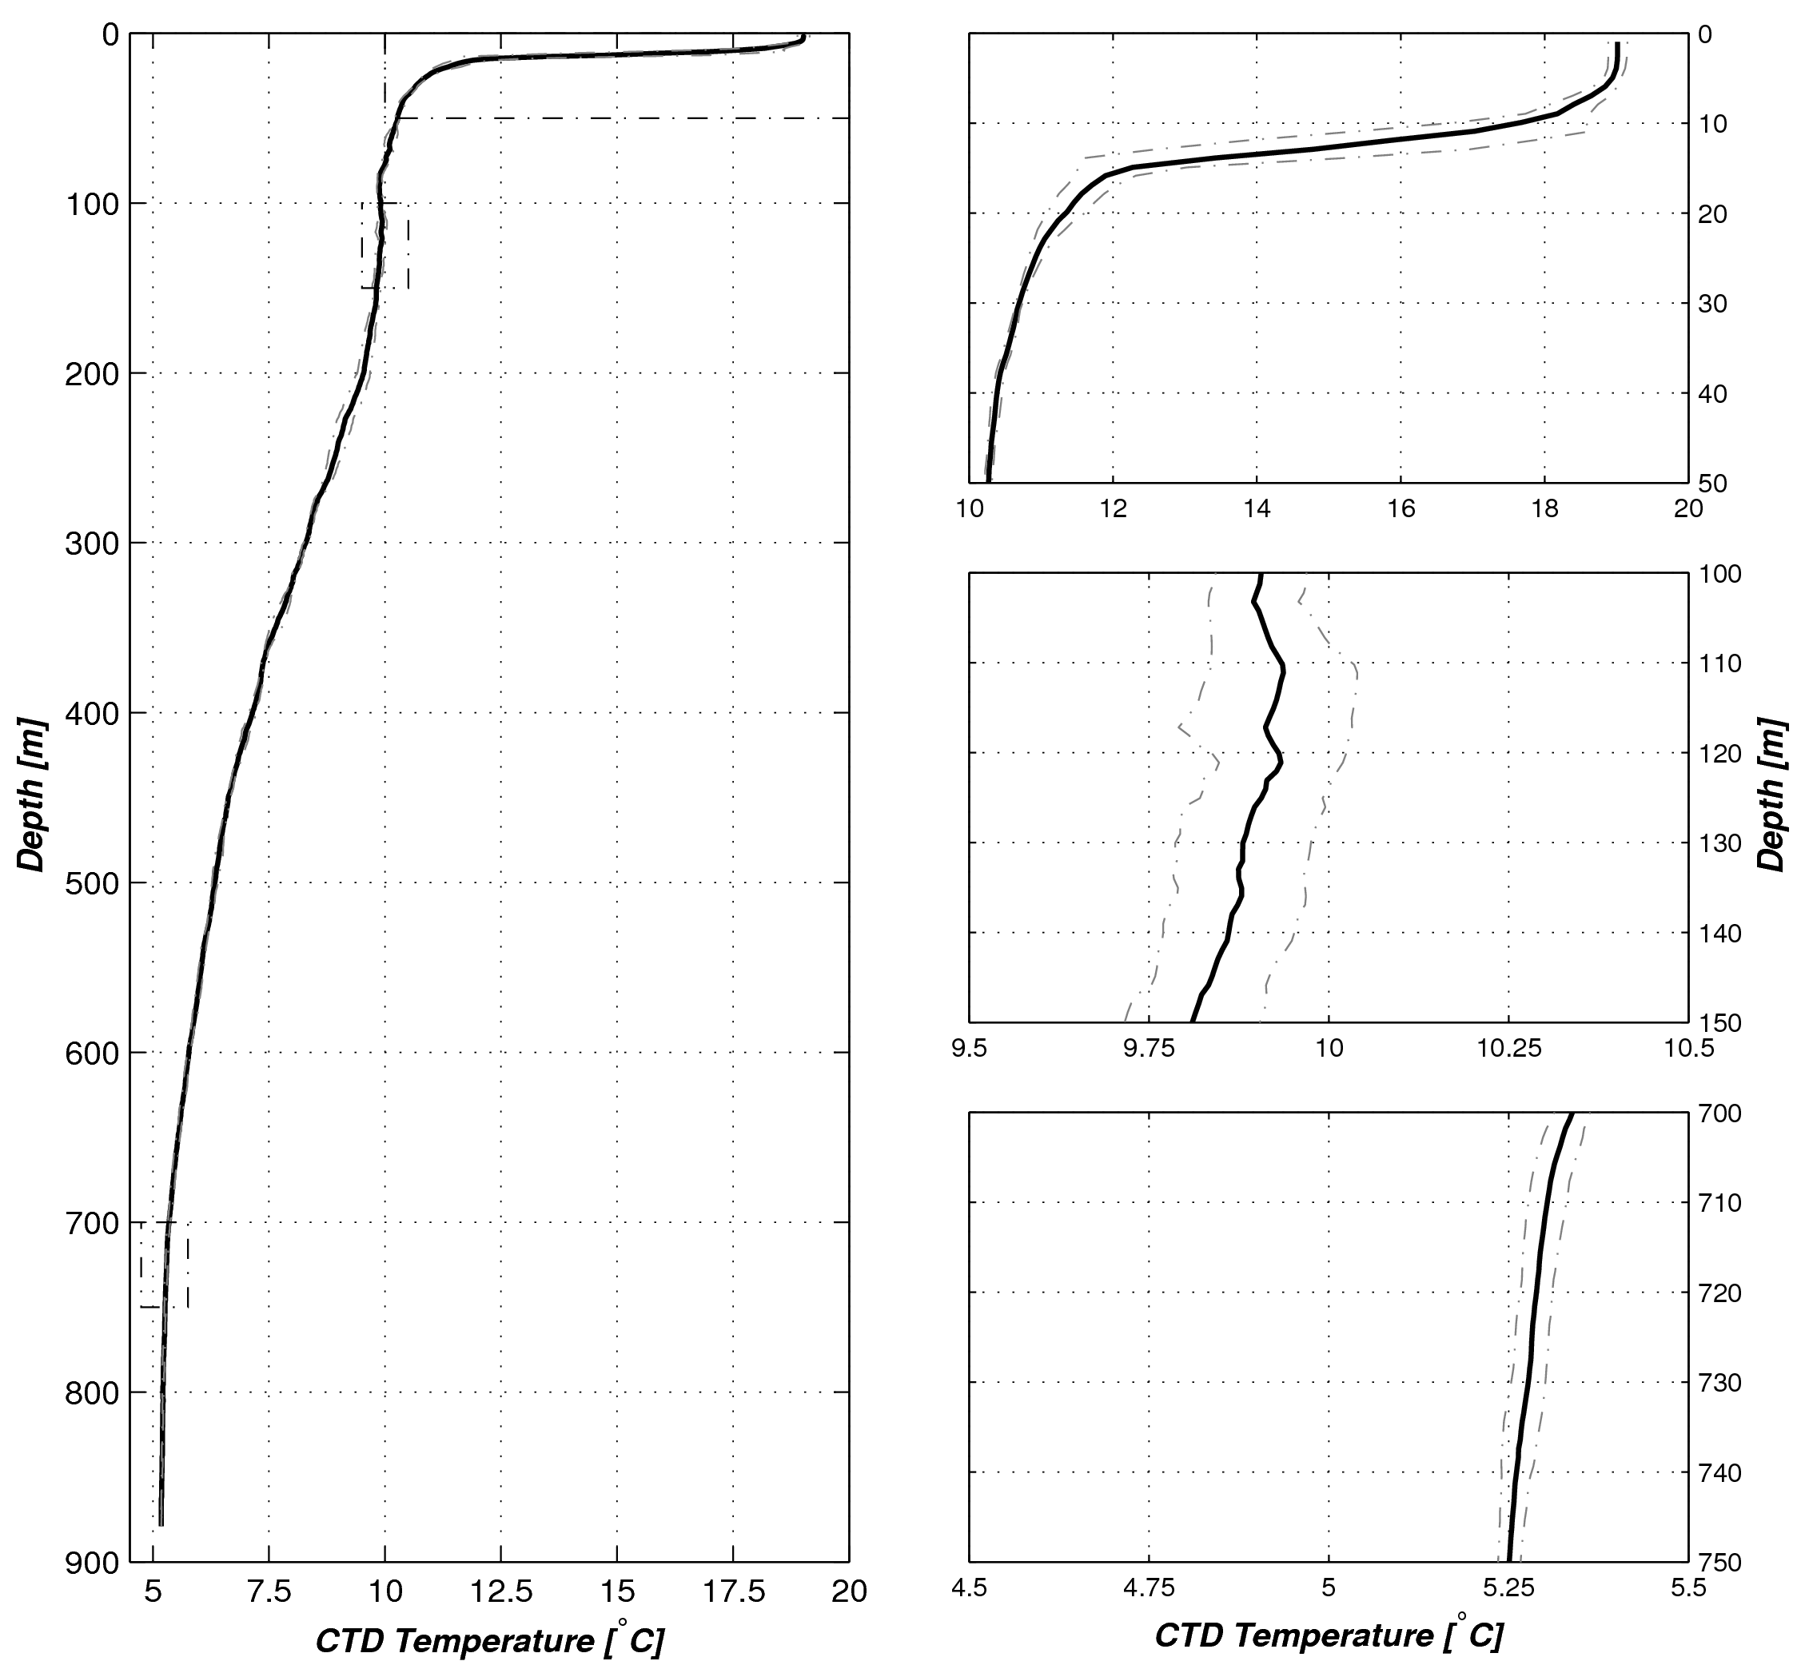
Figure 4. Mean and standard deviation profiles for the seven CTD casts. The dotted regions outline depth intervals characterized by small temperature gradients that are used in more detailed analyses.

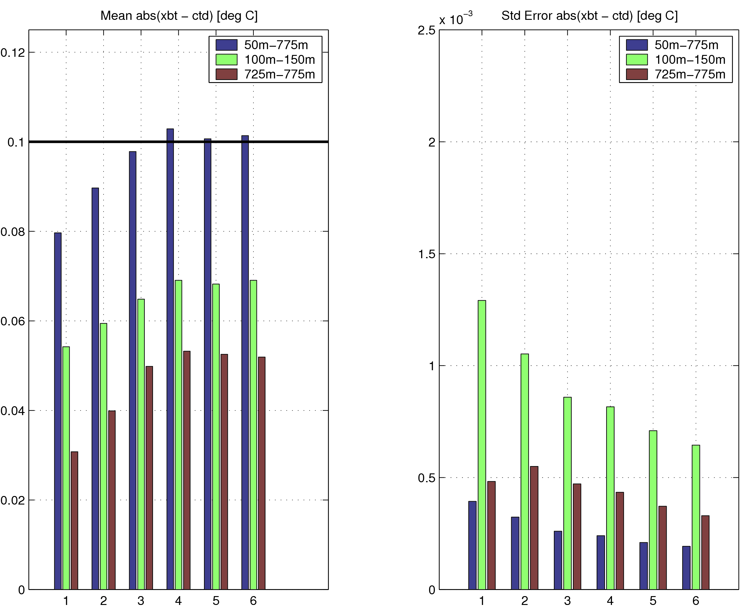
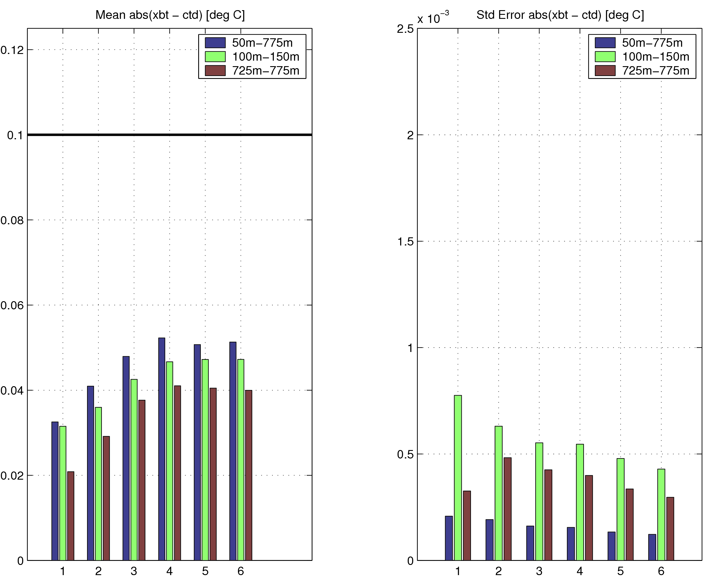

Figure 5. Mean absolute difference and standard error of the mean between XBTs and CTDs for three different segments of the water column. The upper panel shows the summaries for the original data and the lower panel shows the summaries for the data with the new fall rate equation from table \ref{tab:fall_rate_summary}. Along the x-axis, the labels refer to instruments accordingly: 1, aomlauto; 2, devilhand; 3, seasauto; 4, seashand; 5, sioauto; 6, siok98.

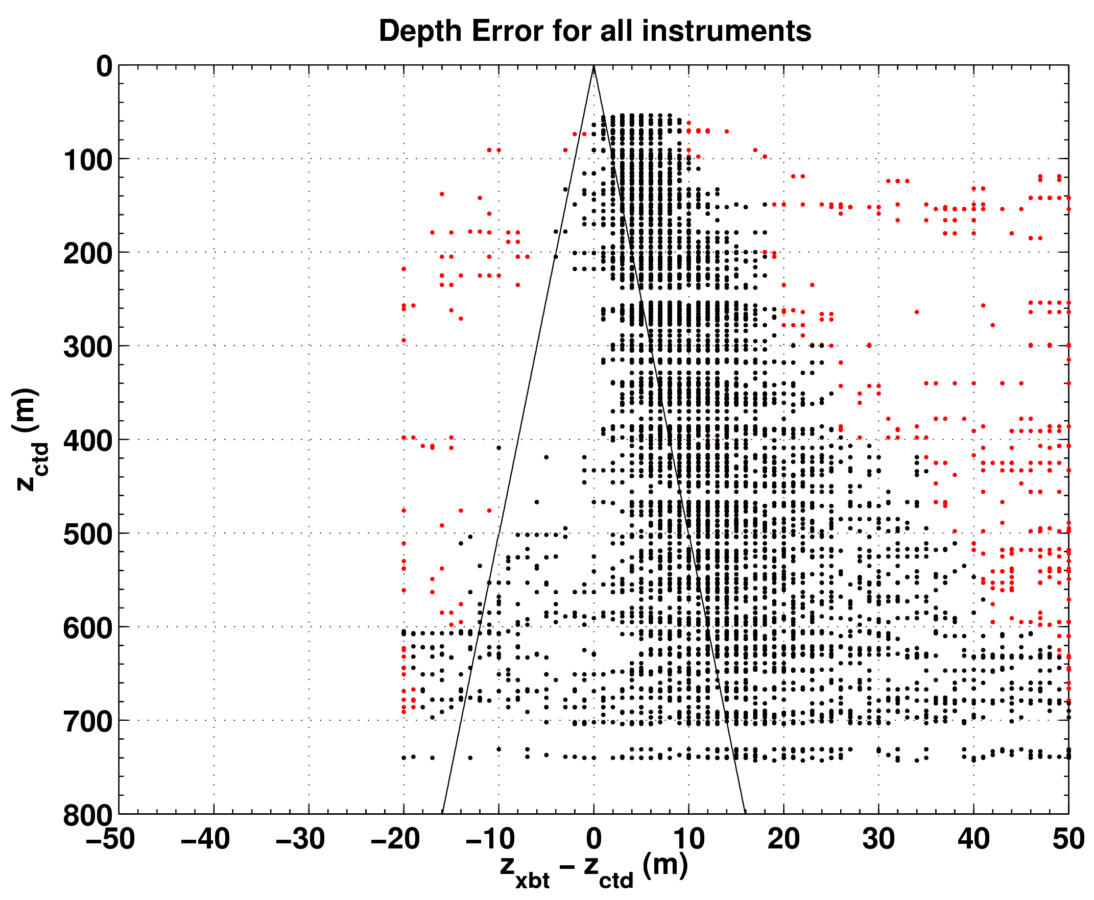
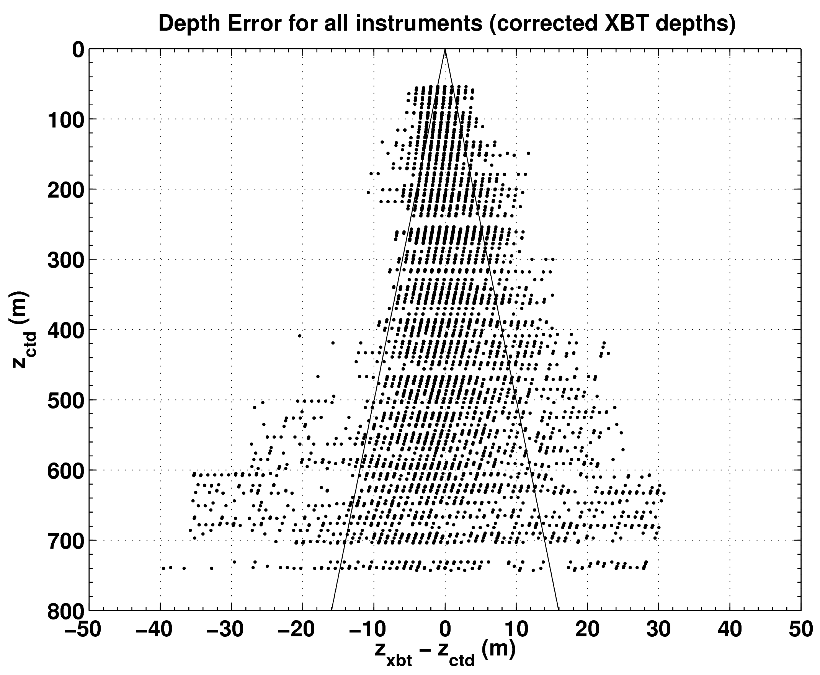
Figure 6. Depth error estimated with the temperature error free method of Hanawa et al. (1995). The upper panel shows the depth errors prior to estimation of a new fall rate equation. The red dots show each (dz,z) point used in the regression estimate of the new fall rate equation and the black dots represent points that were excluded after an outlier detection algorithm was applied to the data. The bottom panel shows the depth errors from the XBT profiles after the new fall rate equation was applied.

