Intensification and sea surface cooling in relation to tropical cyclones in the Mozambique Channel

Gustavo J. Goni, Alberto F. Mavume, Mathieu Rouault, Johann R.E. Lutjeharms, and Lars Rydberg

G. Goni, National Oceanic and Atmospheric Administration, Atlantic Oceanographic and Meteorological Laboratory, Physical Oceanography Division, 4301 Rickenbacker Causeway, Miami, FL 33149, USA (gustavo.goni@noaa.gov)

A. Mavume, Departamento de Física, Universidade Eduardo Mondlane, P. O. Box 257, Maputo, Mozambique. (amavume@uem.mz)

M. Rouault, and J.R.E. Lutjeharms, Department of Oceanography, University of Cape Town, 7700 Rondebosch, South Africa. (rouault@ocean.uct.ac.za, johann@ocean.uct.ac.za)

L. Rydberg, Department of Oceanography, Earth Science Centre, Göteborgs Universitet, Box 460, SE-405 30, Göteborg, Sweden. (lary@oce.gu.se)

Abstract. Tropical cyclones (TC) in the Southwest Indian Ocean represent approximately 15% (12 TCs per year in average) of all TCs that form globally every year. Some of these cyclones may become a crucial component of weather over the Mozambique Channel (MC) since some TCs travelling over its waters experience intensification before making landfall, causing severe damage in coastal and populated areas. This work describes in detail the interaction of three intense TCs with the upper water masses in the MC, two (Hudah and Eline) that moved into this region from east of Madagascar, and one (Japhet) that originated in the MC. It is observed that these three TCs intensified, with increases in their wind speeds of up to 45 m/s, when they travelled over the warm waters of MC, particularly associated with eddies. The upper ocean thermal structure in different parts of the MC – and in particular Mozambique eddies - appeared to play a role in TC intensification. The extent of this role will need to be more closely investigated using in situ observations and using theoretical and numerical modelling studies. Results obtained here suggest that TC intensity studies in this region may be improved by incorporating information on the subsurface thermal structure. The upper ocean conditions pre and post cyclone are investigated in terms of two parameters, the ea surface temperature (SST) and the Tropical Cyclone Heat Potential (TCHP), a measure of the upper ocean heat content. Cooling of surface waters in the wake of these cyclones was manifested by an SST decreases of up to 5 ºC, with the largest values occurring during the passage of TC Hudah. The cooling rate of surface waters in the MC during the cyclone passages ranged from 0.2 to 0.8 ºC per day and 0.15 to 3 kJ/cm² per day in SST and TCHP respectively. The cooling in the sea surface signature produced in the MC by the TCs is observed to last for several weeks after the passage of each cyclone. Results indicate that the Mozambique Channel upper ocean thermal conditions fully recover after the passage of only one of the three TCs studied.

1. Introduction

The Mozambique Channel (MC) is approximately 1500 km long, its width approximately ranges from 400 to 900 km and its depths reach maximum values of about 3000 m. The upper ocean circulation in the channel is dominated by strong mesoscale activity along its western side, consisting of a train of warm, anti-cyclonic eddies travelling from north to south, rather than a continuous and intense western boundary current [De Ruijter et al., 2002]. Currents on its eastern side are in general weak and incoherent. Mozambique eddies have been shown to play an important role in the behaviour of the Agulhas Current [Schouten et al., 2002] and in the subsequent formation of Agulhas Current rings [Van Leeuwen et al., 2000] at the Agulhas Retroflection. These form a critical component of the global Meridional Overturning Circulation. The objective of this study is to illustrate that these eddies may also be critical in weather studies.

Tropical lows in the southwest Indian Ocean associated with the Inter-Tropical Convergence Zone (ITCZ) are characteristic atmospheric features during the austral summer. These tropical lows are considered to be TCs when they have sustained winds above 33 m/s. Most TCs in this region develop over waters warmer than 27ºC [Anthes, 1982], with some of them making landfall and expected to weaken when travelling over Madagascar or Mozambique. The SWIO experiences some 12 TCs per year, which is 15% of the global total [Fink and Speth, 1998]. Observations indicate that many of these cyclones gain strength when they travel over the MC.

Following the same working assumption presented for North Atlantic tropical cyclones [Shay et al., 2000], it is hypothesized here that some tropical cyclones in the MC may rapidly intensify when travelling over warm anticyclonic features that have large values of upper ocean heat content. For example, it has been shown that hurricane Opal (1995) rapidly intensified in the Gulf of Mexico when it travelled over a warm anticyclonic ring that had been shed by the Loop Current [Shay et al., 2000]. Theoretical studies have also supported this hypothesis [Hong et al., 2000], where an ocean-atmosphere coupled model reproduced rapid intensification of hurricane Opal. Similarly, Mainelli et al. (2008) have shown the importance of the upper ocean thermal structure in the intensity forecast of intense (category 5) Atlantic hurricanes. Additionally, in the northwest Pacific Ocean, results from the Coupled Hurricane Intensity Prediction System and from satellite-derived SST fields indicate that a warm eddy worked as a successful insulator between typhoon Maemi (2003) and the deeper and colder waters beneath the mixed layer by suppressing the cooling of sea surface temperatures [Lin et al., 2005]. Results obtained from this model also indicated that the rapid intensification of this TC would have been slower without the presence of the warm eddy. It will be shown in this work that the three intense TCs studied here intensified when they travelled over the waters of the MC associated with warm eddies. To accomplish the abovementioned studies of the importance of warm eddies for TC intensification, the surface and subsurface thermal characteristics in the waters of the MC during the passage of TCs Eline and Hudah in 2000 and Japhet in 2003 are investigated in terms of the SST and Tropical Cyclone Heat Potential (TCHP), a parameter proportional to the upper ocean heat content, respectively.

It has been shown that the passage of a TC leaves a cold wake of considerably reduced SST [Price, 1981; Stramma et al., 1986]. It has been proposed that these major cooling effects are due to entrainment and upwelling by surface ocean currents, and by mixing [Price, 1981; Greatbatch, 1985] and not to evaporative heat loss. The upwelling will be investigated in function of the response of the upper ocean to the passage of TCs in the MC in terms of the difference between the SST and TCHP under the track of the storm before and after the passage of these three TCs. Additionally, estimates are presented on the time it takes the SST and the TCHP in the Mozambique Channel to recover to the conditions existing prior to the passage of each of the TCs.

This manuscript is organized as follows. Section 2 presents a summary of the data and upper ocean thermal fields used in this work. Sections 3 and 4 describe the upper ocean circulation in the MC and the TCs in the SWIO, respectively. In Section 5, for each of the three TCs studied here (Eline, Hudah and Japhet), the upper ocean conditions are evaluated in terms of two parameters, the SST and the TCHP. This study is done by first describing the upper ocean conditions in the MC, second by estimating the mean cooling in the Mozambique Chanel produced by each cyclone, third by computing the cooling under the track generated by each cyclone, and fourth by estimating the time that takes the upper ocean to recover to the original thermal conditions. Section 6 presents a discussion of the results.

2. Data and Tropical Cyclone Heat Potential

The surface and subsurface thermal structures in the MC are analyzed in terms of the SST and the TCHP using satellite observations. The sea surface temperature data belong to measurements from the Tropical Microwave Image on board the Tropical Rainfall Measuring Mission. The altimetry data used to compute the upper ocean heat content belong to the weekly merged AVISO altimetry data that includes all the available altimetry observations from a number of satellites. Data from TCs are obtained from Unisys Weather, where locations and wind speeds are provided every 12 hours (00 and 12Z). The altimetry data are used as a proxy to derive the depth of the 20°C isotherm and then to estimate the Tropical Cyclone Heat Potential (TCHP), defined as the upper ocean heat content from the sea surface to the depth of the 26ºC isotherm [Leipper and Volgenau, 1972; Goni and Trinanes, 2003].

A linear statistical correlation analysis between the altimetry-derived sea height anomaly fields and the depth of the 20°C isotherm obtained from XBT and profiling float observations indicate that these two parameters are highly correlated in parts of the South-West Indian Ocean (SWIO), with correlation coefficients of 0.9 and higher to a significant level of 95% in most areas (Figure 1, left panel). This correlation has negative or low values east of Madagascar probably because of concurrent effects of wind and heating, where the increase in sea height due to surface warming is accompanied by upwelling conditions caused by winds. Within a two-layer reduced-gravity scheme, the gains in these correlations are proportional to the local reduced gravity [Goni et al., 1996], which is a measure of the vertical water stratification, the bias to the mean isotherm depth, and the dispersion of the data points can be viewed as being proportional to the barotropicity in the region. Once the depth of the 20°C isotherm is estimated, the depth of the 26°C isotherm is computed using climatological relationships between these two depths. TCHP values obtained from 400 XBT and profiling float temperature profiles in the MC during 1993-2006 were compared against altimetry derived estimates. The standard deviation of the differences between the altimetry and hydrographic estimates is approximately 10 kJ/cm², and the mean gain is approximately 1 (Figure 1, right panel), which provide an assessment of the error of these estimates. The reader is referred to Goni et al. [1996] and Shay et al. [2000] for the description of the methodology to estimate the depth of the 20°C isotherm and the TCHP fields, respectively, from satellite observations.

3. The upper ocean in the Mozambique Channel

The upper ocean circulation in the southern Indian Ocean is characterized by the subtropical gyre [Stramma and Lutjeharms, 1997]. The South Equatorial Current, which forms the northern limb of this gyre, bifurcates at the east coast of Madagascar forming a northern and southern branch of the East Madagascar Current. The northern branch rejoins the main westward flow of the South Equatorial Current and moves south into the MC at the coast of the African continent . The flow in the Mozambique Channel is mostly composed of eddies that travel with the background flow [ De Ruijter et al., 2002]. These eddies may have cross sections larger than 300 km, maximum surface velocities of 2 m/s, and a vertical structure that usually extends to the bottom. The average annual number of eddies that travel poleward in the MC is four [Schouten et al., 2003], with substantial year-to-year variability. The sea surface temperature in the MC exhibits an annual cycle with mean values that reach slightly above 29ºC during mid-May (see section 5).

The temperature contrast between a MC eddy and its surrounding waters has been observed in hydrographical observations, revealing that at a depth of 50 m the temperature difference between a typical MC eddy and the background waters may reach 5ºC [De Ruijter et al., 2002]. Using remote sensing procedures, these eddies can be detected from sea surface temperature and sea surface height fields, which provide evidence that their surface waters may be 4ºC warmer and up to 30 cm higher than their background waters (see Results section). There are also weak cyclonic eddies in this region containing waters that are colder and have lower sea height than their background waters. In the mean, the contrast between the upper ocean thermal characteristics in the MC and east of Madagascar is important. Mean fields of sea surface temperature obtained between 1982 and 2005 in the MC reveal that between January and June its waters may be up to 3°C warmer than the surface waters east of Madagascar (Figure 2). Similarly, results presented in the following sections reveal that the values of TCHP in the MC could be up to 100 kJ/cm² larger than east of Madagascar.

4. South West Indian Ocean tropical cyclones

Most of the TCs in the SWIO form between 8°S and 22°S and their trajectories may reach as far as 35°S and 4°S to the south and north, respectively (Figure 2). These TCs usually develop as perturbations along the ITCZ, which is located at approximately 10°S (15°S) east (west) of Madagascar. The ITCZ exhibits inter-annual and intra-seasonal variability induced by the interaction of the convective northern monsoon and subsiding easterly trades [Jury et al., 1994]. The southern limit in the region of genesis of these cyclones has a SW-NE slope following the spatial variability of the ITCZ. This slope approximately tracks the monthly climatological 27ºC isotherm in all months except for May, when it tracks the 28°C isotherm.

Roughly 60% of tropical lows reach tropical cyclone intensity in the SWIO by attaining surface wind speeds exceeding 33 m/s. Approximately 8% of SWIO TCs reach Madagascar, the Mozambique Channel or the African mainland, and 6% travel at least within 100 km from the eastern African coast mainly due to the role of mid-level (500 hPa) winds in the eastward propagation of TCs [Vitart et al., 2003; Reason and Keibel, 2004]. Tropical cyclones travel through the MC every year, mostly during the period January-March, and they usually exhibit intensification while travelling in the region. Although the number of TCs making landfall in Mozambique is rather small, they have a great impact on the regions since they are usually category 2 or higher, with sustained wind speeds of at least 43 m/s. Of these cyclones, approximately 40 have formed over the MC itself since 1970 to later reach category 1 intensity.

5. Results

Results are presented here for three intense TCs: Eline and Hudah that formed east of Madagascar and crossed the MC in February and April 2000, respectively; and Japhet that generated over the MC in February 2003. These three cyclones remained in the MC for 5 to 6 days. Although not discussed in this work, daily composites of vertical wind shear at 850-200 hPa, relative humidity, sea surface temperatures and troposphere temperatures derived at NOAA/NCEP indicate a relatively favourable atmospheric environment for TC formation both prior to and during their intensification. Furthermore, the intensification of TCs has also been linked to the upper ocean heat content of warm ocean features (Shay et al., 2000; Lin et al., 2005; Mainelli et al., 2008). These studies showed that TC intensification in the Gulf of Mexico and tropical Atlantic Ocean can occur within 24 to 36 hours after a TC travels over a warm eddy.

The upper ocean conditions are investigated in terms of the SST and the TCHP fields in the MC before and after the passage of each of these three TCs. As the intensification could be due to warm ocean features present in the MC, the location of warm eddies are also analyzed with respect to where each TC intensified. The cooling produced by each cyclone is investigated in terms of the difference between the pre and post conditions in the surface and the upper ocean. The cold wake created by the cyclones is dominated by the strong upwelling. On average, this cooling occupies an area of influence that extends beyond the cyclone track, with the maximum reduction to the left the track of the cyclone, where the winds are stronger. Estimates are presented here on these cold wakes produced in the surface waters, which may remain in the region for several days and even weeks, depending on factors such as the upper ocean stratification, intensity of the TC, and net sea surface heat flux. The recovery time is of key importance because it probably plays a role in the interannual variability of the upper ocean thermal conditions, particularly the SST. Thus, the time that takes the MC (the area limited by Madagascar to the west, continental Africa to the east, and by 25°S and 12°S) to recover to the pre-cyclone upper ocean conditions is estimated. This duration is of interest since, for example, the intensification of cyclones is very dependant on upper ocean conditions, which may have been determined by the passage of a previous recent cyclone. The effect of the wind on coastal areas off Madagascar is also evident by the dominance of upwelling on the western coast of Madagascar, on both sides of the cyclone trajectories..

a) Tropical Cyclone Eline

Cyclone Eline started as a weak tropical storm 250 km south of Bali, at approximately 12°S, on 4 February 2000. Eline moved zonally between 20°S to 15°S across the Indian Ocean and made landfall at Madagascar with sustained winds of 29 m/2 (category 1 TC) on 17 February. Eline entered the MC on 19 February as a tropical depression and moved in a westerly direction before intensifying and making landfall in Mozambique with sustained winds of 44 m/s (category 3) on 22 February.

The fields of SST and TCHP are used to investigate ocean-atmosphere interaction during the passage of this cyclone. On 15 February the SSTs were above 29.5°C throughout most of the MC, approximately 2°C higher than the waters east of Madagascar (Figure 3). The largest values of SST in the MC were associated with warm eddies located at 23.5°S and 13.5°S, with values of 30°C and 31°C, respectively. On 16 February, the mean value of TCHP in the MC was approximately 70 kJ/cm², while it was only 30 kJ/cm² east of Madagascar. The TCHP field is characterized by values above 100 kJ/cm² associated with two warm eddies. The maximum value of TCHP of 125 kJ/cm² corresponds to the warm eddy located at 15°S. The second eddy, located to the south at 23.5°S, has a maximum value of TCHP of 95 kJ/cm². As expected, the surface signature of TCHP and SST for these eddies are not the same as these two parameters may not necessarily have to be proportional. The mean TCHP value under the track of this cyclone in the MC was 82 kJ/cm² . Additionally, relatively weak cyclonic eddies are present but they will not be described in detail because they do not represent a large source of cold waters [DeRuijter et al., 2002]

The upper ocean conditions in the MC under the track of this cyclone are described here. In the MC, the sustained winds of Eline increased from 24 m/s (Tropical Storm) to 44 m/s (category 3) in 48 hours. This increase of intensity occurred while the surface waters under the track of Eline corresponded to the warm eddy located at 23.5°S (Figure 4). The SST of the waters under the TC track was 30.2°C (Figure 4), approximately 3°C warmer than the waters under the track when it travelled east of Madagascar (Figure 3). During the intensification, the TCHP values also increased under the track of the cyclone, from 37 to 60 kJ/cm² (Figure 4). The increase in SST and TCHP under the track of Eline were concurrent and located at 22.5°S, the approximate location of the warm eddy.

The TCHP and SST fields are also evaluated to investigate the response of the upper ocean to the passage of Eline. The difference between pre and post tropical cyclone conditions indicates that the SST decreased on average approximately 1.75°C under the track of the storm (Figure 4). It is noticeable that this decrease is larger at the location of the eddy. The signature of the warm eddy still remains after the passage of Eline in the SST but not in the TCHP. The TCHP reduction under the track of this cyclone is approximately 25 kJ/cm². As with the SST, the decrease in TCHP is slighter larger (40 kJ/cm²) at the location of the warm eddy. One explanation for this is that the winds over the warm eddy were more intense, creating more mixing, upwelling and evaporation, all factors involved in the change of the SST and TCHP fields. Results show a larger SST cooling to the left of the track of the cyclone. On the other hand, this is not evident in the TCHP field.

After the passage of Eline the TCHP and SST mean values in the MC reached within 4 kJ/cm² and 0.2°C of the pre-cyclone mean TCHP and SST values, respectively The mean SST in the MC before the passage of the Eline on 13 February 2000 was 29.9°C. The mean SST in the MC decreased until 23 February, two days after this cyclone made landfall in continental western Africa, to a value of 28°C (Figure 5). The rate of sea surface temperature decrease was 0.2°C per day. On the other hand, the increase of the SST in the MC occurred at two different rates, one of 0.11°C per day until 7 March and another of 0.03°C per day until 27 March, when the SST recovered to 0.2°C of its original value. The rate of decrease and increase of TCHP follows approximately the same pattern as the SST. The maximum mean value of TCHP of 57 kJ/cm² in the MC was observed on 14 February. The minimum value TCHP of 27 kJ/cm² was observed on 24 February. This represents an average decrease of 3 kJ/cm² per day. Similarly, the rate of warming of the upper ocean in terms of the TCHP values occurred at two different rates, 1.7 kJ/cm² per day from 24 February until 6 March, and 0.6 kJ/cm² per day until 26 March. On this day, mean TCHP in the MC reached the value of 53 kJ/cm². It is speculated here that the rapid increase at the beginning is due to the surface heat fluxes, while during the period of lower heating rate the net flux combined with advection becomes more evenly distributed over the upper layer. Results show that the mean values of SST and TCHP in the MC never completely recovered to their original values. However, it took 32 days for the MC to approximately recover to the pre cyclone conditions.

b) Tropical cyclone Hudah

Cyclone Hudah originated near Australia, approximately 15°S, on 24 March 2000. Hudah moved zonally across the South Indian Ocean and made landfall on the north-east coast of Madagascar at 15°S with sustained winds of 65 m/s (category 4) on 2 April. Although the discussion of its intensification east of Madagascar is beyond the scope of this work, fields of TCHP under the track of this TC exhibited values above 130 kJ/cm². Hudah weakened significantly over Madagascar and entered the MC as a tropical storm on 3 April, 5 weeks after cyclone Eline had travelled 5° south in the MC. On 31 March, the upper ocean conditions in the MC showed that the mean TCHP value was approximately 50 kJ/cm², 30 kJ/cm² more than east of Madagascar (Figure 6). The mean SST value on 2 April was approximately 29.1ºC, 2ºC higher than east of Madagascar. (Figure 6). Several warm anticyclonic eddies were located in the MC with maximum values of TCHP above 110 kJ/cm² and of SST above 31ºC. Hudah intensified in the MC with sustained winds reaching 52 m/s (category 3) on 7 April, then made landfall in Mozambique on 8 April after which it rapidly lost strength (Figure 6). After the passage of this cyclone, the surface waters exhibited cooling of their waters and a reduction of their TCHP and SST values.

An examination of the upper ocean conditions in the MC under the track of Hudah shows that this TC encountered very warm surface waters during its transect over the MC, particularly when moving south-westward over the warm eddy centered at 42ºE, 15.5ºS and over the edge of a second warm eddy centered at 39ºE, 20.5ºS (Figure 6). These eddies had maximum values of TCHP of 80 and 100 kJ/cm², respectively. However, the maximum TCHP values under the track of Hudah were 72 kJ/cm² and 58 kJ/cm² (Figure 7). The two main increases in wind speed of Hudah occurred where the TCHP values were highest. However, the maximum wind speed values do not correspond to the locations of maximum values of SST and TCHP. An examination of the values of sea surface temperature under the track of this cyclone suggests that the intensification of Hudah appears to have been concurrent with the increase of SST under the track of the cyclone. The mean TCHP value under the track of this cyclone in the MC was 80 kJ/cm².

The upper ocean cooling under the track of Hudah, estimated from the along track values of TCHP and SST, exhibits a mean reduction of TCHP along the track of this cyclone of approximately 30 kJ/cm², while the mean alongtrack reduction of SST was 2ºC. After landfall, the mean value of TCHP in the MC on 10 April was 43 kJ/cm² while the mean SST value on 8 April was approximately 28.8ºC. The decrease of mean values of TCHP in the MC was 10 kJ/cm² in 12 days; while the decrease of mean SST values was approximately 0.9ºC in 6 days. Cyclone Hudah travelled over the MC after the surface cooling associated to the seasonal cycle had already started. The rate of cooling (Figure 5) after the passage of this cyclone was 0.15ºC per day and 0.8 kJ/cm² per day during the first 10 days as the storm travelled over the MC. The MC never recovered to its original state. An important result shown here is that although prior to the passage of this cyclone the mean values of SST were above historical mean values (constructed using satellite observations from 1990-2005), after the passage of the cyclone their mean values terminated 1ºC below the historical mean values and remained lower than them during the next few months.

c) Tropical cyclone Japhet

Cyclone Japhet formed as a tropical depression off the south-western coast of Madagascar on 26 February 2003, drifting slowly southward (Figure 8). This TC was unusual since only approximately 40 TCs are known to have formed in the MC during the period 1970-2006 (Figure 2). A transitory pressure ridge, approaching from the south-west, altered the cyclone track to the west. On the ridge weakening, the track changed to south-southwest and the cyclone moved in this direction at a high speed of about 40 km/day. The winds of Japhet then intensified from 44 to 60 m/s (category 4) in less than 24 hours. By 3 March the intensity of Japhet started to decline and by the time it made landfall on the coast of Mozambique its maximum speeds had been reduced to 41 m/s.

On 19 February, the mean value of TCHP in the southern portion of the MC was approximately 80 kJ/cm², and the mean surface temperature of the surface waters was approximately 29ºC. The genesis of Japhet on 26 February coincided with this TC originating over a warm eddy located off SW Madagascar (Figure 8) with values of THCP of 90 kJ/cm² and SST of 30.5ºC. The rapid intensification of Japhet from category 2 to category 4 occurred when its track was over the edge of an MC eddy centered at about 40ºE, 22.5ºS. The mean values of TCHP and SST under the track of this cyclone were 72 kJ/cm² and 29.5ºC, respectively.

The mean cooling under the track of this TC (Figure 9) is approximately 30 kJ/cm² and 1.0ºC, for TCHP and SST, respectively. However, on average the southern regions of the MC cooled by approximately 35 kJ/cm² and 3ºC (Figure 8, right panels). The cooling rate of the MC (Figure 5) between 26 February and 3 March (when the mean SST in the MC is minimum) is 0.26ºC per day and 0.35 kJ/cm². The MC eventually recovered to its pre-cyclone upper ocean thermal conditions. It is important to notice that during this year the maximum mean SST values in the MC were reached in February when Japhet originated, while climatological maximum values are reached in March (Figure 5, bottom panel). The warming rate between 3 March and 8 March was 0.16ºC per day, and between 8 March and 22 March, when the SST reached it pre cyclone value of 0.04ºC per day. It took approximately 24 days for the MC to recover to SST pre storm values. The TCHP recovered to the pre storm values of 50 kJ/cm² in 15 days and earlier than the SST did and at a warming rate of 1.2 kJ/cm² per day.

6. Discussion

Studies such as the one presented here are facilitated by the availability of appropriate remote sensing products. The sea height anomaly and sea surface temperature fields were used to investigate some aspects of the ocean-atmosphere interaction of three intense (category 3 and 4) tropical cyclones (Eline, Hudah and Japhet) in the Mozambique Channel. A summary of the main results obtained in this study are shown in Table I.

Results presented here cannot explain the total heat transferred to the atmosphere but can provide estimates of the variability of the upper ocean heat content, one of several factors that play a role in the total heat balance. The upper ocean heat content is estimated by a parameter, the TCHP, which can be indirectly computed from altimetry-derived sea height anomaly fields. Evidence is presented that the genesis or intensification of cyclones in the region could be also linked to favourable environmental ocean factors. There are common oceanic features present at the time of genesis (Japhet) or intensification (Eline and Hudah) with high Tropical Cyclone Heat Potential (upper ocean heat content) and sea surface temperatures in the MC, belonging to Mozambique Channel warm eddies. However, and despite their low number of occurrences, it is evident that during their relatively short sojourn over the MC the increase of wind intensity of these cyclones took place predominantly over the waters of warm eddies. The presence of these warm eddies thus establishes an additional energy source - apart from other atmospheric influences - for cyclones that cross these features and may create an extra potential for intensification of cyclones over the Mozambique Channel. The TCHP fields show evidence that al least two of these cyclones (Eline and Hudah) intensified particularly strongly when their tracks went over the waters of warm anticyclonic eddies, and one (Japhet) originated over a warm eddy. The mean values of TCHP under the track of these cyclones while they travel through the MC were above the threshold value of 60 kJ/cm². This value has been reported to be needed to sustain tropical cyclone winds (DeMaria et al., 2001) and also found to be linked to intensification in statistical models used in the tropical Atlantic [Mainelli et al., 2008]. Other TCs, such as Ernest (2005), Boloetse (2006), and Favio (2007), whose results are not shown here, also exhibited intensification in the MC when they travelled over the MC. From the examples shown here, the correlation with wind speed increase appeared to be strongly correlated to TCHP and SST, meaning that the upper ocean heat content could be considered as predictor of intensity changes.

The decrease in the depth of the 26ºC isotherm due to upwelling produced by Ekman pumping is estimated using the response of the sea level height to the passage of each TC. The variability of the heat content within this layer (the TCHP) and of the SSTs were used to estimate the cooling produced by each cyclone. Although not shown in this study, the decrease in sea level observed after the passage of these TCs ranged from 10-20 cm. These values are somewhat smaller than those observed during hurricane Frederic (1979) [Shay and Chang, 1997]. The mean cooling under the track of these cyclones ranged from 25 to 30 kJ/cm² in TCHP and from 1.0 to 2ºC in SST. The mean rates of cooling in the Mozambique Channel were 0.2 kJ/cm² and 0.2 ºC per day, for TCHP and SST, respectively.

When the cooling period is over, the upper ocean exhibits two different warming rates with the first one approximately 3 times larger than the second one. The MC fully recovered to its pre storm upper ocean conditions in only one of the three cyclones studied in this work, indicating their important effect, at least in contributing to regional year-to-year, high frequency, variability of the upper ocean. The two rates of warming observed after the MC reached its minimum TCHP and SST values have average values of and 1 kJ/cm² and of 0.1 ºC per day, respectively. During hurricane Opal (1995) the observed cooling in SST ranged from 0.5 to 1 º C, while the decrease in temperature was larger (2 to 3 º C) in the rest of the wake [Shay et al., 2000]. Entrainment from the base of the upper layer may account for up to 90% of the cooling, as shown for Atlantic tropical cyclones [Jacob et al., 2000], theoretical studies [Greatbatch, 1985] and numerical results [Price, 1981]. The horizontal advection by geostrophic currents also plays a role in the total heat balance [Jacob et al, 2000], but an investigation of the variability of geostrophic currents was outside the scope of this study. Results presented in this work do not show evidence that the values of TCHP and SST under the tracks of the three TCs are reduced less in warm eddies as previously reported (Lin et al., 2005). However, it is hypothesized here that the temporal and sampling factors of altimetric observations together with the variation of the location of the rings due to their translation may account for this difference.

7. Conclusions

This work represents a clear application of the value of altimetry observations and the products that can be derived from them. This work furthermore presents evidence that the upper ocean heat content, a variable that can be appropriately estimated in this region using altimetry observation, must be further tested for inclusion in TC intensification studies. Results obtained from this work are expected to aid in the understanding of the role that the upper ocean thermal structure plays in tropical cyclone intensification, particularly with respect to including ocean parameters different than the climatological sea surface temperature in intensity forecast models in this region. Subsurface thermal values produced at the National Hurricane Center have already shown a reduction in error in the prediction of TC intensity (Mainelli et al., 2008). Statistical models, such as the U.S. Navy/NOAA STIPS (STatistical Intensity Prediction Scheme) recently started being used experimentally in this region with a subsurface temperature parameter being included as a predictor (John Knaff, personal communication). Results presented stress the importance of further investigating and evaluating the effect of the ocean on tropical cyclone intensification for forecast purposes. However, although altimetric fields may contribute to the overall understanding of the ocean-atmosphere interaction during tropical cyclones, other observations such as concurrent data from profiling floats and drifters close to the track of cyclones will provide more detailed information to investigate mixing and surface currents produced by these cyclones.

Acknowledgements. This investigation was partly funded by the Swedish Agency for Developing Countries, the South African Foundation for Research Development, the South African Water Research Commission, by NOAA through its Science to Operations Program, and by NOAA/AOML. A.M. and J.R.E.L. thank the Göteborgs Universitet for invitations to work there and for warm hospitality received during our stays. Climatological SST data is from NOAA_OI_SST_V2 data provided by the NOAA/OAR/ESRL. Sea surface temperature data is from Remote Sensing Systems. Altimetry data is from AVISO. Dr. J. Trinanes and Mr. P. DiNezio contributed with some of the data processing.

References

Anthes, R.A., Tropical cyclones, their evolution, structure and effects, Meteorol. Mon., 19, 1-208, 1982.

DeMaria, M., J. A. Knaff, and B. A. Connell, A tropical cyclone genesis parameter for the North Atlantic, Wea. Forecast., 16, 219-233, 2001.

De Ruijter, W.P.M., H. Ridderinkhof, J.R.E. Lutjeharms, M.W. Schouten, and C. Veth, Observations of the flow in the Mozambique Channel, Geophys. Res. Lett., 29, 1401-1403, 2002.

Fink A. H., and P. Speth, 1998: Tropical cyclones. Naturwissenschaften, 85, 482–493.

Goni, G. J., S. Kamholz, S. Garzoli and D. Olson, Dynamics of the Brazil-Malvinas Confluence Based on Inverted Echo Sounders and Altimetry, J. Geophys. Res., 101, 16273-16289, 1996.

Goni, G. J. and J. A. Trinanes, Ocean thermal structure monitoring could aid in the intensity forecast of tropical cyclones, Eos, 84, 573-580, 2003.

Greatbatch, R.J., On the role played by upwelling of water in lowering sea surface temperatures during the passage of a storm, J. Geophys. Res., 90, 11751-11755, 1985.

Jacob, D. S., L. K. Shay, A. J. Mariano, and P. G. Black, The 3D oceanic mixed layer response to hurricane Gilbert, J. Phys. Oceanogr., 30, 1407-1429, 2000.

Jury, M. R., B. Parker, and D. Waliser, Evolution and variability of the ITCZ in the SW Indian Ocean: 1988-1990, in Theoretical and Applied Climatology, 187-194, Springer, 1994.

Hong, X., S. Chang, S. Raman, L. K. Shay, and R. Hodur, The interaction between hurricane Opal (1995) and a warm core ring in the Gulf of Mexico, M. Weath. Rev., 128, 1347-1365, 2000.

Leipper, D. F., and D. Volgenau, Hurricane heat potential of the Gulf of Mexico. J. Geophys. Res., 75, 637-657.

Lin, I. I, C.C. Wu, K. A. Emanuel, I.H. Lee, C.R Wu, and I.-F. Pun, The interaction of super typhoon Maemi (2003) with a warm ocean eddy. Month. Weath. Rev., 133, 2635–2649, 2005.

Mainelli, M., M. DeMaria, L. Shay, and G. Goni, Application of Oceanic Heat Content Estimation to Operational Forecasting of Recent Atlantic Category 5 Hurricanes, Weather and Forecasting, 2008 (in press).

Price, J. F., Upper ocean response to a hurricane, J. Phys Oceanogr., 11, 153-175, 1981.

Reason, C. J. C. and A. Keibel, Tropical cyclone Eline and its unusual penetration and impacts over the southern African mainland, Weath. Forecast., 19, 789-805, 2004.

Schouten, M. W., W. P. M. de Ruijter, and P. J. van Leeuwen, Upstream control of Agulhas ring shedding, J. Geophys. Res., 107, doi: 10.1029/2001JC000804, 2002.

Schouten, M. W., W. P. M. de Ruijter, P. J. van Leeuwen, and H. Ridderinkhof, Eddies and variability in the Mozambique Channel, Deep-Sea Res. II, 50, 1987-2003, 2003.

Shay, L. K., and S. W. Chang, Free surface effects on the near-inertial ocean current response to a hurricane: A revisit, J. Phys. Oceanogr., 27, 23-29, 1997.

Shay, L. K., G. J. Goni, and P. G. Black, Effects of a warm oceanic feature on Hurricane Opal, Mon. Weath. Rev., 128, 1366-1383, 2000.

Stramma, L., P. Cornillon, and J.F. Price, Satellite observations of sea surface cooling by hurricanes, J. Geophys. Res., 91, 5031-5035, 1986.

Stramma, L., and J. R. E. Lutjeharms, The flow field of the subtropical gyre of the South Indian Ocean, J. Geophys. Res., 102, 5513-5530, 1997.

Van Leeuwen, P. J., W. P. M. de Ruijter, and J. R. E. Lutjeharms, Natal Pulses and the formation of Agulhas rings, J. Geophys. Res., 105, 6425-6436, 2000.

Vitart F., Anderson D. and T. Stockdale, Seasonal Forecastiong of Tropical Cyclone over Mozambique Journal of Climate, 16, 3932-3945. 2003

Table captions

Table I. Mean ocean parameters estimated for each of the three tropical cyclones. The columns correspond to the tropical cyclones (Eline, Hudah and Japhet), the mean Mozambique Chanel (MC) Tropical Cyclone Heat Potential (TCHP), the mean MC sea surface temperature (SST), the mean under the cyclone track (UT) TCHP, the under the cyclone track cooling of TCHP and SST, the mean MC TCHP and SST cooling and warming rate and the time that took the MC to recover to the pre-cyclone upper ocean thermal conditions conditions.

Figure captions

Figure 1. (left) Correlation coefficient obtained from a lineal regression between altimetry-derived sea height anomaly and the depth of the 20ºC in the South-West Indian Ocean. (right) Observed versus altimetry-derived estimated values of Tropical Cyclone Heat Potential (TCHP) in the Mozambique Channel.

Figure 2. Tropical cyclone trajectories in the southwest Indian Ocean for the months of November through April during 1970-2006. Circles indicate the location where each cyclone started as a tropical depression. The background colours show the monthly mean sea surface temperature, with the white contour indicating the 27ºC isotherm. Highlighted in blue are the three tropical cyclones (Hudah, Eline, and Japhet) that are studied in this work.

Figure 3. (top) Tropical Cyclone Heat Potential (TCHP) and (bottom) sea surface temperature (SST) fields in the MC prior (left) and after (center) to the passage of cyclone Eline. The differences (right) between the post and pre conditions show the upper ocean cooling under the track of the cyclone. The dates used for the TCHP fields to 16 February 2000 (pre) and 1 March (post) and for the SST fields correspond to 15 February 2000 (pre) and 22 February (post). The circles indicate the trajectory locations every 12 hours and their colours correspond to the intensity of the winds: tropical depression (yellow), tropical storm (green), category 1 (red), category 2 (pink), category 3 (gray), category 4 (white). The dates for each of the panels are indicated in Section 5a.

Figure 4. Sea surface temperature (blue lines), Tropical Cyclone Heat Potential (red lines) and wind speed (black lines) before (solid lines) and after (dotted lines) along the track of tropical cyclone Eline. The location of the Mozambique anticyclonic eddies (MAE) are indicated.

Figure 5. Mean Tropical Cyclone Heat Potential (TCHP) and mean sea surface temperature (SST) in the Mozambique Channel during the periods (top) January-May 2000, and (bottom) February-April 2003, showing the upper ocean cooling produced by the cyclones Eline and Hudah (top) and Japhet (bottom). The vertical bars indicate one standard deviation. The monthly mean sea surface temperature (gray line) between 1993-2006 in the Mozambique Channel is included in both panels. The dots indicate the time when Eline and Hudah entered the MC and Japhet originated in the MC.

Figure 6. (top) Tropical Cyclone Heat Potential (TCHP) and (bottom) sea surface temperature (SST) fields in the MC prior (left) and after (center) to the passage cyclone Hudah. The differences (right) between the post and pre conditions show the upper ocean cooling under the track of the cyclone. The dates of the SST fields correspond to 2 April (pre) and 8 April (post) and for the TCHP fields to 26 March 2000 (pre) and 10 April (post). The circles indicate the trajectory locations every 12 hours and their colours correspond to the intensity of the winds: tropical depression (yellow), tropical storm (green), category 1 (red), category 2 (pink), category 3 (gray), category 4 (white). The dates for each of the panels are indicated in Section 5b.

Figure 7. Sea surface temperature (blue lines), Tropical Cyclone Heat Potential (red lines) and wind speed (black lines) before (solid lines) and after (dotted lines) along the track of tropical cyclone Hudah. The location of the Mozambique anticyclonic eddies (MAE) are indicated.

Figure 8. (top) Tropical Cyclone Heat Potential (TCHP) and (bottom) sea surface temperature (SST) fields in the MC prior (left) and after (center) to the passage cyclone Japhet. The differences (right) between the post and pre conditions show the upper ocean cooling under the track of the cyclone. The dates of the SST fields correspond to 26 February 2003 (pre) and 3 March (post) and for the TCHP fields correspond to 26 February (pre) and 5 March (post). The circles indicate the trajectory locations every 12 hours and their colours correspond to the intensity of the winds: tropical depression (yellow), tropical storm (green), category 1 (red), category 2 (pink), category 3 (gray), category 4 (white).

Figure 9. Sea surface temperature (blue lines), Tropical Cyclone Heat Potential (red lines) and wind speed (black lines) before (solid lines) and after (dotted lines) along the track of tropical cyclone Japhet. The location of the Mozambique anticyclonic eddies (MAE) are indicated. The dates for each of the panels are indicated in Section 5c.

TC | MC  TCHP  (kJ/cm²) | MC  SST  (°C) | Mean UT  TCHP  (kJ/cm²) | UT TCHP  Cooling  (kJ/cm²) | UT SST  Cooling  (°C) | MC TCHP  cooling rate  (kJ/cm² per day) | MC SST  cooling rate  (°C per day) | MC TCHP  warming rate  (kJ/cm² per day) | MC SST  warming rate  (°C per day) | MC recovery  time  (days)
Eline | 70 | 29 | 82 | 25 | 1.75 | 3 | 0.2 | 1.7 and 0.6 | 0.1 and 0.03 | 32
Hudah | 50 | 29 | 80 | 30 | 2 | 0.15 | 0.8 | no warming | no warming
Japhet | 80 | 29 | 72 | 30 | 1.0 | 0.35 | 0.3 | 0.16 and 0.04 | 1.2 | 15 (TCHP)  24 (SST)

Table I

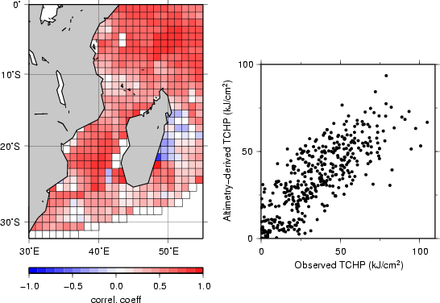

Figure 1

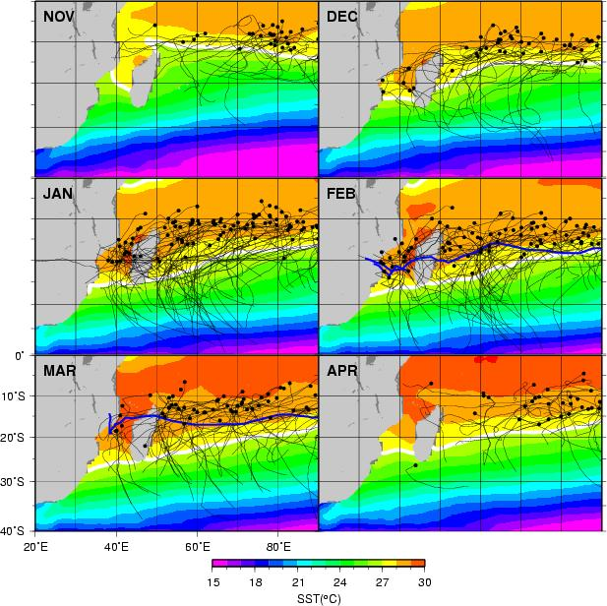

Figure 2

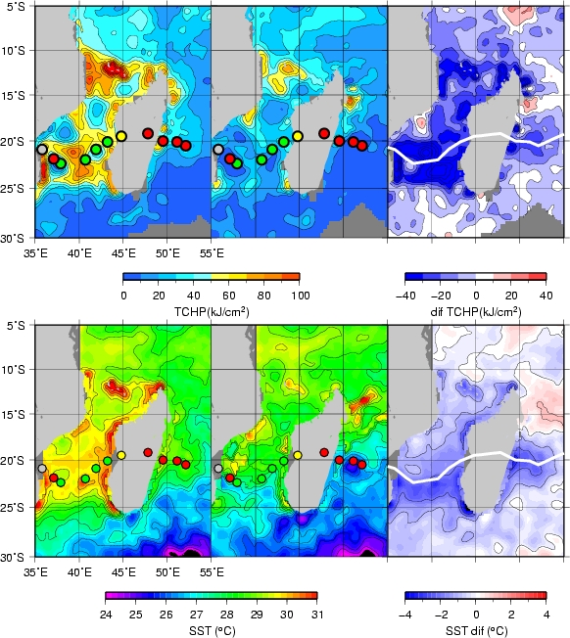

Figure 3

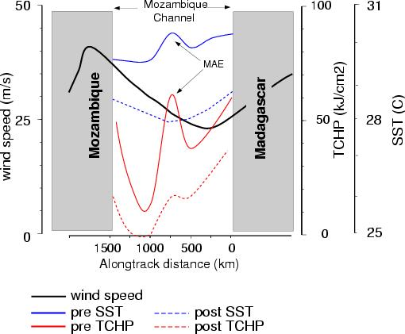

Figure 4

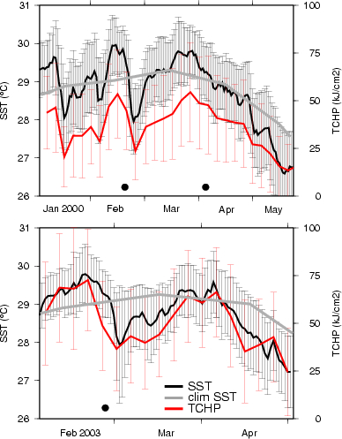

Figure 5

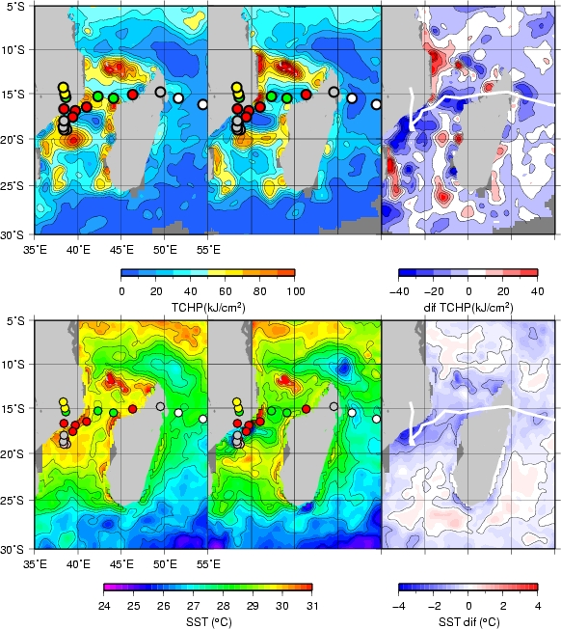

Figure 6
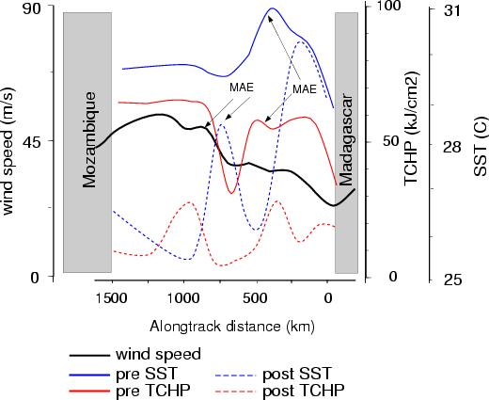

Figure 7

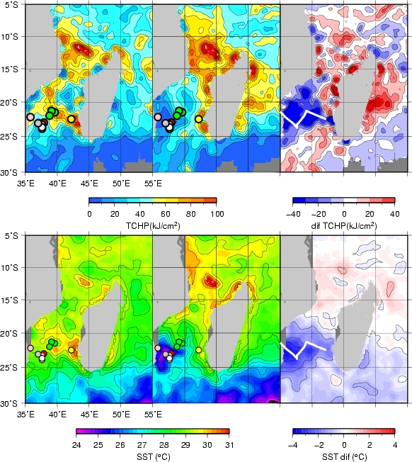
Figure 8

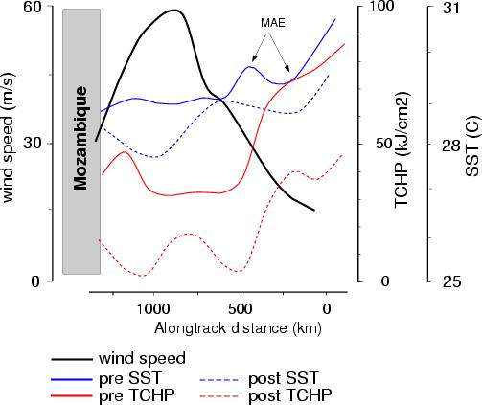
Figure 9

