Thermosalinograph Work Progress
by Gustavo Jorge Goni, NOAA/AOML

Main Goal

To install and maintain thermosalinographs (TSG) equipment on ships that participate in the Ship of Opportunity Program (SOOP), and to retrieve, quality control and distribute their sea surface salinity and temperature data.

Project Description

Sea Surface Salinity is a critical parameter to estimate the influence of oceans on climate. Unlike temperature, SSS has no direct effect on air-sea exchanges, but it determines the convection and re-emergence of water masses, which are crucial for the seasonal to interannual variability of the global system. Sea surface salinity observations have demonstrated to be critical in the studies of water mass formation, ocean front variability, pCO₂ dissolved in sea water climate, ENSO forecast studies, and fisheries. NOAA is currently placing considerable effort and resources to assess the pCO₂ dissolved in the ocean (Staniski and Arkin, 2006). A critical component of this effort is to constrain the fluxes between the major labile reservoirs: the ocean, the terrestrial biosphere, and the atmosphere. Of these three reservoirs, the ocean has by far the largest uptake capacity and is the largest sustained sink for anthropogenic carbon.

Thermosalinographs (TSGs) are instruments mounted close to the water intake of research and cargo ships and that continuously measure the sea surface salinity and temperature along the track of ship. Sea surface salinity derived from TSGs has proven to be key in assessing the inventory of pCO2 dissolved in the ocean. Data obtained from TSGs will be also used, for example, to calibrate and validate observations from the SMOS and Aquarius sea surface salinity satellite missions.

NOAA/AOML currently operates and maintains TSGs in three ships of the SOOP. Data from these ships are being routinely quality controlled and distributed using procedures and software developed at AOML. Additionally, AOML performs installation and maintenance, and data retrieval, quality control and distribution in collaboration with the University of Miami (RSMAS), and with the Institut de Recherche Pour le Developpement (IRD, France). We have recently implemented real-time mode quality control procedures for TSG data obtained from the ships of the SOOP. These procedures will be applied to real-time data once the installation of SEAS2000 software is installed in the ships of SOOP.

Accomplishments

NOAA/AOML worked in collaboration with NOAA/NMFS in Rhode Island to carry out the maintenance of the three ships of the SOOP (Figure 1):

- Oleander transect: From Port Elizabeth to Bermudas. Maintained by NOAA/AOML since 2001. The TSG equipment will be replaced during the summer with a new micro TSG. The equipment connections are now independent of the pCO2 measurements.

- Skogafoss transect: From Everett, MA, to Iceland. Maintained by NOAA/AOML since 2001. The TSG equipment will be replaced during the summer with a new micro TSG. Water samples are taken and analyzed in Iceland and at AOML.

- Cap Victor (formerly Columbus Waikato): From the west coast of the US to New Zealand and Australia. There is a new micro TSG installed and a dedicated computer was installed during the summer. The new route of this ship includes a zonal crossing of the North Atlantic that started this summer.

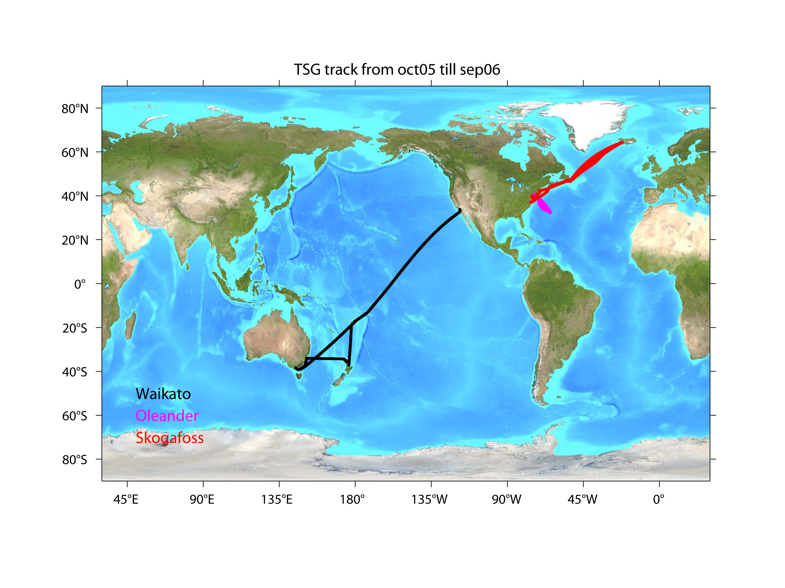

Figure 1. Tracks of the three ships of the SOOP with TSGs maintained by NOAA/AOML.

One key accomplishment has been the installation of SEAS 2000 software in the Cap Victor. The system is currently storing data and retrieve when the ship is serviced in port.

AOML has implemented quality control procedures for historical (delayed mode) and real-time mode observations, based on the ten GOSUD (Global Ocean Surface Underway Data Pilot Project) real time control tests and on additional AOML tests. The quality control tests implemented by AOML are among the most complete for TSG observations, which will assure the quality of the data transmitted to the data centers. The quality control of data in delayed-time mode is already being carried out for three ships of the SOOP. The real-time mode was implemented for the TSG data of the Explorer of the Seas:
(www.rsmas.miami.edu/rccl).

The data quality control procedure to be performed on the real-time TSG data is composed by three steps:

- We identify which format version is the original output data file, and so the consistency of the dataset. Once the file is interpreted, the data is injected in a PostgreSQL database, which guarantees a fast and standardized access for the following analysis;
- We apply a reduced quality control procedure to detect formatting and sensors errors. The approved data is then reduced from few seconds to a regular 5 minutes (or approximately 3km along the track of the ship) spaced dataset using the median, which has a higher resistance against outliers than the mean. These 5 minute data provides excellent spatial resolution to resolve small scale ocean features (figure 2); and
- The reduced dataset is submitted to the full GOSUD and NOAA/AOML quality control procedures. The adequate flags are marked and the data are delivered to the data centers responsible to distribute the data.

The data quality control computer code has been developed using OpenSource, FreeSoftware and multiplatform solutions, which allow great freedom for the future of the project. Probably the major advantage to have the dataset in a relational database, such as PostgreSQL, is the use of indexes for fast sub samples by any criteria, for example QC flags, range limits, time windows or grouped values by sensors or area or ships. On this way, from the same real dataset, could be created virtually infinite metadata sets with the same storage demand and a small development effort. We are planning to install a DAP server, which will allow the direct access to the database from traditional scientific tools, such as MatLab, Python, Grads, Ferret, and others. The core of the system management is done in Python, which has modules for the direct database access, scientific procedures and easily deal with dates between other advantages which allow a robust and fast development.

Details on each of the quality control steps can be found in:
www.aoml.noaa.gov/phod/tsg/data/qc_sheet.pdf.

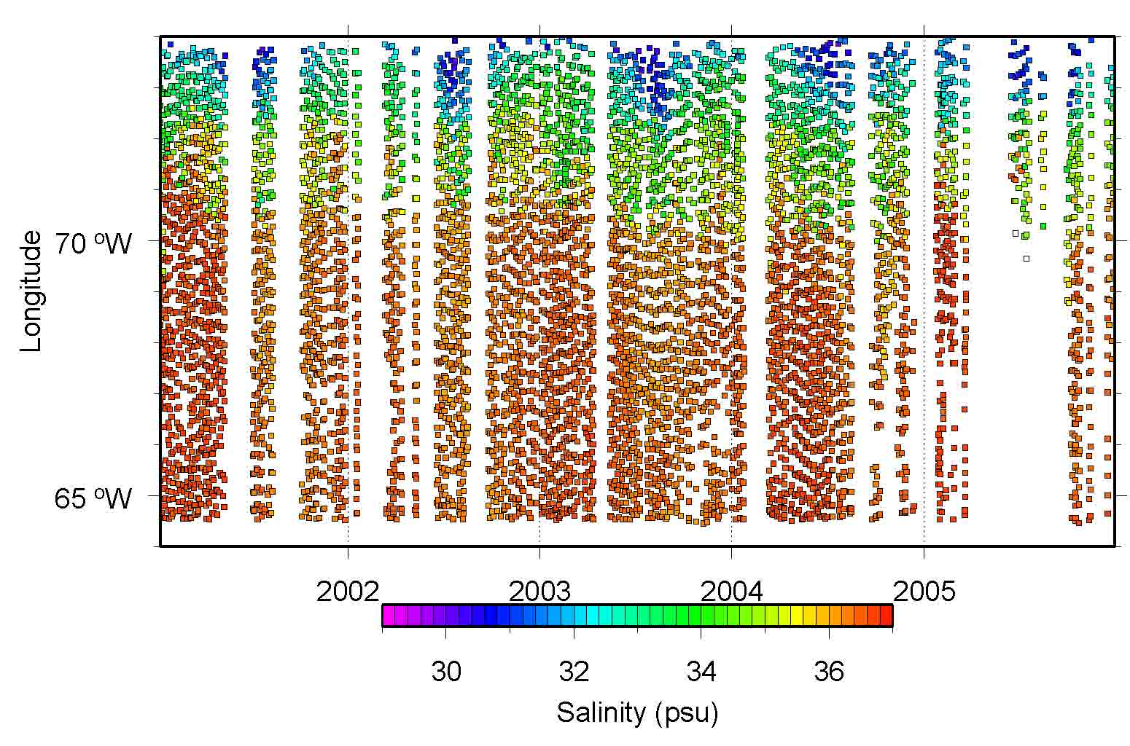
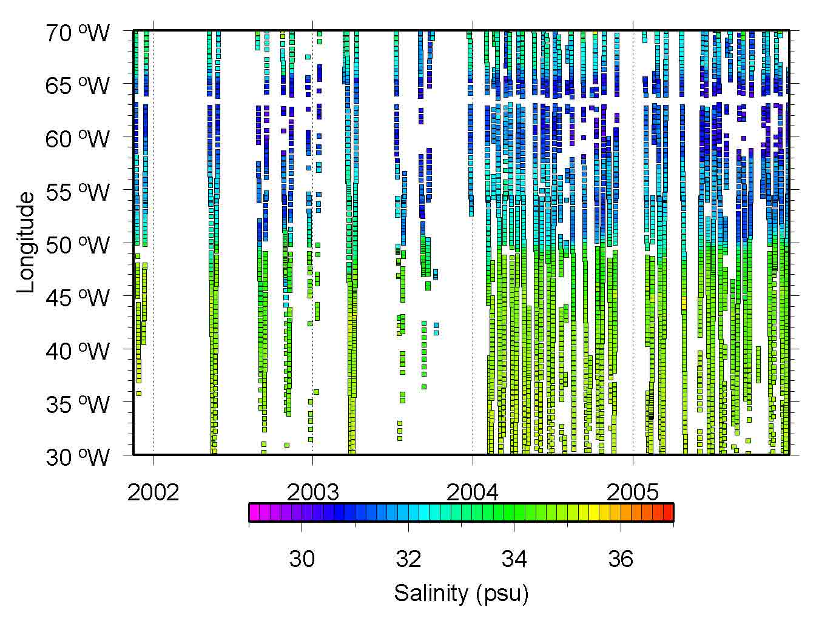
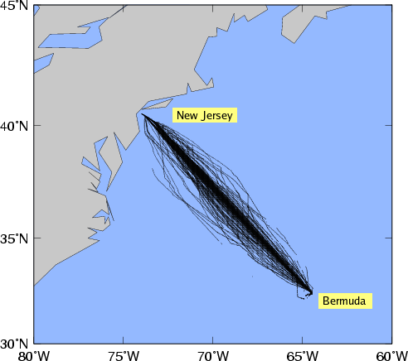
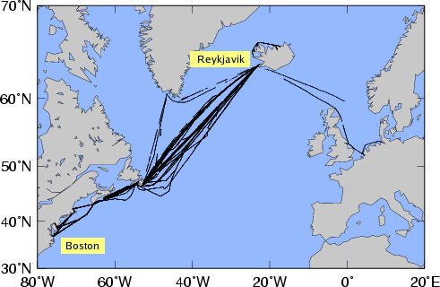

Figure 2. (top) Transects occupied by the Oleander (left) and Skogafoss (right) of the SOOP since 2001. (bottom) Space-time diagrams of sea surface salinity along the above transects of the (left) Oleander and (right) Skogafoss. The 5 minute (or approximately 3km) quality controlled data were subsampled every 2 hours, or approximately 72km. Sharp horizontal gradients are observed and correspond to the variability of the frontal position of the Gulf Stream. The data gaps correspond to periods of time when the instruments were not connected since they were originally installed in support of pCO2 observations, which required a ship rider. The instruments were recently modified to avoid the need for a rider.

Thermosalinograph Work Plan
by Gustavo Jorge Goni, NOAA/AOML

Project Description

SAME AS IN PROGRESS REPORT

Work Plan

The main activities during this year will be:

- Maintenance of the TSGs installed in the three ships of the SOOP,
- Retrieval, quality control, and data distribution of their TSG data in real- and delayed-time
- Data distribution to the GTS and to the appropriate data centers (NODC and CORIOLIS).

The steps to follow to accomplish each of these activities are:

- Real-time data retrieval. We will start the retrieval of data in real-time from the Cap Victor

- Quality control of data. AOML has implemented quality control procedures for historical (delayed mode) and real-time mode observations, based on the ten GOSUD (Global Ocean Surface Underway Data Pilot Project) real time control tests and on additional AOML tests. The quality control tests implemented by AOML are among the most complete for TSG observations, which will assure the quality of the data transmitted to the data centers. The quality control of data in delayed-time mode is being carried out for the three ships of the SOOP. The real-time mode was implemented for the TSG data of the Explorer of the Seas: (www.rsmas.miami.edu/rccl).

Data from all transects undergo a series of quality control tests to ensure that only data of good quality are stored and distributed. The most important quality control steps in our procedure are shown in Figure 6. Details on each of these quality control steps can be found in: www.aoml.noaa.gov/phod/tsg/data/qc_sheet.pdf. Once the data is quality controlled, these data are provided every 5 minutes, or approximately 3km along the track of the ship, the spatial resolution of the quality controlled data, which is sufficient to resolve small scale ocean features. In addition, water samples are regularly collected during research cruises to quality control the data.

- Data transmission to GTS and NODC. The quality controlled data will be sent to the GTS and also distributed to NODC and to CORIOLIS, as per the agreements reached during GOSUD meeting held in Boulder, Colorado, in May 2006. AOML is in contact with Mr. Steven Rutz, NODC Data Management officer, to transmit the quality controlled historical and real-time data to NODC. AOML has already started contacts with CORIOLIS for the transmission of delayed-time data to their data center.

- Metadata. There is currently no standard established for TSG metadata. However, advances have been made during the last GOSUD workshop (Boulder, CO, May 2-4, 2006) in which a group was formed to make recommendations for the appropriate metadata. Today, the growing importance of metadata creation and management makes this issue specially challenging and significant. There is a possibility that the JCOMM ODAS database could be used. AOML will coordinate with NODC and GOSUD to determine the adequate parameters to be included in the metadata as well as the formats (i.e., XML, NetCDF, BUFR, etc.) that will be applied.

- Migration to other platforms. The TSG data center activities described in this proposal include the data acquisition, development and implementation of appropriate quality control and assurance procedures and generation of metadata resources that improve and optimize the integration, migration, accessibility and synchronization of the TSG dataset. To achieve a high degree of infrastructure independence and to ensure long-term data access, we will use open source software and open standards for data and metadata files. This scheme adds flexibility and interoperability to our design and will greatly improve migration to other platforms or computing environments.

- Calibration of equipment. Drifting of the data mostly due to biofouling is common in TSGs. Unless there is an established procedure to quality control and visualize these data in real-time, it is impossible to know when these instruments need calibration. Data from instruments that are not calibrated are not reliable and, in general, cannot be used in scientific studies. On the other hand, instruments that are calibrated ahead of time represent an additional burden of resources to NOAA. We propose here coordinate with NMAO a procedure of communication to inform them when the TSGs need to be calibrated. Mr. Douglas Perry (NMAO) and Gustavo Goni have already initiated conversations on this item on Mr. Perry’s request.

- Provision of data to users. Real-time salinity fields are routinely incorporated in numerical models, such as NCEP’s GODAS, and Navy’s MODAS, for their initialization and validation. These models are used for climate and weather forecasts, including long term forecasts of ENSO events. Please see attached letter by Dr. David Behringer (NOAA/NCEP) endorsing the dissemination of real-time data. The ESA-SMOS and the NASA-Aquarius will use the data to calibrate and validate their estimates. These missions are planned to be launched in 2007 and 2009, respectively. Additionally, the scientific and oceanographic community will benefit by the transmission of these data in delayed and real-time modes to investigate, for example, water mass formation, variability of fronts, heat budgets, fisheries assessments. The data will also be provided through the AOML web page, in the form of maps and space-time diagrams, to visualize the SSS and SST fields. The first version of this page is being created and will be found by mid August in: www.aoml.noaa.gov/phod/TSG

Budget

TSG budget FY07

 |  |  |  |  |  | AOML |  |  | Requested
Labor |  |  |  |  |  | mm | Cost |  | mm | Cost
G. Goni |  |  |  | AOML |  | 2.00 | $ 29,159
D. Snowden |  |  |  | AOML |  | 0.50 | $ 5,241 |  | 1.50 | $ 15,724
J. Farrington |  |  |  | AOML |  |  | $ - |  | 1.00 | $ 10,748
G. Castelao |  |  |  | CIMAS |  |  |  |  | 12.00 | $ 26,142
H. Yang |  |  |  | CIMAS |  |  |  |  | 3.00 | $ 17,548
Sec't support |  |  |  | AOML |  | 0.25 | $ 1,903 |  | 0.25 | $ 1,903
Total Labor (Note 1) |  |  |  |  |  | 2.75 | $ 36,304 |  | 17.75 | $ 72,065
Travel | Meetings |  |  |  |  |  |  |  |  | $ 1,500
Maintenance for existing TSG
 | Calibration/shipping |  |  |  |  | 4 | systems |  |  | $ 5,000
 | Seawater Skogafloss |  |  |  |  |  |  |  |  | $ 5,600
 | Travel |  |  |  |  |  |  |  |  | $ 1,500
New TSGs
 | Hardware |  |  |  |  | 1 | system |  |  | $ 2,000
Total |  |  |  |  |  |  | $ 36,304 |  |  | $ 87,665
 |  |  |  |  |  |  | FY06 funding |  |  | $ 87,665
Note 1 (includes all benefits and overheads)
 |  |  |  |  |  |  | Difference |  |  | $ 0

Budget Justification

Salary is requested for twelve months for a part-time research assistant, RSMAS student, and for three months of a research associate to work on data processing. Jim Farrington and Derrick Snowden will help with the TSG maintenance. Money is requested by GG to attend a TBD scientific meeting. The cost associated with equipment is for the maintenance of the currently installed equipment. Seawater is for the calibration of the salinometer to analyze the water samples. Additionally, AOML is contributing in kind to NOAA/NMFS with 1.5 palettes of XBTs (486 XBTs) for their collaboration with this program. These XBTs are being deployed along the transects to complement the TSG and pCO₂ measurements.

