Scope of Work
FOR ACTIVITIES RELATED TO OIL SPILL RESPONSE IN THE GULF OF MEXICO

RE: DEEPWATER HORIZON MC 252
FISCAL YEAR (FY) 2010

Prepared By: Maria Josefina Olascoaga

Date: | 07/15/10
Science Box Theme: | Oceanography
Title: | Pathways of surface and submerged oil
Keywords: | Oil; tracer; drifter; trajectory; pathway; error.
Location: | RSMAS, University of Miami
Principal Investigator: | Maria Josefina Olascoaga (RSMAS, University of Miami)
Contact Information: | Maria Josefina Olascoaga  RSMAS/AMP, University of Miami  4600 Rickenbacker Cswy.  Miami, FL 33149  305-421-4647 (voice)  305-421-4701 (fax)  jolascoaga@rsmas.miami.edu
Partner Institution(s): | UM/CIMAS, NOAA/AOML, NOAA/SEFEC, NOAA/NESDIS
Co-Principal Investigators: | Gustavo Goni (NOAA/AOML)  John Lamkin (NOAA/SEFEC)  Francisco Javier Beron-Vera (UM/RSMAS)  Rick Lumpkin (NOAA/AOML)  Barbara Muhling (UM/CIMAS - SEFSC)  Joaquin Trinanes (NOAA/NESDIS)
Duration: | 3 months
Planned Start Date: | 09/01/10 (date is flexible)
Planned End Date: | 11/30/10
Total Estimated Cost: | $182,000

Project Description.
This is an interdisciplinary project that involves the collaboration of investigators from several NOAA Line Offices (OAR, NMFS, and NESDIS), the University of Miami, and the Cooperative Institute for Marine and Atmospheric Studies. Products presented in this proposal are outputs of already implemented and running models with their real-time implementation already completed.

Maps and other products generated by the investigators will consist of oil plume extension at the surface and subsurface, and of tar balls, as determined by a suite of numerical models and satellite observations. These maps will help determine areas that will require restoration, by giving warning to decision makers of shoreline protection, which in turn will optimize the use of personnel and equipment. These products will be also linked to maps of the Gulf of Mexico highlighting coastal areas with colors according to probability of being impacted by oil, and maps of the Gulf of Mexico that include larvae habitat that will be used to identify regions where the larvae are likely to be impacted by oil.

This project is motivated by recommendations made in the NOAA/AOML & SEFEC Workshop on “Deepwater Horizon Oil Spill Efforts” held 1-2 July 2010 in Miami, Florida. The specific workshop recommendations that this project addresses are:

1) Monitoring, analyzing, and characterizing the surface oil distribution from integrated observations.

2) Performing quantitative estimates of the extension of the subsurface oil spill at different depth ranges.

3) Coordinating extensive modeling and appropriate analysis efforts to increase our understanding of the circulation in the Gulf of Mexico (GoM), including three dimensional plume modeling, mixing processes, and the investigation of the role of the main mesoscale features (Loop Current and Loop Current eddies) and background flow on the pathways of particles. This effort should also include the evaluation of model outputs using observations.

The objectives of this project are:

- To systematically monitor and determine potential pathways for the evolution of surface and subsurface oil and dispersants in the GoM, based on estimates of oil location.
- To systematically monitor and determine potential pathways for the evolution of tar balls in the GoM, based on estimates of tar ball locations.
- To systematically compute the errors of oil pathways resulting from the implementation of different (model-derived, and satellite-derived) velocity fields.
- To systematically compare simulated oil and dispersants pathways with available satellite-tracked surface drifter trajectories.
- To make use of the inferred potential pathways in the design of drifter deployment experiments.
- To systematically compare our results with remote sensing and in-situ estimates.
- To investigate potential pathways of tar balls based on reported locations.
- To investigate potential overlap between oil-contaminated water and planktonic organisms, including larval fish.
- To report results through web pages, written reports, and workshops; and as requested by NOAA leadership.

Introduction.
Since the explosion of the Deepwater Horizon (DWH) oil rig the Principal Investigators of this project have been engaged in work related to the simulation of oil spill and dispersant evolution in the Gulf of Mexico (GoM). Some of the products developed by the PIs are being made available through the NOAA/AOML web site to allow for their wide distribution:
http://www.aoml.noaa.gov/phod/dhos/lcs.php.

The oil, dispersants, and tar balls are being transported at the surface and subsurface by ocean currents. Therefore, the correct knowledge of currents complement actual observations and help to monitor and to identify potential pathways both at the surface and subsurface. Since the oil and dispersants at the subsurface cannot be observed in a sustained mode from remote and in situ observations, numerical modeling is the preferred tool to monitor and determine potential pathways.

Objectives.
The proposed work will consist in systematically identifying potential pathways of the evolution of surface and submerged oil and tar balls in the GoM. The importance on focusing on the subsurface stems from the fact that there exists evidence that substantial amounts of oil are found at depth (e.g., Joint Analysis Group (JAG) report). Submerged oil has negative implications for subsurface ecosystems. Indeed, methane can be involved in chemical reactions that lead to the consumption of oxygen creating hypoxia.

In addition to identifying pathways for the possible evolution of surface and subsurface oil, we will systematically compute trajectories of drifters deployed almost continually at the ocean's surface and in the subsurface near the location of the DWH oil well and where oil has been reported at the surface. The drifter trajectory computation will be complemented with the construction of instantaneous maps showing the density of simulated oil and maps indicating potential coastal areas that can be impacted by oil. The simulated oil pathways, in particular, will be systematically compared with available satellite-tracked surface drifter trajectories. The identified potential pathways and the computed oil pathways will be made available on a near-real-time (1 day delayed) basis. The potential pathways will also provide guidance for the planning of drifter deployments in support of monitoring and restoration efforts. These drifters will supply us with further trajectories to be compared with simulated trajectories and to be employed in the computation of mixing diagnostics.

Oceanographic features, which concentrate oil slicks and oil-contaminated water, also concentrate planktonic organisms, including larval fish. Oil and weathered oil products are toxic to marine life, including the early life stages of commercially valuable fish species. It is, therefore, critical to investigate potential overlap between oil-contaminated water and these organisms. Comparisons of simulated oil dispersal with spawning habitat models for commercially important species will be carried out. Also, plankton samples from completed and ongoing plankton sampling work in the Gulf of Mexico will be examined for evidence of oil contamination.

Methods and Operations.
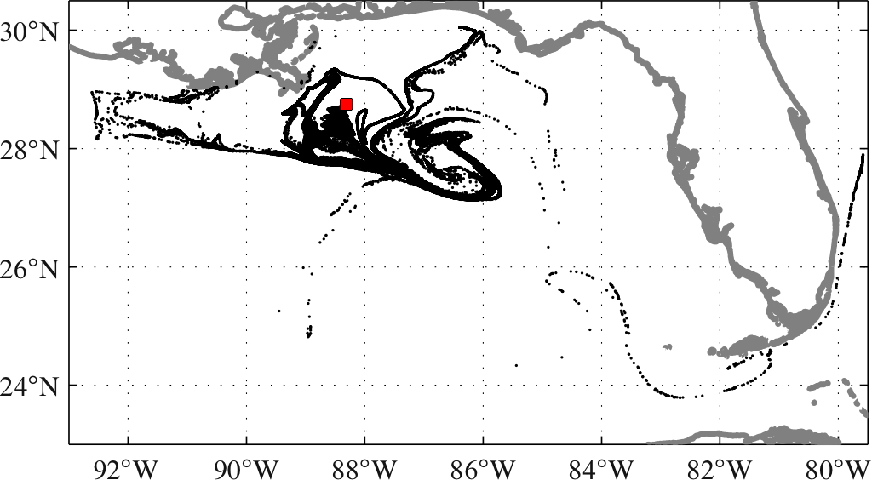
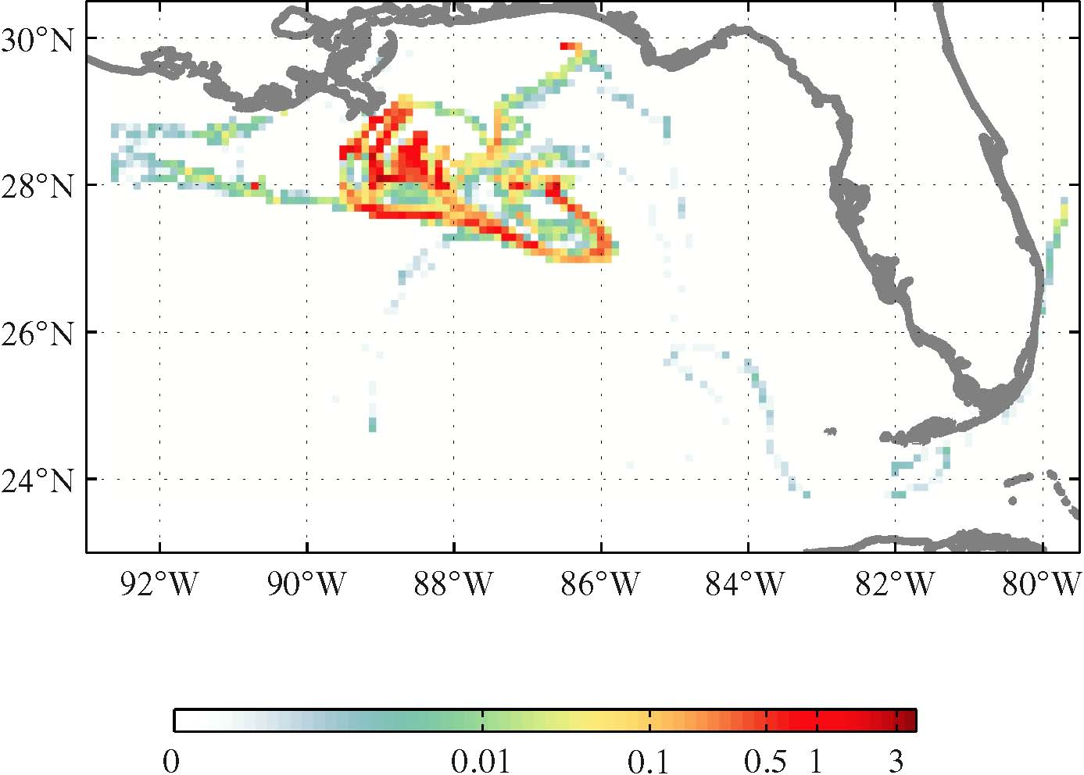
Figure 1 shows examples of the model distribution of oil on 19 May 2010; acquired by the simulated oil particles that were released daily near the location of the DWH oil well since 20 April 2010. The simulated oil is composed of thousands of particles. The right panel shows the percentage distribution of total oil present at the surface in the GoM as obtained by the model. Subsurface ocean conditions at 200-, 700-, and 1200-m depth are also being computed and depicted in plots available at NOAA/AOML’s website (conditions at other depths can and will be calculated following observations and specific NOAA requests). These maps are characterized by the largely heterogeneous distribution of oil, which is characterized by substantial filamentation, as well by the presence of isolated patches of high oil concentration.
Figure 1. Map of simulated oil extension (upper panel) and density distribution (bottom panel) for 19 May 2010. The simulated oil is released daily near the location of the Deepwater Horizon (DWH) oil well since 20 April 2010. Advection is provided by the IASNFS U.S. Naval Coast Ocean Model (NCOM). Plots of this type are being made available at http://www.aoml.noaa.gov/phod/dhos/lcs.php.

It is critically important to identify ocean structures (known as Lagrangian Coherent Structures) that reveal very sensible information about potential pathways that the oil and tar balls can take while being advected passively by ocean currents. These structures are imperceptible to the naked eye: they cannot be guessed visually from the inspection of snapshots of ocean currents. Appropriate techniques (e.g. Haller 2002) must be employed to detect them. Examples of the above mentioned structures are shown in Figure 2. Specifically, these maps show selected snapshots of the surface evolution of the structure of interest (in red) with instantaneous positions of particles (in black) overlaid. Note that the synthetic drifters quite closely follow the evolution of the red curves. This illustrates that the structure in question delineate pathways for the evolution of oil and dispersants. Plots similar to the ones shown in Figure 1 and 2 are being made available at NOAA/AOML’s website:
(http://www.aoml.noaa.gov/phod/dhos/lcs.php), through a voluntary collaboration started between the University of Miami and NOAA/AOML. Potential pathways are extracted using the technique described in Haller (2002). Roughly speaking, such a technique requires to first solve for the fluid particle trajectory equations for a given initial particle position and then to estimate the average rate of maximal stretching about the computed trajectory over a finite interval of time. This technique is repeated for a dense set of trajectories emanating from different locations distributed over a lattice. The result is a time series of fields of finite-time stretching rate. The potential pathways are determined at each time by maximizing curves or ridges of stretching rate field. We have extensive experience in applying this technique to the study of tracer advection in the ocean (e.g., Olascoaga et al., 2006; Olascoaga et al., 2008; Beron-Vera and Olascoaga, 2009).

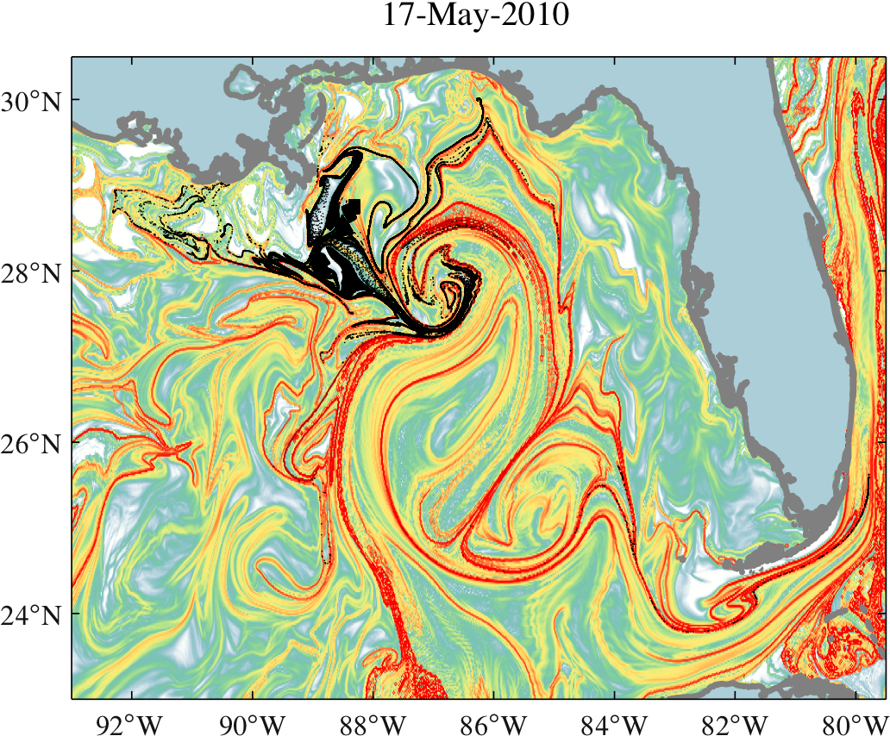
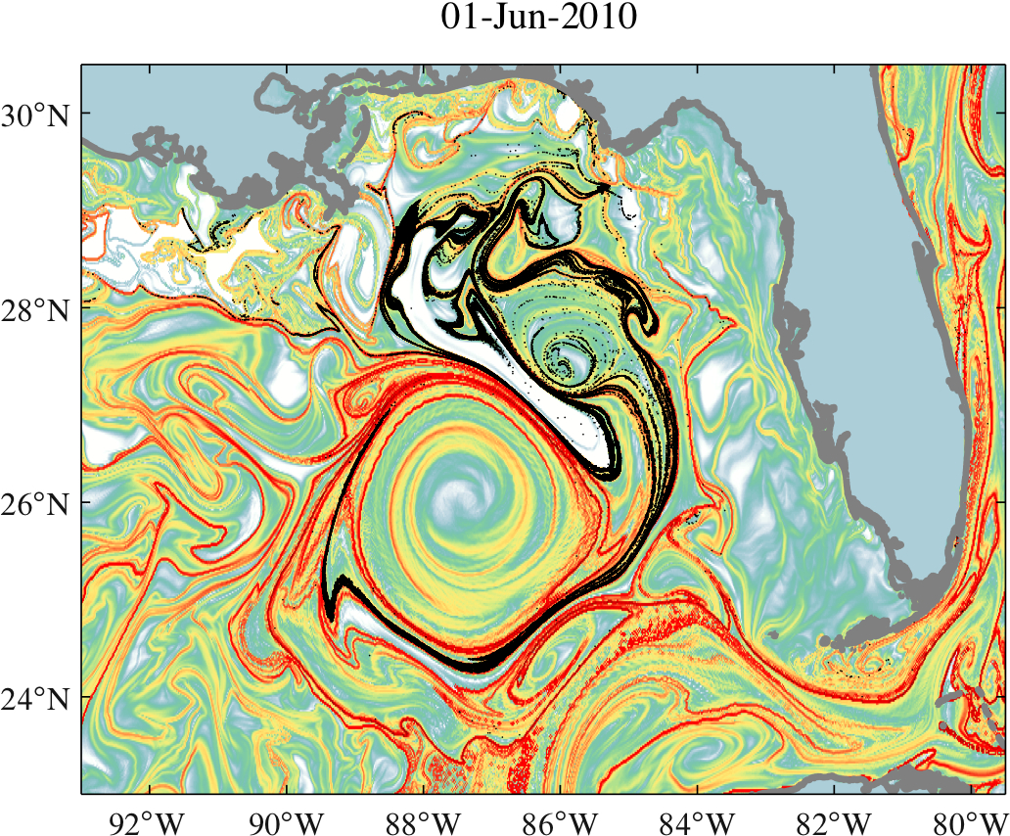
The velocity fields required to compute potential pathways and simulated oil trajectories will be provided by the experimental real-time Intra-Americas Sea Nowcast/Forecast System (IASNF), which is based on the U. S. Naval Coast Ocean Model (NCOM). The velocity fields will correspond to surface ocean currents and currents at conveniently selected depths. In addition to NCOM currents, currents as produced by the HYbrid-Coordinate Ocean Model (HYCOM) will be considered and the computations compared. The HYCOM fields are distributed by the HYCOM Consortium Server at http://www.hycom.org/dataserver. Surface ocean currents will be also derived using altimetric measurements of sea surface height derived at NOAA/AOML. The altimeter products are produced by SSALTO/DUACS and distributed by AVISO, with support from CNES
Figure 2. Selected snapshots of potential pathways for oil evolution (in red) with simulated oil overlaid (in black). Advection is supplied by IASNFS NCOM. Animations of plots of the type shown in this figure are being made available at http://www.aoml.noaa.gov/phod/dhos/lcs.php.
(http://www.aviso.oceanobs.com/duacs/). Comparison of simulated surface oil evolution with the surface oil distributions detected by satellite imagery by NESDIS will be carried out. The latter will be also employed to initialize the simulations.

Figure 3 shows the trajectories of four satellite-tracked surface drifter closely-spaced deployed in a convergence zone where tar balls were observed on June 9, 2010. Notice how the actual trajectories of these drifters quite closely follow the inferred pathways shown in Figure 2, which roughly corresponds to eddy Franklin. Initialization of particles on the model will also be done where tar balls have been reported, to find their potential pathways.
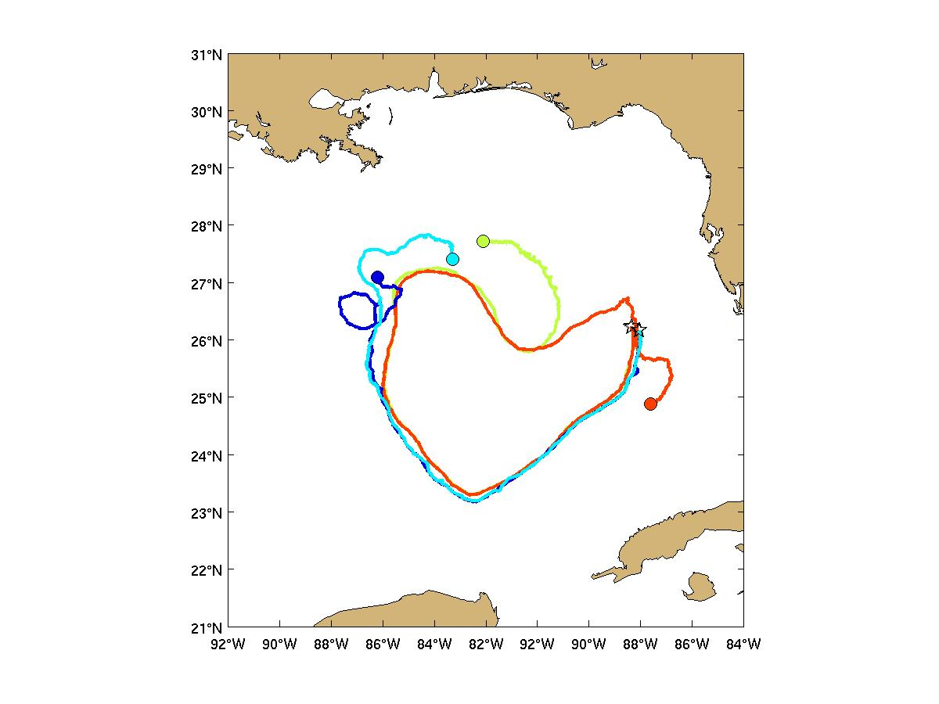
Figure 3. Trajectories of four drifters deployed in two closely-spaced pairs (stars) on 9 June 2010 from the R/V Walton Smith, in a convergence zone where tar balls were observed. Their current positions as on 15 July are shown with dots.
Existing satellite-tracked surface drifter trajectories to be used in the comparison with simulated drifter trajectories will be made available for use in this project through the NOAA/AOML web portal. Additional drifter trajectories will be also employed in the comparison task, which will be produced by drifters deployed according to information provided by the inferred potential pathways for oil evolution. The drifter deployment experiments will be designed to also measure certain diagnostics (such as absolute and relative dispersion), which provide insight into mixing characteristics.

The error in the simulated drifter trajectories will be thoroughly quantified. For example, by calculating a real trajectory, predicting its position t days later, and then computing the rms distance error E. Upon repeating this process every t days of the drifter's trajectory, the result is E(t) curves for the different velocity fields, which is valuable to determine how long the trajectory predictions are accurate, and which velocity fields are best for this.

Based on the information provided by the analysis of plots like those shown in Figures 1 and 2, remote and in situ observations, and the knowledge of ocean circulation of the region, we will create simplified maps of surface and submerged oil pathways. An example of such a simplified map is provided in Figure 4. The distribution of the simulated oil on the date shown is depicted in black. The red curves indicate possible pathways for its evolution with the blue arrows highlighting some of them. The map also shows the coastal areas that have a high probability (purple), medium probability (magenta) and very low probability (light blue) of being affected. Light green indicates areas where oil and tar balls can be found with medium probability, but in very low concentrations. We will be in permanent contact with investigators acquiring observations to validate this and all the aforementioned products.
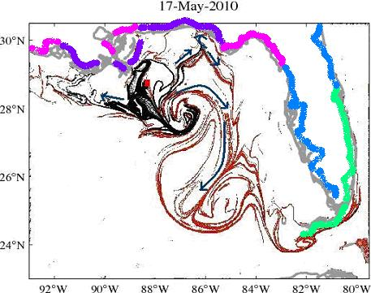
Figure 4. Simplified map of potential pathways for oil evolution (in red) with estimated oil overlaid (in black). Blue arrows highlight some of the pathways that the simulated oil could take in dates subsequent to 17 May 2010. Coastal areas that have high probability, medium probability, and very low probability of being affected by oil are indicated in, purple, magenta, and light blue, respectively. Light green indicates areas where oil and tar balls can be found with medium probability, but in very low concentrations.

Areas across the GoM where bluefin tuna larvae are likely to occur are predicted using an habitat model, trained with 10 years of both larval fish and environmental data. Classification tree analysis is used to define conditions (in terms of satellite sea surface temperature, and chlorophyll) where bluefin tuna larvae are most likely to be collected. During the 2010 spring spawning season (late April through early June), sea surface temperature and chlorophyll data are extracted across the Gulf of Mexico every 0.05 degrees at approximately weekly intervals, and run through the existing habitat classification model. The probability of occurrence of bluefin tuna larvae is then calculated, and mapped. As larvae are likely to be concentrated in convergence zones, particular attention is paid to areas of convergence within suitable larval habitat. Figure 5 combines a habitat map for larvae and surface oil extension. Maps such as this one, are used to quantify the proportion of habitat likely to be impacted by oil slicks or contaminated water.

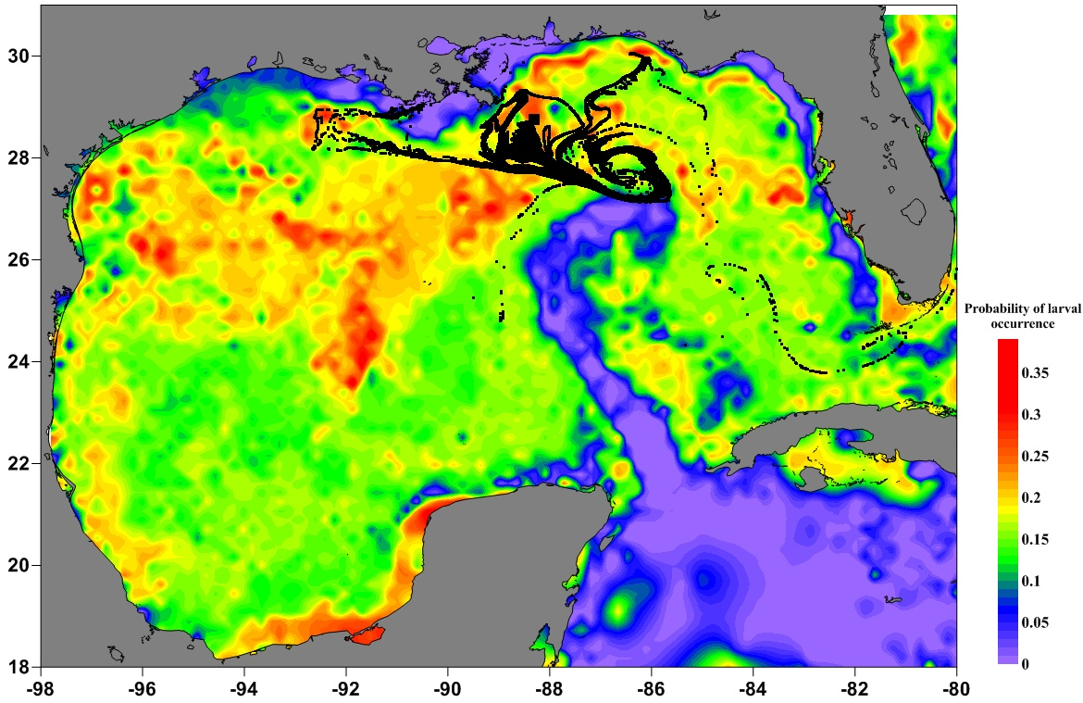
Figure 5. Probability of laval ocurrence (high values in red and low values in purple) with simulated oil overlaid (in black) for May 17 2010.

Deliverables.
- Daily maps in near-real time of surface and subsurface of oil extension and oil density distribution (Similar to Figure 1).
- Daily maps in near-real time of surface and subsurface oil pathways (Similar to Figure 2).
- Maps depicting tar ball trajectories initiated at locations where tar balls have been found (Similar to Figure 3, with drifters and models).
- Maps showing coastal areas at risk of being impacted by oil, dispersants, and tar balls (Similar to Figure 4).
- Reports of comparison of these estimates and actual (in situ and remote) observations.
- Weekly maps of larval bluefin tuna habitat overlaid to weekly maps of oil and dispersant trajectories (Similar to Figure 5).
- Other similar products derived from these estimates as requested from the NOAA Science Box and/or by NOAA Office of Response and Restoration (ORR).
- Distribution of daily maps through NOAA/AOML web page:
http://www.aoml.noaa.gov/phod/dhos/dwh.php

Users.
- NOAA/AOML: these maps will be used to enhance AOML daily analysis of surface currents.
- ORR: Maps of tar ball trajectories, location and extension will help ORR identify regions, including coastal areas, where they can run aground.
- NOAA/NMFS: these maps will be used to compare simulated oil dispersal with spawning habitat models for commercially important species such as Atlantic bluefin tuna (Thunnus thynnus).
- Operational and scientific community: These products will be delivered to the wider community through AOML web pages.

Management and Budget Justification
Although the investigators of this project will cooperate on each of the tasks in the efforts proposed here, each one will have assigned areas of primary responsibility as follows:
- RSMAS: Three months of salary is requested for Olascoaga, who while coordinating all activities will be the main responsible of the computations based on surface currents. Two months of salary is requested for Beron-Vera, who will be responsible of the computations based on subsurface currents. Three months of salary is requested for a research associate, who will assist the investigators of this project with data acquisition, automation of the techniques employed, and the construction of a website for the dissemination of the results.
- AOML: One month of salary is requested for Goni, who will provide the surface velocity fields from altimetry, analysis and coordinating the activities of the NOAA component of this proposal. One month of salary for Lumpkin is requested to carry the drifter deployment experiments based on oil and tar ball locations. This includes comparison of past drifter deployments with model outputs for assessing models. Two months of salary are requested for F. Bringas (CIMAS/AOML) to carry comparisons between drifters, model outputs, and satellite altimetry estimates. Bringas will also implement and maintain the distribution of products through the AOML web page and data through the GTS.
- SEFSC: Lamkin and Muhling will carry computations and carry analyses of simulated oil dispersal patterns with fish larval dispersal patterns. One month of salary is requested for Muhling.
- NESDIS: One month of salary is requested for Trinanes, who will compare NESDIS oil spill pathways derived from this project with remote sensing estimates.

The NOAA costs estimates include the cost for work related to personnel of the three Line Offices involved (OAR, NMFS, and NESDIS). Budget includes overhead and indirect costs. Goni, Bringas, Trinanes, Lumpkin and Muhling are included under the NOAA budget, which is distributed as follows: $80k for AOML and $10K for SEFS. The AOML estimate includes $10k for JT (NESIDS), which will be paid by AOML through CIMAS. Olascoaga, Beron-Vera and TBD assistant are under University of Miami. Travel monies to attend future oceanographic workshops are requested for Olascoaga, Lamkin, Goni, Trinanes and Beron-Vera. This project does not require and it is not requesting ship time. Potential drifter deployments will be done using the resources of planned cruises. Costs of drifters that could be deployed if this project is funded and as consequence of findings of this project are not included in this proposal.

References.
Beron-Vera, F. J. and M. J. Olascoaga. An assessment of the importance of chaotic stirring and turbulent mixing on the West Florida Shelf. J. Phys. Oceanogr., 9:1743–1755, 2009.
Haller, G. Lagrangian coherent structures from approximate velocity data, Phys. Fluids, 14, 1851–1861, 2002.
Olascoaga, M. J., I. I. Rypina, M. G. Brown, F. J. Beron-Vera, H. Kocüak, L. E. Brand, G. R. Halliwell, and L. K. Shay. Persistent transport barrier on the West Florida Shelf. Geophys. Res. Lett., 33:L22603, 2006.
Olascoaga, M. J., F. J. Beron-Vera, L. E. Brand, and H. Kocüak. Tracing the early development of harmful algal blooms on theWest Florida Shelf with the aid of Lagrangian coherent structures. J. Geophys. Res., 113:C12014, 2008.

For Budget/Office Use Only:
Type of Proposal: PRFA _____ NRDA ____ Science Box / ARRA____
Proposal Identifier: __________________________________________________

Proposal Clearance Status:

Science Box Approval Date:

NOAA Budget Review Date:

OR&R Review Date:

FOSC Approval Date:

Cost Estimate
FOR ACTIVITIES RELATED TO OIL SPILL RESPONSE IN THE GULF OF MEXICO
RE: DEEPWATER HORIZON MC 252
FISCAL YEAR (FY) 2010
Prepared by: (M. J. Olascoaga, RSMAS/UM)
Activity | NOAA’s Cost Estimates
Salary and Benefits  Labor  Travel  Contractors  Overtime | $ 75,000  $ 8,000  $ 0  $ 0
Transportation  Vehicle/Vessel Cost  Staging Costs  Days at Sea  Fuel | N/A
Per Diem | N/A
Other Services | N/A
Supplies | N/A
Overhead
TOTAL | $83,000

Activity | Partner’s Cost Estimates
Salary and Benefits  Labor  Travel  Contractors  Overtime | $ 90,000  $ 9,000  $ 0  $ 0
Transportation  Vehicle/Vessel Cost  Staging Costs  Days at Sea  Fuel | N/A
Per Diem | N/A
Other Services | N/A
Supplies | N/A
Indirect
TOTAL: | $99,000

Total Costs: $182,000

