(GRL Submission, FY11Q1) Working Title:
Dynamics in the Gulf of Mexico in July 1010, during the Deepwater Horizon oil spill of 2010

1. Abstract (Lets work on this only after the manuscript is written)
The upper-ocean dynamics in the Gulf of Mexico are dominated by the Loop Current and the eddies which it periodically sheds. During May and June 2010, satellite observations of the Gulf of Mexico (GOM) surface velocity field indicated a potential for connectivity between the northern GOM and the Florida Straits via the Loop Current (LC) system. Numerical model simulations and limited in situ measurements during this period also supported this scenario. Such a pathway could entrain Deepwater Horizon oil spill related contaminants, present in the northern GOM at that time, carrying them directly and/or indirectly towards downstream coastal ecosystems in south Florida and northern Cuba, and into the Gulf Stream. However, by July 2010, shipboard measurements conducted over the southern Gulf of Mexico confirmed remotely-sensed observations, which indicated that a direct transport mechanism was no longer in place, and that the large LC eddy (named "Eddy Franklin") was separated from the main LC by a cyclonic eddy feature.. A hydrographic survey of the eddy field, conducted in July 2010, did not observe oil within the survey region, suggesting that any oil entrained in the months prior had weathered or been dispersed to undetectable levels.

2. Introduction
Following the explosion and sinking of the Deepwater Horizon MC252 drilling platform on April 20, 2010, the Gulf of Mexico (GOM) was subjected to the largest anthropogenic crude oil spill ever recorded. Oil flowed continuously from the damaged MC252 wellhead until it was capped on July 15, 2010. Concerns quickly mounted regarding the extent to which oil was spreading in the surface and subsurface into the rest of the GOM aided by the Loop Current (LC) and eddies, the predominant circulation features of the GOM. Throughout the spill, the response and scientific communities primarily utilized blended remotely-sensed observations with very limited available in situ measurements. The surface circulation was monitored using a suite of satellite observations, such as satellite altimetry (for sea surface height), sea surface temperature, and ocean color imagery to identify the pathways by which oil and dispersants could translate from the spill site into other regions of the GOM and beyond. Additionally, multiple numerical models were employed to simulate the GOM circulation at the surface and subsurface. Where possible, these models were initialized and/or validated with in situ data.
In late April 2010, at the time of the Deepwater Horizon platform explosion, circulation in the GOM was dominated by a mature (need to state what mature means) LC, which extended well into the northern Gulf to approximately 27ºN, 88ºW. The possibility for entrainment and delivery of north GOM waters, including discharge from the Mississippi River, to downstream regions such as the Florida Straits via the LC in such a configuration is well documented (Hu et al., 2005; Ortner et al., 1993). During the first half of May, the LC shed a large anti-cyclone ring, named Eddy Franklin (EF). While this LC ring separation may have inhibited direct connectivity between northern Gulf regions and downstream areas, satellite and Lagrangian drifter
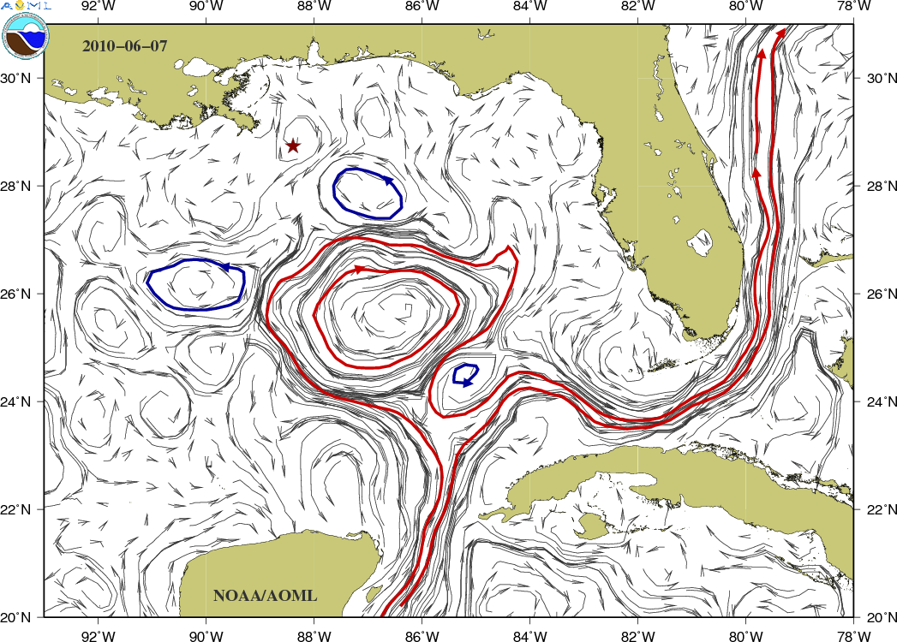
Figure 1. [This figure should have the ADCP velocities superimposed] Altimetry-derived surface currents in the GOM for June 7, 2010 (NOAA/AOML). The degree of connectivity between EF (the anticyclone visible in the center of the plot) and the LC was a concern as aerial and shipboard observations had detected a “tiger tail” of oil along the eastern front of EF during this period.
observations, and numerical model results suggested that EF remained partially attached to the LC throughout the majority of May and June 2010 (references) (Figure. 1). During this time, it was hypothesized that cyclonic eddies situated between the MC252 wellhead and EF could aid in the dispersion of surface oil into the rest of the GOM. In fact, tar balls sourced to MC252 were observed along this front on June 8, 2010 as far south and east as 26°45.85’N 086°03.65’W (M. Wood et al., 2010; or personal communication?).

Due to the lack of in situ surface and subsurface observations in the LC and EF, the extent to which direct and/or indirect pathways between the oil spill site and the rest of the GOM during May and June 2010 was largely assess by analysis of satellite observations and numerical modeling results. This manuscript examines the surface and subsurface conditions in the GOM during July 2010, using mainly data from a research cruise carried out with the main objective of assessing the connectivity between the oil spill site and the rest of the GOM and the Florida Straits, in support of the operational and scientific community efforts. [we need to add somewhere that what differentiates this event from others is that this happened in the open ocean and not in an enclosed area, or coastal region, and had the potential for carrying the oil and dispersants to remote regions.]
Additionally, through the use of dispersants at the spill site and the natural weathering of oil, hydrocarbons had been observed to be spreading at depth in the surrounding area (this is a result).
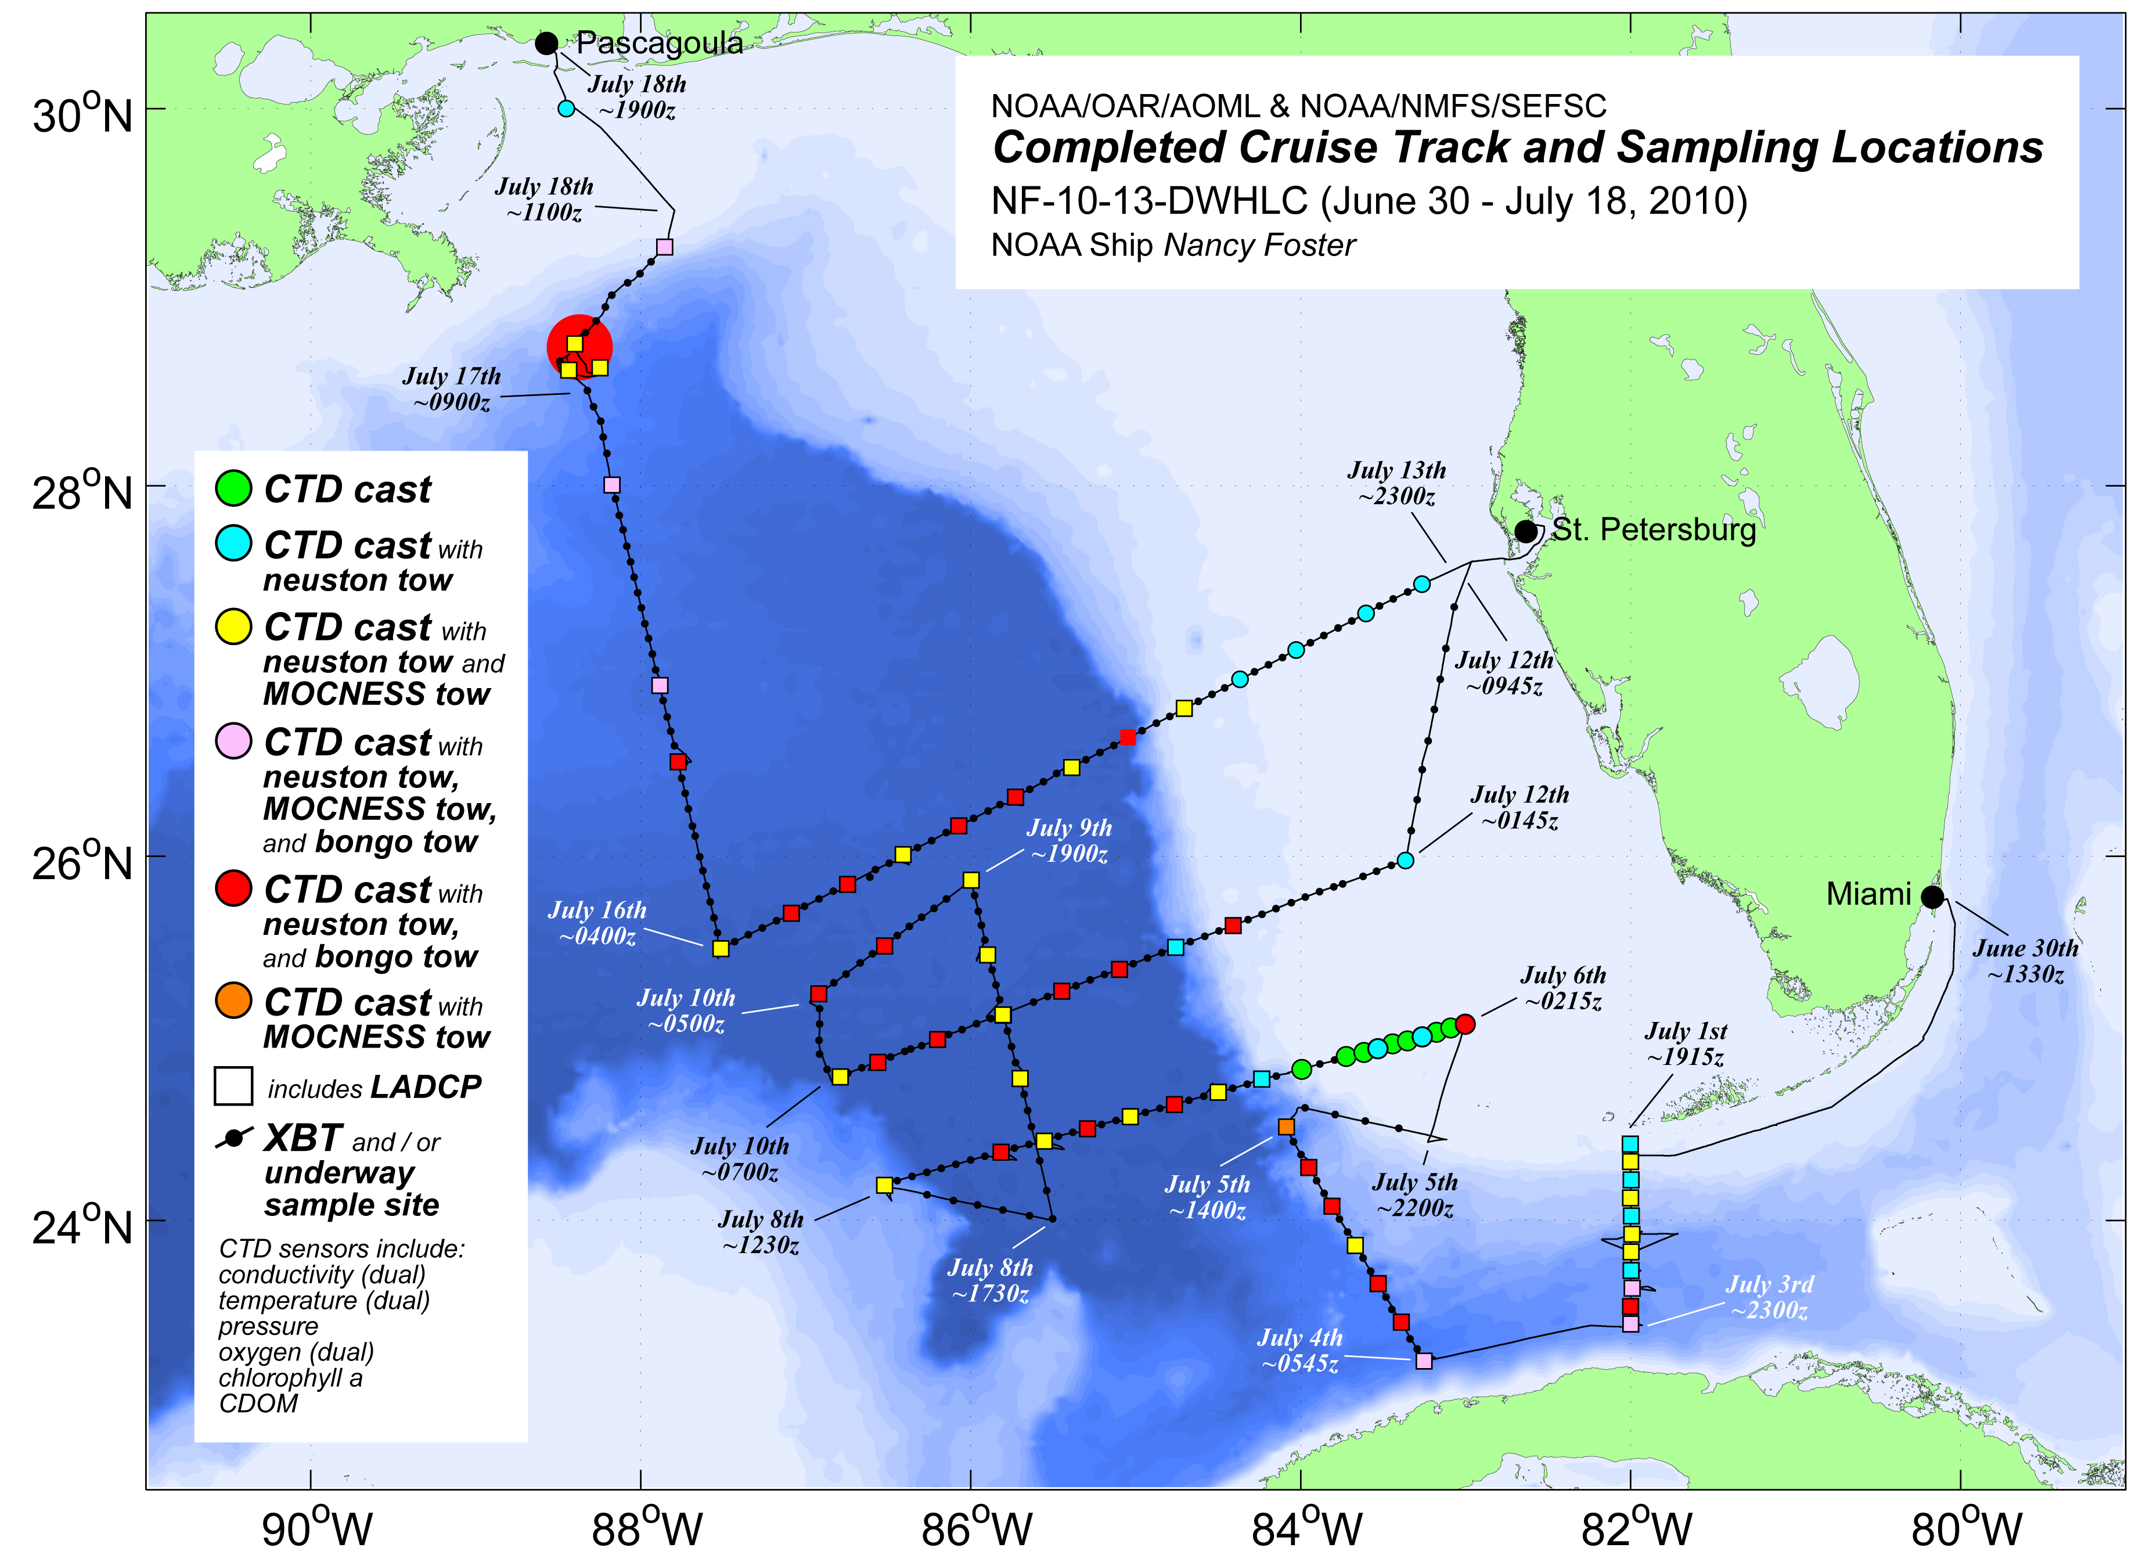
Figure 2. NOAA Ship Nancy Foster southeastern GOM survey track and sampling locations conducted in July, 2010.

3. Observations.
During June 28 and July 18, 2010, interdisciplinary oceanographic observations were conducted jointly by NOAA’s Atlantic Oceanographic and Meteorological Laboratory (AOML) and Southeast Fisheries Science Center (SEFSC) aboard the NOAA Ship Nancy Foster (Figure. 2). A primary objective of this cruise was to assess the complex eddy field between the southern front of EF and the LC to determine the extent of connectivity between these two predominant circulation features, and to document and sample any oil observed in the region.

Shipboard sampling included conductivity-temperature-depth (CTD) casts conducted from the surface to 2000 m, expendable bathythermograph (XBT) deployments (temperature profiles from the surface to 850 m), surface net tows (505 µm mesh bongo and 947 µm mesh neuston), and profiling net tows to 100 m (505 µm mesh multiple opening and closing net environmental sampling system, MOCNESS). The Sea-Bird Electronics (SBE) 9plus CTD was augmented with dual temperature (SBE 3), conductivity (SBE 4), and oxygen sensors (SBE 43); chlorophyll a and CDOM (colored dissolved organic matter) fluorometers (WET Labs ECO FL), a 24-Niskin bottle water sampler, and dual (upward and downward-looking) lowered Teledyne RD Instruments 300 kHz acoustic Doppler current profilers (LADCP). Additionally, continuous underway measurements of the sea surface temperature, salinity, chlorophyll a (chl_a), and CDOM were collected using the ship flow-through seawater system, which was equipped with an SBE 21 thermosalinograph and Sea-Point chlorophyll and ultraviolet fluorometers. Continuous measurements of upper-ocean current velocity were recorded using the hull-mounted Teledyne RD Instruments 150 kHz acoustic Doppler current profiler (SADCP). Satellite-tracked Lagrangian drifting buoys were also deployed during the survey. Biological and chemical samples were collected from the lowered and towed equipment, as well as the flow-through seawater system.
Methods for observing surface oil and tar balls over the survey region included visual observations of the sea surface (during daylight hours), surface net tows and the flow-through system CDOM fluorometer. The search for oil and hydrocarbon contaminants within the water column primarily relied upon the CTD dissolved oxygen sensors and CTD CDOM fluorometer.

(The following should be in analysis/results) Near-field sampling suggested that subsurface (~1100 m) hydrocarbon plumes were producing irregular spikes in CDOM and dissolved oxygen sensor traces, specifically a sharp increase in CDOM fluorescence accompanied with a sharp decrease in dissolved oxygen concentration. The final survey track of the cruise (Fig. 2) evolved at sea following daily examination of the collected in situ observations and the most recent satellite altimetry products available.

4. Analysis

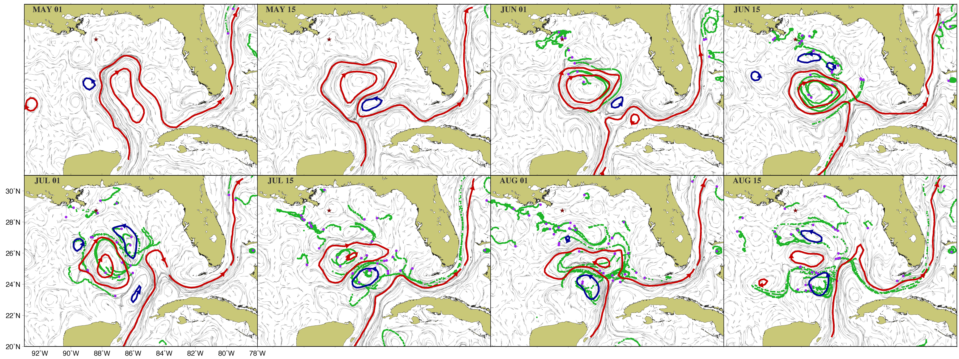
Figure 3. Altimetry-derived surface geostrophic currents (arrows), frontal anticyclonic (cyclonic) boundaries in red (blue) lines, and 15 day-drifter trajectories (green lines) between May 1, 2010 (top left) and August 15, 2010 (bottom right).

(First try) The conditions in the GOM during summer of 2010 were approximately normal; with sea heights slightly lower than average, and sea surface temperatures slightly lower than average (not shown). Horizontal gradients of sea height fields were used to estimate surface geostrophic currents and, from their largest values, to determine the fronts associated with the cyclonic and anticyclonic features (Figure 3). These Geostrophic currents were validated using surface drifters and ADCP measurements during the hydrographic cruise (Figure 1). These fields highlight how highly variable the mesoscale features in this region are, with the LC extending from 24N to 28N and eddies being formed aperiodically. The surface dynamics conditions between April and June 30, 2010 (Figure 3), indicated that the LC extended to the North and West and that during the second half of May, it shed an anticyclonic ring (EF). Geostrophic currents derived from satellite altimetry observations together surface drifter trajectories indicated that EF would subsequently rejoin the LC and separate from it twice until mid August. These altimetry-derived fields provided information on the broad surface circulation patterns before and during the cruise, and aided on determining the cruise track and on where to carry in situ observations.

Ryan, Libby: Please make the summary of what you wrote below:
SECTION A (Havana to Key West)
July 01-02, 2010 (~140 km, 51.6 hours)
- The semi-permanent Tortugas Gyre (TG) was present in the Straits of Florida at the time of
this section occupation.
- This cyclonic gyre, TG, is visible in MODIS imagery for June 26 (clouds on July 01-02).
- Shelf waters from SW Florida and the Florida Keys, associated with this cyclonic circulation
are clearly evident in section θ-S and θ-O2 diagrams. The cyclone extended southward into
the Straits approximately 55 km.
- The total volume transport across this section was ~29.6 Sv (into the Florida Straits). On the
same date, northward transport across the 27N cable was ~34 Sv.
- The maximum velocity observed was 171 cm/s and associated with the Florida Current. The
observed flow was surface intensified.
- Data were not collected within Cuba’s territorial sea (approximately 25 km from the Cuban
coast).
- Velocity data were extrapolated (linearly) across this portion of the section. Extrapolated
flow contributions totaled 1.4 Sv.
SECTION B (Cuba to southwest Florida Shelf)
July 04-05, 2010 (~200 km, 23.7 hours)
- This section was originally designed to cut completely across the retroflecting “young” Loop
Current, but was cut short when Cuban refugees were picked up. The ship diverted towards
the Dry Tortugas to transfer the refugees to the USCG.
- There was no significant flow/circulation observed in association with the sometimes present
anticyclonic “Cuban Vortex” along the southern portion of the section.
- No data were collected within the Cuban territorial sea (equating to approximately 31 km
along the section trackline – between the coast and the first data point). Data were linearly
extrapolated over this area.
- Water mass data were very uniform across this section (from station to station, based on θ-S
and θ-O2 diagrams). Only a slight wiggle in the θ-S profile of the northern-most station
(#18) around σθ = 25.5 kg/m3 (SUW), suggesting the proximity of the southwest Florida
Shelf and associated waters.
- Though incomplete in crossing the Loop Current, transport associated with this section is
approximately 11 Sv less than that observed across section A. Recognizing that this section
nearly reaches the Florida Shelf, this suggests that much of the LC/FC was pushed up against
and onto the shelf (this is confirmed in section E).
- The strongest velocities (normal) observed were associated with the LC and a surface
intensified flow and reached ~97 cm/s.
SECTION C
analysis not completed at this time.
SECTION D
analysis not completed at this time.
SECTION E (Campeche Bank to southwest Florida Shelf)
July 06-08, 2010 (~389 km, 52.7 hours)
- This section was originally planned to cut across the neck between a semi-attached Eddy
Franklin and the Loop Current (however, by the time we finally got out on the Gulf, the
dynamics had changed).
- Velocities along this section and all of the others agree VERY well with AOML altimetry
products.
- Dense station spacing along the eastern end of the section (on the southwest Florida Shelf)
was conducted as a “safety-net” designed to look for potential oil and tar balls approaching
the Dry Tortugas.
- Based on θ-S and θ-O2 diagrams the LC is evident up against and on the southwest Florida
Shelf. The maximum velocity associated with this LC flow (surface intensified) is ~97 cm/s
(normal velocity). Southward flow up on the shelf was less (~50 cm/s) presumably due to
friction.
- West of the LC, along this section, we observe a cyclonic frontal eddy (can we say frontal?).
We cross this eddy south of its center of circulation, but will come close to the center on
section G.
- Within this cyclone, we see mixed/GOM common waters (see θ-S and θ-O2 diagrams).
- Near the western end of the section, we actually get into adjacent Eddy Franklin waters (see
altimetry product for 07/07/2010 for a good view of feature orientation). In addition to
altimetry, this is evident in θ-S and θ-O2 diagrams for station #39.
- Southeastward flow associated with the western half of this section (a component of the
cyclonic feature circulation) has a near-surface (50-100 m) intensified maximum. Maximum
normal velocities in this area reach ~110 cm/s.
- Velocities associated with the cyclone diminish with depth, reaching < 10 cm/s at around
1000 m.
- The distance along this section influenced by the cyclonic feature (remember, we did not
cross its center) was approximately 200 km.
SECTION F
analysis not completed at this time.
SECTION G
July 08-09, 2010 (~224 km, 24.8 hours)
- This section runs from south southeast to north northwest, up through the middle of the
cyclonic eddy situated between Eddy Franklin and the LC.
- The two northern-most stations (#42 and #43) show EF characteristics in their θ-S diagrams.
Station #43 actually looks like a split (not mix, see plot) of EF and GOM common water.
- 40-50 cm/s normal velocities extend down to at least 2000 m in this section across this
cyclonic feature. It is unclear if the deep velocities are associated directly with the 0-1000 m
feature or with some other deep GOM circulation dynamic.
- Flow along this section was surface intensified with normal velocities reaching ~120 cm/s.
- Transport associated with the cyclone: 0-2000 m = 73 Sv, 0-800 m = 35 Sv.
- The radius of the cyclonic feature measured approximately 120 km.
SECTION H
analysis not completed at this time.
SECTION I
analysis not completed at this time.
SECTION J
July 10-12, 2010 (~395 km, 42.8 hours)
- This section cuts across the northern half of the cyclonic frontal eddy observed on sections E
and G and then terminates up on the West Florida Shelf.
- Θ-S and θ-O2 diagrams show mixed profiles, reflecting GOM common water in the cyclone
and remnants of LC water up near and on the shelf. Though velocities in this area are low,
earlier in the month (and in June), the LC extended this far north making a sharp retroflection
south along the shelf.
- Because Eddy Franklin’s shape kept changing and because the eddy continued to translate
west during this part of July, the western end of this section did not reach into Eddy Franklin
even though the western end of section E did.
- θ-S and θ-O2 profiles for stations #44 and #45 (in section H) show EF water, so we were not
too far wary from the EF front on section J (altimetry confirms this).
- As with previous sections across the cyclone, measured velocities (normal ~30 cm/s) extend
down to at least 2000 m. Flow is surface intensified (max normal ~60 cm/s).
SECTION K
analysis not completed at this time.
SECTION L
July 14-16, 2010 (~505 km, 50.3 hours)
- This section was designed to cut across Eddy Franklin, so that we could find its center,
quantify and describe the circulation, and calculate the associated volume transport.
However, curing the cruise the eddy began to flatten (east-west) and propagate westward.
Despite this, we were able to follow this section to the EF center of circulation.
- The radius of the eddy along this section was approximately 250 km.
- The strongest flows were located at a depth of 50-100 m, and reached (normal) velocities of
108 cm/s. In general flows were near-surface intensified with (normal) velocities of 15 cm/s
penetrating to a depth of approximately 1000 m.
- Transport:
Total transport over the eddy radius domain from the surface to 2000* = 57.43 Sv.
Transport over the eddy radius domain from the surface to 1020 m = 41.81 Sv (1020
m was the maximum depth at which EF circulation was observed on section M).
Transport over the eddy radius domain from the surface to 800 m = 37.66 Sv.
Transport over the eddy radius domain from the surface to 200 m (SADCP coverage
area) = 18.48 Sv.
*Anticyclonic flow at depth, from 1000 m to 2000 m, was not observed on section M,
and flow within this depth range on section L may be associated with other (deeper)
GOM circulation dynamics.
- θ-S and θ-O2 diagrams clearly show EF water west of the strongest circulation velocities
(stations #63-#67).
- Surface circulation of the anticyclonic eddy was within approximately 50 km of the West
Florida Shelf.
SECTION M
July 16-18, 2010 (~396 km, 45.7 hours)
- This section was conducted from the center of Eddy Franklin north northwest towards the
DWH wellhead.
- Due to EFs translation westward and the length of time it took to survey section L, we were
not able to occupy as many CTD/LADCP stations along this section as we would have liked.
- The radius of EF, as observed along section M, was approximately 200 km.
- Strongest EF flows were observed between 50-100 m with the maximum normal velocity
reaching ~160 cm/s.
- Despite the low number of CTD/LADCP stations along this section, transports associated
with EF anticyclonic flow are similar to those observed along section L.
- Flow associated with the anticyclonic circulation of EF was near-surface intensified but
penetrated to a depth of ~1020 m.
- Transport:
Transport over the eddy radius domain from the surface to 1020 m = 36.62 Sv.
Transport over the eddy radius domain from the surface to 800 m = 35.99 Sv.
Transport over the eddy radius domain from the surface to 200 m (SADCP coverage
area) = 19.35 Sv.
- The distance between the DWH wellhead and the edge of anticyclonic circulation associated
with Eddy Franklin was approximately 150 km.
SECTION N
analysis not completed at this time.
SECTION O
analysis not completed at this time.

Conclusions
To be covered in this section:
1) Connectivity assessed from altimetry (see merged ADCP and altimetry vector maps)
2) Connectivity assessed from LADCP and SADCP data (see current velocity sections)
3) Connectivity assessed from water mass properties and thermocline depth (see T-S and O2-S diagrams and Libby’s contoured field plots)
4) Feature volume transport assessment from LADCP/SADCP section data (see section notes containing transports, flow characteristics, etc.)
5) If not covered enough in 1-4, additional discussion of feature temporal evolution (over the course of the cruise).
6) Reiterate that with methods available over the survey area we did not detect oil in the far field features described above.

