
U.S. DEPARTMENT OF COMMERCE
National Oceanic and Atmospheric Administration Atlantic Oceanographic and Meteorological Laboratory
4301 Rickenbacker Causeway Miami FL 33149

Dr. Peter Ortner
Director
CIMAS
University of Miami
4600 Rickenbacker Causeway
Miami, FL 33149

Dear Dr. Ortner,
This letter is in support of the request submitted to promote Mr. Ricardo Domingues from RA I to RA II position.

Mr. Domingues started his work at AOML in July 2011. He came to AOML with a B.S. degree in Physical Oceanography from the Federal University of Rio de Janeiro and with two years of working experience at the Brazilian Hydrographic Office.

Mr. Domingues took over duties vacated by Dr. Pedro DiNezio, who graduated from RSMAS and obtained a research faculty position at the University of Hawaii. These duties include providing scientific support on oceanographic research conducted by CIMAS and NOAA/AOML scientists; participating in the logistical activities of the Ship of Opportunity Program, including supporting the NOAA XBT network; maintaining divisional web pages; and conducting scientific research. At this moment, Mr. Domingues is also a M.S. student in good standing at the Meteorology and Physical Oceanography Division of RSMAS.

During his work at AOML, Mr. Domingues has demonstrated exceptional mathematical, computer programming, and analytical skills, which have allowed him to conduct his work with minimum supervision in an effective and successful manner. Mr. Domingues works very well in a team and he is very well respected by his colleagues at work.

Mr. Domingues has recently submitted the manuscript entitled 'Atmospherically forced variability of the Antarctic Circumpolar Current south of Africa between 1993-2010', by R. Dominguez, G. Goni, S. Swart, and S. Dong. The research presented in this work utilizes XBT and altimetry observations to link the variability of the different fronts associated to the Antarctic Circumpolar Current and the upper ocean thermal structure. The scientific level of the work of this manuscript is probably equal to the level of a M.S. thesis.

Mr. Dominguez has shown during his short tenure at CIMAS that his work is already well above the RA I level and that he will have no problem to comply with requirements for an RA II position.
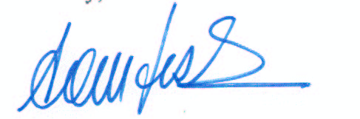
I strongly recommend Mr. Domingues for a promotion to RA II with a 12% increase in his current salary.

Sincerely,

Gustavo Jorge Goni
Director
Physical Oceanography Division
Atlantic Oceanographic and Meteorological Laboratory
National Oceanic and Atmospheric administration
Email: Gustavo.Goni@noaa.gov
