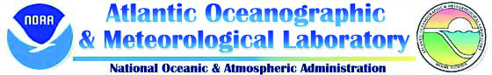

The Global Ocean Observing System (GOOS) Center
http://www.aoml.noaa.gov/phod/goos

The Ship of Opportunity Program (SOOP)

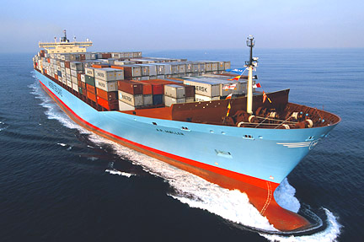
Ships at sea require up-to-date and accurate information, often in the form of forecasts, describing marine weather, sea state, ice cover, and surface currents for safe and effective operations. Surface marine weather and subsurface oceanographic observations collected by commercial mariners have long aided National Weather Service of National Oceanographic and Atmospheric Administration (NOAA) in creating forecast of the previously mentioned parameters.

This partnership between NOAA and the maritime industry has endured for more than 50 years. NOAA’s efforts are a key component of the global Ship Of Opportunity Program (SOOP) administered by the United Nation’s World Meteorological Organization and International Oceanographic Commission to collect marine observations

The National Oceanic and Atmospheric Administration’s Atlantic Oceanographic Laboratory (NOAA/AOML) manages this program. AOML continuously recruits ships to assist scientists in collecting oceanographic data from all ocean basins. Once a vessel has been recruited it is equipped with the instrumentation necessary for each cruise at no charge to the vessel or vessel owners. Some of the equipment deployment and data collection operations are very simple, quick, and can easily be performed by the crew of the ship. Others are labor intensive and require a scientific technician on board the ship to deploy the equipment.

There are currently almost 400 ships aiding NOAA in the collection of meteorological observation and more than 50 ships dedicated to also obtain various oceanographic data. This brochure describes the different ways that ships can volunteer to participate in the Ship Of Opportunity Program.

SEAS 2000 and Search and Rescue
http://seas.amverseas.noaa.gov/seas/

NOAA’s primary means of coordinating and transmitting meteorological and oceanographic data through the ships of the SOOP is using the SEAS 2000. During June 2007 more than 200,000 observations were transmitted.
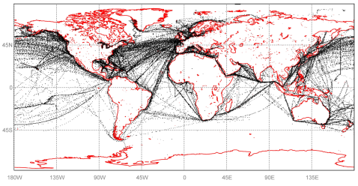

Locations of SEAS 2000 transmissions from cargo ships during June 2007

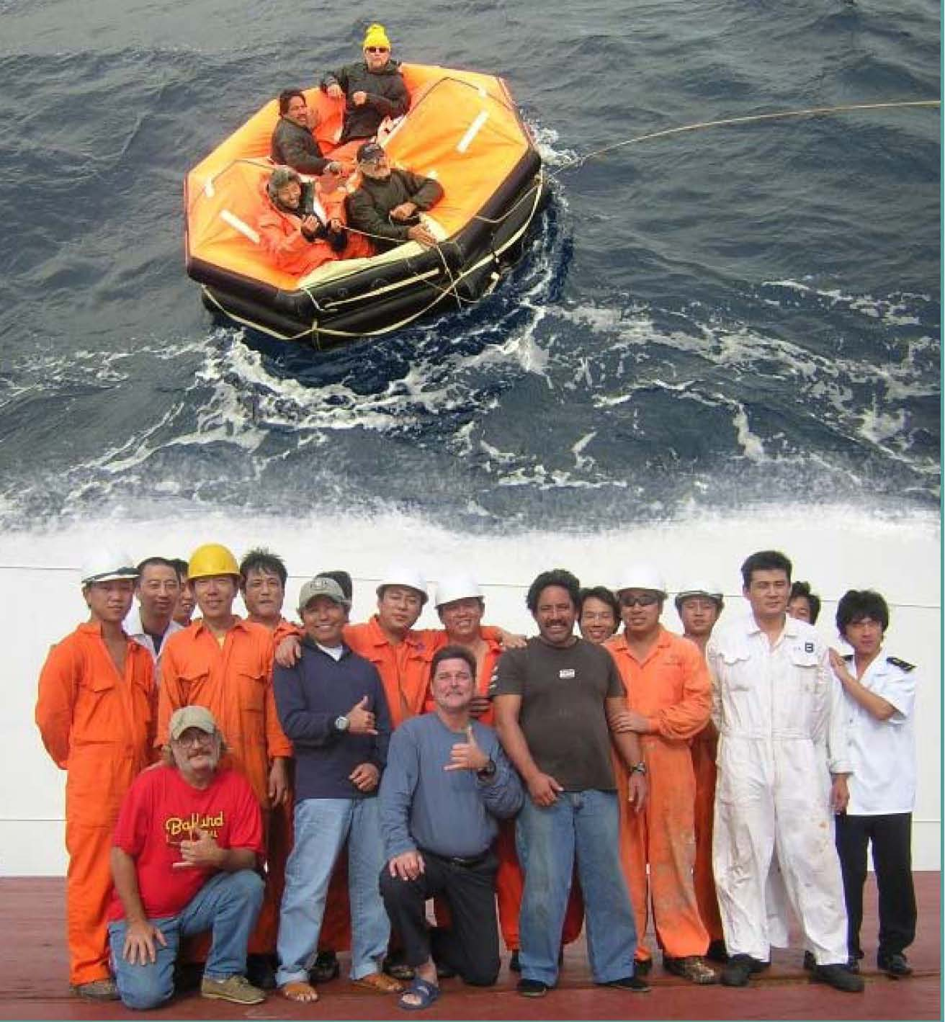
Although the SEAS 2000 software was originally written for transmission of oceanographic and meteorological observations it has now evolved to include a safety at sea component. NOAA and the United States Coast Guard now cooperate to allow SEAS to transmit the Automated Mutual-Assistance Vessel Rescue system (AMVER) reports. The AMVER system allows ships to report their intended voyage track so that in the event of an emergency all available resources may be focused on aiding ships in distress. Both of these systems are intended to aid ship traffic on the high seas. All transmission costs are paid by the U.S. Coast Guard and NOAA.
Crew of the M/V Cape Nelson and survivors from the fishing vessel Abound, that sank 625 miles off the coast of San Francisco

Observations collected by the crew

Low-density XBT (eXpendable BathyThermograph) Program
http://www.aoml.noaa.gov/phod/xbt.php

An XBT is a temperature probe that is launched from the bridge wing of a ship using a hand launcher. AOML operates a global XBT program that utilizes approximately 50 ships of the SOOP to monitor the upper ocean thermal structure along several transects in all ocean basins. The probes are launched by ship personnel 4 to 6 times per day. The data are logged to a computer provided by AOML, where it is processed and formatted for satellite transmission in real-time through the Global telecommunications System (GTS). The data are then used by national and international organizations, universities and government laboratories for weather and climate forecasting and for climate research.

Why to help NOAA deploy XBTs? Because the heat contained in the upper ocean and the surface currents drive the sea surface temperatures, which largely determine the locations of high and low atmospheric pressure systems.

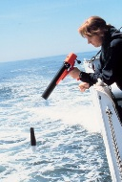
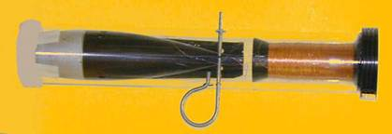

XBT probe

Hand launcher

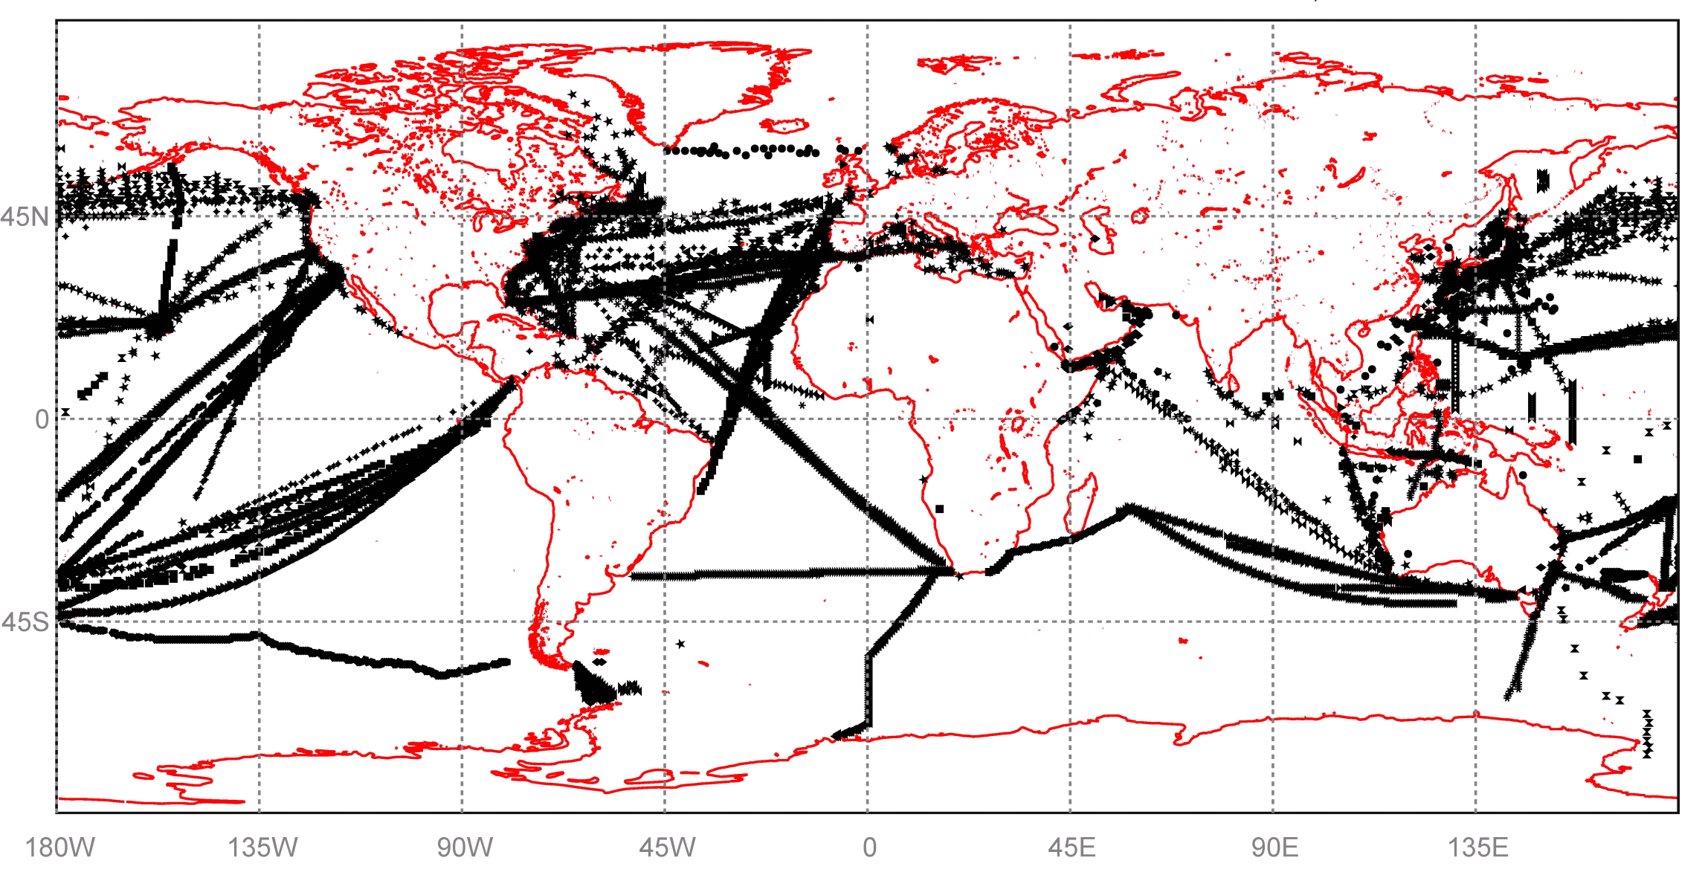

Map showing the location of XBT observations received from deployments from ships of the SOOP during 2006

Global Drifter Program
http://www.aoml.noaa.gov/phod/dac/gdp.html

AOML currently operates in cooperation with the Scripps Institution of Oceanography a global Drifting Buoy Center that annually deploys, via ships of the SOOP, research vessels, and U.S. Navy aircraft, over 400 surface drifters in all ocean basins. These drifters are tracked daily via the ARGOS satellite system. The position of these drifters and the sea surface temperature are distributed globally via the GTS.

Why help NOAA deploy surface drifters? Because drifting buoys measure sea surface temperature and surface currents, data used in climate and weather forecast model development.

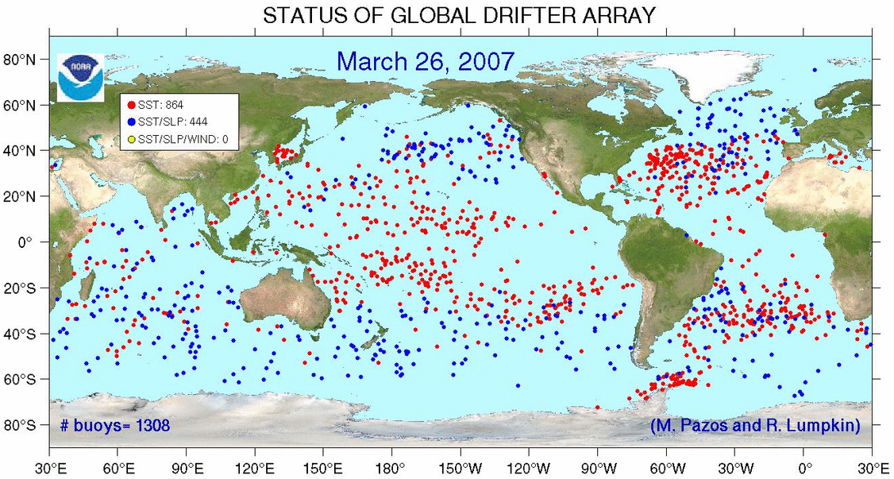

Distribution of drifters in the global ocean as of 17 July 2006

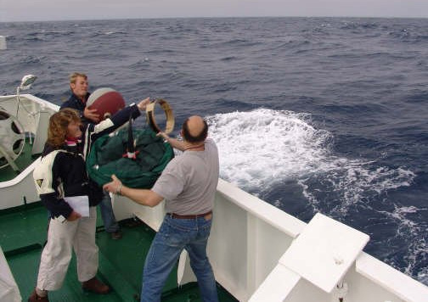

Drifter being deployed

Thermosalinograph (TSG)

Thermosalinographs are instruments that measure salinity and sea surface temperature every 10 seconds, or approximately 100m along the track of the ships. TSGs are simple instruments; they can be automatically operated, are easy to maintain and calibrate, and their data can be transmitted in real-time. TSGs have been utilized for more than 30 years on research and cargo ships and have been the largest contributor of sea surface salinity observations.

AOML currently operates several TSG transects from six ships of the SOOP in the Pacific and Atlantic oceans. Data from these transects are routinely quality controlled and provided to data distribution centers.

Why help NOAA operate a TSG? Because TSG observations help validate model results and satellite observations.

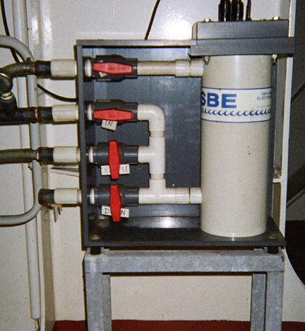

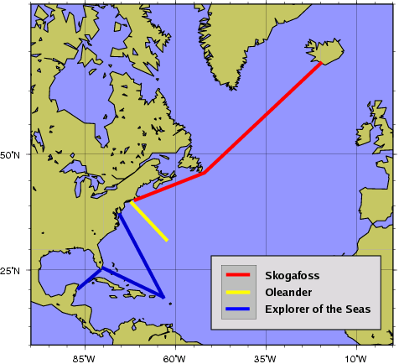

View of a TSG as installed in a ship

Map showing the approximate North Atlantic transects of the ships of the SOOP with TSGs maintained by AOML

Observations collected by a scientific technician

High-Density XBT Program
http://www.aoml.noaa.gov/phod/hdenxbt/high_density_home.html

Some scientific studies require the acquisition of XBT data more closely spaced. For these studies XBTs need to be deployed 20 to 30 times per day and a scientific technician is required on board. With the ship consent the technician will temporarily install an automatic launching system out of the way of normal ship operations. Data are collected and transmitted in real time to data centers. AOML currently maintains 5 high-density lines in the Atlantic Ocean. Other institutions operate similar transects in the Pacific and Indian oceans with the support of AOML. The objectives of these lines are to measure the upper ocean thermal structure and to investigate the meridional and zonal mass and heat transports associated with ocean currents that cross these transects. This effort has been undertaken to, for example, improve our ability to predict important climatic fluctuations.

Figure 9. Autolauncher
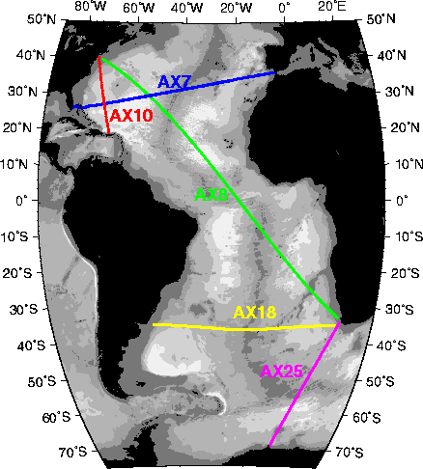
Map showing location of the 5 high-density transects in the Atlantic Ocean currently occupied by AOML

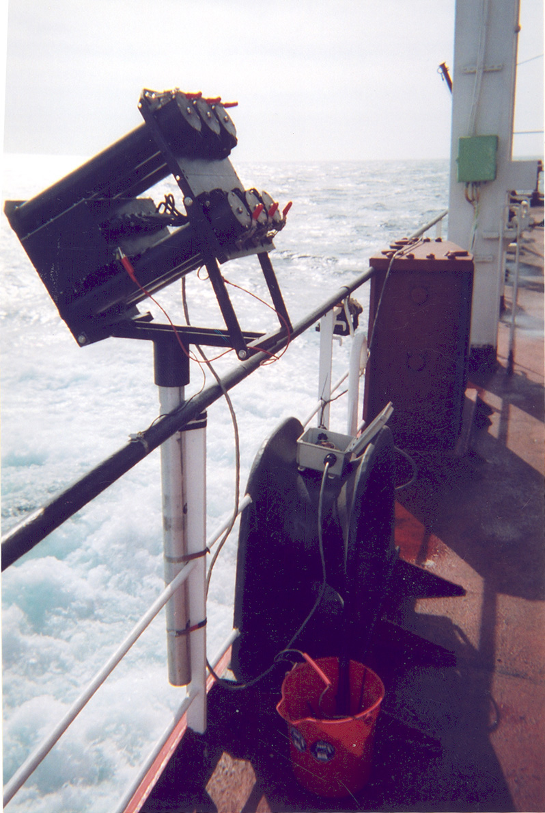

Autolauncher installed in the Horizon Hawaii

ARGO Center
http://www.aoml.noaa.gov/phod/ARGO/HomePage/

In addition to deploying XBTs, a scientific technician will occasionally deploy ARGO floats from the ship while on board.

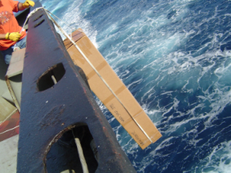

Argo float deployment

ARGO is an international program that calls for the deployment of 3,000 autonomous floats distributed over the global oceans. These floats measure the temperature (T) and salinity (S) profiles from 1000 to 2000 m deep to the surface by ascending to the surface for a few hours after having been submerged for 10 days, thereby providing 100,000 T/S profiles and reference velocity measurements per year.

Why help NOAA deploy ARGO floats? This will allow continuous monitoring of the climate state of the ocean with all data made publicly available to data centers within hours of collection.

Figure 11. Positions of the floats that have delivered data as February 2007.
(updated daily)

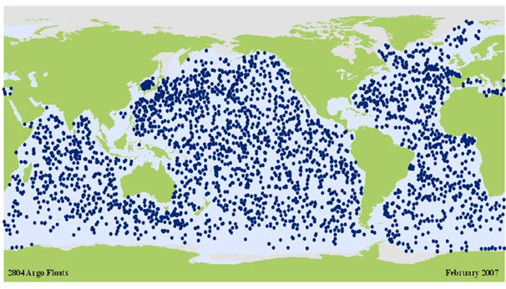

Positions of the ARGO floats that have delivered data as February 2007

Participation
NOAA is constantly seeking new ships to aid in this program. We appreciate continued participation and would welcome participants in any of the elements mentioned in this brochure.

The following are some of the ships that are currently participating:

ATLANTIC ACTION LAURENCE M. GOULD
BARCELONA EXPRESS LYKES CHALLENGER
CAP VAN DIEMEN MAERSK AUCKLAND
CAP VICTOR MSC DIDEM
DIRECT CONDOR NATHANIEL B. PALMER
EVERGAINING NORFOLK EXPRESS
HORIZON ENTERPRISE OLEANDER
HORIZON HAWAII S.F. SEDERBERG
HORIZON PACIFIC SAFMARINE GONUBIE

We would like to thank the following companies for allowing us use of their vessels:

Hapag-Lloyd Maersk Sea Land
Horizon Lines, LLC Alpha Shipping
Safmarine / Maersk Line P&O Nedllyod

Shown below are two of the vessels currently being used in the SOOP program.
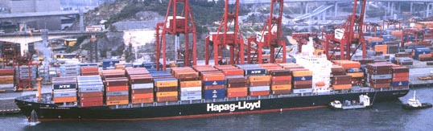

Hapag-Lloyd’s Norlfolk Express. This cargo ship deploys XBT in high density mode

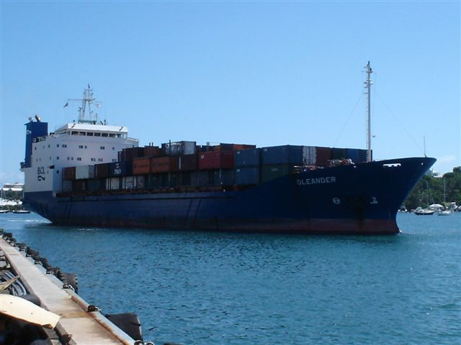

Bermuda Line’s Oleander
This cargo ship deploys XBT and has a TSG installed

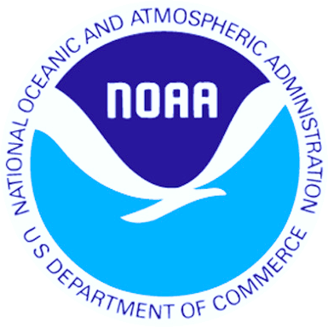


For further information pertaining to any item in this brochure please consult the designated webpage listed or contact:

Dr. Gustavo Jorge Goni
NOAA/AOML/PHOD
4301 Rickenbacker Cswy
Miami, Florida 33149
305/361-4339
E-mail: Gustavo.goni@noaa.gov

For more information on the World Meteorological Organization’s Ship Of Opportunity Program please refer to: http://www.jcommops.org/soopip/

