Proposal Summary (abstract)
This proposal will apply NASA oceanographic data and assimilative models in NOAA’s operational hurricane prediction systems. In addition to the atmospheric conditions responsible for hurricane intensifications, the sea surface temperature (SST) and the upper ocean heat content play an important role in the intensification of major hurricanes. This proposal will develop two new data products and quantify their impact on the hurricane forecast. The current SST data used for the NOAA operational hurricane forecast are weekly and have a resolution of 1/2º or 50-km. Using SST measurements from both in situ and satellite sensors, we will produce an ultra high resolution (1-km) SST data at daily time scale. The current state-of-the-art Tropical Cyclone Heat Potential (TCHP) index that is used to monitor and predict tropical cyclone intensification uses primarily Jason satellite altimetric data with relative coarse resolutions: the cross-track distance is on the order of 300-km and the repeat time is 10 days. We will develop a high resolution (on the order of 5-km) Regional Ocean Modeling System (ROMS) over the northwestern Atlantic Ocean that can assimilate both the satellite measured sea surface temperature and sea surface height from multiple satellites and in situ data (e.g., from Argo floats). A revised TCHP index will be derived from the assimilative model analysis and compared with the standard TCHP index currently being used operationally by the National Hurricane Center (NHC). Using the Statistical Hurricane Intensity Prediction Scheme (SHIPS) currently being used by operational forecasters at NHC, we will quantify the positive impact enabled by the improved SST data and TCHP index. Working with NOAA researchers and operational forecasters from the start of this project, we will ensure that the developed SST data and the TCHP index will be used by NOAA operational centers for real-time hurricane predictions.

Table of Contents

Scientific/Technical/Management Section 3
1. Objectives and Expected Significance 3
2. Technical Approach and Methodology 3
2.1 Operational Statistical Hurricane Intensity Prediction Scheme (SHIPS) 4
2.2 Improved Oceanographic Data Products to Improve Hurricane Intensity Forecast 7
3. Impact of Proposed Work to Current State of Knowledge 15
4. Relevance of Proposed Work 16
5. General Plan of Work 16
5.1 Project Management, Roles and Responsibilities 17
References and Citations 18
Biographical Sketches 19
CV for Principal Investigator: Yi Chao 19
CV for Co-Investigator: Philip S. Callahan 21
CV for Co-Investigator: Toshio Michael Chin 22
CV for Co-Investigator: Zhijin Li 23
CV for Co-Investigator: Jorge Vazquez 24
CV for Co-Investigator: Mark DeMaria 24
CV for Co-Investigator: Gustavo Jorge Goni 25
CV for Collaborator: Joshua K. Willis 26
Current and Pending Support 27
Statements of Commitment and Letters of Support 29
Statements of Commitment for Co-I: Philip S. Callahan 29
Statements of Commitment for Co-I: Toshio Michael Chin 30
Statements of Commitment for Co-I: Zhijin Li 30
Statements of Commitment for Co-I: Jorge Vazquez 30
Statements of Commitment for Co-I: Mark DeMaria 30
Statements of Commitment for Co-I: Gustavo Jorge Goni 30
Statements of Commitment for Co-I: Joshua K. Willias 30
Letters of Support from Dr. Robert Atlas, Director of NOAA AOML 35
Letters of Support from ???, National Hurricane Center (NHC) 36
Budget Justification: Narrative 37
Summary of Personnel 37
Budget Justification for the PI, Chao, and JPL co-Is (Phil Callahan, Mike Chin, Zhijin Li, Jorge Vazquez): 37
Work Efforts and Facilities and Equipment 41
Rationale and Basis of Estimate 41
Budget Details 42
Budget Justification: Details – Year 1 42
Budget Justification: Details – Year 2 43
Special Notifications and/or Certifications 46

Scientific/Technical/Management Section

1. Objectives and Expected Significance
Despite the rapid increase of in situ and remote sensing measurements, little improvement has been made in hurricane intensity forecasts during the last decade. It has been known that the available ocean thermal energy plays a role onhow intense a hurricane can become. As hurricanes move across areas with large horizontal thermal energy gradients they can rapidly intensify or decay, c and the intensity changes could be poorly forecasted if we have not adequately observed such changes. Hurricanes extract energy from below the ocean surface and can mix cold-subsurface water up to the surface. A good example was provided by Hurricane Katrina that developed rapidly on moving over a deep warm pool of water associated with the Gulf Stream Loop Current, which was completely hidden below generally uniform sea surface temperatures. Katrina then weakened substantially as it moved towards a shallow warm pool of water away from the Loop Current.
The proposed work will bring in NASA’s data and assimilative models with an aim to improve the knowledge of this ocean energy in order to improve the operational hurricane intensity forecast. Specifically, a team of NASA scientists, in collaboration with a team of NOAA scientists, will develop the following two data products:
- A merged sea surface temperature (SST) at ultra high resolutions (1-km, and daily)
- A revised Tropical Cyclone Heat Potential (TCHP) index derived from a 3-dimensional Regional Ocean Modeling System (ROMS) with a spatial resolution of 5-km (or better) assimilating all the in situ and satellite observations.
Both the SST data and revised TCHP index will be tested and evaluated using the Statistical Hurricane Intensity Prediction Scheme (SHIPS), which is currently used by the NOAA operational hurricane forecasters at the National Hurricane Center (NHC), as a test bed to demonstrate the positive impact on hurricane intensity forecast. Through our collaborators with both the research and operational units of NOAA hurricane research and prediction centers, we have identified a clear and direct path to transition our developed data products to real-time operations.
Using NASA data and assimilative models to improve hurricane forecast will directly address the science questions and challenges identified by the NASA Earth science. By introducing NASA’s data and models to NOAA’s operational hurricane forecast, we will also contribute to several NOAA initiatives of hurricane forecast with a particular focus on the rapid intensification and decay.

2. Technical Approach and Methodology
Tropical cyclones fluctuate in intensity based on several environmental factors, but the underlying ocean is perhaps the most important in supplying the necessary energy to sustain these systems. Over the years, the NOAA NHC has introduced a number of ocean parameters or predictors into their operational hurricane forecasts. Forecasters at the NOAA NHC are constantly evaluating the improved ocean data products as they become available and assess their impact on the operational hurricane forecast. Once a consistent positive impact is demonstrated, forecasters will include these new and/or improved data products in their operational decision-making (DeMaria and Kaplan, 1999).
Although some progress has been made in the last few years, the skill of operational intensity forecasts is considerably less than that of the track forecasts (DeMaria et. al., 2002). For track forecasting, there is a suite of skillful global and regional prediction models available as guidance to the forecasters. For intensity, there are only three primary models for the Atlantic basin:
- the simple SHIFOR model which uses climatology and persistence to make prediction,
- the Statistical Hurricane Intensity Prediction Scheme (SHIPS) that includes storm environmental conditions in addition to climatology and persistence, and
- the NCEP version of the GFDL hurricane model.

The SHIFOR model is primarily used as a benchmark for evaluating the skill of the official NHC intensity forecasts and those from the objective models. SHIFOR was recently updated using a larger developmental sample, and to provide forecasts to five days (Knaff et. al., 2003). SHIPS is a statistical-regression model (DeMaria and Kaplan, 1995, 1999; DeMaria et al., 2005) that uses a total of 18 basic predictors including atmospheric forecast fields, oceanographic parameters such as SST and ocean heat content, cloud top structure as derived from GOES satellites, climatology and persistence, and empirical parameters such as the hurricane decay rate over land.
The NCEP GFDL hurricane model is a dynamic mesoscale atmospheric model with moving nested domains and data initialization capabilities. It was shown that the statistical SHIPS model and the dynamical GFDL model have comparable skill in forecasting the hurricane intensity for a lead time of five days (Figure 1).

In this proposal, we have selected the SHIPS model, which is currently used by the NOAA NHC operational hurricane forecasters, as a testbed to demonstrate the positive impact on hurricane intensity forecast introduced by high resolution and more accurate oceanographic data products. Specifically, we will introduce the following two enhanced ocean data products to the NOAA NHC operational hurricane forecasters:
- An ultra high resolution (on the order of 1-km) sea surface temperature (SST) data
- Revised Tropical Cyclone Heat Potential (TCHP) fields

Figure 1. Intensity model error (left panel) and forecast skill (right panel) for a lead time of five days for the dynamical GFDL model (red coloe) and the statistical SHIPS model (blue color) as evaluated during the 2003-2006 hurricane seasons (from M. DeMaria, 2007).
These enhanced oceanographic data products will be derived from the emerging Argo ocean observing network, multiple sensors on NASA and NOAA spacecrafts as well as 3-dimensional numerical ocean model with data assimilation capabilities. They will be compared to the existing data products that are currently used by the operational hurricane forecasters at NOAA NHC and the improvement will be quantified. Through the Statistical Hurricane Intensity Prediction Scheme (SHIPS) model, one of the three major operational tools used at NOA NHC for hurricane intensity forecast, we will quantify the positive impact of the improved oceanographic data products on the hurricane intensity forecast.

2.1 Operational Statistical Hurricane Intensity Prediction Scheme (SHIPS)
We will use the operational Statistical Hurricane Intensity Prediction Scheme (SHIPS) model to evaluate and assess the impact of improved oceanographic data on the hurricane intensity forecast.

2.1.1 Impact of High Resolution Sea Surface Temperature
The SHIPS model has been successfully used by the operational hurricane forecasters at NOAA NHC to document the performance improvement of forecasting the hurricane intensity by using a more accurate SST (DeMaria and Kaplan, 1999). The SST originally used by the SHIPS model was obtained from a climatological analysis (Levitus, 1982), but has since transitioned to a weekly 1ºx1º SST product (Reynolds and Smith, 1994), and recently to a daily 1/2ºx1/2º product (Reynolds and Smith, 1995; Reynolds et al., 2002). For the 2002 hurricane season, the inclusion of high resolution SST into the SHIPS model shows an overall reduction of the intensity error forecast. Using the NHC best track, the SHIPS runs with the high resolution SST reduced the mean intensity error by as much as 9.4% at a forecast time of five days (120 hours). Mean bias is also reduced by 2.5 knots at 120 hours. Results also show significant intensity error reduction when a strong along- or cross-track SST gradient is present. A tropical cyclone crossing a strong SST gradient (e.g. along the Gulf Stream) requires an accurate depiction of SSTs to ensure the model incorporates the observed lateral variability of the temperature. Thus, a more accurate representation of the SST would potentially produce more realistic forecasts.

2.1.2 Impact of Tropical Cyclone Heat Potential (TCHP)
In addition to SST, the intensification of tropical cyclones also involves ocean conditions below the sea surface. The upper ocean provides the heat to the atmospheric boundary layer and has been attributed to be responsible for the intensification of hurricanes. For some hurricanes such as hurricane Opal, the sudden intensification of tropical cyclones occurred when their path passed over oceanic warm features (Shay et al., 2000).
In order to quantitatively describe the upper ocean’s influence on hurricanes, an index known as the Tropical Cyclone Heat Potential (TCHP) has been established. In most regions of the oceans, there is a close correspondence between the variability of the vertical thermal structure and the sea level, where the deepening of isotherms is generally compensated by a sea level rise. When the depth of isotherms obtained from temperature profiles is matched to sea height anomaly fields obtained from altimetry, the correlation between them varies with region and with the isotherm considered.
For those isotherms that lie within the thermocline waters, the linear fit between these two variables represent the standard equation of the two layer reduced gravity approximation, where the slope of the fit is proportional to the reduced gravity, while the dispersion of the observations from the linear fit is proportional to the barotropicity in the region. For example, for a completely baroclinic ocean, there would be no dispersion of points and all observations would lie along a straight line.
The sea height anomalies have been used as a proxy to estimate the depth of isotherms to then create altimetry-derived synthetic temperature profiles. For example, the depth of the 20°C isotherm and sea level anomaly are highly correlated in the Caribbean Sea and Gulf of Mexico (Figure 2, left). This is very important since this is the region where there are few hydrographic observations from XBTs and profiling floats and at the same time the investigation of the upper ocean thermal structure is critical for tropical cyclone intensification studies. On average, and for the western North Atlantic, including the Caribbean Sea and the Gulf of Mexico, the correlation coefficient between relevant isotherms and the sea height anomaly is relatively high (Figure 2, right). The sea height anomaly values can then be used as a proxy of the depths of these isotherms to create synthetic temperature profiles.
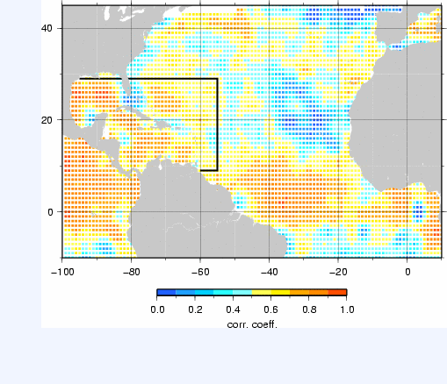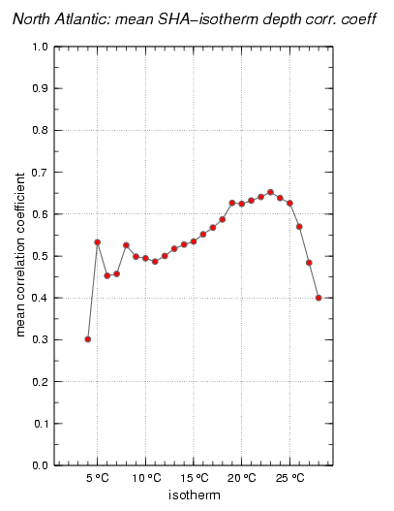
Figure 2. (left) Correlation coefficients between the sea height anomaly and the depth of the 20°C isotherm in the North Atlantic. The box shows the region where the mean correlation coefficient for each isotherm is computed and shown in the right panel. Approximately 100,000 XBT and profiling float observations were used during the period 1993-2006 to compute these correlations.
This methodology provides an estimation of temperature profiles, which have errors that are never larger than the annual climatology. When the correlation coefficient approaches zero, the slope of the linear fit becomes zero and the estimate is the climatological value of the corresponding isotherm. For a given date and location the sea surface temperature derived from satellite observations are used to extend the synthetic profile to the surface.
The TCHP is a measure of the integrated vertical temperature between the sea surface and the depth of the 26ºC isotherm (Shay et al., 2000). The 26ºC isotherm was not chosen arbitrarily, since SSTs larger than 26ºC are needed maintain a storm with tropical cyclone strength. This parameter can be computed from the altimeter-derived synthetic temperature profiles estimates in the upper ocean (Figure 4).
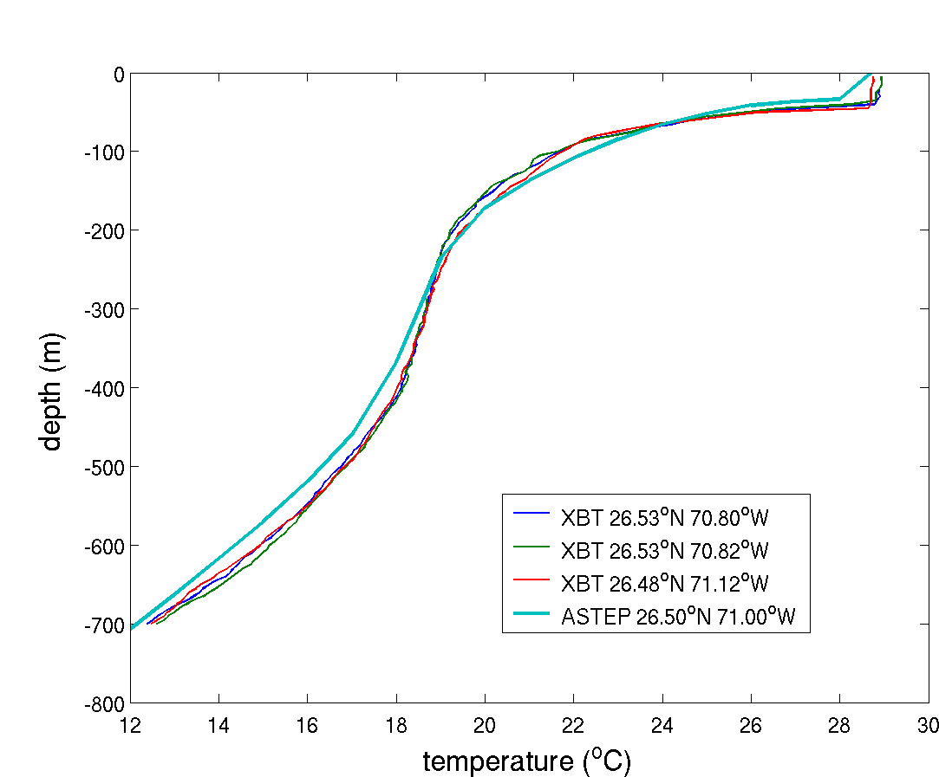

Figure 2. Synthetic temperature profile obtained in 71°W 26.5°N on September 28, 2005 (light blue). This synthetic profile is compared with three profiles from XBT observations obtained from a high density XBT transect within a week of the altimetry estimate.

Recent test using the TCHP index in the SHIPS hurricane intensity forecast has shown small but statistically significant improvement. Figure 5 shows the percentage of improvement enabled by including the TCHP index in the SHIPS forecast of hurricane intensity. Among the six hurricanes shown in Figure 3, only one case has negative impact. The maximum impact can be as high as 20%. Results also showed that the best statistical relationship between intensity change and TCHP was obtained by including only those TCHP values that exceeded 60 kJ/cm². It should be pointed out that areas with TCHP values exceeding 60 kJ/cm² cover only a small part of the Atlantic basin. Thus, the inclusion of TCHP predictor had only a minor effect on most forecasts, but a much large impact on the few that crossed the high heat content regions.

Figure 5. Percentage of improvement of hurricane intensity forecast using SHIPS as a function of lead time up to five days.

