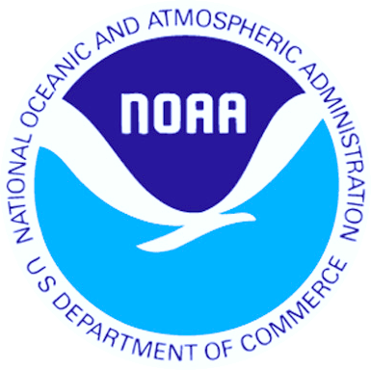
National Oceanic and Atmospheric Administration
Atlantic Oceanographic and Meteorological Laboratory
Miami, Florida, USA.

The Ship of

Opportunity Program
http://www.aoml.noaa.gov/phod/goos
Hapag Lloyd’s Hamburg Express

The Ship of Opportunity Program


Ships at sea require up-to-date and accurate information, often in the form of forecasts describing marine weather, sea state, ice cover, and surface currents for safe and efficient operations. Surface marine weather and subsurface oceanographic observations collected by commercial mariners have long aided the National Oceanographic and Atmospheric Administration’s (NOAA) National Weather Service to produce forecasts of this vital information.

This partnership between NOAA and the maritime industry has endured for more than 50 years. NOAA’s efforts are a key component of the global Ship Of Opportunity Program administered by the United Nation’s World Meteorological Organization (WMO) and the International Oceanographic Commission to collect marine observations.

The National Oceanic and Atmospheric Administration’s Atlantic Oceanographic Laboratory (NOAA/AOML) manages this program. AOML continuously recruits ships to assist scientists in collecting oceanographic data from all world oceans. Once a vessel has been recruited it is equipped with the instrumentation required for each cruise at no charge to the vessel or vessel owners. Some of the data collection operations are very simple, quick, and are easily performed by the crew of the ship. Other operations are labor intensive and require an AOML scientific technician on board the ship.

There are currently about 400 ships aiding NOAA in the collection of meteorological observation and more than 50 ships dedicated to collecting oceanographic data. This brochure describes the different ways that ships can volunteer to participate in the Ship Of Opportunity Program.


AMVER/SEAS and Search and Rescue
http://seas.amverseas.noaa.gov/seas/

NOAA’s primary means of coordinating and transmitting meteorological and oceanographic data through the ships of the SOOP is using the AMVER/SEAS software. During June 2007 more than 200,000 of these observations were collected and transmitted.
Read the AMVER bulletin at: www.amver.com

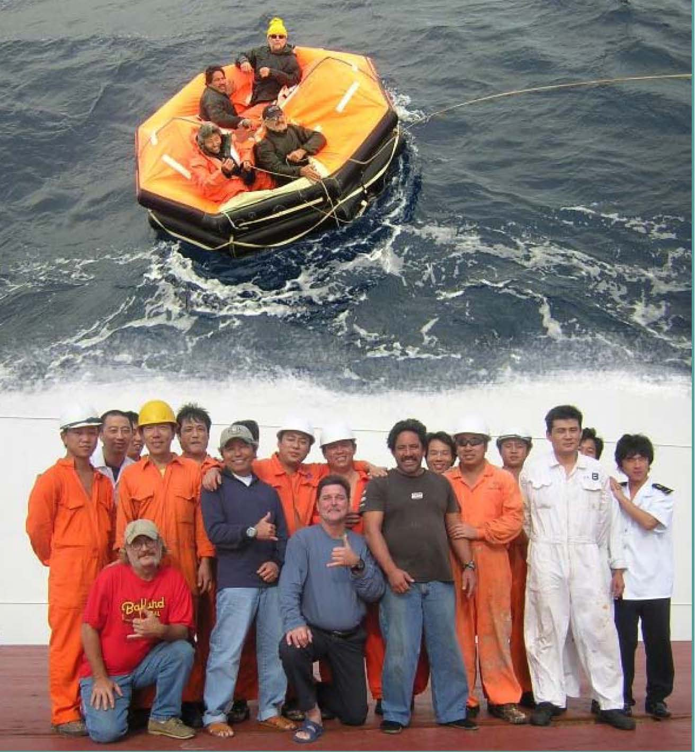

Crew of the M/V Cape Nelson and survivors from the fishing vessel Abound that sank 625 miles off the coast of San Francisco

More than 400 ships participate in the AMVER Program

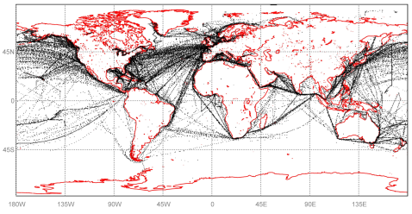

Locations of SEAS 2000 transmissions from commercial ships during June 2007

Although the AMVER/SEAS software was originally developed for transmission of oceanographic and meteorological observations it has now evolved to include a safety at sea module. NOAA and the United States Coast Guard now cooperate allowing SEAS to transmit the Automated Mutual-Assistance Vessel Rescue system (AMVER) reports. The AMVER system allows ships to report their intended voyage track so that in the event of an emergency all available resources may be focused on aiding ships in distress. Both of these systems are intended to facilitate ship traffic on the high seas. All transmission costs are paid by NOAA.

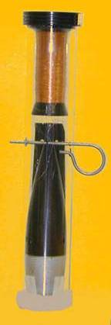
Observations collected by the ship crew

Low-density and Frequently Repeated eXpendable BathyThermograph
Program

XBT probe
http://www.aoml.noaa.gov/phod/xbt.php

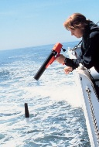
An eXpendable BathyThermograph (XBT) is a temperature probe that is launched from the bridge wing of a ship using a hand launcher. AOML operates a global XBT program that utilizes approximately 50 ships of the SOOP to monitor the upper ocean thermal structure along several transects in all ocean basins. The probes are launched by ship personnel 4 to 6 times per day. The data are logged to a computer provided by AOML, where it is processed and formatted for satellite transmission in real-time through the Global Telecommunications System (GTS). The data are then used by national and international organizations, universities and government laboratories for weather and climate forecasting and for climate research.

Why help NOAA deploy XBTs?

Because XBT provide vital observations to estimate the heat contained in the upper ocean and the surface currents which drive the sea surface temperatures, a critical ocean variable determining the locations of high and low atmospheric pressure systems. The understanding of the upper ocean temperatures provided by XBT observations is vital for better forecasts of marine weather.

Hand launcher
Hand launching device used on low density and frequently repeated XBT lines

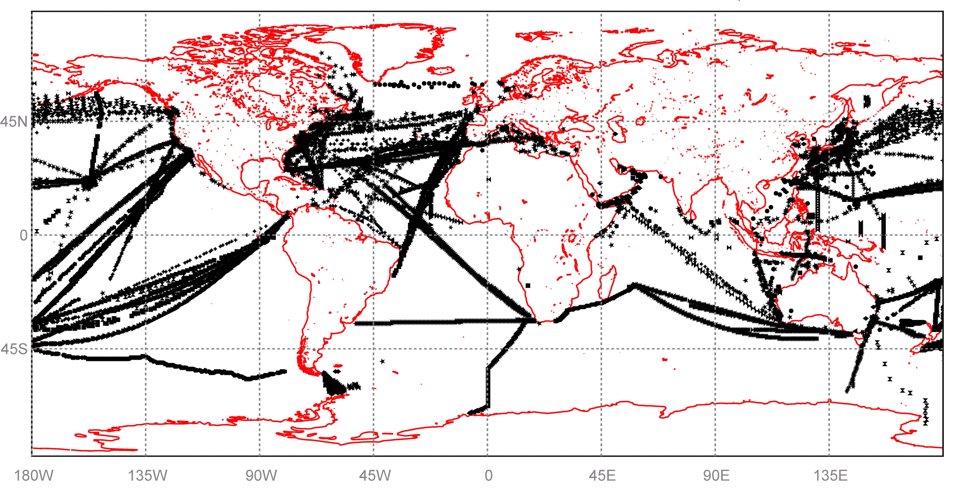

Location of XBT observations received from Ships of Opportunity during 2006
Global Drifter Program
http://www.aoml.noaa.gov/phod/dac/gdp.html

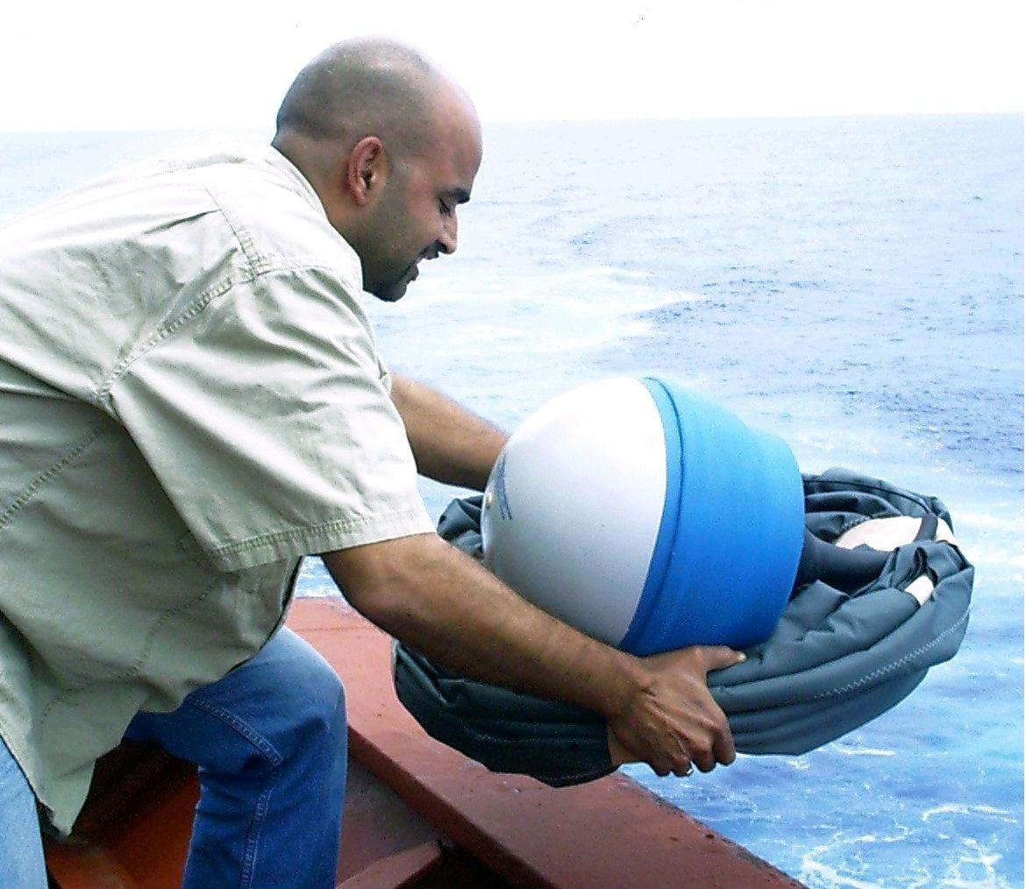
A worldwide array of satellite-tracked drifting buoys (“drifters”) measure sea surface temperature and near surface currents. Temperature is measured by a surface float, which also contains the satellite transmitter. Drifters have a large holey-sock drogue (sea anchor) that unfurls after deployment to follow currents at a depth of 15m. Some drifters can also include sea level pressure, wind speed and rain rate sensors.

Drifters are packaged in a tight bundle for deployment, held together with paper tape. Each drifter is shrink-wrapped with plastic to protect the paper tape before deployment. Deployment is simple: remove the plastic wrap, wake up the drifter by removing a magnet, and throw the drifter over the side, paper tape and all. The paper tape dissolves, the drogue opens, and the drifter begins transmitting to passing satellites.

Drifter measurements are used in operational weather forecasts, seasonal to interannual climate predictions, and climate research

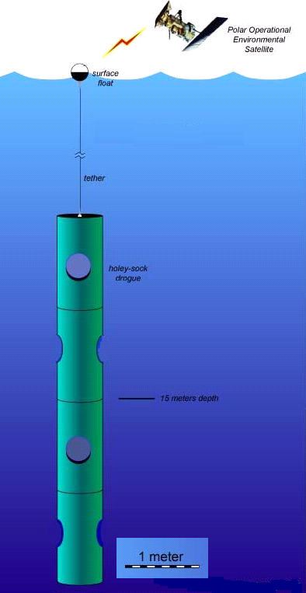
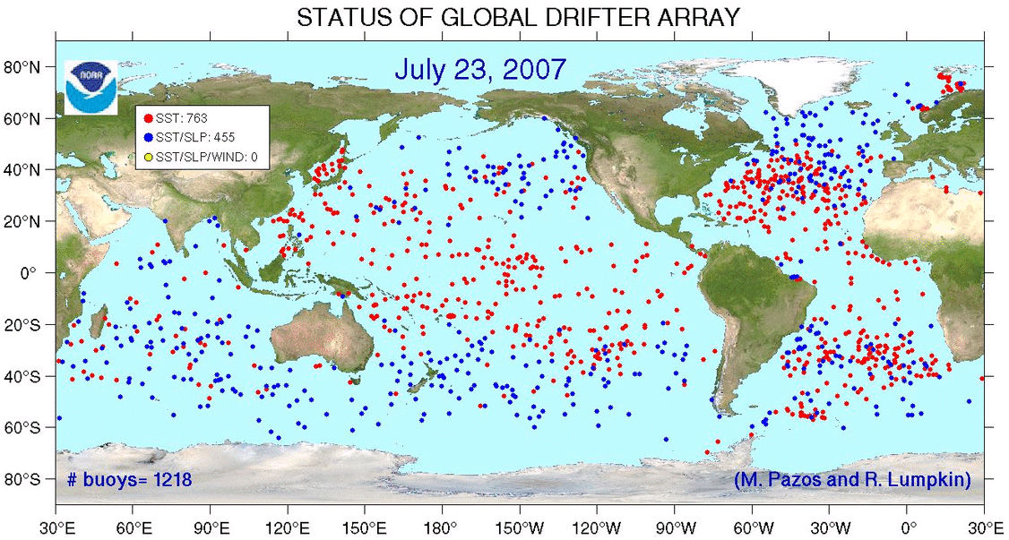

Thermosalinographs
http://www.aoml.noaa.gov/phod/tsg

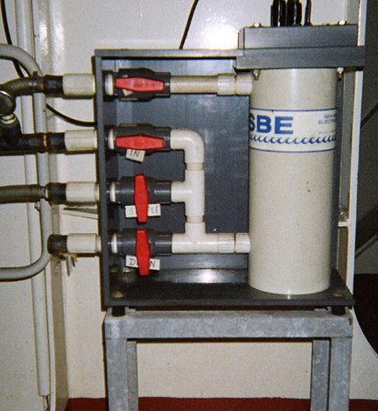
ThermoSalinoGraphs (TSG) are instruments that measure salinity and sea surface temperature every 10 seconds, or approximately 100m along the ship track. TSGs are simple instruments; they can be automatically operated, are easy to maintain and calibrate, and their data can be transmitted in real-time. TSGs have been utilized for more than 30 years on research and cargo ships and have been the single largest contributor of sea surface salinity observations.

Why help NOAA operate a Thermosalinograph?

Because TSG observations are critical to validate weather and climate model results and satellite observations

M/V Oleander.
This cargo ship deploys XBT and has a TSG installed

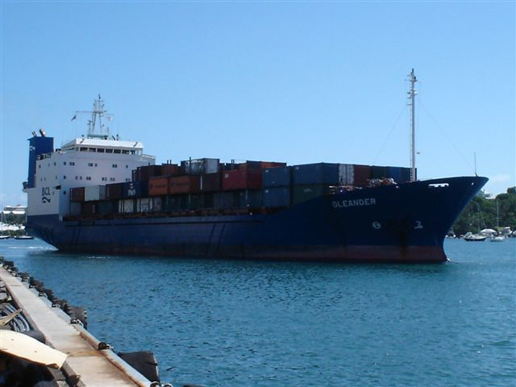

View of a TSG as installed in a ship

AOML currently operates several TSG transects from six Ships Of Opportunity in the Pacific and Atlantic oceans, including Royal Caribbean Cruise Line’s Explorer of the Seas and the M/V Explorer of the Semester At Sea Program of the University of Virginia. Data from these transects are routinely quality controlled and provided to data distribution centers, to be used by weather forecasting offices.

Observations collected by a scientific technician

High-Density XBT Program
http://www.aoml.noaa.gov/phod/hdenxbt/high_density_home.html

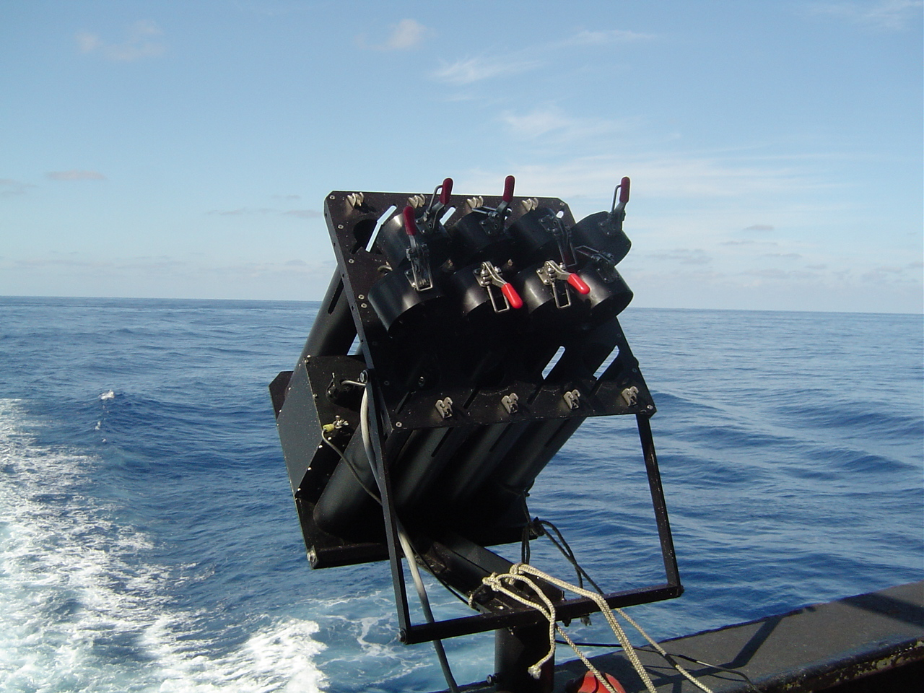
Some scientific studies require the collection of XBT observations more closely spaced than what can be feasibly collected by a crewmember. For this type of studies, XBTs need to be deployed 20 to 30 times per day and hence a scientific technician is required to be on board. With the ship consent the technician will temporarily install an automatic launching system on a stern railing, which will never interfere with normal ship operations.
Autolauncher installed on the Horizon Hawaii

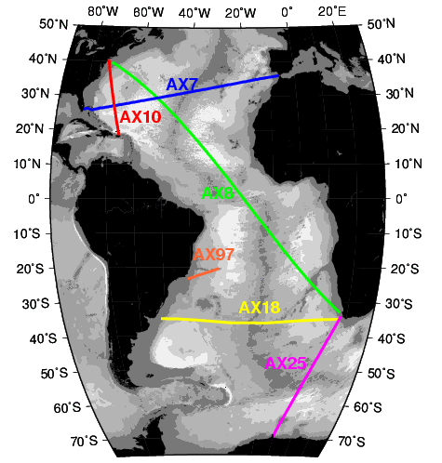
These observations are collected and transmitted in real time and are available to data centers worldwide. AOML currently maintains 6 high-density lines in the Atlantic Ocean. Other institutions operate similar transects in the Pacific and Indian oceans with the support of AOML. The objectives of these lines are to measure the upper ocean thermal structure and to investigate the north-south and east-west mass and heat transports associated with the ocean currents across these transects. For instance, this effort has been undertaken to improve our ability to monitor and predict important climatic fluctuations associated with major currents in the ocean.

Figure 9. Autolauncher
Location of the 6 high-density transects in the Atlantic Ocean currently occupied by AOML

ARGO Floats
http://www.aoml.noaa.gov/phod/ARGO/HomePage/

In addition to deploying XBTs, a scientific technician will occasionally deploy ARGO floats from the ship while on board.

ARGO is an international program that calls for the deployment of 3,000 autonomous floats distributed over the global oceans. These floats measure the temperature and salinity profiles from depths of as great as 2000 m to the surface by ascending to the surface for a few hours after having been submerged for 10 days. The ARGO array provides 100,000 profiles and reference velocity measurements per year.

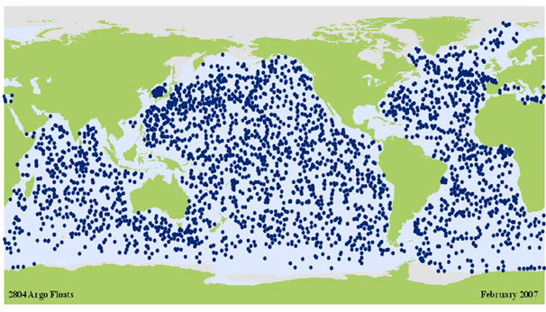
Figure 11. Positions of the floats that have delivered data as February 2007.
(updated daily)

Why help NOAA deploy
ARGO floats?

This will allow continuous monitoring the state of the ocean climate. All data are made publicly available to data centers within hours of collection.

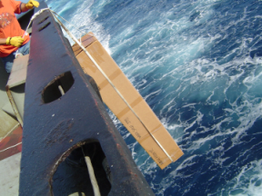

Argo float being deployed by an AOML technician from the Horizon Hawaii

Positions of the ARGO floats that have delivered data as of February 2007

Participation

NOAA is constantly seeking new ships to aid in this program. We appreciate continued participation and would welcome participants in any of the elements mentioned in this brochure.

The following are just some of the more than 50 ships that are currently participating in the Ship Of Opportunity Program collecting oceanographic data:

Atlantic Action Laurence M. Gould Barcelona Express
Lykes Challenger Cap Van Diemen Maersk Auckland
Cap Victor MSC Didem Hansa Flensburg
Ever Gaining Norfolk Express Nathaniel B. Palmer
Oleander Horizon Hawaii Horizon Enterprise
S.F. Sederberg Horizon Pacific Safmarine Gonubie
M/V Explorer Explorer of the Seas Cap Matatula
Polynesia Albert Rickmers Horizon Hawk
Rome Express

We would especially like to thank the following companies for allowing us the use of their vessels:

Hapag-Lloyd Maersk Sea Land
Horizon Lines, LLC Alpha Shipping
Safmarine / Maersk Line P&O Nedllyod
Royal Caribbean Cruise Line Rickmers Reederei
Semester At Sea Program Leonhardt & Bloomberg
Polynesia Lines



Hapag-Lloyd’s Norlfolk Express. This cargo ship deploys XBT in high-density mode.



For further information pertaining to ship recruitment please contact:

Gustavo Jorge Goni (Gustavo.Goni@noaa.gov) or Derrick Snowden (Derrick.Snowden@noaa.gov)

For further information regarding each of the specific programs please contact:

Drifter Program Rick Lumpkin Rick.Lumpkin@noaa.gov
Argo Program Claudia Schmid Claudia.Schmid@noaa.gov
Thermosalinographs Gustavo Goni Gustavo.Goni@noaa.gov
Low Density XBTs Gustavo Goni Gustavo.Goni@noaa.gov
High Density XBTs Molly Baringer Molly.Baringer@noaa.gov
SEAS Program Gustavo Goni Gustavo.Goni@noaa.gov

For more information on the World Meteorological Organization’s Ship Of Opportunity Program please refer to: http://www.jcommops.org/soopip/

National Oceanic and Atmospheric Administration
Physical Oceanography Division
4301 Rickenbacker Causeway
Miami, FL 33149
(305) 361-4340

