CTDO2 Calibration Toolbox

Carlos A. Fonseca
Cooperative Institute for Marine and Atmospheric Sciences (CIMAS)

Derrick Snowden
Atlantic Oceanographic and Meteorological Laboratory (AOML)

This document describes a Matlab toolbox which allows CTDO
2</subscript> lected with a
<trademark class="copyright">Sea-Bird</trademark>
sensor suite to be calibrated against independent analyses of seawater samples.
</para>

Procedures for Autosal Files

- Folder structure

Under the "cruiseid" folder we recommend, at least, the following folders:
-raw_data : copies of the files generated by the Seasave (acquisition program);
-bottle: destination for the .btl files generated by the CTD processing batch;
-proc_data: destination for the .cnv files generated by the CTD processing batch;
-oxy : copies of the .oxy files created by the oxygen titration program
-salts: copies of the files associated with salinity samples.

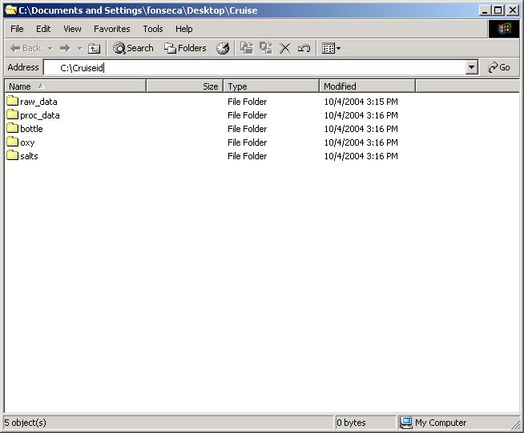

Inside the salts folder we recommend two other folders:
- drift_correction: destination for the files created by the autosal correction m-files;
- original: copies of the files created by the autosal interface.

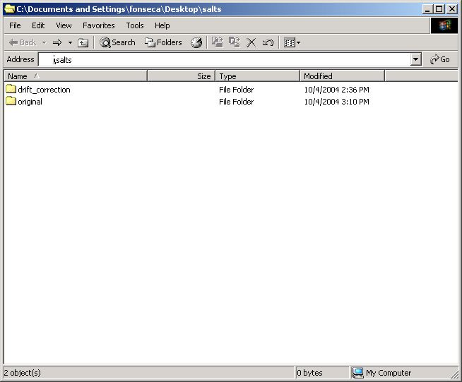

- Autosal files
The survey technician will give you four files (.xls, .dat, .raw and .hdr). usually the files are named like "XXYYZZ" (where XX is the month; YY is the day; and ZZ is the GMT hour). These files should be copied into the original folder inside the salts folder

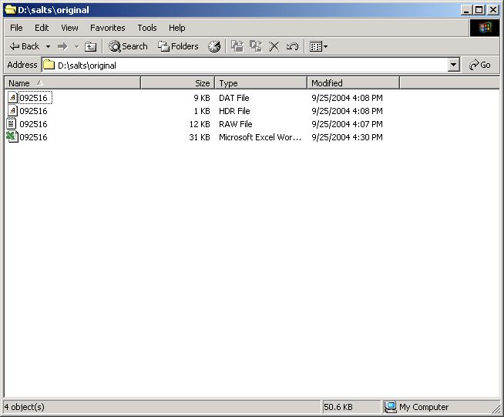

At this point we copy and rename ( if the user thinks it is necessary) the .dat and the .raw files to the drift correction folder. Make sure that the in the "Bottle number" field inside the .dat files you have only numbers (the program is not set to handle alphanumeric bottle numbers). The drift correction folder will have the copies of the .raw and the .dat files as well the m-files necessary to read these files and apply the drift correction for the autosal.

- Reading the autosal files
Start the MATLAB® and go to the drift correction folder.

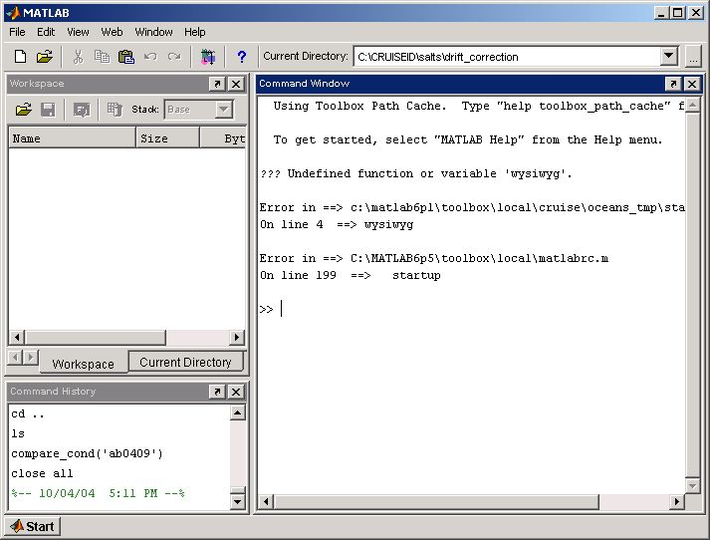

Read the .dat files, in order to do that a m-file was created named read_autosal_dat. The only input argument is the full name of the file (that means file name plus extension, the complete path of the file can be used as well).
Read the .raw files, calling the m-file named read_autosal_raw. The only input argument is the full name of the file (that means file name plus extension, the complete path of the file can be used as well).

- bla bla bla

