PHOD contribution to NOAA/AOML Strategic Plan
Draft 1
May 28, 2009

OCEANS AND CLIMATE

Background

AOML is a key contributor to the global ocean observing system (GOOS), conducting climate studies with global scope to better understand the global setting for regional signals, and how the regional signals contribute to global phenomena. Multi-institutional efforts include studies of the Atlantic Multidecadal Oscillation (AMO), atmosphere-ocean interactions and their impact on the weather, the oceanic circulation at various depth levels research on the global ocean carbon cycle, atmospheric chemistry, and analysis of changes of the global and local oceanic heat storage. The research related to the circulation includes the Meridional Overturning Circulation (MOC), the western boundary currents including the Gulf Stream, Deep Western Boundary Current, Brazil Current, the surface and intermediate depth circulation in the Atlantic Ocean. Gulf of Mexico and Caribbean Sea oceanography. Infrastructure used, developed and analyzed relies on shipboard-conducted surveys for process studies, long-term continuous time series, autonomous free-drifting instruments (e.g. floats, drifters), satellite observations, and numerical models. In addition, AOML is the home of the Global Drifter Program, PIRATA Northeast extension, the U.S. Argo Data Assembly Center and South Atlantic Argo Regional Center, the CLIVAR CO₂ hydrography activity, and the global Ship Of Opportunity Program for the deployment of Expendable BathyThermographs (XBT) and the installation of ThermoSalinoGraphs (TSG). While many of the programs at AOML are global in scope, due to our proximity to the Atlantic Ocean, Gulf of Mexico and Caribbean Sea, there are other programs that are specifically focused on issues of importance in these regions. AOML also contributes to the GOOS Reference stations through the long time series programs of the Florida Current, Western Boundary Time Series and the new programs to measure the Tropical Atlantic variability and the meridional overturning circulation in the North and South Atlantic.

[we will add here a paragraph that will focus on science]

Challenges

One of the major challenges that we impose upon ourselves is the search for new indices and enhanced observing systems that will allow us to observe and understand long-term climate changes. By collecting and analyzing long-term, excellent-quality observations in the ocean and the atmosphere, we will be able to confirm or modify the results derived from model predictions. In addition, new instrument technologies and improved observing system design allow us to enhance the observing system with increased efficiency. Observations are the backbone of all the data analysis conducted at AOML. Therefore, AOML is increasing its ocean modeling capabilities to enhance the scientific analysis of ocean observations by incorporating hydrographic and satellite observations in numerical models and to develop Observing System Simulation Experiments (OSSE) system that will be used to evaluate the impact of the present ocean observing system and design the enhancements required to achieve the stated goals.

Another challenge is collecting oceanic and atmospheric data of high quality and distributing these data in real time. A fast distribution of quality-controlled data is crucial to the improvement of forecasts. We intend to continue improving the existing technology, the data acquisition systems, the quality control and the distribution of data.

PRIORITIES:

The primary priority is to continue being a center of research, with emphasis on the collection of high-quality observations for use in climate diagnostics, analysis, modeling, and forecasting. The activities in climate-related observations must include the full range of data collection activities, from sensor deployment through product generation, and the development of new generations of measurement systems. Equally important, the data collected must be used in analysis efforts to increase understanding of climate dynamics and in design studies directed at maximizing the efficiency of the observing systems. Plans to achieve these priorities are presented next.

Work at AOML will be focus on the development of new products and applications that will provide critical services that are of benefit to the society, such as understanding the effect of the ocean on droughts, hurricane intensification, and long term climate change.

Science Goals and Actions

Goal: To understand the physical processes and mechanisms that control the pathways, water mass transformation and interocean and interhemispheric exchanges of the Meridional Overturning Circulation (MOC) and its related climate impacts.

Actions:
- To play a significant role in the maintenance and enhancement of the current observing system and on the development of deep ocean observing systems that will help to characterize the strength and spatial structure of the MOC in the North and South Atlantic oceans.
- Evaluate the current state of the MOC, its connectivity and coherence and determine the MOCs influence on climate through analysis of observational data and models.
- Utilize models to assess the overall effectiveness of observing systems designed to monitor the heat, mass and fresh water transports of the MOC and develop optimized observing systems.

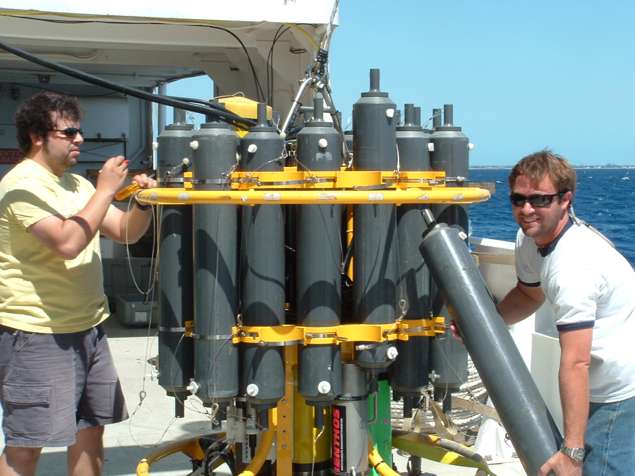
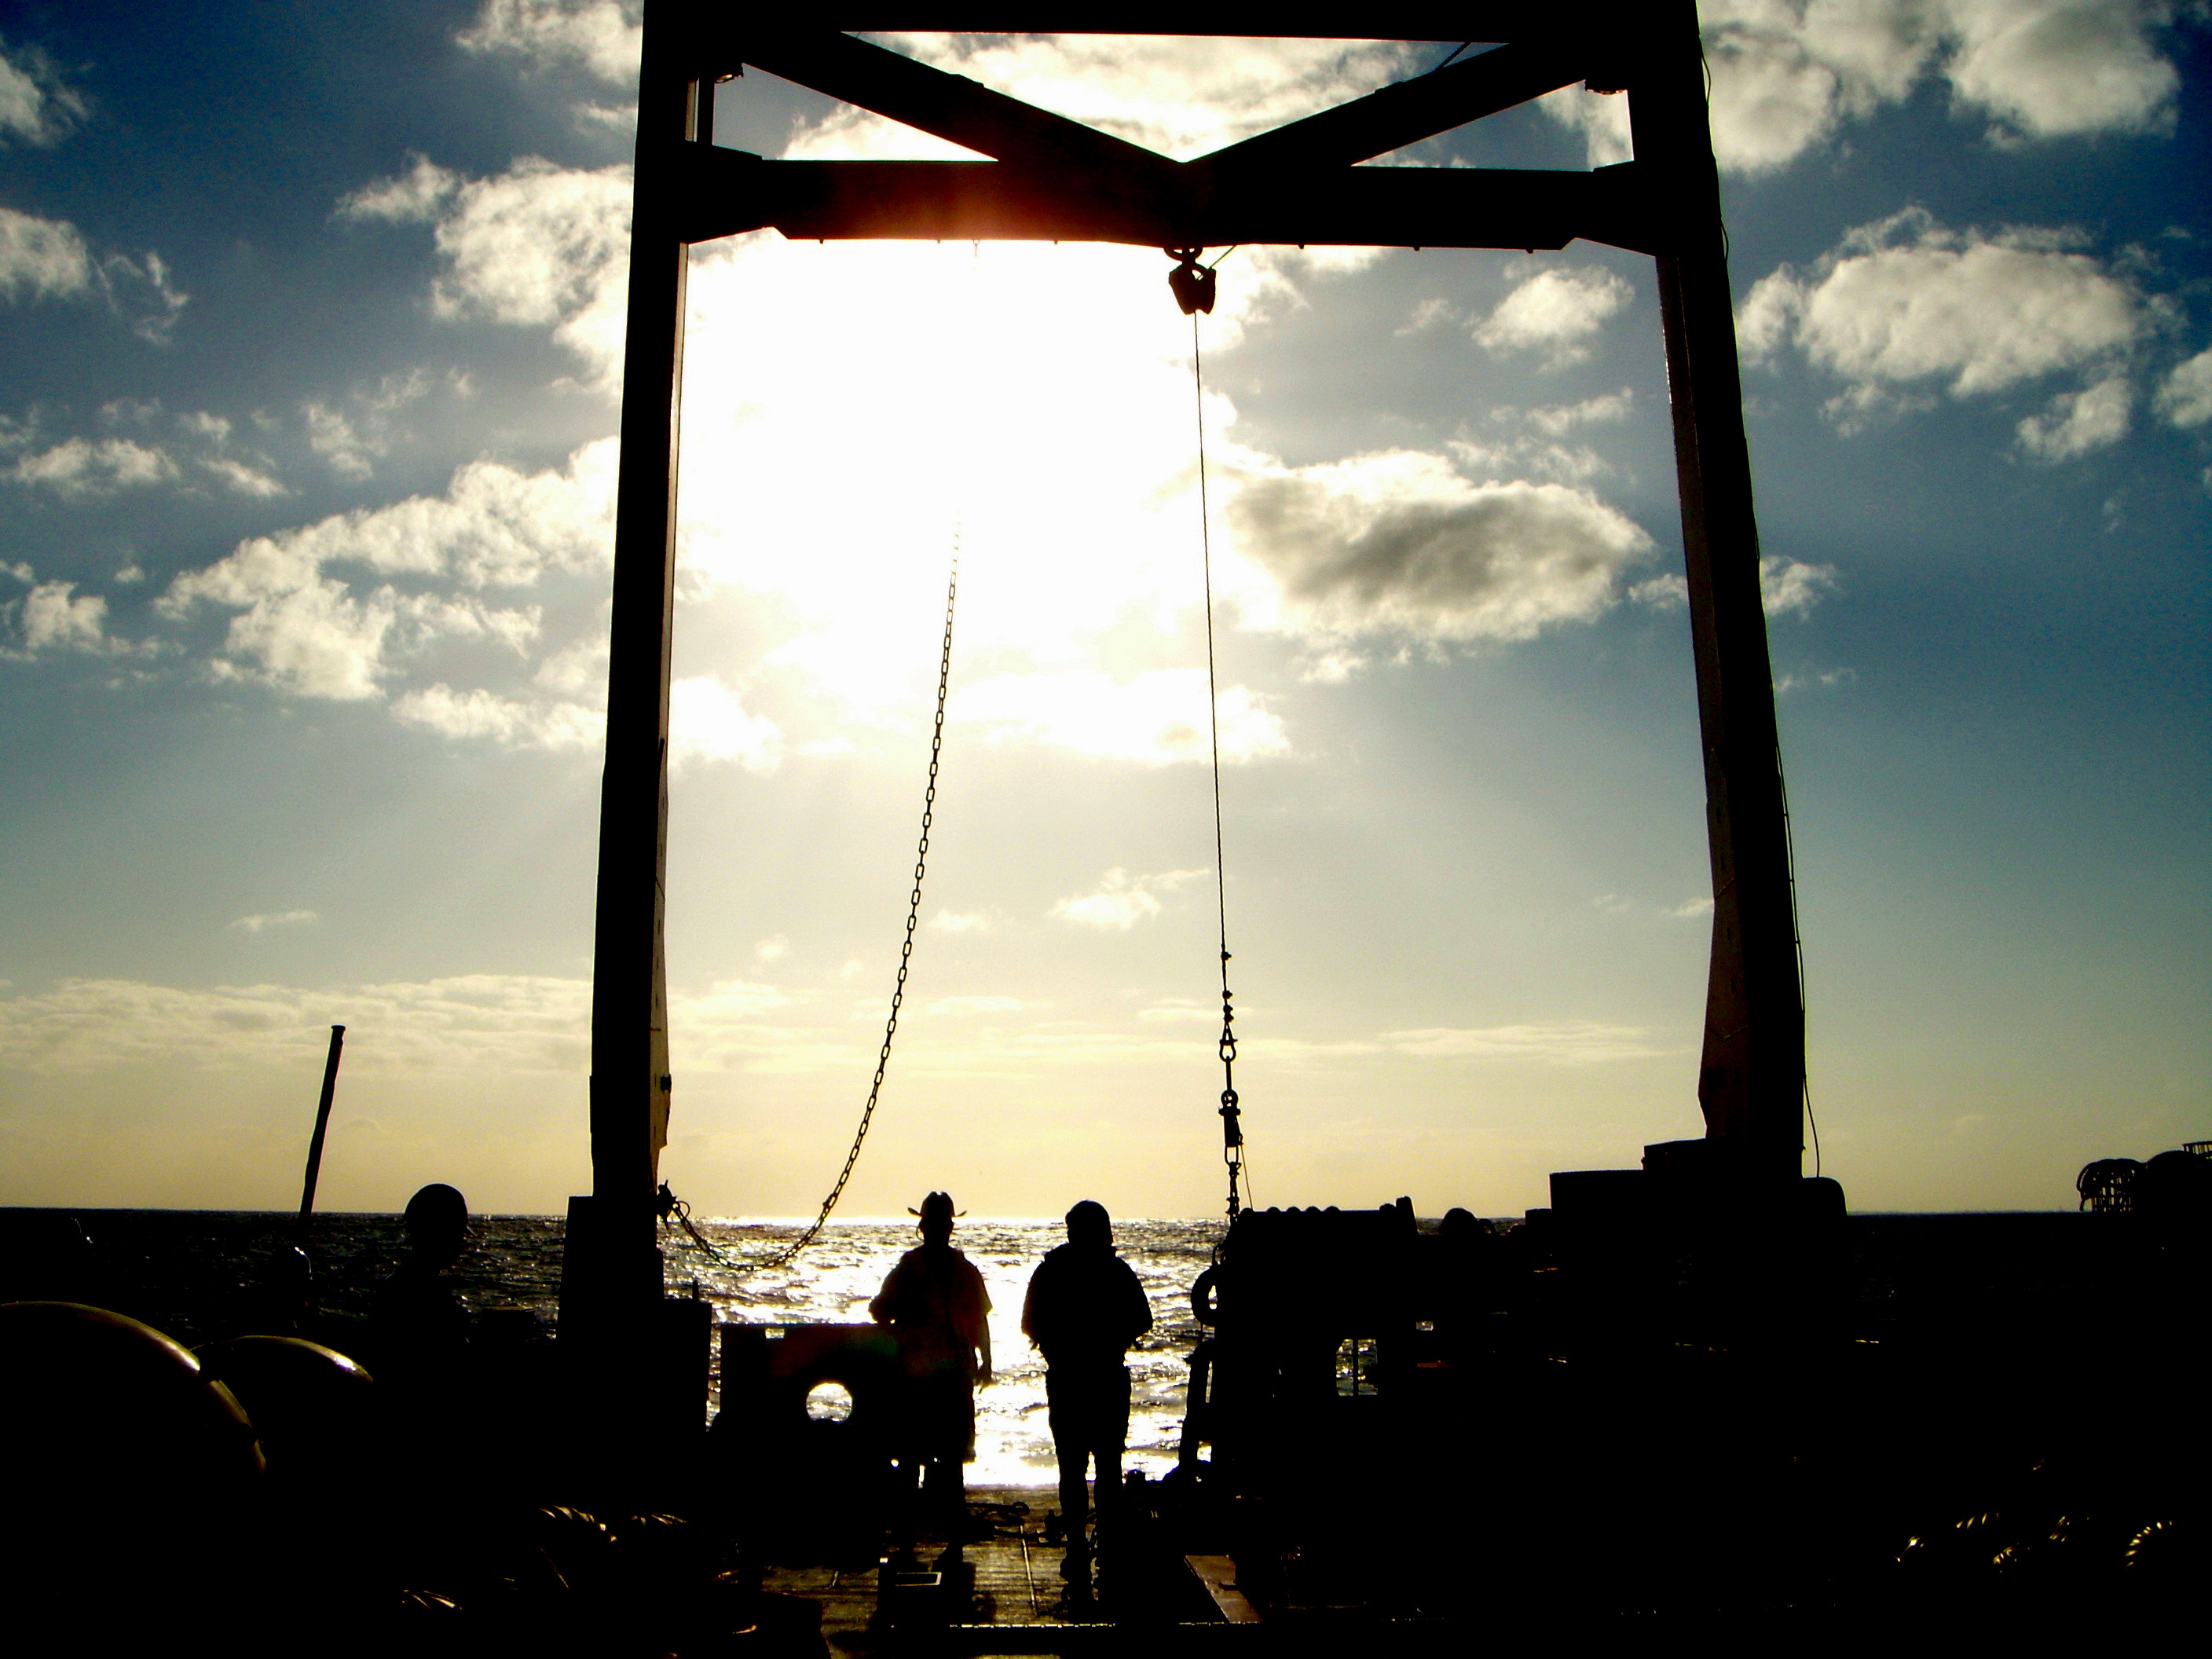

Goal:
Study variability of the Atlantic Warm Pool and the tropical Atlantic to better understand their influence on the climate and weather of surrounding continents.

Actions:
- Propose and implement extensions of Global Ocean Observing System into the Intra-Americas Sea using numerical models and OSSEs for guidance
- Perform complementary diagnostic and modeling studies on the impacts, mechanisms and predictability of the Atlantic Warm Pool.
- Determine the influence of the Atlantic Warm Pool on extreme events such as tornadoes, droughts and floods in the United States and their relationships with moisture transport from the Atlantic Warm Pool region.
- Identify processes and/or parameterizations in coupled ocean-atmosphere models that are responsible for generating model biases in the tropical Atlantic and the Atlantic Warm Pool.

Goal:
Determine how regional and basin-wide ocean circulation are affected by long-term global ocean variability.

Actions:
- Study the variability of ocean gyres, particularly in the South and North Atlantic oceans from hydrographic and satellite observations.
- Improve understanding of changes and locations of major surface currents that are key components of the MOC and determine regional impacts in sea height, sea surface temperature, surface currents, ocean color and heat content.
- Evaluate if numerical models reproduce the long term variability observed in the ocean.
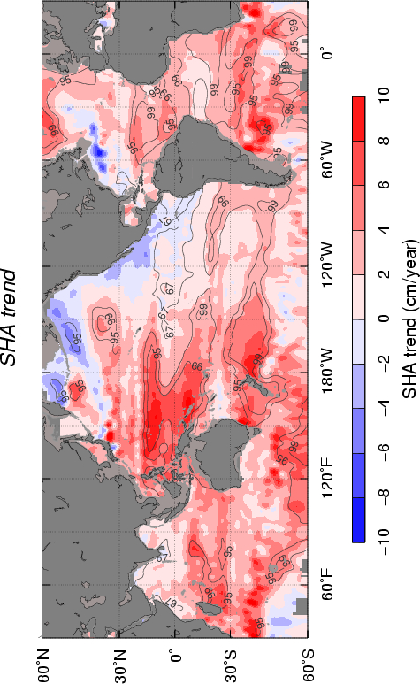

Map sea height trend derived from satellite altimetry during 1993-2007, showing regions where sea level has risen (in red) and has decreased (in blue).

Goal:
Improve our understanding of the role of small scale phenomena in climate dynamics and improve their parameterization in numerical models.

Actions:

- Observe the dynamics of ocean fronts and cross-frontal fluxes in regions of strong SST gradients.
- Characterize the observed distribution of near-inertial energy in the ocean, and document the effect of background mesoscale and large-scale vorticity on this distribution.
- Determine the impact of small-scale features and cross-frontal eddy transports upon dispersion, large-scale air-sea heat fluxes, background circulation, precipitation patterns, and oceanic transports of salt.
- Improve parameterization of small scale and subgridscale processes in numerical simulations.

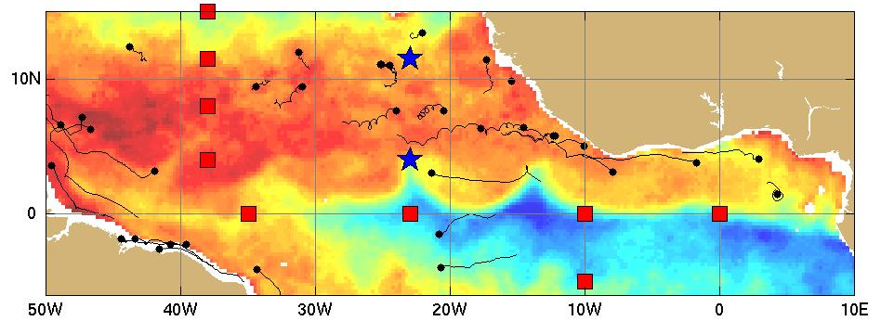

Microwave SST imagery of the equatorial cold tongue on 20 July 2007, showing the cusps associated with Tropical Instability Waves. In-situ measurements are collected by the PIRATA array (backbone moorings shown as red squares, with the Northeast Extension as blue stars) and by surface drifters (black dots with 20 day trajectories).

Goal: Contribute to the maintenance and enhancement of the ocean observing system for understanding and predicting climate change

Actions:
- To continue being a key partner in the implementation and sustainability of the Global Ocean Observing System.
- To provide the scientific background for designing components of the observing system geared, for example, to study the AMOC.
- To conduct numerical experiments to help improve the current observing system.
- To develop capabilities for new instrumentation and data collection and analysis, such as from autonomous underwater vehicles.

Anticipated Impacts

The maintenance of the current observing system will allow to continue the monitoring of the longest climate time series of the Florida Current transport, the semiannual surveys of the physical properties of the Western Boundary Current, the monitoring through a combination of bottom deployed moorings the MOC at the western boundary of the Atlantic Ocean at 27°N and 35°S; developing new instrumentation that would allow monitoring the whole water column at climate time scales.

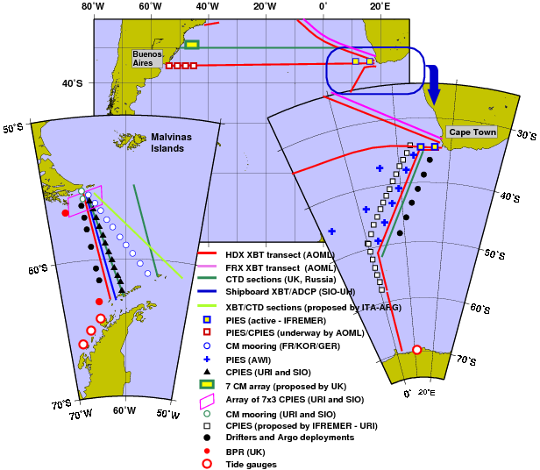

Map showing the different components of the current and proposed ocean observing system in the South Atlantic Ocean.

Anticipated Impacts

The key participation of AOML in the implementation and sustainability of the ocean observing system will lead to studies that will improve significantly the understanding of the role of the global ocean in seasonal to decadal and longer time scales of climate variability and, in particular, the role of the ocean circulation in redistributing heat, fresh water and carbon globally. One such example will be the focus on the Atlantic Meridional Overturning Circulation, where we expect to continue measurements of the variability of the northward flowing Florida Current and Antilles Current and the southward flowing Deep Western Boundary Current (that has been ongoing fro more than 25 years), and is now the cornerstone of the internationally coordinated programs with the National Science Foundation and European partners. The evaluation of numerical models and implementation of OSSE will lead to the implementation of improved observing systems. AOML and national and international cooperating institutions will complete a resurvey of the global oceans and obtained the first direct estimates of carbon sequestration over the past decade in the Atlantic and Pacific and Indian Oceans. AOML will lead the Atlantic alliance of surface pCO2 measurements and will have established a comprehensive observing plan to determine basinwide air-sea CO2 fluxes on seasonal time scales. We will also be at the center of a new frontier in oceanography, one in which ocean variability is sampled in real time and analyzed and predicted operationally much the way the atmosphere is today.

Beyond 2014

As our understanding of climate processes and their indices, precursors, and impacts improve, as real-time in-situ and satellite measurements become the standard, and as we learn how to simulate and predict global ocean variability with our academic partners, we will be moving into exciting new areas of climate research and society-driven applications. The future research will likely still target the Atlantic Overturning Circulation and its role in climate variability, but will now move towards ways to predict its regime shifts and regional impacts. We will also begin the global re-survey of anthropogenic CO2 content in the ocean for the second decade of the 21st century, and produce an operational product of seasonal air-sea CO2 flux maps on global scales.

FROM RIK W.

Goal: Assess the impact of the ocean on the global CO2 cycle

Background

The ocean plays a key role in regulating and modulating atmospheric levels of climate forcing trace gases such a CO2. This is particular pertinent because of rapidly increasing CO2 levels in the atmosphere due to man's activity. Understanding the role of the ocean is paramount for any possible CO2 mitigation strategies. The magnitude of exchange, and the quantification of uptake of CO2 by the ocean are two key processes that are studied at AOML in collaboration with academic and NOAA partners, in particular the ocean carbon group at PMEL with Drs. Feely, Sabine and Alin as leads. The ocean carbon group at AOML addresses the key issues pertaining to the global carbon cycle through observations, analysis, and interpretation. The elements of the research undertaken are:

Actions:
- Quantifying the air-sea CO₂ flux.
- Determining the change in ocean carbon inventory.
- Assessing the impacts of increasing inorganic carbon concentrations on ocean chemistry and biology.

The next decade

We envision a continuation of the main thrust outlined above with the following augmentations.
- We plan a major expansion of efforts to improve our understanding of increasing CO2 levels on ocean ecosystems under the banner of ocean acidification. We will augment of pCO2 work with additional automated sensors and a vigorous bottle sampling campaign on the ships of opportunity to monitor the changing pH levels and associated changes in ocean carbon chemistry in a sustained mode with focus on coastal ecosystems.
- We plan to take advantage of the rapid developments in sensor technology and ocean infrastructure to increase the efficiency and scope of the main projects outlined above. A particular challenge that will be addressed is means to sample [inorganic carbon] properties at depths greater then 2 km with means other then the current Niskin/Rosette sampling approach
- We will engage collaboratively addressing the key research issues relating to the ocean carbon cycle including:
- Quantifying the uptake of anthropogenic carbon on seasonal to decadal timescales
- Understanding the variability of inorganic carbon and nutrient cycling in the [deep] ocean and tease out the natural, anthropogenic, and climate forced components.
- Quantifying and understanding the rapid observed changes in the carbon cycle at high latitude.

PHOD contribution to tropical cyclones (some parts may stay in Oceans and Climate)

Goal: Determine the influence of climate changes on hurricane activity and improve hurricane forecast skill.

Actions:

- Understand how and why global ocean warming and natural climate variability affect Atlantic hurricane activity.
- Investigate the relationship between tropical cyclones in the North Atlantic and the eastern North Pacific.
- Improve the predictability of the Atlantic Warm Pool in ocean models as a means to operational forecasts of hurricane activity.
- Provide oceanic data for improved hurricane forecast skill including hurricane intensification.
- Improvement of upper ocean heat content estimates for tropical cyclone intensification studies and forecasts.
- Collaborate to evaluate and improve ocean model performance within coupled hurricane prediction models.
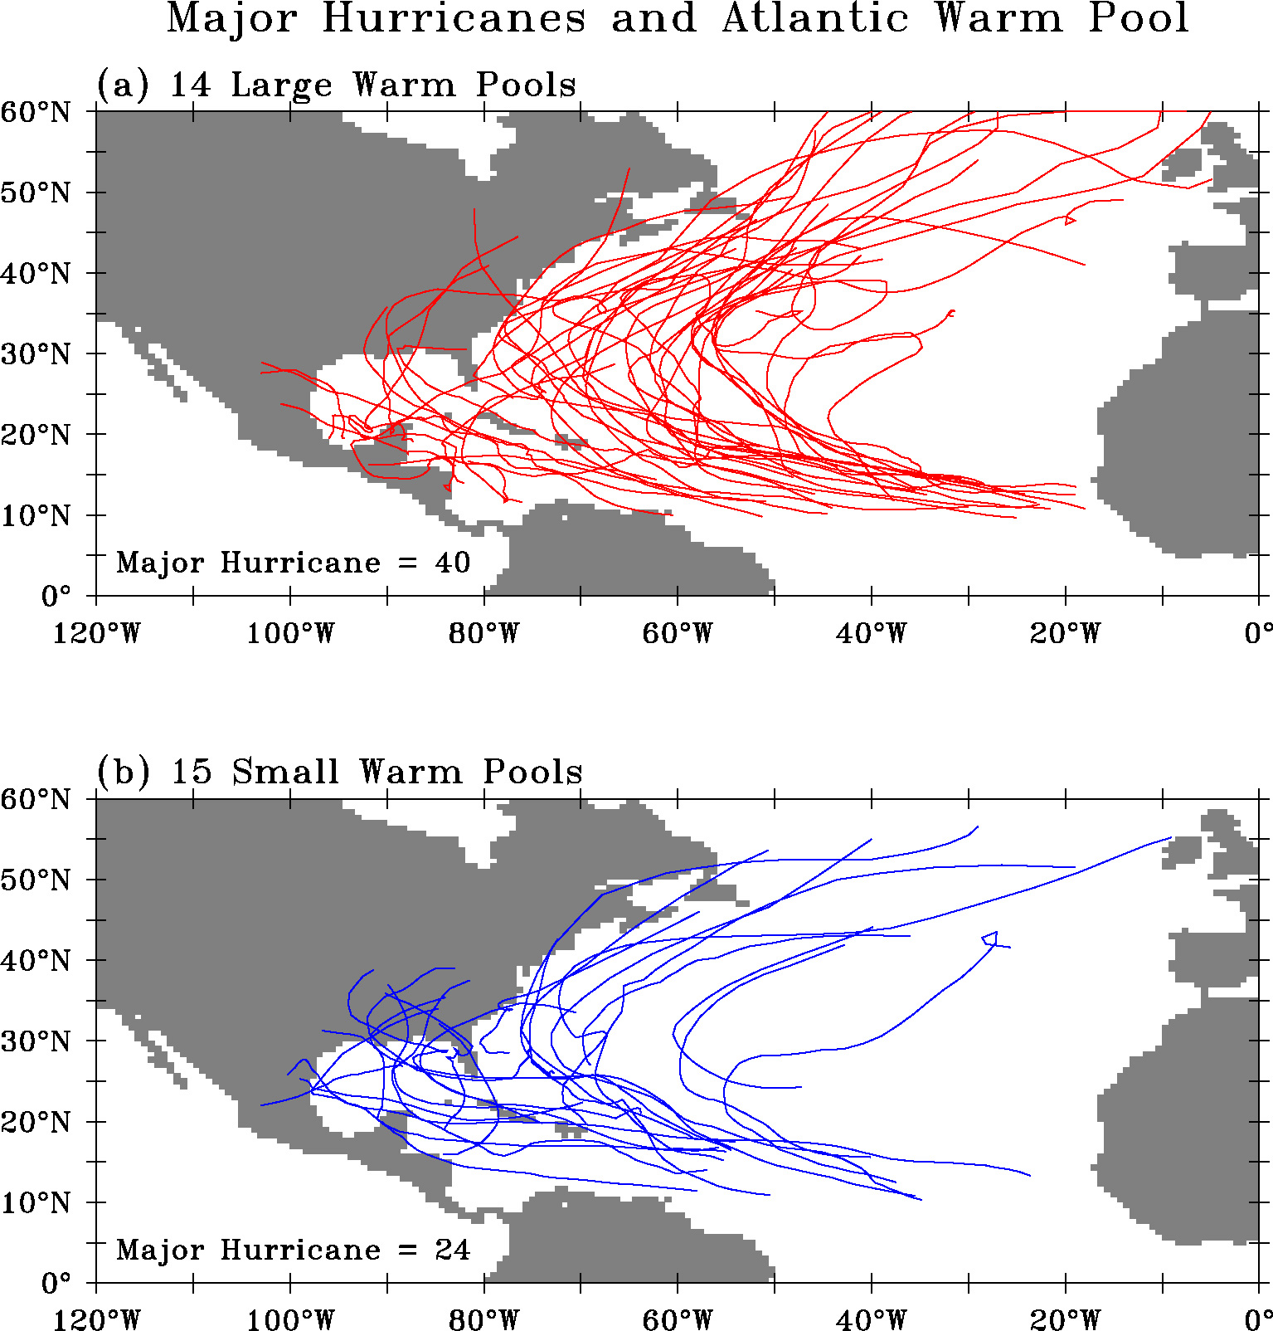

Tracks of major Atlantic hurricane for (a) 14 years of large Atlantic Warm Pool and (b) 15 years of small Atlantic Warm Pool (1950-2003).

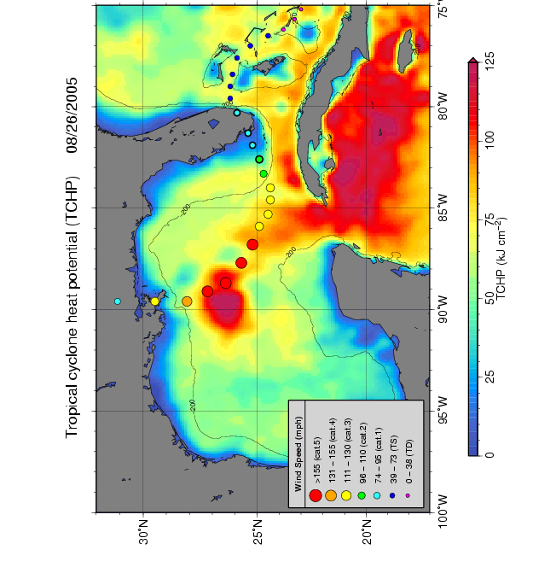

Map showing the upper ocean heat content in the Gulf of Mexico during the passage of hurricane Katrina in August 2005. The intensification of this tropical cyclone occurred in the region of highest values of heat content.

PHOD contributions to the "Coastal and Regional Environments" section of the new strategic plan, although still devating if one goal will be in Oceans and Cliamte

Goal:
Improve understanding of the impact of the Comprehensive Everglades Restoration Plan (CERP) and other restoration actions upon the south Florida coastal marine ecosystem including Florida and Biscayne Bays and the Florida Keys National Marine Sanctuary (FKNMS).
Actions:
- Provide the physical, water quality, and biological data required to verify models and analyze alternative water management and restoration scenarios.
- Define the degree to which restoration actions threaten the FKNMS and its living marine resources
- Evaluate the potential effect of proposed restoration projects on the coastal chemical, physical and biological oceanography and after the projects implementation assess the impact on the coastal ecosystem

Goal:
Determine the degree to which the coastal ecosystems of south Florida, the Gulf of Mexico and the Caribbean Sea are physically and biologically interconnected

Actions:

- Conduct interdisciplinary observational studies collaboratively with the Southeast Fisheries Science Center (SEFSC) to provide the biological and physical data to assess the degree to which the ocean circulation and water properties affect the variety, abundance, and distribution of the regional marine life.
- Utilize numerical model products and remote sensing technologies to delineate the relevant large-scale oceanographic and meteorological forcing processes.
- Synthesize and integrate all available data to provide concise, relevant science-based products that can be used by regional resource managers to make decisions about Marine Protected Areas (MPAs) and other resource conservation strategies

Goal:
Improve understanding of the role of climate change in the health of coastal and regional marine ecosystems of south Florida, the Gulf of Mexico and the Caribbean Sea

Actions:

- Analyze available long-term observed and proxy data sets in collaboration with the Southeast Fisheries Science Center (SEFSC) to determine the degree of climate variability and long-term change in the region, and its impact on the living marine resources.
- Utilize numerical model products to assess the expected future changes in the regional marine environments and provide science-based input to resource managers based on the possible range of climate change scenarios.
- Conduct comparative experiments to delineate ecosystem differences between high carbonate systems in south Florida and those without elevated pCO2 levels.
- Synthesize our current knowledge regarding the interplay between ocean circulation and biological processes with expected changes in order to develop a better expectation of future conditions

