WORLD METEOROLOGICAL ORGANIZATION  ________________________ | INTERGOVERNMENTAL OCEANOGRAPHIC  COMMISSION (OF UNESCO)  ________________________
JOINT WMO / IOC TECHNICAL COMMISSION FOR OCEANOGRAPHY AND MARINE METEOROLOGY (JCOMM)  SHIP OBSERVATIONS TEAM  FIFTH SESSION  GENEVA, SWITZERLAND, 18-22 MAY 2009 | SOT-V/Doc. IV-1.1  (XX.XX.2009)  _______  ITEM IV-1.1  Original: ENGLISH

report by the Chairperson of the SOOP Implementation Panel (SOOPIP)

(Submitted by Gustavo Goni, Chairperson, SOOPIP)

Summary and purpose of the document

This document includes the report by the SOOPIP Chairperson on activities undertaken during the intersessional period.

ACTION PROPOSED
The Team will review the information contained in this report and comment and make decisions or recommendations as appropriate. See part A for the details of recommended actions.

___________________________________________________________________

Appendices: A. XBT data transmissions in real- and delayed-time
B. TSG observations
C. Fall Rate Equation

- A - Draft TEXT for inclusion in the final report

1. The Ship Of Opportunity Program (SOOP) continues being a critical player in the implementation of a sustained ocean observing system. Ships of the SOOP deploy some 25,000 XBTs per year, representing approximately 25% of the upper ocean thermal observations. There has been a continuous increase in the number of profiles transmitted in real-time: 17,586 in 2007; and 19,450 in 2008. This was accomplished due to implementation of transmissions in real- or near real-time by several countries, particularly India, Brazil and South Africa.

2. SOOPIP continues to Incentivate the interaction between the scientific and operational communities operating different observing platforms, such as pCO2, XCTDs, TSGs, CPRs, etc. (Apendix B)

3. In April 2008, a Fall Rate Equation (FRE) meeting was held in Miami, FL, to review and discuss results obtained from several experiments carried out to evaluate the current FRE (Appendix C)

4. SOOPIP is continues to support the testing of BUFR format for XBT data transmissions. The first transmission test took place in 2008.

5. As part of international collaboration, a scientist from India was funded to go to the US and to receive training using a real-time data acquisition system. Real-time data acquisition and transmission systems were also provided to participants in Brazil and South Africa.

6. A white community paper (wcp) is being prepared for the OceanObs 2009 meeting to be held in Venice in September 2009. This paper will evaluate the current XBT network and make recommendations for future work, including logistics, technology, data transmissions and storage. Members of the SOOPIP are also taking active participation in other related wcp, such as GOSUD, VOS, and pCO2.

7. A science and technical presentation on the SOOP operations was made at the Global Ocean Surface Underway Data (GOSUD) Implementation panel, held in Seattle, WA, in June 2008.

8. SOOPIP is evaluating the differences between alternative transmission platforms in XBT transects, such as Inmarsat, Iridium and Argos.

9. A science presentation of SOOP operations was made at the Ocean Science Meeting (Orlando, March 2008), IOC Meeting, and NOAA CPO annual meeting (Washington, May 2008)

10. Through NOAA’s Climate Program Office, the XBT pool for SOOP international partners was increased to enhance their participation the XBT network. These partners currently receive approximately 1800 probes per year.

12. SOOPIP continues a strong interaction with the VOS panel, particularly with several aspects of the logistics, recruitment and operations of many XBT transects.

13. SOOPIP supported and provided material to train scientists and technicians in West African countries as part of a U.S. Navy and NOAA “African Partnership Station”. Three training courses on XBTs, drifters and floats were already carried out, one in South Africa (2007), Ghana (2008) and Nigeria (2009). The first course was on setting up the program, the second course on the technical aspects of the observations, and the third course in the utilization of data.

14. SOOPIP continues supporting the data monitoring of other platforms, such as surface drifters (ZZYY), TSGs (TRACKOB-NNXX), sea stations (TESAC-KKXX) and sea stations for CTD, Argo floats and ADCP (TESAC-KKYY).
15. SOOPIP supported the creating of new visualization tools of data in real-time, such as using Google Earth.

16. SOOPIP improved the facilitation and metadata exchange for XBT transects to be included in the Annual SOOP reports.

17. The meeting made the following recommendations:

  - Enhance the capabilities for real-time transmissions.

  - Continue the strong working relationship with other communities and to communicate the value of XBT observations

  - Have active participation in International Meetings, technical, operational and scientific.

  - Implement XBT transects as recommended by the scientific and operational communities

  - Continue exploring the possibility of creating a pool of XBT that is not dependent of one particular institution. In the meantime, support the continuation of NOAA contributions.

  - Support the continuation of experiments to evaluate the FRE. Implement a new equation if/as recommended by the scientific community.

  - Explore the possibility of building a prototype of a self-contained XBT auto launcher.

  - Support the evaluation of performance of different real-time data transmission platforms.

  - Support the creation a database of all scientific and technical publications that have used XBT observations.

  - Increase the international participation by supporting training of technicians and scientists in developing countries.

18. The meeting decided on the following action items:

- Action 1 (by whom; deadline)

- Action 2 (by whom; deadline)

- Action 3 (by whom; deadline)

- Action 4 (by whom; deadline)

- Action 5 (by whom; deadline)

APPENDIX A

XBT Data transmissions in Real and delayed time

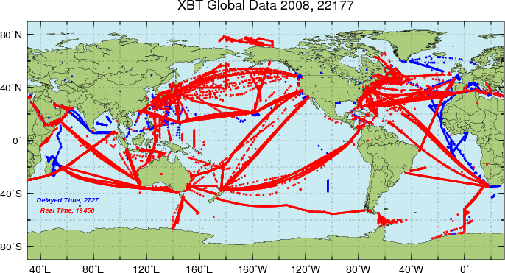
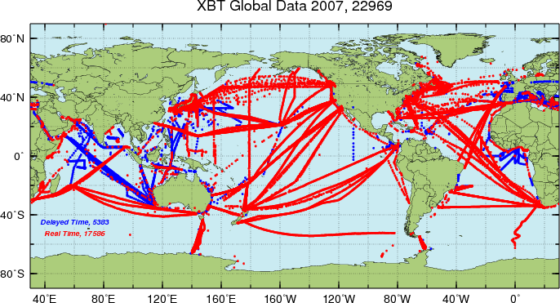

APPENDIX B

TSG observations 2007-2009

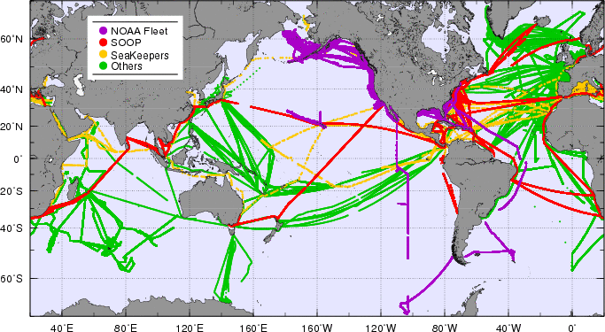
APPENDIX C

Fall rate equation

The determination of the XBT depth is the most important source of error in XBT temperature profiles [McDowell 1977] although other sources of error exist (e.g temperature offsets, recording errors, etc). Unlike Argo observations, XBTs determine the depth of the temperature observations indirectly from a time trace converted into depth using a fall-rate equation (FRE). This FRE results from a simple dynamical model where the net buoyant force is balanced by hydrodynamic drag proportional to the square of the probe speed [Green, 1984; Hallock and Teague, 1992]. The fall speed is virtually equal to the terminal velocity, a reasonable assumption for depths larger than 10 m. The bulk of XBT temperature profiles are collected using probes manufactured by Sippican Incorporated (now Lockheed Martin Sippican). Systematic errors in the computed XBT depths have been identified since the mid 1970s: Early comparison studies between simultaneous XBTs and Conductivity Temperature Depth (CTD) casts found a small positive bias above the thermocline, while a much larger negative bias for depths below [Fedorov, 1978; Flierl and Robinson, 1977; McDowell, 1977; Seaver and Kuleshov, 1982] demonstrating the limitations of the original FREs. Evidence of surface offset associated with initial transients has also been found [Singer, 1990]. Nonetheless, XBT temperature profiles have been shown to be accurate enough to characterize mesoscale phenomena [Seaver and Kuleshov, 1982; Flierl and Robinson, 1977]. It was not until the 1990s when the impact of time-dependant systematic errors on climate applications was recognized. A steady state correction factor was adopted by Sippican after a comprehensive analysis of research-quality CTD and XBT data by Hanawa et al. (1995). This study showed that the manufacturer coefficients in the FRE resulted in depths that were too shallow, producing a cold temperature bias in most of the water column. As a result a stretching factor of 1.0336 was applied to the manufacturer original FRE. Recent studies suggest time-varying biases between XBT and CTD observations [Gouretski and Koltermann, 2007; Wijffels et al., 2008]. The implied changes in the FRE exceed the 2% error specified by the manufacturer (Sippican) and are likely to be responsible for spurious decadal signals in global mean heat storage time series [Wijffels et al., 2008]. Starting in 2000, the rapidly expanding Argo array [Gould et al., 2004] provides global and highly quality controlled ocean temperature and salinity data with CTD accuracy. Nonetheless, XBT profiles currently make up to 25% of the current global temperature profile observations. Therefore, assessing and correcting this bias is critical to monitoring changes of global ocean heat content. Moreover, systematic biases between observing systems with disparate quality capabilities, such as Argo and XBTs, can also introduce spurious climatic signals in heat storage as the ratio of the number of observations collected with each platform changes [e.g. Willis 2008].

____________

____________

