Tropical Cyclone Heat Potential

Gustavo Jorge Goni, NOAA/AOML

The role of the ocean in tropical cyclone (TC) formation has been largely recognized and accepted. The formation of Atlantic hurricanes has been linked to the sea surface temperature (SST), where values of this parameter larger than approximately 26ºC have been shown to be a necessary but insufficient condition for hurricane cyclogenesis. Additionally, the intensification of hurricanes involves a combination of favorable atmospheric conditions, such as trough interactions and vertical shear. After a series of events where the sudden intensification of hurricanes occurred when their path passed over oceanic warm features, it became clear that the upper ocean may play an important role in this process.

Although the sea surface temperature provides a measure of the surface ocean conditions, it gives no information about the subsurface (first tens of meters) ocean thermal structure. It is known that the oceanic skin temperature erodes when the sea surface is affected by strong winds, creating a well-mixed layer that can reach depths of several tens of meters. As the TC progresses, it travels above waters with mixed layer temperatures similar to their skin sea surface temperatures. This provides the motivation to investigate and monitor the upper ocean thermal structure, which has become a key element in the study of tropical cyclone-ocean interactions focused on prediction of sudden tropical cyclone intensification. Warm ocean features, mainly anticyclonic rings and eddies, are characterized by a deepening of the isotherms towards their centers with a markedly different temperature and salinity structure than the surrounding water mass. We present here results that are used to a) monitor the upper ocean heat content in all basins where TCs occur, and b) investigate any possible link between this parameter and the intensification of intense TCs during 2007.

The Tropical Cyclone Heat Potential (TCHP) is the heat contained in the upper ocean from the sea surface to the depth of the 26ºC isotherm. Hydrographic observations cannot provide TCHP fields needed to monitor this parameter on a daily to weekly basis with global coverage. Consequently, a methodology based on a combination of hydrographic and satellite-derived observations is used to create daily global fields of TCHP (Goni et al, 1996; Shay et al, 2000). Statistical analyses of these fields have shown that values of 50 kJ/cm² are usually needed for the ocean to have an effect on the intensification of an Atlantic hurricane (Maineli et al, 2008). Clearly, areas with high values of TCHP may be important only when TCs travel over them.

There are seven basins where TCs occur: North Atlantic, East Pacific, West Pacific, North Indian, Southeast Indian, Southwest Indian, and South Pacific. Results presented separate the North Atlantic basin into tropical Atlantic and Gulf of Mexico. The TCHP anomalies are computed during the months of TC activity in each hemisphere: June through November in the northern hemisphere and November through April in the southern hemisphere. The reference to compute these anomalies corresponds to the mean TCHP obtained for the same months from 1993 to 2007. These anomalies show large variability within and among the basins (Figure 1, left)

In the Pacific Ocean the largest anomalies showed the signature of the negative phase of the 2007 Enso event (La Nina). However, these anomalies are mostly outside regions where TCs occur, with the exception of the West Pacific and South Pacific basins. The West Pacific showed positive anomalies only, while the South Pacific showed both large positive and negative anomalies. The North Indian basin exhibited positive values in the Arabian Sea and negative values in the Bay of Bengal. In the mean, the Gulf of Mexico and the tropical Atlantic exhibited small positive anomalies. Nevertheless, within the tropical Atlantic the anomalies were positive (negative) to the south (north) of approximately 25ºN. The analysis of the monthly TCHP anomalies averaged over each basin since 1993 (Figure 2) showed that the only two basins exhibiting large monthly anomalies (within 75% of their historical extreme values) are the West Pacific and the South Pacific (Figure 1, right). In the mean, all basins, except the Eastern Pacific, showed mean positive annual values of TCHP during 2007.

Several TCs were identified to have gained strength when traveling into regions of very high values of TCHP. Some examples of these intensification events are shown in Figure 2. The results presented here correspond to three intense (category 4 and 5) TCs, where the location of their intensification coincided with an increase of the values of TCHP under their tracks. Additionally, the cooling associated with the wake of the TCs is important since it influences the upper ocean thermal structure on regional time scales within weeks to months after the passage the cyclones. These TCs were Gonu in the North Indian basin (Figure 2, top three panels); Krosa in the West Pacific basin (Figure 2, middle three panels); and Felix in the Caribbean Sea (Figure 2, bottom three panels).

Cyclone Gonu
During June 3 to June 4, 2007, cyclone Gonu, a storm with maximum winds of 90 knots (cat. 2), intensified to maximum sustained winds of 115 knots (cat. 4). This cyclone intensified when traveling from a region with TCHP value of 60 kJ/cm² over a mesoscale feature with TCHP values averaging 110 kJ/cm². The average decrease of TCHP and SST under the wake of this cyclone were of 25 kJ/cm², and 3C, respectively.
Typhoon Krosa
On October 3, 2007, typhoon Krosa, a storm with maximum winds of 75 knots (cat. 1), intensified to one with maximum sustained winds of 120 knots (cat. 4). This typhoon traveled from a region with TCHP values of 30 kJ/cm² over a mesoscale feature with TCHP values of 75 kJ/cm². The average decrease of TCHP and SST values under the wake of this typhoon were 50 kJ/cm² and 3°C, respectively.
Hurricane Felix
On September 2, 2007, hurricane Felix, a cyclone with maximum winds of 90 knots (cat. 2), intensified to a hurricane with maximum sustained winds of 120 knots (cat. 4). This hurricane traveled from a region in the Caribbean Sea with TCHP values of 50 kJ/cm² into a region with TCHP values of 110 kJ/cm². The average decrease of TCHP and SST values under the wake of this hurricane were approximately 10 kJ/cm² and 1°C, respectively. The cooling produced by this hurricane is substantially smaller than those produced by cyclone Gonu and typhoon Krosa.

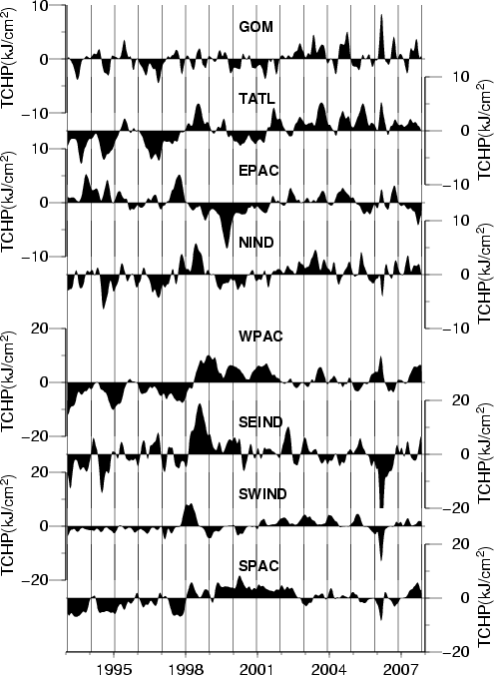
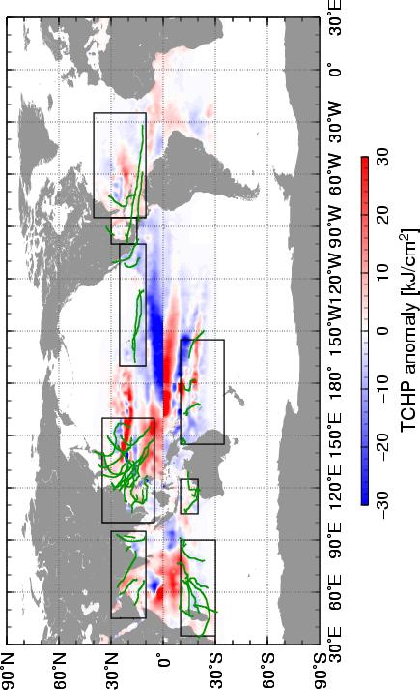

Figure 1. (left) Global anomalies of TCHP corresponding to 2007 computed as described in the text. The boxes indicate the seven regions where TC occur: from left to right, Southwest Indian, North Indian, West Pacific, South Indian, South Pacific, East Pacific, and North Atlantic (shown as Gulf of Mexico and tropical Atlantic separately). The green lines indicate the trajectories of the tropical cyclones category 1 and above during November 2006-april 2007 in the southern hemisphere and June-November 2007 in the northern hemisphere. (right) Time series of monthly TCHP anomalies corresponding to each of the seven basins. Note that two different vertical scales are used in this figure.

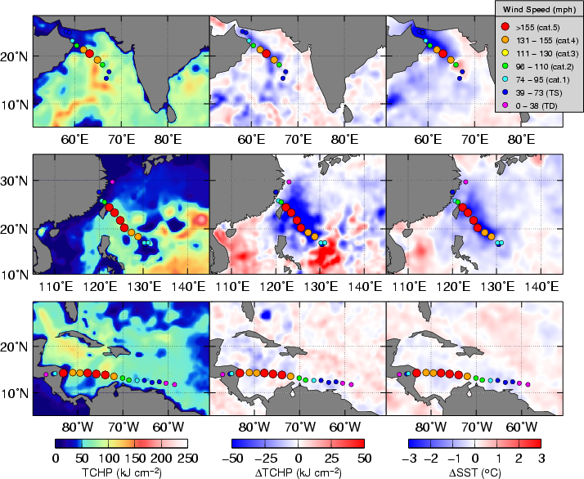

Figure 2. (left) TCHP during three 2007 TCs: Cyclone Gonu (top), Typhoon Krosa (middle) and Hurricane Felix (bottom); (center) TCHP cooling , and (right) SST cooling associated with the wake produced by each TC.

References.

Dynamics of the Brazil-Malvinas Confluence Based on Inverted Echo Sounders and Altimetry. G. Goni, S. Kamholz, S. Garzoli and D. Olson, J. Geophys. Res., 101, 16273-16289, 1996.

Effects of Warm Oceanic Features on Hurricane Opal. L. Shay, G. Goni and P. Black, Mon. Weath. Rev., 128, 131-148, 2000.

Application of Oceanic Heat Content Estimation to Operational Forecasting of Recent Atlantic Category 5 Hurricanes, M. Mainelli, M. DeMaria, L. Shay and G. Goni, Weather and Forecasting, in press, 2008.

