Monitoring and Assessing Implications of the Deepwater Horizon Oil Spill:
Potential Impacts of the Loop Current on Downstream Marine Ecosystems in the
Gulf of Mexico and Florida Straits.

NF-10-13-DWHLC
Mission Summary Report

Miami July 26, 2010.

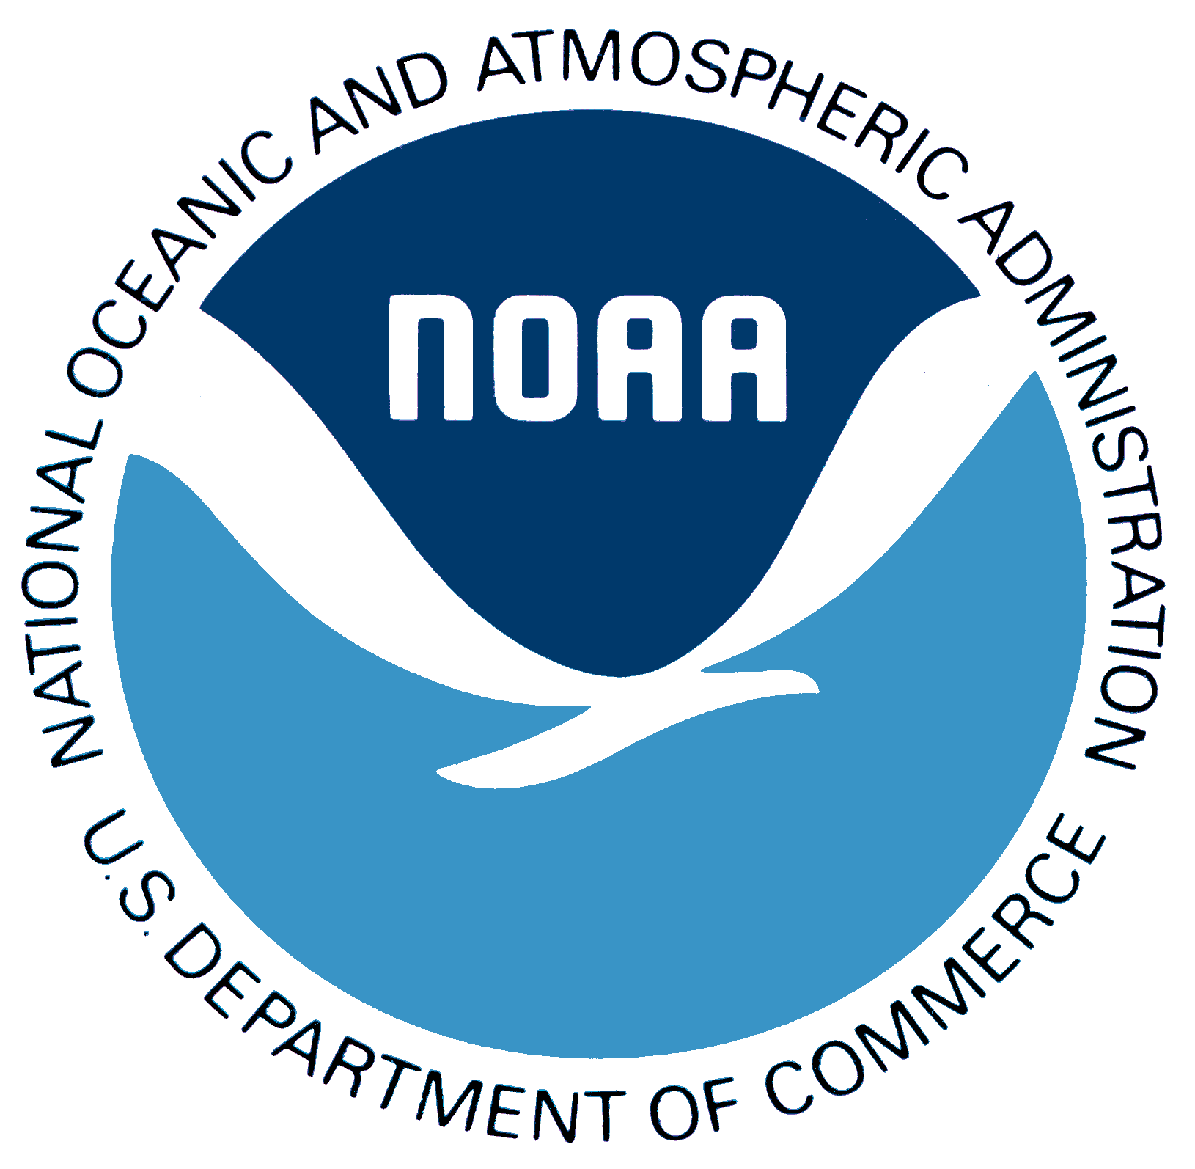

Project Participants:
Dr. Gustavo Goni (AOML/PhOD); Gustavo.Goni@noaa.gov; 305-361-4339
Dr. Michelle Wood (AOML/OCD); Michelle.Wood@noaa.gov; 305-361-4374
Mr. Ryan Smith (AOML/PhOD); Ryan.Smith@noaa.gov; 305-361-4328
Dr. Molly Baringer (AOML/PhOD); Molly.Baringer@noaa.gov; 305-361-4306
Dr. Chris Kelble (AOML/OCD); Chris.Kelble@noaa.gov; 305-361-4330
Dr. Rick Lumpkin (AOML/PhOD); Rick.Lumpkin@noaa.gov; 305-361-4513
Dr. Libby Johns (AOML/PhOD); Libby.Johns@noaa.gov; 305-361-4360
Mr. Shailer Cummings (AOML/OCD); Shailer.Cummings@noaa.gov; 305-361-4385
Dr. John Lamkin (SEFSC/ELH); John.Lamkin@noaa.gov, 305-361-4226

Executive Summary

As part of NOAA’s response to the Deepwater Horizon oil spill, interdisciplinary measurements were conducted in the Gulf of Mexico from the NOAA Ship Nancy Foster, between June 30 and July 18, 2010 (Figure 1). The objectives are detailed below. Personnel and existing assets from NOAA’s Atlantic Oceanographic and Meteorological Laboratory (AOML), Southeast Fisheries Science Center (SEFSC), and Subsurface Monitoring Unit (SMU) participated in support of this mission. This mission summary reports the initial findings based on the oceanographic and chemical observations obtained during the cruise. A more detail cruise report and results and analyses from biological observations will be submitted at a later date.

The Loop Current (LC) and eddies in the Gulf of Mexico redistribute waters in the water column and, therefore, serve to transport surface and subsurface oil and tar balls. Consequently, monitoring the ocean dynamics is key to better understanding the pathways of oil and identifying the areas that can be affected by the oil spill. The assessments performed during this cruise will help to determine how oil, dispersants, and tar balls are spreading through the water column, interacting with the Gulf of Mexico LC system, and potentially threatening the sensitive coastal ecosystems of the Gulf and of the downstream far-field including the southwest Florida shelf, the Florida Keys, the Florida Straits, northern Cuba, and the Bahamas.

This mission summary reports the initial findings based on the oceanographic and chemical observations obtained during the cruise:
- The northern Gulf of Mexico, and in particular the near-field area of the oil spill did not show a direct pathway into the Loop Current. However, indirect pathways exist through the cyclonic and anticyclonic eddies in the region.
- No oil was observed in Eddy Franklin. However, this cruise only partly surveyed this eddy.
- Oil was first observed on July 17, 2010, while conducting the final section of the cruise. Surveying northward from the center of EF towards the Deepwater Horizon wellhead, readings on the Foster’s flow-through CDOM fluorometer rose at approximately 27.5°N, 88.1°W [distance in km from oil spill site].
- Tar balls were first observed at approximately 28.0°N, 88.2°W (0315z), [distance in km from oil spill site].
- [Is what is highlighted in yellow below, the other hightlight of the cruise?]

Objectives (Far and Near Fields):

- To obtain and analyze interdisciplinary observations to assess the connectivity between mesoscale features in the Gulf of Mexico, including the Loop Current and eddies, over the entire water column,
- To investigate the surface and subsurface waters pathways of waters between the northern Gulf of Mexico to the southern Gulf and the Florida Straits,
- To monitor the surface water quality with fluorometers and nets, to identify areas affected by the oil spill,
- To collect samples to determine potential oil spill impacts on phyto-, zoo-, and icthyoplankton species across the region,
- To collect samples of water for oil analysis in water masses that have a strong fluorescence signal, and to collect samples for source fingerprinting where tar balls or other visible surface oil is observed,
- To determine if SBE43 dissolved oxygen (O₂) sensors, being utilized by the scientific/response community, are providing an accurate measure of O₂ in the presence of subsurface hydrocarbons, through comparison of SBE43 sensor O₂ data with O₂ data derived from photometric Winkler titrated bottle samples.

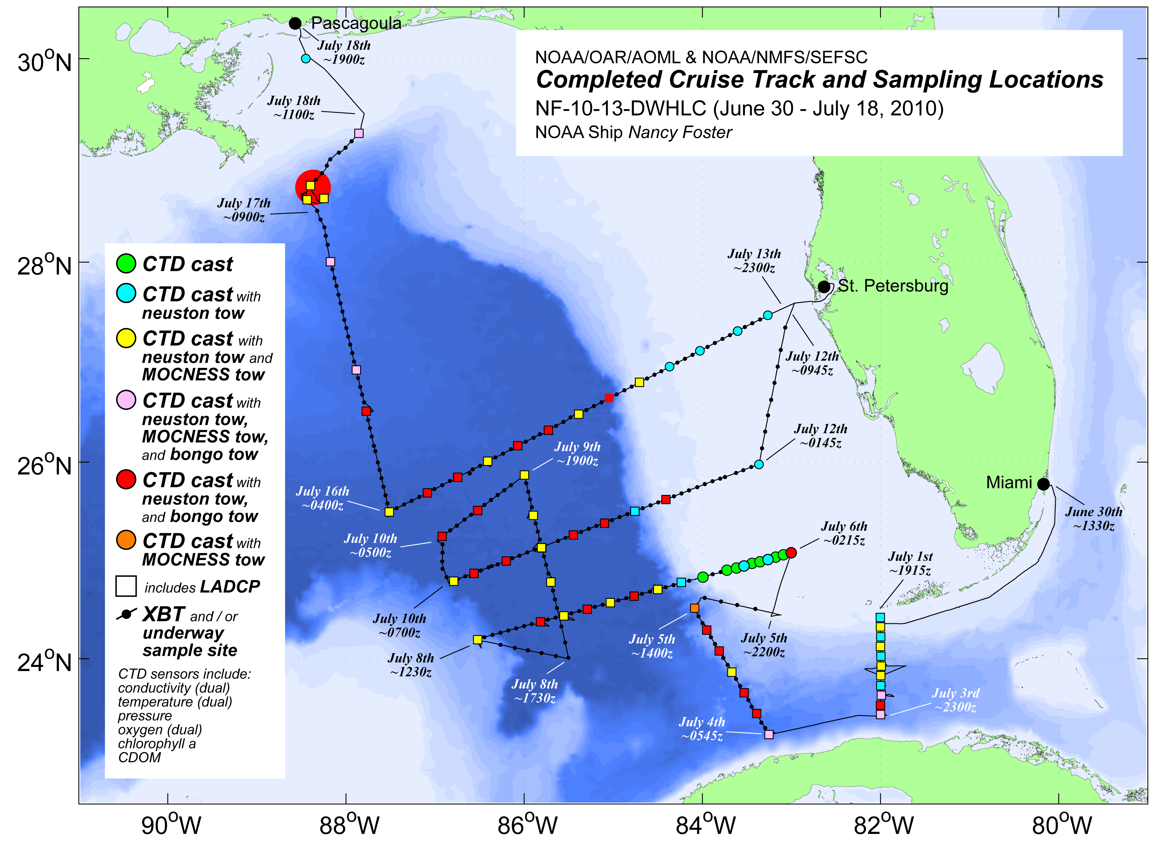

Figure 1. The completed cruise track and sampling methods and locations for NF-10-13-DWHLC are shown above. An expanded view of stations conducted in close proximity to the Deepwater Horizon wellhead may be found in Figure 4.

Background:

As part of NOAA’s response to the Deepwater Horizon oil spill, interdisciplinary measurements were conducted in the Gulf of Mexico from the NOAA Ship Nancy Foster, between June 30 and July 18, 2010 (Figure 1). The objectives are detailed below. Personnel and existing assets from NOAA’s Atlantic Oceanographic and Meteorological Laboratory (AOML), Southeast Fisheries Science Center (SEFSC), and Subsurface Monitoring Unit (SMU) participated in support of this mission. This mission summary reports the initial findings based on the oceanographic and chemical observations obtained during the cruise. A more detail cruise report and results and analyses from biological observations will be submitted at a later date.

The Loop Current (LC) and eddies in the Gulf of Mexico redistribute waters in the water column and, therefore, serve to transport surface and subsurface oil and tar balls. Consequently, monitoring the ocean dynamics is key to better understanding the pathways of oil and identifying the areas that can be affected by the oil spill. The assessments performed during this cruise will help to determine how oil, dispersants, and tar balls are spreading through the water column, interacting with the Gulf of Mexico LC system, and potentially threatening the sensitive coastal ecosystems of the Gulf and of the downstream far-field including the southwest Florida shelf, the Florida Keys, the Florida Straits, northern Cuba, and the Bahamas.

Connectivity between waters in the northern Gulf of Mexico and downstream areas such as northern Cuba, south Florida, and the Florida Keys via the LC is well documented. For example, waters from the Mississippi River have been shown to reach the Florida Keys through pathways that may or may not include the LC. If discharge from the Deepwater Horizon wellhead is entrained directly by the strongest part of the LC, significant quantities of oil could reach the downstream areas relatively quickly (on the order of days to weeks; a direct pathway). However, if this discharge is mostly contained in an LC eddy, not connected to the LC, or in Gulf of Mexico "common waters" (waters not associated with the LC or anticyclonic eddies shed by the LC), most of the oil may remain in the Gulf of Mexico and reach the far-field through more indirect pathways with the potential to ultimately affect the coasts of Texas and Mexico, the southwest Florida shelf, the Florida Keys, the Florida Straits,, the northern coast of Cuba, and the Bahamas.

Although remote sensing observations (sea surface temperature, ocean color, sea height/ocean currents) provide very useful tools to monitor surface conditions, they have limitations (for example, they measure surface parameters only) that need to be complemented by in situ targeted or sustained observations and by numerical model outputs. Since the complex surface circulation is not directly translated to the subsurface, direct measurements are needed to determine subsurface features. Satellite observations were used to guide the cruise on a daily basis. The two main features of the surface and subsurface circulation that were under particular scrutiny during this cruise were the LC and Eddy Franklin (EF), which was being shed from the LC in June and July 2010.

Interdisciplinary Observations:

A suite of interdisciplinary observations were conducted during the cruise:

- 73 Conductivity-Temperature-Depth (CTD) casts, providing continuously profiled measurements of temperature, salinity, O₂, chlorophyll a, and Chromophoric Dissolved Organic Matter (CDOM) from the surface to ~2000 m, with selected water samples at standard depths and features of interest (up to 23 Niskin bottles). Waters from various depths, collected in CTD Niskin bottles, were sampled for a suite of parameters including methane, O₂, chlorophyll a, oil, dissolved inorganic carbon, picoplankton, nutrients, and salinity.
- 57 Lowered Acoustic Doppler Current Profiler (LADCP) casts, providing a continuous profile of current velocity from the surface to ~2100 m (two LADCPs were attached to the CTD package and utilized on all deep CTD casts).
- 191 eXpendable BathyThermograph (XBT) deployments, to measure temperature profiles from the sea surface to 900 m.
- 24 surface drifter deployments, providing a Lagrangian measure of surface currents and validation of satellite analysis.
- Continuous underway hull-mounted Acoustic Doppler Profiler (SADCP) measurements, providing water velocity profiles of the upper ocean from the surface to ~200 m.
- Continuous underway measurements of sea surface temperature, salinity, chlorophyll a, and CDOM utilizing the ship’s flow-through system instrumented with a ThermoSalinoGraph (TSG), dual chlorophyll a fluorometers, and a CDOM fluorometer (CDOM fluorometers, attached to the flow-through system and the CTD, were utilized as an indicator to the presence of petroleum and to guide oil sampling).

interdisciplinary observations continued:

- 55 underway sampling locations for chlorophyll a, picoplankton, and nutrients to augment samples collected via CTD casts (samples were drawn from the ship’s flow-through system).
- Continuous visual observations conducted by the bridge watch and bird/mammal specialist during daylight hours for surface expressions of oil (tar balls, sheens, etc.).
- 69 neuston net tows, utilized for tar ball sampling and for providing a measure of pelagic fish larvae at the ocean surface (net is towed only partially submerged).
- 29 bongo net tows, providing a broader near-surface icthyoplankton sample (net is towed from the surface to 10 m).
- 28 Multiple Opening and Closing Net Environmental Sampling System (MOCNESS) tows, providing a stratified measure of icthyoplankton from the surface to 100 m.
- Continuous visual observations conducted by a bird/mammal specialist during daylight hours for marine birds and mammals (Leg II only).

Conditions in the Gulf of Mexico (Far-Field):

Multiple observations including temperature sections from XBT deployments and CTD casts, salinity sections from CTD casts, satellite (sea surface height, sea surface temperature, and ocean color) observations, surface drifters, and outputs from numerical models were used to identify and monitor the main mesoscale features. However, only the targeted in situ shipboard observations allowed for a combined assessment of the surface and subsurface conditions. All temperature and salinity sections, drifter trajectories, and maps of satellite-derived currents can be found online at AOML’s Deepwater Horizon Oil Spill Response website: http://www.aoml.noaa.gov/phod/dhos. Conditions changed continuously during the cruise, as observed from the different observations (in situ and remote) analyzed. In general, as shown in Figure 2, the Gulf of Mexico is characterized by a homogeneous warm surface layer of approximately 26°C, overlaying the mesoscale features, which is very characteristic during the summer months and which generally prevents the use of satellite-derived sea surface temperature observations to detect and monitor most mesoscale features. Synoptic conditions in the Gulf of Mexico during the cruise can be summarized as follows:

June 30th: The Nancy Foster cruise departs from Miami. Satellite imagery and numerical model products indicate that EF and the LC are partially attached at approximately 25°N, 85°W. A cyclonic eddy is located at 26.5°N, 86.5°W (to the NE of EF) and moving to the south. While attached to the LC, EF provides a direct path of waters from the northern Gulf of Mexico into the LC.

July 7: Temperature and salinity observations obtained during the cruise revealed that EF was at least partially separated from the LC. In addition, and from analyses of satellite observations, it is observed that the LC starts shedding a smaller, cyclonic ring.

July 9: EF is nearly separated from the LC, therefore reducing the probability of a direct path of waters between the northern Gulf of Mexico and the LC. In addition, the LC sheds the small eddy and recedes to the south. This is confirmed by the synoptic cruise data (SST and isotherm depths). Analyses of the dynamic height (roughly equivalent to sea height) and of the temperature and salinity sections obtained from XBT deployments and CTD casts confirm the separation at the surface and subsurface between EF and the LC. The mixed layer, characterized by homogeneous temperatures, is approximately 50m deep. The layer between 50m and 100m is also characterized by having a homogeneous value of higher salinity. The cyclonic eddy, centered at 25.2°N, 84.5°W is characterized by a domed thermocline at 24.5°N, and lower values of salinity at the surface.

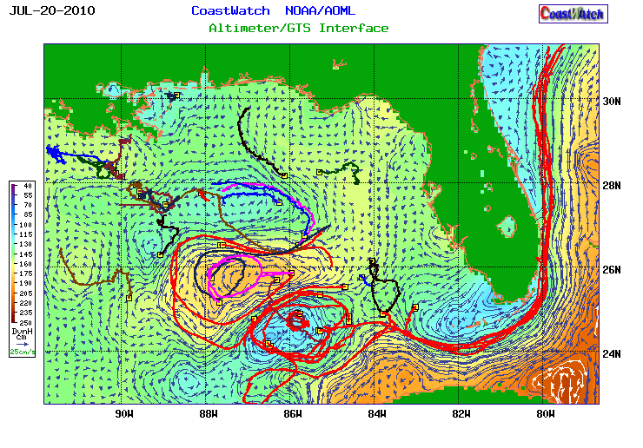

Figure 2. Drifter trajectories during the period July 1-20, superimposed on the altimeter-derived surface current map corresponding to July 20, 2010. The trajectories of drifters deployed during NF-10-13-DWHLC are shown in red. These drifters depict the main mesoscale features, such as EF, the LC, and the other smaller cyclonic and anticyclonic eddies.

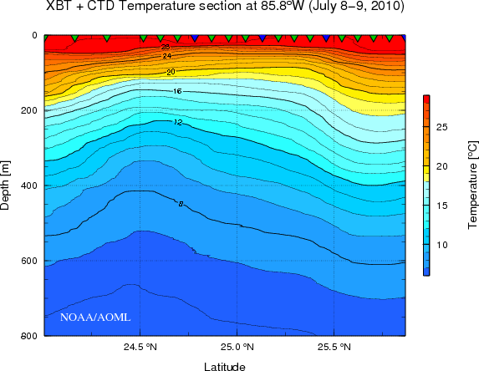
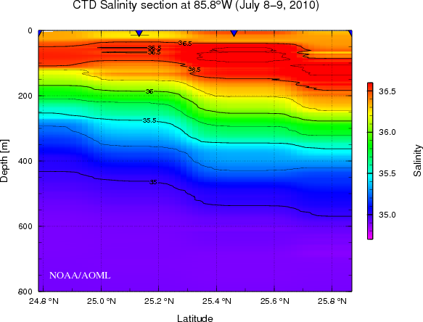

Figure 3. (left) Temperature section along meridional section, situated at approximately 85.8°W, showing proximity to the northern edge of the LC on the left (south) and EF on the right (north), which are characterized by the deepening of the isotherms. Note the shallow warm layer in the top 50 m. (right) salinity section along the same section, depicting the deeper salinity layer of EF, and the lower salinity of the cyclonic eddy center at around 25.2°N. Triangles at the top of each plot indicate the profile locations (XBT = green, CTD= blue).

July 13: Four large mesoscale features are present in the central and northern Gulf of Mexico: the LC, EF, a cyclonic eddy between them, and an anticyclonic eddy shed by the LC during July 7-9. Mixing between the edges of these features provides the connectivity between northern and central Gulf of Mexico waters and the LC. Temperature and salinity sections reveal the lack of connectivity (near 25.5°N, 84.5°W) between the newly shed anticyclonic eddy and EF. This eddy will eventually merge with EF a few days later.

July 15-19: During these days, the cruise surveyed across the northern portion of EF, which shipboard observations confirm to have a well-defined limit with the background waters. In the rest of the Gulf of Mexico, the anticyclonic ring shed by the LC merges with EF on its east side, which continues to be detached from the LC. The main mechanism for water pathways between the northern and central Gulf of Mexico waters into the LC is now mixing along the edge of EF, the cyclonic eddy and the LC. Historical data suggests that EF may either start moving to the W or NW, or reattach to the LC, which is at this time improbable because of the cyclonic eddy located between them.

Oil Observations in the Far-Field:

Throughout the far-field survey, no oil was observed or measured by sampling methods available on the NOAA Ship Nancy Foster. These methods, mentioned previously but listed again here for clarity, included:
- Surface and subsurface net tows.
- Flow-through CDOM fluorometer.
- CTD-mounted CDOM fluorometer.
- CTD-mounted dissolved oxygen sensor (dual sensors).
- Visual sighting (Weather conditions for visual sighting were extremely favorable. A majority of the far-field survey was conducted in seas of 1 foot or less).

Conditions in the Gulf of Mexico (Near-Field):

Oil was first observed on July 17, 2010, while conducting the final section of the cruise. Surveying northward from the center of EF towards the Deepwater Horizon wellhead (Figure 1), readings on the Foster’s flow-through CDOM fluorometer began to rise at approximately 27.5°N, 88.1°W (0130z). Though not during daylight hours, tar balls were first observed at approximately 28.0°N, 88.2°W (0315z), at which point the ship stopped and a CTD/LADCP cast and neuston, MOCNESS, and bongo tows were conducted (station NF-10-13-070). No tar balls were recovered from the three net tows. The CTD-mounted CDOM fluorometer did not show any indication of a subsurface hydrocarbon plume at this location, however there was a slight deviation to the broader slope of the CTD O₂ sensor profiles recorded between 800 m and 1000 m depth.

The location of these initial observations/measurements was just outside (initial CDOM signal increase) or within (station NF-10-13/070) the NOAA/ORR nearshore oil forecast boundaries for July 17th. As the Foster progressed toward the Deepwater Horizon wellhead, flow-through CDOM readings continued to increase. However, with the close proximity to the Mississippi River delta, it is unclear how much of this signal was due to natural riverine outflow versus surface contaminants associated with the oil spill. Following dawn on July 17th, intermittent surface sheens were visible across the sea surface while working around the wellhead; tar balls were not observed.

Working in coordination with SMU and other research vessels in the area, the Foster conducted three stations within close proximity to the Deepwater Horizon wellhead on July 17th (less than 20 km from the wellhead). Illustrated in Figure 4, the first station (NF-10-13/071) was conducted at a location approximately 15 km southwest of the wellhead, where the R/V Ocean Veritas observed a suspected subsurface hydrocarbon plume one day prior. The Nancy Foster also observed this subsurface feature while conducting the NF-10-13/071 CTD cast. Visible on Figure 4, a maximum subsurface CDOM voltage was recorded at approximately 1155 m. This corresponded with a sharp decrease in O₂ (observed on both CTD-mounted oxygen sensors). However, as observed on the previous station, CTD O₂ sensor measurements deviated from the broader slope of the deep O₂ profiles over a larger depth range (yielding lower values than expected). The accompanying current velocity profile for this station produced from LADCP data revealed a WNW current between 800 m and 1200 m with a magnitude of approximately 15 cm/s. Based on the location of this station in relation to the surround bathymetric features of the Mississippi Canyon (Figure 4), this flow may be influenced by topography (e.g. the salt dome immediately north of the station).

Following NF-10-13/071, a station was conducted southeast of the wellhead while awaiting SIMOPS clearance to enter the wellhead-restricted zone. The location for this station was selected based upon a July 16th model projection for deep plume trajectory (the Applied Science Associates’ SIMAP oil fate model which incorporates ADCP data from a moored instrument on the Development Driller 3 platform). While no subsurface CDOM voltage spike was apparent during the NF-10-13/072 CTD cast, O₂ profiles exhibited the same scalloped feature as observed at previous stations at a similar depth (surrounding the suspected plume associated spike on NF-10-13/071).

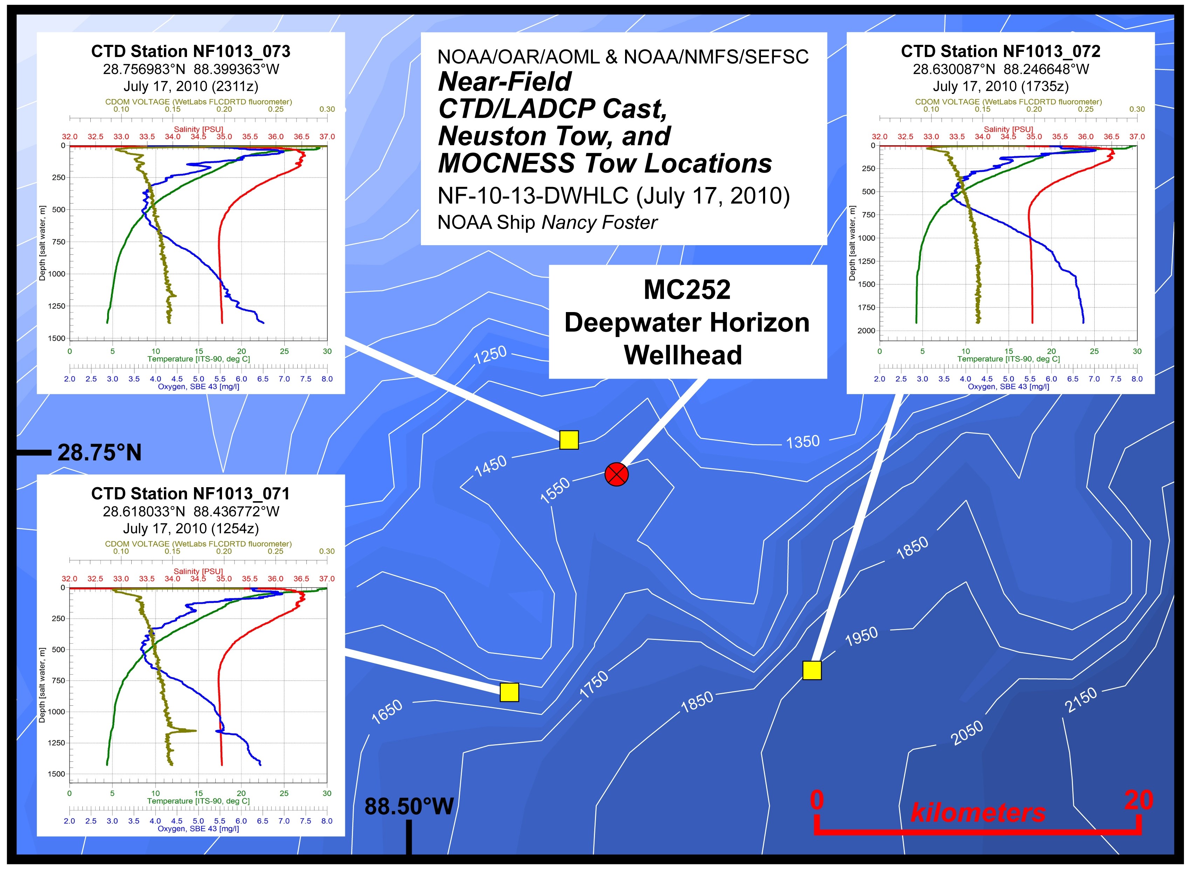

Figure 4. NF-10-13-DWHLC stations conducted on July 17, 2010 in close proximity to the Deepwater Horizon wellhead. CTD sensor profiles for each station are also shown. [Should we have a little square in Figure 1 showing where this are is ?]

Once clearance was granted for the Foster to make a closer approach to the wellhead, station NF-10-13/073 was conducted approximately 4 km northwest of the incident location over an area where seeps had previously been observed (these positions were relayed to the Foster via SMU and Tom Weber). While subsurface CDOM and O₂ sensor profiles indicated a potential subsurface plume in a manner similar to measurements at the previous near-field stations, the associated signals in the NF-10-13/073 profiles were smaller than those observed at NF-10-13/071 (approximately 11 km farther away from the wellhead), and gave no indication that the occupied location was atop an active seep.

Photometric Winkler Titrations and the SBE43 Dissolved Oxygen Sensors [do we need this subtitle?]

Throughout NF-10-13-DWHLC the two CTD-mounted SBE43 O₂ sensors were in close agreement with one another (<0.1 ml/l difference). In addition to these sensors, a photometric Winkler titration rig from AOML was in operation aboard to process bottle samples for O₂ concentration while at sea. On each CTD cast, using O₂ sensor profiles as a guide, water samples were collected over the water column to determine O₂ content via Winkler titration. At most deep stations, O₂ bottle sample density was sufficient to reconstruct an O₂ profile without use of the SBE43 sensors, with even higher sampling density around suspected subsurface hydrocarbon plumes.

Analysis of NF-10-13-DWHLC O₂ data as determined by Winkler titrated bottle samples is still underway. While no indications of subsurface hydrocarbon plumes were observed in the far-field, and only a limited number of stations were conducted in close proximity of the wellhead, preliminary results from the NF-10-13-DWHLC Winkler O₂ data suggest that the SBE43 sensors are accurately recording O₂ concentration in the suspected presence of subsurface hydrocarbon plumes, and that a decrease in O₂ is associated with these features. [see question below, the last bullet of conclusions]

Following oil sample analyses, being performed by Louisiana State University and the University of South Florida, a comprehensive comparison between the resulting hydrocarbon data and sensor O₂, Winkler titrated O₂, and CDOM values will be conducted.

Conclusions

The NOAA Ship Nancy Foster surveyed the Gulf of Mexico between June 30 and July 18, 2010; in order to investigate the connectivity between the northern Gulf and the Loop Current using in situ observations complemented by satellite data; to detect the presence of oil at the surface and subsurface and of tar balls using in situ measurements; and to obtain a suite of interdisciplinary (physical, chemical, and biological) observations to provide information of potential impacts of the oil spill in the near and far fields. This mission summary reports the initial findings based on the oceanographic and chemical observations obtained during the cruise:
- The northern Gulf of Mexico, and in particular the near-field area of the oil spill did not show a direct pathway towards the Loop Current. However, indirect pathways exist through the cyclonic and anticyclonic eddies in the region.
- No oil was observed in Eddy Franklin. However, this cruise only partly surveyed this eddy.
- Oil was first observed on July 17, 2010, while conducting the final section of the cruise. Surveying northward from the center of EF towards the Deepwater Horizon wellhead, readings on the Foster’s flow-through CDOM fluorometer rose at approximately 27.5°N, 88.1°W.
- Tar balls were first observed at approximately 28.0°N, 88.2°W (0315z).
- [Is what is highlighted in yellow, the other hightlight of the cruise/]

Maybe a little bit more wrap-up here?

Also, we might want to say that in addition to the biology results coming, additional physical results will be coming too! Maybe we can reword the end of the first paragraph on the first page, but space up there is tight!

This mission summary report was prepared by:
Ryan Smith, Ryan.Smith@noaa.gov, 305-361-4328
Gustavo Jorge Goni, Gustavo.Goni@noaa.gov, 305-361-4339
Elizabeth Johns, Libby.Johns@noaa.gov, 305-361-4360
Michelle Wood, Michelle.Wood@noaa.gov, 305-361-4374

