FY 2009 Work Plan

Project Title: Ship of Opportunity Program (SOOP), Volunteer Observing Ships, Expendable Bathythermograph (XBT) and Environmental Data Acquisition Program

Dates of Performance: October 1, 2008 – September 30, 2009

Project Managers: Gustavo J. Goni, Molly O. Baringer, and Silvia L. Garzoli
NOAA/AOML/PHOD
4301 Rickenbacker Causeway
Miami FL 33149
(305)361-4338
Gustavo.Goni@noaa.gov 305-361-4339
Molly.Baringer@noaa.gov 305-361-4345
Silvia.Garzoli@noaa.gov 305-361-4338

Primary contact person for finance: Cathy Steward
Cathy.Stewad@noaa.gov (305) 361-4303

Signature for person(s) responsible/accountable

___________________________ ____________________________
Dr. Gustavo Goni Dr. Silvia Garzoli
NOAA/AOML/PHOD Director, NOAA/AOML/PHOD

____________________________ ____________________________
Cathy Steward Dr. Robert Atlas
Adminstrative Officer, AOML Director, NOAA/AOML

Ship of Opportunity Program (SOOP), Volunteer Observing Ships, Expendable Bathythermograph (XBT) and Environmental Data Acquisition Program

Principal Investigators: Gustavo J. Goni, Molly O. Baringer, and Silvia L. Garzoli

PROJECT SUMMARY

This project includes data acquisition, transmission and quality control, related to the Ship of Opportunity Program (SOOP) using volunteer merchant ships for observations of ocean and atmospheric properties. The project includes three main components:

- A system for the merchant fleet to acquire ocean and meteorological information and transmitted in real-time to users worldwide called SEAS (Shipboard Environmental Acquisition System).
- Upper ocean temperature observations using expendable bathythermographs (XBTs) deployed broadly across large ocean regions along repeated transect: the frequently repeated/low-density XBT program.
- Upper ocean temperature observations using XBTs deployed closely spaced in order to measure the mesoscale field: the high-density XBT program

PROJECT DESCRIPTION

1. SEAS System.

SEAS 2K is a Windows based real–time ship and environmental data acquisition and transmission system. The SEAS 2K software acquires atmospheric and oceanographic data. This software is employed on ships of the Ship of Opportunity Program (SOOP) Volunteer Observing Ships (VOS), and on NOAA, University-National Oceanographic Laboratory System (UNOLS), and Coast Guard vessels.

SEAS 2K is a user-friendly software that can be operated by a wide variety of users, including users with limited computer competence. The operators are members of the crew of the vessels, who are extremely busy and have little time for computer malfunctions. Thus, SEAS 2K was designed to be easy to use and thoroughly reliable. As new features are added and current features are improved upon, there is a consistent effort to follow this design philosophy.

SEAS 2K is installed on more than 400 ships of the SOOP and of the Voluntary Observing System (VOS). Over three million SEAS meteorological messages are transmitted per year constituting the largest source of marine meteorological observations, which are used in weather forecast prediction models and analysis, such as the National Hurricane Center. Approximately twenty ships of the SOOP participate with NOAA/AOML in deploying about 13,000 XBTs per year using SEAS 2K software. NOAA/AOML and Scripps Institution of Oceanography are the principal users of the software. National Marine Fisheries Service also runs an Antarctic line (AX22) using this software.

These data are transmitted in real-time to the Gateway Telecommunication System (GTS) and to operational databases to be used by scientists. These data are used for ENSO monitoring and prediction and the initialization of climate models at centers for environmental prediction and in delayed mode for research related to seasonal to decadal climate studies of the upper ocean thermal layer. There are no restrictions on sharing this information as it is distributed in real time on the GTS.

Additionally, SEAS 2K software creates a series of reports, which describe point of departure, route and arrival of a ship. These reports are transmitted using Standard-C and include ships in a real-time search and rescue database.

2. Frequently Repeated/Low-Density XBT Operations.

There are three main modes of deployment of XBT probes: Low Density (LD), Frequently Repeated (FR) and High Density (HD) (Table I). Most of the probes used in this work are Sippican Deep Blue, which reach depths between 750 and 800m.

Frequently repeated (FR) XBT transects are mostly located in tropical regions. These lines typically run north/south, and cross the equator or intersect the low latitude eastern boundary. These transects are geared to monitor strong seasonal to interannual variability in the presence of intra-seasonal oscillations and other small-scale geophysical noise. They are intended to capture the large-scale thermal response to changes in equatorial and extra-equatorial winds. Sampling is ideally on an exactly repeating track to allow separation of temporal and spatial variability, although some spread is possible and always expected. These lines are preferably covered 18 times per year with an XBT drop every approximately 150 km (or 6 deployments per day). This mode of sampling intends to draw a balance between the spatial undersampling, with good temporal sampling inherent in LD deployments and the good spatial sampling, marginal temporal sampling of HD deployments. Increasing both the temporal and spatial sampling in frequently repeated transects relative to low-density sampling greatly decreases the risk of aliasing in equatorial regions.

The LD or broadly spaced XBT mode is used to investigate the large-scale, low-frequency modes of climate variability, while making no attempt to resolve the energetic, mesoscale eddies that are prevalent in much of the ocean, features that are investigated by XBT transects in HD mode. Sampling in LD mode has been the dominant mode in the early days of the SOOP network. The current LD network is comprised of data usually from SOOP XBT lines around the globe, where sampling is done on a monthly basis, with four XBT deployments per day along the track of the ship. Occasionally these lines are also sampled through basic research and operational experiments in which XBTs are deployed to observe various oceanographic processes.

MODE | Spacing | Frequency
Low Density (LD) | ~ 250 km | 12 times per year
Frequently Repeated (FR) | ~ 150 km | 18 times per year
High Density (HD) | ~25 km | 4 times per year
Table I. Spacing and frequency sampling of the three different modes of XBT deployment.

AOML maintains several of the recommended FR and LD transects (Figure 1), with some of them operated in cooperation with international partners from France, Australia, and Noumea. All FR and LD transects lead by the U. S. utilizes SEAS 2K software.

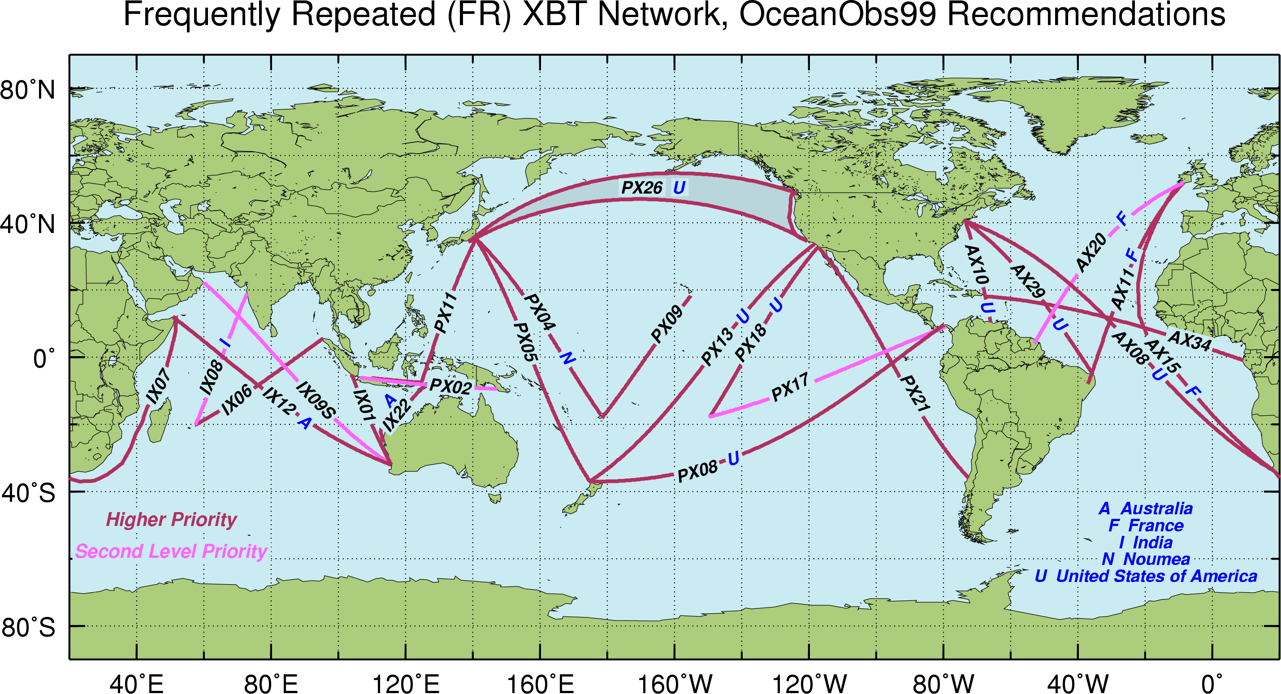

Figure 1. Location of Frequently Repeated and Low Density XBT network recommended by the 1999 Upper Ocean Thermal Review Panel. The blue letters indicate the country that leads the effort of each transect.

3. High Density XBT Operations.

This program is designed to measure the upper ocean thermal structure in key regions of the Atlantic Ocean (Figure 2). XBTs in HD mode are deployed approximately every three months and are deployed approximately 25 km apart (Table I) in order to measure the mesoscale structure of the ocean to diagnose the ocean circulation responsible for redistributing heat and other water properties globally. This transects are carried globally (Figure 2), with AOML taking the lead in the operations in the Atlantic Ocean.

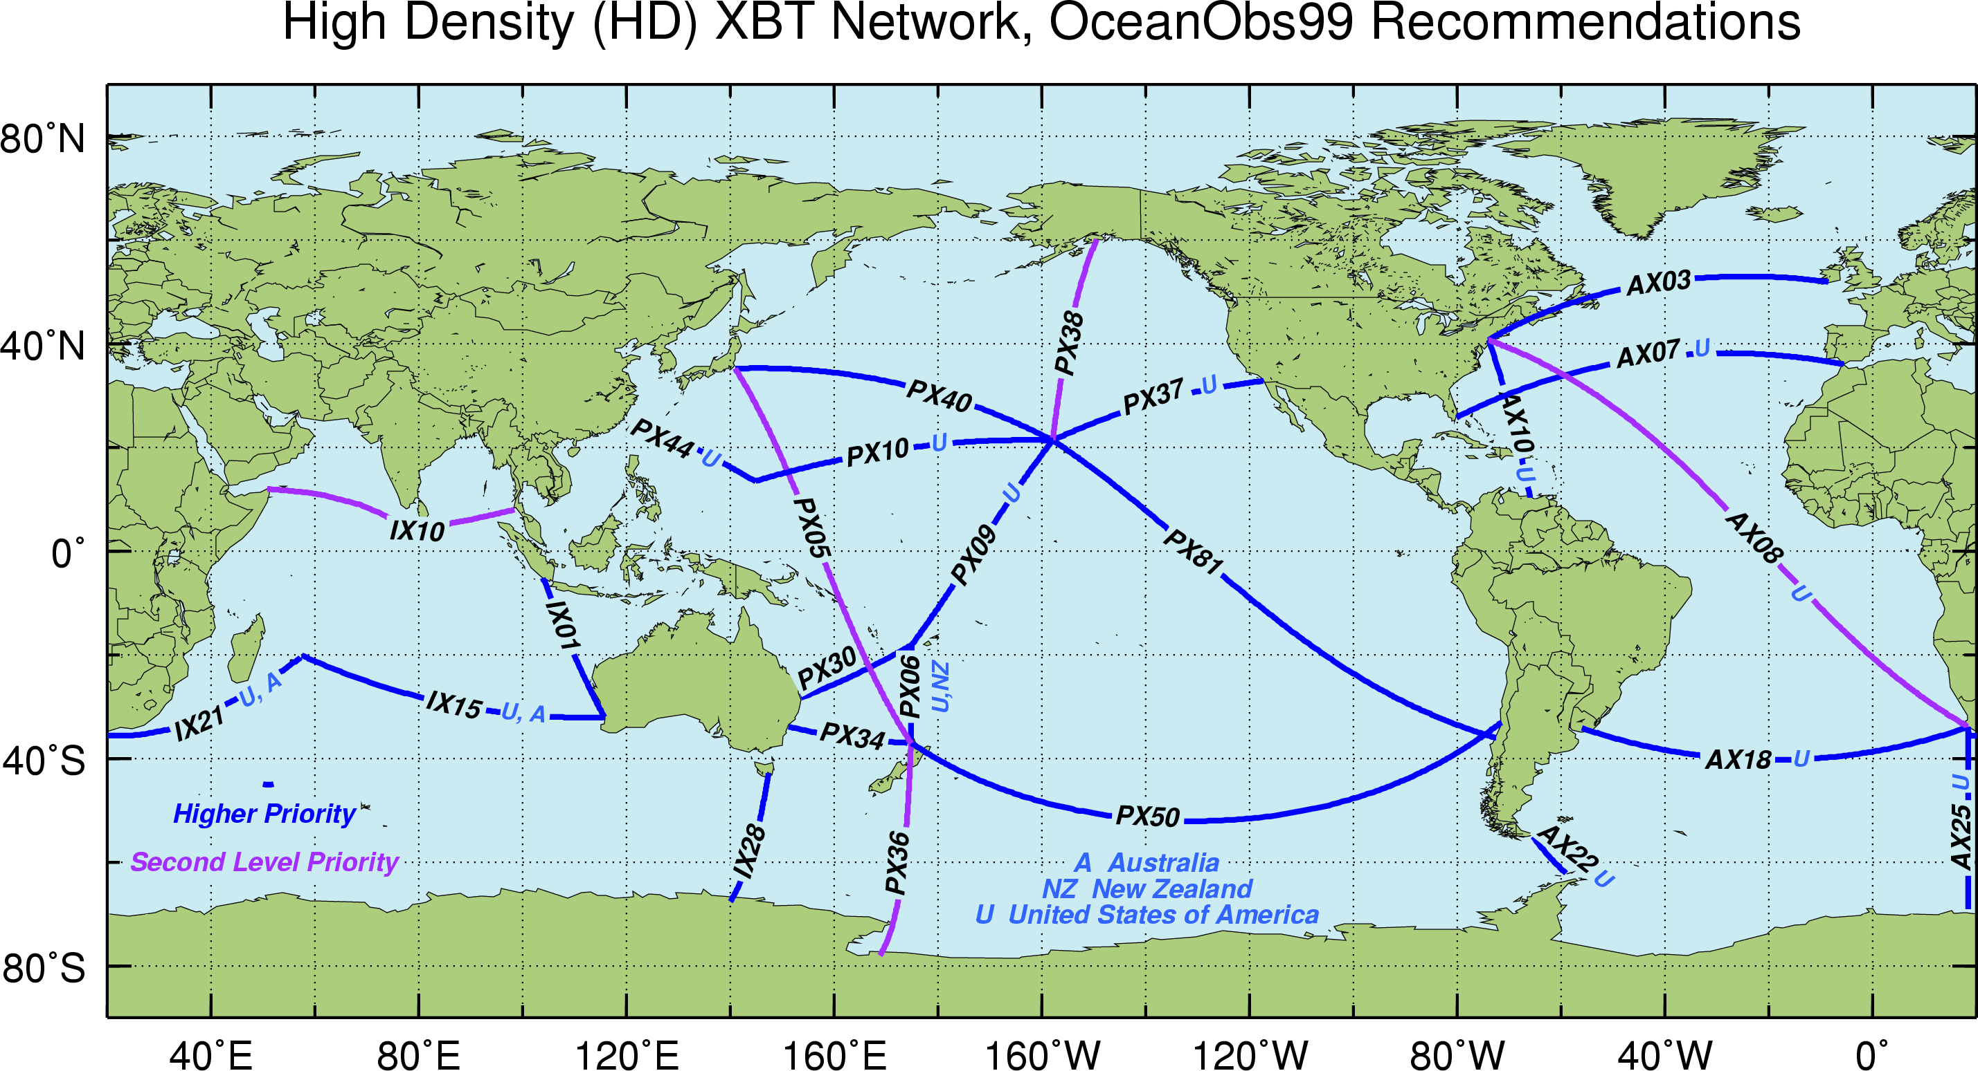

Figure 2. Location of the recommended Low Density/Frequently Repeated XBT network recommended by the 1999 Upper Ocean Thermal Review Panel. The blue letters indicate the country that leads the effort of each transect.

4. Scientific and Operational Goals.

This project addresses both operational and scientific goals of the NOAA program for building a sustained ocean observing system for climate. Specifically, AOML manages a global XBT network that provides subsurface temperature data.

Scientific Goals

The seasonal to interannual variability in upper ocean heat content and transport is monitored to understand how the ocean responds to changes in atmospheric and oceanic conditions and how the ocean response may feedback to the important climate fluctuations such as the North Atlantic Oscillation (NAO). Additional objectives of this project are to provide the resulting data to increase our understanding of the dynamics of the seasonal to interannual and decadal time scale variability and to provide data for model validation studies.

Operational Goals

The data resulting from this project helps to document the ocean heat storage and global transport of heat and fresh water, which is crucial to improving climate prediction models that are initialized with temperature profiles. One primary objective of the AOML XBT component of the internationally coordinated Ship of Opportunity Program (SOOP) is to provide oceanographic data needed to initialize the operational climate forecasts prepared by NCEP. Global coverage is now required as the forecast models not only simulate Pacific conditions but global conditions to improve prediction skill.

5. Rationale

Data from these transects have been used extensively (Meyers et al, 1991; Taft and Kessler, 1991; Goni and Baringer, 2002). For example, the scales of mode water and the distribution and circulation of associated water properties can be readily captured by LD/FRX sampling (Hanawa and Yoritaka, 1999). XBT data are also used in ocean analysis and in climate model initialization. For instance, for El Nino prediction XBT data complement that from the TAO array and from satellite-derived sea surface temperature and sea height observations. The use of XBT data serves to measure the seasonal and interannual fluctuations in the upper layer heat storage, now being complemented by profiling float measurements. Heat transport and geostrophic ocean circulation can be measured using the high-density XBT data that measures the meso-scale field.

Within this context, five XBT transects have been chosen to monitor properties in the upper layers of the Atlantic Ocean in HD mode (Figure 3). The continuation of AX07 and AX10 and the implementation of AX08 and AX18 were recommended by the Upper Ocean Thermal Review Panel in St. Raphael in 1999. The location of the transects recommended at the St. Raphael meeting and the GCOS Implementation Plan (GCOS-92) are based on specific advantages of each lines location. HD transects AX07 and AX10 have been maintained since 1994 and 1996, respectively, providing a homogeneous data set for more than a decade. Sustained observations from these and the other three HD transects are required to have observations with adequate spatial and temporal resolution for climate studies. High-density observations in AX08, AX18, AX25, and AX97 provide observations in poorly surveyed regions. A summary of the justification for each of the HD transect is provided below.

- The HD XBT transect AX07 is located nominally along 30°N extending from the Straits of Gibraltar in the eastern Atlantic to the east coast of the United States at Miami, Florida. This latitude is ideal for monitoring heat flux variability in the Atlantic because it lies near the center of the subtropical gyre, which has been shown to be the latitude of the maximum poleward heat flux in the Atlantic Ocean.

- The HD XBT transect AX10 is located between New York City and Puerto Rico. This line closes off the United States eastern seaboard, where subtropical temperature anomalies could have the greatest interaction with the atmosphere. This transect was chosen to monitor the location of the Gulf Stream and its link to the NAO.

- The HD XBT transect AX08, a component of the Tropical Atlantic Observing System, crosses the tropical Atlantic in a NW-SE direction between North America and South Africa. Historical data along AX08 and other historical temperature observations in the tropics exhibit decadal and multi-decadal signals. It has been hypothesized that this large time scale signal may cause atmospheric variability. Given the importance of the tropical Atlantic in climate variability, and the scarcity of observations in this region, data obtained from the measurements along this transect are key to improving our understanding of the ocean and our ability to forecast climate. Temperature profiles obtained from this transect will help to monitor the main zonal currents, countercurrents and undercurrents in the tropical Atlantic and to investigate their spatial and temporal variability.

- The HD XBT transect AX18, which runs between Cape Town and South America (Montevideo, Uruguay, or Buenos Aires, Argentina) is geared towards improving the current climate observing system in the South Atlantic, a region of poor data coverage. Similarly to the AX07 transect in the North Atlantic, the goal of AX18 is to monitor the meridional mass and heat transport in the upper 800 m across 30ºS. Given the importance of the South Atlantic and the scarcity of observations in this region, data obtained from the measurements along this transect will be used to investigate the role of the South Atlantic in improving climate forecasts.

- The HD XBT transect AX25 was implemented to monitor the variability in the upper layer interocean exchanges between South Africa and Antarctica on seasonal and interannual time scales. In addition, by exploiting the relationship between upper ocean temperature and dynamic height, XBTs are used to infer velocities and to monitor the various frontal locations in the region.

- The HD XBT transect AX97 supports the MOVAR (from the Portuguese: Monitoring the upper ocean transport variability in the western South Atlantic) Project. The fluctuations of the zonally integrated baroclinic transport across this transect will be studied and linked to the variability of the Brazil-Malvinas frontal region. This region is critical since Brazil Current rings are the main mechanism to carry subtropical waters to high latitudes.
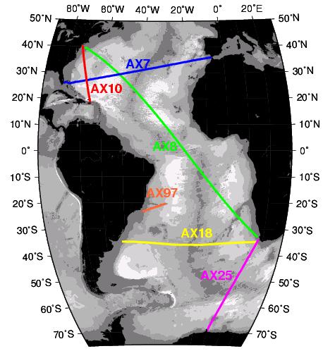

Figure 3. Location of the four High Density transects (AX07, AX08, AX10, and AX18) maintained by NOAA/AOML, and the two transects (AX25 and AX97) maintained in collaboration with the University of Cape Town and the Federal University of Rio Grande, respectively.

6. Partnerships.

AOML maintains several XBT transects and other components of the SEAS operations with the collaboration of domestic and international partners, in order to lower costs and increase efficiency. This collaboration is carried by:
- Providing probes to oceanographic institutions that have demonstrated reliability in logistics and operations,
- Provide software maintenance,
- Contracting riders (HD transects only) to deploy the probes,
- Providing equipment (computers, antennas, etc) and software, and
- Carrying joint analysis of the data.

7. Data Availability and Project Web Sites.

Details of this project, such as logistics, equipment, software, and data distribution, are provided through links that can be accessed through the main NOAA/AOML Global Ocean Observing System (GOOS) web page www.aoml.noaa.gov/phod/goos.

- SEAS: http://www.aoml.noaa.gov/phod/trinanes/SEAS/
- HD: http://www.aoml.noaa.gov/phod/hdenxbt
- FR/LD: http://www.aoml.noaa.gov/phod/goos/ldenxbt

Data from the LD, FRX and most HD deployments are transmitted to the GTS and made available in real-time for operational climate forecast and analyses. Data from the international collaboration are not always available in real-time. HD data is also made available on the project web site listed above.

FY 2009 Work Plan

General

AOML will continue with the XBT operations as carried out in previous years, with special emphasis in reaching the goals for FR and HD transects, and to make these operations more efficient. The work with the international collaborators will be continued to have their data inserted into the GTS. The ratio of deployed versus transmitted data is expected to remain close to 100%. Work will continue in developing the standards for BUFR and metadata. AOML will finalize the data visual quality control transfer to Miami and make the data tracking almost fully automatic with minimal intervention of the operator. Work will be continued to finalize the construction of an autolauncher designed to deploy Deep XBT probes. Gustavo Goni will take the lead in the evaluation and recommendations of the global XBT network. Tests with Iridium will continue for XBT and TSG transmissions. Contractors will continue to provide support in the west coast of the US for LD/FR transects, and with riders for support with HD transects.

Scientific contribution

Although this proposal is funded to conduct fieldwork and data collection, Gustavo Goni, Molly Baringer and Silvia Garzoli will continue with the data analysis. The continued measurements of the western boundary currents will help scientists to:
- Monitor for abrupt climate change,
- Understand natural climate variability, and
- Determine heat, fresh, and volume transports of two major components of the thermohaline circulation.

FY 2009 Budget Justification

AOML Cost Sharing

NOAA/AOML maintains a high level of AOML contributed salary for the SEAS and LD/FRX and HD components of this program through legacy support provided when this project was part of NOS.

This project is directed by the PIs: Drs. Silvia Garzoli, Molly Baringer and Gustavo Goni, with AOML contributing with 9 mm of their salaries. The AOML contribution also includes 12 mm for SEAS software maintenance and upgrades (Janet Roseli), 12mm to support data transmission and data base (Paul Chinn). The AOML support also include 2mm for data base maintenance (Reyna Sabina), 4mm computer support (Jessie Harris), 9mm of ship support and logistics (James Farrington), 4mm of hardware development (Ulises Rivero), 1mm of hardware development (Pedro Pena), 1mm hardware support (Andre Stefanik), 4mm of HD data processing and analysis (Yeun-Ho Daneshzadeh), and 1mm of logistics support (Robert Roddy).

Requested Funds

AOML requests support to cover a contract for data tracking, and to provide guidance in the transition of XBT visual quality control and equipment procurement (Gary Soneira). 12 mm are requested for Ms. Sommyr Pochan and Mr. Juan Delgado. Ms Pochan is a CIMAS employee in charge of logistics for XBT and TSG operations, monitoring XBT goals, and XBT inventory. Mr. Juan Delgado is transitioning the AOML visual and automatic quality control operations and will be working in establishing BUFR transmissions with Dr. Trinanes. 3mm of salary are requested for Dr. Joaquin Trinanes, who is in charge of developing and maintaining software for data monitoring. Dr. Francis Bringas is performing data tracking and developing software for this purpose, and maintains the GOOS web pages and will be a rider in HD transects. Dr. Bringas is in charge of transitioning TSG transmissions into BUFR format. Salary is requested for Kyle Seaton (1.5mm), Pedro Pena (1.5mm), Andrew Stefanik (1mm), and Ulises Rivero (1mm) to work in hardware development and maintenance, including Iridium transmissions. Salary is requested for Pedro DiNezio (3mm) for his work as a HD rider and for data analysis.

This project supports, partially or totally, a large number of Federal Full Time Employees (FTEs) and CIMAS employees:
Number of Federal FTEs supported by this funding: 7
Number of non-Federal FTEs supported by this funding: 12
Number of Federal FTEs working at no cost to the project: 11
Number of non-Federal FTEs working at no cost to the project: 1

Contractors are used on the west coast to reduce ship-greeting expenses that would be incurred if AOML personnel performed this function and to provide storage facilities for XBTs, which serves to reduce shipping costs. Contracts are given to the Olympus Company in Seattle, Washington ($25,500) and Santa Clara Marine Institute (SCMI, $20,000) and contractors hired on an as needed basis (i.e., Olympus or SCMI personnel are not available) to perform this function for PX08, PX13, PX10, PX37, PX44, PX26, which are occupied by ships that embark and disembark from Seattle and Los Angeles.

The total amount of probes needed for the FR/LD operations is 3808 ($144,704): 3410 ($129,580) to maintain current operations in HD mode, and 1782 ($67,716) for international collaboration. The FR/LD/HD probes also include the collaboration effort with the pCO2 project.

The shipping costs are related to those corresponding to ship XBTs to Norfolk (James Farrington) and to our contractors in the west coast. The cost to ship XBTs to the international collaborators are now paid by them.

Travel funds are requested to support the HD operations and FR/LD in the NE coast, to cover the greeting and loading of ships in the AX08 and AX10 transects, and travel for AOML contractors carrying AX08, AX18 transects; and AOML and CIMAS employees carrying out AX10 and AX07 transects. Two trips each year from Miami to DC for Dr. Goni and/or Dr. Bringas ($750 each). Taking into account current expenditure, the operational travel costs amount to approximately $68,850. Funds are requested for travel as follows: One trip from Silver Spring to Miami for a three-day AOML/GOOS meeting to pay for Paul Chinn, Gary Soneira, Janet Roseli and Jim Farrington (from Silver Spring/Norfolk to Miami, $1,600 each). Two trips for the OceansObs09 meeting to be held in Venice in September 2009 are requested for G. Goni and M. Baringer at $3000 each. One trip is requested for G. Goni to attend the SOOPIP meeting in Geneva in May 2009 at a cost of $3000.

Overtime is requested for HD cruises in the amount of $53,824. Riders in AX18, AX25 and some AX08 transects are done by international collaborators from Argentina and South Africa. The contract for all riders amount $40,000.

Agent fees include handling of XBT shipments, meeting the ship rider, helping with customs and port entry in host countries and is based on FY 2008 expenses ($5000). Communication costs for $4,000 include the test transmissions done with Iridium.

Gradual replacement of the existing systems is required as equipment fails. This cost is included for SEAS2K MK21, computer, wires, connections, antennas, modems, etc.

CTD repairs ($4000), and calibrations ($4,000) are required for the R/V Walton Smith CTD cruises in support of the AX07 heat transport HD transect that occurs each quarter: these cruises measure the boundary current transport which is necessary for heat transport estimates. Cruise supplies and miscellaneous repairs ($8,000) include weights and repairs for dropsonde related cruises in support of the AX07 HD transect, replacement cables for the autolauncher, printer supplies and other miscellaneous costs.

FY 2009 Budget
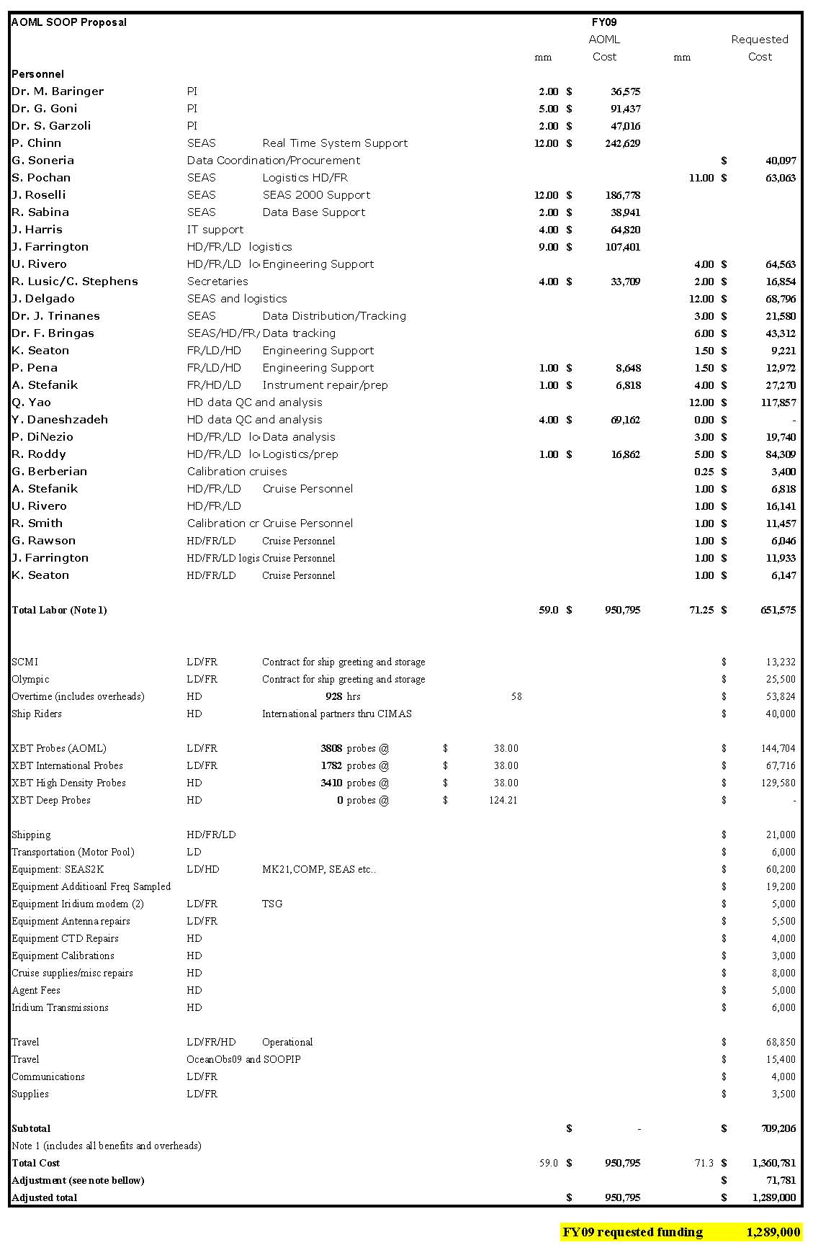
Note: In order to submit a budget at FY2008 level, the amount of $71,781 had to be subtracted from the required funding needed to carry the proposed work. The level funding will be reached by reducing the number of XBT probes used in Low Density XBT operations by approximately 648 units and XBTs provided to international collaborators by approximately 1215 units. Therefore, the goals associated with deployments in LD and with deployments by the international collaborators are not expected to be reached during FY2009.

