Progress Report
Project Title: The Ship Of Opportunity Program (SOOP)

Period of Activity: 01 October 2009 – 30 September 2010

Lab Director  Robert Atlas  NOAA/AOML/OD  4301 Rickenbacker Cswy  Miami, FL 33149 | Division Director  Gustavo Jorge Goni  NOAA/AOML/PHOD  4301 Rickenbacker Cswy  Miami, FL 33149 | Financial Contact  Cathy Steward  NOAA/AOML/OD  4301 Rickenbacker Cswy  Miami, FL 33149
  Signature | Date
  Signature | Date
  Signature | Date

Principal Investigator
Gustavo Jorge Goni
NOAA/AOML/PHOD
4301 Rickenbacker Cswy
Miami, FL 33149
Signature | Date

Co-Principal Investigator  Molly Baringer  NOAA/AOML/OD  4301 Rickenbacker Cswy  Miami, FL 33149 | Co-Principal Investigator  Silvia Garzoli  NOAA/AOML/PHOD  4301 Rickenbacker Cswy  Miami, FL 33149
Table of Contents

- Project Summary 2
- Project Description and Fiscal Year 2010 Accomplishments 2

Ship Of Opportunity Program (SOOP), Volunteer Observing Ships (VOS), Expendable Bathythermograph (XBT) and Shipboard Environmental Data Acquisition System (SEAS)

1. Project Summary

As part of the Ship Of Opportunity Program (SOOP), this project continues providing the contribution to the XBT network in the form of XBT deployments from mostly cargo vessels, their data acquisition and transmission through the Shipboard Environmental Data Acquisition System (SEAS), and providing quality control, and support to other observational networks such as ThermoSalinoGraphs (TSGs), global drifter array, and Argo profiling floats. XBTs deployments supported by this project are deployed along transects recommended by the international community in two different modes: frequently repeated and high density. The SEAS component of this project is also used for the acquisition and transmission of marine meteorological observations made from the Voluntary Observing Ships (VOS).

The project includes these main components:

- A system called SEAS (Shipboard Environmental Acquisition System) for the merchant fleet to acquire ocean and meteorological information and transmit it in real-time to users worldwide;
- Upper ocean temperature observations using expendable bathythermographs (XBTs) deployed broadly across large ocean regions along repeated transect: the frequently repeated XBT program;
- Upper ocean temperature observations using XBTs deployed closely spaced in order to measure the mesoscale field: the high-density XBT program;
- Support of AOML TSG operations; and
- Support of drifter and Argo float deployment opportunities.

This project is necessary and essential to the Department of Commerce’s mission as evidenced by two of the three strategic goals that comprise the Department’s mission statement:

- Foster science and technological leadership by protecting intellectual property, enhancing technical standards, and advancing measurement science,
- Observe, protect, and manage the Earth’s resources to promote environmental stewardship.

2. SOOP Project Description and FY 2010 Developments

2.1. The SEAS System.

The Shipboard Environmental data Acquisition System (SEAS) is a Windows-based real time application that combines acquisition and transmission of environmental data collected over several platforms. The system acquires atmospheric and oceanographic data, such as meteorological, sea surface salinity and temperature. It operates on vessels of the SOOP, VOS, on NOAA vessels, University-National Oceanographic Laboratory System (UNOLS) ships, and Coast Guard vessels, to produce high quality marine weather, and oceanographic observations. NOAA and Scripps Institution of Oceanography are the principal users of the software. Additionally, SEAS creates a series of reports, which describe point of departure, route and arrival of a ship. These reports are transmitted using Standard-C and include ships in a real-time search and rescue database.

SEAS is a user-friendly software, its intuitive design is proper for users at all levels of computer experience. It improves data accuracy with extensive error checking, and allows quality control at the point of the origination of the observation. SEAS software also includes many tools and utilities to simplify operations. SEAS is installed on more than 400 ships of the VOS program to transmit over three million meteorological messages, constituting the largest source of marine meteorological observations, which are used in weather forecast prediction models and analysis, such as the National Hurricane Center. SEAS is also installed in more than 50 ships of the SOOP, which participate with NOAA/AOML in acquiring and transmitting data from approximately 13,000 XBTs per year.

The data acquired by the SEAS system are transmitted in real-time to the Global Telecommunication System (GTS) and to global data distribution centers to be used by scientists and operational centers. These data are used, for example, for ENSO monitoring and prediction, the initialization of climate models at centers for environmental prediction, and in delayed mode for research related to seasonal to decadal climate studies of the upper ocean thermal layer. There are no restrictions on sharing this information as it is distributed in real-time on the GTS.

During the FY 2010 AOML began the SEAS applications system (Figure 1) upgrade, which included several modules such SEAS Console, SEAS TSG Data Recorder, SEAS AutoIMET Data Logger, SEAS Met Observations Logger, and SEAS PC-Watchdog.

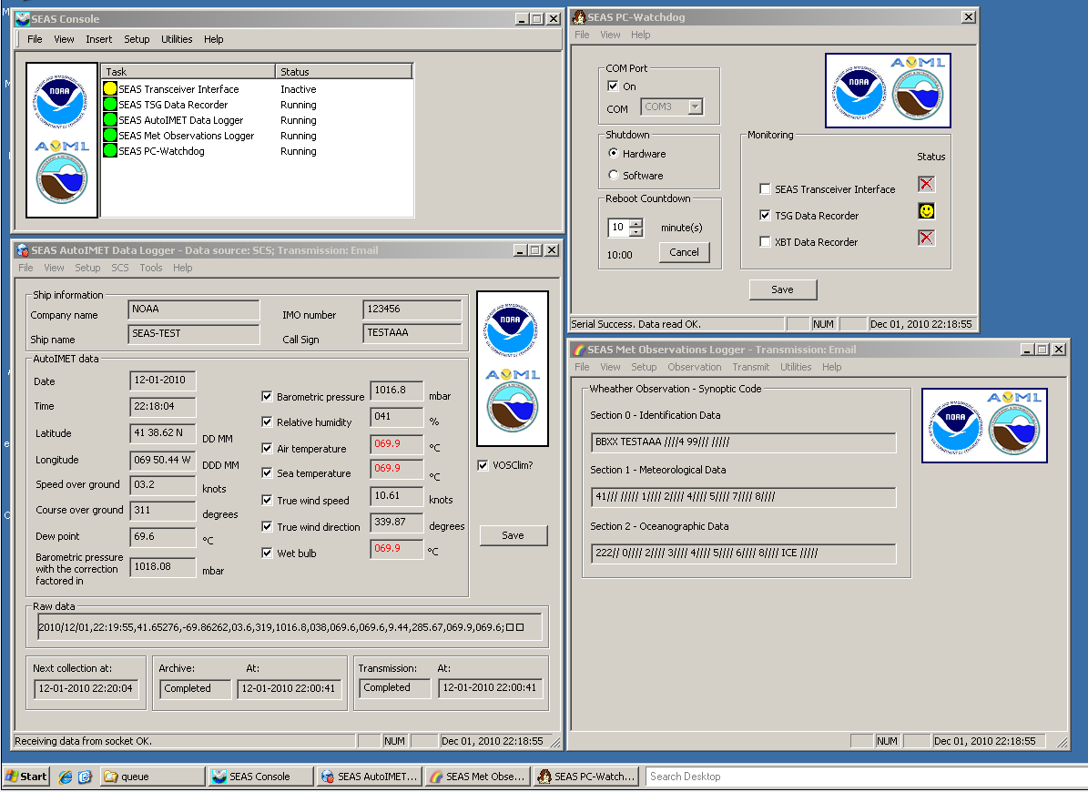

Figure 1. Several applications of SEAS system

SEAS Console

The SEAS Console is the interface to managing the SEAS programs activities. In simple terms, it is a utility where all the SEAS applications management functions are found. A new AmberSEAS console was created with the following benefits:
• Task orientation. This tool is used to work with the SEAS Console and its application oriented.
• Integration. In this new version the user interface for the management of all tasks is held in a single console.
• Extensibility. Developers can now easily extend the base functionality of the SEAS Console, allowing to reuse the tool without writing a lengthly computer code.
• Debugging. The software now creates a log file of error for further debugging.

SEAS TSG Data Recorder

The SEAS TSG Data Recorder (Figure 2) is a real time data acquisition, data processing, and data recording application that operates on vessels where there is a SBE45 Micro Thermosalinograph unit installed. The data recorder continuously receives the measured sea surface temperature and conductivity data over the serial port RS-232, and archives every received TSG data in a file that will be zipped at 12:00 am every day. The user can set the collection sampling interval in seconds between samples that the TSG Data Recorder takes and archives, and the transmission sampling interval in seconds between samples that the TSG Data Recorder takes and makes ready for transmition.

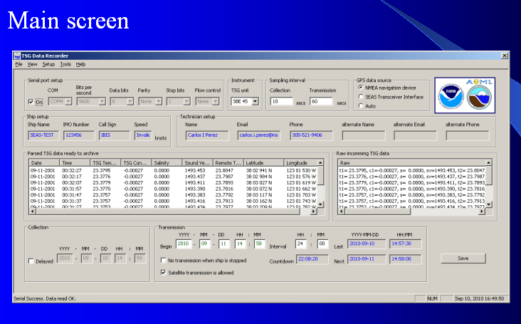

Figure 2. New main screen of the SEAS TSG Data Recorder

The improvements made to the TSG data recorder are:
- The reception and transmission of TSG data is now made in one application.
- The calibration coefficients from SBE 45 MicroTSG and SBE 38 remote temperature sensor are now read automatically.
- A new display of configuration to test if the application is able to communicate with different instruments.
- A new automatic baud rate detection, which changes the baud rate in the SBE 45 and/or SBE 38 for compatibility with the Interface Box. This automatic detection is useful for establishing communication between the instruments.
- A new automatic instrument default setup setting that reads from the .INI file the default setup, and sets the set up appropriately.

SEAS AutoIMET Data Logger

The SEAS AutoIMET (Automatic Air-Sea Interaction Meteorology system) Data Logger is a real time data acquisition, data processing, data recording, and data transmitting application that operates on the Voluntary Observing Ship Program vessels to produce high quality marine weather observations. It connects to the Scientific Computer System (SCS) using sockets to retrieve a comma delimited data stream containing the measured weather parameters (Figure 3). The software formats the parameters and feeds them to user interface for additional augmentation, to allow the marine weather observations to be quality controlled at the point of origination. The data are then transmitted on a user-determined schedule; typically on an hourly basis using the meteorological observation BBXX format.

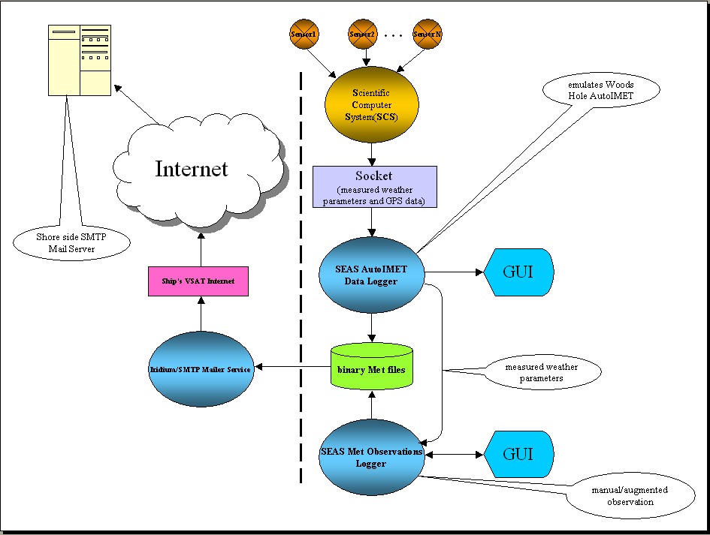

Figure 3. Meteorological Observations Logger Overview

Improvements made to the SEAS AutoIMET Data Logger include:
- Integration in only one application of the receiving meteorological data, the transmission of recorded data, and the administration of metadata,
- Setting the computer clock every few minutes to the incoming GPS time, and
- Automatic setting from UTC (Coordinated Universal Time) replace the former manual action.

SEAS Met Observations Logger

The SEAS Met(eorological) Observations Logger application is used by meteorologists to evaluate local weather conditions, and to locate and determine the strength of weather systems, such as fronts, air masses, high and low pressure systems, tropical storms, and hurricanes. Meteorological observations are made at least four times per day at 00Z, 06Z, 12Z, and 18Z. Ships are encouraged to also submit reports at 03Z, 09Z, 15Z and 21Z. This application provides accurate meteorological and oceanographic data in real time from ships at sea through the use of satellite data transmission techniques.

Improvements made to the SEAS Met Observations Logger were the result from an inter comparison of the three international used Electronic Logbooks:
- The new design applies software wizard principles making the interface something the user will enjoy working with it every day;
- A sequence of dialog boxes are presented to guide the user through a series of well defined steps; and
- The new software version includes recommended improvements given by the SOT Task Team.

SEAS PC-Watchdog

The SEAS PC-Watchdog is the ultimate application to monitor the proper operation of the SEAS components. It was designed this year to keep SEAS applications running continuously.

The benefits of the addition of the PC-Watchdog to SEAS include:
• Reducing downtime,
• Preventing acquisition data loss if the application programs stop or crash,
• Creating a log file of error for further debugging, and
• Saving the costs of dispatching a technician to remote locations to reset/reboot programs or a frozen PC.

The features of the PC-Watchdog include:
• Plain user friendly Graphic User Interface (GUI),
• Monitoring of user selected applications,
• User set up of the reboot countdown time in minutes,
• Setting of an audible and visual alarm during the reboot countdown time,
• Two way to stop the reboot countdown process:
a. The user presses the button “CANCEL”, and
b. The application recovers by itself.
•The user can choose between software or hardware automatic reset (Figure 4).

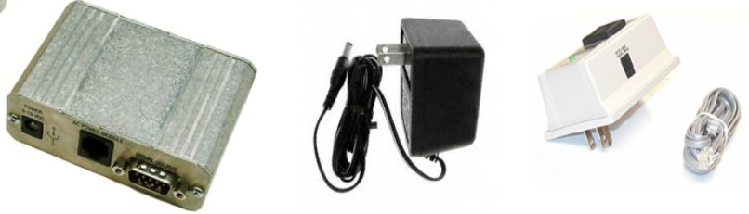

Figure 4. Hardware used with the SEAS PC-Watchdog, (left) external PC serial watchdog, (center) power cord, and (right) connectors.

In addition to the above, time and effort was spent generating high quality software documentation, including technical and user documentations. The technical software documentation, which can be thought as a reference manual, describes how an application functions and the purpose is to instruct the developer/reviewer to use the code.

2.2. XBT Operations.

There are three main modes of deployment of XBT probes: Low Density (LD), Frequently Repeated (FR) and High Density (HD) (Table I). AOML is currently focusing in FR and HD modes. Most of the probes used in this work are Sippican Deep Blue, which reach depths between 750 and 800 m. The international community has made recommendations of XBT transects (Figure 5), some of which are carried by NOAA/AOML under this project. This XBT network is maintained by the international community (Table II).

MODE | Spacing | Frequency
Low Density (LD) | ~ 250 km | 12 times per year
Frequently Repeated (FR) | ~ 150 km | 18 times per year
High Density (HD) | ~25 km | 4 times per year

Table I. Spacing and frequency sampling of the three different modes of XBT deployment.

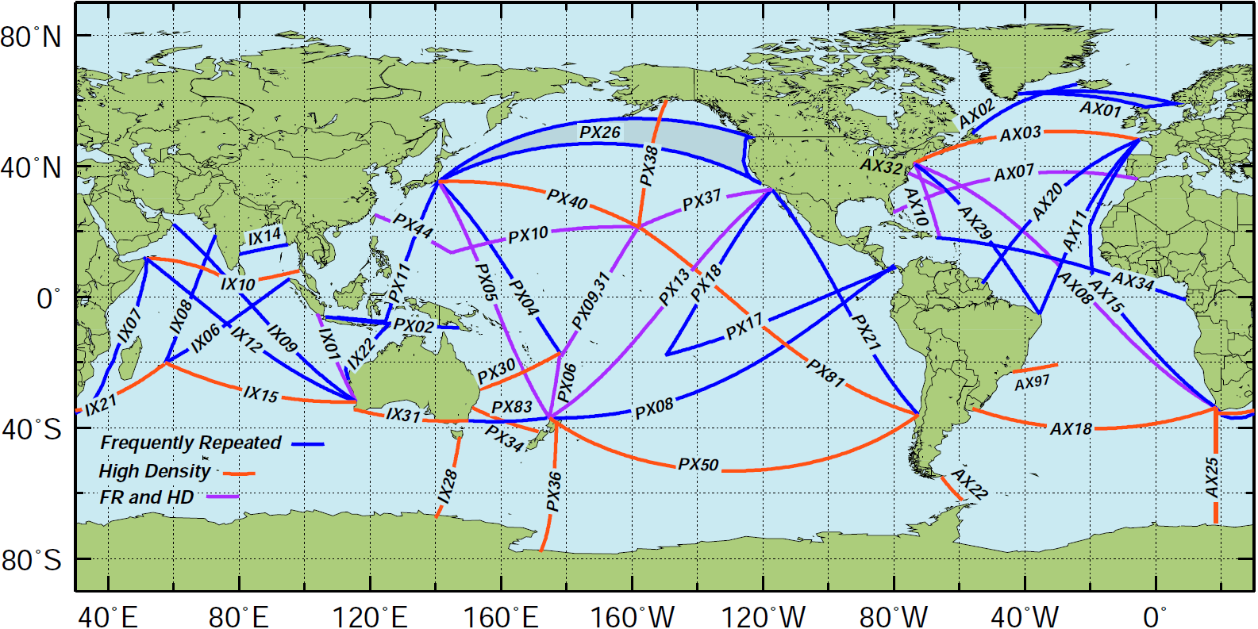

Figure 5. Location of the High Density and Frequently Repeated XBT transects recommended by OceanObs 2009. The countries leading the efforts to carry out each transect are indicated in Table II.

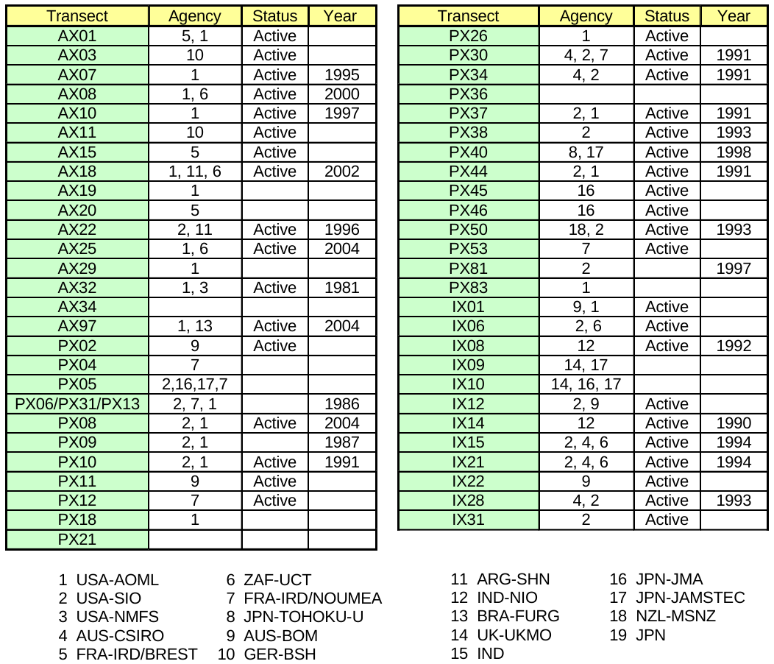

Table II. XBT transects performed by the international community, including their current status and the year in which operations on these transects started.

The XBT operations address both operational and scientific goals of the NOAA program for building a sustained ocean observing system for climate. Specifically, AOML manages a global XBT network that provides subsurface temperature data. During Fiscal Year 2009, NOAA/AOML deployed 5500 XBTs and transmitted 12,300 XBT observations through SEAS (Figure 6).

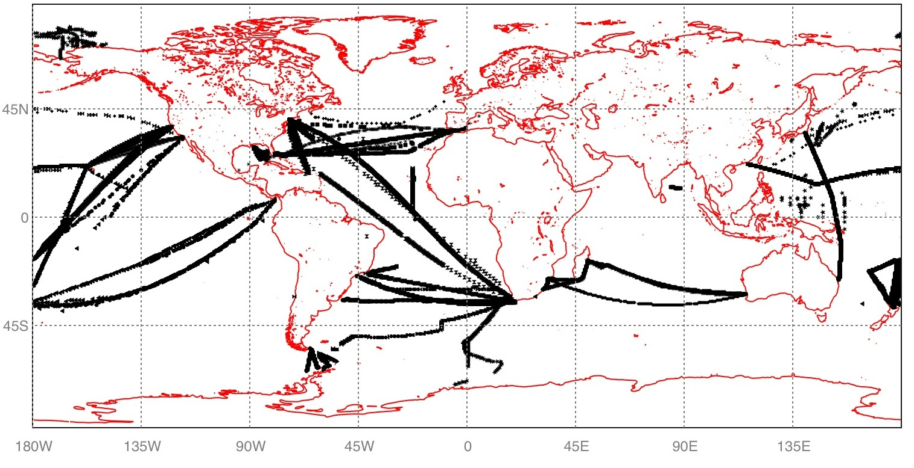

Figure 6. Location of the SEAS XBT observations received and processed by AOML during Fiscal year 2010.

Scientific and Operational Goals

The seasonal to interannual variability in upper ocean heat content and transport is monitored to understand how the ocean responds to changes in atmospheric and oceanic conditions and how the ocean response may feedback to the important climate fluctuations such as the North Atlantic Oscillation (NAO). Additional objectives of this project are to provide the resulting data to increase our understanding of the dynamics of the seasonal to interannual and decadal time scale variability and to provide data for model validation studies.

Data from XBT transects have been used extensively (Meyers et al, 1991; Taft and Kessler, 1991; Goni and Baringer, 2002). For example, the scales of mode water and the distribution and circulation of associated water properties can be readily captured by LD/FR sampling (Hanawa and Yoritaka, 1999). XBT data are also used in ocean analysis and in climate model initialization. For instance, for El Nino prediction XBT data complement that from the TAO array and from satellite-derived sea surface temperature and sea height observations. The use of XBT data serves to measure the seasonal and interannual fluctuations in the upper layer heat storage, now being complemented by profiling float measurements. Heat transport and geostrophic ocean circulation can be measured using the high-density XBT data that determines the mesoscale field.

The data resulting from this project helps to document the ocean heat storage and global transport of heat and fresh water, which is crucial to improving climate prediction models that are initialized with temperature profiles. One primary objective of the AOML XBT component of the internationally coordinated SOOPIP is to provide oceanographic data needed to initialize the operational climate forecasts prepared by NCEP. Global coverage is now required as the forecast models not only simulate Pacific conditions but global conditions to improve prediction skill.

Low Density Transects

The LD or broadly spaced XBT mode was used to investigate the large-scale, low-frequency modes of climate variability, while making no attempt to resolve the energetic, mesoscale eddies that are prevalent in much of the ocean, features that are investigated by XBT transects in HD mode. Sampling in LD mode was the dominant mode in the early days of the SOOP network. The current LD network is comprised of data usually from SOOP XBT transects around the globe, where sampling is done on a monthly basis, with four XBT deployments per day along the track of the ship. Occasionally these transects are also sampled through basic research and operational experiments in which XBTs are deployed to observe various oceanographic processes. AOML does not maintain any XBT transect in LD mode any longer.

Frequently Repeated Transects

Frequently repeated XBT transects are mostly located in tropical regions. These transects typically run north/south, and cross the equator or intersect the low latitude eastern boundary. These transects are geared to monitor strong seasonal to interannual variability in the presence of intra-seasonal oscillations and other small-scale geophysical noise. They are intended to capture the large-scale thermal response to changes in equatorial and extra-equatorial winds. Sampling is ideally on an exactly repeating track to allow separation of temporal and spatial variability, although some spread is possible and always expected. These transects are preferably covered 18 times per year with an XBT drop every approximately 150 km (or 6 deployments per day). This mode of sampling intends to draw a balance between the spatial under sampling, with good temporal sampling inherent in LD deployments and the good spatial sampling, marginal temporal sampling of HD deployments. Increasing both the temporal and spatial sampling in frequently repeated transects relative to low-density sampling greatly decreases the risk of aliasing in equatorial regions.

AOML maintains several of the recommended FR transects with some of them operated in cooperation with international partners from France, Australia, and Noumea (Table II). All FR transects lead by the U.S. utilizes SEAS 2K software.

Transect | AX10 | AX32 | AX07 | AX08 | PX10 | PX13 | PX26 | PX31 | PX08 | TOTAL
XBT  Deployments | 297 | 212 | 414 | 325 | 28 | 151 | 31 | 53 | 640 | 2151

Table III. NOAA/AOML XBT deployments in FR mode transmitted through SEAS during Fiscal Year 2010.

High Density XBT transects

This operation at AOML is designed to measure the upper ocean thermal structure in key regions of the Atlantic Ocean (Figure 7). XBT transects in HD mode are repeated approximately every three months and XBTs are deployed approximately 25 km apart (Table I) in order to measure the mesoscale structure of the ocean to diagnose the ocean circulation responsible for redistributing heat and other water properties globally. HD XBT transects are carried out globally with AOML taking the lead in most of the operations in the Atlantic Ocean.

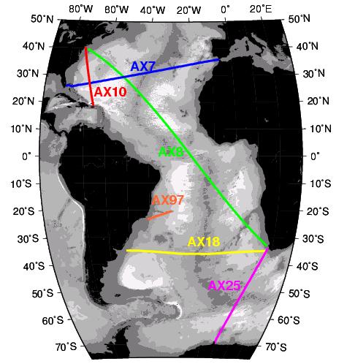

Figure 7. Location of the four High Density XBT transects (AX07, AX08, AX10, and AX18) maintained solely by NOAA/AOML, and the two transects (AX25 and AX97) maintained in collaboration with the University of Cape Town and the Federal University of Rio Grande, respectively. The recently started AX01 XBT transect carried out in collaboration with France/IRD at 60N is not included in this map.

AOML is currently carrying out seven XBT transects in HD mode to determine properties in the upper layers of the Atlantic Ocean (Figure 7). The continuation of AX07 and AX10 and the implementation of AX08 and AX18 were recommended by the Upper Ocean Thermal Review Panel in St. Raphael in 1999, and supported by OceanObs09 recommendations. The location of the transects recommended at the St. Raphael meeting and the GCOS Implementation Plan (GCOS-92) are based on specific advantages of each transect location. The HD transects AX07 and AX10 have been maintained since 1994 and 1996, respectively, providing a homogeneous data set for more than a decade. Sustained observations from these and the other three HD transects are required to have observations with adequate spatial and temporal resolution for climate studies. High-density observations in AX08, AX18, AX25, and AX97 provide observations in poorly surveyed regions. A summary of the justification for each of the HD transect is provided below.

- The HD XBT transect AX07 is located nominally along 30°N extending from the Straits of Gibraltar in the eastern Atlantic to the east coast of the United States at Miami, Florida. This latitude is ideal for monitoring heat flux variability in the Atlantic because it lies near the center of the subtropical gyre, which has been shown to be the latitude of the maximum poleward heat flux in the Atlantic Ocean.

- The HD XBT transect AX10 is located between New York City and Puerto Rico. This transect closes off the United States eastern seaboard, where subtropical temperature anomalies could have the greatest interaction with the atmosphere. This transect was chosen to monitor the location of the Gulf Stream and its link to the NAO.

- HD XBT transect AX08, a component of the Tropical Atlantic Observing System, crosses the tropical Atlantic in a NW-SE direction between North America and South Africa. Historical data along AX08 and other historical temperature observations in the tropics exhibit decadal and multi-decadal signals. It has been hypothesized that this large time scale signal may cause atmospheric variability. Given the importance of the tropical Atlantic in climate variability, and the scarcity of observations in this region, data obtained from the measurements along this transect are key to improving our understanding of the ocean and our ability to forecast climate. Temperature profiles obtained from this transect will help to monitor the main zonal currents, countercurrents and undercurrents in the tropical Atlantic and to investigate their spatial and temporal variability.

- The HD XBT transect AX18, which runs between Cape Town and South America (Montevideo, Uruguay, or Buenos Aires, Argentina) is geared towards improving the current climate observing system in the South Atlantic, a region of poor data coverage. Similarly to the AX07 transect in the North Atlantic, the goal of AX18 is to monitor the meridional mass and heat transport in the upper 800 m across 30ºS. Given the importance of the South Atlantic and the scarcity of observations in this region, data obtained from the measurements along this transect will be used to investigate the role of the South Atlantic in improving climate forecasts.

- The HD XBT transect AX25 was implemented to monitor the variability in the upper layer interocean exchanges between South Africa and Antarctica on seasonal and interannual time scales. In addition, by exploiting the relationship between upper ocean temperature and dynamic height, XBTs are used to infer velocities and to monitor the various frontal locations in the region.

- The HD XBT transect AX97 supports the MOVAR Project (from Portuguese: Monitoring the upper ocean transport variability in the western South Atlantic) and evolved out of international collaboration efforts of the low-density program. The fluctuations of the zonally integrated baroclinic transport across this transect will be studied and linked to the variability of the Brazil-Malvinas frontal region. This region is critical since Brazil Current rings are the main mechanism to carry subtropical waters to high latitudes.

- The HD XBT transect AX01 crosses the North Atlantic subpolar gyre at approximately 60N (not shown in Figure 7), a latitude where the variability of the circulation and heat transport induced by NAO is large. The better understanding of this mode of variability and the associated gyre circulation requires continuous sampling of the temperature and current structures along repeated sections.

Figure 8 shows all XBT deployments to date for each of the five HD transects maintained by AOML. XBT deployments along HD transects preceded as planned in previous years. Note that AX25 is scheduled for only twice each year due to ice coverage. Several ships were recruited (see Recruitment). We continue experiencing difficulties with the AX18 route from Cape Town, South Africa to Buenos Aires, Argentina. The shipping company we used has discontinued this transect and there are currently no shipping companies sailing between these ports. We continue to actively search for a new ship with the help of colleagues in Argentina and South Africa. During FY 2009 this transect was performed by ships traveling from Cape Town to Santos, Brazil, a route that is slightly shifted north from AX18. Because this section is largely justified based on the ability to provide transoceanic heat transport estimates across the subtropical gyre in the South Atlantic, the exact port locations is less important because the heat transport will not change dramatically between these latitudes in this region. However, since we prefer repeated routes we will continue to search for a replacement vessel for AX18.

The locations of XBT deployments along each transect during FY 2009 are shown on the AOML HD XBT web page (http://www.aoml.noaa.gov/phod/hdenxbt/high_density_home.php). A summary of all the cruises conducted in FY 2009 can be found in Table III. A total of 22 High Density XBT cruises were conducted with 3099 XBTs deployed, 21 ARGO profilers and 37 SVP Drifting buoys. Additionally, more than 860,000 TSG records were obtained also from ships of the SOOP.

Note that for Table III we use the start date of the cruise for fiscal year reporting, despite the fact that cruises typically take 5 to 25 days to complete. In this past fiscal year a total of five transects were performed on AX07 and AX10, while three transects were carried out on AX08 and AX18. This is largely due to slight scheduling shifts in the cruise scheduled for September. Next year AX07 and AX10 will officially report 3 cruises in the fiscal year. It is important to notice that this does not imply either undersampling or oversampling in any of the HD transects. All the HD transects are now operating normally and offer no concerns.

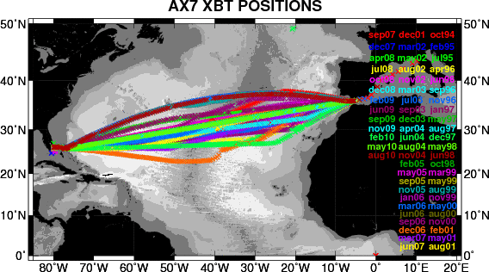
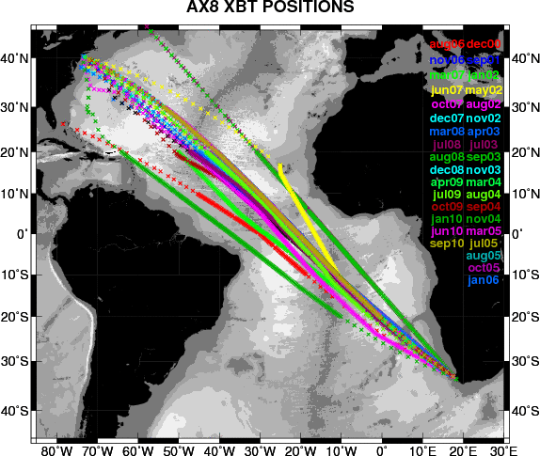
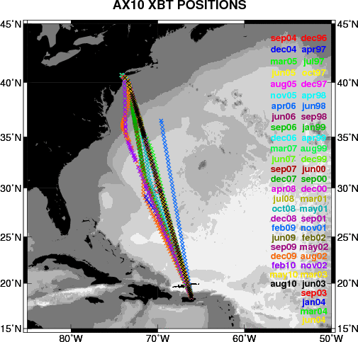
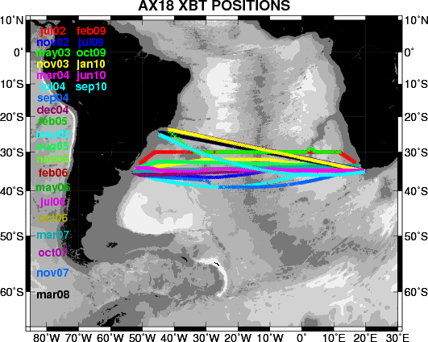
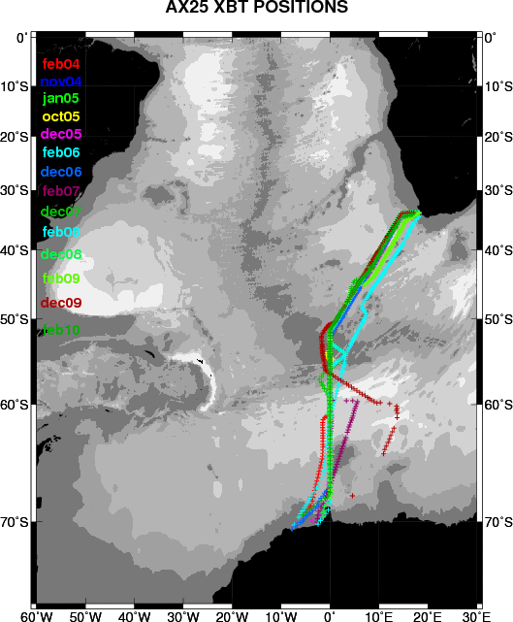
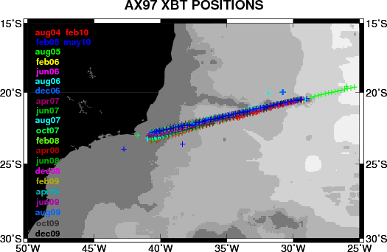

Figure 8. Locations of all AOML XBT deployments in HD mode since the date of their inception until September 2010.

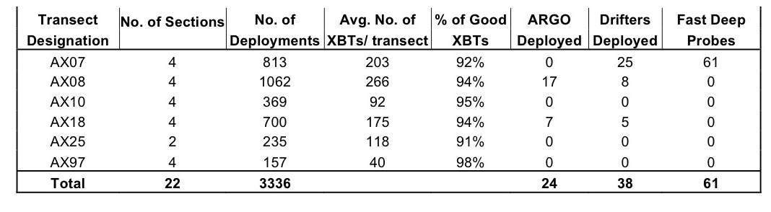

Table III: Table summarizing the XBTs, Argo and drifters deployed on the five main high-density XBT transects operated by AOML during FY 2010. Note that AX01 has not been included in this report as the join AOML/IRD implementation is currently underway.

In addition to the work performed in previous years, the increased communication between our international partners led us to the incorporation during FY 2010 of a new AOML HD transect: AX01. This transect runs at approximately 60N, transiting across the Labrador Sea. This new transect allows NOAA to increase participation in the highest scientific priority areas, High Density transects, that have been enumerated in the OceanObs’09 conference paper of XBT observations. NOAA can thus transition from low-density mode observations to the more unique contributions that XBT transects can make through repeat High Density observations. Leveraging our international partners, NOAA can provide XBTs without incurring the high costs of sending scientific personnel, which is covered in-kind by our partners.

International Collaboration.

The collaboration between AOML and its international partners include the sharing of resources, such as XBT probes, shipping recruiting and logistics, and scientific riders. AOML Provides probes to oceanographic institutions that have demonstrated reliability in logistics and operations. These probes are used to carry out recommended transects in FR and HD modes. By providing probes to international partners, AOML saves the cost of ship greeting for transects that would be difficult and expensive to maintain from the U.S.

AOML provides probes to the following international collaborators:
- IRD, Noumea, 1 pallet (1 pallet=324 XBTs ), collaborator: Mr. David Varillon
- FURG, Brazil, 1 pallet, collaborator: Dr. Mauricio Mata
- IRD, France, 2 pallets, collaborators: Mr. Denis Diverres and Dr. Gilles Reverdin
- CSIRO and Bureau of Meteorology, Australia, 2 pallets, collaborator: Ms. Lisa Cowen

The probes provided to Noumea are being deployed along transects that cross the equator in the western Pacific to complement PX13 and PX08 in the central and eastern Pacific. The probes provided to Australia are used to a basin wide transect in the Indian Ocean that crosses the equator and to partly support a high density transect between Tasmania and Antarctica. The XBTs provided to Brest are used along transects that cross the equator in the Atlantic Ocean and those provided to Brazil along the AX97 transect in the subtropical South Atlantic that monitors the Brazil Current. AOML provided a total of 6 pallets (1944 XBTs) to these partners. Most of the data obtained from these XBTs were placed into the GTS in real-time. For those ships that are not currently transmitting the data in real-time, we are exploring the possibility of installing computers and transmitting antennas for real-time data distribution. Most of the data collected from these deployments were submitted to NODC.

In a collaboration effort with NOAA/AOML, these XBTs were deployed in the following transects:
- Noumea: PX09, PX30, PX51
- Brazil: Sao Paulo-Isla de Trinidade (AX97)
- France : AX05, AX20, AX11, and AX01
- Australia : IX12, IX28

Additionally, several agencies are currently collaborating with this project. The Argentine Hydrographic Naval Office (SHN) provides the personnel to deploy the XBTs on AX18; the University of Cape Town provides for the deployments along AX08 and AX25. The South African Weather Service is our contact in Cape Town and Durban to store the equipment in between transects and to provide ship riders. Deployments along AX97 are done in collaboration with the Federal University of Rio Grande, Brazil.

AOML has been in continuous communication with the Brazilian Navy and have been providing the technical expertise needed for transmitting XBT data from Cruzeiro do Sul during the realization of the AX97 transects.

Drs. Gustavo Goni and Molly Baringer are involved in data analysis and scientific collaboration activities with scientists from University of Cape Town, South Africa, and University of Rio Grande, Brazil.

XBT Reports.

Monthly reports are generated showing the temporal and spatial distribution of the SEAS XBT transects, identifying and tracking the FR and HD XBT transects managed by NOAA/AOML. In addition to a web interface, this project provides CSV files with data and metadata information about individual measurements as well as PDF bulletins comprising information about the last 12 months of data, including transects coverage and mode, both in text and graphical formats. These reports can be obtained from the GOOS web page.

A full report of the XBT deployments by transect is shown at:
http://www.aoml.noaa.gov/phod/goos/ldenxbt/index.php.
The number of XBT deployed in each transect is shown in the AOML XBT report that can be obtained from the GOOS web page at: http://www.aoml.noaa.gov/phod/VOS/REPORTS/

2.3. SEAS Meteorological System in VOS ships.

The SEAS 2K meteorological (MET) software is constantly being upgraded with corrections recommended by the National Weather Service. The automated MET system is complete for integration with the Woods Hole Oceanographic Institute Automated METeorological station (Automated MET). Automated MET continues being developed for the NOAA fleet to integrate SEAS2K with the Scientific Computing System (SCS). The software module is being constantly updated to collect data from the SCS system using socket transfer. Transferring these data into the Automated MET capability of SEAS 2K continue being tested. Once finalized, the data will be transmitted off the ship using ship email.

Approximately 700 merchant ships currently have SEAS software installed, and supported through the NWS/NDBC (Robert Luke and John Wasserman) VOS Program. These ships transmitted approximately 3,700,000 meteorological observations using SEAS software during FY 2010 (Figure 9). This contribution constitutes a large fraction of non-satellite global marine weather observations.

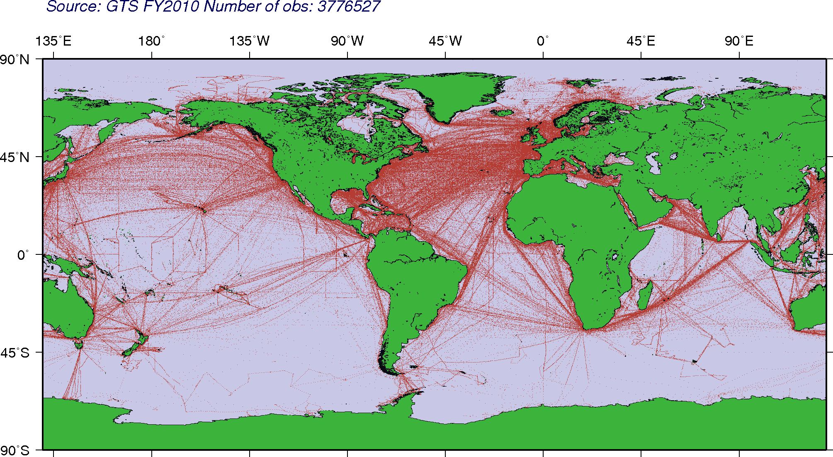

Figure 9. Location of the SEAS meteorological received and processed by AOML during Fiscal year 2010.

2.4. TSG Operations.

During FY2010 the TSG operation at AOML was carry out in support of the pCO₂ operation, with several key developments regarding equipment installation, operation and maintenance, as well as data retrieval, quality control and submission to the GTS and other data centers. AOML is currently receiving, processing and distributing TSG data from 3 ships of the SOOP (MV Explorer, MV Oleander and MV Barcelona Express) and 12 ships of the NOAA fleet. Additionally, effort dedicated to the development of an automated system in the Royal Caribbean’s Explorer of the Seas, will allow resuming its TSG operation soon. Approximately 10 million TSG records were processed at AOML during FY 2009 (Figure 10).

The TSG system, equipped with an external temperature sensor, installed on the MV Barcelona Express during 2009 continues to operate satisfactorily. This ship travels across repeated transects between Gibraltar and Miami. Real-time data transmission capabilities were installed this year.
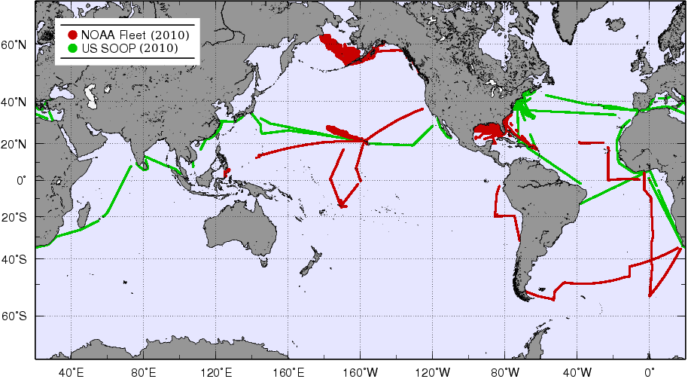

Figure 10. Location of the approximately 10 million TSG observations received and processed by AOML during FY2010 from ships of the SOOP and the NOAA fleet.

The operation of TSG equipment is performed with the SEAS 2K software. During FY2010 several modifications were carryout on this software to enhance the control of the TSG when the ship arrives at port or in any other situation in which the position of the ship remains constant. The software also constantly checks the strength of the Iridium signal before attempting data transmissions. Additionally, log files are created with details of the equipment performance and eventual errors messages. These modifications also enable a reduction in the cost of the operation. Additionally, the transmission system in two ships of the SOOP, MV Explorer and MV Oleander, was also updated at AOML. With this update, the Iridium antenna and modem are now attached together, reducing the signal loss and permitting better data transmissions.

During FY2010 the data processing system for real-time quality control and submission of TSG data into the GTS and other data centers, was enhanced at AOML as part of the TSG operation. All the TSG data received at AOML is quality controlled through several steps based on the GOSUD (Global Ocean Surface Underway Data Pilot Project) real-time control tests. Among other parameters, the quality control procedures check the data for errors in date, location, platform identification, ship speed, global and regional temperature and salinity ranges compatibility, gradient and the presence of spikes. The TSG data is also compared with a monthly climatology (Levitus 2005). The data approved in the quality control tests is then reduced to one point every three minutes and inserted into the GTS. The whole data set is also distributed by the National Oceanographic Data Center (NODC) and Coriolis. This new system is currently fully functional in real-time and its subsequent development is under way for processing data in delayed-time, providing important tools to automatically detect problems in data transmission, equipment calibration and marine operations of ships with TSG data transmission in real-time in general.

AOML/PhOD provided a TSG system that will be installed on the former WHOI’s Atlantis, now commissioned as an oceanographic research vessel in Argentina and operated by the Prefectura Naval Argentina (Coast Guard) as the Dr. Bernardo A. Houssay. We have visited the vessel and have been rendering the technical advice needed for the installation of the TSG system and other instrumentations. Data from this TSG will be crucial for the calibration of the upcoming NASA Aquarius satellite mission.

The TSG web site at AOML was updated during FY 2009, including some new products displaying data in real time from the MV Explorer. This web site currently contains information regarding data analysis and quality control procedures for the NOAA fleet and the SOOP. In particular several products display

2.5. SOOP Partnerships.

In order to lower costs and increase efficiency, AOML maintains several XBT transects and other components of the SEAS operations in collaboration with domestic and international partners. This collaboration includes:
- Providing probes to oceanographic institutions that have demonstrated reliability in logistics and operations,
- Provide software maintenance,
- Contracting riders (HD transects only) to deploy the probes,
- Providing equipment (computers, antennas, etc) and software, and
- Carrying joint analysis of the data.

The SOOP program also partners with other NOAA funded programs and national partners including:
- The Thermosalinograph (TSG) operation,
- The global drifter program, for deployment of drifters on XBT transects,
- The global ARGO program, for deployment of ARGO floats on XBT transects,
- The United State Coast Guard (AMVER vessel emergency response system is integral to SEAS)
- The National Weather Service, through SEAS transmissions of weather observations and from NWS Port Meteorological Officer collaborations for loading, greeting ships, software installation, and crew training.
- The Oleander Project, a joint NOAA/NEFSC, NOAA/AOML, University of Rhode Island, and SUNY/Stony Brook operation.\

2.6. SOOP Data Availability and Project Web Sites.

Details of this project, such as logistics, equipment, software, and data distribution, are provided through links that can be accessed through the main NOAA/AOML Global Ocean Observing System (GOOS) web page www.aoml.noaa.gov/phod/goos.

- SEAS: http://www.aoml.noaa.gov/phod/trinanes/SEAS/
- HD: http://www.aoml.noaa.gov/phod/hdenxbt
- FR: http://www.aoml.noaa.gov/phod/goos/ldenxbt

Data from the LD, FR and most HD deployments are transmitted to the GTS and made available in real-time for operational climate forecast and analyses. Data from the international collaboration are not always available in real-time. HD data is also made available on the project web site listed above.

2.7. SOOP Domestic Collaboration.

The following is a summary of the domestic collaboration that involves AOML SOOP operations:

- In support of the NOAA-funded “Surface pCO₂ Measurements from Ships” (Drs. Rik Wanninkhof, Richard Feely, and G. Goni, PIs), AOML provided 1.5 pallets (486 XBTs) to NOAA/NMFS in Rhode Island to be deployed along the pCO₂ transects AX32 and AX02.

- NOAA/AOML collaborates with the National Weather Service to provide maintenance of SEAS 2K software to transmit marine meteorological observations.

- Through an agreement with the U.S. Coast Guard, NOAA/AOML provide real-time information about the location of ships with the SEAS 2K software installed, which is used for search and rescue operations.

- AOML provides hardware equipment (computer for data acquisition and transmission antenna) for the Oleander operations a joint project between NOAA/AOML, NOAA/SEFSC, University of Rhode Island, and SUNY/Stony Brook. Approximately 350 XBTs are deployed by this ship between New York and Bermuda. A web page displaying the data obtained from this project is on the final stage and will be soon available online. The TSG data obtained from this ship can be seen on the TSG web page at AOML: http://www.aoml.noaa.gov/phod/tsg

- Additional collaboration with the Global Drifter and Argo Programs are detailed below.

2.8. SOOP Data Transmissions and Data Flow.

XBT profiles are transmitted in real-time through the Thrane Standard C units. AOML is now continuously using Iridium transmission in the XBT and TSG operations in the Oleander (AX29) using a direct Internet connection and SMTP e-mail. Iridium transmissions are also done continuously from the TSG installed in the M/V Explorer of Semester at Sea and in the Horizon Navigator, which covers the AX10 transect. The ratio of XBTs deployed to real time data transmitted is essentially 100%.

The XBT profiles undergo automatic quality control (AQC) procedures at AOML. Those profiles that fail the AQC are submitted to visual quality control (VQC) using a MATLAB based code developed at AOML, in which an operator decides whether or not to send the data to the GTS. Probe failure (as measured by the AQC) remains consistently between 5% and 10% with greater higher failure rates in the higher latitudes during the hemispheric winters. From those profiles that fails the AQC, approximately 80% are approved during the VQC. Typically about 97% of all profiles are approved during the quality control process and submitted to the GTS. The development of this new software for VQC activities constitutes an improvement for the XBT operation in general. For example this software provides the capacity of detect systemic and random problems with the XBT operations, such as electrical faults in the XBT hand-launchers, or bad weather carrying the XBT wires to contact the hull of the ship, in real-time. This allows the technical team at AOML to communicate with the riders in HD cruises to minimize problems during the deployment minimizing the lost of probes or the acquisition of bad profiles during these cruises.

2.9. SOOP Data Tracking.

The data tracking operation was transitioned during 2009 from NOAA HQ to AOML. Data tracking is aimed to the verification of data flows from the source (observation platform) to the processing centers, where the data is analyzed, quality controlled, and sent to the Telecommunication Gateway at NWS from where the data is inserted into the GTS. Since this is a very complex process, the tracking of these data ensure that the information obtained by different observation platforms are received and that they are generated with the correct codification so that it can be successfully inserted into the GTS. Otherwise the data cannot be used or, if communication problems are not detected, lost. Routinely, the flow of different kinds of oceanographic data, including XBT, TSG, buoys, drifters and TAO/PIRATA arrays are verified in a daily basis.

Among the several problems that may occur, the most common are:
- Specified platform type not expected from a specific group of headers,
- Data is received from ships with unknown Call Sign,
- Observations are transmitted with wrong date/time,
- Duplicate data is being sent, and
- Data drops: the data is transmitted but it is not reaching its destination.

The data tracking software is based on the comparison of several data sources from AOML, the SEAS team, the NWS Communication Gateway and the GTS. The code allows the detection of several of the previously cited most frequent problems, creating a daily report of the oceanographic data flow state. This represents a great improvement for the data-tracking task since many issues can be detected quickly reducing the operator effort. Nevertheless new types of errors occur all the time, requiring the intervention of the operator to ensure the success of the operation.

2.10. SOOP Data Base.

The SEAS XBT auto-QC System (XBTRT) and the automatic transfer of ndc files from SEAS to AOML were operational except for downtime due to hardware/software maintenance. The tasks being performed are: maintain the XBTRT system, management of the XBTRT operational database residing in a commercial Database Management System, review the daily electronic mail sent by the XBTRT system to detect and report possible problems, assist in identifying data tracking problems, and provide advice regarding software issues.

2.11. Metadata and BUFR.

XBT data are being tested coded in BUFR format, using templates that have been specifically designed to serve operational needs. We are using both BUFR Edition 3 and Edition 4 specifications. A similar approach is underway to migrate TSG data to BUFR. This effort seeks to improve the future migration from the Traditional Alphanumeric Codes (TACs) to Table-Driven Code Forms (TDCFs), as required by WMO. During FY 2009 AOML successfully developed encoding/decoding routines to convert XBT profiles from binary SEAS format into BUFR. Since the development of this code is in the testing stage, the template used is very simple and comprises only a few metadata fields. However, the code is being developed in order to easily include a more complete template as soon as the final version for XBT is approved. The code as well as the template implemented allows the inclusion of several quality control flags provided by the AQC system already in place at AOML for SEAS XBT data. This capability can also be extended to include other quality flags as needed. At this moment, the test of these BUFR bulleting is being coordinated with the Telecommunication Software Branch of the NWS. This test will provide the feedback necessary to detect, identify and correct problems that can arise in the migration process, providing a robust framework for near-real-time collection, quality control and distribution of SOOP data.

2.12. SOOP Web Pages.

An extensive update of the AOML SOOP web pages is being carried out (Figure 9). Data are available online at: www.aoml.noaa.gov/phod/goos and www.aoml.noaa.gov/phod/goos/ldenxbt, respectively. The Frequently Repeated XBT websites features the latest information on operational XBT transects in both FR and HD modes along with specific webpages showing the latest XBT, Meteorological, and TSG observations, available online at: http://www.aoml.noaa.gov/phod/goos/seas/latest/. The GOOS website now features a Google Earth layer displaying Global Marine and Meteorological Observations available online at http://www.aoml.noaa.gov/phod/VOS/GE/GE_AOML_DT.kmz. This application is a potent tool to visualize the global extent of ocean and meteorological observations interactively. Other web sites were also developed for more specific aspects of the SOOP operation, including the display of real-time TSG data from the MV Explorer. A new web site for the Oleander Project is in the final stage and will be soon online, displaying XBT products and data obtained from this ship.

2.13. SOOP SEAS and High Density Installation Manuals.

The extensive effort documenting the operations of the SOOP was continued during FY 2010. This documentation is available online at: www.aoml.noaa.gov/phod/goos/docs in support of our global operations with collaborators from the US and countries around the world. For instance, handbooks including hardware setup and software operation of the semi-automatic equipment developed in-house and used in high density transects is now available to all ship-riders though this website. This handbook has substantially simplified the training of new ship riders. An improved handbook for operation and troubleshooting of the TSG installations is also available. This troubleshooting guide was also updated during FY 2020 including several real situations during this year’s operations. Several examples of good and bad profiles were included in the guise, indicating the most common cause in each case and the steps to resolve them.
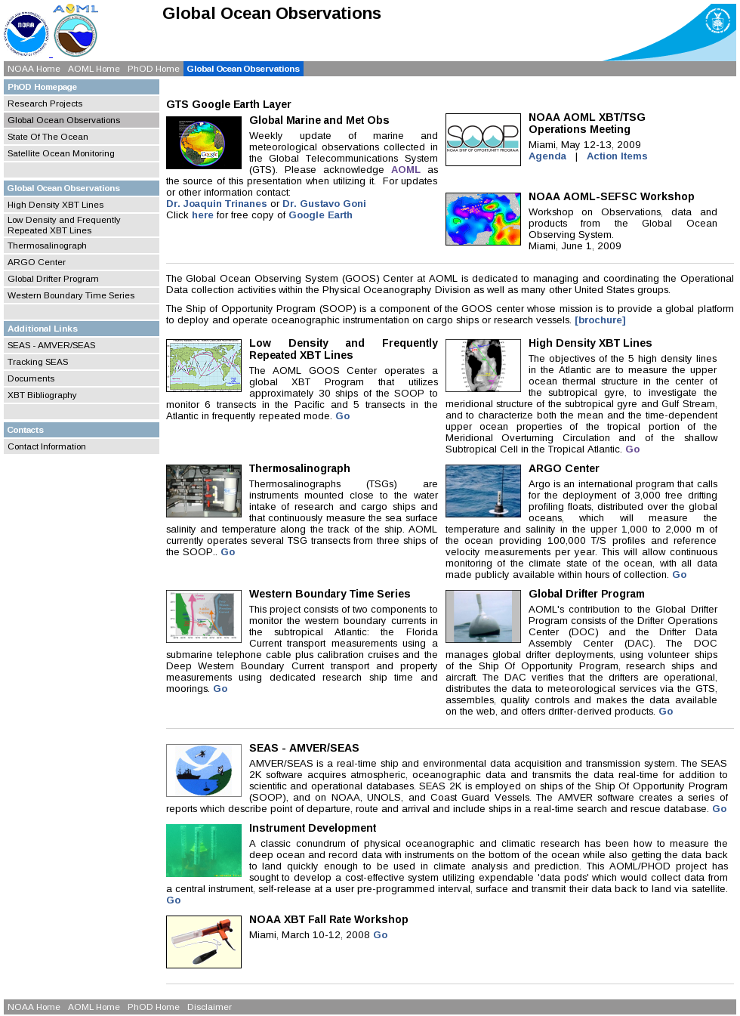

Figure 11. Global Ocean Observing System web page maintained by the SOOP at NOAA/AOML: www.aoml.noaa.gov/phod/goos.php.

2.14. SOOP Collaboration with the Global Drifter Program.

The Surface Drifter Program would not be able to maintain the drifter array without contributions from national and international partners who deploy the drifters worldwide. Many drifters are deployed from vessels cooperating with the NOAA Ship Of Opportunity Program (see Table III for drifters deployed during HD cruises). SOOP personnel (J. Trinanes) also support AOML’s efforts to collect the hurricane drifter data for subsequent quality control and redistribution.

2.15. SOOP Collaboration with the Argo Program.

Ships recruited through SOOP to deploy XBTs are also used as a platform to deploy Argo profiling floats. Betweeen October 2008 and September 2009, a total of 24 floats were deployed from ships of the SOOP (see Table III).

XBT temperature profiles have also been used to identify problems in Argo floats [Willis et al., 2008] highlighting the importance of maintaining independent observing systems for ocean subsurface temperature.

2.16. Education and Outreach.

Google Earth Application.
A Google Earth-based application was continued to be improved to display the status of the ocean observing system network, including SOOP platforms. Through this interface, users can easily monitor the different data streams received operationally through the GTS, identifying possible data gaps affecting data distribution, tracking specific platforms and generating animations including field measurements overlaid on top of the daily global SST fields. This application is now freely available to the public at:
http://www.aoml.noaa.gov/phod/goos.php

SOOP Brochure.
A new brochure was created for recruiting and general information purposes, including a new logo for the program. They can be obtained from the SOOP web site at: http://www.aoml.noaa.gov/phod/goos/docs/

2.17. SOOPIP.

The NOAA/AOML SOOP Program is a participating member of JCOMM and JCOMMOPS. The AOML SOOP XBT program is represented bi-annually at the WMO/IOC Ship Observations Team (SOT) meeting. Participation on these international panels provides an important mechanism for integrating and coordinating with other national or regional programs which, in the long run, improves our national climate mission by making more efficient and effective use of available resources. Dr. Gustavo Goni continues being the Chairman of the WMO/IOC Ship Of Opportunity Program Implementation Panel (SOOPIP) and Dr. Joaquin Trinanes is a member of the Meta-T panel.

2.18. Contribution to Heat Storage quarterly reports.

XBT observations provide approximately 20% of all global temperature profile data and are used to create quarterly reports of heat storage: http://www.aoml.noaa.gov/phod/soto/ghs/reports.php. This work is funded by NOAA/CPO under the project: Evaluating the Ocean Observing System: Performance Measurement for Heat Storage, by C. Schmid and G. Goni.

2.19 Contribution to Heat Transport quarterly reports.

The High Density XBT observations along AX7 (approximately across 30N in the North Atlantic) and AX18 (approximately across 30S in the South Atlantic) are the cornerstone of data used in these reports. Heat transport is computed from the high density XBT data along these lines and posted at:
http://www.aoml.noaa.gov/phod/soto/mht/reports.php. This work is funded by NOAA/CPO under the project: State of the Climate: Quarterly Reports of the Meridional Heat Transport in the Atlantic Ocean, PIs M. Baringer, S. Garzoli and G. Goni.

2.20 Contribution to the Western Boundary Time Series program.

The SOOP program previously funded Florida Straits cruises linked to the High Density XBT transect AX07, used to estimate the meridional heat transport in the North Atlantic. In FY2010, this funding request was moved to the Western Boundary Time Series Program. SOOP still provides for the purchasing of XBT equipment deployed on Florida Strait small boat cruises, submission of all XBT data onto the GTS, and of the SEAS software to collect this XBT data.

2.21. SOOP Brochures.

Brochures are printed for recruiting and general information purposes, including a new logo for the program. They can be obtained from the SOOP web site at: http://www.aoml.noaa.gov/phod/goos/docs/

2.22. Meetings and Workshops.

- NOAA/AOML SEAS, XBT, and TSG Operations, Organized by G. Goni; Miami, Florida, April, 2010.
- Second Fall Rate Equation Workshop, attended by G. Goni and P. DiNezio; Hamburg, Germany, September 2010.
- GTSPP Meeting, attended by M. Baringer and J. Trinanes; Ostende, Beligium, April, 2010.
- OOPC Meeting, organized by G. Goni, attended by M. Baringer, and S. Garzoli; Miami, January 2010.

2.23. Fall Rate Equation Studies.

Since 2008 AOML has been heavily involved in international efforts to estimate and correct systematic errors in XBT observations. The magnitude of these errors does not have an impact on the majority of applications of XBT data, such as monitoring of heat transport or ocean circulation. However, these errors do influence the detection and quantification of variability and trends in global heat content where small, but systematic, errors can have an impact on the global integral. A new methodology using Argo and satellite altimetry was developed by AOML scientists, and is currently being considered to monitor future changes in XBT errors. A manuscript presenting this methodology by DiNezio and Goni was published in the Journal of Oceanic and Atmospheric Technology (Di Nezio, P.N., and G. Goni, 2010: Identifying and Estimating Biases between XBT and Argo Observations Using Satellite Altimetry. Journal of Atmospheric and Oceanic Technology, 27(1):226-240). These improvements in the quality of XBT observations will allow for a more accurate assessment of the progressive warming of the global ocean. Reducing the uncertainty in estimates of ocean heat-uptake will also allow a better evaluation of the physics represented in the climate models used to project future Global Warming. Furthermore, the identification and correction of sources of error in XBT observations is expected to lead to technological improvement of this versatile, economical, and practical instrument.

