Tropical Cyclone Heat Potential – G. J. Goni and J. Knaff

Tropical cyclones (TC) occur in seven regions in all ocean basins: tropical Atlantic, northeast Pacific, northwest Pacific, southwest Indian, north Indian, southeast Indian, and south Pacific. The intensification of TCs includes the interaction of very complex mechanisms that include TC dynamics, upper ocean interaction and atmosphere circulation. The influence of the upper ocean thermal structure on TC intensification, the focus of recent studies, is one of these physical processes. While sea surface temperature (SST) plays a role in the genesis of TCs, the ocean heat content contained between the sea surface and the depth of the 26°C isotherm, also referred as Tropical Cyclone Heat Potential (TCHP), has been shown to play a more important role in TC intensity changes (Shay et al., 2000). The TCHP shows high spatial and temporal variability associated with oceanic mesoscale features. TC intensification has been linked with high values of TCHP contained in these mesoscale features, particularly warm ocean eddies, provided that atmospheric conditions are also favorable. Therefore, resolving the upper ocean mesoscale field is critical to monitor the TCHP. Since sustained in situ ocean observations cannot resolve global mesoscale features and their vertical thermal structure, different indirect approaches and techniques are used to estimate the TCHP. Sea surface height observations derived from satellite altimetry, a parameter that provides information on the upper ocean dynamics and vertical thermal structure, can resolve these features (Goni et al, 2996; Shay et al, 2000). In general, the real-time forecast of TC intensity is highly dependant on track forecast and many of the errors introduced in the track forecast are translated into the intensity forecast. Clearly, areas with high values of TCHP may be important only when TCs travel over them.

The TCHP anomalies are computed during the months of TC activity in each hemisphere: June through November in the northern hemisphere and November through April in the southern hemisphere. Anomalies are defined as departures from the mean TCHP obtained for the same months from 1993 to 2008. These anomalies show large variability within and among the basins (Fig. 1)

The west Pacific basin exhibits the anomalies from the signature of the negative phase of the 2007 ENSO event (La Nina). The South Pacific basin showed only positive anomalies. The North Indian basin exhibited positive values in the Bay of Bengal and in the eastern Arabian Sea and negative values in the western Arabian Sea. The Gulf of Mexico (insert) showed an alternation of regions with positive and negative values. The tropical Atlantic exhibited positive (negative) to the south (north) of approximately 25ºN.
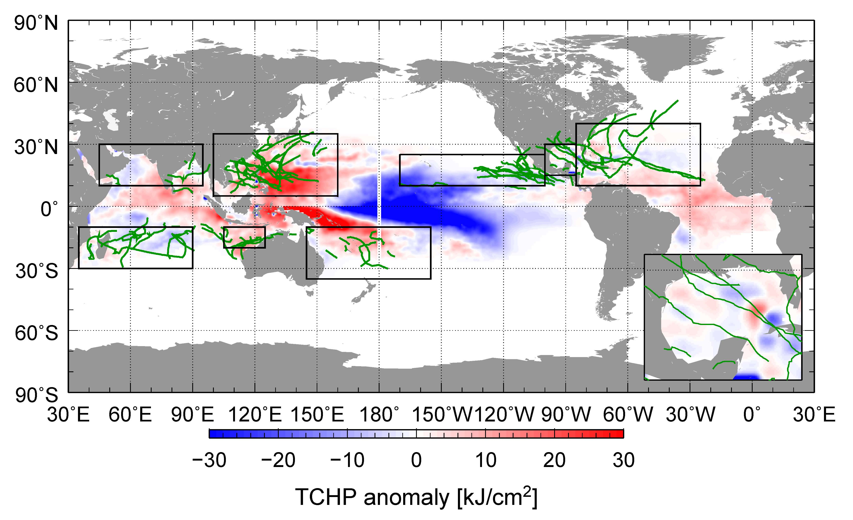
Fig. 1. Global anomalies of TCHP corresponding to 2008 computed as described in the text. The boxes indicate the seven regions where TCs occur: from left to right, Southwest Indian (SWIND), North Indian (NIND), West Pacific (WPAC), Southeast Indian (SEIND), South Pacific (SPAC), East Pacific (EPAC), and North Atlantic (shown as Gulf of Mexico (GOM) and tropical Atlantic (TATL) separately). The green lines indicate the trajectories of all tropical cyclones category 1 and above during November 2007-April 2008 in the southern hemisphere and June-November 2008 in the northern hemisphere. The Gulf of Mexico is shown in detail in the insert shown in the lower right corner.

Several TCs were identified to have gained strength when traveling into regions of very high or higher values of TCHP. Some examples of these intensification events are shown in Fig. 2. The results presented here correspond to five intense (category 4 and 5) TCs, where the location of their intensification coincided with an increase of the values of TCHP along their tracks. Additionally, the cooling associated with the wake of the TCs is important since it influences the upper ocean thermal structure on regional time scales within weeks to months after the passage the cyclones. These TCs were Gustav in the Gulf of Mexico, Ike in the Caribbean Sea, Sinlaku in the western Pacific, Nargis in the northern Indian, and Ivan in the southwest Indian region.

In the Atlantic basin, Hurricanes Gustav and Ike were good examples of major hurricanes whose interaction with TCHP features have been highlighted (reference?). Hurricane Gustav, reached its maximum estimated intensity of 125 kt prior to making landfall in Cuba and at a time when its track was traversing some of the highest values of TCHP west of Jamaica. On the other hand, Hurricane Ike, experienced three separate peak intensities. The first and maximum peak intensity, 125 kt, was obtained in the central Atlantic, northwest of the Leeward Islands. In the next day or so the storm weaken and moved southwest. The second peak shown in Fig 2, occurred in a region of elevated TCHP. The third peak intensity occurred just before making landfall in western Cuba near the region where Gustav reached its maximum intensity a few weeks before. This storm caused big damages in the region as it made landfall twice in Cuba (110, 115 kt) and once in Texas (95 kt).

Typhoon Sinlaku, in the western North Pacific obtained its maximum intensity (125kt) following an encounter with a warm ocean eddy. Following its peak the storm weakened slightly as it moved over lower values of TCHP. Following this weakening it showed a slight intensification as it moved over larger TCHP values. The storm eventually brushed the coast of Taiwan with an estimated intensity of 95 to 100 kt.

In the North Indian Ocean Tropical Cyclone Nargis, made landfall in Myanmar with an estimated intensity of 115 kt. The storm resulted in a devastating storm surge that killed an estimated 146,000 people. The storm intensified over the high TCHP waters of the Bay of Bengal. One aspect of the storm’s forecast is that for the 48 hours prior to landfall the storm was forecasted to have a more northward track that was observed which not only allowed the storm to tack over higher TCHP values, but to make landfall in the low-lying Irrawaddy river delta.

Tropical Cyclone Ivan, is a good example of a very strong and large Southern Hemisphere tropical cyclone, which reached its maximum intensity of 115 kt just as it made landfall in Madagascar. It also tracked across the warmest TCHP during the day or so prior to to landfall.

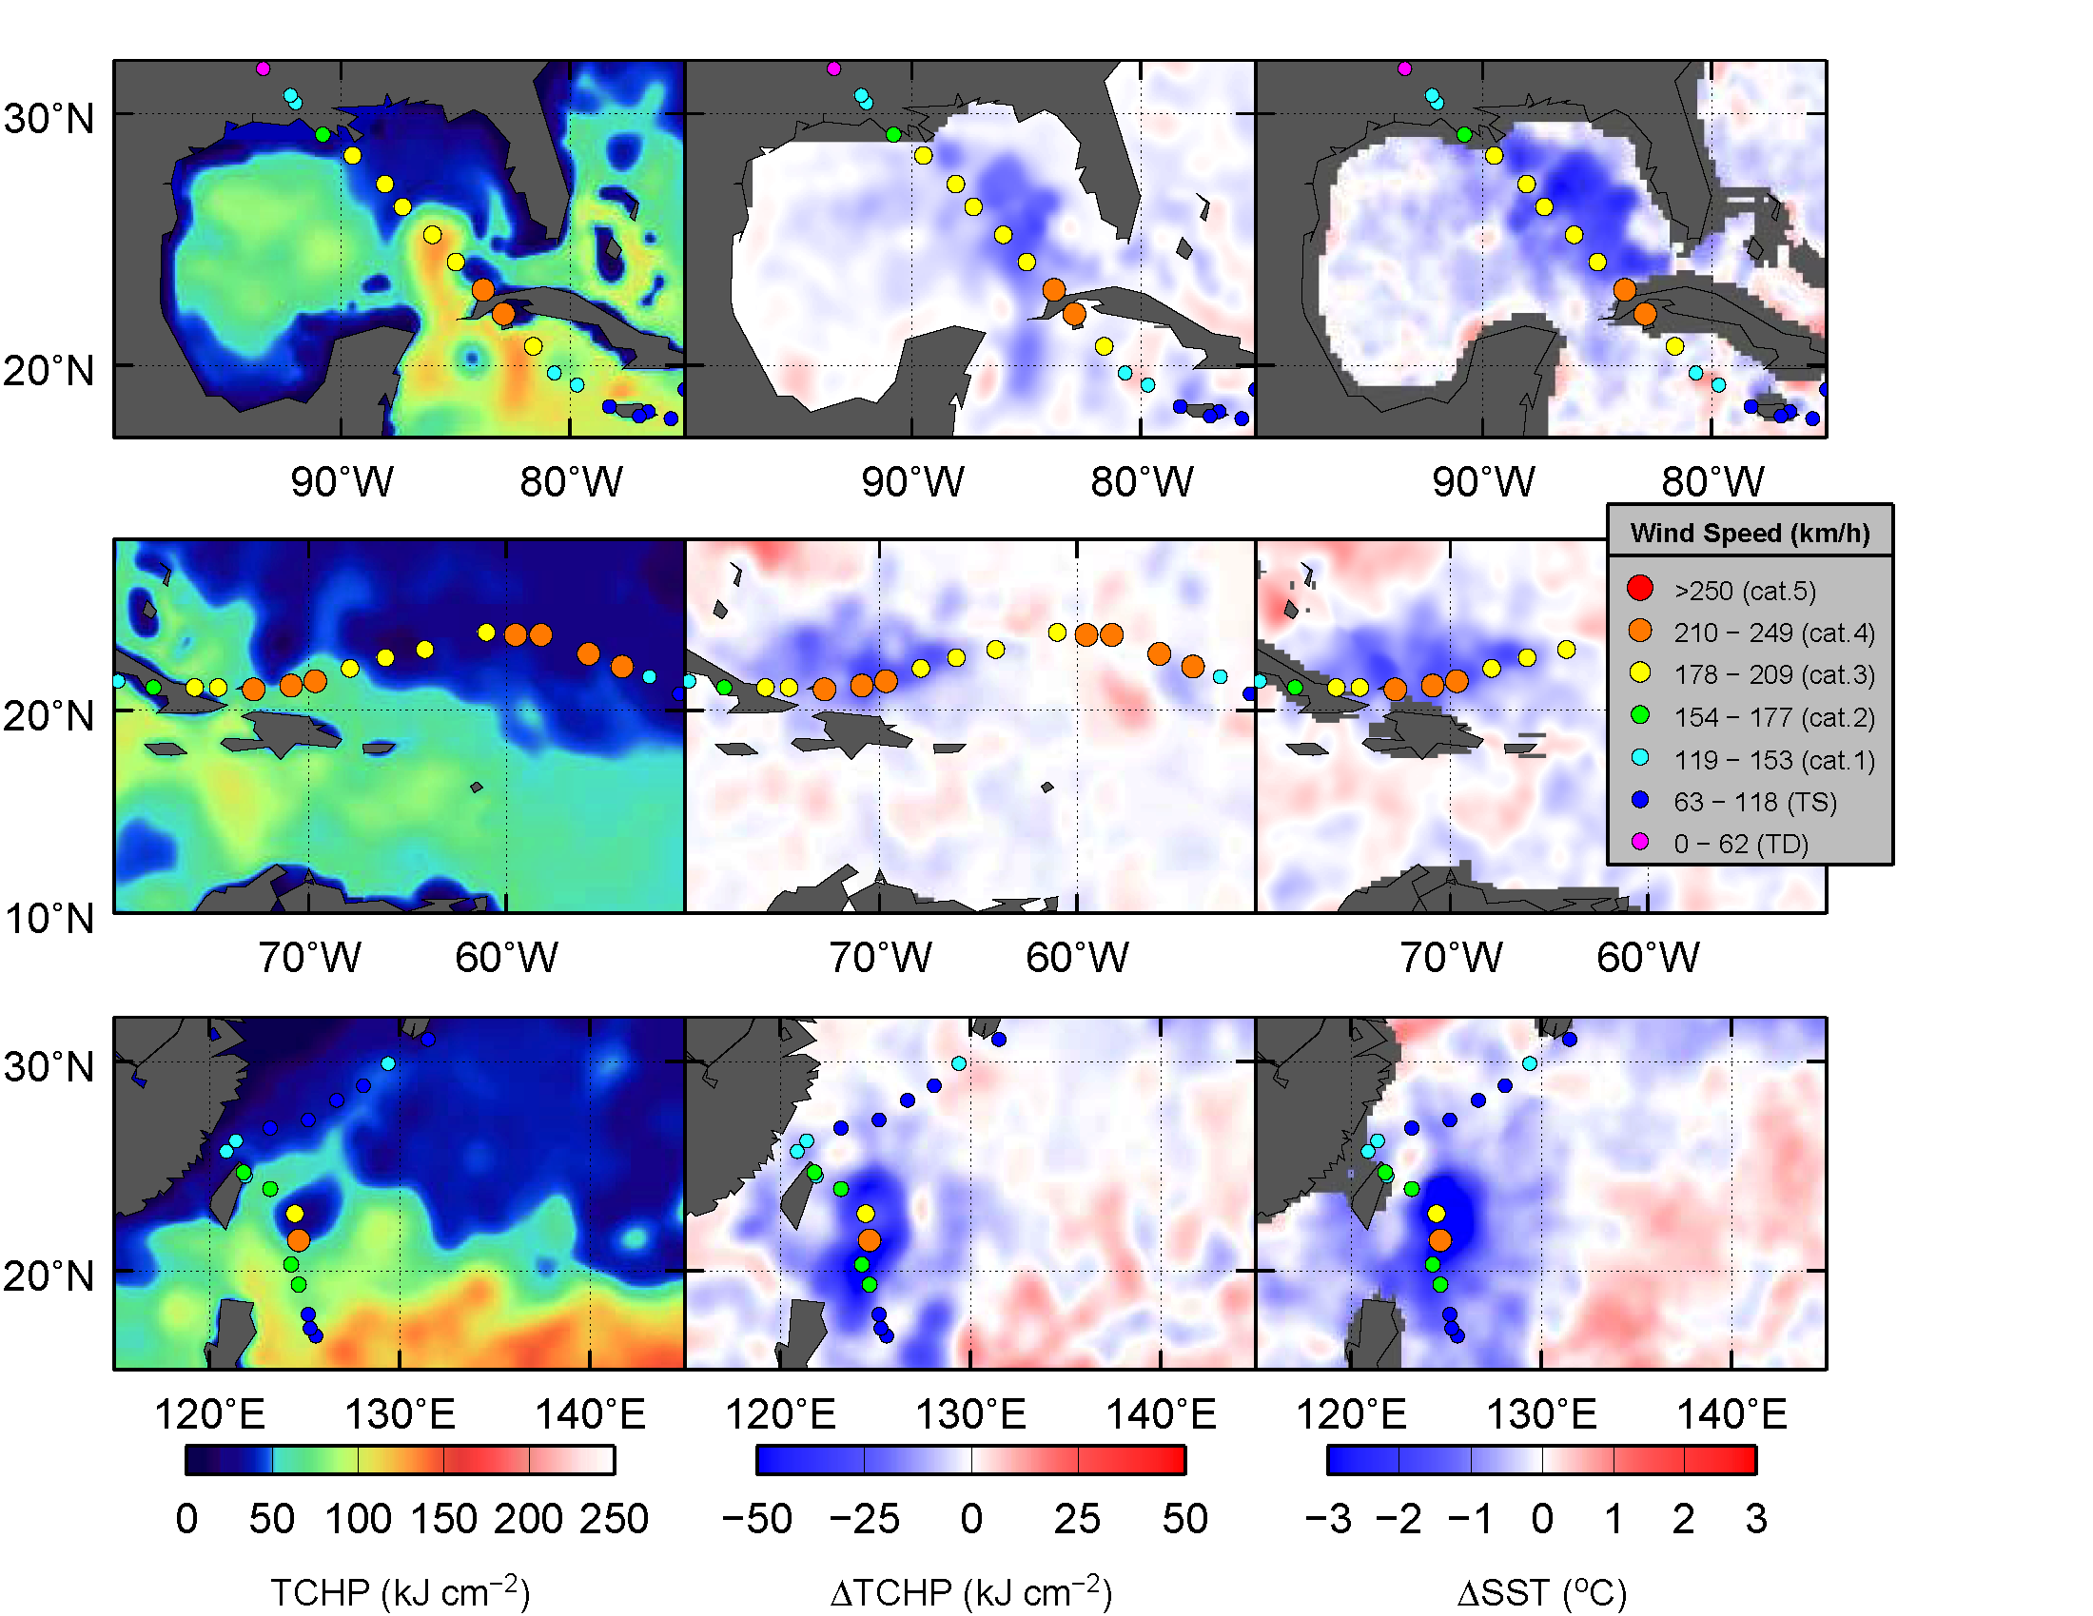

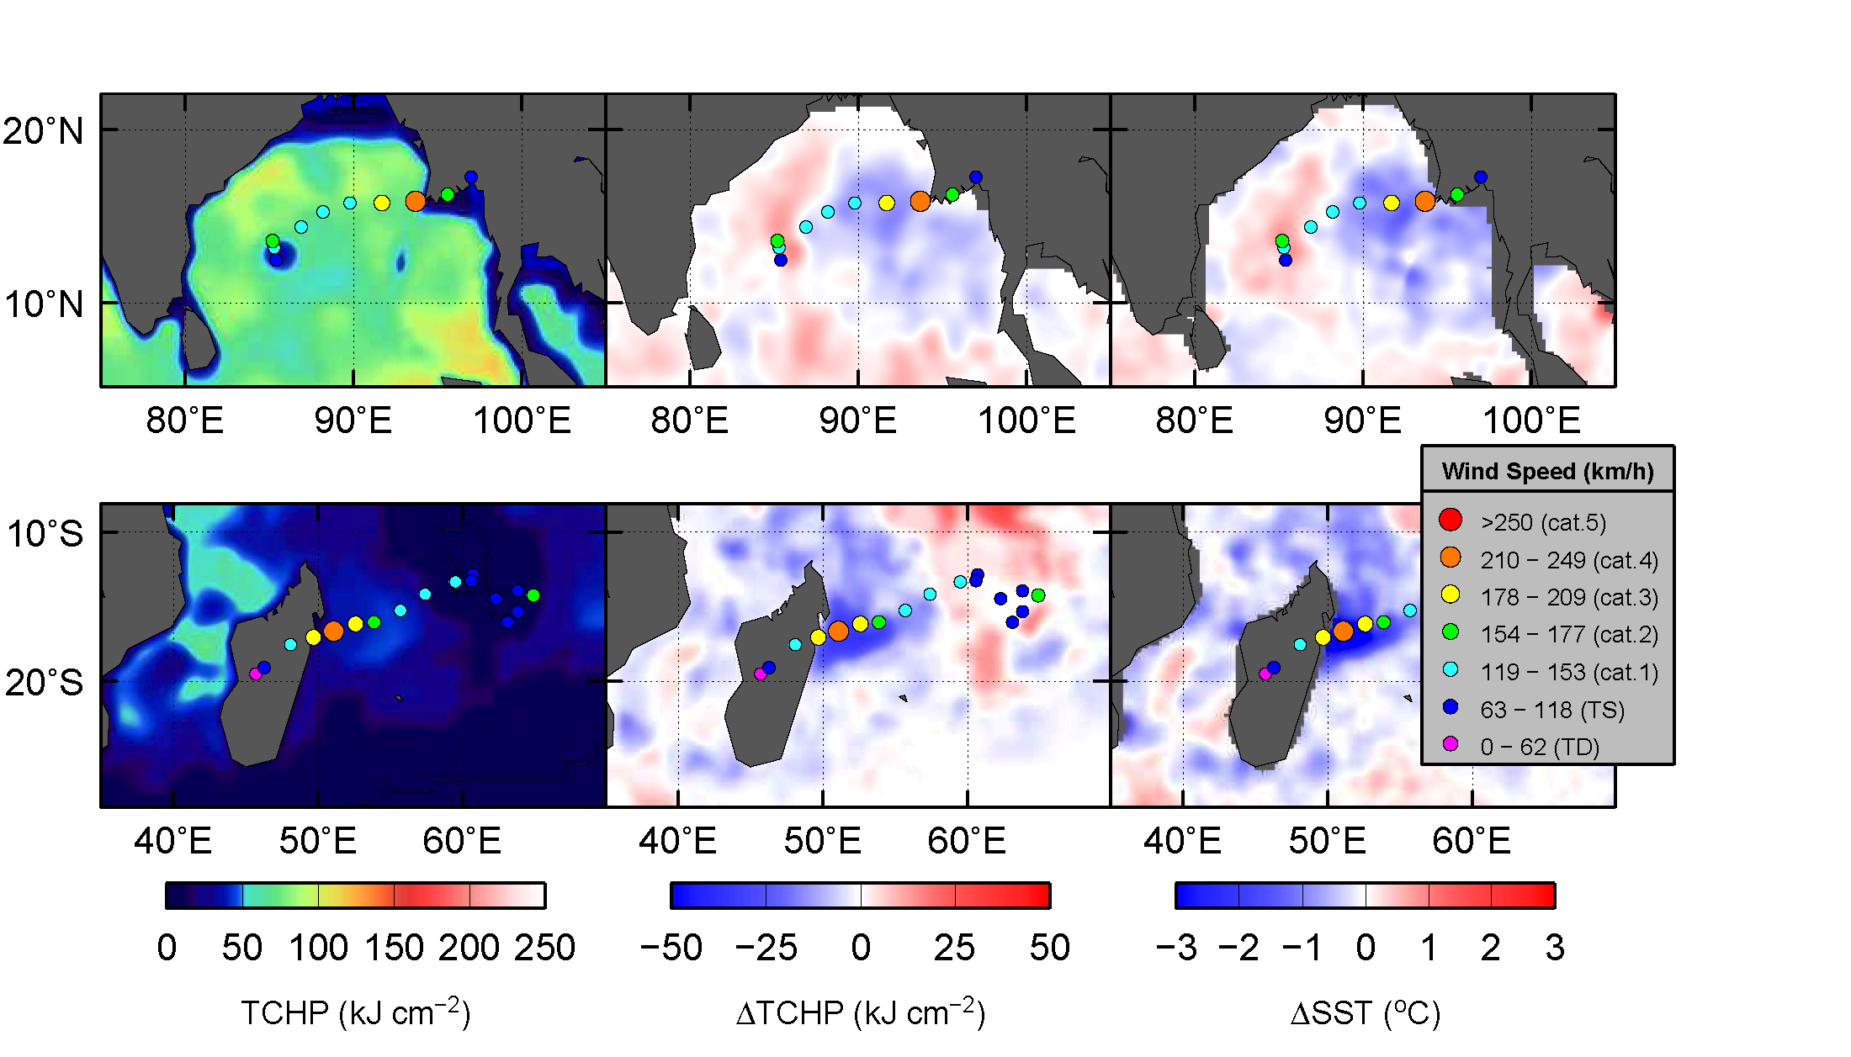

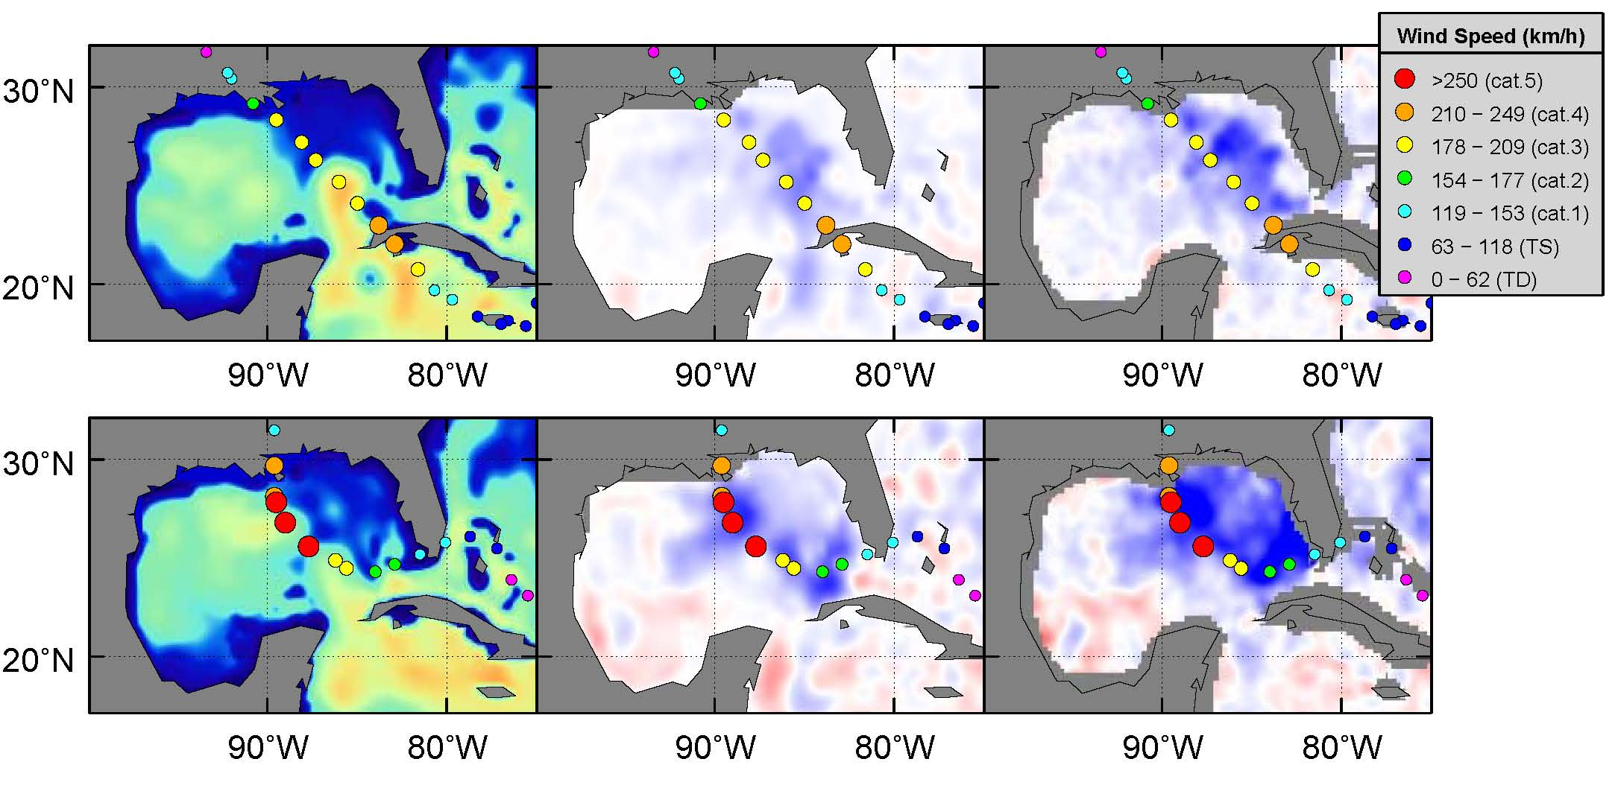
Would we like to include a comparison between Katrina and Gustav ? (figures above)

Unless we are going to speak to the differences in meteorology (YES!), I think it would be difficult. The Gustav Ocean conditions were likely more favorable than for Katrina, but Katrina had all the right stuff at the right time. I am confused here: Looking at the two maps of TCHP, I see that the GOM during Katrina had a warm ring, over which this TC travelled. This feature did not exist during Gustav.

