NOAA/AOML Thermosalinograph

on board the MV Explorer of Semester At Sea

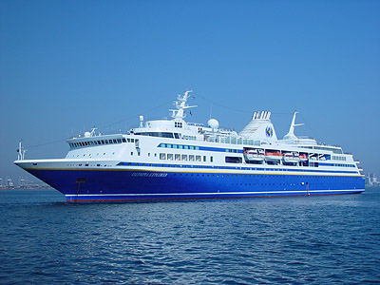

Contact Information:

Gustavo Jorge Goni

National Oceanic and Atmospheric Administration

Atlantic Oceanographic and Meteorological Laboratory

Physical Oceanography Division


4301 Rickenbacker Causeway

Miami, FL 33149

Tel: 305-361-4339

Email: Gustavo.Goni@noaa.gov

Thermosalinographs

A thermosalinographs (TSG) is a simple instrument mounted close to the water intake of research and cargo ships to measure sea surface temperature (SST) and salinity (SSS) along the track of the ship. They are automatically operated, easy to maintain and can transmit data in real-time.

NOAA supports the collection of SST and SST data from thermosalinographs installed on ships of the NOAA fleet and on ships of the Ship of Opportunity Program (SOOP). There are currently 3 vessels of the SOOP and 15 of the NOAA fleet with TSGs that are being operated.

The global atmospheric and oceanic observations, including TSG observations from ships of opportunity (SOOP) and research vessels, have been the foundation for understanding long-term changes in marine climate and are essential input to climate and weather forecast models. Sea surface temperature and salinity observations from TSGs are part of the Global Ocean Observing system, of which NOAA is the single largest contributor.

Sea Surface Salinity is a critical parameter to estimate the influence of oceans on climate. Unlike temperature, SSS has no direct effect on air-sea exchanges, but it determines the convection and re-emergence of water masses, which are crucial for the seasonal to interannual variability of the global system. Data from TSGs are also used to identify oceanic frontal regions that separate currents, jets of surface currents, and cyclonic and anticyclonic eddies and rings. Additionally, with the launch of Aquarius in 2009, a NASA satellite that will measure sea SSS, data from TSGs will provide data to validate and calibrate the satellite observations.

Observations of SSS from the MV Explorer will aid to start producing an accurate record of sea surface salinity in oceanic regions where direct observations are not being carried out or are difficult to obtain.

Data provided by the TSG will be also sent in real-time to a computer installed in the MV Explorer computer room or library to allow the students access to real-time oceanic conditions. A software will be installed in the computer to aid the students identify surface ocean currents, rings, and frontal regions along the track of the ship using the TSG and real-time satellite observations, as well as data obtained from the drifters deployed during the voyage or previously deployed by other ships.

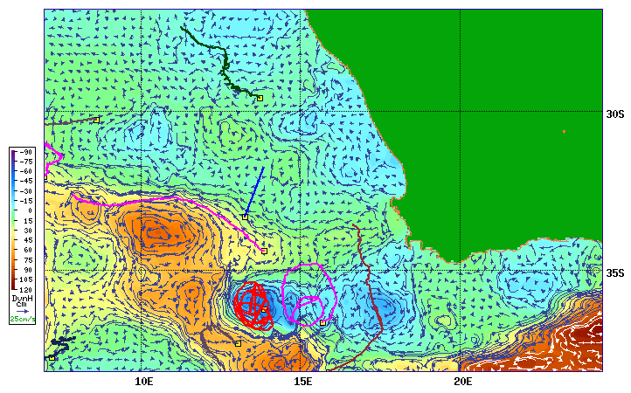

Figure: Type of map, showing surface currents, sea height and drifter trajectories, which will be included in the computer program to support TSG measurements. The map shows part of the Agulhas Current and rings southeast of South Africa.

Typical equipment for the AOML SEAS TSG unit

- Computer Shuttle P4 XPC SS51G: complies with Part 15 of the FCC rules.
- Monitor Sharp model LL-T15G4-B 15" LCD Monitor. This equipment has been tested and found to comply with the limits for a Class B digital device pursuant to Part 15 of the FCC Rules.
- Mitsuko Computer keyboard, tested to comply with FCC standards
- Computer mouse Mitsuko model MO-P033PS00400
- Seabird Micro-TSG (Thermosalinograph Model SBE45) with PC controller box
- Seabird Remote Temperature sensor (Model SBE38)
- Thrane & Thrane A/S, Model TT-3026L/M/S, Std. C Transceiver (non GMDSS). Installed at a compass safe distance that has been measured in accordance with the standards specified in ISO/R 694, Method B. The safe distance found is 50cm. Antenna interface, Times Microwave cable LMR200DB to TT-3026 Maritime Antenna with Elpac DC power supply.
  - Inmarsat Frequencies:
  - Transmission frequency - 1626.5 to 1660.5 MHz.
  - Receive frequency - 1525.0 to 1559.0 MHz.
  - Channel Spacing - 5/2.5/1.25 kHz
- The TT-3026 Maritime Antenna cable is usually run via a thru-hull fitting (which we can install ourselves) to the railing above the bridge where it is mounted in accordance with approved antenna installation procedures. Far enough away from obstructions so that no more than 2 degrees of arc along the horizon is obstructed. Minimum distance to HF antennas >5m. Minimum distance to VHF antennas >4m. Minimum distance to magnetic compass >0.3m.

Typical configuration for the AOML SEAS TSG unit

The TSG data acquisition system is extremely flexible and can be configured to support multiple data sources (e.g. PCO2, XBT) and multiple GPS interfaces.

The most basic configuration consists of the TSG and remote temperature sensor mounted in the engine room near the saltwater intake system. The saltwater supply lines for the Micro TSG (SBE45) can be plumbed from any source provided that the flow volume is confined to between 10-30 GPH (0.63-1.9 liters per minute). The closer the TSG supply line is to the seawater intake, the more accurate the temperature measurements will be. The remote temperature sensor must be as close to the intake as possible. Ideally, the remote temperature sensor (SBE38) would be mounted in or just downstream of the sea chest. Installing the SBE38 requires a through hull penetration or a penetration into the main pipes out of the sea chest. Consequently, this installation must be done under the close supervision of the ship's engineering staff. Often the engineering staff actually performs this part of the installation. The data from the two devices are transmitted via an RS-232 serial interface to an interface box which is also mounted somewhere in the engine room or the engine control room. The interface box marries the data from the two devices (and possibly from a GPS input) into one data stream that is then transmitted via RS-232 or RS-422 to a SEAS PC. The PC can reside in the engine room or on the bridge depending on the distance between the PC and interface box. Limitations in the length of cable over which serial data can be effectively transmitted often necessitate a computer in the engine room handling data logging duties and a second PC on the bridge handling satellite transmission duties. The PC and data collection equipment can be powered from any ordinary engine room outlet (230 or 115 VAC). If necessary a marine grade outlet strip and extension cord run inside metal or plastic coving will be installed.

On the bridge a SEAS PC will be connected to the data interface box or the data logging pc. Additionally, the satellite transmission hardware will be located on the bridge attached to the SEAS PC. The technology for satellite transmission of TSG data will be either Inmarsat-C (detailed in the equipment list above) or Iridium modem. The equipment needed for both transmission mechanisms are comparable in size and power needs. The PC and transmission equipment can be powered from any ordinary bridge outlet (230 or 115 VAC). If necessary, a marine grade outlet strip and extension cord run inside metal or plastic coving will be installed.

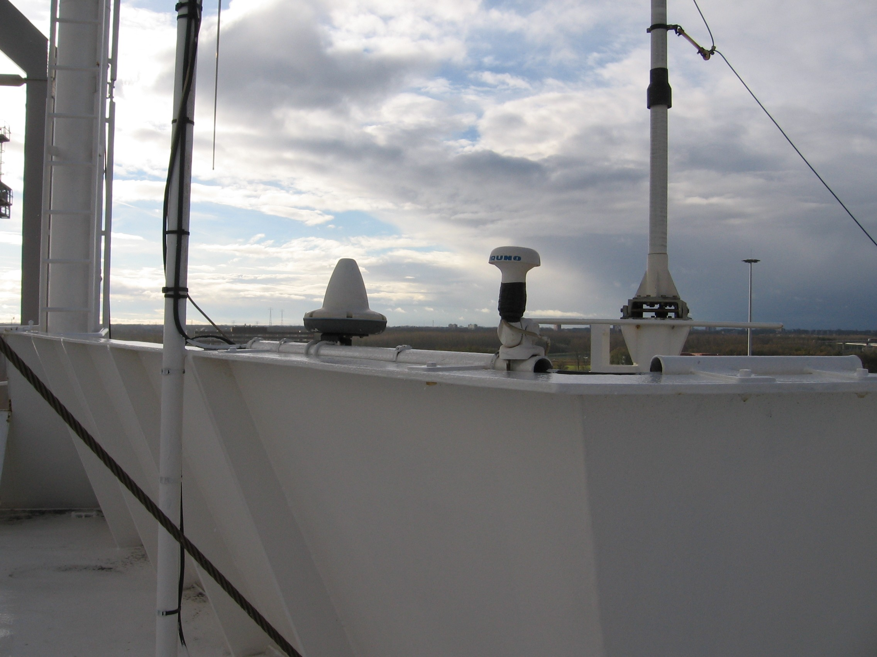
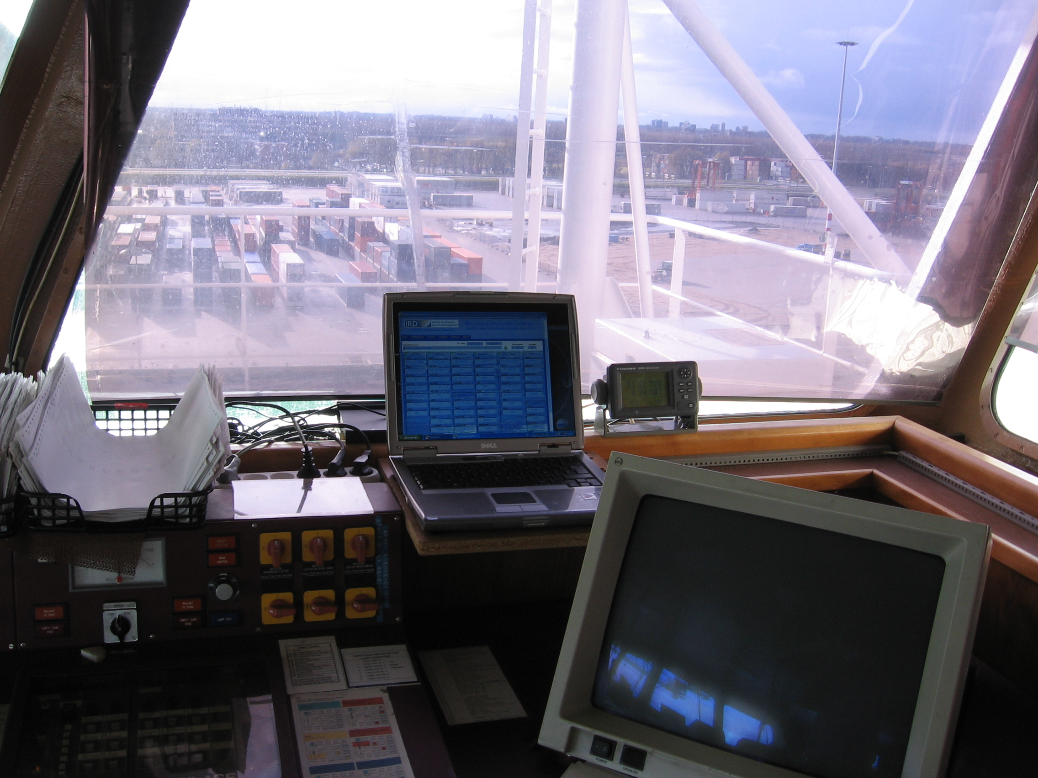
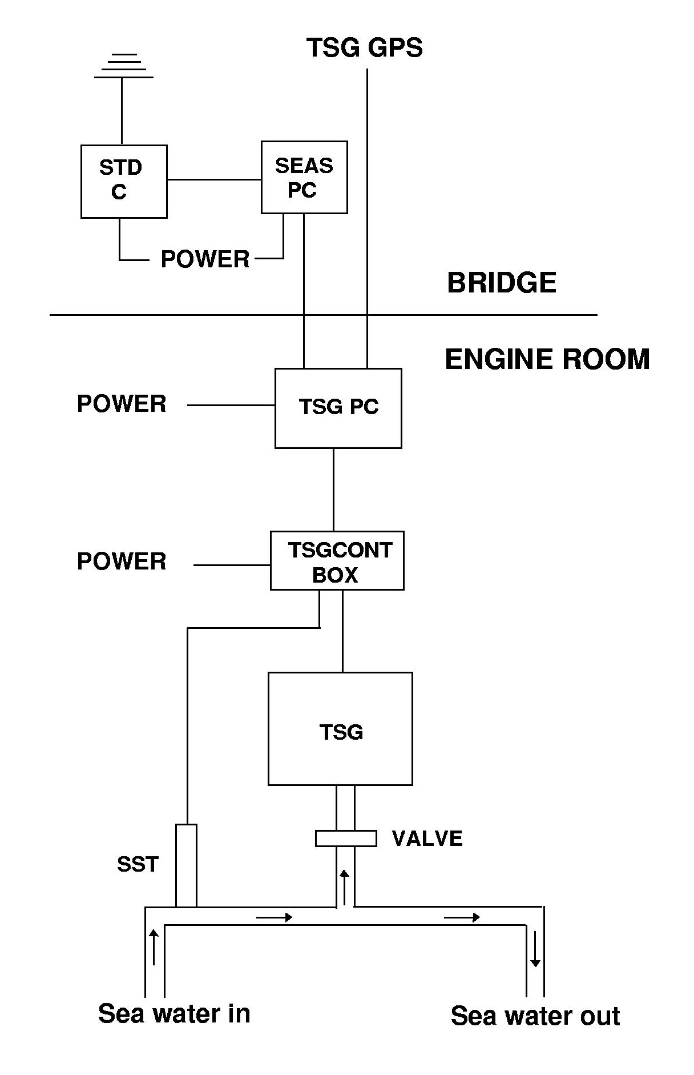

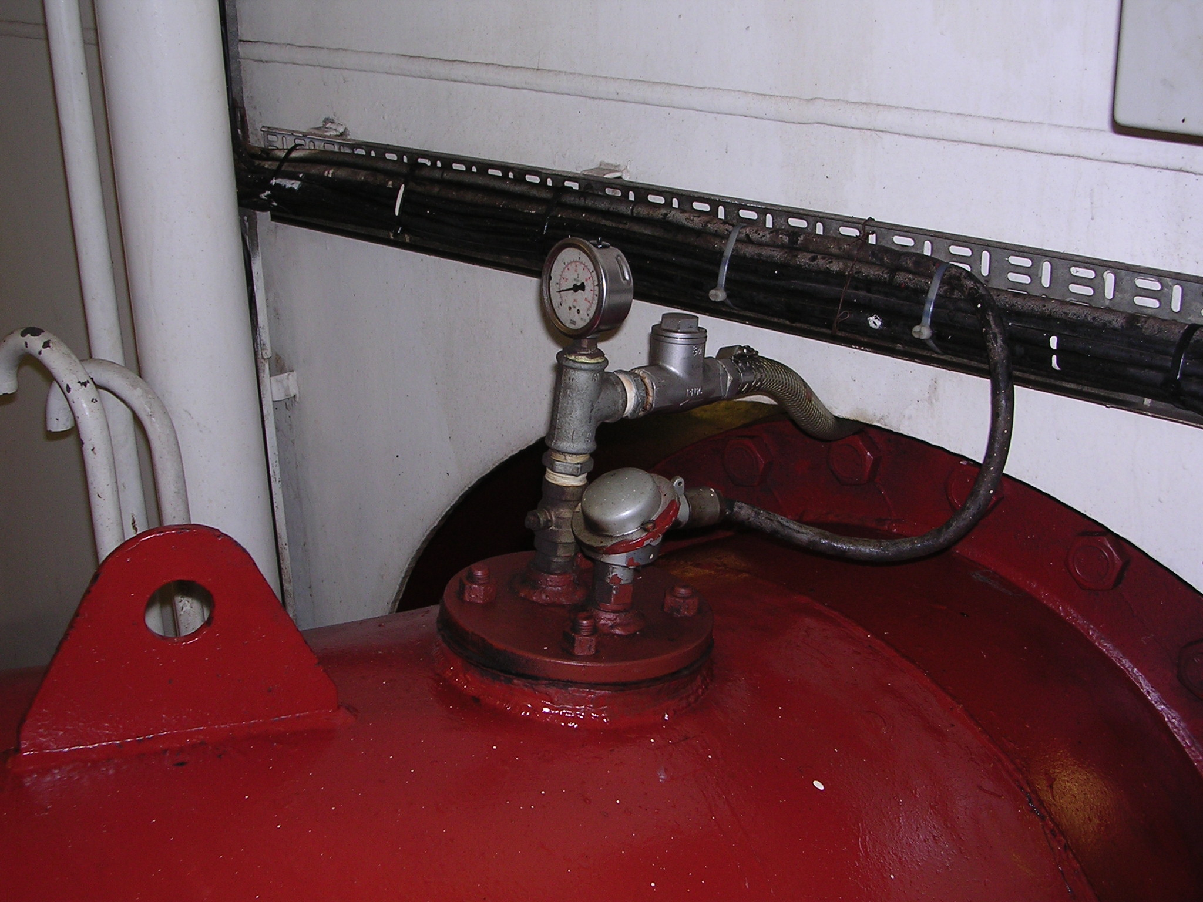
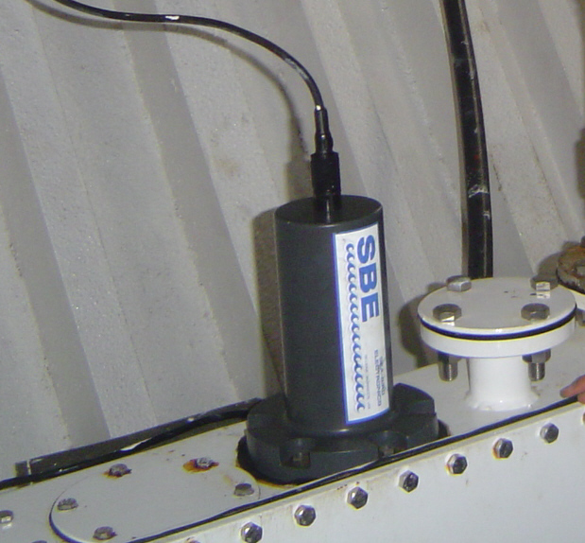
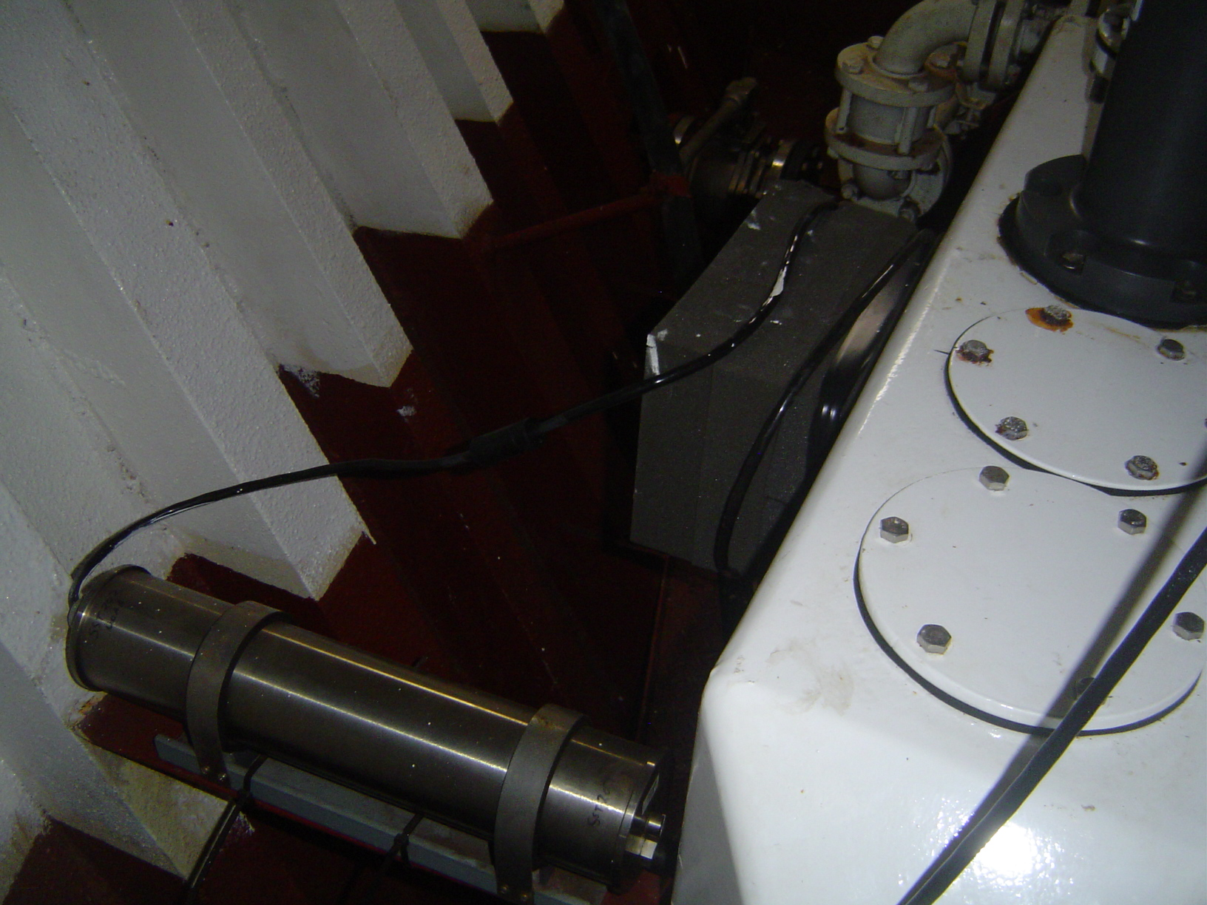

Figure: Diagram of a typical NOAA/AOML TSG configuration

